L1 grammatical attrition in late Spanish-English bilinguals in the UK: aspectual interpretations of present tense in Spanish
Glyn Hicksª* (0000-0003-4126-8655), Laura Domínguezª (0000-0003-2701-2469), E Jamieson^{b} (0000-0001-8679-3360) and Monika Schmid^{b} (0000-0002-3326-2766)
ªDepartment of Languages, Cultures and Linguistics, University of Southampton, Southampton, United Kingdom; ^{b}Department of Language and Linguistic Science, University of York, York, United Kingdom
*Dr Glyn Hicks, Department of Languages, Cultures and Linguistics, Avenue Campus, University of Southampton, Highfield, Southampton, SO17 1BJ, United Kingdom. Email: Glyn.Hicks@soton.ac.uk

L1 grammatical attrition in late Spanish-English bilinguals in the UK: aspectual interpretations of present tense in Spanish
This article sheds light on the linguistic and extralinguistic conditions that determine the likelihood of L1 grammatical attrition in late sequential bilinguals. We explore whether aspectual interpretations associated with the present tense may be a vulnerable area for the native grammar of 30 late Spanish-English bilinguals who have settled in the UK for over 15 years. Attrition of this property in L1 Spanish grammars has been reported by Cuza (2010) for Spanish-English bilinguals in the USA and Canada. Our finding of no attrition for UK-based Spanish bilinguals suggests that in Cuza’s study, attrition may be mediated by dialectal variation in the L1 in the North American context, where Spanish is a widespread and visible community language. Further, we ascribe the absence of attrition to a specific characteristic of the grammatical distinction between the L1 and L2: where the L2 grammar provides options representing only a subset of the options available to the L1 for the corresponding grammatical property, attrition may be disfavoured.
Keywords: L1 attrition; aspect; Spanish

Introduction
This article reports on a multi-method experimental study investigating the extent of native grammatical attrition in 30 late Spanish-English bilinguals who have settled in the UK for over 15 years, focusing on the aspectual interpretations associated with present tense. L1 grammatical attrition is a potential outcome of cross-linguistic influence arising in bilingual speakers, and we restrict attention here to the attrition within mature, ostensibly endstate L1 grammars, adopting the view of grammatical attrition as a potentially enduring modification to the native language grammar of an individual under pressure from extensive exposure to an L2.
While representational changes to an ostensibly endstate L1 grammar are not extensively attested in late sequential bilinguals and grammatical attrition is evidently variable across individuals (e.g., Schmid 2002; Köpke and Schmid 2004), slow and selective changes are confirmed in a number of studies (e.g., Sorace 2000; Tsimpli et al. 2004; Iverson 2012). Yet with ‘relatively limited experimental evidence available in the field so far’ (Schmid 2020:201), further empirical investigation is required to reveal the fundamental characteristics of the phenomenon: what grammatical properties can undergo attrition; to what extent; under what linguistic and extralinguistic conditions?
The present study investigates two predictions of Hicks and Domínguez’s (2020a) ‘Attrition via Acquisition’ model, reviewed in section 2.1 below. Firstly, grammatical attrition is favoured where the L1 and L2 are typologically more similar, with attrition most likely in cases where a speaker is exposed to a new dialect of their L1, and less likely where a speaker is exposed to a typologically distant L2. Second, attrition is favoured for grammatical properties that share similar comparative behaviour in the L1 and L2, but where differences nevertheless remain.. The present study explores potential attrition in one such property in L1 Spanish under the potential influence of L2 English, a typologically distinct language. The two languages share semantic properties with respect to the available aspectual interpretations associated with morphosyntactic tense, yet the interpretations map differently onto tense values in each language: Spanish and English both exhibit a simple present tense, yet while English maps this to a habitual aspectual interpretation, Spanish additionally permits an ongoing/progressive interpretation.
While Cuza (2010) reports grammatical attrition for this property of adult L1 Spanish bilinguals in the US, an explanation of L2-induced change is highly uncertain. Due to the widespread nature of dialectal variation in Spanish in the US, the nature of L1 usage might be more significant than L2 in engendering L1 change in the bilinguals’ grammar. By investigating bilinguals in the UK, the present study achieves a comprehensive insight into the nature of grammatical attrition in aspectual interpretation in Spanish, exclusively under the influence of L2 English. Moreover, our experimental participants and controls are divided into UK-resident groups from both mainland Spain and Latin America, allowing us to determine the potential influence of pre-existing L1 dialectal variation with respect to potential changes in aspectual interpretations.
The extent and nature of attrition are determined via an Acceptability Judgement Task (AJT). A self-paced reading task (SPRT), a nativeness perception study and a participant background questionnaire provide crucial supporting and contextualizing data. Our AJT and SPRT results show that while some dialectal variation distinguishes Latin American from European Spanish-speaker controls/participants, no group-level difference is found between bilinguals and controls.

- L1 grammatical attrition of aspect in Spanish
  - Attrition via Acquisition
Hicks and Domínguez (2020a,b) present a model of grammatical attrition which assumes that the grammatical changes entailed in L1 grammatical attrition engage the same linguistic and acquisitional mechanisms as other forms of L1 and L2 acquisition: this unified model for acquisition and attrition (adapted from Lidz and Gagliardi’s (2015) model of L1 acquisition; see fig. 1) is described as ‘Attrition via Acquisition’, henceforth AvA.

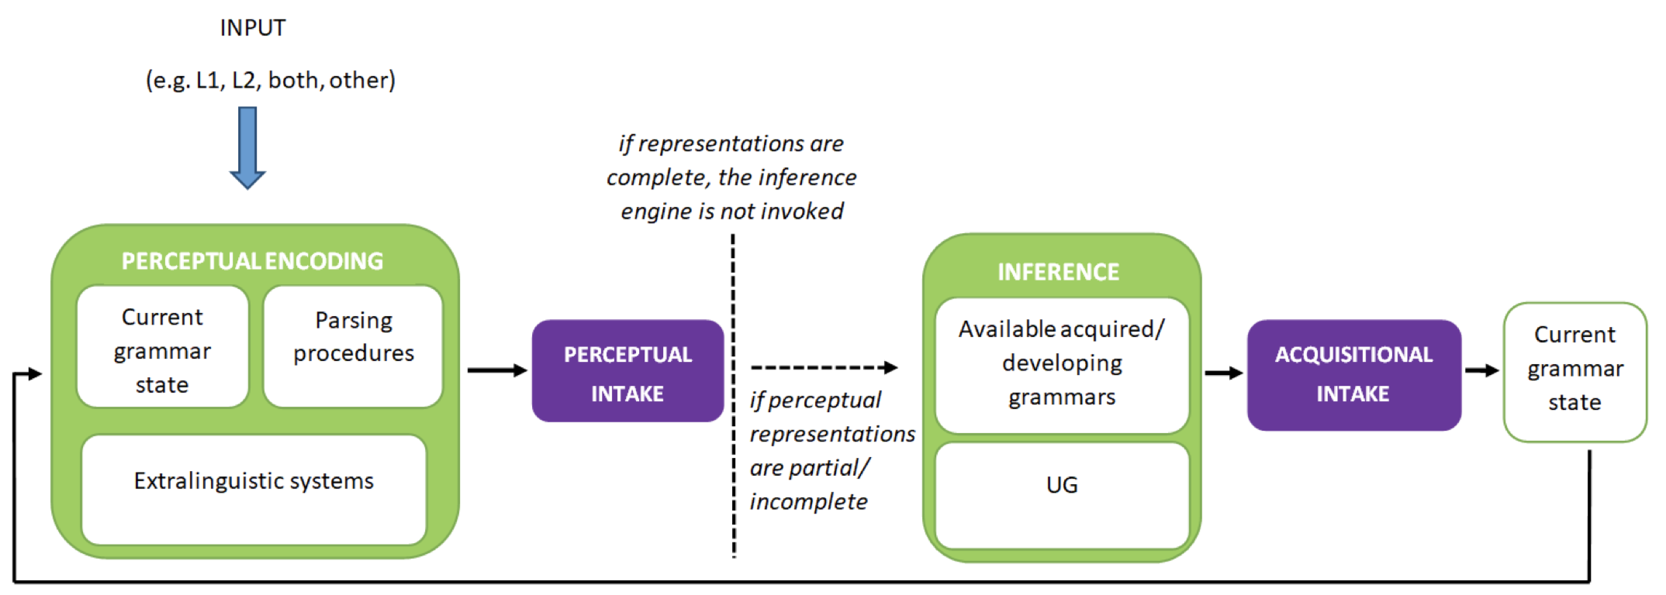
Figure 1. Unified Model of Grammatical Acquisition and Attrition (‘Attrition via Acquisition Model’; Hicks and Domínguez 2020a:152).

Hicks and Domínguez adopt a model of the grammar based on the broad assumptions of the Minimalist programme (e.g., Chomsky 2000; 2001), whereby lexical items are specified with bundled feature assemblies that are manipulated by the syntactic component of the grammar and then read off by the interfaces with the Conceptual-Intentional system (LF) and the Sensori-Motor system (PF). Adopting the UG-constrained mechanism of Feature Reassembly developed for second language acquisition (see e.g. Lardiere 2009), Hicks and Domínguez propose that attrition consists of reassembling the features of L1 lexical items, specifically in a manner which would match the corresponding property of the acquired L2, for which ‘new’ (substantial) input is provided.
This model allows detailed, theoretically-informed assumptions about the nature of any representational change in the L1 grammar to be articulated and accommodates the role of both linguistic factors (e.g., comparative properties of the L1 and L2) and broader processing/acquisitional factors that determine acquisitional intake from the L2 to L1. Linguistic input is processed by a speaker or hearer, and in the case of L2 input, the nature of that processing determines what influence the L2 input ultimately exerts on the L1 grammar. The L2 stimulus first undergoes perceptual encoding, which assigns linguistic representations on multiple levels (e.g., phonetic, phonological, semantic, etc). Where this ‘perceptual intake’ mismatches with the current grammar, the inference engine is invoked: the mechanisms of acquisition activate in order to update the current grammar state (‘acquisitional intake’), such that it can align with the perceptual intake. As L2 acquisition proceeds, the current grammar state better and better matches the L2 input, and so the acquisitional intake becomes more fine-grained: there is then less that feeds through from perceptual intake to the inference engine in order to generate new acquisitional intake. If the acquired L2 grammatical representations match closely—though not exactly—with a corresponding property of the L1, the compatibility between the L1 and L2 representations raises the possibility that the L2 acquisitional intake is also carried over to the L1, particularly in a case of dominant input from the L2 and reduced input from the L1 to reinforce the existing L1 representations. Such change to the L1 grammar—as a consequence of processing L2 input—represents grammatical attrition.
Through this approach to intake based on L2 input in the AvA model, Hicks and Domínguez (2020a) make some predictions about the conditions that may favour such changes to the L1. Two of these are addressed in the present study. Firstly, they assume that grammatical attrition should be favoured where the L1 and L2 are typologically more similar, with attrition most likely in cases where a speaker is exposed to a new dialect of their L1, and least likely where a speaker is exposed an L2 which is typologically distant from their L1. Secondly, Hicks and Domínguez assume that the comparative difference between how a specific grammatical property is realised in a speaker’s L1 and L2 influences its susceptibility to attrition, with attrition more likely for a property that exists both in the L1 and L2 yet where specific differences obtain in that property across the two languages (e.g., Gürel 2002, 2007; Tsimpli 2007; Gürel and Yılmaz 2011, Hicks and Domínguez 2020a).

L1 attrition of aspect in Spanish

The specific grammatical property to be studied is selected to explore these expectations, focusing on possible attrition within the aspectual interpretations of Spanish present tense. Although English and Spanish are relatively distinct typologically, in the selected property there is an apparently straightforward featural configuration with respect to grammatical aspect which underlies the difference between the two languages. English and Spanish both exhibit a periphrastic morphosyntactic configuration consisting of an auxiliary verb be plus a progressive participle (be + -ing and estar + -ando respectively) which maps to an ongoing aspectual interpretation (1b, for Spanish). Spanish and English also both exhibit a simple present tense, yet while English maps simple present tense to a habitual aspectual interpretation, Spanish present tense routinely maps to both ongoing (1a) and habitual (2a) aspectual interpretations:

- a. Ahora ella corre.
Now she runs
‘Now she is running.’
b. Ahora ella está corriendo.
Now she is running
‘Now she is running.’

- a. Todos los días ella corre.
Everyday she runs
‘She runs every day.’
b. *Todos los días ella está corriendo
Everyday she is running

This grammatical property is predicted to be a potential candidate for attrition in the AvA model (Hicks and Domínguez 2020a) because Spanish and English share the same syntactic/semantic features, but they map differently onto morphosyntactic forms: L1 Spanish speakers acquiring the property in L2 English do not acquire a new feature or structure, but they must determine which set of semantic features they associate with. Attrition, if attested, would be represented as the feature specification of present tense in L2 English being mapped to present tense in the L1. It could manifest in a non-targetlike rejection of the L1 grammaticality of present tense where an ongoing interpretation is forced, or in an elevated preference in the L1 for the estar + -ndo configuration over the simple present in production of verbs with progressive interpretations.
Vulnerability of aspectual interpretations associated with the present tense in the L1 of Spanish-English bilinguals is reported by Cuza (2010). Studying 19 Caribbean Spanish speakers who migrated to the US or Canada in ‘early adulthood’ (after the age of 14; mean 16;5), Cuza finds that some bilinguals’ L1 Spanish grammars indicate present tense becoming restricted to habitual interpretations, where monolinguals’ L1 more freely permits the ongoing interpretation. In an acceptability judgment task (addressing written comprehension), Cuza finds a significant group-level difference between controls and bilinguals in the present tense with ongoing interpretation, with the bilinguals showing a lower acceptance, consistent with attrition of the L1 property due to L2 influence. At individual level, while 19 of the 20 controls demonstrated ‘acceptance behaviour’ of the ongoing interpretation for simple present tense (positively rating at least four of the five test items for this condition), only 10 of the 19 bilinguals demonstrated the same acceptance behaviour, with four bilinguals positively rating three of the five test items and five positively rating two or fewer. Cuza considers a number of social and linguistic factors which may have affected the bilinguals’ results, and ultimately correlates their experimental behaviour to greater use of English at work or home.
Cuza (2010) does not address the fact that there is also an apparently significant group-level difference between the bilinguals and controls with respect to rejecting habitual readings for the progressive. While the mean ratings of the control group exhibit an expected general rejection of habitual interpretation with the estar + -ndo configuration, the bilinguals do not reject at the same rate. So while there is a similar group effect on aspectual interpretation, there is no natural explanation based on the properties of the L2, since English robustly rejects habitual interpretation for the corresponding the be + -ing configuration. This may reflect a grammar which is changing not due to L2-induced attrition, but to exposure to dialectal varieties of Spanish exhibiting different aspectual preferences with respect to the available morphosyntactic configurations. In the truth value judgment task (TVJT), addressing listening comprehension, differences between the controls and bilinguals were smaller than for the AJT (interestingly, the non-targetlike failure in the AJT to reject the estar + -ndo with a habitual interpretation was not borne out in the TVJT that the participants also completed), but were still significant at the group level for the progressive interpretation for the simple present condition. Finally, in an elicited production task, Cuza reports that the bilingual participants also selected the present tense rather than estar + -ndo to realise progressive interpretation significantly less frequently than the controls.
Three aspects of the methodology in Cuza’s (2010) study give rise to uncertainty in his conclusion of L2-induced L1 attrition. Firstly, the relatively young age of the participants, particularly given that the five who show rejection behaviour migrated at just 14 years old and received both high school and University education in English. It is possible that age of migration and extended input thus played an important role in their accepting/rejecting behaviour. Secondly, while Cuza concludes that the aspectual interpretation of present tense has eroded in the bilinguals due to contact with English, he recognises a key limitation in that lower acceptability/use of ongoing meaning with present tense in the attriting group might result from these speakers’ contact with other dialects of Spanish where this interpretation is less favoured (e.g. Mexico). If so, then this would be considered an example of bidialectal attrition (see Domínguez and Hicks 2016 for bidialectal attrition in Spanish subject realisation). Finally, indications that community language status may be an important factor influencing the extent of grammatical attrition are provided by Domínguez (2013), where the UK and US contexts are directly compared. Considering the use of null and postverbal subjects in L1 Spanish (a property which distinguishes Spanish from English), Domínguez found evidence of L1 grammatical attrition via changing subject use for these two properties among the Cuban Spanish speakers in Miami, but did not find the same for Spanish speakers in the UK; Dominguez reports that the key difference between these two groups of Spanish-speaking migrants is that the Miami group live in a speech community where many dialects of Spanish are represented, and thus are more likely to have access to variable input.
The present study, outlined below, seeks to test the predictions of the AvA model of attrition in Spanish aspect with a more nuanced methodological approach.

Methodology

Predictions

The study is broadly designed to test the relative influence of two distinct factors expected to affect the likelihood of grammatical attrition within the AvA model (Hicks and Domínguez 2020a). First, the model predicts that grammatical attrition is less likely due to the relative typological distance between Spanish and English. Yet on the other hand, the model predicts (following, among others, Gürel, 2002, 2007; Gürel and Yılmaz, 2011; Tsimpli, 2007) that largely equivalent morphosyntactic properties with fine-grained distinctions between them (encoded in distinct feature assemblies, for Hicks and Domínguez) should favour attrition. The distinction in the interpretive possibilities regarding habitual/generic and progressive aspect in Spanish and English is determined by fine grained syntactic differences (Arche 2014). Whether and to what extent attrition is attested for the participants in our study will help to determine the relative influence of these two factors. Comparison with Cuza’s (2010) study of L1 attrition of progressive aspect with Spanish present tense will help determine whether the broader sociolinguistic context of usage and exposure to L1 variation within the L2 context is influential in determining the likelihood of attrition.

Participants
The bilingual participant group consisted of 30 English-Spanish bilingual adults (27 female; 3 male), who acquired English as a second language in a native-English speaking environment in the UK. The average age of the bilinguals was 48 (range 32-56, SD = 5.28). The mean age of arrival in the UK was 26.5 years, with all participants aged over 18 years upon arrival apart from two (with age of arrival 16 years). The mean length of residence was 21.3 years (minimum 15 years, maximum 34 years).
Due to potential dialectal variation in the usage and acceptability of simple present in ongoing and habitual contexts, the study recruited speakers both from mainland Spain (18 participants) and Latin America (12 participants, from Argentina, Venezuela, Peru, Mexico and Uruguay). The control group consisted of 30 L1 Spanish speakers from Spain (18) and Latin America (12, from Argentina and Mexico). To age match with the bilingual participants, control participants were aged 36-62 with an average age of 50.
Crucially, only participants whose exposure to English was in the UK, rather than in North America were selected. As Cazzoli-Goeta and Young-Scholten (2011) and Corbet and Domínguez (2020) emphasise, whereas Spanish in the USA has widespread presence and visibility as a community language in a number of regions and major cities, there is no visible or recognised community of Spanish speakers in the UK (Pozo-Gutiérrez 2003), despite significant numbers of L1 Spanish speakers currently residing in the UK. Following Corbet and Domínguez’s (2020) study of heritage speakers of Spanish outside of the US, the UK context also provides a crucial insight into the potential role of an L2’s community status in L1 language attrition and allows us to limit the likely influence of the Spanish speakers’ exposure to different varieties of L1.

Instruments
The extent and nature of grammatical attrition was determined by an offline context-dependent acceptability judgment task (AJT) accompanied by an online processing task. In the AJT, participants were required to read a context sentence establishing the relevant interpretation for the continuation sentence as either ongoing or habitual. They were presented with two continuation sentences (firstly in audio form, and subsequently in written form): one with a present tense verb and another with an estar + -ndo configuration, for example:
- Estamos en la estación y llevamos una hora esperando a que llegue nuestro tren. Por fin hay buenas noticias.
[We are at the train station and have been waiting an hour for our train to arrive. Finally, some good news.]

a. Ahora llega nuestro tren.
b. Ahora está llegando nuestro tren.
[Now our train arrives vs. Now our train is arriving]
Participants were asked to rate both sentences on a 1-to-5 Likert scale (Schütze 1996) to establish the acceptability of each sentence as well as the relative preference for each form to realise the required aspectual interpretation. There were 36 contexts, hence 72 sentences were rated in total.
In the online processing task, participants read examples of the simple present and estar + -ndo constructions as part of a self-paced reading task (SPRT). The same 36 contexts and 72 continuing sentences used in the AJT were presented in a pseudo-randomised order and were balanced by 216 items investigating different grammatical phenomena in Spanish. Participants completed the SPRT before the AJT, in order that they had not already been exposed to the test items.
Participants also undertook semi-structured sociolinguistic oral interviews with a Spanish-speaking fieldworker in which the target structures may have arisen, though the results of those are not directly considered here. However, a subset of these recorded interviews formed the basis of a nativeness perception task (e.g. Schmid and Hopp 2014) conducted following the main data collection period. Samples of speech from 17 participants who were originally from Spain were included in the task, alongside four control participant speech samples. Thirty native speakers of Spanish still living in Spain were asked to rate samples of the participants’ speech for nativeness in Spanish, and also evaluated their own confidence in their assessment. These scores were combined to give a general Foreign Accent Rating for each speech sample. Speech samples ranged from 9 to 29 seconds (mean: 19.6 seconds), and raters listened to each clip once. After the clip, they were then presented with a sliding scale from ‘a native speaker’ to ‘a non-native speaker’, and a three-way choice of ‘certain’, ‘somewhat certain’, ‘not certain’.
All participants completed a background questionnaire, adapted from the sociolinguistic questionnaire for language attrition used in Mehotcheva (2010). This collected information about participants’ language histories, attitudes, and use. Importantly, participants were asked to assess their own proficiency in the L1 before arrival in the UK, and their proficiency at the time of completing the questionnaire.

Results and discussion

Experimental results

Modelling the results of the AJT tasks shows no overall attrition at group level; see fig. 2, where each point on the scatter plot shows an individual participant’s mean score from the test items in each condition (minimum score 1, maximum 5):
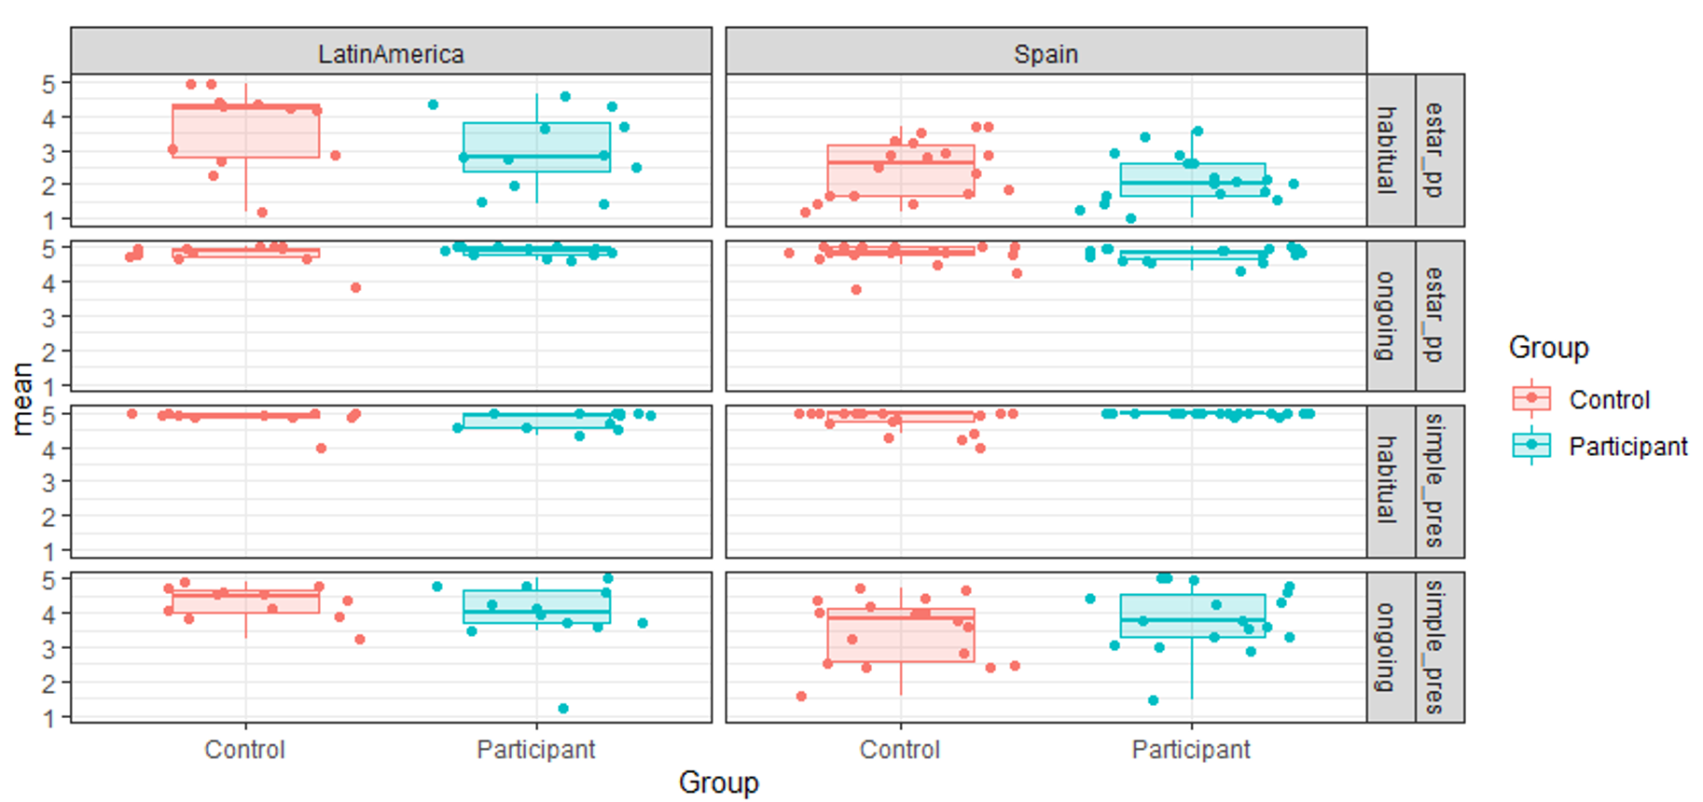
Figure 2. Acceptability of ongoing interpretation for present tense and estar + -ndo in Acceptability Judgement Task.

To better understand the potential influence of dialectal variation with respect to aspectual interpretations, the participants and controls are split into Latin American Spanish versus mainland European Spanish speakers. The clearest distinction in this respect is for the habitual interpretation with periphrastic estar + -ndo condition. Latin American speakers much more freely allow the habitual interpretation than the Spanish controls, and Torres Cacoullos (2000) argues that in Latin American Spanish, there is general change towards habitual interpretations. However for the present study, the key condition regarding attrition concerns the bottom row of fig. 2: the ongoing interpretation of the simple present which is expected to be acceptable for controls, yet where the participants may undergo attrition, as for Cuza (2010). Latin American participants find this overwhelmingly acceptable, as expected (median 4, mode 5, mean 3.93). Yet the controls do too (median and mode 5, mean 4.29). For the mainland Spanish controls, the acceptability is more mixed, indicating variability in the acceptability of the ongoing interpretations (median 4, mode 5, mean 3.50). But again, the participants’ acceptability data matches the controls’ (median 4, mode 5, mean 3.83). Cumulative link mixed models—a form of logistic regression model designed for use with ordinal data, such as AJTs—run in R (Christensen 2022) indicate that there is a significant difference between the two country groups, with participants and controls from Spain overall rating lower than participants and controls from Latin America. However, experimental group (i.e. bilinguals versus controls) was not a significant factor in the models, indicating that there is no significant difference in the ratings of the participants as compared to the controls in either country group.
At the individual level, two bilingual participants (SP12 and SP24) exhibit an English-like pattern, borne out as an almost categorical rejection of the progressive interpretation with simple present (median and mode 1; means 1.44 and 1 respectively), corresponding to the English interpretation of present tense. SP12 is a 46 year old female from Mexico who has been in the UK for 22 years. SP24 is a 46 year old female from Spain who has been in the UK for 15 years. While this pattern might indicate that these participants have undergone attrition, one monolingual speaker in the Spanish control group (SC19) also exhibits the same behaviour (median and mode 1, mean 1.67). Notably, all three show a very strong pattern of rejection of the habitual interpretation of estar + -ndo; while that is not entirely surprising, participants show variability in this regard, and while acceptability is low on the whole, the overall pattern of rejection is far weaker than is borne out for these speakers, with an overall mean of 2.71. All three show the expected pattern of very strong acceptance for the other two conditions (ongoing interpretation for estar + -ndo, habitual interpretation for simple present tense), from which a tentative conclusion is that this may be an indication that these three speakers exhibit a binary system of preference for mapping aspectual interpretations to morphosyntactic configurations, i.e. where simple present is compatible only with habitual, and estar + -ndo only with progressive.
The finding of no overall attrition in the AJT results is supported by the results of the SPRT. Residual reading times were calculated for each participant in each region; the mean residual reading times are plotted in fig. 3.

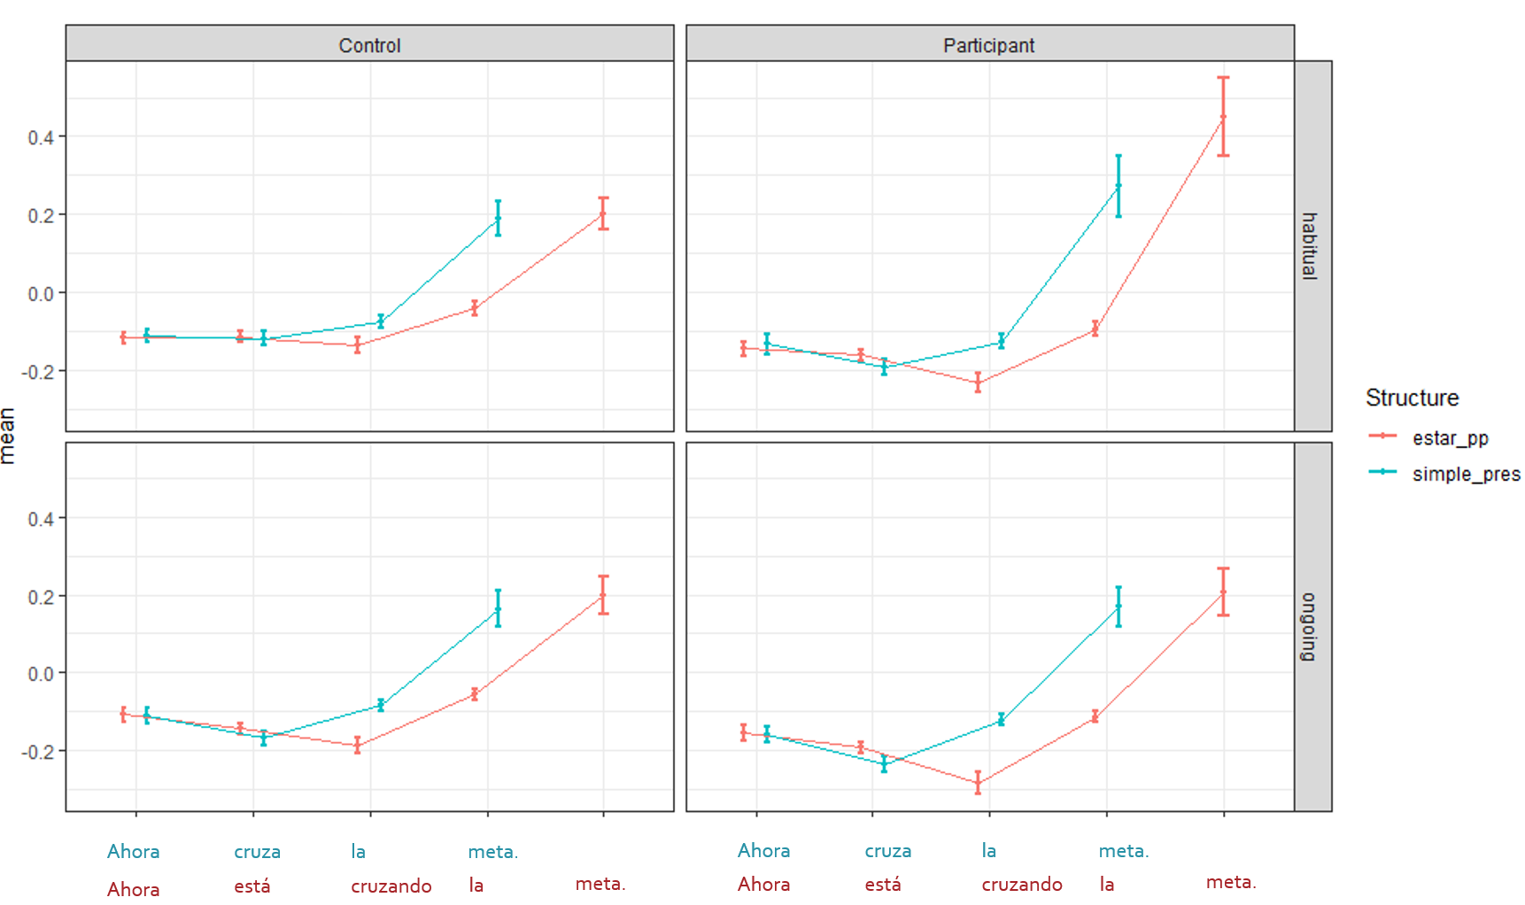
Figure 3. Residual reading times for present tense and estar + -ndo with habitual and progressive interpretations

The data show that the controls and the bilingual participants behave remarkably similarly to each other at the two critical regions. At the first critical region (region 2), there is a main effect of aspect: in general, the ongoing interpretation is read faster than the habitual interpretation. However, there are no effects of structure, or differences between the participants and the controls. In the second critical region (region 3), there is a main effect of structure: simple present examples are read slower than estar + -ndo configurations. This is unsurprising, given that participants will be expecting an -ndo verb following an estar form, while there is not the same level of predictability in what will follow a simple present form. There are no further effects or interactions in this region.

Discussion

In terms of our overall finding of no attrition by contrast with Cuza’s (2010) study, a few potential explanations could be entertained. First, it might be envisaged that the group of participants selected simply turned out to be a sample that did not have the relevant characteristics to be susceptible to attrition (e.g. insufficient length of residence, exposure to L2). However, this explanation can be excluded. In the background questionnaire, participants were asked to assess their own L1 proficiency at the time of arrival in the UK versus the time of the study; 47% of participants reported that their Spanish was now only ‘good’, though it had been ‘very good’ at time of arrival. This does not provide insight into the participants’ grammatical knowledge specifically, but confirms that the bilingual participants felt that their own L1 use had been affected.

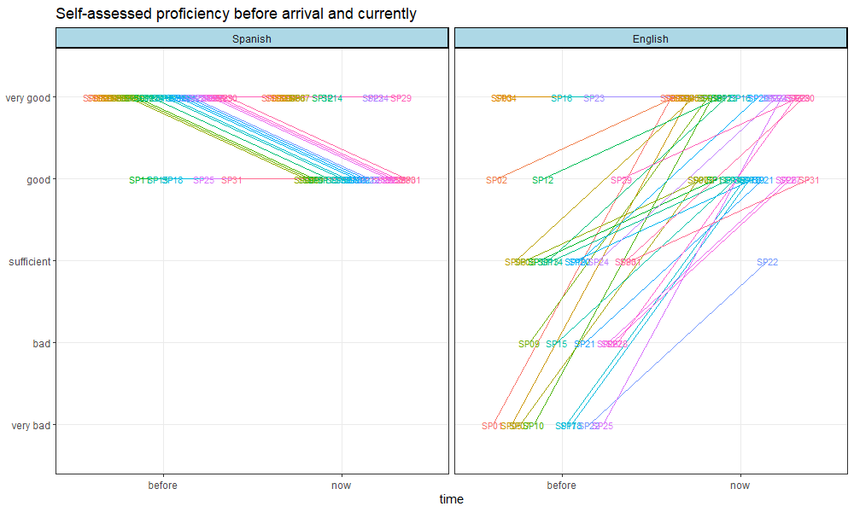
Figure 4. Bilingual participants’ self-assessed proficiency in L1 (Spanish) and L2 (English) before arrival in the L2 environment and currently

Furthermore, the results of the nativeness perception study indicate that bilingual participants were overall given higher mean Foreign Accent Ratings than the monolingual controls (t(15.868) = -2.15, p = 0.047). Considering individuals, 44% of the bilinguals’ mean Foreign Accent Ratings were outside the range of the mean ratings assigned to the monolingual controls:

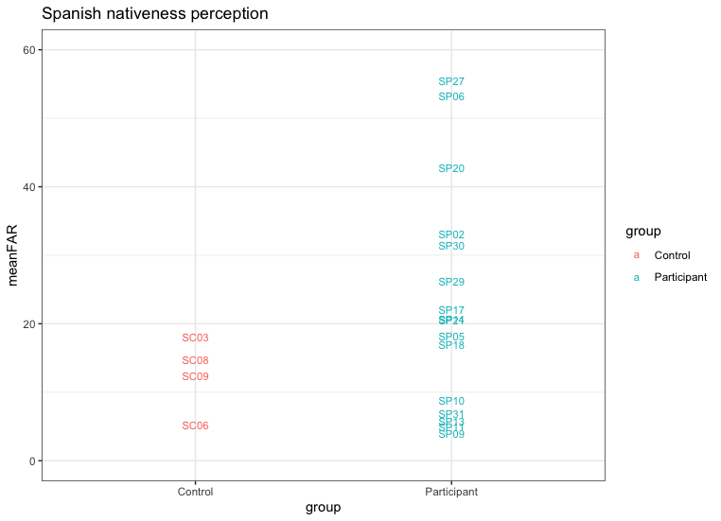
Figure 5. Monolingual speakers’ perceptions of nativeness for bilingual participants and controls

This result confirms that for bilinguals in the experimental tasks, certain characteristics of their L1 knowledge or use had indeed been influenced by long-term exposure to the L2. So, the resilience of the grammatical property of aspectual interpretation for these participants is not due to a failure in recruiting a sample possessing the relevant characteristics to be potentially susceptible to L1 attrition.
A second possible explanation for this absence of attrition is, as initially predicted in 3.1, that the language pair in question may disfavour attrition since the two languages are typologically too distant to engender this type of crosslinguistic interference. Hicks and Domínguez (2020a) propose that typological proximity between an L1 and L2 favours attrition due the completeness of the perceptual representations that can be assigned to L2 input (hence leading to acquisitional intake) and due to the similarity in relevant grammatical representations between the L1 and L2 favouring the detection and encoding of minor differences via feature reassembly. In this respect, we can explain the contrast with Cuza’s (2010) findings for the same property. In the North American context for Spanish, any influence of L2 English may be mediated by quite extensive L1-L2 contact at the community level along with new variability in the L1 input potentially from a range of L1 Spanish dialects represented in the US. For example, Cuza (2010:270) notes that his Caribbean Spanish sample may have been in contact with speakers of Mexican Spanish. The L1-L2 context which may favour attrition most is one where the L1 and L2 are dialectal varieties of the same language (e.g. as found by Domínguez 2013; Domínguez and Hicks 2016 for the realisation of subjects in L1 Spanish speakers migrating to a different Spanish-speaking environment in the USA). We therefore ascribe Cuza’s finding of attrition to bidialectal attrition, which is predicted to arise more readily in the AvA model (Hicks and Domínguez 2020a). On the other hand, as discussed in section 3.2, the conditions for bidialectal attrition—community-level contact between speakers of different dialects of Spanish—do not arise in the UK context: ‘[T]he UK is not fertile ground for emergence of a new variety of Spanish’ (Cazzoli-Goeta et al. 2010: 468).
Nevertheless, there are indications that this language pair should not preclude attrition altogether. A number of other studies have demonstrated grammatical attrition for L1s that are similarly—if not more—distinct from English; see, e.g., Sorace (2000) for Italian L1 speakers, Tsimpli et al. (2004) for Greek and Italian L1 speakers, Gürel (2004) and Gürel and Yılmaz (2011) for Turkish L1 speakers. Given that all other factors in principle appear to favour the possibility of attrition (the characteristics of the bilingual sample and the comparative characteristics of the selected grammatical property in the L1 and L2), it remains to adequately account for why participants in the present study robustly maintain aspectual interpretation.
We propose that a third possible explanation for why L2 English does not directly induce change in L1 Spanish aspectual interpretation is provided by the AvA model, concerning the acquisitional mechanism by which attrition arises: specifically, the nature of the representational change that would be entailed, and the input data required to trigger it. As outlined in section 2.1, Hicks and Domínguez’s (2020a) AvA model regards change to an L1 grammar as being directly induced by L2 acquisition. L2 input which when processed mismatches with the speaker’s current L2 grammar generates acquisitional intake. Grammatical attrition arises when this ‘update’ to the L2 grammar is applied to the corresponding property of the L1 grammar as well. The L2 English input regarding present tense—necessarily restricted to habitual interpretations only—in fact does not provide data that directly mismatches the bilingual speaker’s L1 grammar, since Spanish present tense also permits the same mapping. So, the available L2 input from English present tense verbs fails to provide data that would result in acquisitional intake regarding aspectual interpretation, since the relevant processed English input (present tense verbs with habitual interpretations) would not result in form-meaning mappings that are inconsistent with the corresponding configuration in the L1. Bilingual speakers would not be changing the underlying grammar but adjusting the statistical tendencies of Spanish to rebalance the use of each form to express each meaning, without the grammar necessarily undergoing representational change.
The finding of no attrition for this property is consistent with Gürel’s (2002, 2007) ‘Set-Theoretic Language Attrition Model’. Gürel claims that transfer from L2 to L1 is possible for grammatical properties such that the L2 provides a superset, and the L1 a subset; attrition consists of adding grammatical options to an L1 which is more restrictive. We propose here that the mechanisms for attrition in Hicks and Domínguez’s (2020a) AvA model account for the essential premise of the subset model, regarding L2-induced grammatical change being disfavoured where it constitutes losing a form-meaning mapping from the L1 (as opposed to gaining an additional grammatical representation from the L2, which is possible since the L2 input data provides evidence for it). This tentative explanation makes a natural prediction, then, that if the experimental design of the present study were reversed, L1 speakers of English exposed to L2 Spanish would more readily demonstrate attrition for this property: in the reverse design the L2 would provide input data (Spanish present tense verbs with an ongoing interpretation) that directly mismatches the L1 English grammar. In that context, L1 grammatical attrition would be borne out as the acceptance of an ongoing interpretation for simple present tense verbs in L1 English.

Conclusion

The linguistic and contextual conditions in which grammatical attrition arises are complex. This study makes progress in understanding the relative contributions of some of the relevant factors, reporting on the appearance of possible L1 attrition in Spanish speakers who have migrated to an English-speaking environment in the UK for more than 15 years.
The overarching result from the AJT and SPRT does not challenge the prevailing understanding that, in general, morphosyntactic features of an L1 remain relatively robust even following an extensive period of exposure to an L2. Attrition is not detected in group-level analysis, although the experimental results from individual speakers in the AJT may provide some indication that attrition of aspectual interpretation from present tense is possible for some speakers. However, this finding is tempered by the observation that one monolingual control speaker also exhibited the same pattern of responses in the experimental task. Given that Cuza (2010) reports group-level attrition for this property where speakers were exposed to L2 English but also to dialectal variation in within the community, our finding of no group-level attrition in the UK context appears consistent with Hicks and Domínguez’s (2020a) prediction that attrition is more likely in bidialectal than bilingual contexts.
On the contrary, the absence of attrition suggests that the model's further prediction that similarity in the grammatical property based on functional feature specifications (represented as a shared set of morphosyntactic features assembled onto functional categories in slightly different configurations) should favour attrition is not supported. We tentatively propose that acquisitional rather than purely grammatical factors may account for why L2 English does not directly induce change in L1 Spanish aspectual interpretation. Specifically, this concerns the nature of the representational change that would be entailed in this particular change to the L1 grammar and the input data required to trigger it under the mechanisms of attrition provided by the AvA model (Hicks and Domínguez 2020a). The broader testable prediction of Hicks and Domínguez’s (2020a) model of attrition, then, is that similarly to Gürel (2002, 2007), attrition arises in grammatical contexts that consist of adding an option to the L1 grammar, but not of removing one.

References

Arche, María J. 2014. “The Construction of Viewpoint Aspect: The Imperfective Revisited.” Natural Language and Linguistic Theory 32 (3): 791–831.
Cazzoli-Goeta, Marcela, Pedro Guijarro-Fuentes, and Martha Young-Scholten. 2010. “Beyond Attrition: What We Need to Consider in the Study of New Spanish Varieties.” In New Directions in Language Acquisition: Romance Languages in the Generative Perspective, edited by Pedro Guijarro-Fuentes and Laura Domínguez, 453–478. Newcastle upon Tyne, UK: Cambridge Scholars Publishing.
Cazzoli-Goeta, Marcela, and Martha Young-Scholten. 2011. “Yo gusto: Expanding choice or syntactic attrition?” In Bilingual Youth: Spanish in English-Speaking Societies, edited by Kim Potowski, and Jason Rothman, 201–226. Amsterdam: John Benjamins.
Chomsky, Noam. 2000. “Minimalist Inquiries: The Framework.” In Step By Step: Essays In Syntax in Honor of Howard Lasnik, edited by Roger Martin, David Michaels, and Juan Uriagereka, 89–155. Cambridge, MA: MIT Press.
Chomsky, Noam. 2001. “Derivation by Phase.” In Ken Hale: A Life in Language, edited by Michael Kenstowicz, 1-52. Cambridge, MA: MIT Press.
Christensen, Rune H. B. 2022. “‘Ordinal’ Package for R.” https://cran.r-project.org/web/packages/ordinal/index.html.
Corbet, James, and Laura Domínguez. 2020. “The Comprehension of Tense–Aspect Morphology by Spanish Heritage Speakers in the United Kingdom.” Languages 5 (4): 46.
Cuza, Alejandro. 2010. “On the L1 Attrition of the Spanish Present Tense.” Hispania 93 (2): 256-272.
Domínguez, Laura. 2013. Understanding Interfaces: Second Language Acquisition and First Language Attrition of Spanish Subject Realization and Word Order Variation. Amsterdam: John Benjamins.
Domínguez, Laura, and Glyn Hicks. 2016. “Synchronic Change in a Multidialectal Community: Evidence from Spanish Null and Postverbal Subjects”. In Inquiries in Hispanic Linguistics: from Theory to Empirical Evidence, edited by Alejandro Cuza, Lori Czerwionka, and Daniel Olson, 53-72. Amsterdam: John Benjamins.
Domínguez, Laura, Glyn Hicks, E Jamieson, and Monika S. Schmid. 2023. “CoNGA: A Corpus of Native Grammar Attrition.” https://conga.soton.ac.uk.
Fuchs, Martin, and Paz González. 2022. “Perfect-Perfective Variation across Spanish Dialects: A Parallel-Corpus Study.” Languages 7 (3), 166.
Gonçalves, Bruno, and David Sánchez. 2016. “Learning about Spanish Dialects through Twitter.” Revista Internacional de Lingüística Iberoamericana Vol. 14 2 (28): 65-75.
González, Paz, Margarita J. Yupanqui, and Carmen Kleinherenbrink. 2019. “The Microvariation of the Spanish Perfect in Three Varieties.” Isogloss: A Journal on Variation of Romance and Iberian Languages 4 (1): 113-133.
Gürel, Ayşe. 2002. “Linguistic Characteristics of Second Language Acquisition and First Language Attrition.” PhD diss., McGill University.
Gürel, Ayşe. 2007. “(Psycho)linguistic Determinants of L1 Attrition.” In Language Attrition: Theoretical Perspectives, edited by Barbara Köpke, Monika S. Schmid, Merel Keijzer, and Susan Dostert, 99–119. Amsterdam: John Benjamins.
Gürel, Ayşe, and Gülsen Yılmaz. 2011. “Restructuring in the L1 Turkish grammar: effects of L2 English and L2 Dutch.” Language, Interaction and Acquisition 2 (2): 221-250.
Hicks, Glyn, and Laura Domínguez. 2020a. “A Model for L1 Grammatical Attrition.” Second Language Research 36 (2): 143–165.
Hicks, Glyn, and Laura Domínguez. 2020b. “Modelling L1 Grammatical Attrition through Language Acquisition: A Reply to Comments.” Second Language Research, 36 (2): 231–239.
Iverson, Michael B. 2012. “Advanced Language Attrition of Spanish in Contact with Brazilian Portuguese.” PhD diss., University of Iowa.
Köpke, Barbara, and Monika S. Schmid. 2004 “First language attrition: The next phase.” In First language attrition: Interdisciplinary perspectives on methodological issues, edited by Monika S. Schmid, Barbara Köpke, Merel Keijzer, and Lina Weilemar, 1–43. Amsterdam: John Benjamins.
Lardiere, Donna. 2009. “Some Thoughts on the Contrastive Analysis of Features in Second Language Acquisition”. Second Language Research 25 (2): 173–227.
Lidz, Jeffrey, and Annie Gagliardi. 2015. “How Nature Meets Nurture: Universal Grammar and Statistical Learning.” Annual Review of Linguistics 1 (1): 333-352.
Mehotcheva, Teodora H. 2010. “After the Fiesta is Over: Foreign Language Attrition of Spanish in Dutch and German Erasmus Students.” PhD diss., Universitat Pompeu Fabra.
Pozo-Gutiérrez, Alicia. 2003. “Presencia Española en el Sur de Inglaterra: Una Emigración Silenciosa e Invisible.” [Spanish Presence in the South of England: A Silent and Invisible Emigration]. Migraciones y Exilios 4: 79–90.
Schmid, Monika. S. 2020. “On attrition, spaceships and viruses.” Second Language Research 36 (2): 199–202.
Schmid, Monika S. and Holger Hopp. 2014. “Comparing Foreign Accent in L1 Attrition and L2 Acquisition: Range and Rater effects.” Language Testing 31 (3): 367–388.
Schmid, Monika S., and Barbara Köpke. 2017. “The Relevance of First Language Attrition to Theories of Bilingual Development.” Linguistic Approaches to Bilingualism, 7 (6): 637– 667.
Schütze, Carson T. 1996. The Empirical Base of Linguistics: Grammaticality Judgments and Linguistic Methodology. Chicago: University of Chicago Press.
Sorace, Antonella. 2000. “Differential Effects of Attrition in the L1 Syntax of Near-Native L2 Speakers.” In Proceedings of the 24th Boston University Conference on Language Development, edited by S. Catherine Howell, Sarah A. Fish and Thea Keith-Lucas, 719–725. Somerville, MA: Cascadilla Press.
Tsimpli, Ianthi. M. 2007. “First Language Attrition from a Minimalist Perspective.” In Language Attrition: Theoretical Perspectives, edited by Barbara Köpke, Monika S. Schmid, Merel Keijzer, and Susan Dostert, 83–98. Amsterdam: John Benjamins.
Tsimpli, Ianthi M., Antonella Sorace, Caroline Heycock, and Francesca Filiaci. 2004. “First Language Attrition and Syntactic Subjects: A Study of Greek and Italian Near-Native Speakers of English.” International Journal of Bilingualism 8 (3): 257-277.
Torres Cacoullos, Rena. 2000. Grammaticization, Synchronic Variation, and Language Contact: A Study of Spanish Progressive -ndo Constructions. Amsterdam: John Benjamins.

This work was supported by the Arts and Humanities Research Council [grant number AH/T005157/1]. It was undertaken with the approval of the Faculty of Arts and Humanities Research Ethics Committee, University of Southampton (ERGO number 64464).
For similar definitions, see Schmid and Köpke (2017: 638); Gürel and Yılmaz (2011: 222); Hicks and Domínguez (2020a: 143).
We acknowledge the potential for dialectal differences within the Spanish varieties spoken in Latin America (e.g. Gonçalves and Sánchez 2016), but for the purposes of this study grouped them together: Fig 2, section 4.1 below confirms that the target property of aspectual interpretation in present tense, the Latin American controls from different nationalities exhibited very little variability, with respect to both ongoing and habitual interpretations.
This model includes the possibility that the L2 in question may in fact represent a second dialect of the L1 which a speaker becomes extensively exposed to after childhood.
Throughout this process, the language user may still receive input in the L1 (to varying extents), but the majority of the input will be in the L2.
We assume that a theoretical analysis of tense and aspectual interpretations based on Arche (2014) is capable of accounting for the differences between Spanish and English behaviour, although the details of the analysis are not critical for the purposes of accounting for attrition of this property. Arche’s account of aspectual interpretations in Spanish builds on a body of work in semantics whereby the aspectual properties associated with tenses are determined by underlying functional syntactic structure. In brief, Tense and Aspect are functional categories represented in syntactic structure and serve to establish relationships between intervals of time. These intervals of time are also represented in syntactic structure (as ‘time-denoting phrases’, Zeit Phrases), which occupy specifiers of TP, AspP, VP. Different configurations of these intervals in the functional syntactic structure derive specific types of aspectual and temporal interpretation.
Spanish varieties are known to exhibit variation in the temporal and aspectual interpretation of different morphosyntactic configurations, see e.g. González et al. (2019) and Fuchs & González (2022) for variability in the interpretations of the past tense and present-perfect configurations.
While the production data provides reinforces the AJT and TVJT results, in only recording speakers’ preferences in producing one form over another (i.e. where both forms are grammatical), it offers only an indirect argument for any grammatical attrition of the mapping between simple present and progressive aspect: an oral production task is not sufficiently sensitive to distinguish between underlying representational change in the L1 grammar and adjustments to the frequency of realisation in the absence of any representational change.
Some participants had studied English before they arrived in the UK.
Control participants were not matched for gender. The controls were monolingual or Galician or Catalan bilinguals, though crucially not English bilingual, rating themselves as having poor proficiency in English, and not using it regularly.
Example (3) represents an ongoing content, where the ‘expected’ response is that both present tense and estar + -ndo are acceptable in Spanish.
The oral production data consists of approximately 18 hours / 161,000 transcribed and MOR part-of-speech tagged words from bilingual participants, and is part of a larger Corpus of Native Grammar Attrition (CoNGA, Domínguez et al. 2023).
Note that we did not include the participants from Latin America in the nativeness perception task in order to reduce the possible influence of dialect variation on ratings.
A possible interpretation of the AJT data for habitual interpretations with estar + -ndo is that synchronic change is underway in Latin America favouring a habitual interpretation for this syntactic configuration (Torres Cacoullos, 2000). The relatively lower acceptability of this interpretation for the Latin American participants in the UK may be due to these speakers not being exposed to L1 input that bears out this change, during the extended period in which they have resided in the UK (mean 21.3 years). If there is synchronic change in the L1 context, the controls will have had different L1 input during this period and may have developed different grammatical options and/or changes of frequency in how these options are used to realise a particular aspectual interpretation.

