Title: The use of routinely collected electronic prescribing data to benchmark intravenous antibiotic use between two tertiary paediatric Haematology-Oncology inpatient units: a retrospective study
Authors: Samuel Channon-Wells^{1,2} MBBS, MRCPCH, MMath, Caroline Herin¹ PgDip, MPharm, Ismail ElBeshlawi¹ MD, MRCPCH, Juliet Gray^{3,4} MBBS, FRCPCH, PhD, Sanjay Patel³ MA, MBBS, Stephane Paulus¹ MD, FRCPCH
Author Affiliations:
- Oxford University Hospitals NHS Foundation Trust, Oxford, UK
Address: Oxford Children's Hospital, John Radcliffe Hospital, Headington, Oxford, OX3 9DU
- Department of Infectious Disease, Imperial College London, London, UK
Address: School of Medicine, St Mary's Hospital, Praed Street, London, W2 1NY
- University Hospital Southampton NHS Foundation Trust, Southampton, UK
Address: Tremona Road, Southampton, Hampshire, SO16 6YD
- Centre for Cancer Immunology, University of Southampton and Department of Paediatric Oncology, University Hospital Southampton NHS Foundation Trust, Southampton, UK
Address: University of Southampton, University Road, Southampton, SO17 1BJ
Corresponding author details: Dr Samuel Channon-Wells; samuel.channon18@imperial.ac.uk; 020 7594 3990
Running title: Benchmarking antibiotics in paediatric haematology-oncology

BRIEF REPORT GUIDANCE:
- 1500 words of main text (Current Word count: 1495)
- two figures/tables
- maximum of 20 references

ABSTRACT
Background & Objectives
High quality systematic data on antimicrobial use in UK inpatient paediatric Haematology-Oncology services is lacking, despite this population being at high risk from antimicrobial exposure and resistance. We conducted a retrospective study to demonstrate how routinely collected electronic prescribing data can address this issue.
Patients & Methods
This retrospective study describes and compares intravenous antibiotic consumption between two UK paediatric Haematology-Oncology inpatient units, between 2018-2022. Both sites provide similar services and receive proactive antimicrobial stewardship input. Data were extracted from each sites’ antimicrobial surveillance system, which report monthly Days of Therapy (DOT) per-100-patient-days (PD). Consumption was reported for specific and total antibiotics. Trends were modelled using linear regression and autoregressive moving average models.
Results
Total intravenous antibiotic consumption at each site was similar. Median monthly DOT per-100-PD were 25.9 (interquartile range: 22.1-34.0) and 29.4 (24.2-34.9). Total antibiotic use declined at both sites, with estimated annual yearly reduction of 3.52 DOT per-100-PD (95% confidence interval: 0.46-6.59) and 2.57 (1.30-3.85). Absolute consumption was similar for Carbapenems, Piperacillin/tazobactam and Aminoglycosides, whilst Ceftriaxone and Teicoplanin demonstrated approximately threefold relative differences in median monthly consumption. Meropenem, Piperacillin/tazobactam, Teicoplanin, Vancomycin and Gentamicin all demonstrated statistically significant reductions in use over time at either one or both sites, although this was most marked for Piperacillin/tazobactam and Vancomycin.
Conclusions
Routinely collected electronic prescribing data can aid benchmarking antibiotic use in paediatric Haematology-Oncology inpatients, highlighting areas to target stewardship strategies, and evaluating their impact. This approach should be rolled out nationally, and to other high-risk groups.

INTRODUCTION [259]
Antimicrobial consumption (AC) in children presenting or admitted to hospital is high, both in the UK and globally, and contributes to antimicrobial resistance (AMR).¹ High AC and AMR is a particular concern in paediatric Haematology and Oncology specialties.² AMR and AC vary by centre,³ highlighting the importance of accurate and systematic surveillance.

Unfortunately, major issues exist in the methods used for measuring and reporting AC in children. These include the standard use of the inappropriate defined daily dose metric^{4,5}; estimations from dispensary data rather than actual patient-level administrations⁶; and lack of paediatric-specific reporting.^{7,8} This is a major barrier to benchmarking AC and sharing best antimicrobial stewardship (AMS) practices between centres and regions.

Point-prevalence surveys are often used to collect patient-level AC data in children.^{3,8} These manual surveys are valuable tools to assess appropriateness of antimicrobial prescriptions, but are labour intensive, and only provide a snap-shot in time, resulting in poor estimates of trends over time.⁵ Continuous data from electronic prescribing systems have been shown to improve reliability of estimating AC over time, enhancing the ability to monitor trends and the impact of AMS programmes, but are currently underutilised.

The inevitable move towards electronic prescribing in the UK National health service (NHS) and other high-income countries presents an opportunity to establish more systematic approaches to benchmarking AC in key paediatric populations. Electronic prescribing systems allow application of the Days of Therapy (DOT) metric, which is theoretically and practically more suitable for paediatric populations. To demonstrate this, we performed a retrospective study comparing AC between Haematology-Oncology units at two UK centres.

MATERIALS AND METHODS [332]
Ethics
Permission to use anonymous aggregated data for benchmarking purposes was obtained through Oxford University Hospitals (OUH) and University Hospital Southampton (UHS) NHS Foundation Trusts as part of two ongoing quality improvement projects.
Design & Setting
This retrospective analysis compares data from the inpatient Paediatric Haematology and Oncology units at two UK University hospitals. Each hospital provides tertiary-level Haematology and Oncology services to populations of approximately 3-4 million people and treats around 100-120 children with new oncological diagnoses yearly. Both deliver standard chemotherapy and autologous stem cell transplants in line with national/international protocols. Neither site undertakes allogeneic paediatric stem cell transplants. Specialist Paediatric Infectious Diseases and AMS programmes are available at each centre, providing consult-based services and routine review of all children on antimicrobials through regular AMS rounds (2-3 times per-week).
Data collection
Both hospitals have paediatric antimicrobial surveillance systems (supplementary methods), reporting aggregated ward-level DOT for all antimicrobials, calculated directly from electronic health records, corrected for case load using the patient-days denominator: defined as the number of inpatients at midnight each day.
Between January 2018 and December 2022, monthly DOT per-100-patient days (PD) for each unit were extracted directly from respective AMS systems for a subgroup of intravenous antibiotics, selected by clinical consensus based on their relevance to antibiotic prescribing in current Haematology-Oncology guidelines. Total antibiotic use was calculated as the sum of these antibiotics. Authors did not have direct access to the raw database from which aggregated data were extracted.
Statistical methods
Consumption was reported as median (interquartile range) monthly DOT per-100-PD by site. Median estimates were compared using the Wilcoxon rank-sum test. Time series were modelled using linear regression or autoregressive moving-average (ARMA) models, including seasonality terms, with final model choice depending on Auto Correlation Function (ACF) and partial-ACF plots, and optimal Akaike information criterion.⁹ Estimates of change in consumption over time were reported with 95% confidence intervals (CI) and p-values using robust standard errors where appropriate,¹⁰ without multiple hypothesis correction. Statistical analysis was performed using R version 4.1.1.¹¹

RESULTS [309]
Over the 5-year period total patient-days were 18,505 for OUH and 24,427 for UHS. Total intravenous antibiotic consumption was similar by site, with median monthly consumption of 25.9 (OUH) and 29.4 (UHS) DOT per-100-PD (p-value 0.19, Table 1). We observed similar annual decreases in total consumption over time for both sites (Figure S1, supplementary table 1).
Usage by antibiotic
Median monthly DOT per-100-PD was significantly greater at UHS vs OUH for Meropenem, Piperacillin/tazobactam and Teicoplanin (Table 1), although the relative differences between sites were small for Meropenem and Piperacillin/tazobactam. Ceftriaxone use was three times lower at UHS (Table 1) – a pattern seen across the entire study period (Figure 1). Other antibiotics were used less frequently, with no significant difference between sites (Table 1, Figure S2). Monthly mean, standard deviation, and percentage of total antibiotic use are presented in supplementary table 2.
Trends for specific antibiotics
For the UHS site, Piperacillin/tazobactam consumption decreased annually by 2.3 DOT per-100-PD (95% CI: 1.3-3.3) (Figure 1A, supplementary table 1). A decrease was also seen at OUH, although this was not statistically significant (annual decrease 0.8 DOT per-100-PD, 95% CI: -1.73-3.33). LOESS-fitted curves show that consumption of Piperacillin/tazobactam at OUH decreased in 2018, with steady usage for subsequent years. Conversely, Meropenem consumption showed a significant decrease over time at the OUH site, and no change at UHS (Figure 1B, supplementary table 2). Ceftriaxone consumption showed no significant change over time at either site (Figure 1C, supplementary table 2).
A small but statistically significant decrease in Vancomycin consumption was observed at both sites, with a greater decrease at OUH than UHS (annual decreases of 0.8 and 0.4 DOT per-100-PD respectively, supplementary table 2, Figure 1D). Changes in Teicoplanin use were small, and only statistically significant for OUH. Similarly, we observed a small decrease in Gentamicin use at both sites, which was significant only for UHS.
DISCUSSION [595]
This retrospective study sought to describe intravenous antibiotic use at two inpatient paediatric Haematology-Oncology units. Our findings demonstrate substantial similarity in overall use and trends between sites. Key strengths to our approach are the simplicity, use of longitudinal administration data rather than dispensary data or point-prevalence surveys, and paediatric-appropriate metrics. The observed decrease in overall antibiotic use at both sites is a welcome finding, given the worrying global pattern of increased AMR rates in children and adults.¹² The very low rate of Aminoglycoside and Glycopeptide consumption is also reassuring, suggesting good adherence to national guidelines on management of neutropenic sepsis.¹³

Although prescribing patterns at both sites were similar overall, significant differences were observed, demonstrating the power of this approach to produce vital benchmarking data. For example, the observed lower rate of Ceftriaxone use at UHS identifies a possible target for AMS interventions. As very broad-spectrum antimicrobial use is high in this vulnerable patient group, especially Piperacillin/tazobactam and Meropenem, a switch to Ceftriaxone when appropriate, such as in non-neutropenic febrile patients, is desirable, and also facilitates ambulatory care. Targeting paediatric Haematology-Oncology AMS interventions to specific antimicrobial groups has been shown to be feasible and safe whilst also reducing antimicrobial exposure, AMR rates, and cost.^{14,15} Our use of continuous data also enables temporal intra-site benchmarking, and could be used to assess the impact of such targeted interventions, with greater precision than other methods.

Lack of similar data limits comparisons that can be made between our data and other centres. Where similar data is available, there are often multiple confounders limiting interpretability.^{3,16} This highlights the need for a more systematic approach to AC reporting in children. Numerous expert consensus reviews have highlighted the importance of systematic surveillance of both AC and AMR,^{17,18} as understanding the interplay between these factors is crucial to developing effective and safe AMS strategies.

Our study has important limitations. Including only two sites, neither of which offers allogenic BMT, limits generalisability. However, this is a highly specialised service, offered at a small number of centres. Our data will therefore be meaningful to many units in the UK and abroad.

In this current analysis we were unable to link data to report additional measures of interest, including length of antibiotic course, dosing, indication, prophylaxis versus treatment, case-mix, or clinical outcomes. This would require additional funding specifically for paediatric AMS activities at both sites, but would greatly enhance the clinical impact of this data. We also restricted this analysis to intravenous antibiotics to present a clear message. Future work will focus on additional antimicrobial groups and routes. We have assumed the case-mix is comparable based on the scope and size of each service, and through anecdotal discussion with service providers. However, these discussions revealed some potential differences that could affect our results, but which we could not directly measure, such as the proportions of “outlier” patients, treated for a Haematological or Oncological condition outside of the specialist ward.

Despite these limitations, we believe our study establishes a simple and reproducible methodology for intra-site and inter-site benchmarking of AC, using routinely collected electronic prescribing data, which we show can highlight clinically impactful similarities and differences in practice. This provides a template for coordinating future large-scale paediatric AC monitoring in hospitals. Such programs would fill the existing void in systematic data on AC in paediatric inpatients, but would require a centrally coordinated approach to enable uniformity of data collection, analysis, and reporting, to maximise comparability. This highlights the crucial role played by national bodies in recognising the risk of AMR in children and funding Paediatric AMS services appropriately.^{19,20}

FOOTNOTES
Acknowledgements
Transparency declarations: All authors have no competing interests.
Funding: This research did not receive any specific grant from funding agencies in the public, commercial, or not-for-profit sectors.
REFERENCES
1. Hagedoorn NN, Borensztajn DM, Nijman R, et al. Variation in antibiotic prescription rates in febrile children presenting to emergency departments across Europe (MOFICHE): A multicentre observational study. PLoS Med 2020; 17(8): e1003208.
2. Wolf J, Sun Y, Tang L, et al. Antimicrobial Stewardship Barriers and Goals in Pediatric Oncology and Bone Marrow Transplantation: A Survey of Antimicrobial Stewardship Practitioners. Infect Control Hosp Epidemiol 2016; 37(3): 343-7.
3. Papan C, Reifenrath K, Last K, et al. Antimicrobial use in pediatric oncology and hematology in Germany and Austria, 2020/2021: a cross-sectional, multi-center point-prevalence study with a multi-step qualitative adjudication process. The Lancet Regional Health - Europe 2023.
4. Moehring RW, Anderson DJ, Cochran RL, et al. Expert Consensus on Metrics to Assess the Impact of Patient-Level Antimicrobial Stewardship Interventions in Acute-Care Settings. Clin Infect Dis 2017; 64(3): 377-83.
5. Channon-Wells S, Kwok M, Booth J, et al. The use of continuous electronic prescribing data to infer trends in antimicrobial consumption and estimate the impact of stewardship interventions in hospitalized children. J Antimicrob Chemother 2021; 76(9): 2464-71.
6. Ockfen S, Egle L, Sauter K, et al. Meropenem Use in Pediatric Oncology - Audit on Indication, Appropriateness and Consumption Comparing Patient Derived and Pharmacy Dispensing Data. Klin Padiatr 2021; 233(6): 278-85.
7. UK Health Security Agency (UKHSA). English surveillance programme for antimicrobial utilisation and resistance (ESPAUR). In: UKHSA, editor.; 2022.
8. European Centre for Disease Prevention and Control. Antimicrobial consumption in the EU/EEA (ESAC-Net) - Annual Epidemiological Report 2021. 2022.
9. Diggle PJ. Time Series: A Biostatistical Introduction. 1st Edition ed. Oxford, UK: Oxford University Press; 1995.
10. Diggle PJ, Heagerty P, Liang K-Y, Zeger SL. Analysis of Longitudinal Data. Second Edition ed. Oxford, UK: Oxford University Press; 2013.
11. R Core Team (2022). R: A language and environment for statistical computing. R Foundation for Statistical Computing, Vienna, Austria.
12. Antimicrobial Resistance C. Global burden of bacterial antimicrobial resistance in 2019: a systematic analysis. Lancet 2022; 399(10325): 629-55.
13. National Institute for Health and Care Excellence (NICE). Neutropenic sepsis: prevention and management in people with cancer. Clinical guideline [CG151]. 2012, Updated January 2020.
14. Karandikar MV, Milliren CE, Zaboulian R, et al. Limiting Vancomycin Exposure in Pediatric Oncology Patients With Febrile Neutropenia May Be Associated With Decreased Vancomycin-Resistant Enterococcus Incidence. J Pediatric Infect Dis Soc 2020; 9(4): 428-36.
15. Horikoshi Y, Kaneko T, Morikawa Y, et al. The North Wind and the Sun: Pediatric Antimicrobial Stewardship Program Combining Restrictive and Persuasive Approaches in Hematology-Oncology Ward and Hematopoietic Stem Cell Transplant Unit. Pediatr Infect Dis J 2018; 37(2): 164-8.
16. Mantadakis E, Kopsidas I, Coffin S, et al. A national study of antibiotic use in Greek pediatric hematology oncology and bone marrow transplant units. Antimicrob Steward Healthc Epidemiol 2022; 2(1): e71.
17. Pezzani MD, Carrara E, Sibani M, et al. White Paper: Bridging the gap between human and animal surveillance data, antibiotic policy and stewardship in the hospital sector-practical guidance from the JPIAMR ARCH and COMBACTE-MAGNET EPI-Net networks. J Antimicrob Chemother 2020; 75(Suppl 2): ii20-ii32.
18. Cercenado E, Rodriguez-Bano J, Alfonso JL, et al. Antimicrobial stewardship in hospitals: Expert recommendation guidance document for activities in specific populations, syndromes and other aspects (PROA-2) from SEIMC, SEFH, SEMPSPGS, SEMICYUC and SEIP. Enferm Infecc Microbiol Clin (Engl Ed) 2023.
19. Vergnano S, Bamford A, Bandi S, et al. Paediatric antimicrobial stewardship programmes in the UK's regional children's hospitals. J Hosp Infect 2020; 105(4): 736-40.
20. Kopsidas I, Vergnano S, Spyridis N, Zaoutis T, Patel S. A Survey on National Pediatric Antibiotic Stewardship Programs, Networks and Guidelines in 23 European Countries. Pediatr Infect Dis J 2020; 39(11): e359-e62.

FIGURE LEGENDS:
Figure 1: Consumption by site of specific antibiotics. Dots represent raw monthly DOT per-100-PD. Solid lines represent fitted models for estimating trends over time, as described in methods, dashed lines represent LOESS fitted curves to demonstrate locally averaged changes. A) Piperacillin/Tazobactam, B) Meropenem, C) Ceftriaxone, D) Vancomycin
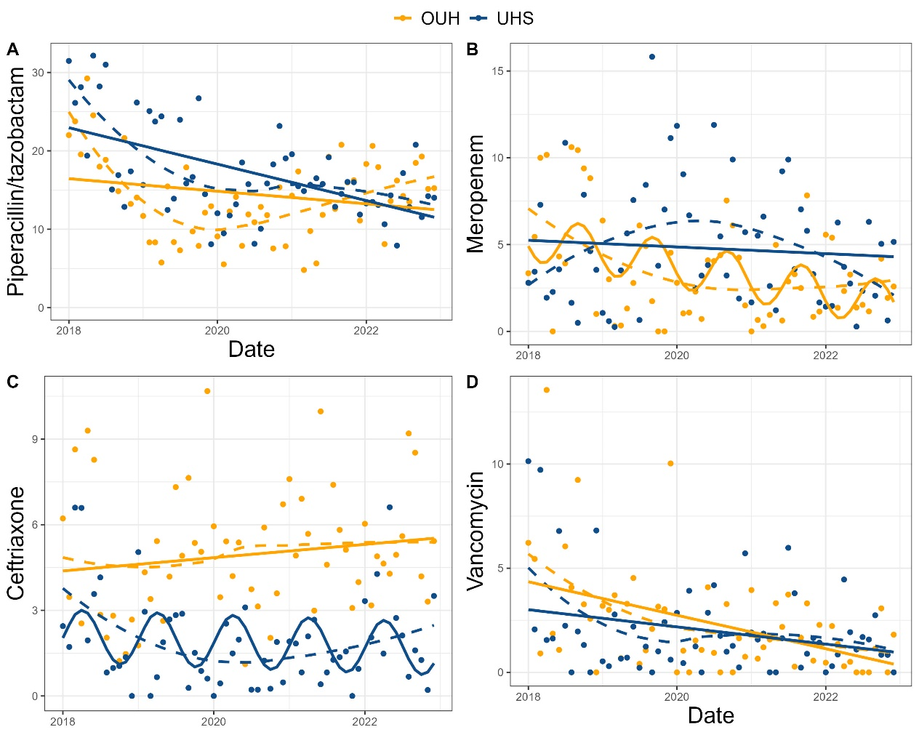

TABLES
Table 1
 | OUH |  | UHS |  | WRS test  p-value
Antimicrobial | Median | IQR | Median | IQR
All | 25.87 | 22.09 - 33.94 | 29.37 | 24.20 - 34.91 | 0.19
Amikacin | 0.00 | 0.00 - 0.00 | 0.00 | 0.00 - 0.00 | 0.33
Gentamicin | 0.55 | 0.26 - 1.28 | 0.78 | 0.16 - 1.84 | 0.38
Ceftazidime | 0.00 | 0.00 - 0.00 | 0.00 | 0.00 - 0.05 | 0.92
Ceftriaxone | 4.90 | 3.27 - 5.97 | 1.54 | 0.79 - 2.67 | <0.0001
Ciprofloxacin | 0.00 | 0.00 - 0.46 | 0.00 | 0.00 - 1.39 | 0.13
Ertapenem | 0.00 | 0.00 - 0.00 | 0.00 | 0.00 - 0.00 | 0.090
Flucloxacillin | 0.00 | 0.00 - 0.45 | 0.00 | 0.00 - 0.62 | 0.54
Meropenem | 2.82 | 1.13 - 4.93 | 3.65 | 2.03 - 6.77 | 0.027
Piperacillin/tazobactam | 13.82 | 9.76 - 17.90 | 15.77 | 13.16 - 19.43 | 0.0057
Teicoplanin | 0.53 | 0.00 - 2.44 | 1.69 | 0.48 - 2.66 | 0.0083
Vancomycin | 1.65 | 0.63 - 3.28 | 1.49 | 0.59 - 2.28 | 0.38

Table 1: Intravenous consumption by antibiotic across the entire study period, displayed as median and interquartile range for monthly DOT per-100-PD. p-values are calculated using the Wilcoxon rank-sum test to compare median consumption over the entire study period. OUH: Oxford University Hospitals; UHS: University Hospital Southampton; IQR: Interquartile Range; WRS: Wilcoxon rank-sum.

