An environmental perspective on developing dual energy storage for electric vehicles - a case study exploring Al-ion vs. supercapacitors alongside Li-ion.
N. Melzack*^{ab}, R. G. A. Willsª, A.Crudenª
ªEnergy Technology Group, University of Southampton, UK
^{b}The Faraday Institution, Didcot, UK
Abstract
Much focus of dual energy storage systems (DESS) for electric vehicles (EVs) has been on the cost reduction and performance enhancement. While these are important in the development of better systems, environmental impacts of system and component level choices should not be overlooked. Current interest in EVs is primarily motivated by environmental reasons such as climate change mitigation and reduction of fossil fuel use, so it is important to develop environmentally sound alternatives at the design stage. Assessing the environmental impact of developmental and mature chemistries provides valuable insights into which technologies to select now and which to develop for the future. This paper presents a cradle-to-gate (i.e., all raw material and production elements are considered however the ‘use’ phase and recycling are not) lifecycle assessment of a DESS with Li-ion and aqueous Al-ion cells, and one with Li-ion cells and supercapacitors. These are also compared to a full Li-ion EV battery in terms of their environmental impact for both a bus and car case study. Key findings show that the use of a DESS overall reduces the environmental impacts over the vehicle lifetime and provides an argument for the further development of aqueous Al-ion cells for this application.
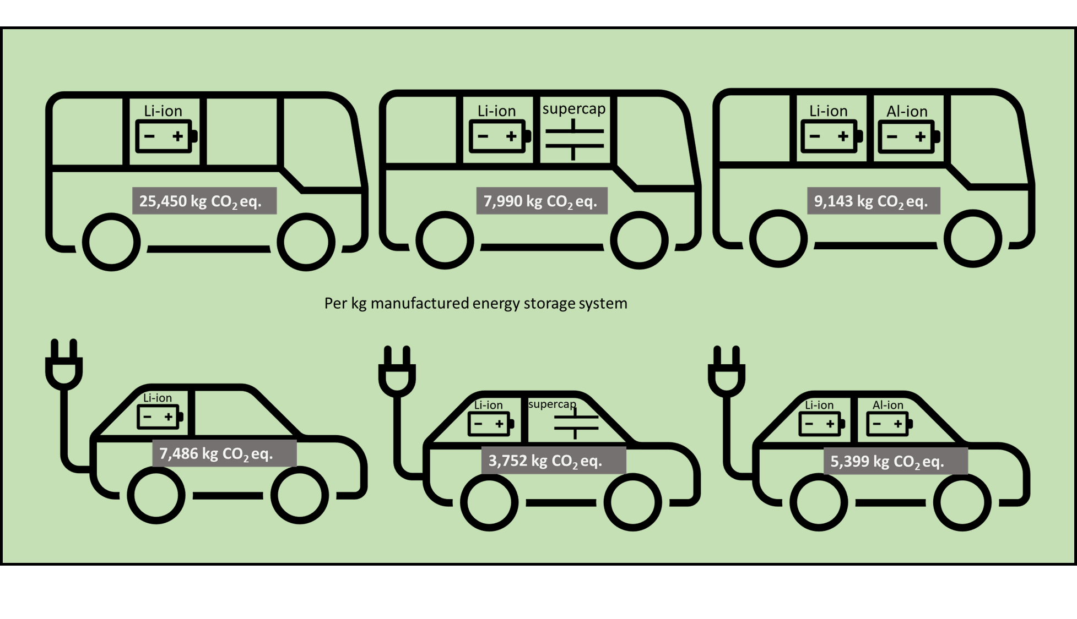
Keywords: aluminium-ion, lifecycle assessment, environmental impact assessment, hybrid energy storage system HESS, dual energy storage system DESS, supercapacitor
Corresponding author: N. Melzack
n.melzack@soton.ac.uk

Nomenclature
aq. Al-ion | Aqueous Aluminium Ion
BMS | Battery Management System
BOL | Beginning Of Life
DESS | Dual Energy Storage System
EOL | End Of Life
ESS | Energy Storage System
EUEF | European Union Environmental Footprint
EV | Electric Vehicle
HE | High Energy
HESS | Hybrid Energy Storage System
HEV | Hybrid Electric Vehicle
HP | High Power
LCA | Life Cycle Assessment
LFP | Lithium Iron Phosphate
Li-ion | Lithium-Ion
NMC | Nickel-Manganese-Cobalt
PEEK | Polyether Ether Ketone
SC | Supercapacitor

Introduction
The move to electric vehicles (EVs) in place of internal combustion engines (ICEs) is ongoing throughout the developing world. Many environmental impact assessments have found that while the initial resource use of an EV battery is higher than for ICEs (1-3), overall, the use of EVs reduces environmental impacts of cars and other vehicles. Various Li-ion based batteries have been used in EVs and assessed environmentally, with Lithium iron phosphate (LFP) often being seen as overall better for the environment than the Nickel-Manganese-Cobalt (NMC) batteries (2, 4). The use of energy storage system (ESS) is a large portion of the overall environmental impact of a vehicle and it is essential to explore different options for electrifying our vehicles. A dual energy storage system (DESS), often called Hybrid energy storage system (HESS), in the context of an electric vehicle (EV) is an energy storage system composed of a high energy (HE) component and a high power (HP) component. The use of the term DESS is to avoid confusion between hybrid electric vehicles (HEV), which refer to a combination of electric and internal combustion power sources. There is also some use of DESS within an HEV, which may further the confusion of definitions (5). Within a DESS, the high energy component provides energy for cruising and other low power manoeuvres, and the high-power component provides additional (or all) power for accelerations along with being a sink for energy generated from braking – limiting the demand on the HE part and extending its lifetime (6). In this work, the life cycle assessment is topology agnostic, however, a schematic of a typical DESS is shown in Figure 1.
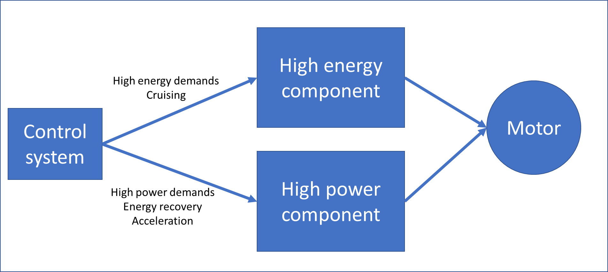
Figure 1 Schematic of DESS
Usually, the HE component is an energy dense battery, such as lithium-ion, with the HP component being provided by supercapacitors (often called ultracapacitors). The use of DESS in EVs is not widely adopted with many discussions of use cases based on different driving styles and different vehicle applications, which are summarised in Table 1. There is a range of configurations for DESS, depending on the specific scenario and vehicle scale, from a city bus driving a normal route (7), to a sports car being driven aggressively (8). While adoption of DESS is in its infancy, some parallels can be made with conventional hybrid (internal combustion engine – battery) systems (9). From Table 1 it is clear that the number of (1 - 38406), the voltage (136 - 444 V), and capacity (0.9 – 115 kWh) of the Li-ion cells as well as the capacitance of the SCs varies widely depending on application. Factors which can impact the configurations are the criteria which are optimised such as minimising weight, cost and charge time. However, there may also be a desire to keep battery replacements to a minimum or reduce the number of charge/discharge cycles or state of charge optimisation over the vehicle’s lifetime. The article focus is highlighted in Table 1. Ensuring the overall battery and DESS state of health is also a driving factor in system configuration (10, 11). Overall, only one study was found to use environmental impact as a key driver (12), instead of a reported output or ‘bonus’ to the other optimisations. For example, two papers optimising a DESS for the Tesla Model S, report differences in power requirements of ~120 kW in the supercapacitors, and ~9 Wh difference in battery provided energy. The higher power and energy demanding result looked at optimising for cost reduction (13), whereas the other took a balanced look at cost, mass and volume reduction to provide a different result (8).
A further distinguishing factor is the ratio of HE:HP components, whether the HP component is being used purely for power-smoothing, or as the main contributor to all high-power needs (such as accelerations). For a power-smoothing application, the HP component makes up a smaller proportion of the DESS. Both options show improvements in terms of overall lifetime of the energy storage system and cost savings, however, there has not been an environmental assessment into which DESS version has the fewest environmental impacts over the lifetime of the vehicle used. This will be addressed as the focus of the assessment presented in this paper. There has been an initial life cycle assessment, LCA, looking at a DESS with two types of Li-ion battery, a high power and high energy version, which saw environmental benefits compared to a single type of Li-ion battery (14), however noted that the emissions produced through manufacturing were higher than a HE only Li-ion battery pack (a 50% increased for CO₂ emissions and almost double for the impact on water acidification), and environmental benefits were only seen here if the lifetime of the car could be doubled. Many LCAs have been performed of different Li-ion battery configurations (15-17), as well as for capacitors and supercapacitors (SCs) (18-20), however these have not been evaluated within a DESS from an environmental perspective. The manufacturing process is a key source of emissions for Li-ions, if emissions can be reduced at production by using different HP components, while providing the same lifetime extension, then overall environmental impacts can be further reduced. Continued reliance on lithium batteries will put more pressure on the already politicised mining of associated minerals and may increase the costs beyond the lifetime extension benefits. Therefore, looking at non-lithium, lower cost and easier to produce options for the high-power component of a DESS is crucial to making them accessible.

Table 1 Summary of optimised SC/battery DESSs from literature and, where available, the configuration (no. in series X, no. in parallel, Y) will be stated as XsYp, as well as Li-ion cell chemistry.
Example vehicle | Supercapacitor configuration | Battery Cell configuration | Li-ion cell chemistry | DC-DC converter power rating | Optimisation aim | Ref
- City bus | 12876 total  222s58p  (3000 F2.7 V 4870 W ea. ) | 38406 total  37s1038p  318 kWh, 136.9 V total | LiFePO₄ | 62 kW | Cost reduction | (7)
- Tesla Model S | 150  150s1p  (1500 F 1850 W ea.) | 11840  74s160p  82 kWh 236.8V total | LiFePO₄ | 268kW | Mass, volume, cost reduction lifetime extension | (13)
- Tesla Model S | 90  90s1p  (3400 F 2.7 V 4420 W ea.)(21) | 7104  96s74p  =92.4 kWh 345.6 V total(22) | LiFePO₄ | 342 kW | Cost reduction lifetime extension | (8)
- VW e-golf | 1  (0.17 kWh) | 1  31080 Wh, 444 V | Not specified | 200 kW | Cost reduction lifetime extension | (23)
- BMW i3 | 94s 350 Wh total | 96s =36.8 kWh* 307.2 V* total | NMC | 35 kW | Cost reduction and lifetime extension | (24)
- 800 kg EV model | 5s (36 F, 9.5 kg ea.) | 1 33.2 kWh 239 V total | Not specified | Not specified | Increasing drive range and mass reduction | (25)
- EV car model | 72 350 F, 0.06 kg, 5.9 Wh/kg ea. | 100s71p  75.0 Wh 320 V total | LiFePO₄ | Not specified | Cost reduction and lifetime extension | (26)
- Military-All Terrain Vehicle (M-ATV) | 2114  151s14p  (1430 F, 1.52 Wh 1848 W)(27) | 116s1p  0.9 kWh 429.2 V total | NMC | 120 kW | Fuel reduction | (28)
- Tesla Roadster | 24  24s1p  (58 F 16 V ea.) | 1869  89s21p  24.3 kWh 320.4 V total (22) | LiFePO₄ | 7.24 kW | Mass, volume, cost reduction lifetime extension | (29)
- City bus | 50  25s2p  140 F 27 V 14.2 Wh | 600  120s5p  =115.2 kWh 384 V total | Not specified | Not specified | Reduced temperature dependence and cost reduction | (30)
- Mid-size EV | 72 (2000 F, 2.7 V ea., 5 Wh kg⁻¹ ) | 152 22.1 kWh 250.8 V total | Not specified | Not specified | Lifetime extension | (31)

This paper specifically considers two case studies, a city bus (example 10) and an electric vehicle (EV) modelled as a 1100 kg car (example 7), taking data from (26, 30). These DESSs have different output suggestions for the proportion of HE: HP components as well as the overall power and energy required. The city bus requires 150kW from the HP component, while the EV requires 19.9 kW. Here, a lifecycle assessment approach is used to analyse the environmental impacts of dual energy storage systems proposed for each case study; namely a Supercapacitor/Li-ion (SC/Li-ion) based on literature results reported. This study further evaluates the use of an aqueous Al-ion/Li-ion configuration as an emerging high power battery technology. Aluminium is an attractive material for battery applications in EVs due to its high charge storage capacity of 2980 mA h g⁻¹/8046 mA h cm⁻³ and relative abundance (32, 33). Aluminium ions are readily solvated in both aqueous and non-aqueous (organic or ionic liquid) solvents with a number of materials, including TiO₂, MoO₃, C and Al being suggested as positive electrodes, while negative electrode materials include Fe-, Mn-, Cu- and V-complexes(34, 35) Aqueous Al-ion batteries are one of a number of metal-ion systems being investigated utilising water as the electrolyte (36). This aqueous Al-ion technology has already been identified as potentially having fewer environmental impacts per kW than some supercapacitors and as such is a good case study to test the methodology of comparing environmental impacts within DESS design (37). The dual energy storage systems will be compared to a Li-ion only configuration. The aim is to evaluate the environmental perspective alongside battery chemistry to link these two aspects during new energy storage device development. This LCA is for the cradle-to-gate section of the product lifecycle, using the methodology set out in (38, 39). Therefore, this assessment includes the mining and production of raw materials through to manufacture, but does not include the use phase, or any second-life applications or end of life activities (such as recycling).

Study Design

Life cycle assessment
The lifecycle assessment (LCA) looks at the cradle-to-gate aspects of the product life cycle. It therefore only considers the mining and production of raw materials and manufacture. The process used when performing the LCA is illustrated in Figure 1. Firstly, the components for the product are defined – in this case the components within each DESS, then the raw material required is identified along with the transportation required and other manufacturing inputs such as energy. The functional unit (FU) is then defined, in this case the FU is per overall DESS – the analysis will then compare each system throughout the vehicle lives. The impact assessment is then performed, using the OpenLCA software and European union’s environmental footprint (EUEF) described below.
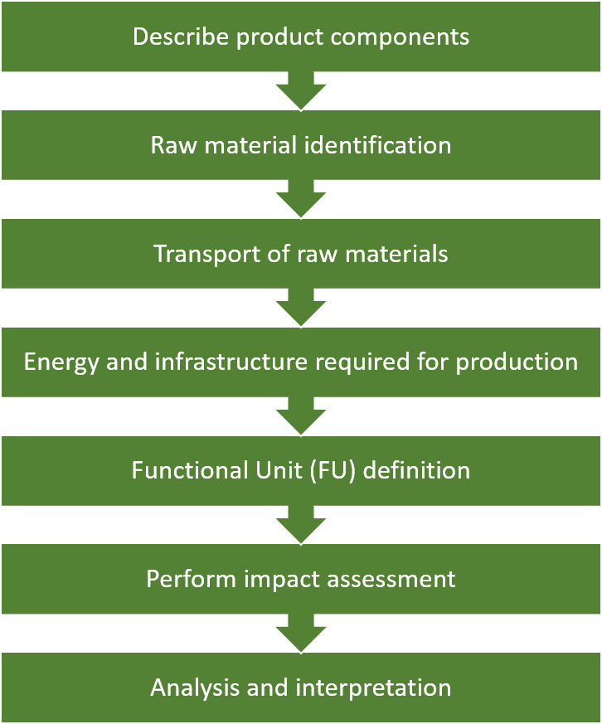
Figure 2 Steps for the LCA

Components within the DESS
The LCA will cover three different ESS designs for each case study. Firstly, a fully HE Li-ion battery pack will be assessed using lithium iron phosphate (LFP) cells. These have been described in (40) and normalised in (17), which provides detailed data sets for the LCA comparison. The battery pack modelled has an energy density of 88 Wh kg⁻¹ – based on total mass of the whole battery pack. These cells will also form the HE component of the further two DESS configurations.
The second configuration composes the LFP cells for the HE component, and a supercapacitor for the HP component. The supercapacitor will be based on the Maxwell BCAP series (41, 42). The third configuration will use the Al-ion aqueous cells described in (43) and (37) as the HP component. These cells have an energy density of 15 Wh kg⁻¹ active material and a power density of 300 W kg⁻¹ active material.

Raw material Inventory, energy, and infrastructure
This section describes the raw material inventory for the three components modelled: the Li-ion battery pack, the supercapacitor, and the aq. Al-ion battery. These have been modelled using OpenLCA 1.10.3 software (44), with datasets from ecoinvent 3.2 (45) and Gabi Thinkstep (46). The OpenLCA Manual states:
OpenLCA is open-source software for Life Cycle Assessment (LCA) and sustainability assessment. It has been developed by GreenDelta since 2006 (www.greendelta.com). As open-source software, it is freely available, without license costs (www.openlca.org). The source code can be viewed and changed by anyone. Furthermore, the open-source nature of the software makes it very suitable for use with sensitive data. The software, as well as any models created, can be shared freely if the database license allows it.
The software takes datasets of products (flows) and processes, some have been compiled elsewhere (such as the ecoinvent and GaBi). Further, the inventory for the Li-ion battery pack modelled in (40) has been adapted from the dataset made available in (17). The supercapacitor inventory is adapted from (18) – however, as this study presents an LCA for 5 F Maxwell supercapacitors, there is likely more packaging and other supporting materials assessed than would be present in a single 140 F supercapacitor for example. This would make the resulting overall mass slightly higher than reality, which makes this a conservative assessment. A single 5F supercapacitor is 2.1 g (47) and the data is scaled to 1 kg. The aqueous Al-ion cell inventory is taken from (37), a single battery is about 25 g, and again this is scaled to 1 kg.
A summary of the key components is provided below. Table 2 summarises the Li-ion battery pack, Table 3 summarises the SC and Table 4 summarises the Al-ion cell, with full inventories found in (17, 18, 37). Per kg, that both the batteries (Li-ion and Al-ion) require a similar amount of energy (~60 MJ), whereas the supercapacitor only requires 37 MJ per kg. We can also see that the amount of electrolyte required per kg is similar for the Al-ion and supercapacitor (about 0.25 kg) while the amount required for the Li-ion is about half – 0.12 kg. The amount of additional water was not provided in the inventory for supercapacitors, which introduces some limitations of the comparison already – however as the overall mass of SCs required in the model is low, it is assumed this will make negligible impact compared to the 380 kg water per kg Li-ion required.

Table 2 Summary of Li-ion Battery Pack components from (17, 40), normalised to 1 kg.
Item | Value | Unit
Battery Management System (BMS) | 0.03 | kg
Cell container – aluminium | 0.201 | kg
Electrode substrate, anode – copper | 0.083 | kg
Electrode substrate, cathode – aluminium | 0.036 | kg
Electrolyte - lithium hexafluorophosphate | 0.12 | kg
Graphite anode paste - graphite, tetrafluoroethylene | 0.08 | kg
LFP cathode paste - lithium iron phosphate, carbon black | 0.25 | kg
Li-Ion battery pack housing - polyethylene terephthalate (PET) | 0.17 | kg
Separator - polyethylene, polypropylene | 0.03 | kg
transport, freight train | 1.276 | t*km
transport, freight, lorry 16-32 metric ton, EURO5 | 0.274 | t*km
water, decarbonised, used during manufacture of 1kg | 380 | kg
Electricity, used during manufacture of 1kg | 60.48 | MJ
Total mass | 1 | kg

Table 3 Summary of Supercapacitor components normalised to 1 kg, from (18)
Item | Value | Unit
Electrode active material -Activated carbon (48) | 0.169 | kg
Electrode substrate -Aluminium foil | 0.134 | kg
Case - aluminium | 0.225 | kg
Collectors - aluminium | 0.046 | kg
Electricity | 63.077 | MJ
Electrolyte - acetonitrile | 0.252 | kg
Paper Separator | 0.043 | kg
Rubber | 0.088 | kg
Lid - aluminium | 0.043 | kg
Total mass | 1 | kg

Table 4 Summary of aqueous Al-ion cell components normalised to 1 kg from (37)
Item | Value | Unit
Battery Case | 0.11 | kg
Current Collector - copper | 0.09 | kg
Electrode substrate - polycarbonate | 0.53 | kg
positive electrode - copper hexacyanoferrate, carbon black, Nafion | 0.005 | kg
negative electrode - titanium dioxide, carbon black, Nafion | 0.005 | kg
Electrolyte - AlCl₃ and KCl | 0.26 | kg
Electricity | 37 | MJ
Water | 8.83 | kg
Hydrochloric Acid | 0.40 | kg
Total Mass | 1 | kg

Cases
The functional unit (FU) used for this study will be the overall mass required to achieve a DESS of appropriate power and capacity to match the vehicle needs.

City Bus
A city bus will be assessed based on that described in (30). For this case the proposed DESS is 50 x 140 F supercapacitors in a 25s2p configuration, alongside 600 LFP cells in a 120s5p configuration, as described in (30) . The equivalent battery only ESS and a DESS using Li-ion/Al-ion has been calculated as follows: Data interpreted from Figure 7 in (30) suggests that the SC array provides a maximum of 150 kW, with an assumed power density of 5.7 kW kg⁻¹ taken from the BCAP150F, which was the closest comparable Maxwell supercapacitor (42). The total mass of the SC component in this example is therefore 26.3 kg. A similar approach was taken for the Al-ion high power component. Given the power density of 300 W kg⁻¹ of the cells, and the 150 kW requirement, a mass of 500 kg active material is needed for the HP component for the Al-ion/Li-ion system. When taking into account the support materials and battery casing (37) a total of 833.3 kg of Al-ion cell mass was required. The BMS and casing mass is assumed to be identical across cases, as this is based on the battery system, with the additional casing required for the Al-ion included in the 833.3 kg. Additionally, as shown in Table 2, 3% of the total mass is for the BMS (battery management system) which has been added in an additional column. It is assumed that the BMS will remain constant for all cases.

EV
Lu et al (26) describes the DESS optimisation for an electric vehicle of 1100 kg (mass without any ESS). The proposed DESS is 7,100 LFP cells in an 100s71p layout, with 72 SC cells – no configuration given. Again an additional mass equivalent to 3% the Li-ion mass is added to model the BMS (as listed in Table 2) The supercapacitors modelled within this paper were based on the Maxwell BCAP0350 (49) which state 4.6 kW kg⁻¹. Given the total mass of the SCs used is 4.32 kg, a total of 19.9 kW is delivered or regenerative breaking capability by the SCs. For the Al-ion/Li-ion case, given the Al-ion cell has a power density of 300 W kg⁻¹, a mass of 66.24 kg of active material is required for the Al-ion HP component, which equates to 1100 kg of total battery mass. The battery only case described in the paper uses only the 71,000 LFP cells with no additional cells.
A summary of the cases is shown in Table 5.
Table 5 Summary of modelled cases
Case | HE (LFP) mass | HP type | HP mass | BMS/casing mass | Total mass
CityBus  Li-ion Only | 1200 kg | N/A | N/A | 39.8 kg | 1239.8 kg
CityBus  SC/Li-ion | 1200 kg | SC | 26.3 kg | 39.8 kg | 1266.1 kg
CityBus  Al-ion/Li-ion | 1200 kg | Al-ion | 833.3 kg | 39.8 kg | 2073.1 kg
EV  Li-ion Only | 568 kg | N/A | N/A | 17.6 kg | 585.04 kg
EV  SC/Li-ion | 568 kg | SC (described as ultracapacitors in the paper) | 4.32 kg | 17.6 kg | 589.92kg
EV  Al-ion/Li-ion | 568 kg | Al-ion | 1100 kg | 17.6 | 1668 kg

However, the lifetime of both the energy systems and the vehicles must be considered in order to understand the full environmental impacts of the ESSs. When looking at the city bus, analysis showed that with the Li-ion only ESS, the battery pack would be replaced once within a ten-year vehicle lifetime, however, with the DESS modelled, this replacement was not necessary (30). Therefore, we can in theory double the battery mass required for this bus over a ten-year period, while keeping the DESS at the same size. For a Tesla Model S, work from (8) assessing battery degradation shows that the degradation of the Li-ion battery pack is halved when using an optimised DESS with supercapacitors, compared to Li-ion only, over one drive cycle. Again, this can be used to estimate the number of battery replacements required over the vehicle lifetime.

Cycle life and replacement modelling
In each case presented, beginning of life (BOL) and end of life (EOL) are modelled. For each vehicle lifetime modelled, the corresponding number of Li-ion battery, supercapacitor, and Al-ion replacements required will be calculated based on an average cycle life of each component. At BOL there are no replacements required and it is assumed the vehicle has not been used. At EOL, the replacement rates for the Li-ion only and SC/Li-ion cases are taken from the respective studies in. The city bus Li-ion only replacement values are taken from (30), taking into account 124 miles and 34 drive cycles per day for the bus, during the ten year lifetime modelled, two replacements would be needed. The projected lifetime of 10 years for the supercapacitor noted in (42) means that no replacements are required during the lifetime. The addition of the supercapacitor further eliminates the need for Li-ion replacements. The Al-ion battery will perform the same as the supercapacitor, and thus eliminate the need for Li-ion replacements during the Al-ion/Li-ion case. Cycle life data from (43) indicates a lifetime of 1750 full cycles for the Al-ion cell, but based on (30), the supercapacitor (and thus Al-ion battery in this case) never complete a full cycle. It is therefore assumed that two replacements for a ten-year lifetime will provide a conservative estimate. For the electric car example, the lifetimes are stated in charge/discharge cycles, assuming a 240 km per charge. The stated lifetime of the Li-ion system is 5129 cycles, whereas the lifetime for the SC/Li-ion system is 6241 (26), offering a 20% lifetime extension. The EOL modelled is therefore the SC/Li-ion lifetime, therefore requiring one replacement of the Li-ion only system during this lifetime. The Al-ion/Li-ion system will be modelled as one Al-ion replacement over the lifetime. Table 6 summarises the replacement rates.
Table 6 Replacements required for each component in the energy storage system based on differing lifetime estimates.

Case | Beginning of life (BOL) |  | End of life (EOL)ª
Case | HP | HE | HP | HE
City bus  Li-ion onlyª | N/A | 0 | N/A | 3
City bus  SC/Li-ionª | 0 | 0 | 0 | 0
City bus  Al-ion/Li-ionª | 0 | 0 | 2 | 0
EV  Li-ion only^{b} | N/A | 0 | N/A | 1
EV  SC/Li-ion^{b} | 0 | 0 | 0 | 0
EV  Al-ion/Li-ion^{b} | 0 | 0 | 1 | 0
ª EOL defined as 516000 km over a 10 year lifetime (30)
^{b} defined as 6241 charge/discharge cycles over the car’s lifetime(26)

Results
Using OpenLCA (44) and the European Union’s Environmental Footprint (EUEF) midpoint analysis (38), a cradle to gate analysis was performed. The fuel consumption and usage of the systems during the car’s lifetime are not considered, only the procurement of raw materials and manufacturing of the energy storage systems are considered. The impacts of production for all required components (including replacement batteries) were assessed over 19 impact categories, including acidification, carcinogenic properties, climate impact, land usage, ozone impact and energy resource. Respiratory particulates are also calculated as part of the EUEF, however with regards to nano-particles (TiO₂ in the Al-ion and graphene in the SCs modelled are nano-powders) this assessment criteria is not fully accurate, as the calculations do not take into account nano-particulates currently, and therefore does not consider the full range of particulates produced during manufacture (50). For the purpose of this assessment, the main impact categories– climate change, acidification and resource use are presented in Table 7, with the impacts shown graphically in Figure 1 for the city bus and Figure 2 for the EV. Full results for all impact categories are shown in the supplementary information. For the SC/Li-ion case modelled, no replacements are needed and so BOL and EOL are plotted as a single value. The replacement of the Al-ion battery over the lifetime increases the environmental impacts, however they are still consistently lower than the equivalent Li-ion case.
Table 7 Results of city bus case study for different ESSs for key environmental impacts.
City Bus | Li-ion Only  BOL | Li-ion Only EOL | SC/Li-ion BOL | SC/Li-ion EOL | Al-ion/Li-ion  BOL | Al-ion/Li-ion  EOL
Climate Change Impact [kg CO₂ eq.] | 8,482 | 25,450 | 7,990 | 7,990 | 8,536 | 9143
Acidification [Mole of H⁺ eq.] | 31.09 | 93.26 | 29.32 | 29.32 | 33.25 | 41.62
Resource Use: Minerals and Metals [kg Sb eq.] | 0.044 | 0.13 | 0.041 | 0.041 | 0.058 | 0.093
Resource Use: Energy Carriers [MJ] | 96,050 | 288,100 | 93,230 | 93,230 | 99,180 | 117,900

Table 8 Results of EV case study for different ESSs for key environmental impacts.
Electric Vehicle (EV) | Li-ion Only  BOL | Li-ion Only EOL | SC/Li-ion BOL | SC/Li-ion EOL | Al-ion/Li-ion  BOL | Al-ion/Li-ion  EOL
Climate Change Impact [kg CO₂ eq.] | 3,740 | 7,486 | 3,752 | 3,752 | 4,541 | 5,399
Acidification [Mole of H⁺ eq.] | 13.72 | 27.44 | 13.76 | 13.76 | 19.06 | 24.66
Resource Use: Minerals and Metals [kg Sb eq.] | 0.019 | 0.039 | 0.019 | 0.019 | 0.021 | 0.063
Resource Use: Energy Carriers [MJ] | 42,390 | 84,770 | 42,940 | 42,940 | 54,380 | 67,090

Initially it is worth noting that the ratio of HP:HE in the DESSs described is different in both cases. The city bus has a mass ratio of ~1:1200 and the car has a mass ratio of ~1:131 for the SC: Li-ion. The differences in these outcomes are likely due to the driving use cases used to optimise the DESSs, and the likely different utilisations of a DESS, with the car using the HP for all high-power cases, and the bus for ‘topping up’ with the higher demand accelerations.
When looking at environmental impacts, the results at BOL are within one order of magnitude for all the cases presented. Therefore, it is fair to say that for a vehicle with a short overall lifetime (defined as less than 5 years for the city bus, and less than ~5000 cycles for the EV), there is no strong environmental reason to use a DESS. Further, a DESS is often more expensive than using just one type of battery (8, 26, 51). Al-ion cells, although adding an appreciable mass to the DESS, have comparable environmental impacts per kW output (37) to the SC. It should be noted that the added mass was not factored into the vehicle lifetime data. The resulting environmental impacts are roughly the same to one significant figure across all BOL cases. When looking at resource use – the Al-ion/Li-ion seems the worst option for the low use case – however as this study does not take into account recycling and re-use – it is likely that the ease of recycling of Al-ion compared with Li-ion batteries (52) would lead to a more sustainable result – however this is beyond the scope of this study.
We see the impact of the lifetime extension provided by the DESS when assessing the EOL results. This impact is shown most strongly with the SC/Li-ion DESS for both case studies. For the city bus example, at EOL, the SC/Li-ion would have just under a third the environmental impacts of the Li-ion only option. Specifically, looking at the climate change impact, for the Li-ion only option at end of life the emissions are around 25,446 kg CO₂ eq. compared to 7936 kg CO₂ eq. for the SC/Li-ion DESS. For the EV there is a ~50% reduction in all impact categories reported. This reduction in impacts is mostly true for both the Al-ion/Li-ion EOL cases. The city bus case study shows that the Al-ion/Li-ion at EOL has 35% the emissions of the Li-ion EOL in climate change impacts, and 70% of Li-ion EOL’s resource use (minerals and metals). This high use of minerals and metals comes from the contribution of the copper current collectors in the Al-ion cell, and while not considered within this study, the recycling and re-use of copper in the future would reduce this impact. For the EV case study, the resource use (minerals and metals) is higher for the Al-ion/Li-ion EOL than the Li-ion EOL, with 0.063 and 0.039 kg Sb eq. respectively. Overall, the impacts reported for the Al-ion/Li-ion EOL for the EV are slightly lower than that of the Li-ion only EOL case - climate change impact is 72% that of the Li-ion only case, while acidification is 90% that of the Li-ion only case. In this example we can see the impact of the ratio of HP:HE and the difference it makes on the environmental output for the DESS.
For the city bus case study, Al-ion could provide the HP component of a DESS in the future, as it provides similar environmental benefits to the SC but has the advantage of being cheaper, safer and easier to produce (34, 37). However, the electric vehicle assessed, with the higher reliance on the HP component would benefit environmentally from an SC/Li-ion DESS. For the EV example, it is useful to discuss what measures are needed to make the Al-ion/Li-ion DESS a viable environmental option, as this will inform future development of the technology. The first option is an increase in the lifetime of the Al-ion battery such that no replacements are needed over the vehicle lifetime – this would lead to the BOL = EOL results, as seen for the SC/Li-ion examples in both case studies. However, if this were not achievable, looking at the impact that is above that of Li-ion only – minerals and metals – we can inspect the data for the key contributor to this category. From (37) we can see the key contributors are the copper current collector and the battery casing, made mainly from PEEK (polyether ether ketone). The battery casing for the Al-ion cell is ~11% wt, compared to the SC and Li-ion casing, which are around 20% of the total mass. The casings for SC and Li-ion however are made of aluminium, a low impact metal with many established routes for production and recycling, which minimises the overall environmental impact of the case used. The copper current collectors, as mentions previously, are assumed to be primary copper, a simple improvement in terms of the resource use here, is to switch to secondary (or recycled) copper for the current collectors, which will minimise the impact and have no design implications. Changing the copper source within the OpenLCA software to 75% recycled reduces the minerals and metals impact to 0.047 kg Sb eq. at EOL – still higher than the 0.39 kg Sb eq. for the Li-ion only EOL case. At 100% recycled copper the impact becomes 0.043 kg Sb eq. – at which point the next highest contributor takes over.
Other options in terms of reducing the overall impact of the EV EOL case using Al-ion, would be to look at overall improvements in terms of the active material utilised within the batteries(53). Currently, only ~0.6% of the mass of the battery is active material – the rest is support, binders, casing etc. However, within a fully commercial cell the active material is closer to 30% (17, 54). With a higher active material %, the overall amount of support materials reduces, which in turn reduces the environmental impacts. Maintaining the active material mass required of 66.24 kg for the Al-ion component. A 30% active material mass percentage in the Al-ion component reduces the overall mass of that component to 220.8 kg, and the impact of the minerals and metals resource category to 0.054 kg Sb eq. Combining this active material increase with 75% recycled copper for the current collectors, we arrive at a value of 0.025 kg Sb eq. – below that of the Li-ion only EOL. These changes require the development of the Al-ion battery electrode, in order to accommodate and utilise more active material throughout the battery life and testing to ensure that the increased material loading does not degrade the battery performance (53).
3
Figure 3 Impact categories scaled to EOL Li-ion for city bus

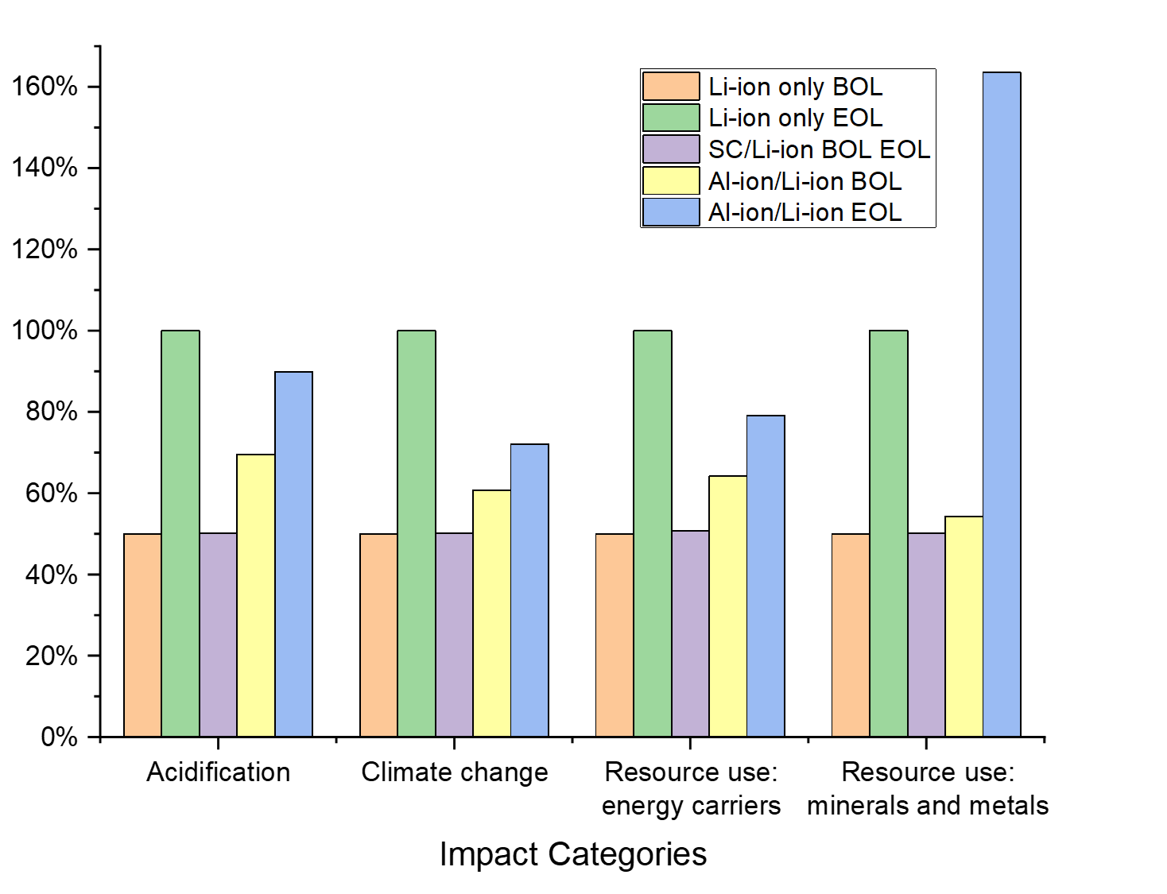
Figure 4 Impact categories scaled to EOL Li-ion for EV

Sensitivity analysis
A key uncertainty within the analysis which are the subject of a sensitivity analysis include the transported distances of the raw materials (calculated in t*km with various transport methods in Table 2 - Table 4). A second uncertainty is the electricity mix used within the production.
For the Li-ion components, the total transportation required comes to 1.55 t*km/kg of battery pack, which is just under half of that for the aq. Al-ion battery – 3.59 t*km/kg of battery pack. The Li-ion transportation assumes only lorries and trains, whereas the Al-ion transportation assumes lorries and barges are used. The supercapacitor paper does not list the transportation assumptions and none were used during the calculation of the overall impacts – as the overall mass of SCs was small it was assumed the transport impacts would be negligible. To evaluate the sensitivity of the analysis to transport, the CityBus BOL and EOL studies will be run with no transport for all three cases, and for double the current amount of assumed transportation, which will be compared with the original result in Figure 4 for BOL and Figure 5 for EOL. For all cases, the overall changes in the 19 impact categories are found in the supplementary data – with the range of change from ±0-10% of the baseline. The largest change seen in BOL is the acidification impact for Al-ion/Li-ion at 10% above the baseline (36.7 mol compared to 33.5 mol). The use of barge transport here and not for the Li-ion system is likely the key reason for this change. It is difficult to explicitly log every journey taken and with which vehicle for these studies. The ranges presented through this analysis do not change the overall take-aways from this study at EOL – with the SC/Li-ion and AL-ion/Li-ion cases still having reduced impacts over all categories compared to the Li-ion systemSche – around a third of the Li-ion EOL values (apart from Al-ion/Li-ion resource use minerals and metals which is at two thirds that of the EOL Li-ion only). For the BOL cases however, the Al-ion/Li-ion system for acidification, climate change and fossil use, become more impactful when looking at the double transport assumption (by 4.66 mol, 477 kg CO₂ eq., and 8136 MJ respectively). Therefore, when looking at the BOL comparison, the Al-ion/Li-ion system may have higher environmental impacts than Li-ion only, with reduced impacts seen only after the lifetime of the vehicle.
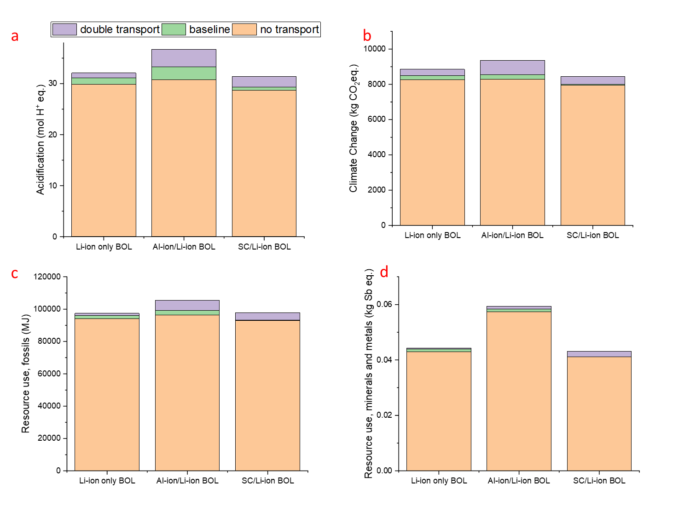
Figure 5 Sensitivity to transportation of raw materials for BOL city bus for a) acidification, b) climate change, c) fossil use and d) mineral and metal use
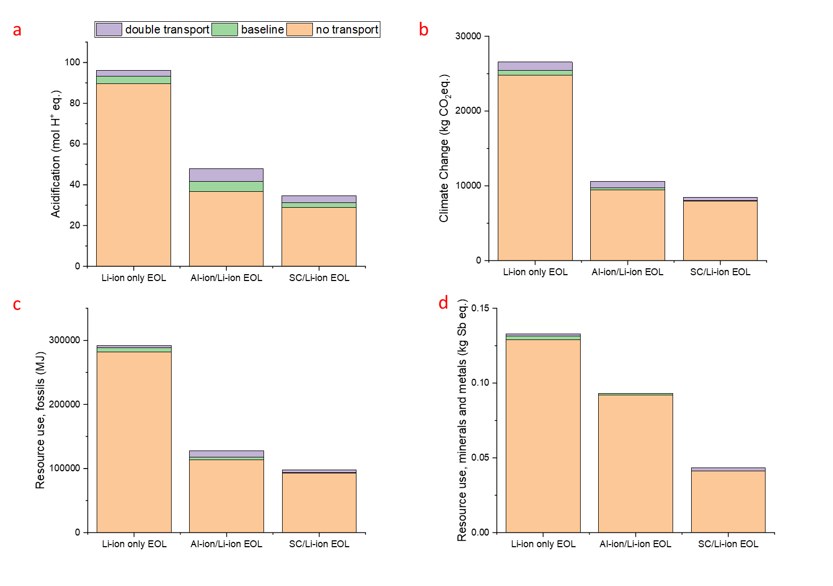
Figure 6 Sensitivity to transportation of raw materials for EOL city bus for a) acidification, b) climate change, c) fossil use and d) mineral and metal use

The electricity mix assumed for the baseline calculations is a mix of 80% renewable and 20% fossil fuel based. The BOL city bus cases underwent a sensitivity analysis, which looked at 100% renewable (wind powered) and 100% fossil fuel based (mixed). Figure 7 shows the results of this analysis, which for both the acidification and climate change impacts show that the renewable option has the least impact, with a 0-1% increase in impact when compared to the baseline. This is somewhat expected as the baseline is 80% renewable. Looking at the fossil fuel only option, the impacts increase by nearly 50% acidification (from 31.8 to 55.7 mol for Li-ion and from 29.3 to 56.6 mol for SC/Li-ion). The impacts on climate change, increase by an order of magnitude – from 8481 to 28196 kg for Li-ion, and from 7990 to 28700 kg for SC/Li-ion. When looking at the Al-ion/Li-ion case though, the fossil fuel case increases the impacts substantially, placing it as the most impactful DESS with this electricity mix. For acidification it increases from 33 to 81 mol, and for climate change impacts, from 8536 to 45028 kg. This shows that the electricity use has a clear impact on these categories, and for the Al-ion/Li-ion case specifically, this must be chosen carefully in order to ensure the most sustainable outcome – considering that acidification is already a high impact category for the Al-ion/Li-ion case.
When looking at the resource use, fossils, the impacts are somewhat expected, with the use of fossil fuel-based electricity increasing this impact the most. The Al-ion/Li-ion DESS is again an outlier as the baseline case here has the least impact. The increases in impacts due to fossil fuel-based electricity, match quite closely to the climate change impacts – with around 200% increase for Li-ion and SC/Li-ion, and around 400% increase from baseline for the Al-ion/Li-ion category. The minerals and metals impacts are interesting as for all three DESSs, the fossil fuel option is not the highest impact. However, the largest change from minimum to maximum impact in this category is only 5%, showing that electricity mix does not have a large impact on the overall resources used.
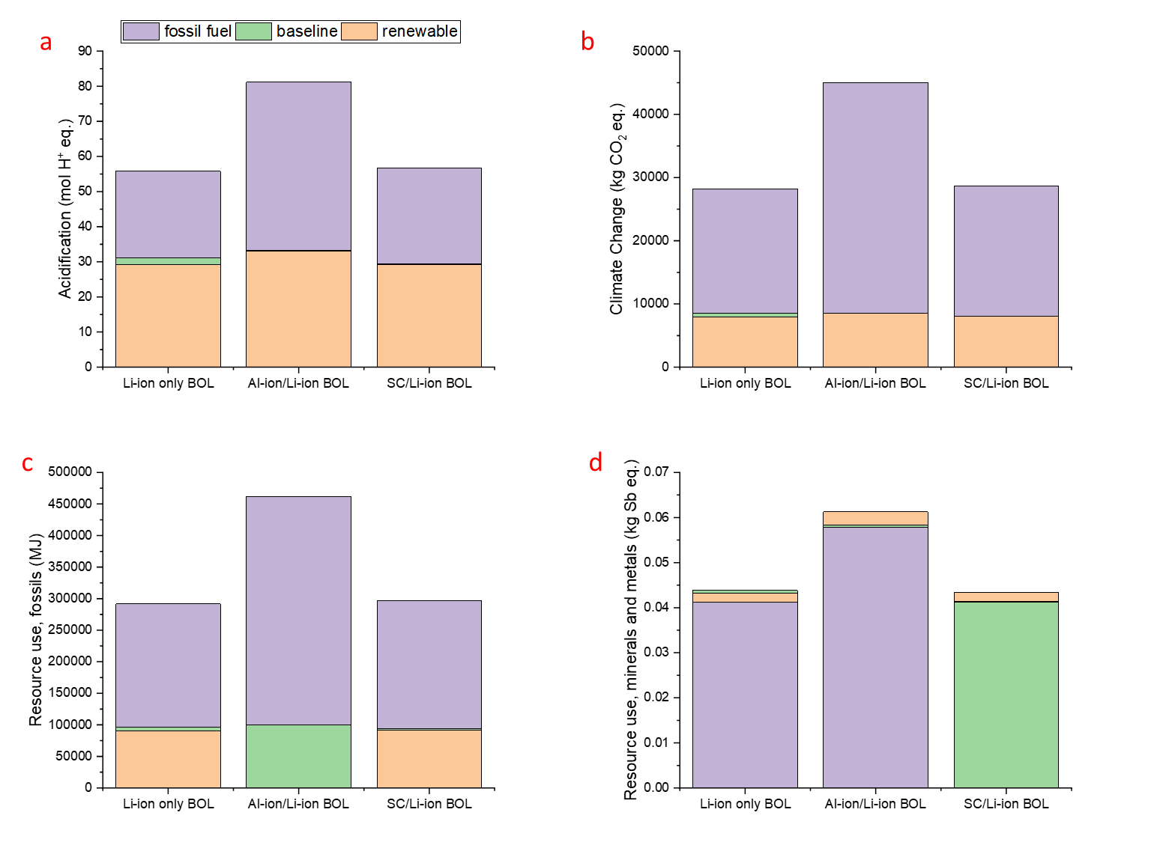
Figure 7 Sensitivity to electricity mix for BOL city bus for a) acidification, b) climate change, c) fossil use and d) mineral and metal use.

Discussion
When assessing the environmental impacts of products, it is important to understand the limitations of the functional unit and approach used. For this case, the size of the ESSs were calculated and assessed based on values from literature. From looking purely at the energy storage systems, using any DESS provides an environmental advantage in terms of the city bus assessed – but only over a long enough lifetime. This holds true even as Li-ion battery development extends the useful lifetime, since the DESS will always offer an advantage. However, for the electric car assessed, the SC/Li-ion had the least environmental impacts, with the Al-ion/Li-ion mostly reducing impacts compared to Li-ion only, except for the resource use of copper in the current collector. For vehicles with high mileage requirements over their lifetime, a SC/Li-ion DESS appears to have a clear environmental (and financial, since Li-ion batteries are expensive (55)) advantage at both HP:HE ratios. However, for short mileage requirements, the benefit may not be seen in the lifetime of the vehicle – but may still preserve the DESS for second life uses. This study does not take into account the growing field of second life uses for car batteries once they have reached 80% capacity and are no longer fit for their initial function. Grid storage and home-batteries for photovoltaics are applications that are currently being studied (56). A DESS would likely have a longer second-lifetime compared to a Li-ion ESS, however this has not yet been studied, and so using these energy storage systems in EVs may not just depend on the use in the EV, but over the whole lifetime of the DESS. This does add mass to the overall system – which is a non-trivial consequence.
A limitation of this study is that the full electricity use and fuel-saving impacts are not taken into account over the vehicle’s operational lifetime. This study only assesses a cradle-to-gate portion of the lifecycle. A further limitation is the Al-ion cells are still lab-based and therefore there are many assumptions made in this scale-up – which are discussed in (37). Further uncertainties are introduced when modelling the use-case, such as electricity mixes, driving consistency and temperature ranges (57). Further, as illustrated in this study, and shown in Table 1, there is a vast range in the make-up of proposed DESSs (varying numbers of cells and supercapacitors, with varying overall performance needs) and the choice with the least environmental impact may depend on the overall design and use assumptions of the DESS.
It is important to understand that the Li-ion battery pack and supercapacitors are already commercial technologies, compared to the Al-ion development stage. Given that the environmental improvements are already comparable with the SC DESS, this shows that there is potential for further improvements as the cell design develops, as shown with the EV example – increasing the active material and using recycled metals in the current collector (53). These are key areas of research that are strongly supported by this work.
A further consideration in developing DESS systems is balancing operational requirements with environmental impact and safety. Environmental and safety aspects are linked to some degree in terms of the impact on acidification and climate change. Operational safety of DESS systems needs to incorporate a discussion of control topologies, which is beyond the scope of this work. Using aqueous, non-toxic materials should provide advantages in reducing the likelihood and impact of thermal events and further work should be done in this area during the development of such systems.
When looking at existing LCAs of Li-ion batteries, the functional units vary. For example Peters (16) evaluates the kgCO₂ eq. per Wh produced over the batteries lifetime – these specific comparisons are assessed within previous work (37, 53). Cossuta (18) reports on impacts per 5 capacitors, while the functional units of this study are per DESS. However, we can convert results into per kg values if we make some assumptions. For supercapacitors, the production phase states that 1.06E-1 kgCO₂ eq. are produced per 5 capacitors. Assuming the capacitor assessed is a Maxwell 5F capacitor (47), the mass of 5 capacitors is equal to 10 g. Within this study 4.32 kg SCs are required for the EV case – therefore based on (18), 45.7 kgCO₂ eq. would be produced. Based on (19), which looked at capacitors (not SCs) per kg, a capacitor produced 3.8 kgCO₂ eq., scaled to this study’s 4.32 kg gives 16.5 kgCO₂ eq. Isolating the 4.32kg of SCs required for the EV in this study, the EUEF method used gives a total emission of 28.7 kgCO₂ eq. The value calculated in this study sits in between those it has been compared to, and there are many factors that can cause discrepancies, including the specific capacitors analysed are different, there are differences in transportation calculations and electricity mixes used in manufacturing, as well as the different calculation methods and software used. It is important therefore to understand these limitations when comparing LCA works and use them to understand trends and ranges to aid our design development.

Conclusions
This study looked at the practical use case of a dual energy storage system (DESS) within a city bus and an EV of 1100 kg. Supercapacitors and aqueous Al-ion cells are assessed as the HP components of the DESS. For the electric vehicles assessed, the use of a DESS extended the energy system’s overall lifetime and reduced the environmental impacts of the energy storage system, compared to a Li-ion Only ESS – apart from the Al-ion/Li-ion for the minerals and metals impact category, where it uses 163% that of the Li-ion only option within the EV. Overall, the SC version of the DESS has lower environmental impacts. Given the SC assessed is commercially available, the mostly comparable results of the lab-based aqueous Al-ion technology is promising in terms of its potential sustainable development – with clear development directions such as using recycled copper and redesigning the battery casing being attainable options. It is likely that as this technology develops, its overall mass will reduce and become a viable option for future DESSs. Further work should include looking to the whole life cycle, including use-phase and end-of-life, to gain a fuller picture of the overall impacts of the DESS within EVs. This must be done in a way that is sensitive to locations of manufacture and use, with the electricity mix used during both the manufacture and the lifetime of the EV being analysed and understood. Further the end-of-life and second-life usage must be explored and recycling options for the different ESSs needs to be realistic to build a pragmatic understanding of where we are and what infrastructure needs to be put in place for the future.
This study strongly argues for the development of DESS for all EVs, as the life-extension compared to a Li-ion only ESS has been proven by multiple studies (8, 11, 23-25, 30, 58-62), and directly links to a reduced environmental impact. Even for low usage cars, this implementation of DESS would increase the lifetime of both the second-hand electric car market, and further second-life applications. We need to design our energy storage with a holistic, multi-use and sustainable viewpoint. No longer should we design energy storage systems for an EV, but for a lifetime of uses, of which EVs are the first use – and a DESS is the best solution for that. Further, the development of aqueous Al-ion HP components shows potential for a further reduced environmental impact as the technology advances and active material loading increases.

Acknowledgements
This work was funded by UKRI under an STFC Studentship and the EPSRC Faraday Training Grant EP/S514901/1. The open access datasets provided through Jens Peters (17) were also greatly appreciated.

Data Availability
The data that support the findings of this study are openly available at 10.5258/SOTON/D2145 References

1. Dolganova I, Rödl A, Bach V, Kaltschmitt M, Finkbeiner M. A Review of Life Cycle Assessment Studies of Electric Vehicles with a Focus on Resource Use. Resources [Internet]. 2020; 9(3).
2. Xia X, Li P. A review of the life cycle assessment of electric vehicles: Considering the influence of batteries. Science of The Total Environment. 2022;814:152870.
3. Verma S, Dwivedi G, Verma P. Life cycle assessment of electric vehicles in comparison to combustion engine vehicles: A review. Materials Today: Proceedings. 2022;49:217-22.
4. Feng T, Guo W, Li Q, Meng Z, Liang W. Life cycle assessment of lithium nickel cobalt manganese oxide batteries and lithium iron phosphate batteries for electric vehicles in China. Journal of Energy Storage. 2022;52:104767.
5. Song Z, Zhang X, Li J, Hofmann H, Ouyang M, Du J. Component sizing optimization of plug-in hybrid electric vehicles with the hybrid energy storage system. Energy. 2018;144:393-403.
6. Lencwe MJ, Chowdhury SPD, Olwal TO. Hybrid energy storage system topology approaches for use in transport vehicles: A review. Energy Science & Engineering. 2022;10(4):1449-77.
7. Ostadi A, Kazerani M. A Comparative Analysis of Optimal Sizing of Battery-Only, Ultracapacitor-Only, and Battery–Ultracapacitor Hybrid Energy Storage Systems for a City Bus. IEEE Transactions on Vehicular Technology. 2015;64(10):4449-60.
8. Zhu T, Lot R, Wills RGA, Yan X. Sizing a battery-supercapacitor energy storage system with battery degradation consideration for high-performance electric vehicles. Energy. 2020;208:118336.
9. Sankarkumar RS, Natarajan R. Energy management techniques and topologies suitable for hybrid energy storage system powered electric vehicles: An overview. International Transactions on Electrical Energy Systems. 2021;31(4):e12819.
10. Zhang L, Hu X, Wang Z, Sun F, Deng J, Dorrell DG. Multiobjective Optimal Sizing of Hybrid Energy Storage System for Electric Vehicles. IEEE Transactions on Vehicular Technology. 2018;67(2):1027-35.
11. Song Z, Hofmann H, Li J, Hou J, Zhang X, Ouyang M. The optimization of a hybrid energy storage system at subzero temperatures: Energy management strategy design and battery heating requirement analysis. Applied Energy. 2015;159:576-88.
12. Venkateswaran VB, Saini DK, Sharma M. Environmental Constrained Optimal Hybrid Energy Storage System Planning for an Indian Distribution Network. IEEE Access. 2020;8:97793-808.
13. Zhu T, Lot R, Wills RGA, editors. Optimization of Dual Energy Storage System for High-Performance Electric Vehicles. 2018 IEEE Vehicle Power and Propulsion Conference (VPPC); 2018 27-30 Aug. 2018.
14. Sanfélix J, Messagie M, Omar N, Van Mierlo J, Hennige V. Environmental performance of advanced hybrid energy storage systems for electric vehicle applications. Applied Energy. 2015;137:925-30.
15. Ellingsen LA, Holland A, Drillet J-F, Peters W, Eckert M, Concepcion C, et al. Environmental Screening of Electrode Materials for a Rechargeable Aluminum Battery with an AlCl3/EMIMCl Electrolyte. Materials. 2018;11(6).
16. Peters JF, Baumann M, Zimmermann B, Braun J, Weil M. The environmental impact of Li-Ion batteries and the role of key parameters – A review. Renewable and Sustainable Energy Reviews. 2017;67:491-506.
17. Peters JF, Weil M. Providing a common base for life cycle assessments of Li-Ion batteries. Journal of Cleaner Production. 2018;171:704-13.
18. Cossutta M, Vretenar V, Centeno TA, Kotrusz P, McKechnie J, Pickering SJ. A comparative life cycle assessment of graphene and activated carbon in a supercapacitor application. Journal of Cleaner Production. 2020;242:118468.
19. Smith L, Ibn-Mohammed T, Koh SCL, Reaney IM. Life cycle assessment and environmental profile evaluations of high volumetric efficiency capacitors. Applied Energy. 2018;220:496-513.
20. Sperling M, Kivelä T. Concept of a Dual Energy Storage System for Sustainable Energy Supply of Automated Guided Vehicles. Energies [Internet]. 2022; 15(2).
21. Maxwell. Datasheet, K2 Ultracapacitors - 2.85V/3400F. Maxwell Technologies; 2013.
22. Panasonic. Lithium Ion NCR18650B. Sanyo Energy; 2012.
23. Ruan J, Song Q, Yang W. The application of hybrid energy storage system with electrified continuously variable transmission in battery electric vehicle. Energy. 2019;183:315-30.
24. Zheng C, Wang Y, Liu Z, Sun T, Kim N, Jeong J, et al. A Hybrid Energy Storage System for an Electric Vehicle and Its Effectiveness Validation. International Journal of Precision Engineering and Manufacturing-Green Technology. 2021.
25. Silva LCA, Eckert JJ, Lourenço MAM, Silva FL, Corrêa FC, Dedini FG. Electric vehicle battery-ultracapacitor hybrid energy storage system and drivetrain optimization for a real-world urban driving scenario. Journal of the Brazilian Society of Mechanical Sciences and Engineering. 2021;43(5):259.
26. Lu X, Wang H. Optimal Sizing and Energy Management for Cost-Effective PEV Hybrid Energy Storage Systems. IEEE Transactions on Industrial Informatics. 2020;16(5):3407-16.
27. Maxwell. Datasheet, K2 Series ultracapacitors. Maxwell Technologies; 2013.
28. Mamun A, Liu Z, Rizzo DM, Onori S. An Integrated Design and Control Optimization Framework for Hybrid Military Vehicle Using Lithium-Ion Battery and Supercapacitor as Energy Storage Devices. IEEE Transactions on Transportation Electrification. 2019;5(1):239-51.
29. Eldeeb HH, Elsayed AT, Lashway CR, Mohammed O. Hybrid Energy Storage Sizing and Power Splitting Optimization for Plug-In Electric Vehicles. IEEE Transactions on Industry Applications. 2019;55(3):2252-62.
30. Song Z, Li J, Hou J, Hofmann H, Ouyang M, Du J. The battery-supercapacitor hybrid energy storage system in electric vehicle applications: A case study. Energy. 2018;154:433-41.
31. Shen J, Dusmez S, Khaligh A. Optimization of Sizing and Battery Cycle Life in Battery/Ultracapacitor Hybrid Energy Storage Systems for Electric Vehicle Applications. IEEE Transactions on Industrial Informatics. 2014;10(4):2112-21.
32. Elia GA, Kravchyk KV, Kovalenko MV, Chacón J, Holland A, Wills RGA. An overview and prospective on Al and Al-ion battery technologies. Journal of Power Sources. 2021;481:228870.
33. Verma J, Kumar D. Metal-ion batteries for electric vehicles: current state of the technology, issues and future perspectives. Nanoscale Advances. 2021;3(12):3384-94.
34. Melzack N, Wills RGA. A Review of Energy Storage Mechanisms in Aqueous Aluminium Technology. Frontiers in Chemical Engineering. 2022;4.
35. Pan W-D, Liu C, Wang M-Y, Zhang Z-J, Yan X-Y, Yang S-C, et al. Non-aqueous Al-ion batteries: cathode materials and corresponding underlying ion storage mechanisms. Rare Metals. 2022;41(3):762-74.
36. Wu D, Li X, Liu X, Yi J, Acevedo-Peña P, Reguera E, et al. 2022 Roadmap on aqueous batteries. Journal of Physics: Energy. 2022;4(4):041501.
37. Melzack N, Wills R, Cruden A. Cleaner Energy Storage: Cradle-to-Gate Life Cycle Assessment of Aluminum-Ion Batteries With an Aqueous Electrolyte. Frontiers in Energy Research. 2021;9(290).
38. Siret C, Tytgat, J., Ebert, T., Mistry, M. Product Environmental Footprint Category Rules for High Specific Energy Rechargeable Batteries for Mobile Applications. The Advanced Rechargeable and Lithium Batteries Association, RECHARGE; 2018.
39. Potocnik J. Commission Recommendation of 9 April 2013 on the use of common methods to measure and communicate the life cycle environmental performance of products and organisations Text with EEA relevance. Official Journal of the European Union. 2013;56.
40. Majeau-Bettez G, Hawkins TR, Strømman AH. Life Cycle Environmental Assessment of Lithium-Ion and Nickel Metal Hydride Batteries for Plug-In Hybrid and Battery Electric Vehicles. Environmental Science & Technology. 2011;45(10):4548-54.
41. Maxwell. 3.0 V 50F ultracapacitor cell. 2019.
42. Maxwell. 3.0 V 150 F ultracapacitor cell. Maxwell Technologies; 2019.
43. Holland A, McKerracher RD, Cruden A, Wills RGA. An aluminium battery operating with an aqueous electrolyte. Journal of Applied Electrochemistry. 2018;48(3):243-50.
44. Ciroth A. ICT for environment in life cycle applications openLCA — A new open source software for life cycle assessment. The International Journal of Life Cycle Assessment. 2007;12(4):209.
45. Wernet G, Bauer C, Steubing B, Reinhard J, Moreno-Ruiz E, Weidema B. The ecoinvent database version 3 (part I): overview and methodology. The International Journal of Life Cycle Assessment. 2016;21(9):1218-30.
46. GaBi Software System and database for Life Cycle Engineering. In: Thinkstep, editor. 6.2 ed. Leinfelden-Echterdingen, Germany2015.
47. Maxwell. 2.7V 5F ULTRACAPACITOR CELL BCAP0005 P270 S01. 2013.
48. Evans MJB, Halliop E, MacDonald JAF. The production of chemically-activated carbon. Carbon. 1999;37(2):269-74.
49. Maxwell. 2.7 V 350 F ultracapacitor cell. Maxwell Technologies; 2019.
50. Salieri B, Turner DA, Nowack B, Hischier R. Life cycle assessment of manufactured nanomaterials: Where are we? NanoImpact. 2018;10:108-20.
51. Vukajlović N, Milićević D, Dumnić B, Popadić B. Comparative analysis of the supercapacitor influence on lithium battery cycle life in electric vehicle energy storage. Journal of Energy Storage. 2020;31:101603.
52. Bi H, Zhu H, Zu L, He S, Gao Y, Peng J. Combined mechanical process recycling technology for recovering copper and aluminium components of spent lithium-iron phosphate batteries. Waste Management & Research. 2019;37(8):767-80.
53. Melzack N. Advancing battery design based on environmental impacts using an aqueous Al-ion cell as a case study. Scientific Reports. 2022;12(1):8911.
54. Ellingsen LA-W, Majeau-Bettez G, Singh B, Srivastava AK, Valøen LO, Strømman AH. Life Cycle Assessment of a Lithium-Ion Battery Vehicle Pack. Journal of Industrial Ecology. 2014;18(1):113-24.
55. Larcher D, Tarascon JM. Towards greener and more sustainable batteries for electrical energy storage. Nature Chemistry. 2015;7(1):19-29.
56. Shahjalal M, Roy PK, Shams T, Fly A, Chowdhury JI, Ahmed MR, et al. A review on second-life of Li-ion batteries: prospects, challenges, and issues. Energy. 2022;241:122881.
57. Onat NC, Kucukvar M. A systematic review on sustainability assessment of electric vehicles: Knowledge gaps and future perspectives. Environmental Impact Assessment Review. 2022;97:106867.
58. Yang B, Zhu T, Zhang X, Wang J, Shu H, Li S, et al. Design and implementation of Battery/SMES hybrid energy storage systems used in electric vehicles: A nonlinear robust fractional-order control approach. Energy. 2020;191:116510.
59. Wang K, Wang W, Wang L, Li L. An Improved SOC Control Strategy for Electric Vehicle Hybrid Energy Storage Systems. Energies. 2020;13(20).
60. Song Z, Li J, Han X, Xu L, Lu L, Ouyang M, et al. Multi-objective optimization of a semi-active battery/supercapacitor energy storage system for electric vehicles. Applied Energy. 2014;135:212-24.
61. Song Z, Hofmann H, Li J, Han X, Ouyang M. Optimization for a hybrid energy storage system in electric vehicles using dynamic programing approach. Applied Energy. 2015;139:151-62.
62. Masih-Tehrani M, Ha'iri-Yazdi M-R, Esfahanian V, Safaei A. Optimum sizing and optimum energy management of a hybrid energy storage system for lithium battery life improvement. Journal of Power Sources. 2013;244:2-10.

