ESI

Chapter 2
S2.1.0 – Spectroscopic data for mer-[In(OTf)₃(terpy)]
S2.2.0 - Spectroscopic data for mer-[Ga(OTf)₃(terpy)]
S2.3.0 - Spectroscopic data for mer-[Al(OTf)₃(terpy)]
S2.4.0 – Spectroscopic data for [In(OTf)(H₂O)(bipy)₂]
S2.5.0 - Spectroscopic data for [Ga(OTf)₂(bipy)₂][OTf]
S2.6.0 - Spectroscopic data for [Al(OTf)₂(bipy)₂][OTf]
S2.7.0 - Spectroscopic data for [In(OTf)₂(phen)₂][OTf]
S2.8.0 - Spectroscopic data for [Al(OTf)₂(phen)₂][OTf]

S2.1.0 – [In(OTf)₃(terpy)]
S2.1.1 - ¹H spectrum (295 K, CD₃CN)
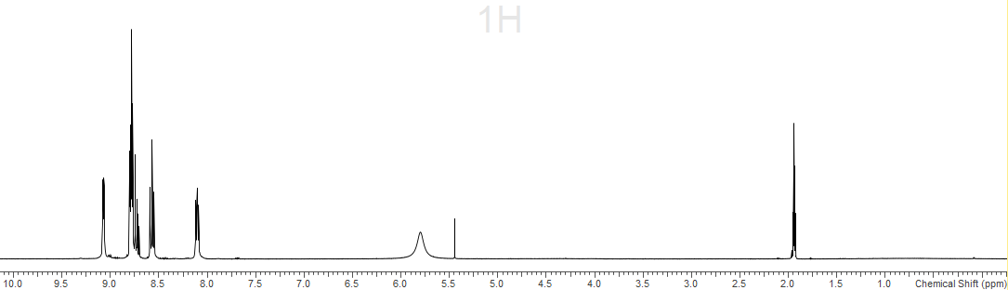
CD3CN
CD2Cl₂
S2.1.2 - ¹³C{¹H} spectrum (295 K, CD₃CN)
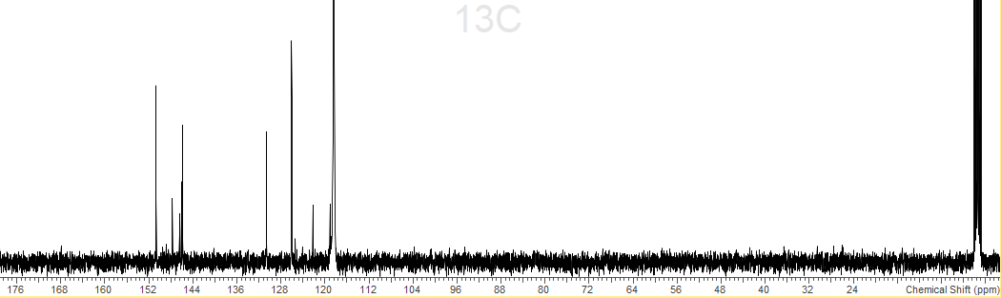
CD3CN
CD3CN
S2.1.3 – ¹⁹F{¹H} spectrum (295 K, CD₃CN)
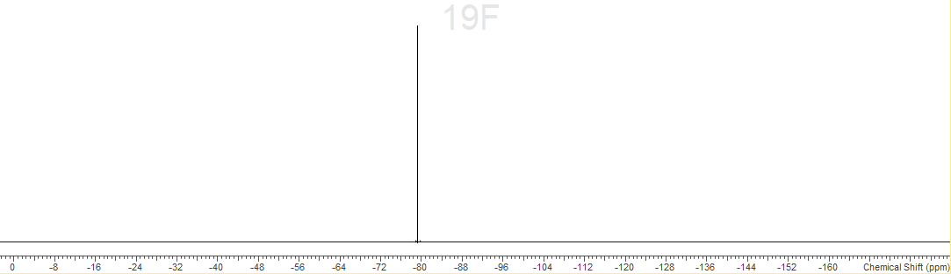
S2.1.4 – IR Spectrum (Nujol)
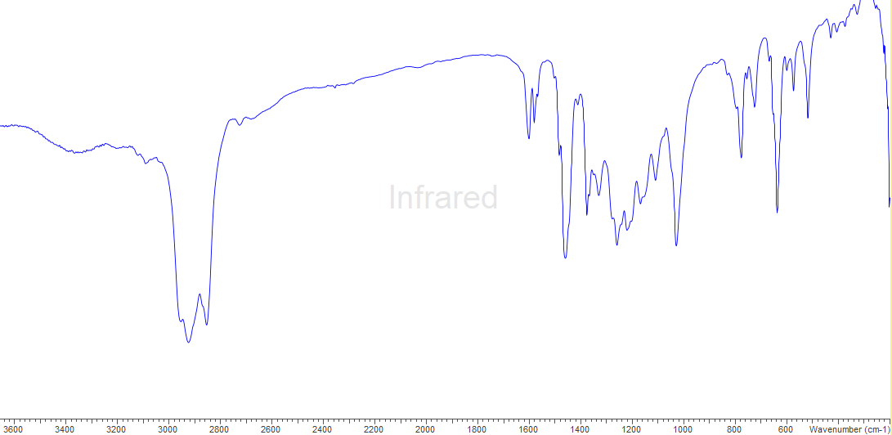
S2.2.0 - [Ga(OTf)₃(terpy)]
S2.2.1 - ¹H spectrum (295 K, CD₃CN)
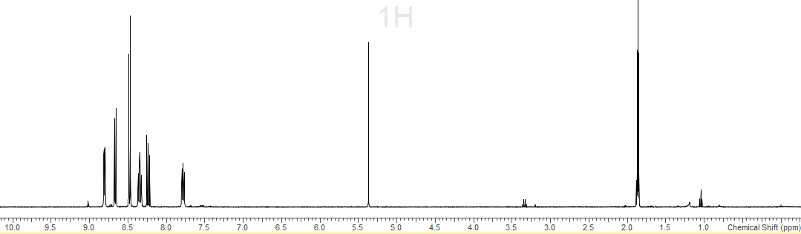
CD2Cl₂
CD3CN
S2.2.2 - ¹³C{¹H} spectrum (295 K, CD₃CN)
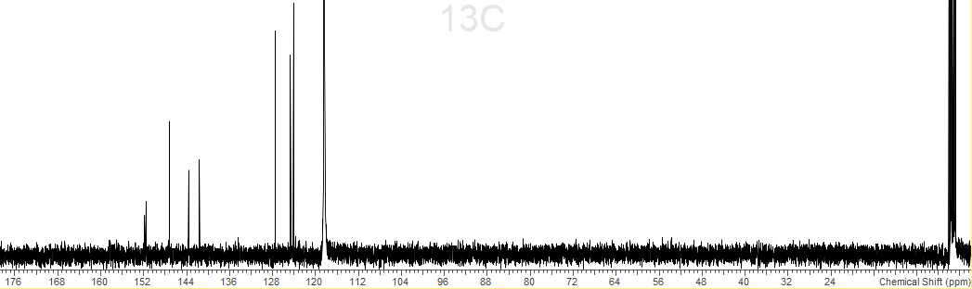
CD3CN
CD3CN
S2.2.3 – ¹⁷F{¹H} spectrum (295 K, CD₃CN)
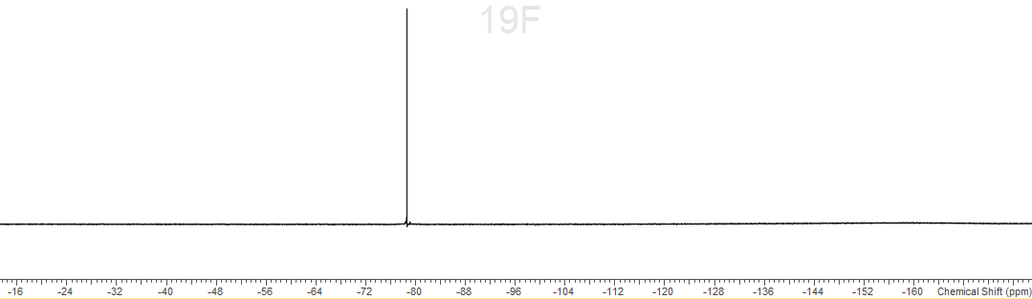
S2.2.4 - IR spectrum (Nujol)
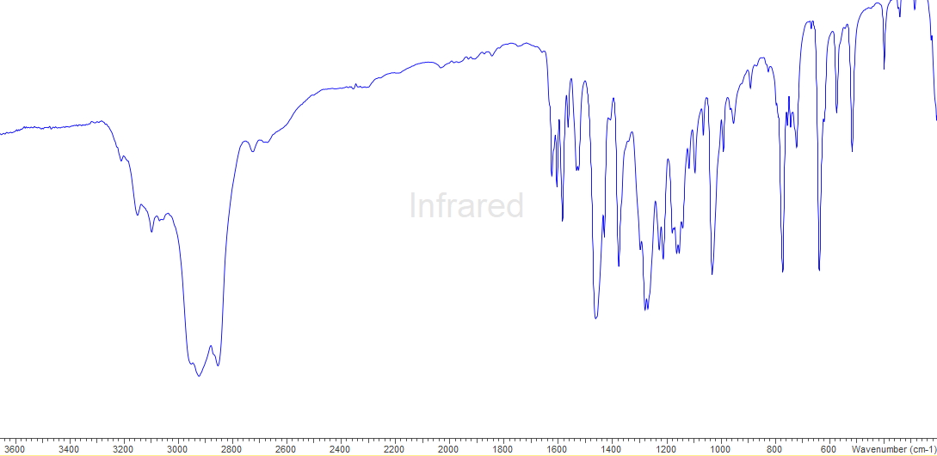
S2.3.0 - [Al(OTf)₃(terpy)]
S2.3.1 - ¹H spectrum (295 K, CD₃CN)
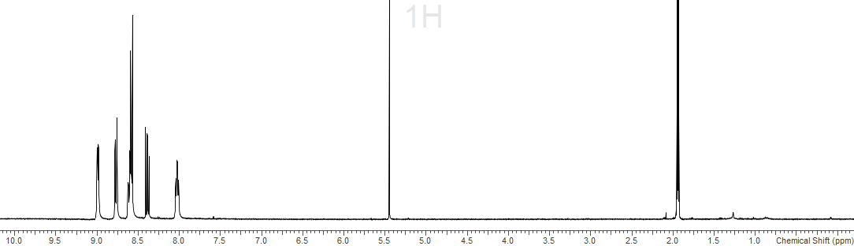
S2.3.2 - ¹³C{¹H} spectrum (295 K, CD₃CN)
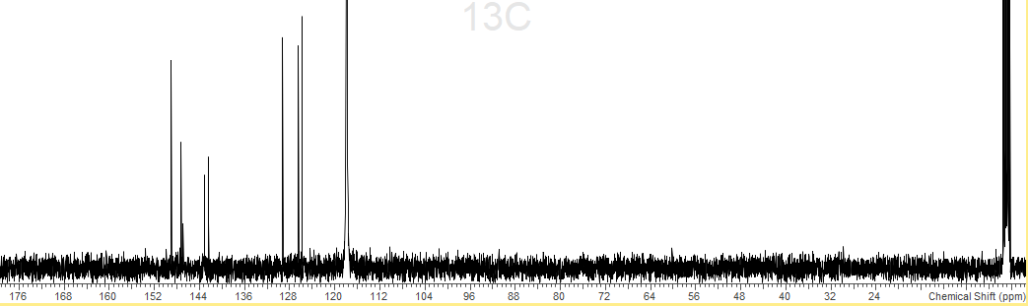
S2.3.3 – ¹⁷F{¹H} spectrum (295 K, CD3CN)
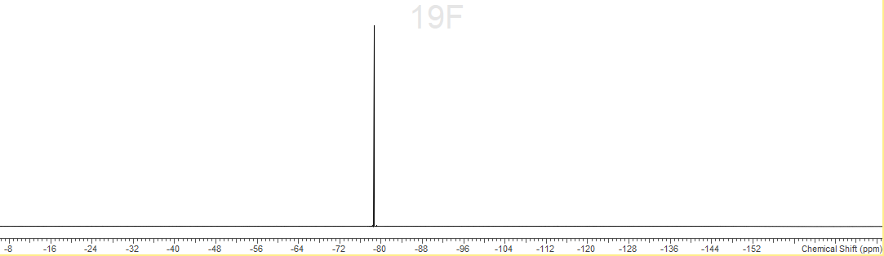
S2.3.4 – IR spectrum (nujol)
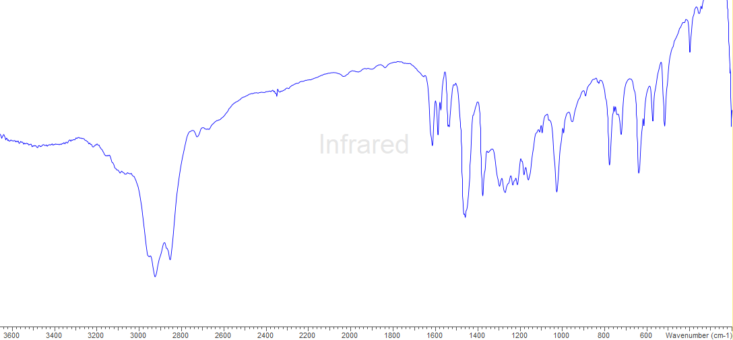
S2.4.0 - [In(OTf)(H₂O)(bipy)₂]
S2.4.1 - ¹H spectrum (295 K, CD₃CN)
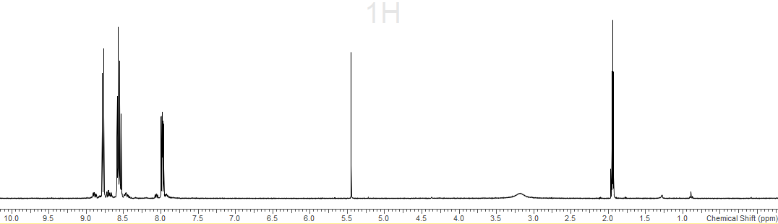
CD₃CN
CD2Cl₂
S2.4.2 - ¹³C{¹H} spectrum (295 K, CD₃CN)
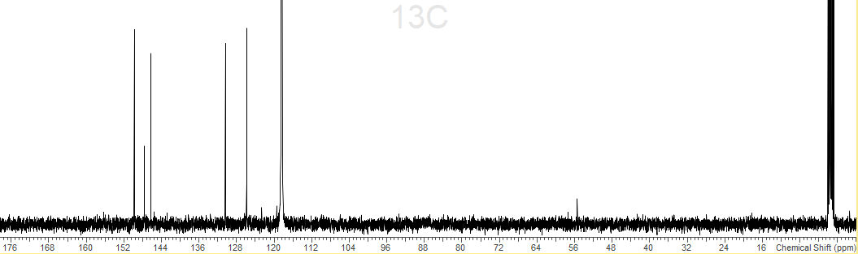
CD₃CN
CD₃CN
S2.4.3 – ¹⁷F{¹H} spectrum (295 K, CD2Cl₂)
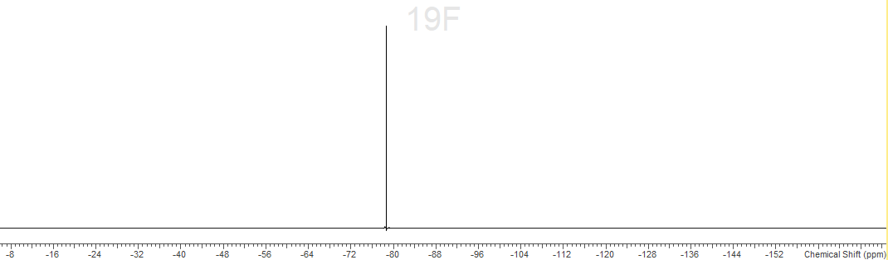
S2.4.4 – IR spectrum (nujol)
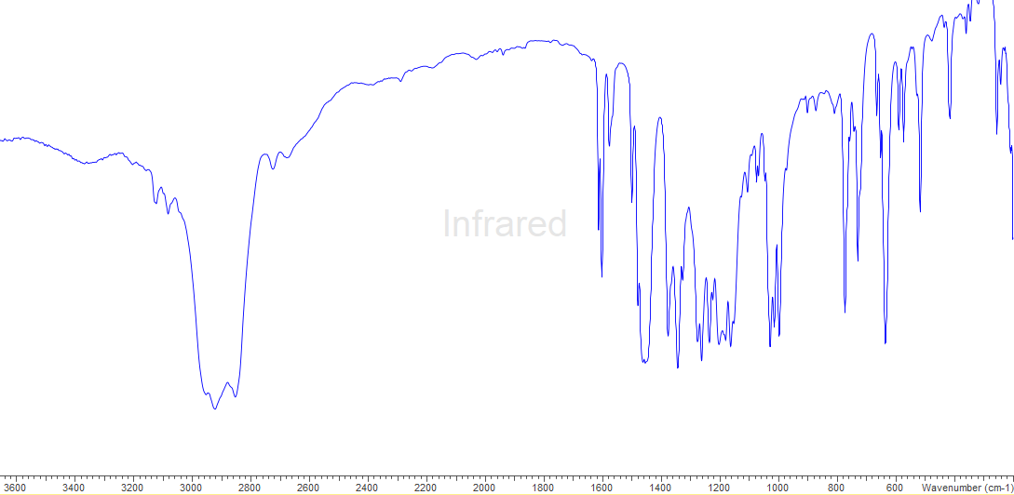
S2.5.0 - [Ga(OTf)₂(bipy)₂][OTf]
S2.5.1 - ¹H spectrum (295 K, CD₃CN)
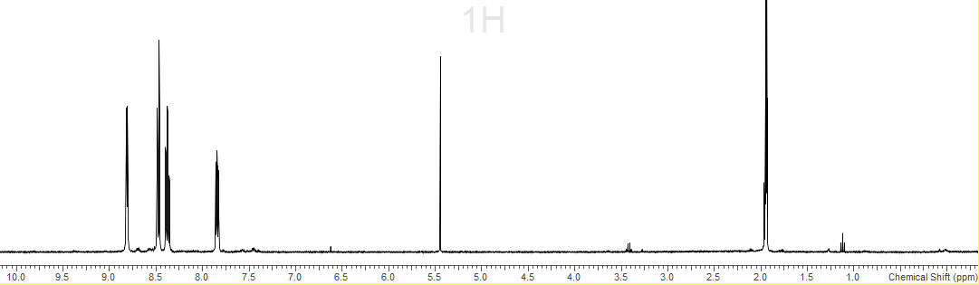
CD₃CN
CD2Cl₂
S2.5.2 - ¹³C{¹H} spectrum (295 K, CD₃CN)
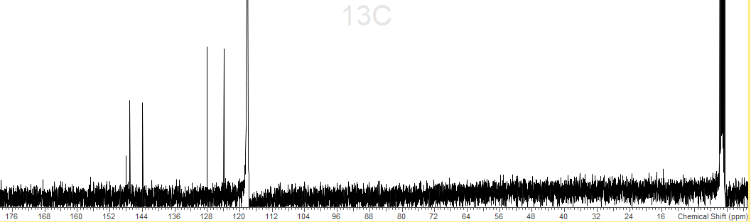
CD₃CN
CD₃CN
S2.5.3 – ¹⁷F{¹H} spectrum (295 K, CD₃CN)
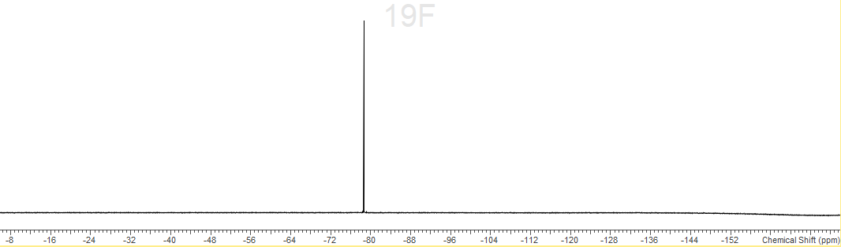
S2.5.4 – IR spectrum (nujol)
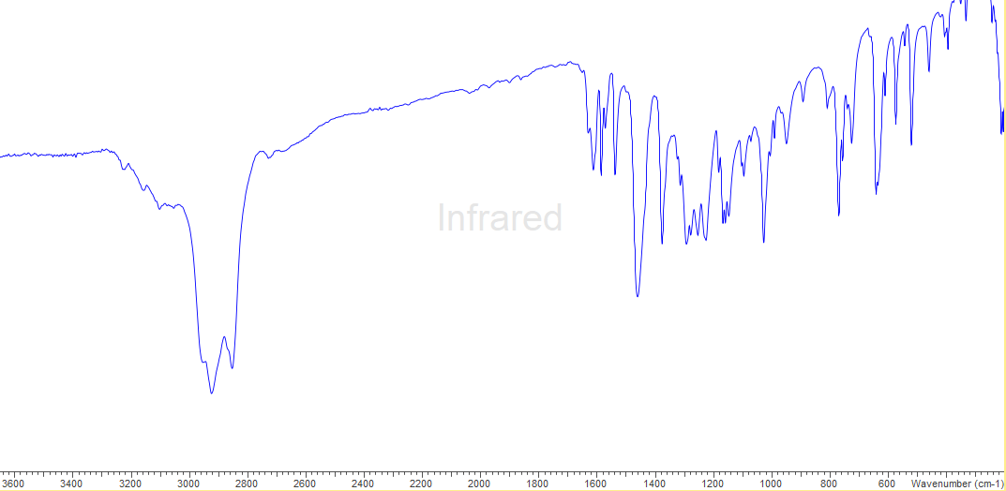
S2.6.0 - [Al(OTf)₂(bipy)₂][OTf]
S2.6.1 - ¹H spectrum (295 K, CD₃CN)
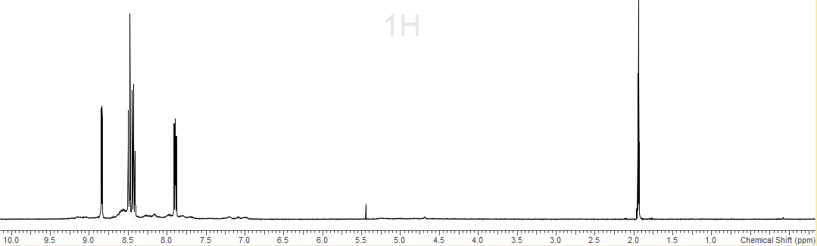
CD₃CN
S2.6.2 - ¹³C{¹H} spectrum (295 K, CD3CN)
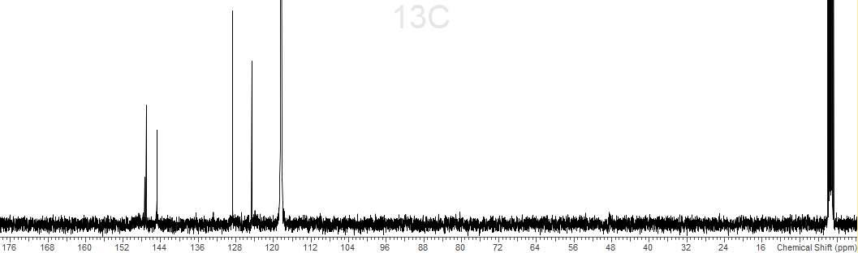
CD₃CN
CD₃CN
S2.6.3 - ¹⁹F{¹H} spectrum (295 K, CD₃CN)
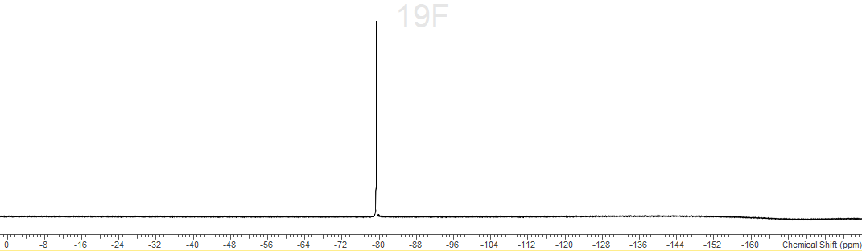
S2.6.4 – ²⁷Al spectrum (295 K, CD₃CN)
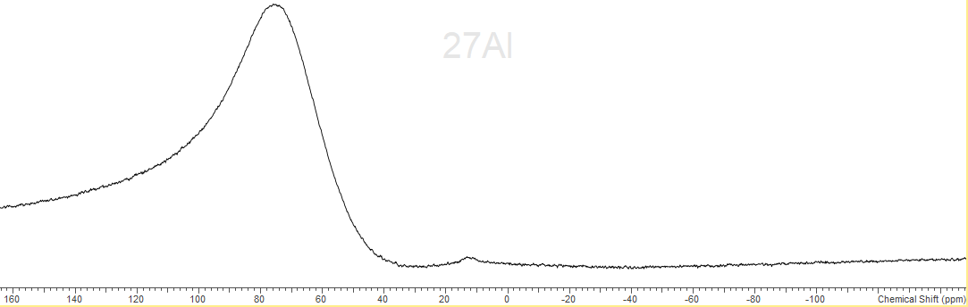
S2.6.5 – IR spectrum (nujol)
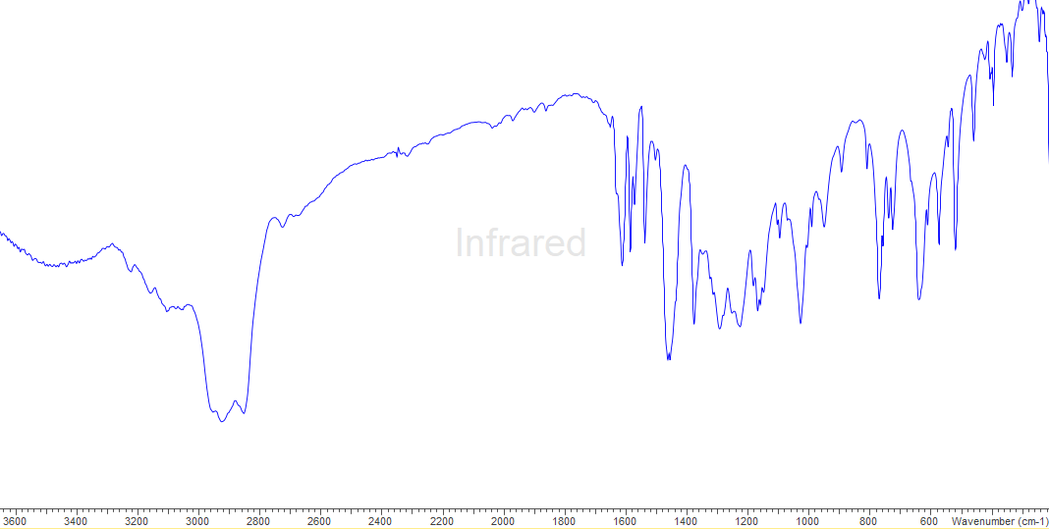
S2.7.0 - [In(OTf)₂(phen)₂][OTf]
S2.7.1 - ¹H spectrum (298 K, CD₃CN)
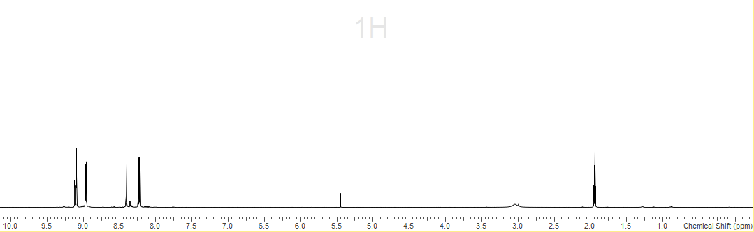
CD₃CN
S2.7.2 - ¹³C{¹H} spectrum (298 K, CD3CN)
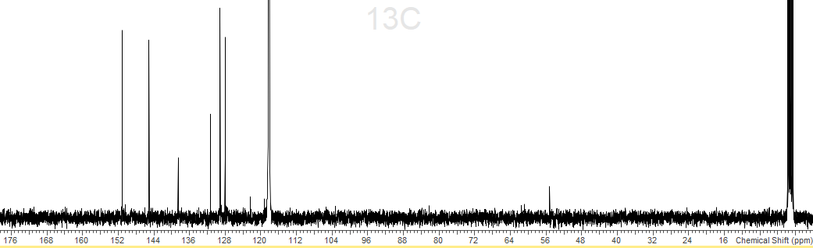
CD₃CN
CD₃CN
S2.7.3 – ¹⁹F{¹H} spectrum (295 K, CD₃CN)
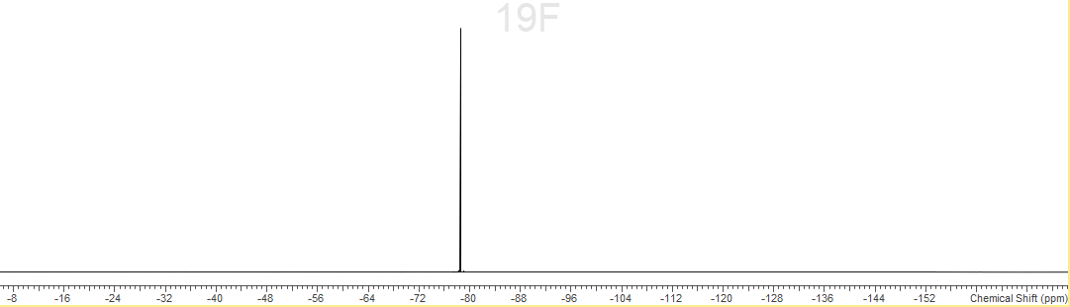
S2.7.4 – IR spectrum (nujol)
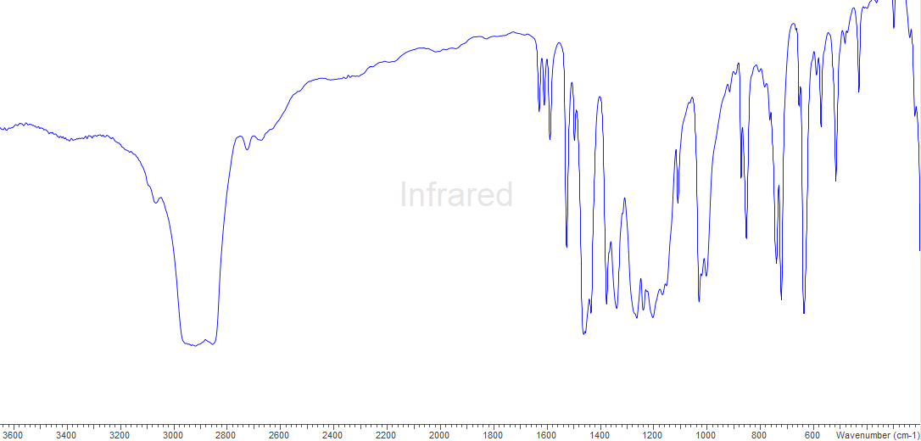
S2.8.0 - [Al(OTf)₂(phen)₂][OTf]
S2.8.1 - ¹H spectrum (295 K, CD₃CN)
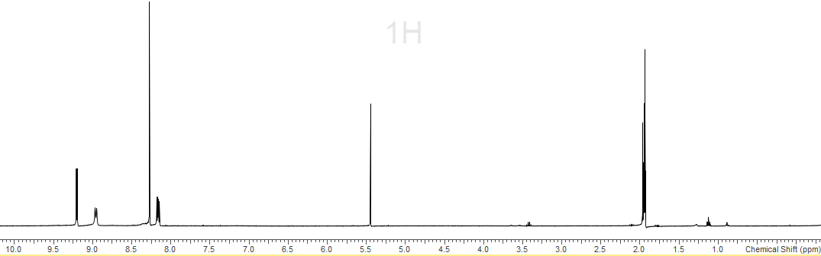
S2.8.2 – ¹³C{¹H} spectrum (295 K, CD₃CN)
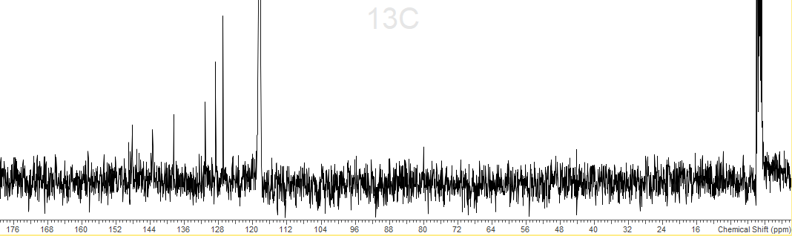
S2.8.3 - ¹⁹F{¹H} spectrum (295 K, CD₃CN)
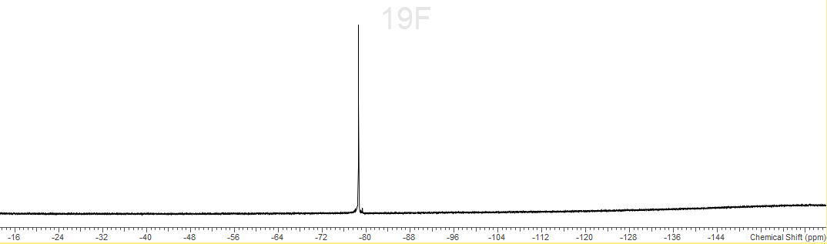
S2.8.4 – ²⁷Al spectrum (295 K, CD₃CN)
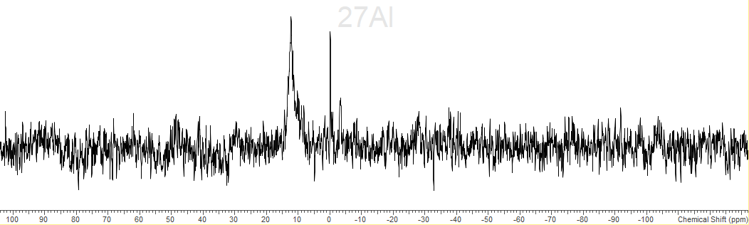
S2.8.5 – IR spectrum (nujol)
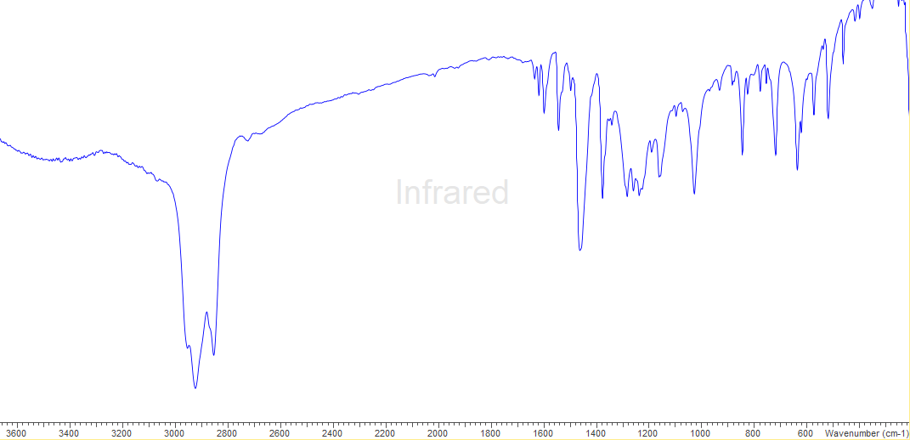

Chapter 3
S3.1.0 – Spectroscopic data for [Al(OTf)₃(OPPh₃)₃]
S3.2.0 – Spectroscopic data for [Ga(OTf)₃(OPPh₃)₃]
S3.3.0 – Spectroscopic data for [In(OTf)₃(OPPh₃)₃]
S3.4.0 – Spectroscopic data for [Al(OTf)₃(OPMe₃)₃]
S3.5.0 – Spectroscopic data for [Ga(OTf)₃(OPMe₃)₃]
S3.6.0 – Spectroscopic data for [In(OTf)₃(OPMe₃)₃]
S3.7.0 – Spectroscopic data for [In(OTf)₂(OPMe₃)₄][OTf].H₂O
S3.8.0 – Spectroscopic data for [In(OTf)(OPMe₃)₅][OTf]₂
S3.9.0 – Spectroscopic data for [In(OPMe₃)₆][OTf]₃
S3.10.0 – Spectroscopic data for [Al(dppmO₂)₃][OTf]₃
S3.11.0 – Spectroscopic data for [Ga(dppmO₂)₃][OTf]₃
S3.12.0 – Spectroscopic data for [In(dppmO₂)₃][OTf]₃
S3.13.0 – Spectroscopic data for [Al(OTf)₂(dppmO₂)₂][OTf]
S3.14.0 – Spectroscopic data for [Ga(OTf)₂(dppmO₂)₂][OTf]
S3.15.0 – Spectroscopic data for [In(OTf)₃(pyNO)₃]

S3.1.0 - [Al(OTf)₃(OPPh₃)₃]
S3.1.1 - ¹H spectrum (298 K, CD3CN)
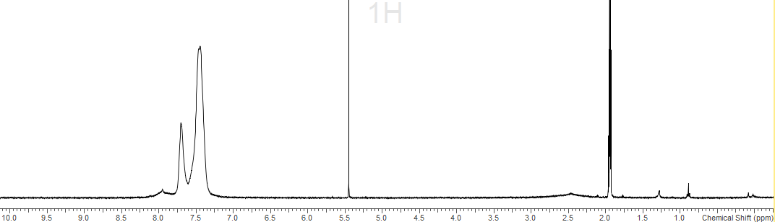
CD2Cl₂
CD3CN
S3.1.2 - ¹³C{¹H} (298 K, CD3CN)
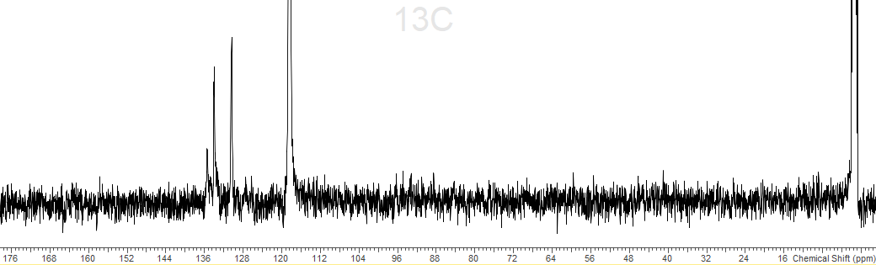
CD3CN
CD3CN
S3.1.3 - ¹⁹F{¹H} spectrum (298 K, CD3CN)
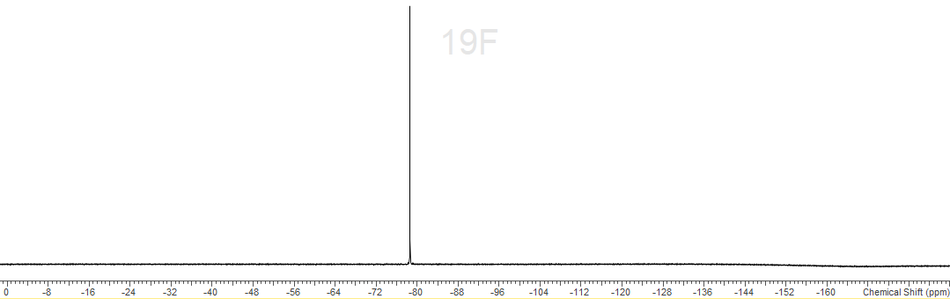
S3.1.4 - ³¹P{¹H} spectrum (298 K, CD3CN)
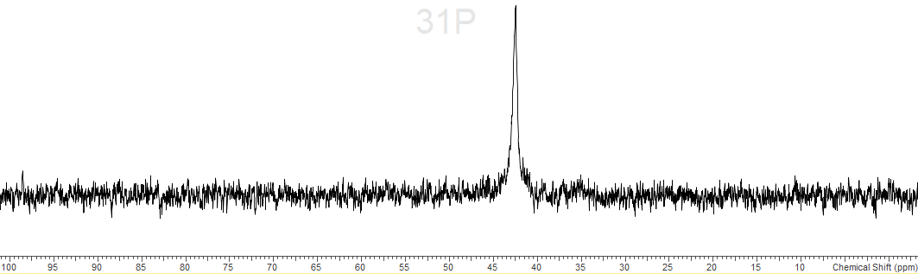
S3.1.5 – IR spectrum (nujol)
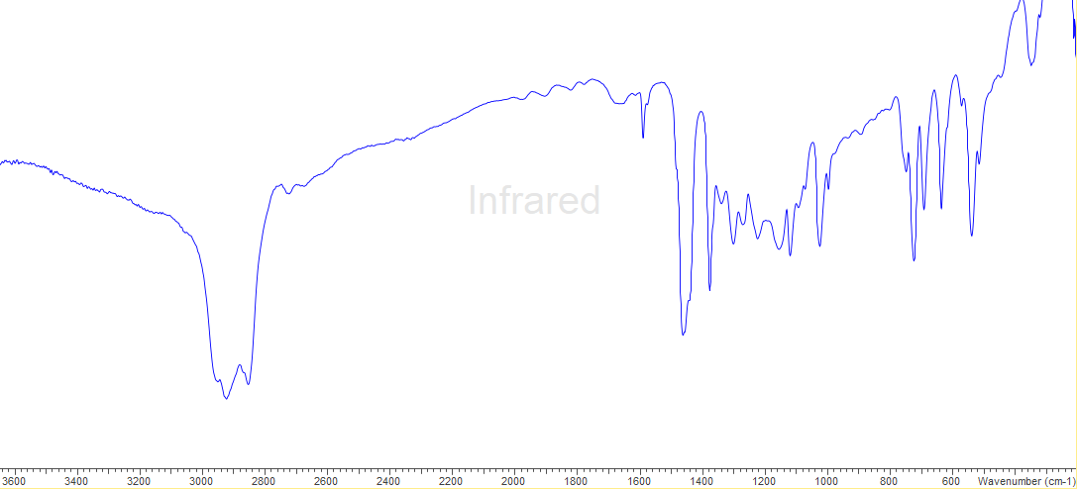
S3.2.0 - [Ga(OTf)₃(OPPh₃)₃]
S3.2.1 - ¹H spectrum (298 K, CD3CN)
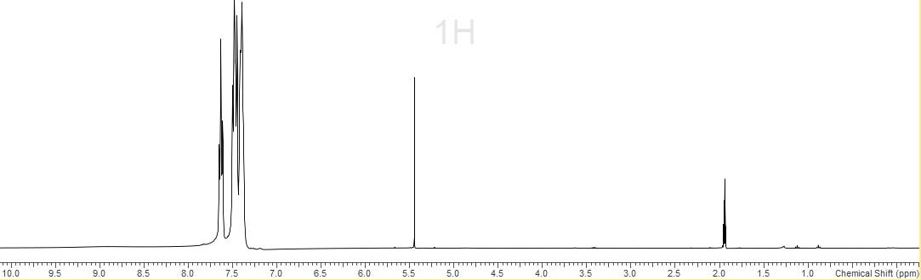
CD2Cl₂
CD3CN
S3.2.2 - ¹³C{¹H} spectrum (298 K, CD3CN)
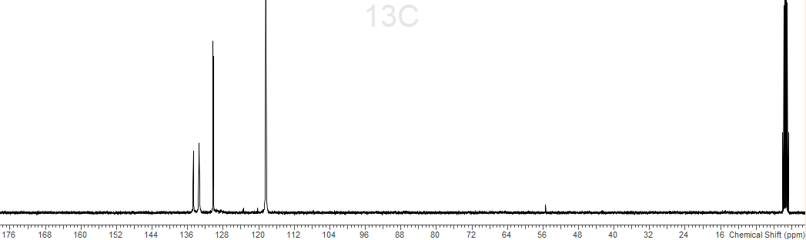
CD3CN
CD3CN
S3.2.3 - ¹⁹F{¹H} spectrum (298 K, CD3CN)
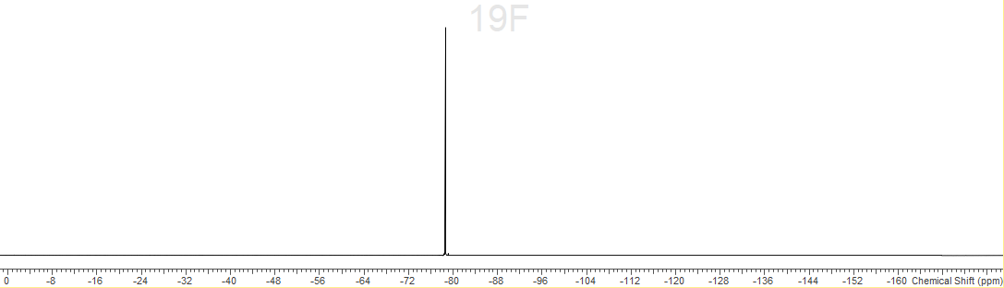
S3.2.4 - ³¹P{¹H} spectrum (298 K, CD3CN)

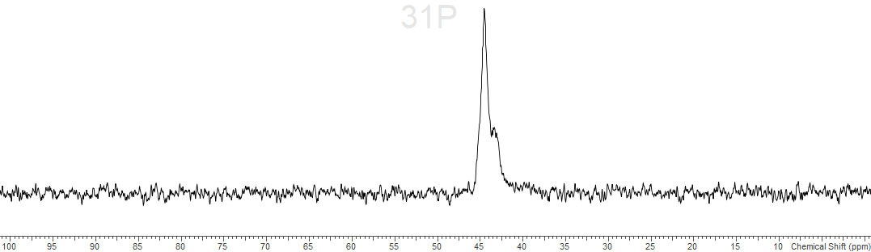
S3.2.5 – IR spectrum (Nujol)

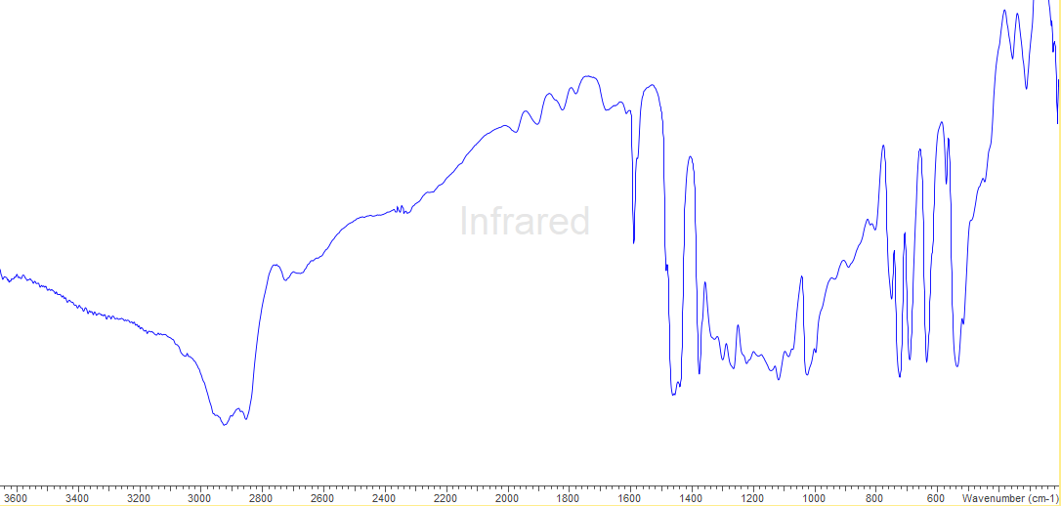
S3.3.0 - [In(OTf)₃(OPPh₃)₃]
S3.3.1 - ¹H spectrum (298 K, CD3CN)

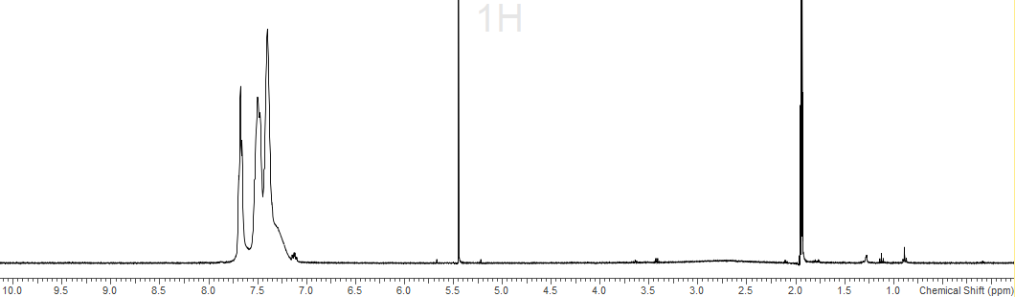
CD2Cl₂
CD3CN
S3.3.2 - ¹³C{¹H} spectrum (298 K, CD3CN)
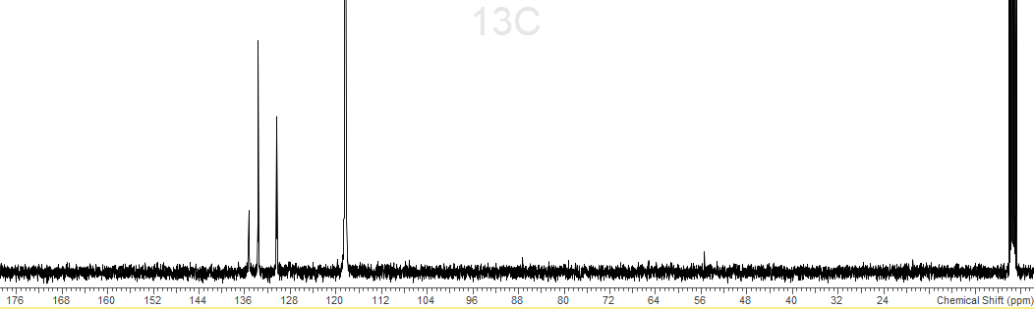
CD3CN
CD3CN
S3.3.3 - ¹⁹F{¹H} spectrum (298 K, CD3CN)
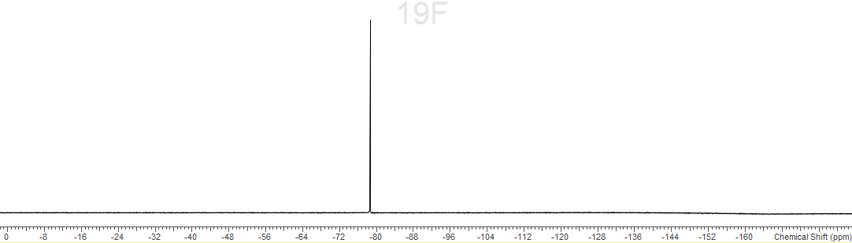
S3.3.4 - ³¹P{¹H} spectrum (298 K, CD₃CN)
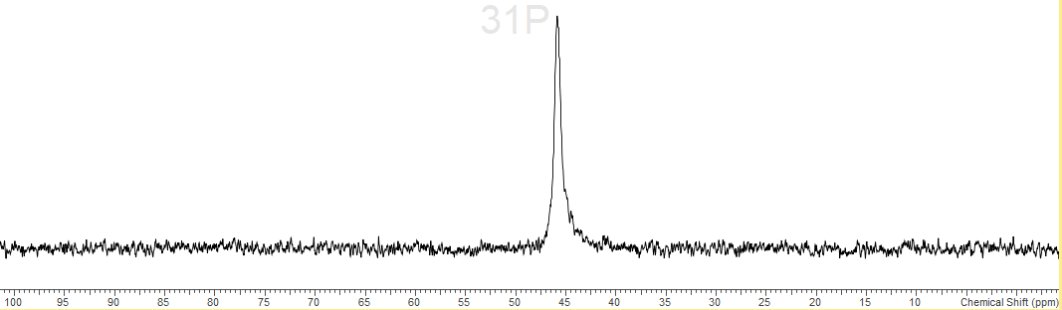
S3.3.5 – IR spectrum (nujol)
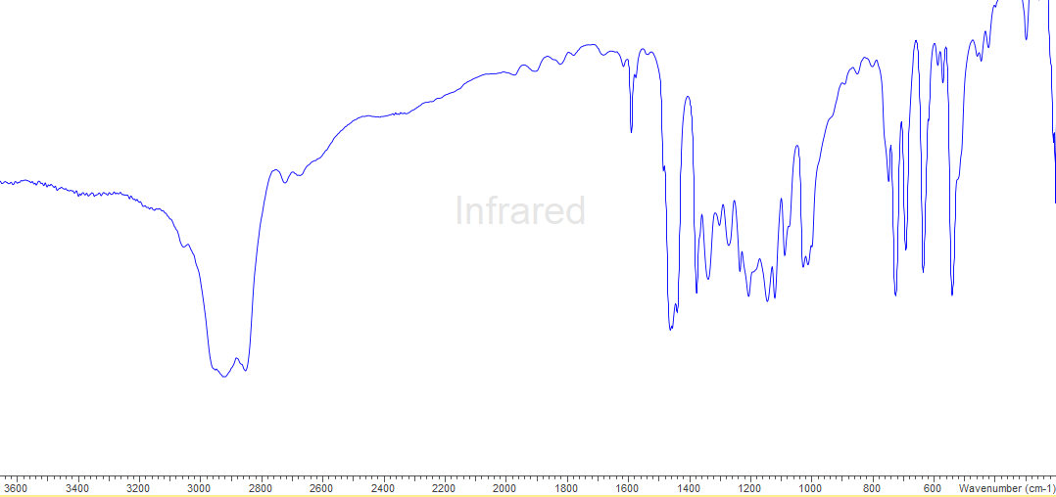
S3.4.0 - [Al(OTf)₃(OPMe₃)₃]
S3.4.1 - ¹H spectrum (298 K, CD3CN)
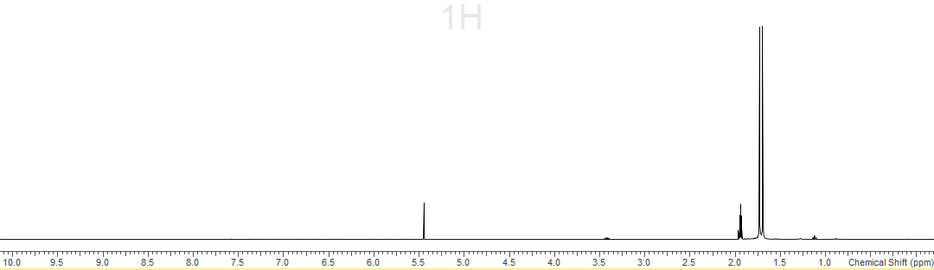
CD2Cl₂
CD3CN
S3.4.2 - ¹³C{¹H} spectrum (298 K, CD3CN)
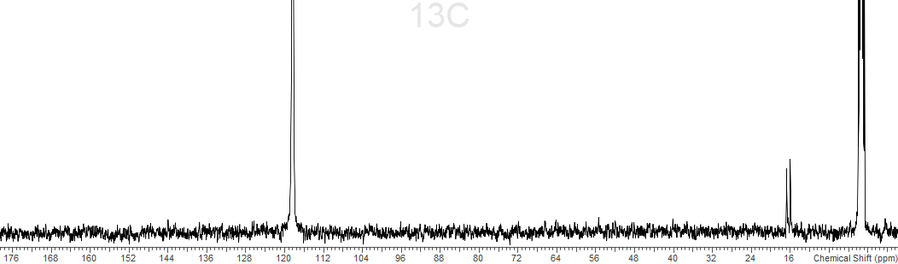
CD3CN
CD3CN
S3.4.3 - ¹⁹F{¹H} spectrum (298 K, CD3CN)
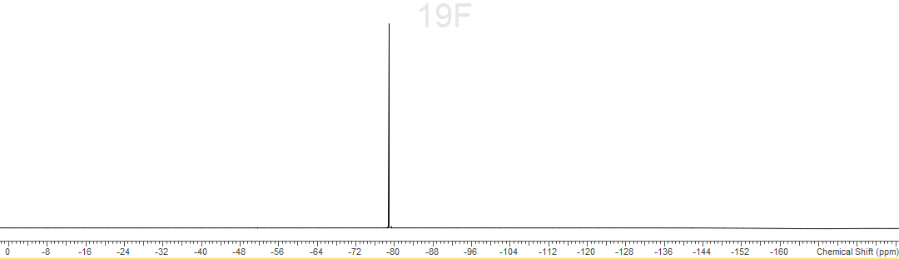
S3.4.4 - ³¹P{¹H} spectrum (298 K, CD3CN)

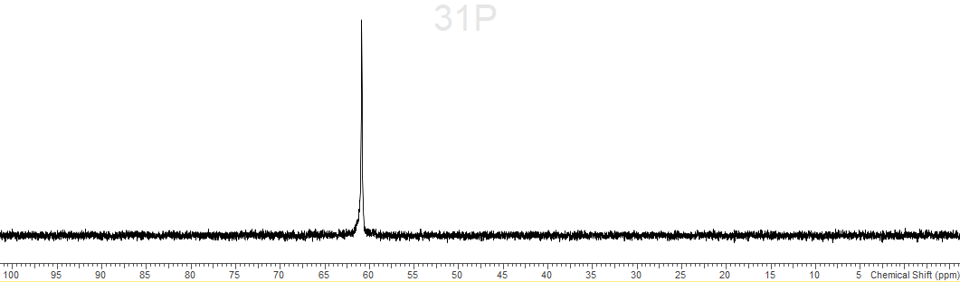
S3.4.5 – IR spectrum (nujol)
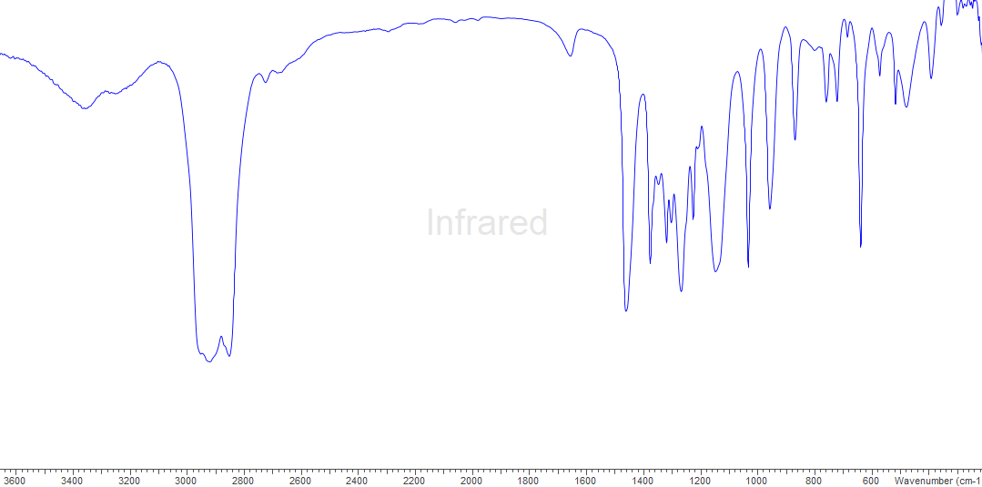
S3.5.0 - [Ga(OTf)₃(OPMe₃)₃]
S3.5.1 - ¹H spectrum (298 K, CD3CN)
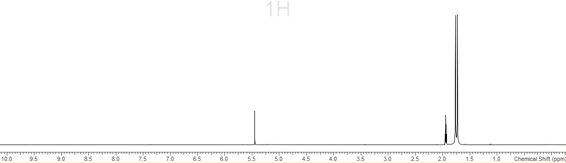
CD2Cl₂
CD3CN
S3.5.2 - ¹³C{¹H} spectrum (298 K, CD3CN)
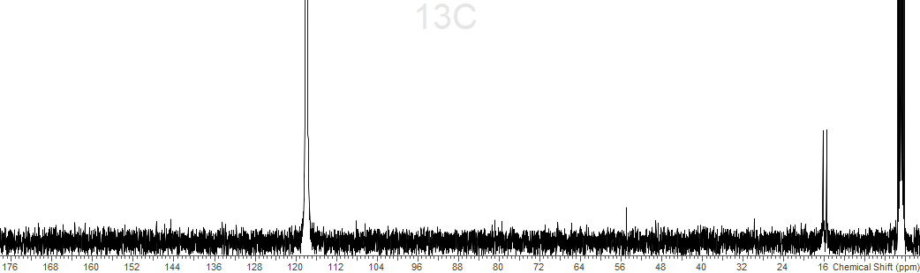
CD3CN
CD3CN
S3.5.3 - ¹⁹F{¹H} spectrum (298 K, CD3CN)
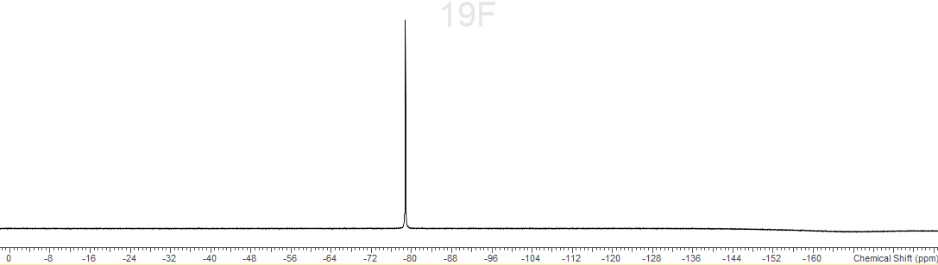
S3.5.4 - ³¹P{¹H} spectrum (298 K, CD3CN)

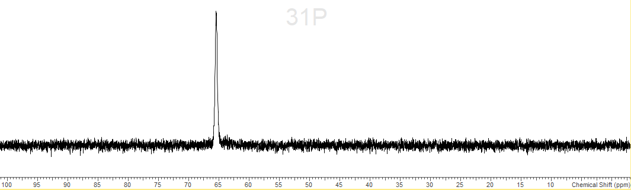
S3.5.5 – IR spectrum (nujol)
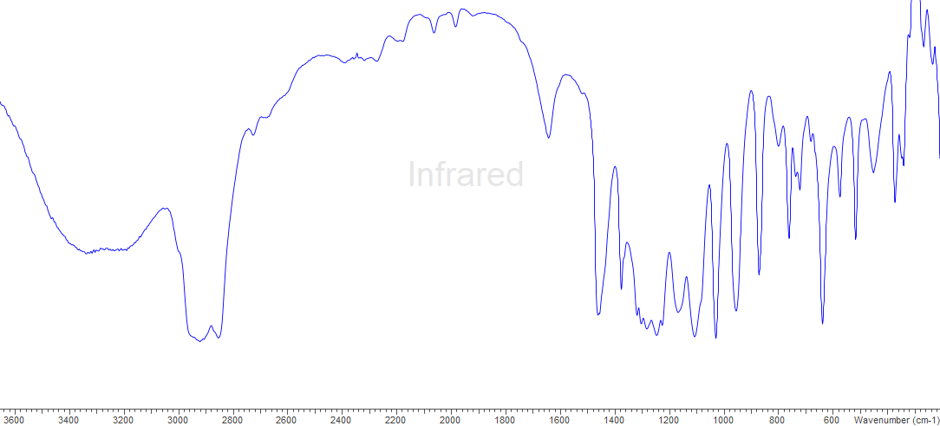
S3.6.0 - [In(OTf)₃(OPMe₃)₃]
S3.6.1 - ¹H spectrum (298 K, CD3CN)
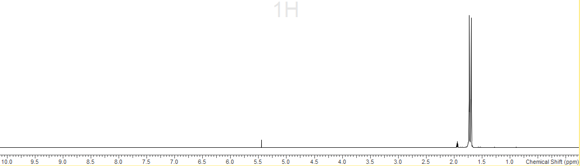
S3.6.2 - ¹³C{¹H} spectrum (298 K, CD3CN)
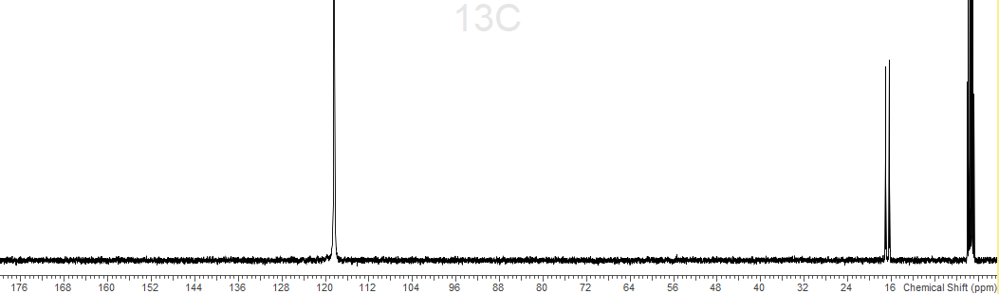
CD3CN
CD3CN
S3.6.3 - ¹⁹F{¹H} spectrum (298 K, CD3CN)

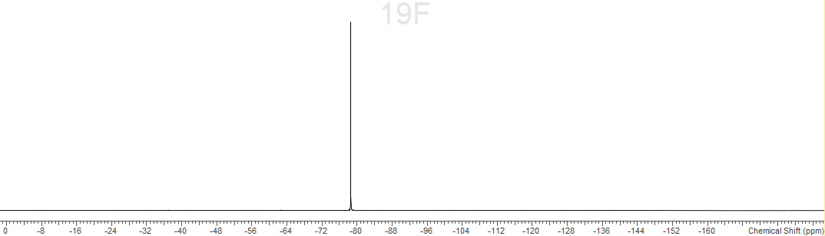
S3.6.4 - ³¹P{¹H} spectrum (298 K, CD3CN)
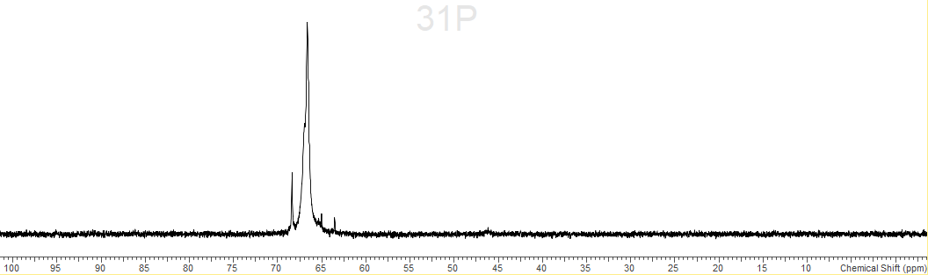
S3.6.5 – IR spectrum (nujol)
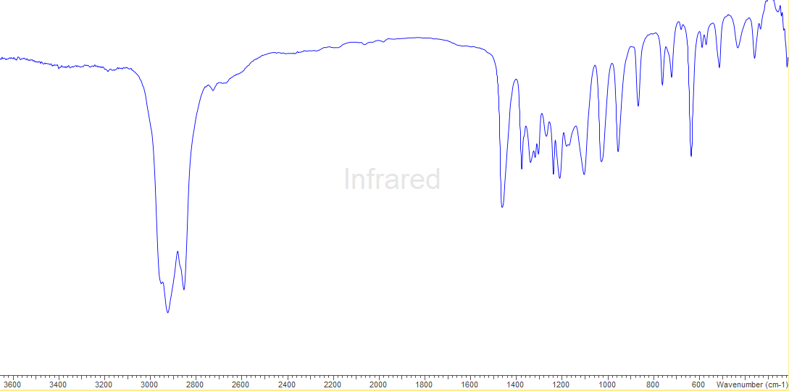
S3.7.0 - [In(OTf)₂(OPMe₃)₄][OTf].H₂O
S3.7.1 - ¹H spectrum (298 K, CD3CN)
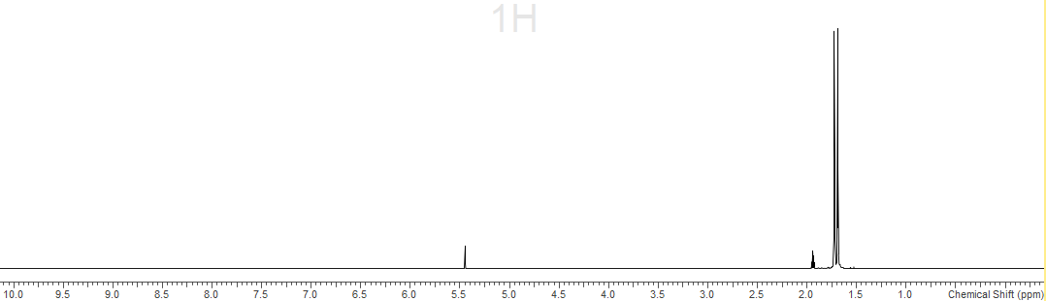
S3.7.2 - ¹³C{¹H} spectrum (298 K, CD3CN)
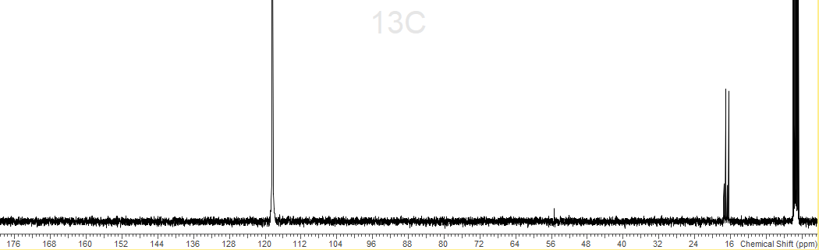
CD3CN
CD3CN
S3.7.3 - ¹⁹F{¹H} spectrum (298 K, CD3CN)
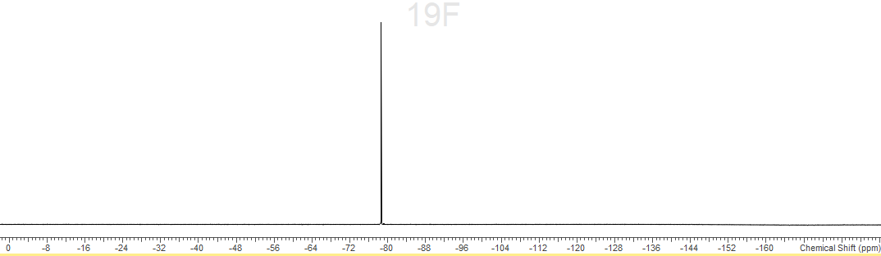
S3.7.4 - ³¹P{¹H} spectrum (298 K, CD3CN)

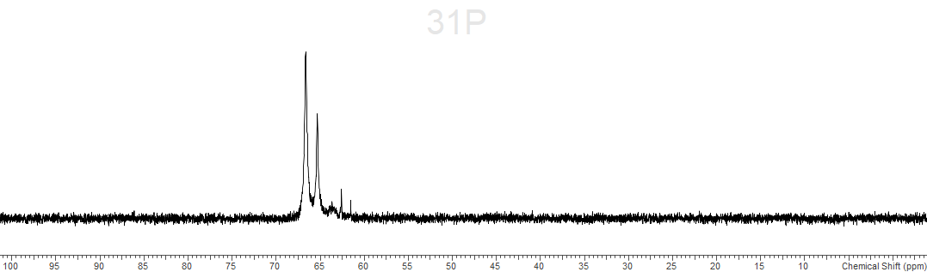
S3.7.5 – IR spectrum (nujol)
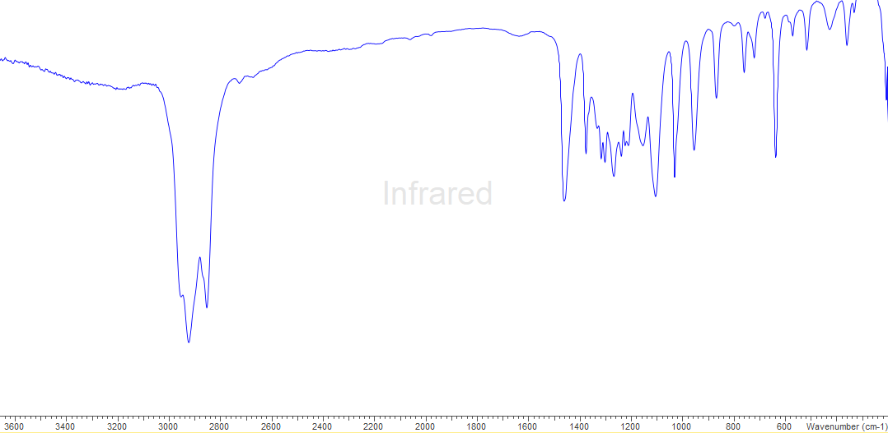
S3.8.0 - [In(OTf)(OPMe₃)₅][OTf]₂
S3.8.1 - ¹H spectrum (298 K, CD3CN)
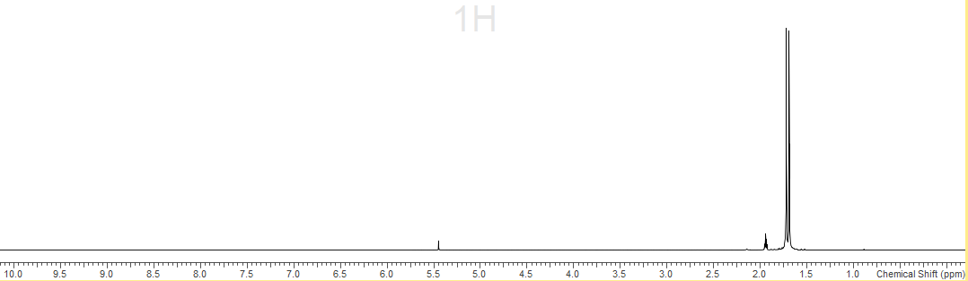
S3.8.2 - ¹³C{¹H} spectrum (298 K, CD3CN)
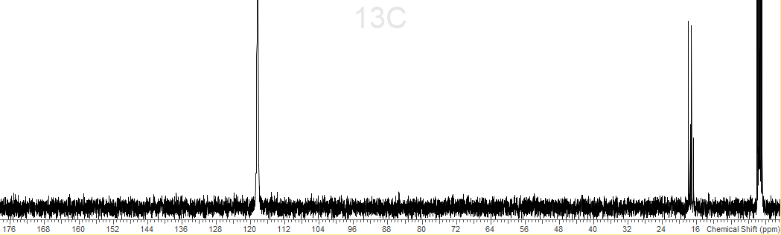
CD3CN
S3.8.3 - ¹⁹F{¹H} spectrum (298 K, CD3CN)
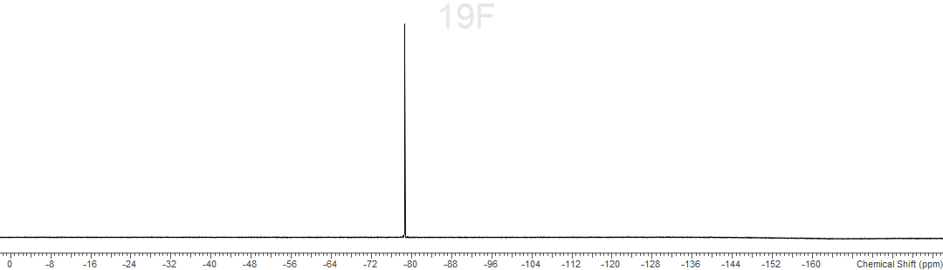
S3.8.4 - ³¹P{¹H} spectrum (298 K, CD₃CN)
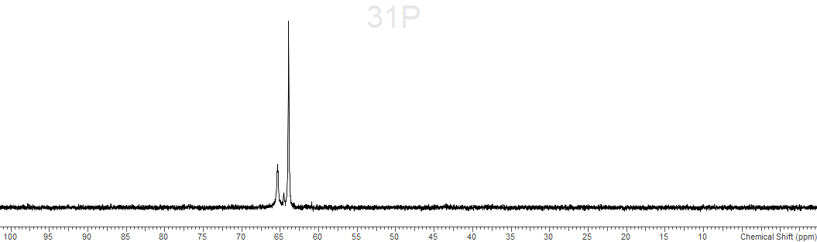
S3.8.5 – IR spectrum (nujol)
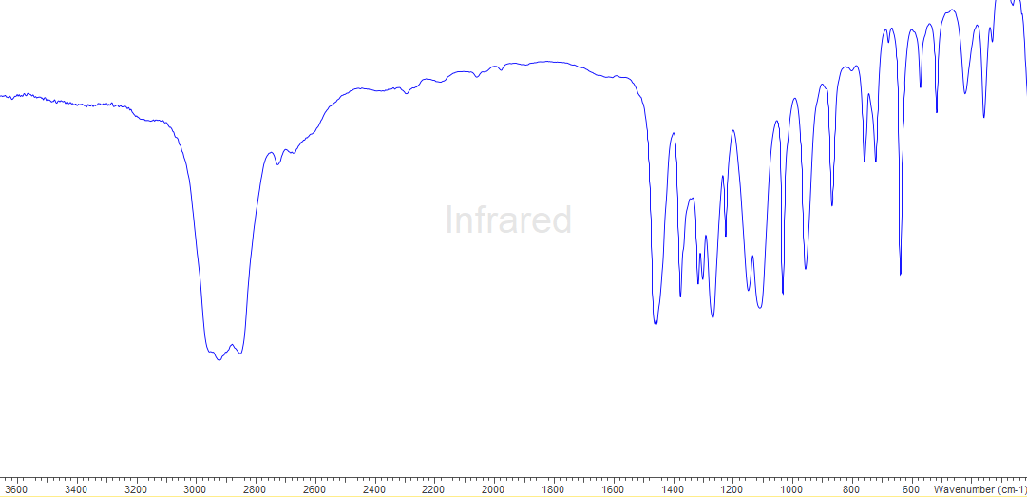
S3.9.0 - [In(OPMe₃)₆][OTf]₃
S3.9.1 - ¹H spectrum (298 K, CD3CN)
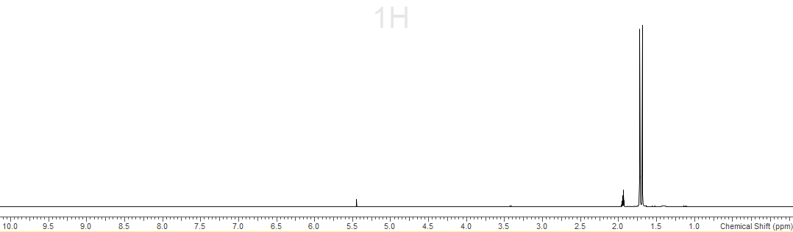
S3.9.2 - ¹³C{¹H} spectrum (298 K, CD3CN)
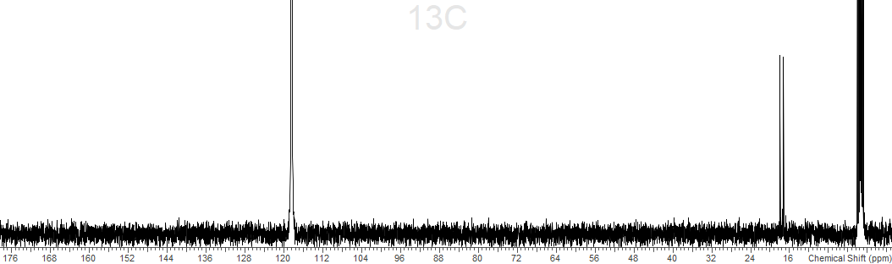
CD3CN
S3.9.3 - ¹⁹F{¹H} spectrum (298 K, CD3CN)
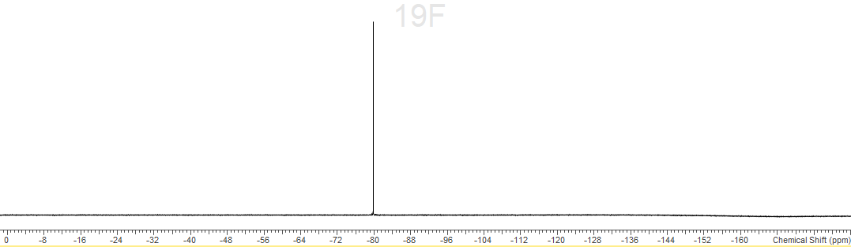
S3.9.4 - ³¹P{¹H} spectrum (298 K, CD3CN)
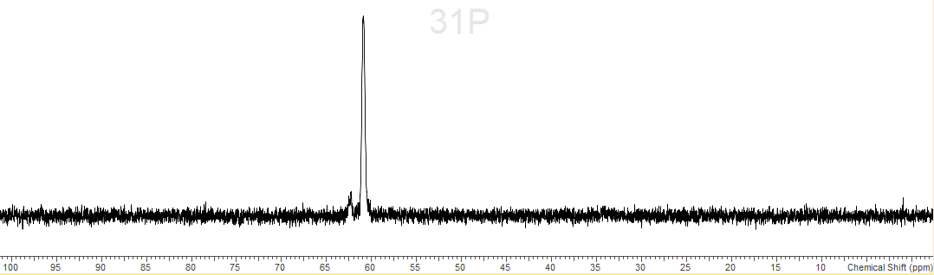
S3.9.5 - ¹¹⁵In spectrum (298K, CD₃CN)
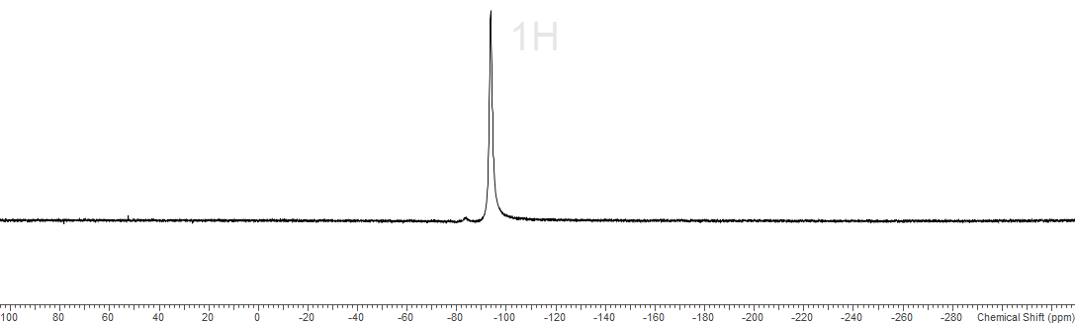
S3.9.6 – IR spectrum (nujol)
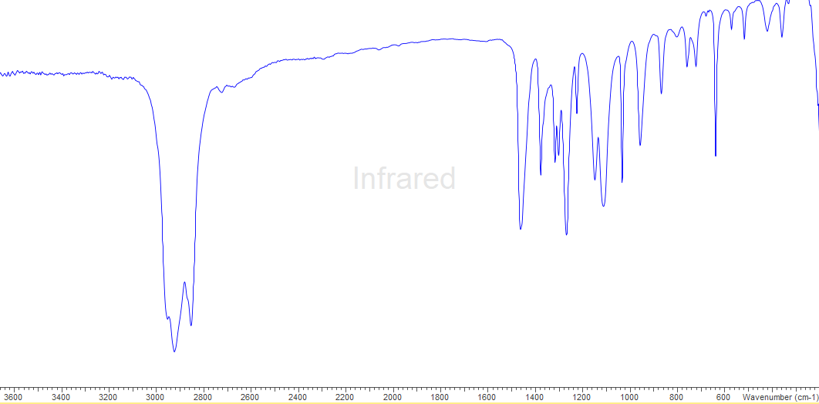
S3.10.0 [Al(dppmO₂)₃][OTf]₃
S3.10.1 - ¹H spectrum (298 K, CD3CN)
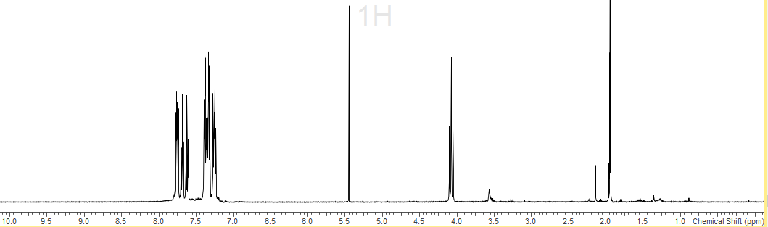
CD2Cl₂
CD3CN
S3.10.2 - ¹³C{¹H} spectrum (298 K, CD3CN)
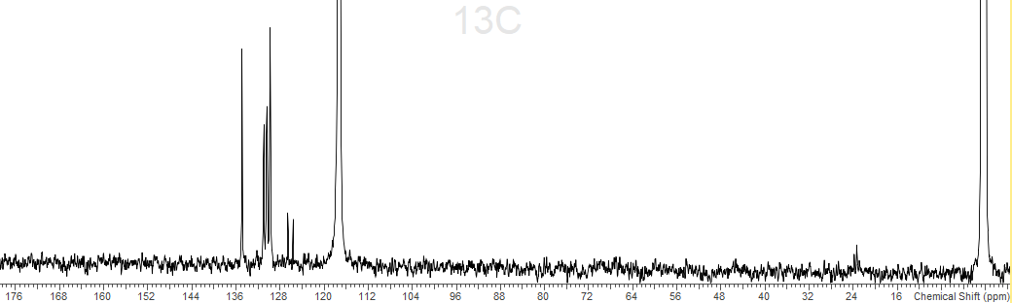
CD3CN
CD3CN
S3.10.3 - ¹⁹F{¹H} spectrum (298 K, CD3CN)
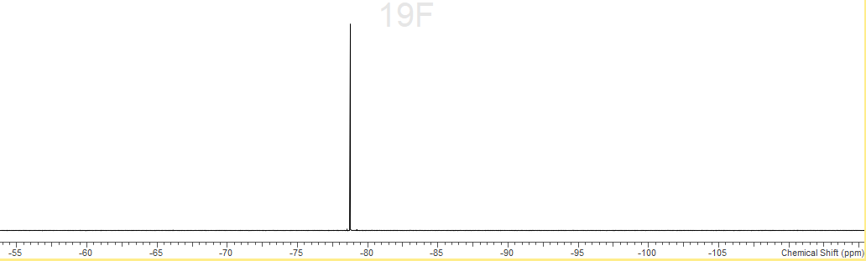
S3.10.4 - ³¹P{¹H} spectrum (298 K, CD₃CN)
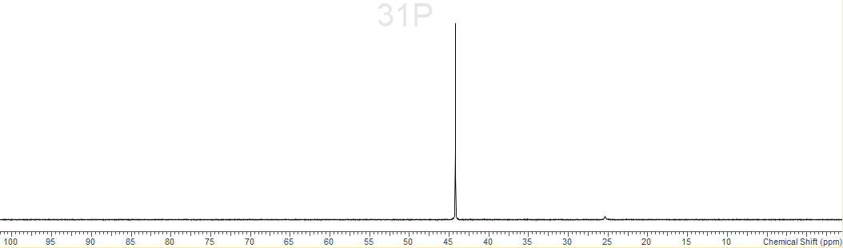
S3.10.5 - ²⁷Al spectrum (298 K, CD₃CN)
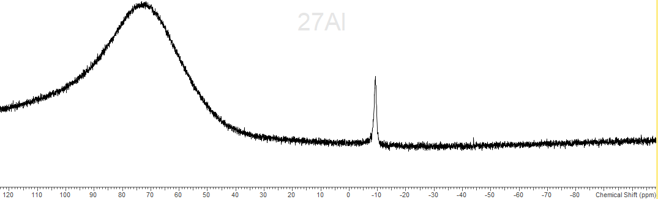
S3.10.6 – IR spectrum (nujol)
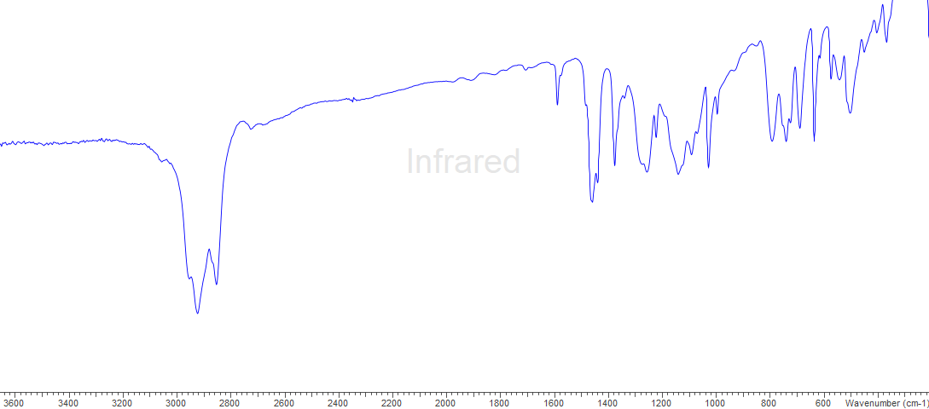
S3.11.0 -[Ga(dppmO₂)₃][OTf]₃
S3.11.1 - ¹H spectrum (298 K, CD3CN)
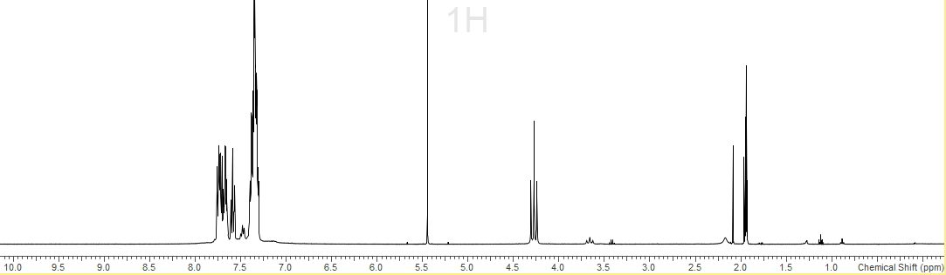
CD2Cl₂
CD3CN
S3.11.2 - ¹³C{¹H} spectrum (298 K, CD3CN)
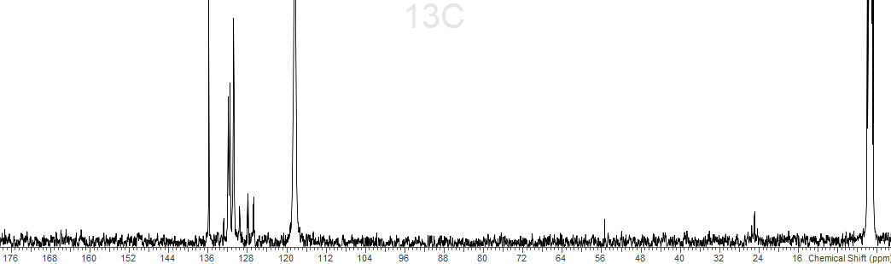
CD3CN
CD3CN
S3.11.3 - ¹⁹F{¹H} spectrum (298 K, CD3CN)
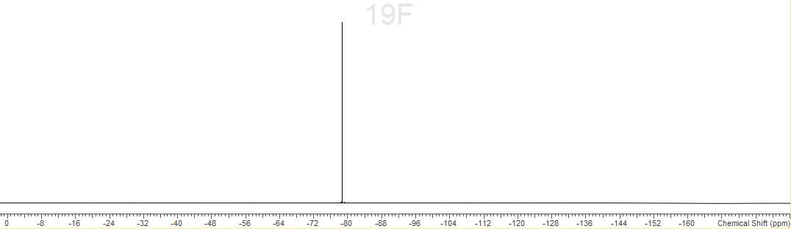
S3.11.4 - ³¹P{¹H} spectrum (298 K, CD₃CN)
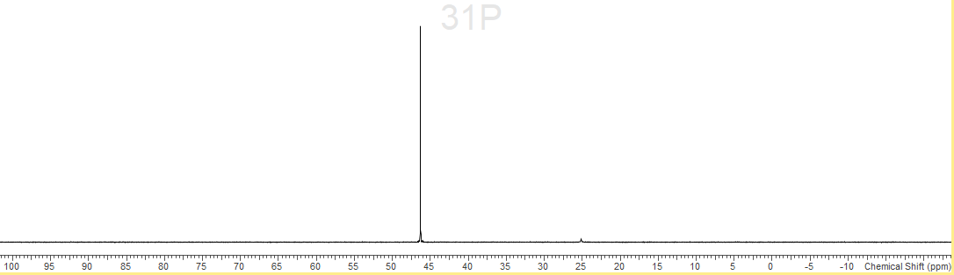
S3.11.5 - ⁷¹Ga spectrum (298 K, CD₃CN)
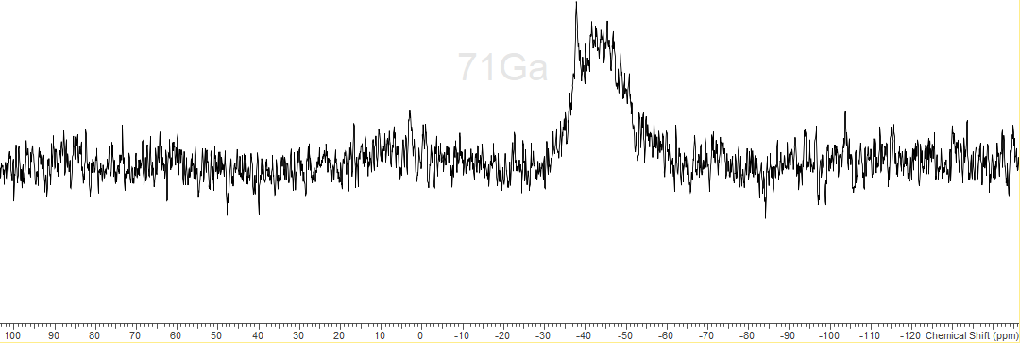
S3.11.6 – IR spectrum (nujol)
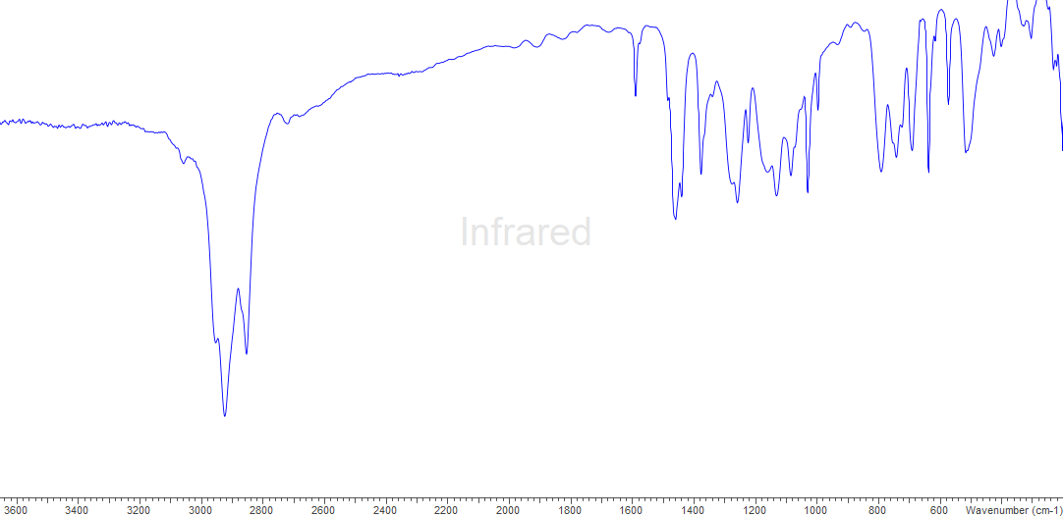
S3.12.0 - [In(dppmO₂)₃][OTf]₃
S3.12.1 - ¹H spectrum (298 K, CD3CN)

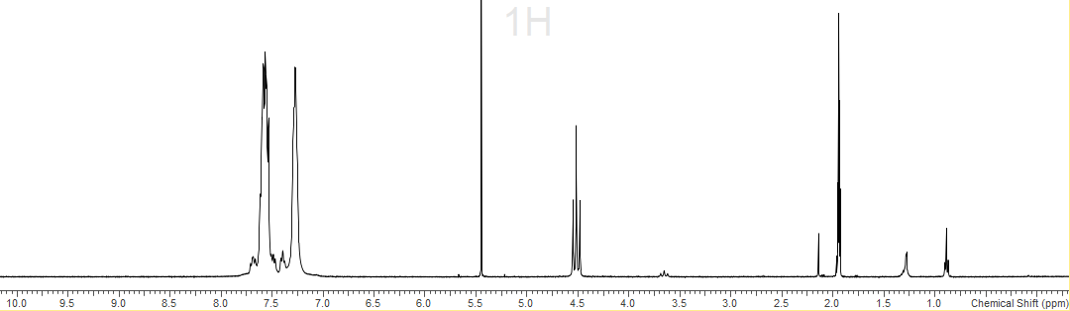
CD2Cl₂
CD3CN
S3.12.2 - ¹⁹F{¹H} spectrum (298 K, CD3CN)
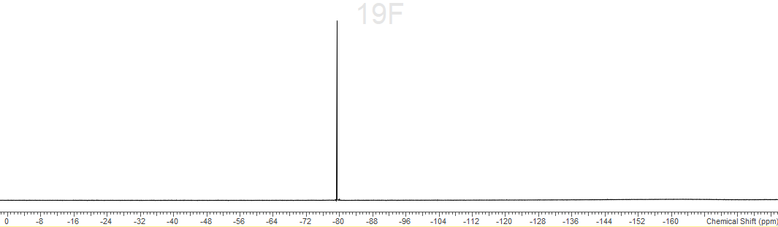
S3.12.2 – ³¹P{¹H} spectrum (298 K, CD3CN)
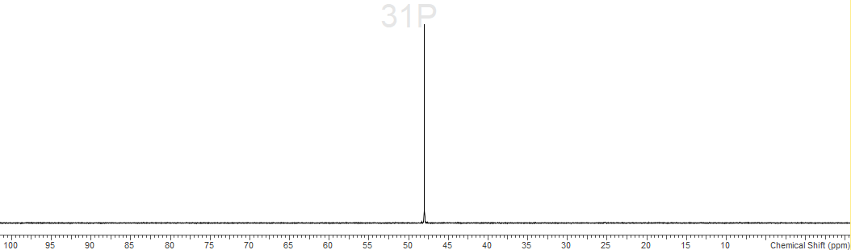
S3.12.3 – IR spectrum (nujol)
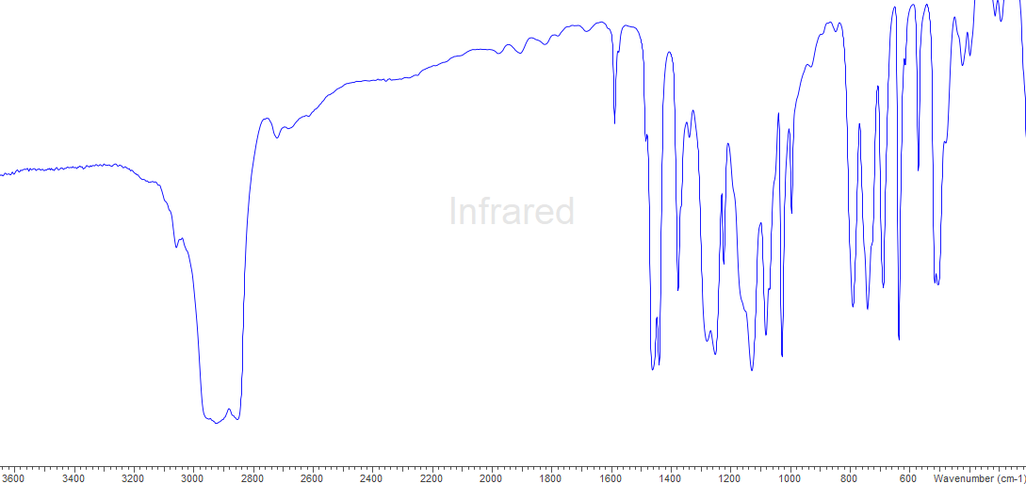
S3.13.0 - [Ga(OTf)₂(dppmO₂)₂][OTf]
S3.13.1 - ¹H spectrum (298 K, CD3CN)
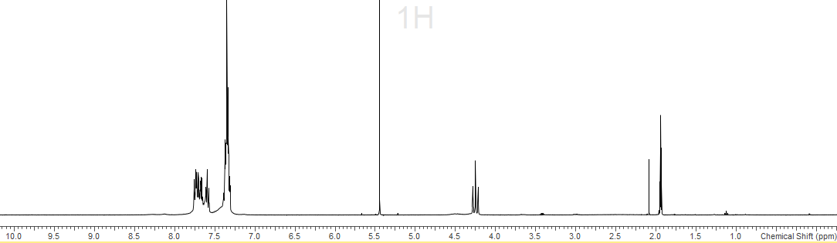
CD2Cl₂
CD3CN
S3.13.2 - ¹³C{¹H} spectrum (298 K, CD3CN)
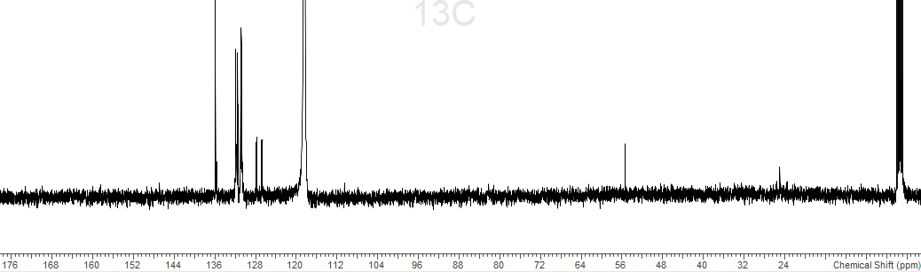
CD3CN
CD3CN
S3.13.3 - ¹⁹F{¹H} spectrum (298 K, CD3CN)
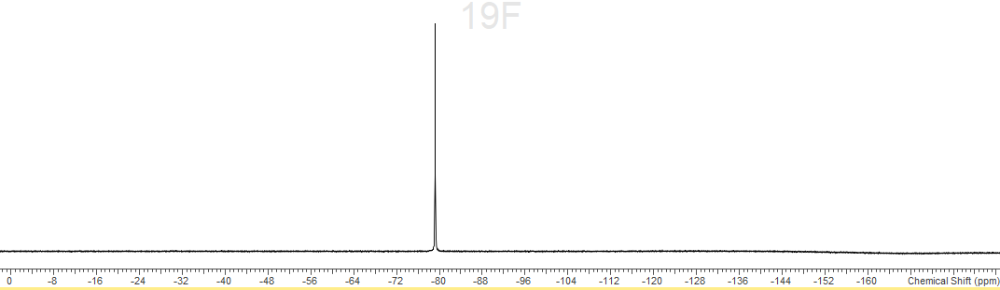
S3.13.4 – ³¹P{¹H} spectrum (298 K, CD3CN)
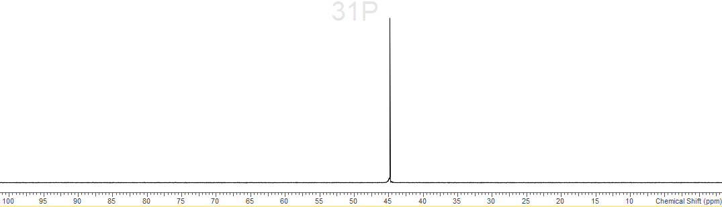
S3.13.5 – IR spectrum (nujol)
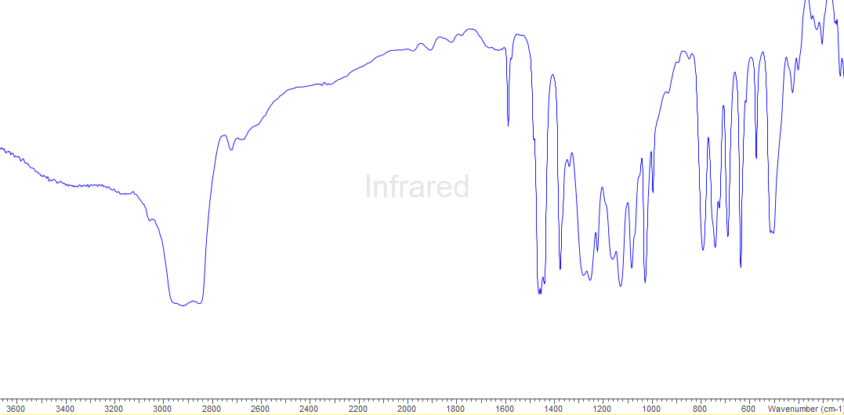
S3.14.0 - [In(OTf)₃(pyNO)₃]
S3.14.1 - ¹H spectrum (298 K, CD3CN)
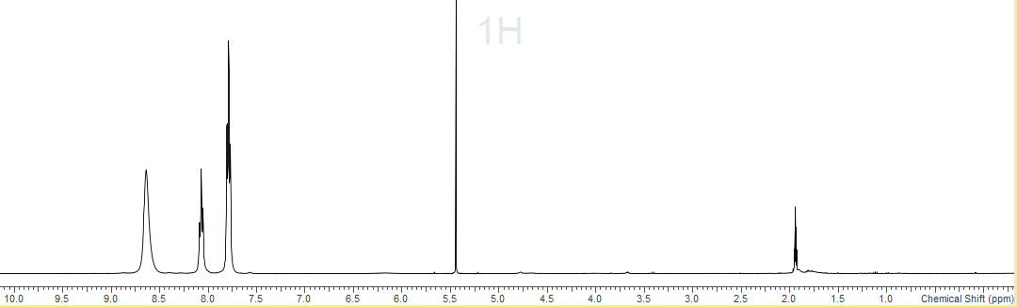
CD2Cl₂
CD3CN
S3.14.2 - ¹³C{¹H} spectrum (298 K, CD3CN)
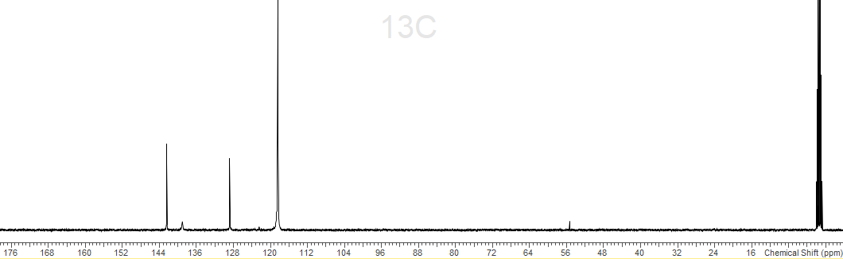
CD3CN
CD3CN
S3.14.3 - ¹⁹F{¹H} spectrum (298 K, CD3CN)
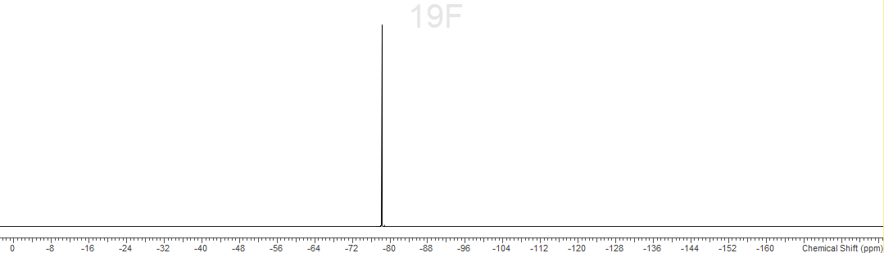
S3.14.4 – IR spectrum (nujol)
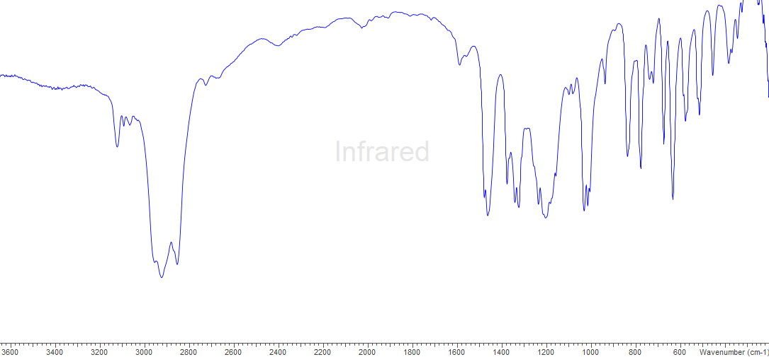

Chapter 4
S4.1.0 – Spectroscopic data for [GaCl₃(PEt₃)]
S4.2.0 - Spectroscopic data for [GaCl₃(AsEt₃)]
S4.3.0 - Spectroscopic data for [GaCl₃(SbEt₃)]
S4.4.0 – Spectroscopic data for [GaCl₃(Sb^{n}Bu₃)]
S4.5.0 - Spectroscopic data for [InCl₃(PEt₃)₂]
S4.6.0 - Spectroscopic data for [InCl₃(AsEt₃)]
S4.7.0 - Spectroscopic data for [InCl₃(AsEt₃)₂]
S4.8.0 - Spectroscopic data for [InCl₃(SbEt₃)]
S4.9.0 – Spectroscopic data for [InCl₃(Sb^{n}Bu₃)]
S4.10.0 - Spectroscopic data for PEt₃
S4.11.0 – Spectroscopic data for SbEt₃
S4.12.0 – Spectroscopic data for Na[BAr^{F}]

S4.1.0 – [GaCl₃(PEt₃)]
S4.1.1 - ¹H spectrum (298 K, CD2Cl₂)
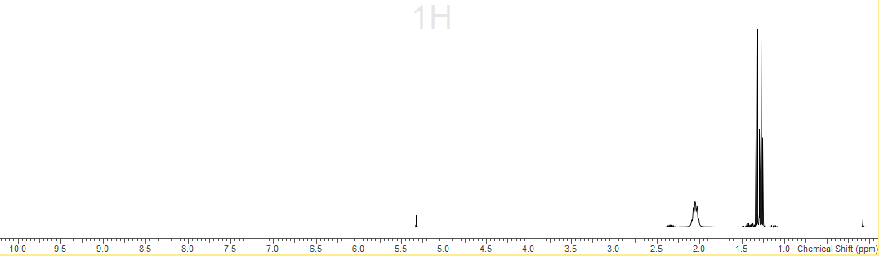
CD2Cl₂
S4.1.2 - ¹³C{¹H} spectrum (298 K, CD2Cl₂)
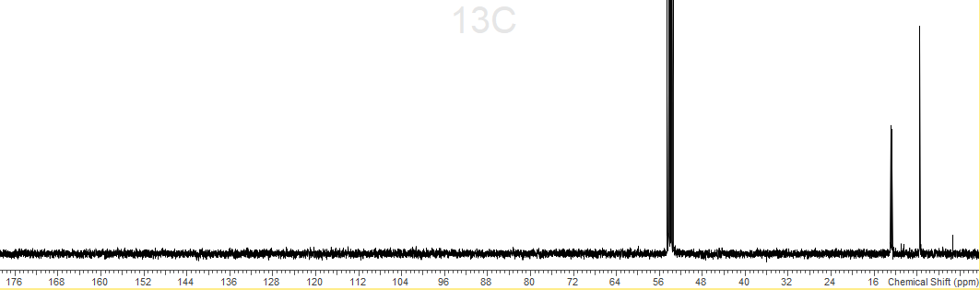
CD2Cl₂
S4.1.3 – ³¹P{¹H} spectrum (298 K, CD2Cl₂)
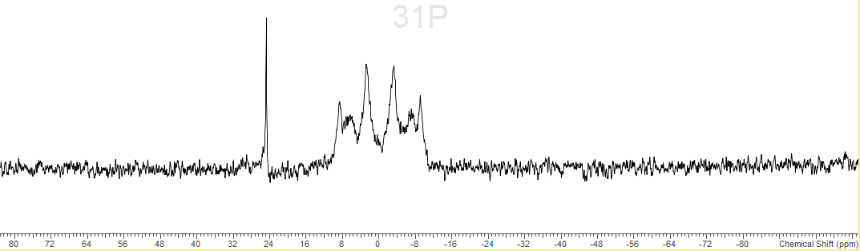
S4.1.3 – ⁷¹Ga spectrum (298 K, CD2Cl₂)
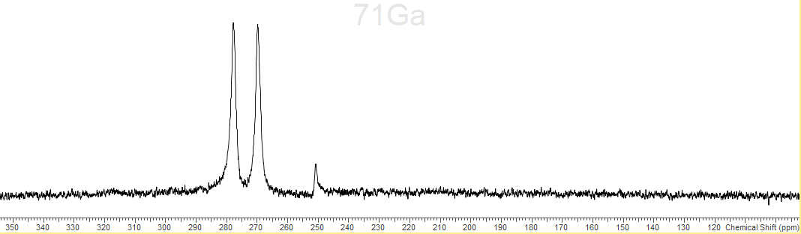
S4.1.4 – IR Spectrum (Nujol)
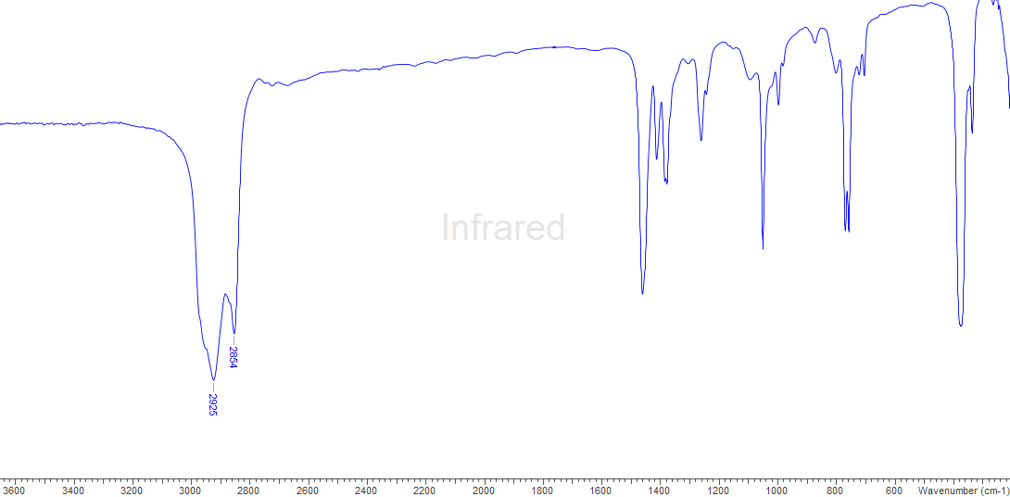
S4.2.0 - [GaCl₃(AsEt₃)]
S4.2.1 - ¹H spectrum (298 K, CD2Cl₂)
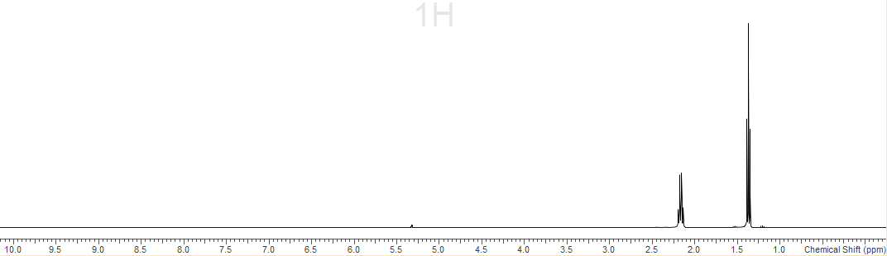
S4.2.2 - ¹³C{¹H} spectrum (298 K, CD2Cl₂)
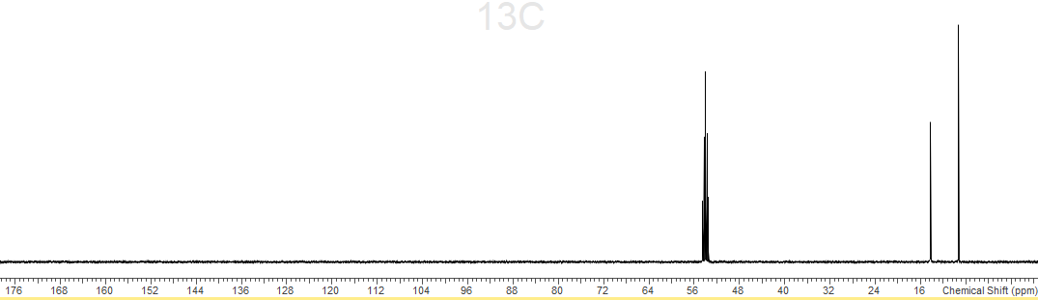
CD2Cl₂
S4.2.3 – ⁷¹Ga spectrum (298 K, CD2Cl₂)
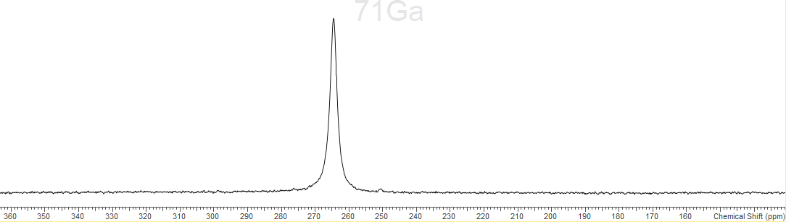
S4.2.4 - IR spectrum (Nujol)
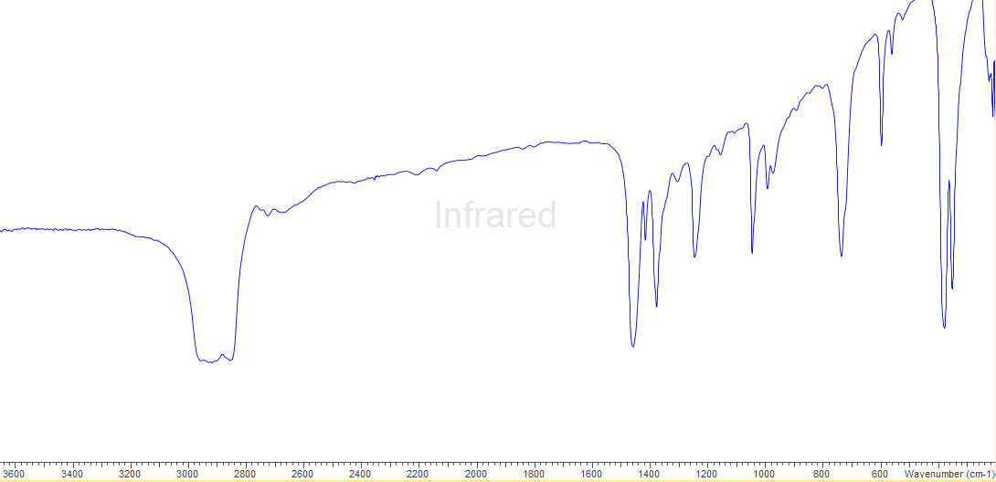
S4.3.0 - [GaCl₃(SbEt₃)]
S4.3.1 - ¹H spectrum (298 K, CD2Cl₂)
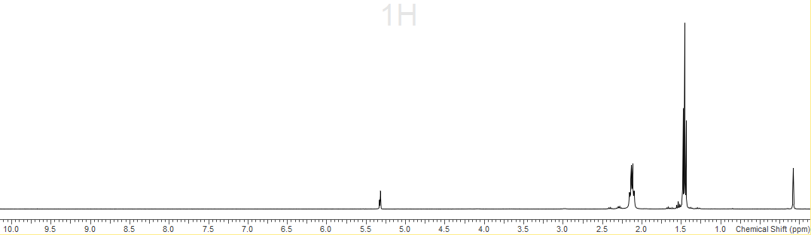
CD2Cl₂
S4.3.2 - ¹³C{¹H} spectrum (298 K, CD2Cl₂)
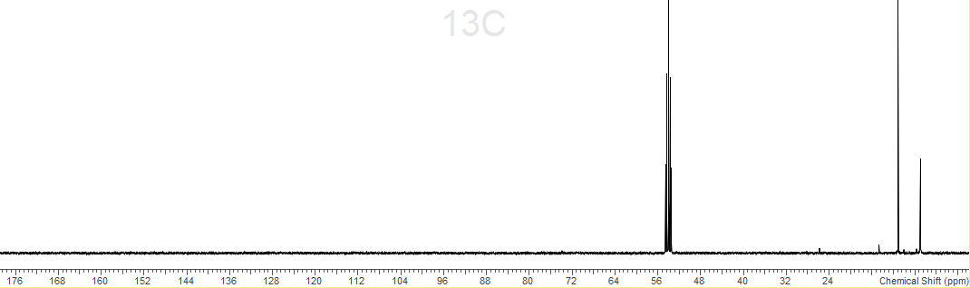
CD2Cl₂
S4.3.3 – ⁷¹Ga spectrum (298 K, CD3Cl₂)
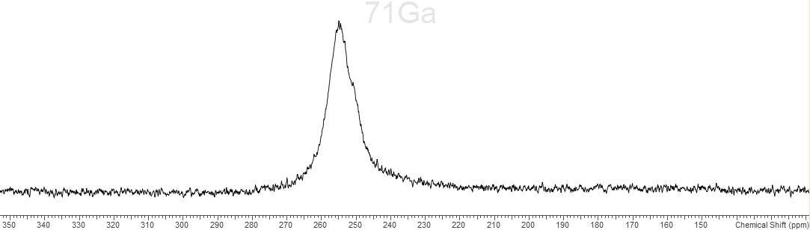
S4.3.4 – IR spectrum (Nujol)
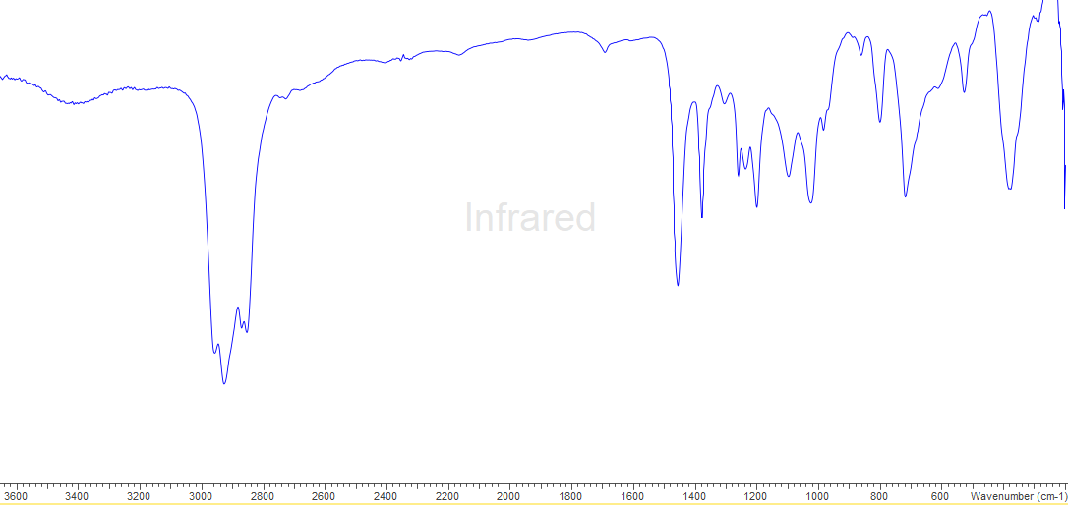
S.44.0 - [GaCl₃(Sb^{n}Bu₃)]
S4.4.1 - ¹H spectrum (298 K, CD2Cl₂)
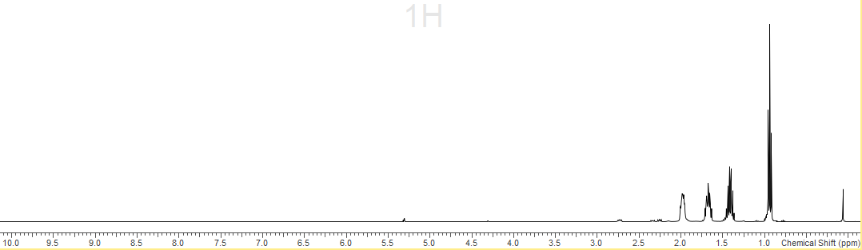
S4.4.2 - ¹³C{¹H} spectrum (298 K, CD2Cl₂)
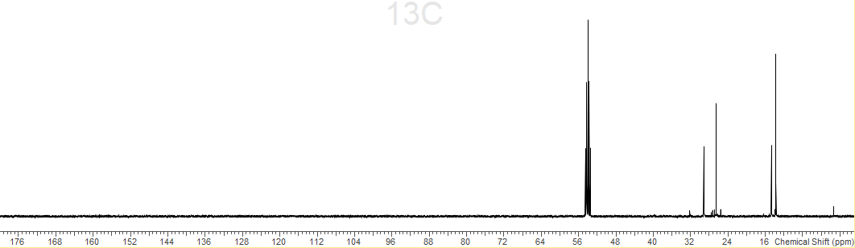
CD2Cl₂
S4.4.3 – ⁷¹Ga spectrum (298 K, CD2Cl₂)
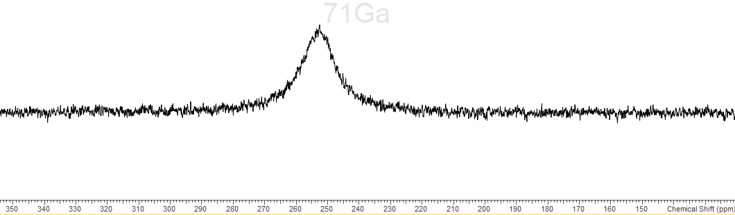
S4.5.0 - [InCl₃(PEt₃)₂]
S4.5.1 - ¹H spectrum (298 K, CD2Cl₂)
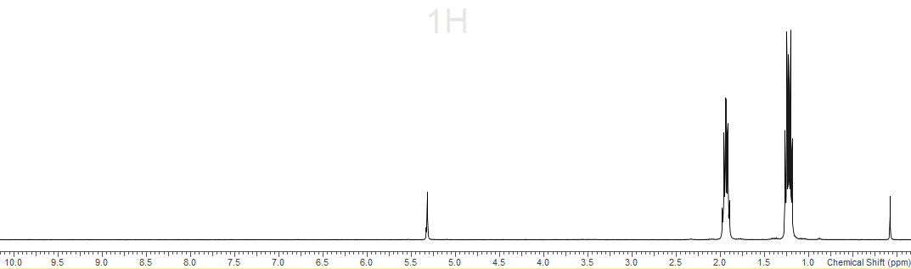
CD2Cl₂
S4.5.2 - ¹³C{¹H} spectrum (298 K, CD2Cl₂)
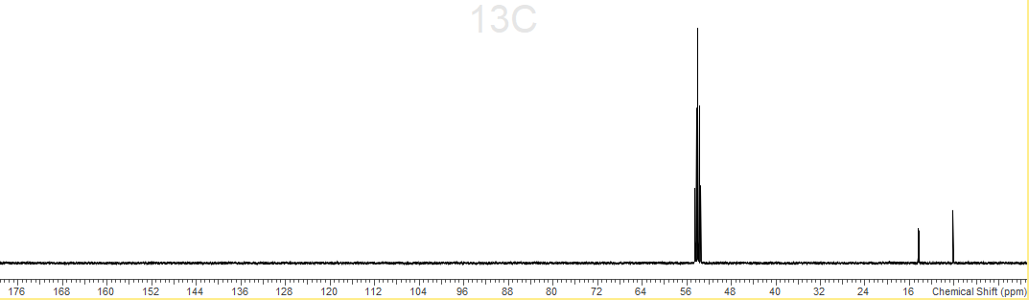
CD2Cl₂
S4.5.3 – ³¹P{¹H} spectrum (298 K, CD2Cl₂)
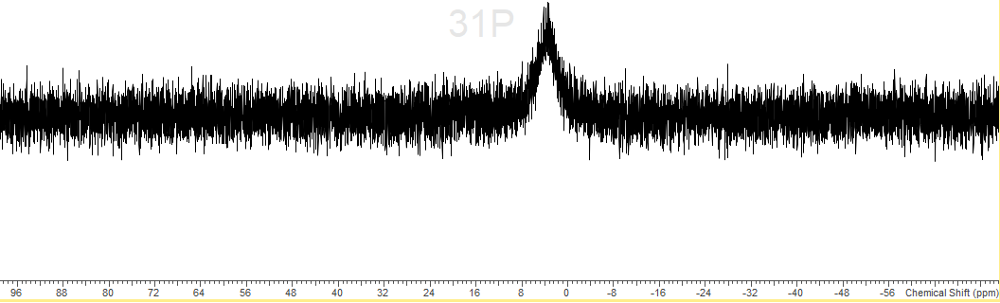
S4.5.4 – IR spectrum (nujol)
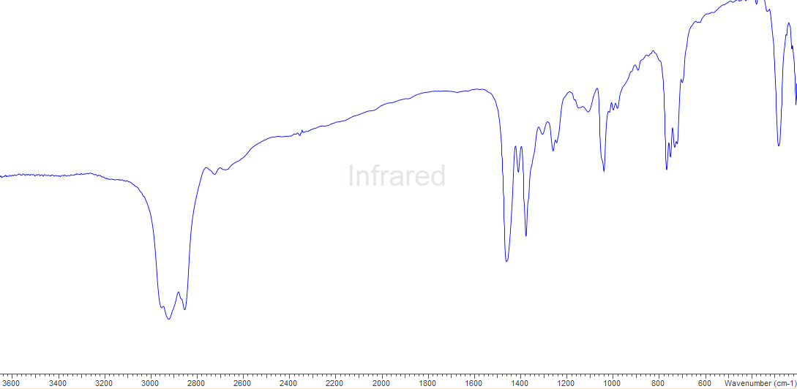
S4.6.0 - [InCl₃(AsEt₃)]
S4.6.1 - ¹H spectrum (298 K, CD2Cl₂)
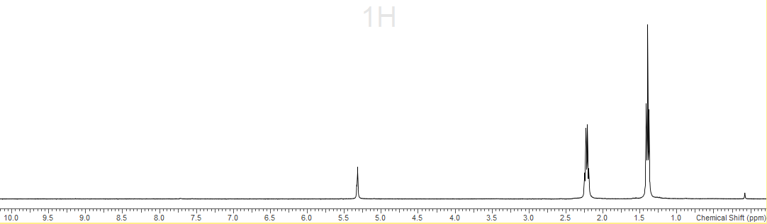
CD2Cl₂
S4.6.2 - ¹³C{¹H} spectrum (298 K, CD3CN)
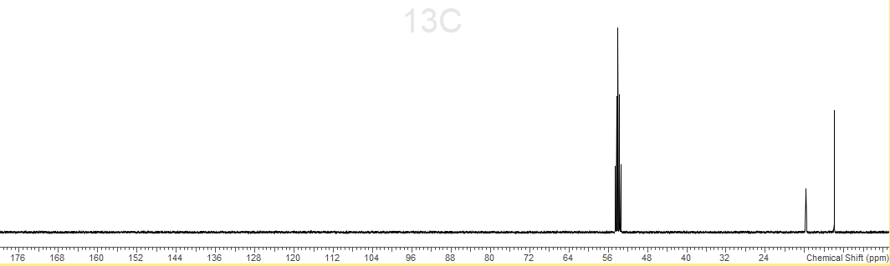
CD2Cl₂
S4.6.5 – IR spectrum (nujol)
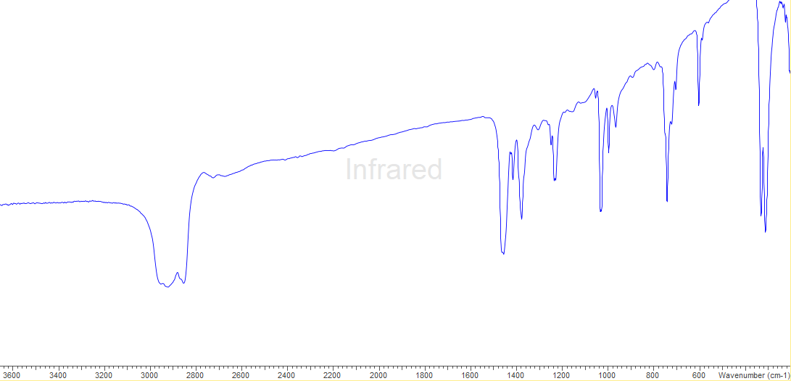
S4.7.0 - [InCl₃(AsEt₃)₂]
S4.7.1 - ¹H spectrum (298 K, CD2Cl₂)
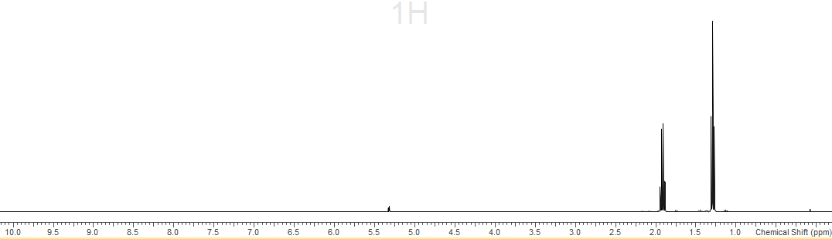
S4.7.2 - ¹³C{¹H} spectrum (298 K, CD3CN)
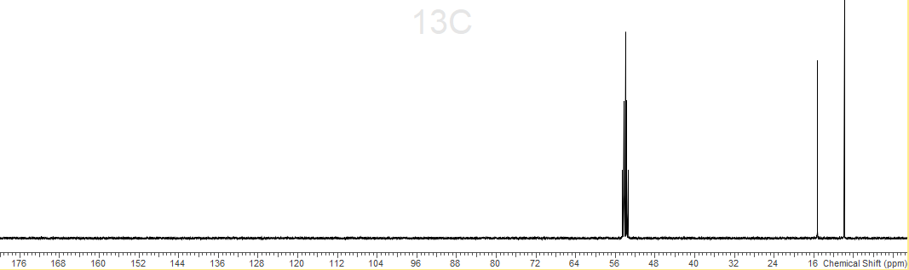
CD2Cl₂
S4.7.3 – IR spectrum (nujol)
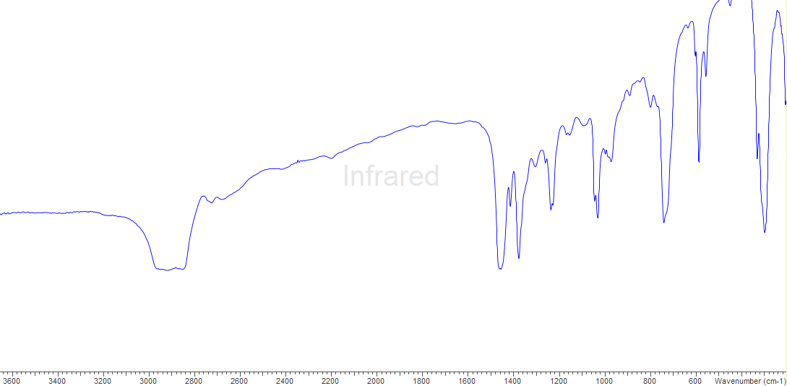
S4.8.0 - [InCl₃(SbEt₃)]
S4.8.1 - ¹H spectrum (298 K, CD2Cl₂)
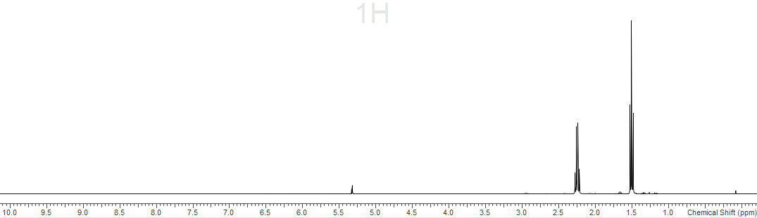
S4.8.2 – IR spectrum (nujol)
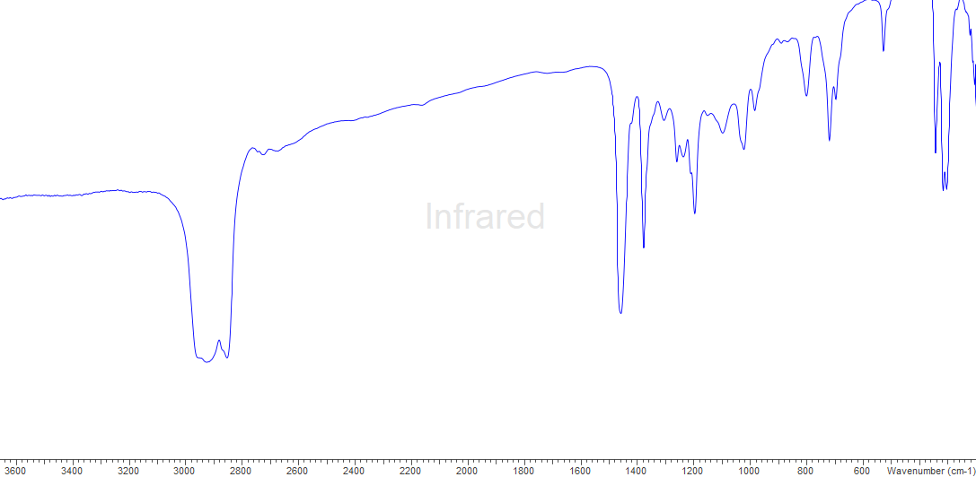
S4.9.0 - [InCl₃(Sb^{n}Bu₃)]
S4.9.1 – ¹H spectrum (298 K, CD₂Cl₂)
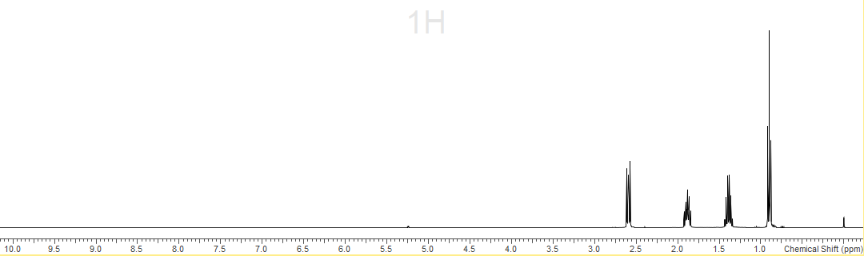
S9.2 - ¹¹⁵In spectrum (298 K, CD₂Cl₂)
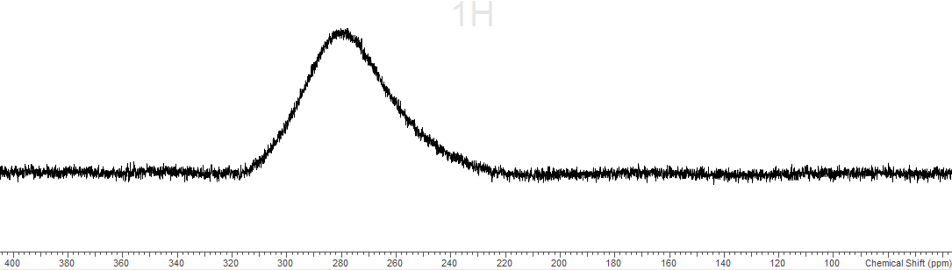
S4.10.0 – PEt₃
S4.10.1 - ¹H spectrum (298 K, C₆D₆)
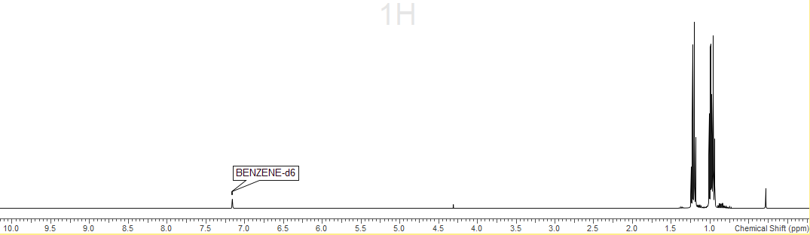
S4.10.2 - ³¹P{¹H} spectrum (298 K, C₆D₆)
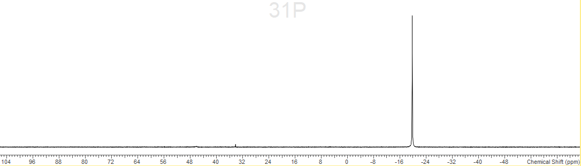
S4.11.0 – SbEt₃
S4.11.1 – ¹H spectrum (298 K, C₆D₆)
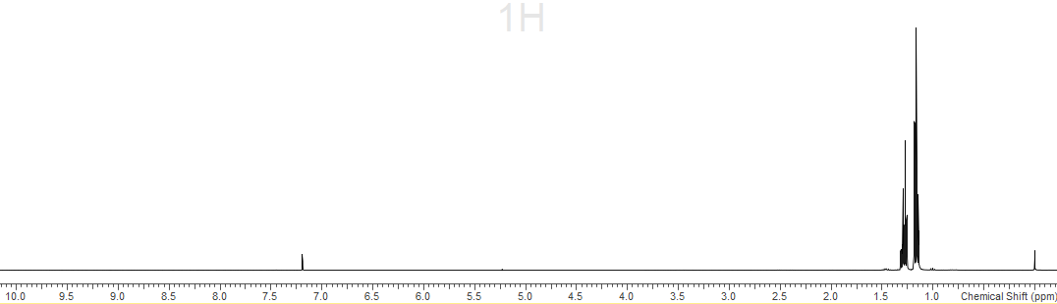
S4.12.0 – Na[BAr^{F}]
S4.12.1 – ¹H spectrum (298 K, CD₃OD)
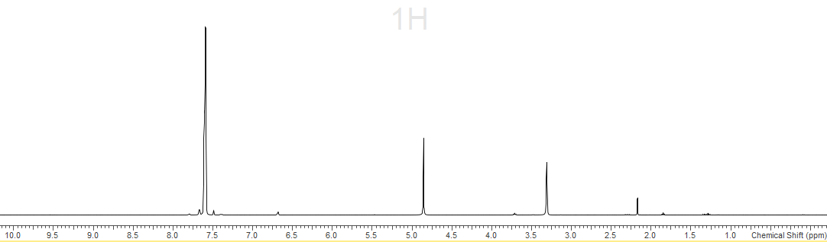
H₂O
CD3OD
S4.12.2 – ¹³C{¹H} spectrum (298 K, CD₃OD)
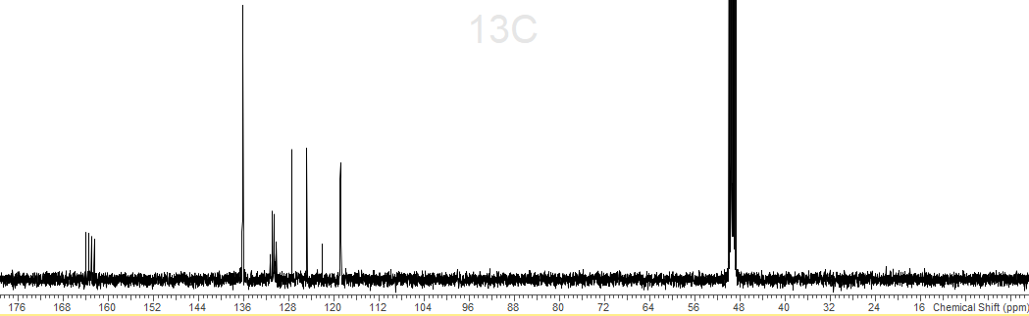
CD3OD
S4.12.3 – ¹⁹F{¹H} spectrum (298 K, CD₃OD)
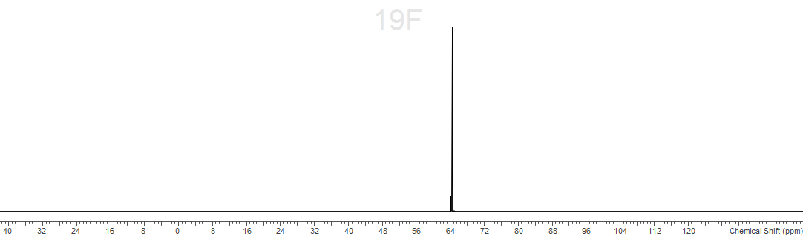

Chapter 5
S5.1.0– Spectroscopic data for [Sn(OTf)2{o-C6H4(PMe2)2}]
S5.2.0 – Spectroscopic data for [Sn(OTf)2{o-C6H4(AsMe2)2}]
S5.3.0 – Spectroscopic data for [Sn(OTf)2{MeC(CH2PPh2)3}]
S5.4.0 – Spectroscopic data for [Sn{MeC(CH2PPh2)3}][BArF]2
S5.5.0 – Spectroscopic data for [Sn(OTf){PhP(CH2CH2PPh2)2}][OTf]
S5.6.0 – Spectroscopic data for [Sn(OTf)2{MeC(CH2AsMe2)3}]
S5.7.0 – Spectroscopic data for [Sn(OTf){P(CH2CH2PPh2)3}][OTf]
S5.8.0 – Spectroscopic data for [Sn(OTf)2{o-C6H4(PPh2)2}]
S5.9.0 – Spectroscopic data for [Pb(OTf)2{o-C6H4(PMe2)2}]
S5.10.0 – Spectroscopic data for [Pb(OTf)2{o-C6H4(AsMe2)2}]
S511.0 – Spectroscopic data for [Pb(OTf)2{MeC(CH2PPh2)3}]
S5.12.0 – Spectroscopic data for [Pb{MeC(CH2PPh2)3}][BArF]2
S5.13.0 – Spectroscopic data for [Pb(OTf)2{MeC(CH2AsMe2)3}]
S5.14.0 – Spectroscopic data for [Pb(OTf){P(CH2CH2PPh2)3}][OTf]
S5.15.0 – Spectroscopic data for [Ge{MeC(CH2PPh2)3}][BArF]2
S5.16.0 – IR spectrum for Sn(OTf)2
S5.17.0 – IR spectrum for Pb(OTf)2
Table S5.2 – Experimental (X-ray) vs. calculated (DFT, B3LYP-D3) metrics for [M{MeC(CH2PPh2)3}]2+ (M = Ge, Sn, Pb)

S5.1.0 – [Sn(OTf)2{o-C6H4(PMe2)2}]
S5.1.1 – 1HMR spectrum (298 K, CD3CN)

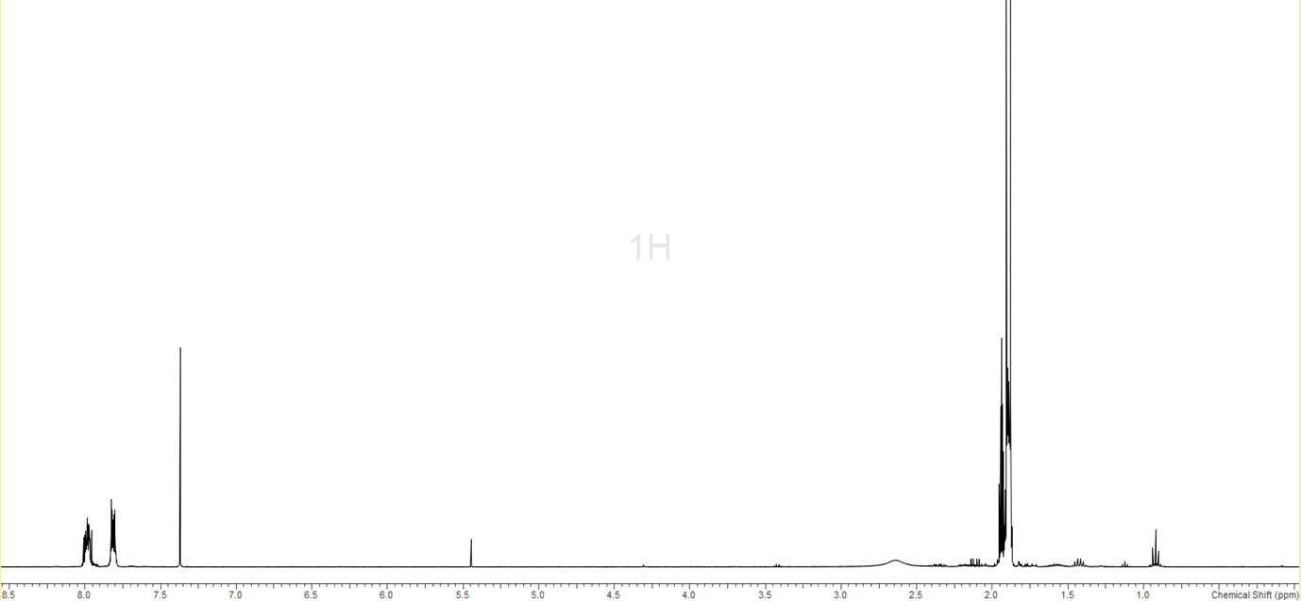
C6H6
CD3CN
Et2O
Et2O
S5.1.2 – 19F{1H} NMR spectrum (298 K, CD3CN)
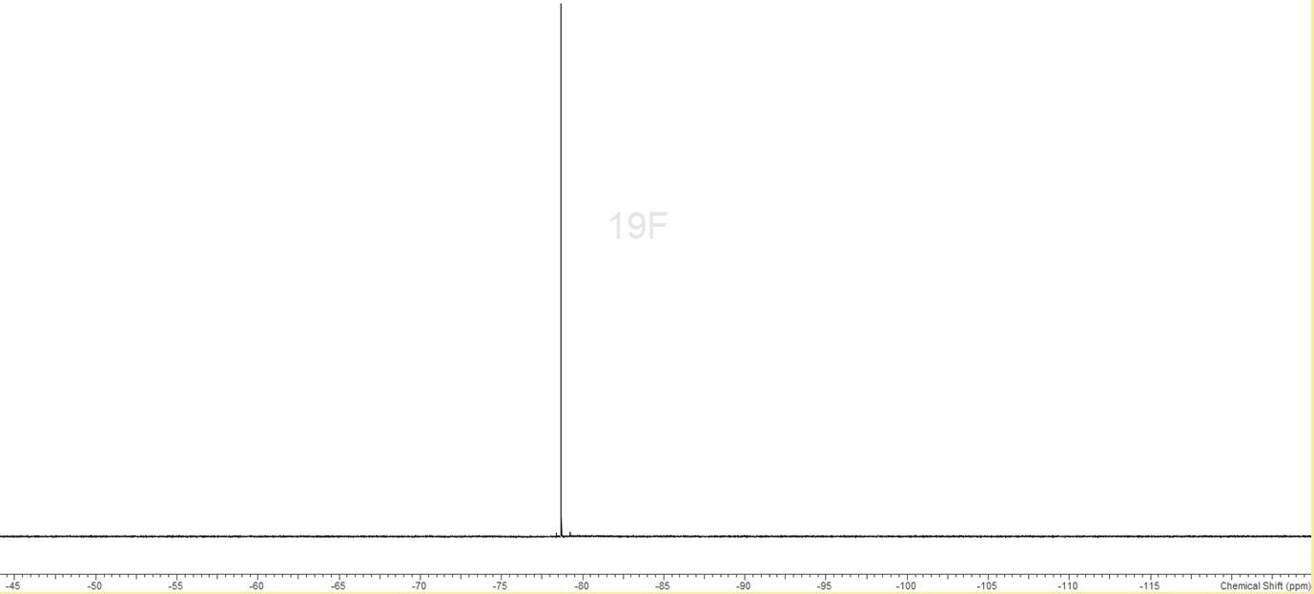
S5.1.3 – 31P{1H} NMR spectrum (298 K, CD3CN) * = unidentified impurity
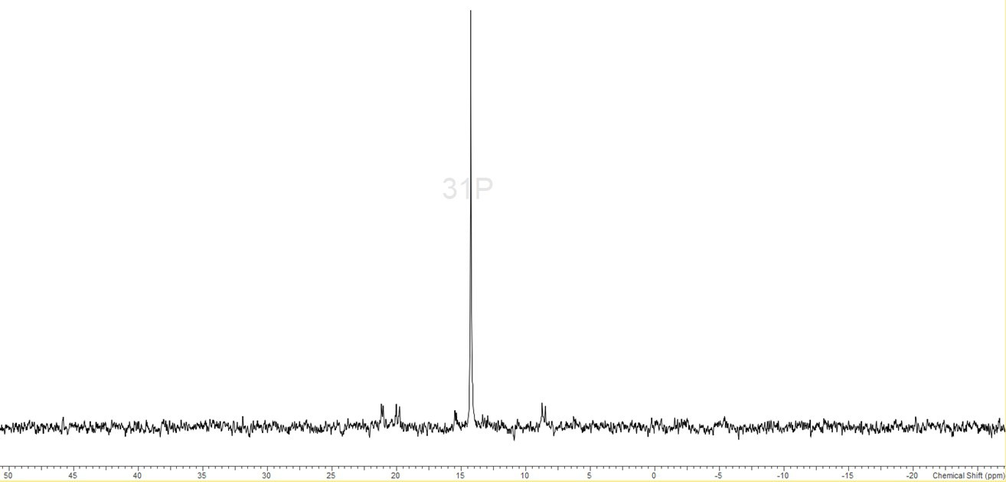
*
*
S5.1.4 – 119Sn NMR spectrum (298 K, CD3CN) * = unidentified impurity
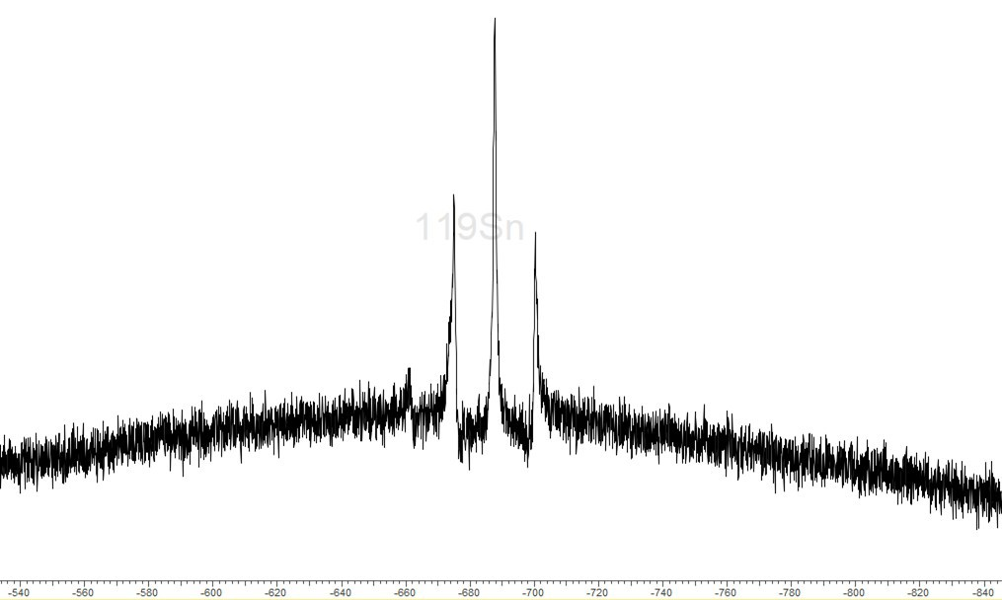
*
S5.1.5 – IR spectrum (Nujol)
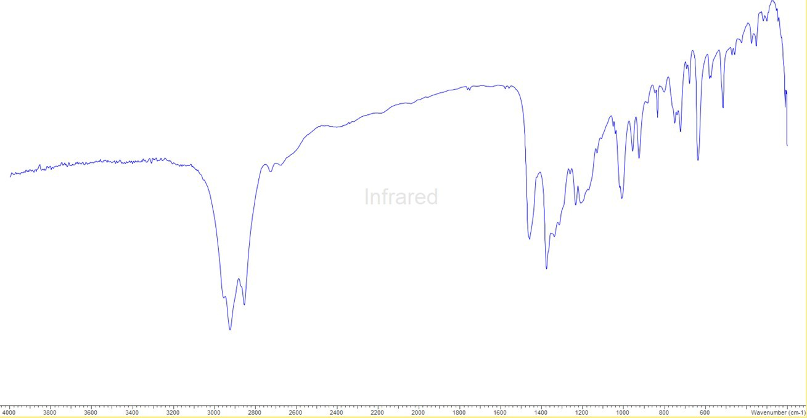

S5.2.0 – [Sn(OTf)2{o-C6H4(AsMe2)2}]
S5.2.1 – 1H NMR spectrum (298 K, CD3CN)
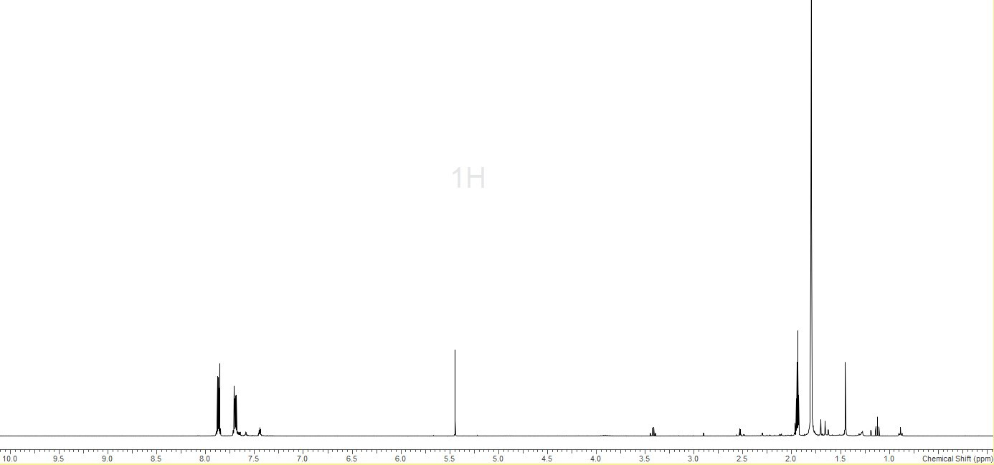
CH2Cl2
CD3CN
Et2O
Et2O
S5.2.2 – 19F{1H} NMR spectrum (298 K, CD3CN)
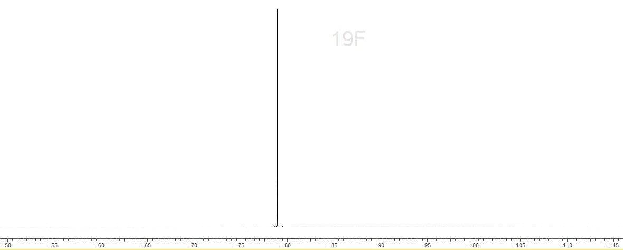
S5.2.3 – 119Sn NMR spectrum (258 K, CD3CN)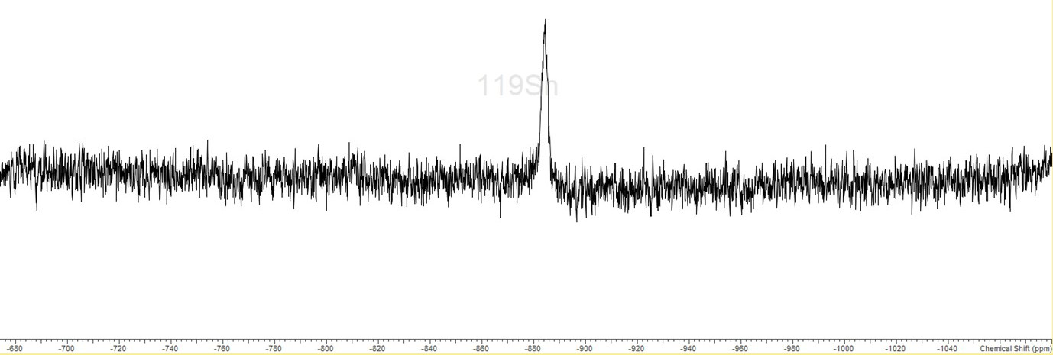
S5.2.4 – IR spectrum (Nujol)
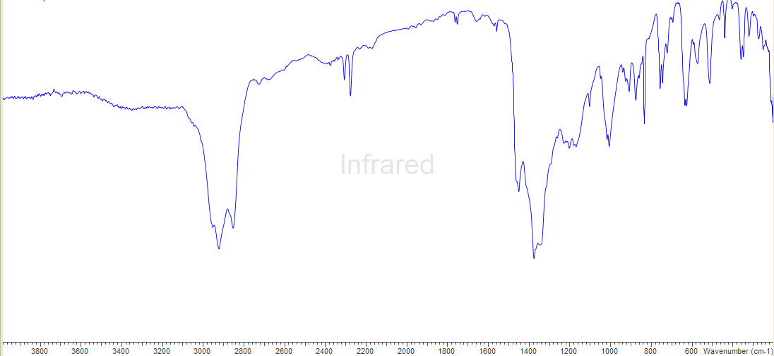
S5.3.0 – [Sn(OTf)2{MeC(CH2PPh2)3}]
S5.3.1 – 1H NMR spectrum (298 K, CD3CN)

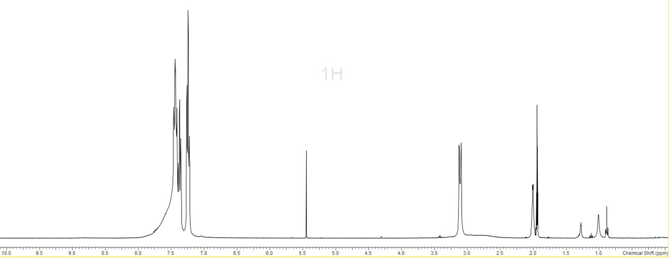
CD3CN
CH2Cl2
n-hexane
S5.3.2 – 19F{1H} NMR spectrum (298 K, CD3CN)
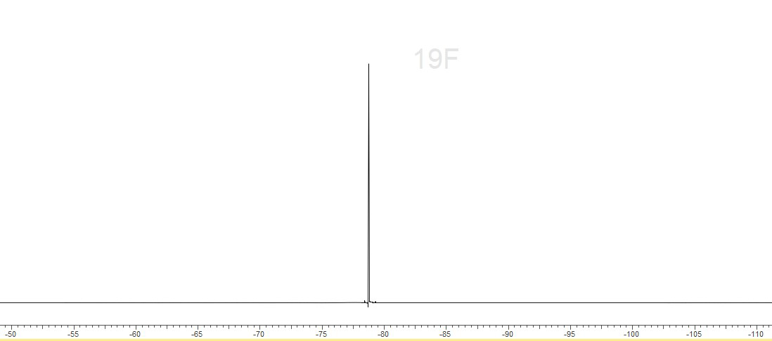
S5.3.3 – 31P{1H} NMR spectrum (298 K, CD3CN) * = unidentified impurity
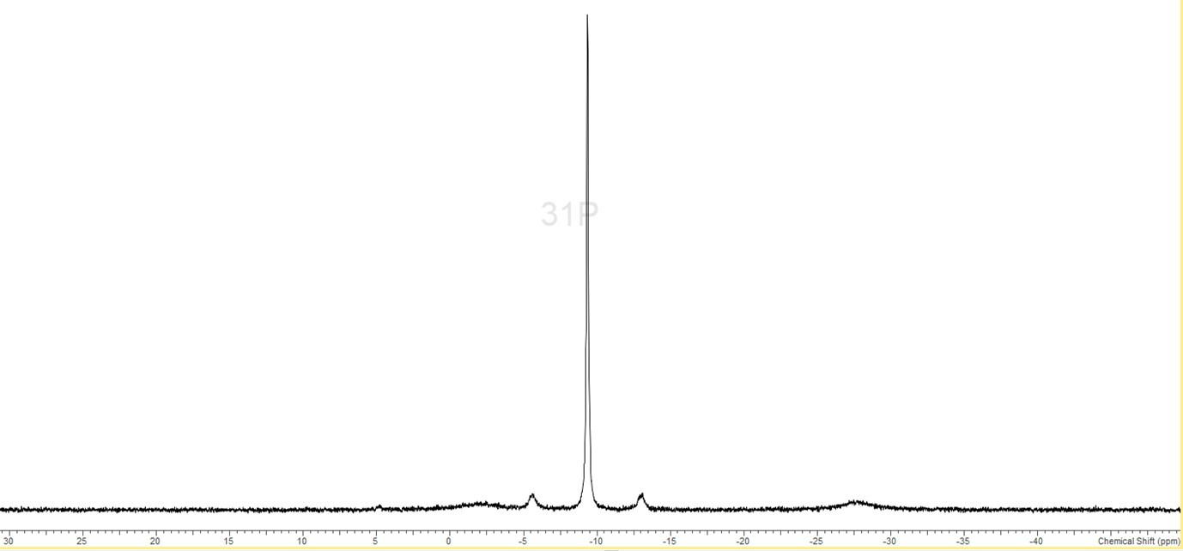S5.3.4 – 119Sn NMR spectrum (298 K, CD3CN)
*

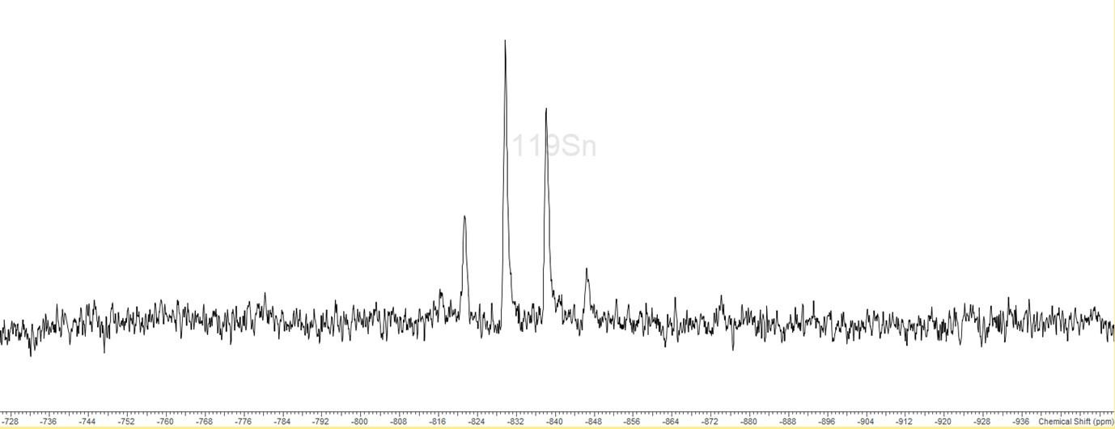
S5.3.5 – IR spectrum (Nujol)
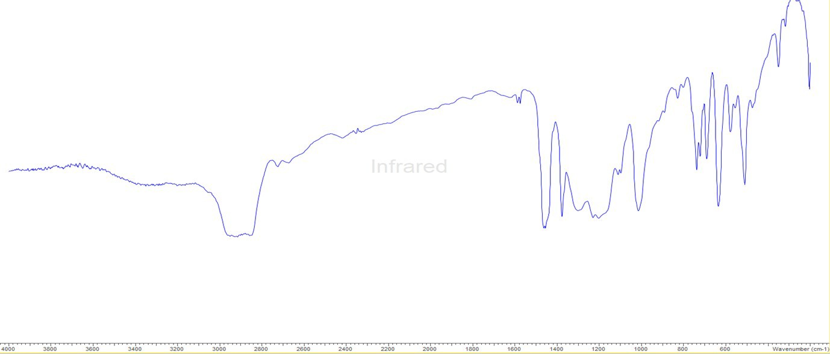
S5.4.0 – [Sn{MeC(CH2PPh2)3}][BArF]₂
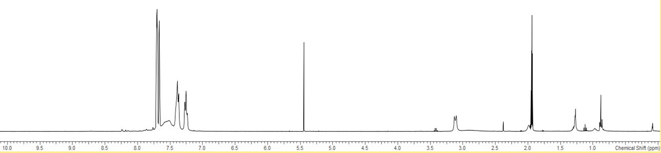
S5.4.1 – ¹H NMR Spectrum (298 K, CD₃CN)
CD₂Cl₂

S5.4.2 – 19F{1H} NMR spectrum (298 K, CD3CN)
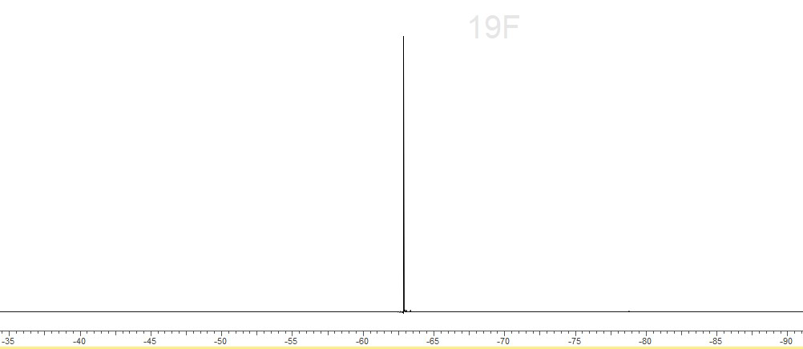
S5.4.3 – 31P{1H} NMR spectrum (298 K, CD3CN)
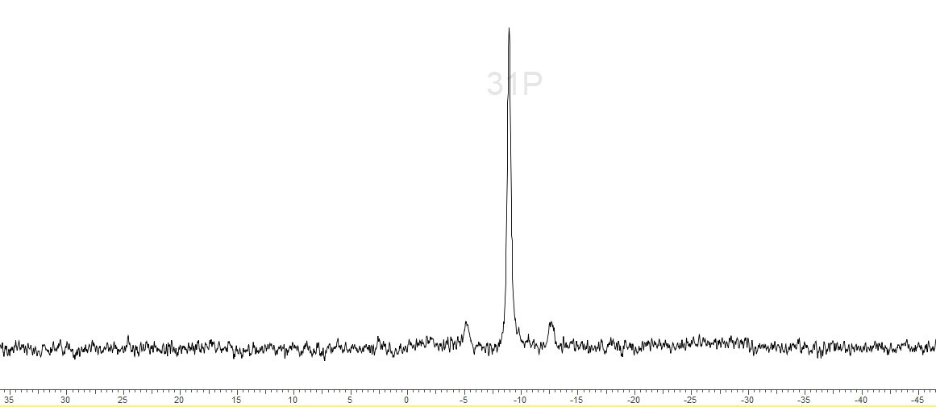
S5.4.4 - 31P{1H} NMR spectrum (258 K, CD3CN) * = unidentified impurity
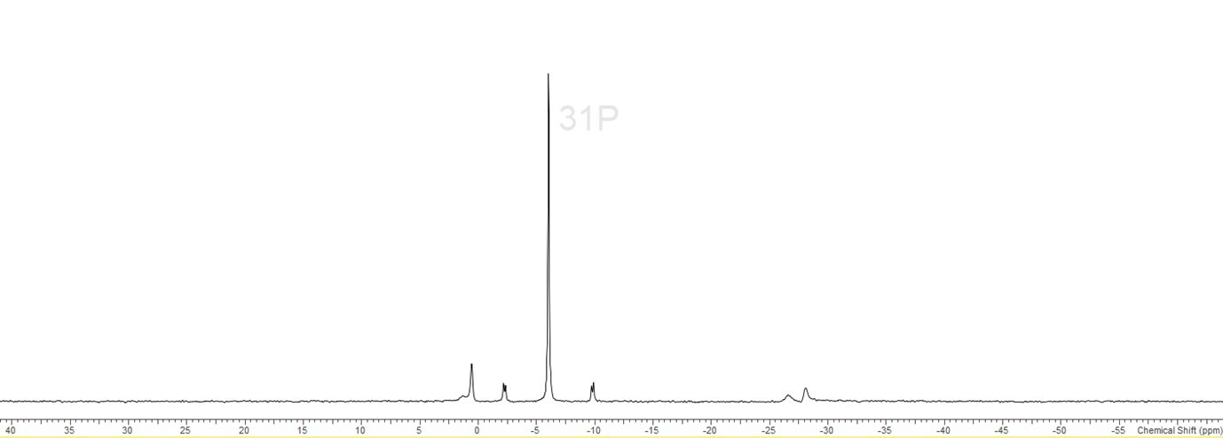
S5.4.5 – 119Sn NMR spectrum (298 K, CD3CN)
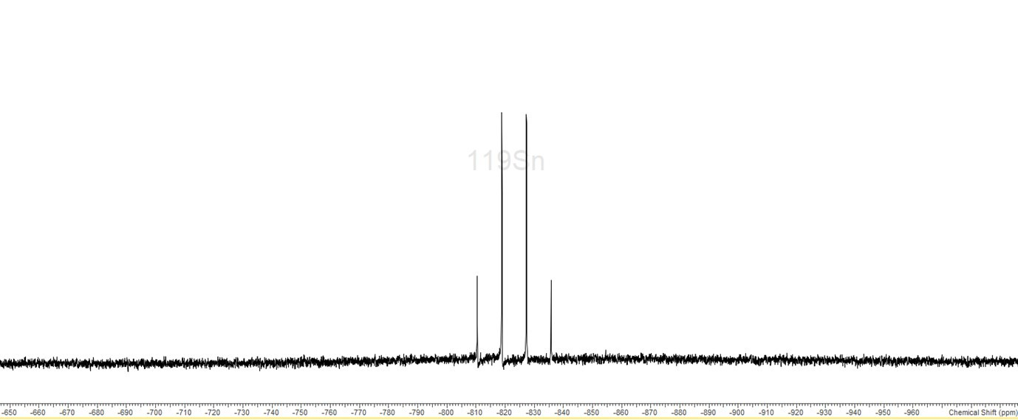
S5.4.6 - 119Sn NMR spectrum (258 K, CD3CN)
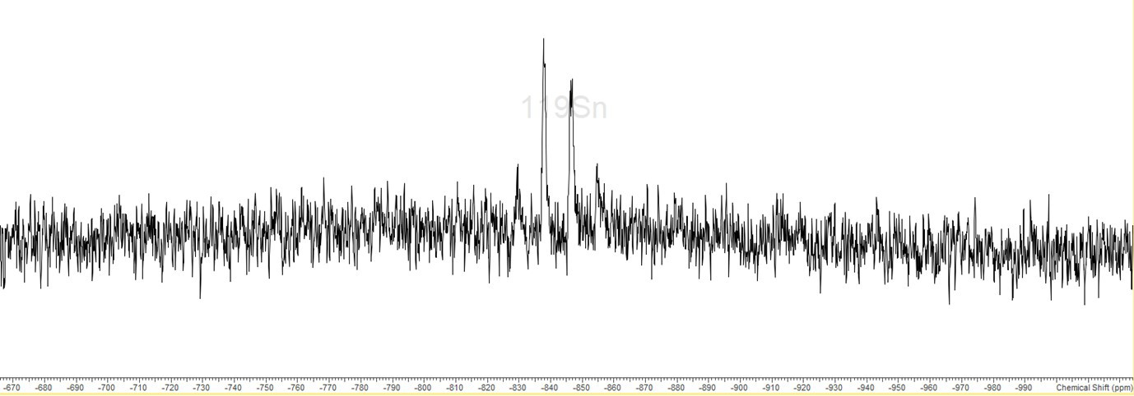
S5.4.7 – IR spectrum (Nujol)
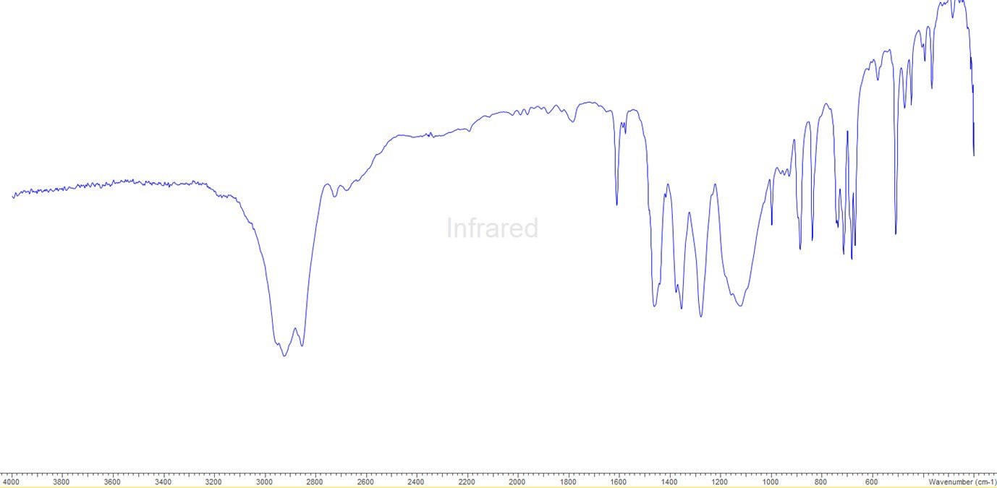
S5.5.0 – [Sn(OTf){PhP(CH2CH2PPh2)2}][OTf]
S5.5.1 – 1H NMR spectrum (298 K, CD3CN)
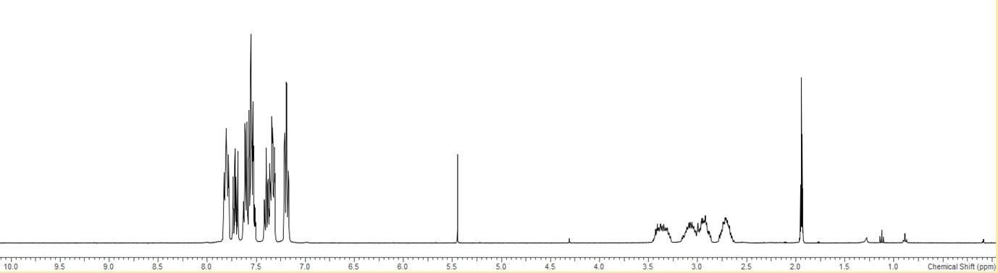
CD3CN
CH2Cl2
S5.5.2 – 19F{1H} NMR spectrum (298 K, CD3CN)
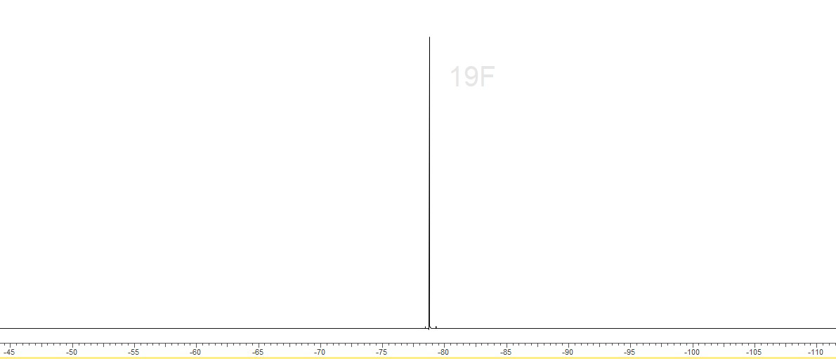
S5.5.3 – 31P{1H} NMR spectrum (298 K, CD3CN)
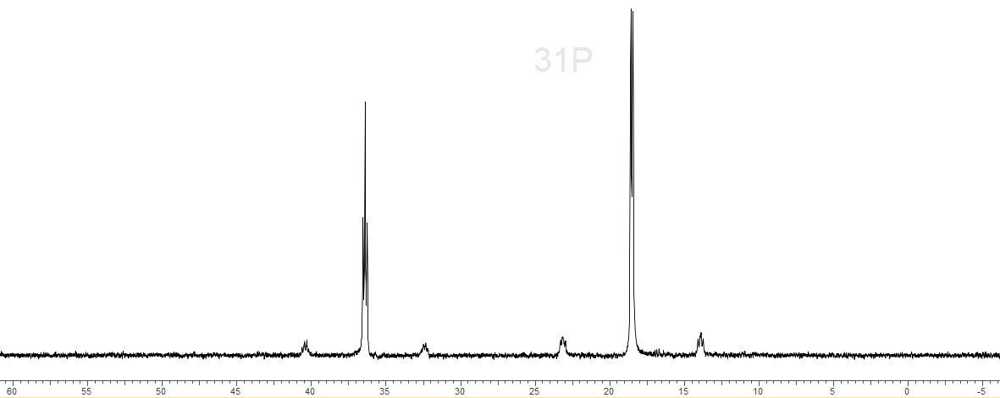
S5.5.4 – 119Sn NMR spectrum (298 K, CD3CN)
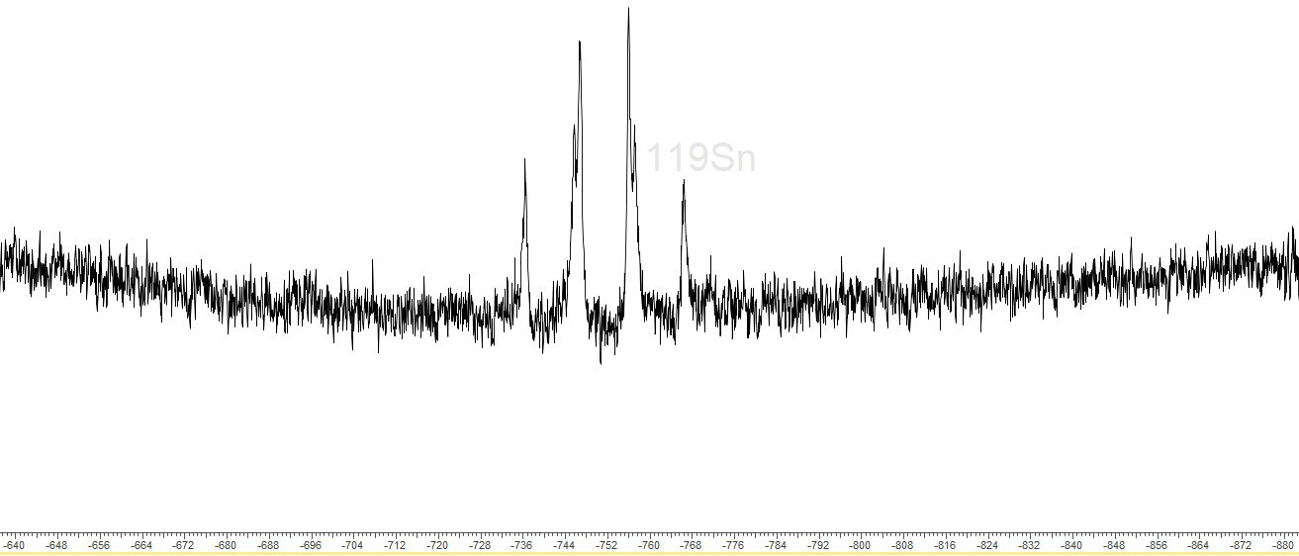
S5.5.5 – IR spectrum (Nujol)
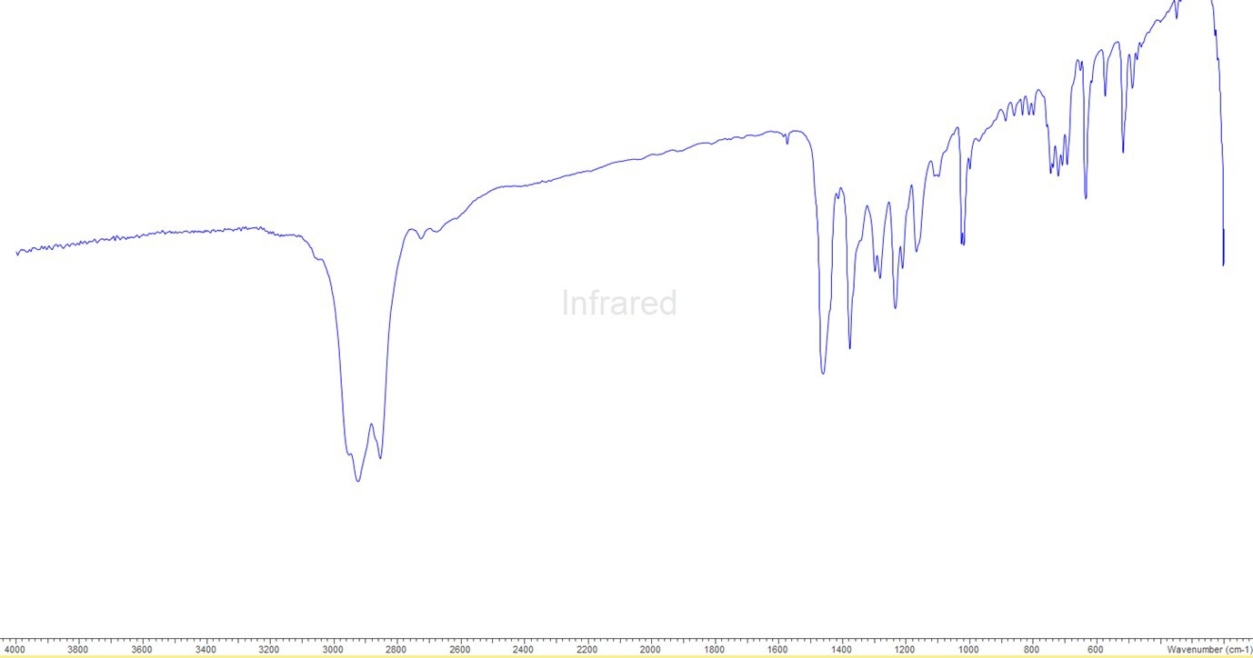
S5.6.0 – [Sn(OTf)2{MeC(CH2AsMe2)3}]
S5.6.1 – 1H NMR spectrum (298 K, CD3CN)
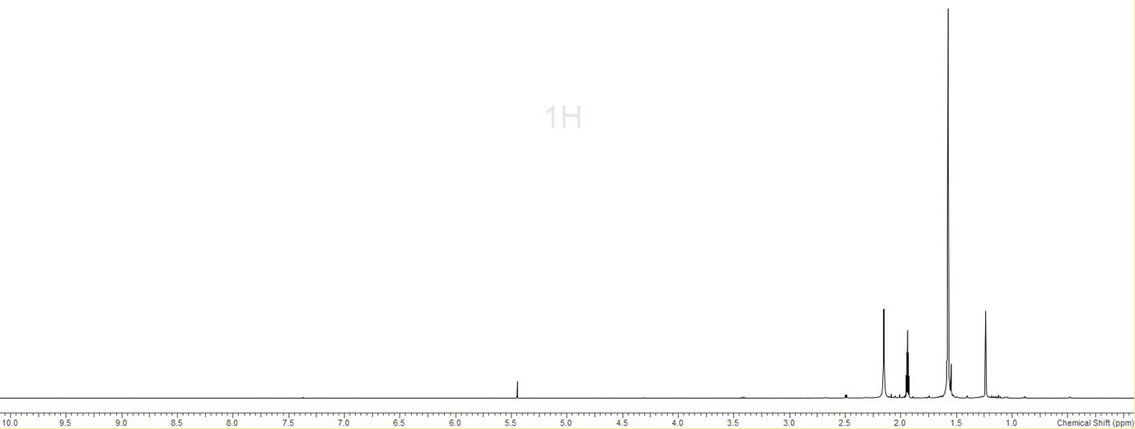
CD3CN
CH2Cl2
S5.6.2 – 19F{1H} NMR spectrum (298 K, CD3CN)
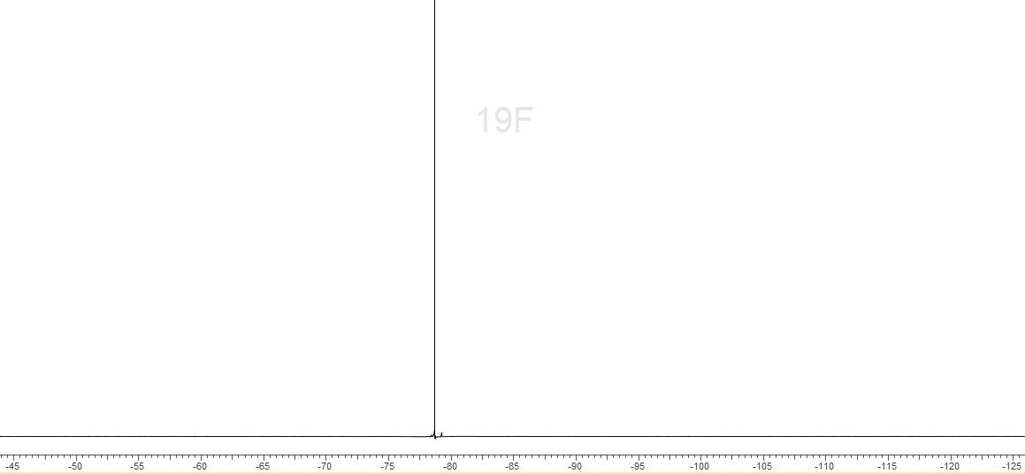S5.6.3 – 119Sn NMR spectrum (258 K, CD3CN)
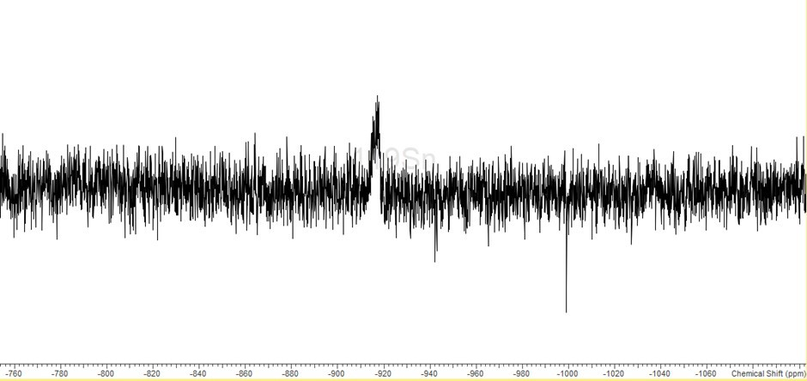
S5.6.4 – IR spectrum (Nujol)
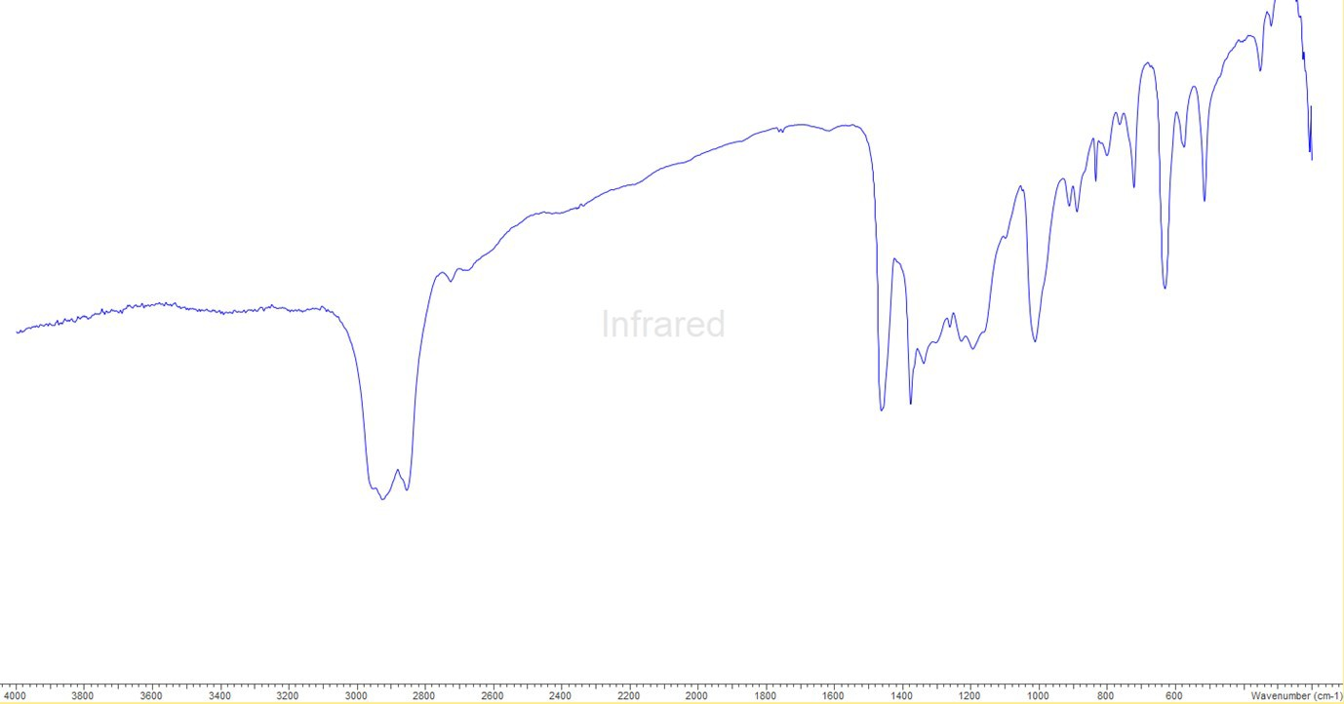
.7.0 - [Sn(OTf){P(CH2CH2PPh2)3}][OTf]
S5.7.1 – 1H NMR spectrum (298 K, CD3CN)
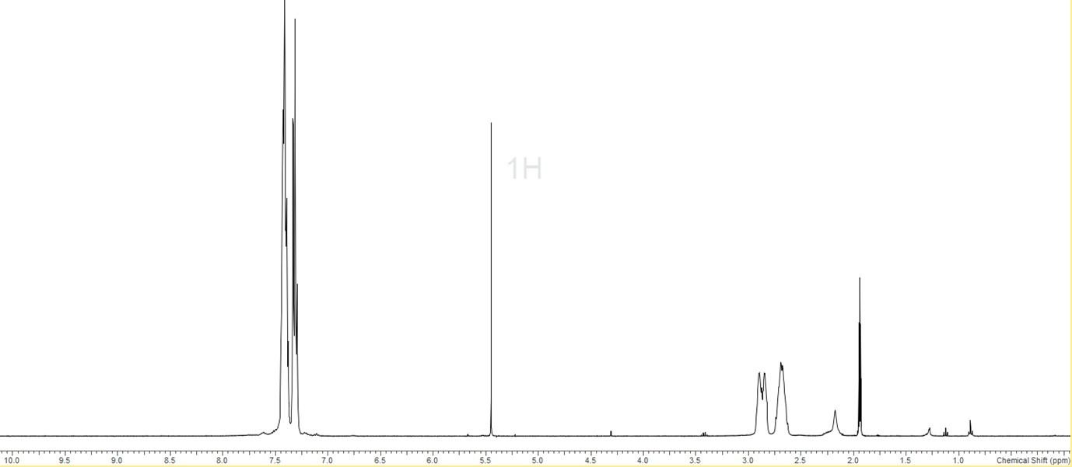
CH2Cl2
CD3CN
S5.7.2 – 19F{1H} NMR spectrum (298 K, CD3CN)
S5.7.3 – 31P{1H} NMR spectrum (298 K, CD3CN) * = minor hydrolysis product
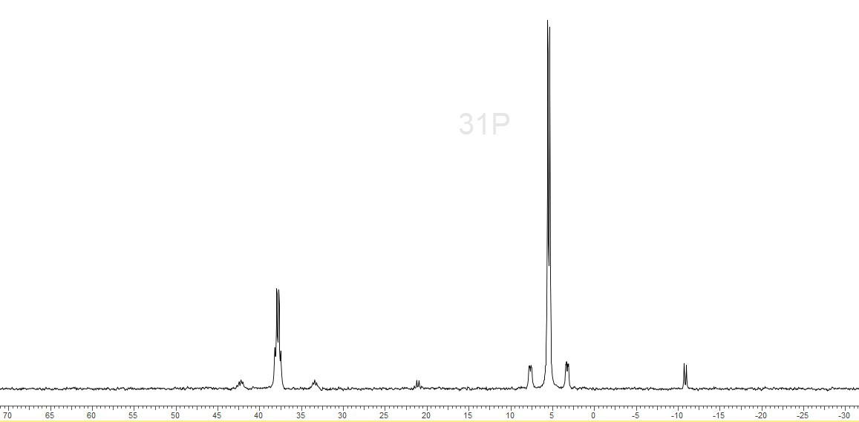
*
*
S5.7.4 – 31P{1H} NMR spectrum (258 K, CD3CN)
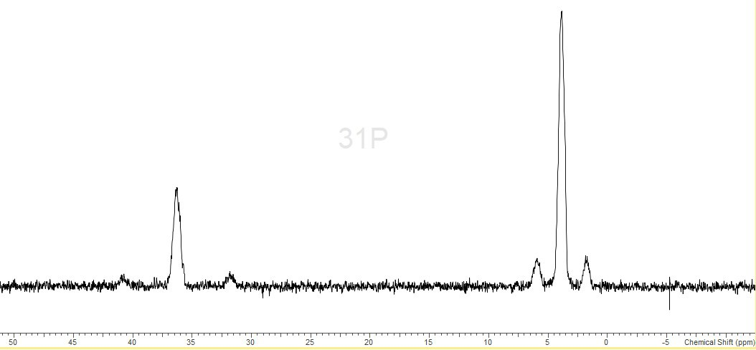
S5.7.5 – 31P{1H} NMR spectrum (298 K, CD2Cl2)
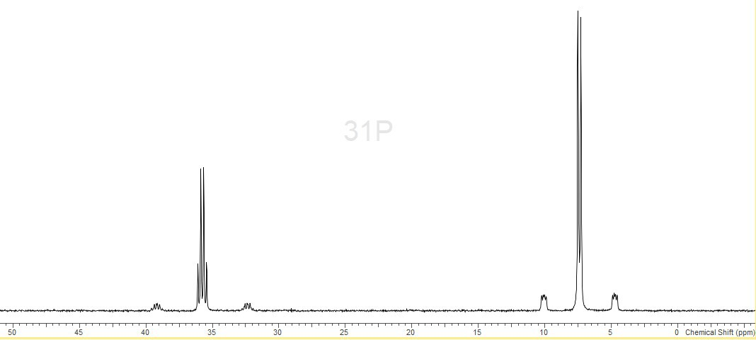
S5.7.6 – 31P{1H} NMR spectrum (208 K, CD2Cl2) * = minor hydrolysis product
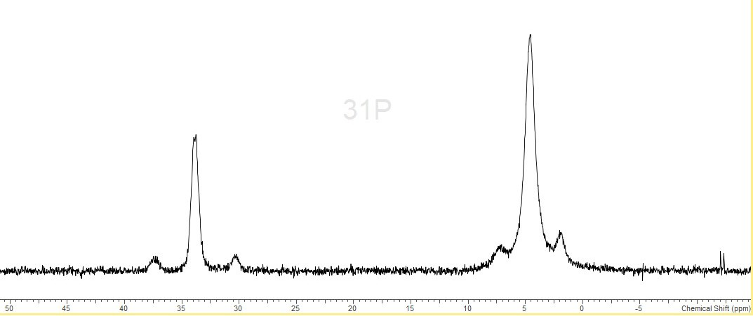S5.7.7 – 119Sn NMR spectrum (298 K, CD3CN)
*
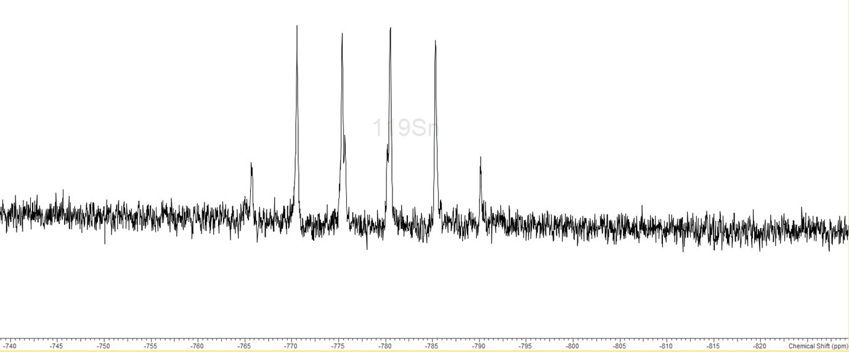
S5.7.8 – 119Sn NMR spectrum (258 K, CD3CN)
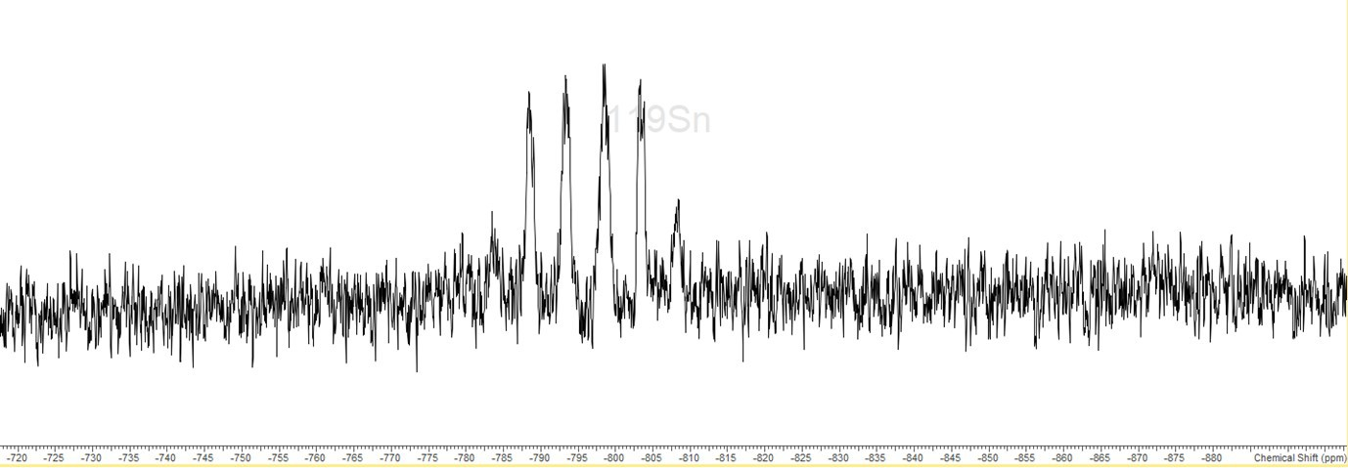
S5.7.9 – IR spectrum (Nujol)
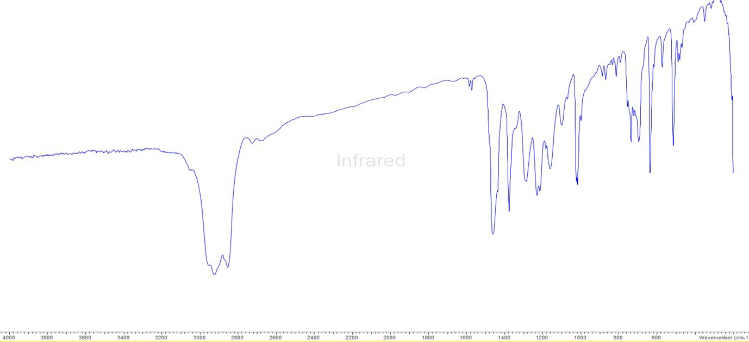
S5.8.0 – [Sn(OTf)2{o-C6H4(PPh2)2}]
S5.8.1 – 1H NMR spectrum (298 K, CD3CN)
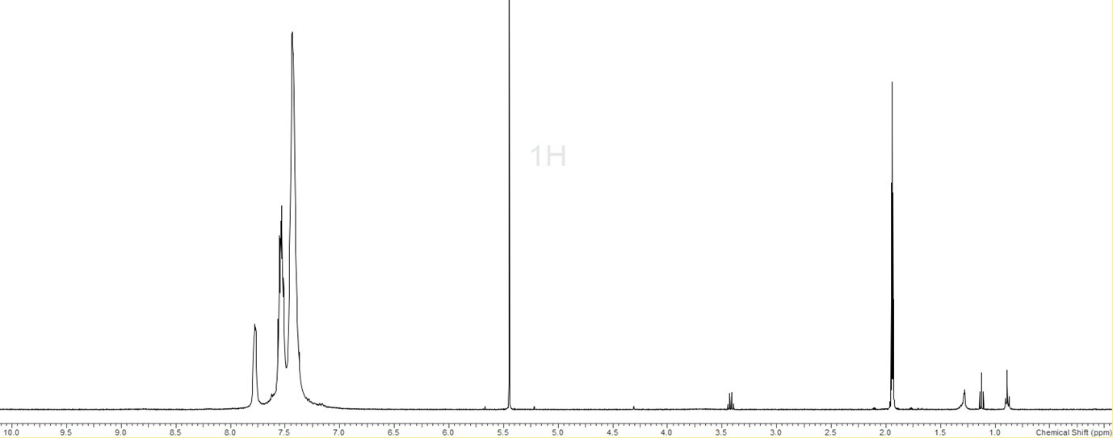
CD₂Cl₂
CD3CN
Et2O
Et2O
S5.8.2 – 19F{1H} NMR spectrum (298 K, CD3CN)
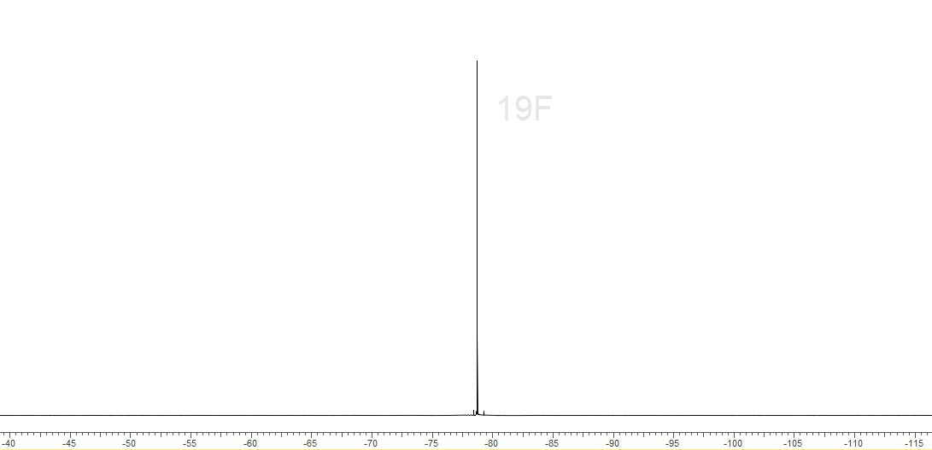
S5.8.3 – 31P{1H} NMR spectrum (298 K, CD3CN)
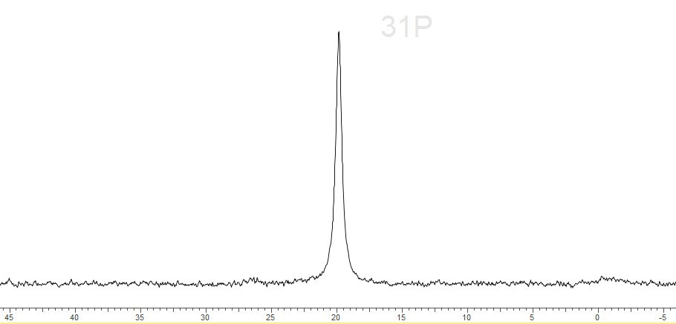
S5.8.4 31P{1H} NMR spectrum (258 K, CD3CN) * = o-C6H4(PPh2H)(PPh2)]+ hydrolysis product
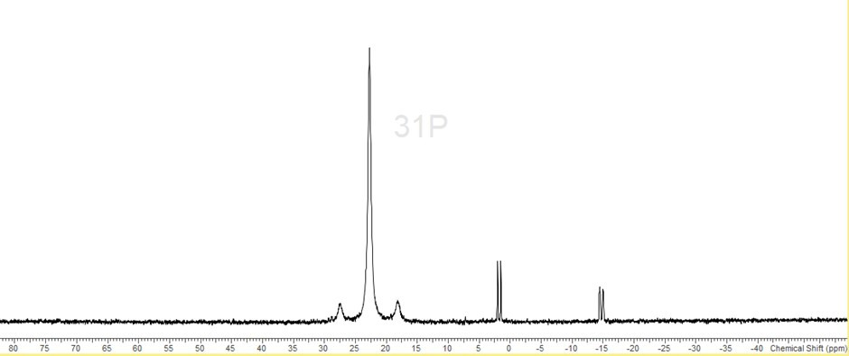
S5.8.5 – 119Sn NMR spectrum (298 K, CD3CN)
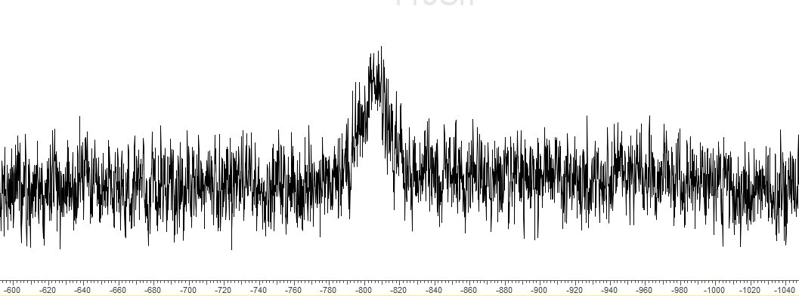S5.8.6 – 119Sn NMR spectrum (258 K, CD3CN) (poorly soluble)
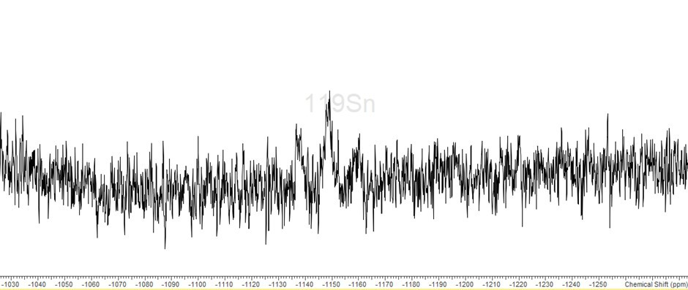
S5.8.7 – IR spectrum (Nujol)
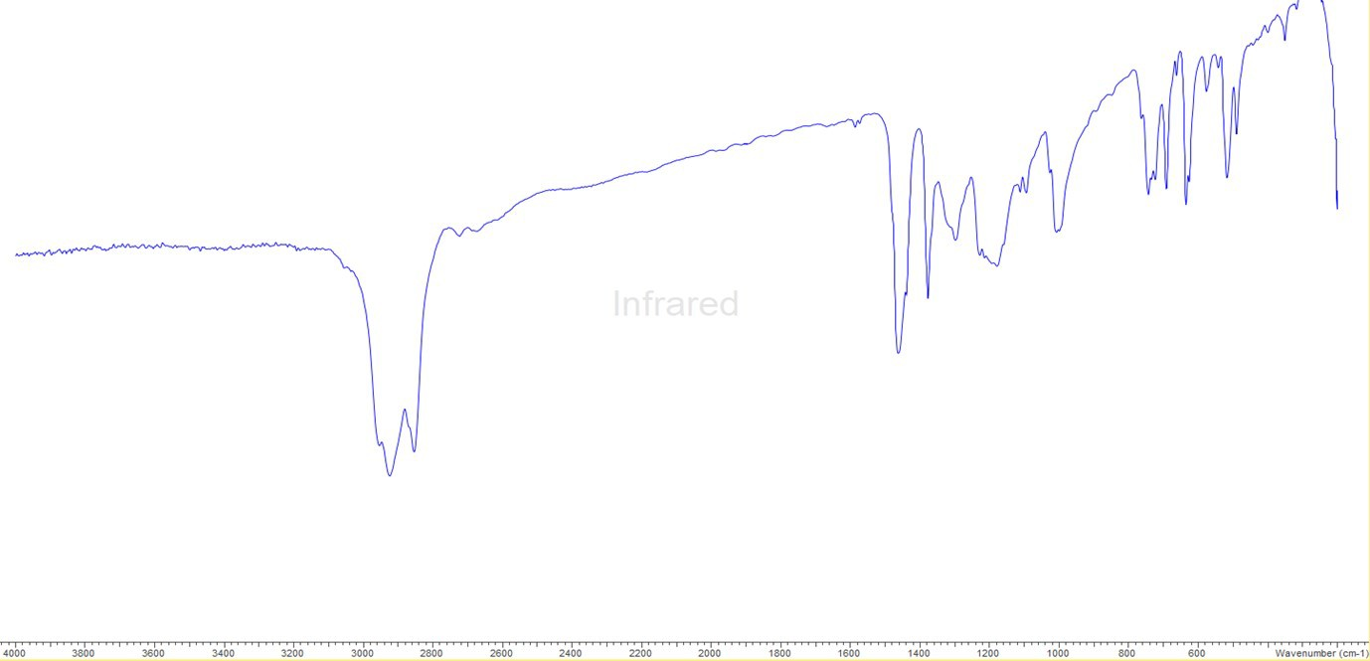
S5.9.0 – [Pb(OTf)2{o-C6H4(PMe2)2}]
S5.9.1 – 1H NMR spectrum (298 K, CD3CN)
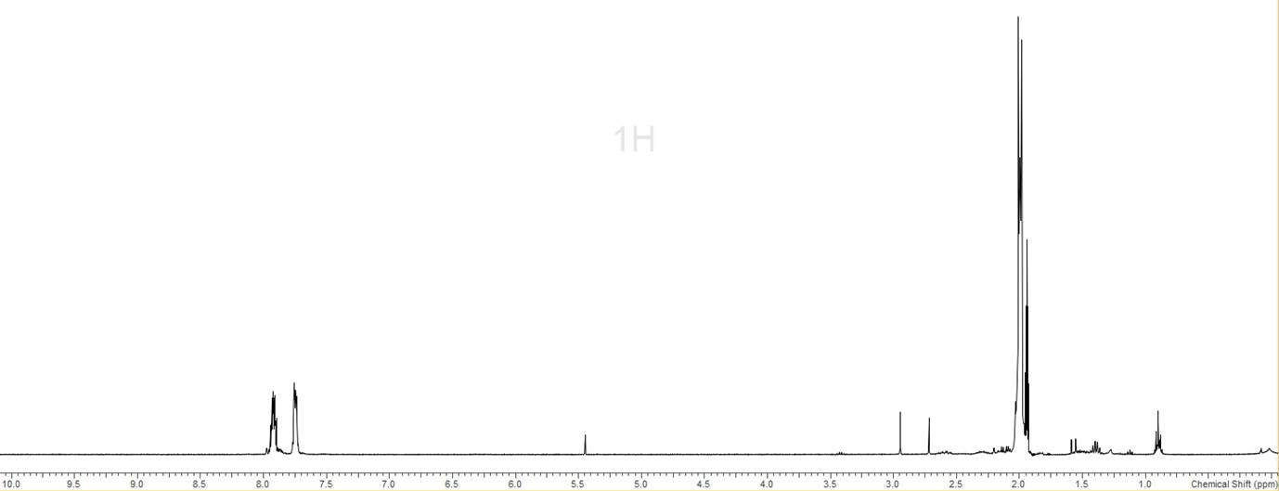
CD3CN
CH2Cl2

S5.9.2 – 19F{1H} NMR spectrum (298 K, CD3CN)
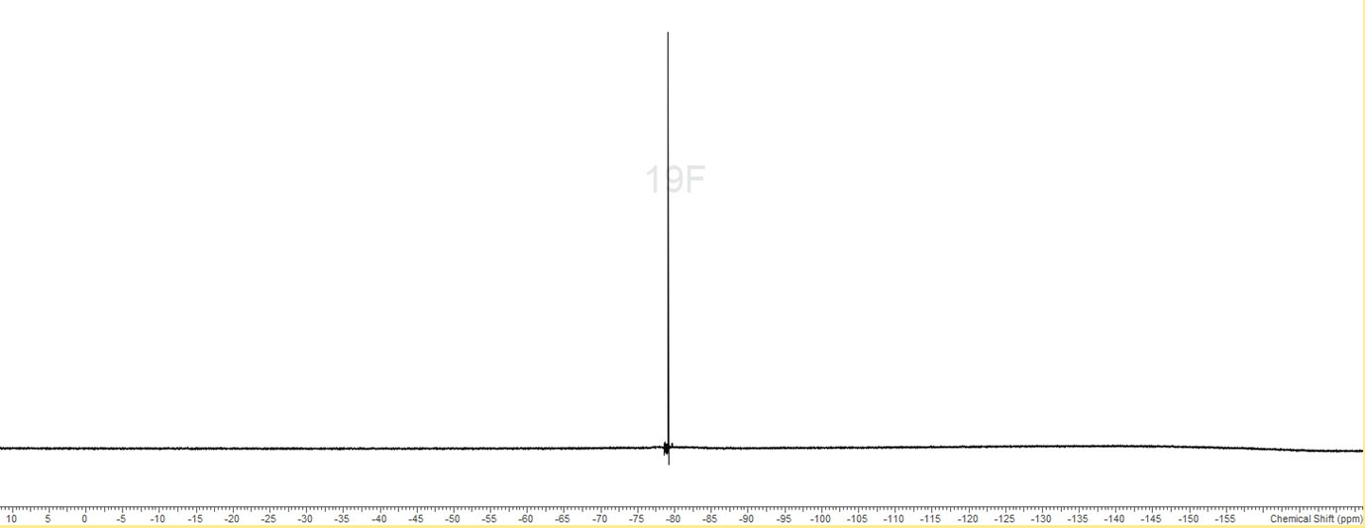
S5.9.3 – 31P{1H} NMR spectrum (298 K, CD3CN)
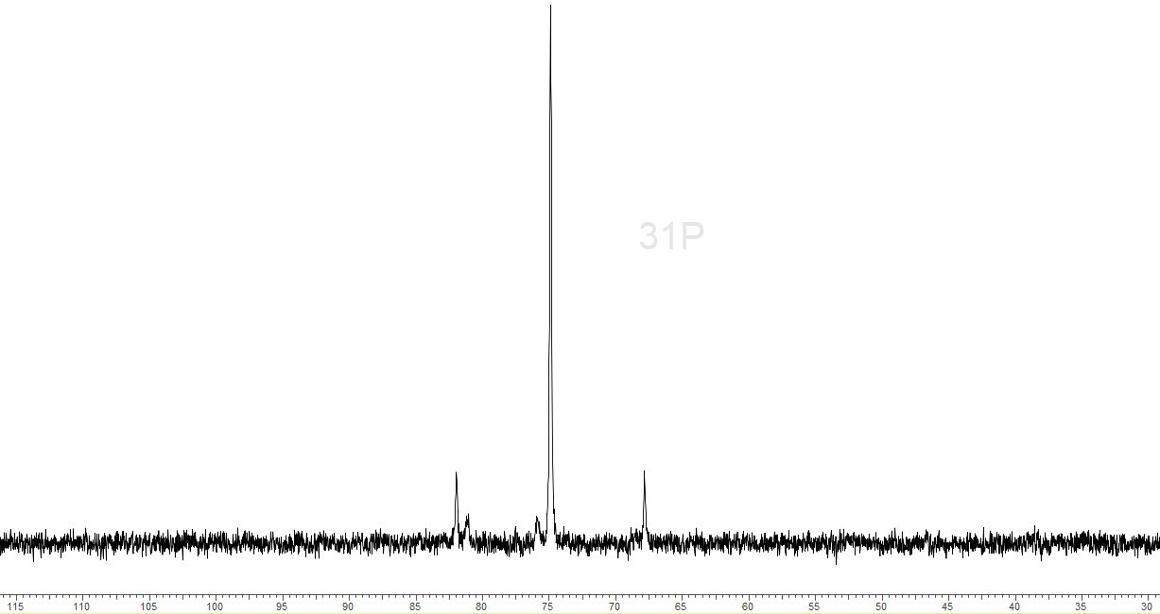
S5.10.0 – [Pb(OTf)2{o-C6H4(AsMe2)2}]
S5.10.1 – 1H NMR spectrum (298 K, CD3CN)
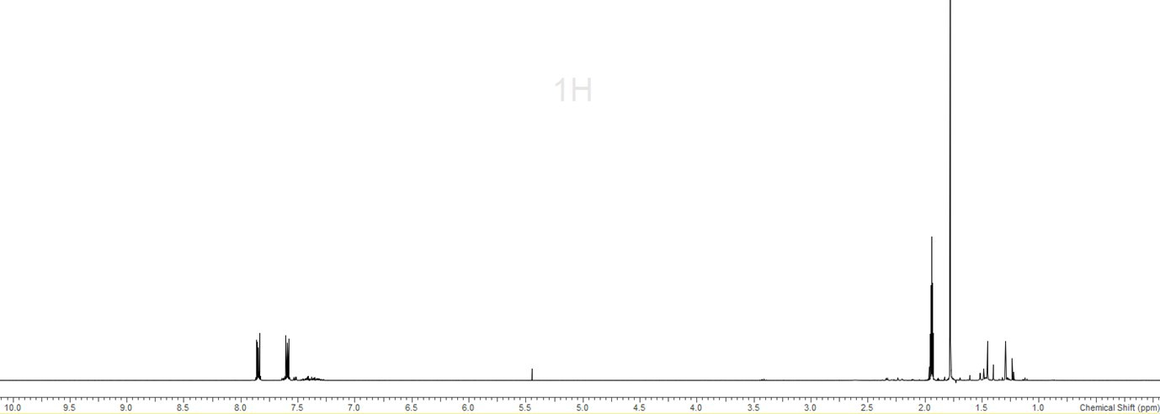
CD3CN
S5.10.2 – 19F{1H} NMR spectrum (298 K, CD3CN)
S5.10.3 – IR spectrum (Nujol)
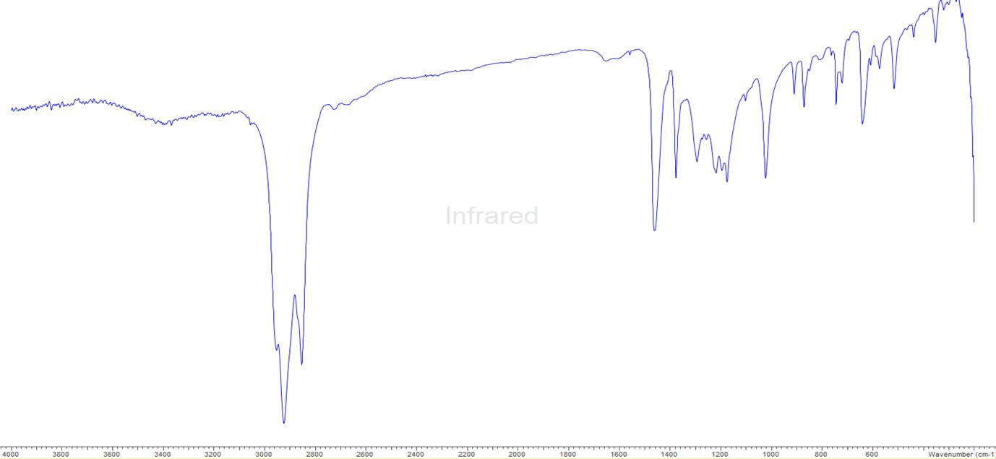

S5.11.0 – [Pb(OTf)2{MeC(CH2PPh2)3}]
S5.11.1 – 1H NMR spectrum (298 K, CD3CN)
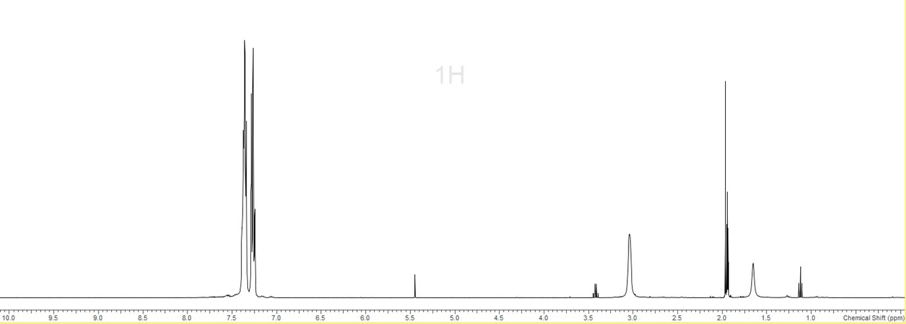
CD3CN
CH2Cl2
Et O
Et2O
2
S5.11.2 – 19F{1H} NMR spectrum (298 K, CD3CN)
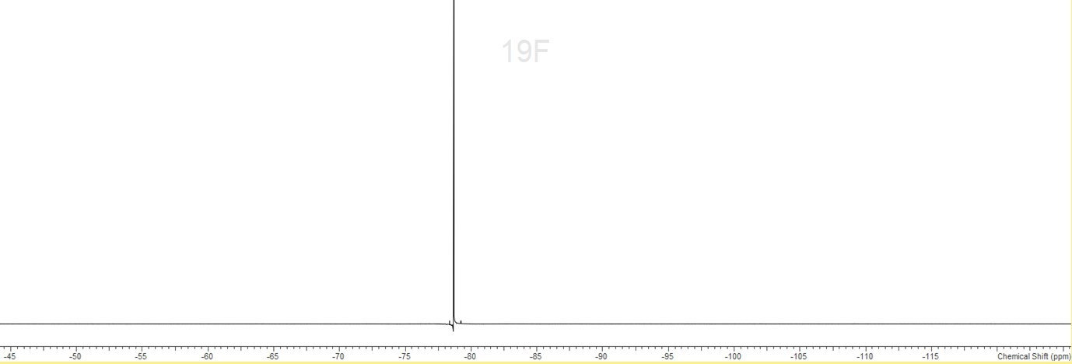
S5.11.3 – 31P{1H} NMR spectrum (298 K, CD3CN)
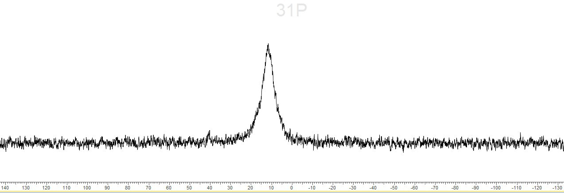
S5.11.4 31P{1H} NMR spectrum (258 K, CD3CN)
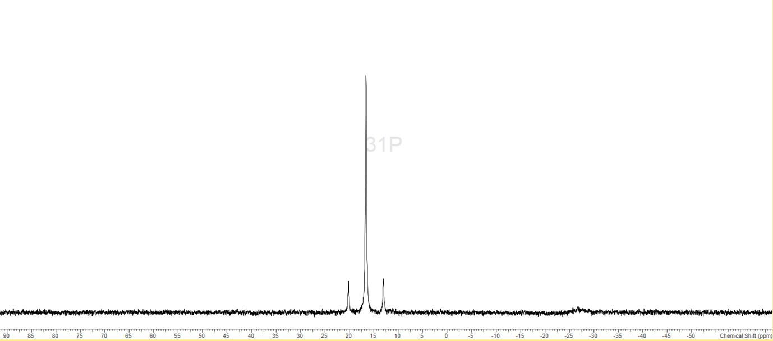
S5.11.5 – IR spectrum (Nujol)
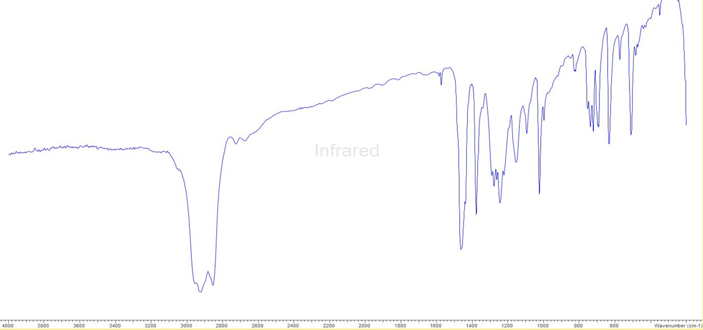
S5.12.0 – [Pb{MeC(CH2PPh2)3}][BArF]2
S5.12.1– 1H NMR spectrum (298 K, CD3CN)
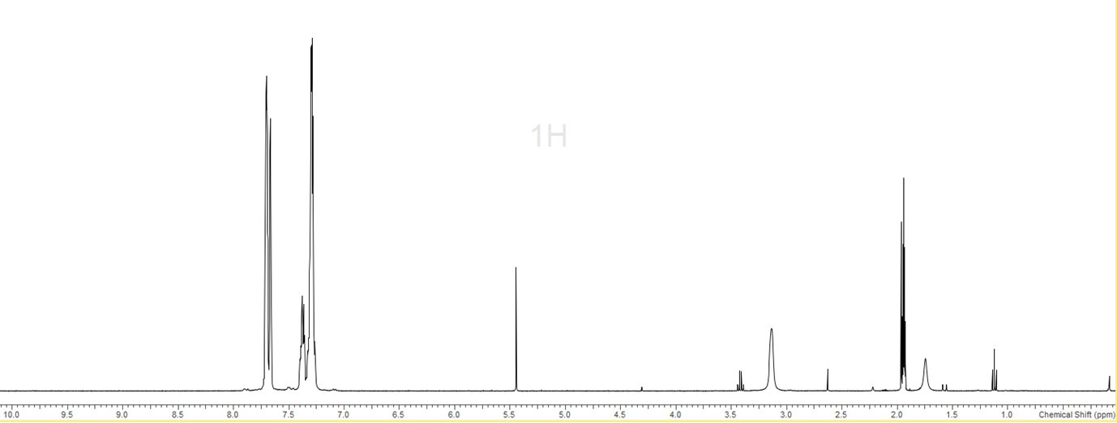
CD2CN
CH2Cl2
Et2O
Et2O

S5.12.2 – 19F{1H} NMR spectrum (298 K, CD3CN)
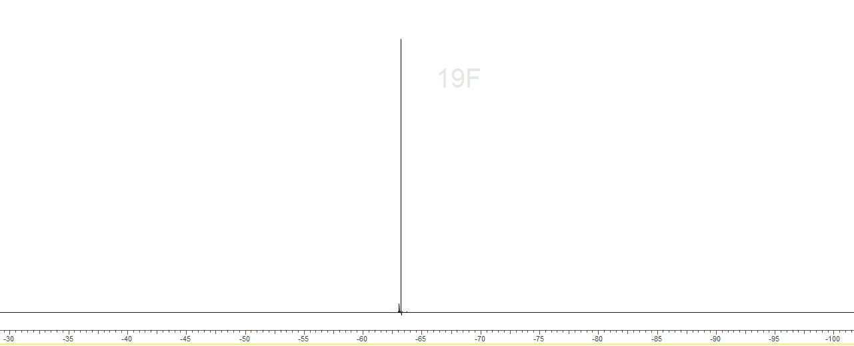
S5.12.3 – 31P{1H} NMR spectrum (298 K, CD3CN)
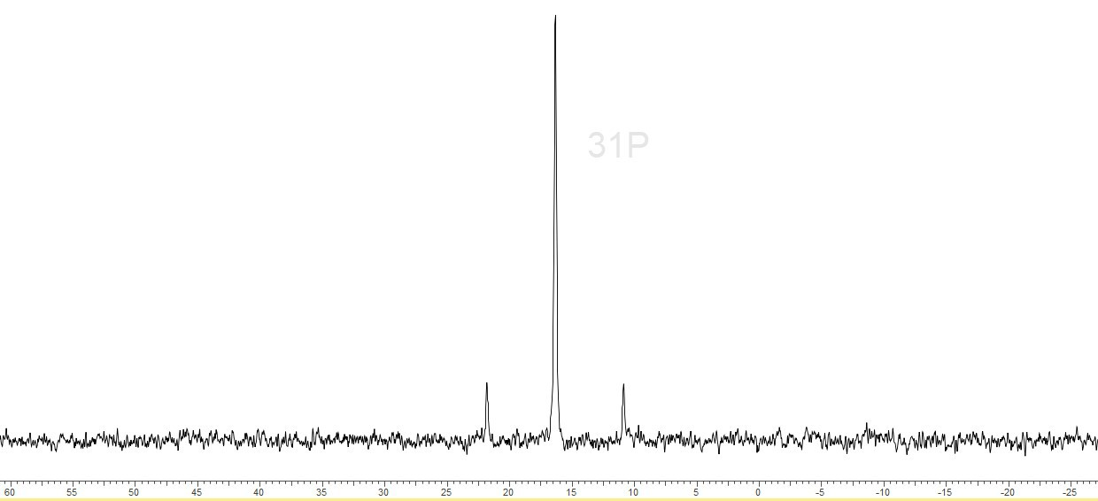
S5.12.4 IR spectrum (Nujol)
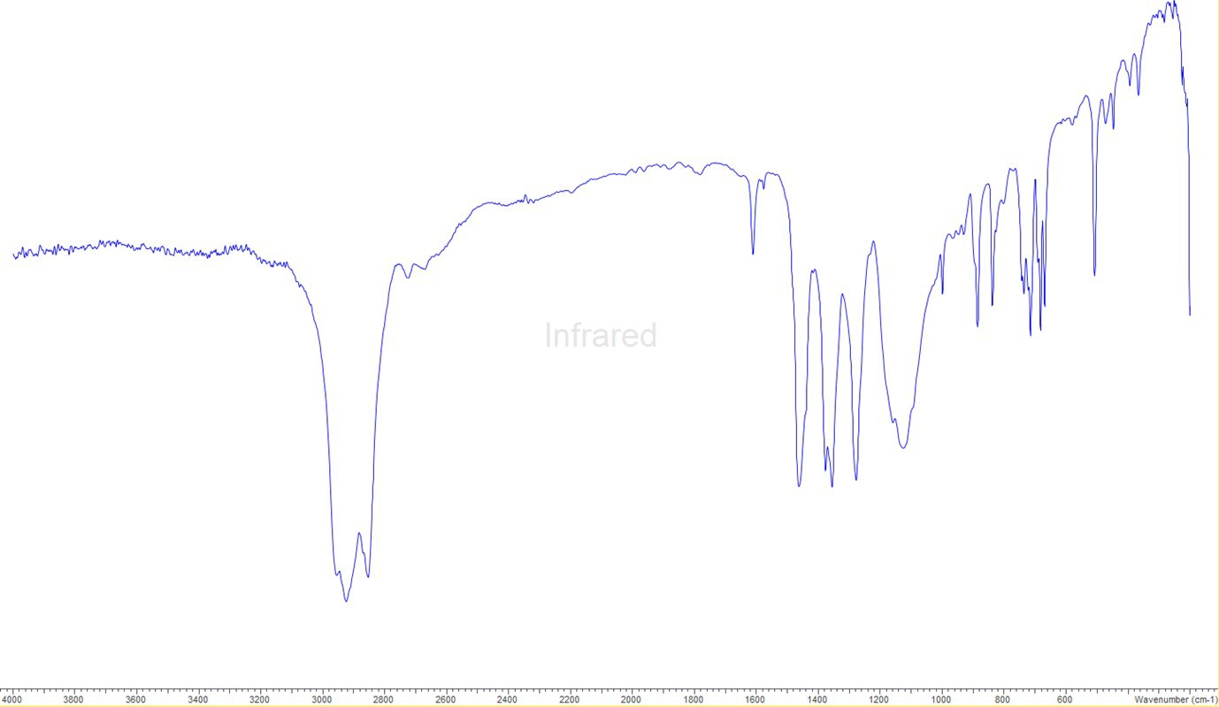
S5.13.0 – [Pb(OTf)2{MeC(CH2AsMe2)3}]
S5.13.1 – 1H NMR spectrum (298 K, CD3CN)
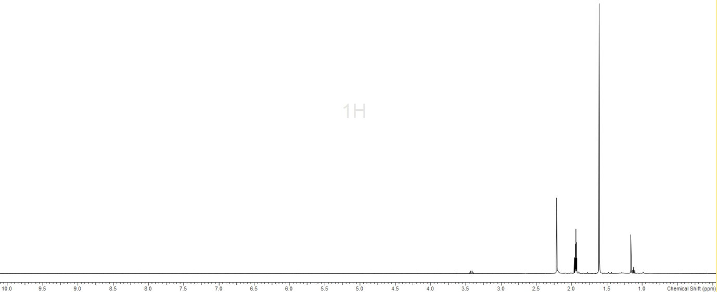
CD3CN
S5.13.2 – 19F{1H} NMR spectrum (298 K, CD3CN)
S5.14.0 – [Pb(OTf){P(CH2CH2PPh2)3}][OTf]
S5.14.1 – 1H NMR spectrum (298 K, CD3CN)
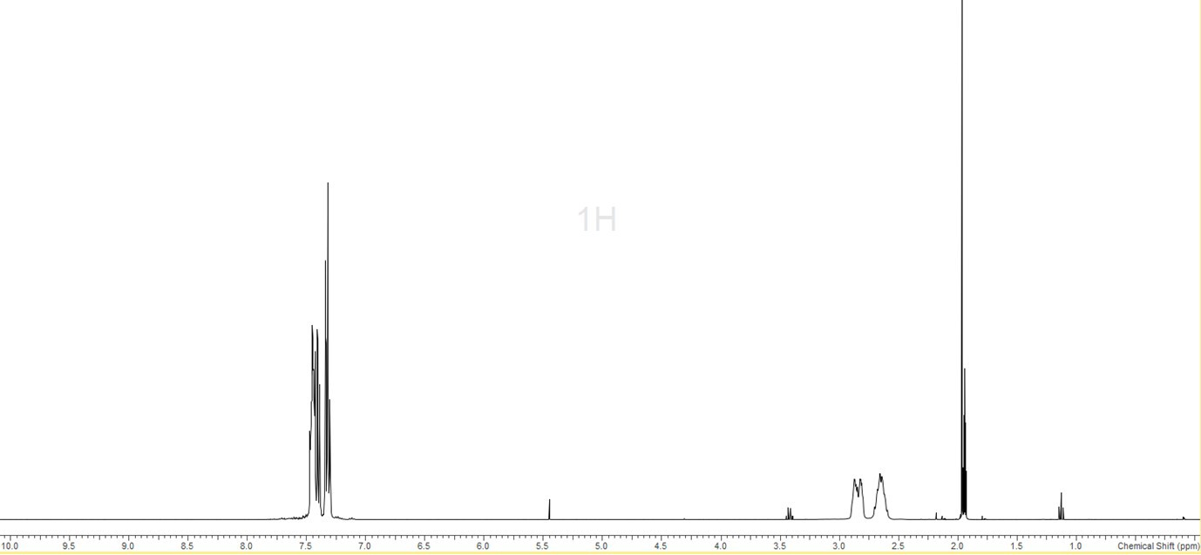
CD₃CN
CH2Cl2
Et2O
Et2O
S5.14.2 – 19F{1H} NMR spectrum (298 K, CD3CN)
S5.14.3 – 31P{1H} NMR spectrum (298 K, CD3CN)
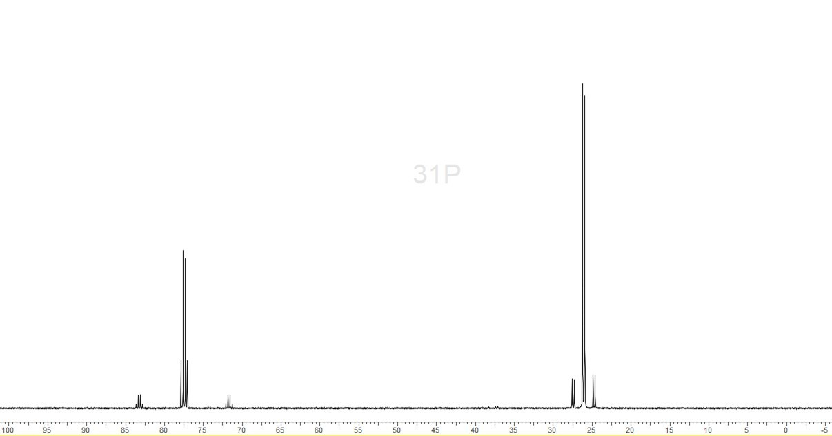
S5.14.4 – IR spectrum (Nujol)
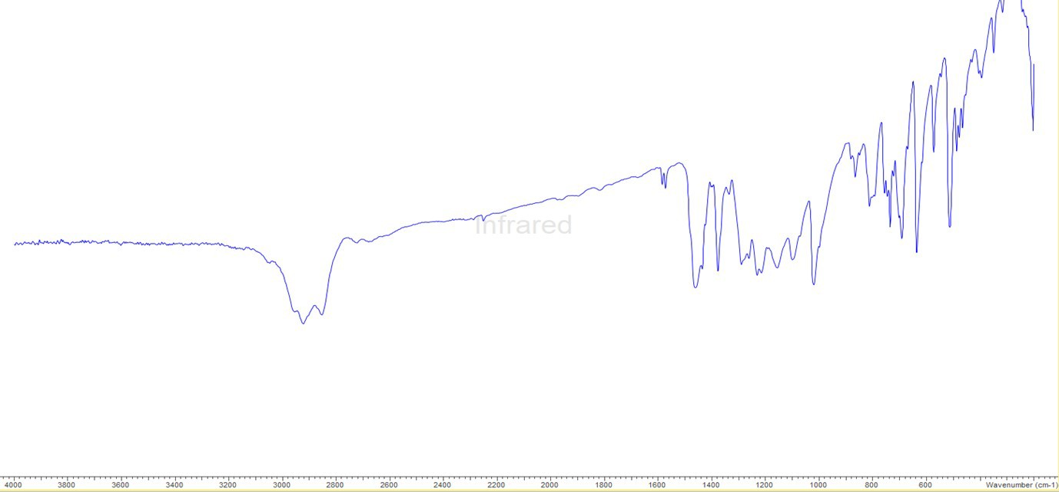
S5.15.0 – [Ge{MeC(CH2PPh2)3}][BArF]2
S5.15.1 – 1H NMR spectrum (298 K, CD2Cl2)
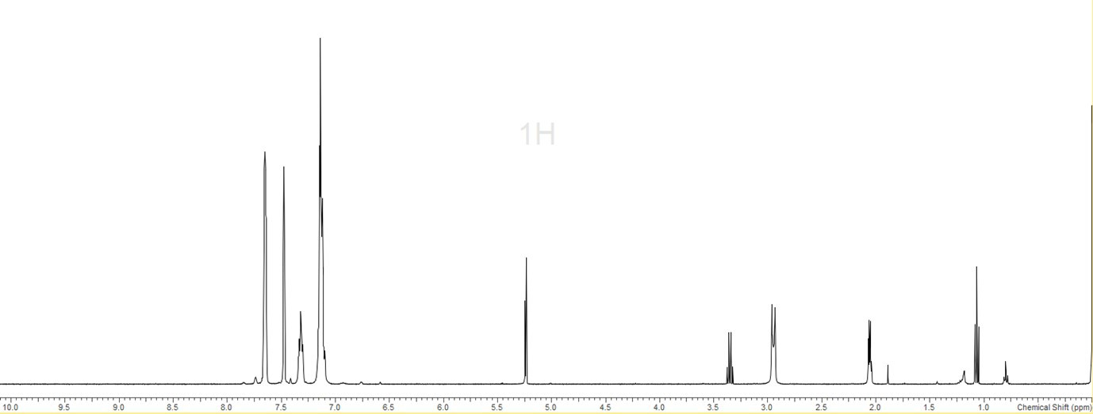
Et2O
CD2Cl2
Et2O
S5.15.2 – 19F{1H} NMR spectrum (298 K, CD2Cl2)
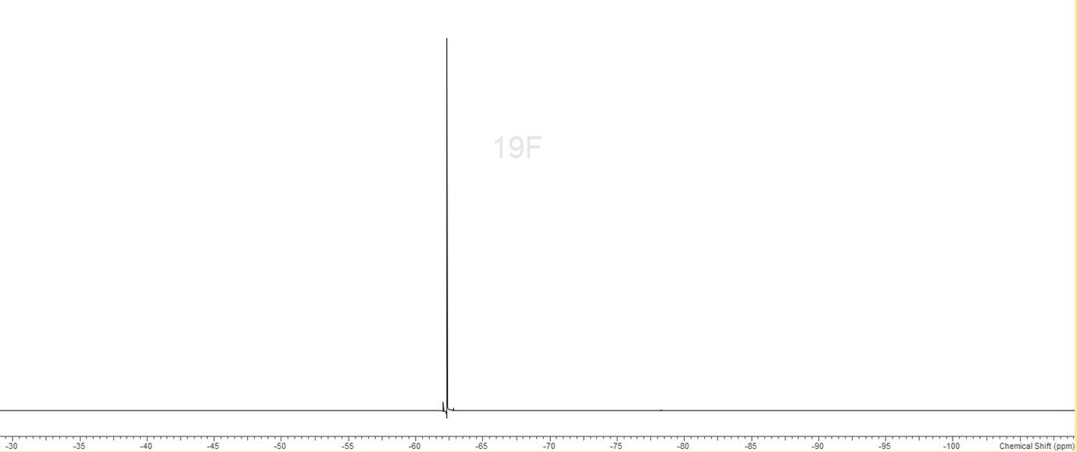
S5.15.3 - 31P{1H} NMR spectrum (298 K, CD2Cl2)
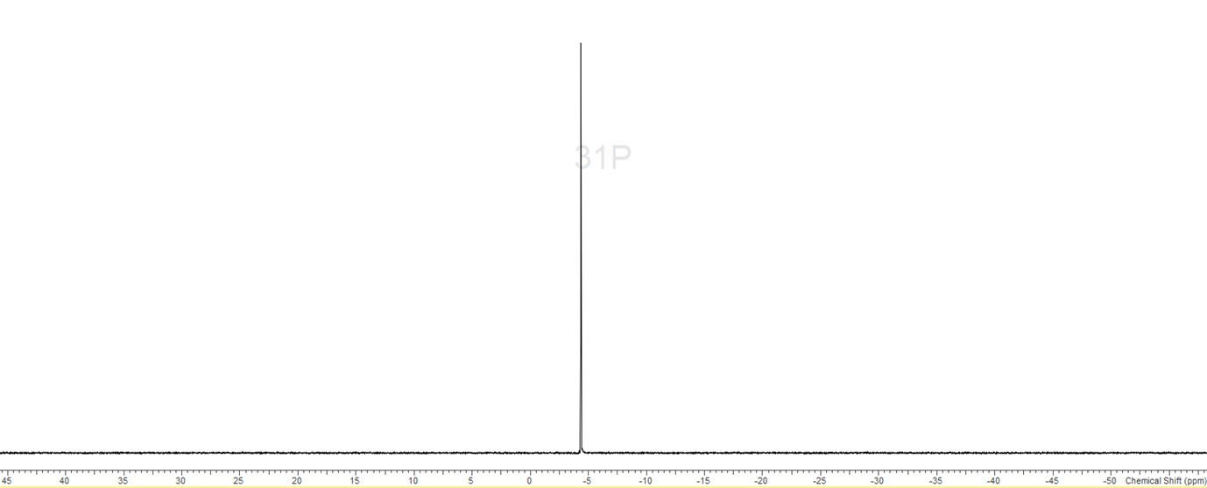
S5.16.0 – Sn(OTf)2
S5.16.1 – IR spectrum (Nujol)
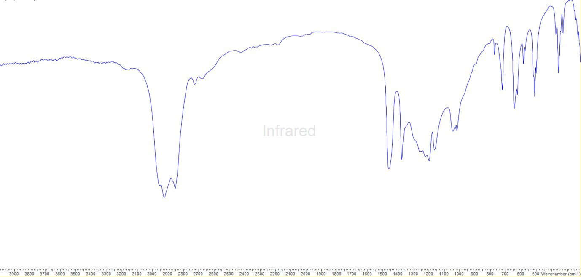
S5.17.0 – Pb(OTf)2
S5.17.1 - IR spectrum (Nujol)
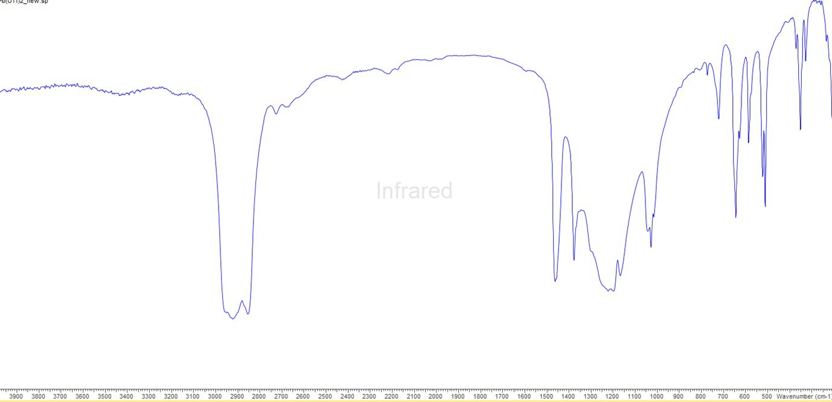

Table S5.2 Experimental (X-ray) vs. calculated (DFT, B3LYP-D3) metrics for [M{MeC(CH2PPh2)3}]2+ (M = Ge, Sn, Pb)
[Ge{MeC(CH2PPh2)3}]2+ | X-ray | DFT
d(Ge-P) / Å | 2.4070(4) | 2.42947
 | 2.4239(4) | 2.42978
 | 2.4110(5) | 2.42966
<(P-Ge-P) / ° | 86.609(14) | 86.13757
 | 85.412(15) | 86.17999
 | 85.912(15) | 86.15668
[Sn{MeC(CH2PPh2)3}]2+ | X-ray | DFT
d(Sn-P) / Å | 2.6194(4) | 2.64552
 | 2.6438(4) | 2.64663
 | 2.6249(4) | 2.64198
<(P-Sn-P) / ° | 82.120(13) | 80.81234
 | 80.160(14) | 81.57846
 | 80.761(14) | 80.70846
[Pb{MeC(CH2PPh2)3}]2+ | X-ray | DFT
d(Pb-P) / Å | 2.7092(6) | 2.71964
 | 2.7184(7) | 2.72140
 | 2.7360(5) | 2.72068
<(P-Pb-P) / ° | 77.868(17) | 79.51974
 | 80.594(17) | 79.61498
 | 78.676(17) | 79.72607

Chapter 6
S6.1.0 – Spectroscopic data for [Sn(OTf)₂(OPPh₃)₂]
S6.2.0 – Spectroscopic data for [Sn(OTf)(OPPh₃)₃][OTf]
S6.3.0 - Spectroscopic data for [Sn(OPPh₃)₄][OTf]₂
S6.4.0 - Spectroscopic data for [Sn(OTf)₂(OPMe₃)₂]
S6.5.0 – Spectroscopic data for [Sn(OTf)₂(dppmO₂)]
S6.6.0 – Spectroscopic data for [Sn(OTf)(dppmO₂)₂][OTf]
S6.7.0 - Spectroscopic data for [Sn(OTf)₂(OAsPh₃)₂]
S6.8.0 - Spectroscopic data for [Sn(OTf)₂(OAsPh₃)₃]
S6.9.0 - Spectroscopic data for [Sn(OTf)₂(pyNO)₂]
S6.10.0 - Spectroscopic data for [Sn(OTf)₂(pyNO)₃]
S6.11.0 – Spectroscopic data for [Sn(OTf)₂(ONMe₃)₃]
S6.12.0 - Spectroscopic data for [Pb(OTf)₂(pyNO)₂]
S6.13.0 – Spectroscopic data for [Pb(OTf)₂(ONMe₃)₃]

S6.1.0 - [Sn(OTf)₂(OPPh₃)₂]
S6.1.1 - ¹H (295 K, CD₂Cl₂)
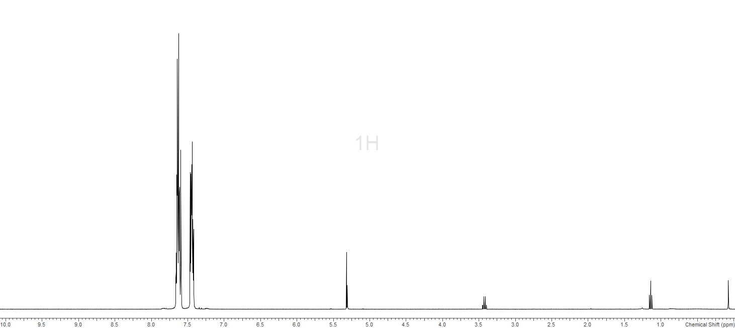
CH₂Cl₂
S6.1.2 - ¹⁹F{¹H} (295 K, CD₂Cl₂)
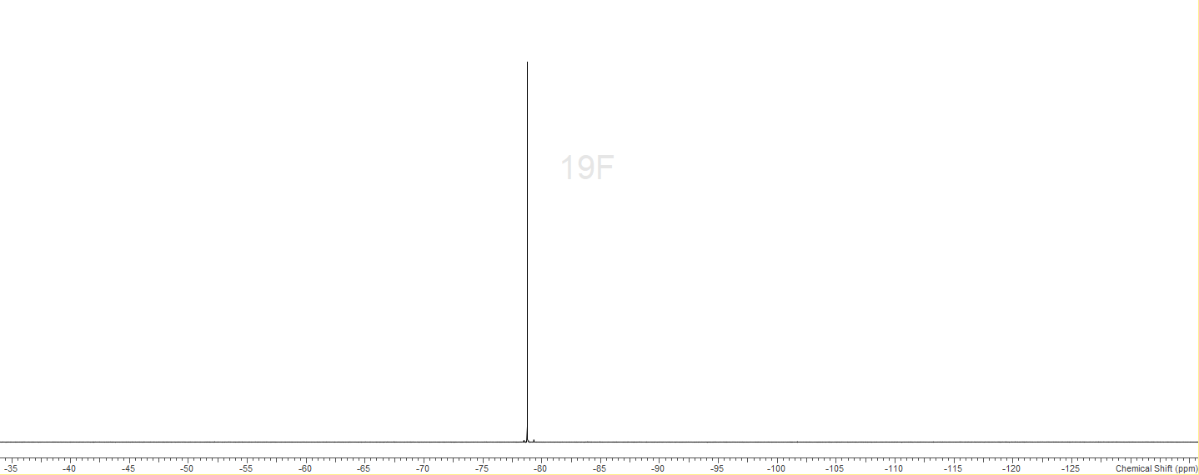
S6.1.3 - ³¹P{¹H} (295 K, CD₂Cl₂)
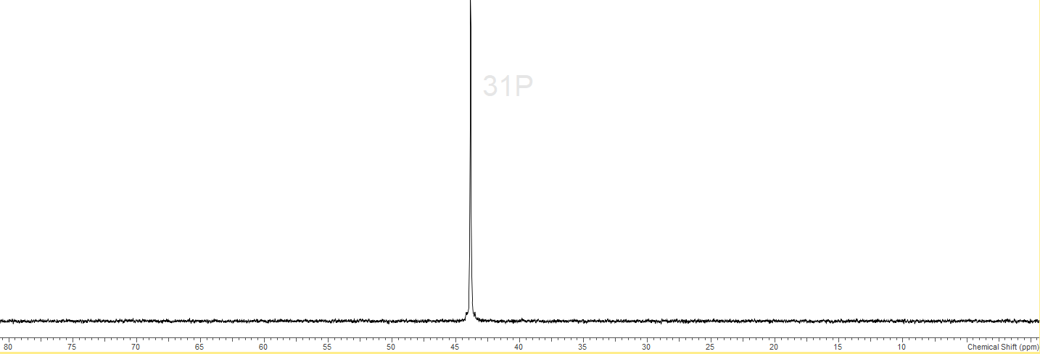
S6.1.4 - IR spectrum (nujol)
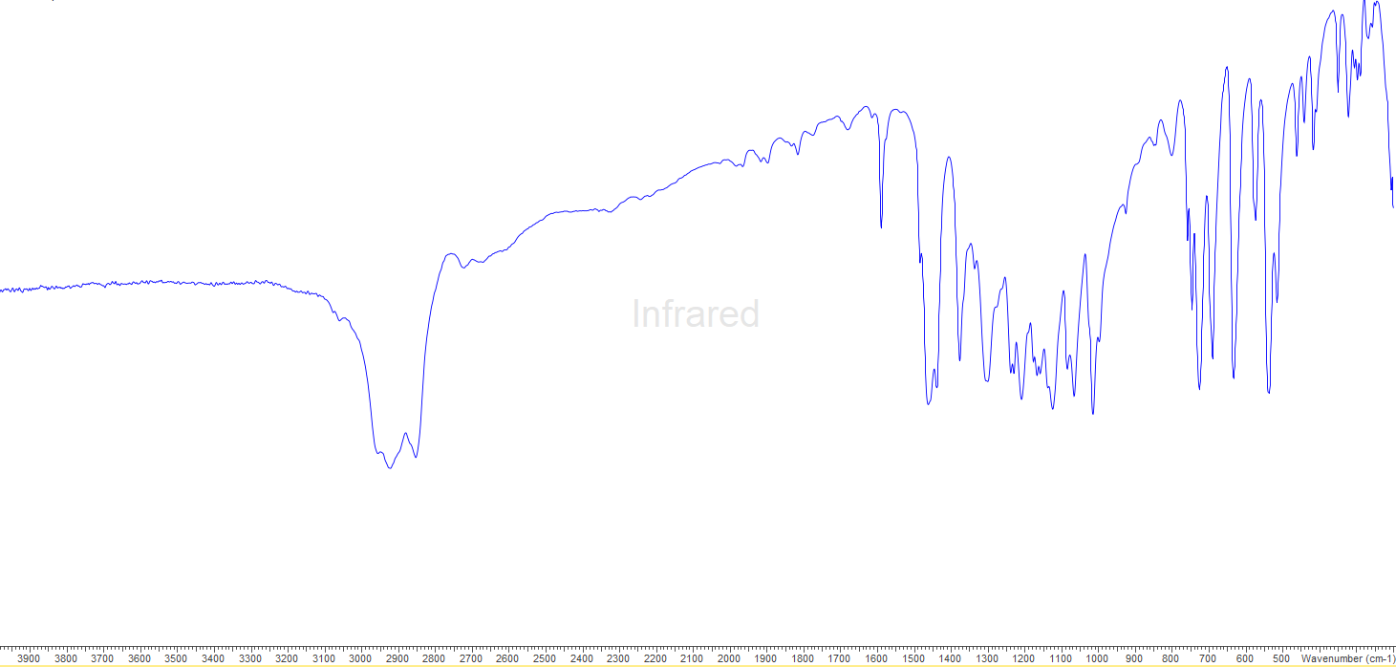
S6.2.0 - [Sn(OTf)(OPPh₃)₃][OTf]
S6.2.1 - ¹H (295 K, CD₂Cl₂)
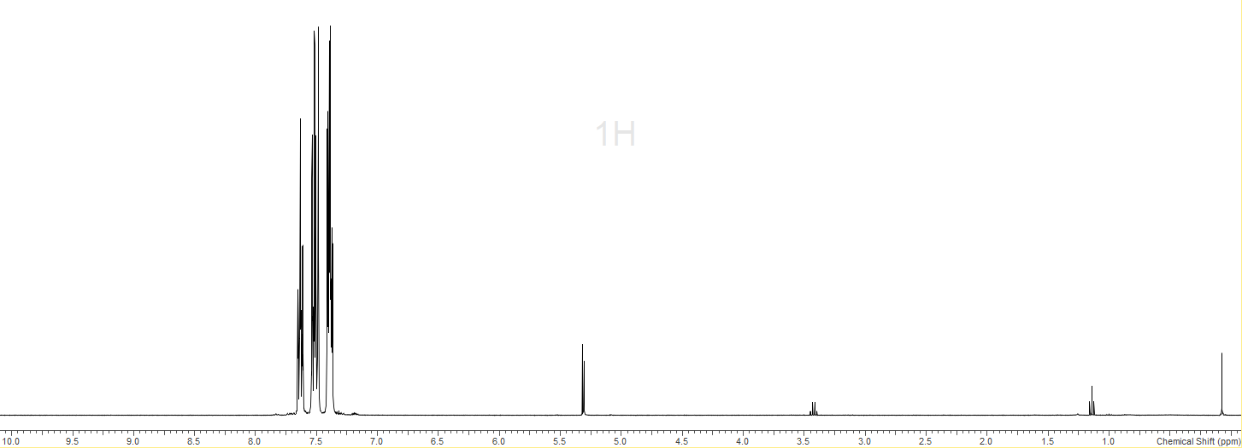
CH₂Cl₂
S6.2.2 - ¹⁹F{¹H} (295 K, CD₂Cl₂)
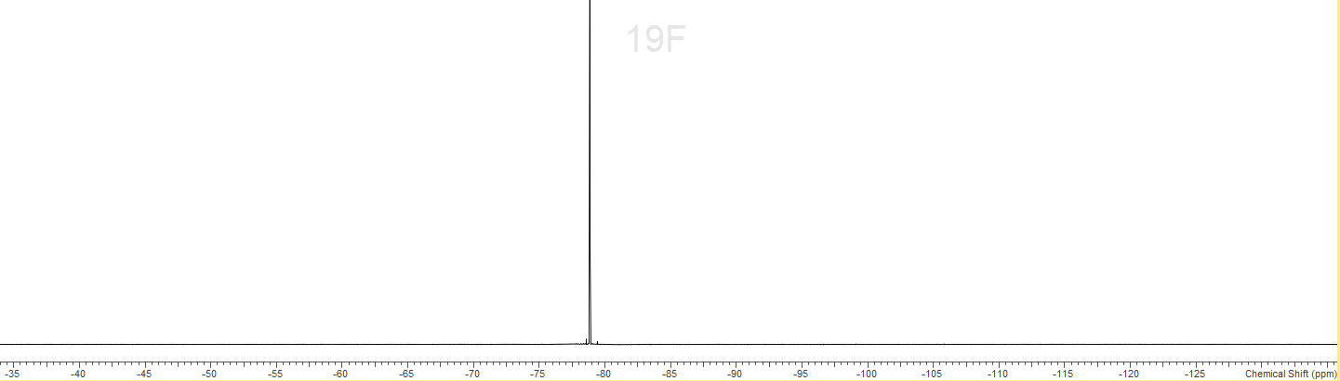
S6.2.3 - ³¹P{¹H} (295 K, CD₂Cl₂)
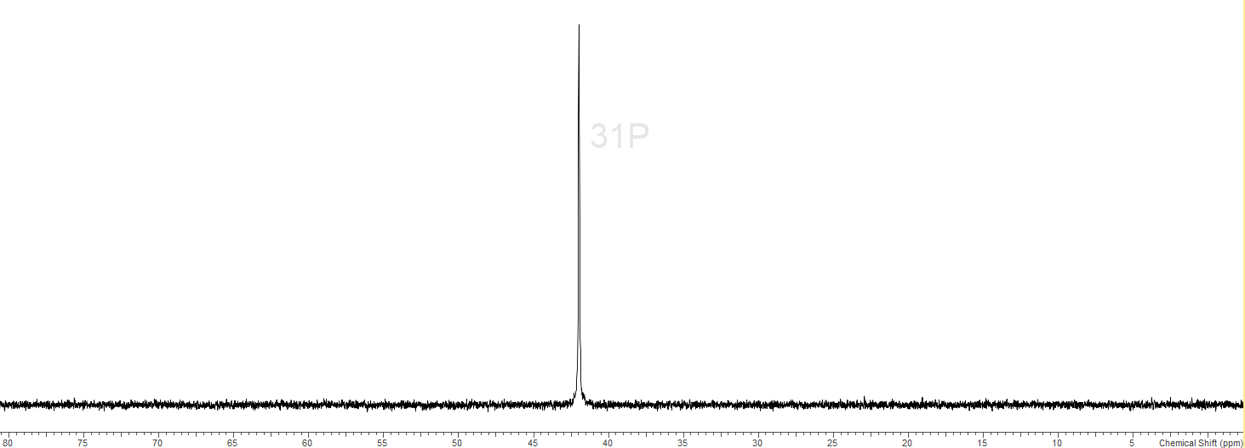
S6.2.4 - IR spectrum (nujol)
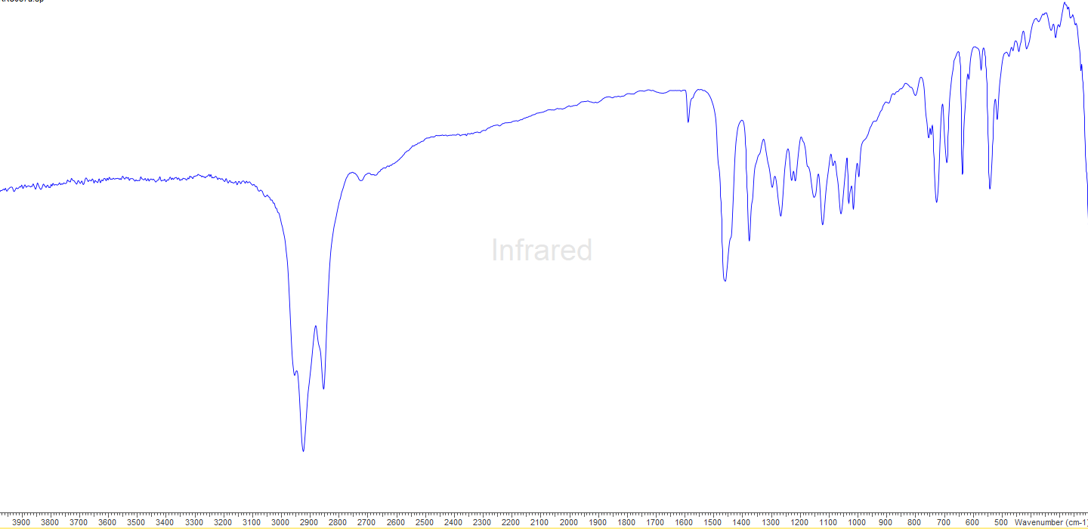
S6.3.0 - [Sn(OPPh₃)₄][OTf]₂
S6.3.1 - ¹H (295 K, CD₂Cl₂)
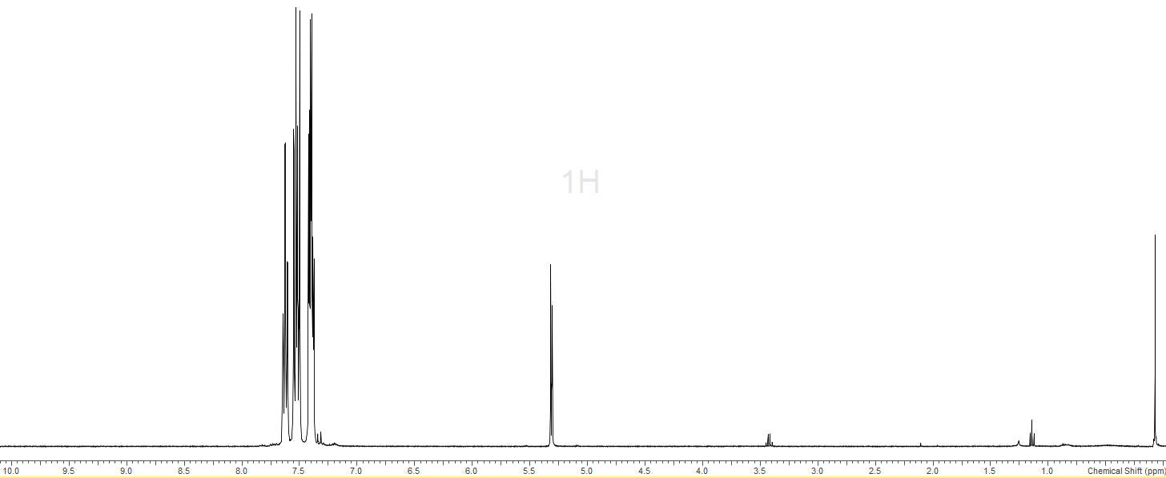
CH₂Cl₂
S6.3.2 - ¹⁹F{¹H} (295 K, CD₂Cl₂)
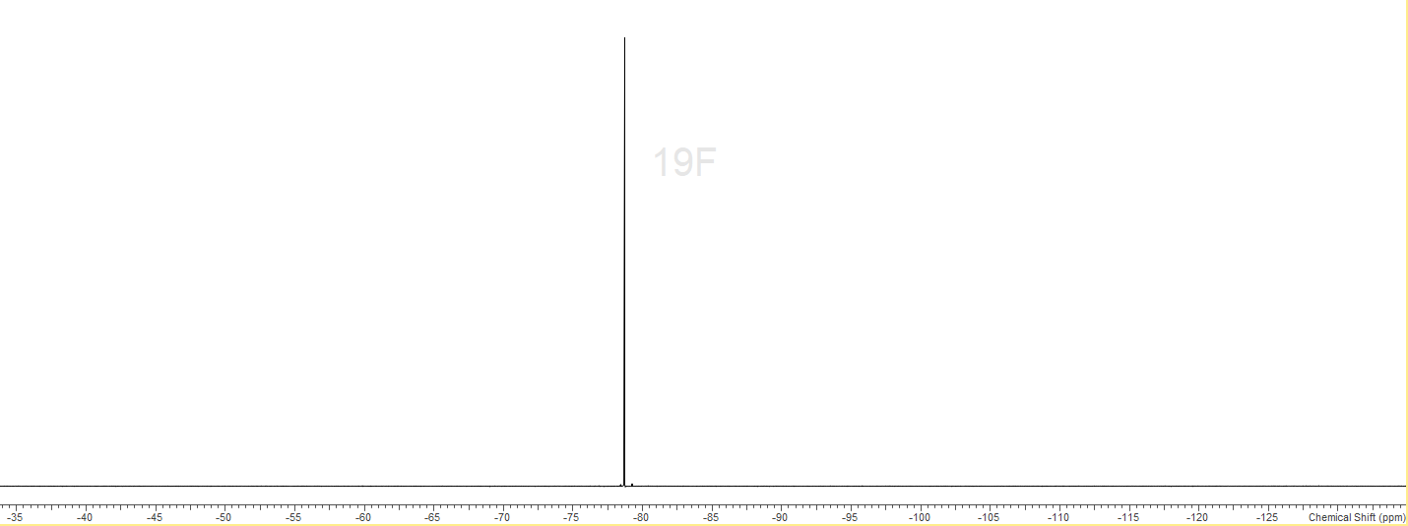
S6.3.3 - ³¹P{¹H} (295 K, CD₂Cl₂)
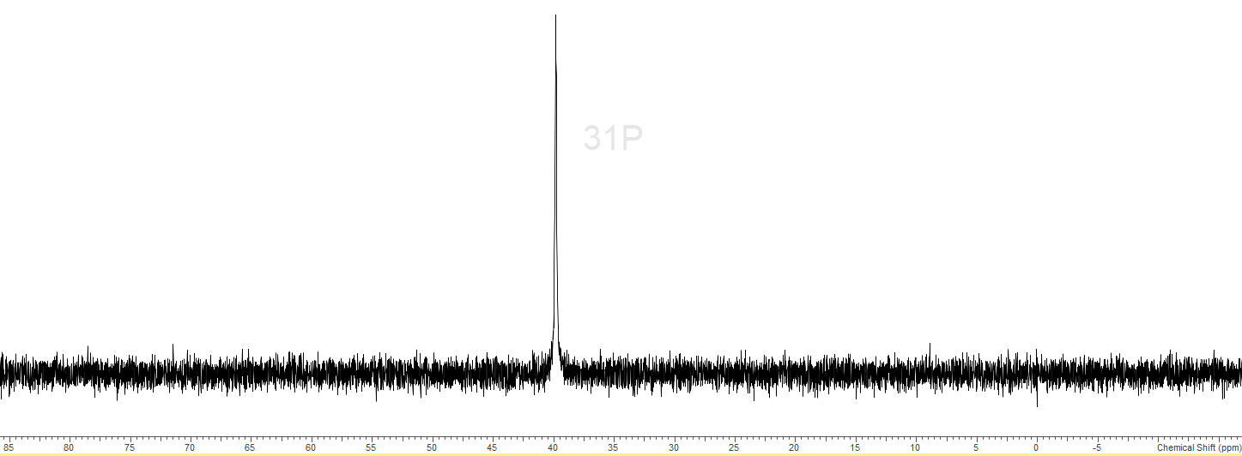
S6.3.4 – IR spectrum (nujol)
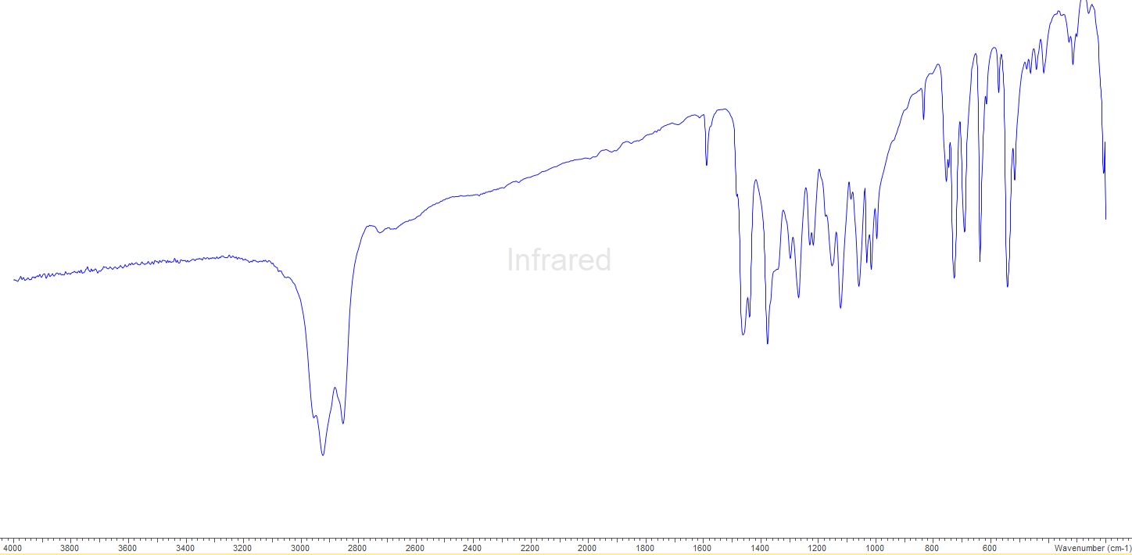
S6.4.0 - [Sn(OTf)₂(OPMe₃)₂]
S6.4.1 - ¹H (295 K, CD₂Cl₂)
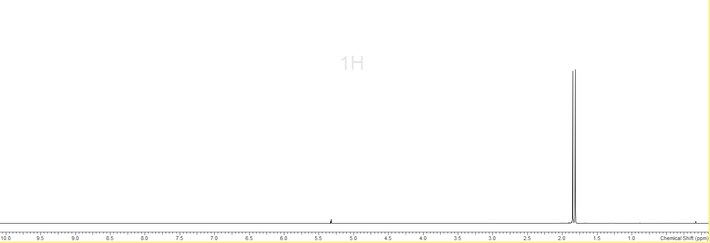
CH₂Cl₂
S6.4.2 - ¹³C{¹H} (295 K, CD₂Cl₂)
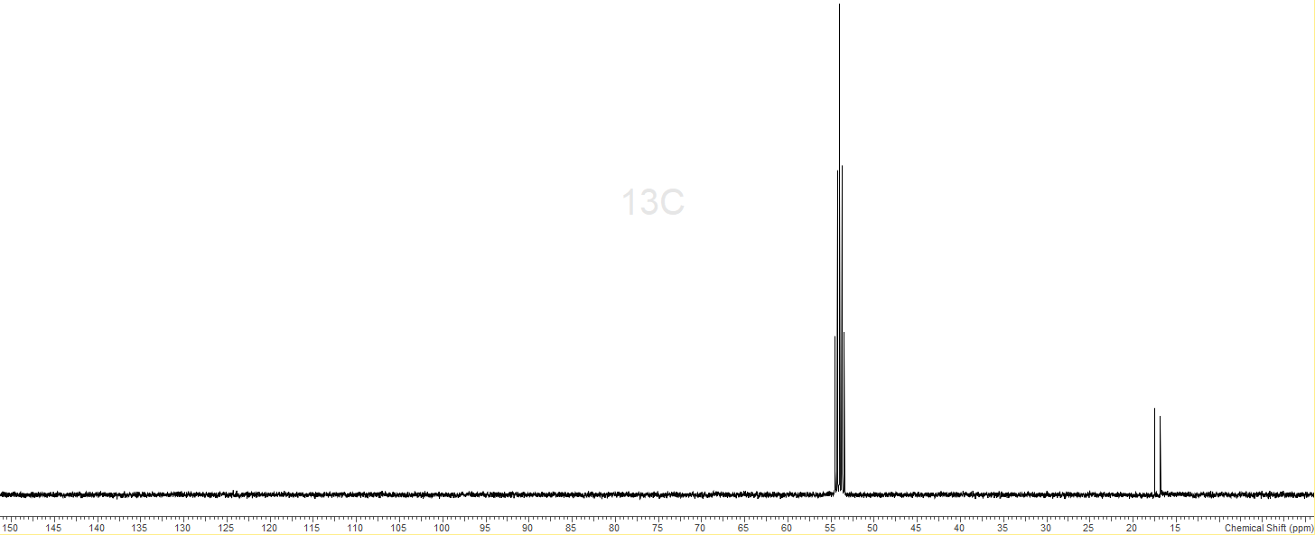
CH₂Cl₂
S6.4.3 - ¹⁹F{¹H} (295 K, CD₂Cl₂)
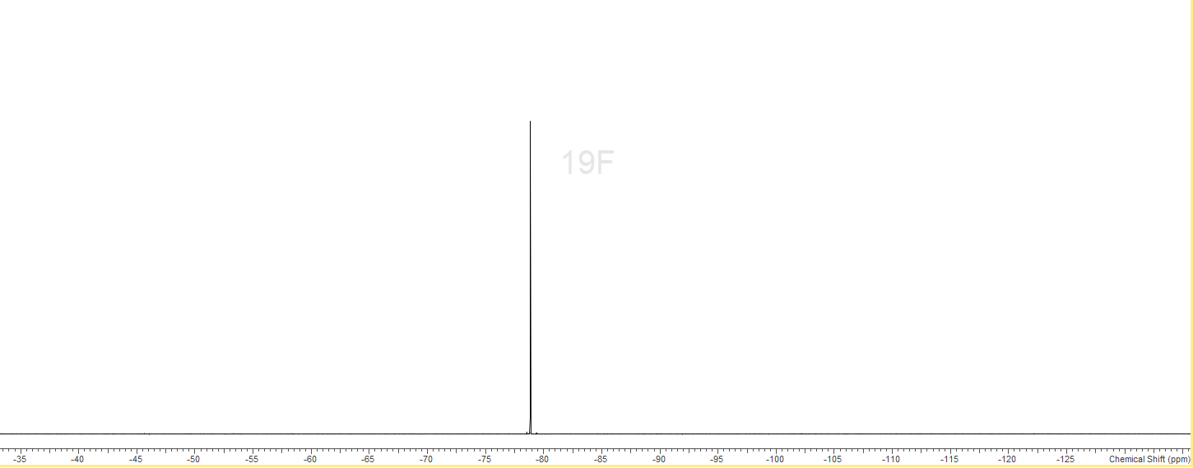
S6.4.4 - ³¹P{¹H} (295 K, CD₂Cl₂)
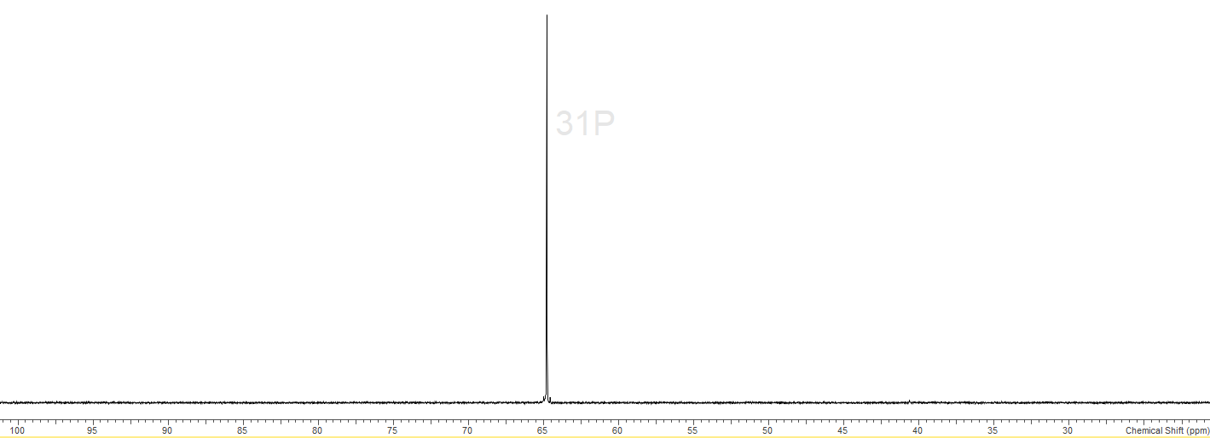
S6.4.5 IR – Nujol, 295K
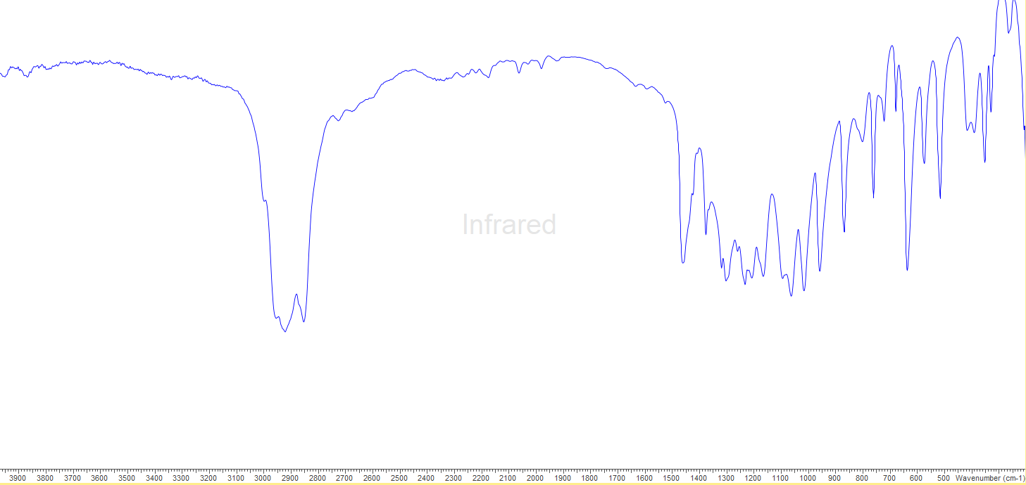
S6.5.0 – [Sn(OTf)₂(dppmO₂)]
S6.5.1 - ¹H (295 K, CD₂Cl₂)
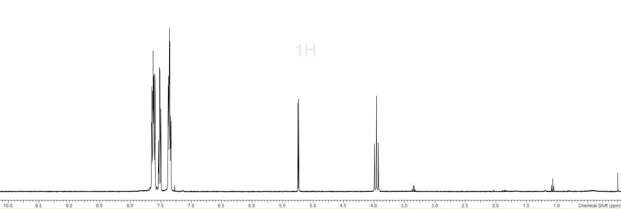
CH₂Cl₂
S6.5.2 - ¹⁹F{¹H} (295 K, CD₂Cl₂)
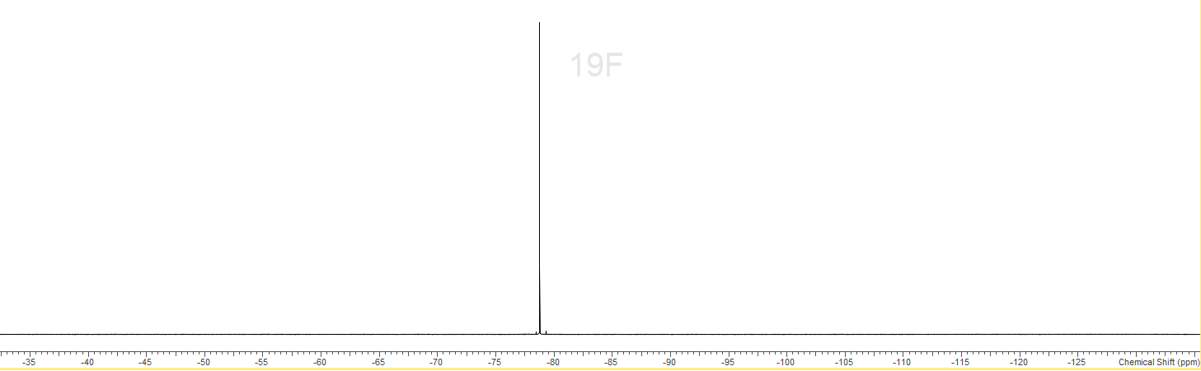
S6.5.3 - ³¹P{¹H} (295 K, CD₂Cl₂)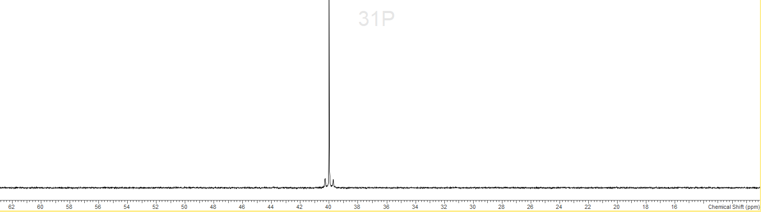
S6.5.4 - IR spectrum (nujol)
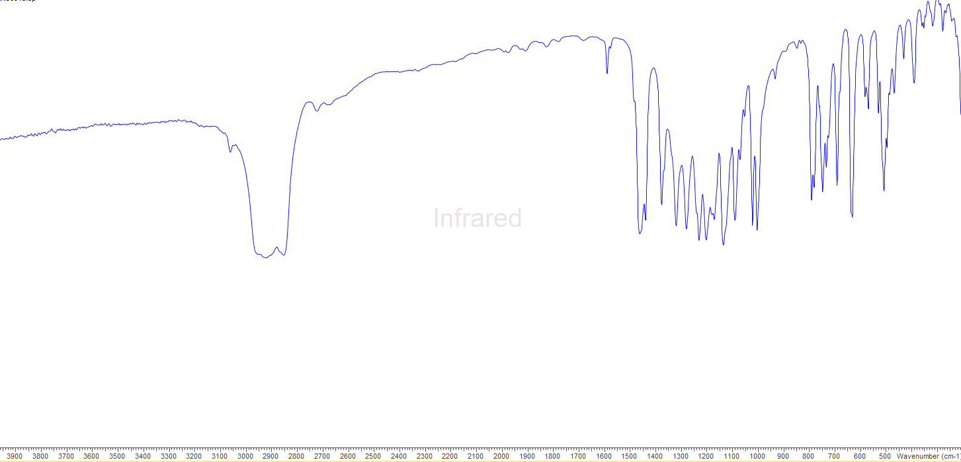
S6.6.0 – [Sn(OTf)(dppmO₂)₂][OTf]
S6.6.1 - ¹H (295 K, CH₂Cl₂)
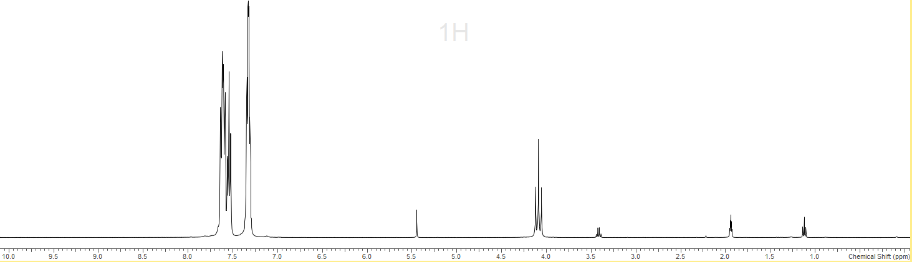
CH₂Cl₂
S6.6.2 - ¹⁹F{¹H} (295 K, CD₂Cl₂)
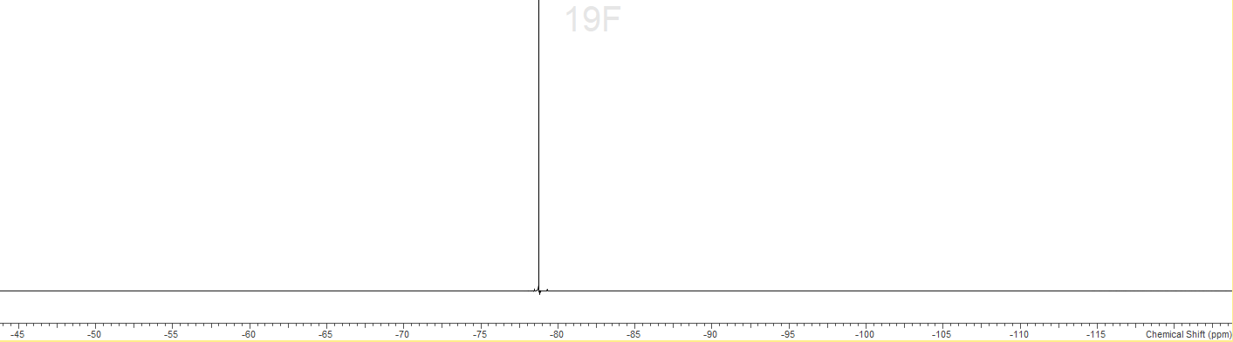
S6.6.3 - ³¹P{¹H} (295 K, CD₂Cl₂)
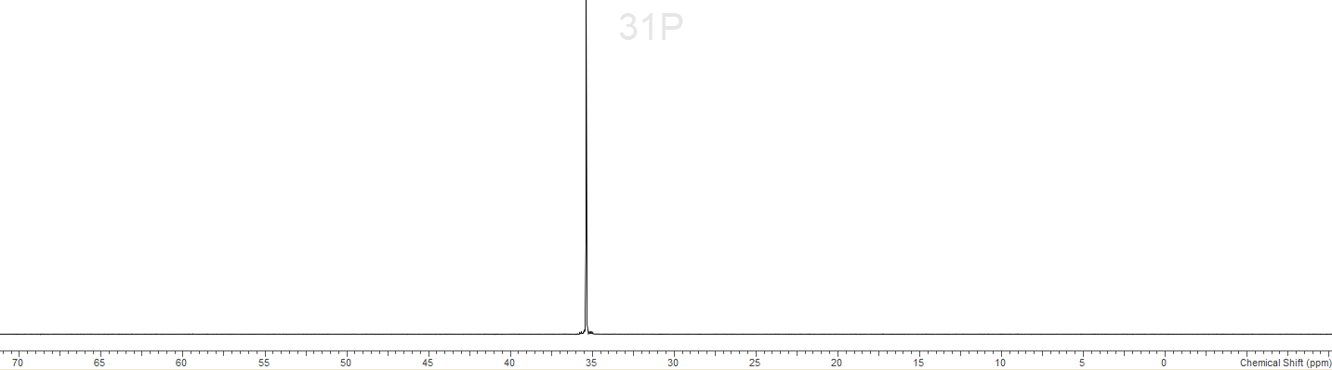
S6.6.4 – ¹¹⁹Sn (295 K, CD₂Cl₂)
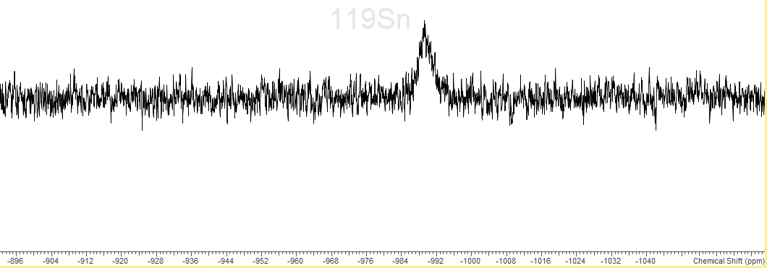
S6.6.4 – IR spectrum (nujol)
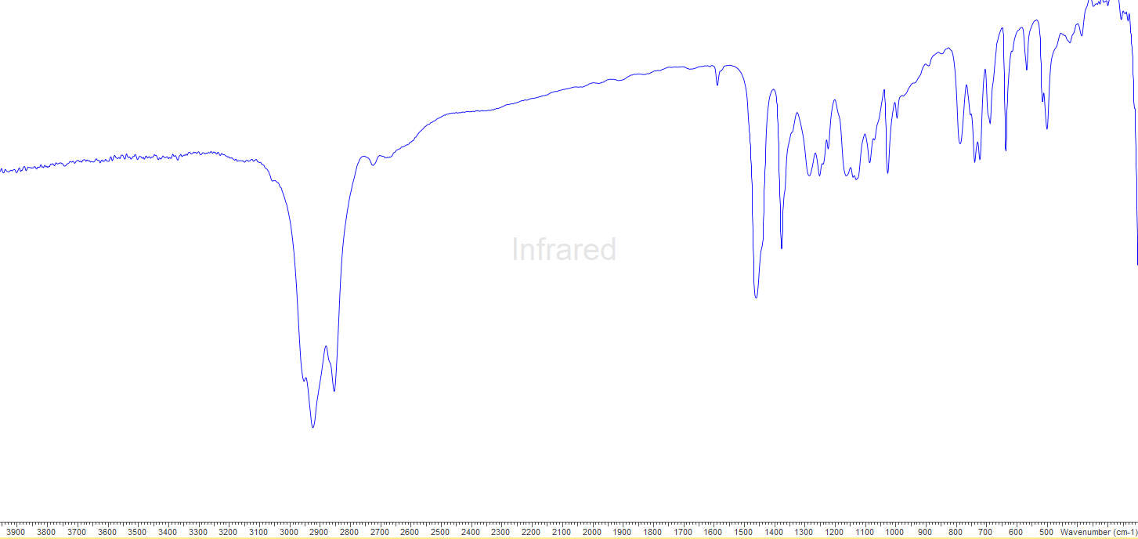
S6.7.0 - [Sn(OTf)₂(OAsPh₃)₂]
S6.7.1 - ¹H (295 K, CD₃CN)
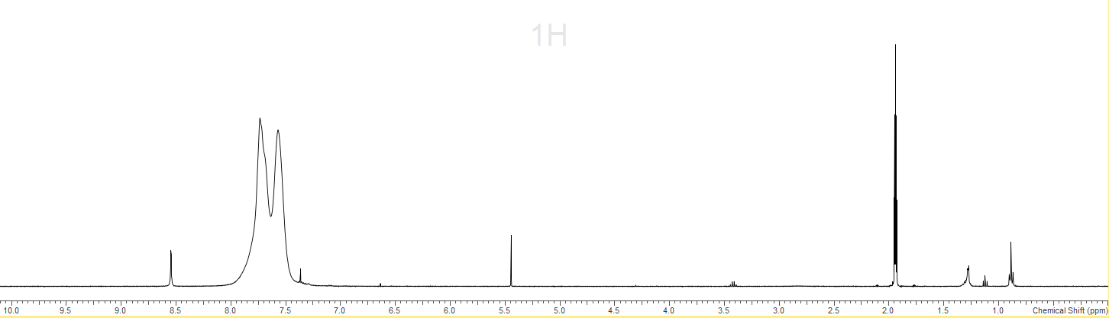
CD₃CN
CH₂Cl₂
S6.7.2 - ¹⁹F{¹H} (295 K, CD₃CN)
S6.7.3 – IR spectrum (nujol)
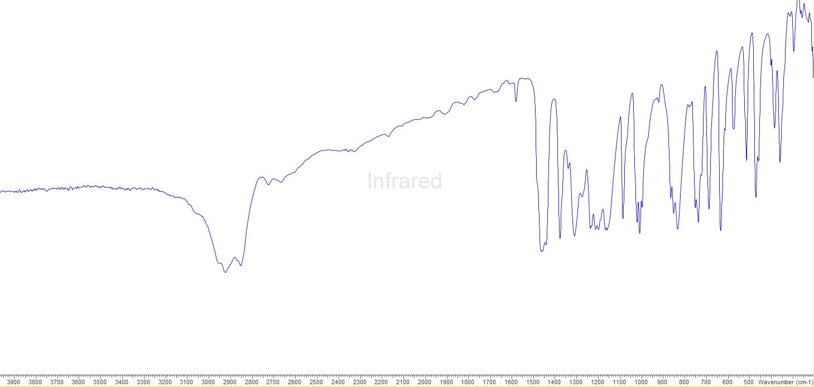
S6.8.0 - [Sn(OTf)₂(OAsPh₃)₃]
S6.8.1 - ¹H (295 K, CD₃CN)
CD₃CN
CH₂Cl₂
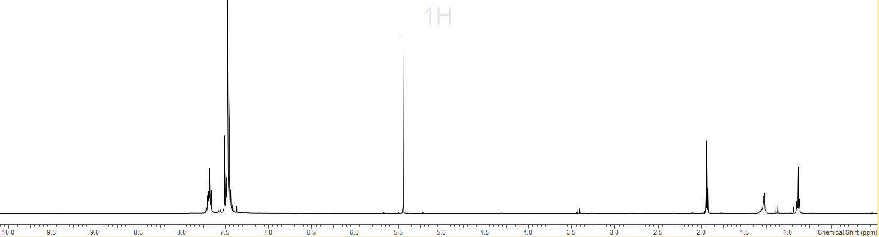
S6.8.2 - ¹³C{¹H} (295 K, CD₃CN)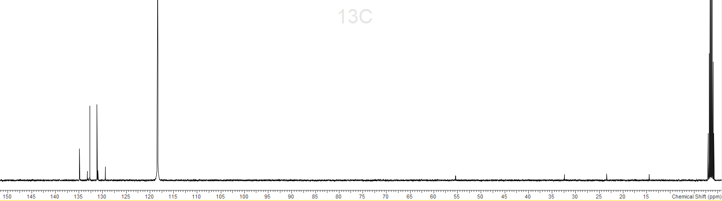
CD₃CN
CD₃CN
S6.8.3 - ¹⁹F{¹H} (295 K, CD₃CN)
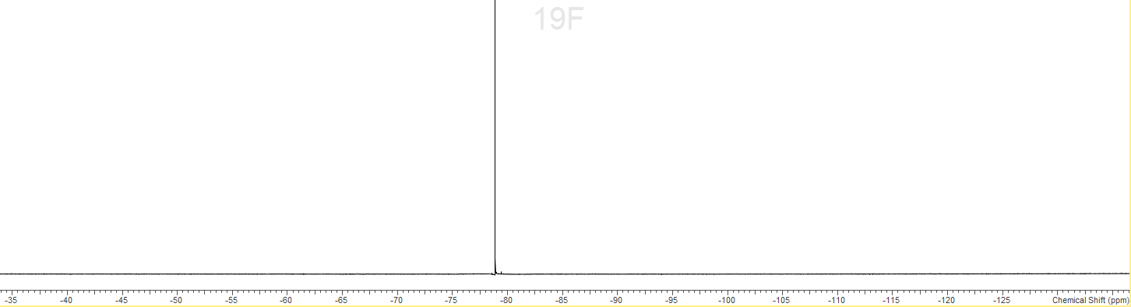
S6.8.4 - IR spectrum (nujol)
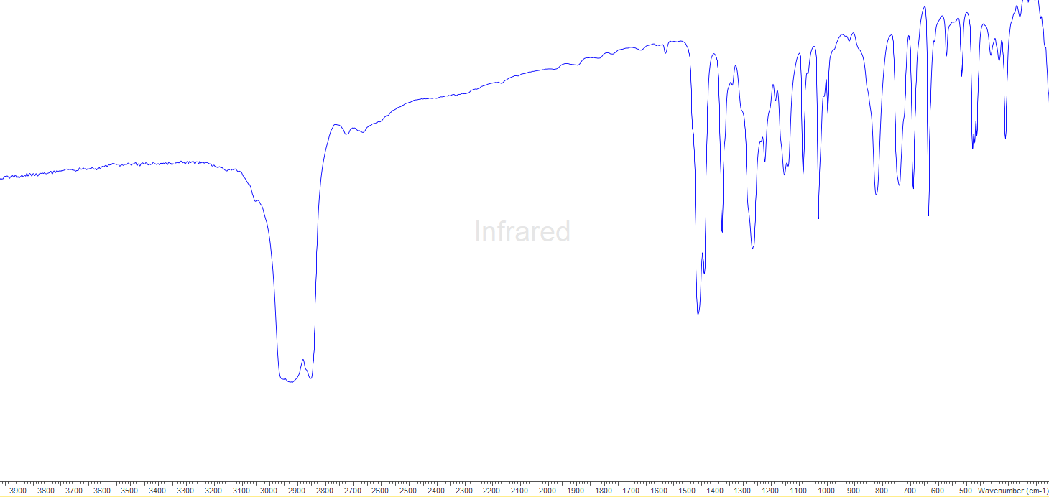
S6.9.0 - [Sn(OTf)₂(pyNO)₂]
S6.9.1 - ¹H (295 K, CD₂Cl₂)
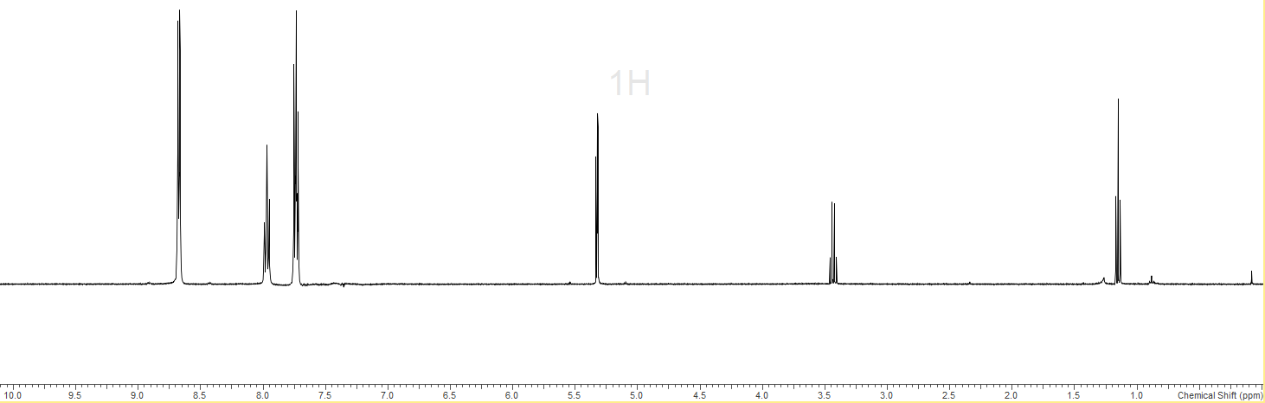
CH₂Cl₂
Et₂O
Et₂O
S6.9.2 - ¹³C{¹H} (295 K, CD₂Cl₂)
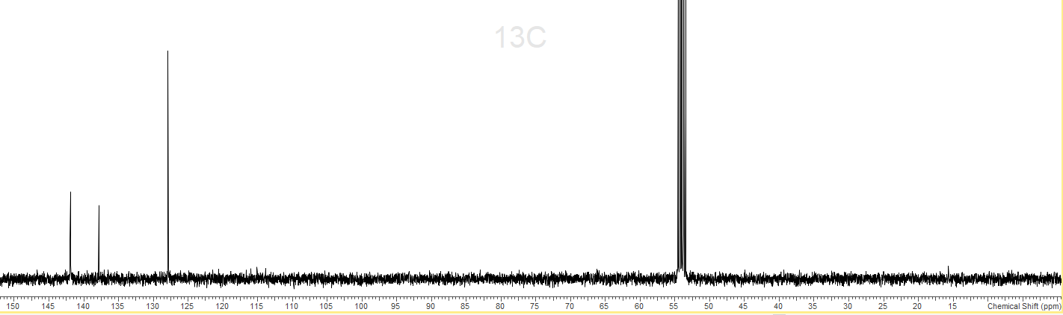
CH₂Cl₂
S6.9.3 - ¹⁹F{¹H} (295 K, CD₃CN)
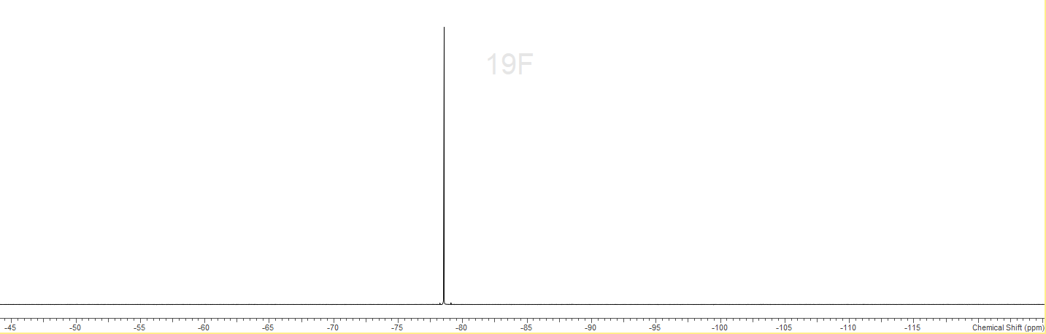
S6.9.4 – IR spectrum (nujol)
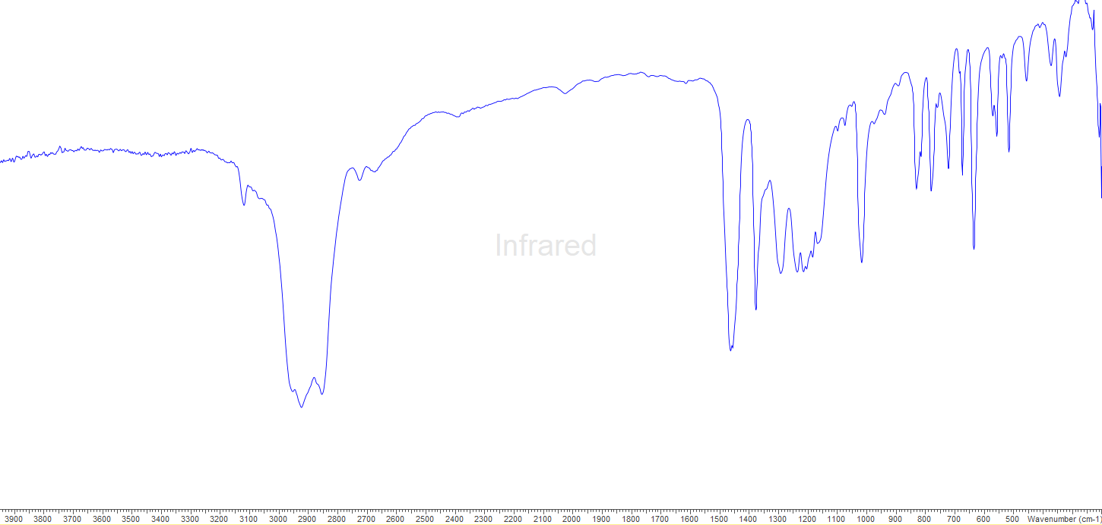
S6.10.0 - [Sn(OTf)₂(pyNO)₃]
S6.10.1 - ¹H (295 K, CD₃CN)
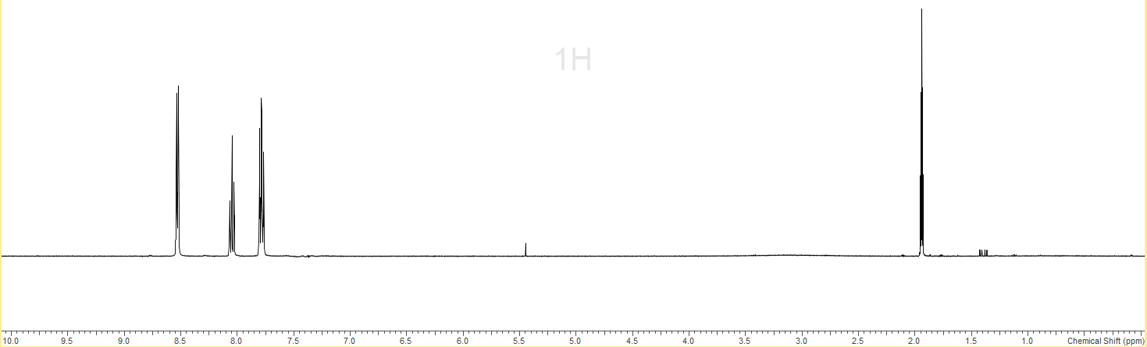
CD₃CN
S6.10.2 - ¹³C{¹H} (295 K, CD₃CN)
CD₃CN
CD₃CN
S6.10.3 - ¹⁹F{¹H} (295 K, CD₃CN)
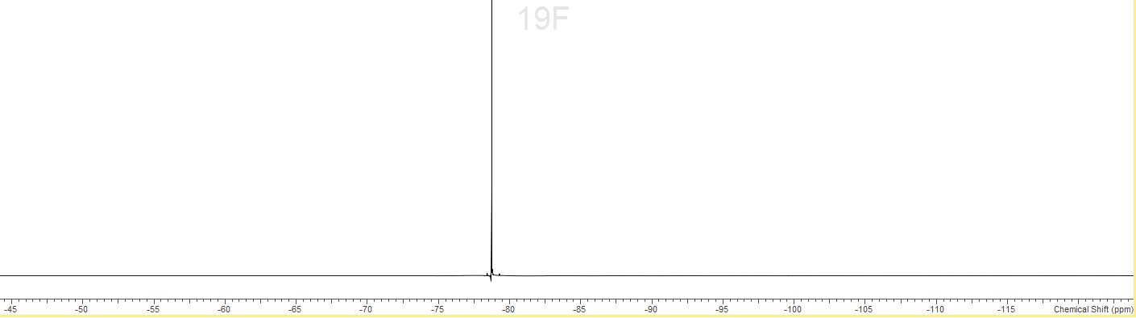
S6.10.4 - IR spectrum (nujol)
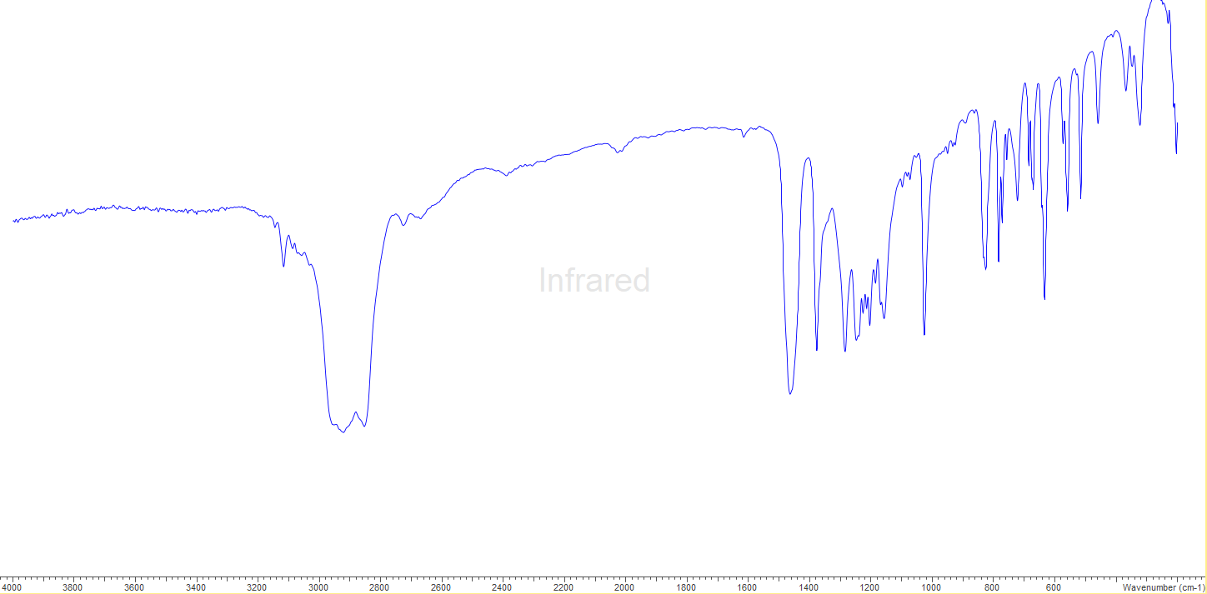
S6.11.0 – [Sn(OTf)₂(ONMe₃)₃]
S6.11.1 - ¹H (295 K, CD₃CN)
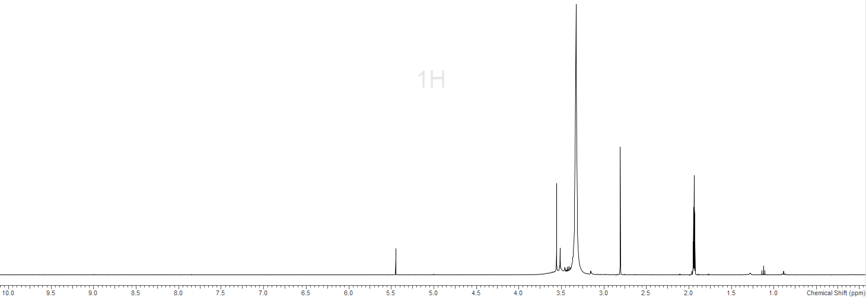
CD₃CN
S6.11.2 - ¹³C{¹H} (295 K, CD₃CN)
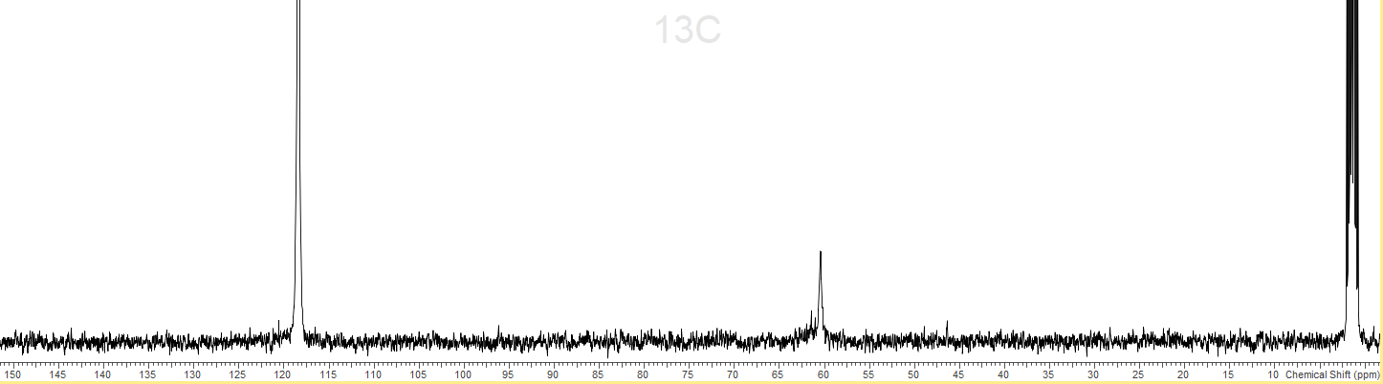
CD₃CN
CD₃CN
S6.11.3 - ¹⁹F{¹H} (295 K, CD₃CN)
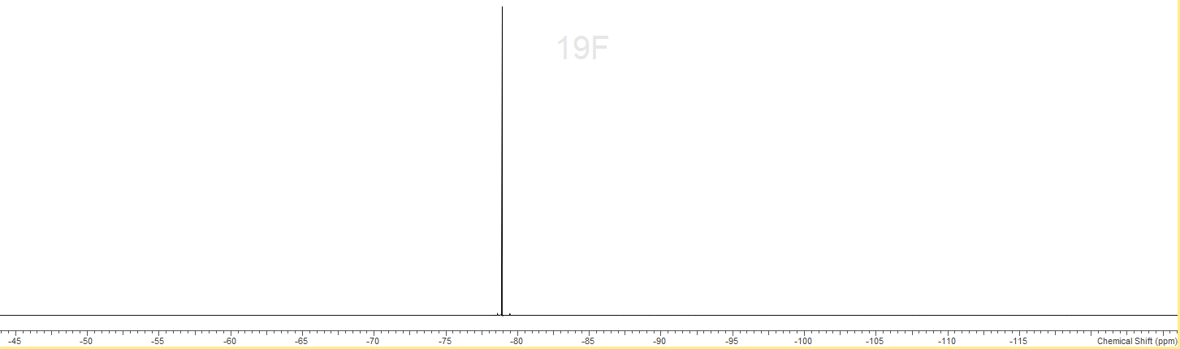
S6.11.4 - IR spectrum (nujol)
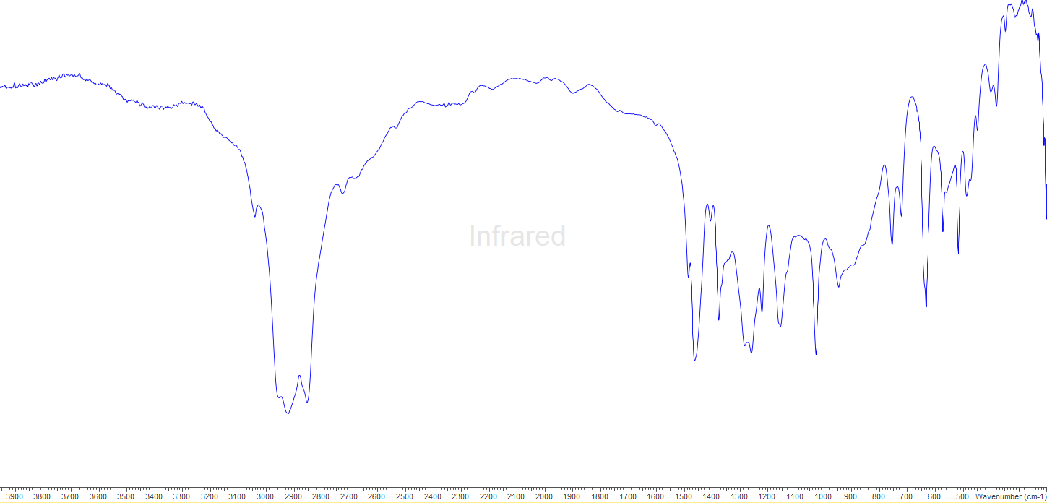
S6.12.0 - [Pb(OTf)₂(dppmO₂)₂]
S6.12.1 - ¹H (295 K, CD₃CN)
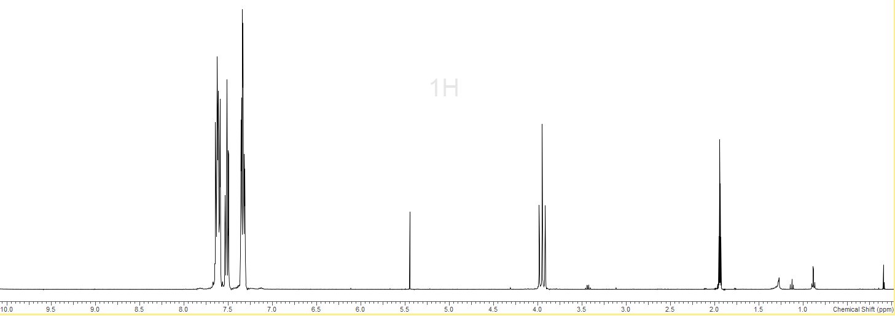
CD₃CN
S6.12.2 - ¹⁹F{¹H} (295 K, CD₃CN)
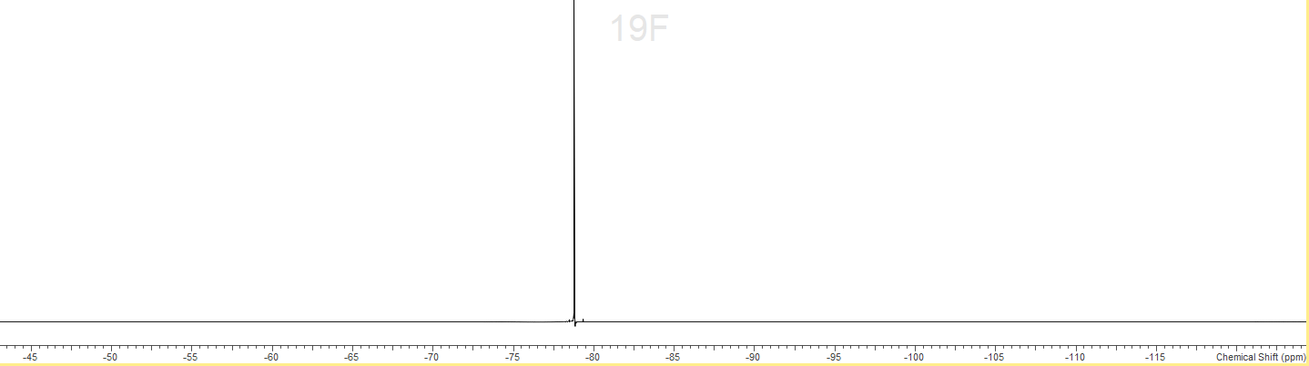
S6.12.3 - ³¹P{¹H} (295 K, CD₃CN)
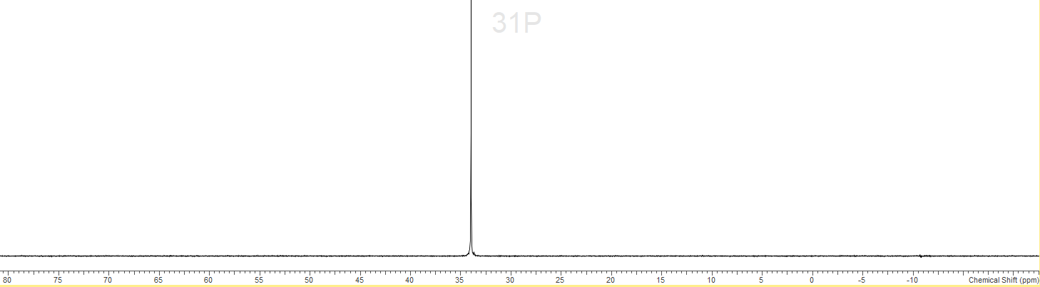
S6.12.4 - IR spectrum (nujol)
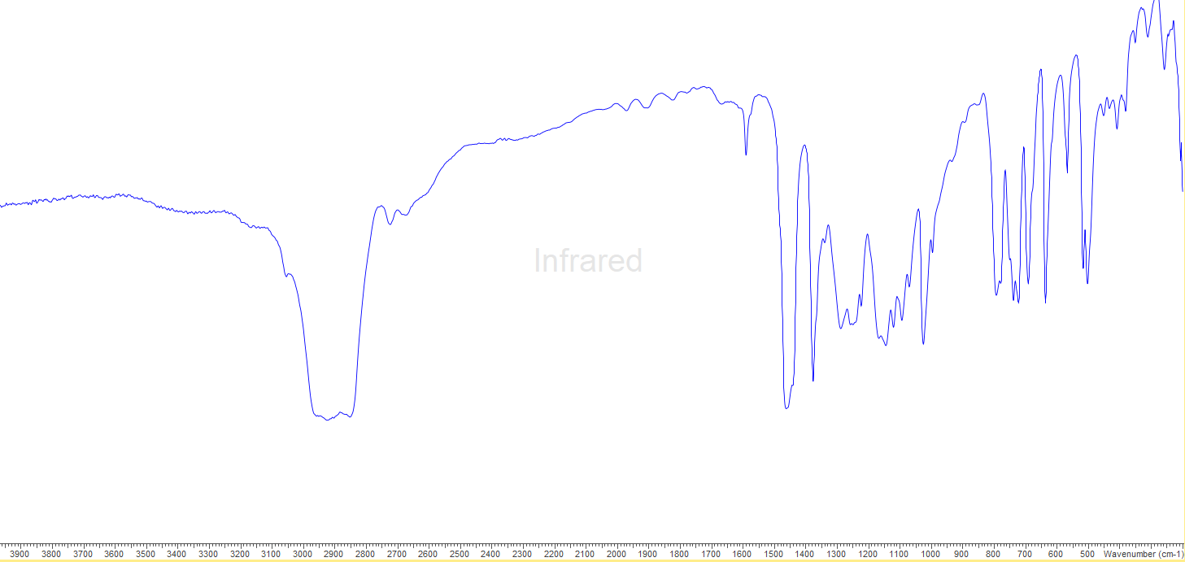
S6.12.0 - [Pb(OTf)₂(pyNO)₂]
S6.12.1 - ¹H (295 K, CD₃CN)
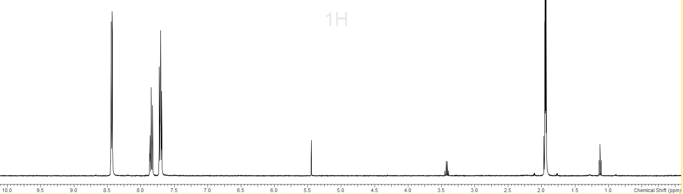
CD₃CN
S6.12.2 - ¹³C{¹H} (295 K, CD₃CN)
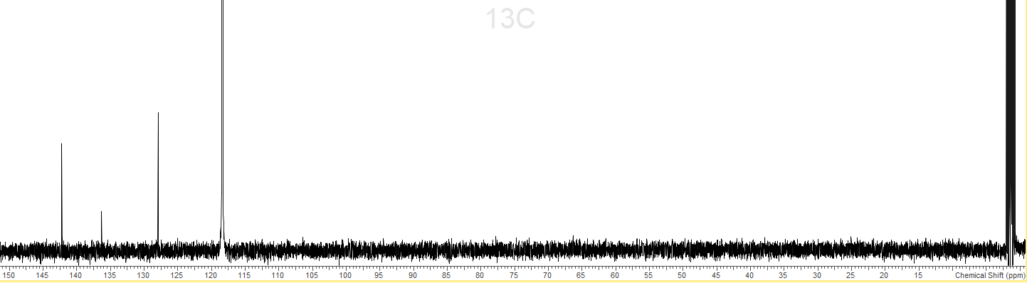
CD₃CN
CD₃CN
S6.12.3 - ¹⁹F{¹H} (295 K, CD₃CN)
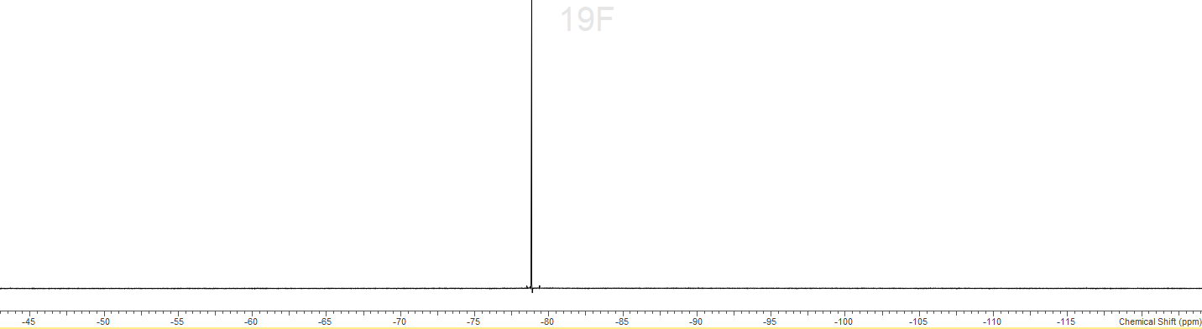
S6.13.0 – [Pb(OTf)₂(ONMe₃)₃]
S6.13.1 - ¹H (295 K, CD₃CN)
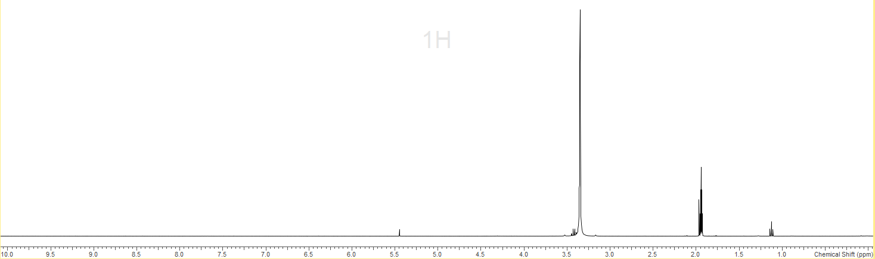
CD₃CN
S6.13.2 - ¹³C{¹H} (295 K, CD₃CN)
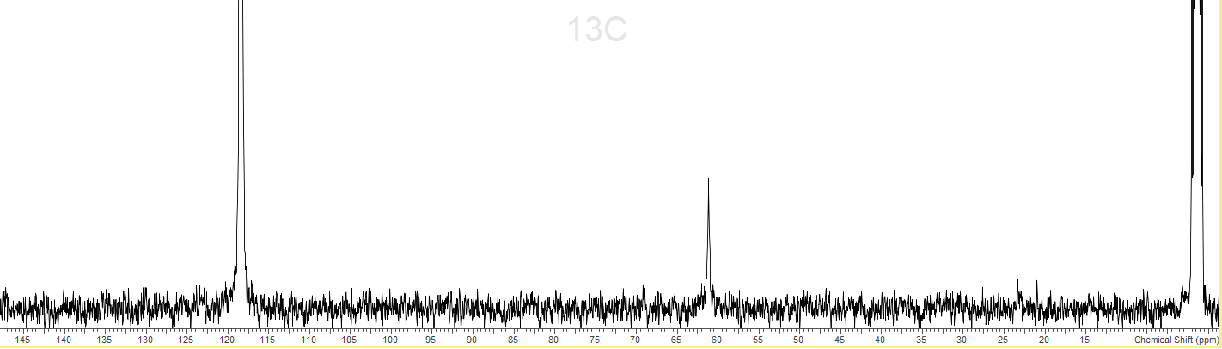
CD₃CN
CD₃CN
S6.13.3 - ¹⁹F{¹H} (295 K, CD₃CN)
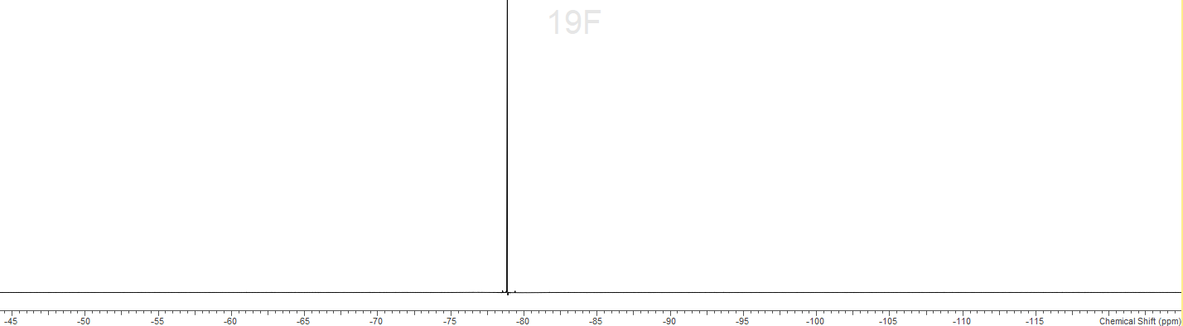

Chapter 7
S7.1.0 - Spectroscopic data for [Sn(OPMe₃)₃][OTf]₂
S7.2.0 – pXRD Patterns of [Sn(OPMe₃)₃][OTf]₂
S7.3.0 - Spectroscopic data for [{Pb(OTf)(OPMe₃)₃}₂(μ-OTf)₂]
S7.4.0 - Spectroscopic data for [Sn(SO₃F)₂(OPMe₃)₃]

S7.1.0 - [Sn(OPMe₃)₃][OTf]₂
S7.1.1 - ¹H spectrum (295 K, CD₂Cl₂)
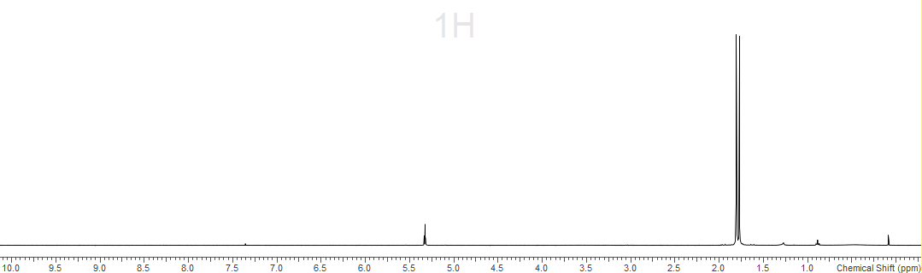
CD₂Cl₂
S7.1.2 – ¹³C{¹H} spectrum (295 K, CD₂Cl₂)
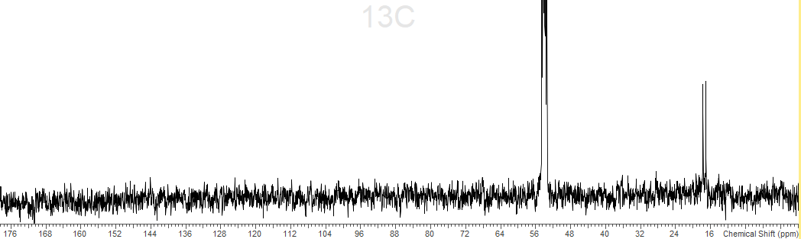
CD₂Cl₂
S7.1.3 – ¹⁹F{¹H} spectrum (295 K, CD₂Cl₂)
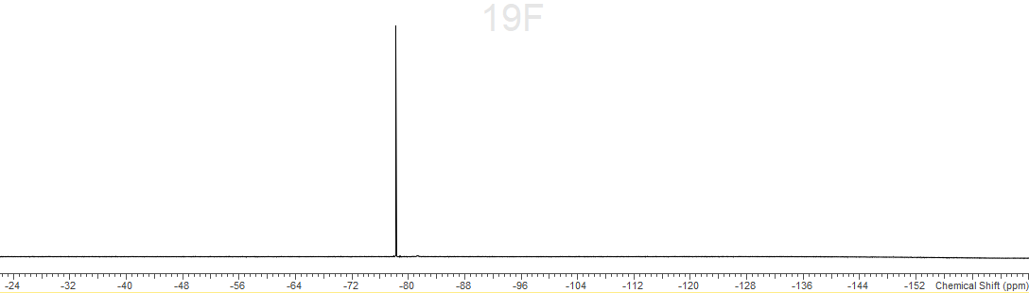
S7.1.4 - ³¹P{¹H} spectrum (295 K, CD₂Cl₂)
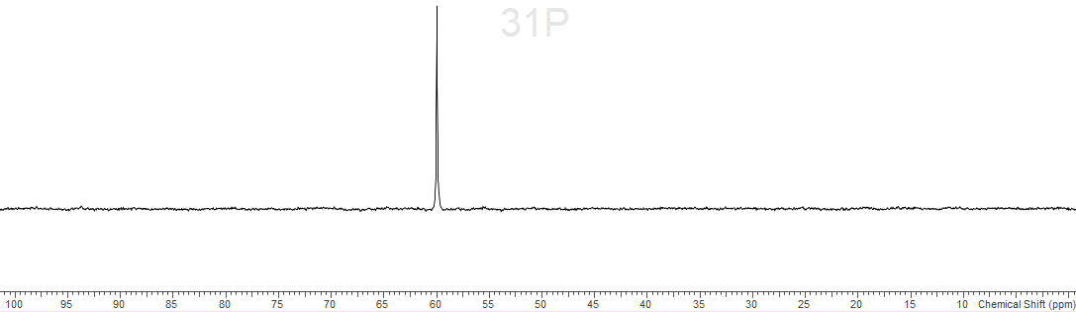

S7.1.5 - ¹¹⁹Sn spectrum (295 K, CD₂Cl₂)
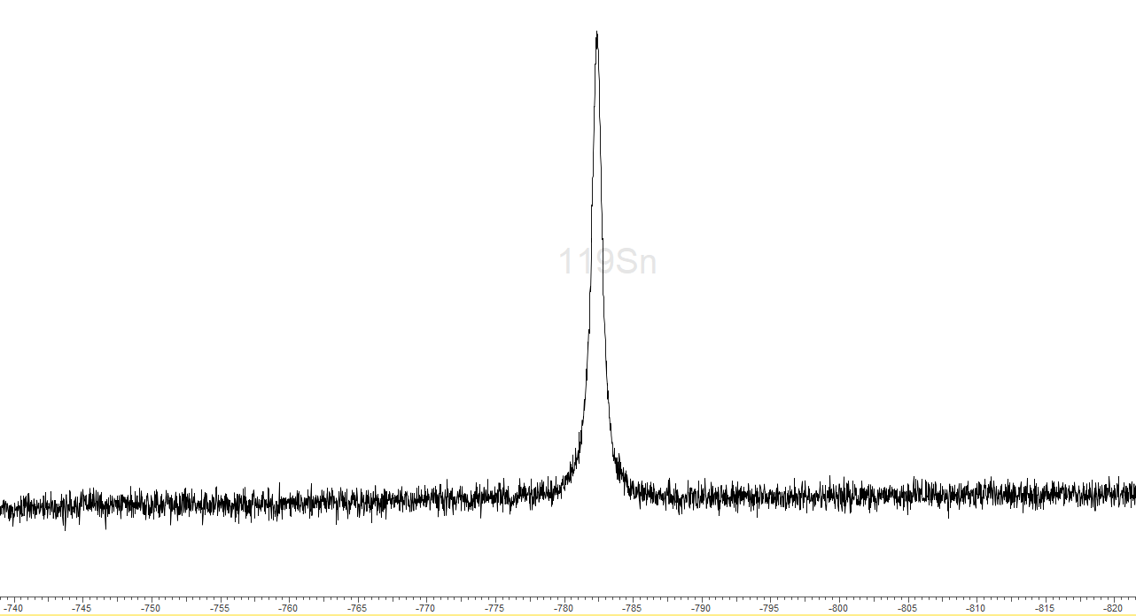
S7.1.6 – IR spectrum (Nujol)
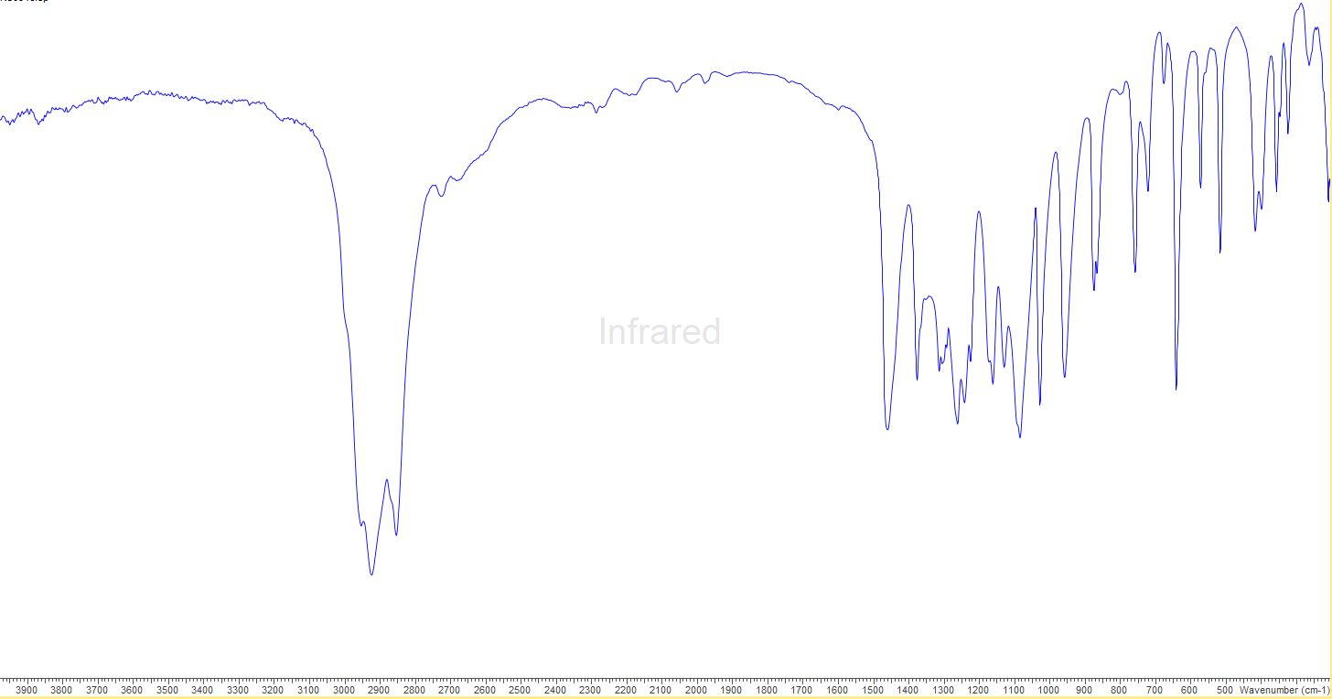

S2.0 - Simulated pXRD pattern of [Sn(OPMe₃)₃][OTf]₂
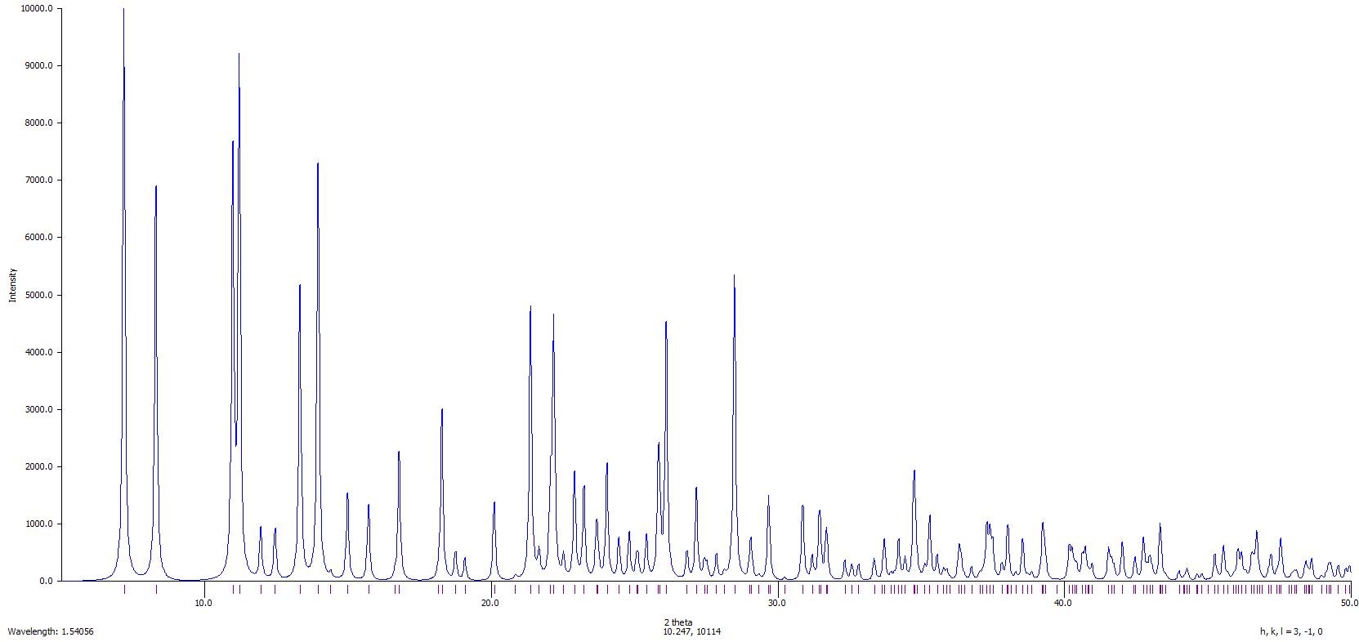
S2.1 - Collected pXRD pattern 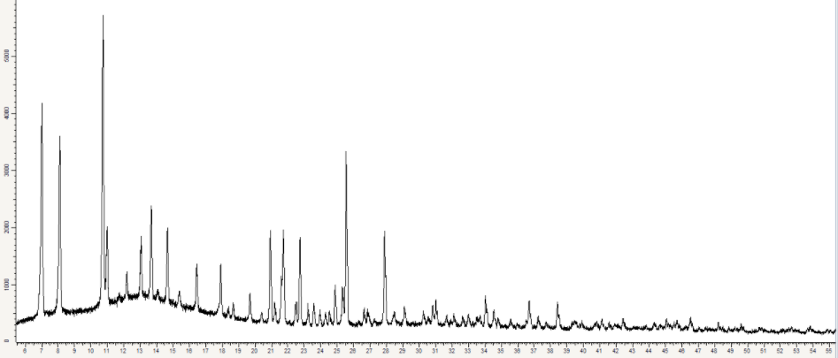

S3.0 - [{Pb(OTf)(OPMe₃)₃}₂(μ-OTf)₂]
S3.1 - ¹H (295 K, CD₃CN)
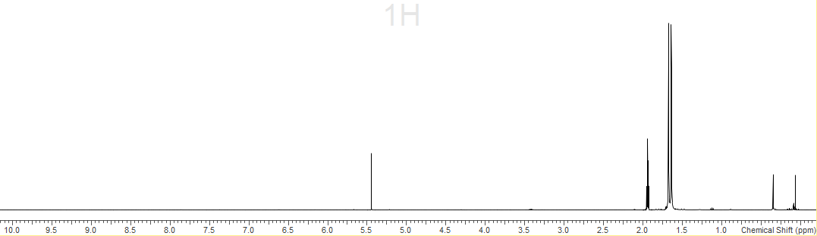
CD₃Cl₂
CD₃CN

S3.2 – ¹³C{¹H} (295 K, CD₃CN)
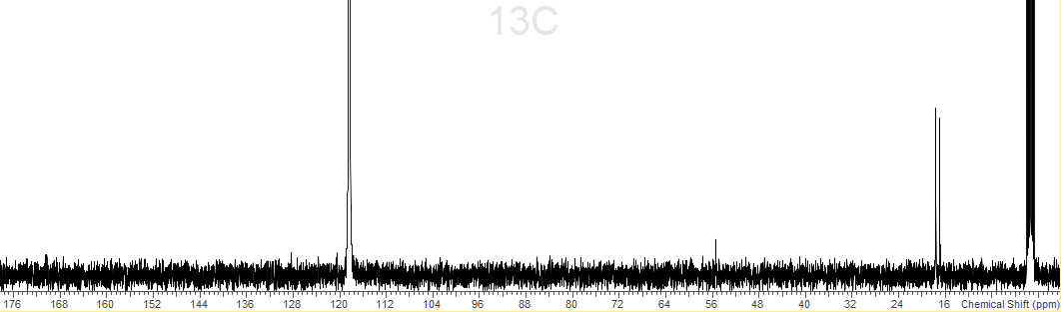
CD₃CN
CD₃CN
S3.3 – ¹⁹F{¹H} (295 K, CD₃CN)
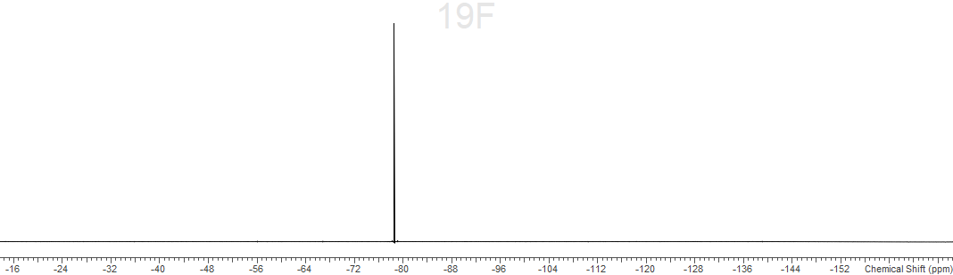S3.4 – ³¹P{¹H} (295 K, CD₃CN)
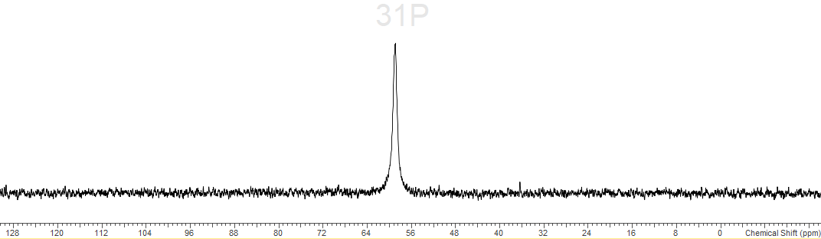
S3.5 – IR spectrum (nujol)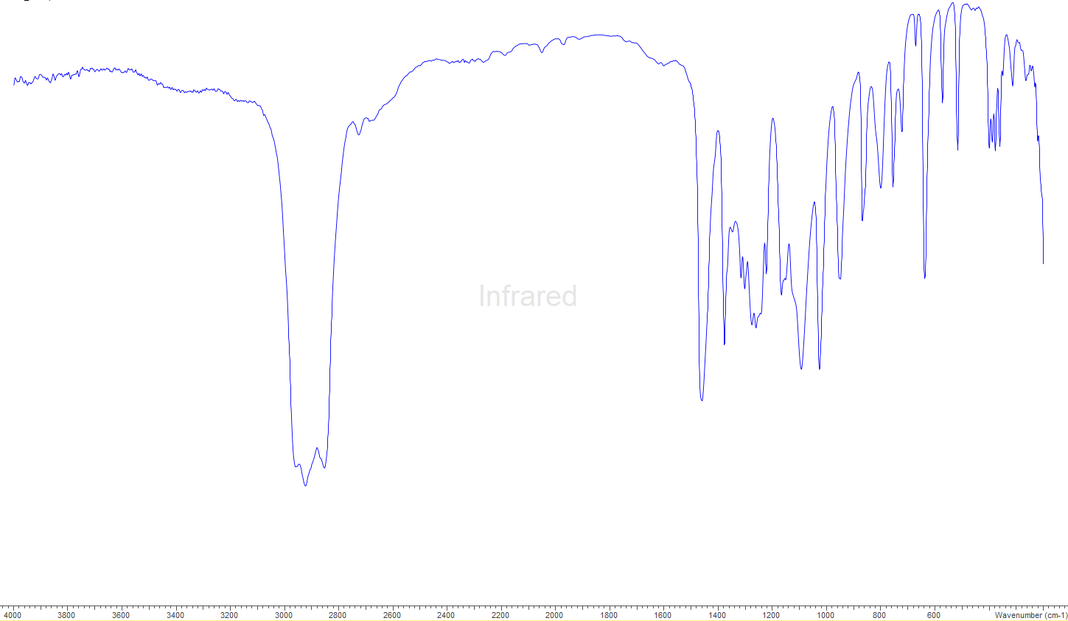
S4.0 - [Sn(SO₃F)₂(OPMe₃)₃]
S4.1 – ¹H (295 K, CD₃CN)
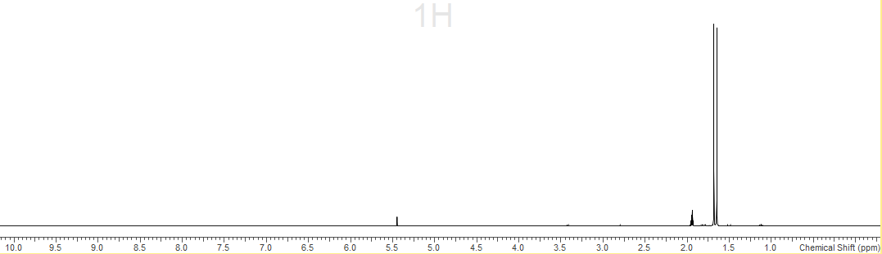
S4.2 – ¹³C{¹H} (295 K, CD₃CN)
CD₃CN
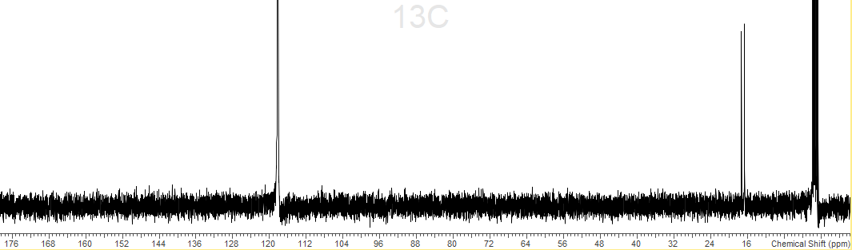
CD₃CN
S4.3 – ¹⁹F{¹H} (295 K, CD₃CN)
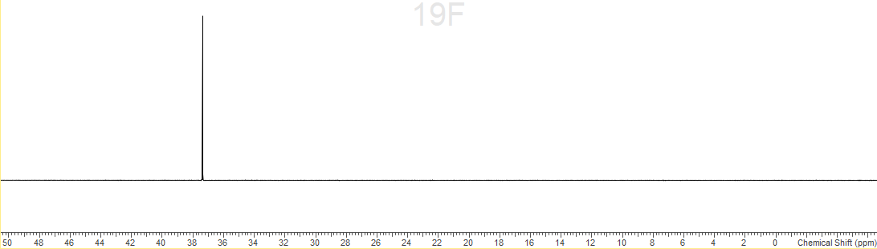
S4.4 – ³¹P{¹H} (295 K, CD₃CN)
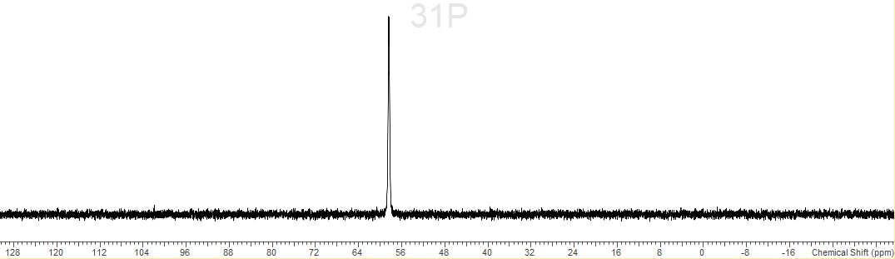
S4.5 – IR spectrum (nujol)
