Forms of culture
Professor Dan Ashton
For Ordinary Things (2-25.11.23)
https://www.southampton.ac.uk/wsa/news/events/2023/11/25-ordinary-things.page

Forms of culture comprises of two text-based pieces – “Forms of Culture: Mix” and “Forms of Culture: Move”. The pieces rework the content of application forms used by UK-based organisations involved in funding arts and culture. Funding bodies can be public sector, charitable trusts and foundations, and commercial businesses. Funding applicants can be responding to a specific funding call set by the funder or seeking funding for their own projects.

The funding application form is an ordinary and everyday aspect of the work of arts and cultural practitioners and organisations intended to result in the funding that then enables programming, projects, events, and so on to be developed and undertaken. Whilst funding application forms are an ordinary and everyday aspects of working in arts and culture for many, they have also received significant scrutiny. This includes technical and accessibility challenges, notably for neurodiverse artists, and constraints placed on how proposed projects can be described and communicated.

“Mix” and “Move” are both participatory pieces which invite the reordering of questions and guidance that were previously fixed in place in funding application forms. “Mix” invites the alignment and realignment of questions and the guidance on how to answer that question. Mixing the question and guidance both suggests the limitations and constraints of forms and potentially opens new possibilities for making sense/not making sense of questions that are asked. “Move” presents a range of similar questions to indicate the adjustments required in moving between different funders and forms and invites reordering or removal of these questions to suggest how descriptions of a project could be narrated and communicated in different ways.

The use of a standard font (Aptos) printed using standard toner on standard office paper aligns with the ways in which funding application forms can be approached as “paperwork” tasks. Using paper is also a response to the limitations and constraints that come with many funding forms being online and digital and not open to editing and reworking.

Materials/media:
Aptos font in black toner on white paper 80gsm
Dimensions:
Forms of Culture: Mix
A4 rind bind folder (210mm x 297mm) with A5 inserts (210mm x 148.55mm)

Forms of Culture: Move
210mm x various
Images courtesy of Dave Gibbons:
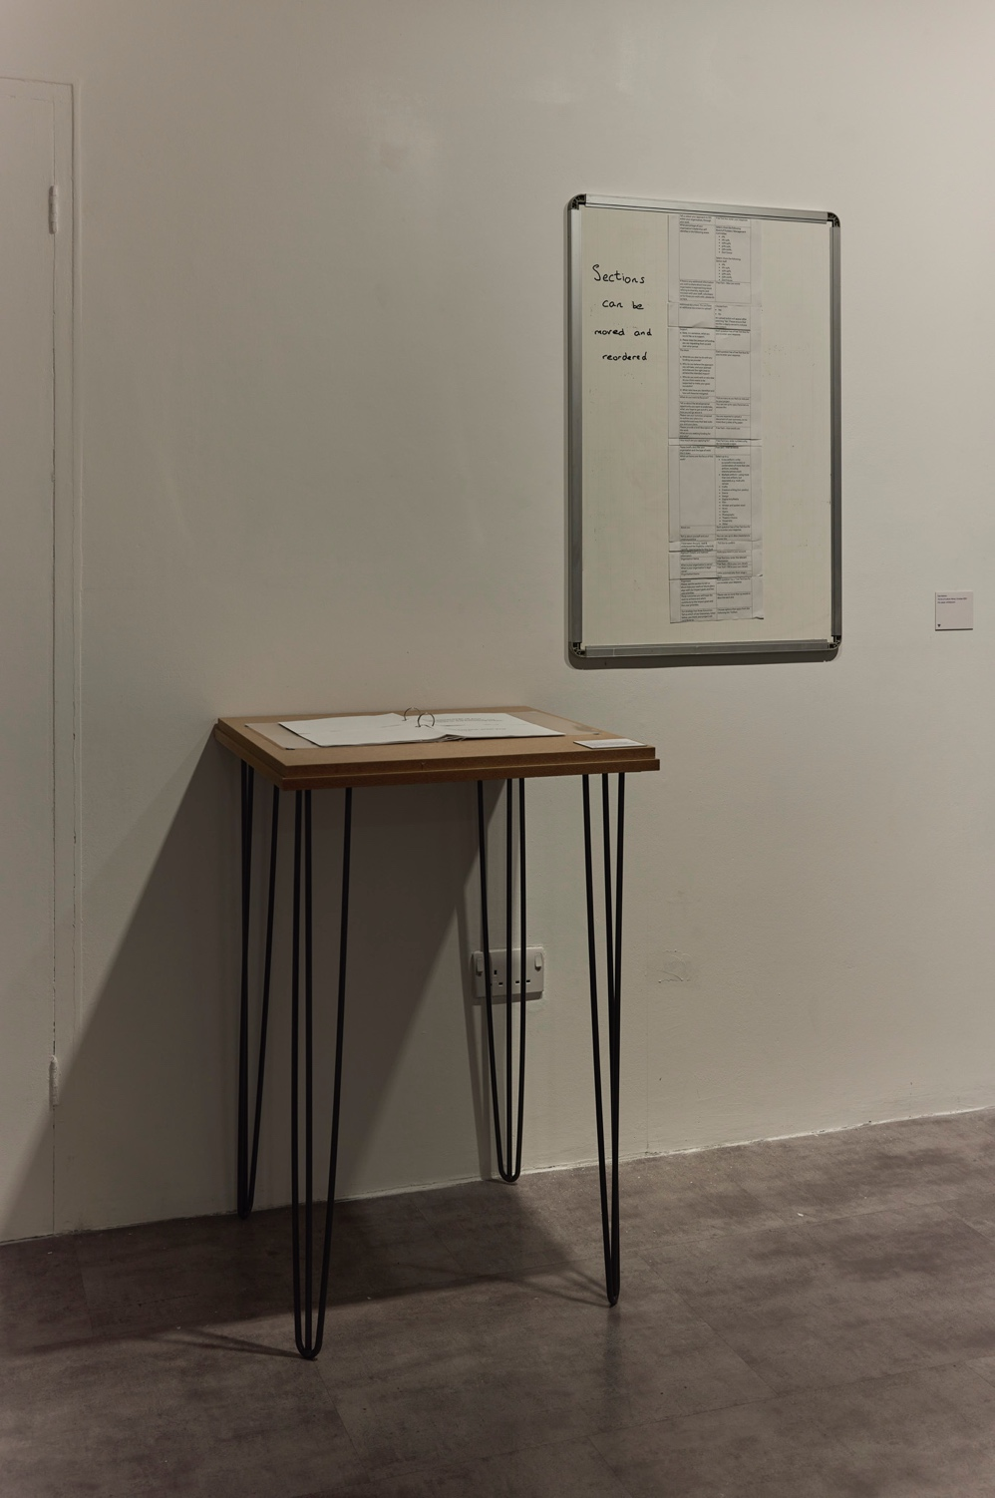

Forms of culture – Mix and Move
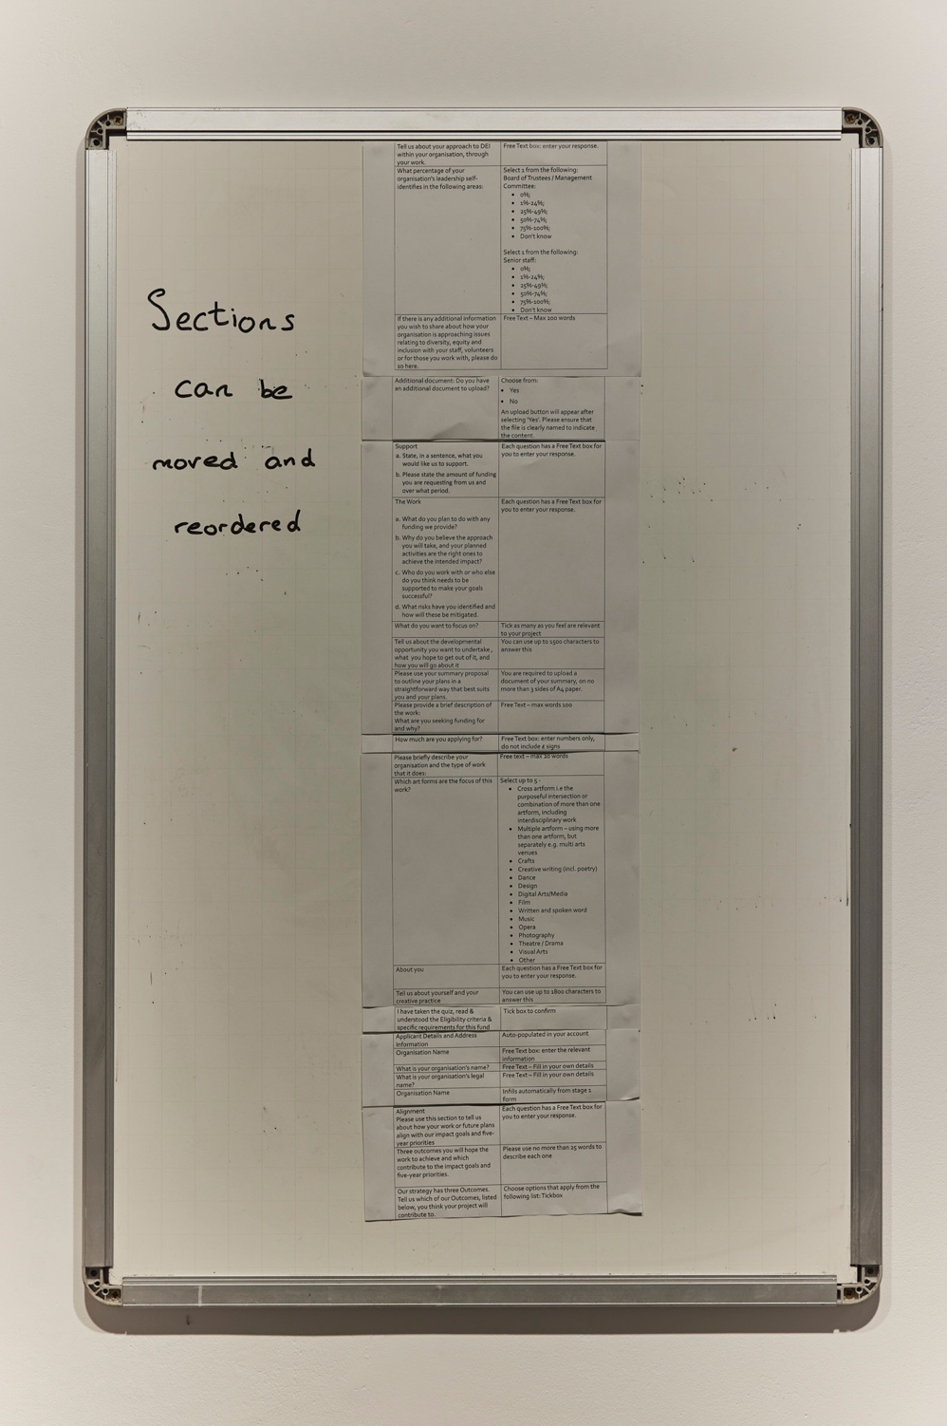

Move
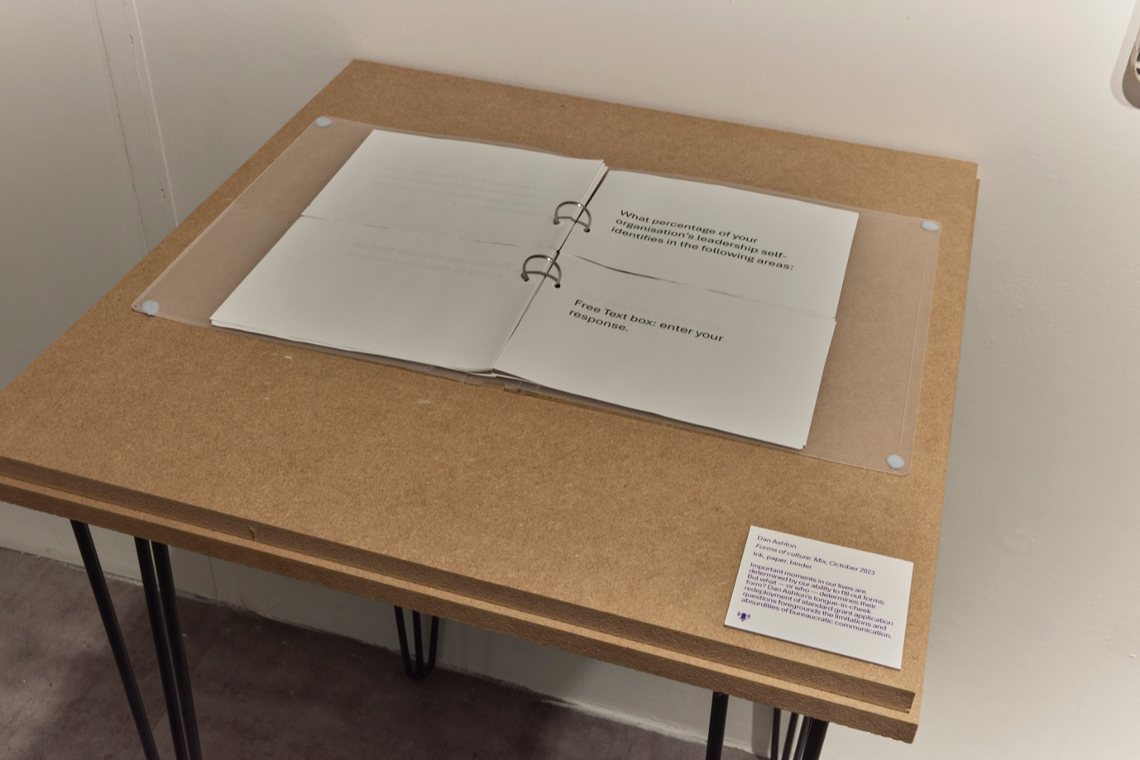

Mix

