Enabling Extreme Fast Charging
of Batteries through the
Pathway of Thermal Management

Tao Zhuª, Andrew Cruden^{b}, Qiao Peng^{c,}*, Kailong Liu^{d,}*
a Warwick Manufacturing Group, University of Warwick, Coventry, CV4 7AL, UK
b School of Engineering, University of Southampton, Southampton, SO17 1BJ, UK
c Information Technology, Analytics & Operations Group, Queen's University Belfast, Belfast, BT7 1NN, UK
d School of Control Science and Engineering, Shandong University, Jinan, 250061, China

E-mail addresses: tao.z.zhu@warwick.ac.uk (T. Zhu); A.J.Cruden@soton.ac.uk (A. Cruden); Qiao.Peng@qub.ac.uk (Q. Peng); Kailong.Liu@email.sdu.edu.cn (K. Liu)
*Corresponding authors: Kailong.Liu@email.sdu.edu.cn (K. Liu); Qiao.Peng@qub.ac.uk (Q. Peng)

Summary:
The need to prevent lithium plating makes battery recharging a slow process. Three pathways are established to facilitate eXtreme Fast Charging (XFC): new electrodes and electrolytes, charging protocol optimisation, and thermal management intervention. In a recent issue of Nature Communications, Zeng et al. pioneered a thermal management approach for XFC.
Main:
Compared to the mere minutes for internal combustion engine vehicles to refuel, battery recharging in electric vehicles (EVs) is considerably slower, often exceeding the 30-minute mark. This is because excessive charging current can easily trigger lithium plating¹ (Li-plating), a phenomenon leading to safety and lifespan concerns. Challenges intensify during fast charging at low temperatures, as reduced liquid diffusion coefficients and slower solid-phase interfacial kinetics further aggravate Li-plating, which heightens the risk of short circuits and promotes mossy growth, diminishing negative electrode porosity and depleting cell electrolyte². The essential task of enhancing battery charging speed while ensuring thermal safety and minimising battery degradation remains a pressing challenge, especially at low temperatures.
The requirements for XFC established by the U.S. Department of Energy are a charging time of less than 15 minutes for a depleted battery to reach 80% State-of-Charge (SoC) and a capacity loss of less than 20% over 500 XFC cycles. Three pathways to achieve XFC have been established: material science, electrical engineering, and thermal engineering, as shown in Figure 1. The material science pathway focuses on developing electrodes with higher porosity and lower tortuosity and electrolytes with higher ionic conductivity and lower viscosity³. Strategies include using silicon composite anodes, increasing the amount of nickel in cathodes, changing the particle size, selective doping, and surface coating⁴. For the electrolyte, solvent compositions and additives can be employed to modify conductivity and viscosity⁵. The material science pathway is a long-term solution to address XFC issues at their root. However, the research and development cycle can be lengthy, and the transition from lab samples to commercial products is fraught with uncertainties, including stability, scalability, ease of manufacture, and cost considerations. The electrical engineering pathway focuses on optimising fast charging currents at different SoCs and/or voltages through experimentation, modelling or a combination of both⁶. Typical fast charging protocols include multi-step constant current, variable current profile, pulse charging, constant power charging, and boost charging⁷. We view the advantages of this pathway as its cost-effectiveness and adaptability, as the optimisation process is software-based and requires minimal additional hardware. However, the disadvantage is that the charging protocol calibrated for one type of battery may not be applicable to other battery chemistries and form factors.
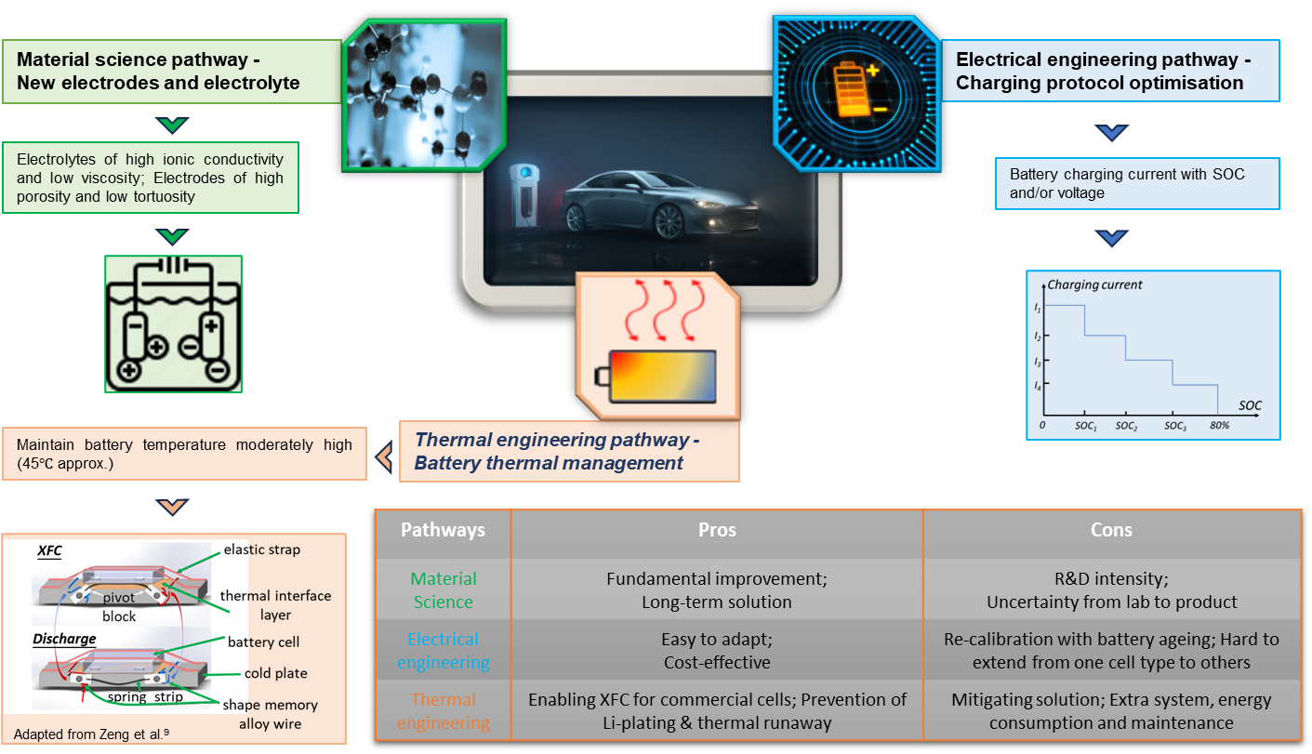
Figure. 1 Three pathways to enable extreme fast charging and their pros and cons.
The thermal management pathway is a mitigating solution aimed to keep battery's temperature moderately high (above 40℃) during the XFC process⁸. Common thermal management systems (TMSs) can use air, liquid, phase change materials, heat pipes, or a combination of these as cooling mediums². We recognise the most significant advantage of this pathway as its ability to maximise XFC for commercial batteries under existing electrochemical technologies. This is achieved by avoiding the occurrence of Li-plating at lower temperatures (even at 25℃, significant Li-plating can occur) through temperature control. However, it is not a fundamental solution, and the arrangement of TMSs can add extra weight, take up extra space, and lead to higher costs and energy consumption.
Through the thermal management pathway, a recent study⁹ by Zeng et al. enabled XFC for energy-dense pouch cells using a cold plate-based system (as shown in the bottom left of Figure 1), particularly at low ambient temperatures (<10℃). They found that the XFC process exhibits a preference for an elevated temperature (~45℃). Such a temperature can enhance battery kinetics, effectively preventing the negative electrode potential from dropping below 0V, thereby thwarting the occurrence of Li-plating – the dominant degradation mechanism for XFC. To maintain an elevated battery temperature, the TMS must possess high insulation capability, meaning the heat transfer coefficient (HTC) during XFC must be adequately low (<10W/K). Unlike the XFC stage, the discharge stage prefers lower temperatures (<35℃), and such temperatures can reduce the rate of detrimental side reactions - the primary degradation mechanism during discharge. In this case, it becomes essential for the TMS to have a sufficiently high HTC (>100W/K). During the XFC stage, they manipulated a low HTC to avoid heat loss, ensuring optimal temperature maintenance. In contrast, they set a high HTC for the subsequent discharge stage to enable swift cooling of the battery. Their efforts culminated in a remarkable outcome: under the conditions of 6C-1C XFC-discharge cycles, they achieved a battery capacity retention comparable to the standard 1C-1C charge-discharge level.
The key inspiration from Zeng’s study is that the perspective on thermal management should extend from the XFC stage to the subsequent discharge stage, rather than solely focusing on XFC itself. ‘Fast charging' implies that the battery will likely be discharged soon after charging. This signifies that the thermal inertia created during XFC will be immediately carried over to the following discharge stage. Consequently, a challenging issue arises: the battery's initial temperature at the onset of the discharge stage is elevated. This demands a prompt reaction from the TMS, rapidly adjusting the HTC to enhance the system's heat dissipation capacity. To facilitate rapid changes in HTC, a most direct solution involves actuation mechanisms that swiftly transition between thermal insulation and thermal contact between the batteries and the cooling medium.
While Zeng’s study adopts an indirect thermal management approach (cold plate-based), we believe it also provides inspiration for direct thermal management approaches, such as immersion thermal management. As highlighted by Zeng, owing to the high thermal mass of batteries, even if the liquid flow rate within the cold plate is reduced to zero, approximately 40% of the battery heat still dissipates to the environment through the cold plates. This circumstance poses challenges for maintaining battery temperature, and Zeng’s solution is to create a thermal-insulating air layer between the batteries and cold plates, effectively curbing heat transfer. This phenomenon could similarly apply to battery immersion systems, where substantial battery heat might be lost to the environment through direct contact with the dielectric liquid. If this deduction holds true, for the purpose of mitigating heat loss during XFC process, it would be beneficial if the dielectric liquid in an immersion system can be predominantly directed into the tank/reservoir rather than staying in the battery modules.
An underreported advantage of the thermal management pathway over the other pathways is its potential to alleviate cell-to-cell (C2C) variations during XFC. The causes of C2C variation can fall into three groups: inherent variations, series-parallel connection induced variations, and thermally induced variations. Cell inherent variations stem from intrinsic discrepancies right from the manufacturing stage, such as subtle differences in impedance and open-circuit-voltage (OCV). The series-parallel connection induced variations arise due to inconsistencies in individual cell operating currents resulting from their series and parallel circuits, leading to differences in SOC and consequent inconsistencies among cells. The thermally induced variations reflect a scenario where the cells inevitably exhibit a certain degree of temperature gradient during the XFC process. Under the cumulative effects of these C2C variations, especially during repeated XFC cycles, the inconsistency between cells can rapidly increase, leading to long-term deviations in capacity and impedance. This can result in some cells being overcharged while others remain undercharged, thereby compromising the overall lifespan and energy efficiency of the entire battery module or pack. One potential solution via the thermal pathway is adopting a modular thermal management architecture, providing poorer thermal insulation for hotter cells (or better thermal insulation for cooler cells), then the thermally induced variations can be more effectively mitigated. Building upon this, the TMS could even intentionally create thermally induced variations to counteract the effects of inherent variations and series-parallel connection induced variations, thus minimising the C2C inconsistency resulting from the combined mechanisms.
In practical XFC applications, both thermal management and electrical engineering pathways face challenges due to their reliance on an implicit and overly idealised assumption. The assumption is that every cell in a battery pack or module is identical at the beginning of its life, with no inherent variations. Based on this premise, optimal cell-level thermal management and charging strategies are derived from experiments and/or modelling and then extrapolated to the pack or module level. However, due to the presence of inherent variations in the real world, strategies derived from cell-level studies will inevitably deviate from the omniscient viewpoint. This deviation tends to grow as the battery ages, and the cumulative effect can render the prescribed strategies increasingly ineffective over extended XFC operations¹⁰, posing a long-term challenge. Future work can pursue two avenues to address this issue. The first approach involves periodically conducting experiments to ascertain the changes in C2C variations, thereby recalibrating the strategies accordingly. The second approach involves leveraging predictive algorithms to anticipate the long-term progression of C2C variations, and to formulate corrective algorithms to fine-tune the strategies. These would ensure the long-term effectiveness of XFC strategies, aligning with the evolving cell parameters and variations over time.
Declaration of interests:
The authors declare no competing interests.
Acknowledgement:
This work is supported by the UK Engineering and Physical Sciences Research Council (EPSRC) grant EP/W005883/1, and the National Natural Science Foundation of China (No. 62373224).

Reference:
1. Qin, Y., Zuo, P., Chen, X., Yuan, W., Huang, R., Yang, X., Du, J., Lu, L., Han, X., and Ouyang, M. (2022). An ultra-fast charging strategy for lithium-ion battery at low temperature without lithium plating. Journal of Energy Chemistry 72, 442-452. https://doi.org/10.1016/j.jechem.2022.05.010
2. Thakur, A.K., Ahmed, M.S., Kang, H., Prabakaran, R., Said, Z., Rahman, S., Sathyamurthy, R., Kim, J., and Hwang, J.Y. (2023). Critical review on internal and external battery thermal management systems for fast charging applications. Advanced Energy Materials 13, 2202944. https://doi.org/10.1002/aenm.202202944
3. Liu, Y., Zhu, Y., and Cui, Y. (2019). Challenges and opportunities towards fast-charging battery materials. Nature Energy 4, 540-550. https://doi.org/10.1038/s41560-019-0405-3
4. Tomaszewska, A., Chu, Z., Feng, X., O'kane, S., Liu, X., Chen, J., Ji, C., Endler, E., Li, R., and Liu, L. (2019). Lithium-ion battery fast charging: A review. ETransportation 1, 100011. https://doi.org/10.1016/j.etran.2019.100011
5. Dufek, E.J., Abraham, D.P., Bloom, I., Chen, B.-R., Chinnam, P.R., Colclasure, A.M., Gering, K.L., Keyser, M., Kim, S., and Mai, W. (2022). Developing extreme fast charge battery protocols–A review spanning materials to systems. Journal of Power Sources 526, 231129. https://doi.org/10.1016/j.jpowsour.2022.231129
6. Attia, P.M., Grover, A., Jin, N., Severson, K.A., Markov, T.M., Liao, Y.-H., Chen, M.H., Cheong, B., Perkins, N., and Yang, Z. (2020). Closed-loop optimization of fast-charging protocols for batteries with machine learning. Nature 578, 397-402. https://doi.org/10.1038/s41586-020-1994-5
7. Bose, B., Garg, A., Panigrahi, B., and Kim, J. (2022). Study on Li-ion battery fast charging strategies: Review, challenges and proposed charging framework. Journal of Energy Storage 55, 105507. https://doi.org/10.1016/j.est.2022.105507
8. Thakur, A.K., Sathyamurthy, R., Velraj, R., Saidur, R., Pandey, A., Ma, Z., Singh, P., Hazra, S.K., Sharshir, S.W., and Prabakaran, R. (2023). A state-of-the art review on advancing battery thermal management systems for fast-charging. Applied Thermal Engineering 226, 120303. https://doi.org/10.1016/j.applthermaleng.2023.120303
9. Zeng, Y., Zhang, B., Fu, Y., Shen, F., Zheng, Q., Chalise, D., Miao, R., Kaur, S., Lubner, S.D., and Tucker, M.C. (2023). Extreme fast charging of commercial Li-ion batteries via combined thermal switching and self-heating approaches. Nature Communications 14, 3229. https://doi.org/10.1038/s41467-023-38823-9
10. Wassiliadis, N., Schneider, J., Frank, A., Wildfeuer, L., Lin, X., Jossen, A., and Lienkamp, M. (2021). Review of fast charging strategies for lithium-ion battery systems and their applicability for battery electric vehicles. Journal of energy storage 44, 103306. https://doi.org/10.1016/j.est.2021.103306

