Putting digital technologies at the forefront of Industry 5.0 for the implementation of a circular economy in manufacturing industries

Sanjiv Narula
School of Management
BML Munjal University, Gurugram, Haryana
Email: sanjivnarula1979@gmail.com

Dr Jagannadha Pawan Tamvada
Southampton Business School
University of Southampton
Email jp.tamvada@soton.ac.uk

Dr Anil Kumar*
Guildhall School of Business and Law
London Metropolitan University
Email: anilror@gmail.com

Dr. Harish Puppala
School of Engineering and Technology
SRM University Amaravati
Email: harish.p@srmap.edu.in

Dr Nakul Gupta
Management Development Institute, Gurgaon
Email: nakul.gupta@mdi.ac.in

*Corresponding author

Putting digital technologies at the forefront of Industry 5.0 for the implementation of a circular economy in manufacturing industries

Abstract
Together with a human-centered approach to designing and operating production and logistics in an industrial context, digital technologies can lead to a sustainable, resilient, and human-centric Industry 5.0 (I5.0). This paper is one of the first interdisciplinary studies integrating digital technologies and circular economy (CE) concepts in I5.0. Using expert-based surveys of industry leaders and analytical hierarchical process techniques advances the knowledge and theory of CE and technology management by empirically investigating the influence of I5.0 on CE aspects in manufacturing. The novel results presented here can enable policymakers and industry leaders to design effective CE strategies.

Keywords: Industry 5.0; Circular economy; Technology management; Digital transformation; Sustainable resilient.

1. Introduction
A decade after the advent of I4.0, the European Commission, formally announced its new initiative, Industry 5.0 (I5.0) in 2021 [1,2]. I5.0 complements I4.0 and emphasizes the need for sustainable and resilient human-centered industries. It underscores the importance of aligning businesses with societal values and social responsibilities beyond digitalization, the mainstay of I4.0. It combines human-centeredness, sustainability, and resilience across technological, social, and ecological spheres [2,3]. The evolution of industrialization from I4.0 to I5.0 emphasizes human elements and sustainability in cyber-physical systems (CPS) and the need to humanize the technological environment of I4.0 [64].
In a 2016 study published in the World Economic Forum, Klaus Schwab outlined how the I4.0 would change society and economy [74]. While I4.0 referred to interconnected machines, processes and systems for optimizing performance, I5.0 involves collaborative interactions between humans and machines to increase efficiency and sustainability [3,4, 76,77,78]. I5.0 combines the promises of I4.0 with greater focus on sustainability, ethical and socially responsible practices, and greater integration between human beings and technology [3,4]. In contrast to I4.0, which focuses on short-term profitability and shareholder value creation, I5.0 aims to promote long-term sustainability and stakeholder value creation [64]. It provides a new impetus to the evolution of circular economy (CE) in contemporary organizations through the adoption of advanced digital technologies [3,4].
While an economy based on digital models emphasizes automation, rationalized production processes, efficiency, and reduced costs, an economy based on a circular model focuses on reusing, recycling, and reducing waste, as CE mainly focuses on 6Rs —Recognize, Reconsider, Realize, Reduce, Reuse, and Recycle—to align organizations and society with sustainability [5]. By combining these two approaches, I5.0 aims to achieve more efficient and sustainable production processes [3,4,39,66]. Thus, I5.0 builds on I4.0 technologies while focusing on sustainability and human-machine interaction towards CE [76]. It promotes a concept of industry that extends beyond the simple economic model of profit and calculates the benefits of a sustainable industry-created prosperity [76,66].
While extant literature has examined the connections between I4.0 and I5.0 [3,4, 39,66, 76,77,78], there is little understanding as to which technologies should be focused on for achieving CE in I5.0 [76,77,78], and the insufficient empirical evidence at the intersection of digitalization and CE in I5.0 research has resulted in a crucial managerial dilemma: should organizations invest in digital technologies or pursue human-centered, sustainable, and resilient strategies? Additionally, what technologies of I5.0 should be prioritized so that circular economy principles can simultaneously be achieved? As businesses are faced with the challenge of making informed decisions about potential investments, the paper aims to examine these crucial research questions to shed light on technologies that can advance CE in I5.0 and enable a more efficient and effective CE implementation in a digitalized future.
Using an expert-based survey conducted among 52 decision makers involved in transforming their respective organizations toward CE in India, Japan and Taiwan, the paper identifies and prioritizes digital technologies that can advance CE implementation in I5.0. The paper makes a novel contribution to the literature at the intersection of the emerging debates on I5.0 and CE by examining which digital technologies should be prioritized for the implementation of the CE during transition into I5.0. Furthermore, the paper makes a methodological contribution by following a new approach of using Interval-Valued Fuzzy Sets (IVFS) in context of I5.0 and CE and having the Fuzzy Evaluation Method (FEM) integrated with AHP for the empirical analysis.
The next section presents a critical review of scholarly articles on CE and I5.0. The third section offers an overview of the research methodology. It describes the data collection process and the analytical approach used in the paper. The fourth section presents the perception of experts on the significance of I5.0 technologies that are prioritized using a fuzzy analytical hierarchical process (FAHP) in the context of CE. The final section presents the conclusion, research implications, limitations of the study, and future research directions.

2 Literature Review
  - Circular economy (CE)
Conceptually, CE combines elements from a variety of scientific fields, including emerging fields that include industrial ecology, eco-efficiency in cradle-to-cradle design, circular material flow and development, resilient social, ecological economics, ecological systems, and natural capitalism, amongst others [6,7,8]. A widely accepted definition of circular economy, given by MacArthur [9], refers to regenerative or sustainable industrial production [10,11]. The different aspects of CE along the product lifespan are summarized in Fig.1.
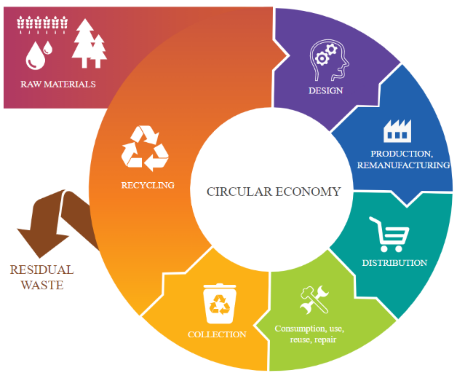
Fig.1 Circular economy model (adapted from Pajula et al., 2017 [12])
As Fig. 1 suggests, an economy built on a circular model replaces end-of-life thinking with repurposing, prioritizes sustainable resources, eliminates hazardous substances, promotes reuse, and reduces waste by optimizing products, processes, and systems [13,14,15]. As a result, CE involves all activities, from mining to manufacturing to delivery, arranged to ensure that one waste of one business becomes another's resource [16,17,18].
However, according to critics, CE's blurry boundaries, ambiguous conceptual foundation, and barriers to adoption make it necessary to study its implementation aspects from different perspectives. Corvellec et al. [21] argue that CE is based on an unrealistic technical and economic agenda, resulting in uncertainty. Murray et al. [22] suggest that CE underestimates the challenges involved in its implementation despite being presented as the solution to sustainability. Niskanen et al. [23] argue that CE perspectives are shaped by industry interventions, policies, and their interactions [23]. Notwithstanding their industrial ecology roots, CE metaphors still lack clarity on the technical context of their implementation as perfect circle [21]. According to Inigo & Blok [24] and Korhonen et al. [13], CE practices have emerged without clear boundaries and policy implementation aspects from the European Union, which makes it a fascinating topic to study from other perspectives.
The concept of CE is not a theory, but rather a method for manufacturing and consuming goods as an umbrella concept that generates interest and excitement because it can help establish a new framework for dealing with a multitude of problems, but it comes under intense scrutiny when implementation raises doubts and concerns. The effort is also supported by a growing number of corporations and local governments [25,26].

2.2 Transition from Industry 4.0 to Industry 5.0 and the Circular Economy

I5.0 builds on I4.0, where the priority has been automation, to focus more broadly on human-centric approach, cross-sector collaboration, and circular economy to leverage technology for a better future [76,77,78,79]. The transition from I4.0 to I5.0 involves moving to a circular economy system that focuses on reusing resources and reducing waste [2,27]. Using digital technologies to enable sustainable growth, I5.0 extends I4.0 to take technical innovation and environmental sustainability to a new level of CE [46]. Complementing the United Nations Sustainable Development Goals, I5.0 aims to achieve a holistic approach in sustainability, resilience, economic growth, and ecological protection [46]. Furthermore, it promotes digitalization with circular economy at its core [76,77,78,79]. Thus, I5.0 aims to make production processes circular: reuse, repurpose and recycle natural resources and minimize waste and pollution. [46,65].

Developed by the European Commission in 2021, I5.0 is a plan for a resilient, sustainable, and human-centric European Industry that effects a fundament shift in the I4.0 paradigm [2,3]. The German high-technology strategy program in 2011 envisioned I4.0, which combined several cutting-edge concepts with digital technologies to revolutionize industries [29]. I4.0 is characterized by disruptive digital technologies that transform the way businesses design, develop, manufacture products and services [30,31]. I4.0 technologies enable manufacturers to increase productivity, efficiency, and cost efficiency, differentiate themselves from their competitors, and improve service, delivery, and quality [30,32]. They enable organizations improve efficiency and productivity through the transformation of business processes [33,34,35]. However, while I4.0 did not consider sustainable manufacturing targets, I5.0 was conceived to facilitate the co-involvement of humans and sustainability [2].

The European Economic and Social Committee describes I5.0 as a combination of CPS and human intelligence to promote sustainability [36]. Within I5.0, the European Commission outlines economic, ecological, and societal aspects of sustainability which are also along with micro goals [37] aligned with the triple bottom line goals of CE. As described by the European Commission, I5.0 does not follow I4.0 chronologically, but instead complements and updates it as well as adding socio-environmental dimensions [38]. With this new focus, industrial development is pushed towards production models that are not only centered on technological innovation and economic growth, but also on a commitment to environmental responsibility and sustainability [76,77,78]. Thus, I5.0 is essentially about integrating the capabilities of humans with the advancements in technology to create a more harmonious and productive work environment [77,78,80,81]. The following are the key facets of I5.0.

Human-Machine Collaboration: In I5.0, machines are not just working autonomously; instead, they're designed to work alongside humans, leveraging their cognitive abilities and problem-solving skills [81]. For instance, in manufacturing, collaborative robots (cobots) are used to assist workers in repetitive or physically demanding tasks, enhancing productivity while ensuring safety.

Customization and Flexibility: One significant aspect of I5.0 is its capability to produce customized products efficiently [76, 77,78, 80]. Advanced manufacturing technologies allow for greater flexibility in production lines, enabling the customization of products to meet specific customer demands without sacrificing efficiency.

Human-Centric Solutions: I5.0 focuses on how technological advancements can improve the lives of workers. Technologies like wearable devices, exoskeletons, and augmented reality are employed not just to boost efficiency but also to ensure the well-being and comfort of workers leading to increased job satisfaction and reduced physical strain [36].

Sustainability and Social Responsibility: I5.0 prioritizes sustainable practices, and technologies are utilized not only to enhance productivity but also to reduce waste, energy consumption, and environmental impact [2, 76, 77]. Businesses are needed to consider their social responsibility by ensuring fair labor practices and contributing positively to their communities.

Thus, the transition from I4.0 to I5.0 involves a fundamental shift in mindset—from a focus on automation and efficiency to a more holistic approach that values the synergy between human skills and technological advancements [2, 76, 77, 77,78,79]. The aim is to create workplaces that are not only highly efficient but also safer, more adaptive, and socially responsible.

As Table 1 suggests, the I5.0 model is a paradigm-shifting model that aims to create a data-driven industrial ecosystem that values sustainable development of industry I5.0 was introduced based on the assumption that I4.0 and its associated technologies focus more on the effectiveness and efficiency than the principles of social fairness and sustainability [27,39, 61]. In the process, it shifts the focus to stakeholder value from shareholder value [1].
Table 1: Comparison of Industry 4.0 and Industry 5.0
Aspects | Evolution phases |  | Xu et al., 2021 [2] | Maddikunta et al., 2021 [36] | Sindhwani et al., 2022 [3] | Ghobakhloo et al., 2022 [40] | Huang et al., 2022[27] | Ivanov, 2022 [39] | Broo et al., 2022 [28] | Lu et al., 2022 [40]
 | Industry 4.0 | Industry 5.0
Scope | Manufacturing value chain | Society as whole | √ | √ | √ | √ | √ | √ | √
Features | Effectiveness  Efficiency | Sustainability  Resilience and human-centric | √ | √ | √ | √ | √ | √ | √ | √
 | Profit-centred productivity | Sustainable development goals |  |  |  | √ | √
 | Economic growth | Economy  Environment and Society |  | √ | √ | √ | √ | √ | √ | √
 | Smart Manufacturing | Sustainable manufacturing |  | √ | √ | √ |  |  |  | √
 | Smart factories | Social smart factory |  | √ |  |  |  |  | √
 | Mass customization | Hyper Customization |  | √ |  |  | √
 | Automated /dark factories | Interdependence of man and machines | √ | √ | √ | √ |  | √ | √
Enabling systems and Technologies | Cyber-physical systems | Cyber-physical systems | √ | √ | √ | √ | √ | √ | √ | √
 | Digital technologies | Digital technologies | √ | √ | √ | √ | √ | √ | √ | √
While I4.0 aligns with traditional economic models emphasizing profits and shareholder interests, it may aggravate some of the underlying socio-environmental issues such as regional inequality, environmental degradation, and global economic fragility [42]. As it primarily aimed at promoting efficiency using technology and maximizing the interconnectedness and applications of technologies, its technologies compete with employees threatening jobs. By contrast, I5.0 represents a new shift in the way humans and technology interact, as it seeks to foster harmonious collaboration between them while addressing environmental challenges and prioritizing well-being of the stakeholders. With a focus on human-centricity, sustainability, and resilience, I5.0 aims to create a future where technology serves humanity in a responsible and ethical manner. Thus, I5.0 is not confined to industry but has a more society-wide scope [2,3, 77].
As technology advances change the way value is created, exchanged, and distributed, it is imperative that these technologies support environment ecology and circular economies. The integration of disruptive technologies in CE improves productivity and quality through effective waste management practices, thereby delivering economic, environmental, and societal benefits [41]. Moreover, Covid-19 has emphasized the need to rethink existing working methods and strategies to make global supply chains more resilient and sustainable [43,44]. For industry to respect its planetary boundaries, it must adopt sustainable business models that re-use, repurpose, and recycle natural resources, reduce waste, and reduce environmental impact, thereby contributing to more efficient, effective, and environmentally friendly sustainability [3,27,36,39,41].
As a result of discussions organized by the Directorate "Prosperity" in 2021, the European Commission officially endorsed I5.0 for a Sustainable, Human-Centric, and Resilient European Industry [2]. Considering the ongoing climate disruption and social tensions, I4.0 may not be an effective framework by 2022, according to the European Commission [37]. I5.0 redefines value chains, business models, and digital transformation in hyper connected environments [2,36].
While scholars have recently made contributions to exploring I5.0's values, these early works concentrated on its micro implications. For example, I5.0 is expected to contribute to several aspects of sustainable development [45,37]. Despite this, little has been done to understand how I5.0 relates to CE and which technologies can accelerate CE's implementation in the context of I5.0 According to Xu et al. (2021) [2] it is crucial to investigate whether I4.0 enabling technologies can also help realize I5.0 goals, or whether there is a need to develop new enabling technologies. I5.0 will require substantial investment from all stakeholders and investments in digital technologies in the context of sustainable development but there is little clarity about which technologies should be prioritized for accomplishing circularity in I5.0 [46].
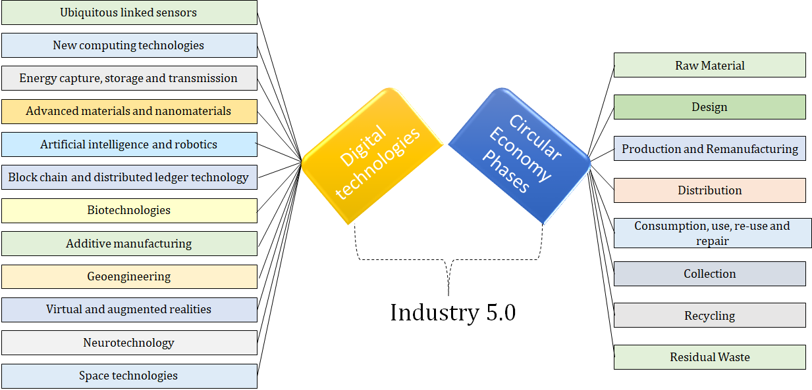
Fig.2: Integration of digital technologies with circular economy towards Industry 5.0

Fig.2 presents the twelve digital technologies identified by the World Economic Forum as key technologies towards future of production [47] and the eight phases of CE [16,17,18, 23]. The figure summarises the key objective of the paper: the identification of the digital technologies that advance CE when transitioning from I4.0 to I5.0. The concept of I5.0 primarily focuses on assimilating the sustainability and social integrity into a smart production system that were untouched in the I4.0 paradigm [47]. Therefore, a symbiotic relationship between the two paradigms, I5.0 and CE can enhance the utilization and restoration of the resources for a healthy planet.
There is vibrant discussion in the literature about the drivers and enablers of digital capabilities to adopt CE [69, 70, 71]. At the same time, a few of studies have explored the associated challenges of this transformation towards digitally enabled CE [72, 73]. Extant research on ‘digital’ circular economy has examined the role of digital technologies for circular strategies in context of I4.0 [46]. Studies have explored the fusion of CE principles with digital technologies, offering various perspectives and frameworks. For instance, Hatzivasilis et al. [82] developed a framework for industrial IoT systems supporting CE, streamlining communication among IoT sensors and facilitating integration with industrial cloud systems [82]. Other studies emphasized different aspects, like the economic analysis of implementing digital technologies for remanufacturing systems and the integration of IoT to address challenges in zero waste management [82].

Karmaker et al., [79] examine sustainability of supply chains in the I5.0 context. They suggest that active involvement of senior managers and financial support are crucial for enabling sustainability in the supply chains [79]. Mukherjee et. al, [77] identify barriers for I5.0 implementation in emerging economies and suggest that financial considerations, capacity scalability and reskilling are the most significant barriers for transitioning into I5.0 in emerging countries. Enang et al., [76] provide a systematic review of the emerging body of literature on the transition from I4.0 to I5.0. Narkhede et al., [85] offer a systematic review of I5.0 literature in the context of the future of sustainable manufacturing. Thus, a rapidly emerging body of literature is examining I5.0, its drivers and its distinct impacts. However, although existing literature highlights the studies specific to drivers, challenges and methodologies in the context of I4.0 and I5.0, extant studies have rarely examined the technologies enabling CE during transition to I5.0. In this context, the paper makes a novel contribution by examining the specific technologies that can accelerate CE when transitioning into I5.0.

3 Research Methodology

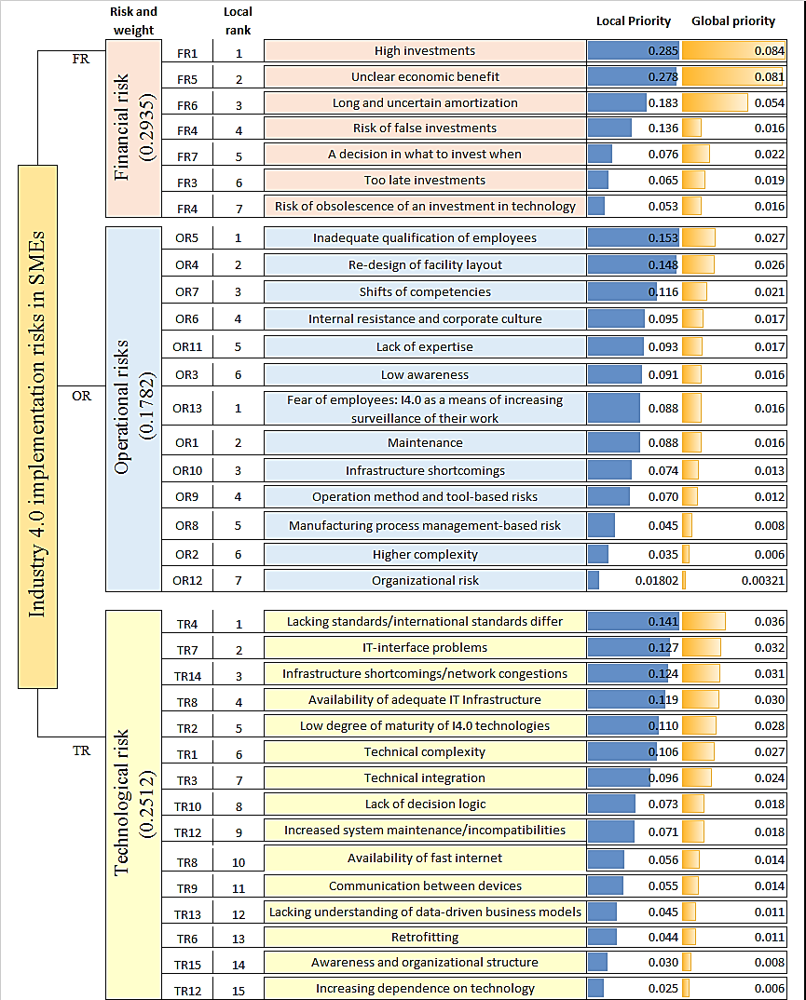
This section presents the research methodology for the prioritization of digital technologies that can advance Circular Economy (CE) implementation in the context of I5.0. The schematic illustration of the steps involved in this study is presented in Fig.3. Evaluating the relative hierarchy is a multi-criteria problem and it is noted that MCDM techniques such as Analytical Network Process (ANP), TOPSIS, and ELECTREE have been widely used in literature. Considering the fact that no quantitative measurements exist for these parameters, AHP technique that uses the perception score obtained from experts to assess the significance of digital technologies is adopted in this study. Fig.3 presents the steps involved in the adopted framework to evaluate the relative dominance of each technology.

An expert-based survey was conducted among various decision makers involved in transforming their respective organizations toward CE and digitalization in manufacturing. In this survey, their perception on the relative comparison of each I5.0 techniques by evaluating over each CE phases is collected. Subsequently, the significance of each CE phase identified in the literature review was evaluated using the Analytical Hierarchy Process. Since the transition from I4.0 to I5.0 is relatively a new area, there may exist a difference in opinion when the perception of the relative importance between the two technologies is collected. Since the AHP technique works on crisp decisions and is ushered by ambiguity and, thus, might not emulate human thinking [48, 62], the concept of Fuzzy is integrated with this study and thus Fuzzy Analytical Hierarchy Process (FAHP) is used in this study to determine the hierarchy of identified technologies.
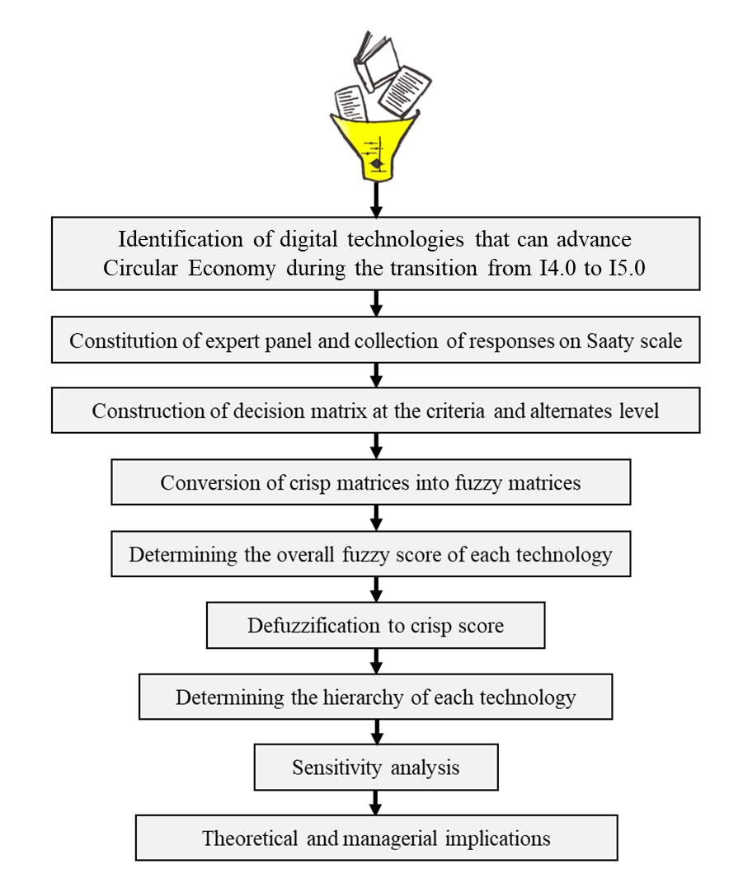
Fig. 3. Schematic illustration of the steps in the proposed research method
As Fig.3 suggests, the analysis first starts with the creation of a hierarchy model representing the total number of layers in the study. This model gives an overview of the total number of criteria and the alternatives as shown in Fig.4. This model is further used as an input to the perform FAHP analysis. A detailed insight into the steps involved in Fuzzy AHP is presented in the subsequent section
3.1. Fuzzy Analytical Hierarchy Process (FAHP): This section discusses the steps involved in analyzing the I5.0 technologies and determine the relative hierarchy.
Step-1: At the primordium of analysis, the scale on which perception is intended to be collected from the experts are identified. Considering the past research works, the Saaty scale, which was widely adopted, is used in this study. This scale contains a wide range of ratings varying between 1 and 9 and is shown in Fig.5. A rating of 1 infers that the two alternatives which are being compared are equally important. This scale also provides flexibility for the user to convert the crisp responses into fuzzy responses as apparent from Fig.5.
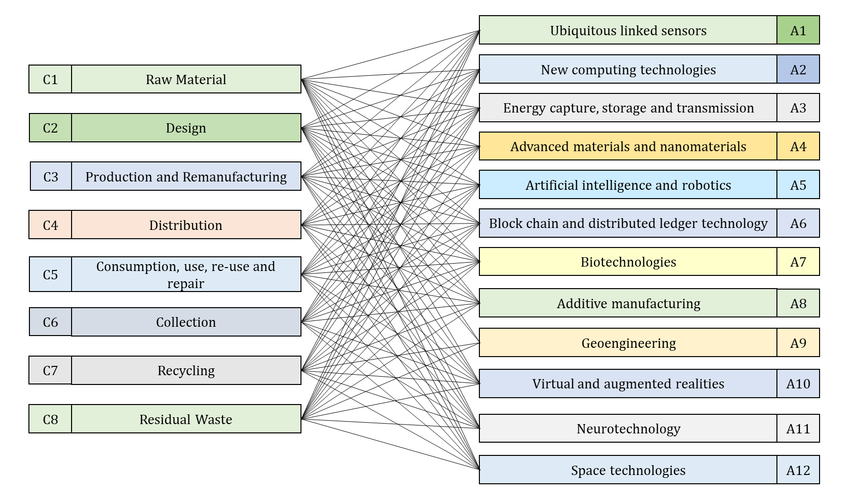
Fig.4. Hierarchical model showing the criteria and the alternatives
Step-2: The obtained responses from the experts are used to construct the pair-wise comparison matrix of alternatives by evaluating them over each criterion. An average method is used to create a representative sample of the responses obtained from the group of experts. As an alternative to the average method, the geometric mean method and range consideration method can also be adopted. The typical representation of the decision matrix is shown in Eq.1.
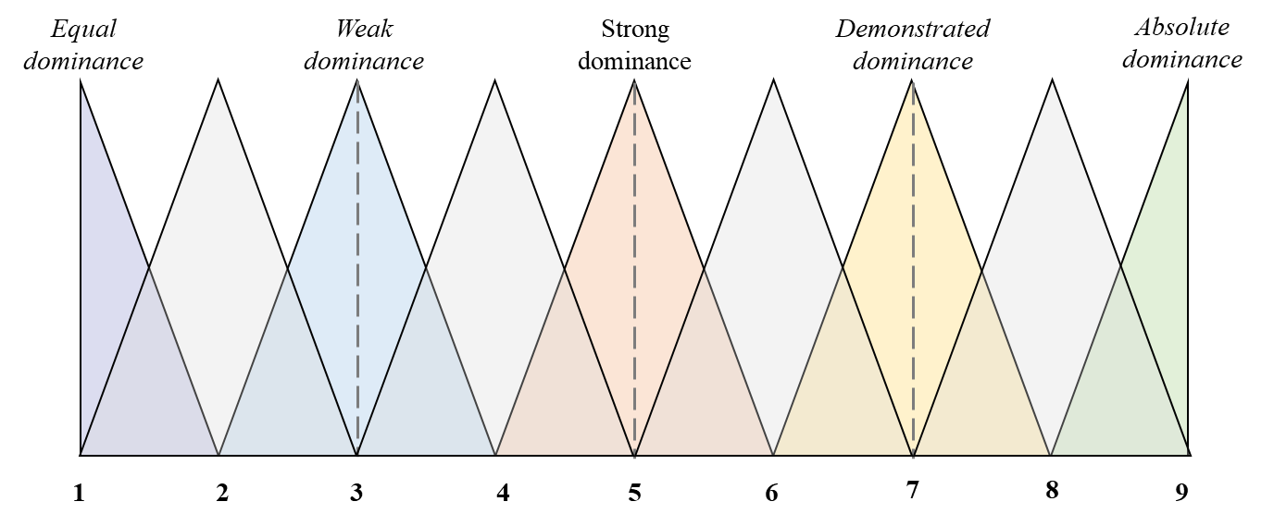
Fig. 5. Crisp and Fuzzy (Triangular fuzzy) weights of Saaty scale
M = $\left[\begin{matrix} & C1 & C2 & C3 & C4 & & Cn \\ C1 & 1 & c_{12} & c_{13} & c_{14} & ⋯ & c_{1n} \\ C2 & 1/{c_{12}} & 1 & c_{23} & c_{24} & ⋯ & c_{2n} \\ C3 & 1/{c_{13}} & 1/{c_{23}} & 1 & c_{34} & ⋯ & c_{3n} \\ C4 & 1/{c_{14}} & 1/{c_{24}} & 1/{c_{34}} & 1 & ⋯ & c_{4n} \\ ⋮ & ⋮ & ⋮ & ⋮ & ⋮ & ⋮ & ⋮ \\ Cn & 1/{c_{1n}} & 1/{c_{2n}} & 1/{c_{3n}} & 1/{c_{4n}} & ⋯ & 1\end{matrix}\right] n =1,2,3....m (1)$
where m is the total number of criteria
Step-3: As part of the evaluation of the significance of each digital technology, the extent analysis method [57] is used. To assist in understanding Chang's extent analysis, we present the mathematical underpinnings below.
Based on the assumption that A = [x1, x2, x3, .... xn] is the array of objects and O = [G1, G2, G3, .... Gn] is the set of objectives, The Chang extent analysis approach calculates the extent of an object in relation to each objective
Fuzzy extent value of each goal (Gi) is computed using triangular fuzzy numbers. Say, if the number of extent values is represented using Eq. 2, the fuzzy extent value of an object can be calculated using Eq. 3 [58].
$$V_{0i}^{1}, V_{0i, }^{2}V_{0i}^{3},V_{0i}^{4},V_{0i}^{5}…………V_{0i}^{v}, i=1, 2, ….n (2)$$
$$S_{i}=\sum_{j=1}^{v}{V_{0i}^{j}⊗{\left[\sum_{i=1}^{n}{\sum_{j=1}^{v}{V_{gi}^{j}}}\right]}^{-1}} (3)$$
where $V_{gi}^{j}$ (j = 1,2, 3,….. v) represents the triangular fuzzy numbers, $S_{i}$ is a normalized fuzzy number, and m denotes the number of extent analysis values for each object. Fuzzy addition operation is performed using Eq. 4 for the computation of second terms in Eq.3 i.e., $\sum_{j=1}^{m}{V_{0i}^{j}}$
$$\sum_{j=1}^{m}{V_{0i}^{j}}= \left(\sum_{j=1}^{v}{p_{i}},\sum_{j=1}^{v}{q_{i}},\sum_{j=1}^{v}{r_{i}} \right) (4)$$
Further, to compute ${\left[\sum_{i=1}^{n}{\sum_{j=1}^{v}{V_{gi}^{j}}}\right]}^{-1}$, the fuzzy addition operation, as shown in Eq. 5, is performed
$${\left[\sum_{i=1}^{n}{\sum_{j=1}^{v}{V_{0i}^{j}}}\right]}^{-1}=\left[\frac{1}{\sum_{i=1}^{n}{r_{i}}}, \frac{1}{\sum_{i=1}^{n}{q_{i}}}, \frac{1}{\sum_{i=1}^{n}{p_{i}}}\right] (5)$$
Step-4: Formulation of overall performance matrix
In this stage of analysis, overall performance of each alternative is determined by evaluating each alternative across all criteria resulting in a fuzzy performance matrix.
Step-5: The defuzzified score helps in determining the hierarchy of technologies on which manufacturing companies should focus on the transition to I5.0 from I4.0.
Step-6: In the last stage of analysis, sensitivity analysis is performed to check the credibility of the derived hierarchy.
Step-7: Theoretical and practical implications are drawn to ease the transition from I4.0 to I5.0

3.2. Sample
To acquire the perception of the identified technologies, an expert panel comprising sustainability heads and engineers is constituted. As I5.0 adoption is in its initial stages, this study explores a targeted sample rather than a general one. The sample for this research involved fifty-two industry leaders from forty-six manufacturing companies that have started the implementation of I5.0 and circular economy. The experts were identified from a database of Confederation of Indian Industries India, Society of India Automobiles, APO Japan, and China Productivity Center in the Republic of Taiwan.
A prior inquiry was made by visiting the websites of applicable organizations and calling them to determine whether any of them have embraced I5.0 and CE. If yes, it was also inquired whether their management has given due importance to facilitating its implementation. Among the targeted sample were chief sustainability officers and heads of digital transformation, who averaged 17 years of industry experience. Selecting the experts was based on the following criteria: 1) have at least a bachelor's degree in technology/engineering; 2) possess leadership experience in digitalization and circular economies within the organization and be available throughout the study period. The data was collected online between December 2021 and March 2022. Approximately thirty minutes were required to complete the survey. The sample size of the research is adequate and in line with research pragmatism [59] due to the novelty of the investigation.
4 Analysis and Results
4.1 Analysis
The analysis started with the collection of responses from each of the experts in the panel to prioritize the I5.0 technologies for advancing CE. The cumulative score of each digital technology was evaluated by assessing them over various CE phases using FAHP using the framework presented in section 3.
The experts were asked to determine the significance of each digital technology over the other by evaluating them over one CE phase at a time. The equivalent analysis is made at the criteria level i.e., different elements of the circular economy. These responses were collected using the Saaty scale and the obtained responses are used in constructing the decision matrices. A sample decision matrix showing the dominance of each digital technology when evaluated by considering raw material as a criterion is shown in Table I of online Appendix-I.
Equivalent attributes corresponding to the evaluations made by considering each other CE phases are also available. It may be noted that the criteria-criteria matrix referring to the evaluation of CE phases is not constructed as it is suggested that there exists no relative hierarchy among the different elements of CE leaving the decision-decision matrix as the identity matrix i.e., all the elements of the matrix are equal to 1.
After the creation of decision matrices, considering the range of responses obtained from the expert panels, an offset distance of 1 is considered and the responses are fuzzified using the scale presented in Fig.5. Subsequently, the fuzzified matrices are constructed by considering by converting the crisp responses into fuzzy responses. Table II of online Appendix-I presents the defuzzified score of each technology. The obtained fuzzy score of each technology is further de-fuzzified to derive the crisp score that helps in understanding the hierarchy of each technology. The total integral value approach is adopted in this study for defuzzification. Eq.2 presents the mathematical relation used to de-fuzzify a fuzzy number ($x,y,z)$.
${ I}_{T}^{λ}$(A) = (1/2) [λz + y + (1-λ) x], λ$∈[0, 1]$ (6)
Where, λ indicates an optimism index, explaining the attitude of the experts. A higher value of λ specifies a high level of optimism. The value of 0 signifies a pessimistic level, that of 0.5 signifies a moderate level, and 1 signifies the optimistic views of the experts. The total integral values parallel to each alternative are calculated using Eq.6 for obtaining the defuzzified score concerning the discrete value of λ at 0.5.

4.2 Empirical Results

The defuzzified score of each technology is presented in Table.2. The empirical analysis suggests that 6 out of 12 digital technologies of I4.0 are significant for achieving circular economy when transitioning into I5.0. These six digital technologies explain nearly 70% of the variance in the experts’ feedback on the relevance of different digital technologies for circular economy. These are ubiquitous sensors (0.174), new computing technologies (0.158), energy capture, storage, and transmission (0.155), advanced materials and nanomaterials (0.15), artificial intelligence, and robotics (0.15), and blockchain technologies (0.148). The hierarchy remains unaltered by the change in the degree of optimism.

Table.2 Overall dominances of each technology in terms of fuzzy and de-fuzzified score
Ubiquitous linked sensors | (0.396, 0.129, 0.040) | 0.174
New computing technologies | (0.357, 0.118, 0.039) | 0.158
Energy capture, storage and transmission | (0.361, 0.112, 0.036) | 0.155
Advanced materials and nanomaterials | (0.342, 0.112, 0.034) | 0.15
Artificial intelligence and robotics | (0.343, 0.111, 0.034) | 0.15
Block chain and distributed ledger technology | (0.338, 0.110, 0.035) | 0.148
Biotechnologies | (0.240, 0.075, 0.024) | 0.103
Additive manufacturing | (0.209, 0.064, 0.019) | 0.089
Geoengineering | (0.201, 0.059, 0.018) | 0.084
Virtual and augmented realities | (0.193, 0.058, 0.018) | 0.081
Neurotechnology | (0.096, 0.023, 0.008) | 0.037
Space technologies | (0.085, 0.022, 0.007) | 0.034
Note: De-fuzzified score is based on an optimistic score of 0.5

Thus, the results suggest that by using ubiquitous sensors, it will be possible to utilize resources more efficiently and sustainably, which is also the objective of CE in I5.0. When adopted with new computing technologies, I5.0 will benefit by optimizing strategies, reducing input materials, and improving process innovation to achieve CE. By reducing energy, water, and chemical consumption, sensor-based technology improves production efficiency, thereby lowering the company's environmental footprint. CE can be accelerated in I5.0 by combining ubiquitous sensors, cutting-edge computing technology, and blockchain, enabling circularity of resources, creating better value propositions, augmenting decision-making processes, and analyzing a huge amount of data generated by smart devices. As a result of the combination of cyber-physical systems including networking, ubiquitous sensors, new computing technologies, artificial intelligence, robotics, and blockchains, an intelligent manufacturing environment can be created to achieve cleaner production strategies using cyber-physical systems.
5. Discussion
This research paper analytically examines the key technologies that advance circular economy when transitioning from I4.0 to I5.0. The new results presented here suggest that ubiquitous linked sensors, new computing technologies, energy capture, storage and transmission, advanced materials, AI and robotics, block chain technology, and additive manufacturing are crucial for CE when transitioning into I5.0.
Ubiquitous sensors: The ubiquitous sensors received the highest rating (0.174) in experts' ratings and will enable more efficient and sustainable resource use, which is also CE's objective. With I5.0, CE can be accelerated by utilizing ubiquitous sensors, enabling circularity of resources, improving value propositions, strengthening decision-making processes, and analyzing huge amounts of data generated by smart devices. Ubiquitous sensors, also known as IoT sensors, track assets and guide decisions that can reinforce CE principles. As an example, German Thyssenkrupp uses IoT to reduce waste and enable predictive maintenance on elevators [86]. As another example, a public-private partnership helped develop GreenLab Skive in Danish Skive Municipality [87]. Energy exchanges between organizations are made possible by the integrated intelligent infrastructure in the park, which optimizes energy use and facilitates business energy exchanges. There are many examples of such technologies being used in the EU, for instance, TagItSmart. These smart tags allow stakeholders - from the factory to recycling; to producers and consumers - to track items and provide additional information [88].
New computing technologies: New computing technologies received an overall score of 0.158, and ranked highly by experts. Using new computing technologies, life cycle assessments can be used to suggest new materials. The advancement of computing technology is having a significant impact on the design and development of sustainable materials, making them eco-friendlier than ever before, enabling the circular economy to become a reality, as well as creating a more sustainable world. New computing technologies, including machine learning and quantum computing, enable us to advance CE despite the constraints of the linear economy. Connected technical infrastructure will advance sustainability by enabling data exploitation from the edge to the cloud, experiments, and collaboration among inter-organizations.
Energy capture, storage and transmission: By capturing, storing, and transmitting renewable energy efficiently during I5.0, CE can be accelerated as a result of reducing reliance on fossil fuels, as evidenced by the high score (0.155 in the experts' score) in the expert survey. Although the technological advancements of I4.0 are applicable to I5.0, new innovations in capturing, storing, and transmitting renewable energy must achieve a balance between humans and machines while protecting the planet from degrading environmental conditions at the same time. As a result of energy capture, storage, and transmission technologies, substantial amounts of waste can be reduced during the production of components, materials, and final products. Through digital tools, waste, emissions, and resource consumption can be reduced. By capturing, storing, and transferring renewable energy efficiently, CE can be accelerated in the I5.0 transition by reducing the need for traditional fuels in the process of the transition.
Advanced materials and nanomaterials: The expert score of 0.15 illustrates that by repurposing waste materials as part of nanotechnology, useful resources can be developed by repurposing waste materials as part of nanotechnology in order to develop useful resources. There are a number of opportunities to use them, including recovering materials and energy from waste, reducing pollution, and creating a more sustainable economy as a result.
Artificial Intelligence and Robotics: The use of artificial intelligence in the circular economy has also been given a high score of 0.15 by an expert analysis of the use of artificial intelligence in the circular economy. AI can also identify opportunities for circular economy initiatives, minimize waste and increase efficiency for CE. Furthermore, designers can refine design suggestions with artificial intelligence by testing various designs with different materials and architectures.
Block Chain Technology: As evidenced by the score of 0.148, Block chain technology can enhance circularity as it increases traceability of recycled rare metals in secondary markets, which can significantly enhance the circularity of recycling rare metals.
As manufacturing moves towards I5.0, CE in manufacturing is about creating products that are environmentally friendly, durable, reusable, and able to be disassembled, upgraded, and reused. Even though there is much work to be done, ubiquitous sensors, advanced materials, nanomaterials, AI, robotics, and additive manufacturing have the promise to accelerate CE during I5.0 transition based on the results presented in Table.2.
I5.0 represents a paradigm shift in the way humans and technology interact. It seeks to foster harmonious collaboration, address environmental challenges, and prioritize the well-being of all stakeholders. With a focus on human-centricity, sustainability, and resilience, the I5.0 aims to create a future where technology serves humanity in a responsible and ethical manner, paving the way for a better world. Last but not least, I5.0 is not confined to the industry from which it derives the tag of industrial revolution, but its scope is society wide.

6 Conclusion
At present, businesses across the world are undergoing transition on two main axes: emergence of circular economy and technological advances acting as a lever for value creation. Both developments have the potential to transform economy and society. Currently, the European Union (EU) and national policymakers are making significant efforts to promote both transitions - but these efforts are rarely aligned. Based on the analysis of feedback received from policymakers and experts working towards digitalization and CE in manufacturing, six technologies are predicted to have the most significant impact on CE when transitioning into I5.0.

Contribution to theory
The I5.0 research area is currently at the very beginning of its development, so the existing literature tends to focus almost exclusively on definitions, concepts associated with, benefits of, and contributions to I5.0, as well as its adoption [1,2,3,4,36,37,39,40]. Despite the fact that I5.0 is often discussed as a method of promoting sustainability through digitalization, its linkage to sustainability practices, such as circular economies, is still not fully explored in the literature. Several prominent researchers have emphasized the need for further research into integration of I5.0 along with contemporary practices to develop a theory [777,78,79, 80,84]. The paper aligns the two discussions that are often held separately (I5.0 and CE), while acknowledging their relevance to greater sustainability and competitiveness. To the best of the authors' knowledge, this is the first study that examines the relationship between I5.0 and CE and determines which technologies of I5.0 should be prioritized to achieve circular economy principles. Moreover, expert judgments and model intervals have never been captured using interval-valued fuzzy sets (IVFS) within I5.0 and this can be argued as a methodological contribution of this study.

Managerial implications
The adoption of CE and I5.0 is one key enabler for organizations to become carbon-neutral by 2050, meet the Sustainable Development Goals 3. The lack of research explicitly linking I5.0 and CE results in a managerial dilemma: which digital technologies to deploy for implementation and which technologies to prioritize?
As a major goal of this study, it aims to merge and align two often divergent discussions among experts on CE and the transition to I5.0, while also recognizing that both transitions will increase competitiveness and sustainability. In a step towards achieving CE, this research prioritizes digital technologies within the context of I5.0 based on the analysis of experts’ feedback using the Fuzzy AHP approach. The originality of the study lies in the expert-based perspective that it takes on I5.0 and its relation to CE, and on a practical level, identifies technologies that must be prioritized if CE is to be realized. Expert feedback reveals that six digital technologies explain nearly 70% of experts' opinions about fast tracking CE adoption in I5.0. These are ubiquitous sensors, new computing technologies, energy capture, storage, and transmission, advanced materials, nanomaterials, artificial intelligence, robotics, and block chain technologies. Moreover, it demonstrates an opportunity to create a fruitful alignment to improve disruptive technologies in the manufacturing sector. The results are more broadly applicable to other sectors and country contexts.

Limitations
The primary focus of the paper is to investigate the influence of I5.0 on CE application in the manufacturing sector. However, this research is profoundly reliant on the understanding of experts and rigorous investigation of the perceived impact of digital technologies in accelerating CE adoption in manufacturing industries. Furthermore, the digital technologies examined here are yet to reach the stage of a practical and marketable level of maturity. This study also focuses on large-scale organizations, as I5.0 technologies are yet to reach a mature level of execution in small-and medium-scale industries. Nevertheless, this study offers key evidence for the requirement to create more structured models that can be established empirically and longitudinally.

Directions for Future Research
In the 2021-2027 Multiannual Financial Framework (MFF), the Commission proposes allocating 15% of the budget to innovation and digital, contributing to the transition to a (digital) CE. Even though EU agencies have not comprehensively linked digitalization with the transition to a CE when developing policies and funding projects, more can be done to align these agendas. Further studies are required to assess the strategies that can be used by various establishments in diverse settings for integrating I5.0 with CE. Future studies can explore the key challenges in integrating sustainability with I5.0 technologies.

After full implementation of I5.0, manufacturers will be able to provide more accurate, up-to-date data and a better understanding of the many issues they face, allowing for more objective analysis and correlation. Subsequent research with OEMs who have implemented I5.0 technologies across the supply chain will help test hypotheses and lead to more detailed theory building. More research is needed to gain a better understanding of how I5.0 is applied in different industries.

Also, future research can draw a comparison between developing and developed countries regarding the prioritization of I5.0 technologies in implementing CE in manufacturing industries. Many challenges, barriers, and risks need to be addressed to achieve a (digital) transition to a CE, which can be a fruitful area of future research. Further studies might be required to assess the strategies embraced by various establishments in diverse settings for integrating I5.0 with contemporary practices. Businesses preparing to initiate I5.0 can start with small-scale research and continuous improvement in a controllable and affordable manner. Additionally, companies must develop practical, large-scale case studies that describe and assess the factors they must consider when incorporating I5.0 into their ongoing sustainable development frameworks. For this, the development of a new tool that provides a practical and usable charter for manufacturing organizations to decide how to start, scale, and sustain the I5.0 transformation can add significant value. Overall, this paper makes a compelling case for achieving the sustainability goals in industry as technology evolves over time, and suggests that dramatic advances such as ubiquitous sensors, new computing technologies, AI and robotics, and blockchain technologies can be leveraged systematically to advance the principles of CE.

References
- Madsen, D. Ø., & Berg, T. (2021). An exploratory bibliometric analysis of the birth and emergence of industry 5.0. Applied System Innovation, 4(4), 87.
- Xu, X., Lu, Y., Vogel-Heuser, B., & Wang, L. (2021). Industry 4.0 and Industry 5.0—Inception, conception and perception. Journal of Manufacturing Systems, 61, 530-535.
- Sindhwani, R., Afridi, S., Kumar, A., Banaitis, A., Luthra, S., & Singh, P. L. (2022). Can industry 5.0 revolutionize the wave of resilience and social value creation? A multi-criteria framework to analyze enablers. Technology in Society, 68, 101887.
- Saniuk, S., Grabowska, S., & Straka, M. (2022). Identification of Social and Economic Expectations: Contextual Reasons for the Transformation Process of Industry 4.0 into the Industry 5.0 Concept. Sustainability, 14(3), 1391
- McDowall, W., Geng, Y., Huang, B., Barteková, E., Bleischwitz, R., Türkeli, S., ... & Doménech, T. (2017). Circular economy policies in China and Europe. Journal of Industrial Ecology, 21(3), 651-661.
- Di Maio, F. and P. C. Rem (2015). A Robust Indicator for Promoting Circular Economy Through Recycling', Journal of Environmental Protection, 6, 1095-1104.
- Stahel, W. R. (2016). The circular economy. Nature, 531(7595), 435-438..
- Centobelli, P., Cerchione, R., Chiaroni, D., Del Vecchio, P., & Urbinati, A. (2020). Designing business models in the circular economy: A systematic literature review and research agenda. Business Strategy and the Environment, 29(4), 1734-1749.
- MacArthur, E. (2013). Towards the circular economy. Journal of Industrial Ecology, 2, 23-44.
- Geissdoerfer, M., Savaget, P., Bocken, N. M., & Hultink, E. J. (2017). The Circular Economy–A new sustainability paradigm?. Journal of cleaner production, 143, 757-768.
- Kirchherr, J., Reike, D., & Hekkert, M. (2017). Conceptualizing the circular economy: An analysis of 114 definitions. Resources, conservation and recycling, 127, 221-232.
- Pajula, T., Behm, K., Vatanen, S., & Saarivuori, E. (2017). Managing the life cycle to reduce environmental impacts. In Dynamics of long-life assets (pp. 93-113). Springer, Cham.
- Korhonen, J., Honkasalo, A., & Seppälä, J. (2018). Circular economy: the concept and its limitations. Ecological economics, 143, 37-46.
- Lopez, F. J. D., Bastein, T., & Tukker, A. (2019). Business model innovation for resource-efficiency, circularity, and cleaner production: what 143 cases tell us. Ecological Economics, 155, 20-35.
- Ghisellini, P., & Ulgiati, S. (2020). Circular economy transition in Italy. Achievements, perspectives, and constraints. Journal of Cleaner Production, 243, 118360.
- Tisserant, A., Pauliuk, S., Merciai, S., Schmidt, J., Fry, J., Wood, R., & Tukker, A. (2017). Solid waste and the circular economy: a global analysis of waste treatment and waste footprints. Journal of Industrial Ecology, 21(3), 628-640.
- Tomić, T., & Schneider, D. R. (2020). Circular economy in waste management–Socio-economic effect of changes in waste management system structure. Journal of environmental management, 267, 110564.
- Velenturf, A. P., & Purnell, P. (2021). Principles for a sustainable circular economy. Sustainable Production and Consumption, 27, 1437-1457.
- Zhu, J., Fan, C., Shi, H., Shi, L. (2019). Efforts for a circular economy in China: A comprehensive review of policies. Journal of Industrial Ecology, 23(1), 110–118.
- Völker, T., Kovacic, Z., & Strand, R. (2020). Indicator development as a site of collective imagination? The case of European Commission policies on the circular economy. Culture and Organization, 26(2), 103–120.
- Corvellec, H., Stowell, A. F., & Johansson, N. (2022). Critiques of the circular economy. Journal of Industrial Ecology, 26(2), 421-432.
- Murray, A., Skene, K., & Haynes, K. (2017). The circular economy: An interdisciplinary exploration of the concept and application in a global context. Journal of Business Ethics, 140, 369–380. https://doi.org/10.1007/s10551-015-2693-2
- Niskanen, J., Anshelm, J., & McLaren, D. (2020). Local conflicts and national consensus: The strange case of circular economy in Sweden. Journal of Cleaner Production, 261, 121117.
- Inigo, E. A., & Blok, V. (2019). Strengthening the socio-ethical foundations of the circular economy: Lessons from responsible research and innovation. Journal of Cleaner Production, 233, 280–29
- Hjaltadóttir, R. E., & Hild, P. (2021). Circular Economy in the building industry European policy and local practices. European Planning Studies, 29(12), 2226-2251.
- Suárez Eiroa, B., Fernández, E., Méndez-Martínez, G., & Soto-Oñate, D. (2019). Operational principles of circular economy for sustainable development: Linking theory and practice. Journal of Cleaner Production, 214, 952-961.
- Huang, S., Wang, B., Li, X., Zheng, P., Mourtzis, D., & Wang, L. (2022). Industry 5.0 and Society 5.0—Comparison, complementation and co-evolution. Journal of Manufacturing Systems, 64, 424-428.
- Broo, D. G., Kaynak, O., & Sait, S. M. (2022). Rethinking engineering education at the age of industry 5.0. Journal of Industrial Information Integration, 25, 100311.
- Buer, S. V., Strandhagen, J. O., & Chan, F. T. (2018). The link between Industry 4.0 and lean manufacturing: mapping current research and establishing a research agenda. International Journal of Production Research, 56(8), 2924-2940
- Liao, Y., Deschamps, F., Loures, E. D. F. R., & Ramos, L. F. P. (2017). Past, present and future of Industry 4.0-a systematic literature review and research agenda proposal. International journal of production research, 55(12), 3609-3629.
- Moeuf, A., Pellerin, R., Lamouri, S., Tamayo-Giraldo, S., & Barbaray, R. (2018). The industrial management of SMEs in the era of I4.0. International Journal of Production Research, 56(3), 1118-1136.
- Kamble, S. S., Gunasekaran, A., and Gawankar, S. A. (2018). 'Sustainable Industry 4.0 framework: A systematic literature review identifying the current trends and future perspectives, Process Safety and Environmental Protection, 117, 408-425.
- Kiel, D., Müller, J. M., Arnold, C., and Voigt, K. I. (2017). ‘Sustainable industrial value creation: Benefits and challenges of industry 4.0’, International Journal of Innovation Management, 21(08), 1740015
- Machado, C. G., Winroth, M., Carlsson, D., Almström, P., Centerholt, V., & Hallin, M. (2019). Industry 4.0 readiness in manufacturing companies: challenges and enablers towards increased digitalization. Procedia Cirp, 81, 1113-1118.
- Nascimento, D. L. M., Alencastro, V., Quelhas, O. L. G., Caiado, R. G. G., Garza-Reyes, J. A., Rocha-Lona, L., & Tortorella, G. (2019). Exploring Industry 4.0 technologies to enable circular economy practices in a manufacturing context. Journal of Manufacturing Technology Management 30(3), 607-627.
- Maddikunta, P. K. R., Pham, Q. V., Prabadevi, B., Deepa, N., Dev, K., Gadekallu, T. R., ... & Liyanage, M. (2021). Industry 5.0: A survey on enabling technologies and potential applications. Journal of Industrial Information Integration, 100257.
- Renda, A., Schwaag Serger, S., Tataj, D., Morlet, A., Isaksson, D., Martins, F., & Giovannini, E. (2022). Industry 5.0, a transformative vision for Europe: governing systemic transformations towards a sustainable industry. European Commission, Directorate-General for Research and Innovation https://doi. org/10.2777/17322.
- Breque, M., De Nul, L., & Petridis, A. (2021). Industry 5.0, towards a sustainable, human-centric and resilient European industry. European Commission, Directorate-General for Research and Innovation. https://research-and-innovation.ec.europa.eu/news/all-research-and-innovation-news/industry-50-towards-more-sustainable-resilient-and-human-centric-industry-2021-01-07_en . accessed on 26th Aug 2022
- Ivanov, D. (2022). The Industry 5.0 framework: viability-based integration of the resilience, sustainability, and human-centricity perspectives. International Journal of Production Research, 1-13.
- Lu, Y., Zheng, H., Chand, S., Xia, W., Liu, Z., Xu, X., ... & Bao, J. (2022). Outlook on human-centric manufacturing towards Industry 5.0. Journal of Manufacturing Systems, 62, 612-627.
- Ghobakhloo, M. (2019). ‘Industry 4.0, digitization, and opportunities for sustainability, Journal of Cleaner Production. 252, 119869.
- Grybauskas, A., Stefanini, A., & Ghobakhloo, M. (2022). Social sustainability in the age of digitalization: A systematic literature review on the social implications of industry 4.0. Technology in Society, 101997.
- Remko, V. H. (2020). Research opportunities for a more resilient post-COVID-19 supply chain–closing the gap between research findings and industry practice. International Journal of Operations & Production Management, 40(4), 341-355.
- Karmaker, C. L., Ahmed, T., Ahmed, S., Ali, S. M., Moktadir, M. A., & Kabir, G. (2021). Improving supply chain sustainability in the context of COVID-19 pandemic in an emerging economy: Exploring drivers using an integrated model. Sustainable production and consumption, 26, 411-427.
- Grabowska, S., Saniuk, S., & Gajdzik, B. (2022). Industry 5.0: improving humanization and sustainability of Industry 4.0. Scientometrics, 1-28.
- Fraga-Lamas, P., Lopes, S. I., & Fernández-Caramés, T. M. (2021). Green IoT and edge AI as key technological enablers for a sustainable digital transition towards a smart circular economy: An industry 5.0 use case. Sensors, 21(17), 5745.
- Martin, C., Samans, R., Leurent, H., Betti, F., Drzeniek-Hanouz, M., Geiger, T., & Schulz, O. B. (2018). Readiness for the future of production report 2018. In World Economic Forum https://www3.weforum.org/docs/FOP_Readiness_Report_2018.pdf accesed on 22nd Jan 2022
- Kahraman Ufuk Cebeci Ziya Ulukan, (2003), "Multi#criteria supplier selection using fuzzy AHP", Logistics information management. 16 (6), 382-394
- Ertuğrul, İ., & Karakaşoğlu, N. (2008). Comparison of fuzzy AHP and fuzzy TOPSIS methods for facility location selection. The International Journal of Advanced Manufacturing Technology, 39(7), 783-795.
- Mangla, S. K., Govindan, K., & Luthra, S. (2017). Prioritizing the barriers to achieve sustainable consumption and production trends in supply chains using the fuzzy Analytical Hierarchy Process. Journal of Cleaner Production, 151, 509-525.
- Van Laarhoven, P. J., & Pedrycz, W. (1983). A fuzzy extension of Saaty's priority theory. Fuzzy Sets and Systems, 11(1-3), 229-241.
- Deng, H. (1999). Multi-Criteria analysis with the fuzzy pairwise comparison. International Journal of Approximate Reasoning, 21, 215-231.
- Wang YM, Luo Y, Hua Z (2008) On the extent analysis method for fuzzy AHP and its applications. European Journal of Operations Research. 186, 735-747.
- Chen G, Pham TT (2001) Introduction to fuzzy sets, fuzzy logic, and fuzzy control systems. CRC Press, Florida.
- Harputlugil, T. İ. M. U. Ç. İ. N., Prins, M. A. T. T. H. I. J. S., & Gultekin, A. T. (2011). Conceptual framework for potential implementations of multi-criteria decision making (MCDM) methods for design quality assessment. Management and Innovation for a Sustainable Built Environment, Amsterdam, June, 20-23, The Netherlands
- Satty, T. L. (1980). The analytic hierarchy process, analytic hierarchy process.
- Chang, D. Y. (1996). Applications of the extent analysis method on fuzzy AHP. European journal of operational research, 95(3), 649-655.
- Puppala, H., Jha, S. K., Singh, A. P., Elavarasan, R. M., & Campana, P. E. (2022). Identification and analysis of barriers for harnessing geothermal energy in India. Renewable Energy, 186, 327-340.
- Buchholz, T., Luzadis, V. A., & Volk, T. A. (2009). Sustainability criteria for bioenergy systems: results from an expert survey. Journal of cleaner production, 17, S86-S98
- Yadav, S., Choi, T. M., Luthra, S., Kumar, A., & Garg, D. (2022). Using Internet of Things (IoT) in agri-food supply chains: a research framework for social good with network clustering analysis. IEEE Transactions on Engineering Management. 10.1109/TEM.2022.3177188
- Sharma, M., Sehrawat, R., Luthra, S., Daim, T., & Bakry, D. (2022). Moving Towards Industry 5.0 in the Pharmaceutical Manufacturing Sector: Challenges and Solutions for Germany. IEEE Transactions on Engineering Management. 10.1109/TEM.2022.3143466
- Chan, H. K., Wang, X., White, G. R. T., & Yip, N. (2012). An extended fuzzy-AHP approach for the evaluation of green product designs. IEEE Transactions on Engineering Management, 60(2), 327-339.
- Circular economy in Africa: Policy https://www.ellenmacarthurfoundation.org/circular-economy-in-africa-policy
- Breque, M., De Nul, L., & Petridis, A. (2021). Industry 5.0: towards a sustainable, human-centric and resilient European industry. Luxembourg, LU: European Commission, Directorate-General for Research and Innovation.
- Leng, J., Sha, W., Wang, B., Zheng, P., Zhuang, C., Liu, & Wang, L. (2022). Industry 5.0: Prospect and retrospect. Journal of Manufacturing Systems, 65, 279-295.
- Nahavandi, S. (2019). Industry 5.0—A human-centric solution. Sustainability, 11(16), 4371.
- Huang, S., Wang, B., Li, X., Zheng, P., Mourtzis, D., & Wang, L. (2022). Industry 5.0 and Society 5.0—Comparison, complementation and co-evolution. Journal of manufacturing systems, 64, 424-428.
- Khan, M., Haleem, A., & Javaid, M. (2023). Changes and improvements in Industry 5.0: A strategic approach to overcome the challenges of Industry 4.0. Green Technologies and Sustainability, 1(2), 100020.
- Bag, S., Gupta, S., & Kumar, S. (2021). Industry 4.0 adoption and 10R advance manufacturing capabilities for sustainable development. International journal of production economics, 231, 107844.
- Bag, S., Sahu, A. K., Kilbourn, P., Pisa, N., Dhamija, P., & Sahu, A. K. (2022). Modeling barriers of digital manufacturing in a circular economy for enhancing sustainability. International Journal of Productivity and Performance Management, 71(3), 833-869.
- Belhadi, A., Kamble, S. S., Jabbour, C. J. C., Mani, V., Khan, S. A. R., & Touriki, F. E. (2022). A self-assessment tool for evaluating the integration of circular economy and industry 4.0 principles in closed-loop supply chains. International Journal of Production Economics, 245, 108372.
- Rajput, S., & Singh, S. P. (2021). Industry 4.0− challenges to implement circular economy. Benchmarking: An International Journal, 28(5), 1717-1739.
- Yadav, G., Luthra, S., Jakhar, S. K., Mangla, S. K., & Rai, D. P. (2020). A framework to overcome sustainable supply chain challenges through solution measures of industry 4.0 and circular economy: An automotive case. Journal of Cleaner Production, 254, 120112.
- Kearney, A. (2018). Readiness for the future of production report 2018. In World Economic Forum: Cologny, Switzerland.
- Fraga-Lamas, P., Lopes, S. I., & Fernández-Caramés, T. M. (2021). Green IoT and edge AI as key technological enablers for a sustainable digital transition towards a smart circular economy: An industry 5.0 use case. Sensors, 21(17), 5745.
- Enang, E., Bashiri, M., & Jarvis, D. (2023). Exploring the transition from techno centric industry 4.0 towards value centric industry 5.0: a systematic literature review. International Journal of Production Research, 1-37.
- Mukherjee, A. A., Raj, A., & Aggarwal, S. (2023). Identification of barriers and their mitigation strategies for industry 5.0 implementation in emerging economies. International Journal of Production Economics, 257, 108770.
- Ivanov, D. (2023). The Industry 5.0 framework: Viability-based integration of the resilience, sustainability, and human-centricity perspectives. International Journal of Production Research, 61(5), 1683-1695.
- Karmaker, C. L., Bari, A. M., Anam, M. Z., Ahmed, T., Ali, S. M., de Jesus Pacheco, D. A., & Moktadir, M. A. (2023). Industry 5.0 challenges for post-pandemic supply chain sustainability in an emerging economy. International Journal of Production Economics, 258, 108806.
[80]. Ghobakhloo, M., Iranmanesh, M., Tseng, M. L., Grybauskas, A., Stefanini, A., & Amran, A. (2023). Behind the definition of Industry 5.0: a systematic review of technologies, principles, components, and values. Journal of Industrial and Production Engineering, 1-16
[81]. Adel, A. (2022). Future of industry 5.0 in society: Human-centric solutions, challenges and prospective research areas. Journal of Cloud Computing, 11(1), 1-15.
[82]. Hatzivasilis, G., Ioannidis, S., Fysarakis, K., Spanoudakis, G., & Papadakis, N. (2021). The green blockchains of circular economy. Electronics, 10(16), 2008.
[83]. Gámez, S., Garcés, K., de la Torre, E., & Guevara, A. (2019). Precious metals recovery from waste printed circuit boards using thiosulfate leaching and ion exchange resin. Hydrometallurgy, 186, 1-11.
[84]. Karmaker, C. L., Bari, A. M., Anam, M. Z., Ahmed, T., Ali, S. M., de Jesus Pacheco, D. A., & Moktadir, M. A. (2023). Industry 5.0 challenges for post-pandemic supply chain sustainability in an emerging economy. International Journal of Production Economics, 258, 108806.
[85]. Narkhede, G., Pasi, B., Rajhans, N., & Kulkarni, A. (2023). Industry 5.0 and the future of sustainable manufacturing: A systematic literature review. Business Strategy & Development.
[86]. Schimek, R.S. "IoT case studies: companies leading the connected economy." American International Group (2016): 1-16.
[87]. Refsgaard, K., Kull, M., Slätmo, E., & Meijer, M. W. (2021). Bioeconomy–A driver for regional development in the Nordic countries. New Biotechnology, 60, 130-137
[88]. Vehmas, K., Georgoulas, S., Krco, S., Hakola, L., Abad, I. L., Gligoric, N., & Polenz, I. (2022). A smart tags driven service platform for enabling ecosystems of connected objects. In Cognitive Hyperconnected Digital Transformation (pp. 283-308). River Publishers.

Previous studies have explored the benefits of I5.0 in CE implementation at an abstract level [3,4].

