International charitable connections: Variation in the countries of operation of overseas charities
Abstract
Charities are long-established and increasingly prominent non-state actors in social policy. However these organisations remain understudied within social policy research, particularly their presence in the delivery of global social policy. This paper provides new cross-national evidence about charities operating internationally. It makes use of a comprehensive administrative dataset covering the country of operation of every overseas charity registered in England and Wales, Australia, and Canada. The international connections of charities are extensive, and these organisations are much more likely to work in countries with shared colonial and linguistic ties, and less likely to work in those with poor governance or high levels of corruption. This paper goes beyond a binary focus on either ‘developing’ or ‘developed’ country contexts, and provides insight into the international connections of ‘non-elite’ as well as ‘elite’ social policy actors.
Keywords: foreign aid, NGOs, overseas charities, international development, global social policy

Introduction
The meteoric rise of charitable organisations in international development over the past three decades is well documented, with these organisations playing a crucial role in expanding democracy, providing public goods and services, and reducing global poverty (Brass et al., 2018; Schofer & Longhofer, 2020). Almost 90 percent of World Bank–financed projects involve these organisations in some capacity (World Bank, 2018), and circa 20 per cent of official development assistance from the Organisation for Economic Co-operation and Development (OECD) flows to or through them (OECD, 2015). As a result the international development activities of charities – especially addressing humanitarian crises – have become a growing focus of scholarly attention in development studies, international relations and global social policy more generally (Clifford, 2016; Dreher et al., 2012). However, a singular focus on international development obscures the broader array of countries of operation and social policy domains that charitable organisations engage in globally (Dupuy et al., 2016).
Charities are a subset of the wider voluntary or nonprofit sector and as organisations can be defined using the Structural-Operational definition: they are formally constituted, non-profit distributing, autonomous and therefore not controlled by state entities, benefitting from voluntary contributions in the form of trustees, volunteers or donations from the public (Salamon and Anheier 1992). Charitable status is only granted to voluntary organisations if they demonstrate they benefit the public in general or a significant section of the public (Morgan, 2010). We use the terms ‘charitable organisation’ or ‘charity’ throughout, though readers may have heard of these organisations under a different name (e.g., international nonprofit organisations (INGO)). We define an overseas charity as an organisation that conducts some or all of its charitable activities for the benefit of individuals, groups or organisations not based in the charity’s home jurisdiction. For example, a charity registered in England and Wales that conducts activities in India would meet our definition. These activities can be delivered onsite in a country, online, or reflect activities that have a general aim of benefitting the global community (e.g., campaigning for climate justice).
This study’s focus on overseas charities is motivated by two major developments. The first is the increasing extensity and intensity of contemporary global networks, driven by substantial improvements in transport and communication infrastructures (Bebbington & Kothari, 2006; Kinsbergen et al., 2013). The second is the important role charities play as intermediaries and service providers in the foreign aid system, becoming important conduits for Western democracies and multilateral institutions for disseminating liberal values, encouraging democratisation, fostering development and expanding human rights (Barnett, 2018; Dietrich & Wright, 2015; Dupuy & Prakash, 2022; Jalali, 2008).
Using high-quality administrative data from three comparable charity jurisdictions –Australia, Canada, and England and Wales –, we specify two research questions. First, how extensive are the international connections of overseas charities: are there particular countries or regions that are (un)popular areas of operation? Second, which factors influence the choice of a country as an area of operation for overseas charities: are they more likely to operate in countries with better governance regimes or lower levels of corruption? Do smaller organisations have different propensities to operate in challenging environments than their larger, more studied peers? This paper answers these questions for the first time in a cross-national context. We illustrate considerable unevenness in patterns of operation across ‘developed’, as well as ‘developing’ country contexts, and for charitable organisations in general – encompassing not just large international development charities but also large numbers of small ‘grassroots’ organisations.
The paper proceeds as follows. We review important theoretical perspectives and empirical evidence on why there is variation in the countries of operation of overseas charities. We then consider issues of data and method before presenting the results. We place our key findings in the context of extant literature and theoretical claims, and conclude with reflections on the value of this work and potential further research.
Theoretical and empirical perspectives on the emergence of charitable organisations
The emergence of charitable organisations, whether in a domestic or international context, is often explained with reference to classical demand and supply-side theories. The former posit that the government or market undersupplies public goods and services in an area and thus there is latent, heterogeneous demand from the populace that charitable organisations can satisfy e.g., public health, care homes, social services, economic development (Hansmann, 1980; Weisbrod, 1975). Supply-side theories contend that the emergence of these organisations is contingent on the availability of sufficient “enabling resources” in an area e.g., a pool of willing and able volunteers and founders, diverse and adequate funding sources (James, 1987; Musick and Wilson, 2008). These theories provide partial explanations for why the presence of charitable organisations might vary across areas, but a fuller perspective takes into account deficiencies in the operational form and logic of voluntarism. Voluntary failure theory (Salamon, 1987) describes two of these flaws as ‘resource insufficiency’ (the inability of a charitable organisation to generate and sustain sufficient operating resources) and ‘philanthropic particularism’ (the disconnect between the preferences of a charitable organisation’s founders / trustees and ‘priority’ areas of need). Both of these ‘failures’ interact with the geographic context in which these organisations emerge and operate: certain areas or countries possess greater levels of enabling resources in the form of social entrepreneurs, volunteers and donations (Musick and Wilson, 2008); and the particular form and focus of charity varies according to the demographic composition and socio-economic needs of an area.More recent theories have focused on the importance of these country-level social, political and economic realities and networks as key drivers of the emergence of charity sectors overall (Bebbington & Kothari, 2006; Salamon & Anheier, 1998). Therefore there is a strong theoretical basis to expect unevenness in the emergence and operating locations of charitable organisations, and many empirical studies have focused on this in a domestic context (e.g., Mayer, 2023; McDonnell et al., 2020).
There is a developing literature on the selection and allocation behaviours of overseas charities. Recent studies have consistently shown a rapid increase – often a trebling or quadrupling – in the number of these organisations founded in the global North and operating internationally (Clifford, 2016; Davis, 2019; Kinsbergen, et al., 2017; Schnable, 2015). This rapid growth is likely a result of the significant lowering of barriers to entry to operating overseas, such as improvements in communication networks, increases in international travel and volunteering, and growth in official development assistance from rich countries (Bebbington & Kothari, 2006; Kinsbergen et al., 2013). The majority of overseas charities are “small-scale, privately-funded, and volunteer-based organisations that are founded and operated by development enthusiasts who provide direct resources to impoverished communities in the global South.” (Davis, 2020: 738).
A number of studies have sought to identify and understand in which regions and countries overseas charities operate. Recent research on Canadian overseas charities revealed a strong clustering pattern in the geographic distribution of these organisations: a handful of countries received the majority of attention, and the probability of operating in a given country was similar across different organisation types e.g., small, medium, large (Davis, 2020; Davis & Swiss, 2020). Nunnenkamp et al. (2009) found that the geographic patterns in the aid allocation behaviour of Swiss non-governmental organisations was highly similar to the allocation of Official Development Assistance (ODA) by the Swiss government. Koch et al. (2009) confirm this pattern, though they propose an alternative hypothesis that these organisations replicate the location choices of their official “backdonors” (i.e., they replicate rather than complement official aid). In addition Koch et al., (2009) show that overseas charities are more active in economically deprived countries, where there are already substantial numbers of these organisations operating, and in countries with shared religious or colonial links. These studies are important contributions but like many initial analyses are restricted to small sample sizes and / or large, ‘elite’ overseas charities (Banks et al., 2020).
Clifford (2016) addressed this gap by using data on all overseas charities registered in England and Wales. Considering the operation of 16,274 charities across 201 countries, the study revealed a sizeable increase in the number of these organisations operating internationally over time (particularly by small charities), and that charities are most likely to operate in countries with shared colonial and cultural ties, those that are prioritised by the UK’s Department of Foreign and International Development, and less likely to work in countries marked by poor governance.
With the exception of Clifford (2016), these studies have focused on particular types of (and thus small numbers of) overseas charities: Grassroots International Non-governmental Organisations (Appe, 2022; Davis, 2020) or large organisations in receipt of government funding (Koch et al., 2009). Our study replicates Clifford (2016) and extends this work by adding a comparative perspective, including the full set of overseas charities registered in three charity jurisdictions: Australia, England and Wales, and Canada. In doing so we reveal a greater extensity of international charitable connections, and identify cross-jurisdictional differences in the propensity of an overseas charity to work in a particular country context.
Data and Method
Data sources
This paper uses a comparative, linked dataset of registered charities in three jurisdictions: Australia, Canada, and England and Wales (one jurisdiction covering both nations). The collection and sharing of country-of-operation data is similar across the three jurisdictions, as is the legislative and regulatory basis for registering charities. Through the annual information returns these organisations are required to complete, regulators collect information on every country in which a given charity states it operates. This is a mandatory field, so is completed by all charities and thus helps address longstanding concerns around accurate measurement of country-level charitable aid allocation (Koch et al., 2009).
We use the publicly available data on overseas countries of operation for charities registered in each of the three regulatory jurisdictions. An overseas charity is included in our analysis if it submitted a non-zero income annual return for a financial year ending in 2019 and reported operating outwith its home jurisdiction (this includes charities that operate in its home jurisdiction (e.g., Australia) and in other countries). Therefore we have a cross-section of overseas charities and their countries of operation for 2019 – at time of writing this year is the most recent available for Canadian charities and is prior to the Covid-19 pandemic that began in early 2020 (an event that almost certainly disrupted and altered the regular operations of overseas charities)..
For each charity we capture the overseas countries they operate in (either virtually or on the ground), their latest annual gross income (converted to 2019 USD for comparability), and whether they pursue religious purposes or conduct religious activities – the latter representing a consistent measure of the type of charity (each jurisdiction has distinctive lists of charitable purposes and activities).
We link the record of a charity’s country of operation to relevant data on the economic, social and governance aspects of that country. The World Bank (2022) captures country-level data on population size, income classification, and geographic region. We include measures of connections between the three charity jurisdictions and other countries: whether the country has English as an official and/or common language (Mayer & Zignago, 2011); whether it ever shared a colonial relationship with one of the jurisdictions; and the distance between the capital cities of the charity jurisdiction and a country (Davis & Swiss, 2020). The Worldwide Governance Indicators (WGI) provide measures of political stability and absence of violence/terrorism, and of control of corruption (Kaufman & Kraay, 2022). We use the Multidimensional Poverty Index (MPI) (Alkire et al., 2021) as a source of data on the range and degree of poverty in over 100 developing countries, reflecting the need to incorporate non-economic domains of poverty. The Polity5 dataset (Marshall & Gurr, 2020) measures the level of democracy or regime type of a country on a spectrum of “most autocratic” to “most democratic” – we use the four-category operationalisation (‘Autocracy’, ‘Closed Anocracy’, ‘Open Anocracy’, ‘Democracy’). We also measure whether a country is an eligible recipient for Official Development Assistance (ODA) in 2018-19. ODA-eligible recipients are countries that are specific targets of government aid by the members of the OECD’s Development Assistance Committee (DAC) – research has shown that the selection and allocation behaviour of overseas charities can closely mimic that of state and multilateral international development agencies (Koch et al., 2009; Nunnenkamp et al., 2009). Finally the CIVICUS Monitor (2021) provides an assessment of the state of civil society freedoms in a country and is a measure of the restrictiveness of the operating environment for domestic and overseas charities alike.
Analytical approach
We consider the overseas activities of 20,334 charities across 175 countries. We organise our data into 3,558,450 rows defined by unique combinations of charity and country of operation. We generate a 0/1 indicator variable which, for each of these row combinations, indicates whether or not that charity operates in that country: for each charity, countries are coded 1 where a charity reports operating and 0 where no operation is reported. The mean number of countries in which a charity operates is 4.7. Therefore, across the population of charities that operate overseas, the average probability π of a charity operating in any given overseas country is 4.7/175=0.0265 (or 2.7 per cent). Using the 0/1 indicator variable as our outcome, we use logistic regression to examine how this probability π_{i} varies according to our covariates:
$$log\frac{π_{i}}{1-π_{i}}=x_{i}^{'}β$$
where the i observations are defined by the 3,558,450 unique combinations of charity and country, x_{i} is a vector of covariates and $β$ is a vector of coefficients. Our main interest is in assessing whether and how the presence of overseas charities varies according to the country-level covariates of interest. However we also include in our regression charity-level covariates capturing the geographical scope of the organisation (whether it operates in one country/2–9 countries/more than 10 countries); its organisation size (measured in income bands); and type of charitable activity (religion or other).
The analysis has limitations. It focuses on charities registered with the respective regulator in each jurisdiction, and thus excludes certain forms of charities (e.g., some churches and chapels in England and Wales) and other nonprofit / voluntary / civil society organisations that operate internationally. The country-level covariates were carefully chosen based on prior empirical work (e.g., Clifford, 2016; Davis & Swiss, 2020; Dupuy et al., 2016) but can not be considered a complete list of relevant factors to the outcome. Relatedly, the cross-sectional research design precludes drawing causal interpretations from the findings. One reason for the absence of causal claims is the varying time periods captured by some of the country-level covariates: for example, data on regime type are for 2018 (most recent year available), while the measure of civil society restrictions mainly refers to 2020 and more recent years. The lack of charity-level covariates – organisation age, programmatic foci, revenue sources – is a natural consequence of differences in the data collection practices and priorities of charity regulators (Searing et al., 2023); for instance, it would be valuable to have a granular, harmonised measure of type of charitable activity but this does not exist currently. Finally, we do not attempt to provide insight into the sum of charitable activity in a particular overseas country, since it does not include the activity of domestic charities or international organisations registered in other jurisdictions (e.g., New Zealand).
Results
In total 20,334 charities indicate that they operate in at least one country or territory outside of their home jurisdiction. This represents a significant proportion (8 per cent) of the population of active charities in 2019, though this varies by jurisdiction: Australia (9 per cent), Canada (4 per cent), and England and Wales (10 per cent). There is a small number of large organisations, including c. 600 with an income of more than $10mn. However, the majority of charities operating overseas are small in size, with c. 60 per cent having an income less than $100k (Table 1). England and Wales has the highest share of these small organisations (65 per cent), with Canada having proportionally higher numbers of large ($10mn+) overseas charities (21 per cent). The scale of operation also varies across jurisdiction. Overall most charities work in a single overseas country (56 per cent), though slightly over half of Australian charities work in two or more countries. Finally, 35 per cent of overseas charities pursue or conduct religious purposes or activities: this increases to 50 per cent for Canadian charities.
[Table 1]
Countries of operation
Are there particular countries or regions that are (un)popular areas of operation for overseas charities? The range of countries of operation of overseas charities is extensive but there is a great deal of variation in the intensity of these connections. Table 2 presents the absolute and relative presence of overseas charities in the most popular countries of operation for each jurisdiction. India, Kenya and United States are among the top ten operating locations for charities. The list appears to contain a variety of countries from across the income classification distribution (i.e., high income, low income), and there are clear links to geographically proximate locations (e.g., Ireland is a common location for English and Welsh charities). The least popular countries of operation for each jurisdiction are:
- Australia – Montenegro (2 overseas charities), Barbados (2), Grenada (1), Turks and Caicos Islands (1), and Antigua (1).
- Canada – Latvia, Domenica, Finland, Eswatini, Bahrain, and Reunion (all 1).
- England and Wales – Reunion (119), Antigua (116), Democratic People’s Republic of Korea (112), American Samoa (97), New Caledonia (94), and Guam (92).
It is worth recalling that a charity can select an overseas country for a number of reasons, which may explain why there are still considerable numbers of English and Welsh charities in the least popular countries. England and Wales is the home jurisdiction of a large number of international humanitarian aid organisations - e.g., Save the Children, Oxfam, Red Cross, Salvation Army – which tend to (or state they do) operate around the world. In some cases there are small overseas charities that have a purpose relevant to a global population but don’t operate there in a physical sense e.g., publishers of magazines or educational pamphlets. And other, usually small charities operate on the ground in these countries, which can stem from a diasporic connection to that place.
[Table 2]
What factors explain the wide variation in the popularity of countries for overseas charities? For each jurisdiction we present scatterplots of the proportion of charities operating in particular countries, within the context of those countries’ geographic region and population size (log scale). In figures 1 and 2, countries indicated by triangles are those that used to be British territories; in figures 3-6, countries indicated by triangles are those in the bottom decile (i.e., most corrupt) of the WGI corruption distribution. Countries are labelled using ISO codes. It is instructive to consider countries on the scatterplots that are outliers, in departing from the general tendency for countries with higher populations to have more charities operating there.
Within the group of high-income countries, Israel (ISR) and Republic of Ireland (IRE) are particularly distinctive as countries where a high proportion of charities work given their populations. Countries that are outside of Europe and not former British territories, like Japan (JPN), South Korea (KOR) and Saudi Arabia (SAU), have a distinctively low number of charities given their population size.
Sub-Saharan Africa and South Asia are of particular interest since charities have the highest propensity to operate in these regions. India (IND), with a very large population and colonial links, is the most popular country in this region. Considering countries that are not former British territories, Nepal (NPL) is noticeably popular, which may explained by the humanitarian aid relief mobilised in the aftermath of the April 2015 earthquake. More generally, holding population size constant, countries that used to be British territories (indicated by triangles) tend to have higher numbers of overseas charities.
In East Asia and Pacific, Australian charities are much more likely to operate in these countries. Interestingly there is little variation across jurisdictions in the proportion (c.4 per cent) of charities working in China (CHN). In Europe and Central Asia, a distinctively high proportion of Canadian and English and Welsh charities work in Romania (ROU). Generally, for a given population size, more charities operate in European countries (e.g. ALB, BGR, BLR, LVA, MDA, SRB) than in the Caucasus (ARM, AZE, GEO) and Central Asia (KAZ, KGZ, TKM, TJK, UZB). In the Latin American and Caribbean region, given its population size, Jamaica (JAM) has a high proportion of Canadian and English and Welsh charities, reflecting its historical connections to the UK and geographical proximity to Canada. Haiti is also distinctive for each jurisdiction, perhaps reflecting its recent experiences of natural disasters and humanitarian crises. In the Middle East and North Africa, a higher proportion of charities work in Lebanon (LBN) and Jordan (JOR) than, for example, populous but relatively inaccessible Iran. Given their population size, North Korea (PRK), Turkmenistan (TKM), Tajikistan (TJK), Uzbekistan (UZB), Libya (LBY), Cuba (CUB), Sudan (SDN), and Venezuela (VEN) all stand out in their respective regions as countries where few charities operate. Notably, these countries (indicated by triangles) are all in the bottom decile of the WGI corruption distribution.
In summary, there is variation across jurisdictions in the association between country-level covariates and the probability of a charity operating in a given country. In particular the patterns for Australian charities are different to those in Canada and England and Wales, especially with respect to working in high income countries and countries based in East Asia and Pacific.
[Figures 1-6]

Patterns in country of operation: relationship with covariates
Across the population of 20,334 charities across 175 countries as a whole, the average predicted probability of a charity working in any given overseas country is 2.7 per cent (Australia: 2 per cent; Canada: 1 per cent; England and Wales: 3 per cent). However the results from the logistic regression models show considerable variation across both countries and jurisdictions in the likelihood of operation. While we use the logit link, which models the log-odds, we present the results in terms of predicted probabilities. In each case, the predicted probabilities are calculated for different levels of the covariate of interest while holding other variables in the model constant at the observed sample values. Then the average of these predicted probabilities is taken across the sample observations. Table 3 collates the results, presenting the average predicted probability of a charity working in any given overseas country by covariate characteristics – this is done for each jurisdiction.
Overall the probability of a charity operating in any given country remains low, conditional on covariates. However it is the relative risks/likelihoods (RR: ratios of the probabilities across the different levels of a covariate), rather than the probabilities themselves, that are of particular substantive interest. Given the comparative research design, we are particularly interested in variation in the relative risks across jurisdictions: that is, does the association between a country-level covariate and the probability of operating in a given country vary across jurisdictions?
Charities from any jurisdiction are likely to work in high-income countries, with this category being the second-most likely region for English and Welsh, and Australian charities. The regional probabilities seem to reflect geographic proximity e.g., English and Welsh charities are very likely to operate in non high-income European countries.
Only Australian charities are more likely to work in the poorest countries as defined by the MPI measure (RR=0.029/0.022=1.32), with Canadian, and English and Welsh charities 50 per cent and 17 per cent less likely to work in these countries respectively. However by an alternative measure of need – 2018/19 priority countries for the Development Assistance Committee – it appears charities in each jurisdiction are more likely to work in lower income countries than middle / upper income countries: for example, Canadian charities are over 50% more likely (RR=0.017/0.011=1.55) to work in these countries.
Charities from each jurisdiction are less likely to work in countries with low levels of governance: Australian and Canadian charities are c.50 per cent less likely to work in countries that are considered the least politically stable (in the bottom decile of the WGI’s stability distribution), while English and Welsh charities are 22 per cent less likely (RR=1-(0.028/0.036)=0.22). However the reverse is true with respect to the corruption indicator: with the exception of Australian charities, those in England and Wales, and Canada are slightly more likely to operate in countries where corruption is considered to be least under control (in the bottom decile of WGI’s corruption distribution).
Unsurprisingly charities from each jurisdiction are less likely to work in autocratic countries, and in countries with considerable limitations and restrictions on civil society : the exception are Canadian charities which are nearly three times as likely to work in ‘closed’ versus ‘open’ countries with respect to civil society restrictions (RR=0.020/0.007=2.86).
Charities are much more likely to work in countries with linguistic and colonial connections to the British Empire: compared to other countries, charities in each jurisdiction are more than 50 per cent as likely to work where English is an official or common spoken language. Similarly charities from every each jurisdiction are more likely to operate in a country that was at some stage a territory that formed part of the British Empire, with the likelihood particularly large for English and Welsh charities. (RR=0.045/0.030=1.5).
[Table 3]
Does the importance of the covariates vary according to the size of charity? It is argued that smaller organisations are more likely to operate in challenging environments (e.g., Appe & Schnable, 2019; Appe & Telch, 2020). We test this proposition by examining whether the associations between our measures of poverty, governance and regime type and where a charity operates are moderated by organisation size. We only show visualisations for interactions that are statistically significant according to a Wald test – the results are shown in figures 7-16.
[Figures 7-16]
For Australian charities there is no statistically significant interaction between charity size and multidimensional poverty. There is a small, statistically significant moderating effect of charity size on the governance: instability measure (figure 7): while charities of all sizes are less likely to work in the bottom decile of countries, the size of the decrease in probability is less drastic for the smallest and largest organisations. The moderating effect of size is more apparent when considering the governance: corruption measure (figure 8): the largest charities are more likely to operate in the most corrupt countries, while charities of other sizes are less likely. Finally, there is a small, statistically significant interaction between regime type and charity size: compared to all other sizes, the largest charities are more likely to work in autocratic states than democratic ones (figure 9).
For Canadian charities there is a statistically significant interaction between charity size and multidimensional poverty (figure 10): the smallest organisations are least likely to work in wealthier countries but second likeliest to operate in the poorest ones. There is a small, statistically significant moderating effect of charity size on the governance: instability measure (figure 11): while charities of all sizes are less likely to work in the bottom decile of countries, the size of the decrease in probability is less drastic for the smallest and largest organisations. There is no statistically significant interaction between size and the governance: corruption measure, and only a small, statistically significant interaction with regime type (figure 12).
For English and Welsh charities there is a statistically significant interaction between charity size and multidimensional poverty (figure 13): only the largest organisations are more likely to work in the poorest countries. There is a small, statistically significant moderating effect of charity size on the governance: instability measure (figure 14): while charities of all sizes are less likely to work in the bottom decile of countries, the size of the decrease in probability is less drastic for the smallest and largest organisations. The moderating effect of size is apparent when considering the governance: corruption measure (figure 15): only the $1mn-$10mn charities are less likely to operate in the most corrupt countries, while charities of other sizes are more likely (especially the largest organisations). Finally, there is a small, statistically significant interaction between regime type and charity size: compared to all other sizes, the largest charities are more likely to work in autocratic states than democratic ones (figure 16).
The main results are robust to model specification: substantive interpretations are unchanged in models with alternative specifications of country need and governance, and alternative functional forms of multidimensional poverty and regime type.
Discussion
This paper provides new, cross-national evidence on the extensity and predictors of the countries of operation of overseas charities. It adopts a distinctive empirical approach by examining the population of overseas charities registered in each jurisdiction, which enables the analysis to consider a wider array of countries of operation and not solely either ‘developing’ or ‘developed’ country contexts (Lewis, 2014). This study also examines the full size distribution of charities, including small ‘grassroots’ charities as well as large professionalised organisations that are considered ‘elite’ actors in international development (e.g., Oxfam, Save the Children). These small organisations are important as while their financial contribution ”to total international development aid is relatively insignificant, their vast network merits attention to explore how these new actors on the development scene can best leverage their voice and experience to achieve broader development goals.” (Davis, 2020: 747) We highlight a number of key findings.
First, we reveal the extensive international connections generated by overseas charities: a sizeable minority (c. 36%) of organisations operate in 2 or more countries. By considering a wider array of countries, we demonstrate the significant proportion of overseas charities operating in high income countries like Ireland, Israel and the United States of America, as well as countries with lower proportions of organisations (China) than we would expect based on population size. While we observe some clustering or ‘herding’ in terms of charities operating in a small number of popular countries (e.g., India, Kenya, Uganda), it appears of a lower degree than other studies (Davis, 2020; Davis & Swiss, 2020), perhaps due to incorporating a greater number of countries in our analysis.
Second we describe, for the first time, significant patterns in the country of operation for the full population of overseas charities from a number of jurisdictions. The analysis illustrates considerable unevenness in country of operation, even after controlling for income classification and population size of the country. In contrast to previous studies, we do not detect a strong association between country need and charitable operations: charities from each jurisdiction are active in high-income countries, and only Australian charities are more likely to work in the poorest countries), with Canadian, and English and Welsh charities 50 per cent and 17 per cent less likely to work in these countries respectively. This is somewhat countered by a higher likelihood of working in countries prioritised for official development assistance by the Development Assistance Committee in 2018/19. However overall the patterns in country of operation are considerably different to patterns in where official development assistance (ODA) is distributed. Only India and Kenya appear in the top ten list of countries of operation for our overseas charities and in the top ten recipients of net ODA for 2019 (OECD, 2023). Thus our analysis shows the greater extensity of international connections and broader role of overseas charities in the international system.
Cultural and linguistic ties are once again important for understanding the distribution of overseas charitable activity (Koch, 2009; Nunnenkamp et al., 2009). There is a mixed picture when we consider how challenging the operating and political conditions are in a country: charities from each jurisdiction are less likely to work in countries with low levels of governance, but more likely (with the exception of Canadian charities) to operate in countries where corruption is considered to be least under control. We also do not find strong evidence that smaller organisations are consistently more likely than their larger peers to work in the most challenging environments (Appe & Schnable, 2019; Appe & Telch, 2020): in cases where the smallest organisations are operating in the most corrupt, poorly governed or economically deprived environments, differences in likelihood are small and contingent on charity jurisdiction. Finally, we find evidence that autocratic regimes and high levels of restrictions and repression against civil society are the least popular operating environments for charities.
Conclusion
Charitable organisations have become increasingly numerous and salient non-state actors in global social policy (Anheier et al., 2020), and there is a pressing need for improved knowledge on the extensity and predictors of their countries of operation (Davis, 2020). The need for evidence is particularly acute for smaller, less professionalised overseas charities who are theorised to have a higher suitability and propensity to operate in challenging geographic environments, provide goods and services that meet immediate or basic needs, and conduct their activities under the radar of official foreign aid initiatives (Appe & Schnable, 2019; Appe & Telch, 2020; Davis & Swiss, 2020). We find mixed support for this claim, with stronger evidence of the importance of cultural and historic/colonial ties for explaining where overseas charities operate. When considering the broad population of charitable organisations – not just those involved in humanitarian aid and international development -, we observe no clear propensity to restrict operations to the most economically deprived countries. These patterns reinforce the particularistic nature of charitable activity, something that is largely seen as a limitation of this sector in tackling social problems (Salamon & Anheier, 1998).
This study meets Brass et al’s (2018) call for research that incorporates contextual conditions in analyses, and addresses longstanding claims that much of our knowledge of international voluntary action is based on a small number of large organisations (Davis, 2020; Davis & Swiss, 2020) and that cross-national research is needed particularly (Schmitz & Mitchell, 2022). Further research should examine longer-term trends in the extensity of overseas charitable activity. The operating conditions for nonprofits remain challenging more generally and have considerably degraded in many countries (e.g., Sudan, Palestine, Afghanistan) and in recent periods (e.g., 2020). As Schofer and Longhofer (2020: 617) caution: “the era of unbounded and unchallenged faith in NGOs may have already passed. NGOs may continue to expand but likely at slower rates. With the ascent of populist and nationalist mobilizations that challenge international institutions, it becomes easier to foresee a world with fewer NGOs." Examining whether this prediction comes to pass, and if so across which geographic and social policy domains, is an important area of future research. As such, this study’s findings – patterns in the selection of countries of operation by overseas charities – provide a useful baseline to assess whether global or regional events alter the extensity of international charitable connections (e.g., will we see greater focus on Ukraine as a site of overseas charitable activity?) The response of overseas charities to varying or deteriorating international operating environments remains at the forefront of the scholarly and international development communities (Banks et al., 2020).
Appendices
[Table A1]
References
Alkire, S., Kanagaratnam, U., & Suppa, N. (2022). The global Multidimensional Poverty Index (MPI) 2022 country results and methodological note. OPHI MPI Methodological Note 52, Oxford Poverty and Human Development Initiative (OPHI), University of Oxford.
Anheier, H. K., Lang, M., & Toepler, S. (2019). Civil society in times of change: Shrinking, changing and expanding spaces and the need for new regulatory approaches. Economics, 13(1), 20190008. https://doi.org/10.5018/economics-ejournal.ja.2019-8
Anheier, H., Lang, M., & Toepler, S. (2020). Comparative Nonprofit Sector Research: A Critical Assessment. In W. Powell & P. Bromley (Eds.), The Nonprofit Sector: A Research Handbook, Third Edition (pp. 648-676). Redwood City: Stanford University Press. https://doi.org/10.1515/9781503611085-040
Appe, S. (2022). Mapping Civil Society. In K. Biekart & A. Fowler (Eds.), A Research Agenda for Civil Society. Cheltenham: Edward Elgar.
Appe, S., & Schnable, A. (2019). Don’t reinvent the wheel: Possibilities for and limits to building capacity of grassroots international NGOs. Third World Quarterly, 40(10), 1832–1849. https://doi.org/10.1080/01436597.2019.1636226
Appe, S., & Telch, F. (2020). Grassroots International NGOs: Using Comparative Interpretive Policy Analysis to Understand Meanings in Private Development Aid. Journal of Comparative Policy Analysis: Research and Practice, 22(1), 30–46. https://doi.org/10.1080/13876988.2019.1582885
Banks, N., Schulpen, L., & Brockington, D. (2020). New sectoral perspectives on international NGOs: scale, dynamics and influences. Development in Practice, 30(6), 695–705.
Barnett, M. (2018). Empire of humanity: A history of humanitarianism. Cornell University Press.
Bebbington, A., & Kothari, U. (2006). Transnational Development Networks. Environment
and Planning A, 38(5), 849–866.
Brass, J.N., Longhofer, W., Robinson, R.S., & Schnable, A. (2018). NGOs and international development: A review of thirty-five years of scholarship. World Development, 112, 136–149.
Civicus (2021). People Power Under Attack 2021. Available at: https://findings2021.monitor.civicus.org/
Clifford, D. (2016). International Charitable Connections: The Growth in Number, and the Countries of Operation, of English and Welsh Charities Working Overseas. Journal of Social Policy, 45(3), 453–486. https://doi.org/10.1017/s0047279416000076
Davis, J. M. (2019). Real “non-governmental” aid and poverty: comparing privately and publicly financed NGOs in Canada. Canadian Journal of Development Studies/Revue canadienne d'études du développement, 40(3), 369–386.
Davis, J.-M. (2020). Canada’s GINGOs: Who are they, what are they doing, and what role for the future? Development in Practice, 30(6), 738–750. https://doi.org/10.1080/09614524.2020.1801584
Davis, J.-M., & Swiss, L. (2020). Need, Merit, Self‐Interest or Convenience? Exploring Aid Allocation Motives of Grassroots International NGOs. Journal of International Development, 32(8), 1324–1345. https://doi.org/10.1002/jid.3505
Dietrich, S., & Wright, J. (2015). Foreign aid allocation tactics and democratic change in Africa. The Journal of Politics, 77(1), 216–234.
Does the Degree of Official Financing Matter? The World Economy, 35(11), 1448–1472.
Dreher, A., Nunnenkamp, P., Thiel, S., & Thiele, R. (2012). Aid Allocation by German NGOs
Dupuy, K., & Prakash, A. (2022). Why Restrictive NGO Foreign Funding Laws Reduce Voter Turnout in Africa’s National Elections. Nonprofit and Voluntary Sector Quarterly, 51(1), 170–189. https://doi.org/10.1177/0899764019897848
Dupuy, K., Ron, J., & Prakash, A. (2016). Hands Off My Regime! Governments’ Restrictions on Foreign Aid to Non-Governmental Organizations in Poor and Middle-Income Countries. World Development, 84, 299–311.
Hansmann, H. (1980). The Role of Nonprofit Enterprise. The Yale Law Journal, 89(5), 835-901.
Jalali, R. (2008). International Funding of NGOs in India: Bringing the State Back In. Voluntas: International Journal of Voluntary and Nonprofit Organizations, 19(2), 161–188. http://www.jstor.org/stable/27928114
James, E. (1987). The Nonprofit Sector in Comparative Perspective. In W. W. Powell (Ed.), The Nonprofit Sector: A Research Handbook, First Edition. New Haven: Yale University Press.
Kaufmann, D., & Kraay, A. (2022). Worldwide Governance Indicators. Available at: https://info.worldbank.org/governance/wgi/
Kinsbergen, S., Schulpen, L., & Ruben, R. (2017). Understanding the Sustainability of Private Development Initiatives: What Kind of Difference Do They Make? 44(2). https://doi.org/10.1080/08039410.2017.1307270
Kinsbergen, S., Tolsma, J., & Ruiter, S. (2013). Bringing the Beneficiary Closer: Explanations
for Volunteering Time in Dutch Private Development Initiatives. Nonprofit and Voluntary
Sector Quarterly, 42(1), 59–83.
Koch, D.-J., Dreher, A., Nunnenkamp, P., & Thiele, R. (2009). Keeping a Low Profile: What Determines the Allocation of Aid by Non-Governmental Organizations? World Development, 37(5), 902–918. https://doi.org/10.2139/ssrn.1109101
Lewis, D. (2013). Building the Welfare Mix or Sidelining the State? Non-Governmental
Organisations in Developing Countries as Social Policy Actors. In R. Surender &
R. Walker (Eds.), Social Policy in a Developing World, Cheltenham: Edward Elgar.
Lewis, D. (2014). Heading South: Time to Abandon the ‘Parallel Worlds’ of International NonGovernmental Organisation (NGO) and Domestic Third Sector Scholarship? Voluntas:
International Journal of Voluntary and Nonprofit Organisations, 1–19.
Marshall, M.G., & Gurr, T.R. (2020). Political Regime Characteristics and Transitions, 1800-2018: Dataset Users’ Manual. Center for Systemic Peace.
Mayer, D. J. (2023). Understanding Location and Density: A Spatial Analysis of Cuyahoga County Ohio’s Nonprofit Sector. Nonprofit and Voluntary Sector Quarterly, 0(0). https://doi.org/10.1177/08997640231171074
Mayer, T., & Zignago, S. (2011). Notes on Cepii’s Distances Measures: The Geodist Database.
CEPII Document de Travail No 2011–25.
McDonnell, D., Mohan, J., & Norman, P. (2020). Charity Density and Social Need: A Longitudinal Perspective. Nonprofit and Voluntary Sector Quarterly, 49(5), 1082–1104. https://doi.org/10.1177/0899764020911199
Musick, M. A., & Wilson, J. (2008). Volunteers: A Social Profile. Bloomington, IN: Indiana University Press.
Organisation for Economic Co-Operation and Development. (2015). Aid for CSOs.
Organisation for Economic Co-Operation and Development. (2023). Aid (ODA) disbursements to countries and regions [DAC2a]. https://stats.oecd.org/Index.aspx?DataSetCode=Table2A, accessed 27/10/2023.
Salamon, L. M., & Anheier, H. K. (1998). Social Origins of Civil Society: Explaining the Nonprofit Sector Cross-Nationally. Voluntas, 9(3), 213-248.
Schmitz, H.P., & Mitchell, G.E. (2022). Understanding the Limits of Transnational NGO Power: Forms, Norms, and the Architecture. International Studies Review, 24(3), https://doi.org/10.1093/isr/viac042
Schnable, A. (2015). New American Relief and Development Organizations: Voluntarizing Global Aid. Social Problems 62(2), 309–329.
Schofer, E. & Longhofer, W. (2020). The Global Rise of Nongovernmental Organizations. In W. Powell & P. Bromley (Eds.), The Nonprofit Sector: A Research Handbook, Third Edition (pp. 603-617). Redwood City: Stanford University Press. https://doi.org/10.1515/9781503611085-037
Searing, E. A. M., Grasse, N. J., & Rutherford, A. (2023). The Promise and Perils of Comparing Nonprofit Data Across Borders. Nonprofit and Voluntary Sector Quarterly, https://doi.org/10.1177/08997640221114140.
Weisbrod, B.A. (1975). Toward a theory of the voluntary nonprofit sector in a three-sector economy. In E.S. Phelps (Ed.), Altruism, Morality, and Economic Theory (pp. 171-195). New York: Russell Sage Foundation.
World Bank (2022). Population figures. Available at: https://data.worldbank.org/indicator/SP.POP.TOTL
World Bank (2022). World Bank Country and Lending Groups. Available at: https://datahelpdesk.worldbank.org/knowledgebase/articles/906519-world-bank-country-and-lending-groups

Tables and figures
Table 1. Distribution of charities by size, scale and activity
Covariate |  | % of charities
Size |  | Australia | Canada | England and Wales | Total
 | Under $10k | 14 | 8 | 24 | 20
 | $10k-$100k | 37 | 29 | 41 | 38
 | $100k-$1mn | 32 | 41 | 25 | 29
 | $1mn-$10mn | 13 | 16 | 8 | 10
 | $10mn+ | 4 | 5 | 2 | 3
Scale
 | One | 48 | 62 | 55 | 56
 | 2-9 | 44 | 35 | 34 | 36
 | 10+ | 8 | 3 | 10 | 8
Activity
 | Religion | 72 | 50 | 67 | 35
 | Other | 28 | 50 | 33 | 65
Notes: column percentages rounded to nearest integer and thus may not sum to 100.

Table 2. Most popular countries of operation, by jurisdiction
 | Australia |  | Canada |  | England and Wales
1 | India | 549 (18%) | United States | 652 (18%) | India | 2857 (21%)
2 | Macao SAR, China | 515 (17%) | India | 411 (12%) | Kenya | 2111 (15%)
3 | New Zealand | 418 (14%) | Haiti | 350 (10%) | United States | 1838 (13%)
4 | Philippines | 416 (14%) | Mexico | 306 (9%) | Uganda | 1699 (12%)
5 | Indonesia | 386 (13%) | Kenya | 293 (8%) | South Africa | 1530 (11%)
6 | Cambodia | 349 (12%) | Uganda | 288 (8%) | Ireland | 1333 (10%)
7 | Guinea | 338 (11%) | Philippines | 271 (8%) | Israel | 1315 (10%)
8 | Papua New Guinea | 332 (11%) | Guatemala | 205 (6%) | Ghana | 1257 (9%)
9 | United States | 315 (10%) | Israel | 198 (6%) | France | 1232 (9%)
10 | Kenya | 285 (9%) | China | 173 (5%) | Pakistan | 1218 (9%)

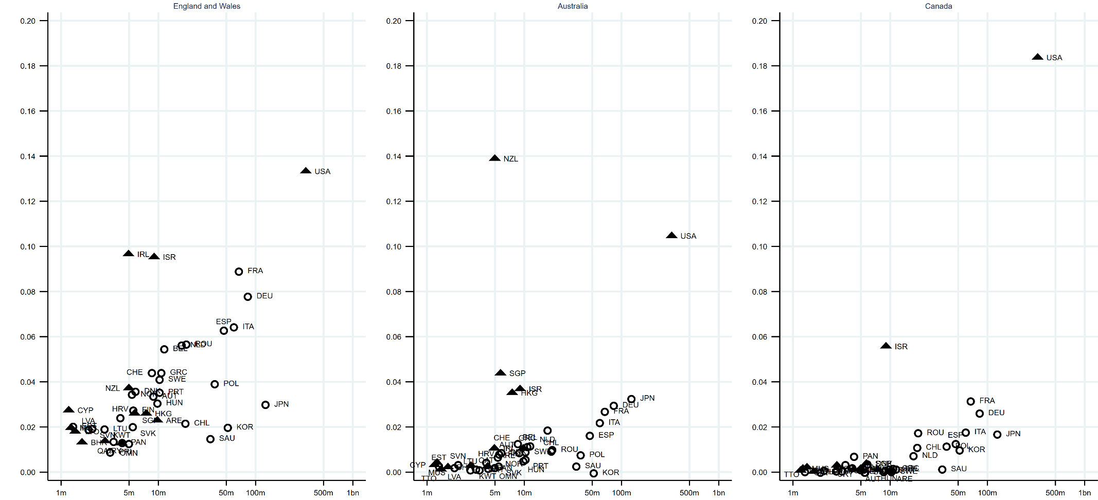
Figure 1. Proportion of overseas charities operating in particular High Income countries, for different jurisdictions: England and Wales (left); Australia (middle); Canada (right).
Notes: Vertical axis: proportion of overseas charities operating in a particular country; horizontal axis: country population (log scale). Triangles show former British territories.
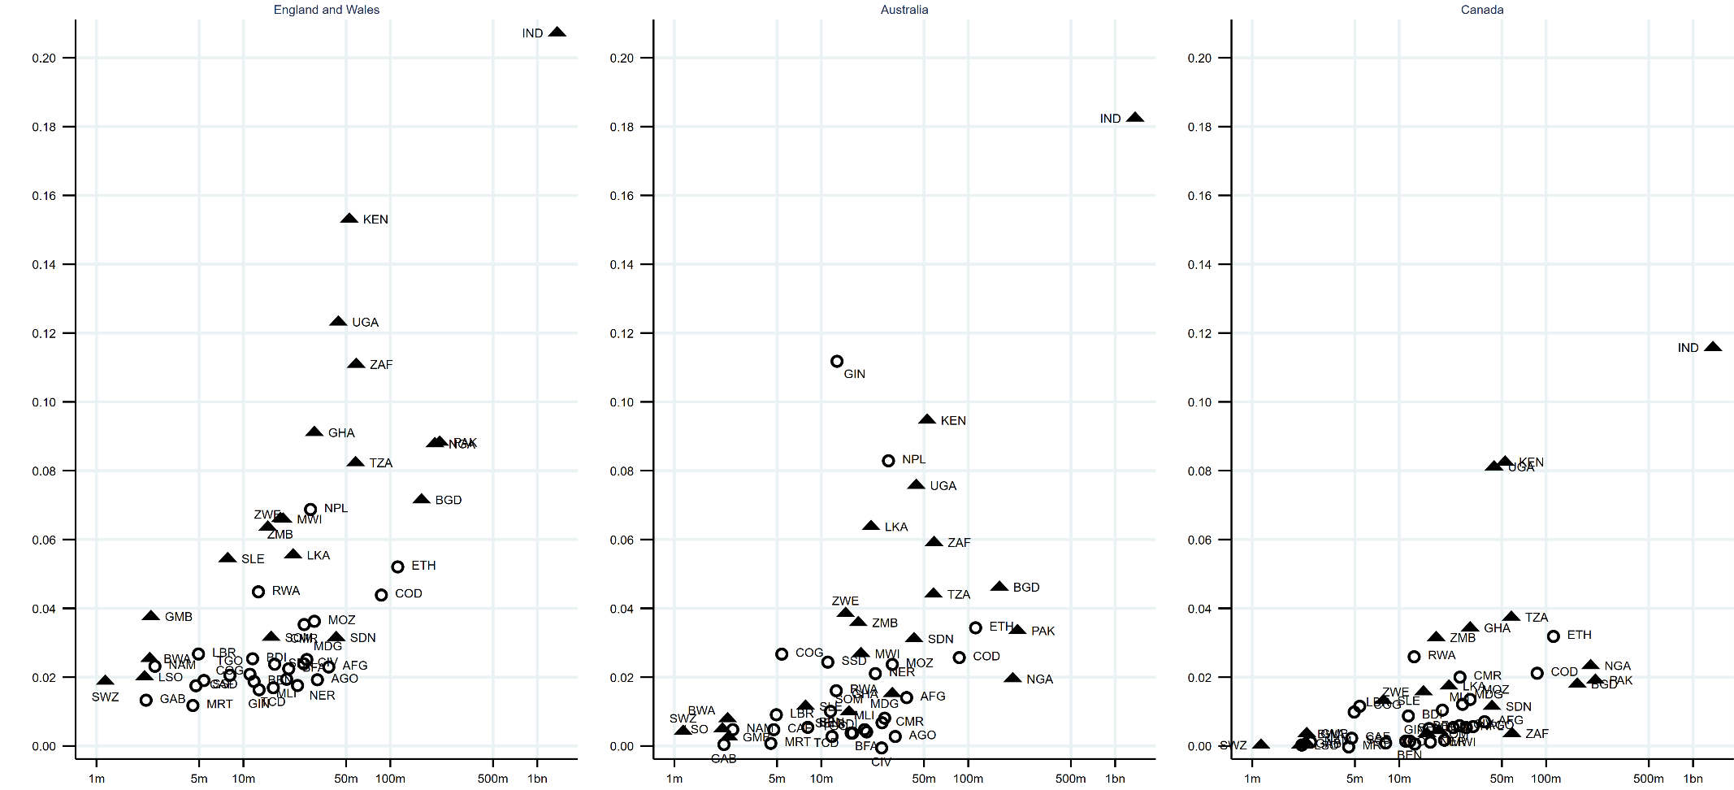
Figure 2. Proportion of overseas charities operating in particular countries in Sub-Saharan Africa & South Asia, for different jurisdictions: England and Wales (left); Australia (middle); Canada (right).
Notes: Vertical axis: proportion of overseas charities operating in a particular country; horizontal axis: country population (log scale). Triangles show former British territories.
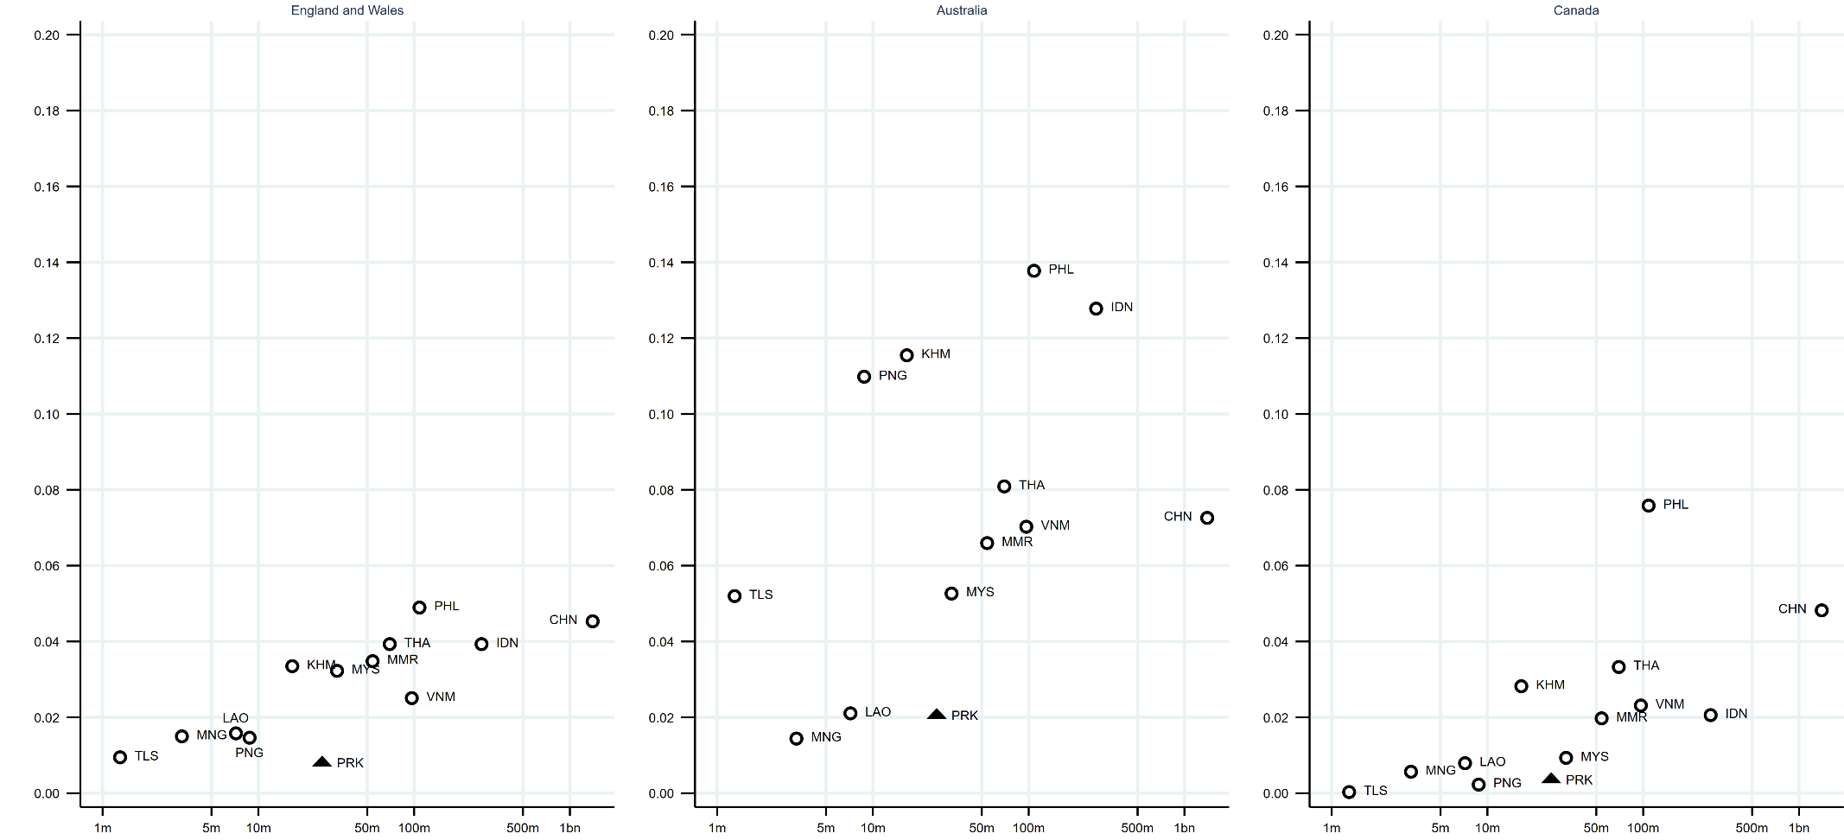
Figure 3. Proportion of overseas charities operating in particular countries in East Asia & Pacific, for different jurisdictions: England and Wales (left); Australia (middle); Canada (right).
Notes: Vertical axis: proportion of overseas charities operating in a particular country; horizontal axis: country population (log scale). Triangles show countries that suffer most from corruption (WGI). For country codes see Table A1.
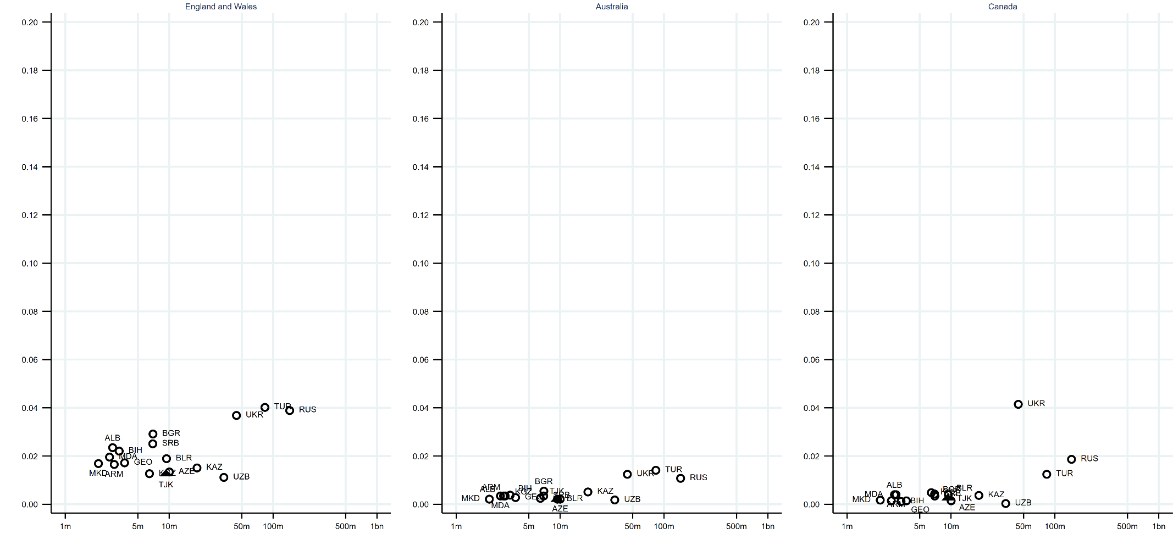
Figure 4. Proportion of overseas charities operating in particular countries in Europe & Central Asia, for different jurisdictions: England and Wales (left); Australia (middle); Canada (right).
Notes: Vertical axis: proportion of overseas charities operating in a particular country; horizontal axis: country population (log scale). Triangles show countries that suffer most from corruption (WGI).
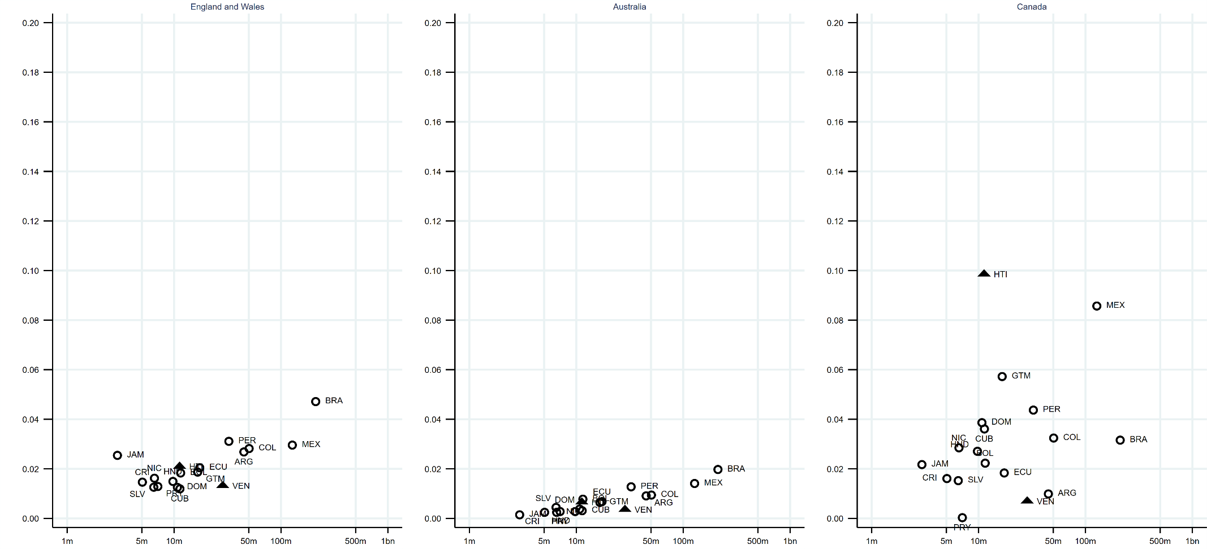
Figure 5. Proportion of overseas charities operating in particular countries in Latin America & Caribbean, for different jurisdictions: England and Wales (left); Australia (middle); Canada (right).
Notes: Vertical axis: proportion of overseas charities operating in a particular country; horizontal axis: country population (log scale). Triangles show countries that suffer most from corruption (WGI).
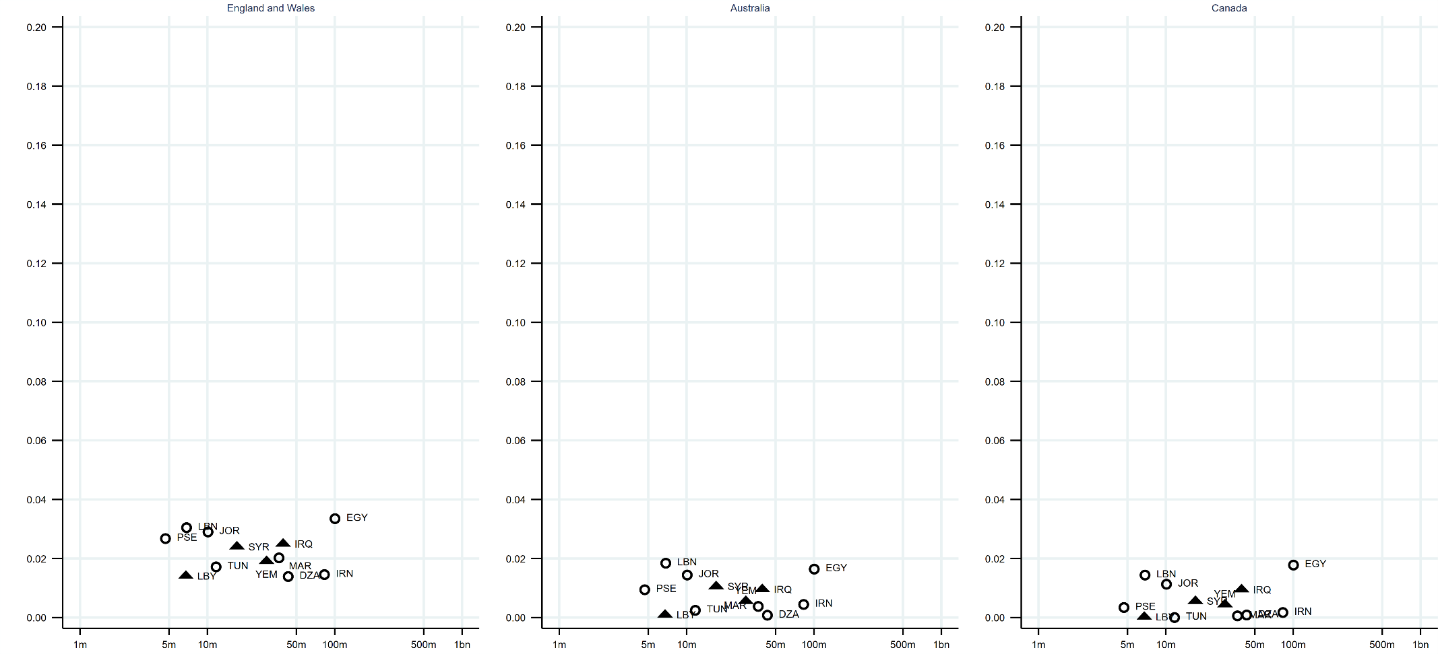
Figure 6. Proportion of overseas charities operating in particular countries in Middle East & North Africa, for different jurisdictions: England and Wales (left); Australia (middle); Canada (right).
Notes: Vertical axis: proportion of overseas charities operating in a particular country; horizontal axis: country population (log scale). Triangles show countries that suffer most from corruption (WGI).
Table 3. Logistic regression results: average predicted probability of a charity working in any given overseas country, by covariate characteristics and charity jurisdiction
 | Australia | Canada | England and Wales
Region
High Income | 0.026 (0.023 - 0.028) | 0.018 (0.016 - 0.021) | 0.036 (0.035 - 0.037)
East Asia & Pacific | 0.029 (0.028 - 0.031) | 0.019 (0.018 - 0.020) | 0.028 (0.028 - 0.029)
Europe & Central Asia | 0.011 (0.009 - 0.012) | 0.014 (0.012 - 0.015) | 0.030 (0.029 - 0.031)
Latin America & Caribbean | 0.010 (0.009 - 0.011) | 0.028 (0.026 - 0.030) | 0.028 (0.028 - 0.029)
Middle East & North Africa | 0.012 (0.010 - 0.013) | 0.004 (0.004 - 0. 005) | 0.020 (0.019 - 0.020)
Sub-Saharan Africa & South Asia | 0.022 (0.021 - 0.023) | 0.012 (0.011 - 0.012) | 0.043 (0.042 - 0.043)
Need: multidimensional poverty index (MPI)
Decile 1–9 of MPI distribution | 0.022 (0.021 - 0.022) | 0.016 (0.015 - 0.016) | 0.035 (0.035 - 0.035)
Top decile (poorest countries) | 0.029 (0.026 - 0.031) | 0.008 (0.007 - 0.009) | 0.028 (0.027 - 0.029)
Need: DAC ODA-eligible recipient (2018-19)
Not a recipient country | 0.018 (0.017 - 0.020) | 0.011 (0.010 - 0.012) | 0.033 (0.032 - 0.034)
Recipient country | 0.023 (0.023 - 0.024) | 0.017 (0.016 - 0.017) | 0.036 (0.035 - 0.036)
Governance: instability
Decile 2–10 of WGI distribution | 0.023 (0.023 - 0.024) | 0.016 (0.015 - 0.016) | 0.036 (0.035 - 0.036)
Bottom decile (poorest governance) | 0.012 (0.011 - 0.013) | 0.010 (0.009 - 0.011) | 0.028 (0.027 - 0.029)
Governance: corruption
Decile 2–10 of WGI distribution | 0.022 (0.022 - 0.023) | 0.015 (0.015 - 0.015) | 0.035 (0.034 - 0.035)
Bottom decile (poorest governance) | 0.020 (0.018 - 0.022) | 0.018 (0.016 - 0.019) | 0.038 (0.036 - 0.039)
Regime type
Democracy | 0.022 (0.022 - 0.023) | 0.016 (0.015 - 0.017) | 0.036 (0.036 - 0.037)
Open Anocracy | 0.024 (0.023 - 0.026) | 0.018 (0.016 - 0.019) | 0.032 (0.031 - 0.033)
Closed Anocracy | 0.027 (0.025 - 0.028) | 0.018 (0.017 - 0.019) | 0.035 (0.034 - 0.035)
Autocracy | 0.014 (0.012 - 0.015) | 0.007 (0.006 - 0.008) | 0.026 (0.026 - 0.027)
Openness to civil society
Open | 0.025 (0.023 - 0.028) | 0.007 (0.006 - 0.008) | 0.041 (0.039 - 0.042)
Narrowed | 0.017 (0.016 - 0.019) | 0.012 (0.011 - 0.013) | 0.037 (0.036 - 0.038)
Obstructed | 0.024 (0.023 - 0.025) | 0.015 (0.015 - 0.016) | 0.037 (0.036 - 0.037)
Repressed | 0.021 (0.020 - 0.022) | 0.016 (0.016 - 0.017) | 0.031 (0.030 - 0.031)
Closed | 0.020 (0.021 - 0.023) | 0.020 (0.018 - 0.022) | 0.032 (0.031 - 0.033)
History: official / common spoken languages
Doesn’t include English | 0.019 (0.019 - 0.020) | 0.012 (0.011 - 0.012) | 0.030 (0.030 - 0.031)
Includes English | 0.027 (0.028 - 0.030) | 0.021 (0.020 - 0.022) | 0.044 (0.044 - 0.045)
History: British Empire
Not former British territory | 0.021 (0.020- 0.021) | 0.014 (0.013 - 0.014) | 0.030 (0.030 - 0.030)
Former British territory | 0.024 (0.023 - 0.025) | 0.018 (0.017 - 0.019) | 0.045 (0.044 - 0.045)
N | 442,176 | 521,556 | 2,025,366
McFadden’s adjusted R² | .25 | .19 | .29
McKelvey and Zavoina’s R² | .39 | .34 | .38
Cragg and Uhler’s R² | .27 | .20 | .33
LL full model | -34,996.66 | -33,223.68 | -215,412.78
Notes: All models include controls for the logarithm of the country population size, logarithm of distance (km) between capital cities, and the three charity-level covariates (geographic scale of operations, annual income, religious purpose / activities). Figures for model summary statistics rounded to two decimal places. 95% CI in brackets.
Figures 7-16. Moderating effect of charity size on probability of working in a country, by country type and jurisdiction
Figure 7 | Figure 8
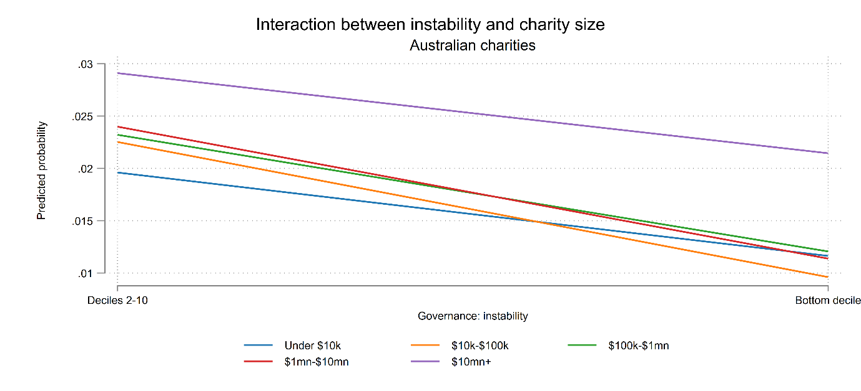 | 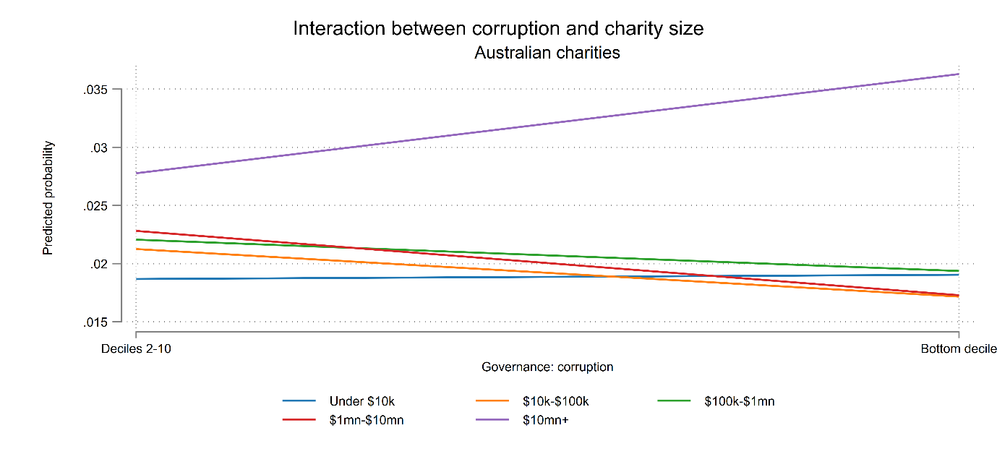
Figure 9 | Figure 10
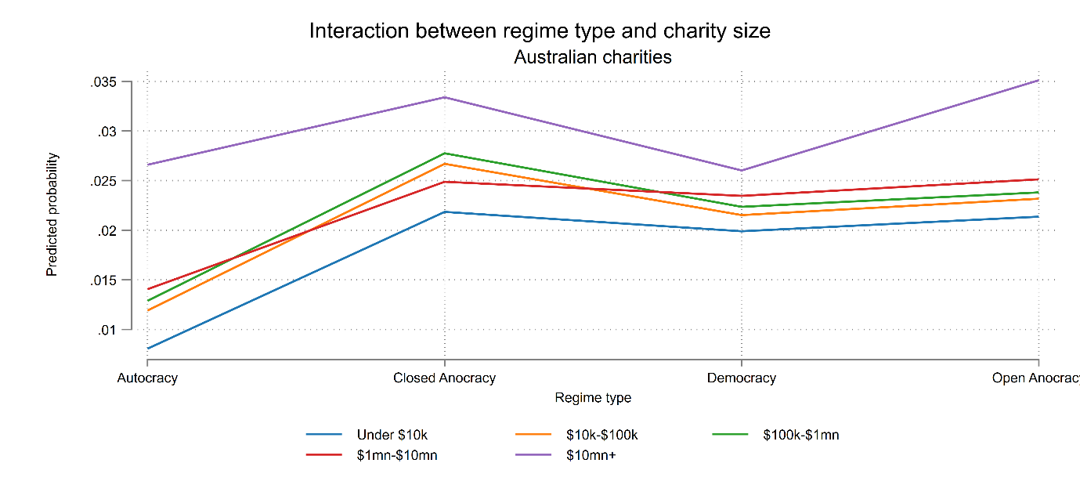 | 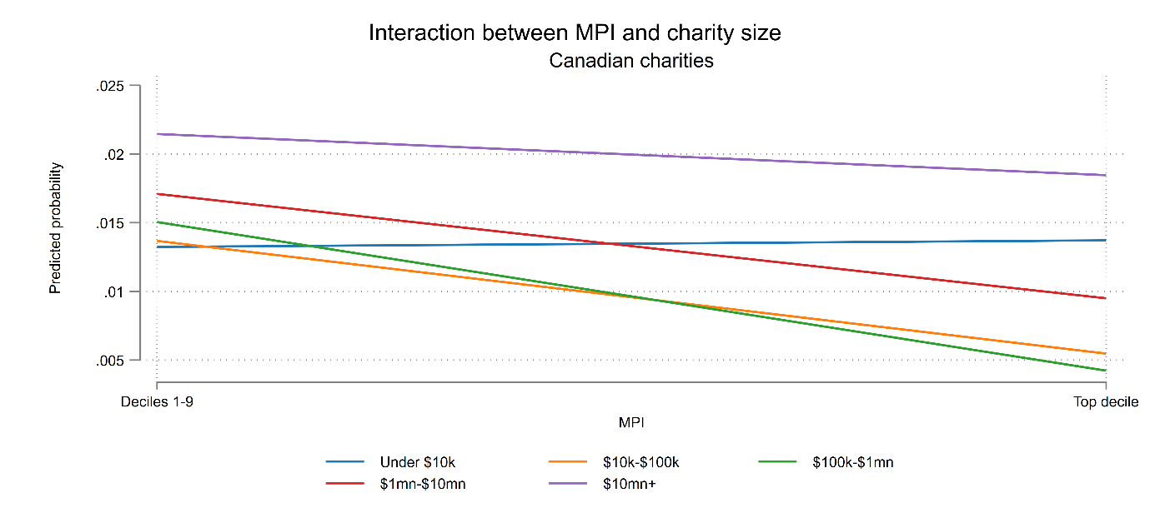
Figure 11 | Figure 12
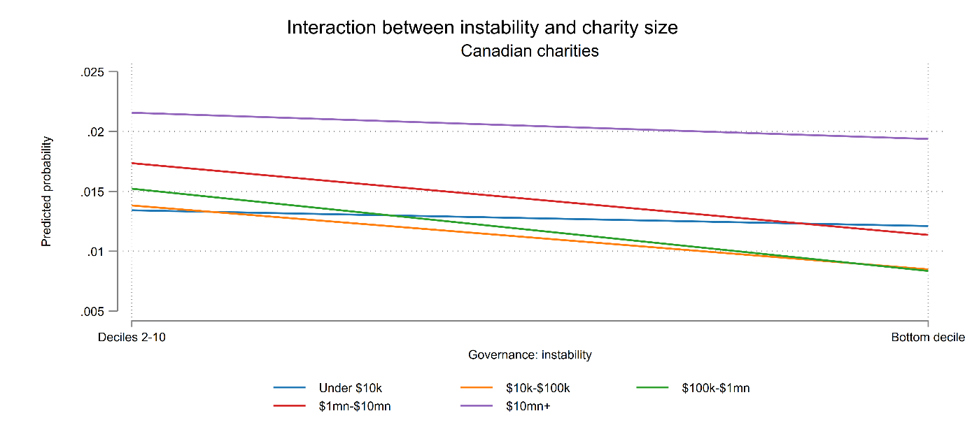 | 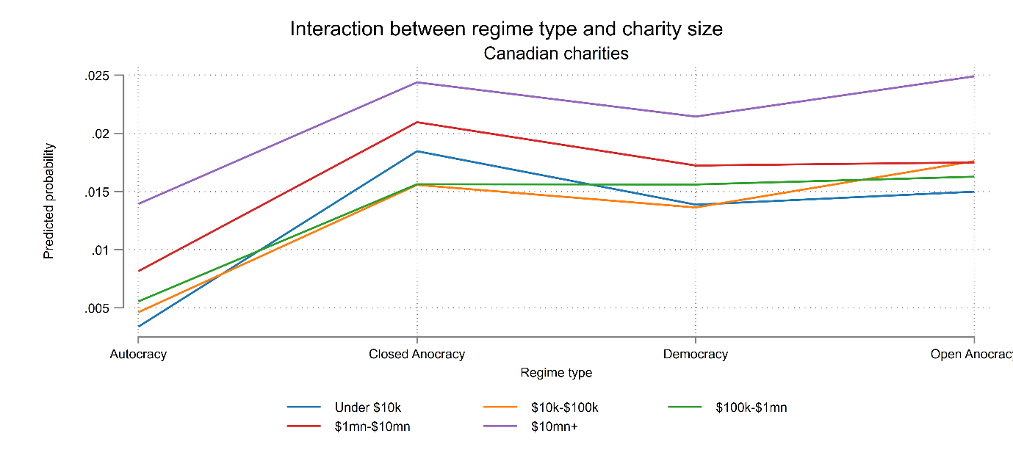
Figure 13 | Figure 14
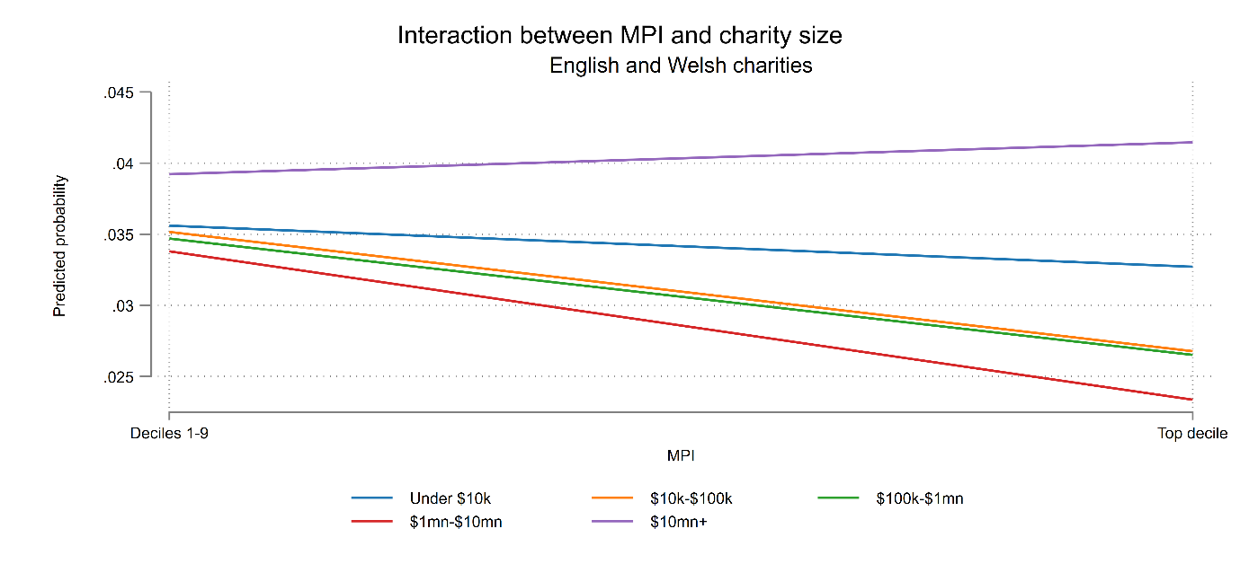 | 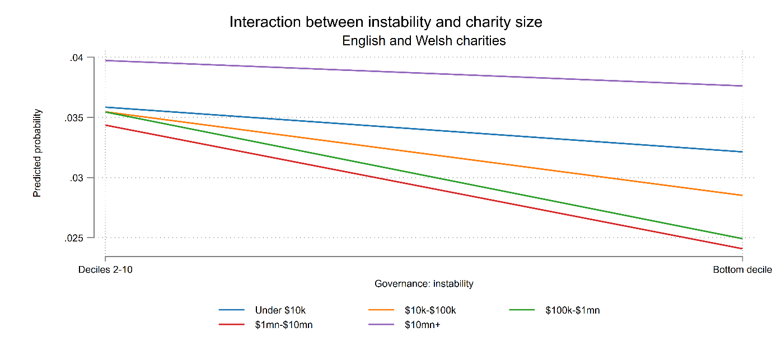
Figure 15 | Figure 16
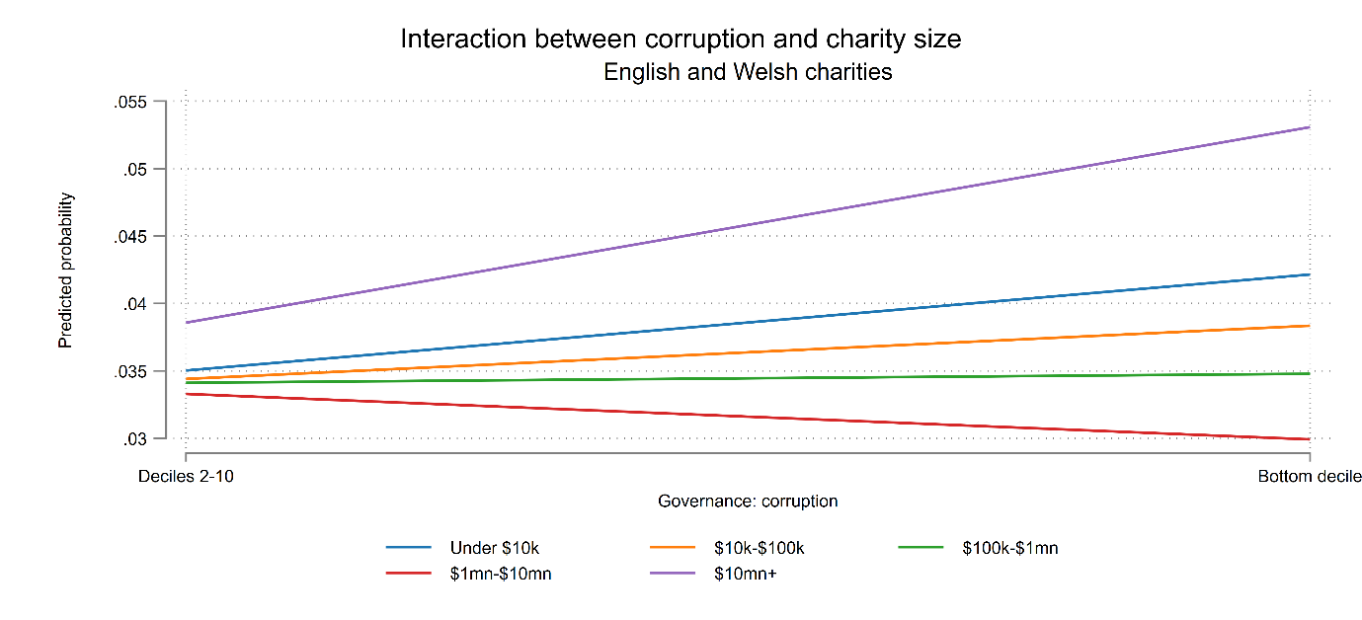 | 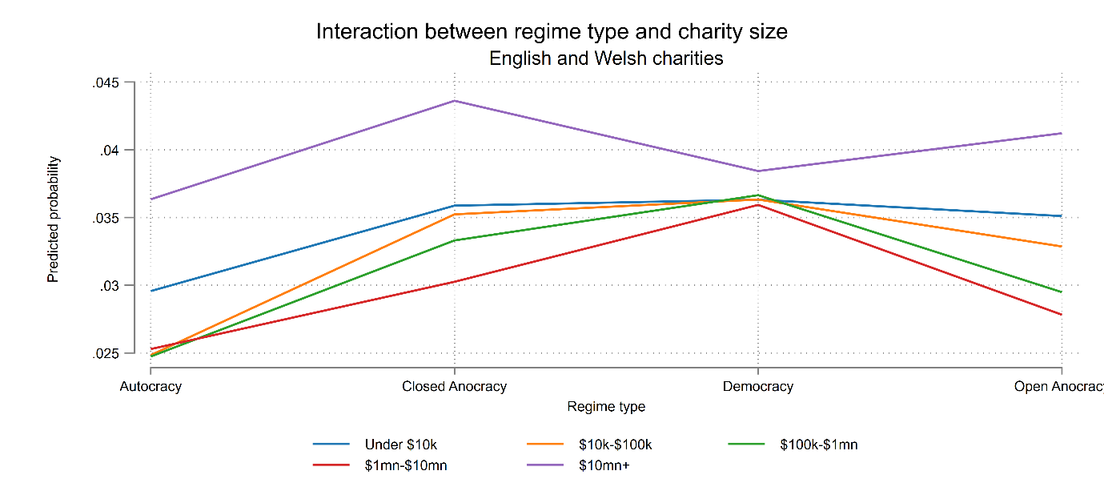

We consider the set of 175 countries that are common to all jurisdictions. That is, at least one charity in each jurisdiction operates in these countries. While this reduces the overall number of countries and territories under consideration, we feel it aids comparability as we cannot be sure that charities in each jurisdiction have the same opportunity to report a given operating location.
https://wits.worldbank.org/wits/wits/witshelp/content/codes/country_codes.htm

