**Automating the production of [Fe18FF2(BnMe2-tacn)] and investigating radiostabilisers for use with** **high-activity [18F]F****−**

Madelaine S. Woodwarda, Danielle E. Runacresa, Julian Griggb, Imtiaz Khanb, William Levasona, Graeme McRobbieb and Gillian Reida*

1. School of Chemistry, University of Southampton, Southampton SO17 1BJ, UK; email: [G.Reid@soton.ac.uk](mailto:G.Reid@soton.ac.uk)
2. GE Healthcare, Pollards Wood, Nightingales Lane, Chalfont St Giles, Bucks HP8 4SP, UK

**Abstract**

The manual radiofluorination and purification of [FeF3(BnMe2-tacn)] (tacn = 1,4,7-triazacyclononane) using 18F− in aqueous EtOH has been translated to a GE FASTLabTM automatic synthesis platform and optimised by conducting a series of low-activity radiolabelling experiments to explore the effects of varying the precursor concentration, temperature, heating time, addition of NaOAc buffer and EtOH:H2O ratio. The optimal conditions were determined to be 1 mg/mL of the precursor being heated at 120°C for 10 mins. in 75%:25% EtOH:H2O containing 18F−, with elution using 10 mM NaOAc, giving 61% radiochemical yield (RCY). These conditions were then employed with high-activity 18F− giving a 97% radiochemical purity (RCP) at t = 0, which decreases by 22% over 5 h.

Sodium ascorbate, nicotinamide and *p*-benzoic acid (*p*ABA) were then tested as potential radiostabilisers for this system, initially using low-activity 18F−. These experiments revealed very rapid defluorination of the radioproduct in the presence of sodium ascorbate. In contrast, both nicotinamide and *p*ABA appear to be effective radiostabilisers, resulting in RCP values of 91% and 89%, respectively, after 2 h, which compare with an RCP of 81% under analogous conditions at t = 2 h in their absence.

High-activity experiments were then undertaken with addition of 5 mg/mL of nicotinamide, with a radio-active concentration (RAC) of 220 MBq/mL, giving RCY of 26% and following purification, RCP values for the [Fe18FF2(BnMe2-tacn)] product of 97% at t = 0 and 86% after 3 h.

**Introduction and background**

The positron-emitting fluorine-18 radioisotope is the most widely used radionuclide for positron emission tomography (PET) imaging in nuclear medicine. While [18F]FDG ([18F]fluorodeoxyglucose), a modified glucose molecule, dominates in the clinic, accounting for ca. 95% of PET scans, there continues to be significant interest in expanding the range of 18F-based PET tracers to achieve higher selectivity for uptake in specific organs and tissues to enable wider application of PET imaging in oncology, cardiology, *etc*., and especially for the earlier detection of disease. Alongside continuing development of more elaborate organofluorine tracers that is motivated by the high strength of the C-F bond [[1]], the last decade has seen growing interest and new developments to explore other highly fluorophilic molecules [[2]], including various examples with boron [[3]] or silicon [[4]], as well as metal-chelate species that are typically based on trivalent Al [[5]], Ga [[6]], Fe [[7]] and Sc [[8]] complexes, the majority of which are incorporate triaza-macrocyclic co-ligands, with functionalised pendant arms bearing either anionic donor groups or alkyl groups on the amine N atoms.

Our previous studies showed that metal(III) trifluoride complexes with tacn-based ligands (tacn = 1,4,7-triazacyclononane) could offer a possible platform for PET radiotracer development, due to their stability, ease of synthesis, and the ability to radiofluorinate in aqueous media under mild conditions and in some cases even at very low (< 30 micromolar) concentrations. Specifically, we demonstrated that (manual) radiofluorination of [FeF3(BnMe2-tacn)] can be conducted through 18F/19F isotopic exchange reactions with [18F]F− in a 75% MeCN/25% H2O (unbuffered) solution, with the resultant [Fe18FF2(BnMe2-tacn)] radio-product exhibiting very good radiochemical stability in a range of formulations, including 10% EtOH/phosphate buffered saline (PBS) and 10% EtOH/human serum albumin (HSA) (Scheme 1) [7].



Scheme 1: 18F radiolabelling conditions for the isotopic exchange reaction with [FeF3(BnMe2-tacn)] [7].

The water used in these reactions was an aliquot of the cyclotron target water containing [18F]F− (activity = 40-180 MBq), producing radiochemical yields (RCYs) of around 40% when starting with precursor concentrations of 2.36 mM (1 mg/mL) or 236 μM (0.1 mg/mL). Radiofluorination at even lower precursor concentration (24 μM) was also demonstrated [7]. These results provided a very promising basis for further development of this metal-macrocyclic scaffold as an effective fluoride binder. The aromatic (benzyl) substituent also provides a convenient site for linking to a biomolecule for targeting specific disease sites/receptors in future work using established protocols.

The translation of radiopharmaceuticals from the laboratory into a clinical setting requires implementation of and compliance with good manufacturing practices (GMP), including automation of the radiochemical synthesis to ensure both the production of a consistent drug product for the patient and also to enable the use of radionuclides at higher activity [[9]]. A number of commercial synthesis modules are currently used for GMP production, as well as for pre-clinical research. These include the FASTlab™ (GE HealthCare), E&Z Modular Lab (Eckert & Ziegler), Explora® (Siemens Healthcare), and AllInOne (Trasis) [[10]]. Careful optimisation is required at each stage of the automated synthesis to ensure reproducibility, therefore automation on these systems is often non-trivial [[11]]. In this work we have used a FASTlab™ platform; this is an automated, cassette-based synthesis platform which can be employed to facilitate highly reproducible synthesis. Since the FASTlab™ is installed inside a lead-lined hot cell, this also protects the operator from the risk of radiation dose, which would otherwise be significant, especially when working with [18F]F− at tens of GBq radioactivity [[12]]. The single-use cassettes for the synthesis can be safely disposed of after use. A further consideration for radiolabelling experiments conducted at high-activity is radiolysis, which can require the introduction of a radiostabiliser to the formulation to maintain a high radiochemical purity over the shelf-life of around 8 h.

For practical applications in the clinic, activity values for 18F-labelled PET imaging probes are typically much higher, often starting with activities of 10-100 GBq [[13]]. Under these conditions, radiolysis is expected to be a significant factor that could impact the stability of the desired radioproduct. Radiolysis of aqueous solutions forms radicals and reactive species, such as ·OH, ·H or H2O2, which could react with the radioproduct, causing its degradation over time [[14]],[[15]],[[16]]. There is detailed literature on the use of radiostabilisers to quench radiolysis and preserve high radiochemical purity of the desired product, for example, using gentisic acid (Liu and Edwards) [[17]], sodium ascorbate (Chen and co-workers; Liu and co-workers) [[18]],[[19]],[[20]], methionine (Breeman and co-workers) [[21]], and ethanol (Chen and co-workers; Filice and co-workers) [19],[[22]]. Figure 1 shows a selection of the radiostabilisers typically used in this area of work.

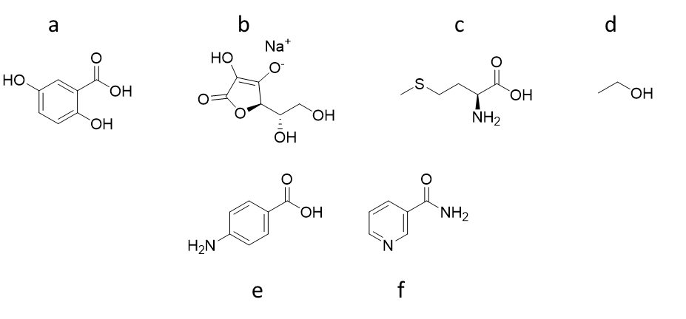

Figure 1: Structures of several established radiostabilisers: gentisic acid **a**, sodium ascorbate **b**, methionine **c**, ethanol **d**, *p*-aminobenzoic acid (*p*ABA) **e**, and nicotinamide **f**.

A purification method, developed by Engell and co-workers in GE HealthCare, successfully used *p*ABA (Figure 1**e**) as a biocompatible carrier and radioprotectant for the cyclic tripeptide tracer, [18F]fluciclatide (Figure 2), which is used to selectively image tumour cells and vasculature [[23]]. The *p*ABA radiostabiliser inhibits degradation reactions by trapping highly reactive free-radical species [[24]].



Figure 2: The structure of the radiotracer [18F]fluciclatide.

Nicotinamide (Figure 1**f**) has also been shown to be an effective radiostabiliser, with its use reported in several patents [[25]],[[26]]. For example, it was the preferred stabiliser for a number of radioiodine compounds that are used in therapy and diagnostics [27].

Here we report an improved protocol for radiolabelling the complex, [FeF3(BnMe2-tacn)], with [18F]fluoride using an EtOH/H2O solvent system, together with the results of our work to optimise and automate the synthesis of [Fe18FF2(BnMe2-tacn)] using a commercially-available synthesis platform (FASTlab™), by varying parameters including the eluent composition, precursor concentration, temperature and organic:aqueous solvent ratio. The optimised conditions have then been employed with high-activity [18F]F− (30 GBq) on the FASTlab™ system, and a series of radiostabilisers investigated for their compatibility with the iron(III) complex and to test their ability to reduce radiolysis at high-activity, in order to identify potential candidates for use in a clinical setting.

**Results and discussion**

**Radiofluorination of [FeF3(BnMe2-tacn)] using low-activity [18F]F−**

The preparation of the precursor complex, [FeF3(BnMe2-tacn)], was undertaken as described in the literature [7]. The radiofluorination experiments we reported in the same paper were performed in MeCN and provided the first example of a transition metal (TM) complex where radiofluorination with [18F]F− was achieved through the formation of an TM-18F bond directly [7]. Since EtOH itself can act as a radiostabliser, replacing MeCN with EtOH in the radiofluorination step could also be advantageous. Therefore, we were interested to determine whether aqueous EtOH would be a suitable solvent system for the radiochemistry. To this end, [FeF3(BnMe2-tacn)] was radiolabelled manually at low-activity in aqueous EtOH to establish the % RCY and purity under these modified conditions. [FeF3(BnMe2-tacn)] (0.1 mg, 278 nmol) was dissolved in 0.75 mL of EtOH and [18F]F− in cyclotron target water (0.25 mL, 367 MBq) was added, followed by heating to 80 °C for 10 minutes (Scheme 2). The desired radioproduct, [Fe18FF2(BnMe2-tacn)], was obtained with RCY = 72%. The radio-HPLC and UV traces are shown in Figure 3.



Scheme 2: Modified synthesis of [Fe18FF2(BnMe2-tacn)] using EtOH/H2O.

**18F-**

Retention time / min

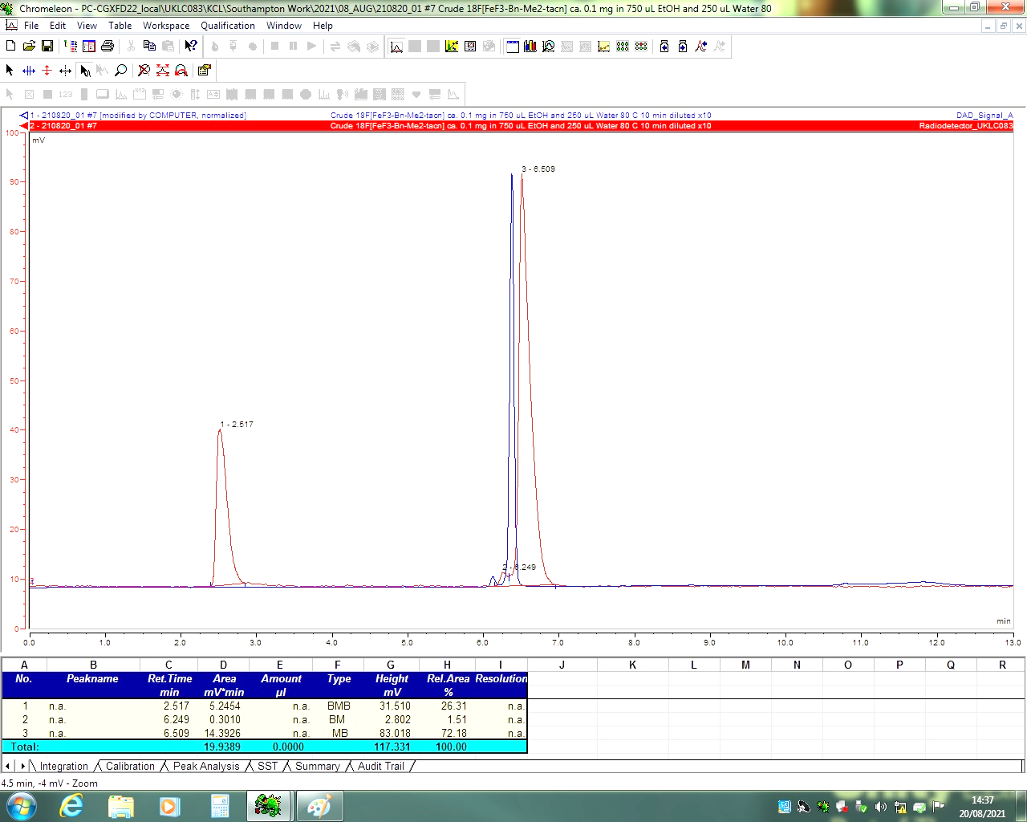

Figure 3: Analytical radio-HPLC trace (red) and UV trace (blue) of the crude product from the reaction of [FeF3(BnMe2-tacn)] with 18F− in 75% EtOH:25% water at 80 °C for 10 min.

The crude product was then passed through a hydrophilic-lipophilic-balanced (HLB) solid phase extraction (SPE) cartridge to purify the crude reaction mixture. The SPE purification method worked effectively, and the RCP of the purified [18F]-fluorinated product, [Fe18FF2(BnMe2-tacn)] was calculated as 98% at t = 0, remaining unchanged over at least 2 h (Figure 4).

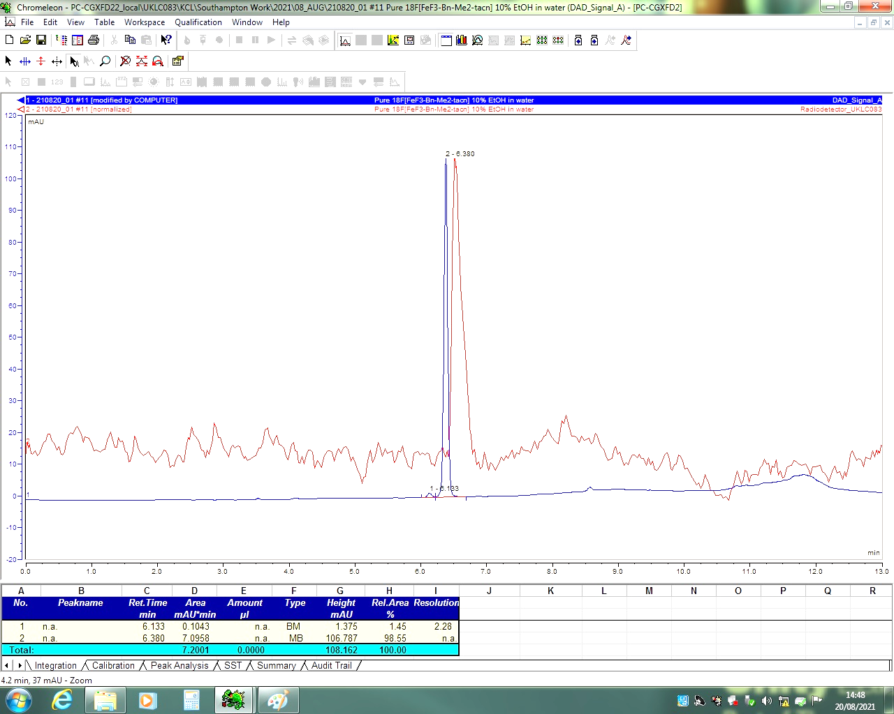

Retention time / min

Figure 4: Analytical radio-HPLC (red) and UV (blue) trace of the SPE purified [Fe18FF2(BnMe2-tacn)] (red) product after 2 h, with an RCP of 98%. The low signal:noise for the radio-HPLC baseline is due to the low-activity of the 18F− used.

### Synthesis on the FASTlab™ platform

All subsequent radiochemistry experiments were performed on the FASTlab™ synthesis platform with single-use cassettes. The [18F]F− activity in these experiments ranged from 100 MBq for the initial optimisation to 30 GBq for testing at high activity.

Initial optimisation experiments were performed using a 0.1, 0.6 and 1 mg/mL concentration of [FeF3(BnMe2-tacn)] in EtOH/H2O. The [18F]F− was trapped onto a QMA cartridge and the 18O water was eluted into a recovery vial for collection; NaOAc (0.64 mL) eluted the [18F]F− through the QMA cartridge into the reaction vessel. The FASTlab cassette layout used for the radiosynthesis of [Fe18FF2(BnMe2-tacn)] is presented in Table 1 and an example of the FASTlab™ cassette layout is shown in Figure 5. The labelling conditions for the FASTlab radiosynthesis of [Fe18FF2(BnMe2-tacn)] are described in Table 2.

Table 1: General FASTlab™ cassette reagent positions

|  |  |  |  |
| --- | --- | --- | --- |
| **Cassette**  **Position** | **Reagent or hardwarea** | **Cassette**  **Position** | **Reagent or hardwarea** |
| 1 | Short tubing to [18F] target water collection vial | 14 | N/A |
| 2 | NaOAc – QMA eluent | 15 | Water bag |
| 3 | Syringe 1 | 16 | EtOH – SPE eluent |
| 4 | QMA light SepPak cartridge | 17 | Short tubing to SPE cartridge |
| 5 | Short tubing to QMA light SepPak cartridge | 18 | SPE cartridge |
| 6 | [18F] inlet | 19 | N/A |
| 7 | Short tubing to left side of reaction vessel | 20 | N/A |
| 8 | Short tubing to middle of reaction vessel | 21 | N/A |
| 9 | N/A | 22 | N/A |
| 10 | Short tubing to crude product | 23 | Long tubing to external product formulation vial |
| 11 | Syringe 2 | 24 | Syringe 3 |
| 12 | Precursor | 25 | Long tubing to the right side of the reaction vessel |
| 13 | N/A |  |  |

a N/A = not applicable

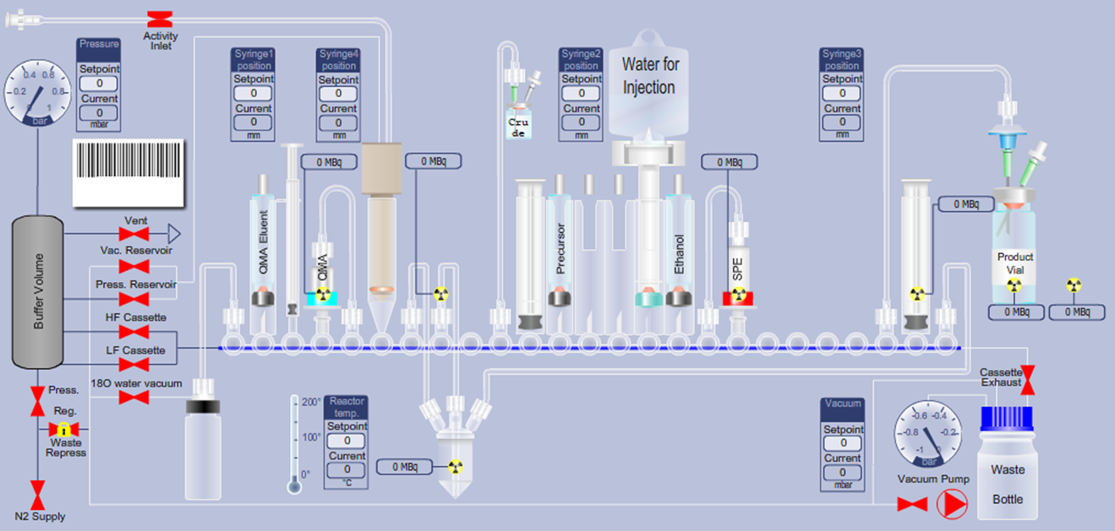

1 2 3 4 5 6 7 8 9 10 11 12 13 14 15 16 17 18 19 20 21 22 23 24 25

Figure 5: FASTlab™ cassette layout for the radiosynthesis of [Fe18FF2(BnMe2-tacn)]. P = position. P1 - tubing to 18F recovery vial; P2 – vial containing NaOAc (QMA eluent); P3 – Syringe 1; P4 – QMA cartridge; P5 ‑ tubing to QMA cartridge; P6 - [18F]F− inlet reservoir; P7 – tubing to left side of reaction vessel; P8 – tubing to middle of reaction vessel; P9 - N/A; P10 – tubing to crude product; P11 – Syringe 2; P12 – precursor dissolved in EtOH; P13-14 – N/A; P15 – water bag; P16 – EtOH (SPE eluent); P17 – tubing to SPE cartridge; P18 – SPE cartridge; P19-22 – N/A; P23 – tubing to external product formulation vial; P24 – Syringe 3; P25 – tubing to right side of reaction vessel.

Table 2: Summary of the radiofluorination conditions explored for optimising the radiofluorination of [Fe18FF2(BnMe2-tacn)] on the FASTlab™.

|  |  |  |  |  |  |
| --- | --- | --- | --- | --- | --- |
| [FeF3(BnMe2-tacn)]a  Mass  / mg | Temp.  / °C | EtOH/H2O  Ratio | NaOAc eluent  conc. / mM | Time  / min. | Crude RCYb  / % |
| 0.1 | 80 | 60/40 | 100 | 2 | 0 |
| 0.1 | 120 | 60/40 | 100 | 10 | 1 |
| 1 | 80 | 60/40 | 100 | 2 | 0 |
| 1 | 120 | 60/40 | 100 | 10 | 33 |
| 0.6 | 100 | 60/40 | 100 | 6 | 35 |
| 1 | 120 | 75/25 | 10 | 10 | 61 |

a note that the precursor complex is isolated with 3.5 H2O solvent molecules per Fe; b determined by integrating the peaks in the analytical HPLC radio-traces

It was determined early on that a 100 mM concentration of NaOAc eluent was causing issues, presumably due to the highly concentrated solution preventing the reaction of [18F]F− with the iron complex. It was also evident that both increasing the temperature and decreasing the concentration of NaOAc to 10 mM improved the RCY significantly. The conditions in the final entry in Table 2 gave the highest RCY and these conditions were therefore selected for the next stage, *i.e*. to optimise the SPE purification protocol.

A further four radiofluorination experiments were undertaken, with the following conditions maintained throughout: 10 mins. at 120 °C, 10 mM NaOAc, EtOH:H2O 75%:25%. In this method the crude mixture from the reaction vessel was diluted to below 10% organic content, passed through the SPE cartridge, allowing the unreacted [18F]F− to pass through to waste, whilst the product was trapped onto the SPE cartridge. Several washes with water ensured the removal of unreacted [18F]F− before the purified radioproduct was eluted with EtOH (1.5 mL). Thus, [Fe18FF2(BnMe2-tacn)] was successfully purified on the FASTlab™, to leave the metal chelate bound 18F complex as the main radioproduct in the product with a retention time of 7.18 min. in the radio-HPLC (Figure 6), with an RCP of >99%. The non-decay-corrected radiochemical yield for this reaction was 45%.

**Peak 2**

**Peak 1**

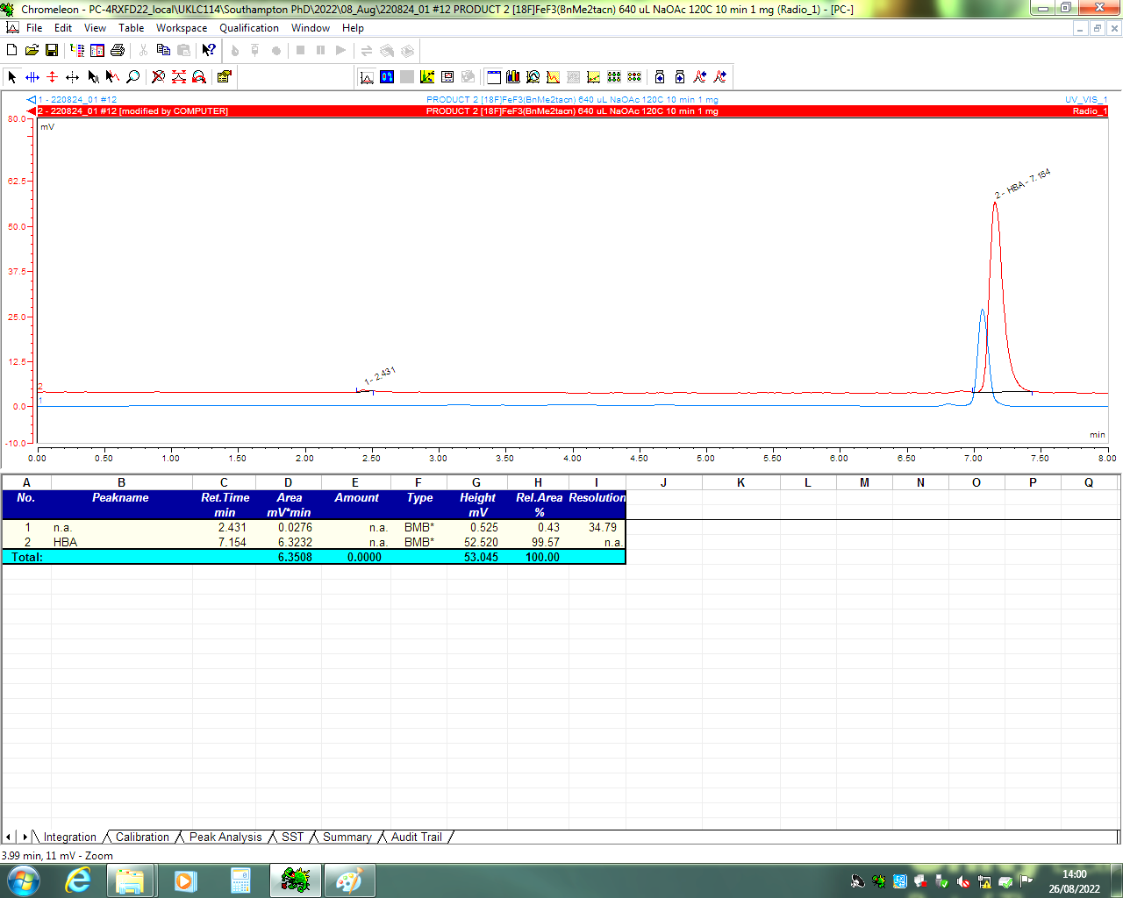

Retention time / min

Figure 6: Radio-HPLC (red) and UV chromatogram (blue) of the purified product at t = 0 from the low-activity radiofluorination of [FeF3(BnMe2-tacn] (1 mg/mL) in 75%/25% EtOH/H2O. Blue trace = UV: Rt = 7.08 ([FeF3(BnMe2-tacn)] reference). Red trace: peak 1: Rt = 2.43 min, <1% (18F−); red trace, peak 2: Rt = 7.18, >99% ([Fe18FF2(BnMe2-tacn)]).

### High-activity radiofluorination experiments

Radiotracers employed in the clinic generally use significantly higher amounts of radioactivity. Experiments using high-activity [18F]F−, up to 30 GBq, were therefore performed to assess the suitability of the [FeF3(BnMe2-tacn)] precursor to undergo radiolabelling at significantly higher radioactivity levels.

The optimised conditions developed in the low-activity work described earlier were also used for the reactions at high-activity. The first experiment was performed without addition of a radiostabiliser, to determine how the complex might be affected by radiolysis. The non-decay corrected yield from this experiment was 42%, resulting in a product radioactive concentration (RAC) of 922 MBq/mL.

Figure 7 shows the RCP (red) and the UV trace (blue) at time intervals from t = 0 to t = 5 h. The retention time corresponds to that of the reference standard ([FeF3(BnMe2-tacn)]). The results, summarised in Table 3, show that in this high-activity radiofluorination experiment, the [Fe18FF2(BnMe2-tacn)] product undergoes degradation over time, with up to 22% liberation of [18F]F− observed over 5 h.

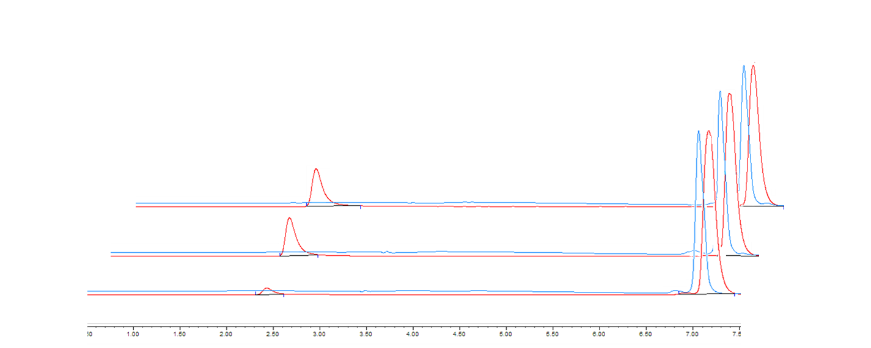

c

b

a

1. t = 0
2. t = 3 h
3. t = 5 h

Retention time / min

Figure 7: Stacked plot showing radio-HPLC (red) and corresponding UV traces (blue) of the purified product, [Fe18FF2(BnMe2-tacn)], at a) t = 0, b) t = 3 h and c) t = 5 h.

Table 3: Percentage RCP determined by integrating the HPLC traces recorded at time points from t = 0 to 5 h (in the absence of a radiostabiliser)

|  |  |
| --- | --- |
| Time / h | RCP / % a |
| 0 | 97 |
| 1 | 90 |
| 2 | 84 |
| 3 | 81 |
| 4 | 80 |
| 5 | 78 |

a n = 1

Further high-activity radiolabelling experiments were then undertaken to test the effect of three potential radiostabilisers and hence to determine whether the lower radiochemical stability observed over time (Table 3) was due to radiolysis and could be improved *via* the addition of a stabiliser.

***Effect of sodium ascorbate***

Sodium ascorbate (Figure 1**b**) is non-toxic to humans and has been shown to be an effective radiostabiliser in the 111In, 90Y and 177Lu radiolabelling of a DOTA-based conjugate, with applications in diagnostics and therapeutics in endothelial cells of tumour neovasculature [19],[[27]]. It has also been shown to be an effective additive for the production of [18F]Fluoropyridine‑Candesartan, preventing radiolysis, with the radiochemical purity being >97% after 10 h; this tracer has applications in cardiovascular imaging and AngII type 1 receptors, which are expressed in the kidneys [[28]].

Sodium ascorbate was selected as the first potential radiostabiliser to be investigated in the high-activity radiolabelling of [FeF3(BnMe2-tacn)], since previous work showed that the analogous complex, [Ga18FF2(BnMe2-tacn)], was not affected by the addition of sodium ascorbate, albeit in that case the experiment was conducted at low-activity [[29]].

The radiofluorination was repeated with the other experimental conditions unchanged (10 mins. at 120 °C, 10 mM NaOAc, EtOH:H2O 75%:25%), but with the addition of sodium ascorbate at a concentration of 50 mg/mL to both the crude product diluent solution (prior to loading onto the SPE cartridge) and the product vial. The RCP at t = 0 was only 54%, significantly lower than anticipated and in marked contrast to the equivalent high-activity experiment performed without sodium ascorbate, where the RCP = 97% at t = 0 min. Furthermore, at t = 15 min. in the presence of sodium ascorbate, a dramatic decrease in the RCP of the product was observed, with almost quantitative release of 18F- (Figure S1).

It is known that Fe(III) species can be reduced by sodium ascorbate; therefore it is likely that this is the cause of the observed behaviour, leading to the complete liberation of 18F−. It is worth noting that this behaviour was not observed in earlier radiofluorination experiments with the analogous [GaF3(BnMe2-tacn)] precursor, with the Ga(III) ion being much less susceptible to reduction than Fe(III) [[30]],[[31]]. A further low-activity experiment (311 MBq) to assess whether using a ten-fold lower concentration of sodium ascorbate (5 mg/mL) would lead to any improvement on the RCP of [Fe18FF2(BnMe2-tacn)] in fact resulted in a decrease from 90% at t = 0 to 11% at t = 2 h, confirming that even at lower concentration, sodium ascorbate causes significant degradation of the radioproduct. Alternative radiostabilisers that would be less likely to react directly with the Fe(III) complex were therefore sought.

#### *Effects of p-aminobenzoic acid and nicotinamide*

Low-activity experiments were also conducted to assess the effects of *p*‑aminobenzoic acid (*p*ABA, Figure 1**e**) and nicotinamide (Figure 1**f**) [24],[25] on the radiochemical stability of [Fe18FF2(BnMe2-tacn)], using the same conditions (10 mins. at 120 °C, 10 mM NaOAc, EtOH:H2O 75%:25%), but with the addition of 5 mg/mL of (i) *p*ABA or (ii) nicotinamide to the product formulation vial only, and using a starting activity of 577 MBq. The RCP for experiment (i) with *p*ABA decreased from 98% to 89% after 2 h, while for (ii) with nicotinamide the RCP decreased from 98% at t = 0 to 91% at t = 2 h.

These results are shown in Figure 10, and clearly indicate that both *p*ABA and nicotinamide lead to very significant improvements in the RCY over time, compared to sodium ascorbate.

Figure 10: Graph showing the trend in radiochemical purity of [Fe18FF2(BnMe2-tacn)] over time in the presence of each of the three potential radiostabilisers; sodium ascorbate (NaAsc), *p*-aminobenzoic acid (*p*ABA) and nicotinamide, from experiments performed with low 18F− activity.

Since nicotinamide and *p*ABA performed similarly in the low-activity experiments, nicotinamide was selected to be investigated for the high-activity experiments. Thus, radiolabelling was undertaken using the same conditions (10 mins. at 120 °C, 10 mM NaOAc, EtOH:H2O 75%:25%), but with nicotinamide (at either 5 or 50 mg/mL) added to the product formulation vial. The radio-active concentration (RAC) was calculated to be 220 MBq/mL with RCY = 26%. The RCP of [Fe18FF2(BnMe2-tacn)] reduced from 97% at t = 0 to 86% after 3 h. The graph in Figure 11 summarises these results, and shows that while the [Fe18FF2(BnMe2-tacn)] radioproduct degrades very rapidly in the presence of sodium ascorbate compared to that in EtOH/H2O alone, in contrast, nicotinamide performs much better, leading to some additional stabilisation of [Fe18FF2(BnMe2-tacn)] against radio-decay, indicating that it can be a suitable radiostabiliser candidate for use when working with high [18F]F− activity.

Figure 11: Graph representing the RCP (%) of [Fe18FF2(BnMe2-tacn)] using potential radiostabilisers; nicotinamide (5 mg/mL), nicotinamide (50 mg/mL), sodium ascorbate (5 mg/mL), sodium ascorbate (50 mg/mL) and 10% EtOH in water with no added radiostabiliser (n=1).

**Experimental**

[FeF3(BnMe2-tacn)] was prepared, purified and characterised as reported in the literature [7].

**Manual radiolabelling procedure: [Fe18FF2(BnMe2-tacn)]**

[FeF3(BnMe2-tacn)] (0.1 mg, 236 nmol) was dissolved in EtOH (0.75 mL) and radiofluorinated using [18F]F− in cyclotron target water (0.25 mL, 367 MBq) and the reaction mixture was heated to 80 °C for 10 min.

**General FASTlab**™ **radiolabelling procedure: [Fe18FF2(BnMe2-tacn)]**

[FeF3(BnMe2-tacn)] (1 mg, 2.36 mmol) was dissolved in EtOH (0.75 mL). To this solution, an aqueous solution of [18F]F− (100 MBq to 30 GBq) was eluted from a QMA light SepPak cartridge with NaOAc (0.64 mL) and added to the reaction vessel and heated to 120 °C for 10 min. The crude reaction mixture was diluted with water (19 mL) so that the diluted crude product contained <10% EtOH.

**SPE purification protocol**

The diluted crude reaction mixture was then trapped on a pre-conditioned HLB cartridge, washed with water (2 x 10 mL) to remove unreacted 18F- and then eluted from the HLB cartridge with EtOH (1 mL) into the product formulation vial. The formulated product was analysed by analytical HPLC at t = 0 and various time intervals.

**Addition of radiostabilisers**

The radiolabelling experiment and SPE purification protocols were as above. The product was eluted from the HLB cartridge with 1 mL of EtOH into the product formulation vial containing the radiostabiliser: nicotinamide, sodium ascorbate or *p*-aminobenzoic acid. This gave a final product formulation of either a 5 mg/mL or 50 mg/mL concentration of radiostabiliser.

**Analytical HPLC method**

Column: Phenomenex Luna 5 μm C18(2) 250 × 4.6 mm. Mobile phase A = water, Mobile phase B = MeCN. Flow rate 1 mL min‑1. Gradient 0‑15 min (10‑90% B), 15‑20 min (90% B), 20‑21 min (90‑10% B), 21‑26.5 min (10% B). RCY and RCP values are quoted as percentages throughout.

**Materials and methods**

QMA light SepPak cartridge and SPE HLB cartridges were purchased from Waters. QMA light SepPak cartridges were used as received, HLB cartridges were pre-conditioned with EtOH (5 mL), followed by H2O (5 mL).

Water refers to sterile ultrapure water (18.2 MΩ-cm). Experiments were analysed using an Agilent 1290 HPLC system with an Agilent 1260 DAD UV detector and a Bioscan sodium iodide PMT with rate meter. Dionex Chromeleon 6.8 Chromatography data recording software was used to integrate the peak areas.

The RCY is the amount of activity in the isolated product, expressed as a percentage of the starting activity used in the reaction. The RCP refers to the radioactivity of the desired radioproduct, as a percentage or fraction of any other radioactive compounds present, this is measured by a radiodetector that is attached to the HPLC system [[32]],[[33]].

**Conclusions**

A protocol for radiofluorination of [FeF3(BnMe2-tacn)] with [18F]F− in EtOH/H2O has been developed. This procedure has been translated onto a FASTlab™ synthesis platform, allowing for the optimisation and automation of the radiochemistry, as well as to facilitate radiofluorination with high-activity [18F]F−. These were shown to be successful with [18F]F− ranging from *ca.* 100 MBq (low-activity) up to *ca*. 30 GBq (high-activity), producing [Fe18FF2(BnMe2-tacn)] with good radiochemical yield.

In the absence of a radiostabiliser, the high-activity 18F/19F isotopic exchange reaction on a FASTlab™ platform, shows a reduction from 97% to 78% RCP after 5 h, suggesting that radiolysis is a factor promoting the degradation. However, while the addition of sodium ascorbate caused rapid and complete degradation of the radioproduct, liberating free 18F−, the addition of nicotinamide improved the radiochemical stability of the radioproduct at high-activity, with degradation from RCP = 97% to 86% after 4 h.

The successful development of an optimised protocol for the automation of the [18F]fluoride radiolabelling of [FeF3(BnMe2-tacn)] and implementation of high 18F− activity demonstrates the feasibility of this precursor system providing a proof of concept. Future work on similar systems containing bioconjugated peptides can be undertaken using the protocol developed here as a good starting point for its optimisation.

**Acknowledgements**

This research was funded by a CASE studentship to M.S.W from GE Healthcare and EPSRC grant number EP/R513325/1, and through the EPSRC Mithras Programme Grant (EP/S032789/1).

**Supporting Information**

Additional radiotraces from the radiofluorination of [FeF3­(BnMe2-tacn)] (Figures S1 and S2).

**References**

1. # [] P. W. Miller, N. J. Long, R. Vilar, A. D. Gee, Synthesis of 11C, 18F, 15O, and 13N Radiolabels for Positron Emission Tomography. *Angew. Chem., Int. Ed*., 47, 8998 (2008).

  
2. # [a)] K. Chansaenpak, B. Vabre, F. P. Gabbaï, [18F]-Group 13 fluoride derivatives as radiotracers for positron emission tomography. *Chem. Soc. Rev.*, 45, 954 (2016).

   # b) W. Levason, F. M. Monzittu, G. Reid, Coordination chemistry and applications of medium/high oxidation state metal and non-metal fluoride and oxide-fluoride complexes with neutral donor ligands. *Coord. Chem. Rev.*, 391, 90 (2019).

  
3. # [a)] R. Ting, M. J. Adam, T. J. Ruth and D. M. Perrin, Arylfluoroborates and Alkylfluorosilicates as Potential PET Imaging Agents:  High-Yielding Aqueous Biomolecular 18F-Labeling. *J. Am. Chem. Soc*., 127, 13094 (2005).

   # b) T. W. Hudnall, F. P. Gabbaï, Ammonium Boranes for the Selective Complexation of Cyanide or Fluoride Ions in Water. *J. Am. Chem. Soc.*, 129, 11978 (2007).

   # c) A. Khoshnevisan, M. Jauregui-Osoro, K. Shaw, J. B. Torres, J. D. Young, N. K. Ramakrishnan, A. Jackson, G. E. Smith, A. D. Gee, P. J. Blower, [18F]tetrafluoroborate as a PET tracer for the sodium/iodide symporter: the importance of specific activity. *EJNMMI Res.*, 6, 34 (2016).

   # d) J. O’Doherty, M. Jauregui-Osoro, T. Brothwood, T. Szyszko, P. K. Marsden, M. J. O’Doherty, G. J. R. Cook, P. J. Blower, V. Lewington, 18F-Tetrafluoroborate, a PET Probe for Imaging Sodium/Iodide Symporter Expression: Whole-Body Biodistribution, Safety, and Radiation Dosimetry in Thyroid Cancer Patients. *J. Nucl. Med.*, 58, 1666 (2017).

   ## e) Z. Li, K. Chansaenpak, S. Liu, C. R. Wade, P. S. Conti, F. P. Gabbaï, Harvesting 18F-fluoride ions in water via direct 18F–19F isotopic exchange: radiofluorination of zwitterionic aryltrifluoroborates and in vivo stability studies. *MedChemComm*, 3, 1305 (2012).

   # f) K. Chansaenpak, M. Wang, Z. Wu, R. Zaman, Z. Li, F. P. Gabbaï, [18F]–NHC–BF3 adducts as water stable radio-prosthetic groups for PET imaging. *Chem. Commun.*, 51, 12439 (2015).

   # g) Z. Liu, M. Pourghiasian, M. A. Radtke, J. Lau, J. Pan, G. M. Dias, D. Yapp, K. S. Lin, F. Bénard, D. M. Perrin, An Organotrifluoroborate for Broadly Applicable One-Step 18F-Labeling. *Angew. Chem., Int. Ed.*, 53, 11876 (2014).

  
4. # [a)] R. Schirrmacher, G. Bradtmoller, E. Schirrmacher, O. Thews, J. Tillmanns, T. Siessmeier, H. G. Buchholz, P. Bartenstein, B. Wängler, C. M. Niemeyer, K. Jurkschat, 18F-Labeling of Peptides by means of an Organosilicon-Based Fluoride Acceptor. *Angew. Chem., Int. Ed.*, 45, 6047 (2006).

   # b) C. Wängler, B. Waser, A. Alke, L. Iovkova, H. G. Buchholz, S. Niedermoser, K. Jurkschat, C. Fottner, P. Bertenstein, R. Schirrmacher, J. C. Reubi, H. J. Wester, B. Wängler, One-Step 18F-Labeling of Carbohydrate-Conjugated Octreotate-Derivatives Containing a Silicon-Fluoride-Acceptor (SiFA): In Vitro and in Vivo Evaluation as Tumor Imaging Agents for Positron Emission Tomography (PET). *Bioconjugate Chem.*, 21, 2289 (2010).

   # c) S. Niedermoser, J. Chin, C. Wängler, A. Kostikov, V. Bernard-Gauthier, N. Vogler, J. P. Soucy, A. J. McEwan, R. Schirrmacher, B. Wängler, In Vivo Evaluation of 18F-SiFAlin–Modified TATE: A Potential Challenge for 68Ga-DOTATATE, the Clinical Gold Standard for Somatostatin Receptor Imaging with PET. *J. Nucl. Med.*, 56, 1100 (2015).

  
5. # [a)] P. Laverman, W. McBride, R. Sharkey, A. Eek, L. Joosten, W. Oyen, D. Goldenberg, O. Boerman, A Novel Facile Method of Labeling Octreotide with 18F-Fluorine. *J. Nucl. Med.*, 51, 454 (2010).

   # b) W. McBride, C. D’Souza, R. Sharkey, H. Karacay, E. Rossi, C. Chang, D. Goldenberg, Improved 18F Labeling of Peptides with a Fluoride-Aluminum-Chelate Complex. *Bioconjugate Chem.*, 21, 1331 (2010).

   # c) W. McBride, R. Sharkey, H. Karacay, C. D’Souza, E. Rossi, P. Laverman, C. Chang, O. Boerman, D. Goldenberg, A Novel Method of 18F Radiolabeling for PET. *J. Nucl. Med.*, 50, 991 (2009).

   # d) W. McBride, C. D’Souza, H. Karacay, R. Sharkey, D. Goldenberg, *Bioconjugate Chem.*, 23, 538 (2012).

   # e) J. H. Teh, M. Braga, L. Allott, C. Barnes, J. Hernandez-Gil, M.-X. Tang, E. O. Aboagye, N. J. Long, A kit-based aluminium-[18F]fluoride approach to radiolabelled microbubbles. *Chem Commun*., 57, 11677 (2021).

   # f) S. Schmitt, E. Moreau, Radiochemistry with {Al18F}2+: Current status and optimization perspectives for efficient radiofluorination by complexation. *Coord. Chem. Rev.*, 480, 215028 (2023).

   # g) W. Levason, S. K. Luthra, G. McRobbie, F. M. Monzittu, G. Reid, [AlCl3(BnMe2-tacn)] – a new metal chelate scaffold for radiofluorination by Cl/F exchange. *Dalton Trans*., 46, 14519 (2017).

  
6. # [a)] F. M. Monzittu, I. Khan, W. Levason, S. K. Luthra, G. McRobbie, G. Reid, Rapid Aqueous Late-Stage Radiolabelling of [GaF3(BnMe2-tacn)] by 18F/19F Isotopic Exchange: Towards New PET Imaging Probes. *Angew. Chem., Int. Ed.*, 57, 6658 (2018).

   # b) R. Bhalla, W. Levason, S. K. Luthra, G. McRobbie, G. Sanderson, G. Reid, Radiofluorination of a Pre-formed Gallium(III) Aza-macrocyclic Complex: Towards Next-Generation Positron Emission Tomography (PET) Imaging Agents. *Chem. – Eur. J.*, 21, 4688 (2015).

   # c) R. Bhalla, C. Darby, W. Levason, S. K. Luthra, G. McRobbie, G. Reid, G. Sanderson, Triaza-macrocyclic complexes of aluminium, gallium and indium halides: fast 18F and 19F incorporation *via* halide exchange under mild conditions in aqueous solution. *Chem. Sci.*, 5, 381 (2014).

   # d) T. K. Venkatachalam, P. V. Bernhardt, D. H. R. Stimson, G. K. Pierens, R. Bhalla, D. C. Reutens, A Novel Strategy to Introduce 18F, a Positron Emitting Radionuclide, into a Gallium Nitrate Complex: Synthesis, NMR, X-Ray Crystal Structure, and Preliminary Studies on Radiolabelling with 18F. *Aust. J. Chem.*, 71, 81 (2018).

   # e) P. J. Blower, R. Cusnir, A. Darwesh, N. J. Long, M. T. Ma, B. E. Osborne, T. W. Price, J. Pellico, G. Reid, R. Southworth, G. J. Stasiuk, S. Y. A. Terry, R. Torres Martin de Rosales, Gallium: New developments and applications in radiopharmaceutics. *Adv. Inorg. Chem.,* 78, 1 (2021).

  
7. # [] P. J. Blower, W. Levason, S. K. Luthra, G. McRobbie, F. M. Monzittu, T. O. Mules, G. Reid, M. N. Subhan, Exploring transition metal fluoride chelates – synthesis, properties and prospects towards potential PET probes.

   *Dalton Trans.* **48**, 6767 (2019).
8. # [] J. N. Whetter, B. A. Vaughn, A. J. Koller, E. Boros, An Unusual Pair: Facile Formation and In Vivo Validation of Robust Sc–18F Ternary Complexes for Molecular Imaging. *Angew. Chem., Int. Ed*., 61, e202114203 (2022).

  
9. # [] L. Allott, A. Amgheib, C. Barnes, M. Braga, D. Brickute, N. Wang, R. Fu, S. Ghaem-Maghami, E. O. Aboagye, Radiolabelling an 18F biologic *via* facile IEDDA “click” chemistry on the GE FASTLab™ platform. *React. Chem. Eng.,* 6, 1070 (2021).

  
10. [] S. Li, A. Schmitz, H. Lee, R. H. Mach, Automation of the Radiosynthesis of Six Different 18F-labeled radiotracers on the AllinOne. *EJNMMI Radiopharm. and Chem.,* **1**, 15 (2016).
11. # [] T. Wickstrøm, A. Clarke, I. Gausemel, E. Horn, K. Jørgensen, I. Khan, D. Mantzilas, T. Rajanayagam, D.-J. In 't Veld, W. Trigg, The development of an automated and GMP compliant FASTlab™ Synthesis of [18F]GE-180; a radiotracer for imaging translocator protein (TSPO). *J. Labelled Compd. Radiopharm.,* 57, 42 (2014).

   
12. # [] L. Allott, E. O. Aboagye, Chemistry Considerations for the Clinical Translation of Oncology PET Radiopharmaceuticals. *Mol. Pharmaceutics,* 17, 2245 (2020).

   
13. # [] S. M. Ametamey, M. Honer, P. A. Schubiger, Molecular Imaging with PET. *Chem. Rev.,* 108, 1501, (2008).

   
14. # [] C. D. Jonah, A Short History of the Radiation Chemistry of Water. *Radiat. Res.,* 144, 141 (1995).

   
15. [] W. M. Garrison, Reaction Mechanisms in the Radiolysis of Peptides, Polypeptides, and Proteins. *Chem. Rev.,* **87**, 381 (1987).
16. # [] D. Swiatla-Wojcik, G. V. Buxton, On the possible role of the reaction H+H2O→H2+OH in the radiolysis of water at high temperatures. *Rad. Phys. and Chem.,* 74, 210 (2005).

   
17. # [] S. Liu, D. S. Edwards, Bifunctional Chelators for Therapeutic Lanthanide Radiopharmaceuticals. *Bioconjugate Chem.,* 12, 7 (2001).

   
18. # [] S. Liu, C. E. Ellars, D. S. Edwards, Ascorbic Acid:  Useful as a Buffer Agent and Radiolytic Stabilizer for Metalloradiopharmaceuticals. *Bioconjugate Chem.,* 14, 1052 (2003).

   
19. # [] J. Chen, K. E. Linder, A. Cagnolini, E. Metcalfe, N. Raju, M. F. Tweedle, R. E. Swenson, Synthesis, stabilization and formulation of [177Lu]Lu-AMBA, a systemic radiotherapeutic agent for Gastrin Releasing Peptide receptor positive tumors. *Appl. Rad. Isot.,* 66, 497 (2008).

   
20. # [] S. Liu, E. Cheung, M. Rajopadhye, N. E. Williams, K. L. Overoye, D. S. Edwards, Isomerism and Solution Dynamics of 90Y-Labeled DTPA−Biomolecule Conjugates. *Bioconjugate Chem.,* 12, 84 (2001).

   
21. # [] W. A. P. Breeman, A. C. Fröberg, E. de Blois, A. van Gameren, M. Melis, M. de Jong, T. Maina, B. A. Nock, J. L. Erion, H. R. Mäcke, E. P. Krenning, Optimised labeling, preclinical and initial clinical aspects of CCK-2 receptor-targeting with 3 radiolabeled peptides. *Nucl. Med. Biol.,* 35, 839 (2008).

   
22. # [] A. Filice, A. Fraternali, A. Frasoldati, M. Asti, E. Grassi, L. Massi, M. Sollini, A. Froio, P. A. Erba, A. Versari, Radiolabeled Somatostatin Analogues Therapy in Advanced Neuroendocrine Tumors: A Single Centre Experience. *J. Oncol.,* 320198 (2012).

   
23. [] T. Engell, D. Mantzilas, J. Grigg, Purification of [18F] – fluciclatide. (2013). US09180213B2, publication date 01-11-2015.
24. # [] R. Pettitt, J. Grigg, T. Engell, C. Wickmann, The development of an automated synthesis of an RGD peptide [18F]fluciclatide utilising chemometric design. *J. Nucl. Med.,* 51, 530 (2010).

   
25. [] K. K. Solanki, Stabilization of radiopharmaceutical compositions. (1993). US5262175A, publication date 16-11-1993.
26. [] F. P. Charleson, Stabilized radiopharmaceutical compositions. (1989). US4880615A, publication date 14-11-1989.
27. # [] S. Liu, D. S. Edwards, Stabilization of 90Y-Labeled DOTA-Biomolecule Conjugates Using Gentisic Acid and Ascorbic Acid. *Bioconjugate Chem.,* 12, 554 (2001).

   
28. # [] A. M. Abreu Diaz, G. O. Drumeva, D. R. Petrenyov, J.-F. Carrier, J. N. DaSilva, Synthesis of the Novel AT1 Receptor Tracer [18F]Fluoropyridine–Candesartan via Click Chemistry. *ACS Omega,* 5, 20353 (2020).

   
29. [] F. Monzittu, “Main group and transition metal-based chelates for PET applications”, PhD Thesis,

    University of Southampton, Southampton (2018).
30. # [] J. Shen, P. T. Griffiths, S. J. Campbell, B. Utinger, M. Kalberer, S. E. Palson, Ascorbate oxidation by iron, copper and reactive oxygen species: review, model development, and derivation of key rate constants. *Scientific Reports,* 11, 7417 (2021).

   
31. # [] M. J. Hynes, D. F. Kelly, The reduction of iron(III) by ascorbic acid. *J. Chem. Soc., Chem. Commun.,* 849 (1988).

   
32. # [] H. H. Coenen, A. D. Gee, M. Adam, G. Antoni, C. S. Cutler, Y. Fujibayashi, J. M. Jeong, R. H. Mach, T. L. Mindt, V. W. Pike, A. D. Windhorst, Consensus nomenclature rules for radiopharmaceutical chemistry - Setting the record straight. *Nucl. Med. Biol.*, 55, v-xi (2017).

   
33. [] R. Edwards, H. E. Greenwood, G McRobbie, I. Khan, T. H. Witney, Robust and Facile Automated

    Radiosynthesis of [18F]FSPG on the GE FASTlab. *Molec. Imag. Biol.,* **23**, 854 (2021).