Coatings and surface modification of alloys for tribo-corrosion applications
Robert Wood^{1)*} , Ping Lu²⁾ ¹⁾
1) National Centre for Advanced Tribology, University of Southampton, Southampton, SO17 1BJ, United Kingdom
2) Centre for Manufacturing and Materials, Coventry University, Coventry CV1 5FB, UK
Abstract
This review of tribocorrosion of coatings and surface modifications has covered nearly 195 papers and reviews that have been published in the past 15 years which compares to only 37 published upto 2007 which were the subject of a previous review published in 2007. It shows the research into the subject area is vibrant and growing to cover emerging deposition, surface modification and testing techniques, environmental influences and modelling developments. This growth reflects the need for machines to operate in harsh environments with a coupling to increased service life, lower running costs and improved safety factors. Research has also reacted to the need for multifunctional coating surfaces as well as functionally graded through depth systems. The review covers a range of coating types designed for a wide range of potential applications. The emerging technologies are seen to be from molten, solution, PVD and PEO based coatings with CVD coatings being a less popular solution. There is a growing research interest in duplex surface engineering and coating systems. Surface performance shows a strong playoff between wear, friction and corrosion rates often with antagonistic relationships and complicated interactions between multiple mechanisms at different scale lengths within tribocorrosion contacts. The tribologically induced stresses are seen to drive damage propagation and accelerate corrosion either within the coating or at the coating coating-substrate interface. This puts a focus on coating defect density. The environment (such as pH, DO₂, CO₂, salinity and temperature) is also shown to have a strong influence on tribocorrosion performance. Coating and surface modification solutions being developed for tribocorrosion applications include a whole range of electrodeposited coatings, hard on tough coatings and high impedance coatings such as doped diamond like carbon. Hybrid and multi-layered coatings are also being used to control damage penetration into the coating (to increase toughness) and to manage stresses. A particular focus involves the combination of various treatment techniques. The review has also shown the importance of the microstructure, the active phases that are dissolved and the critical role of surface films and their composition (oxide or passive) in tribocorrosion performance which although discovered for bulk materials will be equally applicable to coating performance. New techniques show the way to reveal response of surfaces to tribocorrosion (i.e. scanning electrochemical microscopy).
Modelling tribocorrosion has yet to embrace the full range of coatings and the fact that some coatings/environments result in reduced wear so are antagonistic rather than synergistic. The actual synergistic/antagonistic mechanisms are not well understood making it difficult to model.

Abbreviation list
a-C: Amorphous carbon
ALTR: adverse local tissue reactions
AP: aluminium phosphate
ARMD: adverse reactions to metal debris
CBPCC: chemically bonded phosphate ceramic coating
CF: corrosion fatigue
CVD: Chemical Vapor Deposition
DLC: Diamond-Like Carbon
EIS: Electrochemical Impedance Spectroscopic
ESD: electro-spark deposition
FDA: Food and Drug Administration
GSR: gross slip regime
H/E: hardness to elastic modulus
HA: hydroxyapatite
HEA: high entropy alloy
HVOF: High-Velocity Oxygen Fuel
IBAD: Ion Beam Assisted Deposition
MAO: Micro-Arc Oxidation
MOCVD: Metal Organic Chemical Vapor Deposition
MoM: metal-on-metal
NAB: nickel aluminium bronze
OCP: open circuit potential
PAE: pulsed arc evaporation
PDMS: polydimethylsiloxane
PDP: Potentiodynamic Polarization
PECVD: plasma-enhanced chemical vapor deposition
PEO: Plasma Electrolytic Oxidation
PU: polyurethane
PVP: polyurethane and polyvinylpyrrolidone
PWRs: Pressurized Water Reactors
SCC: stress corrosion cracking
THR: total hip replacements
TO: Thermal Oxidation
TSA: Thermally Sprayed Aluminium
UCFT: ultrasonic cold forging technology
UHMWPE: Ultra-High Molecular Weight Polyethylene
UNSM: Ultrasonic nanocrystal surface modification
XPS: X-Ray Photoelectron Spectroscopy
- Introduction and signpost of reviews
This review focuses on coating and surface modification solutions for applications where tribocorrosion is present. The definition of tribocorrosion can be described as a complex form of material degradation that occurs when a material is exposed to a combination of mechanical wear and electrochemical corrosion in a tribological contact [1]. As far back as 1875, when Edison observed changes in friction coefficient under different applied potentials [2] , it has been widely acknowledged that wear in chemically active environments can differ significantly from wear caused by purely mechanical factors. Similarly, corrosion rates can differ greatly under static, free-surface conditions compared to conditions in which surfaces are also subjected to rubbing or abrasion [3]. The degradation of materials in tribocorrosion is not simply the result of corrosion or wear acting independently, but rather a complex interaction between both mechanical and chemical factors, which can either work synergistically or antagonistically.
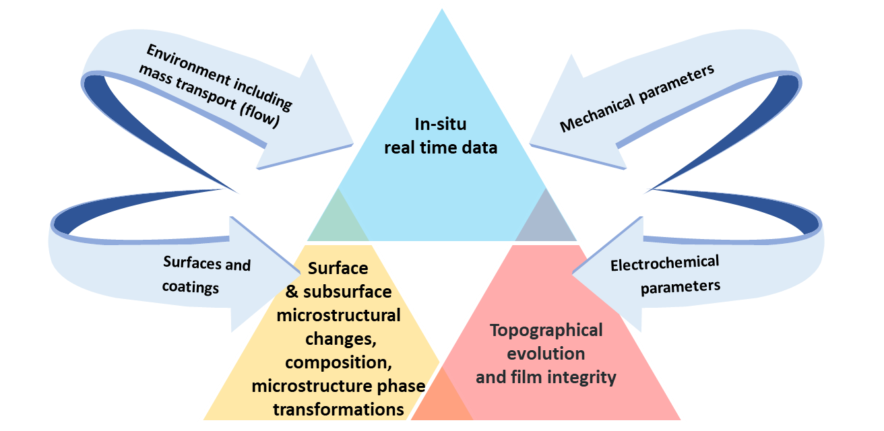
Figure 1 Factors considered for tribocorrosion mechanisms
Tribocorrosion therefore is interaction between wear and corrosion simultaneously. Both temporal and spatial aspects are important but tribocorrosion is often a marriage of not fully understood complex wear processes with the very precise field of electrochemistry and corrosion science. For a comprehensive understanding of the mechanisms and to explain the observed trends, it is essential to consider multiple factors, see Figure 1. These contributing factors are broadly classified into four categories: (1) Mechanical and operational factors: This group encompasses mechanical attributes such as the magnitude of forces, their velocities, the alignment of tribocorrosion, as well as the geometric shape and size of the components. (2) Electrochemical factors: These include variables such as electrical resistance, the potential applied to the system, and the growth of protective or reactive films on the surface. (3) Surface and coating characteristics: This category covers the material aspects of the system, including the roughness or textural features of the surface, material hardness, and the nature of the wear particles produced. (4) Environmental properties: This group accounts for the conditions of the solution in contact with the material, including temperature, pH, viscosity, concentrations of dissolved oxygen DO₂ and carbon dioxide CO₂, salinity and temperature) and electrical conductivity. An in-depth understanding of these dynamic material properties provides further insights into the resistance of materials to wear, facilitating a more detailed exploration of how corrosion contributes to material degradation [4]. Experiments should monitor and report on the key factors listed in Figure 1 (surface film, recovery, composition, environment, friction and wear, microstructural changes both in surface and subsurface, roughness changes, what electrochemical reaction(s) are occurring and so on. This would allow a more generic understanding across a very diverse set of coatings and surface modification techniques being investigated.
Research trends in tribocorrosion resistant coatings from 2008 to 2023 have been analysed by a literature survey conducted on the 'Web of Science' database, deploying 'tribocorrosion' as the targeted keyword within abstracts, yielded a corpus of approximately 880 scholarly articles on this domain. A deeper insight into this extensive research arena is achieved through a meticulous bibliographic coupling analysis, visualized in Figure 2. This analytical process, realized utilizing VOSviewer (with set parameters - full counting, a minimum threshold of 20 citations per document, and a selection of 30 key documents), underscores three main sectors - bioengineering, fundamental studies, and marine/offshore - as the primary focal points within the field of tribocorrosion studies.
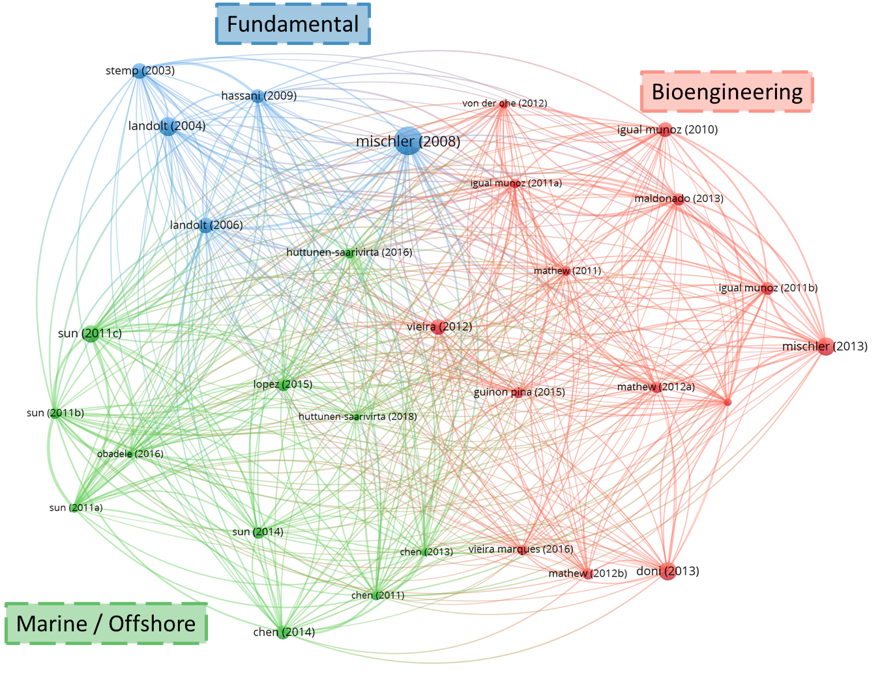
(a)
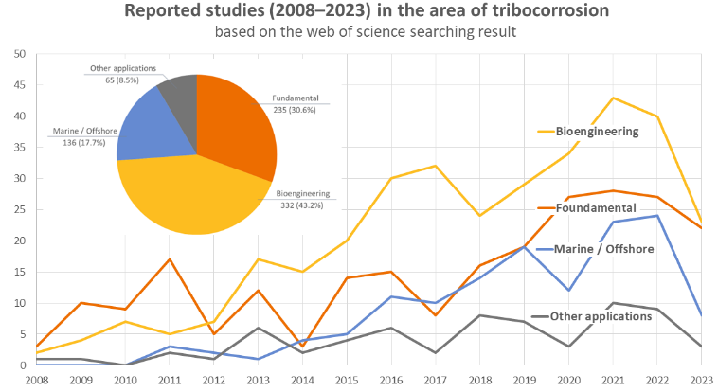
(b)
Figure 2 (a) Identified Research Clusters: An Illustration Generated via VOSviewer Employing Bibliographic Coupling for tribocorrosion. (b) Reported studies in the area of tribocorrosion (source: Web of Science searching results)
To tackle tribocorrosion effectively, a wide array of surface modification methods have been devised and progressively improved over time. For a thorough exploration of thin film deposition techniques, readers may refer to a comprehensive review by Abegunde [5]. When selecting coating materials for tribocorrosion applications, it is important to consider factors such as wear resistance, corrosion resistance, friction, adhesion, and compatibility with the substrate material. Figure 3 (a) illustrates a range of surface coating methods [6] and Figure 3 (b) displays various treatment techniques [6–8]. Figure 3 (c) further details the number of papers published on each technique over the years. It is evident that the period from 2019-2023 witnessed a significant increase in publications, particularly in the realm of PEO and PVD techniques. This suggests a growing interest and preference towards these methods in recent years.
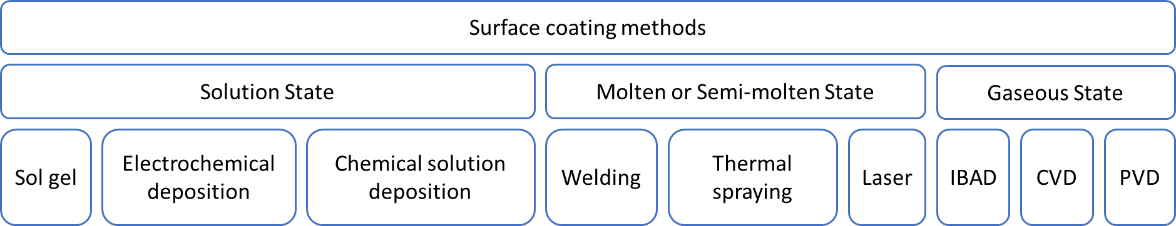
(a)
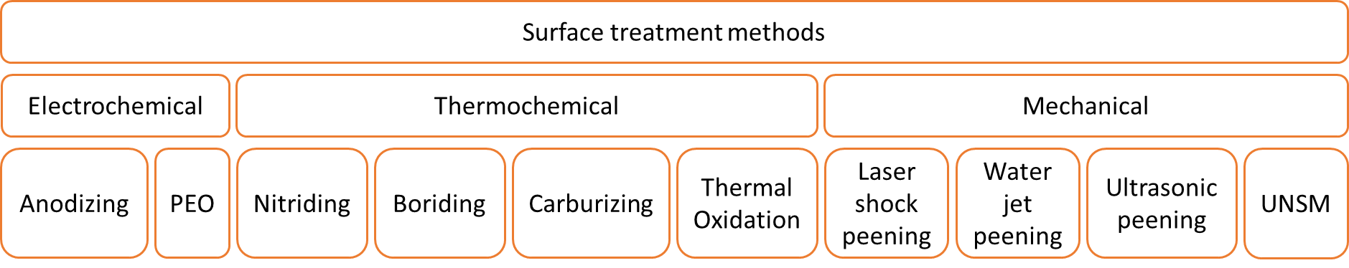
(b)
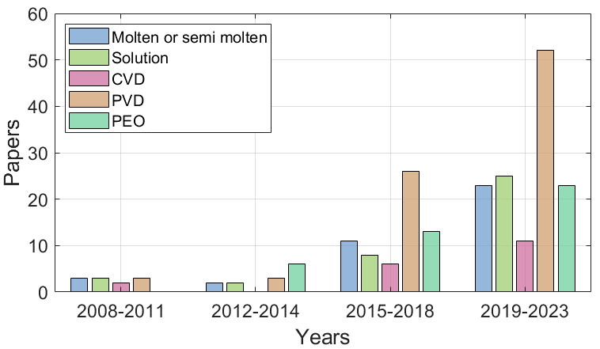
(c)
Figure 3 (a) Typical coating techniques, adapted from [6], (b) surface treatment methods, adapted from [6–8] (c) papers published using individual techniques
Wear corrosion interactions [9]:
Under wear-corrosion (i.e. sliding or abrasive wear), total damage, $T$, is given by:
 | $$T=W+C+S$$ | (1)
Where $W$ is the mass loss due to wear, $C$ is the pure corrosion rate and $S$ is the synergistic term. Synergy is defined as ‘the difference between wear-corrosion and the summation of its two parts’ and can be expressed by:
 | $$S=T-\left(W+C\right)= ∆C_{W}+∆W_{C}$$ | (2)
Wear can mechanically strip the protective corrosion film creating fresh (nascent) reactive corrosion sites and producing wear enhanced corrosion (ΔC_{w}) [10]. The recovery and inhibition of corrosion is dependent on the rate of repassivation/surface film regrowth and the integrity of the film formed. Tribological stimulii can also change the microstructure (grain refinement), phases (strain induced transformations) as well as the integrity of surfaces and subsurface (applied stresses induce cracking for example). The other possible driving mechanisms of ΔC_{w} are summarised here and include (i) local acidification, (ii) increased mass transport of reactants, (iii) lowering the fatigue strength, (iv) anodic wear scars can cathodically polarize the surrounding unworn surfaces [11] and (v) surface roughening [12]. Corrosion enhanced wear mechanisms ΔW_{c} are also possible. The ΔW_{c} wear rate could be due to (vi) the removal of work hardened surfaces [13], (vii) preferential corrosive attack at grain boundaries [14], (viii) the increase in the number of stress concentration defects resulting from micropitting and (ix) detachment of plastically deformed flakes on the metal surface due to stress corrosion cracking. Most of the above mechanisms, if dominant, would be expected to lead to positive synergy [9].
Summary of reviews: López-Ortega discussed the evolution of test procedures and standards for assessing the tribocorrosion of passive materials. The work emphasized the adaptation and development of various electrochemical techniques and the importance of understanding the tribocorrosion mechanisms through these methods. A gap identified was the lack of a universal standard that addresses the complexities of tribocorrosion mechanisms, particularly for active materials, which behave differently from passive alloys [2].
The reviews by Mathew T. Mathew and Charlotte Skjöldebrand focused on the critical role of tribocorrosion in biomedical applications, especially regarding implants. Mathew's work laid the foundation by highlighting the challenges in comprehending the complex interactions at play and the absence of a standardized test apparatus. The reviews called for an integrated approach to develop standardized testing methods that can accurately simulate in vivo conditions. Furthermore, Mathew's insights pointed to a gap in translational research, emphasizing the need for collaboration to translate laboratory findings into clinical practice [4, 15]. Skjöldebrand's review complemented this by examining the current status and potential of wear-resistant coatings for hip and knee implants. The review identified the success of certain coatings, such as TiN and TiNbN, in improving implant properties and reducing the risk of metal ion release and hypersensitivity reactions. However, it also highlighted the critical issue of coating adhesion, which is paramount for the longevity and functionality of implants. Skjöldebrand noted the limited follow-up times and low revision rates, which present a challenge in assessing the long-term performance of these coatings [16]. Additionally, a recent review by Puthillam also delved into the topic of tribocorrosion in biomaterials and its control techniques [17].
The work of Wood provided insights into the tribocorrosion performance of marine materials. The reviews pointed out the lack of understanding in the synergy between mechanical wear and corrosion processes and the need for better prediction models for marine systems. Wood's papers suggested that further research is needed to develop testing facilities with high data acquisition capabilities that can capture the nuanced behaviours of materials under marine tribocorrosion conditions. For your review, a potential avenue of exploration could be to outline methodologies for spatial and temporal analysis that can predict material performance in marine environments more accurately. You might also consider evaluating the efficacy of different coating materials and technologies in mitigating marine wear and tribocorrosion, such as the performance of nickel-aluminum bronze in aggressive ocean environments [18, 19].
This review presents a comprehensive overview of the advancements in coating development for tribocorrosion resistance, offering a broad perspective that spans a variety of application domains, from biomedical to marine environments. It serves as a signpost to the recent progress and activities in coatings research, highlighting innovations, challenges, and potential synergies across these diverse fields. While the review may touch on specific details, it aims to give an overview of trends in recent research that include emerging coating deposition techniques, compositions, applications, testing and modelling.
The review has the following sections: introduction and drivers for research, coating development, modelling, environmental effects, conclusions and remaining challenges.
- Coating development
  - Coating techniques (Monolayers):

    - Molten deposition
Monticelli looked at thermally sprayed ceramic coatings deposited on steel and exposed to a 3.5% NaCl solution [20]. Coatings prepared by plasma spraying Cr₂O₃ and Al₂O₃/13% TiO₂ powders on a Ni-20Cr bond coat were studied. Due to high levels of porosity the substrate was not fully protected against corrosion so further work is needed to improve coating quality before these are used in tribocorrosion conditions. The same authors also looked at the tribocorrosion of PVD magnetron deposited nanoscale multilayer CrN/NbN coatings deposited on top of thermal spray coatings on steel in 3.5% NaCl solutions [21]. The thermally sprayed coatings being HVOF WC–12Co and Cr₃C₂–37WC–18Me. They found the PVD top coating offered better tribocorrosion performance of the system, but the coatings degraded over time and hence this benefit was lost.
Tribocorrosion wear rates of 6.5 x 10⁻⁶ mm³/(mN) for arc-sprayed AlFeSi Metallic Glass coatings in 3.5% NaCl (pH 7) solutions reciprocating against 12.7 mm diameter alumina balls under 15N load are reported by Yunyun Ge [22]. Figure 4 compares the wear rates of various coatings under tribocorrosion conditions, as reported in the literature [23–25, 22]. Kuptsov looked at single-layer and multilayer Nb-doped TiC coatings obtained by pulsed arc evaporation (PAE), electro-spark deposition (ESD) in vacuum and a hybrid approach of these [26]. Tribocorrosion tests were conducted in air and 3.5% NaCl solution. The single-layer PAE coating demonstrated improved performance and oxidation resistance. The ESD sublayer in the PAE/ESD provided enhanced toughness and increased thickness.
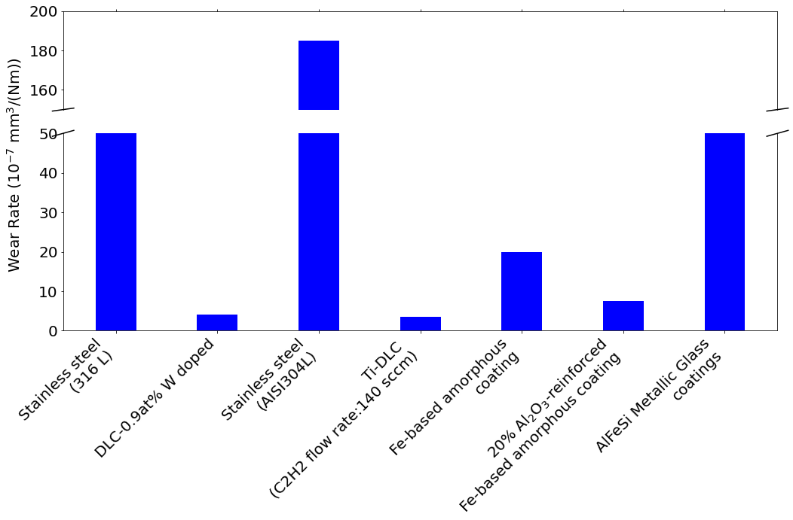
Figure 4 Wear rate for various coatings under tribocorrosion conditions in 3.5% NaCl solution, data from [23–25, 22]
HVOF WC-12Co, WC-10Co4Cr and WC- Cr₃C₂-7Ni coatings were studied in 3.5% NaCl solution by Kai Hu [27]. They found that the formation of CoCr phase on the surface reduced the dissolution of the Co matrix and was not easily removed, making the WC-10Co4Cr coating the most tribocorrosion resistant. Rosanna Pileggi [28] studied HVOF Cr₃C₂–NiCr cermet coatings and found a strong dependence of the coefficient of friction on the polarisation potential with a value of 0.28 when the system was under cathodic conditions to a value of 0.11 when under anodic conditions. Rodrigues [29], looked at HVOF Cr₃C₂-25(80Ni20Cr) in double-distilled de-aerated water, 3.5 wt% NaCl, 0.2 M NaOH and 0.2 M H₂SO₄ solutions. The study found that the coating exhibited similar resistance in distilled water, NaOH, and NaCl solutions, while the coating showed improved tribocorrosion resistance H₂SO₄ solutions.
    - Vapour deposition
A major deposition route for hard coatings with a thickness of a few to tens of microns is by using vapour methods such as Physical Vapor Deposition (PVD) or Chemical Vapor Deposition (CVD). They are widely used to improve the electrochemical and thermal properties surface performance of various applications, microelectronics, encompassing cutting tools, automotive components, and biomedical devices. Recent advancements in hard thin film coatings for tribocorrosion prevention have primarily focused on two main categories: hard nitride coatings and amorphous carbon (a-C) coatings.
Transition metal nitride coatings, including TiN, CrN, TiCN, TiZrN, and TiAlN, are recognized for their hard nitride properties. In a study by Caha, TiN coatings were applied to pure titanium. The impact of various deposition times on the coating performance was analysed in a 9g/L NaCl solution maintained at body temperature. The findings indicated that a prolonged deposition time of 80 minutes resulted in a thicker coating, enriching the percentage of the Ti₂N phase. This enhancement led to an increased resistance against wear [30]. Merl looked at PVD TiAgN and TiSiN hard coatings for protecting stainless steel for biomedical applications [31]. Cui’s studies compared the tribocorrosion performance of TiN and TiZrN coatings on Ti-6Al-4V substrate. The TiN coating showed marked chemical stability and an elevated H³/E² ratio, enhancing its resistance to corrosion and wear. And the TiZrN coating had wear rates 40%-60% lower than TiN, highlighting the role of zirconium in boosting the properties of the TiN coating [32] [33]. Sáenz de Viteri found that the TiCN coating provides excellent protection against tribocorrosion and fretting, as a carbon-rich tribo layer is generated during the sliding process thereby reducing friction [34]. Tijerina-Gonzalez found that coatings containing oxygen (AlTiON and AlCrON) diminished the porosity and increased the hardness; however, these coatings exhibited higher wear and more damage after tribological test when compared to AlTiN and AlCrN systems. They also suggest that there is no consistent relationship between the coating hardness or roughness and their adhesion strength or coefficient of friction [35]. Other types of coating include carbide coatings such as TiC, ZrC, and TiNbC [36] have been studied by Pana.
Amorphous carbon (a-C) coatings, also known as DLC coatings, have garnered considerable attention since the late 20th century. They are recognized as exceptional protective barriers and for their excellent hardness, reduced friction and wear, electrical insulation, chemical stability, and biocompatibility [34]. Their proven efficacy in enhancing wear and corrosion resistance has expanded their use, and therefore their play a crucial role in the management of tribocorrosion in various applications [24, 37–40].
It is reported by Oliveira that the corrosion resistance could be enhanced up to 59 times compared to the bare SS304 substrate with controlled hydrogen and carbon contents [41]. E. Gracia-Escosa studied TiB_{x}C_{y}/a-C coatings deposited on AISI 316L steel in an aqueous solution of 0.26 vol.% acetic, 0.16 vol.% peracetic and 0.18 vol.% hydrogen peroxide [42]. The corrosion current density of the TiB_{x}C_{y}/a-C coating ranges on the same order as bare steel but with a significantly decreased coefficient of friction (0.1 vs. 0.6) and wear rate (~10 times lower).
Nonetheless, DLC coatings have their own challenges. Hydrogen-free and low-Cr-doped hydrogenated diamond-like carbon (DLC) films on AZ91DMg alloy have been studied by Xue-Jun Cui et al, but results show severe tribocorrosion of the substrate in NaCl solutions hence more work is needed to improve coating quality. Wu looked at Cr-doped diamond-like carbon (Cr-DLC) sliding against different counterparts in hydrochloric acid (HCl), and the Cr-DLC film sliding against tetrahedral amorphous carbon (ta-C) showed the best tribological performance [43]. The prevalent high internal stresses and adhesion issues when applied to softer substrates significantly hinder their widespread adoption. Depositing ultrahard coatings on softer substrates can led to mechanical and chemical property mismatches between coating the substate resulting in high intrinsic stresses and poor adhesion. An additional concern is the presence of defects through the coating thickness [24, 44].
To address these challenges, the introduction of metallic elements (Si or N) into the DLC matrix has been explored. This approach involves the formation of a composite structure where metal or metal carbide grains are embedded within an amorphous carbon matrix, effectively mitigating the internal stresses. Subsequent studies have furthered the understanding of DLC coatings. Sun has looked at diamond-like carbon (DLC) films with various nitrogen content deposited on TC4 titanium alloys using plasma-enhanced chemical vapor deposition (PECVD) [45]. The effects of the nitrogen content on the tribocorrosion properties in Hanks’ solution show that the doped nitrogen induced the formation of new sp² sites generated graphitization in the doped DLC film. The tribocorrosion resistance of the doped DLC film was improved due to the increased adhesion strength and provent ionic solution permeation. Cui investigated the tribocorrosion properties of a PECVD deposited multilayer diamond-like carbon (DLC) film doped with Si in NaCl solution [46] and report lower wear rate in NaCl solution compared to the substrate and a single layer DLC film. Corrosion and tribocorrosion behaviour of super-thick Si doped diamond-like carbon films deposited by plane hollow cathode PECVD on stainless steel in NaCl solution is reported by Jibin Pu [47]. Three kinds of DLC films with different thickness (4-21 µm) and modulation periods (3-7) were deposited on stainless steel. The tribocorrosion behaviour was evaluated in 3.5 wt% NaCl solution using a ball-on-flat tribometer. The life of film is increased with the thickness and the tribocorrosion resistance is impact by the modulation period of the DLC films. The best tribocorrosion resistance DLC film was observed with thickness of 21 µm and 7 periods.
In a comparative study, Wang and colleagues have carefully compared the performance of transition metal nitride coatings and amorphous carbon (a-C) coating in simulated body fluids (SBF) [48]. The coatings were deposited on tungsten carbide (WC) discs with a cobalt content of 8.0 at.%, and the tribological tests were performed using a pin-on-disc rig against an alumina (Al2O3) ball with an 8 mm. After a sliding distance of 1000 meters, the wear track depths and widths on the coatings were analyzed and compared, as illustrated in Figure 5 (a). The depths of the wear tracks for the TiAlN, a-C:H, and TiN coatings were significantly deep, measuring 2.5 mm, 3 mm, and 1 mm, respectively, which exceeded the thicknesses of the films. In stark contrast, the CrN coating's wear track depth was only 0.6 mm, remaining below the film's thickness. The widths of the wear tracks also mirrored the depth trends, with the TiAlN coating exhibiting the widest track at 0.56 mm and the CrN coating the narrowest at 0.18 mm. Notably, the edge of the a-C:H coating's wear track, highlighted by a red frame in Figure 5 (a), appeared remarkably neat and well-defined compared to the others, which may be indicative of complete delamination under the contact stress experienced during the test. This phenomenon contributed to the high wear rate observed for the a-C:H coating, yet interestingly, the delaminated particles from this coating might have acted as a self-lubricating layer, which is suggested by the relatively low friction coefficient of 0.372.
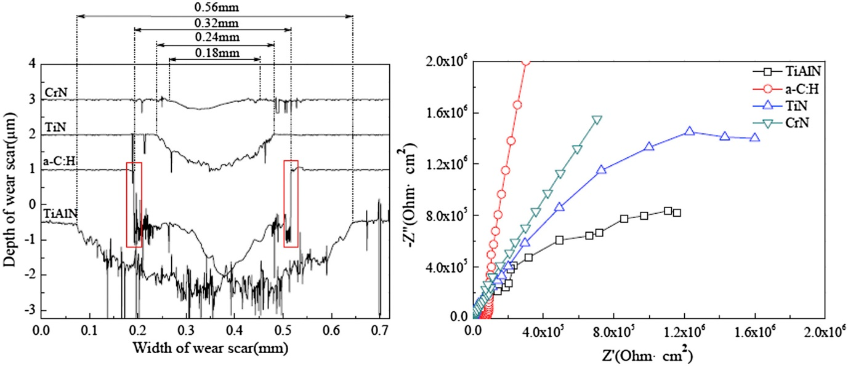
Figure 5 Comparison of different coatings: (a) the cross-sectional contour lines of wear tracks (b) Nyquist plots [48]
Further electrochemical analysis depicted in Figure 5 (b) showed that the a-C:H coating displayed the largest capacitive resistance arc in Nyquist plots, followed by the CrN coating, while the TiAlN coating showed the smallest one. This suggests that the a-C:H coating has a superior ability to resist corrosion in SBF compared to the other coatings tested. The larger capacitive arc indicates a higher resistance to charge transfer, which could be due to the formation of a more protective passive layer on the a-C:H coating in the corrosive environment of the SBF.
Another group of coatings being studied are based on the high performing refractory high entropy alloys (HEA). Four BCC-structured VNbMoTaW and VNbMoTaWCr high entropy alloy coatings with different Cr contents on 304 stainless steel (304SS) by a pulsed DC magnetron sputtering is studied by Luo [49]. Tribocorrosion tests immersed in a 3.5 wt% NaCl aqueous solution at room temperature under 1 N load using a pin-on-disk tribometer were conducted. Coatings with more than 24.7 at.% Cr exhibited a high hardness range of 16.4 to 16.5 GPa and superior corrosion resistance, both in isolated corrosion and under tribocorrosion conditions. The tribocorrosion behaviour, particularly at potentials exceeding the breakdown potential, was significantly affected by the protection degradation ratio (Pdr), which is the ratio of polarization resistance in pure corrosion versus tribocorrosion. The lowest recorded wear rate was 2.55 × 10⁻⁵ mm³N⁻¹m⁻¹ for the coating with 11.65 at.% Cr, which showed a performance 1.4 times better than that of 304 stainless steel (304SS) under similar conditions.
    - Deposition from solutions
Different coatings on a variety of substrates that have been deposited by solution techniques for enhanced tribocorrosion protection. In [50], Taşdemir has looked at different concentrations of polyurethane and polyvinylpyrrolidone (PVP) blends applied to AISI 316L stainless steel using a dip coating method. They found that coatings containing up to 25% PVP protected the substrate surface under tribocorrosion conditions induced by reciprocating sliding in a NaCl solution. [51] have looked at sprayed coatings of Si₃N₄@MoS₂ core–shell structure and show an enhanced tribocorrosion resistance of the epoxy resin/polyacrylate interpenetrating polymer network organic matrix.
A range of Ni based coatings have been investigated. In [52], the tribological behaviour of electroplated functionally graded nickel-Al₂O₃ nanocomposite coating produced at different duty cycles in 3.5%wt NaCl solution was investigated. The results show that by decreasing the duty cycle, the width of the wear track decreased due to more particles being incorporated into the coating and a change from a (001) structure to a compact random texture. Although the corrosion resistance decreased by increasing the embedded particles, the increased hardness and compact structure of the coating resulted in better tribocorrosion properties. A change in wear mechanism is also seen from adhesive wear for coatings plated at a high duty cycle to the abrasive wear for coatings deposited at a lower duty cycle.
The tribocorrosion of electrodeposited Ni/B coatings are investigated by R. Offoiach [53]. They found that Ni/B coatings with 0.1wt% of B are not protective against tribocorrosion due to the presence of cracks in the coating, however, crack free Ni/B coatings with 0.04wt% and 0.06wt% of B show good tribocorrosion behaviour with respect to pure Ni coatings. This improved performance is thought to be due to their higher hardness.
The tribocorrosion behaviour of the electrodeposited Ni–W coating using a ring on block tester has been reported by Lee, H.B [54]. They report that columnar grains were embedded with lamellar and nanocrystalline microstructure in the deposited coatings. The results showed that wear rate increased as the applied overpotential increased and the surface W-content increased but the coefficient of friction decreased. XPS analysis determined the surface corrosion film was composed of Ni(OH)₂, NiO, and WO₃. The formation of this porous corrosion film at high overpotential was found to cause an accelerated mass loss under tribocorrosion. The tribocorrosion resistance of electrodeposited Ni–Co nanocrystalline coatings in NaOH solution have been investigated by Hassani [55]. They found that by adding saccharin into the bath produced a reduced the grain size, increased hardness, a change in texture from (2 0 0) to (1 1 1), reduced surface roughness, increased corrosion resistance and improved the tribocorrosion behaviour.
The tribocorrosion behaviour of heat-treated NiP–SiC composite coatings with low particles concentrations were found to be similar to the NiP coatings. However, for coatings with higher particles concentrations (NiPSiC80 and NiPSC200), the electrochemical properties were compromised but had improved wear resistance compared to lower concentrations [56].
Benea, L. studied the tribocorrosion behaviour of microstructured ZrO₂–Ni composite coatings using a pin-on-disc in 0.5 M K₂SO₄ solution[57]. The enhanced tribocorrosion properties of ZrO2–Ni composite coatings are due to ZrO₂ particle dispersion into the nickel matrix, leading to structural improvements and strengthening effects.
Lee Chun-Ying studied electroplated Ni-Mo coating using a block-on-ring configuration immersed in 5 wt% NaCl solution [58]. Mass loss was increased with applied anodic potential and minimum coefficient of friction was obtained due to the oxide film. The synergetic effect between wear and corrosion was less significant compared to other Ni-alloys (such as Ni-P, Ni-W, and Ni-W-P).
The fretting and wear behaviour of Ni/nano-WC composite coatings on stainless steel were in dry and wet conditions by [59]. The studies were performed on a ball-on-disk tribometer to simulate the primary water circuit of Pressurized Water Reactors (PWRs), and results showed that Ni/nano-WC composite coatings displayed a low friction coefficient, high nanohardness, and superior wear resistance compared to pure Ni coatings.
Electrodeposited cobalt–tungsten alloy coatings with a mixed amorphous/nanocrystalline structure have been studied by N. Fathollahzade & K. Raeissi [60]. However, they report that during wear at open circuit potential (OCP), the potential continuously increased to nobler values and then remained at high values even after the end of rubbing. Under anodic polarisation, rubbing caused a sharp increase in current density. However, at the end of rubbing, it returned to the initial value. They suggest mass transport, depassivation, cracking and structure variation played major roles in determining the poor tribocorrosion behaviour of the coating.
Nickel oxide nanoparticles ranging from 50 nm to 220 nm have been embedded into Ni-P electroless coatings to create NiO@Ni-P nanoparticle reinforced composite coating on a brass substrate by Mohammad Reza Rajabi [61]. They found that by increasing the percentage of NiO-NPs in the coating enhances the corrosion and tribocorrosion resistance of the coatings.
A. Salicio-Paz have looked at the impact of the multilayer approach on the tribocorrosion behaviour of nanocrystalline electroless nickel coatings [62]. The multilayer coatings exhibited an enhanced tribocorrosion resistance due to the load bearing ability compared to monolayered ones. Ultrasound-assisted Ni-B coatings have been shown to have tribocorrosion behaviour that was similar or better than pure Ni coatings [63]. F Tabatabaei studied the effect of heat treatment on tribocorrosion of nanostructure Ni–P coatings [64]. High phosphorus Ni–P coatings were deposited on mild steel, and then isothermally heat treated. Tribocorrosion tests were conducted in 3.5 wt-%NaCl solution showed that the maximum tribocorrosion resistance and minimum coefficient of friction was obtained for heat treated Ni–P coating at 600°C.
The tribocorrosion performance of chemically bonded phosphate ceramic coatings (CBPCCs) with different aluminium phosphate(AP) concentrations was studied in [65]. The coating with 35% AP demonstrated the lowest tribocorrosion material loss. AP's presence improved wear resistance and the AlPO₄-coated alumina particles in the coatings enhanced the overall tribocorrosion resistance by altering electrolyte movement during wear and corrosion.
The tribocorrosion protection of Ti-6Al-4V by a composite coating with a plasma electrolytic oxidation layer and sol-gel layer filled with graphene oxide (GO) is reported by Tianlu Li [66]. The addition of GO is seen to improve the tribocorrosion resistance of the PEO/sol-gel film, reduced the wear, and acted as a solid lubricant to prevent corrosion in the friction process. Similarly, Bian Da’s study shows enhanced tribocorrosion protection from chemically bonded phosphate ceramic coating (CBPCC) with added GO-ZnO. The GO-ZnO blocked the electrolyte diffusion pathway increasing corrosion resistance [67].
While a substantial potential is seen by using of hard coatings, it has also been widely noted that the existence of pores or cracks within such coatings can facilitate the diffusion of corrosive ions, leading to coating failure [68]. Delamination of these single layered coatings may occur due to the significant hardness difference between the hard coating and soft substrates, which lead to subsequent exposure of the substrate to the electrolyte significant decrease of the impedance [40]. Challenges related to the adhesion between the coating and substrate, as well as delamination, remain significant failure mechanisms limiting the use of coatings in vivo. Various clinical case reports indicate that the micro-moving surfaces of recovered TiN-coated joint prostheses that have been used for more than five years have experienced spallation and flaking [69]. Consequently, researchers have invested efforts into developing multilayered coatings and duplex treatment processes, recognizing that the interlayer could crucially influence tribocorrosion behaviour.
Duplex (thin-on-thick) coating systems formed by thin CrN or DLC layers sputter deposited on top of thick HVOF deposited Fe3Al layers on 304-type stainless steel substrates have been studied by Fabrice Pougoum [70]. The tribocorrosion experiments confirm that addition of DLC and CrN layers is particularly beneficial when the duplex system is subjected to wear tests during cathodic polarization. However, in the anodic regime, defects formed at the surface are detrimental as the electrolyte infiltrates the top layer and causes the dissolution of the Fe₃Al interlayer. Kovacı looked at the tribocorrosion properties of duplex surface treatments consisting of plasma nitriding and DLC coating [71]. The effect of damage caused by the synergistic effect of corrosion and wear mechanisms was reduced by two basic coating parameters of temperature and time. The 600°C-4h + DLC coating exhibited the best tribocorrosion resistance. Bayón studied the effect of repassivation on the tribocorrosion performance of two types of multilayer coatings : one with alternating Cr and CrN layers, and another with layers of CrN and ZrN [72]. The study found that while the friction force does not directly affect tribocorrosion, wear processes do. A phenomenological model for the repassivation of these coatings was established, which correlates the rate of mechanical activation caused by friction with the behaviour of the open-circuit potential.
Numerous multilayered coatings for biomedical applications were proposed in the literature. One strategy aims to further enhance the coating hardness and close single layer defects. Bai's research demonstrated that the incorporation of Ta- or Ti-doped multilayered structures onto Ti-6Al-4V alloy enhances the tribocorrosion resistance of a-C films, providing them with improved wear and corrosion resistance compared to both the single layered a-C film and Ti-6Al-4V [73]. Comakli investigated the surface hardness of a TiN/TiAlN multilayer and found that the maximum hardness was reached for TiN/TiAlN multilayer-coated samples [74]. Caha's research determined that, although the TiN coating did not enhance the tribocorrosion resistance of Ti-12Nb alloy due to the coating delaminating, applying a ZnO layer on top of the TiN coatings significantly improved performance by increasing microhardness and providing a robust physical barrier [75]. CrN and CoCrMo carbon S-phase layer were systematically studied by Bertram Mallia’s group [76–78]. Among these, CrN/S coatings on 316L demonstrated remarkable tribocorrosion resistance, attributed to their high hardness and substrate adhesion.
Another approach is to use a combination of the hard and brittle nitride coatings with a softer metal (Cr, Ti, Ta, and Zr) as an interlayer, which is recommended to manage interfacial stress and to avoid crack growth. Attempts of (Ti/TiN) were studied by Naghibi [79] and Zhao [80], Zhao showed that the tribocorrosion resistance of multi layered coating were increased by approximately two times compared with the single-layered TiN coating. Recently, the study by Beliardouh applied (Ta/ZrN)n on Ti-6Al-4V evidenced that the synergistic effect leads to complete deterioration of the multilayer coating. The coatings architectural thickness design is critical, see Figure 6, and elasto-plastic properties of the adjacent surfaces are a key factor in the wear mechanism [81].
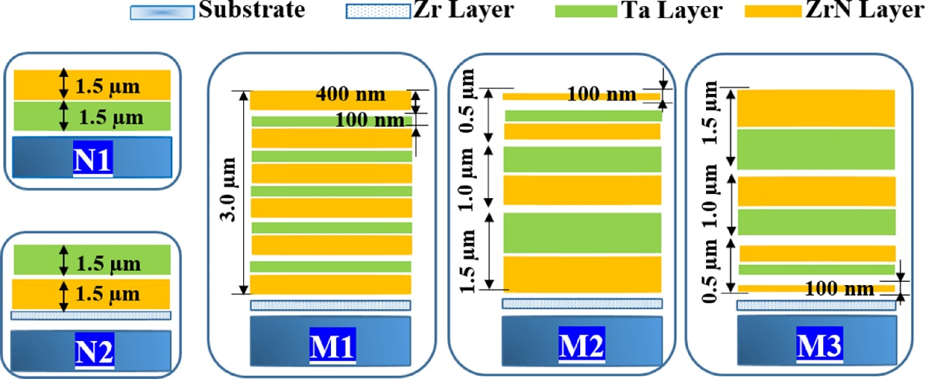
Figure 6 Gradient multi-layer coatings [81]
Recently, duplex layered coatings, which encompass a hybrid technique involving an initial thermo-chemical treatment (such as oxidation, nitriding, or carburizing) followed by a subsequent film deposition process, have attracted substantial research attention. Frutos looked at nitrogen diffusion layers, achieving a thickness of up to 12 μm, followed by the application of a CrN coating through PVD. The findings reveal a substantial enhancement in surface hardness, increasing it by a factor of 5.5, while also exhibiting a marked reduction in both pitting susceptibility and wear volume loss compared to the untreated counterpart [82]. Zhao evaluated the effects of plasma nitriding and DLC surface modifications on three different substrates, discovering that nitrided SS316 and CoCrMo negatively impact tribocorrosion performance, while plasma nitriding on pure Ti produces a thick, dense, and homogeneous TiN layer similar to the DLC coating [83]. Conversely, Uzun found that a duplex surface-treated sample on SS316 improves performance instead of exhibiting negative effects [84]. Grabarczyk studied the effects of oxidation or carburizing prior to the DLC coating deposition on Ti-6Al-4V, indicated that a two-step modification of oxidation followed by DLC coating yielded optimal outcomes [85]. In general, the adequate combination of thermo-chemical treatment and coating deposition can significantly improve tribological and corrosion properties, while the parameters set for the treatment process determine the resulting phases and further impact the final performance.
PEO, or Plasma Electrolytic Oxidation, has emerged as a significant topic of research and industrial application, particularly gaining momentum from the 2010s onward. This process, used to create oxide coatings on lightweight metals such as aluminium, titanium, and magnesium, generates enhanced wear resistance, improved corrosion resistance and increased surface hardness. These coatings have been found promote bone ingrowth and ensure stable implant fixation, marking them as crucial developments for biomedical implant materials. Creating a thin organic/inorganic layer on a PEO coating is one of the most attractive methods which has been considered by many researchers. A comprehensive study by A. López-Ortega using PEO has demonstrated the potential for creating ceramic-like oxide layers on titanium alloys, enhancing wear-corrosion resistance and cell adherence, crucial for successful osteointegration. These layers have been modified with various elements to enhance osteointegration and provide antibacterial properties [86]. A series of composite coatings have been developed on Mg alloys and Zr alloys to enhance their properties.
Table 1 summarizes the characteristics and preparation methods of these coatings, showcasing a range of approaches and their effectiveness as determined through various tests.
In addition to the advancements in Plasma Electrolytic Oxidation (PEO), the boriding process emerges as another notable surface modification technique. Specifically, TiB2+TiB coatings were formed on Ti–6Al–4V through a molten-salt diffusional process at temperatures of 850 °C and 900 °C for 16 h by Rahmatian [87]. The research highlights that at a higher temperature of 900 °C, the TiB layer's thickness increases significantly, enhancing the material's wear resistance. This process results in a substantial decrease in the tribocorrosion rate, demonstrating a 98% reduction compared to uncoated Ti–6Al–4V
after enduring 36,000 cycles of sliding under a 15 N load. However, the borided layers applied at 850 °C showed complete wear, indicating the critical role of temperature in this process.
Another surface modification method is laser shock peening (LSP). A Ti40Zr25Ni3Cu12Be20 bulk metallic glass (BMG) is treated by laser shock peening with 1, 2 and 30 times , leading to internal structural changes and the generation of free volume [88]. This process improved the BMG's plasticity, crack resistance, and increased its surface microhardness. The average tribocorrosion volume loss rate of the LSP specimen decreased by approximately 11 %. However, excessive LSP caused increased surface roughness (552.9 nm), which made the surface more prone to pitting and reduced its tribocorrosion resistance.
Table 1 Summary of Research on PEO Techniques Applied to Mg and Zr Alloys
Substrate | Tech | Solution | Test | Findings | Ref
AZ31B Mg alloy | PEO with pullulan | SBF | EIS, OCP, PDP | An optimal pullulan concentration in the silicate-based electrolyte solution for achieving the best anti-corrosion properties in the PEO-treated alloys. Specifically, the corrosion resistance improved as the pullulan concentration increased from 0 to 1.0 g/L. | [89]
AZ31B Mg alloy | PEO + CS dip | SBF | EIS, OCP, PDP | The PEO-treated AZ31B Mg alloy is porous and has multiple micro-cracks. Using hydrothermal treatment (HT) leads to the precipitation of Mg(OH)2 crystals over the PEO sample. When a chitosan (CS) layer was applied on top of these treated samples, it effectively sealed the pores and cracks. As a result, the combination of PEO, HT, and CS coating significantly enhanced the corrosion resistance of the Mg alloy, as evidenced by the order of anti-corrosion property: PEO/HT/CS > PEO/CS > PEO/ HT > PEO > substrate. | [90]
Zr-2.5 Nb alloy | PEO (ZrO2-Al2O3) | PBS | EIS, OCP | The main wear mechanism for the uncoated Zr-2.5 Nb alloy substrate was identified as adhesion, with wear particles adhering to the surface locally. In contrast, for the coated surfaces, delamination was the predominant wear mechanism, signifying a significant improvement in wear resistance for the coatings. | [91]
AZ31B Mg alloy | PEO with multi-walled carbon nanotubes | SBF | OCP, PDP | The presence of MWCNTs induced the formation of Mg2SiO4 in the coating, in addition to the already existing MgO. The reinforcement with MWCNTs led to a 15% reduction in the coefficient of friction and decreased wear-related damage by 60%. Moreover, the corrosion resistance of the coating was enhanced, especially against pitting corrosion. | [92]
AZ31B Mg alloy | MAO Ca/P Coating | SBF | EIS, OCP, PDP | The magnesium alloy, when treated with ultrasonic cold forging technology (UCFT) followed by micro-arc oxidation (MAO) containing calcium phosphate, demonstrated superior tribocorrosion resistance. When friction was applied to the samples, there was a significant increase in corrosion. | [93]
AZ31B Mg alloy | Si,  Si+P,  Si+B | SBF | EIS, OCP, PDP | The microstructure and surface morphology of the MAO coatings were found to be similar, with all having an outer porous layer and an inner dense layer. Among the various coatings, the one produced with both Si and B (Si+B) in the electrolyte was the thickest and exhibited the highest hardness. | [94]

- Modelling
Modelling tribocorrosion requires mechanical wear and electrochemical corrosion components as well as their interaction that creates synergy or antagonism between the two processes, see previous section on wear-corrosion interactions. Thus, modelling needs a way to accommodate surface damage, removal of protective surface films and their rate of regrowth. Modelling synergy/antagonism between wear and electrochemical processes allows prediction of the total surface removal. Synergy has a ΔWc (Corrosion enhanced wear) and ΔCw (wear enhanced corrosion) component. Recent modelling and mapping papers that address tribocorrosion are shown in Table 2. As can be seen, many papers look at passivating metals and use finite element models (BEM/FEM) and look at affected area (galvanic model) of sliding and use a form of the Archard wear law and mechanically (wear) accelerated corrosion / electrochemical equations (i.e. Tafel, Landolt, Mott–Schottky and Faraday’s equations) or COMSOL for current density modelling to predict the tribocorrosion loss from the surface [95–103]. For instance, one study compared the tribo-electrochemical Open Circuit Potential (OCP) experimental curve with mathematical simulations for stellite sample in 0.5 M H₂SO₄, see Figure 7. Landolt’s wear-enhanced corrosion model, which incorporates the repeated removal of the passive film within the contact area, is depicted in Figure 8 [104]. One model combines this with a lubrication model, see Figure 9 [105]. Distribution of current density of electrolyte on various electrodes are calculated and presented by Miyabe [106], see Figure 10. Care should be taken when using Faraday’s law to convert current into volume loss as the exact electrochemical reactions occurring and the number of electrons being transferred. Other models look at passive metals undergoing plastic deformation at asperity scales that accommodate micro-shearing and low cycle fatigue. Depassivation at asperity contacts can be summed to model quantify total corrosion current. More advanced modelling for cycle loading effects seek to model the interaction of applied fatigue and tensile stresses, based on corrosion fatigue (CF) and stress corrosion cracking (SCC) mechanisms [107, 108]. One paper uses DFT to look at the origins of corrosion [109].
One model uses the kinetics for interface limited film growth to find analytical expressions for the current transients, including the conductivity and pH of the electrolyte as well as the contribution from the confined geometry within the mechanical contact [110, 111]. The corrosion enhanced wear aspects of synergy have not been modelled until recently where a deterministic model has calculated the corrosion-enhanced wear (DWc) and proposes that changes in the topography are responsible for this synergistic effect [103, 112]. Only one paper was found that models tribocorrosion of coatings [109]. Tribocorrosion mapping using machine learning is reported in [113–116] that uses experimental data to predict regimes of degradation, see Figure 11, Figure 12 and Figure 13. The low-cycle micro-fatigue wear affected by corrosion was modelled by Jiang [117], see Figure 14.
Modelling tribocorrosion has yet to embrace the full range of coatings and the fact that some coatings/environments result in reduced wear so are antagonistic rather than synergistic. The actual synergistic/antagonistic mechanisms are not well understood making it difficult to model, so these need to be fully understood to enable modelling to advance. However, models developed for bulk surfaces, discussed above, are applicable but are themselves still under development. Other areas that need to be included are; the role of debris in the contact, temperature/flash temperatures, areal roughness evolution, chemistry of oxides and corrosion reactions, complete and partial film removal and growth rates, porosity and defects, microstructural and compositional evolution, selective phase corrosion attack, environmental changes in the interface, strain hardening/phase transformations, material transfer between mating surfaces, porosity of coating and subsequent permeation of electrolyte to coating-substrate interface, interfacial corrosion / cathodic disbondment, galvanic coating-substrate interactions, the role of corrosion products as well as intrinsic residual and surface stresses. Table 2 tabulates papers with a focus on modelling triborrosion and the approaches these have taken. Although few focus on coatings, the bulk surface models show a way forward and the coupling between mechanical and electrochemical approaches and the platforms (e.g. FEM, Multiphysics, Machine learning/neural networks) needed for modelling coatings. Examples of the different contact scales and approaches are given in Figures 7-14.
Table 2 Modelling summary
eModel | Technique | validation | reference
Wear maps | Rough asperities are represented as a system of adjacent cuboids. Each cuboid refers to one asperity to explore levels of deformation and stress. Two mechanisms of asperity wear are considered: micro-shearing and low cycle fatigue. | Repassivation of AISI 304 steel in a 0.5 M solution of H2SO4 | [114]
Modelling the evolution of electrochemical current in potentiostatic condition using an asperity-scale model of tribocorrosion | This is an asperity-scale electrochemical model coupled to a computational contact mechanics solution. It models the real-time evolution of surface topography, wear and corrosion. | The model determines the micro scale current and the summation of these currents defines the macro-scale quantity of the current.  This model has been validated with experiments using a ball-on-plate tribometer. | [103]
A New Asperity-Scale Mechanistic Model of Tribocorrosive Wear: Synergistic Effects of Mechanical Wear and Corrosion. | A corrosive wear model is considered at the asperity-scale and coupled with a traditional Archard-type mechanical wear model. The geometry of the surface asperities is modified in a contact mechanics model. This deterministic model, calculates the corrosion-enhanced wear. | This work studied CoCrMo as the working electrode (WE) and Si₃N₄ ball as the counter body in a reciprocating configuration. Contributions of total mechanical wear and corrosion suggest that wear enhanced corrosion was a significant contribution in the overall degradation of the material. | [112]
Predictive wear model based on a mechanistic approach of tribocorrosion and lubrication and taking into account clinical relevant parameters such as normal load, velocity and clearance. | Passive metals considered that allows for plastic deformation at asperity contacts combining mechanical wear (Archard's law), chemical wear (wear accelerated corrosion) and hydrodynamic lubrication. | Good agreement with wear rates observed in tribometers and the running-in wear rate of artificial hip joints tested in simulators | [105]
Time dependence of the material degradation mechanisms | BEM/Archard | AISI316L in a 3% NaCl solution | [95]
Tribocorrosion mechanisms of NiCrMo- 625alloy: electrochemical modelling | Archard plus electrochemical model | Experimentally validated | [96]
Hip joint stem interface modelling | An adaptive finite-element-based model using a combination of Landolt’s passive film equation and Faraday’s law, in parallel with Archard’s wear model to simulate fretting corrosion | This model was able to predict the damage pattern at the retrieved head-neck interface. | [104]
Finite element based simulation of tribocorrosion at the head-neck junction of hip implants | Finite element (FE) model forthe head-neck junction of hip implants. Archard wear equation and Maldonado electrochemical model used ( S. Guadalupe Maldonado, S. Mischler, M. Cantoni, W.-J. Chitty, C. Falcand, D. Hertz  Mechanical and chemical mechanisms in the tribocorrosion of a stellite type alloy  Wear, 308 (1) (2013), pp. 213-221) | The FE-predicted wear patterns were comparable with those observed in retrieved tapers. | [98]
In situ determinations of the wear surfaces, volumes and kinetics of repassivation: Contribution in the understanding of the tribocorrosion behaviour of a ferritic stainless steel in various pH | Wear model using the Archard's law, however, a non-linear dependence of Archard's coefficient with pH is seen. The role of pH in influencing the film regrowth kinetics is shown | The film reactivity depends on pH, tribocorrosion experiments were performed on ferritic stainless steels in sulphate solution (pH 1.5, 6.5 or 12.5). | [103]
Electrochemical Simulation of the Current and Potential Response in Sliding Tribocorrosion | Combined Tafel, galvanic (wear/surrounding area), Archard equations | Excellent agreement of experimental wear data and the experimental OCP curves | [99]
Area-dependent impedance-based voltage shifts during tribocorrosion of Ti-6Al-4V biomaterials | An area-dependent Randle's circuit is used with the tribocorrosion current equation. The potential drop over time depends on the surface impedance characteristics, the area of the electrode, the material and the mechanical conditions giving rise to the oxide film abrasion. It accounts for the effects of oxide film onset potential, the voltage dependence of the oxide film properties and repassivation, and galvanic effects. The model has also incorporated voltage-dependent circuit elements such as the Tafel and the Mott–Schottky elements to account for the changes in these properties with voltage. | Experiments using titanium pin-on-disc fretting corrosion | [101, 102]
Modelling nanostructured metallic multilayers | A finite element (FE) based computational model and density functional theory (DFT) calculations. | Nanomechanical and electrochemical measurements were coupled with advanced material characterization tools | [109]
Multiphysics modeling and uncertainty quantification of tribocorrosion in aluminum alloys | Finite element based multiphysics model. Two surrogate models, Gaussian process and neural network with dropout, were used for uncertainty quantification of the finite element model. | validated by existing tribocorrosion experiments of two Al alloys. | [97]
Tribocorrosion of CoCr Alloy and Ti with Galvanic Coupling in Simulated Body Fluid | Numerical simulation of current density distributions conducted COMSOL Multiphysics software. | Experimental results | [106]
Modelling Current Transients in a Reciprocal Motion Tribocorrosion Experiment | Kinetics for interface limited film growth were used to find an analytical expression for the current transients. This included the conductivity of the electrolyte as well as the contribution from the confined geometry within the mechanical contact. | Good experimental fit over a range of electrolyte conductivities, and with electrochemical impedance spectroscopy | [110]
Growth mechanism and repassivation kinetic determinations on stainless steel under sliding: Role of the solution pH and dissolved oxygen concentration, | Higher wear rates were measured in low pH and aerated solution. Temporal analysis of the transients showed faster passivation of the wear track in acidic solution. | The degradation rate was correlated to the passivation kinetic. | [111]
Machine Learning Model to Map Tribocorrosion Regimes in Feature Space | Unsupervised machine learning is used to identify and label clusters from tribocorrosion data. The clusters are used to train a support vector classification model which is used to generate tribocorrosion maps. | The generated maps are compared with those from the literature. | [115]
Applicability of a recently proposed tribocorrosion model to CoCr alloys with different carbides content | Dowson model for mechanical and electrochemical wear D. Dowson  Tribological principles in metal-on-metal hip joint design  Proc. Inst. Mech. Eng. Part H, 220 (H2) (2006), pp. 161-171  Tribological principles in metal-on-metal hip joint design  Proc. Inst. Mech. Eng. Part H, 220 (H2) (2006), pp. 161-171 | Validated by tests on Stellite 6 and Stellite 21. | [100]
Fully Coupled TribocorrosionSimulation Method for Anchor Chain Considering Mechano-Electrochemical Interaction | Fortran model where both stress-accelerated corrosion and corrosion-accelerated wear can be considered to predict the time-variant damage morphology. | Simulation results were compared to theoretical values | [108]
Modelling the multi-degradation mechanisms of combined tribocorrosion interacting with static and cyclic loaded surfaces of passive metals exposed to seawater | Model coupling corrosion fatigue (CF) and stress corrosion cracking (SCC) mechanisms. The multi-degradation model is based on surface hardness and corrosion resistance. | Further experiments needed to validate model | [107]

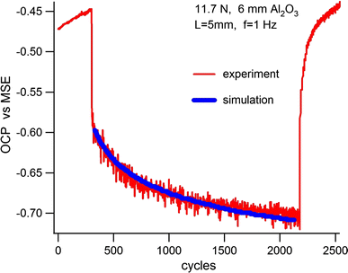
Figure 7 Tribo-electrochemical OCP experimental curve and the mathematical simulation (superposed) for the stellite 21 sample in 0.5 M H₂SO₄ at 11.7 N normal load, showing the close agreement of the OCP evolution prediction with the experimental response [99]
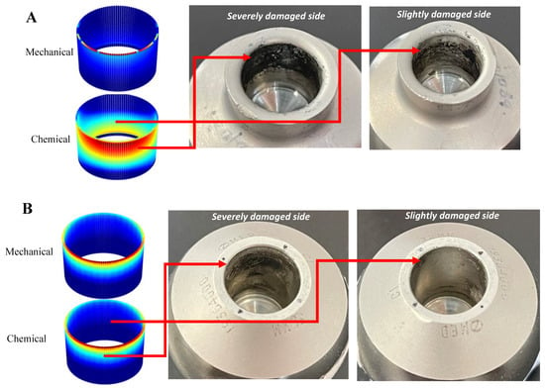
Figure 8 The figure shows comparison between the tribocorrosive wear profiles on the head tapers between FE model and retrieved samples with different levels of assembly force: (A) less than/equal to 2 kN, (B) more than/equal to 4 kN. [104]

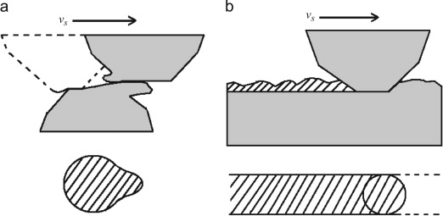
Figure 9 Schematics of the contacts between asperities (a) or between asperity and flat counter body (b) (Dashed areas represent plastically deformed and then depassivated metal surface) [105].

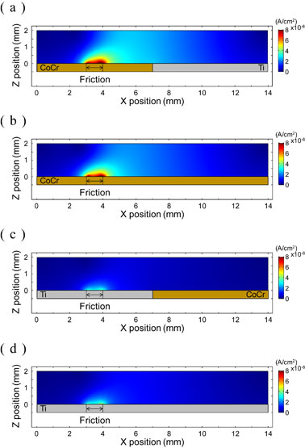
Figure 10 Distribution of current density of electrolyte on various electrodes. (a) CoCr(Tribo.)–Ti model, (b) CoCr(Tribo.) model, (c) Ti(Tribo.)–CoCr model and (d) Ti(Tribo.) model [106]
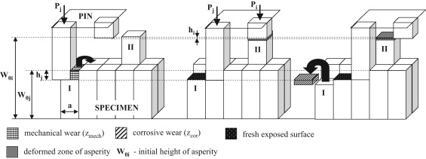
Figure 11 Model of the tribosystem [113]

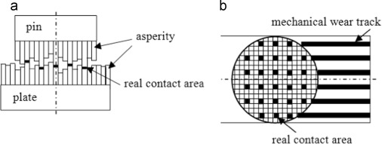
Figure 12 Computational model: a) axial cross-section of the pin-on-plate combination, b) nominal contact area beneath the pin. [114]
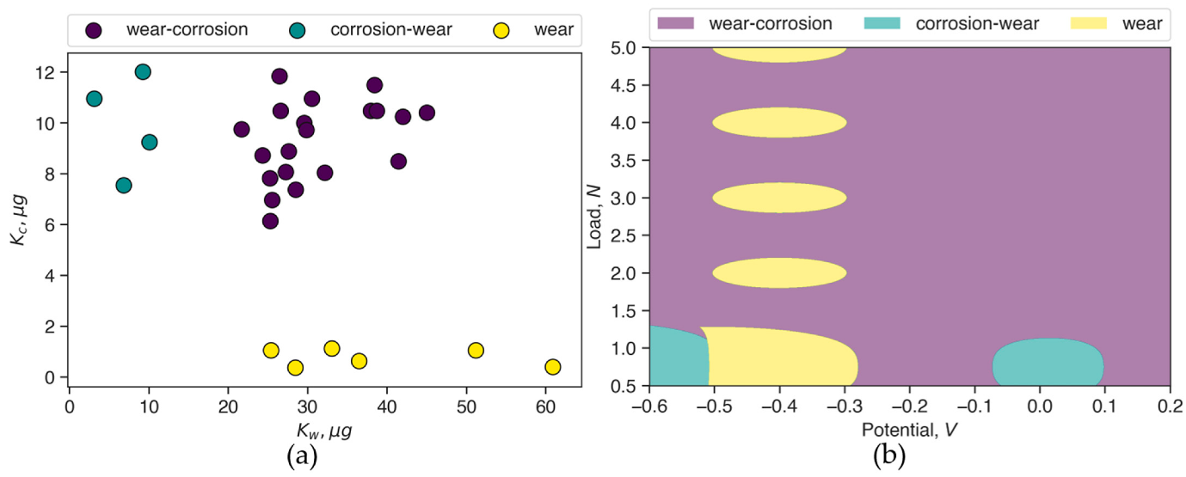
Figure 13 (a) Three clusters in dataset 2 identified using K-means clustering; and (b) the tribocorrosion mechanism map of Co–Cr generated using SVM [116]
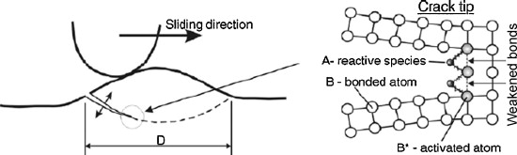
Figure 14 Low-cycle micro-fatigue wear affected by corrosion [117]

- Environmental effects on tribocorrosion
The influence of tribocorrosion on a diverse set of applications, such as biomedical implants, marine equipment, and machinery components, has been extensively studied. Especially in recent years, the study has been further exacerbated by the increasing number of applications and their deployment in harsh environmental conditions. In this section, we will provide an overview of the challenges of tribocorrosion in these applications and discuss the potential of coatings as solutions to mitigate its effects.
  - pH (Non-bio and marine)
Careful and systematic tests on model and engineering bulk surfaces in different environments show the direction the field should take for coated sample testing although results show the importance of surface oxide or passive films on the tribocorrosion performance of these bulk materials. Wahl, for example, has looked at the tribocorrosion behaviour of 2205 duplex stainless steel in 0.6 M NaCl and 0.6 M Na₂SO₄ under reciprocating wear. She found that the presence of aggressive chloride (Cl⁻) ions enhanced material loss at applied anodic potentials within the passive regime for this material. Sliding wear in 0.6 M NaCl increased the amount of material loss by 23–36% compared to experiments in 0.6 M Na₂SO₄. Wear induced corrosion was also promoted by the presence of Cl⁻ at 600 and 800 mVSCE, where attack occurred predominately in the ferrite phase and at the ferrite/austenite boundary. Ming Lui has studied the tribocorrosion behaviour of 304 stainless steel in dilute sulfuric acid and in distilled water using a reciprocating sliding. Damage was caused by micro-cutting and with synergism caused by corrosive embrittlement of the surface layer and damage to the passivation film causing galvanic corrosion. Liwen Tan reports the tribocorrosion behaviour and degradation mechanisms of 316L stainless steel, in four industrial corrosion media under potentiostatic control. Unusually, under cathodic protection in NaOH solution, corrosive reactions still occurred and coupled with wear, led to abnormally high material loss.
Mohsen Feyzi on the other hand looked at the tribocorrosion behaviour of Ti-6Al-4V alloy and the kinematics of repassivation in buffered saline solution under reciprocating motion between 1 and 15 Hz. Volume loss was maximum at 5 Hz with a subsequent reduction when increased to 15 Hz. Compared to the total and corrosion losses, mechanical losses showed significant variation with frequency and complex interactions between the normal force and frequency. These findings are contradictory to the general understanding of an increase in the total loss with increasing frequency i.e. Archard like behaviour. B-B Zhang focuses on the influence of the solution pH on the tribocorrosion behaviour of nickel aluminium bronze (NAB) rubbing against Al₂O₃ using a pin-on-disc tribometer equipped with a potentiostat. Results show that a high pH solution increases corrosion and gives rise to accelerated material loss. The NAB oxidation process was driven by the dissolution of Κ_{II} phase at pH below 4.2, whereas its anodic behaviour was dominated by the preferential corrosion attack of copper-rich α-phase within the α+Κ_{III} eutectoid when pH was higher than 4.2. They found that the pure mechanical and corrosion-accelerated wear was due to delamination and abrasive wear processes.
In a related area, Neville addresses the tribochemical phenomena involved in micropitting in tribocorrosion systems where different levels of dissolved-water are present in a model lubricant. The tribochemical change of the reaction films was studied by X-Ray Photoelectron Spectroscopy (XPS) which confirmed that the (poly)phosphate chain length and tribofilm thickness are reduced with increased dissolved-water level.
In the literature, studies on tribocorrosion involving NaCl solutions are extensively reported. The effects of nanoscale chemical heterogeneity on the wear, corrosion, and tribocorrosion resistance of ZrCuNiAl thin film metallic glasses were investigated by Wenbo Wang and found the tribocorrosion resistance of heter-Zr samples to be better than that of homo-Zr sample [118]. Furthermore, examinations of the behaviour of uncoated substrates, such as stainless steel, titanium alloys, and aluminium alloys in NaCl solutions, have yielded consistent results across a range of studies, without presenting any notably unique findings [119–125].
Hesham Mraied showed that alloying aluminum with manganese in a super-saturated solid solution enhances both the wear resistance of aluminum and the protectiveness of its passive layer, thereby significantly improving its overall tribocorrosion resistance in a 0.6M NaCl solution. Higher Mn content increased the ratio of hardness to elastic modulus (H/E) and promoted the formation of denser and more compact passive film, hence improving tribocorrosion resistance of Al. In particular, alloying with 20.5 at% Mn led to an increase in corrosion resistance by 10 times and hardness by 8 times compared to pure Al. Interestingly, they developed a simple galvanic cell model to investigate the depassivation-repassivation kinetics during tribocorrosion and found that alloying with 5.2at%Mn led to more than a 10-fold reduction in the current density required to re-passivate similar worn areas generated with pure Al [123].
Kossman's study [124] assessed the tribocorrosion properties of 316L stainless steel with three industrial surface finishes: passivation (SSO), electropolishing-passivation (SSEP), and micro-undulation (SSM) mechano-chemical, in NaCl solution [126]. The results showed that the SSEP treatment increased chemical wear due to its passive film's properties, the micro-undulated SSM surface decreased contact area and enhanced lubrication, improving tribocorrosion resistance.
Wahl studied the correlation between increasing material loss rates and damage to the protective oxide layer in passivating alloys under tribocorrosion in an electrochemical cell. Findings indicated that sliding mechanical contact under anodic potentials within the passive oxide region led to pitting corrosion and localized increases in electrochemical cell current, particularly in chromium-depleted secondary austenite phases.
Yue Zhang et al look at the tribocorrosion behaviour of stainless steel 304 in chloride-containing solutions with different alkalinity [127]. They suggest corrosion was accelerated due to the formation of galvanic couples between the mechanical depassivated areas and the surrounding passivated areas. Both the friction coefficient and total material loss reduce with increasing pH with pure mechanical and corrosion-accelerated wear, including abrasion and delamination, being among the main reasons for material loss. While Jingyi Zou looked at 316L stainless steel in 0.1 mol/L NaOH alkaline solution to investigate the synergism between wear and corrosion [128]. Larger material loss was found at a cathodic potential of − 0.8 V and lower material loss at anodic potential when compared with that under pure wear condition. The formation of tribo-films with different properties at different potentials was responsible for these performances. The tribo-film formed at − 0.8 V had the highest oxygen content and was very brittle. By contrast, the tribo-films formed at anodic potentials were more complete and the oxygen content was much lower thus was more ductile and could better protect the stainless steel from wear.
Long Xin studied fretting of Inconel 690TT in NaOH (pH = 9.8) and showed that when normal force increased from 15 to 30 N, fretting was in the gross slip regime (GSR), and wear volume gradually increased [129]. When normal force increased further to 45 N, wear volume significantly decreased due to the fretting changing to the partial slip regime (PSR). Fretting wear broke the passive film at the contacting surface, which caused the worn surface to be more active and prone to corrosion. However, the broken passive film was quickly repaired in subsequent oxidation. The damage and repair of the passive film was found to be strongly dependant on normal force. In GSR, increasing force aggravated the damage while in PSR, the passive film was not easily damaged.
Junxiao Du studied the tribocorrosion behaviour of pure nickel in citrate buffer solution at pH 4.5 [130]. Results show that the wear of nickel was higher in the passive domain due to wear accelerated corrosion (DWc) compared to that in the cathodic domain. Surprisingly, both alumina and zirconia counter-faces were worn by the nickel in tribocorrosion condition under passive potentials as well as in dry condition. However, in the cathodic domain, negligible wear was observed on the alumina and zirconia balls. The formation of mixed nickel and aluminum/zirconium oxides was proposed as the wear mechanism of alumina and zirconia.
Espallargas reports on the tribocorrosion of overlay welded Ni–Cr 625 alloy sliding against alumina in 0.5 M H₂SO₄ and 0.5 M HNO₃ solutions [131]. The tribocorrosion behaviour of the alloy in sulphuric acid was found to be similar to that of stainless steels reported in other studies, with much lower wear at cathodic potential compared to passive conditions. However, the behaviour in nitric acid was highly influenced by the reduction of nitric acid at the electrode–electrolyte interface. This reaction leads to the oxidation of the alloy even at cathodic potential.
  - Biomedical sectors
The exponential growth of the aging population has resulted in a significant increase in the use of orthopaedic prostheses [132] and dental implants [133] to meet the demands of maintaining quality of life and related activities [134]. Tribocorrosion in biomedical applications presents a significant challenge, largely due to the exposure of implants to body fluids and electrolytes at moderate temperatures and are subjected to complex, high mechanical stresses [135].
For instance, the environment in the oral cavity is marked by having high acidity, diverse bacterial interactions, and recurrent mechanical stresses during mastication. In the context of hip and knee joints, the load and frequency of movement can influence wear patterns and the rate of corrosion. Such exposure, in combination with tribocorrosion phenomena that occur when the implant comes into contact with other surfaces such as bone or cartilage [136], can lead to implant failure, tissue damage, inflammation, reduced mobility, and pain for patients [16]. Over recent decades, there has been a rise in the incidence of failure and clinical issues associated with prosthetic dental and orthopaedic implants [137]. Particularly, dental implant failures are around 1–20% [138], whereas for orthopaedic implants, this number is higher than 35% [139]. Adding to the concern, wear debris with sizes ranging from nanometric to micrometric dimensions can enter the circulatory system and accumulate in cells, lungs, and osteoblasts [140].
Metallic biomaterials have played a crucial role in the development of medical implants, which constitute approximately 70–80% of all implanted materials [141]. The material options are constrained by biocompatibility, but the most common biomedical materials include stainless steel, cobalt-based alloys, and titanium-based alloys [142]. Each of these materials has unique properties, with some being more suitable for specific applications than others. Stainless steel metal implants, with their high availability and low cost, are nowadays mostly used for total hip replacement stems and bone-fixation tools such as nails, screws, and fracture plates [143]. CoCr28Mo6, more commonly known as CoCrMo, has historically been the preferred material in the design of medical implants. However, its use in permanent implants is currently restricted due to the prolonged release of Co, Cr, and Ni ions [144]. While it should be noted that concerns have been raised about the potential release of elements (Co, Cr, and Ni) from these materials into the body that may cause patients allergic reactions [145]. Commercially pure titanium (cpTi) and Ti-6Al-4V are used especially in bone fusion, bone fixation, and joint arthroplasty, both of which give clinical success rates of up to 99% at 10 years [146]. The utilization of titanium in the production of dental implants is largely due to its exceptional biocompatibility, chemical inertness, suitable mechanical properties, and outstanding clinical performance, alongside its ability to form a natural protective oxide layer known as TiO₂ [147]. This protective oxide film, ranging from 1.5 to 10 nm in thickness, is credited with providing titanium's excellent corrosion resistance [148]. Nonetheless, there are numerous factors, such as surface friction and scratches incurred during implant placement, which can compromise this protective coating [149]. Furthermore, there is evidence to suggest that concentrations of titanium exceeding 13 ppm can precipitate necrosis in epithelial cells and heighten the vulnerability of peri-implant mucosa epithelial cells to microorganisms [150]. Additionally, the elements vanadium (V) and aluminium (Al) have been implicated in various neurological disorders, including Alzheimer’s disease [151].
Therefore, the primary challenge in ensuring the durability and functionality of these biomedical devices is balancing tribocorrosion management with optimal biocompatibility. In response, various research initiatives are developing specialized coatings to improve the structural, tribological, and electrochemical properties of these materials to address and mitigate potential health risks. The coated implants currently available in the market are ZrO₂ coated Zr (Smith and Nephew), TiN coated CoCr or Ti6Al4V (Implantcast, Link orthopaedic), TiNbN coated CoCr (OHST medical technology) and TiN coated Ti6Al4V (Endotec) [16]. Recent studies on coating techniques for 316L and Ti-6Al-4V alloys have shown promising results in enhancing material properties. Laser cladding of 316L with 1-3 layers of Fe-based amorphous material resulted in a microstructure evolution from primary FCC to BCC with increasing layers, leading to increased hardness. Notably, a 2-layered coating was found to be the most effective [152]. This finding was echoed in another study with 1-12 layers, where again the 2-layered coating showed optimal performance [153]. In contrast, arc spraying of 316L with Fe-based amorphous material demonstrated improved tribocorrosion resistance compared to uncoated 316L SS, particularly during sliding wear in PBS and NaCl solutions [154].
Table 3 provides a summary of various other techniques tested in Bio environments.
    - Dental
Dental implants, serving as artificial dental roots, are surgically placed into either the upper or lower jawbone, with the advantage of not affecting adjacent healthy teeth. The success rate of these implants is impressive, ranging from 90% to 96.5% [155]. Nevertheless, the increasing demand for dental implants, coupled with the evolving needs of patients, underscoring the need for continuous improvement in implant technologies to reduce rejection and the necessity for replacing failed implants [86].
A primary cause of dental implant failure is tribocorrosion, a process that can hasten the deterioration of implant components. This issue is particularly critical in biomedical fields where implant failures not only impair function but also risk patient health due to the release of harmful wear products. Tribocorrosion is triggered by various factors including mastication, saliva, pH changes, and temperature variations, leading to damage at the implant interfaces [4]. Dental implants are continuously exposed to a moist environment, making them susceptible to corrosion and microbial colonization throughout their lifespan [156].
Specifically, three interfaces in dental implants are prone to fretting corrosion (see Figure 15): the connections between the crown and abutment, the abutment and implant, and the implant and bone. The repetitive loading from biting and chewing can disrupt protective films on these interfaces, accelerating corrosion [157]. This type of damage, caused by micromotion, is known as fretting corrosion [4].
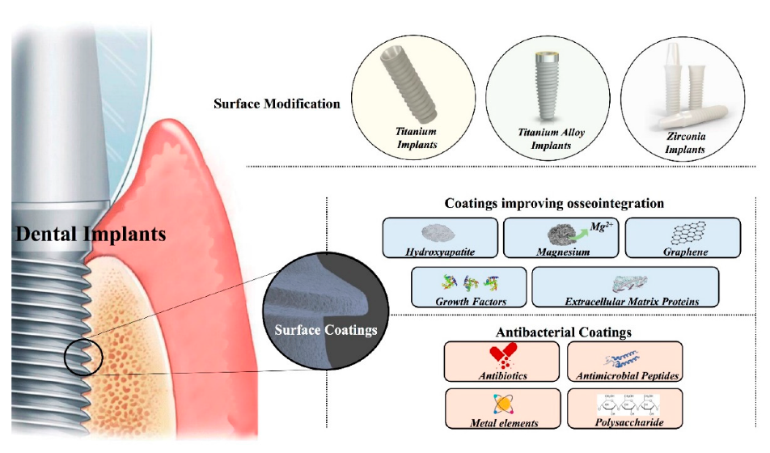
Figure 15 implants [158]
Coating technology plays a crucial role in enhancing implant performance. Richard et al. investigated coatings of nano-ZrO2 and Al2O3-13 wt% TiO₂ on titanium, finding improved wear and corrosion resistance [159]. One study explored the coating of variously treated titanium substrates with titanium dioxide (TiO₂) films using Low-Pressure Metal Organic Chemical Vapor Deposition (MOCVD), revealing that substrate morphology significantly influences the crystalline structure, wettability, ion release, electrochemical behaviour, tribocorrosion performance, and nano-mechanical properties of TiO₂ coatings, with sandblasted/acid-etched coated Ti substrates showing the most promising functional properties for dental implant fabrication [160]. Additionally, TiN coatings have gained popularity in dentistry due to their biological properties, such as reducing the release of harmful ions and providing an aesthetic golden colour [161].
Alves and co-authors have focused on enhancing the tribocorrosion behaviour of titanium alloys used in dental implants, particularly from 2013 to 2022. Initial studies on Cp-Ti highlighted the advantages of Plasma Electrolytic Oxidation (PEO) and anodic treatment in enhancing substrate performance through varied surface topographies and compositions [162, 163]. Subsequent research expanded to include anodic treatment of Ti-6Al-4V and cp-Ti surfaces, leading to the development of nanotubular structures and porous designs that significantly improved tribocorrosion resistance [164]. From 2018 to 2021, the effects of electrolyte composition in the Micro-Arc Oxidation (MAO) process on cp-Ti and Ti-6Al-4V were studied. These studies highlighted how the addition of bio-active elements (Ca and P) optimized tribocorrosion behaviour, surface hardness, and microstructure [165–168]. For the Ti40Nb alloy, a two-step anodic treatment and heat treatment were employed to develop a TiO₂-based nanotubular surface with improved adhesion, further enhanced by the addition of an extra oxide layer from a fluoride-free electrolyte [169]. Building on that, studies conducted on the Ti-40Nb + TiN and Ti-25Nb-5Fe + TiN alloys revealed that the incorporation of TiN reinforcement, coupled with bio-functionalization, led to substantial improvements in hardness, microstructure, and the formation of a strongly adhered anatase-rutile TiO₂-based nanotubular layer, significantly boosting both corrosion and tribocorrosion behaviours [170, 171]. Apart from the comprehensive studies by Alves, other researchers have also explored the techniques of PEO and MAO on Ti-6Al-4V substrates. For example, Garcia-Cabezón in Spain demonstrated that PEO–Ca/P coatings on these substrates offer enhanced performance due to a higher rutile-to-anatase ratio and smoother surface [172]. Similarly, in China, You Zuo's research indicated that increasing the voltage in MAO coatings adjusts the rutile-to-anatase ratio [173], and incorporating graphene oxide particles notably improves tribocorrosion resistance [174]. Binbin He's study further emphasized the effectiveness of Cu_{x}O-containing PEO coatings in significantly reducing mass loss [175]. Examples of PEO treated dental screws are shown in Figure 16.
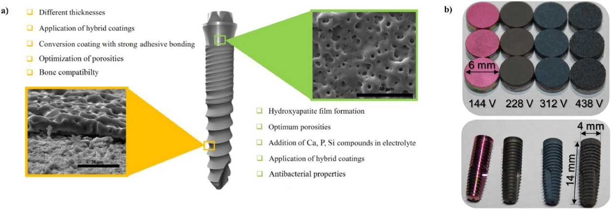
Figure 16 a) Possible enhancements of titanium implant screws by PEO coating b) dental screws coated with PEO in various colours [176]
Among various coating methods exist, plasma spray is the predominant technique used clinically for titanium dental implants. Layers of calcium phosphates, primarily consisting of hydroxyapatite (HA-Ca₁₀(PO₄)₆(OH)₂) are used to coat metallic implants. This composition closely mimics the inorganic portion of bone, thereby facilitating osseointegration. The properties of these coatings, such as porosity and thickness, are critical for facilitating bone cell differentiation [177]. However, the tribocorrosion performance of these coatings are rarely discussed.
    - Joint prostheses
A critical issue in the failure of hip implants is the wear and corrosion, notably in the metal-on-metal (MoM) design of total hip replacements (THR), as illustrated in Figure 17. These MoM implants have been adversely affected by tribocorrosion, leading to the production of unexpectedly high levels of wear and corrosion debris. This release can cause damage to bone and tissue surrounding the implant, leading to adverse local tissue reactions (ALTR) or adverse reactions to metal debris (ARMD). The corrosive internal environment of the human body exacerbates tribocorrosion, resulting in the formation of pseudo-tumours around the THR area due to increased wear particles [178]. Additionally, the increased tribocorrosion reaction in these implants leads to a higher release of metal ions, which can potentially lead to tumour formation in various body regions as these ions are transported through the bloodstream [179]. Reactions such as pain, implant loosening, device failure, and the subsequent need for revision surgery that requires the removal and replacement of faulty implants have been observed. These issues have prompted responses from healthcare authorities such as the Food and Drug Administration (FDA) [180].
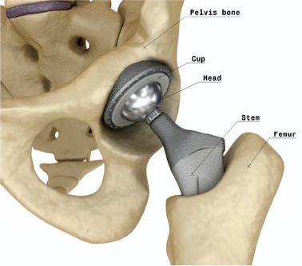
Figure 17 Total hip arthroplasty [181]
Recent literature has documented the occurrence of mixed forms of damage on retrieved hip implants, including wear, corrosion, and fretting corrosion [4]. This damage is primarily observed in two critical areas: the sliding-corrosion at the femoral head and acetabulum bearings, and the fretting-corrosion at the taper junction connecting the femoral head to the stem [182]. Clinically, the modular junction between the hip implant's neck and head is susceptible to micromotions, typically in the range of 5–15 μm, as cited in studies [183, 184]. These micromotions within the corrosive biological environment can induce fretting corrosion, potentially leading to implant loosening and the formation of harmful degradation products [4]. While current research efforts are predominantly focused on coatings applied on bearing surfaces to reduce wear and corrosion, particularly for solving the sliding corrosion problems.
Regarding titanium nitride-coated hip implants, both Harman et al. [185] and Raimondi and Pietrabissa [186] documented the failure of these implants when paired with UHMWPE liners. Their respective studies revealed significant degradation in the coatings of implants retrieved after short usage periods. Specifically, Harman et al. identified delamination and adhesive wear, whereas Raimondi and Pietrabissa observed a saw-toothed degradation pattern and heightened surface roughness on the coatings, factors that were associated with increased material loss from the UHMWPE liners.
It's important to recognize that the wear behaviour in human hip joints differs significantly from the reciprocating sliding wear seen in hip-simulators, incorporating diverse motion paths, resting periods, and strokes. The risk of sudden fractures, especially with the brittle nature of ceramic materials, is a significant concern. There have been unsuccessful introductions to the market, such as DLC coated implants. This was reflected in a clinical study by Taeger et al., which specifically compared the performance of DLC coatings on CoCrMo femoral heads with alumina-oxide ceramic heads. Their follow-up investigation revealed a significant disparity, with DLC-coated implants exhibiting considerably lower survival rates than their alumina counterparts mainly due to mechanical failures, particularly delamination of the coating [187]. In the quest for an ideal coating for medical implants, ongoing advancements and emerging technologies are bringing this goal within closer reach. The significant amount of research in progress offers hope for the future clinical implementation of various effective combination coatings, likely to significantly improve patient outcomes [139].
Coating technology remains a valuable method for enhancing resistance against tribocorrosion, with the caveat that issues such as delamination need to be resolved and the gap between in vitro and in vivo study results needs to be narrowed [4]. Moreover, there is increasing interest in adapting these advanced coating technologies to other applications, like hip modular-tapers, where fretting-corrosion processes are predominant.
Table 3 Overview of coating techniques applied on different alloys to enhance tribocorrosion resistance
Substrate | Tech | Solution | Test | Findings | Ref
Ti-6Al-4V | Thermal sprayed  Alumina,  Alumina -Zirconia,  Alumina- titania | bovine calf serum (BCS) | OCP | Ceramic These coatings primarily suffered from mechanical wear rather than corrosion.  The nanostructured bilayered IDZAT coating demonstrated the best performance. | [188]
316L | Dipping  polyurethane (PU)–polydimethylsiloxane (PDMS) blended coatings | Ringer’s solution | OCP | The wear volume and the friction coefficient of PU–PDMS coatings decreased with the increased PU concentration in the blend.  Polymer-coated samples containing up to 50% PDMS prevented corrosive wear. PU25–PDMS75 coating could not protect the surface due to its weaker mechanical properties. | [189]
304 | Electrodeposition  Co/nano-CeO2 | Hank ́s solution | EIS | The inclusion of nano-CeO2 particles into the cobalt matrix by electroco-deposition significantly reduces the friction coefficient, wear weight loss, and corrosion damage. | [190]
304 | PVD  calcium phosphate-calcium titanate | Hank ́s solution | Polarization  OCP | Fretting  Calcium titanate coatings showed reduced wear of the bone compared to bare stainless steel, with wear decreasing as the calcium titanate content increased.  Calcium titanate coatings are potentially more effective candidate materials than calcium phosphate coatings for bone tissue replacement in hip prostheses. | [191]
Ti-6Al-4V  (additive manufactured) | PVD  TiN | 25%(v/v) new born bovine serum (17 g/L total protein content) diluted by PBS | OCP | Duplex-TiN coatings were applied on both ALM and traditionally wrought manufactured Ti-6Al-4V substrates. The coatings enhanced hardness (from 3.5 GPa to 14–15 GPa), improved corrosion resistance, and showcased excellent wear resistance (wear depth of 0.3 μm against a coating thickness of 3-6 μm). The coated materials displayed the ability to rapidly recover their protective layer after wear tests. | [192]
Ti | plasma spraying  Ti-6Al-4V-TiB-TiN | Hank ́s solution | PDP  OCP | The tests also revealed domination of synergistic effects i.e. corrosion affects wear more than wear effect on corrosion.  Increasing the deposition speed and/or decreasing the plasma power led to an increase in mechanical wear and corrosion loss. | [193]
Ti | double-glow plasma alloying  Nb | Ringer’s solution | OCP | DG-Nb wear rate is merely 4.92% of that of Pure Ti | [194]
Ti,  Ti-6Al-4V Ti13Nb13Zr | CVD  Nanocrystalline diamond (NCD) coatings | 9 g/L NaCl | OCP | NCD coatings showed promise in corrosion resistance, their response under combined wear and corrosion was mixed. Notably, the occurrence of blistering could hinder the long-term performance of such implants. | [195]
  - Marine and Offshore Sector
Marine equipment faces distinct tribocorrosion challenges, greatly impacted by its environment characterized by high salinity, low electrical resistivity, and continuous mechanical stress. These conditions adversely affect a range of materials, including stainless steel and marine-grade alloys. The situation is exacerbated by the sector's growth, driven by global efforts to reduce greenhouse gas emissions. The expansion of offshore energy production, encompassing sectors such as oil and gas platforms, deep-sea mining operations, thermal recovery systems, wind turbines, wave/tidal energy systems, and mooring line installations, intensifies the tribocorrosion challenges faced in these demanding marine environments. In response to these challenges, there is a concerted effort among governments, industry experts, and researchers. This collaboration focuses on developing new materials, coatings, and monitoring techniques that are robust enough to endure the demanding conditions of the offshore environment [196, 197]. To mitigate these effects and protect these structures, standards like ISO 12944 and NORSOK M-501 are utilized. They help categorize the corrosivity of offshore installations with classifications like C5-M and Im2 (see Table 4), guiding the implementation of appropriate protective measures [198].
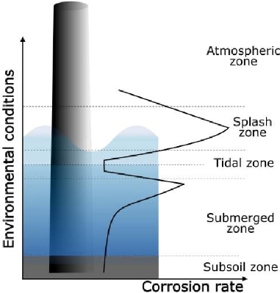

Figure 18 Corrosion rate [198]
Table 4 Typical coating systems employed in offshore applications in the different exposure zones with the desired properties and corrosivity category required (ISO 12944) [198]
Exposure Zone | Category (ISO 12944) | Coating system | Desirable coating properties
Atmospheric | C5-M | Zinc-rich epoxy primer (60-100 µm)  Epoxy intermediate layer (100-120 µm)  Polyurethan topcoat (50-80 µm) | Corrosion-resistant,  Erosion-resistant, anti-icing, UV-resistant
Splash and tidal | C-M and Im2 | Two or three epoxy-based coats (>1000 µm in total)  Polyurethane topcoat (50-80 µm) | Combination of atmospheric and submerged coatings’ properties
Submerged | Im2 | Two or three epoxy-based coats (>450 µm in total) | Corrosion-resistant, antifouling, wear-resistance

In managing tribocorrosion, the marine and offshore industries must strategically select coating systems based on the environmental conditions specific to each exposure zone [199]. Referring to Figure 18, structures within the atmospheric zone require coatings that deliver resistance to corrosive elements and additional protection against UV radiation and icing, as indicated by the ISO 12944 C5-M category. In the splash and tidal zones, where structures are intermittently exposed to both air and seawater, the coatings must embody a combination of atmospheric and submerged coatings’ properties. For fully submerged structures, the focus shifts primarily to corrosion resistance, while also incorporating antifouling and wear-resistant characteristics as necessitated by the Im2 category [198].
​Steel remains a pivotal structural material in offshore settings. To safeguard these structures against harsh marine environments, significant advancements in protective coatings have been made. Aiying Wang's team studied the effectiveness of various PVD coatings, such as Cr/GLC and DLC-based variants, in a 3.5 wt% NaCl environment. Their studies highlighted that while some coatings like TiCx/DLC excel in short-term durability due to high hardness, others like Ti‒TiCx/DLC offer superior long-term performance through a balance of hardness and toughness [200–202]. Studies by other researchers have demonstrated that PVD coatings exhibit diverse performances under both stationary and dynamic conditions. These studies highlight that certain coatings provide enhanced resistance to wear and corrosion, showcasing the range of effectiveness these coatings can offer in different environmental scenarios [203–207]. The effectiveness of these coatings is also influenced by the substrate material, as seen in studies involving different steel types with PVD CrCN coatings [208]. Additionally, coatings like CrN and Cr/CrCN on steel have been observed to alter wear mechanisms depending on environmental conditions, highlighting the importance of coating composition [209, 210]. Innovations in coatings such as Ti, TiSiC, TiSiCN, AlFeCrNiMo, and W-doped DLC have shown to improve wear resistance and durability [211, 212]. Moreover, nanocomposite structures like TiSiN-Cu and CrN/AlN coatings provide enhanced mechanical properties and resistance, proving beneficial in corrosive environments [213, 214]. Moreover, plasma nitriding before PVD coating can significantly enhance the corrosion and tribocorrosion resistance of steels, making them suitable for marine applications [215]. In addition to PVD, there have been significant advancements in Thermally Sprayed Aluminium (TSA) coatings, which have markedly enhanced their capability to protect steel structures in offshore environments. Composite coatings of TSA with Al₂O₃ particles have lower wear rates and friction coefficients than pure Al coatings [216]. The integration of the Plasma Electrolytic Oxidation (PEO) technique into TSA coatings has led to the development of a robust TSA/PEO duplex coating. Extensively tested for sliding wear, electrochemical corrosion, and tribocorrosion in synthetic seawater, it shows enhanced durability and resistance in harsh marine environments [217]​. Ceramic materials are traditionally favoured for their wear and corrosion resistance but are limited by brittleness. This has led to the innovation of Ti-C-N coatings, which balance hardness with toughness, addressing the brittleness issue [218]. Complementing these, metal-ceramic coatings applied via High-Velocity Oxygen Fuel (HVOF) spraying techniques are particularly effective for deep-sea equipment, where conventional oil lubrication is insufficient. Coatings such as WC-based variants offer high hardness and wear resistance, effectively tackling the multifaceted tribocorrosion challenges in marine settings [219]. Further details on other studies are provided in Table 5.
Titanium, often termed "Ocean Metal," is renowned for its lightweight, high strength, and exceptional corrosion resistance, particularly against saltwater and marine atmospheric conditions. This makes it an ideal material for marine engineering, marking it as a pivotal material in this field. Kuptsov deposited TiC/C coatings on Ti substrate using electro-spark deposition (ESD). By altering electrode polarity and pulse energy, control over the carbon content, microstructure, and phase composition of the modified Ti layer was achieved. Results show coatings with an upper graphite layer exhibited low friction and high corrosion resistance in saltwater [220]. Recent research towards coatings for titanium alloy substrates, particularly Ti-6Al-4V, has solidified its status as one of the key materials in marine engineering, especially suitable for light, marine equipment. Extensive research on PVD CrMoSiCN and CrMoSiN coatings for Ti-6Al-4V alloys were conducted by Zhou. They discovered that these coatings exhibited varying tribocorrosion behaviours, which were influenced by the Ag target current. The study revealed that with an increase in the Ag current, the tribocorrosion mechanisms of CrMoSiCN/Ag coatings shifted, highlighting different wear resistance levels under varying conditions [221–224]. Different PVD coatings like TiAlCN and TiSiN/Ag have been looked by Li, including nitrided TiSiCN. Their research demonstrated that annealing could enhance the corrosion resistance and reduce the friction of TiSiN and TiSiN/Ag coatings. The studies also revealed that the carbon content in the TiSiCN coating significantly influenced its tribocorrosion properties, with its nanocomposite structure and graphitization effects playing a crucial role in wear reduction [225–230].
The exploration of advanced coating technologies in the marine sector is a pivotal response to its unique tribocorrosion challenges, reflecting the evolving needs and dynamic solutions being developed. This comprehensive review highlights the industry's commitment to enhancing the durability and performance of marine structures and machinery, from adopting robust coatings like Thermally Sprayed Aluminium (TSA) to innovative materials like titanium alloys. The strategic selection of these coatings, tailored to specific environmental exposures and operational requirements, is crucial for both static and dynamic marine components. Static components, such as hull plates, deck structures, and anchoring systems, require coatings with strong anti-corrosive properties and enhanced wear resistance due to their continuous exposure to seawater and marine sediments. Conversely, dynamic components like propeller blades, rudder hinges, and winches necessitate coatings that not only resist wear and corrosion but also reduce friction to maintain operational efficiency. This specialized approach, driven by ongoing research and collaborative efforts across academia and industry, is vital for ensuring the functionality and longevity of marine machinery. It embodies a dedicated strategy to overcome the multifaceted challenges of marine engineering, ensuring that structures and equipment can withstand the harsh marine environment while fostering sustainable and efficient offshore operations.
Table 5 Overview of coating techniques used on marine equipment for tribocorrosion resistance
Substrate | Tech | Interlayer | Solution | Tests | Findings | Ref
AISI 1045 | PVD  Cr/CrN | Nitrided | 3.5 wt% NaCl | OCP,  PDP | A clear synergy effect of over 30% between friction and corrosion, the synergy effect is caused by the fact that corrosion processes create local cavities which at successive time intervals are most likely to intensify mechanical wear. The area around the cavities facilitates plastic deformation, the initiation of cracking of cyclically deformed layers and the tearing off larger fragments of material (especially at higher unit pressures in the frictional contact zones). | [231]
316L, TC4, and H65 copper | PVD  Si-Doped TiSiN-Ag |  | artificial seawater | OCP, PDP | TiSiN-Ag composite coatings with 8 wt.% Si doping exhibit superior characteristics. These coatings' network structure effectively hinders the generation and growth of cracks.  Si doping content can help mitigate the presence of defects such as pinholes and cracks. | [232]
Ti-6Al-4V | W-DLC  CrN + a-C:H:W HVOF  Cr3C2 in Ni/Cr  Ion implantation  nitriding |  | artificial seawater | OCP  PDP | The Ion implantation treatment on Ti6Al4V substrate yielded the best static corrosion resistance.  The W-DLC coated Ti6Al4V substrate exhibited the most stable and lowest friction, leading to a commendable wear and corrosion resistance in artificial seawater.  Both the HVOF coating and Ion implantation treated substrates had noticeable crack initiation, increasing susceptibility to localized corrosion. | [233]
F22 steel | Thermal spray  Fe-based amorphous |  | artificial seawater | OCP  PDP | Synergy effect: Wear-induced material loss (Vw) is the major material damage under the current experimental conditions.  Seawater aided in lubrication and reducing friction | [234]
SS316 | Thermal spray WC/Ni60 |  | artificial seawater |  | the WC phases in the coating help resist wear, while the Ni-based materials improve corrosion resistance. | [235]
SS316 | Laser cladding  titanium carbonitride |  | 3 M NaCl saturated solution | OCP, PDP | 316L laser claddings reinforced with titanium carbonitride grains improved its tribocorrosion performance by over 10-fold in certain conditions. The optimized addition of (Ti,Mo)(C,N)-Ni powder led to homogeneously distributed reinforcements, enhancing durability.  Inappropriate quantities of (Ti,Mo)(C,N)-Ni powder can cause either high agglomerations or uneven dispersion. | [236]
SS304 | High-Intensity Pulsed Ion Beam (HIPIB)  CrN/TiN |  | 3.5 wt% NaCl | OCP | Coated surfaces present excellent tribocorrosion properties in seawater, showcasing a high open circuit potential, low coefficient of friction, and low specific tribocorrosion rate, all without pitting corrosion due to the high surface integrity, stable interfaces, and dense microstructure. | [237]
R4 mooring chain | pack cementation method FeAl |  | 3.5 wt% NaCl | OCP,  PDP | Improved corrosion resistance offered by the aluminized coating, with the oxide layer on the surface playing a key role in this improvement. But its wear resistance decreased due to the presence of brittle phases. | [238]
- Conclusions and future challenges
Surface design often has a strong playoff between wear, friction and corrosion rates often with antagonistic relationships and complicated interactions between multiple mechanisms at different scale lengths within tribocorrosion contacts. However, the tribologically induced stresses can create damage propagation and accelerate corrosion either within the coating or at the coating coating-substrate interface. Any crack systems in the coating or porosity allows the environment to permeate into the coating and eventually to the coating/substrate interface accelerating substrate corrosion and coating disbondment often causing early failure or poor performance.
This review has highlighted the role of stress as a driver for damage processes and the need to understand the stress fields induced under sliding or rolling contacts. Stress and dynamic loadings are shown to enhance both wear and corrosion and, therefore, tribocorrosion. The environment (pH and temperature) is also shown to have a strong influence on tribocorrosion performance. Experiments should monitor and report on the key factors listed in Figure 1 (surface film, recovery, composition, environment, friction and wear, microstructural changes both in surface and subsurface, roughness changes, what electrochemical reaction(s) are occurring and so on. This would allow a more generic understanding across a very diverse set of coatings and surface modification techniques being investigated.
Coating solutions being developed for tribocorrosion applications include a whole range of Ni based electrodeposited coatings, hard on tough coatings and high impedance coatings such as PECVD N and Si doped diamond. Hybrid and multi-layered coatings are also being used to control damage penetration into the coating (to increase toughness) and to manage stresses. A particular focus involves the combination of various treatment techniques. For example, the use of surface treatment methods such as Plasma Electrolytic Oxidation (PEO) alongside deposition techniques is gaining traction.
In biomedical applications, the development and utilization of coated implants have gained significant traction. The market currently offers a diverse range of these implants, featuring advanced coatings such as Titanium Nitride (TiN), Titanium Niobium Nitride (TiNbN), Zirconium Nitride (ZrN), and surface-treated Zirconium that results in an oxidized surface layer (ZrO_{x}). Additionally, a wide array of candidate materials is under active research, including carbon-based, silicon nitride, chromium nitride, as well as Titanium-based (Ti-based), Zirconium-based (Zr-based), Tantalum-based (Ta-based), and alumina-based coatings. However, a notable discrepancy is seen between the outcomes of simulator tests and actual in vivo (clinical) usage of these coatings. In several instances, coatings that have successfully passed rigorous laboratory testing, have failed to demonstrate similar performance in clinical settings. A case in point is the introduction and subsequent market withdrawal of Diamond-Like Carbon (DLC) coated implants. Such instances raise serious concerns, as the failure of coatings within the body can lead to severe complications. This situation highlights the urgent need for more reliable and realistic testing methods.
Global interest in marine research is increasing, with recent notable contributions from a diverse set of countries including China. In this field, thermal spray techniques have become particularly valuable. For example, aluminium coatings ae being used on submerged components and often post deposition treated with an organic sealant. Additionally, Thermally Sprayed Carbide Coatings, known for their high hardness and wear resistance, are widely employed, offering enhanced corrosion resistance. While research in this area frequently adopts a trial-and-error methodology, adapting techniques from other applications. Recent advances have also seen the use of thin film techniques, such as Diamond-Like Carbon (DLC) and Nitride coatings, applied via Physical Vapor Deposition (PVD). However, it remains crucial to recognize the distinct and challenging nature of the marine environment in these applications for thin film technologies.
The review has also shown the importance of the microstructure, the active phases that are dissolved and the critical role of surface films and their composition (oxide or passive) in tribocorrosion performance which although discovered for bulk materials will be equally applicable to coating performance. New techniques show the way to reveal response of surfaces to tribocorrosion (i.e. scanning electrochemical microscopy).
Modelling tribocorrosion has yet to embrace the full range of coatings and the fact that some coatings/environments result in reduced wear so are antagonistic rather than synergistic. The actual synergistic/antagonistic mechanisms are not well understood making it difficult to model. These interactions need to be fully understood to enable modelling to advance. Other areas that need to be included are; the role of debris in the contact, temperature/flash temperatures, areal roughness evolution, chemistry of oxides and corrosion reactions, complete and partial film removal and growth rates, porosity and defects, microstructural and compositional evolution, selective phase corrosion attack, environmental changes in the interface, strain hardening/phase transformations, material transfer between mating surfaces, porosity of coating and subsequent permeation of electrolyte to coating-substrate interface, interfacial corrosion/cathodic disbondment, galvanic coating-substrate interactions, the role of corrosion products as well as intrinsic residual and surface stresses. Also, repassivation or oxidation rates are often unknown hampering prediction of tribocorrosion and the assumption that Archard wear law applies is often applied without evidence that Archard is applicable.
A significant challenge in the field is the lack of overarching design principles. The application of coating processes is quite varied, making it challenging to form a general understanding. The diversity in testing methods, the assessment and characterisation of the tribocorrosion components and mechanisms also makes it difficult to compare performance of different coatings and therefore coating selection. The diversity in coating types and compositions further complicates the development of a generic understanding. An often-overlooked aspect is the cost-benefit analysis to facilitate the transition of scientific research into practical industrial applications which is also hindering the uptake of research outcomes into businesses.
Moreover, several factors still require thorough investigation, such as the effects of cyclic-loading stress. There's also a need to ensure that coatings developed in laboratories are effective when used in service. Variability in coatings from different production batches poses a challenge; thus, addressing issues of repeatability and reproducibility is critical for consistent quality assurance in coating applications.

References:
1. Kumar V, Agarwal AK, Jena A, Upadhyay RK (2022) Advances in Engine Tribology. Springer Singapore, Singapore
2. López-Ortega A, Arana JL, Bayón R (2018) Tribocorrosion of Passive Materials: A Review on Test Procedures and Standards. Int J Corros 2018:1–24. https://doi.org/10.1155/2018/7345346
3. Blau PJ, Wood R, Stack MM, et al (2013) Future Needs and Challenges in Tribo-Corrosion Research and Testing. In: Blau PJ, Celis J-P, Drees D (eds) Tribo-Corrosion: Research, Testing, and Applications. ASTM International, 100 Barr Harbor Drive, PO Box C700, West Conshohocken, PA 19428-2959, pp 214–226
4. Mathew MT, Cheng K, Sun Y, Barao VAR (2023) The Progress in Tribocorrosion Research (2010–21): Focused on the Orthopedics and Dental Implants. J Bio- Tribo-Corros 9:48. https://doi.org/10.1007/s40735-023-00767-4
5. Oluwatosin Abegunde O, Titilayo Akinlabi E, Philip Oladijo O, et al (2019) Overview of thin film deposition techniques. AIMS Mater Sci 6:174–199. https://doi.org/10.3934/matersci.2019.2.174
6. Pinto G, Silva F, Porteiro J, et al (2018) Numerical Simulation Applied to PVD Reactors: An Overview. Coatings 8:410. https://doi.org/10.3390/coatings8110410
7. Bozkurt Y, Kovaci H, Yetim A, Celik A (2022) Tribocorrosion properties and mechanism of a shot peened AISI 4140 low-alloy steel. Surf Coat Technol 440:. https://doi.org/10.1016/j.surfcoat.2022.128444
8. Liu R, Yuan S, Lin N, et al (2021) Application of ultrasonic nanocrystal surface modification (UNSM) technique for surface strengthening of titanium and titanium alloys: a mini review. J Mater Res Technol 11:351–377. https://doi.org/10.1016/j.jmrt.2021.01.013
9. Wood RJK (2007) Tribo-corrosion of coatings: a review. J Phys Appl Phys 40:5502–5521. https://doi.org/10.1088/0022-3727/40/18/S10
10. Zeisel H, Durst F (1990) Computations of erosion–corrosion processes in separated two-phase flows NACE Corrosion. NACE
11. Vignal V, Mary N, Ponthiaux P, Wenger F (2006) Influence of friction on the local mechanical and electrochemical behaviour of duplex stainless steels. Wear 261:947–953
12. Zhou S, Stack MM, Newman RC (1996) Characterization of synergistic effects between erosion and corrosion in an aqueous environment using electrochemical techniques. Corrosion 52:934–946
13. Matsumura M (1994) Erosion-corrosion of metallic materials in slurries. Corros Rev 12:321–340
14. Neville A, Hodgkiess T, Xu H (1999) An electrochemical and microstructural assessment of erosion–corrosion of cast iron. Wear 233:523–534
15. Mathew MT, Srinivasa Pai P, Pourzal R, et al (2009) Significance of Tribocorrosion in Biomedical Applications: Overview and Current Status. Adv Tribol 2009:1–12. https://doi.org/10.1155/2009/250986
16. Skjöldebrand C, Tipper JL, Hatto P, et al (2022) Current status and future potential of wear-resistant coatings and articulating surfaces for hip and knee implants. Mater Today Bio 15:100270. https://doi.org/10.1016/j.mtbio.2022.100270
17. Puthillam U, Selvam RE (2023) Tribocorrosion in biomaterials and control techniques: a review. https://doi.org/10.1515/corrrev-2023-0008
18. Wood RJK (2017) Marine wear and tribocorrosion. Wear 376–377:893–910. https://doi.org/10.1016/j.wear.2017.01.076
19. Wood RJK (2006) Erosion–corrosion interactions and their effect on marine and offshore materials. Wear 261:1012–1023. https://doi.org/10.1016/j.wear.2006.03.033
20. Monticelli C, Balbo A, Zucchi F (2011) Corrosion and tribocorrosion behaviour of thermally sprayed ceramic coatings on steel. Surf Coat Technol 205:3683–3691. https://doi.org/10.1016/j.surfcoat.2011.01.023
21. Monticelli C, Balbo A, Zucchi F (2010) Corrosion and tribocorrosion behaviour of cermet and cermet/nanoscale multilayer CrN/NbN coatings. Surf Coat Technol 204:1452–1460. https://doi.org/10.1016/j.surfcoat.2009.09.046
22. Ge Y, Cheng J, Yan C, et al (2021) Devitrification and sliding wear behaviors of AlFeSi metallic glass coatings. J Mater Res Technol 15:7022–7032. https://doi.org/10.1016/j.jmrt.2021.11.136
23. Cao L, Liu J, Wan Y, Pu J (2020) Corrosion and tribocorrosion behavior of W doped DLC coating in artificial seawater. Diam Relat Mater 109:108019. https://doi.org/10.1016/j.diamond.2020.108019
24. Shen Y, Luo J, Liao B, et al (2022) Tribocorrosion and tribological behavior of Ti-DLC coatings deposited by filtered cathodic vacuum arc. Diam Relat Mater 125:. https://doi.org/10.1016/j.diamond.2022.108985
25. Yasir M, Zhang C, Wang W, et al (2015) Wear behaviors of Fe-based amorphous composite coatings reinforced by Al2O3 particles in air and in NaCl solution. Mater Des 88:207–213. https://doi.org/10.1016/j.matdes.2015.08.142
26. Kuptsov KA, Sheveyko AN, Manakova OS, et al (2020) Comparative investigation of single-layer and multilayer Nb-doped TiC coatings deposited by pulsed vacuum deposition techniques. Surf Coat Technol 385:125422. https://doi.org/10.1016/j.surfcoat.2020.125422
27. Hu K, Liu X, Zhang S, et al (2022) Tribocorrosion behavior of HVOF sprayed WC-based cermet coatings in sodium chloride solution environment in relation to binder phases. Surf Coat Technol 435:. https://doi.org/10.1016/j.surfcoat.2022.128248
28. Pileggi R, Tului M, Stocchi D, Lionetti S (2015) Tribo-corrosion behaviour of chromium carbide based coatings deposited by HVOF. Surf Coat Technol 268:247–251. https://doi.org/10.1016/j.surfcoat.2014.10.007
29. Rodrigues I, Nunes B, Almeida A, et al (2020) Are Cr3C2-25(80Ni20Cr) coatings deposited by HVOF suitable for reciprocating sliding contacts under aqueous media? Tribol Int 149:105825. https://doi.org/10.1016/j.triboint.2019.06.018
30. Caha I, Alves A, Affonco L, et al (2019) Corrosion and tribocorrosion behaviour of titanium nitride thin films grown on titanium under different deposition times. Surf Coat Technol 374:878–888. https://doi.org/10.1016/j.surfcoat.2019.06.073
31. Merl D, Panjan P, Cekada M, et al (2013) Tribocorrosion degradation of protective coatings on stainless steel. Mater Tehnol 47:435–439
32. Cui W, Niu F, Tan Y, Qin G (2019) Microstructure and tribocorrosion performance of nanocrystalline TiN graded coating on biomedical titanium alloy. Trans Nonferrous Met Soc China 29:1026–1035. https://doi.org/10.1016/S1003-6326(19)65011-9
33. Cui W, Cheng J, Liu Z (2019) Bio-tribocorrosion behavior of a nanocrystalline TiZrN coating on biomedical titanium alloy. Surf Coat Technol 369:79–86. https://doi.org/10.1016/j.surfcoat.2019.04.036
34. Sáenz de Viteri V, Barandika G, Bayón R, et al (2016) Development of Ti–C–N coatings with improved tribological behavior and antibacterial properties. J Mech Behav Biomed Mater 55:75–86. https://doi.org/10.1016/j.jmbbm.2015.10.020
35. Tijerina-Gonzalez JL, Hernandez-Rodriguez MAL, Lozano DE, et al (2021) Tribological Characterization of AlCrN, AlTiN, AlTiON, and AlCrON Coatings on CoCrMo Alloy. Tribol Trans 64:119–125. https://doi.org/10.1080/10402004.2020.1812780
36. Pana I, Vladescu A, Constantin L, et al (2020) In Vitro Corrosion and Tribocorrosion Performance of Biocompatible Carbide Coatings. COATINGS 10:. https://doi.org/10.3390/coatings10070654
37. de Oliveira SMM, da Silva NS, Sene A, et al (2019) Comparative Study of Candida albicans Inactivation by Nonthermal Plasma on Stainless Steel with and without Diamond-like Carbon Film. ACS Omega 4:6891–6902. https://doi.org/10.1021/acsomega.8b03640
38. Bayon R, Igartua A, Gonzalez J, de Gopegui U (2015) Influence of the carbon content on the corrosion and tribocorrosion performance of Ti-DLC coatings for biomedical alloys. Tribol Int 88:115–125. https://doi.org/10.1016/j.triboint.2015.03.007
39. Liu J, Wang X, Wu B, et al (2013) Tribocorrosion behavior of DLC-coated CoCrMo alloy in simulated biological environment. VACUUM 92:39–43. https://doi.org/10.1016/j.vacuum.2012.11.017
40. Azzi M, Paquette M, Szpunar J, et al (2009) Tribocorrosion behaviour of DLC-coated 316L stainless steel. WEAR 267:860–866. https://doi.org/10.1016/j.wear.2009.02.006
41. Oliveira SMM, Barzotto ILM, Vieira L, et al (2019) Tribocorrosion studies on diamond-like carbon film deposited by PECVD on 304 stainless steel in simulated body fluid. Biomed Phys Eng Express 5:045012. https://doi.org/10.1088/2057-1976/ab18e9
42. Gracia-Escosa E, Garcia I, Sanchez-Lopez J, et al (2015) Tribocorrosion behavior of TiBxCy/a-C nanocomposite coating in strong oxidant disinfectant solutions. Surf Coat Technol 263:78–85. https://doi.org/10.1016/j.surfcoat.2014.12.047
43. Wu J, Wu G, Kou X, et al (2020) Probing Tribological Behaviors of Cr-DLC in Corrosion Solution by Tailoring Sliding Interface. Tribol Lett 68:95. https://doi.org/10.1007/s11249-020-01334-5
44. Shen Y, Luo J, Liao B, et al (2022) Enhanced Anti-Tribocorrosion Performance of Ti-DLC Coatings Deposited by Filtered Cathodic Vacuum Arc with the Optimization of Bias Voltage. COATINGS 12:. https://doi.org/10.3390/coatings12050697
45. Sun J, Tang Y, Xu X, et al (2022) Synthesis of Nitrogen-Doped Diamond-Like Carbon Films Produced by Plasma-Enhanced Chemical Vapor Deposition and their Tribocorrosion Behavior in Hanks’ Solution. J Mater Eng Perform 31:8334–8345. https://doi.org/10.1007/s11665-022-06984-1
46. Cui M, Pu J, Liang J, et al (2015) Corrosion and tribocorrosion performance of multilayer diamond-like carbon film in NaCl solution. RSC Adv 5:104829–104840. https://doi.org/10.1039/c5ra21207c
47. Pu J, Wang J, He D, Wan S (2016) Corrosion and tribocorrosion behaviour of super-thick diamond-like carbon films deposited on stainless steel in NaCl solution. Surf INTERFACE Anal 48:360–367. https://doi.org/10.1002/sia.5987
48. Wang Q, Zhou F, Wang C, et al (2015) Comparison of tribological and electrochemical properties of TiN, CrN, TiAlN and a-C:H coatings in simulated body fluid. Mater Chem Phys 158:74–81. https://doi.org/10.1016/j.matchemphys.2015.03.039
49. Lou B-S, Rahmadtulloh I, Wang C-J, et al (2023) Tribocorrosion behaviors of VNbMoTaWCr high entropy alloy coatings. Surf Coat Technol 130250. https://doi.org/10.1016/j.surfcoat.2023.130250
50. Tasdemir M, Senaslan F, Celik A (2021) Wear, Corrosion and Tribocorrosion Behavior of Polyurethane and Polyvinylpyrrolidone Blends as Coating for Corrosion Protection of AISI 316L Stainless Steel. Int J Electrochem Sci 16:. https://doi.org/10.20964/2021.05.09
51. Lin Q, Wang X, Cai M, et al (2021) Enhancement of Si3N4@MoS2 core–shell structure on wear/corrosion resistance of epoxy resin/polyacrylate IPN composite coating. Appl Surf Sci 568:150938. https://doi.org/10.1016/j.apsusc.2021.150938
52. Lajevardi SA, Shahrabi T, Szpunar JA (2017) Tribological Properties of Functionally Graded Ni-Al ₂ O ₃ Nanocomposite Coating. J Electrochem Soc 164:D275–D281. https://doi.org/10.1149/2.0731706jes
53. Offoiach R, Lekka M, Lanzutti A, et al (2019) Tribocorrosion study of Ni/B electrodeposits with low B content. Surf Coat Technol 369:1–15. https://doi.org/10.1016/j.surfcoat.2019.04.047
54. Lee HB (2013) Synergy Between Corrosion and Wear of Electrodeposited Ni–W Coating. Tribol Lett 50:407–419. https://doi.org/10.1007/s11249-013-0134-x
55. Hassani S, Raeissi K, Azzi M, et al (2009) Improving the corrosion and tribocorrosion resistance of Ni-Co nanocrystalline coatings in NaOH solution. Corros Sci 51:2371–2379. https://doi.org/10.1016/j.corsci.2009.06.026
56. Malfatti C, Veit H, Santos C, et al (2009) Heat Treated NiP-SiC Composite Coatings: Elaboration and Tribocorrosion Behaviour in NaCl Solution. Tribol Lett 36:165–173. https://doi.org/10.1007/s11249-009-9471-1
57. Benea L (2009) Electrodeposition and tribocorrosion behaviour of ZrO2-Ni composite coatings. J Appl Electrochem 39:1671–1681. https://doi.org/10.1007/s10800-009-9859-5
58. Chun-Ying L, Wei-Ti M, Ming-Der G, Hung-Bin L (2019) A study on the corrosion and wear behavior of nanocrystalline Ni-Mo electrodeposited coatings. Surf Coat Technol 366:286–295. https://doi.org/10.1016/j.surfcoat.2019.03.048
59. Benea L, Basa S, Danaila E, et al (2015) Fretting and wear behaviors of Ni/nano-WC composite coatings in dry and wet conditions. Mater Des 65:550–558. https://doi.org/10.1016/j.matdes.2014.09.050
60. Fathollahzade N, Raeissi K (2016) A tribocorrosion study of cobalt–tungsten electrodeposited coating with a mixed amorphous/nanocrystalline structure. Trans IMF 94:328–335. https://doi.org/10.1080/00202967.2016.1224488
61. Rajabi M, Tahmasebi K, Ehteshamzadeh M, Soroushian S (2021) Tribological and magnetic behaviour of Ni-P coating modified with NiO nanoparticles. Tribol-Mater Surf INTERFACES 15:243–251. https://doi.org/10.1080/17515831.2020.1840208
62. Salicio-Paz A, Dalmau A, Grande H, et al (2020) Impact of the multilayer approach on the tribocorrosion behaviour of nanocrystalline electroless nickel coatings obtained by different plating modes. Wear 456–457:203384. https://doi.org/10.1016/j.wear.2020.203384
63. Vitry V, Bonin L (2019) Effect of temperature on ultrasound-assisted electroless nickel-boron plating. Ultrason Sonochem 56:327–336. https://doi.org/10.1016/j.ultsonch.2019.04.027
64. Tabatabaei F, Raeissi K, Saatchi A, et al (2013) Effect of heat treatment on tribocorrosion of nanostructure Ni–P coatings. Surf Eng 29:671–676. https://doi.org/10.1179/1743294413Y.0000000175
65. Wang J, Bian D, Liu Y, et al (2021) Influence of aluminum phosphate on the tribocorrosion performance of chemically bonded phosphate ceramic coatings. Mater Corros-Werkst Korros 72:1677–1686. https://doi.org/10.1002/maco.202112426
66. Li T, Li L, Qi J, Chen F (2020) Corrosion protection of Ti6Al4V by a composite coating with a plasma electrolytic oxidation layer and sol-gel layer filled with graphene oxide. Prog Org Coat 144:105632. https://doi.org/10.1016/j.porgcoat.2020.105632
67. Da B, Yaxuan L, Vasu AT, et al (2021) Improving tribocorrosion performance of chemically bonded ceramic phosphate coating reinforced by GO-ZnO. Ceram Int 47:15722–15731. https://doi.org/10.1016/j.ceramint.2021.02.143
68. Ripoll MR, Torres H (2021) Chapter 6 - Tribocorrosion of hard coatings and thin films. In: Siddaiah A, Ramachandran R, Menezes PL (eds) Tribocorrosion. Academic Press, pp 127–171
69. Łapaj Ł, Wendland J, Markuszewski J, et al (2016) Retrieval analysis of titanium nitride (TiN) coated prosthetic femoral heads articulating with polyethylene. J Mech Behav Biomed Mater 55:127–139. https://doi.org/10.1016/j.jmbbm.2015.10.012
70. Pougoum F, Qian J, Martinu L, et al (2019) Study of corrosion and tribocorrosion of Fe3Al-based duplex PVD/HVOF coatings against alumina in NaCl solution. Surf Coat Technol 357:774–783. https://doi.org/10.1016/j.surfcoat.2018.10.060
71. Kovacı H, Bozkurt YB, Yetim AF, et al (2021) Corrosion and tribocorrosion properties of duplex surface treatments consisting of plasma nitriding and DLC coating. Tribol Int 156:106823. https://doi.org/10.1016/j.triboint.2020.106823
72. Bayon R, Nevshupa R, Zubizarreta C, et al (2010) Characterisation of tribocorrosion behaviour of multilayer PVD coatings. Anal Bioanal Chem 396:2855–2862. https://doi.org/10.1007/s00216-010-3538-6
73. Bai WQ, Li LL, Xie YJ, et al (2016) Corrosion and tribocorrosion performance of M (M Ta, Ti) doped amorphous carbon multilayers in Hank’s solution. Surf Coat Technol 305:11–22. https://doi.org/10.1016/j.surfcoat.2016.07.078
74. Çomaklı O (2021) Improved structural, mechanical, corrosion and tribocorrosion properties of Ti45Nb alloys by TiN, TiAlN monolayers, and TiAlN/TiN multilayer ceramic films. Ceram Int 47:4149–4156. https://doi.org/10.1016/j.ceramint.2020.09.292
75. Çaha I, Alves AC, Affonço LJ, et al (2021) Degradation behaviour of Ti-12Nb alloy coated with ZnO/TiN double layer. Surf Coat Technol 413:127104. https://doi.org/10.1016/j.surfcoat.2021.127104
76. Sun Y, Dearnley PA, Mallia B (2017) Response of duplex Cr(N)/S and Cr(C)/S coatings on 316L stainless steel to tribocorrosion in 0.89% NaCl solution under plastic contact conditions: Response of Duplex Cr(N)/S and Cr(C)/S Coatings. J Biomed Mater Res B Appl Biomater 105:1503–1513. https://doi.org/10.1002/jbm.b.33690
77. Mazzonello A, Buhagiar J, Chetcuti R, et al (2022) A tribocorrosion appraisal of a dual layer PVD coated CoCrMo alloy tribopair. Surf Coat Technol 442:. https://doi.org/10.1016/j.surfcoat.2022.128341
78. Chetcuti R, Dearnley P, Mazzonello A, et al (2020) Tribocorrosion response of duplex layered CoCrMoC/CrN and CrN/CoCrMoC coatings on implant grade 316LVM stainless steel. Surf Coat Technol 384:. https://doi.org/10.1016/j.surfcoat.2019.125313
79. Naghibi S, Raeissi K, Fathi M (2014) Corrosion and tribocorrosion behavior of Ti/TiN PVD coating on 316L stainless steel substrate in Ringer’s solution. Mater Chem Phys 148:614–623. https://doi.org/10.1016/j.matchemphys.2014.08.025
80. Zhao C, Zhu Y, Yuan Z, Li J (2020) Structure and tribocorrosion behavior of Ti/TiN multilayer coatings in simulated body fluid by arc ion plating. Surf Coat Technol 403:126399. https://doi.org/10.1016/j.surfcoat.2020.126399
81. Beliardouh N, Ramoul C, Nouveau C, et al (2022) Synthesis and tribocorrosion performances of multilayer (Ta/ZrN) n coatings. THIN SOLID FILMS 749:. https://doi.org/10.1016/j.tsf.2022.139184
82. de Frutos A, Arenas M, Fuentes G, et al (2010) Tribocorrosion behaviour of duplex surface treated AISI 304 stainless steel. Surf Coat Technol 204:1623–1630. https://doi.org/10.1016/j.surfcoat.2009.10.039
83. Zhao G-H, Aune RE, Espallargas N (2016) Tribocorrosion studies of metallic biomaterials: The effect of plasma nitriding and DLC surface modifications. J Mech Behav Biomed Mater 63:100–114. https://doi.org/10.1016/j.jmbbm.2016.06.014
84. Uzun Y (2022) Tribocorrosion properties of plasma nitrided, Ti-DLC coated and duplex surface treated AISI 316L stainless steel. Surf Coat Technol 441:. https://doi.org/10.1016/j.surfcoat.2022.128587
85. Grabarczyk J, Gaj J, Pazik B, et al (2021) Tribocorrosion behavior of Ti6Al4V alloy after thermo-chemical treatment and DLC deposition for biomedical applications. Tribol Int 153:106560. https://doi.org/10.1016/j.triboint.2020.106560
86. Lopez-Ortega A, de Viteri V, Alves S, et al (2022) Multifunctional TiO2 coatings developed by plasma electrolytic oxidation technique on a Ti20Nb20Zr4Ta alloy for dental applications. Biomater Adv 138:. https://doi.org/10.1016/j.bioadv.2022.212875
87. Rahmatian B, Ghasemi HM, Sohi MH, De Baets P (2023) Insight into tribocorrosion resistance and tribofilm formation on titanium boride coatings in a phosphate buffer saline solution. J Mater Res Technol 27:6847–6862. https://doi.org/10.1016/j.jmrt.2023.11.105
88. Zhai H, Cui S, Li S, et al (2024) Tribocorrosion behaviors of Ti-based bulk metallic glass via laser shock peening in 3.5 wt % NaCl solutions. Intermetallics 164:108127. https://doi.org/10.1016/j.intermet.2023.108127
89. Xu L, Zhang D, Su H, et al (2022) Improving the tribocorrosion performance of plasma electrolytic oxidized coatings on AZ31B magnesium alloy using pullulan as an electrolyte additive. Surf Coat Technol 446:. https://doi.org/10.1016/j.surfcoat.2022.128754
90. Xu L, Fu X, Su H, et al (2022) Corrosion and tribocorrosion protection of AZ31B Mg alloy by a hydrothermally treated PEO/chitosan composite coating. Prog Org Coat 170:. https://doi.org/10.1016/j.porgcoat.2022.107002
91. Sourani F, Raeissi K, Enayati M, et al (2022) Corrosion and tribocorrosion behavior of ZrO2-Al2O3 composite coatings developed by plasma electrolytic oxidation for load-bearing implants. J ALLOYS Compd 920:. https://doi.org/10.1016/j.jallcom.2022.165856
92. Daavari M, Atapour M, Mohedano M, et al (2021) Biotribology and biocorrosion of MWCNTs-reinforced PEO coating on AZ31B Mg alloy. Surf Interfaces 22:100850. https://doi.org/10.1016/j.surfin.2020.100850
93. Yang J, Gu Y, Zhou X, Zhang Y (2018) Tribocorrosion behavior and mechanism of micro-arc oxidation Ca/P coating on nanocrystallized magnesium alloys. Mater Corros-Werkst Korros 69:749–759. https://doi.org/10.1002/maco.201709674
94. Xu L, Liu N, Cao L, Wan Y (2021) Influences of electrolytes on tribocorrosion performance of MAO coating on AZ31B magnesium alloy in simulated body fluid. Int J Appl Ceram Technol 18:1657–1669. https://doi.org/10.1111/ijac.13817
95. Dalmau A, Buch AR, Rovira A, et al (2018) Wear model for describing the time dependence of the material degradation mechanisms of the AISI 316L in a NaCl solution. Wear 394–395:166–175. https://doi.org/10.1016/j.wear.2017.10.015
96. Papageorgiou N, von Bonin A, Espallargas N (2014) Tribocorrosion mechanisms of NiCrMo-625 alloy: An electrochemical modeling approach. Tribol Int 73:177–186. https://doi.org/10.1016/j.triboint.2014.01.018
97. Wang K, Wang Y, Yue X, Cai W (2021) Multiphysics modeling and uncertainty quantification of tribocorrosion in aluminum alloys. Corros Sci 178:. https://doi.org/10.1016/j.corsci.2020.109095
98. Fallahnezhad K, Feyzi M, Ghadirinejad K, et al (2022) Finite element based simulation of tribocorrosion at the head-neck junction of hip implants. Tribol Int 165:. https://doi.org/10.1016/j.triboint.2021.107284
99. Papageorgiou N, Mischler S (2012) Electrochemical Simulation of the Current and Potential Response in Sliding Tribocorrosion. Tribol Lett 48:271–283. https://doi.org/10.1007/s11249-012-0022-9
100. Guadalupe S, Cao S, Cantoni M, et al (2017) Applicability of a recently proposed tribocorrosion model to CoCr alloys with different carbides content. Wear 376–377:203–211. https://doi.org/10.1016/j.wear.2016.11.048
101. Gilbert JL, Mali SA, Liu Y (2016) Area-dependent impedance-based voltage shifts during tribocorrosion of Ti-6Al-4V biomaterials: theory and experiment. Surf Topogr Metrol Prop 4:034002. https://doi.org/10.1088/2051-672X/4/3/034002
102. Gilbert JL, Zhu D (2020) A metallic biomaterial tribocorrosion model linking fretting mechanics, currents, and potentials: Model development and experimental comparison. J Biomed Mater Res B Appl Biomater 108:3174–3189. https://doi.org/10.1002/jbm.b.34643
103. Dalbert V, Mary N, Normand B, et al (2020) In situ determinations of the wear surfaces, volumes and kinetics of repassivation: Contribution in the understanding of the tribocorrosion behaviour of a ferritic stainless steel in various pH. Tribol Int 150:. https://doi.org/10.1016/j.triboint.2020.106374
104. Fallahnezhad K, Feyzi M, Hashemi R, Taylor M (2022) The Role of the Assembly Force in the Tribocorrosion Behaviour of Hip Implant Head-Neck Junctions: An Adaptive Finite Element Approach. Bioeng-BASEL 9:. https://doi.org/10.3390/bioengineering9110629
105. Cao S, Maldonado S, Mischler S (2015) Tribocorrosion of passive metals in the mixed lubrication regime: theoretical model and application to metal-on-metal artificial hip joints. WEAR 324:55–63. https://doi.org/10.1016/j.wear.2014.12.003
106. Miyabe S, Fujii N, Fujimoto S (2021) Numerical Simulation of Tribocorrosion of CoCr Alloy and Ti with Galvanic Coupling in Simulated Body Fluid. Mater Trans 62:1489–1494. https://doi.org/10.2320/matertrans.MT-Z2021007
107. von der Ohe CB, Johnsen R, Espallargas N (2010) Modeling the multi-degradation mechanisms of combined tribocorrosion interacting with static and cyclic loaded surfaces of passive metals exposed to seawater. Wear 269:607–616. https://doi.org/10.1016/j.wear.2010.06.010
108. Wang H, Liu T, Zhang Y, et al (2022) A Fully Coupled Tribocorrosion Simulation Method for Anchor Chain Considering Mechano-Electrochemical Interaction. LUBRICANTS 10:. https://doi.org/10.3390/lubricants10120330
109. Wang W, Wang K, Zhang Z, et al (2021) Ultrahigh tribocorrosion resistance of metals enabled by nano-layering. ACTA Mater 206:. https://doi.org/10.1016/j.actamat.2020.116609
110. Olsson C-OA, Munoz ANI, Cao S, Mischler S (2021) Modeling Current Transients in a Reciprocal Motion Tribocorrosion Experiment. J Electrochem Soc 168:031503. https://doi.org/10.1149/1945-7111/abe6ed
111. Mary N, Ter-Ovanessian B, Normand B (2020) Growth mechanism and repassivation kinetic determinations on stainless steel under sliding: Role of the solution pH and dissolved oxygen concentration. Wear 460–461:203478. https://doi.org/10.1016/j.wear.2020.203478
112. Ghanbarzadeh A, Salehi FM, Bryant M, Neville A (2019) A New Asperity-Scale Mechanistic Model of Tribocorrosive Wear: Synergistic Effects of Mechanical Wear and Corrosion. J Tribol 141:021601. https://doi.org/10.1115/1.4041246
113. Stachowiak A, Zwierzycki W (2012) Analysis of the tribocorrosion mechanisms in a pin-on-plate combination on the example of AISI304 steel. WEAR 294:277–285. https://doi.org/10.1016/j.wear.2012.07.013
114. Stachowiak A, Tyczewski P, Zwierzycki W (2016) The application of wear maps for analyzing the results of research into tribocorrosion. Wear 352–353:146–154. https://doi.org/10.1016/j.wear.2016.02.009
115. Ramachandran R (2020) Machine learning model to cluster and map tribocorrosion regimes in feature space
116. Ramachandran R (2021) Machine Learning Model to Map Tribocorrosion Regimes in Feature Space. COATINGS 11:. https://doi.org/10.3390/coatings11040450
117. Jiang J, Stack MM, Neville A (2002) Modelling the tribo-corrosion interaction in aqueous sliding conditions. Tribol Int 35:669–679. https://doi.org/10.1016/S0301-679X(02)00058-0
118. Wang W, Mraied H, Diyatmika W, et al (2020) Effects of nanoscale chemical heterogeneity on the wear, corrosion, and tribocorrosion resistance of Zr-based thin film metallic glasses. Surf Coat Technol 402:. https://doi.org/10.1016/j.surfcoat.2020.126324
119. Zou J, Wang Z, Ma Y, et al (2022) Role of gradient nano-structured surface in collapsed pitting corrosion on AISI 316L stainless steel during tribocorrosion. Corros Sci 197:. https://doi.org/10.1016/j.corsci.2021.110043
120. Liu Z, Liu E, Du S, et al (2021) Tribocorrosion Behavior of Typical Austenitic, Martensitic, and Ferritic Stainless Steels in 3.5% NaCl Solution. J Mater Eng Perform 30:6284–6296. https://doi.org/10.1007/s11665-021-05846-6
121. Tan L, Wang Z, Ma Y (2021) Tribocorrosion Behavior and Degradation Mechanism of 316L Stainless Steel in Typical Corrosive Media. Acta Metall Sin Engl Lett 34:813–824. https://doi.org/10.1007/s40195-020-01182-1
122. Sousa JM, Alves AC, Toptan F, et al (2019) Corrosion and Tribocorrosion Behavior of Ti-B4C Composites Joined with TiCuNi Brazing Alloy. J Mater Eng Perform 28:4972–4982. https://doi.org/10.1007/s11665-019-04217-6
123. Mraied H, Cai W (2017) The effects of Mn concentration on the tribocorrosion resistance of Al–Mn alloys. Wear 380–381:191–202. https://doi.org/10.1016/j.wear.2017.03.017
124. Obadele BA, Andrews A, Shongwe MB, Olubambi PA (2016) Tribocorrosion behaviours of AISI 310 and AISI 316 austenitic stainless steels in 3.5% NaCl solution. Mater Chem Phys 171:239–246. https://doi.org/10.1016/j.matchemphys.2016.01.013
125. Sun Y, Rana V (2011) Tribocorrosion behaviour of AISI 304 stainless steel in 0.5M NaCl solution. Mater Chem Phys 129:138–147. https://doi.org/10.1016/j.matchemphys.2011.03.063
126. Kossman S, Coelho LB, Mejias A, et al (2020) Impact of industrially applied surface finishing processes on tribocorrosion performance of 316L stainless steel. Wear 456–457:203341. https://doi.org/10.1016/j.wear.2020.203341
127. Zhang Y, Yin X, Yan Y, et al (2015) Tribocorrosion behaviors of 304SS: effect of solution pH. RSC Adv 5:17676–17682. https://doi.org/10.1039/C4RA13728K
128. Zou J, Wang Z, Ma Y, Tan L (2022) Tribocorrosion Behavior and Degradation Mechanism of 316L Stainless Steel in Alkaline Solution: Effect of Tribo-Film. ACTA Metall Sin-Engl Lett 35:1365–1375. https://doi.org/10.1007/s40195-022-01374-x
129. Xin L, Jiang L (2020) Effects of Normal Force on the Tribocorrosion Behavior of a Nickel-Based Superalloy in Alkaline Solution: An Electrochemical Study. MATERIALS 13:. https://doi.org/10.3390/ma13183959
130. Du J, Cao S, Igual Munoz A, Mischler S (2019) Tribological and tribocorrosion behavior of nickel sliding against oxide ceramics. Wear 426–427:1496–1506. https://doi.org/10.1016/j.wear.2019.01.007
131. Espallargas N, Mischler S (2010) Tribocorrosion behaviour of overlay welded Ni-Cr 625 alloy in sulphuric and nitric acids: Electrochemical and chemical effects. Tribol Int 43:1209–1217. https://doi.org/10.1016/j.triboint.2009.12.009
132. Balla VK, Das M (2017) Advances in Wear and Tribocorrosion Testing of Artificial Implants and Materials: A Review. Trends Biomater Artif Organs 31:150+
133. Zheng Y, Bashandeh K, Shakil A, et al (2022) Review of dental tribology: Current status and challenges. Tribol Int 166:107354. https://doi.org/10.1016/j.triboint.2021.107354
134. Zindani D, Kumar K, Paulo Davim J (2019) Metallic biomaterials—A review. In: Mechanical Behaviour of Biomaterials. Elsevier, pp 83–99
135. Siddaiah A Understanding the Tribocorrosion Behavior of Engineered Surfaces. 163
136. Ferreira D, Almeida S, Soares R, et al (2019) Synergism between mechanical wear and corrosion on tribocorrosion of a titanium alloy in a Ringer solution. J Mater Res Technol-JMRT 8:1593–1600. https://doi.org/10.1016/j.jmrt.2018.11.004
137. Shahmohammadi M, Sun Y, Yuan JC-C, et al (2022) In vitro corrosion behavior of coated Ti6Al4V with TiO2, ZrO2, and TiO2/ZrO2 mixed nanofilms using atomic layer deposition for dental implants. Surf Coat Technol 444:128686. https://doi.org/10.1016/j.surfcoat.2022.128686
138. Alves SA, Patel SB, Sukotjo C, et al (2017) Synthesis of calcium-phosphorous doped TiO2 nanotubes by anodization and reverse polarization: A promising strategy for an efficient biofunctional implant surface. Appl Surf Sci 399:682–701. https://doi.org/10.1016/j.apsusc.2016.12.105
139. Tobin EJ (2017) Recent coating developments for combination devices in orthopedic and dental applications: A literature review. Adv Drug Deliv Rev 112:88–100. https://doi.org/10.1016/j.addr.2017.01.007
140. Ribeiro AR, Gemini-Piperni S, Travassos R, et al (2016) Trojan-Like Internalization of Anatase Titanium Dioxide Nanoparticles by Human Osteoblast Cells. Sci Rep 6:23615. https://doi.org/10.1038/srep23615
141. Yang R, Hao Y, Li S (2011) Development and application of low-modulus biomedical titanium alloy Ti2448. Biomed Eng Trends 10:225–247
142. Mastnak T, Maver U, Finšgar M (2022) Addressing the Needs of the Rapidly Aging Society through the Development of Multifunctional Bioactive Coatings for Orthopedic Applications. Int J Mol Sci 23:2786. https://doi.org/10.3390/ijms23052786
143. Brooks EK, Brooks RP, Ehrensberger MT (2017) Effects of simulated inflammation on the corrosion of 316L stainless steel. Mater Sci Eng C 71:200–205. https://doi.org/10.1016/j.msec.2016.10.012
144. Rafiq NM, Wang W, Liew SL, et al (2023) A review on multifunctional bioceramic coatings in hip implants for osteointegration enhancement. Appl Surf Sci Adv 13:100353. https://doi.org/10.1016/j.apsadv.2022.100353
145. Manam NS, Harun WSW, Shri DNA, et al (2017) Study of corrosion in biocompatible metals for implants: A review. J Alloys Compd 701:698–715. https://doi.org/10.1016/j.jallcom.2017.01.196
146. W. Nicholson J (2020) Titanium Alloys for Dental Implants: A Review. Prosthesis 2:100–116. https://doi.org/10.3390/prosthesis2020011
147. Li J, He X, Zhang G, et al (2018) Electrochemical corrosion, wear and cell behavior of ZrO2/TiO2 alloyed layer on Ti-6Al-4V. Bioelectrochemistry 121:105–114. https://doi.org/10.1016/j.bioelechem.2018.01.011
148. Alhamad M, Barão VAR, Sukotjo C, et al (2021) Ti-Ions and/or Particles in Saliva Potentially Aggravate Dental Implant Corrosion. Materials 14:5733. https://doi.org/10.3390/ma14195733
149. Chellappa M, Vijayalakshmi U (2017) Improved corrosion resistant and mechanical behavior of distinct composite coatings (silica/titania/zirconia) on Ti–6Al–4V deposited by EPD. J Asian Ceram Soc 5:326–333. https://doi.org/10.1016/j.jascer.2017.06.005
150. Romanos G, Fischer G, Delgado-Ruiz R (2021) Titanium Wear of Dental Implants from Placement, under Loading and Maintenance Protocols. Int J Mol Sci 22:1067. https://doi.org/10.3390/ijms22031067
151. Elias CN, Fernandes DJ, Resende CRS, Roestel J (2015) Mechanical properties, surface morphology and stability of a modified commercially pure high strength titanium alloy for dental implants. Dent Mater 31:e1–e13. https://doi.org/10.1016/j.dental.2014.10.002
152. Ji X, Luo C, Jin J, et al (2022) Tribocorrosion performance of 316L stainless steel enhanced by laser clad 2-layer coating using Fe-based amorphous powder. J Mater Res Technol-JMRT 17:612–621. https://doi.org/10.1016/j.jmrt.2022.01.046
153. Ji X, Luo C, Sun Y, Zhao J (2019) Corrosive wear of multi-layer Fe-based coatings laser cladded from amorphous powders. Wear 438–439:203113. https://doi.org/10.1016/j.wear.2019.203113
154. Luo C, Ji X, Ji C, et al (2018) Tribocorrosion of Fe-Based Amorphous Coating in Simulated Body Fluids. Lubricants 6:37. https://doi.org/10.3390/lubricants6020037
155. Kirmanidou Y, Sidira M, Drosou M-E, et al (2016) New Ti-Alloys and Surface Modifications to Improve the Mechanical Properties and the Biological Response to Orthopedic and Dental Implants: A Review. BioMed Res Int 2016:1–21. https://doi.org/10.1155/2016/2908570
156. Costa RC, Abdo VL, Mendes PHC, et al (2021) Microbial Corrosion in Titanium-Based Dental Implants: How Tiny Bacteria Can Create a Big Problem? J Bio- Tribo-Corros 7:136. https://doi.org/10.1007/s40735-021-00575-8
157. Shemtov-Yona K, Rittel D (2015) On the mechanical integrity of retrieved dental implants. J Mech Behav Biomed Mater 49:290–299. https://doi.org/10.1016/j.jmbbm.2015.05.014
158. Dong H, Liu H, Zhou N, et al (2020) Surface Modified Techniques and Emerging Functional Coating of Dental Implants. Coatings 10:1012. https://doi.org/10.3390/coatings10111012
159. Richard C, Kowandy C, Landoulsi J, et al (2010) Corrosion and wear behavior of thermally sprayed nano ceramic coatings on commercially pure Titanium and Ti–13Nb–13Zr substrates. Int J Refract Met Hard Mater 28:115–123. https://doi.org/10.1016/j.ijrmhm.2009.08.006
160. Visentin F, Galenda A, Fabrizio M, et al (2019) Assessment of synergistic effects of LP-MOCVD TiO2 and Ti surface finish for dental implant purposes. Appl Surf Sci 490:568–579. https://doi.org/10.1016/j.apsusc.2019.06.067
161. Mezger PR, Creugers NHJ (1992) Titanium nitride coatings in clinical dentistry. J Dent 20:342–344. https://doi.org/10.1016/0300-5712(92)90021-4
162. Alves S, Bayon R, Igartua A, et al (2014) Tribocorrosion behaviour of anodic titanium oxide films produced by plasma electrolytic oxidation for dental implants. Lubr Sci 26:500–513. https://doi.org/10.1002/ls.1234
163. Alves AC, Oliveira F, Wenger F, et al (2013) Tribocorrosion behaviour of anodic treated titanium surfaces intended for dental implants. J Phys Appl Phys 46:404001. https://doi.org/10.1088/0022-3727/46/40/404001
164. Toptan F, Alves A, Pinto A, Ponthiaux P (2017) Tribocorrosion behavior of bio-functionalized highly porous titanium. J Mech Behav Biomed Mater 69:144–152. https://doi.org/10.1016/j.jmbbm.2017.01.006
165. Costa AI, Viana F, Toptan F (2021) Preliminary tribocorrosion evaluation of bio-functionalized Ti doped with Ca-P-Sr. Mater Lett 283:128775. https://doi.org/10.1016/j.matlet.2020.128775
166. Rodrigues N, Alves A, Toptan F, Rocha L (2018) Preliminary investigation on the tribocorrosion behaviour of nanotubular structured Ti6Al4V surfaces. Mater Lett 213:214–217. https://doi.org/10.1016/j.matlet.2017.11.067
167. Costa AI, Sousa L, Alves AC, Toptan F (2020) Tribocorrosion behaviour of bio-functionalized porous Ti surfaces obtained by two-step anodic treatment. Corros Sci 166:108467. https://doi.org/10.1016/j.corsci.2020.108467
168. Sousa L, Mendes A, Pinto A, et al (2021) Influence of Calcium Acetate Concentration in Electrolyte on Tribocorrosion Behaviour of MAO Treated Titanium. METALS 11:. https://doi.org/10.3390/met11121985
169. Caha I, Alves A, Chirico C, et al (2021) A promising method to develop TiO2-based nanotubular surfaces on Ti-40Nb alloy with enhanced adhesion and improved tribocorrosion resistance. Appl Surf Sci 542:. https://doi.org/10.1016/j.apsusc.2020.148658
170. Caha I, Alves A, Chirico C, et al (2022) Tribocorrosion-Resistant Ti40Nb-TiN Composites HavingTiO(2)-Based Nanotubular Surfaces. ACS Biomater Sci Eng 8:1816–1828. https://doi.org/10.1021/acsbiomaterials.1c01446
171. Çaha I, Alves AC, Chirico C, et al (2021) Improved tribocorrosion behavior on bio-functionalized β-type titanium alloy by the pillar effect given by TiN reinforcements. Surf Coat Technol 415:127122. https://doi.org/10.1016/j.surfcoat.2021.127122
172. Garcia-Cabezón C, Rodríguez-Méndez ML, Borrás VA, et al (2021) Improvements in tribological and anticorrosion performance of porous Ti-6Al-4V via PEO coating. Friction 9:1303–1318. https://doi.org/10.1007/s40544-020-0480-2
173. Zuo Y, Li T, Jiang X, et al (2020) Tribocorrosion behavior of Ca-P MAO coatings on Ti6Al4V alloy at various applied voltages. J Mater Res 35:444–453. https://doi.org/10.1557/jmr.2019.344
174. Zuo Y, Li T, Yu P, et al (2019) Effect of graphene oxide additive on tribocorrosion behavior of MAO coatings prepared on Ti6Al4V alloy. Appl Surf Sci 480:26–34. https://doi.org/10.1016/j.apsusc.2019.02.065
175. He B, Xin C, Chen Y, et al (2022) Biological performance and tribocorrosion behavior of in-situ synthesized CuxO/TiO2 coatings. Appl Surf Sci 600:. https://doi.org/10.1016/j.apsusc.2022.154096
176. Aliofkhazraei M, Macdonald DD, Matykina E, et al (2021) Review of plasma electrolytic oxidation of titanium substrates: Mechanism, properties, applications and limitations. Appl Surf Sci Adv 5:100121. https://doi.org/10.1016/j.apsadv.2021.100121
177. Revathi A, Borrás AD, Muñoz AI, et al (2017) Degradation mechanisms and future challenges of titanium and its alloys for dental implant applications in oral environment. Mater Sci Eng C 76:1354–1368. https://doi.org/10.1016/j.msec.2017.02.159
178. Hart AJ, Satchithananda K, Liddle AD, et al (2012) Pseudotumors in Association with Well-Functioning Metal-on-Metal Hip Prostheses: A Case-Control Study Using Three-Dimensional Computed Tomography and Magnetic Resonance Imaging. JBJS 94:
179. Urban RM, Jacobs JJ, Tomlinson MJ, et al (2000) Dissemination of Wear Particles to the Liver, Spleen, and Abdominal Lymph Nodes of Patients with Hip or Knee Replacement*. JBJS 82:
180. Concerns about Metal-on-Metal Hip Implants. In: US Food Drug Adm. https://www.fda.gov/medical-devices/metal-metal-hip-implants/concerns-about-metal-metal-hip-implants. Accessed 12 Nov 2023
181. Boulila A, Bouzid L, Ayadi M (2023) Chapter 6 - Failure of total hip arthroplasty (THA): State of the art. In: Boubaker O (ed) Medical and Healthcare Robotics. Academic Press, pp 157–181
182. Cheng K-Y, Bijukumar D, Runa M, et al (2021) Chapter 5 - Tribocorrosion aspects of implant coatings: Hip replacements. In: Siddaiah A, Ramachandran R, Menezes PL (eds) Tribocorrosion. Academic Press, pp 93–126
183. Swaminathan V, Gilbert J (2012) Fretting corrosion of CoCrMo and Ti6Al4V interfaces. BIOMATERIALS 33:5487–5503. https://doi.org/10.1016/j.biomaterials.2012.04.015
184. Norman TL, Denen JE, Land AJ, et al (2019) Taper-Trunnion Interface Stress Varies Significantly With Head Size and Activity. J Arthroplasty 34:157–162. https://doi.org/10.1016/j.arth.2018.09.004
185. Harman MK, Banks SA, Hodge WA (1997) Wear analysis of a retrieved hip implant with titanium nitride coating. J Arthroplasty 12:938–945. https://doi.org/10.1016/S0883-5403(97)90164-9
186. Teresa Raimondi M, Pietrabissa R (2000) The in-vivo wear performance of prosthetic femoral heads with titanium nitride coating. Biomaterials 21:907–913. https://doi.org/10.1016/S0142-9612(99)00246-X
187. Taeger G, Podleska LE, Schmidt B, et al (2003) Comparison of Diamond-Like-Carbon and Alumina-Oxide articulating with Polyethylene in Total Hip Arthroplasty. Mater Werkst 34:1094–1100. https://doi.org/10.1002/mawe.200300717
188. Cheng K, Gopal V, McNallan M, et al (2019) Enhanced Tribocorrosion Resistance of Hard Ceramic Coated Ti-6Al-4V Alloy for Hip Implant Application: In-Vitro Simulation Study. ACS Biomater Sci Eng 5:4817–4824. https://doi.org/10.1021/acsbiomaterials.9b00609
189. Tasdemir M, Senaslan F, Celik A (2021) Investigation of corrosion and thermal behavior of PU-PDMS-coated AISI 316L. E-Polym 21:355–365. https://doi.org/10.1515/epoly-2021-0035
190. Benea L, Simionescu N, Celis JP (2020) Electro-codeposition of CeO2 nanoparticles into cobalt matrix to improve the tribocorrosion performances of Co/nano CeO2 composite layers in biological solution for medical applications. J Mech Behav Biomed Mater 101:103443. https://doi.org/10.1016/j.jmbbm.2019.103443
191. Esguerra-Arce J, Castañeda AB, Esguerra-Arce A, et al (2018) Fretting corrosion between bone and calcium phosphate-calcium titanate coatings. Wear 414–415:366–375. https://doi.org/10.1016/j.wear.2018.08.021
192. Esfahani E, Bukuaghangin O, Banfield S, et al (2022) Surface engineering of wrought and additive layer manufactured Ti-6Al-4V alloy for enhanced load bearing and bio-tribocorrosion applications. Surf Coat Technol 442:. https://doi.org/10.1016/j.surfcoat.2022.128139
193. Anand A, Das M, Kundu B, et al (2021) Tribocorrosion characteristics of Ti6Al4V-TiB-TiN in-situ composite coatings prepared using plasma spraying. J Compos Mater 55:1935–1946. https://doi.org/10.1177/0021998320981129
194. Zhu X, Dang B, Li F, et al (2021) Tribocorrosion behavior of Nb coating deposited by double-glow plasma alloying. Mater Res EXPRESS 8:. https://doi.org/10.1088/2053-1591/abdc39
195. Gopal V, Chandran M, Rao MSR, et al (2017) Tribocorrosion and electrochemical behaviour of nanocrystalline diamond coated Ti based alloys for orthopaedic application. Tribol Int 106:88–100. https://doi.org/10.1016/j.triboint.2016.10.040
196. López-Ortega A, Bayón R, Arana JL (2018) Evaluation of protective coatings for offshore applications. Corrosion and tribocorrosion behavior in synthetic seawater. Surf Coat Technol 349:1083–1097. https://doi.org/10.1016/j.surfcoat.2018.06.089
197. Sun X, Huang D, Wu G (2012) The current state of offshore wind energy technology development. Energy 41:298–312. https://doi.org/10.1016/j.energy.2012.02.054
198. López-Ortega A, Bayón R, Arana JL (2019) Evaluation of Protective Coatings for High-Corrosivity Category Atmospheres in Offshore Applications. Materials 12:1325. https://doi.org/10.3390/ma12081325
199. Yan H, Cai M, Song S, et al (2022) Expounding the interaction of ultraviolet irradiation and tribocorrosion on soap fiber enhanced epoxy coating. Prog Org Coat 163:. https://doi.org/10.1016/j.porgcoat.2021.106604
200. Li H, Liu L, Guo P, et al (2022) Long-term tribocorrosion resistance and failure tolerable of multilayer carbon-based coatings. FRICTION 10:1707–1721. https://doi.org/10.1007/s40544-021-0559-4
201. Liu Y, Li S, Li H, et al (2022) Controllable defect engineering to enhance the corrosion resistance of Cr/GLC multilayered coating for deep-sea applications. Corros Sci 199:. https://doi.org/10.1016/j.corsci.2022.110175
202. Xu X, Guo P, Zuo X, et al (2020) Understanding the effect of Al/Ti ratio on the tribocorrosion performance of Al/Ti co-doped diamond-like carbon films for marine applications. Surf Coat Technol 402:. https://doi.org/10.1016/j.surfcoat.2020.126347
203. Kuptsov KA, Antonyuk MN, Bondarev AV, et al (2021) Electrospark deposition of wear and corrosion resistant Ta(Zr)C-(Fe,Mo,Ni) coatings to protect stainless steel from tribocorrosion in seawater. Wear 486–487:204094. https://doi.org/10.1016/j.wear.2021.204094
204. Zhang C, Lu X, Wang C, et al (2022) Tailoring the microstructure, mechanical and tribocorrosion performance of (CrNbTiAlV)N-x high-entropy nitride films by controlling nitrogen flow. J Mater Sci Technol 107:172–182. https://doi.org/10.1016/j.jmst.2021.08.032
205. Niu D, Zhang C, Sui X, et al (2022) Microstructure, mechanical properties and tribo-corrosion mechanism of (CrNbTiAlVMo)xN1−x coated 316 L stainless steel in 3.5 wt% NaCl solution. Tribol Int 173:107638. https://doi.org/10.1016/j.triboint.2022.107638
206. Wang Y, Zhang J, Wang Y, et al (2021) Inhibiting tribocorrosion damage of Cr/CrxN coatings by multi-layer design. Ceram Int 47:842–850. https://doi.org/10.1016/j.ceramint.2020.08.196
207. Wang Y, Zhang J, Zhou S, et al (2020) Improvement in the tribocorrosion performance of CrCN coating by multilayered design for marine protective application. Appl Surf Sci 528:147061. https://doi.org/10.1016/j.apsusc.2020.147061
208. Zhang J, Su X, Shan L, et al (2019) Preparation and tribocorrosion performance of CrCN coatings in artificial seawater on different substrates with different bias voltages. Ceram Int 45:9901–9911. https://doi.org/10.1016/j.ceramint.2019.02.031
209. Shan L, Wang Y, Zhang Y, et al (2016) Tribocorrosion behaviors of PVD CrN coated stainless steel in seawater. Wear 362–363:97–104. https://doi.org/10.1016/j.wear.2016.05.016
210. Xu X, Sun J, Xu Z, et al (2021) Microstructure, electrochemical and tribocorrosion behaviors of CrCN nanocomposite coating with various carbon content. Surf Coat Technol 411:. https://doi.org/10.1016/j.surfcoat.2021.126997
211. Wang H, Ou Y, Zhang X, et al (2020) Tribocorrosion behaviors of TiSiCN nanocomposite coatings deposited by high power impulse magnetron sputtering. Mater Res Express 7:076407. https://doi.org/10.1088/2053-1591/ab95d4
212. Zeng Q, Xu Y (2020) A comparative study on the tribocorrosion behaviors of AlFeCrNiMo high entropy alloy coatings and 304 stainless steel. Mater Today Commun 24:101261. https://doi.org/10.1016/j.mtcomm.2020.101261
213. Ma F, Li J, Zeng Z, Gao Y (2019) Tribocorrosion behavior in artificial seawater and anti-microbiologically influenced corrosion properties of TiSiN-Cu coating on F690 steel. J Mater Sci Technol 35:448–459. https://doi.org/10.1016/j.jmst.2018.09.038
214. Ma F, Li J, Zeng Z, Gao Y (2018) Structural, mechanical and tribocorrosion behaviour in artificial seawater of CrN/AlN nano-multilayer coatings on F690 steel substrates. Appl Surf Sci 428:404–414. https://doi.org/10.1016/j.apsusc.2017.09.166
215. Alkan S, Gök MS (2022) Influence of plasma nitriding pre-treatment on the corrosion and tribocorrosion behaviours of PVD CrN, TiN and AlTiN coated AISI 4140 steel in seawater. Lubr Sci 34:67–83. https://doi.org/10.1002/ls.1572
216. Cheng J, Ge Y, Wang B, et al (2020) Microstructure and Tribocorrosion Behavior of Al2O3/Al Composite Coatings: Role of Al2O3 Addition. J Therm Spray Technol 29:1741–1751. https://doi.org/10.1007/s11666-020-01062-1
217. López-Ortega A, Arana JL, Rodríguez E, Bayón R (2018) Corrosion, wear and tribocorrosion performance of a thermally sprayed aluminum coating modified by plasma electrolytic oxidation technique for offshore submerged components protection. Corros Sci 143:258–280. https://doi.org/10.1016/j.corsci.2018.08.001
218. Ou Y, Wang H, Hua Q, et al (2022) Tribocorrosion behaviors of superhard yet tough Ti-C-N ceramic coatings. Surf Coat Technol 439:. https://doi.org/10.1016/j.surfcoat.2022.128448
219. Wu D, Cheng Q, Yu Q, et al (2022) Influence of high hydrostatic pressure on tribocorrosion behavior of HVOF WC-10Co-4Cr coating coupled with Si3N4 in artificial seawater. Int J Refract Met HARD Mater 108:. https://doi.org/10.1016/j.ijrmhm.2022.105936
220. Kuptsov KA, Sheveyko AN, Sidorenko DA, Shtansky DV (2021) Electro-spark deposition in vacuum using graphite electrode at different electrode polarities: Peculiarities of microstructure, electrochemical and tribological properties. Appl Surf Sci 566:150722. https://doi.org/10.1016/j.apsusc.2021.150722
221. Fu Y, Zhou F, Zhang M, et al (2020) Structural, mechanical and tribocorrosion performances of CrMoSiN coatings with various Mo contents in artificial seawater. Appl Surf Sci 525:146629. https://doi.org/10.1016/j.apsusc.2020.146629
222. Zhang M, Zhou F, Wang Q, et al (2021) Tribocorrosion characteristics of CrMoSiCN/Ag coatings on Ti6Al4V alloys in seawater. Ceram Int 47:31780–31797. https://doi.org/10.1016/j.ceramint.2021.08.060
223. Fu Y, Zhou F, Zhang M, et al (2021) Structure and tribocorrosion behavior of CrMoSiCN nanocomposite coating with low C content in artificial seawater. Friction 9:1599–1615. https://doi.org/10.1007/s40544-020-0445-5
224. Fu Y, Zhou F, Wang Q, et al (2020) Electrochemical and tribocorrosion performances of CrMoSiCN coating on Ti-6Al-4V titanium alloy in artificial seawater. Corros Sci 165:108385. https://doi.org/10.1016/j.corsci.2019.108385
225. Wang Y, Li J, Dang C, et al (2017) Influence of bias voltage on structure and tribocorrosion properties of TiSiCN coating in artificial seawater. Mater Charact 127:198–208. https://doi.org/10.1016/j.matchar.2017.03.012
226. Liu K, Ma F, Lou M, et al (2021) Structure and tribocorrosion behavior of TiAlCN coatings with different Al contents in artificial seawater by multi-arc ion plating. Surf Topogr Metrol Prop 9:045004. https://doi.org/10.1088/2051-672X/ac1046
227. Zhu Y, Dong M, Li J, Wang L (2020) The improved corrosion and tribocorrosion properties of TiSiN/Ag by thermal treatment. Surf Coat Technol 385:125437. https://doi.org/10.1016/j.surfcoat.2020.125437
228. Dong M, Zhu Y, Xu L, et al (2019) Tribocorrosion performance of nano-layered coating in artificial seawater. Appl Surf Sci 487:647–654. https://doi.org/10.1016/j.apsusc.2019.05.119
229. Dong M, Zhu Y, Wang C, et al (2019) Structure and tribocorrosion properties of duplex treatment coatings of TiSiCN/nitride on Ti6Al4V alloy. Ceram Int 45:12461–12468. https://doi.org/10.1016/j.ceramint.2019.03.180
230. Wang Y, Li J, Dang C, et al (2017) Influence of carbon contents on the structure and tribocorrosion properties of TiSiCN coatings on Ti6Al4V. Tribol Int 109:285–296. https://doi.org/10.1016/j.triboint.2017.01.002
231. Kowalski M, Stachowiak A (2021) Tribocorrosion Performance of Cr/CrN Hybrid Layer as a Coating for Machine Components Used in a Chloride Ions Environment. Coatings 11:242. https://doi.org/10.3390/coatings11020242
232. Cai K, Jiang B, Zhang J, Su X (2021) Preparation and Tribocorrosion Performance of Different Si-Doped TiSiN-Ag Coatings on Different Substrates in Seawater. Coatings 11:459. https://doi.org/10.3390/coatings11040459
233. Totolin V, Pejaković V, Csanyi T, et al (2016) Surface engineering of Ti6Al4V surfaces for enhanced tribocorrosion performance in artificial seawater. Mater Des 104:10–18. https://doi.org/10.1016/j.matdes.2016.04.080
234. Zhou X, Dong Q, Zhu S, et al (2021) Exploration of tribocorrosion behavior of Fe-based amorphous coating in simulated seawater. J Adhes Sci Technol. https://doi.org/10.1080/01694243.2022.2057103
235. Liu E, Zhang Y, Wang X, et al (2019) Tribocorrosion behaviors of thermal spraying WC/Ni60 coated 316L stainless steel in artificial seawater. Ind Lubr Tribol 71:741–748. https://doi.org/10.1108/ILT-12-2017-0386
236. Pejakovic V, Berger L, Thiele S, et al (2021) Fine grained titanium carbonitride reinforcements for laser deposition processes of 316L boost tribocorrosion resistance in marine environments. Mater Des 207:. https://doi.org/10.1016/j.matdes.2021.109847
237. Ou YX, Wang HQ, Liao B, et al (2019) Tribological behaviors in air and seawater of CrN/TiN superlattice coatings irradiated by high-intensity pulsed ion beam. Ceram Int 45:24405–24412. https://doi.org/10.1016/j.ceramint.2019.08.162
238. Alkan S (2022) ENHANCEMENT OF MARINE CORROSION AND TRIBOCORROSION RESISTANCE OF OFFSHORE MOORING CHAIN STEEL BY ALUMINIZING PROCESS. BRODOGRADNJA 73:131–159. https://doi.org/10.21278/brod73407

