⁵³Cr Solid-State Nuclear Magnetic Resonance: New Observations and Comprehensive Correlations as a Probe of Valence and Magnetic States

Timothy J. Bastow¹, Anita J. Hill^{1*}, Katherine M. Nairn², and Mark E. Smith^{3*}
¹CSIRO Manufacturing, Stewart Bastow Building, Clayton, Victoria, 3168 Australia
²Department of Materials Engineering, Monash University, Victoria, 3800, Australia
³Vice-Chancellor and President's Office and Department of Chemistry, University of Southampton, Southampton SO17 1BJ, UK.
*corresponding authors: anita.hill@csiro.au m.e.smith@soton.ac.uk
ORCID
T. J. Bastow 0000-0002-3743-9434
A. J. Hill 0000-0003-1574-243X
K. M. Nairn
M. E. Smith 0000-0002-6254-6792

Abstract
New ⁵³Cr solid-state NMR measurements are presented for Cr₂N, CrB₂, CrO₂, Cr₂O₃, (NH₄)₂CrO₄, and BaCrO₄. Measurements of the ⁵³Cr nuclear quadrupole coupling constants, asymmetry parameters, and chemical (Knight) shifts of chromium compounds provide important experimental data for the validation of quantum chemistry calculations. In this work, natural abundance ⁵³Cr magnetic resonance, at 9.4 T, is used to examine the metals Cr₂N and CrB₂ as well as the diamagnetic insulating chromates (NH₄)₂CrO₄ and BaCrO₄ at room temperature. ¹⁴N and ¹¹B NMR spectra are also obtained at room temperature for Cr₂N and CrB₂, respectively. The shift observed from CrB₂ is believed to be the largest Cr(0) Knight shift (−9982 ppm) for any chromium-containing metallic material. ⁵³Cr measurements in zero applied magnetic field as a function of temperature are reported for ferromagnetic CrO₂ and antiferromagnetic Cr₂O₃. Within experimental accuracy the magnetization behaviour in CrO₂ is modelled using Bloch spin wave theory where the magnetization decreases as T^{3/2} over temperatures from 4.2 to 295 K, which also appears to adequately model the sublattice magnetization of Cr₂O₃. These new experimental results are put into context of previous magnetic resonance results found in the literature by providing the first comprehensive tabulation of such ⁵³Cr magnetic resonance data from solids for over 50 years. The low temperature zero applied magnetic field central frequencies are correlated with valence state, and spin stiffness has been calculated for sixteen chromium compounds. A knowledge of these parameters will enable further progress in using ⁵³Cr magnetic resonance as a probe of electronic and magnetic structures thereby contributing to the more systematic development of novel materials.

Keywords: chromium, NMR, zero applied field, magnetic hyperfine interactions, quadrupolar, shifts, spin waves

1. Introduction
⁵³Cr NMR studies of solid chromium-containing compounds were first reported in the 1960s as research teams sought to unravel the nature of the bonding in antiferromagnetic and ferromagnetic materials and to test theoretical schemes for approximating the nature of magnetic ordering [1-5]. With the current level of interest in quantum materials, for applications in spintronics and as topological insulators, the challenge of understanding, predicting, and controlling magnetic properties and quantum states in Cr compounds has reinvigorated ⁵³Cr NMR studies [6-8]. The literature of relevance to the compounds observed here for the first time is introduced, followed by a report of new measurements of ⁵³Cr NMR at 9.4 T and in zero applied field with ⁵³Cr in natural abundance. These new results are compared with the literature where the ability to understand the valence and magnetic environment are highlighted. A key aim here is to provide a comprehensive overview of the literature on ⁵³Cr magnetic resonance from 1961 to date. The implications for the trends in these data and the ability to probe bonding and spin properties for correlation with other materials properties (e.g. magnetization, spin density) are examined. Suggestions for future work are highlighted throughout the results and discussion.
2. State-of-the-art of magnetic resonance observation of chromium in solids
The first report of solid-state ⁵³Cr (I=3/2, natural abundance 9.5%) NMR was in ferromagnetic CrBr₃ by Gossard et al. [1]. The NMR lineshape could be obtained in zero applied field because of the existence of a strong internal magnetic hyperfine field at the Cr nucleus at temperatures below the ferromagnetic Curie point temperature T_{C} = 37 K. Using the internal field in materials with spontaneous magnetization to observe the magnetic resonance signal is termed zero field NMR or ferromagnetic nuclear resonance (FNR). The temperature dependence of the ⁵³Cr resonance was measured from 1.34 to 4.2 K, and the data were fitted with spin wave theory [9-11]. These ⁵³Cr NMR results were the first experimental test of spin wave theory for a ferromagnetic compound using NMR. Three months after the Gossard et al. report [1], Narath [2] reported the first zero field ⁵³Cr NMR in an antiferromagnetic compound, CrCl₃ (Néel temperature, T_{N} = 16.8 K) measured from 1.23 to 4.02 K, providing data for a further test of spin wave theory. The ferromagnet CrI₃ (T_{C} = 68 K) was subsequently characterized using ⁵³Cr zero field NMR as a low temperature test of spin wave theory [3]. Anisotropic Cr orbital states form a current topic of materials research interest for spintronic devices, and as such the chromium trihalides are still under investigation experimentally and theoretically as 2D materials with intrinsic ferromagnetic and antiferromagnetic properties [12,13].
Rubinstein et al. [14] studied ⁵³Cr in antiferromagnetic Cr₂O₃ in zero applied field using powder samples with ⁵³Cr in natural abundance and enriched. For measurements at 1.6 K, the central line was detected at 70.43 MHz with the satellite transitions lying 262±10 kHz to either side, yielding a quadrupolar frequency ν_{Q} of 0.525 MHz and a quadrupole coupling constant C_{Q} of 1.05 MHz for Cr₂O₃ (ν_{Q} and C_{Q} defined in Section 4.1). The central line resonance frequency was reported as constant within the accuracy of the measurement over the temperature range studied from 1.6 to 16 K. To date no one has reported ⁵³Cr NMR measurements of Cr₂O₃ at temperatures much above liquid helium temperature. Internal field magnetic resonance data are reported in the present work significantly extending the temperature range.
The first report of ⁵³Cr NMR in ferromagnetic CrO₂ was in 1963 by Yasuoka et al. [15] who detected a single peak at 36.14 MHz in zero field at 77 K with the weak signal disappearing above 240 K. A later study [16] at 4.2 K and zero applied field reported two ⁵³Cr peaks at 26.3 and 36.7 MHz, even though a single chromium site is expected in the rutile structure of stoichiometric highly crystalline CrO₂; the authors tentatively attributed the high frequency line to the expected single Cr site and the low frequency line to Cr atoms affected by vacancies. The origin of these two ⁵³Cr sites has continued to be the subject of study. In 2007 Shim et al. [17] showed that the sites could not be due to vacancies, nor could they be due to Cr sites in domains and domain walls. Much recent work has been reported on ⁵³Cr in CrO₂ due to renewed interest in anomalous electronic states of half metallic chromium oxides [18-21], with the most robust recent attribution of the two sites to an electronic state caused by local orbital order [18-20].
⁵³Cr NMR measurements in numerous diamagnetic chromates have been reported with nuclear quadrupolar coupling constants, C_{Q}, ranging from 1.17 to 5.01 MHz for eleven chromates and 7.25 to 8.28 MHz for two dichromates [22-24]. The ⁵³Cr chemical shift range reported in diamagnetic alkali earth chromate and dichromate compounds is −117 ppm to 188 ppm attributed to the small shielding anisotropies expected for d⁰ Cr(VI) complexes [22,25]. Nowak and co-authors [26,27] have reported ⁵³Cr NMR in hexagonal and cubic chromium hydrides establishing these compounds as metals (Pauli paramagnets) and reporting the temperature independent Knight shift for each phase. Barnes and Graham determined the Knight shift in pure Cr metal in the paramagnetic state above T_{N} = 313 K and at 300 K in Cr_{1−x}V_{x} alloys with up to 3 at% V [6]. Kontani [28] reported ⁵³Cr NMR for the Cr_{1−-x}Mo_{x} system with x varying from 0.25 to 26.3 at%. Although there are several important Cr-containing stoichiometric compounds that are metals, e.g. the chromium boride refractory metals and the chromium nitrides, to date there has been very little ⁵³Cr NMR reported in metals and alloys [29-31]. ⁵³Cr has a nuclear gyromagnetic ratio, γ, of −2.406 MHz/T which is low [29], and ⁵³Cr is not the most favoured of the low-γ nuclides for solid-state NMR, sometimes being referred to as exotic, miscellaneous, unreceptive, and difficult. However, it has been shown in recent years that a combination of relatively large samples and, for wide lines, techniques such as frequency stepping can aid in the observation of low-γ nuclei [24,29,30,32], helping to overcome the challenges of low sensitivity, low natural abundance, and broad resonance lines. This study encompasses a wide range of samples some of which will have high internal magnetic fields or large Knight shifts which can produce a large fluctuating spin density/magnetic field at the ⁵³Cr site resulting in short T₁ relaxation times. In other samples, (e.g. non-magnetic insulating samples) the relaxation can be significant slower. Typically the recycle delays were set to produce relaxed or partially relaxed spectra tailored to the sample. In most samples fast relaxation occurs so a repetition time of 20-100 ms was used. The ability to recycle quickly for most samples means spectra can be rapidly collected helping the observation, especially when frequency-stepping strategies are adopted to locate the resonances by looking over a large frequency range. In addition, for ferro- and ferrimagnetic samples the way the electronic magnetization responds to applied rf field can lead to very significant additional boost to the magnitude of the signal through the enhancement mechanisms operating [33,34].

3. Experimental details
CrO₂ and CrB₂ powders (99% purity), Cr₂O₃ and BaCrO₄ powders (purity ≥ 98%), and (NH₄)₂CrO₄ powder (98% purity) were obtained from Sigma Aldrich. Industrial grade Cr₂N powder (92% purity) was obtained from Japan. Powder X-ray diffraction (XRD) scans were measured using a Bruker D8 Advance spectrometer using Cu Kα radiation to confirm crystallinity and purity. Analysis of the data was performed using the Bruker XRD search match program EVA™4.2. Differential scanning calorimetry (DSC) was performed on 10 mg of the Cr₂O₃ powder using a Mettler Toledo DSC 2 at a heating rate of 10 K/min from 133 to 373 K in flowing nitrogen (40 ml/min). Analysis of the data was performed using the STAR^{e} software. A Zeiss Merlin field emission scanning electron microscope (SEM) was used to acquire images of the CrO₂ powder at an accelerating voltage of 3 kV and 100,000x magnification.
High field (9.4 T) and zero applied field NMR spectroscopy were performed using a Bruker Avance 400 spectrometer to generate the pulses and detect the signal via a phase-cycled two pulse echo sequence using a pulse duration of ~4 to 10 μs, pulse separation of ~50 μs, and pulse repetition time of 20 to 500 ms depending on nuclear relaxation rate. The Larmor resonance frequencies for the investigated nuclei ¹¹B, ¹⁴N, and ⁵³Cr at B₀ = 9.4 T are 128.40, 28.91, and 22.66 MHz, respectively. The reference ¹¹B NMR zero line shift was set using NaBH₄ in dilute aqueous solution; the reference for ¹⁴N was solid NH₄Cl; the reference for ⁵³Cr was (NH₄)₂CrO₄ in saturated aqueous (D₂O) solution. For CrO₂, small low power 1 μs pulses were used since the signal strength is boosted by the inter- and intra-domain signal enhancement mechanism in ferromagnets described elsewhere [33,34]. There was not a systematic determination here of the enhancement factor, although for ⁵³Cr the core domains (as opposed to the domain walls) where it is reported in the papers summarised here it is usually in the range 10-100 and typically around 30. The probe bandwidth was approximately 800 kHz (full width at half maximum (fwhm) of the tuning curve). The ⁵³Cr zero field NMR lines were recorded at 77, 195, and 295 K at an operating frequency adjusted to put the line maximum at the centre of the frequency range. Frequency-stepped spectra [32] for ⁵³Cr were obtained at 295 K for CrB₂ and Cr₂N at 9.4 T and at 77 and 195 K in zero field for Cr₂O₃. For the lines defined by frequency stepping, the width of the pulses was varied to achieve the pulse bandwidth for the chosen frequency slice: typically, 5 μs for a 200 kHz slice using 300 W transmitter power. For Cr₂O₃ the higher power 5 μs pulses were necessary since the signal enhancement mechanism that operates for ferromagnets is not applicable to antiferromagnets. The probe head was an 8 cm long cylindrical copper pot with an enamelled wire wound coil attached to a home-built matching circuit by a short, low thermal conductivity, transmission line [35].
4. Results and discussion
4.1 Hyperfine interactions
Hyperfine interactions experienced by a nucleus act as fingerprints of the different atomic sites in materials. In the case of the compounds examined here, the parameters determined by magnetic resonance measurements provide a sensitive probe of the local and magnetic structure around the ⁵³Cr atomic sites. The interactions experienced by a ⁵³Cr nucleus include quadrupolar via electric field gradients (efgs), shielding (either chemical shift from conventional localised electronic bonding or Knight shift from delocalised conduction electrons) and for electronic magnetism the local internal field [29,30,33,34]. An atomic nucleus with spin I > 1/2 has an electrical quadrupole moment which interacts with any efg, whose largest component V_{zz} (J/Cm²) is defined as
V_{zz} = ∂²V/∂z² (Eq. 1)
Simulation of the lineshape features can give the nuclear quadrupole coupling constant, C_{Q}, in units of frequency and asymmetry parameter η, defined as
C_{Q} = eQV_{zz} /h and η = (V_{xx}-V_{yy})/V_{zz} (Eq. 2)
where Q is the quadrupole moment of the nucleus in units m², e is the electron charge in units of Coulomb (C), h is Planck’s constant and V_{ii} are the respective efg tensor components. In highly crystalline, well-ordered samples the resulting powder lineshapes of all transitions will be structured with clear peaks and singularities from which the quadrupolar interaction parameters can be extracted [29,30]. Often such structure cannot be observed, then the second-order perturbed central line width Δ (fwhm) can be used to estimate C_{Q} via [29,30]:
Δ = (25(ν_{Q}²)/144 ν_{L}) (I(I +1)−3/4), where ν_{Q} = 3C_{Q} [√(1+(η²/3))]/(2I(2I−1)) (Eq. 3)
The value of C_{Q} from experiment can be compared with the V_{zz} calculated from density functional theory (DFT). This combination of spectroscopic measurement and quantum chemistry calculations of quadrupole parameters provides a powerful means to study the solid state (see for example Bastow et al. [36]).
Recently, DFT methods have also been used to calculate the magnetic shielding or hyperfine induced shift of the nuclear resonance (Knight shift, KS) in elemental metals [37] using the Wien2k program [38] where both orbital and spin contributions are needed for the transition metals. For ⁵³Cr in pure Cr metal, the theoretical KS of 6818 ppm is in excellent agreement with the experimental KS of 6870 ± 100 ppm [4,37]. Where possible in this study, measured values for C_{Q} and chemical (Knight) shift are compared to DFT predictions for these values. For Cr compounds with spontaneous magnetization, the Knight shift (in %) is related to the Pauli spin susceptibility χ_{P} per Cr atom (in cm³/mol) by
KS = [A][ χ_{P} /(N_{A}μ_{B})] (Eq. 4)
where A is the hyperfine coupling constant in T/μ_{B}, N_{A} is Avogadro’s number 6.022 x 10²³ mol⁻¹ and μ_{B} = 9.27x10⁻²⁴ J/T.
When there are unpaired electrons then an internal magnetic field is generated and usually no magnetic field needs be applied. The zero field applied NMR (zf) center-line resonance, ν_{zf}, (in units of MHz) is a measure of the hyperfine field at the ⁵³Cr nucleus, B_{hf} (in units of T) through the relationship
B_{hf} = ν_{zf} /⁵³γ (Eq. 5)
where ⁵³γ is the gyromagnetic ratio of the ⁵³Cr nucleus (in units of MHz/T). At 0 K, ν_{zf}(0), is related to the local magnetic moment at 0 K, M(0). The high field approximation is made here because the local field is the dominant determinant of the observed frequency. Other interactions can make small perturbations to the zero field frequency position [39]. The ground state magnetic moment M can be estimated from the spin-only contribution from the number, n, of unpaired electrons, M = √n(n+2) or estimated as the average magnetic moment through the Landé g-factor for the ion ground state with
M = gμ_{B}S (Eq. 6)
where S = n/2 is the spin, and μ_{B} is the Bohr magneton per Cr ion (μ_{B}/Cr), and M can be directly measured using neutron diffraction or magnetometry. The ⁵³Cr Landé g-factor for ground state ions can be estimated from EPR measurements within ~ 4 % as 2 [40]. NMR measurements as the temperature approaches 0 K (liquid helium temperatures) in zero field are necessary to minimize thermal effects on the value of the hyperfine constants derived from the data and for comparison with quantum chemical calculations of hyperfine interactions. The sublattice magnetization and ν_{zf} will decrease as the temperature rises due to thermally excited spin waves. The relationship between the ⁵³Cr ν_{zf} near 0 K and the magnetic moment M near 0 K in μ_{B} per Cr ion can be described by
ν_{zf}(0) = ⁵³γ |A| M(0) (Eq. 7)
where |A| is the absolute value of the hyperfine coupling constant in T/μ_{B}. The gyromagnetic ratio of the ⁵³Cr nucleus, ⁵³γ = 2.406 MHz/T, is a constant. The absolute value of the hyperfine coupling constant, |A|, depends on the configuration and valence of the Cr ion in the compound, which is discussed in Section 4.7.1.
4.2 (NH₄)₂CrO₄ and BaCrO₄
Alkali metal chromates and alkaline-earth metal chromates have four Cr-O bonds of nearly equal length giving slightly distorted tetrahedral coordination of the Cr in the oxochromate (VI) anions, CrO₄²⁻. This configuration restricts the magnitude of the efg at the Cr site, such that the coupling constant for the electric hyperfine interaction, C_{Q}, at the Cr site is typically less than 10 MHz [22]. In this circumstance the electric hyperfine interaction can be conveniently measured by conventional high applied field ⁵³Cr NMR via a simulation of a second-order perturbed lineshape [39] which yields C_{Q} and η (Eq. 2) where η measures the departure from axial symmetry of the efg tensor [29]. Ammonium chromate (NH₄)₂CrO₄ is monoclinic with space group C2/m, [41] whilst barium chromate BaCrO₄ is orthorhombic with space group Pnma [42]; both compounds have no electronic magnetic moment and no magnetic ordering.
Sharply defined ⁵³Cr NMR spectra are presented for (NH₄)₂CrO₄ and BaCrO₄ obtained at 9.4 T, along with DMFIT [43] simulations of the central transition based on second-order quadrupole perturbation theory, in Figure 1. The ⁵³Cr spectrum for (NH₄)₂CrO₄ has not been previously reported although a preliminary value for C_{Q} of ~2.5 MHz was mentioned in earlier work [44]. The values obtained here for C_{Q} and η in BaCrO₄ are in excellent agreement with parameters reported at higher fields as shown in Table 1. In these crystalline diamagnetic compounds, the central (1/2, −1/2) ⁵³Cr NMR transition displays relatively sharp singularities enabling accurate measurement of C_{Q}, η, and isotropic chemical shift δ_{iso} from the second-order quadrupolar features. The resulting isotropic chemical shift δ_{iso} = 0 ppm for both chromates, with the reference zero shift obtained from (NH₄)₂CrO₄ in aqueous solution, is in good agreement with the previously reported value of δ_{iso} = 1750±20 ppm for BaCrO₄ powder determined under MAS and referenced to Cr(CO)₆ in chloroform solution known to be shifted −1797 ppm relative to the CrO₄²⁻ used here [44,45]. Buhl [45] has calculated the chemical shift for CrO₄²⁻ using two density functionals and has reported values of 21 ppm and 81ppm as compared to the experimental value of 0 ppm.
Table 1 ⁵³Cr quadrupolar coupling constant C_{Q} and asymmetry parameter η for (NH₄)₂CrO₄ and BaCrO₄ measured at 9.4 T compared with values previously reported.
Compound | C_{Q} (MHz) | η | Field Strength (T) | Reference
(NH₄)₂CrO₄ | 3.1±0.1 | 0.58±0.05 | 9.4 | present work
(NH₄)₂CrO₄ | ~2.5 | not reported | 7.05 or 9.4 | [44]
BaCrO₄ | 4.9±0.1 | 0.16±0.05 | 9.4 | present work
BaCrO₄ | 5.0 ± 0.05 | 0.14 ± 0.03 | 11.75 and 18.8 | [22]

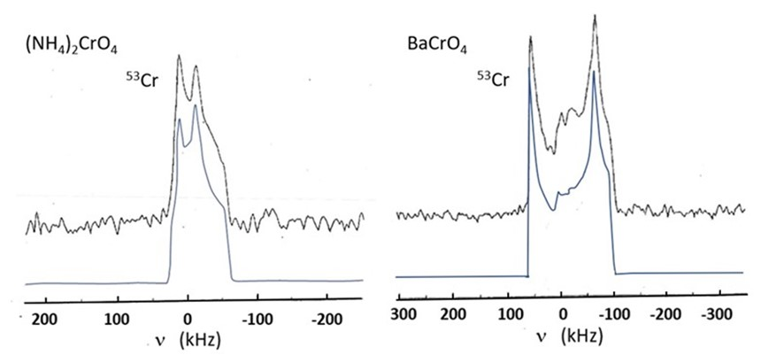
Figure 1. Experimental (top) and simulated (bottom) central (1/2, −1/2) transition static ⁵³Cr NMR lineshape for static powder samples of (NH₄)₂CrO₄ (left) and BaCrO₄ (right) at 9.4 T. Intensity values are shifted on the y axis for clarity.
4.3 Cr₂N
Cr₂N is an interstitial compound showing metallic behaviour and no magnetic transitions; its principal use is as a tempering agent in steel making. The crystal structure is trigonal [46] with a single Cr site (fully occupied) with no axis of symmetry. The powder XRD spectrum [35] indicates a well crystallized specimen with minor impurity phases of CrN_{0.98} (6±1%) and Cr (1.6±0.9%). It may be noted in passing that mono-chromium nitride, CrN, is an insulator at room temperature and an antiferromagnetic metal below the Néel temperature of 286 K [47]. Ab initio DFT calculations for two dimensional Cr₂N MXene have predicted an antiferromagnetic metal [48].
The ⁵³Cr and ¹⁴N NMR spectra for Cr₂N are reported here for the first time. There exists a relatively substantial electric quadrupole interaction at the Cr site. The ⁵³Cr NMR spectrum (Figure 2(a)) at a magnetic field of 9.4 T has a width of approximately 300 kHz and a Knight shift of −1900 ppm. It was found not possible to capture the spectrum using standard (echo) pulsed NMR at a single operating frequency. The strategy employed here, and subsequently for the Cr₂O₃, was to record the amplitude using a frequency-stepped echo approach [32]. Simulation of the spectrum using DMFIT [43] gives C_{Q} = 6.3±0.2 MHz and η = 0.15±0.10.

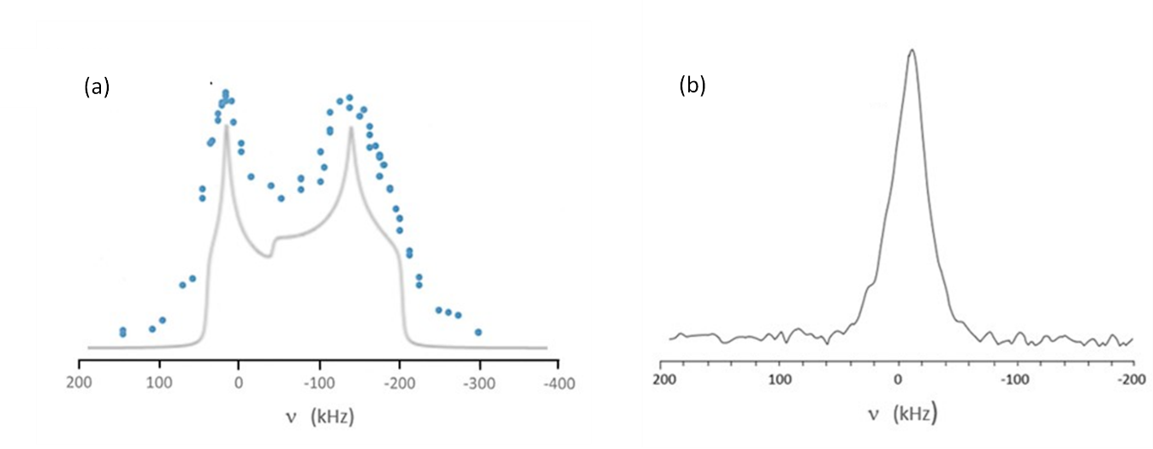
Figure 2. (a) Static ⁵³Cr NMR data from Cr₂N showing experimental (top) and simulated (bottom) central (1/2, −1/2) transition lineshape. Intensity values are shifted on the y axis for clarity. (b) Static ¹⁴N NMR spectrum of Cr₂N.
The crystal structure [46] also indicates four N sites – one unoccupied, one fully occupied, and two partially occupied; however, a static pulsed ¹⁴N NMR spectrum (Figure 2(b)) of the specimen indicates a single line with 35 kHz width (fwhm) and a small negative shift δ_{iso} = −200 ppm. The single narrow ¹⁴N NMR line is somewhat surprising considering (i) the site symmetry of all the N sites is no higher than , and (ii) ¹⁴N (I=1) is one of few quadrupolar nuclei with integer spin, and in non-cubic environments exhibits a first-order broadened ¹⁴N NMR lineshape [39]. The observed line possibly originates from the one fully occupied site. This single line may be due to vacancy assisted mobility of the nitrogen atoms meaning that only the permanently filled site will be detected. Low temperature NMR measurements may shed light on the origin of the ¹⁴N lineshape and are suggested as future work. From our room temperature lineshape, an upper limit value of C_{Q} < 0.047 MHz can be estimated from the fwhm [49]. Bastow et al. [50] have previously reported ¹⁴N C_{Q} values for other metal nitrides including AlN (C_{Q} < 0.01 MHz). For AlN the ¹⁴N static spectrum was an approximately Gaussian lineshape with fwhm of 7.5 kHz which gave the upper limit C_{Q} value ((4/3)fwhm) of < 0.01 MHz. This work has recently been revisited in a single crystal AlN specimen by Zeman et al. [51] reporting that C_{Q} = 8.19 kHz; hence this method is found to be robust for estimating an upper limit for C_{Q} within 20%.

4.4 CrB₂
CrB₂ has been established as a metal by single crystal measurements of (inter alia) electrical resistivity, Hall coefficient, and magnetic susceptibility [52] with weak itinerant antiferromagnetic ordering below the Néel temperature of 88 K [53]. The crystal structure [54] is hexagonal P6/mmm with Cr in 2a at (0,0,0) and B in 4d at (⅓,⅔,½), a = 2.969 Å, c=3.006 Å, both sites having axial symmetry and η = 0. The powder XRD [35] shows well crystallized CrB₂ with Cr₃B₄ detected as a minor impurity.
The ⁵³Cr NMR lineshape for CrB₂ has not been previously reported. In the present work, frequency-stepped ⁵³Cr NMR was used to delineate the lineshape for CrB₂ at 295 K: a single narrowly peaked somewhat asymmetric lineshape (fwhm = 38 kHz) (Figure 3(a)) exhibiting a very large negative Knight shift: K_{iso} = −9982 ppm (−226 kHz at 9.4T). There is no quadrupolar structure, suggesting a relatively small C_{Q}.

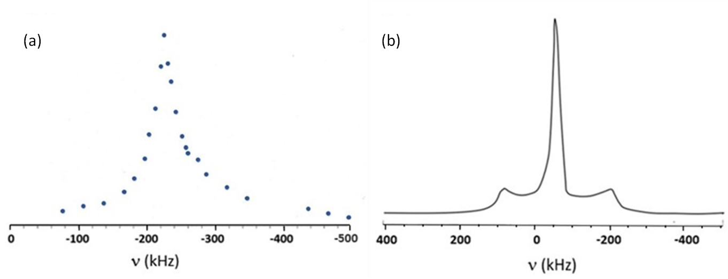
Figure 3. Static NMR data from CrB₂ showing (a) the central (1/2, −1/2) transition for ⁵³Cr and (b) the central as well as first-order quadrupole broadened (±3/2, ±1/2) transition for ¹¹B.
The absence of a significant quadrupolar interaction in the ⁵³Cr lineshape is somewhat unexpected given the substantial nuclear quadrupole interaction exhibited at the metal sites by the isostructural neighbouring group III and IV transition metal diborides ScB₂, TiB₂, and ZrB₂ [36]. These diborides have sharp features for the second-order perturbed central line splitting and for the first-order perturbed satellite singularities allowing precise determination of C_{Q} values. In CrB₂, the narrow ⁵³Cr NMR lineshape is presumably due to a fortuitous cancellation of all efg contributions. Attributing the observed, relatively narrow, ⁵³Cr lineshape to a second-order perturbed quadrupolar linewidth (Eq. 3), with I=3/2 and the Larmor frequency ν_{L} = 22.66 MHz at 9.4 T, yields an estimate for ν_{Q} ≈ 1.285 MHz giving C_{Q} ≈ 2.6 ± 0.5 MHz. This C_{Q} value estimated for ⁵³Cr compares reasonably well with the value of 3.05 MHz calculated ab initio by Schwarz et al. [55]. The broader underlying intensity is probably a result of some satellite transition intensity.
The ⁵³CrB₂ lineshape has presumably gone undetected for decades due to the large negative Knight shift making it difficult to know where to search for the resonance. The Knight shift for pure Cr metal is large and positive, 6870 ppm [4]. Although the transition metal monoborides and diborides formed the basis of substantial early work, the ⁵³Cr resonance proved difficult to detect [56,57]. The present work may encourage ⁵³Cr NMR study of the bonding and electronic structure in the stable chromium borides, e.g. Cr₂B, Cr₅B₃, CrB, Cr₃B₄, CrB₄ and CrB₂ for comparison with theoretical predictions [58].
The ¹¹B NMR spectrum at 295 K exhibits a first-order quadrupolar lineshape [59]. For ¹¹B (I=3/2), the separation of the satellite transitions (±1/2, ±3/2) defines the quadrupolar frequency ν_{Q} (Eq. 3). For crystallographic sites with axial symmetry this equation simplifies as η = 0, and for ¹¹B (I=3/2) therefore 2ν_{Q} = C_{Q}. An ¹¹B NMR spectrum at 295 K yielding a C_{Q} of 0.58 MHz was measured as shown in Figure 3(b). Schwarz et al. [55] calculated ¹¹B C_{Q} = 0.589 MHz in excellent agreement with this experimental value. The measured values of ¹¹B C_{Q} = 0.58 MHz and Knight shift = −390 ppm are in reasonable agreement with values first reported by Silver and Kushida [60] measured using continuous wave spectroscopy. The main ¹¹B lineshape was reported to vanish below 88 K [61] and a transition to antiferromagnetism deduced. Subsequently Funahashi et al. [62], using neutron diffraction, observed a helical magnetic structure in CrB₂ below 88 K. Bauer et al. [53] confirmed the incommensurate spin order reported by Funahashi et al. [62]. Recent ab initio calculations for two dimensional CrB₂ have predicted a ferromagnetic half metal with T_{C}=175K [63].

4.5 CrO₂
In this ferromagnetic oxide the hyperfine interaction at the Cr site is sufficiently large that the ⁵³Cr spectrum can be conveniently examined in zero applied field. This interaction is progressively thermally averaged to lower values as the temperature rises from 4.2 K to the Curie temperature T_{C} = 395 K [17,64]. CrO₂ has the tetragonal rutile structure and is ferromagnetic below T_{C}. Until recently this compound was used as the magnetic coating for high quality magnetic tapes, and having a convenient Curie temperature relative to room temperature makes it attractive for use in flexible magnetic composite devices [64]. An SEM micrograph of the powder [35] displays a characteristic nanorod microstructure [19,20] with typical rod dimensions: length ~ 200 to 300 nm, diameter ~ 30 nm. The powder XRD pattern [35] indicates a well crystallized material with CrO(OH) (Guyanaite) detected as a minor impurity.
The rutile structure implies one distinguishable Cr site per unit cell, so that there should be only one central line visible in the ⁵³Cr zero field NMR spectrum. However two widely separated narrow lines of approximately equal intensity at frequencies ν_{low} and ν_{high} of 26.5 and 37.2 MHz, respectively, are observed at 4.2 K [16-18,20,21]. A self-doping mechanism has been tentatively suggested for the existence of two distinct Cr sites [17]. A hypothesis that the sites originate from intra-domain and domain wall Cr atoms, respectively, has been considered and experimentally discounted [17]. Recently, it has been hypothesized that the two different Cr sites have different 3d orbital occupation numbers [20]. Because CrO₂ is a half metal with a Curie temperature above ambient temperature, it is being investigated for use in spintronic devices [65].
The frequencies, ν_{low} and ν_{high}, for these two lines measured in this work at 77, 195 and 295 K (Table 2) were located by systematically searching frequencies below the reported values at 4.2 K. Increasing spin wave excitation as the temperature rises is presumably responsible for the steadily decreasing ν_{zf}(T) for the two Cr sites as the temperature rises (Figure 4). There is a correlation with Bloch ferromagnetic spin wave theory [9,11] that predicts a T^{3/2} decrease in magnetization. Using Bloch theory, the data in Figure 4 for the two Cr sites predict resonance frequencies at 0 K of 26.407 MHz and 37.068 MHz, indicating hyperfine fields at the nuclei of 12.7 and 17.8 T, respectively. The relationship between the hyperfine parameters, the magnetic moment and the chromium valence is further discussed in Section 4.7, as is spin wave theory.
The ⁵³Cr NMR linewidths diminish along with decreasing signal-to-noise ratio as the temperature rises towards the Curie temperature (Table 2 and Figure 5). Within experimental error, the frequency difference, (ν_{high} − ν_{low}), remains essentially constant as the temperature rises from 4.2 K with an average value of 10.55 MHz. Shim et al. [17] have reported the saturation magnetization (measured using a magnetometer) in CrO₂ from 10 to 380 K indicating a T^{3/2} decrease in magnetization by 50% up to approximately 375 K, followed by a rapid continuous decrease of the remaining 50% of the magnetization toward zero in the critical region at the Curie temperature of 395 K. Recently, Piskunov et al. [21] have measured ⁵³Cr NMR data from 4.2 K to 365 K in high purity CrO₂, giving values similar to those reported here.
It may be noted that there is no evidence of a quadrupole interaction in the ⁵³CrO₂ NMR spectrum in the published or present data. Compare TiO₂ (also rutile structure) where the ⁴⁹Ti nuclei see a substantial efg (C_{Q} = 13.9 MHz, η = 0.19) [66] and α−VO₂ (rutile) where the ⁵¹V C_{Q} = 2.77 MHz and η = 0.86. [67]. It is possible that the broad ⁵³Cr lines have a second-order quadrupole interaction folded in, which, since this quantity generally decreases with increasing temperature, would explain why the observed line widths decrease with increasing temperature. Takeda et al. [20] report single crystal ⁵³CrO₂ NMR measurements at 4.2 K, in an applied magnetic field of 0.3 T parallel to the c axis, giving fwhm for the low and high resonances as 190 kHz and 280 kHz, respectively. A rough estimate of the upper limit for C_{Q} can be made from the narrowest linewidth that still obscures the quadrupolar splitting, where assuming η = 0 and perturbation theory still holds, a second-order perturbed quadrupolar linewidth Δ from Eq. 3 where I = 3/2, ν_{L} = 0.723 MHz at 0.3 T, then using the measured fwhm 190 kHz as Δ yields estimates for ν_{Q} ≈ 0.513 MHz and C_{Q} ≈ 1.03 MHz. Our estimate of 0.513 MHz for ν_{Q} is in good agreement with a recent estimate of ν_{Q} ≈ 0.5 MHz [21]. It can be noted that a (hypothetical) value of η = 0.4 decreases C_{Q} by only 2.6%. To the best of our knowledge ab initio calculations of the ⁵³Cr efg in CrO₂ have not been published.
Table 2 CrO₂ ⁵³Cr zero field NMR line peak frequencies ν_{high} and ν_{low} and linewidths Δv at various temperatures below T_{C}.
T(K) T^{3/2} (K^{3/2}) | ν_{low} (MHz) Δv (kHz) | ν_{high} (MHz) Δv (kHz) | Reference
4.2 8.6 | 26.5 450 | 37.2 680 | [20]
6.5 16.6 | 26.4 485 | 37.1 450 | [17]
77 676 | 25.3 530 | 35.9 510 | present work
195 2723 | 23.3 510 | 33.7 460 | present work
295 5067 | 20.2 390 | 30.7 420 | present work

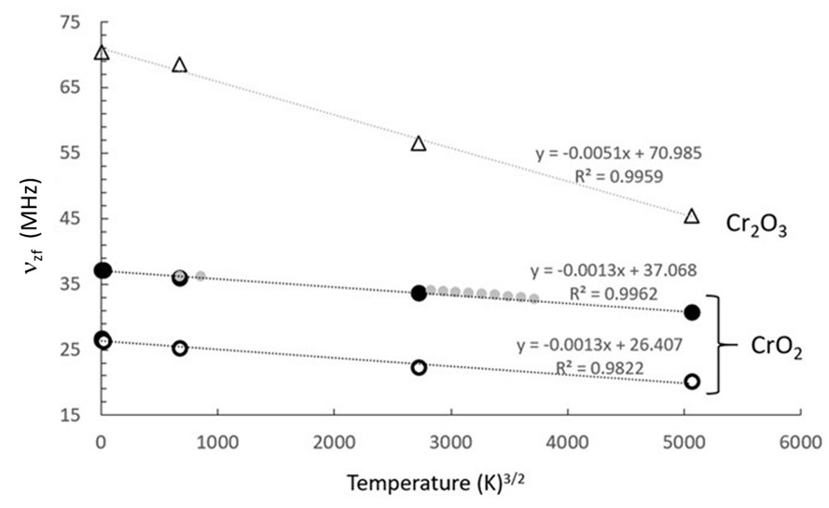
Figure 4. ⁵³Cr frequencies ν_{high} (•) and ν_{low} (O) for CrO₂ plotted as a function of T^{3/2}. With best fit equation and R² value displayed for the dotted line fits. Data of Yasuoka et al. [15] for ⁵³CrO₂ ν_{high} (•) included for information as described in the text. ⁵³Cr frequency (Δ) for Cr₂O₃ plotted as a function of T^{3/2} with best fit displayed.
The resonance reported by Yasuoka et al. [15] in 1963 for CrO₂ was detected using a marginal oscillator and a super-regenerative oscillator. The resonance, which can be attributed to ν_{high}, was reported for eleven temperatures over a range from 77 to 240K. These data were added to the data shown in Figure 4 in order to further refine the fit to spin wave theory T^{3/2} and resulted in a best fit, y = −0.0012x + 37.104 (R² = 0.9866), in excellent agreement with that obtained from frequencies measured using zero field pulsed NMR. It can be noted that neither a T² fit nor a linear T fit to these data was as good as the T^{3/2} fit [11]. Comparison of the ⁵³Cr zero applied field NMR frequency, ν_{high}, from the present work, Yasuoka et al. [15], and Piskunov et al. [21], with the saturation magnetization data of Shim et al. [17] as functions of temperature for CrO₂, show agreement with Bloch spin wave theory to T = 340 K or T = 0.86T_{C} [35]. Data from 340 K to 365 K (up to 0.9T_{C}) indicate a rapid continuous decrease of ν_{high} and ν_{low} toward zero in the critical region near the Curie temperature of 395 K [21] although the values of ν_{zf} are still at the 40-50% level of decrease from 4.2 K when measured at 365 K [35]. It remains to be demonstrated whether the local ⁵³Cr sublattice magnetization transition at T_{C} = 395 K will be first order, i.e. a discontinuous drop to zero of spontaneous magnetization rather than a smooth transition to the paramagnetic state; i.e. zero magnetization. ⁵³Cr NMR measurements up to and through T_{C} (395 K) are suggested for future work.

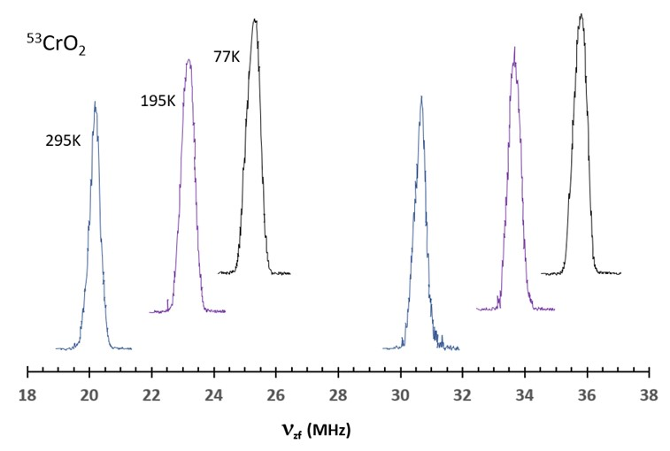
Figure 5. ⁵³Cr NMR lineshapes for CrO₂ at 295, 195 and 77 K. Intensity values are shifted on the y axis for clarity.

4.6 Cr₂O₃
This antiferromagnetic compound has the corundum (Al₂O₃) structure with one distinguishable Cr atom per unit cell at a site with axial symmetry so that any detectable second-order lineshape should indicate an efg with η = 0. An XRD spectrum [35] indicated good crystallinity with no trace of impurity. The antiferromagnetic to paramagnetic transition temperature, Néel temperature, T_{N} = 307.9 ± 0.2 K, was measured using DSC. The DSC traces were made on two separate samples of the powder, and both measurements [35] indicate a lambda anomaly in specific heat at T_{N}, characteristic of a second-order phase transition.
Antiferromagnetic ordering was established in Cr₂O₃ by Brockhouse in 1953 [68] and Corliss et al. [69,70]. Previous internal NMR, as discussed in Section 2, has been reported by Rubinstein et al. [14] using a super-regenerative oscillator detector, with a ⁵³Cr 95% enriched specimen at temperatures from 1.6 to 16 K. Over this relatively small temperature range the NMR line was detected at a constant frequency of 70.43 MHz, with the signal disappearing into the noise above 16 K. The frequency separation of the satellites (⁵³Cr, I=3/2) gave ν_{Q} = 0.525 MHz and C_{Q} = 1.05 MHz using Eq. 4 for η=0. Takeda et al. [19] using a much later, spectroscopically more sophisticated, method, recently reported a similar value of ν_{Q} = 0.54 MHz. The ⁵³Cr NMR spectrum of Takeda et al. [19] at 4.2 K is reproduced here in Figure 6; its sharp central line centred at 70.43 MHz with clear (±1/2, ±3/2) satellites measuring ν_{Q} = 0.54 MHz (C_{Q} = 1.08 MHz) can be compared with the ⁵³Cr spectra reported in the present work as described below.
In the present work, the ⁵³Cr zero field NMR signal was searched for below 70.43 MHz, first at 77 K. This search revealed a surprisingly broad lineshape (Figure 6) centred at 68.5 MHz with width 1.7 MHz, delineated by frequency stepping. A search at 195 K located, again by frequency stepping, a somewhat broader essentially featureless lineshape of width 2.0 MHz centred at 56.5 MHz. At 295 K a single line at 45.5 MHz of fwhm = 0.16 MHz was measured. The 295 K measurement was repeated and verified the original result. Spectra taken at increasing positive and negative 50 kHz frequency offsets from this value confirmed a single absorption line at 45.5 MHz. It is unclear what line broadening mechanism is operating at 77 and 195 K and what is happening to remove this mechanism at 295 K. The specimen was studied over a wide temperature range (10-300 K) using synchrotron radiation powder XRD, and there was no indication of a phase transition. The DSC trace [35] starts upwards from 140 K and there are no transitions other than the Néel temperature at 307.9 K. Karnachev [71] studied the rare earth orthochromite Dy_{0.2}Er_{0.8}CrO₃ (T_{N} = 141K) over the temperature range 58-91 K using zero applied field NMR and observed line broadening attributed to efg inhomogeneity. We can find no other report of line broadening in Cr₂O₃ and suggest further exploration of the mechanism as potentially fruitful future experimental work and DFT calculation. Figure 4 shows a plot of the central line frequency for ⁵³Cr in Cr₂O₃ as a function of T^{3/2} consistent with spin wave theory, predicting a resonance frequency at 0 K of 70.985 MHz, indicating a hyperfine field at the nucleus of 34.1 T. A hyperfine magnetic field still exists at 19 T at approximately 10 K below the Néel temperature (Figure 4). Corliss et al. [69,70] showed that greater than 50% of the macroscopic magnetization decrease in Cr₂O₃ powder (measured using neutron diffraction) occurs in the critical region between 295 K and the Néel temperature [35]. The present work suggests that ⁵³Cr studies of the magnetic sublattice in Cr₂O₃ over a wide temperature range inclusive of T_{N} will be fruitful.

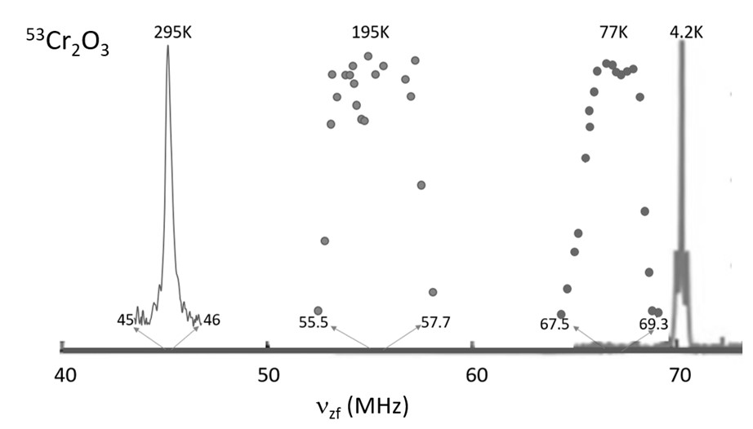
Figure 6. ⁵³Cr NMR lineshapes for Cr₂O₃ in zero field over a range of temperatures. Spectrum at 4.2 K adapted from Takeda et al. [19].

4.7 Compilation of ⁵³Cr solid-state NMR in alloys and compounds
Chromium exhibits seven valence states in its alloys and compounds with the most prevalent being Cr(0) for the metal, metallic alloys, and strong field ligand complexes, and Cr(III) and Cr(VI) for other compounds. The present work has reported NMR spectra for 3d⁶ Cr(0) paramagnetic (Cr₂N) and 3d⁶ Cr(0) antiferromagnetic (CrB₂) metals, a 3d³ Cr(III) antiferromagnetic (Cr₂O₃) semiconductor, a 3d² Cr(IV) ferromagnetic half metal (CrO₂), and 3d⁰ Cr(VI) diamagnetic (BaCrO₄, (NH₄)₂CrO₄) insulators. As discussed, ⁵³Cr magnetic resonance data can be used to elucidate the bonding environment of Cr in materials. Table 3 summarises the calculated integer valence and theoretical spin only magnetic moments expected for chromium in its compounds as compared to the range of reported low temperature measured magnetic moments [72-76]. Table 4 comprehensively summarises ⁵³Cr magnetic resonance data for the compounds reported here within the context of data from the literature on Cr alloys and compounds [77-116]. To the best of our knowledge, past ⁵³Cr solid-state NMR studies have not been tabulated in one place since 1971 [117]. For the literature surveyed here, which covers 1961 to 2022, 73% of the compounds studied are magnetic compounds, with 27% of those having their critical magnetic ordering temperature (T_{C} or T_{N}) above 300 K. For these studies of magnetic materials, 89% report NMR data with zero applied magnetic field.

4.7.1 Zero applied field NMR at low temperatures
This section will first focus on magnetic ⁵³Cr compounds and their NMR data at zero applied magnetic field. In Table 4, for zero field NMR reports, we include the low temperature resonance position of the central line(s); in reports where domain and wall resonances are distinguished, we have included only the data from domains; in reports where T_{C} or T_{N} > 77 K and measurements were made at both liquid helium and liquid nitrogen temperatures we have included those data for comparison purposes. For the spin echo technique, only domain signals are observed due to the short relaxation times of the broad resonance signals from walls. Three low temperature zero field NMR reports attribute separate resonances to domain and domain wall sites [3, 94, 118] for CrI₃, EuCrO₃, and CrBr₃, respectively, with the domain wall resonances located from 0.89 MHz to 1.42 MHz below the domain resonances. Where possible, low temperature Cr valence is given and it should be noted that in some compounds (mixed valence or those with a phase transition), valence can change with temperature.
The background to the hyperfine interactions at zero applied magnetic field, where the center-line resonance, ν_{zf}, (in units of MHz) is a measure of the hyperfine field at the ⁵³Cr nucleus, has been introduced in Section 4.1 (Eqs. 4 to 6) under the approximations noted above. NMR measurements as the temperature approaches 0 K (liquid helium temperatures) in zero field are necessary to minimize thermal effects on the value of the hyperfine constants derived from the data and for comparison with quantum chemical calculations of hyperfine interactions. The sublattice magnetization, and the resonance frequency will decrease as the temperature rises due to thermally excited spin waves. ⁵³Cr zero applied field and magnetization measurements for CrO₂ and Cr₂O₃ [35] illustrate the frequency-magnetization relationship, i.e., proportionality of ν_{zf}(T) and M(T), along with the T^{3/2} relationship for temperatures up to ~ 0.8 (T_{C} or T_{N}) (cf. Figure 4).
The absolute value of the hyperfine coupling constant |A| depends on the configuration and valence of the Cr ion in the compound, indicates the extent of delocalization of the unpaired electron, and can be calculated ab initio for the 3d^{n}4s⁰ ions [119] or calculated from the measured values of ν_{zf}(0) and M(0) for a given compound [1]. Several authors [119-121] calculate A for the chromium 3d^{n}4s⁰ ions, giving the core polarization hyperfine field per unpaired valence electron, within the Hartree Fock scheme as −12.5 T/μ_{B}. This value results from the approximation of (i) the magnetic hyperfine 3d exchange interaction transferred at the chromium nucleus (through covalency and overlap) as the Fermi contact interaction and (ii) the magnetic moment as the spin density at the nucleus. Values of A derived from low temperature experiment are compared with theory to ascertain the extent of delocalization or magnitude of the transferred field. Alternatively, theoretical values of A are used with measured values of ν_{zf} at low temperature to predict magnetization and valence. The ground state magnetization can also be calculated using ab initio DFT methods where the approximation of the exchange and correlation potential is the subject of much research in chromium compounds [122-125].
Other methods for the calculation of the hyperfine coupling constant have been reported for ⁵³Cr with values of |A| ranging from 8.3 to 12.2 T/μ_{B} [125-129]. The value A = −10 T/μ_{B} is often used, as this is the average value for the core polarization hyperfine field per unpaired valence electron for the 3d transition metals reported by Blugel et al. [128]. The value of |A| = 8.33 T/μ_{B} results from a first principles calculation of the contact field for Cr³⁺ [125]. Rubinstein et al. [14] first reported the measured value of A = −9.76 T/μ_{B} based on zero applied field measurements of ⁵³Cr³⁺ in an octahedral environment of oxygen atoms in Cr₂O₃ with ν_{zf} = 70.43 MHz at 1.6 K and with M(0) assumed to be 3 μ_{B} per Cr atom. The theoretical value of |A| for an isolated Cr³⁺ ion (12.5 T/μ_{B}) has been shown to be very close to the measured values (11.3 to 12.4 T/μ_{B}) in Cr molecular rings and chains [10,104,105]. The theoretical values compare favourably with the range of measured (calculated from measurements on Cr compounds) values of |A| shown in Table 3.
Table 3 is also useful for estimating the range of observed frequencies near 0 K for the ⁵³Cr nucleus in various compounds. Using the range of |A| values and the spin only magnetic moment values, the anticipated range of ⁵³Cr ν_{zf}(0) is 38-110 MHz; using the measured local magnetic moment values, the anticipated range is 10-114 MHz; as compared to the reported measured range of ν_{zf} in Table 4 which is 13-79 MHz. This measured range of ν_{zf}(0) reported for each configuration in Table 4 can be compared to the range calculated from Table 3 in a form of Slater-Pauling-like curve (see Figure 7). The Slater-Pauling curve (magnetic moment M as a function of valence electron concentration) for 3d transition metal compounds has been calculated ab initio by Dederlichs et al. [129] for Fe, Ni, and Co based alloys. Such an ab initio calculation for Cr-based alloys has not been reported and is recommended as fruitful future work.
The theoretical value |A| = 8.33 T/μ_{B}, [125] along with the spin only magnetic moment values from Table 3 for each valence, are used to calculate the theoretical internal field frequencies for each valence in Figure 7 (b). Figure 7 (b) shows that the value of the hyperfine interaction constant |A| has a great bearing on the goodness of fit between theory and experiment. It can be noted that a variation in |A| from 8.3 to 12.5 T/μ_{B} results in a variation of predicted resonance frequency (e.g. for Cr(III), using spin only M = 3 μ_{B}) from 60 to 90 MHz. In addition, it should be noted that in Figure 7 (b) the mixed valence compounds are shown together at the boundaries of the integer valence values which may also affect goodness of fit.
Future work on ab initio calculations for magnetic Cr alloys and compounds would be useful and could help predict the mixed valence values for ν_{zf}(0). Mixed valence is thought to enable local double exchange mediated magnetic order [130] which, in topological insulators, is postulated as a pathway to room temperature quantum transport in zero magnetic field [131,132]. Also, ab initio calculations of ν_{zf}(0) would be helpful for locating Cr(I) and Cr(V) internal field resonances that, to the best of our knowledge, have not yet been reported by zero field NMR studies. In Figure 7 (b) we have indicated, with dashed line ellipses, where one might expect to find the low temperature ⁵³Cr zero applied field NMR resonances for 3d⁵ low spin and 3d¹ compounds in future experiments or calculations.
Some further comments on Figure 7 (b) are warranted as it is the first time the literature data for ⁵³Cr have been compiled in such a format. As reviewed in this section, previous ⁵³Cr reports have mainly focussed on a single material with a single Cr valence (predominantly Cr³⁺), with authors choosing either to fix the hyperfine coupling constant A or to fix the magnetic moment. The data in Figure 7 (b) now provide a summary of ⁵³Cr ν_{zf}(0) values for a wide range of Cr compounds across the valences Cr(0) to Cr(IV) including mixed valence, high spin, low spin, octahedral and tetrahedral configurations, metals, semi metals, semiconductors, insulators, and varying crystal and magnetic structures. These data allow us to test our understanding of magnetism in Cr alloys and compounds. Cottenier [133] has noted the difficulty of DFT functionals in capturing the physics of the ground state for Cr alloys and compounds, making these alloys ideal testing grounds for improved DFT functionals. The data set may also prove helpful as a training set for a machine learning approach to property prediction as well as testing hypotheses and models.
- It can be found in the literature that the covalency of the Cr-x bond increases as x=O is successively replaced by x=halides, x=S, and x=Se [120]. The “covalency school model” [120] expects the magnetic moment of the electron spins (and hence ν_{zf}) to decrease with decreasing electronegativity, i.e. with increasing covalency, which it does as shown in Figure 7 (b) for d³ Cr(III)^{oct} oxides, halides, sulphides and selenides.
- The reported non-integer valence values for mixed valence compounds from Table 4 have been plotted as an expanded section [35] and show the expected decrease in low temperature ⁵³Cr internal magnetic field resonance frequency with valence from Cr³⁺ to Cr⁴⁺ for mixed valence chromium oxides.
- The two Cr²⁺ high spin d⁴ Cr(II)^{oct} compounds may appear as outliers; however, they are high spin and sit approximately 10 MHz lower than would be predicted using the spin only magnetic moment M = 4 and |A| = 8 .33 T/μ_{B}.

Table 3. Magnetic moment, integer valence, and ionic radius of chromium in its alloys and compounds.
Configuration | Valence | Number of unpaired electrons, n  Spin S=n/2 | Spin Only Magnetic moment, M (μ_{B}) calc  M=√n(n+2) | Magnetic moment, M (μ_{B}) measured [72]  Octahedral |Tetrahedral |  | Average Magnetic Moment, M (μ_{B})  M = gμ_{B}S  (using g=2) | Hyperfine Coupling Constant |A| (T/μ_{B}) | Metallic or Ionic Radius  (pm) [73,74] | Cr Valence Reference Standard Compounds [75,76]
Cr (0) [Ar]3d⁵4s¹  configuration is for a non-bonded isolated Cr | Cr | 6  S=3 | 6.93 | NA | NA | 6 | Theory  12.5 | 140 | NA
Cr (0) [Ar]3d⁶4s⁰ | Cr | hs 4 ls 0  S=2 S=0 | 4.90 0 | ls 0.4-0.6 |  | 4 0 | Measured  11.3 - 13.9 | ls 128 | Cr, Cr(CO)₆
Cr (I) [Ar]3d⁵4s⁰ | Cr⁺ | hs 5 ls 1  S=$\frac{5}{2}$ S=$\frac{1}{2}$ | 5.92 1.73 | ls 1.77 |  | 5 1 | 9.8 | ls 109 | (C₆H₆)₂CrI
Cr (II) [Ar]3d⁴ | Cr²⁺ | hs 4 ls 2  S=2 S=1 | 4.90 2.83 | hs 4.0-5.0  ls 2.7-3.4 |  | 4 2 | 8.6  7.5 - 9.0 | hs 80  ls 73 | CrSe  CrCl₂
Cr (III) [Ar]3d³ | Cr³⁺ | 3  S=$\frac{3}{2}$ | 3.87 | 2.7-4.0 |  | 3 | 9.0 – 12.7 | 61.5 | CrCl₃, Cr₂O₃
Cr (IV) [Ar]3d² | Cr⁴⁺ | 2  S=1 | 2.83 |  | 2.6-2.8 | 2 | 5.6 - 8.0 | 55 | CrO₂
Cr (V) [Ar]3d¹ | Cr⁵⁺ | 1  S=$\frac{1}{2}$ | 1.73 |  | 1.7-1.8 | 1 | 7.4-7.8 | 49 | CrOCl₃, YbCrO₄, NdCrO₄
Cr (VI) [Ar]3d⁰ | Cr⁶⁺ | 0  S=0 | 0 |  | 0 | 0 | NA | 44 | CrO₃, CaCrO₄, K₂CrO₄, K₂Cr₂O₇
hs=high spin, ls=low spin. The notation Cr (I, II, …) for oxidation state should not be confused with some authors’ use of this nomenclature for inequivalent Cr atom positions in a unit cell.
Table 4. ⁵³Cr hyperfine interaction parameters of chromium compounds from magnetic resonance measurements. Cr valence expected at 0 K. Local magnetic moment near 0 K, when reported. Note the measurement temperature, as the chemical shift δ_{iso} or Knight shift for metals, the zero applied field NMR center line frequency, the Cr sublattice magnetization, and the Cr ion valance can be functions of temperature. Material character and critical magnetic transition temperatures are given where known.
Compound | Chromium Valence  Local Magnetic Moment | δ_{iso} or Knight shift (ppm)* | Center line frequency (MHz) | C_{Q} (MHz) | η | Temperature  (K) | Character  AFM = antiferromagnetic  FM = ferromagnetic  PM = paramagnetic | Reference
Cr | Cr(0)  0.5μ_{B}/Cr | 6870 | 16.60 |  |  | 314 to 387  314 | Metallic, AFM below T_{N} = 313K, PM above | [4]  [31]
Cr_{1-x}V_{x} (x = 0.25 to 3 at%) | Cr(0) | 6850 to 6990 |  |  |  | 300 | Metallic, AFM below T_{N} = 287K (0.25 at% V) to 65K (3 at% V), PM above | [4,5]
Fe_{1-x}Cr_{x} (x = 0.25 to 26.3 at%) | Cr(0)  0.46μ_{B}/Cr |  | 15.85 to 17 |  |  | 1.2 | Metallic, FM below T_{C} = 1050K (0.25 at% Cr) to 920K (26.3 at% Cr), PM above | [77]
Cr_{1-x}Mo_{x} (x = 12.9 to 22.6 at%) | Cr(0) | 6800 |  |  |  | 1.4 | Metallic, AFM below T_{N} = 146K (12.9 at% Mo) to 20K (22.6 at% Mo), PM above | [28]
Cr₃AsN (2 inequivalent sites) | Cr(0)  0.5μ_{B}/Cr |  | 13.66, 14.51 |  | 0  0 | 4  4 | Metallic, itinerant AFM below T_{N} = 255K, PM above | [78]
CrH_{0.93} and CrH_{0.97} (hexagonal) | Cr(0) | 5300 |  |  |  | 3 to 300 | Metallic, paramagnetic | [27]
CrH_{0.93} and CrH_{0.97}(cubic) | Cr(0) | 3000 |  |  |  | 3 to 300 | Metallic, paramagnetic | [27]
Al_{1-x}Cr_{x} (x = 0.1 and 0.5 at%) | Cr(0) | −3800 |  |  |  | 1 to 4 | Metallic, dilute substitutional site | [79]
Pt_{1-x}Cr_{x} (x = 0.1 and 0.5 at%) | Cr(0) | −8200 |  |  |  | 1 to 4 | Metallic, dilute substitutional site | [80]
CrB₂ | Cr(0) | −9982 |  | 2.57ª | 0 | 295 | Metallic, weak itinerant AFM below T_{N} = 88K, PM above | present work
Cr₂N | Cr(0) | −1900 |  | 6.3 | 0.15 | 295 | Metallic, paramagnetic | present work
Cr(CO)₆ | Cr(0) | −1814** |  | 0.348 | 0.48 | 295 | Insulator, diamagnetic | [44]
Rb₂CrCl₄ | Cr(II)^{oct}  4μ_{B}/Cr |  | 82.3  67.4^{b} | 3.2 |  | 4.2 | Semiconductor, FM below T_{C} = 52K, PM above | [81]
SrCr₂As₂ | Cr(II)^{oct}  1.9μ_{B}/Cr |  | 71 | ^{c} |  | 1.6 | Metallic, AFM below T_{N} = 615K, PM above | [82]
Cr₃Te₄ (2 inequivalent sites) | Cr(II), Cr(III)  1.79μ_{B}/Cr or  2.35μ_{B}/Cr |  | 57.5, 45.3  56.0, 44.5  55.2, 44.8  50.0, 36.9  47.0, 36.5 |  |  | 4.2  4.2  20  77  77 | Metallic, FM below T_{C} = 329K, PM above | [83]  [84]  [85]  [84]
Cr₅Te₆ (2 inequivalent sites) | Cr(II), Cr(III)  2.5μ_{B}/Cr |  | 53.0, 41.0 |  |  | 77 | Metallic, FM below T_{C} = 327K, PM above | [84]
Cr₇Te₈ (2 inequivalent sites) | Cr(II), Cr(III)  1.8μ_{B}/Cr |  | 58.2, 45.1  52.6, 40.8 |  |  | 4.2  77 | Metallic, FM below T_{C} = 350K, PM above | [86]
CrTe (2 inequivalent sites) | Cr(II), Cr(III)  2.4μ_{B}/Cr |  | 54.0, 42.2  55.2, 45.1 |  |  | 77  77 | Metallic, FM below T_{C} = 340K, PM above | [85,87]  [84]
Y₃Fe_{4.57}Cr_{0.43}O₁₂ | Cr(III) |  | 78.8  78.0 |  |  | 4.2  77 | Insulator, ferrimagnetic below T_{C} = 500K, PM above | [88]
CrCl₃ | Cr(III)  2.9μ_{B}/Cr |  | 62.42  62.32 | 0.882  0.9 | 0 | 1.23  1.4 | Semiconductor, AFM below T_{N} = 16.8K, PM above | [2]  [13]
CrBr₃ | Cr(III)  2.99μ_{B}/Cr |  | 58.038 | 1.184 | 0 | 1.34 | Semiconductor, FM below T_{C} = 37K, PM above | [1]
CrI₃ | Cr(III)  3.1μ_{B}/Cr |  | 49.392 | 0.744 | 0 | 1.65 | Semiconductor, FM below T_{C} = 68K, PM above | [3]
CuCrO₂ | Cr(III)  2.8μ_{B}/Cr |  | 63.8 to 66.0 |  |  | 4.2 | Insulator, AFM below T_{N} = 24.3K, T_{N} = 23.6K, PM above | [89]
Cr₂O₃ | Cr(III)  2.48μ_{B}/Cr |  | 70.43  70.43  68.5 | 1.05  1.08 | 0 | 1.6  4.2  77 | Semiconductor, AFM below T_{N} = 308K, PM above | [14]  [19]  Present work
Dy_{0.2}Er_{0.8}CrO₃ | Cr(III) |  | 63.6 | 4.4 | 0 | 69 | Semiconductor, AFM below T_{N} = 141K, PM above | [71]
GdCrO₃  (2 magnetic sublattices) | Cr(III) |  | 68.8  68.3 | 4.4  1.88 | 0 | 4  10 | Insulator, AFM below T_{N} = 170K, PM above | [90]
ErCrO₃ (low T AFM phase, higher T weakly FM phase) | Cr(III) |  | 68.97  67.6 | 2.7  1.8 | 0  0 | 4.2 (AFM)  37 (weakly FM) | Insulator, weakly FM below T_{C} = 133K, PM above | [91]  [92]
TmCrO₃  (2 magnetic sublattices) | Cr(III) |  | 68.9  69.1 | 1.36  3.52 | 0  0 | 1.8 to 5.6  1.8 to 65 | Insulator, AFM below T_{N} = 125K, PM above | [93]
LuCrO₃ | Cr(III) |  |  | 2.92 | 0 | 4.2 | Insulator, AFM below T_{N} = 120K, PM above | [94]
EuCrO₃ | Cr(III) |  | 68.7 | 2.76 | 0 | 14.3 | Insulator, AFM below T_{N} = 140K, PM above | [94]
LaCrO₃ | Cr(III) |  | 68.63 |  |  | 4.2 | Semiconductor, AFM below T_{N} = 290K, PM above | [95]
MnCr₂O₄ | Cr(III) |  | 66.5  66.2 |  |  | 4.5  6.5 | Insulator, ferrimagnetic below T_{C} = 41K, PM above | [96]  [97]
CuCr₂O₄ | Cr(III) |  | 63  63.2  59.4 |  |  | 5  0  77 | Insulator, ferrimagnetic below T_{C} = 135K, PM above | [98]  [99]
FeCr₂O₄ | Cr(III) |  | 50.8  46.8 |  |  | 0  77 | Insulator, ferrimagnetic below T_{C} = 80K, PM above | [87]
FeCr₂S₄ | Cr(III) |  | 50.8  46.8 |  |  | 0  77 | Metallic, ferrimagnetic below T_{C} = 180K, semiconductor PM above | [99]
CoCr₂S₄ | Cr(III)  2.7μ_{B}/Cr |  | 49.3  47.4 |  |  | 0  77 | Semiconductor, ferrimagnetic below T_{C} = 222K, PM above | [87]
Mn_{x}Zn_{1-x}Cr₂O₄ (x>0.7) | Cr(III) |  | 65.5 |  |  | 1.8 | Insulator, ferrimagnetic below T_{C} = 41K, PM above | [100]
Ga_{0.2}Fe_{0.8}NiCrO₄ | Cr(III) |  | 75 |  |  | 4.2 | Insulator, frustrated ferrimagnetic below T_{C} = 480K, PM above | [101]
NaCrS₂ | Cr(III) |  | 53.45 | 0.2 |  | 1.5 | Semiconductor, AFM below T_{N} = 17K, PM above | [102]
Cr₃As₂ | Cr(III) |  | 56.0  55.8 |  |  | 77  81.4 | Insulator, ferrimagnetic below T_{C} = 243K, PM above | [103]
Cr₇Ni | Cr(III) |  |  |  |  | 1.6 | Semiconductor, AFM ring | [104]
Cr₇Cd (3 inequivalent sites) | Cr(III) |  | (44, 46, 57)^{b} |  |  | 1.6 | Semiconductor, AFM ring | [105]
Cr₈Cd | Cr(III) |  |  |  |  | 1.6 | Semiconductor, AFM ring | [8]
YCrO₃ | Cr(III) |  | 68.73  68.74 | 1.99  2.0  1.52 | 0  0  0 | 4.2  4.2  77 | Insulator, AFM below T_{N} = 140K, PM above | [106]  [19]  [94]
NaCr₂O₄ | Cr(III), Cr(IV):  Cr^{3.5+} |  | 52 |  |  | 4.2 | Insulator, AFM below T_{N} = 125K, PM above | [107]
K₂Cr₈O₁₆  (4 inequivalent sites: A,B,C,D) | Cr(III), Cr(IV):  Cr^{3.75+} 2.25μ_{B}/Cr |  | A 46,56  B 46,56  C 43,53  D 39,49 |  |  | 4.2 | Half metal, FM below T_{C} = 180K PM above, metal-insulator transition T_{MI} = 95K | [19]
SrRu_{1−x}Cr_{x}O₃  (x = 0.05, 0.12) | Cr(III), Cr(IV):  Cr^{3.75+} 2.4μ_{B}/Cr |  | 60.8 (x = 0.05) 60.3 (x = 0.12) |  |  | 1.3 | Insulator, itinerant FM below T_{C} = 175 to 186K (x = 0.05, 0.12), PM above | [108]
CuCr₂Te₄ | Cr(III), Cr(IV) |  | 34.9 |  |  | 77 | Semiconductor, FM below T_{C} = 326K, PM above | [109]
CuCr₂Se₄ | Cr(III), Cr(IV) |  | 38.2 | 0.39 |  | 77 | Semiconductor, FM below T_{C} = 430K, PM above | [109]  [110]
ZnCr₂Se₄ | Cr(III), Cr(IV) |  | 46.7  44.75 | 1.48 |  | 1.4  6 | Semiconductor, AFM below T_{N} = 20K, PM above | [111]  [6]
CuCr₂S₄ | Cr(III), Cr(IV)  2.67μ_{B}/Cr |  | 39.8  38.9  27 | 1.8  1.8 | 0 | 4.2  77  300 | Metallic, FM below T_{C} = 420K, semiconductor PM above | [112]  [87]
CuCr_{2-x}Sb_{x}S₄  (x=0, 0.02, 0.07) | Cr(III), Cr(IV) |  | 39.5  39.3  39.4 | 1.8  1.8  1.8 | 0  0.1  0.2 | 77  77  77 | Metallic, FM below T_{C} = 420K, semiconductor PM above | [110]
Cd_{1-x}Ag_{x}Cr₂Se₄  (x=0, 0.001, 0.005, 0.015) | Cr(III), Cr(IV) |  | 44.05 | 3.68 |  | 4.2 | Semiconductor, FM below T_{C} = 130K, semiconductor PM above | [113,114]
CdCr₂Se₄ | Cr(III), Cr(IV) |  | 44.06  34.8 | 3.52 | 0 | 4.2  77 | Semiconductor, FM below T_{C} = 129K, PM above | [115]  [109]
CdCr₂S₄ | Cr(III), Cr(IV) |  | 46.02  45.97 | 3.80 | 0 | 1.4  4.2 | Insulator, FM below T_{C} = 87K, PM above | [111]  [115]
HgCr₂Se₄ | Cr(III), Cr(IV) |  | 43.07  42.97 | 3.92 | 0 | 1.4  4.2 | Semiconductor, FM below T_{C} = 105K, PM above | [111]  [115]
HgCr₂S₄ | Cr(III), Cr(IV) |  | 45.68 | 3.8 |  | 1.4 | Semiconductor, AFM below T_{N} = 22K, PM above | [111]  [110]
Cr_{0.33}NbSe₂ (2 inequivalent sites) | Cr(III), Cr(IV)  2.3μ_{B}/Cr |  | 49.98  53.44 | 2.48  7.64 |  | 4.2 | Semiconductor, FM below T_{C} = 82K, PM above | [7]
Cr_{0.5}NbSe₂ | Cr(III), Cr(IV)  1.9μ_{B}/Cr |  | 54.31 | 7.64 |  | 4.2 | Semiconductor, AFM below T_{N} = 53K, PM above | [7]
Cr_{0.33}NbS₂ (2 inequivalent sites) | Cr(III), Cr(IV)  2.82μ_{B}/Cr  2.1μ_{B}/Cr |  | 65.3-66.6,  49.9-50.2  55.5-56.8  38.3-38.7 | 2.46  2.16  2.46  2.16 |  | 4.2  77 | Semiconductor, FM below T_{C} = 127K, PM above | [116]
CrO₂ (1 site but 2 frequencies, see text in Section 4.5) | Cr(IV)  1.94μ_{B}/Cr |  | 26.5, 37.2  26.3, 37.1  26.4, 37.1  25.3, 36.2  25.3, 35.9 | 1.03 ª  1ª | 0 | 4.2  6.5  77  77 | Half metal, FM below T_{C} = 395K PM above | [19]  [21]  [17]  [21]  present work
Li₂CrO₄ (dihydrate) | Cr(VI) | −62** |  | 4.00 | 0.30 | 295 | Insulator, diamagnetic | [22]
Li₂CrO₄ (anhydrous) | Cr(VI) | −17** |  | 1.80 | 0.15 | 295 | Insulator, diamagnetic | [22]
K₂CrO₄ | Cr(VI) | −35**  −32** |  | 1.76  1.75 | 0.43  0.40 | 295  295 | Insulator, diamagnetic | [22]  [44]
Rb₂CrO₄ | Cr(VI) | −24** |  | 1.28 | 0.80 | 295 | Insulator, diamagnetic | [22]
Cs₂CrO₄ | Cr(VI) | −19**  −22** |  | 1.23  1.17 | 0.23  0 | 295 | Insulator, diamagnetic | [22]  [44]
Ag₂CrO₄ | Cr(VI) | 188** |  | 4.10 | 0.28 | 295 | Insulator, diamagnetic | [22]
(NH₄)₂CrO₄ | Cr(VI) | 0 |  | 3.1 | 0.58 | 295 | Insulator, diamagnetic | present work
MgCrO₄ (dihydrate) | Cr(VI) | −67** |  | 2.62 | 0.38 | 295 | Insulator, diamagnetic | [22]
CaCrO₄ | Cr(VI) | −117** |  | 4.55 | 0 | 295 | Insulator, diamagnetic | [22]
SrCrO₄ | Cr(VI) | -27** |  | 5.0 | 0.68 | 295 | Insulator, diamagnetic | [22]
BaCrO₄ | Cr(VI) | 0  −47** |  | 4.9  5.00 | 0.16  0.14 | 295  295 | Insulator, diamagnetic | present work  [22]
PbCrO₄ | Cr(VI) | 68** |  | 4.4 | 0.85 | 295 | Insulator, diamagnetic | [22]
Cs₂Cr₂O₇ | Cr(VI) | −17** |  | 7.25 | 0.30 | 295 | Insulator, diamagnetic | [22]
αK₂Cr₂O₇  (2 inequivalent sites) | Cr(VI) | −22**  −67** |  | 7.48  8.28 | 0.30  0.21 | 295 | Insulator, diamagnetic | [22]
* shift with respect to saturated aqueous solution of alkali chromate (Na₂CrO₄ or (NH₄)₂CrO₄)
** originally reported with respect to Cr(CO)₆ in chloroform solution (the difference is −1797 ppm, i.e., aq Cr(CO)₆ is 0 ppm wrt itself or −1797 ppm wrt aq Na₂CrO₄)
ª no singularities, upper limit estimate of C_{Q} using fwhm of Gaussian peak as Δ
^{b} extrapolation from field dependent data using γ = 2.406 MHz/T
^{c} Ding et al. [82] estimate a value for ν_{Q} but it appears to be inconsistent with the spectrum.
antiferromagnetic=AFM; ferromagnetic=FM; paramagnetic=PM
The reader should consult the references to ascertain XRD structure, phase purity, annealing state, and other experimental factors.

Table 5. ⁵³Cr centre-line zero applied field magnetic resonance frequency data ν_{zf}(T) modelled using Bloch spin-wave theory.
Compound | Bloch spin wave formulation  ν_{zf} = ν_{zf}(0) − c(T/T_{Crit})^{3/2} | R²  goodness of fit | Valence | Critical Transition (Néel or Curie) Temperature T_{Crit} (K) | Spin Wave Stiffness D  (meV Å²) | Reference
Dy_{0.2}Er_{0.8}CrO₃ | ν_{zf} = 74.401 − 32.371(T/T_{Crit})^{3/2} | 0.995 | d³ Cr(III) ^{oct} | 141 | 34.8 | [71]
Cr₂O₃ | ν_{zf} = 70.985 − 27.436(T/T_{Crit})^{3/2} | 0.996 | d³ Cr(III) ^{oct} | 308 | 76.3 | present work
MnCr₂O₄ | ν_{zf} = 66.657 − 5.198(T/T_{Crit})^{3/2} | 0.990 | d³ Cr(III) ^{oct} | 41 | 39.7 | [96]
CuCr₂O₄ | ν_{zf} = 63.254 − 8.343(T/T_{Crit})^{3/2} | 0.985 | d³ Cr(III) ^{oct} | 135 | 88.7 | [98]
CrCl₃ | ν_{zf} = 63.111 − 39.731(T/T_{Crit})^{3/2} | 0.999 | d³ Cr(III) ^{oct} | 16.8 | 4.7 | [2,135]
Cr₃As₂ | ν_{zf} = 58.621 − 14.110(T/T_{Crit})^{3/2} | 0.904 | d³ Cr(III) ^{oct} | 243 | 164 | [103]
CrBr₃ | ν_{zf} = 58.229 − 20.265(T/T_{Crit})^{3/2} | 0.998 | d³ Cr(III) ^{oct} | 37 | 18.4 | [1]
NaCrS₂ | ν_{zf} = 54.072 − 12.092(T/T_{Crit})^{3/2} | 0.988 | d³ Cr(III) ^{oct} | 17 | 8.0 | [102]
FeCr₂S₄ | ν_{zf} = 51.381 − 14.145(T/T_{Crit})^{3/2} | 0.988 | d³ Cr(III) ^{oct} | 180 | 107 | [99]
CrI₃ | ν_{zf} = 49.596 − 15.368(T/T_{Crit})^{3/2} | 0.987 | d³ Cr(III) ^{oct} | 68 | 32.5 | [3]
ZnCr₂Se₄ | ν_{zf} = 46.657 − 11.115(T/T_{Crit})^{3/2} | 0.988 | d³ Cr(III) ^{oct} | 20 | 14.1 | [6]
K₂Cr₈O₁₆  Sites A and B  Site C | ν_{zf} = 46.484 − 23.074(T/T_{Crit})^{3/2}  ν_{zf} = 42.963 − 21.332(T/T_{Crit})^{3/2} | 0.998  0.998 | mixed valence  d² Cr(IV) and  d³ Cr(III) | 180 | 142  151 | [19]
CdCr₂Se₄ | ν_{zf} = 44.179 − 20.103(T/T_{Crit})^{3/2} | NA | mixed valence  d² Cr(IV) and d³ Cr(III) | 129 | 65 | [111,115]
CuCr₂S₄ | ν_{zf} = 40.188 − 21.756(T/T_{Crit})^{3/2} | 0.997 | mixed valence  d² Cr(IV) and d³ Cr(III) | 420 | 137 | [87,112]
CrO₂ ν_{high}  CrO₂ ν_{high}  ν_{low} | ν_{zf} = 37.038 − 8.681(T/T_{Crit})^{3/2}  ν_{zf} = 37.068 − 9.882(T/T_{Crit})^{3/2}  ν_{zf} = 26.407 − 10.151(T/T_{Crit})^{3/2} | 0.993  0.996  0.982 | d² Cr(IV) ^{tet} | 395 | 127  113  90.4 | [15]  present work  present work
Cr₃AsN | ν_{zf} = 14.504 − 2.397(T/T_{Crit})^{3/2} | 0.992 | d⁶ Cr(0) low spin | 255 | 410 | [78]

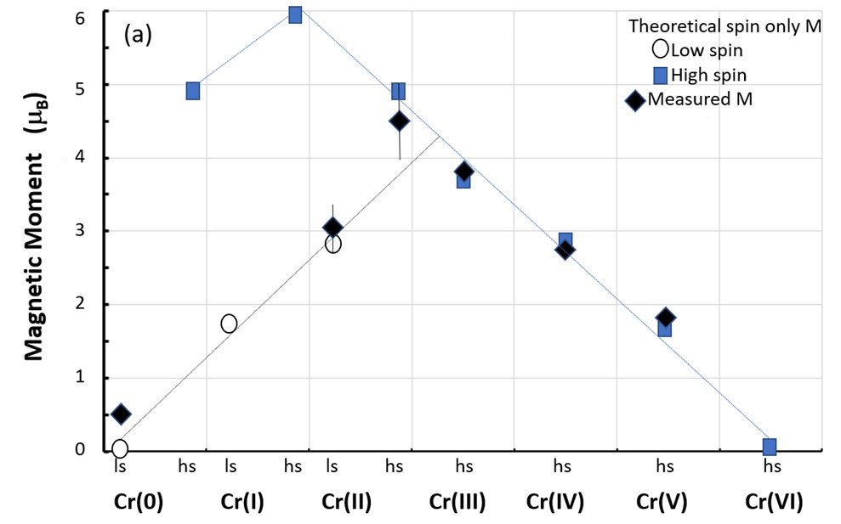

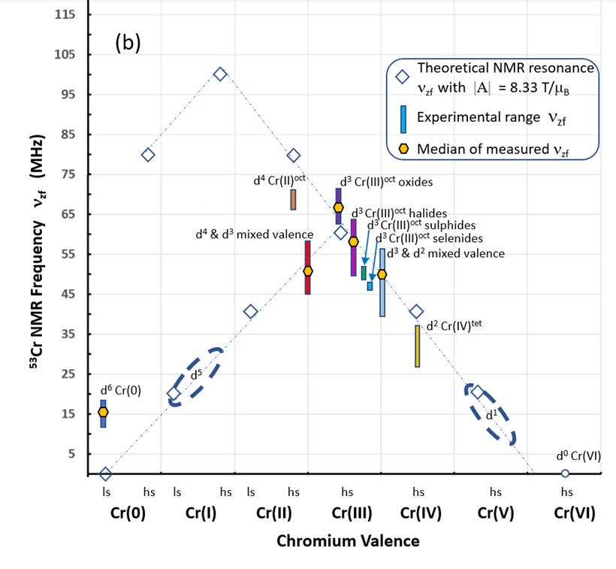
Figure 7. (a) Magnetic moment as a function of valence for Cr compounds, and (b) the ⁵³Cr zero applied field magnetic resonance frequency near 0 K as a function of Cr valence.

Hence the internal field data near 0 K can be used to gain knowledge of the local internal field at the ⁵³Cr nucleus in the ground state and can be used to understand the valence state. As discussed in the next section, the temperature dependence of the magnetic resonance central frequency for systems adequately modelled by spin wave theory can also prove useful for understanding magnetic stability.

4.7.2 Zero applied field NMR as a function of temperature
As discussed in Section 4.5, the internal field data as a function of temperature well below the critical temperature region (< 0.8T_{Crit}) may be modelled using the Bloch T^{3/2} relation which is valid for any crystal structure [134]. Table 5 provides data for Cr compounds (in addition to CrO₂ and Cr₂O₃) where the magnetization (antiferromagnetic, ferromagnetic and ferrimagnetic) can be modelled to a first approximation by Bloch spin wave theory. The magnetic resonance data for these sixteen compounds are summarised in Figure 8.
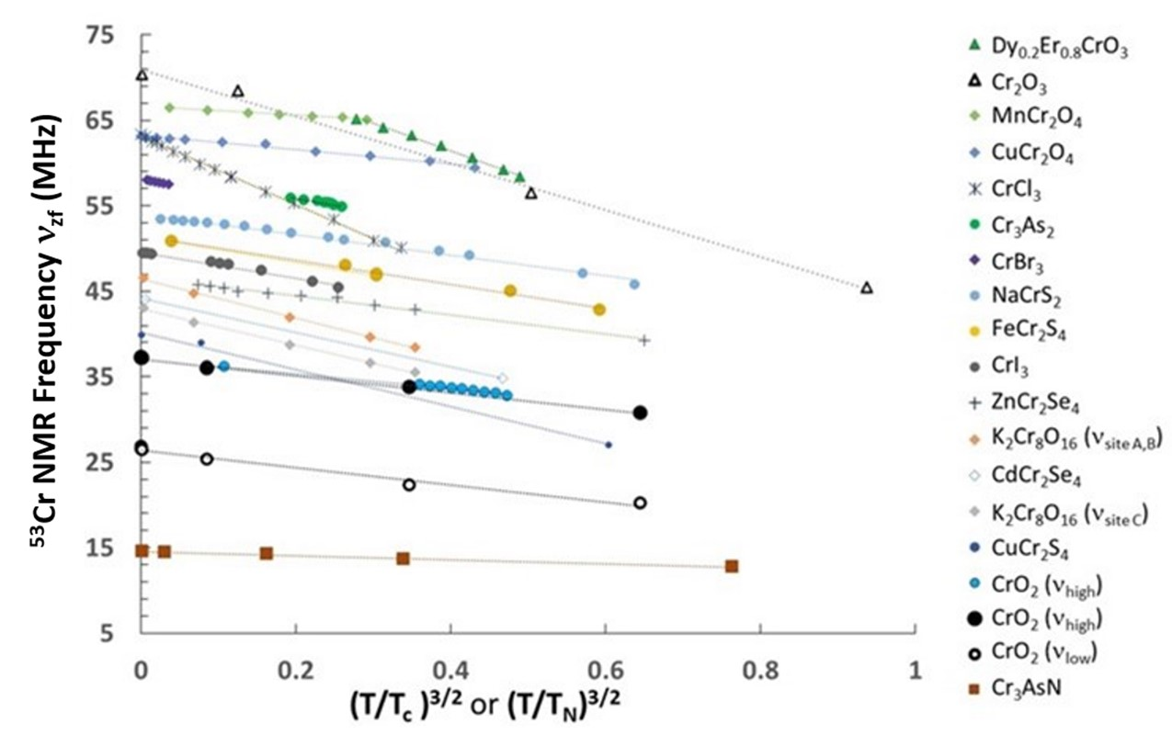
Figure 8. Bloch spin wave theory applied to internal field NMR centre-line frequency, ν_{zf}, data for sixteen compounds using data adapted from the literature cited in Table 5.

Bastow et al. [136,137] have shown that experimental Debye-Waller factors for a range of crystalline solids also have a T^{3/2} dependency attributed to the variation of the mean square amplitude of vibration of atoms in crystals over a temperature range from the Debye temperature to close to the melting point. As the data in Figure 8 are for crystalline compounds far below their Debye temperature, the T^{3/2} dependency can be attributed to the fundamental magnetization behaviour described by spin wave theory [11]. The goodness of fit values for these data (Table 5 and SI Table S7a) support further investigation of parameters that can be extracted from the Bloch spin wave relationship for the temperature dependence of the magnetization M at T < T_{Crit} as follows [11,134]:
M(T)/M(0) = 1 – a_{3/2}(T)^{3/2} (Eq. 8)
where a_{3/2} has units of K^{−3/2} and is related to the spin stiffness in zero field, D, using the relationship [134]:
a_{3/2} = [2.612(gμ_{B})/(ρM(0))][k_{B}/(4πD)]^{3/2} (Eq. 9)
where g is the dimensionless Lande g factor, ρ is the density in kg/m³, μ_{B} = 9.27x10⁻²⁴ J/T, k_{B} = 8.617 x 10⁻⁵ eV/K, and M(0) is the saturation magnetization at 0 K in J/(Tkg). Rewriting Eq. 8 using the relationship between ν_{zf} and M in Eq. 7 and as presented in Table 5, gives
ν_{zf}(T) = ν_{zf}(0) – c(T/T_{crit})^{3/2} (Eq. 10)
where ν_{zf}(0) is related to the electronic and magnetic properties, and the slope, c = a_{3/2}ν_{zf}(0)(T_{crit})^{3/2} with the parameter a_{3/2} related to the lattice geometry and magnetic exchange interaction. Since the data are well fitted to the Bloch T^{3/2} relationship, the spin wave excitation gap can be considered negligible [138]. For the sixteen compounds in Table 5, values of a_{3/2}, density, and low temperature saturation magnetization are given in [35] and used to calculate spin stiffness D. Figure 9 (a) shows that the low temperature saturation magnetization values reported in the literature for these Cr compounds as compared to values calculated from ν_{zf}(0) are in very good agreement, in support of the validity of Eq. 7 for these compounds. As shown in Table 5, the compound with the highest slope c, CrCl₃ has the lowest spin stiffness of 4.7 meV Å². The compound with the lowest slope c, Cr₃AsN has the highest spin stiffness of 410 meV Å². Only two of the sixteen compounds have published values for D from magnetic measurements or theory, and these are CrI₃ D = 27±6 meV Å² [138], where the error bars of ~20% reflect the population standard deviation for different samples, and CrO₂ D = 91 meV Å² [139]. Both published D values for these ferromagnetic compounds compare well (within ~15%) with the values calculated from the internal field data as shown in Table 5. Calculation of D from magnetization data for the antiferromagnetic semiconductor ZnCr₂Se₄ [140] gives D = 13.7 meV Å² within 3 % of the value D = 14.1 meV Å² calculated from the internal field data. Calculation of D from magnetization data for the antiferromagnetic semiconductor Cr₂O₃ [69] gives D = 61.2 meV Å² within 20 % of the value D = 76.3 meV Å² calculated from the internal field data. The D value calculated for Cr₃AsN can be compared with D values for other metals. Lowde [141] has published D values for the metallic CrFe system in the range 100-300 meV Å², and Lewis [142] has reported D = 284±40 meV Å² for metallic ferrimagnetic Pt₃Cr; all values are the same order of magnitude as the value calculated for metallic ferrimagnetic Cr₃AsN in Table 5, noting that an analysis of published magnetic measurements of Cr₃AsN [78] suggests D = 229 meV Å² which is ~40% lower than the value from internal field magnetic resonance data. Thus, the values of D in Table 5 appear reasonable for ferro- ferri- and antiferromagnetic chromium compounds, and this tabulation can be useful for comparison with magnetic measurements or density functional approaches to the calculation of spin stiffness in Cr alloys and compounds. Figure 9 (b) shows the relationship between spin stiffness and critical transition temperature for the Cr(III) d^{3oct} subset of compounds from Table 5. This relationship, D = (0.45 meV Å²/K)T_{Crit} resembles that reported for a family of magnetic cobalt Heusler alloys of D = (0.36 meV Å²/K)T_{Crit} [143]. The relationship between spin stiffness D and T_{crit}, for all Cr alloys and compounds from Table 5, is D = (0.37 meV Å²/K)T_{Crit} [35].

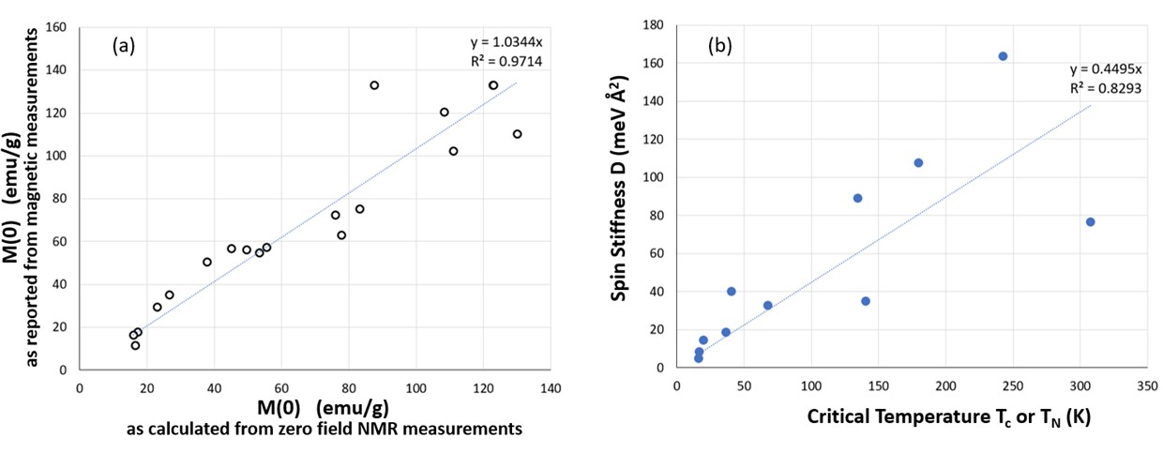
Figure 9. (a) Comparison of spontaneous magnetization at low temperature as reported from magnetic measurements and as calculated from internal field magnetic resonance data. (b) Spin stiffness and critical temperature for the d³ Cr(III)^{oct} compounds in Table 5, including ferromagnetic, antiferromagnetic, and ferrimagnetic compounds.

4.7.3 External field NMR
The second focus of Section 4.7 is inclusive of non-magnetic Cr compounds. Two recent solid-state NMR reviews have commented on the challenges of recording ⁵³Cr solid-state NMR spectra, citing only three reports on ⁵³Cr NMR of the diamagnetic octahedral Cr(0) d⁶ compound Cr(CO)₆ and diamagnetic tetrahedral Cr(VI) d⁰ chromates and dichromates [23,24]. The comprehensive up to date summary of magnetic and non-magnetic compounds presented in Table 4 permits an expanded discussion of the ⁵³Cr solid-state NMR characteristics of interest to experimentalists and theorists. The range of C_{Q} observed for these compounds (Cr(0), Cr(II), Cr(III), Cr(IV), mixed valence, and Cr(VI)) is 0.2 MHz < C_{Q} < 8.28 MHz. The range reported in diamagnetic alkali earth chromate and dichromate compounds alone is 1.28 MHz < C_{Q} < 8.28 MHz [22,44], all with Cr(VI) electron configuration. Some generalizations can be made based on the data in Table 4 – the Cr compounds with C_{Q} ≤ ~ 1 MHz tend to be semiconductors. Insulating compounds have C_{Q} values ranging from 1.3 to 4.4 MHz. The compounds with C_{Q} > 4 MHz tend to be semiconductors and metals. These observations provide some general guidelines for the likely magnitude of C_{Q} to be found in such materials. These are some of the parameters that could feature in an NMR crystallography approach to detailed local structural characterisation.
As discussed in Section 4.1, DFT calculations of Knight shifts and chemical shifts in transition metal compounds require orbital and spin contributions to accurately reproduce the experimental values. Knight shifts for the ⁵³Cr compounds in Table 4 range from −9982 to 6990 ppm and can be temperature dependent. As shifts are reported relative to the Cr ion in solution, ionic compounds typically have shifts near 0 ppm, i.e. −100 ppm < δ < 100 ppm (see Figure 10). As (CO)₆ is a strong field ligand, the Cr(0) complex Cr(CO)₆ is more shielded (−1814 ppm) than the chromate salts. As bonding covalency increases leading finally to metallic conduction, the shielding also increases and the Fermi contact term dominates the contribution to the shift. As shown in Table 4, the present work, to the best of our knowledge, has measured the largest Cr(0) Knight shift (−9982 ppm for CrB₂) for any chromium-containing metallic material reported to date. Figure 10 illustrates the range of chemical and Knight shifts for ⁵³Cr alloys and compounds.
The hyperfine coupling constant A, or the core polarization hyperfine field per unpaired valence electron for the 3d transition metal ⁵³Cr, plays a role in the shielding of the nucleus or the magnetic shift away from the Larmor frequency that can be measured by NMR. The exchange polarization between d electrons on the Fermi surface and s electrons in the core orbitals dominates the Knight shift and leads to the large observed Knights shifts in metallic Cr compounds shown in Figure 10 [31]. In Section 4.7.1 we have shown that the value of |A| of 8.33 T/μ_{B} reasonably describes Cr alloys across the range of crystal structures. Assuming A is independent of temperature, the Knight shift should be proportional to the magnetic susceptibility, such that a large Knight shift is indicative of a large Pauli spin susceptibility χ_{P} per Cr atom (Eq. 4). The experimental magnetic susceptibility of CrB₂ at room temperature in the paramagnetic state has been reported in a range from 0.485 to 0.795 (10⁻³ cm³/mol) [144-147]. Using this range for susceptibility and the measured ⁵³Cr Knight shift value of −0.9982 % reported here, the Clogston-Jaccarino [148] analysis can be applied [35], assuming negligible orbital contribution to the Knight shift and negligible transferred hyperfine field, resulting in a range of values for |A| from 7.0 to 11.5 T/μ_{B}, in agreement with the treatment presented in Section 4.7.1. Ab initio calculation of the magnetic susceptibility for CrB₂ metal in the paramagnetic state suggests that the magnetic susceptibility is dominated by the spin contribution, χ_{spin} = 0.703 (10⁻³ cm³/mol) in agreement with experimental results [145]. It can be noted that Laskowski and Blaha [37] have calculated the Knight shift and magnetic susceptibility for Cr metal including orbital and spin contributions, with their theoretical values coming within 10% of the measured values. Our results suggest that theoretical calculation of the Knight shift for CrB₂ should be the subject of fruitful future work.
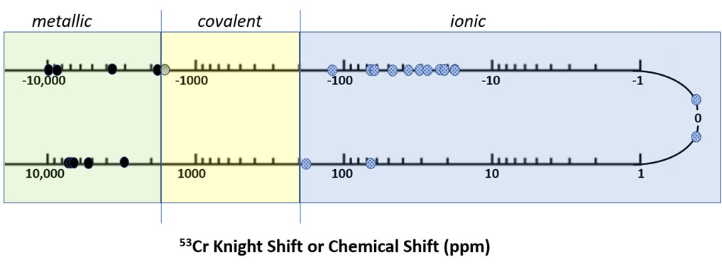
Figure 10. Knight shift or chemical shift for ⁵³Cr compounds from Table 4.

4.7.4 Hyperfine interactions as a guide to the production of novel materials
A theme of the discussion thus far has been the ability of magnetic resonance to determine parameters that can be useful to check theoretical models and their predictions in magnetic and non-magnetic Cr alloys and compounds. In addition, it is suggested that the hyperfine interactions probed by magnetic resonance are useful guides for the selection and production of novel materials for industrial applications. The multivalent nature of chromium makes for a variety of stable compounds with diverse magnetic properties. The ability to tune and control room temperature accessible magnetic states makes chromium alloys and compounds prime candidates for quantum engineering devices, and NMR adds to the ways these states can be probed. The results presented here have shown a correlation between the critical transition temperature (T_{C} or T_{N}) and the spin stiffness in zero field, D, calculated from magnetic resonance data for Cr alloys and compounds. The local, site specific nature of magnetic resonance as a probe technique means that this approach can be used across a range of valences, including mixed valence, various crystal structures, and ferro-, ferri-, antiferro- magnetic order. D is a measure of the resistance of the spin lattice to thermal disturbance, hence the magnetic resonance parameters enable an indirect test of the robustness of spin polarization in Cr alloys and compounds. The data presented here can also guide the discovery of technologically important ferro-, ferri-, and antiferro- magnetic materials with high critical temperatures and stable properties given the correlations that have been developed here. A number of approximations are involved in the treatment of these compounds using Bloch spin wave theory including (i) dominance of spin rather than spin orbital contributions, (ii) same treatment for all crystal and magnetic structures, (iii) temperature independent and valence independent hyperfine coupling constant, (iv) an isotropic Fermi contact interaction, and (v) a dominant core polarisation contribution to the hyperfine field, such that the treatment points to some key features as drivers of behaviour in these systems. With the accumulation of experimental data for training sets, it is hoped that these key features will be able to be investigated using machine learning. Extending this approach, one might speculate what local site properties at chromium could be related directly to the macroscopic properties needed, such as the size of the efg as a characteristic of the local site distortion and the impact on quantum switching. In low-dimensional spin systems hyperfine fields contribute to decoherence in the system leading to limitation in the performance of potential quantum devices [125].
5. Summary
This study encompassing new experimental observations and a comprehensive survey of magnetic resonance parameters collected on ⁵³Cr shows it can be quite a receptive nucleus for NMR with an external field or zero field. Therefore ⁵³Cr NMR can be used to characterize a range of important materials including metals, half metals, insulators, semiconductors, ferromagnetic, antiferromagnetic, and diamagnetic materials. The ⁵³Cr solid-state NMR work to date of relevance to the new observations here has been summarised and put into context. The work presented here has established quadrupolar coupling constants and chemical/Knight shifts for the first time for several important compounds. The T^{3/2} behaviour of the sublattice magnetization of CrO₂ and Cr₂O₃ measured via ⁵³Cr zero applied field NMR are reported here over a wide temperature range from liquid He temperature to room temperature. The large negative Knight shift of ⁵³Cr in the transition metal intermetallic CrB₂ has been measured. Unexplained lineshapes have been reported here for high purity Cr₂O₃, and these should be the subject of future verification and elucidation. Also, as in the case of AlN, it may take careful single crystal work or enriched specimens or both to pinpoint singularities and C_{Q} values in some of the Cr compounds discussed here where only an upper limit on C_{Q} could be estimated.
The first comprehensive summary of ⁵³Cr NMR interaction parameters for chromium compounds reported from 1961 to 2022 has been tabulated. Here is shown how low temperature internal field central frequencies have been correlated with valence state, and spin stiffness has been calculated for sixteen chromium compounds. The local information provided from ⁵³Cr NMR complements bulk measurements. Therefore, such NMR data can help determine whether new materials show promising characteristics, and if one could go further and relate these characteristics directly to site parameters (e.g. shift, anisotropy, efg) then one could have a direct measure of desirable properties. Additional theoretical and computational studies have been suggested based on current gaps in the data for ⁵³Cr NMR parameters. Knowledge of these parameters will enable further progress in understanding and capturing the benefits from electronic and magnetic structure-property-function relationships in Cr compounds.

Acknowledgements
We gratefully acknowledge Aaron Seeber for the XRD scans, Mark Greaves for the SEM, Yesim Gozukara for the DSC, and Justin Kimpton for the research undertaken on the powder diffraction beamline at the Australian Synchrotron, part of ANSTO. Professor Ekaterina Izgorodina is thanked for helpful discussions. Adrian Trinchi and Lyndsey Benson are thanked for their support of the work as the leaders of the Functional Powders team at CSIRO. Sadly, Tim Bastow died during the revision of this manuscript. AJH, KMN, and MES thank Tim for sharing his fascination with chromium and passion for magnetic resonance with them.

Author Contributions
TJB devised the experimental plan, contributed the overall supervision of this work, and performed NMR measurements, data analysis, and co-wrote the manuscript. AJH assisted in data collection and analysis and co-wrote the manuscript. KMN and MES assisted in data analysis and editing of the manuscript.

Competing interests statement: The authors declare no competing interests.

See Supplemental Material at [35] http://link.aps.org/supplemental... for NMR probe, XRD spectra, SEM image, DSC scans, internal field NMR data, mixed valence data, spin stiffness data, and Clogston-Jaccarino analysis. URL will be inserted by publisher.

References
- Gossard AC, Jaccarino V, Remeika JP. Experimental test of the spin-wave theory of a ferromagnet. Phys. Rev. Letts. 1961; 7 (4): 122.
- Narath A. Nuclear magnetic resonance of Cr⁵³ in antiferromagnetic CrCl₃. Phys Rev Letts. 1961; 7 (11): 410.
- Narath A. Zero-field ⁵³Cr nuclear magnetic resonance in ferromagnetic CrI₃: renormalized spin-wave and Green's-function analysis. Phys. Rev. 1965; 140 (3A): A854.
- Barnes RG, Graham TP. Nuclear magnetic resonance in chromium metal. Phys. Rev. Letts. 1962; 8: 248.
- Barnes RG, Graham TP. Néel temperatures of chromium vanadium alloys from NMR measurements. Journal of Applied Physics. 1965; 36 (3): 938. https://doi.org/10.1063/1.1714268
- Park S, Kwon S, Lee S, Khim S, Bhoi D, Park CB, Kim KH. The zero field ⁵³Cr nuclear magnetic resonance interactions in the bond-frustrated helimagnet ZnCr₂Se₄ investigated by NMR. Scientific Reports. 2019; 9: 16627. https://doi.org/10.1038/s41598-019-52962-4
- Toporova NM, Sherokalova EM, Selezneva NV, Ogloblichev VV, Baranov NV. Crystal structure, properties and griffiths-like phase in niobium diselenide intercalated with chromium. Journal of Alloys and Compounds. 2020; 848: 156534.
- Garlatti E, Allodi G, Bordignon S, Bordonali L, Timco GA, Winpenny REP, Lascialfari A, De Renzi R, Carretta S. Breaking the ring: ⁵³Cr-NMR on the {Cr₈Cd} molecular nanomagnet. Journal of Physics: Condensed Matter. 2020; 32 (24): 244003. https://doi.org/10.1088/1361-648X/ab7872
- Bloch F. On the theory of ferromagnetism. Z. Physik. 1930; 61: 206.
- Dyson, FJ. Thermodynamic behaviour of an ideal ferromagnet. Phys. Rev. 1956; 102: 1230-1244.
- Kittel, C. Introduction to Solid State Physics. 2nd Edition Wiley 1959; Ch 15.
- Huang B, Clark G, Navarro-Moratalla E, Klein DR, Cheng R, Seyler KL, Zhong D, Schmidgall E, McGuire MA, Cobden DH, Yao W, Xiao D, Jarillo-Herrero P, Xu X. Layer-dependent ferromagnetism in a van der Waals crystal down to the monolayer limit. Nature. 2017; 546: 270–273.
- Grönke, M. Synthesis and characterization of layered transition metal trihalides MCl₃ (M = Ru, Mo, Ti, Cr) and CrX₃ (X = Cl, Br, I). Dissertation, BTU Cottbus-Senftenberg; 2020. DOI: 10.26127/BTUOpen-5282
- Rubinstein M, Stauss GH, Krebs JJ. Nuclear magnetic resonance of Cr⁵³ in antiferromagnetic Cr₂O₃. Phys. Letts. 1964; 12(4): 302.
- Yasuoka H, Abe H, Hirai A, Hashi T. Nuclear magnetic resonance of Cr⁵³ in ferromagnetic CrO₂. J. Phys. Soc. Japan. 1963; 18: 593.
- Nishihari H, Tsuda T, Hirai A, Shinjo T. Nuclear magnetic resonance of Cr⁵³ in ferromagnetic CrO₂. J. Phys. Soc. Japan. 1972; 32(1): 85.
- Shim JH, Lee S, Dho J, Kim DH. Coexistence of two different Cr ions by self-doping in half-metallic CrO₂ nanorods. Phys. Rev. Letts. 2007; 99(5): 057209. doi: 10.1103/physrevlett.99.057209
- Takeda H, Shimizu Y, Itoh M, Isobe M, Ueda Y. Electronic states of half-metallic chromium oxides probed by ⁵³Cr NMR. J. Phys.: Conf. Ser. 2012; 400: 032098. doi:10.1088/1742-6596/400/3/032098
- Takeda H, Shimizu, Y, Itoh, M, Isobe, M, Ueda Y. Local electronic state in the high-valence hollandite-type chromium oxide K₂Cr₈O₁₆ investigated by ⁵³Cr NMR. Phys. Rev. B. 2013; 88: 165107. doi: 10.1103/PhysRevB.88.165107
- Takeda H, Shimizu Y, Kobayashi Y, Itoh M, Jin-no T, Isobe M, Ueda Y, Yoshida S, Muraoka Y, Yokoya T. Local electronic state in the half-metallic ferromagnet CrO₂ investigated by site-selective ⁵³Cr NMR measurements. Phys. Rev. B. 2016; 93: 235129. doi: 10.1103/PhysRevB.93.235129
- Piskunov YV, Sadykov, AF, Ogloblichev VV, Smolnikov AG, Gerashenko AP, Si PZ. Valence state of chromium ions in the half-metallic ferromagnet CrO₂ probed by ⁵³Cr NMR. Phys Rev. 2022; 106: 094428.
- Forgeron MAM, Wasylishen RE. A solid-state ⁵³Cr NMR study of chromate and dichromate salts. Magn. Reson. Chem. 2008; 46(3): 206.
- Leroy C, Bryce DL. Recent advances in solid-state nuclear magnetic resonance spectroscopy of exotic nuclei. Progress in Nuclear Magnetic Resonance Spectroscopy. 2018; 109: 160–199.
- Smith ME. Recent progress in solid-state nuclear magnetic resonance of half-integer spin low-γ quadrupolar nuclei applied to inorganic materials. Magn. Reson. Chem. 2021; 59: 864–907. DOI: 10.1002/mrc.5116
- Epperlein BW, Krüger, H, Lutz O, Nolle A, Mayr W. ⁵³Cr Fourier transform nuclear magnetic resonance studies. Z. Naturforsch. 1975; 30 a: 1237-1240.
- Nowak B, Żogal OJ, Niedźwiedź K, Tkacz M, Żolnierek Z, ⁵³Cr Knight shift and magnetic susceptibility of hexagonal CrH_{0.93}. Physica B. 1994; 193: 102.
- Poźniak-Fabrowska J, Nowak B, Tkacz M. Magnetic properties of cubic and hexagonal chromium hydrides: a comparison of the magnetic susceptibility with the ⁵³Cr NMR Knight shift. Journal of Alloys and Compounds. 2001; 322: 82.
- Kontani M, Hioki T, Masuda Y. Hyperfine fields in an incommensurate antiferromagnetic Cr-Mo alloy system. J. Phys. Soc. Japan. 1975; 39 (3): 672-674.
- Smith ME, MacKenzie KJD. Multinuclear solid state NMR of inorganic materials. Pergamon Press Oxford. 2002.
- Smith ME, van Eck ERH. Recent advances in experimental solid state NMR methodology for half-integer spin quadrupolar nuclei (Review). Prog. NMR Spectrosc. 1999; 34: 159-201.
- Carter GC, Bennett LH, Kahan DJ. Metallic shifts in NMR: A review of the theory and comprehensive critical data compilation of metallic materials. Progress in Materials Science Volume 20. Pergamon Press Oxford. 1977.
- Bastow TJ. Materials characterisation by nuclear quadrupole interaction. Z Naturforsch. 1994; 49a: 320-328.
- Turov EA, Petrov MP. Nuclear magnetic resonance in ferro- and antiferromagnets. Halsted Press John Wiley and Sons Inc New York. 1972.
- Meny C. Panissod P. Nuclear magnetic resonance in ferromagnets: Ferromagnetic nuclear resonance; a very broadband approach. Annual Reports on NMR Spectroscopy. 2021; 103: 47-96.
- See Supplemental Material at http://link.aps.org/supplemental... for NMR probe, XRD spectra, SEM image, DSC scans, internal field NMR data, mixed valence data, spin stiffness data, and Clogston-Jaccarino analysis.
- Bastow TJ, Burgar MI, Maunders C. Electric field gradients in metals: correlation of experimental results with ab initio calculation. Solid State Comms. 2002; 122: 629-632.
- Laskowski R, Blaha P. NMR shielding in metals using the augmented plane wave method. J. Phys. Chem. C. 2015; 119: 19390−19396. doi: 10.1021/acs.jpcc.5b05947
- Blaha P, Schwarz K, Madsen GKH, Kvasnicka D, Luitz J. WIEN2k, an augmented plane wave plus local orbitals program for calculating crystal properties. Vienna University of Technology: Vienna, Austria. 2001; ISBN 3-9501031-1-2.
- Slichter, CP. Principles of Magnetic Resonance, 3rd Edition Springer-Verlag New York. 1989.
- Wertz JE, Bolton JR. Electron Spin Resonance. Chapman and Hall New York. 1986; 11: 258-312.
- Stephens JS, Cruikshank DWJ. A re‐investigation of the crystal structure of (NH₄)₂CrO₄. Acta Cryst. 1970; B26: 437. https://doi.org/10.1107/S0567740870002546
- Lentz A, Büchele W, Schöllhorn H. Crystal growth from silica gels and single crystal structure of barium chromate. Cryst. Res. Technol. 1986; 21: 827.
- Massiot D, Fayon F, Capron M, King I, Le Calvé S, Alonso B, Durand J-O, Bujoli B, Gan Z, Hoatson G. Modelling one- and two-dimensional solid-state NMR spectra. Magn. Reson. Chem. 2002; 40: 70.
- Bryce DL, Wasylishen RE. The first chromium-53 solid-state nuclear magnetic resonance spectra of diamagnetic chromium(0) and chromium(VI) compounds. Phys. Chem. Chem. Phys. 2001; 3: 5154.
- Bühl M. Density-functional computation of ⁵³Cr NMR chemical shifts. Magn. Reson. Chem. 2006; 44: 661.
- Lee TH, Kim SJ, Shin E, Takaki S. On the crystal structure of Cr₂N precipitates in high-nitrogen austenitic stainless steel. III. Neutron diffraction study on the ordered Cr₂N superstructure. Acta Cryst B. 2006; 62: 979.
- Corliss LM, Elliot, N, Hastings, JM. Antiferromagnetic structure of CrN. Phys Rev. 1960; 117 (4): 929-935.
- Wang G. Theoretical prediction of the intrinsic half-metallicity in surface-oxygen-passivated Cr₂N MXene. J Phys. Chem C. 2016; 120 (3): 18850-18857. https://doi.org/10.1021/acs.jpcc.6b05224
- O’Dell LA. Direct detection of nitrogen-14 in solid-state NMR spectroscopy. Progress in Nuclear Magnetic Resonance Spectroscopy. 2011; 59: 295-318.
- Bastow TJ, Massiot D, Coutures JP. ¹⁴N NMR in AlN and BN. Solid State Nuclear Magnetic Resonance. 1998; 10: 241–245.
- Zeman OEO, Moudrakovski IL, Hartmann C, Indris S, Bräuniger T. Local electronic structure in AlN studied by single-crystal ²⁷Al and ¹⁴N NMR and DFT calculations. Molecules. 2020; 25: 469.
- Tanaka T, Nozaki H, Bannai E, Ishizawa Y, Kawai S, Yamane T. Preparation and properties of CrB₂ single crystals. J. Less Common Metals. 1976; 50: 15-21.
- Bauer A, Regnat A, Blum CGF, Gottlieb-Schönmeyer S, Pedersen B, Meven M, Wurmehl S, Kuneš J, Pfleiderer C. Low-temperature properties of single-crystal CrB₂. Phys. Rev. B. 2014; 90: 064414.
- Guy CN, Uraz, AA. The chromium-boron system. J. of the Less Common Metals. 1976; 48: 199-203.
- Schwarz K, Ripplinger H, Blaha P. Electric field gradient calculations on various borides. Z. Naturforsch. 1996; 51a: 527-533.
- Schoenberger RJ, Barnes RG. NMR study of the antiferromagnetic transition in V_{x}Cr_{1-x}B₂. AIP Conf Proc. 1972; 5: 392.
- Guy CN, The electronic properties of chromium borides. J. Phys. Chem Solids. 1976; 37:1005-1009.
- Chong XY, Jiang YH, Zhou R, Feng J. Elastic properties and electronic structures of Cr_{x}B_{y} as superhard compounds. Journal of Alloys and Compounds. 2014; 610: 684.
- Barnes RG. Nuclear magnetic resonance in the non-cubic metals. In Magnetic Resonance. Coogan CK Ed, Plenum Press. 1970; 63-90.
- Silver AH, Kushida T. Nuclear magnetic resonance in transition-metal diborides, J. Chem. Phys. 1963; 38: 865-872.
- Barnes RG, Creel RB. Chromium-like antiferromagnetic behavior of CrB₂. Phys. Lett. A. 1969; 29 (4): 203-204.
- Funahashi S., Hamaguchi Y, Tanaka T, Bannai E. Helical magnetic structure in CrB₂. Solid State Commun. 1977; 23: 859.
- Wang Y, Jiang X, Wang Y, Zhao J. Ferromagnetic Dirac half-metallicity in transition metal embedded honeycomb borophene. Phys. Chem. Chem. Phys. 2021; 23: 17150-17157. DOI: 10.1039/d1cp01708j
- Li M, Wang Y, Chen A, Naidu A, Napier BS, Lia W, Rodriguez CL, Crooker SA, Omenetto FG. Flexible magnetic composites for light-controlled actuation and interfaces. PNAS. 2018; 1-6. doi:10.1073/pnas.1805832115
- He, S, Zhou, P, Yang, Y, Wanga, W, Sun LZ. 1T-CrO₂ monolayer: a high-temperature Dirac half-metal for high-speed spintronics. Nanoscale Advances. 2021; 3: 3093-3099. doi: 10.1039/d0na00884b
- Bastow TJ, Gibson MA, Forwood CT. ^{47,49}Ti NMR: hyperfine interactions in oxides and metals. Solid State Nuclear Magnetic Resonance. 1998;12: 201-209.
- Lynch GF, Segel SL, Sayer M. Nuclear magnetic resonance of polycrystalline VO₂. J. Mag Res. 1974; 15:8-18.
- Brockhouse BN. Antiferromagnetic structure in Cr₂O₃. J. Chem. Phys. 1953; 21: 961-962.
- Corliss LM, Hastings JM. Magnetic structure studies at Brookhaven National Laboratory. Journal de Physique. 1964; 25 (5): 557-562. doi: 10.1051/jphys:01964002505055701f
- Corliss LM, Hastings JM, Nathans R, Shirane G. Magnetic structure of Cr₂O₃. J Appl Phys. 1965; 36 (3): 1099-1100.
- Karnachev AS, Lukina MM, Solov’ev EE. Magnetic phases and quadrupolar effects in rare-earth orthochromites. Fizika nizkich temperatur. 1995; 21 (6): 617-620.
- Johnson Matthey Magnetic Susceptibility Balance Instruction Manual, Issue 3, 10th March 2004, ECN 306, Appendix C.
- Slater JC. Atomic radii in crystals. J. Chem. Phys. 1964; 41: 3199-3204. https://doi.org/10.1063/1.1725697
- Shannon RD. Revised effective ionic radii and systematic studies of interatomic distances in halides and chalcogenides. Acta Cryst. 1976; A32: 751-767. https://doi.org/10.1107/S0567739476001551
- Daulton TL, Little BJ. Determination of chromium valence over the range Cr(0) - Cr(VI) by electron energy loss spectroscopy. Ultramicroscopy. 2006; 106: 561-573.
- Farges F. Chromium speciation in oxide-type compounds: application to minerals, gems, aqueous solutions and silicate glasses. Phys. Chem. Minerals. 2009; 36: 463-481. DOI 10.1007/s00269-009-0293-3
- Dubiel SM, Lütgemeier H. ⁵³Cr site hyperfine fields in iron-rich Fe-Cr alloys. Phys. Lett. A. 1981; 84A: 396-398.
- Waki T, Takao K, Tabata Y, Ohta H, Yajima T, Hiroi Z, Nakamura H. Possible itinerant-electron canted antiferromagnetism in tetragonal antiperovskite Cr₃AsN. Journal of the Physical Society of Japan. 2017; 86: 104706-7. https://doi.org/10.7566/JPSJ.86.104706
- Narath A, Weaver HT. Impurity nuclear magnetic resonance shifts and spin-lattice relaxation rates in Al:V, Al:Cr, and Al:Mn. Phys. Rev. Lett. 1969; 23(5): 233-236.
- Narath A. Magnetic hyperfine interaction studies of magnetic impurities in metals. Critical Reviews in Solid State and Material Sciences. 1972; 3(1): 1-37. doi: 10.1080/10408437208244860
- Le Dang K, Veillett P, Walker PJ. Nuclear magnetic resonance studies of ⁵³Cr in a single crystal of Rb₂CrCl₄. J. Phys. C: Solid State Phys. 1977; 10: 4593-4597.
- Ding Q-P, Pakhira S, Sangeetha NS, Krenkel EH, Timmons EI, Tanatar MA, Prozorov R, Johnston DC, and Furukawa Y. Itinerant G-type antiferromagnet SrCr₂As₂ studied by magnetization, heat capacity, electrical resistivity, and NMR measurements. Phys. Rev. B. 2022; 105: 134408.
- Yamaguchi M, Hashimoto T. Magnetic properties of Cr₃Te₄ in ferromagnetic region. Journal of the Physical Society of Japan. 1972; 32(3): 635-638.
- Jedryka E, Wojcik M, Pajaczkowska A. NMR investigation in some compounds of the Cr-Te system. Acta Physica Polonica. 1977; 52(6): 773-778.
- Le Dang K, Veillett P. Résonance magnétique nucléaire dans CrTe et Cr₃Te₄. Comptes Rendus Academie des Sciences Série B. 1967; 264: 1154-1157.
86. Hashimoto T, Yamaguchi M. Magnetic properties of Cr₇Te₈. Journal of the Physical Society of Japan. 1969; 27(5): 1121-1126.
87. Le Dang K. Interaction hyperfine des ions du groupe fer dans les composes ferro et ferrimagnetiques. In Magnetic Resonance and Radiofrequency Spectroscopy. Proceedings of the 15th Colloque A.M.P.E.R.E., Grenoble, September 1968. Edited by P. Averbuch North Holland Publishing Co: Amsterdam 1969; 505-510.
88. Le Dang K, Rotter M, Krishnan R. Hyperfine interaction of Cr³⁺ and Cu²⁺ ions in Cr- and Cu-doped YIG. phys. stat. sol.(a). 1972; 12: 569-574.
89. Smol’nikov AG, Ogloblichev VV, Verkhovskii SV, Mikhalev KN, Yakubovskii AY, Kumagai K, Furukawa Y, Sadykov AF, Piskunov YV, Gerashchenko AP, Barilo SN, Shiryaev AV. ⁵³Cr NMR study of CuCrO₂ multiferroic. JETP Letters. 2015; 102 (10): 674–677.
90. Karnachev AS, Klechin YI, Kovtun NM, Moskvin AS, Solov'ev EE, Tkachenko AA. Spin-flip and nuclear quadrupole interactions in the rare-earth orthochromites GdCrO₃. Sov. Phys. JETP. 1983; 58(2); 390-394.
91. Karnachev AS, Soboleva TK, Solov'ev EE, Stefanovskiĭ EP. Temperature dependences of magnetization and frequencies of nuclear magnetic resonance in Cr-53 in yttrium and erbium orthochromites. Solid State Physics. 1979; 21(5): 1451-1454.
92. Karnachev AS, Kovtun NM, Kurkin MI, Solov'ev EE, Tkachenko AA. Quadrupole splitting and nuclear magnetic relaxation in ErCrO₃ near a Morin-type phase transition. Sov. Phys. JETP. 1983; 58(1); 130-134.
93. Karnachev AS, Klechin YI, Kovtun NM, Moskvin AS, Solov'ev EE, Tkachenko AA. NMR investigation of spin flip in TmCrO₃. Sov. Phys. JETP. 1987; 65(1); 157-160.
94. Butler MA, Eibschütz M, van Uitert LG. ⁵³Cr nuclear magnetic resonance in the rare-earth orthochromites. Phys. Rev. B. 1972; 6(1): 51-58.
95. Edmonds DT, Taylor DR. An estimate of the zero-point spin deviation in a spin 3/2 antiferromagnet including the transferred hyperfine interaction. Proc. Phys. Soc. 1967; 91: 356-358.
96. Nagasawa H, Tsushima T. Cr⁵³ nuclear magnetic resonance in the non-collinear ferrimagnet MnCr₂O₄. Physics Letters. 1965; 15: 205-206.
97. Yoon DY, Lee S, Oh YS, Kim KH. NMR study on the stability of the magnetic ground state in MnCr₂O₄. Phys. Rev. B. 2010; 82: 094448.
98. Jo E, Kang B, Kim C, Kwon S, Lee S. Spin state and orbital ordering in CuCr₂O₄ investigated by NMR. Phys. Rev. B. 2013; 88: 094417. doi: 10.1103/PhysRevB.88.094417
99. Le Dang K. Résonance magnétique nucléaire dans CuCr₂O₄ et FeCr₂S₄. Comptes Rendus de l'Académie des Sciences Série B. 1966; 262 (24): 1555-1558.
100. Le Dang K, Mery MC, Veillet P. Spin-glass-like behaviour of the mixed spinel systems Mn_{x}Zn_{1-x}Cr₂O₄ and Mn_{0.75}Mg_{0.25}(Cr_{1- y}V_{y})₂O₄, Journal of Magnetism and Magnetic Materials. 1984; 43 (2): 161-165.
101. Srivasta JK, Le Dang K, Veillet P. NMR and magnetization studies of the mixed spinel ferrites Ga_{x}Fe_{1-x}NiCr_{1-y}Al_{y}O₄. Journal of Magnetism and Magnetic Materials. 1986; 54-57: 1341-1342.
102. Carr SL, Erdos P, Moulton WG, Robinson J. Nuclear magnetic resonance experiments and theory of the magnetic properties of NaCrS₂. Solid State Comms. 1969; 7: 1673-1676.
103. Shinohara T, Watanabe H. Nuclear magnetic resonance in Cr₃As₂. J. Phys. Soc. Japan. 1966; 21: 2076.
104. Casadei CM, Bordonali L, Furukawa Y, Borsa F, Garlatti E, Lascialfari A, Carretta S, Sanna S, Timco GA, Winpenny REP. Local spin density in the Cr₇Ni antiferromagnetic molecular ring and ⁵³Cr-NMR. J. Phys.: Condens. Matter. 2012; 24: 406002. doi:10.1088/0953-8984/24/40/406002
105. Micotti E, Furukawa Y, Kumagai K, Carretta S, Lascialfari A, Borsa F, Timco GA, Winpenny REP. Local spin moment distribution in antiferromagnetic molecular rings probed by NMR. Phys. Rev. Lett. 2006; 97: 267204.
106. Pieper MW, Lütgemeier H, Zinn W. Double nuclear magnetic resonance in the weak ferromagnet YCrO₃. Z. Phys. B - Condensed Matter. 1986; 63: 369-373.
107. Takeda H, Shimizu Y, Itoh M, Chikusa-ku F, Sakurai H, Takayama-Muromachi E. Magnetic frustration effects in the new colossal magnetoresistance oxide NaCr₂O₄. Journal of the Korean Physical Society. 2013; 62 (12): 1914-1918. doi: 10.3938/jkps.62.1914
108. Han ZH, Budnick JI, Hines WA, Dabrowski B, Kolesnik S, Maxwell T. Nuclear magnetic resonance study of the enhanced ferromagnetic ordering in polycrystalline SrRu_{1−x}Cr_{x}O₃ (0 < x < 0.12) J. Phys.: Condens. Matter. 2005; 17: 1193–1200. doi:10.1088/0953-8984/17/7/011
109. Yokoyama H, Watanabe R, Chiba S. Nuclear Magnetic Resonance Studies of CuCr₂Se₄ and CuCr₂Te₄. J. Phys. Soc. Japan. 1967; 23: 450.
110. Berzhanskii VN, Gorbovanov IAI, Polulyakh SN. Nuclear spin resonance of ⁵³Cr in ferromagnetic CuCr₂S₄. Physics of the Solid State. 2005; 47 (3): 502–507.
111. Berger SB, Budnick JI, Burch TJ. Systematics of the hyperfine and exchange interactions in the chromium chalcogenide spinels. Phys. Rev. 1969; 179 (1); 272-274.
112. Berger SB, Burch TJ, Budnick JI, Darcy L. NMR of CuCr_{2−x}V_{x}S₄ spinels. Journal of Applied Physics. 1971; 42: 1309-1310. https://doi.org/10.1063/1.1660231
113. Abelyashev GN, Berzhansky VN, Sergeev NA, Fedotov YV. Multiquantum effects and NMR in magnetically ordered substances. Phys. Letts. A. 1988; 133 (4,5): 263-265.
114. Abelyashev GN, Berzhansky VN, Polulyakh SN, Sergeev NA. Relaxation of spin echo signals of ⁵³Cr nuclei in Ag-doped CdCr₂Se₄. Physica B. 2000; 292: 323-336.
115. Berger SB, Budnick JI, Burch TJ. NMR of ⁵³Cr and ⁷⁷Se in ferromagnetic chalcogenide spinels. J. Appl. Phys. 1968; 39; 658–660.
116. Oglobichev VV, Piskunov YuV, Mushenok FB. Magnetic order in the structurally disordered helicoidal magnet Cr_{1/3}NbS₂: NMR at ⁵³Cr nuclei. Journal of Experimental and Theoretical Physics. 2017; 125 (2): 317–322.
117. Feldman D, Kirchmayr HR, Schmolz A, Velicescu M. Magnetic materials analyses by nuclear spectrometry: A joint approach to Mössbauer effect and nuclear magnetic resonance. IEEE Transactions on Magnetics. 1971; 7(1): 61 – 91. doi: 10.1109/TMAG.1971.1067012
118. Gossard AC, Jaccarino V, Remeika JP. NMR in domains and walls in ferromagnetic CrBr₃. J. Appl. Phys. 1962; 31(2) Supplement: 1187.
119. Heine V. Hyperfine structure of paramagnetic ions. Phys. Rev. 1957; 107 (4): 1002 – 1003.
120. Anderson PW. Theory of magnetic exchange interactions: exchange in insulators and semiconductors. Journal of Physics C: Solid State Physics. 1963; 14: 99-214. DOI:10.1016/S0081-1947(08)60260-X
121. Freeman AJ, Watson RE. Hyperfine interactions in magnetic materials. In Magnetism. ed. Rado, GT, Suhl H. Academic Press 1965; Vol. IIA: 167-305.
122. Schwarz K. CrO₂ predicted as a half-metallic ferromagnet. J Phys. F: Met. Phys. 1986; 16: L211-L215.
123. Tran F, Doumont J, Kalantari L, Huran AW, Marques MAL, Blaha P. Semilocal exchange-correlation potentials for solid-state calculations: Current status and future directions. Journal of Applied Physics. 2019; 126: 110902. https://doi.org/10.1063/1.5118863
124. Bellini V, Olivieri A, Manghi F. Density-functional study of the Cr8 antiferromagnetic ring. Phys. Rev. B. 2006; 73: 184431. DOI: 10.1103/PhysRevB.73.184431
125. Troiani F, Bellini V, Affronte M. Decoherence induced by hyperfine interactions with nuclear spins in antiferromagnetic molecular rings. Phys. Rev. B. 2008; 77: 054428. DOI: 10.1103/PhysRevB.77.054428
126. Budick B, Goshen RJ, Jacobs S, Marcus S. Core polarization in Cr⁵³. Phys. Rev. 1966; 144(1): 103-109.
127. Friedt JM, Sanchez JP. Origin of the magnetic hyperfine field transferred at iodine in ferromagnetic CrI₃. Journal of Physics C: Solid State Physics. 1978; 11(17): 3731-3739.
128. Blugel S, Akai H, Zeller R, Dederichs PH. Hyperfine fields of 3d and 4d impurities in nickel. Phys. Rev. B. 1987; 35(7): 3271-3283.
129. Dederlichs PH, Zeller R, Akai H, Ebert H. Ab-initio calculations of the electronic structure of impurities and alloys of ferromagnetic transition metals. Journal of Magnetism and Magnetic Materials. 1991; 100: 241-260.
130. Zener C. Interaction between the d shells in the transition metals. Phys. Rev. 1951; 81(4): 440-444.
131. Yang C-Y, Pan L, Grutter AJ, Wang H, Che X, He QL, Wu Y, Gilbert DA, Shafer P, Arenholz E, Wu H, Yin G, Deng P, Borchers JA, Ratcliff II W, Wang KL. Termination switching of antiferromagnetic proximity effect in topological insulator. Science Advances. 2020; 6: eaaz8463.
132. Tokura Y, Yasuda K, Tsukazaki A. Magnetic topological insulators. Nature Reviews Physics. 2019; 1: 126-143. https://doi.org/10.1038/s42254-018-0011-5
133. Cottinier S, De Vries B, Meersschaut J, Rots M. What density-functional theory can tell us about the spin-density wave in Cr. Journal of Physics Condensed Matter. 2002; 14(12): 3275-3283. DOI:10.1088/0953-8984/14/12/314 2002
134. Keffer F. Spin waves. In H. P. J. Wijn (ed.), Ferromagnetism. Springer-Verlag Berlin Heidelberg 1966: 1-273.
135. Narath A. Low-temperature sublattice magnetization of antiferromagnetic CrCl₃. Phys. Rev. 1963; 131(5): 1929.
136. Bastow TJ, Mair SL, Wilkins SW. Empirical T^{3/2} law for atomic thermal vibration parameters. J. Appl. Phys. 1977; 48: 494-497.
137. Bastow TJ. T^{3/2} dependence of the high temperature electrical resistivity of metals. Phys. Letts. 1977; 60A: 487-489.
138. Shu Z, Kong T. Spin stiffness of chromium-based van der Waals ferromagnets. J. Phys. Condens. Matter. 2021; 33: 195803. https://doi.org/10.1088/1361-648X/abe44d
139. Liu H, Zheng RK, Wang Y, Bai HL, Zhang XX. Transport and magnetotransport properties of cold-pressed CrO₂ powder. phys. stat. sol. (a). 2005; 202 (1): 144– 150. DOI 10.1002/pssa.200406912
140. Yokaichiya F, Krimmel A, Tsurkan V, Margiolaki I, Thompson P, Bordallo HN, Buchsteiner A, Stüßer N, Argyriou DN, Loidl A. Spin-driven phase transitions in ZnCr2Se4 and ZnCr2S4 probed by high-resolution synchrotron x-ray and neutron powder diffraction. Phys. Rev. B. 2009; 79: 064423. DOI: 10.1103/PhysRevB.79.064423
141. Lowde RD, Shimizu M, Stringfellow MW, Torrie BH. Density of states effects in the magnetic stiffness of 3d-3d transition metal alloys. Phys. Rev. Lett. 1965; 14(17) 698-700.
142. Lewis BG. The magnetic properties of some pseudo-binary platinum–chromium–manganese alloys. PhD Thesis Loughborough University. 1974. https://hdl.handle.net/2134/13148.
143. Umetsu RY, Okubo A, Fujita A, Kanomata T, Ishida K, Kainuma R. Spin wave stiffness constants of half-metallic ferromagnets Co₂YZ (Y = Cr, Mn, and Fe, Z = Ga, Al, and Si) Heusler alloys. IEEE Transactions on Magnetics. 2011; 47(10): 2451-2154.
144. Castaing J, Costa P, Hertier M, Lederer P. Spin fluctuation effects in nearly antiferromagnetic vanadium and chromium diborides. J. Phys. Chem. Solids. 1972; 33(2): 533-547.
145. Grechnev GE, Fedorchenko AV, Logosha AV, Panfilov AS, Svechkarev IV, Filippov VB, Lyashchenko AB, Evdokimova AV. Electronic structure and magnetic properties of transition metal diborides. J. Alloys and Compounds. 2009; 481: 75-80.
146. Balakrishnan G, Majumdar S, Lees MR, Paul DMcK. Single crystal growth of CrB₂ using a high-temperature image furnace. Journal of Crystal Growth. 2005; 274: 294–296.
147. Leyarovska L, Leyvarovski E. A search for superconductivity below 1 k in transition metal borides. J. Less Common Metals. 1979; 67: 249-255.
148. Clogston AM, Jaccarino V. Susceptibilities and negative Knight shifts of intermetallic compounds. Phys Rev. 1961; 121(5): 1357-1362.

Supporting Information

⁵³Cr Solid-State Nuclear Magnetic Resonance: New Observations and Comprehensive Correlations as a Probe of Valence and Magnetic States

Timothy J. Bastow¹, Anita J. Hill^{1*}, Katherine M. Nairn², and Mark E. Smith^{3*}
¹CSIRO Manufacturing, Stewart Bastow Building, Gate 4 Normanby Road, Clayton, Victoria, 3168 Australia
²Department of Materials Engineering, 3rd Floor New Horizons, Monash University, Victoria, 3800, Australia
³Vice-Chancellor and President's Office and Department of Chemistry, University of Southampton, Southampton SO17 1BJ, UK.
*corresponding authors: anita.hill@csiro.au m.e.smith@soton.ac.uk

Contents

1. Figure S1 Internal field NMR probe used in this study

2. Figure S2 XRD spectrum of Cr₂N

3. Figure S3 XRD spectrum of CrB₂

4. CrO₂: Figure S4a SEM micrograph of CrO₂ powder, Figure S4b XRD spectrum of CrO₂ and Figure S4c comparison of ⁵³Cr internal field NMR frequency, ν_{zf}, values from Figure 4 (main text) and magnetization as function of temperature.

5. Cr₂O₃: Figure S5a XRD spectrum of Cr₂O₃, Figure S5b DSC thermograms for two separate samples and Figure S5c comparison of ⁵³Cr internal field frequency, ν_{zf}, values from Figure 4 (main text) and magnetization as function of temperature.

6. Figure S6a. Trends (dotted lines) for two values of the hyperfine coupling constant |A| for ⁵³Cr for different valence. Figure S6b Copy of Figure 7 (main text) (left) with expanded area (right) showing ⁵³Cr internal field frequency range, ν_{zf}, reported for Cr³⁺ and Cr⁴⁺ and mixed valence chromium oxides.

7. Table S7a Internal field NMR data and fits in the form ν_{zf}(T) = ν_{zf}(0)[1 – a_{3/2}(T)^{3/2}]. Table S7b Values of a_{3/2} calculated from internal field NMR data of Table 5 (main text) where a_{3/2} = c/( ν_{zf}(0)(T_{crit})^{3/2}), values of density ρ and saturation magnetization M(0) from literature reports, used to calculate the spin stiffness parameter D in Table 5 (main text). Figure S7a Values of spin stiffness D and T_{crit} for all Cr compounds in Table 5. Figure S7b ⁵³Cr Knight shift versus magnetic susceptibility for CrB₂ showing the Clogston-Jaccarino analysis.

Figure S1. Top: 8 cm long cylindrical copper pot, detached from transmission line to show sample and enamelled wire wound coil. Bottom (left): copper pot and transmission line attached to a home-built matching circuit. Bottom (right): close up of sample and enamelled wire wound coil.

S2 Cr₂N powder sample
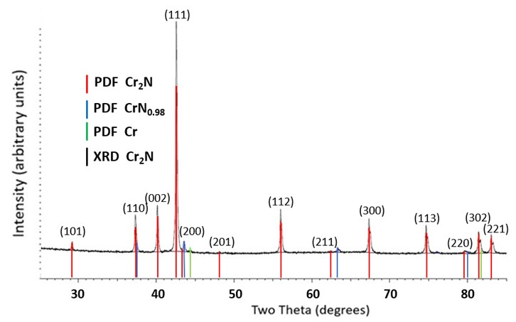
Figure S2. XRD spectrum of Cr₂N including powder diffraction file (PDF) peak positions. The Cr₂N diffraction peaks are indexed.

S3 CrB₂ powder sample
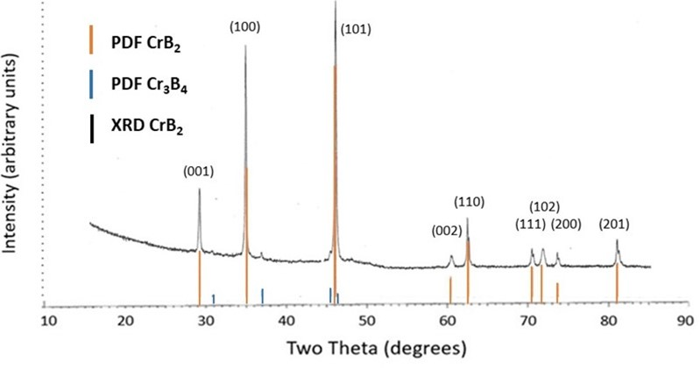
Figure S3. XRD spectrum of CrB₂ including powder diffraction file (PDF) peak positions. The CrB₂ diffraction peaks are indexed.

S4 CrO₂ powder sample
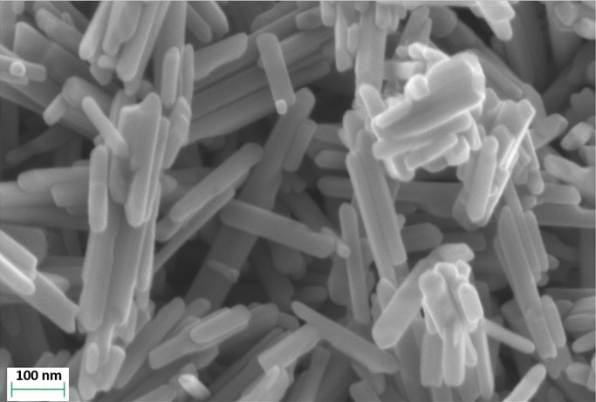
Figure S4a. SEM micrograph of CrO₂ powder.

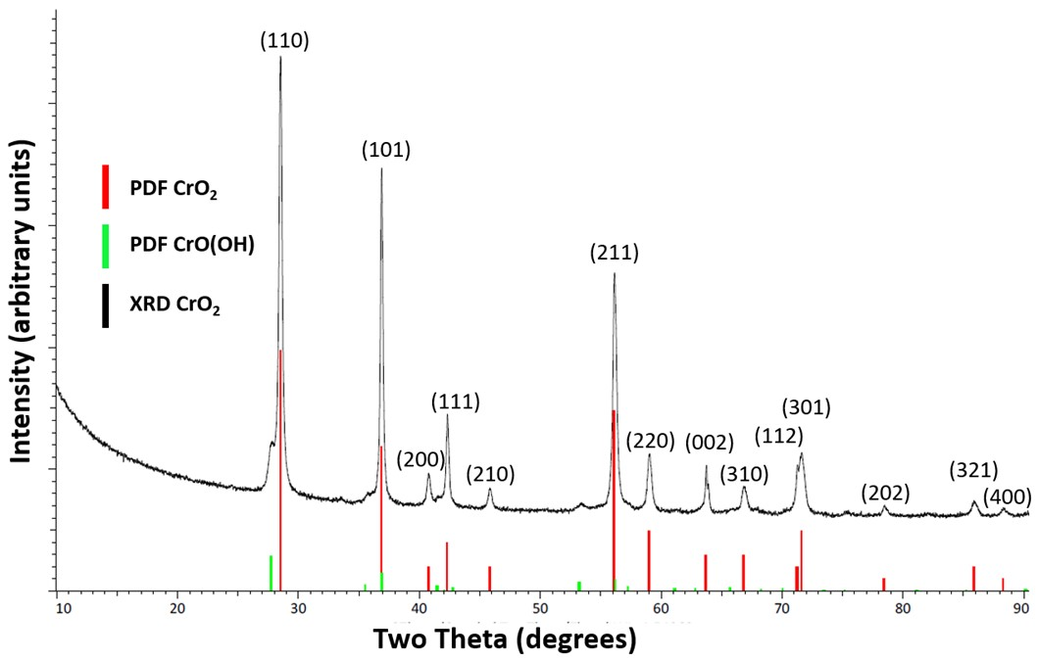
Figure S4b. XRD spectrum of CrO₂ including powder diffraction file (PDF) peak positions. The CrO₂ diffraction peaks are indexed.

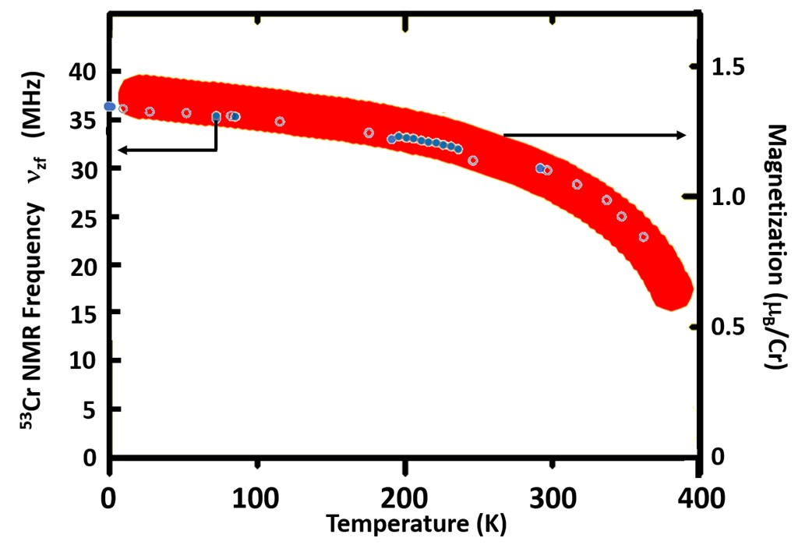
Figure S4c. Comparison of ⁵³Cr internal field NMR frequency, ν_{high}, values from Figure 4 (main text), closed circles, for present work and Yasuoka et al. [1963], and from Piskunov et al. [2022], open circles, and magnetization at 0.2 T, octagons (10 – 380 K), (adapted from Shim et al. [2007]) for CrO₂ as functions of temperature. Piskunov et al. suggest that data up to approximately 300 K (or ~0.76T_{C}) can be fitted with a T^{3/2} dependence, their data for ν_{high} decrease by ~20% (from 37.1 MHz to 30.5 MHz) up to 300 K and fit well with the T^{3/2} dependence from Figure 4 (main text). The fit to spin wave theory T^{3/2} for their results from 4.2 to 300K gives a best fit, y = −0.0013x + 37.089 (R² = 0.9863). The data of Piskunov et al. deviate from the T^{3/2} relationship at ~ 350 K, similar to the magnetization data, which may indicate a first order transition at 395K; however, to date there has been no report of ⁵³Cr NMR data up to T_{C} for CrO₂.

S5 Cr₂O₃ powder sample
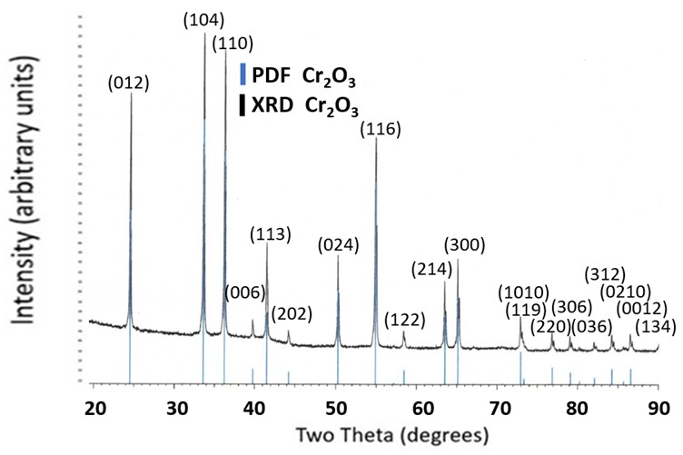
Figure S5a. XRD spectrum of Cr₂O₃ including powder diffraction file (PDF) peak positions.

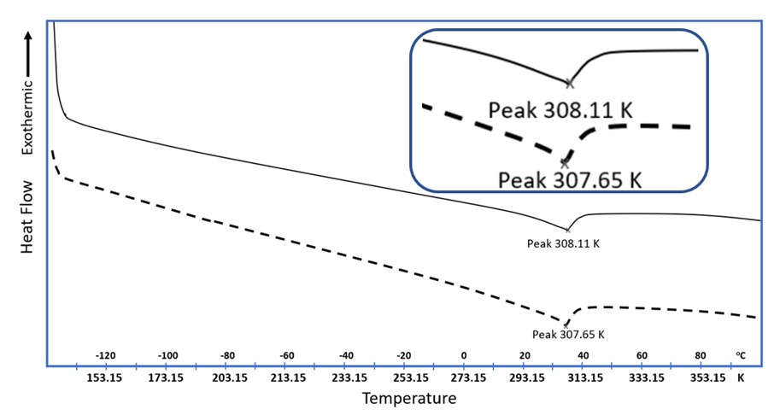
Figure S5b. DSC thermograms for two separate samples of Cr₂O₃ during heating showing T_{N}. Inset is a magnification of T_{N}.

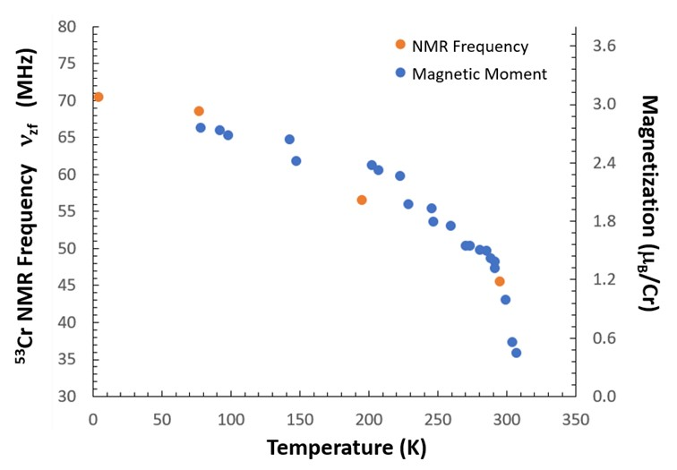
Figure S5c. Comparison of ⁵³Cr internal field frequency, ν_{zf}, values from Figure 4 (main text) and magnetization (adapted from [Corliss 1964]) for Cr₂O₃ as functions of temperature.

S6 ⁵³Cr internal field frequency – valence relationship

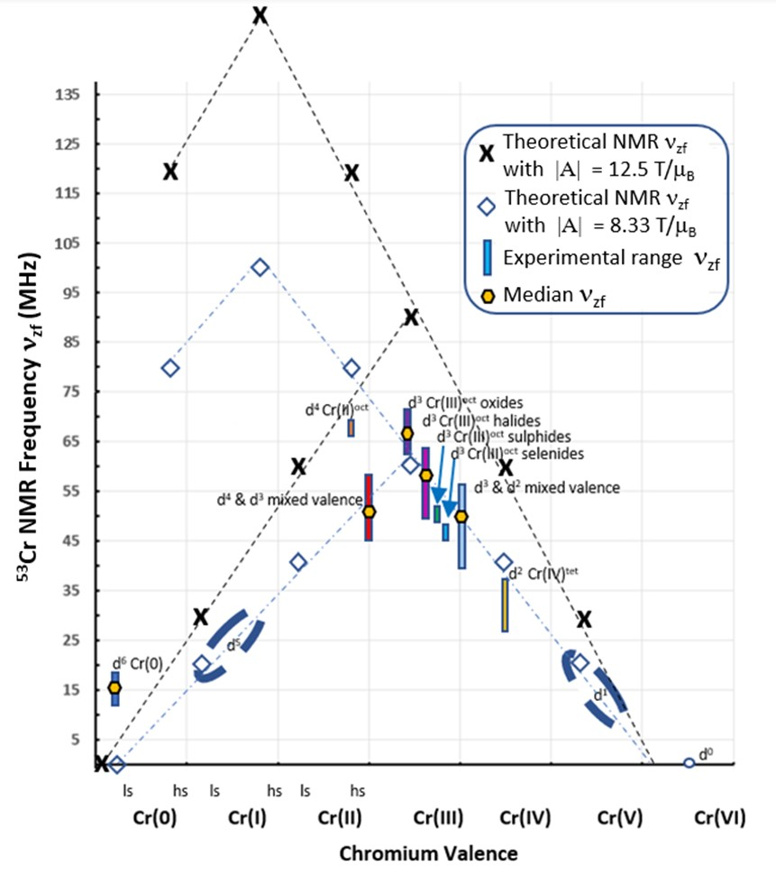
Figure S6a. Copy of Figure 7 from main text including trends (dotted lines) for two values of the hyperfine coupling constant |A| for ⁵³Cr.

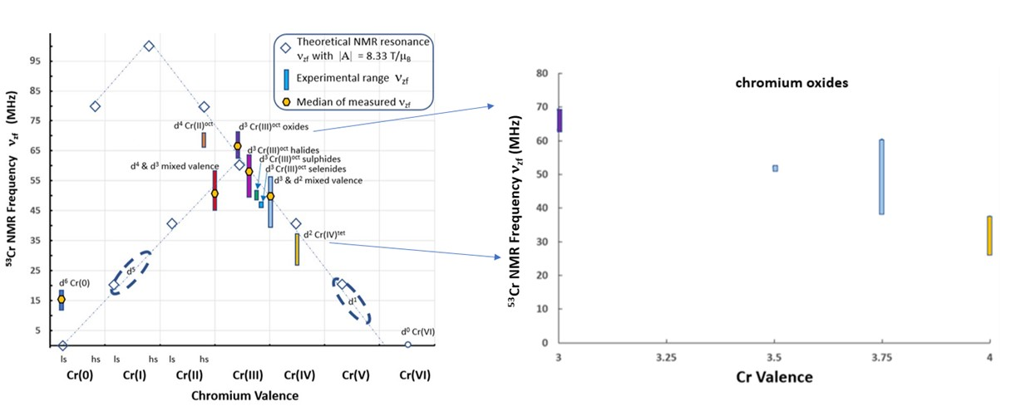

Figure S6b. Copy of Figure 7 from main text (left) with expanded area (right) showing ⁵³Cr internal field frequency range, ν_{zf}, reported for Cr³⁺ and Cr⁴⁺ and mixed valence chromium oxides.

S7 Spin Wave Analysis of ⁵³Cr internal field NMR Data
Table S7a. Internal field NMR data and fits in the form ν_{zf}(T) = ν_{zf}(0)[1 – a_{3/2}(T)^{3/2}]
Compound | Bloch spin wave formulation  ν_{zf} = ν_{zf}(0) - ν_{zf} (0)a_{3/2}(T)^{3/2} | R²  goodness  of fit | a_{3/2}  (x10⁻³ K^{-3/2})
Dy_{0.2}Er_{0.8}CrO₃ | ν_{zf} = 74.401 - 0.0193(T)^{3/2} | 0.995 | 0.2594
Cr₂O₃ | ν_{zf} = 70.985 - 0.0051(T)^{3/2} | 0.996 | 0.0718
MnCr₂O₄ | ν_{zf} = 66.657 - 0.0198(T)^{3/2} | 0.990 | 0.2970
CuCr₂O₄ | ν_{zf} = 63.254 - 0.0053(T)^{3/2} | 0.985 | 0.0838
CrCl₃ | ν_{zf} = 63.111 - 0.5770(T)^{3/2} | 0.999 | 9.1426
Cr₃As₂ | ν_{zf} = 58.621 - 0.0037(T)^{3/2} | 0.904 | 0.0631
CrBr₃ | ν_{zf} = 58.229 - 0.0900(T)^{3/2} | 0.998 | 1.5456
NaCrS₂ | ν_{zf} = 54.072 - 0.1717(T)^{3/2} | 0.988 | 3.1754
FeCr₂S₄ | ν_{zf} = 51.381 - 0.0064(T)^{3/2} | 0.988 | 0.1114
CrI₃ | ν_{zf} = 49.596 - 0.0274(T)^{3/2} | 0.987 | 0.5524
ZnCr₂Se₄ | ν_{zf} = 46.657 - 0.1243(T)^{3/2} | 0.988 | 2.6641
K₂Cr₈O₁₆  Sites A and B  Site C | ν_{zf} = 46.484 - 0.0096(T)^{3/2}  ν_{zf} = 42.963 - 0.0088(T)^{3/2} | 0.998  0.998 | 0.2065  0.2048
CdCr₂Se₄ | ν_{zf} = 44.179 - 0.0139(T)^{3/2} | NA | 0.3146
CuCr₂S₄ | ν_{zf} = 40.188 - 0.0025(T)^{3/2} | 0.997 | 0.0622
CrO₂ ν_{high}  CrO₂ ν_{high}  ν_{low} | ν_{zf} = 37.038 - 0.0011(T)^{3/2}  ν_{zf} = 37.068 - 0.0013(T)^{3/2}  ν_{zf} = 26.407 - 0.0013(T)^{3/2} | 0.993  0.996  0.982 | 0.0297  0.0351  0.0492
Cr₃AsN | ν_{zf} = 14.504 - 0.0006(T)^{3/2} | 0.992 | 0.0414

Table S7b. Values of a_{3/2} calculated from internal field NMR data of Table 5 (main text) where a_{3/2} = c/(ν_{zf}(0)(T_{crit})^{3/2}), values of density ρ and saturation magnetization M(0) from literature reports, used to calculate the spin stiffness parameter D in Table 5 (main text).
Compound | Bloch Spin Wave Coefficient a_{3/2}  (x10⁻³ K^{-3/2}) | Density ρ  (kg/m³) | Saturation Magnetization M(0)  (emu/g)
Dy_{0.2}Er_{0.8}CrO₃ | 0.259405 | 8198 | 62.9
Cr₂O₃ | 0.071846 | 5210 | 110
MnCr₂O₄ | 0.297043 | 4930 | 75.2
CuCr₂O₄ | 0.083789 | 5430 | 72.4
CrCl₃ | 9.142622 | 2870 | 102
Cr₃As₂ | 0.063117 | 3804 | 54.8
CrBr₃ | 1.545622 | 3940 | 57.2
NaCrS₂ | 3.175396 | 3180 | 120
FeCr₂S₄ | 0.111400 | 3854 | 56.2
CrI₃ | 0.552464 | 4740 | 56.6
ZnCr₂Se₄ | 2.664123 | 5550 | 35.0
K₂Cr₈O₁₆  Sites A and B  Site C | 0.206523  0.204827 | 4450  4450 | 17.6  16.3
CdCr₂Se₄ | 0.314629 | 5680 | 29.4
CuCr₂S₄ | 0.062207 | 5440 | 50.4
CrO₂ ν_{high}  CrO₂ ν_{high}  ν_{low} | 0.029699  0.035071  0.049229 | 4890  4890  4890 | 133  133  133
Cr₃AsN | 0.041368 | 7015 | 11.4

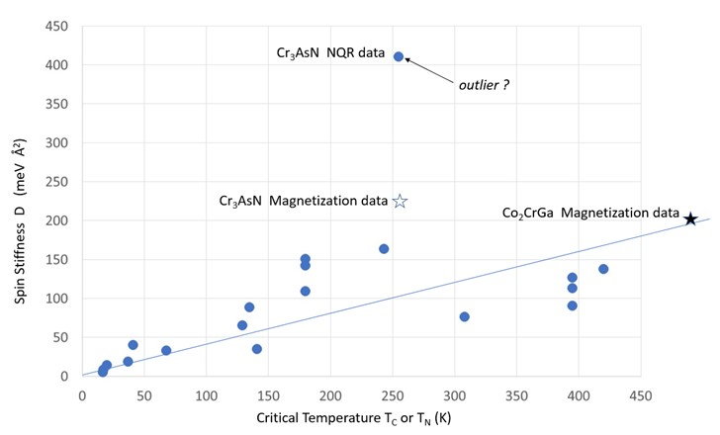
Cr₃AsN internal field data
Figure S7a. Values of spin stiffness D and T_{crit} for all Cr compounds in Table 5 (main text). The star symbols are for D values from magnetization measurements [Waki 2017, Umetsu 2011]. The solid line is the best fit from Figure 9 (b) for the Cr(III)^{oct} d³ subset of Cr compounds. If the outlier (Cr₃AsN) is removed, the best fit equation is D = (0.37 meV Å²/K)T_{Crit} with R² = 0.8181 for all Cr compounds in Table 5 (main text).

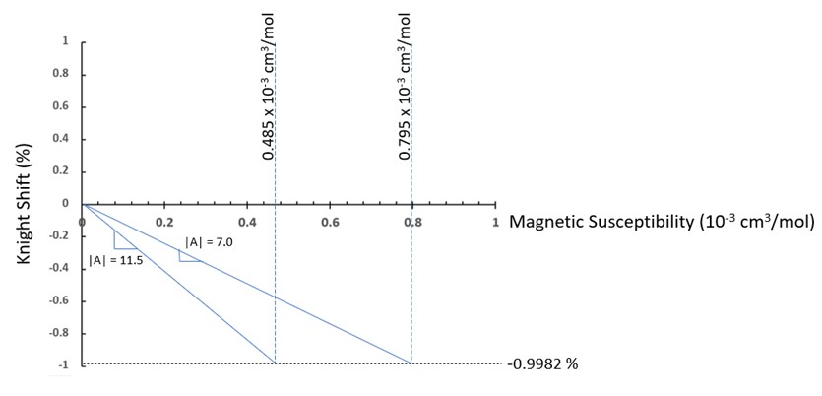
Figure S7b. Illustration of the Clogston-Jaccarino [1961] analysis, with negligible orbital contribution to the ⁵³Cr Knight shift, to extract a range of values for |A| from the range of reported magnetic susceptibility values for CrB₂ with the measured value for the ⁵³Cr Knight shift, using the relationship in Eq. 4 (main text).

References
Yasuoka H, Abe H, Hirai A, Hashi T. Nuclear magnetic resonance of Cr⁵³ in ferromagnetic CrO₂. J. Phys. Soc. Japan. 1963; 18: 593.
Shim JH, Lee S, Dho J, Kim DH. Coexistence of two different Cr ions by self-doping in half-metallic CrO₂ nanorods. Phys. Rev. Letts. 2007; 99(5): 057209. doi: 10.1103/physrevlett.99.057209
Piskunov YV, Sadykov, AF, Ogloblichev VV, Smolnikov AG, Gerashenko AP, Si PZ. Valence state of chromium ions in the half-metallic ferromagnet CrO₂ probed by ⁵³Cr NMR. Phys Rev. 2022; 106: 094428.
Corliss LM, Hastings JM. Magnetic structure studies at Brookhaven National Laboratory. Journal de Physique. 1964; 25 (5): 557-562. doi: 10.1051/jphys:01964002505055701f
Waki T, Takao K, Tabata Y, Ohta H, Yajima T, Hiroi Z, Nakamura H. Possible itinerant-electron canted antiferromagnetism in tetragonal antiperovskite Cr₃AsN. Journal of the Physical Society of Japan. 2017; 86: 104706-7. https://doi.org/10.7566/JPSJ.86.104706
Umetsu RY, Okubo A, Fujita A, Kanomata T, Ishida K, Kainuma R. Spin wave stiffness constants of half-metallic ferromagnets Co₂YZ (Y = Cr, Mn, and Fe, Z = Ga, Al, and Si) Heusler alloys. IEEE Transactions on Magnetics. 2011; 47(10): 2451-2154.
Clogston AM, Jaccarino V. Susceptibilities and negative Knight shifts of intermetallic compounds. Phys Rev. 1961; 121(5): 1357-1362.

