Aday, A., Guo, Y., Mehta, S., Chen, S., Hall, W., Götz, F., Sedikides, C., & Schmader, T. (2024). The SAFE model: State authenticity as a function of three types of fit. Personality and Social Psychology Bulletin. Advance online publication. https://doi.org/10.1177/01461672231223597

The SAFE Model:
State Authenticity as a Function of Three Types of Fit

Audrey Aday and Yingchi Guo
University of British Columbia

Smriti Mehta and Serena Chen
University of California, Berkeley

William Hall
Brock University

Friedrich Götz
University of British Columbia

Constantine Sedikides
University of Southampton

Toni Schmader
University of British Columbia

This work was partially supported by the Social Sciences and Humanities Research Council under Grant 895-2017-1025 awarded to Toni Schmader. Correspondent author: Toni Schmader, Professor of Psychology, 2136 West Mall, Department of Psychology, University of British Columbia, Vancouver, B.C. V6T 1Z4, Canada; Email: tschmader@psych.ubc.ca

Abstract
The SAFE model asserts that State Authenticity stems from three types of Fit to the Environment. Across two studies of university students, we validated instruments measuring self-concept-, goal-, and social fit as unique predictors of state authenticity. In Study 1 (N = 969), relationships between fit and state authenticity were robust to controlling for conceptually similar and distinct variables. Using experience sampling methodology, Study 2 (N = 269) provided evidence that fit and authenticity co-vary at the state (i.e., within-person) level, controlling for between-person effects. Momentary variation in each fit type predicted greater state authenticity, willingness to return to the situation, and state attachment to one’s university. Each fit type was also predicted by distinct contextual features (e.g., location, activity, company). Supporting a theorized link to cognitive fluency, situations eliciting self-concept fit elicited higher working memory capacity and lower emotional burnout. We discuss implications of fit in educational contexts.
Keywords: Authenticity, fit, social belonging, motivation, experience sampling methodology

The SAFE Model: State Authenticity as a Function of Three Types of Fit
People are motivated to feel authentic and true to themselves (Maslow, 1954; Rogers, 1961). Although authenticity was originally considered a disposition (Kernis & Goldman, 2005; Wood et al., 2008), it varies both between and within-person (Chen, 2019; Fleeson & Wilt, 2010; Landa & English, 2021; Lenton et al., 2016; Sedikides et al., 2019). State authenticity encompasses “the sense of feeling that one is currently in alignment with one’s true or genuine self” (Sedikides et al., 2017, p. 521). Given the benefits of feeling authentic for well-being (Hicks et al., 2019, Kifer et al., 2013; Lutz et al., 2023), a moral sense of self (Newman et al., 2014), and a sense of power (Gan et al., 2018; Kraus et al., 2011), people are understandably attracted to contexts where they feel authentic. Yet, predictors of state authenticity are not well established.
We sought to elucidate the role of person-environment fit in predicting state authenticity, which in turn guides one’s approach and avoidance of situations. We provide the first empirical test of key assumptions from the SAFE model, which asserts that state authenticity reflects three types of fit to the environment: self-concept, goal, and social fit (Schmader & Sedikides, 2018). Two studies using survey and experience sampling methods validate instruments to guide future investigations on when, why, and how people self-select into contexts that cue authenticity.
The SAFE Model: Three Types of Fit to the Environment
The SAFE model (Schmader & Sedikides, 2018) conceptualizes state authenticity as a subjective state that is situated within, and activated by, the environment. State authenticity is not only experienced as a short-lived emotion but can be repeatedly experienced in a given context (for example, feeling most like oneself when at home). People seek out situations that afford authenticity and avoid those that do not. Importantly, because contexts contain identity-relevant cues, the same setting can allow some individuals or groups to thrive while alienating others. According to the SAFE model, state authenticity arises from three distinct but interrelated types of fit between the self and environment: self-concept fit, goal fit, and social fit. The focus of the SAFE model is on the subjective experience of fit, not objective measures of correspondence between personality and situational characteristics (Fulmer et al., 2010; Götz et al., 2018).
Self-Concept Fit
Self-concept fit is theorized to be the cognitive component of state authenticity. According to the SAFE model, self-concept fit occurs when the environment activates a familiar sense of self (Markus & Wurf, 1987). For example, when entering a sports arena, one’s self-concept as “sports fan” might be activated. Given that repeated activation of cognitions facilitates fluent processing, and cognitions processed fluently are judged to be true (Reber & Unkelbach, 2010), self-concept fit and corresponding feelings of cognitive fluency manifest as a sense of a ‘true self.’ In contrast, a mismatch between the self and the environment will be cognitively disfluent, placing demands on executive attention and working memory capacity (Engle, 2002), and eliciting inauthenticity. Self-concept fit can be passively elicited from environmental cues and does not require active goal pursuit or the presence of others.
Goal Fit
Goal fit is theorized to be the motivational component of state authenticity, occurring when environments facilitate motivational fluency toward self-relevant goals. People feel motivational fluency when task demands match their own orientation toward the task (Higgins, 2005). For example, students who prefer to learn through quiet reflection feel greater goal fit when constructing a persuasive argument in writing versus group discussion (Kim, 2002). When individuals’ own goal orientation matches environmental affordances, their actions feel autonomous and authentic (Heppner et al., 2008; Ryan & Ryan, 2019). Thus, environments that cue goal fit and a corresponding sense of motivational fluency offer another route to state authenticity.
Social Fit
Social fit is the social component of state authenticity and occurs when other people in the environment accept and validate one’s true self, facilitating interpersonal fluency. For example, an artist might feel social fit when their creativity is recognized and encouraged. The need to belong is a fundamental human need (Baumeister & Leary, 1995), and people automatically detect cues of acceptance or rejection (Pickett et al., 2004). People feel authentic when they are able to enact their true self in social interactions (Swann, 2012) and feel inauthentic when they try to gain social acceptance by conforming to others’ standards (Goffman, 1959; Lenton, Bruder, et al., 2013).
The Benefits of Distinguishing Among Three Types of Fit
Because these three distinct predictors of state authenticity have not previously been empirically tested, validating an instrument to disentangle different routes to state authenticity could have several benefits. This does not mean that a given environment will only cue one type of fit, but rather that different types of fit can be theoretically and empirically distinguished. For example, one situation could involve being with similar others who both activate a default sense of self (high self-concept fit) and socially validate that self-view (high social fit), but another situation could signal a domain that activates a default sense of self (high self-concept fit) even though the people there do not validate that self-view (low social fit). Distinguishing among the cognitive, motivational, and social facets of fit can also help pinpoint environment-specific predictors of state authenticity. Self-concept fit might uniquely predict state authenticity in familiar environments, goal fit might uniquely predict authenticity when productivity is valued, and social fit might uniquely predict authenticity during social interactions with close others. We sought to validate distinct measures of fit that explain unique variance in state authenticity both across people in the same general environment (e.g., students’ experience at their university) and across different situations for the same person (e.g., daily experiences on campus).
Second, the three types of fit are extensions of related constructs. For example, belonging measures often capture a general feeling of fit (Good et al., 2012; Mendoza-Denton et al., 2002), but have been used to assess interpersonal fit (Schnabel et al., 2013; Walton & Cohen, 2007), goal-relevant fit (Belanger et al., 2020), and ambient inclusion (Cheryan et al., 2009; Trawalter et al., 2021). A tripartite conception of fit provides greater theoretical specificity for these experiences and a validated measure that can distinguish among them. Relatedly, self-determination theory (SDT; Deci & Ryan, 1985) parses people’s needs for autonomy, relatedness, and competence that, when satisfied, promote authenticity (Heppner et al., 2008; Thomaes et al., 2017). Whereas SDT focuses on individual needs, the SAFE model emphasizes the dynamic fit between the environment and identity.
Third, the SAFE model hypothesizes that each type of fit predicts engagement with environments via state authenticity (Schmader, & Sedikides, 2018). People gravitate toward environments that activate their default self-concept (self-concept fit; Cheryan et al., 2009; Matz & Harari, 2021), afford personally valued goals (goal fit; Diekman et al., 2017), and socially validate their self-views (social fit; Dasgupta, 2011; Leary & Kelly, 2009). People leave environments that fail to afford experiences of fit. For example, in educational and work settings, a lack of fit between one’s own values and those of the institution can predict lower performance and motivation (Cable & DeRue, 2002; Phillips et al., 2020; Stephens et al., 2012) with implications for a student’s intention to drop out of school (Suhlmann et al., 2018).
Our approach extends prior work not only by estimating the relative contribution of each type of fit to university students’ level of authenticity, but also by identifying predictors and outcomes of students’ feelings of fit to their academic environment. In addition, the constructs and instruments we validate are intended to generalize beyond academic settings, with eventual applications to experiences of misfit felt by marginalized groups.
Overview
We report two studies assessing students’ state authenticity and academic experiences as predicted by three distinct types of fit. In Study 1, we validated a new self-report instrument (i.e., the SAFE scale) that assesses each type of fit, and tested whether self-concept, goal, and social fit explained unique variation in undergraduates’ state authenticity and dropout intentions. In Study 2, we used an experience sampling paradigm to test whether: (1) students feel more authentic in campus situations that cue each type of fit, (2) different situational features uniquely predict each type of fit, and (3) within-person variation in fit predicts momentary outcomes including situation selection and state attachment to the university as well as working memory capacity and burnout (potential indicators of cognitive fluency). All studies were approved by the Institutional Review Board (IRB) of the last author (Study 1 was also approved by the third author’s IRB).
Study 1
Pilot Study
We first conducted an online pilot study to develop SAFE scale items assessing self-concept, goal, and social fit experienced by employees in their organization. Two of the authors generated an initial pool of 26 items derived from descriptions of each type of fit in Schmader and Sedikides (2018; see Supplementary Figures S1-2, Table S2), and 259 working adults on MTurk rated these items. An exploratory principal axis factor analysis with oblique, promax rotation (Costello & Osborne, 2005) suggested three discrete factors that aligned with the theoretical foundations of the SAFE model. Based on this analysis, we selected the five highest-loading items from each factor (all factor loadings > .40, all with cross-loadings below .30; Boateng et al., 2018; Costello & Osborne, 2005), and created reliable composites for each type of fit (see Table 1).
In Study 1, we modified and validated the SAFE scale to assess university students’ self-concept, goal, and social fit, and tested the hypothesis that all three types of fit would explain unique variability in dropout intentions, mediated by state authenticity. We established construct validity by testing the convergent validity of the SAFE scale with an undifferentiated measure of belonging. We also tested the discriminant validity of each fit from other distinct constructs (e.g., self-determination theory constructs—Deci & Ryan, 2000; sense of self—Flury & Ickes, 2007; goal motivation—Sedikides et al., 2019; and social belonging—Yeager et al., 2016) when predicting state authenticity. Finally, we tested positive/negative affect and social desirability as alternative explanations for relationships between fit and authenticity. Data and analysis code are archived at https://osf.io/sb83d/?view_only=3d80718175b94914bdc6bf0a248f130a.

Table 1
Items on the SAFE Scale Assessing Self-Concept, Goal, and Social Fit in an Organizational (Pilot) and University Context (Study 1)
Fit Type | Item Wording
Self-Concept Fit  Pilot: α = .94  Study 1: α = 94 | Even when I’m alone and doing nothing, simply being at [university name/ company name] makes me feel like myself.
 | Just being at [university name/ company name] suits the way I see myself.
 | [University name/ company name] feels right for who I am.*
 | Being at [university name/ company name] brings out who I am.*
 | I feel ‘at home’ when I’m at [university name/ company name].
Goal Fit  Pilot: α = .91  Study 1: α = 86 | [University name/ company name] is a place where I feel intrinsically motivated by my own goals.
 | Standards of success at [university name/ company name] match what I think it means to be successful.
 | I feel that [university name/ company name] is a place that allows me to realize my own goals.
 | My behavior at [university name/ company name] is motivated by things I value.
 | Classes at [university name]/ Tasks at [company name] are designed in a way that fits how I like to [learn/ work].
Social Fit  Pilot: α = .91  Study 1: α = 89 | When I’m around [other students/ my coworkers] on campus, I feel like I can act natural.*
 | I don’t feel like I need to be a different person around others at [university name/ company name].
 | Other students at [university name/ Other coworkers at [company name] do NOT judge me for being myself.*
 | I never have to hide my true behavior when I’m with others at [university name/ company name].*
 | I feel that people at [university name/ company name] understand exactly who I am.
Note. In Study 1, we reworded five items (*) from the pilot study to exclude mention of “true self” intending to reduce conceptual overlap with the authenticity measure. Items were rated from 1 (strongly disagree) to 7 (strongly agree).

Method
Participants
Participants were university students (N = 969; M_{age} = 21.89 years, SD_{age} = 4.91; 59.75% women, 37.25% men, 2.37% trans/nonbinary), who were predominately White (36.53%) or East Asian (21.67%). Study 1 involved two waves of data collection across three samples. Wave 1 included n_{SampleA} = 320 Canadian and n_{SampleB} = 219 American undergraduates. Wave 2 included a preregistered replication (AsPredicted #48026: https://aspredicted.org/UVB_YUR) of Wave 1 among n_{SampleC} = 540 American undergraduates recruited online via Prolific). Data collection continued until the semester (Wave 1) or funding (Wave 2) ended; participants received partial course credit (Wave 1) or $9.87 USD/hr (Wave 2). As results largely replicated across samples, we report analyses on a combined sample (results by Wave in Supplementary Materials). A sensitivity analysis in G*Power (Faul et al., 2009), conducted for a multiple regression model with three predictors, revealed that our final sample (N = 969) allowed us to detect a minimum standardized beta of 𝛽 = .09, with 80% power, alpha = .05.
Procedure
Participants completed all measures clustered by scale, with scale order randomized. In addition to fit items, participants completed measures of state authenticity, dropout intentions, social belonging, autonomy, relatedness, competence, sense of self, goal motivation, positive/negative affect, socially desirable responding, and demographics. See Supplementary Materials for additional measures.
Measures
Three Types of Fit. Self-concept ($α$ = .94), goal ($α$ = .86), and social fit ($α$ = .89) were assessed with the university-framed items in Table 1.
State Authenticity. Participants rated their state authenticity on a single, face-valid item: “At [University], I feel…” (1 = inauthentic, 7 = authentic).
Dropout Intentions. We assessed dropout intentions with four items created for this project. Three items were rated in terms of agreement (1 = strongly disagree, 6 = strongly agree): “I do not feel “emotionally attached” to [University],” “I will likely actively look to transfer out of [University] in the next year,” and “I often think about dropping out” (1 = strongly disagree, 6 = strongly agree). A fourth item was rated in terms of frequency (1 = never, 5 = always): “This semester, how often have you thought about dropping out of school?” (1 = never, 5 = always). We reverse-scored and standardized responses before combining them into a composite ($α$ = .75).
Social Belonging. We assessed social belonging with a composite of three (reverse-scored) belonging uncertainty items (Yeager et al., 2016; e.g., “Sometimes I worry that I do not belong in college”; 1 = not true at all, 5 = completely true) and a fourth face-valid item (“I feel like I belong at [University]”; 1 = strongly disagree, 7 = strongly agree; $α$ = .86).
Autonomy, Relatedness, and Competence. To assess SDT constructs, we used 21 items from the Basic Needs Satisfaction in General Scale (Johnston & Finney, 2010; 1 = not at all true, 7 = very true). Seven items referred to autonomy (e.g., “I feel like I am free to decide for myself how to live my life”; $α$_{Autonomy} = .75), eight to relatedness (e.g., “I really like the people I interact with”; $α$_{Relatedness} = .86), and six to competence (e.g., “People I know tell me I am good at what I do”; $α$_{Competence} = .74).
Sense of Self. We assessed sense of self with the 12-item Flury and Ickes (2007) Sense of Self Scale (SOSS; e.g., “I have a clear and definite sense of who I am and what I’m all about”; 1 = very uncharacteristic of me, 6 = very characteristic of me; $α$ = .86).
Goal Motivation. To assess goal motivation, we had participants rate their most important goal with five statements (e.g., “I am motivated to pursue this goal”; 1 = strongly disagree, 7 = strongly agree; $α$ = .87).
Positive and Negative Affect. We assessed positive and negative affect using the Scale of Positive and Negative Experience (SPANE; Diener, 2009). Participants read: “Please think about what you have been doing and experiencing since coming to [University],” and rated (1 = very rarely or never, 5 = very often or always) how frequently they experience six positive (e.g., “Good”;$α$_{Positive} = .90) and six negative (e.g., “Bad”; $α$_{Negative} = .85) varieties of affect.
Social Desirability. We measured social desirability using two subscales of the Balanced Inventory of Desirable Responding Short Form (BIDR-16—Hart et al., 2015; based on the BIDR-40, Paulhus, 1998): (1) self-deceptive enhancement (SDE, $α$ = .72; e.g., “I am very confident of my judgments”), and (2) impression management (IM, $α$ = .71; e.g., “I sometimes tell lies if I have to”). We analyzed the subscales separately given their modest correlation (r = .35, p < .001).
Results
We provide descriptive statistics and variable inter-correlations in Table 2.
Confirmatory Factor Analysis of Fit
Given that an exploratory factor analysis in the pilot study yielded a three-factor solution, we used confirmatory factor analysis (CFA) from the R package lavaan version 0.6-3 (Rosseel, 2012) to model each type of fit as an interrelated latent construct with five respective fit items and no residual correlations. We used full information maximum likelihood (FIML) estimation to account for missing data. The chi-square test of model fit was significant ($χ$² (87) = 362.80, p < .001) as is typical for large samples (Bentler & Bonett, 1980; Curran et al., 2003). Other fit indices, less biased by sample size, suggested good model fit; CFI = .97, RMSEA = .06, SRMR = .04 (Clark & Watson, 2019; Hu & Bentler, 1999). Figure 1 depicts the full CFA model with factor loadings and covariances between latent constructs. All subscale items loaded >= .67 onto each latent factor.
Table 2
Descriptive Statistics and Correlations Among Variables Measured in Study 1
 | M (SD) | (1) | (2) | (3) | (4) | (5) | (6) | (7) | (8) | (9) | (10) | (11) | (12) | (13) | (14) | (15)
(1) Self-Concept Fit (α = .94) | 4.57 (1.47)
(2) Goal Fit (α = .86) | 4.87 (1.19) | 0.66***
(3) Social Fit (α = .89) | 4.49 (1.32) | 0.64*** | 0.51***
(4) State Authenticity (Single-Item) | 4.93 (1.39) | 0.61*** | 0.53*** | 0.61***
(5) Dropout Intentions (α = .75) | 0.00 (0.81) | -0.62*** | -0.53*** | -0.43*** | -0.49***
(6) Social Belonging (α = .86) | 0.00 (0.84) | 0.58*** | 0.55*** | 0.52*** | 0.54*** | -0.63***
(7) Autonomy (α = .75) | 4.65 (0.91) | 0.40*** | 0.42*** | 0.49*** | 0.46*** | -0.36*** | 0.49***
(8) Relatedness (α = .86) | 5.19 (1.00) | 0.41*** | 0.36*** | 0.50*** | 0.42*** | -0.39*** | 0.46*** | 0.60***
(9) Competence (α = .74) | 4.53 (1.05) | 0.38*** | 0.43*** | 0.38*** | 0.43*** | -0.40*** | 0.54*** | 0.63*** | 0.54***
(10) Positive Affect (α = .90) | 3.59 (0.70) | 0.63*** | 0.56*** | 0.50*** | 0.54*** | -0.55*** | 0.58*** | 0.49*** | 0.52*** | 0.53***
(11) Negative Affect (α = .85) | 2.76 (0.76) | -0.34*** | -0.43*** | -0.34*** | -0.36*** | 0.37*** | -0.47*** | -0.43*** | -0.28*** | -0.43*** | -0.53***
(12) BIDR-16 (SDE) (α = .72) | 3.81 (0.91) | 0.20*** | 0.26*** | 0.34*** | 0.34*** | -0.23*** | 0.41*** | 0.44*** | 0.27*** | 0.48*** | 0.34*** | -0.40***
(13) BIDR-16 (IM) (α = .71) | 4.17 (0.95) | 0.14*** | 0.19*** | 0.26*** | 0.25*** | -0.17*** | 0.17*** | 0.21*** | 0.15*** | 0.20*** | 0.18*** | -0.22*** | 0.35***
(14) Sense of Self (α = .86) | 3.79 (0.90) | 0.20*** | 0.25*** | 0.31*** | 0.35*** | -0.27*** | 0.46*** | 0.54*** | 0.42*** | 0.59*** | 0.34*** | -0.40*** | 0.65*** | 0.25***
(15) Goal Motivation (α = .87) | 6.02 (0.94) | 0.27*** | 0.39*** | 0.30*** | 0.37*** | -0.29*** | 0.36*** | 0.43*** | 0.36*** | 0.49*** | 0.42*** | -0.28*** | 0.31*** | 0.19*** | 0.33***
Note. *p < .05. **p < .01. ***p < .001. BIDR = Balanced Inventory of Desirable Responding, IM = Impression Management, SDE = Self-Deceptive Enhancement. We standardized Dropout Intentions and Social Belonging prior to forming composites, as responses scales were different.
Figure 1. Confirmatory Factor Analysis of Fit Measures in Study 1
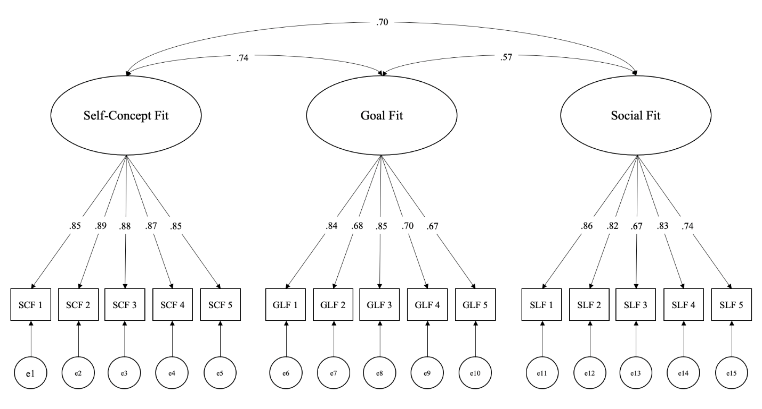
The three fit factors were positively correlated, with self-concept and goal fit showing the strongest correlation (r = .74). However, a simplified two-factor model combining self-concept and goal fit items showed poorer fit to the data ($χ$²(89) = 1198.77, p < .001, CFI = .89, RMSEA = .11, SRMR = .06) than the theoretically-derived three-factor model ($χ$² (87) = 362.80, p < .001, p < .001, CFI = .97, RMSEA = .06, SRMR = .04). Self-concept and social fit were also highly correlated (r = .70), and an alternative model combining the two also showed poorer fit to the data ($χ$²(89) = 1537.58, p < .001, CFI = .86, RMSEA = .13, SRMR = .07) than the three-factor model. These results empirically support three distinct types of fit.
Effects of Fit on Students’ State Authenticity and Dropout Intentions
Having established three-factors of the SAFE scale, we next conducted a structural regression model to examine the predictive effect of each type of fit on state authenticity (single item measure). All three fit types uniquely predicted state authenticity: self-concept fit, 𝛽 = .21, p < .001; goal fit, 𝛽 = .20, p = < .001; social fit, 𝛽 = .38, p < .001. The effect size for each relationship of fit to state authenticity was above the threshold (𝛽 = .09) specified by the sensitivity analysis. Together, the three types of fit explained 49% of the variance in state authenticity, $χ$² (99) = 383.80, p < .001; CFI = .97, TLI = .97, SRMR = .03, RMSEA = .06.
Next, a parallel structural regression model tested the predictive effect of each type of fit on dropout intentions, which was included in the model as a latent factor indicated by four observed items. Both self-concept fit, 𝛽 = -.17, p = .007, and goal fit, 𝛽 = -.41, p < .001, significantly and uniquely predicted dropout intentions. Social fit, 𝛽 = -.01, p = .822, did not predict dropout intentions after accounting for the other types of fit. Together, this model explained 31% of the variance in latent dropout intentions with good fit, $χ$² (146) = 884.85, p < .001; CFI = .94, TLI = .93, SRMR = .08, RMSEA = .07.
Finally, a structural regression model tested state authenticity as a mediator of fit effects on latent dropout intentions, $χ$² (161) = 906.492, p < .001; CFI = .94, TLI = .93, SRMR = .08, RMSEA = .07 (using the R package lavaan version 0.6-3, Rosseel, 2012; see Figure 2). All three types of fit uniquely predicted state authenticity: self-concept fit, 𝛽= .21, p < .001; goal fit, 𝛽 = .20, p < .001; social fit, 𝛽 = .38, p < .001. State authenticity predicted dropout intentions (𝛽 =- .13, p = .002), and there were indirect effects of self-concept fit (a*b = -.03, p = .013), goal fit (a*b = -.03, p = .009), and social fit (a*b = -.05, p = .004). With state authenticity in the model, self-concept fit (𝛽 = -.14, p = .024) and goal fit (b = -.39, p < .001) retained direct effects to dropout intentions, but not social fit (𝛽 = .04, p = .424). See Table 3 for path coefficients and 95% confidence intervals.

Table 3
Structural Regression Modelling Results of State Authenticity Mediating Effects of Fit on Dropout Intentions
 | State Authenticity | Total Effects of Fit on Dropout Intentions | Direct Effects of Fit on Dropout Intentions | Indirect Effects of Fit on Dropout Intentions
Three Types of Fit Predicting Outcomes
Self-Concept Fit | β = .21***  [0.12, 0.31] | β = -.17**  [-0.28, -0.05] | β = -.14*  [-0.26, -0.02] | β = -.03*  [-0.05, -0.01]
Goal Fit | β = .20***  [0.11, 0.28] | β = -.41***  [-0.51,- 0.31] | β = -.39***  [-0.49, -0.29] | β = -.03**  [-0.05, -0.01]
Social Fit | β = .38***  [0.31, 0.46] | β = -.01  [-0.10, 0.08] | β = .04  [-0.06, 0.14] | β = -.05**  [-0.09, -0.02]
State Authenticity Predicting Dropout Intentions
β = -.13**
[-0.22, -0.05]
Note. The betas represent standardized coefficients, with their 95% CIs at below.

Figure 2. Relationship of Each Type of Fit to Organizational Commitment as Mediated Via State Authenticity in Study 1. Regression coefficients are standardized; relationships among fit constructs reflect standardized covariances.

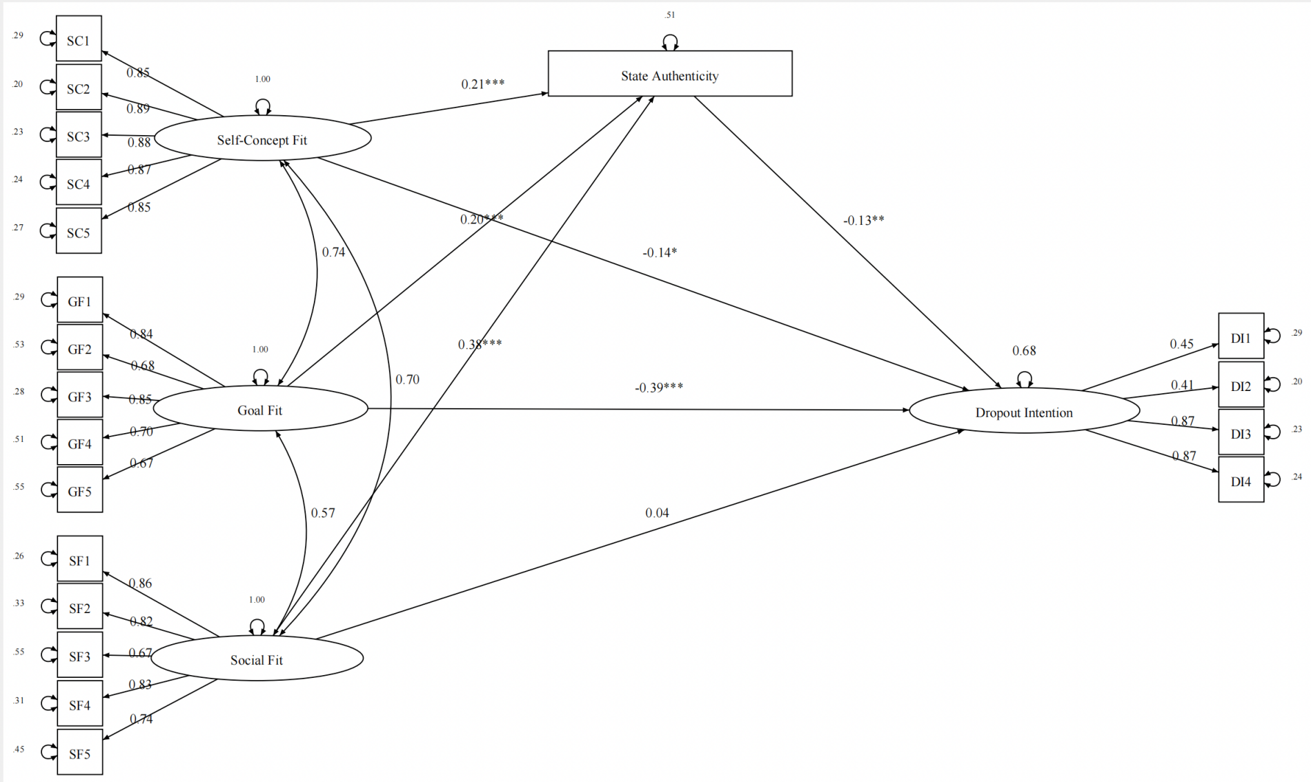

Note. SC = Self-Concept Fit; GF = Goal Fit; SF = Social Fit; DI = Dropout Intentions. All coefficients are standardized. Path coefficients are marked with * p < .05, ** p< .01, *** p< .001.
Tests of Convergent and Discriminant Validity
Next, we tested the convergent and discriminant validity of the SAFE scale by examining the relationship of fit to other, conceptually similar but distinct measures.
Convergent Validity with Belonging. In the aggregate, the SAFE scale aims to assess a construct similar to – but more nuanced than – belonging, by differentiating among different types of fit. Thus, two regression models predicted belonging from: (1) a composite of all three types of fit, and (2) the three types of fit separately. As expected, the composite of all three fit types was strongly related to belonging, 𝛽 = .63, p < .001, yielding evidence of convergent validity. In addition, when entered simultaneously, each fit type had a unique relationship with belonging (self-concept fit, 𝛽 = .27, p < .001; goal fit, 𝛽 = .25, p < .001; social fit, 𝛽 = .21, p < .001), all with effects above the threshold (𝛽 = .09) specified by sensitivity analyses.
Discriminant Validity from Other Distinct Constructs. To assess discriminant validity of the SAFE scale, we tested two separate models. Model 1 predicted state authenticity from self-concept, goal, and social fit while controlling for SDT constructs (autonomy, relatedness, competence). Model 2 accounted for sense of self, goal motivation, and social belonging (conceptually related to self-concept, goal, and social fit, respectively). As shown in Table 4, all three fit types predicted unique variance in state authenticity beyond other similar but distinct constructs, establishing discriminant validity.

Table 4

Results of Models Testing Divergent Validity by Controlling for Conceptually Related Variables When Regressing State Authenticity Onto Fit Measures in the Combined Analysis in Study 1

 | Original  Model | Self-Determination  Theory | Motivation, Self, and Belonging Constructs | Positive and Negative  Affect | Socially Desirable Responding  Constructs
 | Model 0 | Model 1 | Model 2 | Model 3 | Model 4
Self-Concept Fit | .27***  [0.20, 0.35] | .26***  [0.19, 0.33] | .27***  [0.19, 0.34] | .21***  [0.13, 0.29] | .31***  [0.24, 0.38]
Goal Fit | .17***  [0.10, 0.23] | .12***  [0.05, 0.19] | .07*  [0.00, 0.14] | .12***  [0.05, 0.18] | .13***  [0.06, 0.19]
Social Fit | .34***  [0.28, 0.41] | .29***  [0.22, 0.35] | .26***  [0.19, 0.32] | .32***  [0.25, 0.38] | .28***  [0.22, 0.35]
Competence | - | .11***  [0.05, 0.17] | - | - | -
Autonomy | - | .08*  [0.01, 0.15] | - | - | -
Relatedness | - | .02  [-0.05, 0.08] | - | - | -
Sense of Self | - | - | .12***  [0.06, 0.17] | - | -
Goal Motivation | - | - | .12***  [0.06, 0.17] | - | -
Belonging | - | - | .11***  [0.05, 0.18] | - | -
Positive Affect | - | - | - | .16***  [0.09, 0.23] | -
Negative Affect | - | - | - | -.04  [-0.10, 0.01] | -
BIDR (SDE) | - | - | - | - | .13***  [0.07, 0.18]
BIDR (IM) | - | - | - | - | .07**  [0.02, 0.12]
Note. *p < .05. **p < .01. ***p < .001. The reported coefficients in this table are standardized coefficients, with their 95% CIs at below.

Ruling Out Alternative Explanations
Finally, to test whether the relationships between fit and state authenticity were better explained by positive and negative affect or social desirability, we tested two additional models predicting state authenticity from each fit type and each set of control variables (Model 3 included positive/negative affect and Model 4 included social desirability; Table 4). Positive affect had the strongest relationship to state authenticity, supporting evidence that state authenticity is experienced positively (Lenton, Slabu et al., 2013). However, each fit type predicted unique variance in state authenticity even when accounting for alternative explanatory variables.
Discussion
Study 1 provided empirical support for three types of fit that can be independently measured to uniquely predict state authenticity. Although the three fit types can be distinct routes to state authenticity, they need not all predict any given outcome. Indeed, students’ self-concept and goal fit, but not social fit, directly predicted their dropout intentions. That said, all three fit types showed significant indirect effects on dropout intentions via state authenticity. Importantly, the SAFE scale had a good factor structure, showing convergent and discriminant validity from other related constructs, and being robust to alternative explanations in relation to authenticity (i.e., positive/negative affect, social desirability).
Although Study 1 validated our tripartite conceptualization of fit, the cross-sectional survey methodology only tested between-person (not between-situation) variation in responses. As such, our findings yielded evidence of fit and authenticity as situated within a context; Study 2 aimed to assess momentary variation in experiences of fit, authenticity, and relevant outcomes.

Study 2
In Study 2, we used an experience sampling design to isolate within-person effects (as distinct from between-person effects) of fit and authenticity as linked to variation in contextual cues and outcomes (see Supplementary Materials). We archived materials (i.e., data, analysis code, preregistration) at https://osf.io/s9y85/?view_only=fb98a7ae10564c0fbc93a0bd1dcd214e. Our primary hypothesis was that in university situations where students feel greater self-concept-, goal-, and/or social fit, they will also report greater authenticity, willingness to return to the situation, and state attachment to their university. To establish the implications of misfit and inauthenticity beyond self-report measures, Study 2 also included a performance-based measure of working memory capacity. Reduced working memory capacity is often linked to burnout (Gavelin et al., 2022), which we also measured, and thus linking these outcomes to experiences of misfit could provide important evidence of cognitive disfluency. We preregistered analyses to test the unique role of each type of fit in predicting all outcomes, with no specific hypotheses about the relative strength of these relationships.
The experience sampling design allowed us to isolate how each type of fit is uniquely cued by contextual features. Drawing from the SAFE model, we preregistered hypotheses that students would experience: (1) higher self-concept fit in situations that were familiar or freely chosen, as these situations would activate the default self-concept, (2) higher goal fit in situations involving active (vs. passive) engagement or social (vs. solitary) actions, as these situations would afford valued goals, and (3) higher social fit in presence of close (vs. non-close) others, as these situations would foster social validation.
Method
Procedure
Study 2 was embedded within a larger longitudinal project with three phases: a T1 baseline survey about one month after the start of the term, a two-week experience-sampling phase, and a T2 survey at the end of the term (T1 and T2 surveys are less relevant to the current study; see Supplementary Materials). Participants began the 14-day experience-sampling phase of the study approximately 6-8 weeks after the term started. Each day, participants received emailed survey prompts at 2pm, 5pm, and 8pm. The 3-minute survey was accessible via laptop, smartphone or tablet and contained questions about the current context (e.g., “What are you doing right now?”), state authenticity, and fit, as well as momentary outcomes (i.e., likelihood to return, state university attachment, burnout, working memory capacity).
Participants
Our preregistered sample size was 220, based on Monte Carlo simulations (Arend & Schäfer, 2019), but we continued to recruit participants for two academic terms at a Canadian University and compensated them with research credit in psychology classes or payment. Of the 290 students who enrolled in the study, 37 were excluded from analyses (as preregistered) because they completed no experience-sampling surveys about on-campus experiences. In this final sample of 253 (54.15% 1st-year undergraduates, 45.85% 2nd-year undergraduates; M_{age} = 18.98 years, SD_{age} = 1.76; 80.24% women, 16.60% men, 2.37% non-binary, 0.39% non-specified gender; East Asian: 39.13%, White/European:18.58%, South Asian: 17.00%, Southeast Asian: 5.93%, each other ethnicity < 5.00%), 252 completed more than 50% questions in T1 survey. Each of these 253 participants completed an average of 9.68 experience-sampling surveys on campus, SD = 8.04, Min = 1, Max = 41. Seventeen participants completed all 42 survey prompts (including both on-campus and off-campus experiences), and 140 participants completed more than 80%, qualifying them for a $5 bonus. At the end of the academic term, 67.19% of 253 participants completed the T2 survey.
Experience Sampling Measures
Contextual Information. We measured location with a single question: “Where are you right now?” and five response options (“at home,” “familiar place on campus,” “unfamiliar place on campus,” “familiar place off-campus,” “unfamiliar place off-campus”). We also asked participants, “Did you choose to be here?” (yes/no) and “What are you doing right now?” (“doing something active [e.g., studying, exercising, working],” “doing something passive [e.g., watching TV, reading, browsing the web, relaxing],” “doing something social [e.g., talking with friends or family],” “doing something solitary [e.g., staying by yourself”]). To assess social company, participants responded to the question stem: “I am with…” (“solo: I’m alone,” “close others: friends/relationship partner/family,” “non-close others: acquaintances(classmates/coworkers)/strangers.” Note that company categories were not mutually exclusive; participants could be with both close and non-close others.
Momentary Fit. We assessed each type of fit with the highest-loading item from their respective subscale in Study 1, Wave 1: self-concept fit (“Just being here in this space suits the way I see myself”), goal fit (“This is a place where I feel intrinsically motivated by my own goals”), and social fit (“I can act natural around the people who are here”) on a scale ranging from 1 (strongly disagree) to 7 (strongly agree).
State Authenticity. Participants rated their state authenticity at their university on a single item: “At [University] I feel…” (1 = inauthentic, 7 = authentic).
Behavioral Intentions. Participants rated, “Are you likely to return to this setting?” (1 = definitely not, 7 = definitely yes).
State Attachment. Participants reported their state attachment with their university with a single rating (1 = completely emotionally disengaged from [University], 7 = strongly emotionally attached to [University]).
Burnout. Participants reported their burnout on the item, “Right now, I feel emotionally drained” (1 = none at all, 7 = extremely).
Working Memory Capacity. We added a measure of working memory capacity to represent a performance-based measure of cognitive fluency. To avoid cognitive overload, we only included the measure in 50% of the experience-sampling prompts (randomly selected). On these occasions, after filling out self-report measures, participants completed a memory updating task that correlates highly with other working memory measures (Oberauer et al., 2000) and has been used in previous experience sampling research (Riediger et al., 2011). We trained participants on the memory updating task during the T1 survey. The memory updating task started by presenting participants with a 2x2 matrix of frames (four frames in total; see Supplementary Materials). Four single-digit numbers (one per frame) were displayed simultaneously for 6.5 seconds, and participants were instructed to memorize the four numbers. The four numbers then disappeared. A single-digit addition or subtraction updating operation (e.g., +4) appeared in one of the frames. Participants’ task was to update the original number in the corresponding frame according to the operation and hold that new number in working memory. After 3.5 seconds, the updating operation disappeared, and a new operation was presented in a different frame. Participants completed four updating operations, requiring them to remember four updated numbers that, at the end, were asked to input into a blank 2x2 matrix.
The working memory task was programmed in Qualtrics to only accept numeric responses and R code double validated that. For each working memory trial, we calculated an accuracy score as the proportion of numbers answered correctly, with possible scores being 0.00, 0.25, 0.50, 0.75, and 1.00. Initial data screening revealed that only 10 participants received 0.00 correct responses on all of their trials (constituting only 19, or less than 2%, of the 1197 working memory trials collected). These scores were retained and thus no observations on this measure were excluded.
Dispositional Authenticity
The T1 survey included a 12-item measure of dispositional authenticity (Wood et al., 2008; e.g., “I think it is better to be yourself, than to be popular”; 1 = does not describe me at all, 7 = describes me very well; α = .82).
Results
Analysis Plan
We used multilevel modeling (R package ‘lme4’; Bates, 2015) with each short survey response as a level-1 unit and each person as a level-2 cluster. We cluster-mean centered all continuous level-1 predictors (momentary ratings of the three fit types) to disaggregate within-person and between-person effects, and we grand-mean centered any level-2 predictors (e.g., dispositional authenticity; Raudenbush & Bryk, 2002; Rights & Sterba, 2019). As preregistered, we analyzed only on-campus experiences (2,448 out of 8,222 total observations), and did not control for day of week.
Table 5 summarizes descriptive statistics and bivariate correlations (for both within- and between-person levels). Correlations among the three fit types and state authenticity were positive, but the magnitude of relationships was smaller at the within- than between-person level. Dispositional authenticity was modestly correlated with between-person variance in fit and authenticity but uncorrelated with within-person variance in these measures. These patterns support distinguishing these constructs at the state level.
Among on-campus observations, 86.85% of participants were at familiar places and had chosen to be there in 94.04% of the cases. Participants were often engaged in something active (58.37%, vs. passive), and 21.24% of the time they were actively engaged in social (vs. solitary) activity. On 36.73% of occasions participants reported that they were alone, on 40.44% only with close others, on 15.43% only with non-close others, and on 7.40% with both close and non-close others.
Does Momentary Variation in Fit Predict State Authenticity?
Using multilevel modeling with random intercepts and slopes, we regressed state authenticity onto both within-person and between-person components of all three fit measures, allowing the intercept and slopes to vary across individuals. Supporting preregistered hypotheses, all three fit types significantly predicted state authenticity within-person: self-concept fit, 𝛽 = .11, p < .001; goal fit, 𝛽 = .12, p < .001; social fit, 𝛽 = .14, p < .001. Together, the three types of fit explained 9.07% of total variance (computed with Rights & Sterba’s, 2019, procedure). Thus, when participants reported higher levels of each type of fit, they also reported feeling more authentic.
The between-person level analyses replicated patterns from Study 1. Participants who, on average across situations, reported higher state authenticity also reported, on average, higher self-concept fit, 𝛽 = .20, p = .03, 95% CI [.02, .39]; goal fit, 𝛽 = .24, p = .006, 95% CI [0.07, 0.41]; and social fit, 𝛽 = .48, p < .001, 95% CI [0.35, 0.62]. Thus, at the between-person level, the three types of fit also explained total variance in authenticity, R² = .34.
Does Momentary Variation in Fit Predict Momentary Outcomes?
Next, we regressed each outcome variable on both within-person and between-person components of all three types of fit, allowing the intercept and slope to vary across participants in multilevel modeling. We summarize results for within-person effects in Table 6, as these are the primary focus of the study. These findings control for between-person effects, which are reported in Supplementary Materials.
State Attachment to the University. The within-person components of self-concept fit (𝛽 = .10, p < .001), goal fit (𝛽 = .13, p < .001), and social fit (𝛽 = .07, p = .005) each uniquely and significantly predicted participants’ state attachment to the university and explained 7.46% of the total variance in this variable. Although in Study 1 social fit was not directly related to dropout intentions, in Study 2 it did uniquely predict state attachment.
Willingness to Return to the Situation. Supporting preregistered hypotheses, in those situations where participants felt more self-concept fit, 𝛽 = .16, p < .001, goal fit, 𝛽 = .11, p < .001, and/or social fit, 𝛽 = .15, p < .001, they also reported significantly higher willingness to return to that situation. Taken together, the within-person components of the three types of fit explained 13.17% of the total variance in behavioral intentions.
Burnout. Analysis of burnout revealed a different pattern. Participants reported greater burnout in situations where they experienced less self-concept fit, 𝛽 = -.12, p < .001, explaining 3.73% of the total variance. Neither goal fit nor social fit significantly predicted burnout.
Table 5
Descriptive Statistics and Correlations Among Key Variables in Study 2
 | Mean (SD) | (1) | (2) | (3) | (4) | (5) | (6) | (7) | (8) | (9)
(1) Self-Concept Fit | 5.21 (1.22) |  | 0.82*** | 0.73*** | 0.62*** | 0.56*** | 0.49*** | -0.12*** | 0.10*** | 0.31***
(2) Goal Fit | 5.14 (1.36) | 0.43*** |  | 0.60*** | 0.59*** | 0.46*** | 0.52*** | -0.15*** | 0.13*** | 0.23***
(3) Social Fit | 5.20 (1.46) | 0.33*** | 0.19*** |  | 0.60*** | 0.49*** | 0.43*** | -0.07*** | 0.05* | 0.33***
(4) State Authenticity | 4.99 (1.30) | 0.27*** | 0.3`*** | 0.25*** |  | 0.36*** | 0.85*** | -0.15*** | -0.01 | 0.33***
(5) Likelihood to Return | 5.73 (1.40) | 0.28*** | 0.23*** | 0.26*** | 0.17*** |  | 0.23*** | -0.05* | 0.17*** | 0.21***
(6) State Attachment | 4.76 (1.45) | 0.22*** | 0.26*** | 0.11*** | 0.38*** | 0.10*** |  | -0.12*** | 0.05* | 0.22***
(7) Burnout | 3.97 (1.69) | -0.15*** | -0.05 | -0.11*** | -0.16*** | -0.05 | -0.18*** |  | -0.09*** | -0.11***
(8) Working Memory Capacity | 0.76 (0.32) | 0.06 | 0.01 | -0.06* | -0.02 | 0.02 | -0.01 | -0.02 |  | -0.05*
(9) Dispositional Authenticity (α = .82) | 4.60 (0.89) | -0.01 | 0.01 | 0.00 | -0.00 | -0.00 | 0.01 | 0.01 | -0.00
Note. *p < .05. **p < .01. ***p < .001. Variables (1) - (8) are single-item measures. The means and SDs we present here are the grand-means and SDs. Correlations above the diagonal are between-person, whereas those below the diagonal are within-person, except for the last row showing level 1–level 2 correlations.

Working Memory Capacity. Similarly, participants’ working memory capacity was higher in situations where they felt higher self-concept fit (𝛽 = .12, p = .004), but also lower social fit (𝛽 = -.08, p = .020), explaining 1.64% of the total variance. Goal fit did not significantly predict momentary variation in working memory capacity, and none of the between-person components of the three types of fit significantly predicted working memory capacity (see Supplementary Materials), revealing the contextualized nature of this outcome.
Does Momentary Variation in Authenticity Predict Momentary Outcomes?
Having established that each outcome was uniquely predicted by one or more measures of fit, we next predicted each outcome from state authenticity (in place of momentary fit). As hypothesized, in situations where participants felt more authentic, they reported a higher willingness to return, 𝛽 = .23, p < .001, higher state attachment to the university, 𝛽 = .36, p < .001, and lower burnout, 𝛽 = -.23, p < .001. However, state authenticity did not predict momentary variation in working memory capacity, 𝛽 = -.01, p = .79.
As in Study 1, we conducted path analysis with multilevel data structure using R package lavaan version 0.6-3 (Rosseel, 2012) and focused on within-person variance. Given the lack of a significant relationship between within-person state authenticity and working memory capacity, we only conducted these exploratory analyses involving willingness to return, state attachment, and burnout. Each type of fit showed significant indirect effects on momentary state attachment to the university: self-concept fit a*b = .03, p < .001, 95% CI [0.02, 0.05], goal fit a*b = .05, p < .001, 95% CI [0.03, 0.06], social fit a*b = .04, p < .001, 95% CI [0.03, 0.06]. For burnout, the direct effect between self-concept fit on burnout was mediated by state authenticity (indirect effect: a*b = -.02, p < .001, 95% CI [-0.03, -0.01]). However, the effects of fit on willingness to return were unmediated by state authenticity (Figure 3).
Figure 3. Within-Person Relationship of Each Type of Fit to State Attachment to the University, Burnout, and Willingness to Return as Mediated Through State Authenticity in the Combined Analysis. Path coefficients reflect standardized betas; relationships among fit constructs reflect raw covariances (i.e., estimates may surpass 1.00).

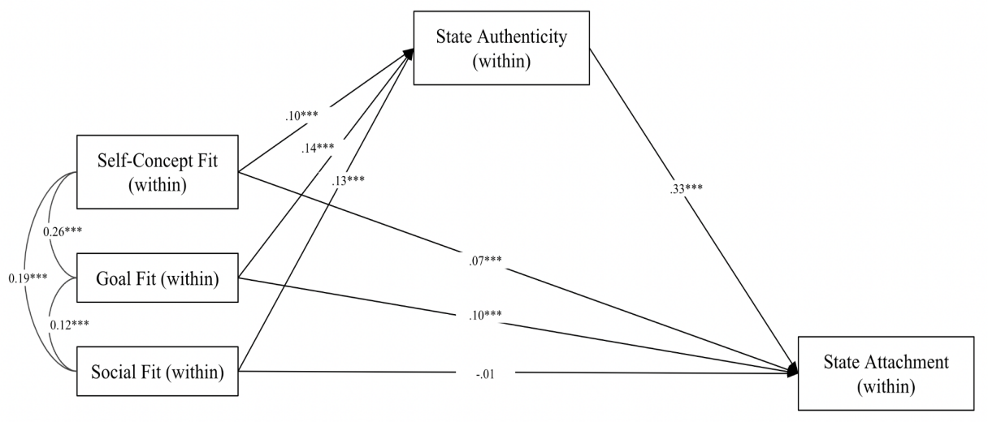
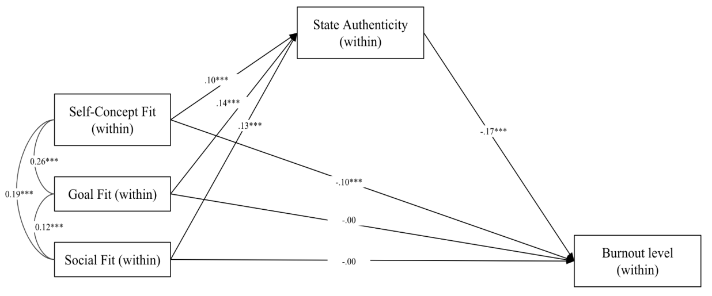
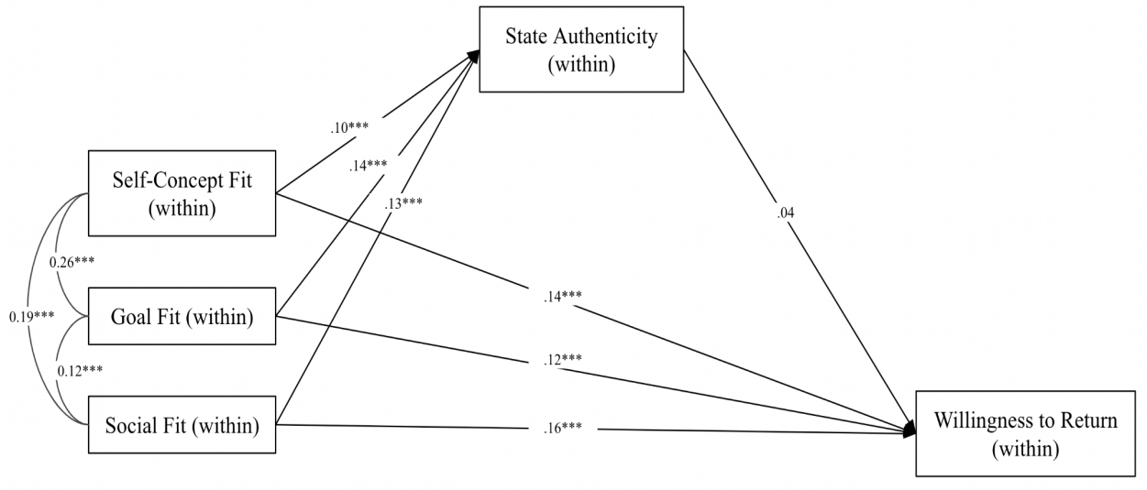

Table 6
Within-Person Results of Momentary Fit and Authenticity Predicting Momentary Outcomes
 | State Authenticity | Willingness  to Return | State Attachment | Working Memory | Burnout
Predicting Outcomes from Fit
Momentary Self Concept  Fit | β = .11***  [0.07, 0.16] | β = .16***  [0.10, 0.21] | β = .10***  [0.06, 0.15] | β = .12**  [0.04, 0.19] | β = -.12***  [-0.18, -0.06]
Momentary Goal Fit | β = .12***  [0.07, 0.16] | β = .11***  [0.06, 0.16] | β = .13***  [0.08, 0.17] | β = -.04  [-0.10 , 0.03] | β = -.03  [-0.09 , 0.02]
Momentary Social Fit | β = .14***  [0.10, 0.19] | β = .15***  [0.10, 0.20] | β = .07**  [0.02, 0.11] | β = -.08*  [-0.16, -0.01] | β = -.04  [-0.10 , 0.02]
Predicting Outcomes from State Authenticity
State Authenticity | NA | β = .23***  [0.15,0.31] | β = .36***  [0.30, 0.43] | β = -.01  [-0.10, 0.08] | β = -.23***  [-0.30, -0.15]
Note. *p < .05. **p < .01. ***p < .001. 95% CIs are reported in brackets. Variables (1) - (8) are single-item measures. We conducted separate models to test the unique predictive effects of fit (in one model to predict state authenticity and another set of models to predict outcomes) and state authenticity (in a separate model).

Do Features of the Context Uniquely Predict Different Types of Fit?
Lastly, we tested preregistered hypotheses about the types of contextual features that predict each type of fit. We ran a series of multilevel models with random intercepts regressing a given momentary fit rating (controlling for other fit measures) on each contextual variable (see Table 7; company was represented with three dummy-coded variables (i.e., “only close others”, “only non-close others”, “both close and non-close others”; with “alone” as the reference group).
Self-concept fit. Supporting preregistered hypotheses, participants experienced more self-concept fit in situations that were familiar (vs. unfamiliar), 𝛽 = .11, p = .01, or freely chosen, 𝛽 = .31, p < .001. No other contextual variable predicted self-concept fit uniquely.
Goal fit. Partially supporting hypotheses, participants experienced greater goal fit when engaged in active (vs. passive) activities, 𝛽 = .36, p < .001, but not when engaged in social (vs. solitary) activity, 𝛽 = .01, p = .89. No other contextual variable predicted goal fit uniquely.
Social fit. As hypothesized, participants experienced significantly greater social fit in situations with only close others (vs. alone), 𝛽 = .29, p < .001, and significantly less social fit in situations with only non-close others (vs. alone), 𝛽 = -.43, p < .001. Although not preregistered, participants also experienced greater social fit in situations that were familiar, and unsurprisingly, when engaged in social (vs. solitary) activities. They also experienced less social fit during activities that were active versus passive (Table 7).

Table 7

Contextual Features Predicting Momentary Fit

 | Self-Concept Fit |  | Goal Fit |  | Social Fit
 | Not Controlling for Other Fit | Controlling for Other Fit | Not Controlling for Other Fit | Controlling for Other Fit | Not Controlling for Other Fit | Controlling for Other Fit
Choose to be Here | 0.56***  [0.40, 0.71] | 0.31***  [0.18, 0.44] | 0.38***  [0.21, 0.54] | 0.07  [-0.07, 0.21] | 0.36***  [0.21, 0.51] | 0.13  [-0.01, 0.28]
Familiar Place | 0.29***  [0.19, 0.39] | 0.11*  [0.02, 0.19] | 0.24***  [0.13, 0.35] | 0.07  [-0.03, 0.16] | 0.32***  [0.22, 0.42] | 0.21***  [0.12, 0.30]
Actively Engaged | 0.13**  [0.04, 0.21] | -0.01  [-0.08, 0.06] | 0.41***  [0.32, 0.49] | 0.36***  [0.28, 0.43] | -0.12**  [-0.20, -0.04] | -0.22***  [-0.30, -0.14]
Social Activities | 0.23**  [0.09, 0.37] | 0.07  [-0.05, 0.18] | 0.13  [-0.03, 0.28] | 0.01  [-0.13, 0.15] | 0.29***  [0.15, 0.43] | 0.19**  [0.06, 0.31]
With Only Close Others | 0.10*  [0.02, 0.19] | 0.004  [-0.07, 0.08] | 0.01  [-0.08, 0.10] | -0.07  [-0.15, 0.01] | 0.32***  [0.24, 0.40] | 0.29***  [0.21, 0.36]
With Only Non-close Others | -0.22***  [-0.33, -0.11] | -0.02  [-0.11, 0.07] | -0.11  [-0.22, 0.01] | 0.05  [-0.06, 0.15] | -0.50***  [-0.61, -0.40] | -0.43***  [-0.53, -0.34]
With both Close and Non-close Others | -0.04  [-0.19, 0.10] | 0.08  [-0.04, 0.20] | -0.15†  [-0.31, 0.00] | -0.13†  [-0.26, 0.01] | -0.15*  [-0.29, -0.01] | -0.12†  [-0.25, 0.01]
Note. † p<.10. *p < .05. **p < .01. ***p < .001. 95%CIs are reported in brackets.
Discussion
Study 2 confirmed that three types of fit uniquely predict state authenticity and other momentary outcomes. Although results of between-person analyses constitute a conceptual replication of Study 1, the experience sampling method provides greater insight into how fit and authenticity vary from one situation to the next within-person. Controlling for individual differences, perceiving one’s environment as a fit to one’s self-concept, goals, and sociality offers independent pathways to feeling authentic in the moment. That said, momentary variation in fit only explained 9.07% of the total variation in state authenticity, suggesting that other unmeasured variables (both within and between-person) also play a role.
In line with the SAFE model, three distinct types of fit are predictive of situation selection, measured as one’s willingness to return to the situation. Just as fit and authenticity predicted students’ dropout intentions in Study 1, in Study 2 momentary variation in each type of fit (including social fit) predicted students’ state attachment to their university. Moreover, consistent with the SAFE model’s proposition that self-concept fit cues cognitive fluency, only self-concept fit predicted higher working memory capacity and lower burnout. Unexpectedly, social fit also predicted lower working memory capacity, perhaps because people were more distracted around close others. A puzzle of Study 2 is that state authenticity did not statistically mediate the effects of fit on one’s willingness to return to the situation, though there was evidence consistent with mediation for fit effects on state attachment and burnout (especially for self-concept fit). We revisit this issue in the General Discussion.
Finally, evidence supported preregistered hypotheses about contextual features that predict each type of fit. Choosing to be in a familiar place elicits self-concept fit, whereas active (vs. passive) engagement in a situation elicits goal fit. Social fit is elicited in a wider range of contexts: when people are with close (vs. non-close) others, in familiar places, and passively engaged in shared activities. Taken together, these patterns provide contextual evidence that these types of fit represent conceptually distinct ways in which individuals experience state authenticity as fit to their environment.
General Discussion
The present research tested key tenets of the SAFE model (Schmader & Sedikides, 2018), which posits three distinct types of person-environment fit—self-concept, goal, and social—that predict state authenticity and one’s attraction to, or attrition from, a given context. We tested these hypotheses across two studies examining university students’ fit and authenticity on campus, given possible consequences of these experiences for students’ engagement. Our work has theoretical, methodological, and practical implications.
Theoretically, the findings provide the first empirical support of key hypotheses derived from the SAFE model. Across multiple samples and two different methods, students reported greater authenticity to the degree that the context afforded higher self-concept, goal, and/or social fit. We established the predictive validity of a new SAFE scale using between-person analyses of students’ fit and authenticity felt at their university (Study 1) and in within-person analyses of three fit types across specific situations on campus (Study 2). These analyses confirm that although each type of fit is related to one another, they are also distinct predictors of state authenticity.
Furthermore, tests of convergent validity indicated that an undifferentiated measure of belonging is related to each type of fit, suggesting that research on belonging might be enhanced by distinguishing fit stemming from social acceptance from fit stemming from passive cues to the default self or from active engagement with valued goals. Tests of discriminant validity show that, although the SAFE scale is correlated with other related constructs (autonomy, relatedness, competence, sense of self, goal motivation, and belonging), it explains variability in authenticity that is unique from these variables. Finally, each fit’s relationship to state authenticity cannot be fully explained by positive affect or social desirability.
Study 2 provided evidence of the environmental cues that elicit each type of fit. Goal fit was uniquely experienced during active (vs. passive) activities, whereas self-concept fit was uniquely experienced in familiar and chosen situations, and social fit was uniquely experienced when with close (and without non-close) others. These results further reveal that each type of fit provides a unique pathway to state authenticity.
In addition to these theoretical advances, we psychometrically validated a new multidimensional SAFE scale that can be adapted to a variety of contexts. A pilot study provided initial evidence for a three-factor model corresponding to the three types of fit in the SAFE model. In Study 1, a CFA showed that our predicted three-factor model performed better than two-factor alternatives and yielded reliable scales. Single-item measures of each fit were related to distinct contextual factors in Study 2’s experience sampling paradigm. Thus, our studies provide researchers with easy-to-administer measures for examining distinct types of fit.
Our work makes a practical advance by linking fit and state authenticity to meaningful student outcomes. In Study 1, this included evidence that self-concept and goal fit (but not social fit) uniquely predicted students’ dropout intentions, as statistically mediated by state authenticity. In Study 2, within-person analyses revealed that momentary variation in each fit type uniquely predicted not only state authenticity, but also willingness to return to the situation and state attachment to one’s university. Such findings could inform interventions to enhance different types of fit. For example, if students report leaving a university computer science program because of social misfit, interventions might focus on facilitating social inclusion for those students. Low self-concept fit would instead suggest interventions that cue a sense of familiarity inclusive of students with a diversity of backgrounds or interests.
Although the present research focused on fit and authenticity in a general sample, the SAFE model provides a framework to examine how individuals with devalued social identities self-select out of domains where they systematically feel a lack of fit and authenticity. Ancillary analyses in Study 1 revealed that White students scored significantly higher than non-White students on self-concept, goal fit, and state authenticity (Supplementary Materials). Study 2’s smaller sample size made similar tests underpowered although mean comparisons between White and non-White students were in the same expected direction. As such, our findings complement research on cultural (mis)match and belonging (Stephens et al., 2012), self-esteem (Fulmer et al., 2010), and well-being (Götz et al., 2018). Having validated our multidimensional SAFE scale across several broad samples of university students, future work is needed to examine the effects of marginalization on these different types of fit, with possible implications for disparities in motivation, performance, and/or attrition and tailored interventions to close those gaps.
Limitations and Future Directions
The correlational design of this research precludes causal inferences about the relationship between fit and state authenticity or between state authenticity and engagement with the environment. However, the experience sampling methodology of Study 2 allows us to link these responses to ecologically valid features of the environment (Scollon et al., 2009) and approach/avoidance intentions. Causal relationships can be established in future experimental research that independently manipulates each type of fit to observe effects on other components of the SAFE model. Assuming that fit causally boosts engagement via state authenticity, there may also be recursive processes at work: feeling higher state authenticity might increase engagement and reinforce one’s fit to the environment.
Although our findings relied mainly on self-report measures, we note that subjective sense of fit and authenticity are critical for situational engagement. Additionally, Study 2 included a performance measure of working memory capacity and revealed that cognitive fluency was enhanced in situations that afforded high self-concept (and low social) fit. This link between self-concept fit and working memory capacity is consistent with the theorized link between self-concept fit and cognitive fluency (Schmader & Sedikides, 2018). Future research could include behavioral measures of motivational fluency elicited by goal fit (e.g., task persistence) and interpersonal fluency elicited by social fit (e.g., speech hesitations), as well as objective measures of situational selection or avoidance.
Finally, although we focused on intrapersonal experiences of state authenticity, state authenticity can also operate interpersonally, vis-à-vis the relational self (Chen, 2019; Chen et al., 2006). Interpersonal experiences of state authenticity might vary, as relational authenticity is predicted by enacting an ideal, as opposed to an actual, self (Gan & Chen, 2017). Future investigations might also examine how state authenticity is expressed much like nonverbal emotional expression (Ekman, 1993). Expressions of state authenticity might communicate norms about who will fit in that setting.
Conclusion
Feelings of fit and belonging have long been considered by laypeople and social scientists alike as driving decisions about which environments people enter or exit. The SAFE model extends this literature by delineating the different ways in which people feel a sense of fit to their environment (self-concept, goal, and social) and how these feelings of fit predict situation selection via state authenticity. By empirically distinguishing these three types of fit, our work provides a theoretical framework and newly validated measures to guide research on when, why, and how people self-select into some situations and out of others.

References
Arend, M.G., & Schäfer, T. (2019). Statistical power in two-level models: A tutorial based on Monte Carlo simulation. Psychological Methods, 24(1), 1–19. https://doi.org/10.1037/met0000195
Bates, D., Mächler M., Bolker, B., & Walker, S. (2015). Fitting linear mixed-effects models using lme4. Journal of Statistical Software, 67(1), 1–48. https://doi.org/doi:10.18637/jss.v067.i01.
Baumeister, R.F., & Leary, M.R. (1995). The need to belong: Desire for interpersonal attachments as a fundamental human motivation. Psychological Bulletin, 117(3), 497–529. https://doi.org/10.1037/0033-2909.117.3.497
Belanger, A.L, Joshi, M.P., Fuesting, M.A., Weisgram, E.S., Claypool, H.M., & Diekman, A.B. (2020). Putting belonging in context: Communal affordances signal belonging in STEM. Personality and Social Psychology Bulletin, 46(8), 1186–1204. https://doi.org/10.1177/0146167219897181
Bentler, P.M., & Bonett, D.G. (1980). Significance tests and goodness of fit in the analysis of covariance structures. Psychological Bulletin, 88(3), 588–606. https://doi.org/10.1037/0033-2909.88.3.588
Cable, D.M., & DeRue, D.S. (2002). The convergent and discriminant validity of subjective fit perceptions. Journal of Applied Psychology, 87(5), 875–884. https://doi.org/10.1037/0021-9010.87.5.875
Chen, S. (2019). Authenticity in context: Being true to working selves. Review of General Psychology, 23(1), 60–72. https://doi.org/10.1037/gpr0000160
Chen, S., Boucher, H. C., & Tapias, M. P. (2006). The relational self revealed: Integrative conceptualization and implications for interpersonal life. Psychological Bulletin, 132(2), 151–179. https://doi.org/10.1037/0033-2909.132.2.151
Cheryan, S., & Markus, H.R. (2020). Masculine defaults: Identifying and mitigating hidden cultural biases. Psychological Review, 127(6), 1022–1052. https://doi-org.ezproxy.library.ubc.ca/10.1037/rev0000209.supp
Cheryan, S., Plaut, V.C., Davies, P.G., & Steele, C.M. (2009). Ambient belonging: How stereotypical cues impact gender participation in computer science. Journal of Personality and Social Psychology, 97(6), 1045–1060. https://doi.org/10.1037/a0016239
Clark, L.A., & Watson, D. (2019). Constructing validity: New developments in creating objective measuring instruments. Psychological Assessment, 31(12), 1412–1427. https://doi.org/10.1037/pas0000626
Cook, J., & Wall, T. (1980). New work attitude measures of trust, organizational commitment and personal need non‐fulfilment. Journal of Occupational Psychology, 53(1), 39-52.
https://doi.org/10.1111/j.2044-8325.1980.tb00005.x
Costello, A.B., & Osborne, J. (2005). Best practices in exploratory factor analysis: Four recommendations for getting the most from your analysis. Practical Assessment, Research, and Evaluation, 10(7), 1–9. https://doi.org/10.7275/jyj1-4868
Curran, P.J., Bollen, K.A., Chen, F., Paxton, P., & Kirby, J.B. (2003). Finite sampling properties of the point estimates and confidence intervals of the RMSEA. Sociological Methods & Research, 32(2), 208–252. https://doi.org/10.1177/0049124103256130
Dasgupta, N. (2011). Ingroup experts and peers as social vaccines who inoculate the self-concept: The stereotype inoculation model. Psychological Inquiry, 22(4), 231–246. https://doi-org.ezproxy.library.ubc.ca/10.1080/1047840X.2011.607313
Deci, E.L., & Ryan, R.M. (1985). Intrinsic motivation and self-determination in human behavior. Plenum Press.
Diekman, A.B., Steinberg, M., Brown, E.R., Belanger, A.L., & Clark, E.K. (2017). A goal congruity model of role entry, engagement, and exit: Understanding communal goal processes in STEM gender gaps. Personality and Social Psychology Review, 21(2), 142–175. https://doi.org/10.1177/1088868316642141
Diener, E., Wirtz, D., Tov, W., Kim-Prieto, C., Choi. D., Oishi, S., & Biswas-Diener, R. (2009). New measures of well-being: Flourishing and positive and negative feelings. Social Indicators Research, 39, 247–266. https://doi.org/10.1007/978-90-481-2354-4_12
Engle, R. W. (2002). Working memory capacity as executive attention. Current directions in psychological science, 11(1), 19-23.
Faul, F., Erdfelder, E., Buchner, A., & Lang, A.-G. (2009). Statistical power analyses using G*Power 3.1: Tests for correlation and regression analyses. Behavior Research Methods, 41(4), 1149–1160. https://doi.org/10.3758/BRM.41.4.1149
Fleeson, W., & Wilt, J. (2010). The relevance of Big Five trait content in behavior to subjective authenticity: Do high levels of within-person behavioral variability undermine or enable authenticity achievement? Journal of Personality, 78(4), 1353–1382. https://doi.org/10.1111/j.1467-6494.2010.00653.x
Flury, J.M., & Ickes, W. (2007). Having a weak versus strong sense of self: The Sense of Self Scale (SOSS). Self and Identity, 6(4), 281–303. https://doi.org/10.1080/15298860601033208
Fulmer, C.A., Gelfand, M.J., Kruglanski, A.W., Kim-Prieto, C., Diener, E., Pierro, A., & Higgins, E.T. (2010). On “feeling right” in cultural contexts: How person-culture match affects self-esteem and subjective well-being. Psychological Science, 21(11), 1563–1569. https://doi.org/10.1177/0956797610384742
Gan, M., Heller, D., & Chen, S. (2018). The power in being yourself: Feeling authentic enhances the sense of power. Personality and Social Psychology Bulletin, 44(10), 1460–1472. https://doi.org/10.1177/0146167218771000
Gavelin, H.M., Domellöf, M.E., Åström, E., Nelson, A., Launder, N.H., Stigsdotter Neely, A., & Lampit, A. (2022) Cognitive function in clinical burnout: A systematic review and meta-analysis, Work & Stress, 36(1), 86–104. https://doi.org/10.1080/02678373.2021.2002972
Goffman, E. (1959). The presentation of self in everyday life. Anchor Books.
Götz, F. M., Ebert, T., & Rentfrow, P. J. (2018). Regional cultures and the psychological geography of Switzerland: Person–environment–fit in personality predicts subjective well being. Frontiers in Psychology, 9, 17. https://doi.org/10.3389/fpsyg.2018.00517
Hart, C.M., Ritchie, T.D., Hepper, E.G., & Gebauer, J. E. (2015). The balanced inventory of desirable responding short form (BIDR-16). Sage Open, 5(4), 2158244015621113. https://doi.org/10.1177/2158244015621113
Heppner, W.L., Kernis, M.H., Nezlek, J.B., Foster, J., Lakey, C.E., & Goldman, B.M. (2008). Within-person relationships among daily self-esteem, need satisfaction, and authenticity. Psychological Science, 19(11), 1140–1145. https://doi.org/10.1111/j.1467-9280.2008.02215.x
Hicks, J.A., Schlegel, R.J., & Newman, G.E. (2019). Introduction to the special issue: Authenticity: Novel insights into a valued, yet elusive, concept. Review of General Psychology, 23(1), 3–7. https://doi.org/10.1177/1089268019829474
Higgins, E.T. (2005). Value from regulatory fit. Current Directions in Psychological Science, 14(4), 209–213. https://doi.org/10.1111/j.0963-7214.2005.00366.x
Hu, L., & Bentler, P.M. (1999). Cutoff criteria for fit indexes in covariance structure analysis: Conventional criteria versus new alternatives. Structural Equation Modeling: A Multidisciplinary Journal, 6(1), 1–55. https://doi.org/10.1080/10705519909540118
Johnston, M.M., & Finney, S.J. (2010). Measuring basic needs satisfaction: Evaluating previous research and conducting new psychometric evaluations of the Basic Needs Satisfaction in General Scale. Contemporary Educational Psychology, 35(4), 280–296. https://doi.org/10.1016/j.cedpsych.2010.04.003
Kernis, M.H., & Goldman, B.M. (2005). A multicomponent conceptualization of authenticity: Theory and research. Advances in Experimental Social Psychology, 38, 283–357. https://doi.org/10.1016/S0065-2601(06)38006-9
Kifer, Y., Heller, D., Perunovic, W.Q.E., & Galinsky, A.D. (2013). The good life of the powerful: The experience of power and authenticity enhances subjective well-being. Psychological Science, 24(3), 280–288. https://doi.org/10.1177/0956797612450891
Kim, H.S. (2002). We talk, therefore we think? A cultural analysis of the effect of talking on thinking. Journal of Personality and Social Psychology, 83(4), 828–842. https://doi.org/10.1037/0022-3514.83.4.828
Kraus, M.W., Chen, S., & Keltner, D. (2011). The power to be me: Power elevates self-concept consistency and authenticity. Journal of Experimental Social Psychology, 47(5), 974–980. https://doi.org/10.1016/j.jesp.2011.03.017
Landa, I., & English, T. (2021). Variability in state authenticity predicts daily affect and emotion regulation. Emotion, 22(8), 1995–1999. https://doi.org/10.1037/emo0001017.supp
Leary, M.R., & Kelly, K.M. (2009). Belonging motivation. In M.R. Leary & R.H. Hoyle (Eds.), Handbook of individual differences in social behavior (400–409). Guilford Press.
Lenton, A.P., Bruder, M., Slabu, L., & Sedikides, C. (2013). How does “being real” feel? The experience of state authenticity. Journal of Personality, 81(3), 276–289. https://doi.org/10.1111/j.1467-6494.2012.00805.x
Lenton, A.P., Slabu, L., & Sedikides, C. (2016). State authenticity in everyday life. European Journal of Personality, 30(1), 64–82. https://doi.org/10.1002/per.2033
Lenton, A.P., Slabu, L., Sedikides, C., & Power, K. (2013). I feel good, therefore I am real: Testing the causal influence of mood on state authenticity. Cognition & Emotion, 27(7), 1202–1224. https://doi.org/10.1080/02699931.2013.778818
Lutz, P.K., Newman, D.B., Schlegel, R.J., & Wirtz, D. (2023). Authenticity, meaning in life, and life satisfaction: A multicomponent investigation of relationships at the trait and state levels. Journal of Personality, 91(3), 541–555. https://doi.org/10.1111/jopy.12753
Markus, H., & Wurf, E. (1987). The dynamic self-concept: A social psychological perspective. Annual Review of Psychology, 38(1), 299–337. https://doi.org/10.1146/annurev.ps.38.020187.001503
Maslow, A.H. (1954). Motivation and personality. Harper & Row.
Matz, S.C., & Harari, G.M. (2021). Personality–place transactions: Mapping the relationships between Big Five personality traits, states, and daily places. Journal of Personality and Social Psychology, 120(5), 1367–1385. https://doi.org/10.1037/pspp0000297
Mendoza-Denton, R., Downey, G., Purdie, V.J., Davis, A., & Pietrzak, J. (2002). Sensitivity to status-based rejection: Implications for African American students' college experience. Journal of Personality and Social Psychology, 83(4), 896–918. https://doi.org/10.1037/0022-3514.83.4.896
Newman, G.E., Bloom, P., & Knobe, J. (2014). Value judgments and the true self. Personality
and Social Psychology Bulletin, 40(2), 203–16. https://doi.org/10.1177/0146167213508791
Oberauer, K., Süß, H. M., Schulze, R., Wilhelm, O., & Wittmann, W.W. (2000). Working memory capacity—facets of a cognitive ability construct. Personality and Individual Differences, 29(6), 1017–1045. https://doi.org/10.1016/S0191-8869(99)00251-2
Paulhus, D. (1998). Paulhus Deception Scales (PDS): The Balanced Inventory of Desirable Responding—7: User’s manual. Multi-Health Systems.
Phillips, L.T., Stephens, N.M., Townsend, S.S.M., & Goudeau, S. (2020). Access is not enough: Cultural mismatch persists to limit first-generation students’ opportunities for achievement throughout college. Journal of Personality and Social Psychology, 119(5), 1112–1131. https://doi-org.ezproxy.library.ubc.ca/10.1037/pspi0000234.supp
Pickett, C.L., Gardner, W.L., & Knowles, M. (2004). Getting a cue: The need to belong and enhanced sensitivity to social cues. Personality and Social Psychology Bulletin, 30(9), 1095–1107. https://doi.org/10.1177/0146167203262085
Raudenbush, S.W., & Bryk, A.S. (2002). Hierarchical linear models: Applications and data analysis methods (Vol. 1). Sage.
Reber, R., & Unkelbach, C. (2010). The epistemic status of processing fluency as source for
judgments of truth. Review of Philosophy and Psychology, 1(4), 563–581. https://doi.org/10.1007/s13164-010-0039-7
Riediger, M., Wrzus, C., Schmiedek, F., Wagner, G.G., & Lindenberger, U. (2011). Is seeking bad mood cognitively demanding? Contra-hedonic orientation and working-memory capacity in everyday life. Emotion, 11(3), 656–665. https://doi.org/10.1037/a0022756
Rights, J.D., & Sterba, S.K. (2019). Quantifying explained variance in multilevel models: An integrative framework for defining R-squared measures. Psychological Methods, 24(3), 309–338. https://doi.org/10.1037/met0000184
Rogers, C. (1961). On becoming a person: A therapist’s view of psychotherapy. Houghton Mifflin.
Rosseel, Y. (2012). Lavaan: An R package for structural equation modeling and more. Version
0.5–12 (BETA). Journal of Statistical Software, 48(2), 1–36.
https://doi.org/10.18637/jss.v048.i02
Ryan, R.M., & Deci, E.L. (2000). Self-determination theory and the facilitation of intrinsic
motivation, social development, and well-being. American Psychologist, 55(1), 68–78. https://doi.org/10.1037110003-066X.55.1.68
Schmader, T., & Sedikides, C. (2018). State authenticity as fit to environment: The implications of social identity for fit, authenticity, and self-segregation. Personality and Social Psychology Review, 22(3), 228–259. https://doi.org/10.1177/1088868317734080
Sedikides, C., Lenton, A.P., Slabu, L., & Thomaes, S. (2019). Sketching the contours of state authenticity. Review of General Psychology, 23(1), 73–88. https://doi.org/10.1037/gpr0000156
Sedikides, C., Slabu, L., Lenton, A.P., & Thomaes, S. (2017). State authenticity. Current Directions in Psychological Science, 26(6), 521–525. https://doi.org/10.1177/0963721417713296
Stephens, N.M., Fryberg, S.A., Markus, H.R., Johnson, C.S., & Covarrubias, R. (2012). Unseen disadvantage: How American universities’ focus on independence undermines the academic performance of first-generation college students. Journal of Personality and Social Psychology, 102(6), 1178–1197. https://doi.org/10.1037/a0027143
Suhlmann, M., Sassenberg, K., Nagengast, B., & Trautwein, U. (2018). Belonging mediates effects of student-university fit on well-being, motivation, and dropout intention. Social Psychology, 49(1), 16–28. https://doi.org/10.1027/1864-9335/a000325
Swann, W.B., Jr. (2012). Self-verification theory. In P. Van Lange, A. Kruglanski, & E. T. Higgins (Eds.), Handbook of theories of social psychology (pp. 23-42). Sage Publications.
Walton, G.M., & Cohen, G.L. (2007). A question of belonging: race, social fit, and achievement. Journal of Personality and Social Psychology, 92(1), 82–96. https://doi.org/10.1037/0022-3514.92.1.82
Yeager, D.S., Walton, G.M., Brady, S.T., Akcinar, E.N., Paunesku, D., Keane, L., Kamentz, D., Ritter, G., Duckworth, A.L., Urstein, R., Gomez, E.M., Markus, H.R., Cohen, G.L., & Dweck, C.S. (2016). Teaching a lay theory before college narrows achievement gaps at scale. Proceedings of the National Academy of Sciences, 113(24), E3341–E3348. https://doi.org/10.1073/pnas.1524360113

Supplementary Materials

The SAFE Model: State Authenticity as a Function of Three Types of Fit

Table of Contents
Section | Page
Pilot Study – Summary of Key Measures | 1
Pilot Study - Results  Study 1 – Supplemental Materials | 4  11
Study 1 – Supplemental Results: Factor Analysis | 17
Study 1 – Supplemental Results: Core Findings | 22
Study 1 – Comparisons by Race/Ethnicity | 26
Study 2 – Supplemental Measures | 27
Study 2 – Supplemental Results | 29

Pilot Study
Our goal for this pilot study was to test whether state authenticity and commitment to one’s organization are a function of three distinct types of fit. To this end, we developed a fit measure containing three distinct subscales to assess self-concept, goal, and social fit. We internally generated an initial pool of items drawing on theoretical considerations from the SAFE model, all framed within an organizational context (see Table S2 for item wording). We then administered these items to a sample of working adults and subjected all three subscales to an exploratory factor analysis (EFA) to determine whether a three-factor solution corresponding to self-concept, goal, and social fit emerged. Using path modeling, we tested our theoretically- derived hypotheses that each type of fit would explain unique variability in participants’ state authenticity, which, in turn, would statistically mediate effects on their organizational commitment (i.e., commitment to their current job).
Method
Participants
Participants were 259 adults (M_{age} = 37.09, SD_{age} = 10.21; 52.51% women, 44.40% men, 3.09% non-specified gender) recruited for a 30-minute survey through Amazon’s Mechanical Turk and remunerated with $0.75. We restricted recruitment to participants who indicated they were currently employed in a workplace with at least three coworkers. We initially aimed to collect a sample of N = 250. A sensitivity analysis conducted in G*Power for a linear bivariate regression analysis (Faul et al., 2009) revealed that a sample of N = 259 would allow us to detect a standardized regression coefficient of .17 or greater with 80% power and an alpha of .05.
Procedure
Participants completed a 26-item fit inventory (grouped and counterbalanced by subscale; see Table S2). After completing several exploratory measures of fluency, participants reported their current level of state authenticity and organizational commitment, as well as exploratory measures of approach and avoidance motivation (exploratory variables are not described here). Finally, participants self-reported demographics.
Measures
Fit. We measured fit with a series of 26 items (9 measuring self-concept fit, 8 measuring goal fit, 9 measuring social fit; see Table S2 for full item text). Participants rated their agreement with each item (1 = strongly disagree, 7 = strongly agree).
State Authenticity. We measured state authenticity with Lenton et al.’s (2013b) real-self overlap scale (RSOS). This scale uses a single-item pictorial measure of seven pairs of circles, with each pair varying in degree of overlap between them. The instructions read: “Please look at the pair of circles below. In each pair, the circle on the left represents who you feel yourself to be IN YOUR WORKPLACE and the circle on the right represents your REAL SELF. Your real self is who you truly are (which may not necessarily be the same as who you would like to be).” In each pair, one circle was labeled “me now,” and the other circle was labeled “real me.” Participants were instructed to select the circle pair that best represented how close they feel in their workplace to their true self.
Organizational Commitment. We measured organizational commitment with six items adapted from Cook and Wall (1980; e.g., “I would be very happy to spend the rest of my career with this organization;” “I often think about quitting,” reverse scored). Participants rated their agreement with each item (1 = strongly disagree, 6 = strongly agree). The composite showed excellent reliability, $α$ = .90.
Results
Evidence for Three Distinct Types of Fit
Factor Analysis. We assessed the Kaiser-Meyer Olkin (KMO) Measure of Sampling Adequacy and conducted Bartlett’s Test of Sphericity to assess the data’s factorability. Both tests showed the data were factorable (KMO = .96, $χ$² (325) = 6154.85, p = .00). An initial principal components analysis yielded a three-components solution that explained 71.96% of the total variance. Similarly, the scree plot (see Figure S1) revealed the slope of the curve leveled off after three components.
Figure S1. Scree Plot from a Principal Components Analysis of 26 Fit Items

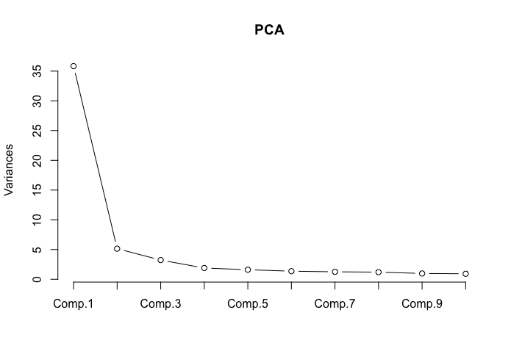
We also conducted a parallel analysis (Revelle, 2021), which suggested three factors (see Figure S2 and Table S1). We note that – while clearly above its simulated counterpart (eigenvalue = 0.50) – the third factor extracted through parallel analysis (eigenvalue = 0.95) fell just below the commonly applied Kaiser criterion (i.e., threshold of eigenvalue > 1). However, given the theoretical considerations of the SAFE model (and the very minor deviation from the cutoff as well as the superior performance over the simulated data), we opted to pursue a three-factor solution.

Figure S2. Parallel Analysis of 26 Fit Items
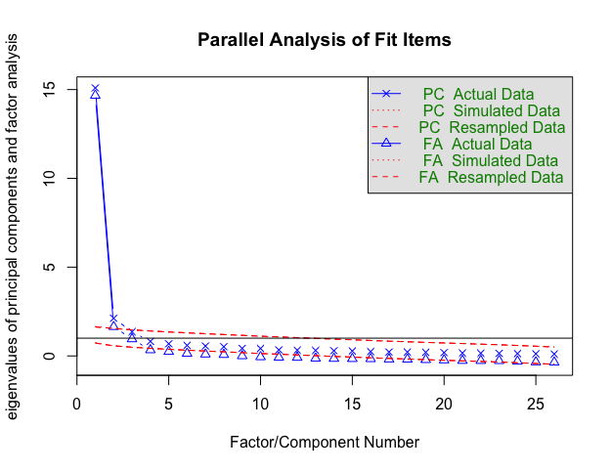
Table S1
Results of Parallel Analysis Among Fit Items in the Pilot Study
Factor | Empirical Eigenvalue | Simulated Eigenvalue
1 | 14.67 | 0.75
2 | 1.64 | 0.58
3 | 0.95 | 0.50

We next subjected all 26 fit items to a principal axis factor analysis with oblique, promax rotation (Costello & Osborne, 2005). As seen in Table S2, the three types of fit showed excellent factor structure, with each type of fit loading onto a separate factor (all factor loadings > .40, with no cross-loadings > .30 on the 15-item scale; Table S2).

Table S2
Results of Factor Analysis Among Fit Items in the Pilot Study
Item | Description | Factor 1 |  | Factor 2 | Factor 3
SCF 2 | Even when I’m alone and doing nothing, simply being in my workplace makes me feel like myself. | .91 | -.08 |  | .04
SCF 3 | Just being in my workplace suits the way I see myself. | .82 | .17 |  | -.10
SCF 8 | My workplace feels true to who I am. | .80 | .05 |  | .07
SCF 1 | Being in my workplace brings out my true self. | .79 | -.02 |  | .09
SCF 6 | I feel ‘at home’ when I’m in my workplace. | .70 | .14 |  | .06
SCF 9 | When I am in my workplace, I generally feel in line with the ‘real me.’ | .70 | -.04 |  | .27
SCF 4 | My workplace is a good fit for who I am. | .64 | .33 |  | -.08
SCF 7 | I do NOT feel isolated from my inner self in my workplace. | .49 | .07 |  | .19
SCF 5 | I feel at ease with myself being in my workplace. | .41 | .30 |  | .22
GLF 3 | My job is a place where I feel intrinsically motivated by my own goals. | .01 | .91 |  | -.04
GLF 5 | Standards of success at my job match what I think it means to be successful. | -.03 | .88 |  | -.04
GLF 2 | I often feel that my job is a place that allows me to realize my goals. | .06 | .82 |  | -.03
GLF 6 | My behavior at work is motivated by things I value. | -.02 | .77 |  | .01
GLF 4 | Tasks at my job are designed in a way that fits how I like to work. | -.06 | .75 |  | .13
GLF 7 | My job allows me to pursue topics and interests I am motivated to learn about. | .13 | .72 |  | -.04
GLF 8 | When working at my job, I feel like I am working toward my most prized goals. | .24 | .69 |  | -.07
GLF 1 | My workplace’s values are a good fit to my own personal values. | .10 | .67 |  | .00
SLF 9 | When I’m around my coworkers, I feel like I am my true self. | .14 | -.11 |  | .85
SLF 6 | I don’t feel like I need to be a different person around others at my job. | .10 | -.22 |  | .85
SLF 8 | My coworkers do NOT judge me for being my true self. | .04 | -.14 |  | .82
SLF 7 | I never have to hide the ‘real me’ when I’m with others at work. | .07 | -.02 |  | .81
SLF 5 | I feel that people at my job understand exactly who I am. | -.01 | .14 |  | .74
SLF 4 | Other people at my job see me in the same way I see myself. | .06 | .07 |  | .74
SLF 1 | When I’m with other coworkers at my job, I feel I can by myself. | -.05 | .18 |  | .71
SLF 3 | I feel that other people at my job accept me for who I am. | -.18 | .39 |  | .63
SLF 2 | I feel connected to my coworkers. | -.04 | .27 |  | .55
Note. SCF = Self-Concept Fit, GLF = Goal Fit, SLF = Social Fit. The five highest loading (or most face-valid, in cases where there was a tie) items on each factor are bolded.

Descriptive Statistics and Internal Consistency. Based on the results of this analysis, we selected the five highest-loading items from each factor, all with cross-loadings below .30 (Boateng et al., 2018; Costello & Osborne, 2005), and created a composite for each type of fit. For cases where there was a tie (i.e., between SLF 5 and SLF 4), we retained the item with higher face validity. Table S3 provides the overall means (SDs) and internal consistencies for all key variables measured in the pilot study. All three fit composites showed excellent reliability and did not correlate above r = .70.
Tests of Predictive Validity
The pilot study also provided an opportunity to carry out an exploratory test of the scale’s predictive validity by examining the unique relationships between each fit subscale and two key outcomes: state authenticity and organizational commitment.
State Authenticity. When we regressed state authenticity onto the three fit subscales simultaneously, the measures of self-concept fit (𝛽 = .50, p < .001) and social fit (𝛽 = .36, p < .001) both showed sizeable, unique relationships to state authenticity. Goal fit did not significantly predict state authenticity with the other two types of fit included in the model, and in fact showed a slight negative relationship (𝛽 = -.08, p = .23), suggesting a possible suppressor effect. The effect size for the relationship of self-concept fit and social fit, but not goal fit, to state authenticity was above the threshold of 𝛽 = .17 specified by sensitivity analyses. Together, the model explained over 50% of variance in state authenticity, F(3, 239) = 93.75, p < .001, R²_{adj} = .53.
Table S3
Descriptive Statistics and Correlations Among Key Variables Measured in the Pilot Study
 | M (SD) | (1) | (2) | (3) | (4)
(1) Self-Concept Fit (α = .94) | 4.63 (1.45)
(2) Goal Fit (α = .91) | 5.06 (1.27) | .70***
(3) Social Fit (α = .91) | 4.83 (1.39) | .70*** | .58***
(4) State Authenticity (1 item) | 4.68 (1.45) | .69*** | .48*** | .66***
(5) Org. Commitment (α = .90) | 3.86 (1.37) | .61*** | .68*** | .55*** | .55***
Note. *p < .05. **p < .01. ***p < .001.

Organizational Commitment. When we repeated this same simultaneous regression analysis with organizational commitment as the outcome, self-concept fit (𝛽 = .17, p = .018), goal fit (𝛽 = .48, p < .001), and social fit (𝛽 = .15, p = .024) each showed a unique predictive relationship to organizational commitment, although the direct effect of social fit fell below the threshold of 𝛽 = .17 specified by sensitivity analyses. Together, the three types of fit explained half of the variance in organizational commitment, F(3, 241) = 83.38, p < .001, R²_{adj} = .50.
Discussion
The results of this pilot study provided preliminary support for a new measure of fit that could be used to test several key propositions from the SAFE model by: (1) developing a highly reliable fit scale that empirically distinguishes among three fit constructs and (2) establishing the predictive validity of this measure by demonstrating that different types of fit uniquely predicts both state authenticity and interest in staying in versus leaving a setting (i.e., organizational commitment). Specifically, an exploratory factor analysis of a newly developed set of fit items supported a model positing three types of fit. Examining people’s feelings of fit at their place of work revealed that self-concept and social fit both uniquely predicted state authenticity and all three types of fit uniquely predicted one’s commitment to stay at one’s organization. Informed by the findings of this pilot study, we designed Study 1 to replicate and extend these preliminary findings in a different context: university students’ feelings of fit, authenticity, and commitment to their university. We adapted items used in this pilot study to refer to their university. In addition, we had some concerns that the mention of ‘true self’ in the item wording of some fit items and the authenticity measure could have artificially inflated their association. Thus, we made wording changes to four items in the fit scale to exclude mention of "true self" in an effort to reduce conceptual overlap with the authenticity measure. We also added a face valid measure of state authenticity in Study 1 to reduce this overlap.
Study 1 Supplemental Materials
Study 1 combined data across two waves of data collection from three separate samples that used largely overlapping measures and revealed very similar results. For the sake of parsimony and power, we report analyses on a combined dataset but provide a summary of analyses on the separate samples here.
Method
Participants
Sample A and B (collected during Wave 1 of data collection) included undergraduate students recruited from two large North American universities (n = 320 from University A in Canada, n = 219 from University B in the United States). Sample 3 (collected during Wave 2) was a preregistered (https://aspredicted.org/UVB_YUR) replication of Wave 1 with a broader sample of 430 U.S. university or college students (M_{age} = 23.19, SD_{age} = 6.22; 45.7% women, 44.1% men, 2.8% non-specified gender), recruited through Prolific Academic. A comparison of demographic characteristics across the three samples is provided in Table S4. Compared to Wave 1, Wave 2 had a higher proportion of male, White, Hispanic, and Black/African-American participants, but a lower proportion of Asian participants.

Table S4
Demographics by Sample in Study 1

Gender | Wave 1  University A  N (%) | Wave 1  University B  N (%) | Wave 1  Total  N (%) | Wave 2  Prolific Total  N (%)
Male | 103 (32.19%) | 51 (23.29%) | 154 (28.57%) | 207 (48.14%)
Female | 214 (66.88%) | 160 (73.06%) | 374 (69.39%) | 205 (47.67%)
Trans/non-binary | 3 (0.94%) | 6 (2.74%) | 9 (1.67%) | 14 (3.26%)
Generation Status  (First in family to attend college) | Wave 1 University A  N (%) | Wave 1 University B  N (%) | Wave 1  Total  N (%) | Wave 2  Prolific Total  N (%)
First Generation (Yes) | 40 (12.50%) | 34 (15.53%) | 74 (13.73%) | 87 (20.23%)
Non-First Generation (No) | 247 (77.19%) | 183 (83.56%) | 430 (79.78%) | 340 (79.07%)
Racial/Ethnic Background | Wave 1 University A  N (%) | Wave 1 University B  N (%) | Wave 1  Total  N (%) | Wave 2  Prolific Total  N (%)
East Asian | 104 (32.50%) | 66 (30.14%) | 170 (31.54%) | 40 (9.30%)
South Asian | 42 (13.13%) | 22 (10.05%) | 64 (11.87%) | 19 (4.42%)
Southeast Asian | 24 (7.50%) | 20 (9.13%) | 44 (8.16%) | 27 (6.28%)
Black/African/African  American | 9 (2.81%) | 4 (1.83%) | 13 (2.41%) | 44 (10.23%)
Hispanic/Latinx | 5 (1.56%) | 17 (7.76%) | 22 (4.08%) | 54 (12.56%)
Middle Eastern | 19 (5.94%) | 5 (2.28%) | 24 (4.45%) | 6 (1.40%)
Native American or Alaska  Native | 3 (0.94%) | 1 (0.46%) | 4 (0.74%) | 1 (0.23%)
Pacific Islander | 2 (0.63%) | 1 (0.46%) | 3 (0.56%) | 0 (0.00%)
White/European | 83 (25.94%) | 64 (29.22%) | 147 (27.27%) | 207 (48.14%)
Biracial/Mixed | 20 (6.25%) | 16 (7.31%) | 36 (6.68%) | 26 (6.05%)
Not Listed | 8 (2.50%) | 1 (0.46%) | 9 (1.67%) | 2 (0.47%)
 | Wave 1 University A  M (SD) | Wave 1 University B  M (SD) | Wave 1  Total  M (SD) | Wave 2  Prolific Total  M (SD)
Age (Years) | 21.01 (3.61) | 20.65 (2.39) | 20.86 (3.18) | 23.19 (6.22)
Between-Sample Comparison | t(534) = -1.29, p = .20, d = .11 |  | t(960) = -7.51, p < .001, d = .49
Family Social Class (1-6 scale) | 4.24 (0.93) | 4.16 (1.16) | 4.21 (1.03) | 3.72 (1.12)
Between-Sample Comparison | t(534) = -0.90, p = .37, d = .08 |  | t(959) = 7.04, p < .001, d = .46
Note. Percentages do not sum to 100 due to missing data.
Procedure and Measures
Participants completed all measures listed below clustered by scale with scale order randomized. In addition to measures of self-concept, goal, and social fit, participants reported their state authenticity, university commitment, social belonging, autonomy, relatedness, competence, sense of self, and goal motivation, positive and negative affect, and socially desirable responding. Responses to demographics questions concluded the session. Because these samples were collected as part of broader projects with additional goals, additional variables were assessed that were not analyzed or reported for this project. Below is the full list of variables included in the two waves of data collection (with variations across wave noted in parentheses). Variables analyzed and reported in the manuscript are denoted with an asterisk.

Conceptual Variables

- Academic Difficulty
- Imposter Feelings
- Belonging*
- Academic Help-seeking (one sub-scale not included in Wave 2)
- Growth Mindset
- Self-efficacy (only in Wave 2)
- Competitiveness
- Collective Self-Esteem
- Self-Concept Fit*
- Goal Fit*
- Social Fit*
- State Authenticity (RSOS)*
- State Authenticity (Single Item)*
- University Commitment*
- Autonomy, Competence, Relatedness *
- Positive/Negative Affect*
- Socially Desirable Responding*
- Sense of Self*
- Goal Motivation*
Demographics

- First-Generation Status
- Age
- Gender
- Semesters of College Completed
- Transfer Student Status
- Racial and/or Ethnic Background
- Mother Education
- Father Education
- Family Social Class
- Course Average
- University Name & Location (only in Wave 2)

Table S5a
Descriptive Statistics and Correlations Among Variables Measured in Study 1 (Wave 1)
 | M (SD) | (1) | (2) | (3) | (4) | (5) | (6) | (7) | (8) | (9) | (10) | (11) | (12) | (13) | (14) | (15)
(1) Self-Concept Fit (α = .94) | 4.44 (1.42)
(2) Goal Fit (α = .84) | 4.60 (1.18) | 0.64***
(3) Social Fit (α = .89) | 4.55 (1.25) | 0.60*** | 0.45***
(4) State Authenticity (Single-Item) | 4.89 (1.34) | 0.57*** | 0.50*** | 0.58***
(5) University Commitment (α = .74) | 0.00 (0.81) | 0.59*** | 0.47*** | 0.38*** | 0.45***
(6) Social Belonging (α = .85) | 0.01 (0.83) | 0.56*** | 0.51*** | 0.48*** | 0.48*** | 0.60***
(7) Autonomy (α = .73) | 4.68 (0.85) | 0.40*** | 0.43*** | 0.50*** | 0.42*** | 0.35*** | 0.49***
(8) Relatedness (α = .86) | 5.34 (0.94) | 0.36*** | 0.35*** | 0.52*** | 0.40*** | 0.35*** | 0.42*** | 0.62***
(9) Competence (α = .73) | 4.45 (0.95) | 0.34*** | 0.39*** | 0.36*** | 0.38*** | 0.33*** | 0.48*** | 0.56*** | 0.52***
(10) Positive Affect (α = .90) | 3.57 (0.65) | 0.63*** | 0.53*** | 0.47*** | 0.48*** | 0.50*** | 0.53*** | 0.49*** | 0.51*** | 0.48***
(11) Negative Affect (α = .84) | 2.83 (0.71) | -0.33*** | -0.38*** | -0.33*** | -0.30*** | -0.32*** | -0.39*** | -0.43*** | -0.31*** | -0.38*** | -0.47***
(12) BIDR-16 (SDE) (α = .69) | 3.78 (0.85) | 0.17*** | 0.25*** | 0.32*** | 0.28*** | 0.19*** | 0.34*** | 0.38*** | 0.21*** | 0.40*** | 0.30*** | -0.36***
(13) BIDR-16 (IM) (α = .70) | 4.14 (0.94) | 0.15*** | 0.18*** | 0.24*** | 0.20*** | 0.14** | 0.12* | 0.21*** | 0.17*** | 0.15*** | 0.14** | -0.18*** | 0.30***
(14) Sense of Self (α = .85) | 3.82 (0.82) | 0.17*** | 0.24*** | 0.30*** | 0.29*** | 0.23*** | 0.43*** | 0.52*** | 0.42*** | 0.58*** | 0.31*** | -0.38*** | 0.62*** | 0.19***
(15) Goal Motivation (α = .86) | 5.92 (0.96) | 0.23*** | 0.36*** | 0.27*** | 0.33*** | 0.22*** | 0.31*** | 0.38*** | 0.39*** | 0.48*** | 0.39*** | -0.18*** | 0.24*** | 0.19*** | 0.32***
Note. *p < .05. **p < .01. ***p < .001. BIDR = Balanced Inventory of Desirable Responding, IM = Impression Management, SDE = Self-Deceptive Enhancement. We standardized University Commitment and Social Belonging prior to forming composites due to items being on different scales.

Table S5b
Descriptive Statistics and Correlations Among Variables Measured in Study 1 (Wave 2)
 | M (SD) | (1) | (2) | (3) | (4) | (5) | (6) | (7) | (8) | (9) | (10) | (11) | (12) | (13) | (14) | (15)
(1) Self-Concept Fit (α = .94) | 4.58 (1.55)
(2) Goal Fit (α = .88) | 5.10 (1.19) | 0.70***
(3) Social Fit (α = .89) | 4.44 (1.25) | 0.69*** | 0.60***
(4) State Authenticity (Single-Item) | 4.97 (1.44) | 0.64*** | 0.55*** | 0.65***
(5) University Commitment (α = .75) | 0.00 (0.81) | 0.65*** | 0.61*** | 0.49*** | 0.52***
(6) Social Belonging (α = .87) | 0.00 (0.85) | 0.60*** | 0.60*** | 0.56*** | 0.58*** | 0.65***
(7) Autonomy (α = .76) | 4.63 (0.97) | 0.41*** | 0.43*** | 0.48*** | 0.48*** | 0.37*** | 0.50***
(8) Relatedness (α = .84) | 5.00 (1.03) | 0.48*** | 0.45*** | 0.48*** | 0.44*** | 0.45*** | 0.51*** | 0.59***
(9) Competence (α = .77) | 4.54 (1.12) | 0.43*** | 0.48*** | 0.40*** | 0.48*** | 0.46*** | 0.60*** | 0.70*** | 0.58***
(10) Positive Affect (α = .90) | 3.46 (0.72) | 0.63*** | 0.60*** | 0.53*** | 0.58*** | 0.60*** | 0.64*** | 0.49*** | 0.57*** | 0.59***
(11) Negative Affect (α = .85) | 2.59 (0.78) | -0.37*** | -0.44*** | -0.37*** | -0.38*** | -0.44*** | -0.58*** | -0.45*** | -0.35*** | -0.50*** | -0.59***
(12) BIDR-16 (SDE) (α = .75) | 3.84 (0.98) | 0.23*** | 0.27*** | 0.36*** | 0.39*** | 0.26*** | 0.47*** | 0.49*** | 0.36*** | 0.55*** | 0.38*** | -0.44***
(13) BIDR-16 (IM) (α = .73) | 4.18 (1.01) | 0.14*** | 0.21*** | 0.29*** | 0.30*** | 0.20** | 0.22*** | 0.20*** | 0.13*** | 0.26*** | 0.22*** | -0.27*** | 0.40***
(14) Sense of Self (α = .88) | 3.79 (0.97) | 0.23*** | 0.28*** | 0.33*** | 0.42*** | 0.30*** | 0.50*** | 0.56*** | 0.43*** | 0.60*** | 0.37*** | -0.44*** | 0.67*** | 0.30***
(15) Goal Motivation (α = .88) | 6.11 (0.92) | 0.31*** | 0.42*** | 0.35*** | 0.39*** | 0.37*** | 0.41*** | 0.49*** | 0.38*** | 0.52*** | 0.46*** | -0.38*** | 0.38*** | 0.20*** | 0.36***
Note. *p < .05. **p < .01. ***p < .001. BIDR = Balanced Inventory of Desirable Responding, IM = Impression Management, SDE = Self-Deceptive Enhancement. We standardized University Commitment and Social Belonging prior to forming composites, as responses scales were different.

Study 1 Supplemental Results
Confirmatory Factor Analysis of Fit
Table S5a and b summarizes descriptive statistics, scale reliabilities, and bivariate correlations for all variables in the two Waves of data collection. Given that an exploratory factor analysis in the pilot study yielded a three-factor solution, we used a confirmatory factor analysis (CFA) from the R package lavaan version 0.6-3 (Rosseel, 2012) to model each of the three types of fit as an interrelated latent construct, measured with the five respective fit items from each subscale. We used maximum likelihood estimation and full information maximum likelihood (FIML) to account for missing data. Here we report the results of this CFA on each Wave of data collection.
CFA on Wave 1. The chi-square test of model fit was significant, $χ$² (87) = 276.73, p < .001, but this is to be expected for large samples (Bentler & Bonett, 1980; Curran et al., 2003). Other fit indices less biased by sample size suggested good model fit, CFI = .97, RMSEA = .06, SRMR = .04 (Clark & Watson, 2019; Finch & West, 1997; Hu & Bentler, 1999; Pituch & Stevens, 2015). Table S6 and Figure S3a summarizes the full CFA model with factor loadings and covariances between latent constructs. All subscale items loaded .62 or higher onto each latent factor. This table also reveals that separate CFAs on Sample A and B (collected at different universities during Wave 1 of data collection), revealed very similar fit statistics and factor loadings.
The three fit factors were positively inter-correlated, with self-concept and goal fit showing the highest degree of overlap (r = .73). However, when comparing the hypothesized three-factor model to a simplified two-factor model that combined self-concept and goal fit items, the two-factor model showed poorer fit to the data ($χ$²(76) = 613.55, p < .001, CFI = .89, RMSEA = .12, SRMR = .07) compared to the theoretically derived three-factor model ($χ$²(87) = 276.73, p < .001, CFI = .97, RMSEA = .06, SRMR = .04).
Table S6

Results of Confirmatory Factor Analysis for Full Sample in Study 1 (Wave 1) and by Site

 |  |  | Standardized Factor Loadings
Latent Factor | Item |  | Full Sample |  | University A |  | University B
Self-Concept Fit | SCF 1 |  | .84 |  | .84 |  | .83
 | SCF 2 |  | .89 |  | .90 |  | .88
 | SCF 3 |  | .89 |  | .89 |  | .90
 | SCF 4 |  | .89 |  | .90 |  | .86
 | SCF 5 |  | .83 |  | .83 |  | .82
Goal Fit | GLF 1 |  | .82 |  | .83 |  | .81
 | GLF 2 |  | .62 |  | .68 |  | .51
 | GLF 3 |  | .84 |  | .84 |  | .84
 | GLF 4 |  | .70 |  | .71 |  | .67
 | GLF 5 |  | .63 |  | .67 |  | .59
Social Fit | SLF 1 |  | .85 |  | .85 |  | .85
 | SLF 2 |  | .84 |  | .83 |  | .87
 | SLF 3 |  | .68 |  | .66 |  | .69
 | SLF 4 |  | .82 |  | .82 |  | .84
 | SLF 5 |  | .74 |  | .75 |  | .74
 |  |  | Standardized Covariances
Latent Factors |  |  | Full Sample |  | University A |  | University B
Self-Concept Fit, Goal Fit |  |  | .73 |  | .72 |  | .74
Self-Concept Fit, Social Fit |  |  | .64 |  | .61 |  | .71
Goal Fit, Social Fit |  |  | .50 |  | .47 |  | .57
 |  | Model Fit Statistics
 |  | Full Sample |  | University A |  | University B
$χ$² (87) |  | 276.73, p < .001 |  | 207.27, p < .001 |  | 178.08, p < .001
CFI |  | .97 |  | .96 |  | .96
RMSEA |  | .06 |  | .07 |  | .07
SRMR |  | .04 |  | .05 |  | .04
Note. SCF = Self-Concept Fit, GLF = Goal Fit, SLF = Social Fit.

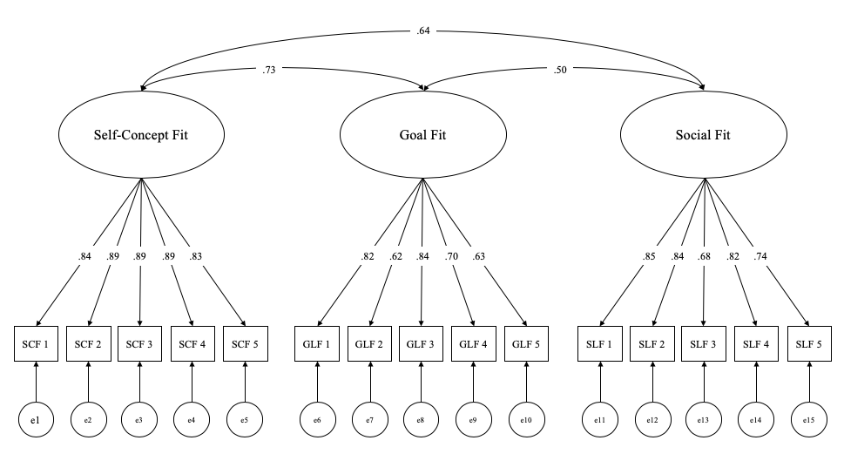
Figure S3a. Confirmatory Factor Analysis of Fit Measures in Study 1 (Wave 1).

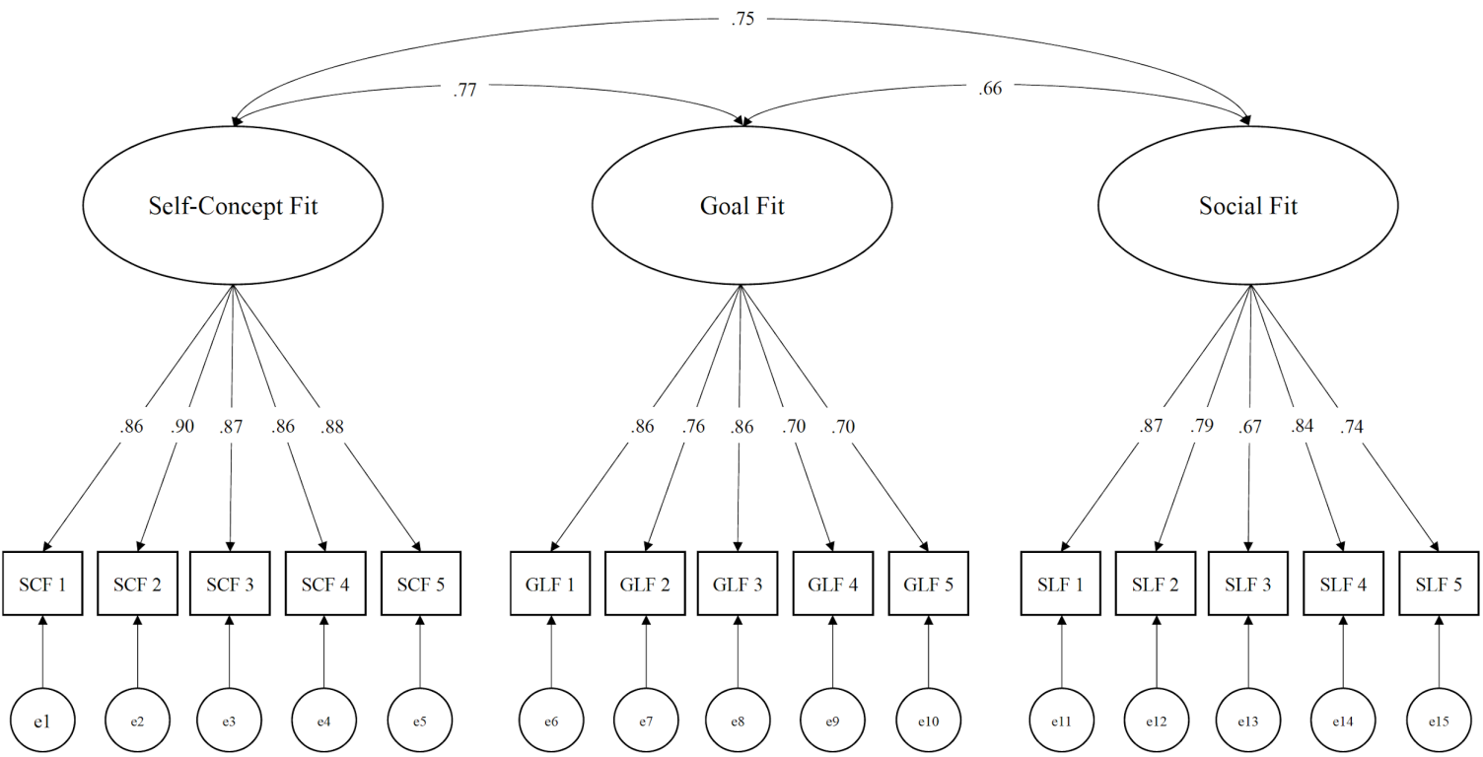
Figure S3b. Confirmatory Factor Analysis of Fit Measures in Study 1 (Wave 2).

CFA on Wave 2. In Wave 2, again the chi-square test of model fit was significant, $χ$² (87) = 183.21, p < .001, but other fit indices less biased by sample size indicated good model fit; CFI = .98, RMSEA = .05, SRMR = .03 (Clark & Watson, 2019; Finch & West, 1997; Hu & Bentler, 1999; Pituch & Stevens, 2015). All subscale items loaded .67 or higher onto each latent factor (See Figure S3b). The correlations among the three fit factors were slightly larger than in Wave 1, with self-concept and goal fit again showing the highest overlap (r = .77). As in Wave 1, however, a two-factor model (combining self-concept and goal fit items) had poorer fit to the data ($χ$² (89) = 553.47, p < .001, CFI = .90, RMSEA = .11, SRMR = .06) compared to the three-factor model ($χ$² (87) = 183.21, p < .001, CFI = .98, RMSEA = .05, SRMR = .03).
Distinguishing Fit from State Authenticity and Belonging. In the full sample (combining Wave 1 and 2), we also conducted an exploratory factor analysis (EFA) to examine whether the three types of fit are also distinct from both state authenticity and belongingness (5 for self-concept fit, 5 for goal fit, 5 for social fit, 2 for state authenticity, and 4 for belongingness). The self-determination (SDT) items were not included in these analyses because those items failed to factor analyze into their theoretically defined three-factor structure in an initial analysis (contact authors for details).
First, both a Kaiser-Meyer Olkin (KMO) Measure of Sampling Adequacy and Bartlett’s Test of Sphericity showed that the data were factorable (KMO = .96, χ² (210) = 14428.22, p < .001). Moreover, an exploratory factor analysis (parallel analysis, Revelle, 2021) revealed the expected five factor solution (Figure S4). We then subject all items to a principle axis factor analysis with oblique, oblimin rotation. With a cut-off at 0.40, three types of fit, authenticity, and belongingness loaded separately onto different factors (see Table S7). These analyses confirm that our three measures of fit are empirically as well as conceptually distinct from our measure of state authenticity and from a measure of belonging.

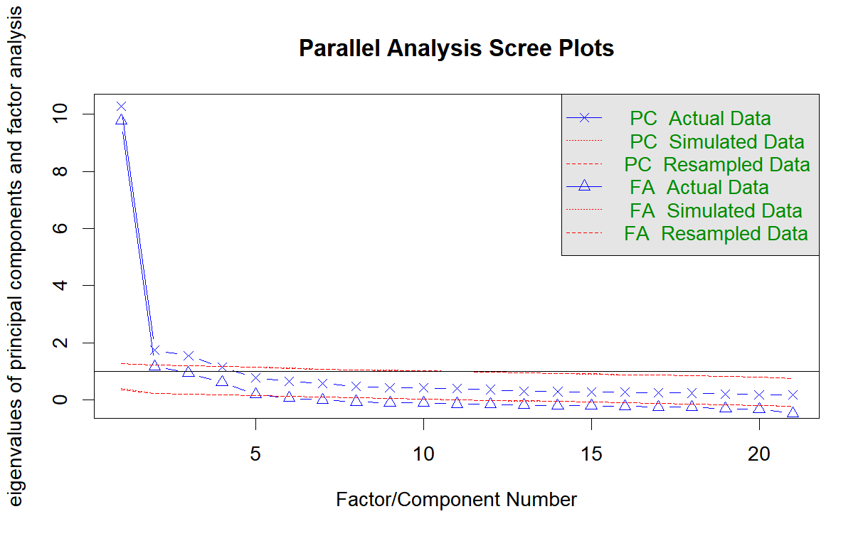
Figure S4. Parallel Analysis of Fit, Authenticity, and Belongingness Items
Table S7
Results of Factor Analysis Among Fit, Authenticity, and Belongingness Items
Item | Factor 1 | Factor 2 | Factor 3 | Factor 4 | Factor 5
SCF1 | .91 | .02 | -.04 | -.05 | -.04
SCF2 | .85 | .02 | .06 | .02 | -.05
SCF3 | .78 | .00 | .11 | .06 | -.01
SCF4 | .73 | .08 | .07 | -.04 | .10
SCF5 | .81 | .03 | -.04 | .04 | .09
GLF1 | -.04 | .00 | .83 | .00 | .09
GLF2 | .02 | .03 | .71 | .01 | -.11
GLF3 | .07 | -.01 | .80 | -.01 | .03
GLF4 | .01 | .01 | .60 | .06 | .14
GLF5 | .02 | .05 | .68 | .04 | -.15
SLF1 | .10 | .75 | -.01 | .05 | .04
SLF2 | -.06 | .85 | -.05 | .05 | .07
SLF3 | .02 | .69 | .06 | .03 | -.16
SLF4 | .00 | .82 | .05 | -.04 | .02
SLF5 | .21 | .56 | .08 | -.01 | .01
Belong1 | -.05 | -.04 | .08 | .81 | -.02
Belong2 | -.05 | .11 | -.04 | .83 | -.02
Belong3 | .24 | .01 | .03 | .59 | .08
Belong4 | .39 | -.04 | .07 | .48 | .14
Auth1 | .11 | .25 | .21 | .06 | .42
Auth2 | .08 | .23 | .07 | .08 | .46
Note. SCF = Self-Concept Fit, GLF = Goal Fit, SLF = Social Fit, Belong = Belongingness, Auth = State Authenticity. Those loadings above the .40 cut-off are bolded.

Which Types of Fit Predict Students’ State Authenticity and University Commitment?
Predicting State Authenticity from Fit. Core analyses in the main paper present results collapsed across wave/sample. Here we describe them separated. Consistent with the SAFE model, all three types of fit significantly and uniquely predicted state authenticity both in Wave 1: self-concept fit, 𝛽 = .23, p < .001; goal fit, 𝛽 = .19, p < .001; and social fit, 𝛽 = .35, p < .001 (explaining 42% of the variance in state authenticity, F(3, 491) = 121.70, p < .001, R²_{adj} = .42); and in Wave 2: self-concept fit, 𝛽 = .33, p < .001; goal fit, 𝛽 = .13, p < .001; social fit, 𝛽 = .34, p < .001 (explaining 50% of the variance in state authenticity, F(3, 425) = 144.8, p < .001, R²_{adj} = .50.
Predicting University Commitment from State Authenticity. In addition, we regressed university commitment simultaneously on all three fit measures both in Wave 1 (with Sample A/B as a covariate, which did not moderate effects) and Wave 2. In Wave 1, both self-concept fit, 𝛽 = .46, p < .001, and goal fit, 𝛽 = .14, p = .004 (but not social fit, 𝛽 = .03, p = .548) significantly and uniquely predicted university commitment (explaining 36% of the variance in university commitment, F(4, 481) = 70.22, p < .001, R²_{adj} = .36). Similarly, in Wave 2, self-concept fit, 𝛽 = .43, p < .001; and goal fit, 𝛽 = .30, p < .001 (but not social fit, 𝛽 = .005, p = .928) significantly predicted university commitment (explaining 47% of the variance in university commitment, F(4, 425) = 125, p < .001, R²_{adj} = .47).
Does Fit Predict University Commitment via State Authenticity? Finally, path analyses testing the unique relationship between each type of fit and university commitment as statistically mediated through state authenticity using the R package lavaan version 0.6-3 (Rosseel, 2012) also revealed similar effects in each Wave (see Figure S5a and b). For Wave 1 analyses, Sample A/B was included as a significant covariate only in paths predicting commitment (but not from each type of fit to authenticity).
In Wave 1 analyses, there was a significant indirect effect of self-concept fit (a*b = .02, p = .008), goal fit (a*b = .02, p = .01), and social fit (a*b = .03, p = .003). Self-concept fit (𝛽 = .25, p < .001), but neither goal fit (𝛽 = .06, p = .067) nor social fit (𝛽 = -.01, p = .786), retained direct effects to university commitment with state authenticity in the model. In Wave 2 analyses, we replicated the significant indirect effect of self-concept fit (a*b = .02, p = .016) and social fit (a*b = .03, p = .014); but the indirect effect of goal fit was marginal (a*b = .01, p = .059). With state authenticity in the model, self-concept fit (𝛽 = .20, p < .001) and goal fit (𝛽 = .19, p < .001), but not social fit (𝛽 = -.02, p = .45), retained direct effects to university commitment.
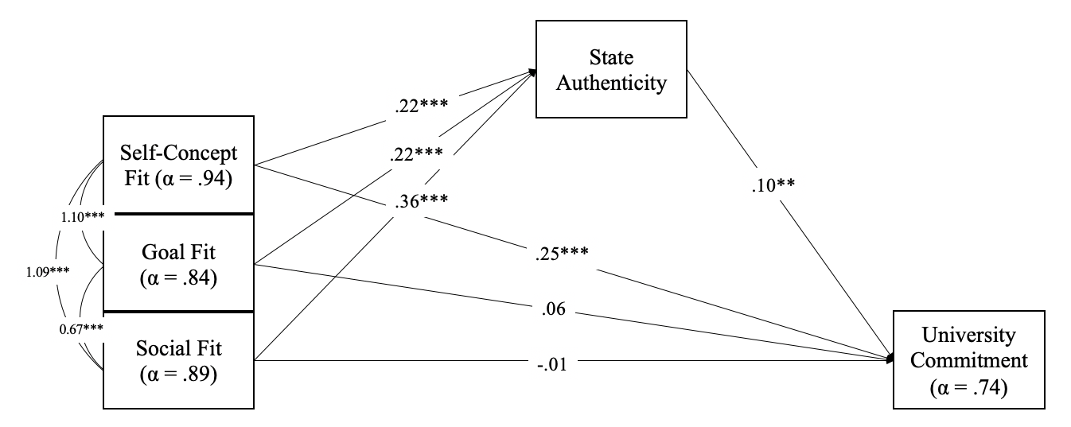
Figure S5a. Study 1 (Wave 1): Relation of Each Type of Fit to Organizational Commitment as Mediated Via State Authenticity. Path Coefficients Reflect Standardized Betas; Relationships Among Fit Constructs Reflect Raw Covariances (i.e., Their Estimates May Surpass 1.00)

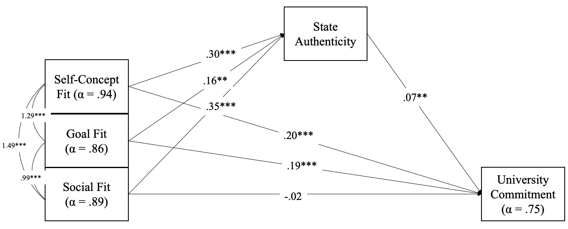
Figure S5b. Study 1 (Wave 2): Relation of Each Type of Fit to University Commitment as Mediated by State Authenticity. Path Coefficients Reflect Standardized Betas; Relationships Among Fit Constructs Reflect Raw Covariances (i.e., Their Estimates May Surpass 1.00)

Tests of Convergent and Discriminant Validity
The main manuscript provides tests of convergent and discriminant validity on the combined sample as well as analyses ruling out alternative explanations for the links between fit and authenticity. Here we provide these analyses separately by each Wave of data analysis. As summarized in Table S8, the results of these analyses yielded similar results for each Wave of data collection (note also that there was no evidence that results from Wave 1 were moderated by Sample A/B). The one exception was that in Wave 2, the relationship between goal fit and state authenticity (which had a weaker overall effect size in Wave 2) was not robust to controlling for other related constructs.

Table S8
Results of Models Testing Discriminant Validity by Controlling for Conceptually Related Variables When Regressing State Authenticity onto Fit Measures in Study 1 (Wave 1 and 2)
 | Original Model  (Model 0) |  |  | Self-Determination  Theory (Model 1) |  |  | Motivation, Self, & Belonging (Model 2) |  | Positive & Negative  Affect (Model 3) |  | Social Desirability  (Model 4)
 | Wave 1 | Wave 2 | Wave 1 |  | Wave 2 | Wave 1 |  | Wave 2 | Wave 1 | Wave 2 | Wave 1 | Wave 2
Self-Concept Fit | .23*** | .33*** | .23*** |  | .30*** | .23*** |  | .31*** | .18*** | .25*** | .26*** | .36***
Goal Fit | .19*** | .13** | .15** |  | .07 | .10* |  | .03 | .16*** | .06 | .15*** | .10*
Social Fit | .35*** | .31*** | .30*** |  | .28*** | .28*** |  | .25*** | .33*** | .31*** | .32*** | .25***
Competence | - | - | .09* |  | .13* | - |  | - | - | - | - | -
Autonomy | - | - | .05 |  | .10* | - |  | - | - | - | - | -
Relatedness | - | - | .03 |  | .02 | - |  | - | - | - | - | -
Sense of Self | - | - | - |  | - | .08 |  | .14*** | - | - | - | -
Goal Motivation | - | - | - |  | - | .10* |  | .13*** | - | - | - | -
Belonging | - | - | - |  | - | .10* |  | .13** | - | - | - | -
Positive Affect | - | - | - |  | - | - |  | - | .12* | .20*** | - | -
Negative Affect | - | - | - |  | - | - |  | - | -.14 | -.06 | - | -
BIDR (SDE) | - | - | - |  | - | - |  | - | - | - | .08* | .17***
BIDR (IM) | - | - | - |  | - | - |  | - | - | - | .04 | .10**

Note. *p < .05. **p < .01. ***p < .001. BIDR = Balanced Inventory of Desirable Responding, IM = Impression Management, SDE = Self-Deceptive Enhancement.

Study 1: Comparisons by Race/Ethnicity

Exploratory analyses of the combined sample compared fit and authenticity by race/ethnicity (Table S9). Compared with their White peers, non-White participants reported significantly lower levels of self-concept fit, goal fit, and state authenticity (but equivalent levels of social fit).

Table S9

Descriptive Statistics for Fit and Authenticity by Race in Study 1

 |  | Descriptive Statistics
Latent Factor | Non-White (n= 608)  M (SD) | White (n=354)  M (SD) | Cohen’s d | t-test
Self-Concept Fit  Goal Fit  Social Fit | 4.46 (1.46) | 4.74 (1.47) | .19 | -2.84**
 | 4.79 (1.20) | 5.01 (1.16) | .18 | -2.76**
 | 4.49 (1.30) | 4.47 (1.35) | .01 | 0.15
State Authenticity  RSOS  Combined Measure | 4.66 (1.45) | 4.79 (1.43) | .09 | -1.39
 | 4.85 (1.40) | 5.05 (1.36) | .15 | -2.21*
 | 4.75 (1.26) | 4.93 (1.24) | .14 | -2.12*
Note. *p < .05. **p < .01. ***p < .001.

Study 2: Supplemental Measures

Additional Measures for Study 2
Although the focus of Study 2 was the within-person effects described in the main manuscript, this study included additional measures intended for other sets of pre-registered hypotheses. The following measures were included in the T1 baseline survey (and, in some cases, again in the T2 survey): Acculturation Level (Vancouver Index of Acculturation; Ryder, Alden, Paulhus, 2000), Personality (Big Five Inventory – 2 Short Form; John & Soto, 2015), Academic Motivation (Academic Motivation Scale-College; Vallerand, et al., 1992), University Commitment, and Cross-Cultural Friendship Similarity.
Study 2: Sample Stimuli for Working Memory Capacity Measure
Participants received the following instructions in the T1 baseline survey to familiarize them with the working memory capacity measure.
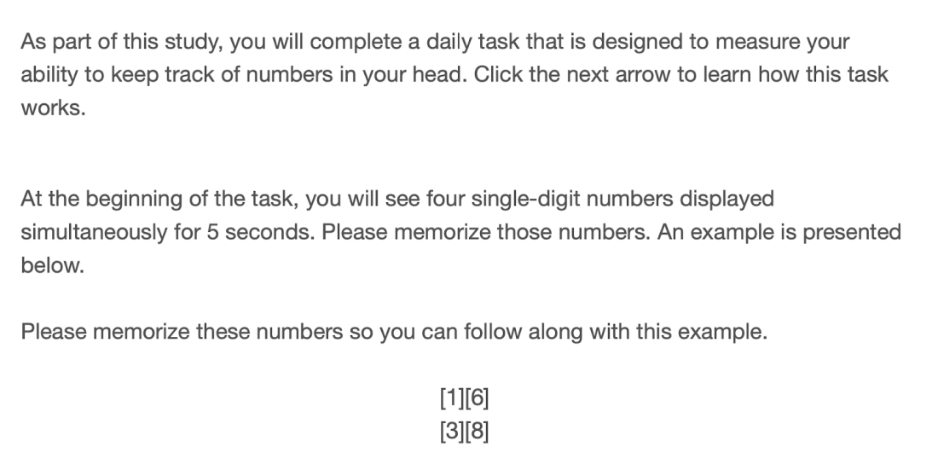
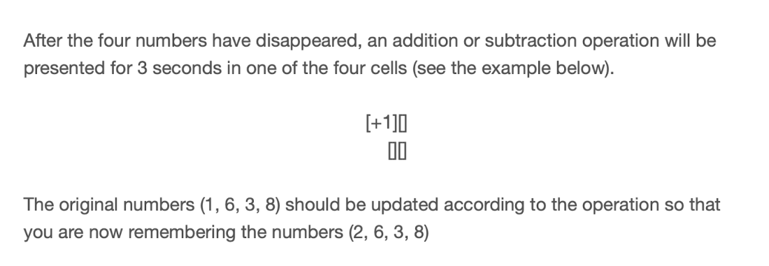
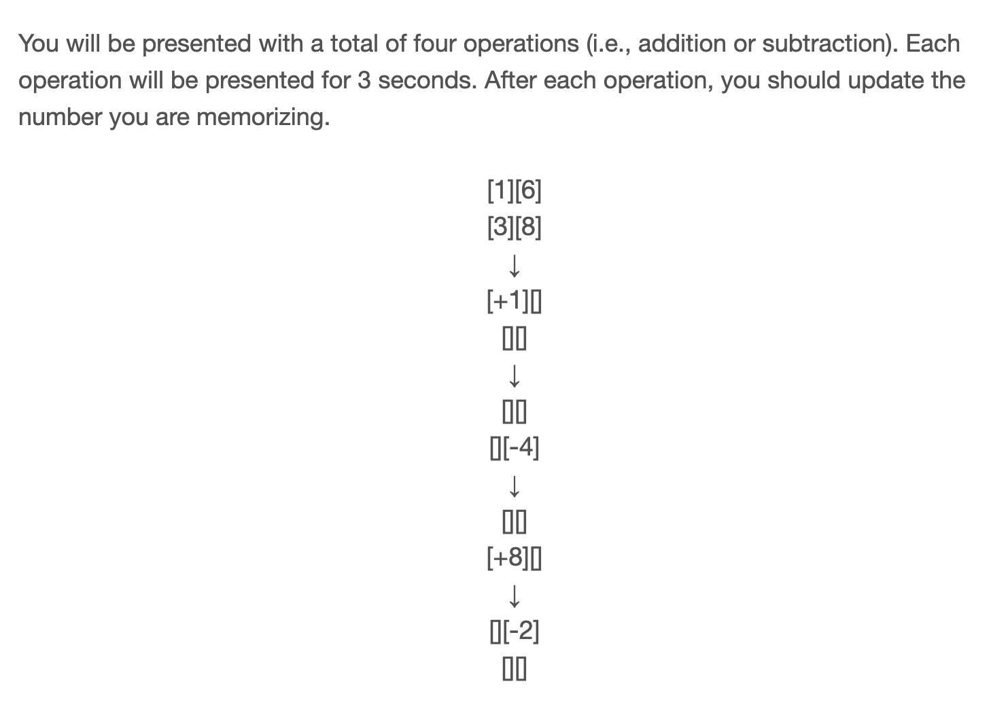

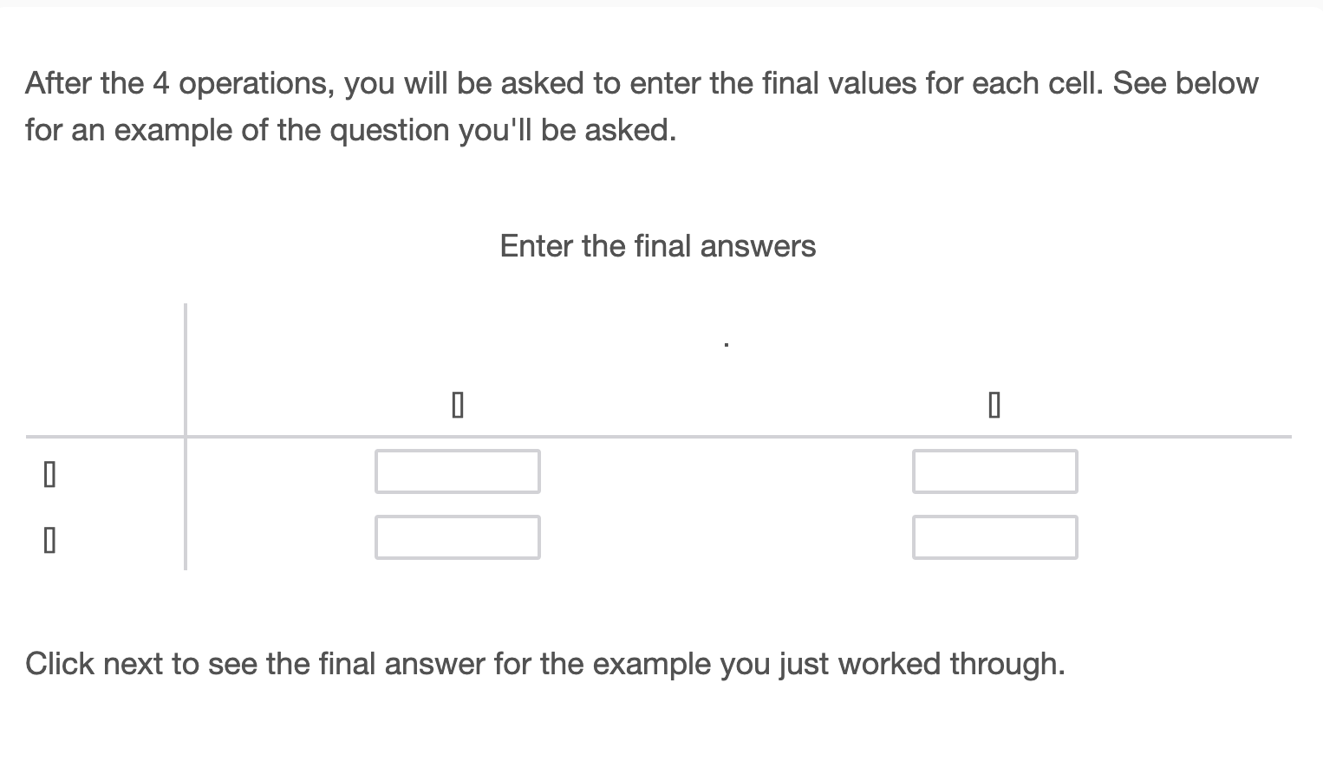
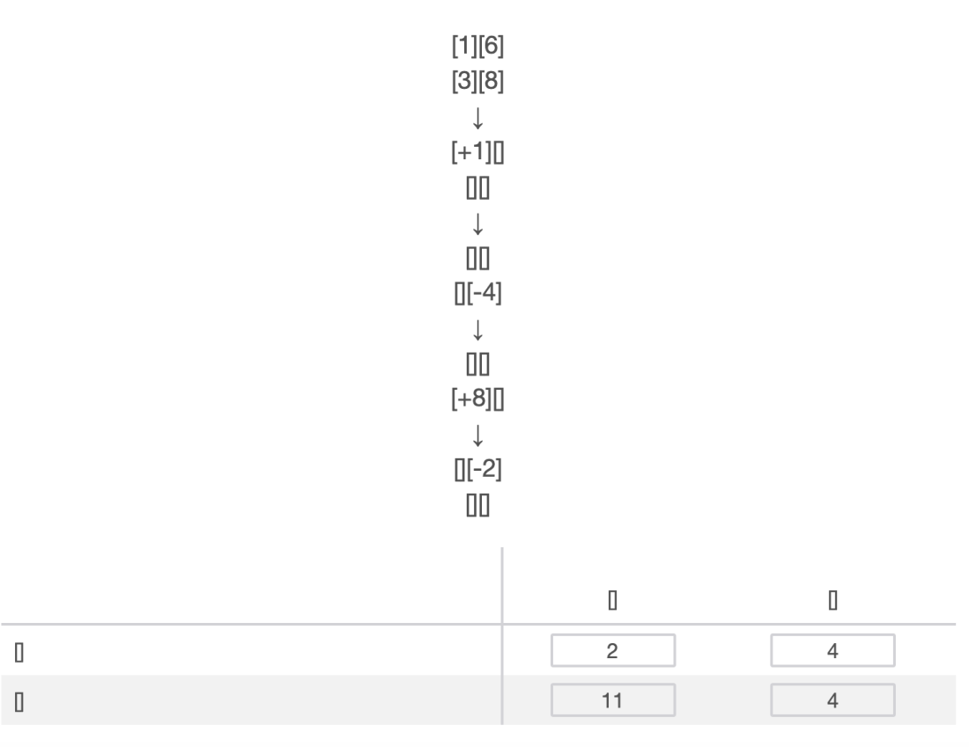

Study 2: Supplemental Results
The primary focus of Study 2 was the within-person effects that reflect the state-specificity of fit and authenticity predicting outcomes. Table S10 provides a summary of the between-person effects from these same analyses. Both within- and between-person variability in authenticity predicted each of the outcomes (except working memory capacity). For measures of fit, within-person variability in fit predicted outcomes more consistently than between-person variability.
Exploratory analyses similar as in Study 1 compared fit and authenticity by race/ethnicity (Table S11). Contrast to Study 1, we did not find significant difference in fit or state authenticity between White vs. Non-White participants, although the means are in the predicted direction.

Table S10
Study 2 Within-Person & Between-Person Results of Momentary Fit and Authenticity Predicting Momentary Outcomes
 | Willingness to Return |  | State Attachment  to University |  | Working Memory Capacity |  | Emotional Burnout
 | Within-Person | Between-Person | Within-Person | Between-Person | Within-Person | Between-Person | Within-Person | Between-Person
Predicting Outcomes from Fit
Momentary Self-Concept Fit | β = .16*** | β = .45*** | β = .10*** | β = .11 | β = .12** | β = .19 | β = -.12*** | β = -.10
Momentary Goal Fit | β = .11*** | β = .04 | β = .13*** | β = .34*** | β = -.04 | β = -.08 | β = -.03 | β = -.06
Momentary Social Fit | β = .15*** | β = .12 | β = .07** | β = .31*** | β = -.08* | β = -.10 | β = -.04 | β = -.11
Predicting Outcomes from Authenticity
State Authenticity | β = .23*** | β = .38*** | β = .36*** | β = .79*** | β = -.01 | β = -.05 | β = -.23*** | β = -.14*

Table S11
Study 2 Exploratory Analyses Comparing Fit and State Authenticity by Race/Ethnicity
 | White  (n = 47)  M (SD) | Non-White  (n = 206)  M (SD) | t | p
Self-concept fit | 5.29 (0.90) | 5.07 (0.89) | t(68.01)=-1.50 | 0.14
Goal fit | 5.24 (0.91) | 5.12 (0.91) | t(68.73)=-0.79 | 0.43
Social fit | 5.17 (1.15) | 4.93 (1.10) | t(66.51)=-1.29 | 0.20
State Authenticity | 5.13 (1.12) | 4.95 (1.07) | t(66.49)=-1.01 | 0.32

Although self-concept and goal fit correlated .70, in this pilot study as in Study 1, a three-factor model provided much greater fit to the data than a two factor model (see SOM for details).
A second visual measure of authenticity (Real-Self Overlap Scale; Lenton, Bruder et al., 2013) was positively related to the first, r = .60, p < .001, and effects relying on a combined measure were similar (Supplementary Materials). We report results only on the face valid measure to minimize construct overlap with fit measures.
We included social belonging in tests of both convergent and divergent validity because in past work (Yaeger et al., 2016), belonging has been defined in terms of social acceptance but measured with items that more broadly capture fit. We thus tested the assumption that the SAFE scale is convergent to this commonly used measure that references fit; but that our social fit scale is divergent from this as a measure of social belonging.
Three participants completed over 42 valid surveys due to their continuous reporting until T2.
The within-person variation of three types of fit accounted for 31.08% of the within-person variance in state authenticity.
All results are unchanged when controlling for dispositional authenticity measured in the T1 survey (Supplementary Materials).
A restriction in range on the chosen variable might constrain the size of this effect.
A sensitivity analysis conducted in G*Power for a multiple regression model with three predictors (i.e., types of fit) yielded the same effect size threshold, r = .17.
Further CFA analysis showed that a simplified two-factor model combining self-concept and goal fit items has poorer fit to the data (χ²[103] = 641.32, p < .001, CFI = .85, RMSEA = .15, SRMR = .07) than the theoretically-derived three-factor model (χ²[101] = 328.94, p < .001, CFI = .93, RMSEA = .10, SRMR = .05). We thus retain the theoretical three-factor model.
In addition to the face-valid authenticity item reported in the main manuscript, we also included a single-item pictorial measure (RSOS; Lenton, Bruder et al., 2013), adapted to refer to participants’ university. This visual measure of authenticity was positively correlated with the face-valid item, r = .58, p < .001, and effects using a combined measure were the same. However, we report results using only the face valid measure because of concerns of construct overlap with fit measures mentioning ‘real self’.
Examining residual correlations suggested that the item SLF 5 (“I feel that people at [University] understand exactly who I am”) showed modest overlap with items from the self-concept fit subscale. Because excluding this item revealed no significant drop in model fit, $∆χ$² (4) = -44.39, p = 1.00; we retained it in the social fit subscale, acknowledging its shared variance with the self-concept fit subscale. Additionally, conducting the CFA separately by each university showed largely similar fit indices and factor loadings (results provided in this SOM), suggesting no substantial variation by site.

