Workshop 1 report: Regulatory regimes: national and comparative regulation of public transport.

John Preston^{a*} and Anders Wretstrand^{b}

ª School of Engineering, Boldrewood, University of Southampton, Southampton, SO16 7QF. Tel: 44 (0)23 8059 4660. Email: jpreston@soton.ac.uk
^{b} [full postal address (where work was completed)] [phone number with international code] [email address]
*Corresponding author

JEL classification: (minimum of 3, maximum 6)
L51 Economics of regulation, L92 Railroads and other surface transportation, L98 Government policy

Keywords: (minimum 5, no maximum, separated with a semi-colon)
Bus, Competition, Ownership, Rail, Regulation

ABSTRACT

This workshop considered whether there was a need a for a fourth way (or ways) to organise and regulate public transport to complement the three existing models of classic regulation, deregulation and limited competition. This was particularly viewed from the perspective of what constitutes a good (public) transport authority. The evidence was based on five source papers and extensive discussions between the 14 workshop participants from eight countries. The key outcome was an update and extension of the STO (Strategic, Tactical and Operational) framework for the planning and control of public transport, with an enhanced focus on organisational aspects and on wider socio-economic aspects. However, the search for the elusive fourth way and the specification of the transport authority (and related bodies) to deliver public value continues.

1. Introduction

This workshop was envisaged as a follow-up to Workshop 2 at Thredbo 16 held in Singapore
in 2019 and summarised by van de Velde and Alexandersson (2020). Traditionally, there has been a binary divide between largely publicly owned and controlled public transport systems (classic regulation) and privately owned and controlled systems (free market deregulation or limited regulation). The Thredbo Conference series coincided with (renewed) interest in a third way of limited competition in public transport (such as competitive tendering) that was largely authority led and built-on outsourcing in other sectors, such as municipal waste (Domberger et al., 1986). Therefore, the broad aim of this workshop was to consider a fourth way (or ways) in which there is greater operator involvement in limited competition models with a focus on the implications for authorities and regulators. In essence, this involved a continued search for new institutional regimes.

This search involved consideration of at least five thematic questions. Firstly, what does it take to have a well-performing public transport authority (PTA) or, indeed, a more general transport authority (TA)? Secondly, and following on from this, who will set up good contracting (whether competitively tendered or not)? The scope for specialist third party agencies might be considered here. Thirdly, how can the governance of urban transport be improved through the engagement of key stakeholders in a coordinating PTA? This would require the consideration of mechanisms for collaboration. Fourthly, where a trend for more public and/or private sector involvement (re-)develops, what arrangements could be proposed to ensure that public entities competently and efficiently provide transport services? Lastly, what does it take to make public entities competitive with the private sector in efficiency and performance? This will require consideration of corporatisation and yardstick competition, as in Japan (see Mizutani, 1997, Mizutani et al., 2009), as well as competition in the market (deregulation) and competition for the market (limited competition).

The intention was to consider these question for uni-modal and multi-modal contexts and also for multi-sectoral contexts (such as the interactions between scheduled public transport and the provision of transport in the education, health care and social service sectors). These questions would also be considered in both metropolitan (big city) and non-metropolitan (smaller cities and towns and rural areas) contexts.

Given the above, the structure of this report will be as follows. In the next section, the evidence presented, both in the form of the papers, and the ensuing discussion, will be outlined. In section 3, some concepts that emerged from this evidence will be discussed and some of the key contributions of the workshop outlined. In section 4, policy and research recommendations will be given.

2. Evidence Presented to the Workshop

The Workshop was relatively small, based on five source papers and contributions from 14 Workshop participants, representing 8 countries and a wide range of perspectives from industry, government and academia. However, the limited number of papers left plenty of time for discussion, whilst the small size of the group meant that everybody had a chance to contribute. The source papers and participants are listed at the end of this report. The five source papers were split into two broad groups.

The first group provided national reviews of Portugal, South Africa and Great Britain. The second group of papers provide international reviews of open access competition in the rail sector, with particular foci on Italy and on Austria, Czechia and Slovakia. These papers will be briefly discussed in turn.

Rosario Macario outlined recent developments in Portugal, with a focus on the Great Lisbon area. The backdrop is the European Union’s directives to liberalise public transport. However, the key developments are institutional. In 2015, two metropolitan areas were established (Lisbon and Porto) and 23 inter-municipal authorities. This was accompanied by the emergence of a double headed regulatory regime in which AMT (Autoridade da Mobilidade e Transportes) is the economic regulator and IMT (Instituto de Mobilidade e Transportes) is the technical regulator. Furthermore, in 2019 TML (Transportes Metropolitanos de Lisboa) was created. However, only 15 of the 18 municipalities in the Greater Lisbon areas have delegated their transport powers to TML. Tellingly, the city of Lisbon is one the authorities that has not done so and here the classic public monopoly model remains largely intact. TML will contract services on the basis of four zones with gross cost contracts of seven years duration. Two of the four zonal contracts (for areas south of the River Tagus) were let in the summer of 2022. The other two are expected to be let in early 2023. It is clearly too early to assess the impacts of the contracting-out (this will be the subject of future papers) but it seems likely that organisational rivalries and local politics have led to a sub-optimal institutional design that is unlikely to lead to policies that greatly enhance net economic benefits.

Jackie Walters and Noleen Pisa provided a review of South Africa’s public transport system, updating two previous reviews (Walters, 2008, 2013). The review reiterated some of the findings of the earlier work. Competitive tendering has stalled, with no new awards since 2002, although there may be some developments for BRT. The informal minibus sector has continued to gain market share from the formal public transport sector. This process has been exacerbated by Covid with the collapse of the urban rail commuter market and gross maladministration of the industry. Aside from a few BRT services and the Gautrain high speed services, it is clear that the aspirations of the 1996 White Paper on National Transport Policy have not been realised and root and branch reform of public transport organisation and planning may be required.

John Preston provided a review of public transport competition and ownership in Great Britain. Here two policy documents published in 2021, Bus Back Better and the Williams-Shapps Plan for Rail, seem to suggest an end to the era of deregulation and privatisation in Great Britain. However, this might be an overly simplistic interpretation. For buses outside London, the reliance on Enhanced Quality Partnerships will mean that private bus operators will be the key arbiters in policy developments, outside of a handful of city regions such as Manchester. For rail, the (eventual) creation of Great British Railways will vertically integrate rail planning and increase public control. However, at least in England, rail operations are likely to continue to be contracted to the private sector. As in both Portugal and South Africa, a combination of Covid and politics have added to the problematic nature of public transport competition and ownership, with the final demise of Boris Johnson’s premiership taking place during the conference.

In terms of reviews with an international element, Vardhman Lunkar described a data set for long distance rail services operating in 2019 between 69 European city pairs. More competition does not always reduce prices but instead seems to have a greater influence on service quality (including speed), capacity and price dispersion. The outcome in competed markets seem likely to result in too frequent services, with too small vehicles, an expected outcome of oligopolistic competition (Preston, 2008). An interesting issue at the network level is that a variant of the empty core problem may lead to markets that could be served by a regulated monopolist unserved in a more competitive environment (Button, 1992, Faulhaber, 1975). Jakub Chini and Ondrej Spetik reviewed on-track rail competition in Austria, Czechia and Slovakia. They note marked variations in incumbent market shares and in prices and highlight the importance of vertical separation, the role of the state in the competitive process and the advantages of incumbency.

Discussions drew on participants’ experiences from the countries represented in the workshop that were not covered by source papers (principally, Australia, New Zealand and Sweden). As would be expected, these experiences were mixed but there were some common themes. These included greater risk aversity post Covid resulting in the dominance of gross costs contracts (where contracting out is practised), agglomeration of both operators and contracts, the emergence of bodies such as the Independent Pricing and Regulatory Tribunal (IPART) in New South Wales and moves back towards public ownership in, for example, Sweden and South Australia.

3. Emerging Concepts and Workshop Outcomes

The workshop discussions were framed around previous taxonomies of public transport organisation that had framed the workshop 1 discussions at Thredbo 16 (Preston and Walters, 2020), including those of Hensher and Brewer (2001) and Currie (2016), but particularly that of van de Velde (1999). Discussions were framed around two perspectives raised by the source paper of Macario and Costa. Institutional perspectives included issues related to institutional design, the degree of centralisation (or decentralisation) of governance and the balance between public and private ownership and control. Policy perspectives considered the extent of service supply and the degree of productivity and effectiveness of different regimes. Figure 1 outlines the position of the source paper case studies using the taxonomy of Currie (op cit.), whilst Figure 2 uses the taxonomy of van de Velde (op cit.).
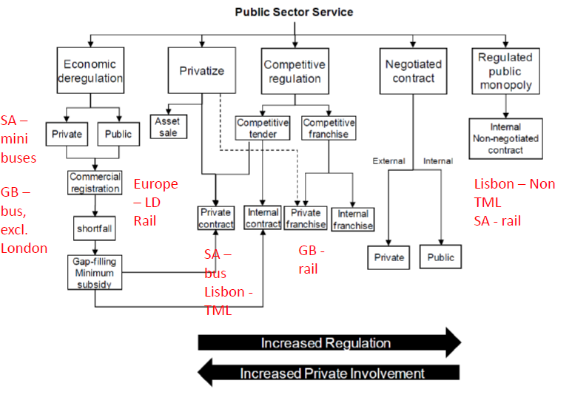
Figure 1: Models of Ownership and Competition in Public Transport
GB = Great Britain, LD = Long Distance, SA = South Africa, TML = Transportes Metropolitanos de Lisboa

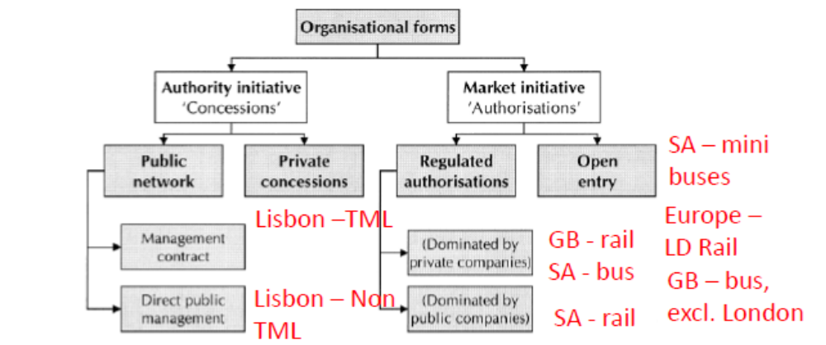

Figure 2: Organisational forms in public transport

Despite a relatively small number of case studies, a near full spectrum of organisational forms can be detected. The full range of ownership models can be seen in Figure 1 from the ‘pure’ private system of Minibuses in South Africa and the ‘pure’ public system in Lisbon (at least since 1975), but with a number of hybrid models in-between with a mix of public and private participants. Figure 2 shows that Portugal may be represented as an authority initiative in which ownership of the market rests with the state (as also in the French model). Great Britain and South Africa may be characterised as market initiatives in which ownership of the market rests with individual firms. Parts of the long-distance rail market in central Europe might be characterised this way, although the open access rail competition in Italy is more difficult to categorise using the schema of Figure 2. This might suggest that different schema may be required for categorisation of competition in the market models.

One such schema was supplied by the source paper of Beria et al. and is shown by Figure 3. This model makes important distinctions between route and network competition, niche and head-on intensive competition (see also Preston et al., 1999) and competition in the price, quantity, quality and product differentiation dimensions. Further developments for railways might usefully incorporate aspects of industrial structure related to vertical and horizontal integration (or separation) and to regulatory regimes. Variants of Figure 3 might also be usefully deployed to examine on the road competition, for example with respect to the deregulated long distance coach services in France and Germany or deregulated urban bus services in Great Britain outside London.
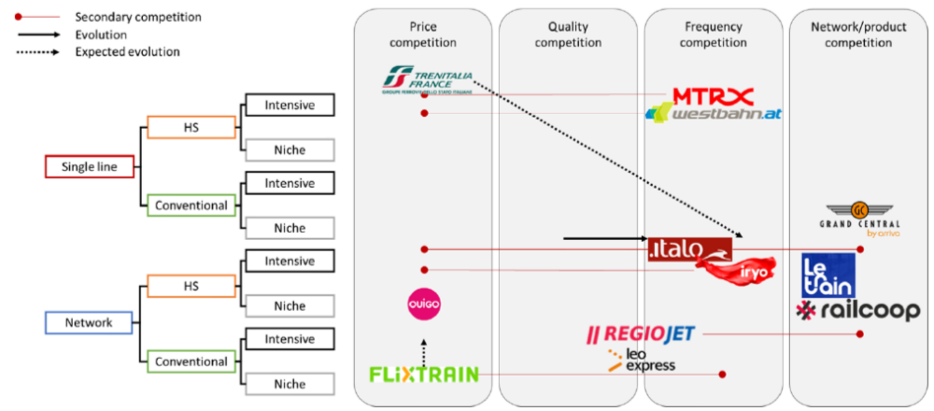
Figure 3: A taxonomy of competition in long-distance rail
HS = High Speed

However, the situation with respect to organisational form is rather more dynamic than the static analyses of Figures 1 and 2 would suggest. This is partly addressed by Figure 3 which indicates the evolution of competition in Italy. It also raises the need to consider regulatory cycles, as illustrated by Figure 4, which is based on Dementiev and Han, 2020.

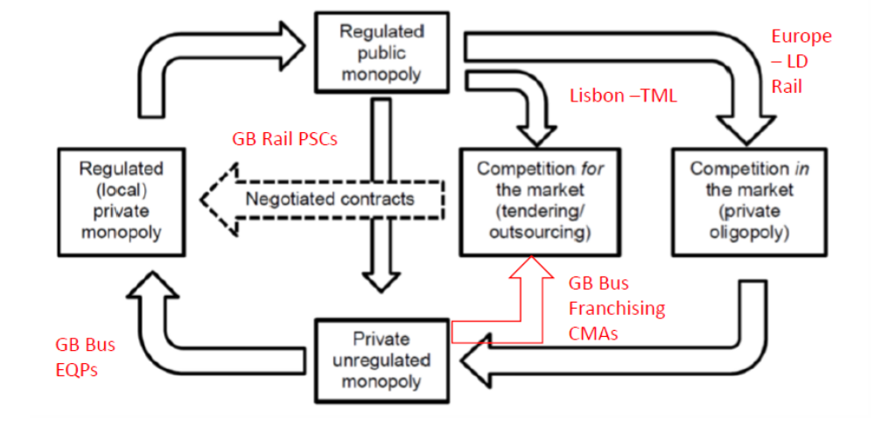
Figure 4: Regulatory cycles in public transport
CMAs = Combined Mayoral Authorities (e.g. Greater Manchester), EQPs = Enhanced Quality Partnerships, PSCs = Passenger Service Contracts.

The outer loop of Figure 4 is the conventional regulatory cycle outlined, for example, by Gwilliam (2008). The British bus industry is a good example of this, characterised by competition in the market in the 1920s, but becoming a regulated private monopoly following the 1930 Road Traffic Act and a regulated public monopoly following nationalisation (and municipalisation), particularly in 1947 and 1968. Outside London, the industry became competitive again following deregulation in 1986, as a result of the 1985 Transport Act. The latest twists of the regulatory cycle include shifts towards regulated local monopolies (or oligopolies) through the introduction of Enhanced Quality Partnerships or a shift towards competition for the market in the form of franchising (previously known as Quality Contracts) in a small number of Combined Mayoral Authorities (Cambridge, Liverpool, Manchester). The European long-distance rail market has undergone deregulation as a result of the European Union’s Fourth Package of reforms, with this competition being small group in nature. One of the features of Dementiev and Han’s model is the inner cycle. The TML areas in Greater Lisbon, outside the main centres, are examples of moving from regulated monopolies to competition for the market. Rail in Great Britain, at least in the immediate aftermath of Covid, is an example of moving away from franchising to negotiated contracts, which could be a feature of the new Passenger Service Contracts (although it is likely that most will be competed).

Another feature of the work of van de Velde (1999) that was discussed in this workshop was the three levels of the planning and control of public transport: Strategic, Tactical and Operational. This is the well known STO framework and is illustrated by Figure 5.

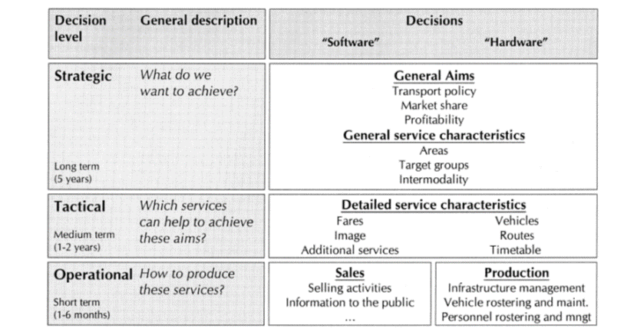

Figure 5: The STO Framework

The starting presumption of the workshop was that there should be public control of strategic planning and private control of public transport operations. The allocation of tactical roles seemed less clear cut and might involve third parties.

A key contribution of the workshop was to develop an expanded version of the STO framework as shown by Table 1 (additions in italics). A key addition is the column labelled organiware. At the strategic level, this involves deciding where on the regulatory and ownership taxonomies shown by Figures 1 to 3 the industry should be positioned. Another key decision is institutional – whether there should be a separate (and specialist) public transport authority or whether these duties should be executed by a more general, multi-modal transport authority. As well as TMT in Lisbon, the discussion focussed on the Land Transport Authority (Singapore), Transport for London (Great Britain) and Transport for New South Wales (Australia), suggesting a presumption in favour of multi-modal transport authorities. At the tactical level, the key decisions related to the extent to which some form of competitive tendering would be used and the nature of the contracts. At the operational level, this would involve issues around the award and enforcement of such contracts.

- With respect to software and hardware at the strategic level, it was felt more emphasis should be placed on socio-economic factors, in addition to the financials, with a focus on sustainability. At the tactical level, there might be greater focus on quality (for example as an award criteria) and on networks rather than routes (in part to address the empty core problem referred to above). Infrastructure provision is increasingly important, particularly for refuelling of zero emission vehicles and especially for guided systems. With respect to operations, data from the travelling public (mobile phone location, social media platforms etc.) will become increasing important as well as open data initiatives. New skills and training will be required to harness big data analytics and developments in machine intelligence. For zero emission vehicles, the scheduling of operations to permit refuelling will be important. There is likely to be an increasing role for on-demand services delivered by Mobility as a Service apps.

Table 1: An Expanded STO Framework

Decision Level | General Description | Decision Type
Decision Level | General Description | Software | Hardware | Organiware
Strategic | What do we want to achieve? | Aim: Transport Policy, Market Share, Profitability (Financial & Socio-Economic)  Service characteristics: Area, Target Groups, Intermodality Environmental & Employment Outcomes. SDGs, ESG, EDI etc. |  | Regulatory & Ownership Models  TA or specialist PTA.
Tactical | What activities will help us achieve what we want? | Fares  Image  Additional Services  Service Quality  Information provision | Vehicles  Routes/Networks  Timetable/Service Specification  Infrastructure | Delivery: In-house v NC v CT, Gross v Net Cost, Contract length, Flexibility, (Dis)incentives.
Operational | How do we produce these activities? | Selling activities  Information to (& from) the public Open data, on demand services etc.  Skills & training. | Infrastructure management.  Vehicle rostering & maintenance  Personnel rostering & management  Refuelling scheduling | Delivery implementation: procurement, monitoring & enforcement.

CT = Competitive Tendering, EDI = Equality, Diversity and Inclusion, ESG = Environmental, Social and Governance, NC = Negotiated Contract, PTA = Public Transport Authority, SDG = Sustainable Development Goals, TA = Transport Authority.

4. Recommendations

Based on the discussions within the Workshop and within the wider Conference, a set of policy and research recommendations have been drawn up. The implications for the next conference (Threbdo 18) are then considered.

4.1 Policy recommendations

A good transport authority should have a clear vision and be experienced (or have the ability to acquire experience), well resourced, decisive and consistent. They should avoid silo mentalities, have good corporate memory and be flexible in the face of disruption. The sense was that the perfect authority was out there somewhere, but had yet to be found.

However, it is also unlikely that the solution would involve just one body. Some regulatory activities could be undertaken by an independent agency and there was discussion of the role of IPART in New South Wales and of what is currently the Office of Rail and Road (ORR) in Great Britain. The issue of the regulation of the regulators (Quis custodiet ipsos custodes?) could be dealt with through Audit Offices and appropriate Key Performance Indices. There are though dangers of regulatory overreach and duplication (as with AMT and IMT in Lisbon)

There should be stakeholder involvement at the strategic planning and the tactical contract design stages. This could include associations of authorities, operators and citizens, either separately or jointly. The importance of co-creation between stakeholders and the principles of inclusive design were stressed.

There were perceived to be potential benefits of (controlled) in-the-market competition, yardstick competition (possibly in combination with negotiated contracts) and mixed regimes of various hues. There was believed to be scope for continued experimentation as regulatory cycles evolve.

There was a recognition that success requires trust between politicians, transport authority officers and operators through clear mandates, common interests and appropriate investments of time.

There remains scope for a Centre of Excellence in Public Transport regulation and there is a continued requirement for the documentation of both good and bad practices.

4.2 Research Recommendations

The workshop felt there was a need for a clarification of distinctions between tendering and franchising (and their efficacy). Evidence from the evolving regulatory systems in Great Britain and elsewhere should be informative.

The taxonomies of competition that have been reviewed should be extended (for example by studying competition in both capital and product markets as in Hartley et al., 1991). They should also be tested in other contexts, such as the deregulation of express coaches.

The impacts of infrastructure provision and access charging on outcomes should be further studied and where appropriate incorporated into the taxonomies above.

There is believed to be a need for assessments (both qualitative and quantitative) of the relative performance of transport authorities and public transport authorities, both with and without Independent Regulators.

For a given institutional design, the ‘optimal’ allocation of STO activities between public authorities, private operators and intermediaries need to be determined. Appropriate pathways for evolution over time need to be established.

There needs to be a consideration of the extent that the STO framework links to realist evaluation of policy objectives, inputs, processes, outputs, outcomes and impacts, building on the work of Pawson and Tilley (1997).

There is also scope for an assessment of the levels of trust engendered by different delivery models (such as competitive tenders and negotiated contracts) and how that varies with notions of institutional maturity.

There should be consideration of the relationships between levels of regulations and levels of disruption and the impacts on innovation.

Lastly, it is recommended that the theory of public value should be developed and applied to public transport, building on the work of Mark H. Moore (Moore, 1995).

4.3 Implications for Thredbo 18

The discussions above indicate that there remain many open questions on the appropriate organisational structure and regulatory regimes for public transport. Further, it is likely that many public transport markets post-Covid will have something of an existential crisis. It is therefore probably time to have a re-think as to what public transport is for and what are the best institutional designs to ensure that satisfactory outcomes are achieved. This might be best tackled by assessing the best features of transport authorities and the industrial and regulatory settings in which they operate. This might include both multimodal and multisectoral approaches, given the increasing role of active travel, shared services and micromobility in the first and last mile and the increasing coupling of public transport to the electricity sector.

5. Conclusions

The workshop detected a post-covid move to more hands-on regulation of public transport – in the terminology of Rhodes (1996) as a shift back from governance by steering to governance by rowing. However, it might be a mistake to just have a further turn of the established regulatory cycle. The search for the elusive fourth way to regulate and organise public transport and the specification of the transport authority (and related bodies) to deliver public value should continue. The Thredbo conference series should play a prominent role in this search and this workshop offers the extended STO framework of the planning and control of public transport as what is hoped to be a useful starting point.

Source Papers

Beria, P., Lunkar, V., Tolentino, S., Paril, V. and Kvasnicka, M. The seed of competition in long-distance rail transport. Comparing the early open-access countries.

Chini, J., Spetik, O. and Kvizda, M. What it the actual market power of rail incumbents?

Macario, R. and da Costa, N. M. Changing Urban Mobility Systems in Portugal; an arm-twist between politics and policy.

Preston, J. All Things Must Pass? Recent Changes to Competition and Ownership in Public Transport in Great Britain.

Walters, J. and Pisa, N. Review of South Africa’s Public Transport System’s Sub-Optimal Performance.

Workshop Participants

Jakob Chini (Czechia), Roz Chivers (Australia), Clint Feuerherdt (Australia), Kevin Wei-Ting (Australia), Vardhman Lunkar (Italy), Rosario Macario (Portugal), Noleen Pisa (South Africa), John Preston (UK), Veronica Schultz (Australia), Ondrej Spetik (Czechia), Ian Stuart (New Zealand), Matt Threlkeld (Australia), Jackie Walters (South Africa) and Anders Wretstrand (Sweden).

References
Button, K. (1996) Liberalising European aviation: Is there an empty core problem? Journal of Transport Economics. 275-291.

Currie, G. (2016) Deregulation, Franchising, Outsourcing and Corporatisation in Local Public Transport. International Transport Forum Discussion Paper 10. OECD, Paris.

Dementiev, A. and Han, H. J. (2020) A theory of deregulation in public transport. Research in Transportation Economics, 83, 100953.

Domberger, S., Meadowcroft, S. and Thompson, D. (1986) Competitive tendering and efficiency: The case of refuse collection. Fiscal Studies, 7, 4, 69-87.

Faulhaber, G.R. (1975) Cross-subsidisation: Pricing in Public Enterprise. American Economic Review, 65, 966-977.

Gwilliam, K. (2008) Bus transport: Is there a regulatory cycle? Transportation Research Part A, 42, 9, 1183-1194.

Hartley, K., Parker, D. and Martin, S. (1991) Organisational Status, Ownership and Productivity. Fiscal Studies, 12, 2, 46-60.

Hensher, D.A. and Brewer, A. (2001) Transport: An Economics and Management Perspective Management. Oxford University Press, Oxford.

Mizutani, F. (1997) Empirical Analysis of Yardstick Competition in the Japanese Railway Industry. International Journal of Transport Economics, 24, 3, 367-392.

Mizutani, F., Kozumi, H. and Matsushima, N. (2009) Does Yardstick Regulation Really Work? Empirical Evidence from Japan’s Rail Industry. Journal of Regulatory Economics, 36, 3, 308-32.

Moore, M. H. (1995) Creating Public Value: Strategic Management in Government. Harvard University Press, Cambridge, Mass.

Pawson, R. and Tilley, N. (1997) Realistic Evaluation. Sage, London.

Preston, J. (2008) Competition in Transit Markets. Research in Transportation Economics. 23, 75-84.

Preston, J., Whelan, G. and Wardman, M. (1999) An analysis of the potential for on-track competition in the British passenger rail industry. Journal of Transport Economics and Policy, 33, 1, 77-94.

Preston, J. and Walters, J. (2020) Workshop 1. Models of Mainstream Public Transport Provision. Research in Transportation Economics, 83, 100924.

Rhodes, R. (1996). The new governance: Governing without government. Political Studies, 652-667.

van de Velde, D. (1999) Organisational forms and entrepreneurship in public transport. Transport Policy, 6, 147-158.

van de Velde, D. and Alexandersson, G. (2020) Workshop 2 report: Practical
considerations in implementing different institutional regimes. Research in Transportation Economics, 83, 100920.

Walters, J. (2008) Overview of public transport policy developments in South Africa. Research in Transportation Economics, 22, 98-108.

Walters, J. (2013) Overview of public transport policy developments in South Africa. Research in Transportation Economics, 39, 34-45.

Declaration of interests

None.

