Evaluation of geomagnetic relative palaeointensity as a chronostratigraphic tool in the Southern Ocean: Refined Plio-/Pleistocene chronology of IODP Site U1533 (Amundsen Sea, West Antarctica)

Abstract
International Ocean Discovery Program (IODP) Expedition 379 to the Amundsen Sea margin of West Antarctica recovered drill cores at two sites spanning the Latest Miocene–Holocene interval with the aim of reconstructing past West Antarctic Ice Sheet dynamics. The recovered Plio-/Pleistocene sediment sequences offer an opportunity to apply and test different dating approaches in an Antarctic deep-sea drift setting, where the records are nearly continuous and unaffected by scouring of icebergs or grounded ice. Here, through palaeomagnetic analysis of continuous u-channel samples and application of X-ray fluorescence (XRF) scanning, we revise the IODP Exp. 379 Site U1533 age model for the uppermost Pliocene and Pleistocene composite interval (0.0–2.9 Ma). We first refine the magnetostratigraphic age model with high-resolution u-channel analysis and interpreted directional data. Consistent with shipboard results, all major geomagnetic polarity chrons and subchrons are identified in the Pleistocene section. The new high-resolution u-channel dataset also allows us to identify a geomagnetic polarity excursion at ~884 ka (interpreted as the Kamikatsura excursion) and another excursion at ~2734 ka with confidence (potentially the Porcupine excursion). Based on the improved polarity stratigraphy, we then develop two new highly resolved age models for Site U1533 using: (i) barium enrichment cycles identified in XRF scanning data, and (ii) geomagnetic relative palaeointensity (RPI). In our first age model, we correlate cyclic variations in sedimentary barium enrichment, inferred to represent changes in export productivity, to glacial‒ interglacial cycles of the Lisiecki and Raymo (2005) benthic foraminiferal oxygen isotope (δ18O) stack (LR04). Nearly all Pleistocene Marine Isotope Stages (MIS) are interpreted to be present in the barium enrichment record of Site U1533, assuming simultaneous changes in Antarctic sea-ice extent/local export productivity and global oxygen isotope stratigraphy. We then construct the second, independent age model using the Plio-/Pleistocene RPI record developed for Site U1533, which represents the longest (nearly) continuous RPI record currently available for the Antarctic margin. Comparison of the two, independently derived age models shows a variable offset, on average ± 12 kyr, with the RPI-based ages consistently older than the barium-based ages in the interval from 1.9 to 2.9 Ma and then consistently younger from 0.0 to 1.9 Ma. We interpret these offsets to result from a combination of lock-in depth effects in the younger interval (due to the relatively low sedimentation rates at this site, ~2 cm/kyr), temporal offsets between global δ18O changes in the deep ocean and productivity response on the Antarctic margin, and/or systematic miscorrelation in the construction of the two age models. Finally, we construct a hybrid age model for the Pleistocene section of Site U1533 by combining a mixture of RPI- and barium-based age tie points that are deemed to be robust. The Site U1533 RPI record is then used, together with other Southern Ocean RPI records, to construct an Antarctic RPI stack (designated as ‘ANT-1600’) for the interval 0.0–1.6 Ma. Although sedimentation rates at two-thirds of the sites selected for the stack are lower than 10 cm/ kyr, the new ANT-1600 stack is strongly coherent with the SINT-2000 RPI stack (Valet et al., 2005) on time scales of ~20–200 kyr, allowing for its use as a regional RPI reference curve in future studies. Overall, we demonstrate that RPI at Antarctic margin/Southern Ocean sites provides a viable and valuable independent dating method for application to Plio-/Pleistocene Antarctic sediments.

Introduction
Robust chronologies are required to reconstruct accurate rates of palaeoenvironmental changes archived in marine sediments. For Plio-/ Pleistocene sedimentary records south of the Antarctic Polar Front (APF) in the Southern Ocean, including the Antarctic continental margin, application of oxygen isotope (δ18O) stratigraphy, calcareous microfossil biostratigraphy, and radiocarbon dating are all typically hampered by the scarcity and/or poor preservation of calcareous microfossils (e.g., Anderson, 1975). Reworking of older microfossils into younger sediment material is also a common problem in ice-proximal sedimentary environments on the Antarctic continental margin. This is a concern for all types of microfossil biostratigraphy, in addition to the general absence or sometimes poorly constrained age ranges of biostratigraphic marker species in the high latitudes. Radiocarbon dating of acid-insoluble organic carbon is also commonly applied to Southern Ocean sediments from south of the APF (Pugh et al., 2009; Collins et al., 2012), but is limited to the last 50 kyr and is also often complicated by marine carbon reservoir effects (Gordon and Harkness, 1992; Sikes et al., 2000; Skinner et al., 2010) and contamination with reworked fossil organic matter (Hillenbrand et al., 2010).
For dating of Cenozoic sediment cores from the Antarctic margin, a bio-magnetostratigraphic approach is typically employed, where magnetic polarity reversals are correlated to established geomagnetic polarity timescales with the aid of biostratigraphic age constraints (e.g., Cordes, 1990; Roberts et al., 1998; Florindo et al., 2001; Florindo et al., 2005; Acton et al., 2002; Venuti and Florindo, 2004; Florindo and Roberts, 2005; Ohneiser and Wilson, 2012; Reilly et al., 2021). However, the time span between magnetic polarity reversals is relatively long (e.g., Brunhes Chron, 0–773 ka (Channell et al., 2020; Ogg, 2020)), while biostratigraphy at high latitudes is often influenced by reworking of key species and poor preservation (Anderson, 1975; Scherer, 1991). This is particularly problematic in the Plio-/Pleistocene interval, where highly refined age control on glacial-interglacial timescales is typically required. Therefore, to better determine the timing of environmental changes across glacial‒interglacial cycles, additional chronostratigraphic approaches are required.
Independent chronostratigraphic methods that can be used to construct highly resolved age models that are (i) applicable to Plio-/ Pleistocene Antarctic sediments and (ii) not reliant on the presence/ good preservation of in situ microfossils are limited. However, two key methods have been utilized in previous studies: (1) barium enrichment correlation to oxygen isotope stratigraphy, and (2) correlation of geomagnetic relative palaeointensity (RPI) signals to age-calibrated reference records. Barium enrichment peaks are considered a proxy for intervals of high palaeoproductivity in regions south of the APF (e.g., Bonn et al., 1998; Jaccard et al., 2013), and can be correlated to global δ18O signals that represent interglacial periods (e.g., Presti et al., 2011). RPI utilizes variations in geomagnetic intensity information recorded in marine sediments and correlates these to known, well dated changes in the Earth’s magnetic field. This method has previously been applied at high latitude sites, with varying levels of success for improved age control (e.g., Nowaczyk and Knies, 2000; Macrì et al., 2005, 2006, 2010; Barletta et al., 2008; Carricchi et al., 2019; Channell et al., 2019).
‘Biogenic’ barium (Ba) is formed as discrete barite (BaSO4) microcrystals within sinking particulate organic matter (Dymond et al., 1992; Bonn et al., 1998; Gingele et al., 1999; Eagle et al., 2003; Paytan and Griffith, 2007) as the organic matter degrades and is subsequently delivered to the seafloor. Because of its relationship to the amount of organic carbon exported from the surface ocean (Dymond et al., 1992; Gingele and Dahmke, 1994), biogenic barite concentration in sediments is used as a proxy for export palaeoproductivity. Barium counts measured through X-ray fluorescence (XRF) scanning have often been used as a proxy for biogenic barium, as these data can be obtained much quicker and at much higher resolution than determination of biogenic barium concentration in discrete sediment samples via wet chemical methods (e.g., Paytan and Kastner, 1996). Around Antarctica, several Pleistocene-age cores have successfully been dated using barium as a chronostratigraphic tool in combination with other dating methods, such as biostratigraphy, magnetostratigraphy or radiocarbon dating (e. g., Hillenbrand et al., 2009; Presti et al., 2011; Wu et al., 2017; Wilson et al., 2018), when application of oxygen isotope stratigraphy was not possible. Barium typically has a higher preservation potential than other biogenic sediment components (organic carbon, carbonate, opal, etc.), though barite preservation can be compromised by reductive dissolution through burial in high organic carbon-bearing sediments (Dymond et al., 1992; McManus et al., 1998).
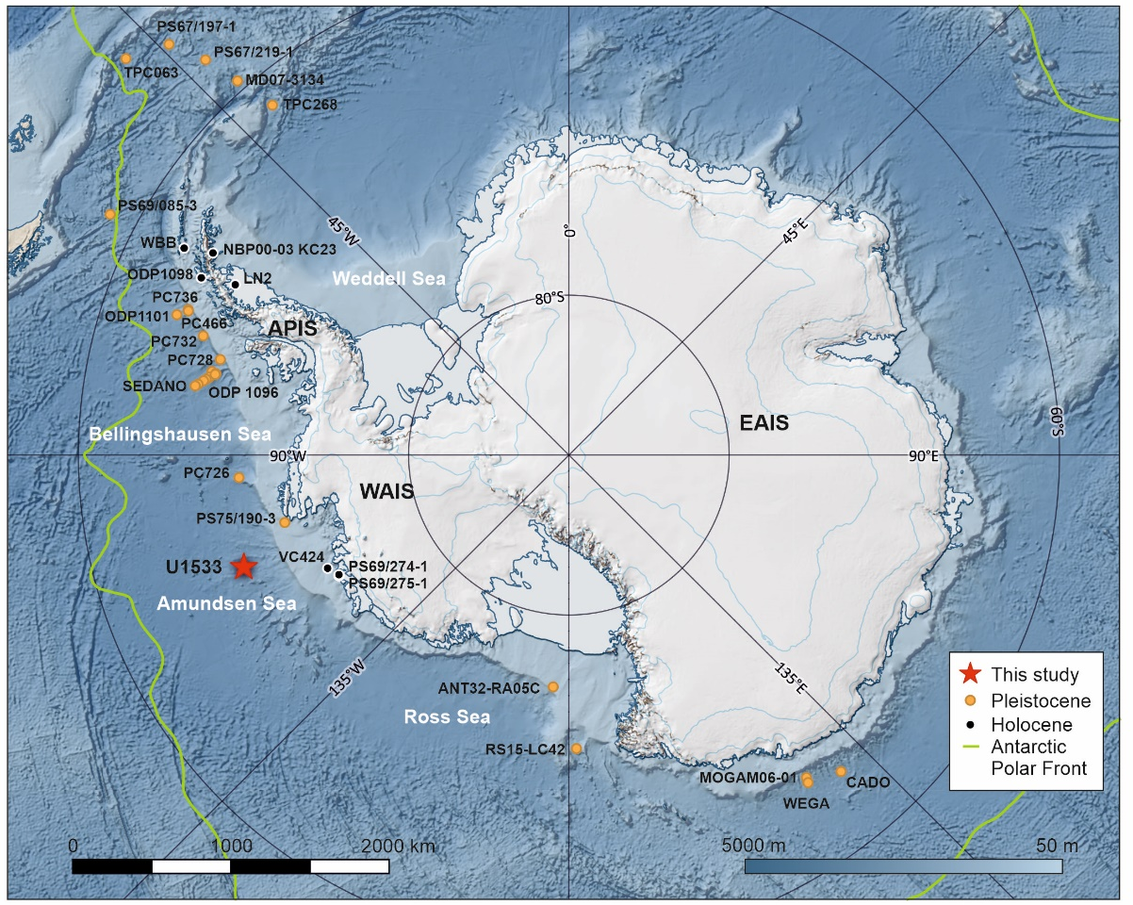
Figure 2-1. Bathymetric map of the Southern Ocean and topographic map of Antarctica with IODP Site U1533 (this study) highlighted (red star). Circles indicate locations of sediment cores with published RPI records for the Pleistocene–Holocene (yellow) and Holocene only (black); detailed core information for each site is given in Supplementary Table S1. The West Antarctic Ice Sheet (WAIS), East Antarctic Ice Sheet (EAIS), Antarctic Peninsula Ice Sheet (APIS) and Antarctic Polar Front are marked.
RPI records provide estimates of changes in geomagnetic field strength. In principle, major fluctuations in relative field strength are quasi-synchronous around the globe (Valet and Meynadier, 1998; Valet et al., 2005). RPI records can be constructed from lava flows (Croudace and Rothwell, 2015), mid-ocean spreading ridges (Gee et al., 2000), and lake and marine sediment cores (Levi and Banerjee, 1976; Kent, 1973; King et al., 1983; Tauxe, 1993; Peck et al., 1996; Tauxe and Yamazaki, 2015; Lund et al., 2016). Many RPI records spanning a large part of the Pleistocene have been compiled and stacked on regional (e.g., Laj et al., 2000; Stoner et al., 2002; Xuan et al., 2016) and global scales (e.g., Laj et al., 2004; Valet et al., 2005; Channell et al., 2009; Panovska et al., 2018). These stacks are comprised of a varying number of records in their construction (n = 5–76), with sedimentation rates for these records ranging from 0.3 to 35 cm/kyr (e.g., PADM2M, Ziegler et al., 2011). In the Antarctic/Southern Ocean region, several previous studies have applied RPI dating to Pleistocene sediment cores (Fig. 1; Supplementary Table S1). For example, RPI has been used to date Late Quaternary sediment cores from drifts on the western Antarctic Peninsula continental rise (Sagnotti et al., 2001; Macrì et al., 2006; Vautravers et al., 2013; Channell et al., 2019; Carlson et al., 2021), from the East Antarctic continental rise (Macrì et al., 2005, 2010; Jimenez-Espejo et al., 2020), and from the Scotia Sea (Collins et al., 2012; Weber et al., 2012). RPI approaches have also been used to date sedimentary sequences spanning the Holocene and last glacial period from the Antarctic Peninsula shelf (Brachfeld et al., 2003; Willmott et al., 2006; Smith et al., 2021) and the Amundsen Sea shelf (Hillenbrand et al., 2010; Klages et al., 2017) (Fig. 1).
The RPI record from Ocean Drilling Program (ODP) Site 1101, located on a sediment drift in the Bellingshausen Sea spans the interval 700–1100 ka (Guyodo et al., 2001) and has recently been extended back to 1600 ka (Channell et al., 2019). This was previously the oldest RPI record available for Antarctica. Although also successfully applied at many other Antarctic sites (Fig. 1), there are numerous challenges in the construction of reliable RPI records. Lithological and magnetic properties can influence the ability of sediments to reliably record RPI (e.g., Brachfeld et al., 2000). For instance, previous studies have inferred that the relative percentage of opal to terrigenous material (Brachfeld et al., 2003; Hillenbrand et al., 2010), or early diagenetic alteration of magnetic minerals (Channell et al., 2019; Hillenbrand et al., 2021) can lead to unreliable RPI reconstructions for intervals or even entire sediment sequences.

This study applies and explores the reliability of the barium enrichment and RPI approaches as an independent chronostratigraphic tool for a sediment sequence collected at Site U1533 during International Ocean Discovery Program (IODP) Expedition 379 to the Amundsen Sea, Antarctica (Gohl et al., 2021a). We consider the various influences that may impact the reliability and accuracy of our constructed age models, and aim to evaluate both barium enrichment and RPI as a dating tool for sediments from the Antarctic continental margin. In addition, we develop and evaluate a new RPI stack for this region and assess whether relative palaeointensity should be used more widely as a dating technique for Late Cenozoic sediments from around Antarctica.

Materials and methods

IODP Exp. 379 Site U1533
IODP Site U1533 (Fig. 1; 68◦44′S, 109◦0′W, water depth ~4180 m) was drilled south of the APF on the West Antarctic continental rise in the Amundsen Sea, during IODP Expedition 379 in 2019 (Wellner et al., 2021). Four holes were drilled at the site (Holes U1533A‒D) on the southwestern flank of a sediment drift named ‘Resolution Drift’ (Gohl et al., 2021a). The hole with the deepest penetration, Hole U1533B, extends down into Upper Miocene strata to a total depth of 382.6 m below seafloor (m CSF-A). Different segments of a composite Pleistocene interval were recovered in all four holes at the site using advanced piston coring with a recovery ranging from 100 to 104% (Wellner et al., 2021). The lateral distance between holes at Site U1533 is larger than for most IODP sites on other expeditions (e.g., the distance between Hole U1533A and Hole U1533B is 1.6 km), which was necessary to avoid icebergs while drilling the site (Wellner et al., 2021).

Shipboard lithological assessment and preliminary age model

Lithology
The Plio-/Pleistocene sediments recovered at Site U1533 (Fig. 2a) primarily consist of two alternating sediment types interpreted to reflect glacial–interglacial variations, similar to observations in other records from the Antarctic continental margin (e.g., Grobe and Mackensen, 1992; Pudsey and Camerlenghi, 1998; O ´ Cofaigh et al., 2001; Hillenbrand et al., 2002, 2009; Bollen et al., 2022; Rodrigues et al., 2022). The sediments interpreted as “glacial” are usually laminated and dominated by fine-grained siliciclastic silty clay (Fig. 2a). This detritus was likely originally subglacially eroded by grounded ice in interior West Antarctica and on the Amundsen Sea continental shelf, transported as part of unsorted glacigenic debris across the shelf by advancing ice streams and bulldozed over the shelf edge. The material was then redeposited downslope by sediment gravity flows to the continental rise (slumps and slides on the upper continental slope, debris flows on the middle slope, and turbidity currents at the base of the slope), where turbidity currents eroded large channels into the rise and transferred the coarser particles further offshore to the abyssal plain (Dowdeswell et al., 2006). On the continental rise, the fine-grained components (clay, fine silt) of the turbidity currents were captured by bottom currents and subsequently deposited on Resolution Drift as contourites. Thin beds of concentrated sand and coarse silt present in the U1533 sediments are interpreted as overspill deposits supplied by turbidity currents travelling along the channel adjacent to Resolution Drift (Wellner et al., 2021, Gohl et al., 2021b). Deposits at Site U1533 interpreted as “interglacial” consist of hemiplegic sediments and typically contain biosiliceous material accumulated from overlying surface waters or advected together with fine-grained terrigenous detritus to the site from offshore sources by ocean currents. The concentration of microfossils decreases downcore, with fewer present in “interglacial” intervals of the early Pleistocene and late Pliocene. These intervals are bioturbated, reflecting periods of high marine productivity in the surface waters (Wellner et al., 2021). The presence of isolated granules and pebbles throughout the “glacial” and “interglacial” sediments results from the deposition of iceberg-rafted debris. The “glacial” and “interglacial” intervals have similar thicknesses in the late Pliocene and Pleistocene section of Site U1533.

Chronostratigraphy
Pass-through superconducting rock magnetometer (SRM) measurements of the archive halves of the Site U1533 core sections were conducted onboard RV JOIDES Resolution during IODP Expedition 379 (Wellner et al., 2021). Shipboard palaeomagnetic data after 20 mT demagnetisation were shown to be of good to reasonable quality, suitable for the construction of magnetostratigraphy. All major Pleistocene polarity (sub-)chrons (C1n to C2An.1n; 0–3.032 Ma) were identified (Wellner et al., 2021).
Biostratigraphic assessments of diatom and radiolarian species distributions were carried out onboard using sediment samples from core catchers and split core sections. All sections analysed for the study here contain biosiliceous material in the interglacial intervals, with the exception of the lowermost study interval (Uppermost Pliocene‒Lower Pleistocene cores U1533B-2H, -3H, and U1533D-5H (~36.75–57.42 m CSF-A)). Two last occurrence datums for diatom species (Actinocyclus ingens and Fragilariopsis barronii) and one maximum age constraint provided by the first occurrence of a radiolarian species (Phormospyris antarctica) were identified during shipboard biostratigraphic analysis of the Pleistocene sequence recovered at Site U1533 (Wellner et al., 2021). These species have been age calibrated at other Southern Ocean sites (e. g., ODP Leg 177 cores, Zielinski and Gersonde, 2002).

Shore-based data collection methods

X-ray fluorescence (XRF) scanning data
XRF scans of the archive halves of the core sections were conducted post-cruise at the IODP Gulf Coast Repository (College Station, Texas, USA) using an Avaatech XRF core scanner. The archive halves were scanned at 2-cm resolution and analysed for a range of elements. For this study, barium (Ba) and rubidium (Rb) measured at 50 kV and 30 kV, respectively, are used to determine the Ba/Rb ratio, which is used as a proxy for barium enrichment resulting from enhanced flux of biogenic barite during interglacials.

Core composite splice
A composite splice for the uppermost Pliocene–Pleistocene section of Holes U1533A‒D was constructed based on shipboard whole-round core magnetic susceptibility data (Wellner et al., 2021). This composite splice was subsequently refined with minor adjustments using the XRF core scanning datasets, with Ba/Rb ratio records from each hole used as the primary hole-to-hole correlation tool. All core depths below are referenced to “m CCSF-M”, which represents the downcore “mapped” composite depths resulting from detailed correlation of all out-of-splice intervals to in-splice intervals. The use of this depth scale is advantageous because it aligns all core intervals both within and outside of the designated splice.

Sedimentary barium enrichment
Barium enrichment in marine sediments south of the APF is attributed to increased input of biogenic barite during periods of high productivity and therefore interglacials (e.g., Nürnberg et al., 1997; Jaccard et al., 2005; 2010; Pudsey, 2000; Wu et al., 2017; Ashley et al., 2021), and is largely controlled by sea ice cover (Ceccaroni et al., 1998; Pudsey and Camerlenghi, 1998; Hillenbrand and Cortese, 2006; Jaccard et al., 2013). During warm, interglacial periods, spring and summer sea ice is greatly reduced. This leads to an increased phytoplankton productivity, more particulate organic matter exported to the sea floor, and therefore higher biogenic barite accumulation.
For this study of the Plio-/Pleistocene sequence of Site U1533, the biogenic barite content of the sediments was not directly measured. However, previous studies have concluded that XRF-derived barium enrichment patterns (i.e., Ba normalised by a terrigenous element such as Al, Ti, or Rb) reflect changes in the biogenic barite contents (Nürnberg et al., 1997; Bonn et al., 1998; Pudsey and Camerlenghi, 1998; Hillenbrand et al., 2002; 2009, 2021; Presti et al., 2011; Tauxe et al., 2015). For Site U1533, rubidium was selected as a terrigenous normaliser as it is a robust heavier element, and thus its quantification by XRF scanning is less affected by the water content changes, resulting from variations in sediment density/porosity, sediment properties and core quality (drilling disturbance) than lighter elements such as aluminium (Tjallingii et al., 2007). Rubidium is primarily present in the terrigenous (siliciclastic) clay fraction (e.g., Croudace and Rothwell, 2015; Wu et al., 2021), and thus can be used to adjust total barium counts for changes in terrigenous clay content of the sediments at Site U1533 (which also contains low concentrations of barium). Following the recommendation of Weltje and Tjallingii (2008), the natural log of Ba/Rb is used to track the trends in barium enrichment.

Magnetic methods
Forty-nine u-channel samples (total length: 62.5 m) were collected from the working halves of core sections from Holes U1533A, U1533B and U1533D. The sampled intervals span a nearly continuous interval between 0.0 and 57.37 m CCSF-M in the composite splice. Only one section within the splice was not sampled (Section U1533D-5H-6; 45.40–46.80 m CCSF-M) due to the presence of an unusual sand horizon in that section. Natural and laboratory-induced remanent magnetisations of the u-channel samples were analysed at 1-cm interval resolution on a 2G Enterprises Model-755R pass-through SRM in the Palaeomagnetism and Environmental Magnetism Laboratory at the University of Southampton (UK). Natural remanent magnetisation (NRM) of the u-channel samples was measured before and after stepwise alternating field (AF) demagnetisation with peak fields of 0, 10, 15, 20, 25, 30, 35, 40, 45, 50, 55, 60, 70, 80, and 100 mT. The peak AF required to reduce the NRM intensity to half its initial value (median destructive field (MDFNRM) was calculated to determine the coercivity of the NRM carriers in the sediment. Anhysteretic remanent magnetisation (ARM) was acquired for the samples in a 100-mT AF with a direct current (DC) bias field of 0.05 mT and subsequently measured before and after the same demagnetisation steps as those used for the NRM analysis. Isothermal remanent magnetisation (IRM) was induced in the samples using a DC pulse field of 300 mT at room temperature and measured before and after the same demagnetisation steps as those used for the NRM analysis. Magnetic susceptibility (MS) of the u-channel samples was measured at 1-cm intervals on a magnetic susceptibility track equipped with a Bartington MS3 metre and a 36-mm diameter MS2C loop sensor.
NRM demagnetisation data indicate that the influence of drilling overprint was effectively removed at 20 mT demagnetisation, isolating the characteristic remanent magnetisation (ChRM), as previously demonstrated by the shipboard analyses on the archive half sections (Wellner et al., 2021). Component inclination and declination for each 1-cm depth interval were calculated based on principal component analysis (PCA) of NRM data (Kirschvink, 1980) from the 20–60 mT demagnetisation steps using the UPmag software (Xuan and Channell, 2009) with NRM data unanchored to origin. PCA estimates are associated with maximum angular deviation (MAD) values that measure the quality of component directions definition, with values below 5◦ considered high-quality, and those below 15◦ considered reasonably good quality. We calculated corrected declination data to remove the effect of core barrel rotation during drilling. We assume the mean value of declinations for a core to be 0◦ (360◦) or 180◦ for normal and reversed polarity intervals, respectively. The component directions were used to refine all shipboard polarity reversal depths and assign ages according to the Geomagnetic Polarity Timescale (GPTS) 2020 (Ogg, 2020).
Rock magnetic experiments, including IRM acquisition (IRMacq), hysteresis loop and IRM backfield were carried out using four selected bulk sediment samples (i.e., from 3.83 m, 18.26 m, 38.53 m and 53.48 m CCSF-M) on a Princeton Measurements Corp. (now Lakeshore Inc.) Model 3900 vibrating sample magnetometer (VSM). All samples were measured in a saturation field of 1 T with an averaging time of 300 ms and results were weight normalised. Hysteresis loop measurements were processed using the HystLab software (Paterson et al., 2018), and produced bulk coercive force (Hc), saturation magnetisation (Ms) and saturation remanence (Mrs), while remanent coercive force (Hcr) was determined from the IRM backfield measurements. Samples were also freeze-dried for high temperature susceptibility measurements on a Kappabridge KLY-4S with a CS3 furnace. Magnetic susceptibility was monitored while samples were heated in argon gas from room temperature to ~700 ॰C.
RPI is determined by normalising NRM intensity against a labinduced magnetisation that activates the same population of magnetic grains carrying the NRM signal (Banerjee and Mellema, 1974; Levi and Banerjee, 1976; King et al., 1983; Valet and Meynadier, 1998; Hounslow et al., 2022). For our study, ARM-normalised RPI was calculated using u-channel NRM and ARM data from the 20–55 mT demagnetisation steps following the slope method (also known as the pseudo-Thellier method; Tauxe et al.,1995; Channell et al., 2002) embedded in the UPmag software (Xuan and Channell, 2009). RPI was also estimated using magnetic susceptibility and IRM intensity as normalisers. ARM-normalised RPI shows consistent trends with MS- and IRM-normalised RPI records, suggesting that NRM intensity consists of a geomagnetic field component that can be normalised by any of the three methods (Supplementary Fig. S1a). However, we interpret ARM as the most suitable normaliser for RPI estimates for Site U1533 as ARM typically activates fine magnetic grains that also carry NRM, while IRM is often sensitive to both fine and coarse (i.e., multi-domain) remanence-carrying magnetic gains and magnetic susceptibility is sensitive to both remanence-carrying and non-remanence-carrying grains (Hounslow et al., 2022). In addition, IRM data acquisition for some of the u-channel samples in our study set was prone to measurement drift issues (where strong IRM possibly led to frequent flux jumps during measurement), which complicates its suitability as a normaliser for RPI estimates. Linear correlation coefficients (r) associated with the slope method (Channell et al., 2002) provide a measure of the quality for RPI estimates with values closest to 1 being the most robust. ARM-normalised r values are slightly more consistent throughout the record with an average of 0.983 when compared to IRM-normalised r values (average of 0.978).

X-ray images
X-radiographs of the u-channels from Site U1533 were collected at the British Ocean Sediment Core Research Facility (BOSCORF; Southampton, UK) with a GEOTEK ScoutXcan X-ray imaging system. Changes in physical properties can be detected in these images, with higher density materials (e.g., rock clasts) showing up as darker in the x-radiographs. The resolution of the x-radiographs that were collected is 300 pixels per cm, allowing for detection of mm scale features. Together with shipboard core descriptions and half core-section images, the x-ray images were closely examined to identify sandy intervals, small rock clasts, bioturbated sections and artefacts (e.g., coring disturbance, drying cracks) (Supplementary Fig. S2). Palaeomagnetic data obtained from such cores intervals are clearly affected by these features, and so we excluded data from the corresponding intervals from the interpreted records as well as data from intervals with (foam-filled) voids.

Palaeomagnetic results

NRM demagnetisation behaviours and rock magnetism
NRM demagnetisation data of the Site U1533 study section are largely dominated by well-defined unidirectional magnetisation components, although there are a few intervals with either more than one magnetic component being present in the record (e.g., Fig. 3i) or with magnetisations not being completely reduced to zero after 100 mT demagnetisation treatment (e.g., Fig. 3j). MAD values associated with the component direction estimates are mostly less than 5◦ (Fig. 2b), indicating generally high-quality palaeomagnetic directional data at Site U1533. Larger MAD values are typically found across polarity boundaries.
Representative NRM demagnetisation behaviours of samples from both normal and reversed polarity intervals (Fig. 3) reveal NRM was largely removed after 100-mT demagnetisation, suggesting NRM of the samples is mostly carried by low coercivity magnetic minerals (i.e., magnetite). Occasionally, NRM of samples shows significant remanence after 100-mT demagnetisation (e.g., Fig. 3j, Hole U1533A, 28.17 m CCSF-M) indicating the presence of higher coercivity magnetic phases in some intervals. The quality of the palaeomagnetic directional data is not influenced by changes in sediment lithology, with high-quality (i.e., MAD values < 5◦) directional data present in all lithologies (Fig. 2a). 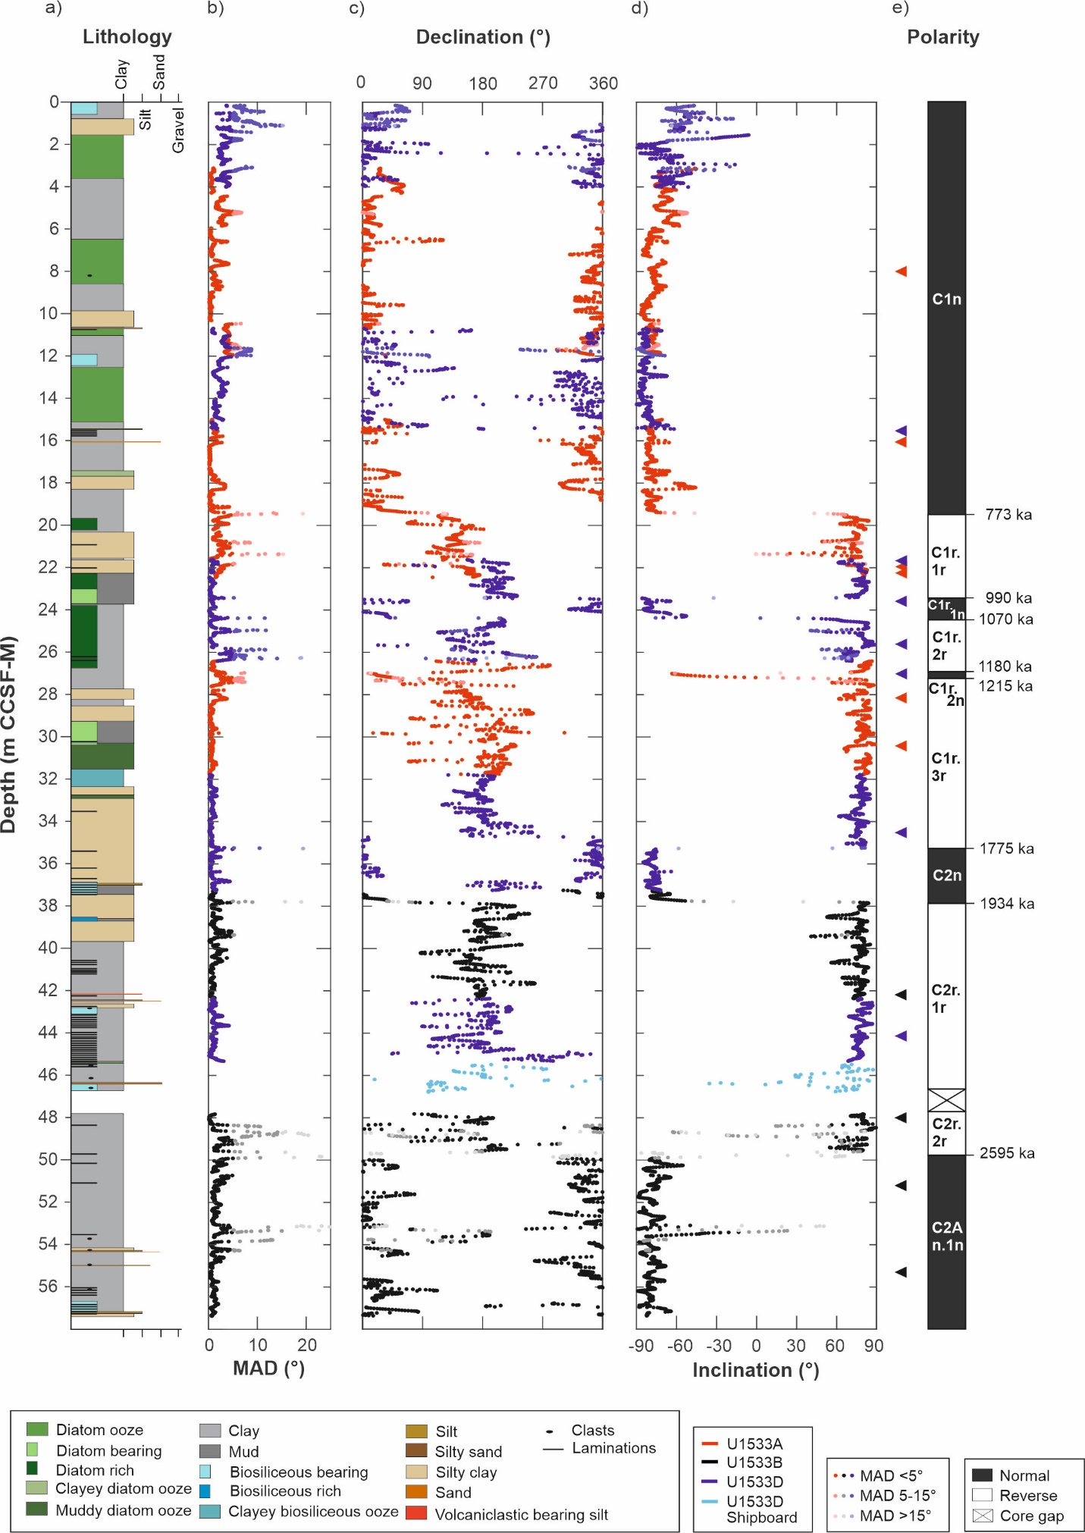
Figure 2-2. Site U1533 lithology and palaeomagnetic directional data from u-channel samples: a) lithology; b) maximum angular deviation (MAD); c) corrected declination, d) inclination with depths for representative Zijderveld diagrams shown in Fig. 3 marked by triangles (right); e) interpreted polarity and chrons. All the data are plotted relative to the composite depth scale (m CCSF-M). Directional data are from Principal Component Analysis (PCA) on the NRM data from the 20–60 mT demagnetisation steps. Data plotted in the panels are colour-coded according to drill hole, with saturation of colour indicative of MAD values (>15◦ are lighter coloured).
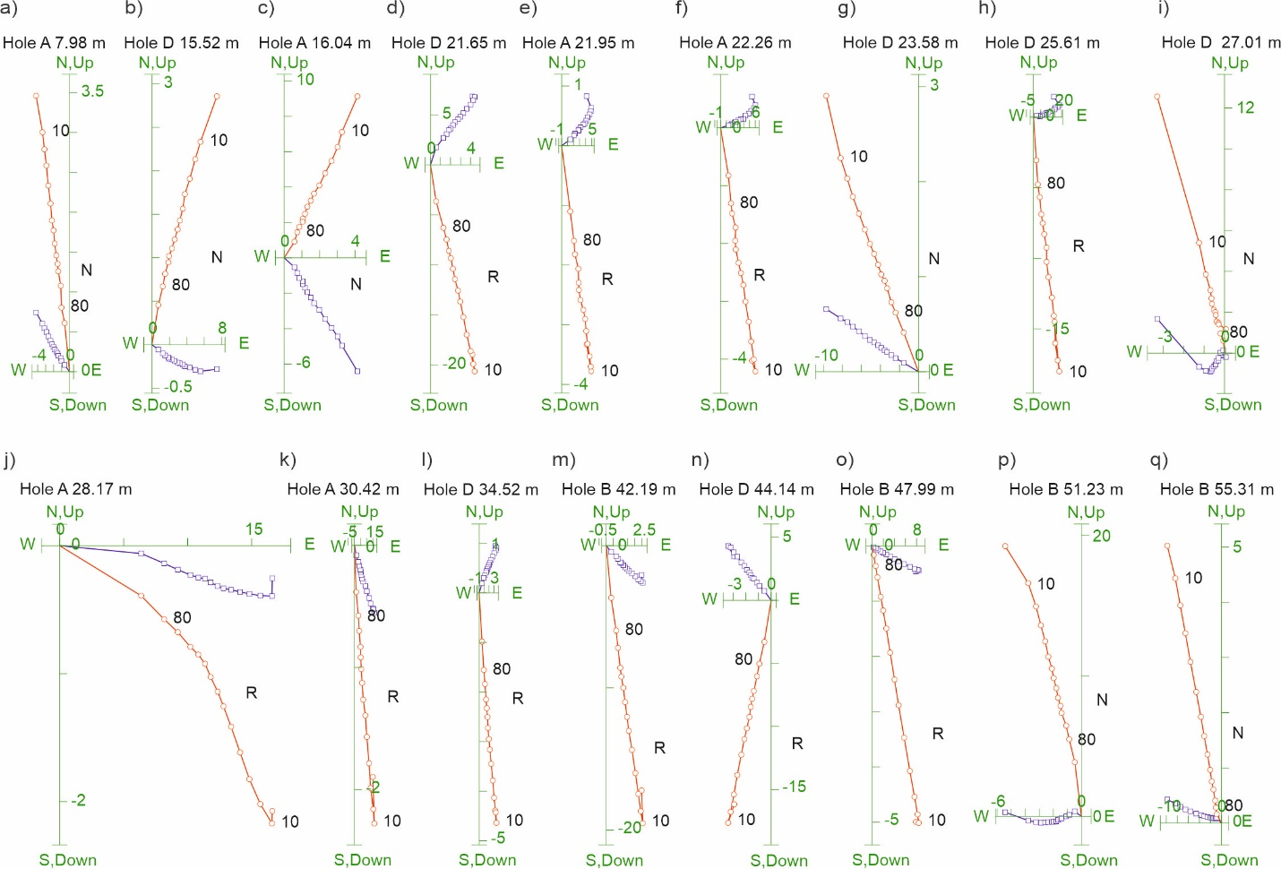
Figure 2-3. Representative Zijderveld diagrams for Site U1533 sediments. All demagnetisation steps are shown (see Methods). Red circles indicate projection endpoints on the vertical plane, and blue squares indicate projection endpoints on the horizontal plane. Normal (N) and reverse (R) polarity chrons are indicated. The 10 and 80 mT demagnetisation steps are labelled on the vertical plane projections.
Results from the rock magnetic analyses are consistent with magnetite being the primary magnetic mineral in U1533 sediments (Fig. 4). High-temperature susceptibility data of all samples show a primary drop at ~580 ◦C, which is the Curie temperature of magnetite. Hysteresis loops of the samples are closed at 100 mT) component. Samples with higher coercivity component also show a ‘hump’ between ~150 and 300 ◦C in high-temperature susceptibility data. We interpret the higher coercivity component in some of the samples as maghemite formed (and later preserved) during sea-floor oxidation of detrital magnetite (e.g., Xuan and Channell, 2009; Channell et al., 2019). The presence of maghemite in some of the sediments does not appear to have significantly influenced the palaeomagnetic recording, presumably because magnetite is still the dominant magnetic mineral throughout the studied sections.
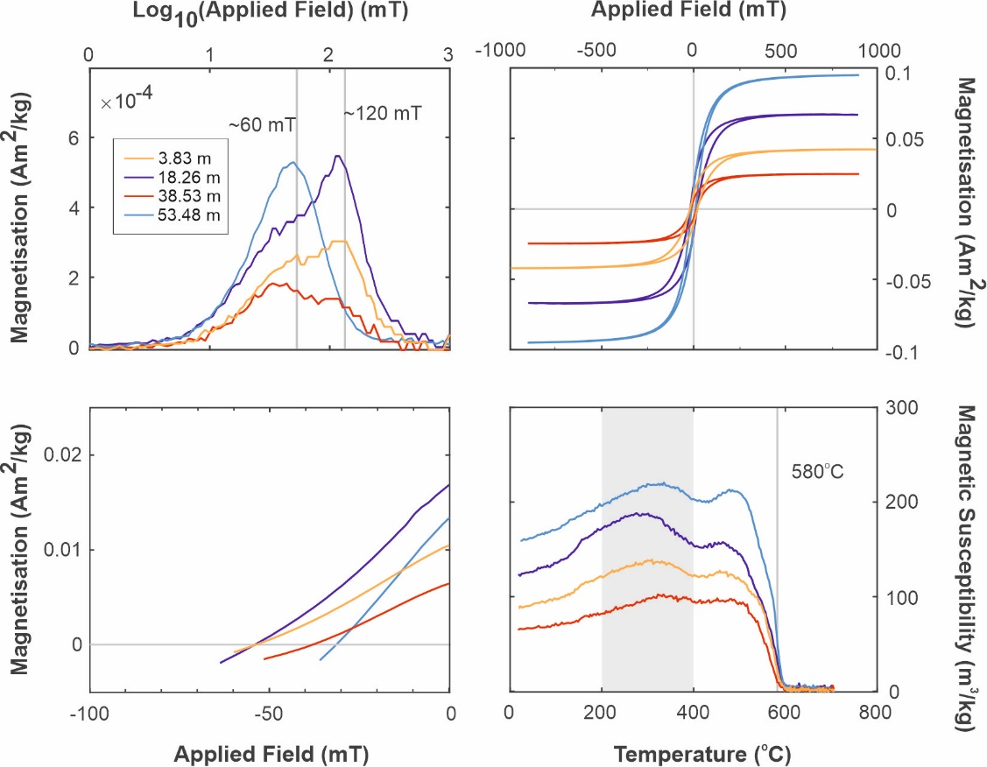
Figure 2-4. Rock magnetic analyses of selected Site U1533 samples including gradient of IRM_{acq} (top left), hysteresis loops (top right), IRM backfield (bottom left) and high-temperature susceptibility (bottom right). Blue/purple colours refer to glacial samples and red/yellow colours to interglacial samples (glacial and interglacial periods defined by barium enrichment data).

U-channel magnetostratigraphy
All of the primary Pleistocene polarity reversal boundaries initially recognised in shipboard analysis (Wellner et al., 2021) are also identified in the new u-channel dataset (Fig. 2; Table 1), with the positions of reversals better defined due to more complete demagnetisation and higher resolution (1-cm depth interval) analyses of u-channels (shipboard measurements were made at 2.5-cm depth interval). The refined polarity boundary positions are shifted by a few cm to a few tens of cm from their shipboard-defined positions for most reversals, with the exception of the Matuyama/Gauss boundary, which is shifted 88 cm downcore with respect to the position determined by shipboard measurements.
Table 2-1. Site U1533 magnetostratigraphic boundaries refined by u-channel analysis in this study. Ages are from the Geomagnetic Polarity Time Scale (GPTS) 2020 (Ogg, 2020).
Core information | Depth (m CCSF-M) | Age (ka) | Name
U1533A-2H-4W | 19.44 | 773 | Brunhes/Matuyama boundary
U1533D-3H-3W | 23.44 | 990 | Jaramillo top
U1533D-3H-4W | 24.39 | 1070 | Jaramillo base
U1533D-3H-6W | 26.98 | 1180 | Cobb Mountain top
U1533D-3H-6W | 27.18 | 1215 | Cobb Mountain base
U1533D-4H-5W | 35.28 | 1775 | Olduvai top
U1533B-2H-2W | 37.79 | 1934 | Olduvai base
U1533B-3H-2W | 49.87 | 2595 | Matuyama/Gauss boundary
The ChRM inclination values for our Site U1533 study interval predominantly range between 75◦ and 85◦, consistent with those expected for a geocentric axial dipole at 68◦ S (~79◦ inclination) (Fig. 2d). Polarity chrons and subchrons were confidently identified based on the u-channel data and their ages assigned according to the 2020 GPTS (Ogg, 2020) (Fig. 2); in contrast, GPTS ages from the 2012 timescale (Ogg, 2012) were used for shipboard data interpretation. Confirmation of the polarity boundaries identified during Exp. 379 shipboard analysis and refinement of their depth positions due to high-resolution analysis and more complete demagnetisation provide a robust magnetostratigraphy for the Plio-/Pleistocene sedimentary sequence recovered at Site U1533.
In addition to major polarity shifts identified as reversals, we also observe apparent excursional behaviours in directional records within polarity chrons and subchrons at ~18.22 m, ~21.36 m, ~24.97 m, ~25.86 m, ~26.32 m, ~40.65 m, ~42.54 m, ~48.73 m, and ~53.13 m CCSF-M (Fig. 2, Supplementary Table S2). Component inclinations from these depths often do not reach opposite polarity, possibly due to signal smoothing caused by magnetisation lock-in under low sedimentation rates (Lund and Keigwin, 1994; Roberts and Winklhofer, 2004) and/or a convolution effect during pass-through measurements on the SRM (e.g., Xuan and Oda, 2015, 2019). In order to verify if these apparent excursions represent genuine field behaviours (i.e., true geomagnetic excursion events), the following criteria were used: (1) the apparent directional changes do not coincide with changes in lithology, large drying cracks in the u-channels, or disturbed intervals; (2) magnetic properties of the sediments (e.g., magnetic concentration, grain size, composition, coercivity etc.) do not show apparent changes at these depths; (3) Zijderveld plots of NRM demagnetisation data show clear, well-defined excursional behaviours over these depth intervals. There are two potential intervals that show strong directional changes meeting these criteria (~21.36 m and ~53.13 m CCSF-M, Supplementary Table S2). Zijderveld plots of NRM demagnetisation data across these two depth intervals are shown in Supplementary Figs. S3 and S4. The polarity change within Section U1533A-2H-5W shows a short-lived normal excursion at ~21.36 m CCSF-M with a strong almost unidirectional signal (Supplementary Fig. S3), to which we assign a high-confidence interpretation of a palaeomagnetic excursion. In contrast, Section U1533B-3H-4W shows a reversed excursion at ~53.13 m CCSF-M that appears to have a secondary component in the declination data, deviating from the origin at higher demagnetisation steps (i. e., 53.11 m CCSF-M, Supplementary Fig. S4c), making the interpretation of a short-lived polarity excursion in this interval more tentative. Therefore, we consider the presence of this older excursion in Site U1533 to be of low confidence.

Age model construction

Barium age model
Barium enrichment records from Antarctic continental margin sediments have been previously correlated with global deep-sea benthic foraminiferal δ18O stacks to derive age models, in conjunction with supporting chronological constraints based on biostratigraphy, magnetostratigraphy, RPI, δ18O stratigraphy, U/Th measurements and/or radiocarbon dating (e.g., Bonn et al., 1998; Pudsey and Camerlenghi, 1998; Pudsey, 2000; Hillenbrand et al., 2002; 2009, 2021; Presti et al., 2011; Tang et al., 2016; Wu et al., 2017). Here, we construct a barium enrichment-based age model for Site U1533 through correlation of barium enrichment [ln(Ba/Rb)] maxima, clear transitions, and minima to corresponding cycles in the LR04 δ18O stack (Lisiecki and Raymo, 2005). The underlying assumption in this approach is that barium enrichment in Site U1533 sediments reflects higher productivity during interglacial intervals (and vice versa). Polarity reversals provided by the magnetostratigraphy for Site U1533 were used as initial constraints in the construction of this age model but not as direct ties (similar to how LR04 is guided by but not tied to magnetic reversals; Lisiecki and Raymo, 2005). Tiers of confidence were assigned to each tie point that was established (Tier 1: most reliable, Tier 3: least reliable), and ages were linearly interpolated between tie points (Supplementary Table S3.). Typically, Tier 1 tie points are those close to magnetostratigraphic boundaries, as these offer robust age control starting points. Tier 1 correlations also include distinct features identified in both the Site U1533 record and reference records. The correlations are generally less confident away from reversal boundaries, and therefore these tie points are assigned as Tier 2 or 3. Most tie points were preferentially chosen at the transitions between glacial and interglacial periods in the LR04 stack because the downcore changes in the barium enrichment record display mainly a symmetrical pattern (Fig. 5), unlike the asymmetrical patterns of glacial and interglacial Marine Isotope Stages (MIS) in the LR04 stack, especially prominent in the 100 kyr world (0–0.95 Ma) following the Mid-Pleistocene Transition (MPT).
We correlate nearly all major maxima and minima in the barium enrichment record of Site U1533 to interglacial and glacial MIS in the LR04 stack, respectively (Fig. 5). Many barium maxima/minima have a shape very similar to that of the corresponding MIS (e.g., MIS 39, 1264–1286 ka), while others look less like the assigned MIS (e.g., MIS 5, 71–130 ka). There are also some intervals where the correlation is uncertain: most of MIS 37 (1215–1244 ka) is interpreted to fall into a hitherto unrecognized hiatus at Site U1533 because this interglacial period seems to be largely missing in the barium enrichment record (Fig. 5); MIS 23 (900–917 ka) is also missing from the barium enrichment record as the amplitude of the ln(Ba/Rb) signal is greatly reduced in this interval and lacks a maximum, with low values similar to previous glacial/low productivity intervals. For other cycles, the barium enrichment signal does not clearly match the LR04 trend (e.g., MIS 85, 2207–2236 ka; MIS 93, 2373–2387 ka). Some barium enrichment maxima appear to be reduced in amplitude when compared to the corresponding interglacial δ18O minimum (MIS 59, 1670–1698 ka), while other barium minima do not reach the low values of other glacial intervals (e.g. MIS 14, 533–563 ka; MIS 20, 790–814 ka; MIS 48, 1452–1469 ka; MIS 88, 2273–2291 ka; MIS 90, 2309–2333 ka). MIS 99 (2494–2510 ka) is not recorded in the barium enrichment record of Site U1533, as it likely coincides with a core recovery gap between the base of Core U1553D-5H and the top of Core U1533B-3H (47.075–47.690 m CCSF-M). Additionally, the pattern of variation in barium enrichment in the section spanning from 2.06 to 2.42 Ma (MIS 79–97) is often quite different from that observed in the corresponding δ18O data of the LR04 stack.
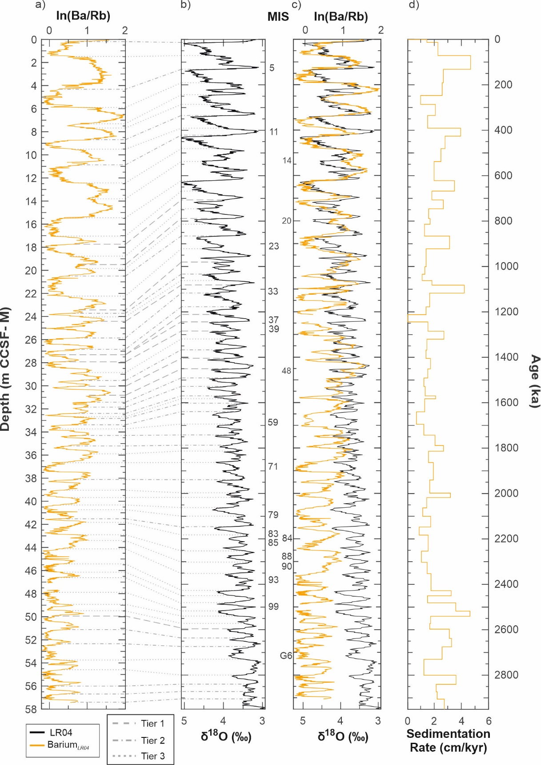
Figure 2-5. Correlation of downcore changes in XRF scanning-derived barium/rubidium ratios, ln(Ba/Rb), at Site U1533 to the global LR04 δ18O stack (Lisiecki and Raymo, 2005): a) ln(Ba/Rb) on the composite (m CCSF-M) depth scale, with tie lines to b) LR04 δ18O record versus age with Marine Isotope Stages (MIS) labelled; c) ln(Ba/Rb) and LR04 δ18O records versus age; d) sedimentation rates calculated using the barium age model approach illustrated here. Tie points are separated by tiers of confidence (see key), whereby Tier 1 is most reliable, and Tier 3 is least reliable. MIS mentioned in the text are labelled.
In summary, almost all glacial‒interglacial MIS are identified in the barium enrichment record from Site U1533, with the exceptions of MIS 23, 37, 71, 85 and 99, which do not appear to be recorded at this site. In addition, interglacial MIS 59 and 93 and glacial MIS 14, 20, 48, 84, 88 and 90 are detectable but muted with respect to the preceding interglacial/glacial intervals. This allows for a relatively straight-forward correlation to the LR04 stack (Figure 5).

Relative palaeointensity (RPI) age model
Site U1533 RPI estimates (especially the NRM/ARM slopes) generally satisfy the criteria for constructing a reliable RPI record (Tauxe, 1993; King et al., 1982; Hounslow et al., 2022). The NRM/ARM slopes are associated with r values close to 1 (largely above 0.96, see Supplementary Fig. S1b). NRM of the sediments is largely carried by a well-defined component magnetisation that led to the construction of a robust magnetostratigraphic record. Magnetic concentration variations downcore are generally within an order of magnitude (Supplementary Fig. S5), and multiple normalisation methods show consistent RPI trends (Supplementary Fig. S1a). Moreover, RPI shows little coherence to the normaliser (ARM) (Supplementary Fig. S6).
In order to construct a second age model that is independent of the barium enrichment approach, the RPI record of Site U1533 (the NRM/ ARM slopes) was correlated to the PISO-1500 stack (Channell et al., 2009) for the interval 0–1.5 Ma. Currently, there are very few individual RPI records from around Antarctica (Guyodo et al., 2001; Channell et al., 2019; Bollen et al., 2022) or Southern Hemisphere stacked records (Macrì et al., 2005) that extend beyond the last 800 kyr that could be used as a target curve for this age model approach. PISO-1500 is a high-resolution RPI stack composed of 13 individual RPI records predominantly from North Atlantic drill cores that have been independently dated using benthic foraminiferal δ18O stratigraphy. Because our Plio-/Pleistocene RPI record from Site U1533 extends further back in time than the PISO-1500 stack, the RPI record from Site U1533 was also correlated to the RPI record from Site U1308 (Channell et al., 2008, 2016) for the interval 0–3 Ma. PISO-1500 was built using Site U1308 as a reference record, and we consider the Site U1308 RPI data a suitable record for correlation. Similar to the barium-based age model, tie points between the Site U1533 RPI record and the reference RPI records were divided into three tiers based on confidence (Tier 1: most reliable, Tier 3: least reliable; Supplementary Table S4), and polarity reversals were used as approximate age constraints.
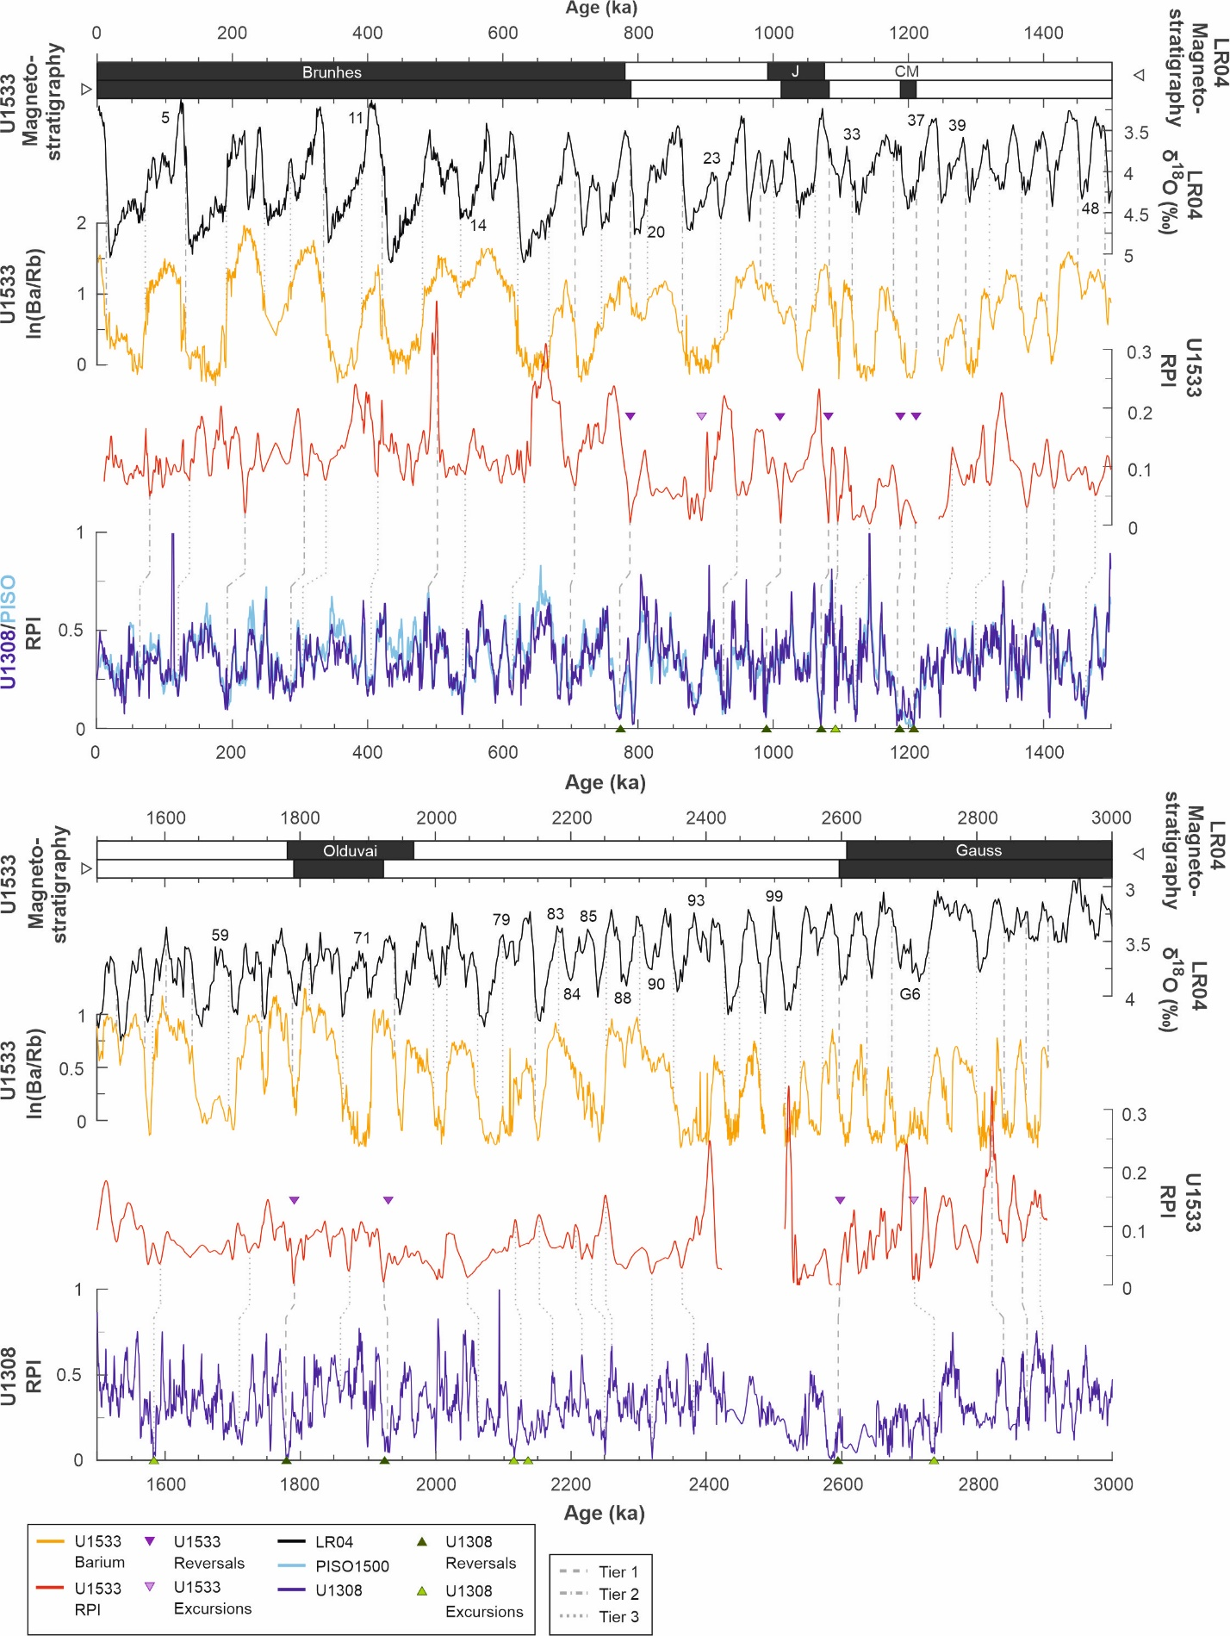
Figure 2-6. Site U1533 data plotted on the barium age model plot (upper age axes): LR04 δ18O (black), Site U1533 barium/rubidium ratios (yellow), Site U1533 RPI record (red). Correlations of Site U1533 RPI to the PISO-1500 RPI stack (light blue; Channell et al., 2009; lower age axes) and the Site U1308 RPI record (dark blue; Channell et al., 2016; lower age axes) are shown in the lower part of each panel. RPI correlation tie points are distinguished by tiers of confidence (see key), whereby Tier 1 is most reliable and Tier 3 is least reliable. Magnetic reversals and excursions for sites U1533 (purple) and U1308 (green) are shown as triangle markers. Chrons and subchrons are labelled (J: Jaramillo, CM: Cobb Mountain). Marine Isotope Stages (MIS) mentioned in the text are labelled with respective numbers. Offsets are also shown between the LR04 magnetostratigraphy (black and white bar at top; chrons and subchrons as used in Lisiecki and Raymo, 2005) and the Site U1533 magnetostratigraphy (bar directly below).
Many pronounced, long-term features evident in the Site U1533 RPI record (Fig. 6) are clearly observed in and correlatable to the reference records (i.e., PISO-1500 and Site U1308; Channell et al., 2008, 2009, 2016). The Site U1533 RPI record can be confidently correlated to PISO-1500 and U1308 RPI for the interval from 0 to 1.5 Ma, with many of the maxima and minima matching between all three records. This interval shows the highest variability in the Site U1533 RPI record (e.g., 0–120 ka, 400–600 ka). The main discrepancies are differences in the amplitude of the U1533 RPI signal (e.g., 490 ka, 800–900 ka) when compared to the reference curves. In the Site U1533 RPI record older than 1.5 Ma, there is less variation in the RPI signal, and most features appear to be more poorly resolved (e.g., 1600–1650 ka, 2020–3000 ka). From 2.0 to 2.6 Ma, the correlation between the RPI records from Site U1533 and Site U1308 is particularly challenging.
The short excursional events observed at ~21.36 m and more tentatively interpreted at ~53.13 m CCSF-M in the U1533 inclination record (see Section 3.2) fall into intervals of low RPI. Using the RPI age model, the RPI lows in these intervals have estimated ages of ~884 ka (~21.36 m CCSF-M) and ~2734 ka (~53.13 m CCSF-M) (Fig. 6), which correspond with the reported Kamikatsura and Porcupine excursions (e. g., Xuan et al., 2016; Channell et al., 2020), respectively. Average sedimentation rates near these intervals inferred from the RPI age model appear to be higher (1.7–2.9 cm/kyr and 2.3 cm/kyr respectively) in comparison to the preceding intervals (1.3 cm/kyr prior to ~884 ka and 2.1 cm/kyr prior to ~2734 ka). Due to their short-lived nature, excursions are often not recorded in sediments accumulated at low sedimentation rates due to smoothing caused by the magnetisation lock-in process (e.g. Roberts and Winklhofer, 2004). The concurrence of comparatively higher sedimentation rates near ~21.36 m and ~53.13 m CCSF-M at Site U1533 supports the interpretation of these intervals as geomagnetic excursions, though the presence of the younger Kamikatsura excursion in our record is of higher confidence as the excursion is better revealed in NRM demagnetisation data (Supplementary Figs. S3 and S4, Supplementary Table S2).

Comparison of the two age models for Site U1533
The barium enrichment-based and the RPI-based age models for Site U1533 do not conflict with the magnetostratigraphic age model and do not impart unrealistic changes in sedimentation rates (Fig. 7). There are, however, small but systematic differences between the two age models, and the temporal offset between the two age models varies. It is often less than 10 kyr but is on average ~12 kyr (Supplementary Fig. S7), mainly because the offset increases to 35 kyr between 0 and 400 ka (10 m CCSF-M). Notably, the tie point offset direction between the two age models is consistent between 0 and 1900 ka (0–38 m CCSF-M), with the RPI age model derived ages being younger than the ages derived from the barium-enrichment age model (Fig. 6). Between 1900 and 2900 ka, however, this relationship reverses, with the RPI ages being older than the barium-enrichment ages. The largest divergence between the two age models occurs in the interval from 0 to 550 ka. The tie points of both the RPI age model and the barium-enrichment age model are well correlated with their respective reference records in this interval, so the offset is unlikely to be caused by an erroneous selection of tie points.
A significant methodological difference between the barium-based age model and the RPI age model is the number of tie points used in their construction (68 tie points in the former vs. 44 tie points in the latter). The barium age model has more tie points across all three tiers of confidence, as there are regular glacial-interglacial cycles to which barium enrichment maxima and minima can be correlated. In comparison, the RPI signal contains more shorter-scale variabilities in both Site U1533 and Site U1308 records, making the selection of tie points for correlation more challenging. This may explain the large age divergence between the two age models for Site U1533 in some intervals where the RPI correlations are less certain (e.g., ~50–55 m CCSF-M, corresponding to 2.6–2.8 Ma).
Despite differences in the age models, similar sedimentation rates are calculated from each age model (Fig. 7), with an average sedimentation rate of ~2 cm/kyr. A higher variability in sedimentation rates is inferred from the barium-based age model, which, at least in part, results from the relatively high number of tie points (Fig. 7). This analysis also reveals that sedimentation rates oscillated between glacial and interglacial periods, with averages of ~2.2 cm/kyr during interglacials, and ~2.4 cm/kyr during glacials for the interval 0–1 Ma, which can be assessed because of the regularity of tie points at glacial-interglacial transitions.
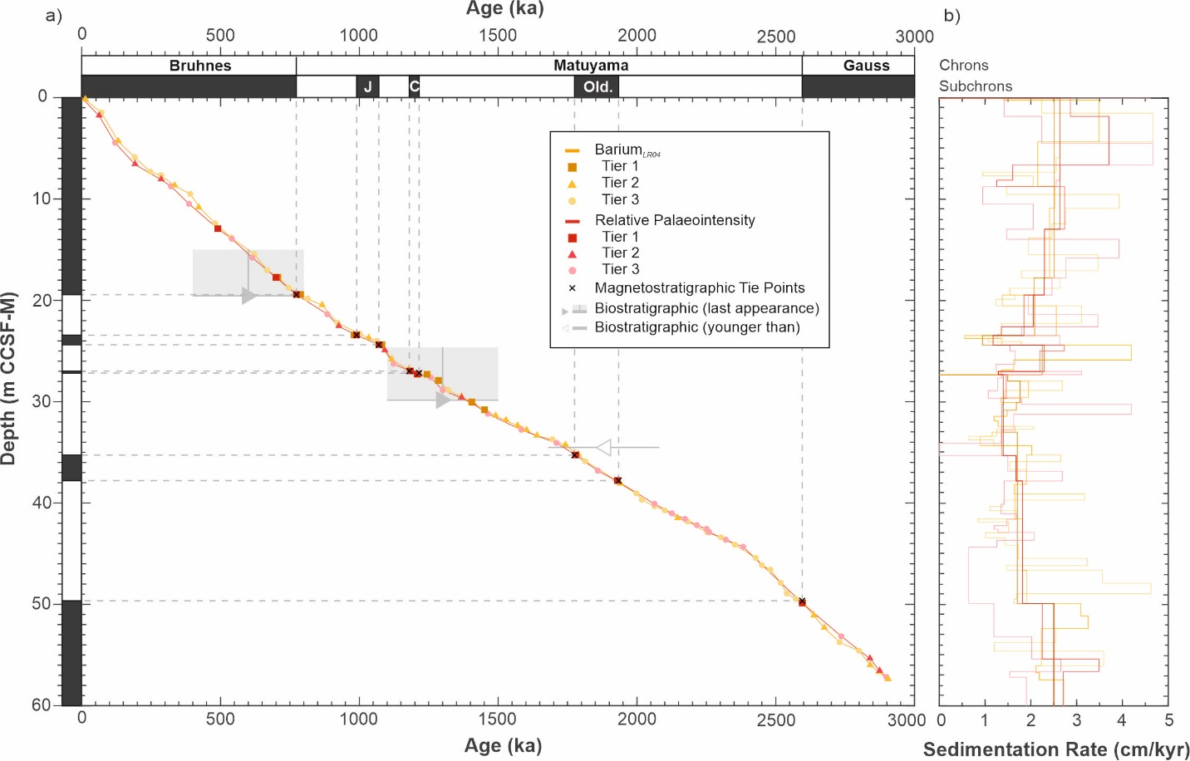
Figure 2-7. Age-depth plot for Site U1533 showing both barium- and RPI-derived age models, along with initial magnetostratigraphic correlations including the Brunhes/ Matyama boundary, the Jaramillo (J), the Cobb Mountain (CM), the Olduvai (Old) subchrons, and the Matuyama/Gauss boundary. All tie points are distinguished by tier classification. Grey boxes indicate diatom last appearance datums with uncertainties in both depth and age represented, and the grey line with an open arrow indicates a radiolarian first appearance datum.

RPI records typically resolve changes in the geomagnetic field at a higher resolution than glacial-interglacial cycles. The Site U1533 RPI age model has a lower temporal resolution than the barium age model partly because longer term changes in the RPI records can be more confidently correlated. This is largely due to the low sedimentation rates (~2 cm/kyr) at Site U1533, which could filter out short-term variations in field intensity and primarily facilitate the recording of long-term changes in geomagnetic field intensity. In contrast, the cyclic changes in productivity recorded by the sedimentary barium enrichment occur on shorter glacial-interglacial timescales.
Age differences between the barium enrichment and RPI age models in the interval from ~39 to 50 m CCSF-M (corresponding to 2.0–2.6 Ma) at Site U1533 are difficult to evaluate, since correlations in this interval are predominantly characterized by Tier 3 (low confidence) tie points. In this interval, many of the barium cycles are likely amalgamated (e.g., MIS 83–85, 2185–2236 ka), which makes correlation more difficult for the barium enrichment age model, whilst RPI variability in this part of the record is greatly smoothed. Both of these issues are likely caused by the relatively low sedimentation rates in this interval, especially from 38 to 45 m CCSF-M (corresponding to 1.93–2.4 Ma) where the average sedimentation rates are ~1.5 cm/kyr according to both age models, which prevents the recording of productivity changes and geomagnetic signals on relatively short timescales. This adds some uncertainty to age assignments in this depth interval.

Discussion

Evaluation of the barium-derived age model
We infer preservation of biogenic barite to be relatively minimally impacted by reductive dissolution throughout the investigated Site U1533 sequence because post-burial dissolution of barite typically only occurs when pore-water sulphate is depleted under reducing conditions driven by relatively high organic carbon content of sediments (Dymond et al., 1992; McManus et al., 1998; Anderson et al., 2002; Wu et al., 2017). At Site U1533, organic carbon content of the sediment is very low (largely < 0.1 wt% but with a few maxima reaching up to 0.26 wt%) (Wellner et al., 2021), and there is no evidence of significantly reducing conditions in the Upper Pliocene to Pleistocene section, with sulphate concentrations in interstitial waters ≥20 mM in the upper 100 m of Site U1533 (Wellner et al., 2021) indicating that sulphate reduction is not actively occurring in this section. We therefore consider the barium enrichment in the sediments as a suitable palaeoproductivity proxy throughout the analysed section of Site U1533, with the missing or muted cycles likely to be a result of local productivity variations, rather than poor barite preservation or reductive dissolution in the sediment column.
One potential uncertainty in the barium age model is a possible systematic miscorrelation with MIS in the LR04 stack. The potential for miscorrelation is especially high in intervals where barium cycles are amalgamated or where interglacial MIS appear to be missing, and may be further complicated for the last 800 kyrs where the barium enrichment record shows almost symmetrical cyclic trends (reflecting gradual changes from seasonally open water during interglacials to perennial sea-ice cover during glacials, and vice versa) contrary to the δ18O records characterised by a saw-tooth pattern that show step-like shifts at glacial terminations. In part this is mitigated near magnetostratigraphic boundaries, where independent tie points help constrain any consistent error in tie points. Therefore, when using barium enrichment as a method for age model construction, it is important to apply it in conjunction with other independent chronological methods (such as magnetostratigraphy, as we did here).
On the Antarctic continental margin, plankton productivity is mainly controlled by spring/summer sea ice extent, with large differences in sea-ice distribution modulating productivity on glacial‒interglacial timescales (e.g., Bonn et al., 1998; Jaccard et al., 2013). According to data- and model-based sea-ice reconstructions, Site U1533 was positioned well south of the inferred winter sea ice margin during the Last Glacial Maximum (LGM) (Gersonde et al., 2005; Roche et al., 2012; Bostock et al., 2013; Goosse et al., 2013; Benz et al., 2016), and near the LGM summer-sea-ice margin (Bostock et al., 2013). This suggests that sea-ice coverage was the prominent control on productivity at Site U1533 during both glacials and interglacials. Other factors influencing primary productivity in the Southern Ocean south of the APF, such as the supply of nutrients and iron via upwelling of deep waters (De Baar et al., 1995; Ito et al., 2005; Annett et al., 2015; Lu et al., 2022), windblown dust flux (Martin, 1990; Matsumoto et al., 2002), and iceberg melting (Raiswell et al., 2008; Duprat et al., 2016; Wu and Hou, 2017; Hopwood et al., 2019), are likely of secondary importance to phytoplankton productivity variations throughout the Late Pliocene and Pleistocene, which is predominantly controlled by the availability of light and, thus, the presence/absence of sea ice. It should be taken into account, however, that especially south of the APF iron fertilisation from the release of iron-rich detritus by iceberg, could be responsible for enhanced productivity at glacial terminations (e.g., at the very beginning of MIS 1, 5, 11), when large-scale iceberg calving events may have been initiated (Diekmann et al., 2000; Weber et al., 2014). This would lead to a peak in biological productivity well before the peak interglacial (which is marked by a δ18O minimum in the LR04 stack), and a systematic offset between the barium-enrichment and RPI derived age models observed from 1900 to 2900 ka. Therefore, while the barium-derived palaeoproductivity changes at Site U1533 are considered to primarily reflect long-term changes in sea-ice extent during the spring-summer season over a glacial-interglacial cycle, similar to what has been observed at other Antarctic continental margin sites (Ceccaroni et al., 1998; Hillenbrand et al., 2009; Wilson et al., 2018; Holder et al., 2020; Hartman et al., 2021), the timing of such changes may not be entirely in-phase with the global δ18O signal.
Sea-ice extent in the Southern Ocean is also known to be highly variable spatially and temporally, both between different and within the same Southern Ocean sectors and over glacial and interglacial periods (Gersonde et al., 2005; Parkinson and Cavalieri, 2012; Chadwick et al., 2020; 2022; Eayrs et al., 2021; Green et al., 2022), and therefore can be expected to differ in response to climate over different interglacial periods, and from the global δ18O signal in LR04. MIS 23, an exceptionally cold interglacial that is not ‘accurately’ recorded in barium enrichment at Site U1533, was assumed not to be resolved in core PS58/254, which was recovered in close vicinity of Site U1533 (Konfirst et al., 2012). In addition, the expression of MIS 23 is also missing from planktic foraminiferal δ18O data and proxies for export production (Ba/Fe) and carbonate preservation (Ca/Fe) at ODP Site 1094 in the Atlantic sector of the Southern Ocean (Jaccard et al., 2013). The “muted” interglacial conditions during MIS 23, which coincided with the MPT, are thought to result from both the development of long-term Northern Hemisphere glaciation (Clark et al., 2006) and a suggested increase of Antarctic Ice Sheet volume at 900 ka (Elderfield et al., 2012), that led to persistent sea ice cover and therefore a reduced productivity signal in barium or carbonate proxies as well as a muted interglacial δ18O signal. Conversely, productivity at Site U1533 during MIS 14 (533–563 ka), a weak glacial period, was apparently sustained at levels similar to the prior interglacial (MIS 15), suggesting that this glacial interval was not pronounced on the Amundsen Sea margin, with retreat of the spring/summer sea ice edge south of Site U1533. A weak representation of glacial MIS 14 is also seen in other barium enrichment records from the Amundsen Sea (i.e., PS58/254, Hillenbrand et al., 2009; PC493, Williams et al., 2019) and in other climate records from the Southern Ocean and around the world (see references in Hillenbrand et al., 2009).
While sea-ice extent on the West Antarctic margin might be expected to vary with ice-sheet extent, it is also debated whether Antarctic ice volume varied synchronously with Northern Hemisphere ice sheets over glacial‒interglacial timescales (Raymo et al., 2006; Reilly et al., 2021). Variations in sea ice extent, therefore, may not react in phase with changes in the δ18O composition of deep-sea benthic foraminifera (Lisiecki and Raymo, 2005) that are strongly influenced by Northern Hemisphere ice volume, with the Antarctic ice volume signal likely being muted (Reilly et al., 2021). In addition, precession cycles (23 kyr), which largely control summer insolation, are out of phase between the Northern and Southern Hemispheres. Their influence on Antarctic ice sheet and sea ice variations would largely be masked by obliquity cycles (41 kyr) and the Northern Hemisphere signal in the δ18O stack (Raymo et al., 2006), causing climate responses to be out of sync (Kawamura et al., 2007). At Site U1533, it is difficult to determine the exact temporal offsets between the barium-enrichment changes and δ18O changes in the LR04 stack due to a lack of other, independent age constraints for the U1533 sediments. Analysis of barium cycles on a magnetostratigraphic age model based on the ages derived from the LR04 stack (Lisiecki and Raymo, 2005) reveal that the barium age model both leads (Supplementary Figs. S8c and S8d) and lags (Supplementary Figs. S8a and S8b) the δ18O record, but the offset duration amounts to less than one precession cycle at tie points near magnetic reversal boundaries (Laskar et al., 2011). For example, the Brunhes-Matuyama boundary (Supplementary Fig. S8a), which has an age of 773 ka in the recent GPTS published by Ogg (2020) (Fig. 2), but had a slightly older age of 780 ka in the previous GPTS used for developing the LR04 δ18O stack (Lisiecki and Raymo, 2005), lies at the base of a barium maximum at Site U1533, i.e., at the transition between MIS 20 and MIS 19 (Fig. 6). The glacial terminations were used as a tie line between the barium record at Site U1533 and the LR04 stack (Fig. 5), where, however, the Brunhes‒Matuyama boundary coincides with the peak of MIS 19 (Fig. 6). Even when the same magnetostratigraphic age for the Brunhes‒ Matuayama boundary of 780 ka used by Lisiecki and Raymo (2005) is used for the corresponding magnetic reversal at Site U1533, it becomes clear that in this interval an age offset of ~10 kyr exists at the reversal depth between the barium record at Site U1533 and LR04 because in LR04 the transition between MIS 20 and MIS 19 has an age of 790 ka (Supplementary Fig. S8a). At the tie points used for correlation (i.e., the glacial termination), the offset increases to 18 kyrs between the two records.
Despite these factors that contribute uncertainty to the barium enrichment-derived age model for Site U1533, the correlation between the LR04 stack and the barium record appears to work well (Fig. 5c). In general, there is strong coherency between the two curves throughout the Late Pliocene and Pleistocene (Fig. 5), despite the presence of intervals that are more difficult to correlate (e.g., 2200–2600 ka). Across magnetostratigraphic boundaries, correlations are considered to be particularly reliable due to the better resolved tie points and therefore provide a strong starting point for glacial–interglacial assignments of changes in biogenic barium content.

Evaluation of the RPI derived age model
Many prominent features evident in the Site U1533 RPI record can be correlated to major features in the two reference records (i.e., the PISO1500 stack and the RPI record from Site U1308) (Fig. 6). However, as noted above, much of the short-term variability present in the two reference records, which is typically characterised by lower amplitude variation, is often not detectable in the Site U1533 RPI record (e.g., 1.6–1.7 Ma; Fig. 6). In addition, the amplitudes of individual features in the records differ for many intervals (e.g., at 520 ka). Various factors can impact an RPI signal, including sedimentation rate and lock-in depth (Roberts and Winklhofer, 2004), environmental influences, secondary magnetisations (e.g., chemical remanent magnetisation) and the behaviour of the regional geomagnetic field.
The lack of some short-term features in the Site U1533 RPI record relative to the reference records may, in part, be caused by differences in sedimentation rates. Site U1533 has a comparatively low sedimentation rate: only ~2 cm/kyr on average, according to the RPI age model. In comparison, records used to construct the PISO-1500 stack typically have sedimentation rates greater than 10 cm/kyr (Channell et al., 2009), and the average sedimentation rate at Site U1308 is ~8.5 cm/kyr (Channell et al., 2008, 2016). Low sedimentation rates result in smoothing of the magnetic signal recorded during deposition that filters the geomagnetic signal over time. This results in sediments only recording changes in long-term geomagnetic intensity, and not the shorter-lived, high-resolution changes as seen in the North Atlantic and at Site U1308, and at other sites on the Antarctic margin where sedimentation rates are high. Vautravers et al. (2013) developed an RPI record that enabled the identification of the sediment interval deposited during MIS 3 (29–57 ka) at core site PC466 on the western Antarctic Peninsula continental margin (Fig. 1), where the sedimentation rates ranged from 4 to 25 cm/kyr. This allowed the authors to tie millennial scale maxima in planktic foraminifera concentration in core PC466 to Antarctic Isotope Maxima recorded in the EPICA Dronning Maud Land ice core. Sedimentation rates alone, however, cannot explain discrepancies between the Site U1533 RPI record and the reference curves for all intervals, as the sedimentation rate at Site U1533 in some of those intervals (e.g., between 2.0 and 2.6 Ma) is similar (~1.7 cm/kyr) to that in younger intervals (~1.8 cm/kyr, 770–1200 ka), where RPI correlation is relatively straightforward.
Low sedimentation rates do not only smooth the magnetisation signal (including RPI), but also lead to a delay between the time when the sediment is deposited on the seafloor and when the final magnetic signal is locked in (‘lock-in effect; Irving and Major, 1964; Kent, 1973; Roberts and Winklhofer, 2004; Sagnotti et al., 2005). As a result, the age of the sediment deposition for a particular horizon is older than the age of the fixation of the remanent magnetisation signal in this horizon, affecting both the RPI and magnetostratigraphic age models. Lock-in depth can vary between 2 and 20 cm below the seafloor‒seawater interface (Lund and Keigwin, 1994; Tauxe et al., 1996) and is thought to be deeper in low sedimentation rate environments (Channell et al., 2004). It can also be influenced by bioturbation, chemical alteration/diagenesis and sediment particle flocculation (Tauxe et al., 2006; Sakuramoto et al., 2017). It is difficult to quantify lock-in depth effects at individual sites without an additional independent means of precisely and accurately dating the sediments (Roberts et al., 2013; Snowball et al., 2013). Tauxe et al. (1996) found lock-in depths to be a few centimetres deep in equatorial regions and in the North Atlantic when comparing magnetic reversal boundaries and chronologies based on δ18O stratigraphy for a series of marine sediment cores. In sediment records from the equatorial western Pacific, offsets were identified between magnetic reversals and concentrations of the nuclide ¹⁰Be (a global proxy for magnetic field strength), resulting in a lock-in depth range of 2.5–20 cm (Suganuma et al., 2010; Sakuramoto et al., 2017; Valet et al., 2019). Comparison of two adjacent cores recovered in the Mediterranean Sea revealed that lock-in depth can vary substantially (by up to 15 cm) even over a short distance (Sagnotti et al., 2005). At Site U1533, the average absolute offset between the barium enrichment- and RPI-based age models for the interval 0–1.9 Ma, where the RPI age model provides consistently younger ages than the barium derived age model, is ~13 kyr. This would correspond to an estimated initial lock-in depth of 26 cm (calculated as absolute average offset multiplied by average sedimentation rate, and assuming no delay/offset in the barium-enrichment age model from LR04). This may be the reason for the consistent discrepancy between the two age models during that period (Fig. 6). A more accurate lock-in depth estimate would require an independent dating method across a known interval such as a polarity boundary (e.g., the use of 10Be), in order to determine the duration of offset. However, as lock-in depth can be affected by various processes including bioturbation, a difference between glacial and interglacial lock-in depths could be expected for Site U1533, even though sedimentation rates were relatively similar under both climate conditions (averaging 2.2 cm/kyr for interglacials and 2.4 cm/kyr for glacials during the last 1 Myr).
Not all discrepancies between the RPI record from Site U1533 and the RPI reference curves can be explained by lock-in effects. Other factors that can impact the preservation of the palaeointensity signal include lithological changes which usually are related to changes in environment and climate. The sediments in the interval at Site U1533 where the RPI correlation is most challenging (2.0–2.6 Ma, corresponding to ~39–50 m CCSF-M) are not characterized by a high content of coarse-grained material that could bias the RPI signal (Fig. 2). In addition, the RPI signal remains very similar, regardless of the normaliser used (Supplementary Fig. S1a), which can sometimes cause discrepancies between RPI records (Valet and Meynadier, 1998). This indicates that the RPI record at Site U1533 is not strongly biased by lithological changes.
Diagenesis and magnetic mineral alteration are also known to impact the magnetic record through oxidation, reduction and dissolution (Henshaw and Merrill, 1980; Karlin and Levi, 1983; Roberts, 2015). Increased diagenesis and maghemitisation can lead to sections of records to be less reliable for RPI construction (e.g., Channell et al., 2019; Hillenbrand et al., 2021). One benefit of the low sedimentation rates at Site U1533 is that the organic carbon content of the sediments is very low, mostly < 0.1 wt% (Wellner et al., 2021), which in turn favours the preservation of the original palaeointensity imprint due to a low diagenesis potential. In section U1533D-5H-6 (45.82 m CCSF-M, 2.44 Ma), there is a change from darker greyish sediment in the older part to red tinged colour in the younger part (as documented in shipboard a* colour reflectance data (Wellner et al., 2021); Supplementary Fig. S5), which likely indicates a change in redox conditions. This is supported by a major change in ln(Mn/Fe) data (cf. Pavia et al., 2021) across the interval 45.33–47.83 m CCSF-M (2.42–2.52 Ma). However, the lack of significant changes in magnetic properties (e.g., ARM which was used as the RPI normaliser) and the magnetic signal recorded by the sediment itself (NRM) suggests that no major change in the concentration or behaviour of magnetic particles occured across this interval.
A final consideration in evaluating RPI correlations between different regions around the world is the assumption that all changes in the Earth’s magnetic field polarity and intensity are globally synchronous on geological timescales (Valet and Meynadier, 1998; Langereis et al., 2010; Ogg, 2020). However, the exact timescales on which geomagnetic intensity changes can be considered globally synchronous are not clear. The modern geomagnetic field clearly shows spatial variabilities as highlighted by the South Atlantic Anomaly – a low intensity zone currently located over South America and the Atlantic Ocean (Hartman et al., 2021; Terra-Nova et al., 2017). The presence of such anomalies, if long lived, may have impacted the regional field strength around Antarctica.

Short-lived polarity excursions
Some short-lived polarity excursions may have been missed in our Site U1533 record due to the response function of the magnetometer that smooths the signal during pass-through measurements (Oda and Shibuya, 1996; Guyodo et al., 2002; Xuan and Oda, 2015), bioturbation and lock-in effects (Coe and Liddicoat, 1994; Guyodo and Channell, 2002; Channell et al., 2009; Roberts and Winklhofer, 2004), or the presence (or lack thereof) of a centre of geomagnetic secular variation at a core site (Channell et al., 2000), masking the axial dipole signal and resulting in incomplete or no changes in ChRM. Based on lock-in modelling, Roberts and Winklhofer (2004) proposed that >10 cm/kyr sedimentation rates are needed to record excursions with > 10 cm/kyr sedimentation rates are needed to record excursions with < 10⁴ years in duration.
At some (sub-)Antarctic sites, short polarity excursions have previously been identified due to changes in inclination in the Pleistocene. The Laschamp excursion (~41 ka) was identified at core sites in the Scotia Sea (Collins et al., 2012), Weddell Sea (Grünig, 1991; Pudsey, 1992) and in the South Atlantic (Channell et al., 2000) and South Indian (Mazaud et al., 2002) sectors of the Southern Ocean. The Mono Lake excursion (~32 ka) was also identified in the Scotia Sea (Xiao et al., 2016). In the WEGA RPI stack, which spans 0–780 ka and is based on cores from the continental rise offshore from Wilkes Land, East Antarctica, anomalously shallow inclinations were correlated to twelve known excursions within the Brunhes Chron (Macrí et al., 2005), though identifications were tentative.
We identify two potential full polarity excursions of different levels of confidence in the Site U1533 record that may correlate to the previously documented Kamikatsura excursion, and less confidently, the Porcupine excursion (Fig. 6, Supplementary Figs. S3 and S4). Neither of these events have been previously identified at sites on the Antarctic margin. The Kamikatsura excursion has previously been identified on the Pacific Islands of Hawaii and Tahiti (Singer et al., 1999; Coe et al., 2004), in the North Atlantic (Xuan et al., 2016), and on the Asian continent (Maenaka, 1983; Takatsugi and Hyodo, 1995; Yang et al., 2004). Published ages of this excursion vary (Laj and Channell, 2007), with many records reconciling at ~886 ka (Singer et al., 1999; Roberts et al., 2013; Xuan et al., 2016). In comparison, the Porcupine excursion was reported at Site U1308 in the North Atlantic and was originally assigned an age of 2737 ka (Channell et al., 2016). This excursion may also have been identified in magnetostratigraphic records from the Caspian (Lazarev et al., 2021) and the Caribbean seas (Hatfield et al., 2021), though interpretation at these sites is also tentative. There are very few other known excursions in the Gauss Chron (2.595–3.596 Ma) (Laj and Channell, 2007). The lack of knowledge about the Porcupine (or other Gaussian excursions), and the secondary signal shown in Zijderveld diagrams for this interval (Supplementary Fig. S4) makes identification of this excursion less confident than that of the Kamikatsura excursion, despite meeting our other excursion criteria (Supplementary Table S2).
The possible presence of short-lived polarity excursions at Site U1533 may indicate that these excursions were of sufficient duration (Kamikatsura ~16 kyr (Yang et al., 2004); Porcupine duration currently unknown) to be preserved on the Antarctic continental margin, despite the low sedimentation rates at Site U1533. Both excursions occurred during intervals when the barium record indicates low export productivity (MIS 23 and G6; Fig. 6) and when sedimentation rates at Site U1533 inferred from the barium age model were higher than during the preceding and subsequent intervals (MIS 23: ~3.1 cm/kyr compared to 1.2–1.3 cm/kyr before and after; MIS G6: ~3.2 cm/kyr compared to 2.5–3.1 cm/kyr before and after), which should have increased the likelihood of signal preservation.

Construction of a hybrid U1533 age model
Since both the barium- and RPI-based age models have their limitations and intervals with uncertainty, we constructed a hybrid age model that combines both the barium correlation and RPI approaches. This reduces the potential impact of uncertainties within each individual method. Each tie point was previously identified in either the barium or RPI age model and evaluated for its impact on the overall age model (e. g., barium tie points widely offset from RPI trends, RPI tie points that do not affect the glacial-interglacial cyclicity). The tie points from all tiers deemed suitable for both barium and RPI record correlation (i.e., tie points that did not have a negative impact on the two individual age models and create offsets of tie points exceeding 50 kyrs) were selected for this hybrid age model. Where the two individual age models showed major disagreement, no tie point was selected for the hybrid age model, and instead it was allowed to ‘float’ between the two selected neighbouring points. As discussed above, each tie point was assigned a tier order based on confidence (Supplementary Table S5; Supplementary Fig. S9).
The selected hybrid tie points are fairly well distributed in the younger part of the record (~0–2 Ma: n = 41). Correlation in the older section (~2–3 Ma) is more difficult, and the presence of fewer tie points (n = 13) in the final age model reflects this. One outcome of the combined age model is an apparent delayed response of barium maxima and minima to δ18O minima and maxima for many glacial-interglacial cycles (e.g., MIS 15, Supplementary Fig. S9). Some of this delay is probably caused by choosing RPI tie points, which can produce ages younger than the true ages of sediment deposition ‒ and, thus, the true ages of the barium signal ‒ when the RPI signal is recorded at sub-seafloor depth due to lock-in effects, and therefore can cause a delay in the barium cycle relative to LR04. However, as mentioned previously, in intervals where barium leads δ18O, this may be the result of iron-fertilisation caused by high rates of iceberg melting during glacial terminations, so there is the potential the two impacts are minimised through the combination of both age models.

Application of age models
The barium-derived age model is best used when considering changes on glacial-interglacial timescales, due to the resolution of our record and the tie points selected. Processes that can be correlated to global δ18O records should use this method, especially when comparing to records from outside Antarctica with age models based on δ18O stratigraphy or characteristic glacial-interglacial changes in productivity. Any bias through the use of correlation to LR04 (Lisiecki and Raymo, 2005) should be similar to other records using the same method.
The RPI-based age model should be considered for use on longer time scales as the low sedimentation rate smoothed (and therefore filtered) short-term variabilities in the geomagnetic field. It can be applied for comparison with records whose age models are solely based on palaeomagnetic dating methods. The RPI record is considered to be independent from climate effects (in that the RPI signal is not dominated by glacial-interglacial variability) and so can be used to establish an independent age model for evaluating offsets between proxies.
As the hybrid age model combines the most appropriate tie points from both barium- and RPI based age models, it minimises the impact of miscorrelation within one method or the other, and ensures any uncertainties or controlling factors (e.g., sea ice variability, lock-in effect) have a reduced effect on the final age model. As such, we also recommend the use of this age model for Site U1533 when considering long term trends. As exemplified in the following application, we use the hybrid age model for developing a new Antarctic RPI stack.

Wider context and correlation to published Southern Ocean RPI records
RPI records have been successfully developed at several sites around Antarctica (Fig. 1; Supplementary Table S1, Supplementary Figs. S10–S12): Wilkes Land margin (Macrì et al., 2005; Macrì et al., 2010; Jimenez-Espejo et al., 2020), Antarctic Peninsula (Guyodo et al., 2001; Sagnotti et al., 2001; Brachfeld et al., 2003; Macrì et al., 2006; Willmott et al., 2006; Venuti et al., 2011; Vautravers et al., 2013; Channell et al., 2019; Smith et al., 2021), Ross Sea (Lu et al., 2022; Bollen et al., 2022), Scotia Sea (Collins et al., 2012; Weber et al., 2012; Xiao et al., 2016; Wu et al., 2021), Bellingshausen Sea (Channell et al., 2019), and Amundsen Sea (Hillenbrand et al., 2010; Klages et al., 2017). Many of the published Antarctic and Southern Ocean RPI records are short in duration, spanning only the Holocene (Brachfeld et al., 2003; Willmott et al., 2006; Hillenbrand et al., 2010; Smith et al., 2021) or the late Pleistocene (Weber et al., 2012; Klages et al., 2017), which poses an issue for an RPI-based age model development beyond the last ~400 kyr. Previous Antarctic RPI records have been correlated to the SAPIS RPI stack for the Southern Hemisphere (Stoner et al., 2002), but this stack is also relatively short (80 kyr) and was established using cores from predominantly lower latitudes (40–47◦ S). Currently, the Site U1533 RPI record is the longest in Antarctica, exceeding that of Site 1101 from the western Antarctic Peninsula margin (Guyodo et al., 2001; Channell et al., 2019) and Site RS15-LC42 from the Ross Sea margin (Bollen et al., 2022) by 1400 and 1650 kyr, respectively.
We propose to use Site U1533 as the foundation for a new Antarctic RPI stack for the interval 0–1600 ka. The benefit of stacking RPI records is that temporal variations in Earth’s geomagnetic field are better resolved, while spurious signals, which result from site-specific local sedimentary, magnetic or environmental effects, are suppressed (Guyodo and Valet, 1999; Guyodo and Channell, 2002; McMillan et al., 2004; Valet et al., 2005; Channell et al., 2009). Where sedimentation rates are extremely low (i.e., ≤1 cm/kyr), stacked RPI records cannot be used to resolve information on short orbital timescales, especially if they are based on pass-through analyses of continuous samples (e.g., u-channels) due to convolution effect (Guyodo and Channell, 2002).
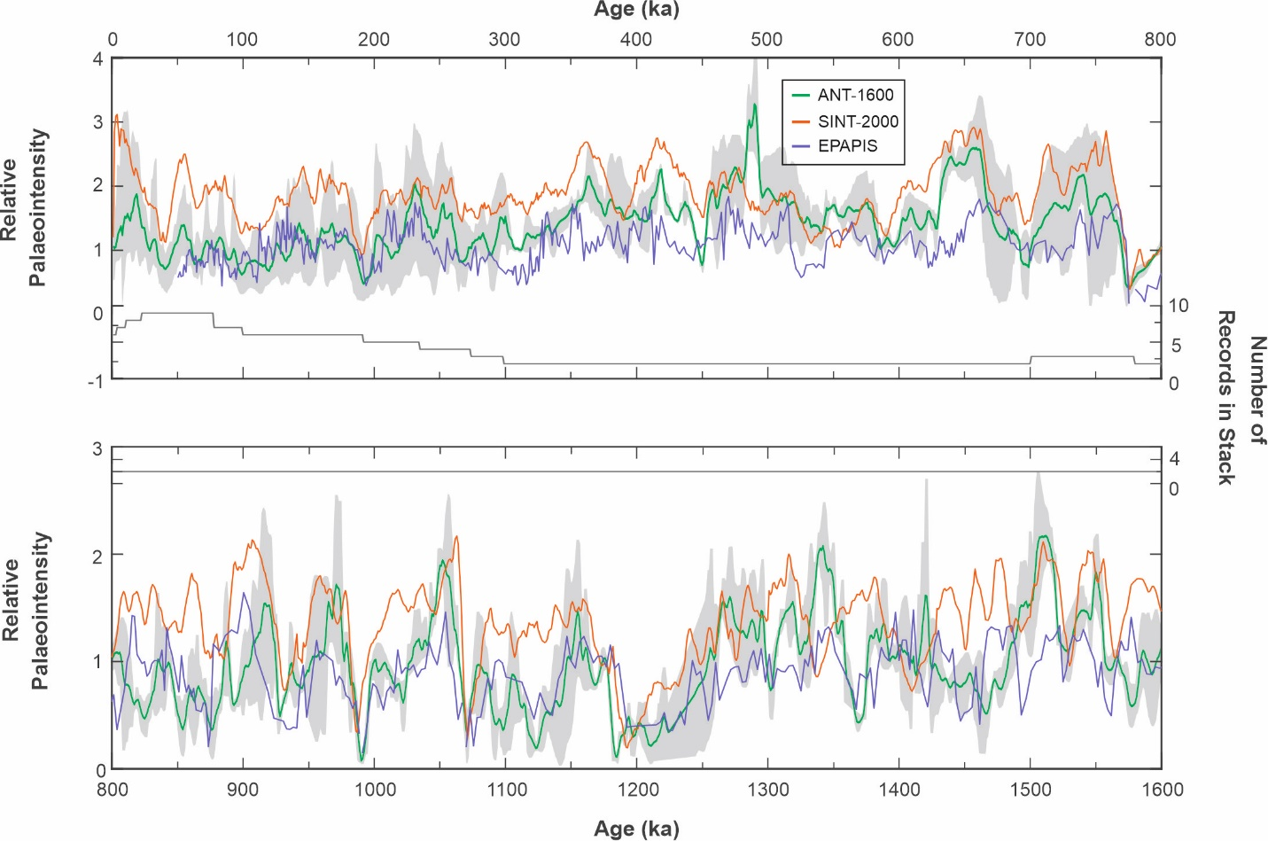
Figure 2-8. New Antarctic RPI stack (ANT-1600) for the interval 0–1.6 Ma (green line) with comparison to the two global reference RPI stacks: SINT 2000 (Valet et al., 2005; orange line) and EPAPIS (Yamazaki and Oda, 2005; purple line). Grey envelope shows the 90% confidence interval for the ANT-1600 stack. Number of RPI records used is shown on each panel.
Nine published RPI records together with the one from Site U1533 were selected for the construction of the new regional Antarctic RPI stack ANT-1600 (Table 2; Supplementary Figs. S10, S11, S12), though the number of records ranges from two to nine for any particular time interval (Fig. 8). These records are of varying lengths and resolutions (with sedimentation rates ranging from 1 to 37 cm/kyr), though most of the records span the time period 1–300 ka (Table 2; Supplementary Figs. S10 and S11). Each record was interpolated using their mean age increment, and normalised by their mean value from selected time intervals (e.g., following the methods in Xuan et al., 2016). For all records except Site 1101, we used the mean from 23 to 77 kyr, as this interval is common between nine of the records. Site 1101 was normalised using its mean across the whole record (701–1600 kyr). The new ANT-1600 stack was then constructed by bootstrapping each record centred at each 1-kyr time-step (10,000 times) with a 1-kyr overlapping window where RPI values can be drawn from. The same number of resampling was used for each record to ensure equal weight. For each time-step, the mean of the 10,000 randomly drawn RPI values was used to produce the ANT-1600 stack (Fig. 8), and a 90% confidence interval was determined (grey interval, Fig. 8). Variations between all RPI records are likely due to variable lock-in depths and environmental factors, but they all show consistent long-term trends throughout, suggesting a generally coherent palaeointensity signal. The RPI record from Site U1533 has the lowest temporal resolution of all records included in the ANT-1600 stack.
Errors can be introduced into RPI stacks due to poor age control of individual sediment cores, uncertainties in tie points selected, low sedimentation rates and use of erroneous composite depth scales for individual records (Guyodo and Channell, 2002; McMillan et al., 2002; 2004; Carlson et al., 2021). Discrepancies between individual RPI records are likely the result of primary lithological and secondary diagenetic differences (Macrì et al., 2005) that impact the ability of sediments to record palaeointensity. In order to ensure that the produced ANT-1600 stack is robust, we evaluated the lithologies and age models for the records included in the stack. The chosen records all have age models based on multiple methods of age construction, including proxy correlation to δ18O (Guyodo et al., 2001; Channell et al., 2019), radiometric (¹⁴C, ²¹⁰Pb) dates (Macrì et al., 2005; Jimenez-Espejo et al., 2020) and magnetostratigraphic correlations to known reversals or excursions (Guyodo et al., 2001; Macrì et al., 2005; Lu et al., 2022). These Antarctic RPI records were also correlated to the global reference records SINT-800 (Guyodo and Valet, 1999) and PISO-1500 (Channell et al., 2009), as well as local and regional records. All the chosen records consist predominantly of fine-grained siliciclastic sediments, such as muds and silty clays, while records described as sandy were avoided.
We compare our new ANT-1600 stack to the global records SINT2000 (Valet et al., 2005) and EPAPIS (Yamazaki and Oda, 2005). Broad features are consistent between all three stacks (e.g., at 195 ka, 450 ka, 590 ka, 680 ka, 880 ka, 920 ka, 995 ka, 1075 ka, 1200 ka, 1530 ka and 1560 ka) supporting a consistent geomagnetic signal, but there are also discrepancies (e.g., at 960 ka, 1410 ka) (Fig. 8). SINT-2000 and ANT-1600 show generally strong in-phase coherence on timescales of ~16–250 kyrs (Supplementary Fig. S13), on which both RPI stacks might record common global geomagnetic intensity changes. The two RPI stacks appear to be coherent on a wide range of timescales during the younger time interval (0–800 ka) where independent age constraints for cores used in the stacks are better and more individual RPI records were incorporated in the ANT-1600 stack. In the oldest interval (1200–1600 ka), the two RPI stacks are generally less coherent, except on longer (>100 kyr) time scales, possibly due to the less well-constrained independent chronology for the individual RPI records used for the ANT-1600 stack over this time interval.
Table 2-2. Antarctic RPI records used in the ANT-1600 stack.
Name | Period (ka) | Location | Average Sedimentation Rate (cm/kyr) | Reference
PC728 | 1–100 | Antarctic Peninsula | 11.87 | Channell et al., 2019
PC732 | 1–80 | Antarctic Peninsula | 13.14 | Channell et al., 2019
PC736 | 1–80 | Antarctic Peninsula | 12.82 | Channell et al., 2019
ANT32-RA05C | 0–200 | Ross Sea | 1.37 | Li et al., 2022
PC726 | 1–250 | Antarctic Peninsula | 5.36 | Channell et al., 2019
SEDANO | 4–270 | Antarctic Peninsula | 2.3 | Macrí et al., 2006
WEGA | 1–780 | Wilkes Land margin | 19 | Macrí et al., 2005
MOGAM | 23–400 | Wilkes Land margin | 1.4 | Jimenez-Espejo et al., 2020
ODP Site 1101 | 701–1600 | Antarctic Peninsula | 7.5 | Guyodo et al., 2001; Channell et al., 2019
Site U1533 | 0-2905 | Amundsen Sea | 1.9 | This study
Discrepancies between the RPI stacks could be due to lithological differences, uncertainties within the age models of cores used in stacks, or regional effects (e.g., occurrence of a regional Antarctic geomagnetic event that is not seen elsewhere). In order to mitigate the impact of these factors on the ANT-1600 stack, available Antarctic RPI records were evaluated, and only those considered to meet our criteria were selected. In addition, an evaluation of the two RPI stacks that we compare ANT1600 to is useful. The EPAPIS record was constructed from six records from the equatorial Pacific. The age models for the individual cores used for that stack were constructed by inferring glacial-interglacial cyclicity from magnetic concentration parameters and correlating the cycles to the LR04 stack and the δ18O record from ODP Site 1143 (Yamazaki and Oda, 2005). As previously discussed, correlating any non-δ18O proxy to δ18O records assumes that both signals respond simultaneously to global changes. The age models for the EPAPIS cores themselves also show an offset between the top of the Olduvai subchron, suggesting inherent uncertainties within the age models of the cores. Channell et al. (2009) identified an offset between the PISO-1500 stack and EPAPIS during their evaluation which may have carried over to the ANT-1600 stack as many other RPI records use PISO-1500 in their age model construction. In comparison, the SINT-2000 RPI stack was constructed from more RPI records with a wider geographical distribution. This stack used individual site age models (mostly correlated to δ18O records or other palaeoclimate proxies), and for some individual RPI records intensity minima were correlated prior to stacking to improve the age controls. The two global records also have comparatively lower sedimentation rates (averaging < 2 cm/kyr for EPAPIS (Yamazaki & Oda); 1–4 cm/kyr for SINT-2000 (Valet et al., 2005)) than the ANT-1600 stack (on average 10.4 cm/kyr according to the average sedimentation rates for the individual records). The range of sedimentation rates across all records used (Table 2, Valet et al., 2005; Yamazaki and Oda, 2005) impacts the resolution of stacks due to smoothing, which adds some uncertainty in particular intervals. This is reflected in the ANT-1600 stack confidence interval (90% confidence shown in grey intervals), which shows varying ranges of confidence across the record.
The ANT-1600 RPI stack provides a regional palaeointensity record that can be used for correlation in the Southern Ocean. This is especially important as other long-term records are being developed for sites across the Antarctic Circumpolar Current (IODP Exp. 383; Winckler et al., 2021) and in the Scotia Sea (IODP Exp. 382; Weber et al., 2021), which may allow for the development of a longer and more temporally refined Antarctic RPI stack in the future, which is important not only as a stratigraphic tool but also for studying the dynamics of the geomagnetic field.

Summary
The palaeomagnetic study of u-channel samples for the composite sedimentary section from Site U1533 spanning the past ~3 Ma reveals the presence of major polarity reversals and sub-chrons that can be unambiguously correlated to the GPTS (Ogg, 2020). These polarity reversals are used to refine the positions of polarity boundaries identified in shipboard analyses (Wellner et al., 2021). Two potential geomagnetic excursions (Kamikatsura and possibly Porcupine) were identified in the Site U1533 palaeomagnetic record.
Beyond the magnetostratigraphic age model, two higher-resolution age models were developed for the Late Pliocene‒Pleistocene interval at Site U1533. These age models use two independent methods: correlation of downcore changes in biogenic barium content to the global δ18O stack, and correlation of the U1533 RPI record to reference RPI stacks/records. We infer that the barium-LR04 correlation is a suitable method for age model development in Antarctica when used in conjunction with other methods (e.g., magnetostratigraphy). Biogenic barium content is controlled by export productivity and is interpreted to be higher at the study site during interglacial periods due to reduced sea ice cover in the spring/summer months. However, there are some assumptions inherent to this approach concerning the phasing between productivity cycles (i.e., summer sea ice extent) and the global ice volume/deep-sea temperature signal. Additionally, differences in cycle shape between the barium record at Site U1533 and the global δ18O cycles of the last 800 kyr (almost symmetrical barium variations vs. sawtooth-like δ18O fluctuations) introduces uncertainty in defining tie points at glacial‒interglacial cycle transitions for this time period.
Our analysis indicates that RPI is also a viable alternative and independent method for age model construction. Major features of our new U1533 RPI record correlate well with two published Northern Hemisphere-dominated records (PISO-1500, Channell et al., 2009; U1308, Channell et al., 2008, 2016), as well as nearby regional records from the Antarctic margin/Southern Ocean. The development of this palaeointensity record at Site U1533 indicates that it is possible for Antarctic margin sediments to record Earth’s geomagnetic field changes even in relatively low sedimentation rate environments. The impact of the lock-in effect in this low-sedimentation rate environment may be enhanced and may explain the observed temporal offsets of up to 35 kyr between the RPI- and barium-based age models. However, without independent dating of distinct core horizons it is difficult to determine the absolute age offset produced by lock-in depth effects.
A hybrid age model for the Late Pliocene‒Pleistocene sequence at Site U1533 was created using robust tie points from both the barium and RPI-based age models. This age model was then used as the foundation for developing a new Antarctic RPI stack (ANT-1600) that incorporates Site U1533 as well as 9 previously published RPI records. The ANT-1600 stack spans 0.0–1.6 Ma, though the temporal resolution and number of records used for different intervals of the stack varies. Overall, there is a coherent signal between all RPI records, and differences between the individual records can be attributed to varying sedimentation rates, differences in lock-in depths, environmental/sedimentary effects (e.g., influences by lithology, bioturbation, diagenesis) and uncertainties in age models. ANT-1600 is characterised by the primary trends and major features documented in published global records. However, short-term variability in regional RPI is likely not resolved due to low sedimentation rates of some sites used in the stack. The ANT-1600 stack will aid in age model development for Antarctic sediment cores with robust palaeomagnetic records, but limited alternative means of dating. To further evaluate and develop the stack, additional Antarctic RPI records on robust independent age models are required.

Author contributions
Becky Hopkins: Conceptualization, Methodology, Formal analysis, Investigation, Writing - original draft, Writing – review & editing; Visualization; Chuang Xuan: Conceptualization, Supervision, Writing – review & editing; Claus-Dieter Hillenbrand: Conceptualization, Writing – review & editing, Supervision, Project administration, Funding acquisition; Tim E. van Peer: Methodology, Formal analysis, Investigation, Writing – review & editing; Yuxi Jin: Resources, Methodology; Thomas Frederichs: Writing – review & editing; Liang Gao: Writing – review & editing; Steve M. Bohaty: Conceptualization, Writing – review & editing, Supervision, Project administration, Funding acquisition.

Declaration of competing interest
The authors declare that they have no known competing financial interests or personal relationships that could have appeared to influence the work reported in this paper.

Data availability
Data is attached in Supplementary Tables and will be made available in PANGAEA post publishing.

Acknowledgements
We thank the officers, crew, shipboard and shore-based scientists from IODP Expedition 379 for their work in gathering the material used in this study. We thank the IODP Gulf Coast Repository (College Station, Texas) staff for the collection and preparation of u-channel samples. We thank the Exp. 379 chief scientists Julia Wellner and Karsten Gohl for commenting on the manuscript prior to submission. We also thank the International Association of Sedimentologists (IAS) for their funding, and the British Ocean Sediment Core Research Facility (BOSCORF) for supporting the generation of the X-radiography data used in this study. Additional funding comes from the National Environmental Research Council INSPIRE Doctoral Training Partnership (NE/S007210/1). C.-D. H. acknowledges funding by NERC UK-IODP grant NE/T010975/1. T.E. v.P. was supported by NERC Grant NE/M021254/1 and supported as a Research Fellow by the University of Leicester. The authors are grateful for constructive suggestions provided by Stefanie Brachfeld and another anonymous reviewer, which have significantly improved the manuscript.

References
G.D. Acton, Y. Guyodo, S.A. Brachfeld (2002) Magnetostratigraphy of sediment drifts on the continental rise of West Antarctica (ODP Leg 178, Sites 1095, 1096, and 1101). In Barker, P.F., Camerlenghi, A., Acton, G.D., and Ramsay, A.T.S. (eds.) Proc. ODP, Sci. Results, 178: College Station, TX (Ocean Drilling Program), 1–61, doi:10.2973/​odp.proc.sr.178.235.2002
J.B. Anderson (1975) Factors controlling CaCO₃ dissolution in the Weddell Sea from foraminiferal distribution patterns, Marine Geology, 19(5), 315-332
R.F. Anderson, Z. Chase, M.Q. Fleisher, J. Sachs (2002) The Southern Ocean’s biological pump during the Last Glacial Maximum, Deep Sea Research Part II: Topical Studies in Oceanography, 49(9), 1909-1938
A.L. Annett, M. Skiba, S.F. Henley, H.J. Venables, M.P. Meredith, P.J. Statham, R.J. Ganeshram (2015) Comparative roles of upwelling and glacial iron sources in Ryder Bay, coastal western Antarctic Peninsula, Marine Chemistry, 176, 21-33
K.E. Ashley, R. McKay, J. Etourneau, F.J. Jimenez-Espejo, A. Condron, A. Albot, X. Crosta, C. Riesselman, O. Seki, G. Massé, N.R. Golledge, E. Gasson, D.P. Lowry, N.E. Barrand, K. Johnson, N. Bertler, C. Escutia, R. Dunbar, J.A. Bendle (2021) Mid-Holocene Antarctic sea-ice increase driven by marine ice sheet retreat, Climate of the Past, 17(1), 1-19
S.K. Banerjee, J.P. Mellema (1974) . A new method for the determination of paleointensity from the A.R.M. properties of rocks, Earth and Planetary Science Letters, 23 (2), 177–184.
F. Barletta, G. St-Onge, J.E.T. Channell, A Rochon, L. Polyak, D. Darby (2008) High-resolution paleomagnetic secular variation and relative paleointensity records from the western Canadian Arctic: Implication for Holocene stratigraphy and geomagnetic field behaviour, Canadian Journal of Earth Sciences, 45(11), 1265-1281
V. Benz, O. Esper, R. Gersonde, F. Lamy, R. Tiedemann (2016) Last Glacial Maximum sea surface temperature and sea-ice extent in the Pacific sector of the Southern Ocean, Quaternary Science Reviews, 146, 216-237
M. Bollen, C.R. Riesselman, C. Ohneiser, O. Albot, R. McKay, M.K. Lee, K.-C. Yoo, S. Kim, J.I. Lee, R. Levy (2022) Pleistocene oceanographic variability in the Ross Sea: A multiproxy approach to age model development and paleoenvironmental analyses, Global and Planetary Change, 216, 103901
W.J. Bonn, F.X. Gingele, H. Grobe, A. Mackensen, D.K. Fütterer (1998) Palaeoproductivity at the Antarctic continental margin: opal and barium records for the last 400 ka, Palaeogeography, Palaeoclimatology, Palaeoecology, 139(1), 195-211
H.C. Bostock, T.T. Barrows, L. Carter, Z. Chase, G. Cortese, G.B. Dunbar, M. Ellwood, B. Hayward, W. Howard, H.L. Noble, A. Mackintosh, P.T. Moss, A.D. Moy, D. White, M.J.M. Williams, L.K. Armand (2013) A review of the Australian-New Zealand sector of the Southern Ocean over the last 30 ka (Aus-INTIMATE project), Quaternary Science Reviews, 74, 35-57
S. Brachfeld, G. Acton, Y. Guyodo, S.K. Banerjee (2000) High-resolution paleomagnetic records from Holocene sediments from the Palmer Deep, Western Antarctic Peninsula, Earth and Planetary Science Letters, 181(3), 429-441
S. Brachfeld, E. Domack, C. Kissel, C. Laj, A. Leventer, S. Ishman, R. Gilbert, A. Camerlenghi, L.B. Eglinton (2003) Holocene history of the Larsen-A Ice Shelf constrained by geomagnetic paleointensity dating, Geology, 31(9), 749-752
A.E. Carlson, B.L. Beard, R. G. Hatfield, M. Laffin (2021) Absence of West Antarctic-sourced silt at ODP Site 1096 in the Bellingshausen Sea during the last interglaciation: Support for West Antarctic ice-sheet deglaciation, Quaternary Science Reviews, 261(1), 106939
C. Carricchi, R.G. Lucchi, L. Sagnotti, P. Macrí, A. Di Roberto, P. Del Carlo, K. Husum, J.S. Laberg, C. Morigi (2019) A High-Resolution Geomagnetic Relative Paleointensity Record From the Arctic Ocean Deep-Water Gateway Deposits During the Last 60 kyr, Geochemistry, Geophysics, Geosystems, 20(5), 2355-2377
L. Ceccaroni, M. Frank, M. Frignani, L. Langone, M. Ravaioli, A. Mangini (1998) Late Quaternary fluctuations of biogenic component fluxes on the continental slope of the Ross Sea, Antarctica, Journal of Marine Systems, 17(1), 515-525
M. Chadwick, C.S. Allen, L.C. Sime, C.-D. Hillenbrand (2020) Analysing the timing of peak warming and minimum winter sea-ice extent in the Southern Ocean during MIS 5e, Quaternary Science Reviews, 229, 106134
M. Chadwick, C.S. Allen, L.C. Sime, X. Crosta, C.-D. Hillenbrand (2022) Reconstructing Antarctic winter sea-ice extent during Marine Isotope Stage 5e, Climate of the Past, 18, 129-146
J.E.T. Channell, J.S. Stoner, D.A. Hodell, C.D. Charles (2000) Geomagnetic paleointensity for the last 100 kyr from the sub-antarctic South Atlantic: a tool for inter-hemispheric correlation, Earth and Planetary Science Letters, 175(1-2), 145-160
J.E.T. Channell, A. Mazaud, P. Sullivan, S. Turner, M.E. Raymo (2002) Geomagnetic excursions and paleointensities in the 0.9–2.15 Ma interval of the Matuyama Chron at ODP Site 983 and 984 (Iceland Basin), Journal of Geophysical Research, 107(B6), EPM-1
J.E.T. Channell, J.H. Curtis, B.P. Flower (2004) The Matuyama-Brunhes boundary interval (500-900 ka) in North Atlantic drift sediments, Geophysical Journal International, 158(2), 489-505
J.E.T. Channell, D.A. Hodell, C. Xuan, A. Mazaud, J.S. Stoner (2008) Age calibrated relative palaeointensity for the last 1.5 Myr at IODP Site U1308 (North Atlantic), Earth and Planetary Science Letters, 274(1), 59-71
J.E.T. Channell, C. Xuan, D.A. Hodell (2009) Stacking paleointensity and oxygen isotope data for the last 1.5 Myr (PISO-1500), Earth and Planetary Science Letters, 283(1), 14-23
J.E.T Channell, D.A. Hodell, J.H. Curtis (2016) Relative paleointensity (RPI) and oxygen isotope stratigraphy at IODP Site U1308: North Atlantic RPI stack for 1.2-2.2 Ma (NARPI-2200) and age of the Olduvai Subchron, Quaternary Science Reviews, 131(1), 1-19
J.E.T. Channell, C. Xuan, D.A. Hodell, S.J. Crowhurst, R.D. Larter (2019) Relative paleointensity (RPI) and age control in Quaternary sediment drifts off the Antarctic Peninsula, Quaternary Science Reviews, 211(1), 17-33
J.E.T. Channell, B.S. Singer, B.R. Jicha (2020) Timing of Quaternary geomagnetic reversals and excursions in volcanic and sedimentary archives, Quaternary Science Reviews, 228, 106114
P.U. Clark, D. Archer, D. Pollard, J.D. Blum, J.A. Rial, V. Brovkin, A.C. Mix, N.G. Pisias, M. Roy (2006) The middle Pleistocene transition: characteristics, mechanisms, and implications for long-term changes in atmospheric pCO2, Quaternary Science Reviews, 25 (23–24), 3150–3184.
R.S. Coe, J.C. Liddicoat (1994) Overprinting of natural magnetic remanence in lake sediments by a subsequent high-intensity field, Nature, 367, 57-59
R.S. Coe, B.S. Singer, M.S. Pringle, X. Zhao (2004) Matuyama-Brunhes reversal and Kamikatsura event on Maui: paleomagnetic directions, ⁴⁰Ar/³⁹Ar ages and implications, Earth and Planetary Science Letters, 222(2), 667-684
L.G. Collins, M.W. Hounslow, C.S. Allen, D.A. Hodgson, J. Pike, V.V. Karloukovski (2012) Palaeomagnetic and biostratigraphic dating of marine sediments from the Scotia Sea, Antarctica: First identification of the Laschamp excursion in the Southern Ocean, Quaternary Geochronology, 7, 67-75
D. Cordes (1990) Sedimentologie und Paläomagnetik an Sedimenten der Maudkuppe (Nördliches Weddellmeer) (Sedimentology and Palaeomagnetism of sediments from Maud Rise, Northeast Weddell Sea). Berichte zur Polarforschung = Reports on Polar Research, 71, 1-158
I.W. Croudace, R.G. Rothwell (2015) Twenty Years of XRF Core Scanning Marine Sediments: What Do Geochemical Proxies Tell Us? In: IW Croudace & GR Rothwell (eds), Micro-XRF Studies of Sediment Cores: Applications of a non-destructive tool for the environmental sciences. Developments in Paleoenvironmental Research, vol. 17, Springer, Netherlands, 25-102
H.J.W. de Baar, J.T.M. de Jong, D.C.E. Bakker, B.M. Löscher, C. Veth, U. Bathmann, V. Smetacek (1995) Importance of iron for plankton blooms and carbon dioxide drawdown in the Southern Ocean, Nature, 373, 412-415
J.A. Dowdeswell, J. Evans, C. Ó Cofaigh, J.B. Anderson (2006) Morphology and sedimentary processes on the continental slope off Pine Island Bay, Amundsen Sea, West Antarctica, GSA Bulletin, 118(5-6), 606-619
B. Diekmann, G. Kuhn, V. Rachold, A. Abelmann, Y. Brathauer, D. K. Fütterer, R. Gersonde, H. Grobe (2000) Terrigenous sediment supply in the Scotia Sea (Southern Ocean): response to Late Quaternary ice dynamics in Patagonia and on the Antarctic Peninsula, Palaeogeography, Palaeoclimatology, Palaeoecology, 162(3-4), 357-387
L.P.A.M. Duprat, G.R. Bigg, D.J. Wilton (2016) Enhanced Southern Ocean marine productivity due to fertilization by giant icebergs, Nature Geoscience, 9, 219-221
J. Dymond, E. Suess, M. Lyle (1992) Barium in Deep-Sea Sediment: A Geochemical Proxy for Paleoproductivity, Paleoceanography, 7(2), 163-181
M. Eagle, A. Paytan, K.R. Arrigo, G. van Dijken, R.W. Murray (2003) A comparison between excess barium and barite as indicators of carbon export, Paleoceanography, 18(1), 1021
C. Eayrs, X. Li, M.N. Raphael, D.M. Holland (2021) Rapid decline in Antarctic sea-ice in recent years hints at future change, Nature Geoscience, 14, 460-464
H. Elderfield, P. Ferretti, M. Greavers, S. Crowhurst, I.N. McCave, A.M. Piotrowski (2012) Evolution of Ocean Temperature and Ice Volume Through the Mid-Pleistocene Climate Transition, Science, 337 (6095), 704–709
F. Florindo, A.P. Roberts (2005) Eocene-Oligocene magnetobiochronology of ODP Sites 689 and 690, Maud Rise, Weddell Sea, Antarctica, GSA Bulletin, 117(2), 46-66
F. Florindo, G.S. Wilson, A.P. Roberts, L. Sagnotti, K.L. Verosub (2001) Magnetostratigraphy of Late Eocene-Early Oligocene Strata from the CRP-3 Core, Victoria Land Basin, Antarctica, Terra Antarctica, 8(3), 599-613
F. Florindo, G.S. Wilson, A.P. Roberts, L. Sagnotti, K.L. Verosub (2005) Magnetostratigraphic chronology of a late Eocene to early Miocene glacimarine succession from the Victoria Land Basin, Ross Sea, Antarctica, Global and Planetary Change, 45(3), 207-236
J.S. Gee, S.C. Cande, J.A. Hildebrand, K. Donnelly, R.L. Parker (2000) Geomagnetic intensity variations over the past 780 kyr obtained from near-seafloor magnetic anomalies, Nature, 408 (1), 827–832
R. Gersonde, X. Crosta, A. Ablemann, L. Armand (2005) Sea surface temperature and sea ice distribution of the Southern Ocean at the EPILOG Last Glacial–Maximum - a circum-Antarctic view based on siliceous microfossil records, Quaternary Science Reviews, 24(7), 869-896
F.X. Gingele, A. Dahmke (1994) Discrete barite particles and barium as tracers of paleoproductivity in South Atlantic sediments, Paleoceanography, 9(1), 151-168
F.X. Gingele, M. Zabel, S. Kasten, W.J. Bonn, C.C. Nürnberg (1999) Biogenic Barium as a Proxy for Paleoproductivity: Methods and Limitations of Application, In G. Fischer, G. Wefer (1999) Use of Proxies in Paleoceanography: Examples from the South Atlantic. Springer-Verlag Berlin Heidelberg, 345-364
K. Gohl, J.S. Wellner, A. Klaus, T. Bauersachs, S.M. Bohaty, M. Courtillat, E.A. Cowan, M.A. De Lira Mota, M.S.R. Esteves, J.M. Fegyveresi, T. Frederichs, L. Gao, A.R. Halberstadt, C.-D. Hillenbrand, K. Horikawa, M. Iwai, J.-H. Kim, T.M. King, J.P. Klages, S. Passchier, M.L. Penkrot, J.G. Prebble, W. Rahaman, B.T.I. Reinardy, J. Renaudie, D.E. Robinson, R.P. Scherer, C.S. Siddoway, L. Wu, M. Yamane (2021a) Expedition 379 summary, In Gohl, K., Wellner, J.S., Klaus, A., and the Expedition 379 Scientists, Amundsen Sea West Antarctic Ice Sheet History. Proceedings of the International Ocean Discovery Program, 379: College Station, TX (International Ocean Discovery Program), https://doi.org/10.14379/iodp.proc.379.104.2021
K. Gohl, G. Uenzelmann-Neben, J. Gille-Petzoldt, C.-D. Hillenbrand, J.P. Klages, S.M. Bohaty, S. Passchier, T. Frederichs, J.S. Wellner, R. Lamb, G. Leitchenkov, IODP Expedition 379 Scientists (2021b) Evidence for a Highly Dynamic West Antarctic Ice Sheet During the Pliocene, Geophysical Research Letters, 48(14), doi:10.1029/2021gl093103
H. Goosse, D.M. Roche, A. Mairesse, M. Berger (2013) Modelling past sea ice changes, Quaternary Science Reviews, 79, 191-206
J.E. Gordon, D.D. Harkness (1992) Magnitude and geographic variation of the radiocarbon content in Antarctic marine life: Implications for reservoir corrections in radiocarbon dating, Quaternary Science Reviews, 11, 696–708
R.A. Green, L. Menviel, K.J. Meissner, X. Crosta, D. Chandan, G. Lohmann, W.R. Peltier, X. Shi, J. Zhu (2022) Evaluating seasonal sea-ice cover over the Southern Ocean at the Last Glacial Maximum, Climate of the Past, 18(4), 845-862
H. Grobe, A. Mackensen (1992) Late Quaternary climatic cycles as recorded in sediments from the Antarctic continental margin, In: J.P. Kennett, D.A. Warnke, (eds.), The Antarctic Paleoenvironment: a perspective on Global Change, Antarctic Research Series, American Geophysical Union, 56, 349-376
S. Grünig (1991) Quaternary sedimentation processes on the continental margin of the South Orkney Plateau, NW Weddell Sea (Antarctica), PhD Thesis, Universität Bremen
Y. Guyodo, J.E.T. Channell (2002) Effects of variable sedimentation rates and age errors on the resolution of sedimentary paleointensity records. Geochemistry, Geophysics, Geosystems, 3(8), 1-18
Y. Guyodo, J.-P. Valet (1999) Global changes in geomagnetic intensity during the past 800 thousand years, Nature, 399, 249-252
Y. Guyodo, G.D. Acton, S. Brachfeld, J.E.T. Channell (2001) A sedimentary paleomagnetic record of the Matuyama chron from the Western Antarctic margin (ODP Site 1101), Earth and Planetary Science Letters, 191(1), 61-74
Y. Guyodo, J.E.T. Channell, R. Thomas (2002) Deconvolution of u-channel paleomagnetic data near geomagnetic reversals and short events, Geophysical Research Letters, 29(17), 1845, doi:10.1029/2002GL014927
J.D. Hartman, F. Sangiorgi, M.A. Barcena, F. Tateo, F. Giglio, S. Albertazzi, F. Trincardi, P.K. Bijl, L. Langone, A. Asioli (2021) Sea-ice, primary productivity and ocean temperatures at the Antarctic marginal zone during the late Pleistocene, Quaternary Science Reviews, 266, 107069
R.G. Hatfield, J.S. Stoner, A.J. Frass (2021) Relative Paleointensity Record of Integrated Ocean Drilling Program Site U1396 in the Caribbean Sea: Geomagnetic and Chronostratigraphic Observations in the Pliocene, Geochemistry, Geophysics, Geosystems, 22, e2021GC009677. https://doi.org/10.1029/2021GC009677
P.C. Henshaw Jr., R.T. Merrill (1980) Magnetic and Chemical Changes in Marine Sediments, Reviews of Geophysics and Space Physics, 18(2), 483-504
C.-D. Hillenbrand, G. Cortese (2006) Polar stratification: A critical view from the Southern Ocean, Palaeogeography, Palaeoclimatology, Palaeoecology, 242(3), 240-252
C.-D. Hillenbrand, D. Fütterer, H. Grobe, T. Frederichs (2002) No evidence for a Pleistocene collapse of the West Antarctic Ice Sheet from continental margin sediments recovered in the Amundsen Sea, Geo-Marine Letters, 22(2), 51-59
C.-D. Hillenbrand, G. Kuhn, T. Frederichs (2009) Record of a Mid-Pleistocene depositional anomaly in West Antarctic continental margin sediments: an indicator for ice-sheet collapse? Quaternary Science Reviews, 28(13), 1147-1159
C.-D. Hillenbrand, J. Smith, G. Kuhn, O. Esper, R. Gersonde, R.D. Larter, B. Maher, S.G. Moreton, T.M. Shimmield, M. Korte (2010) Age assignment of a diatomaceous ooze deposited in the western Amundsen Sea Embayment after the Last Glacial Maximum, Journal of Quaternary Science, 25(3), 280-295
C.-D. Hillenbrand, S.J. Crowhurst, M. Williams, D.A. Hodell, I.N. McCave, W. Ehrmann, C. Xuan, A.M. Piotrowski, F.J. Hernández-Molina, A.G.C. Graham, H. Grobe, T.J. Williams, J.R. Horrocks, C.S. Allen, R.D. Larter (2021) New insights from multi-proxy data from the West Antarctic continental rise: Implications for dating and interpreting Late Quaternary palaeoenvironmental records, Quaternary Science Reviews, 257, 106842
L. Holder, M. Duffy, B. Opdyke, A. Leventer, A. Post, P. O’Brien, L.K. Armand (2020) Controls Since the mid-Pleistocene Transition on Sedimentation and Primary Productivity Downslope of Totten Glacier, East Antarctica, Paleoceanography and Paleoclimatology, 35(12), e2020PA003981
M.J. Hopwood, D. Carroll, J. Höfer, E.P. Achterberg, L. Meire, F.A.C. Le Moigne, L.T. Bach, C. Eich, D.A. Sutherland, H.E. González (2019) Highly variable iron content modulates iceberg-ocean fertilisation and potential carbon export, Nature Communications, 10, 5261
M.W. Hounslow, C. Xuan, A. Nilsson (2022) Chapter 5: Palaeomagnetism: using the geomagnetic field for correlation and dating, In: A.L. Coe (ed.) Deciphering Earth’s History: the Practice of Stratigraphy, Geological Society London, Geoscience in Practise, 81-100
E. Irving, A. Major (1964) Post-depositional detrital remanent magnetization in a synthetic sediment, Sedimentology, 3, 135-143
T. Ito, P. Parekh, S. Dutkiewicz, M.J. Follows (2005) The Antarctic Circumpolar Productivity Belt, Geophysical Research Letters, 32(13), L13604
S.L. Jaccard, G.H. Haug, D.M. Sigman, T.F. Pedersen, H.R. Thierstein, U. Röhl (2005) Glacial/Interglacial Changes in Subarctic North Pacific Stratification, Science, 308(5724), 1003-1006
S.L. Jaccard, E.D. Galbraith, D.M. Sigman, G.H. Haug (2010) A pervasive link between Antarctic ice core and subarctic Pacific sediment records over the past 800 kyrs, Quaternary Science Reviews, 29(1), 206-212
S.L. Jaccard, C.T. Hayes, A. Martínex-García, D.A. Hodell, R.F. Anderson, D.M. Sigman, G.H. Haug (2013) Two Modes of Change in Southern Ocean Productivity Over the Past Million Years, Science, 339(6126), 1419-1423
F.J. Jimenez-Espejo, M. Presti, G. Kuhn, R. Mckay, X. Crosta, C. Escutia, R.G. Lucchi, R. Tolotti, T. Yoshimura, M.O. Huertas, P. Macrì, A. Caburlotto, L. De Santis (2020); Late Pleistocene oceanographic and depositional variations along the Wilkes Land margin (East Antarctica) reconstructed with geochemical proxies in deep-sea sediments, Global and Planetary Change, 184(1), 1030-45
R. Karlin, S. Levi (1983) Diagenesis of magnetic minerals in Recent haemipelagic sediments, Nature, 303, 327-330
K. Kawamura, F. Parrenin, L. Lisiecki, R. Uemura, F. Vimeux, J.P. Severinghaus, M.A. Hutterli, T. Nakazawa, S. Aoki, J. Jouzel, M.E. Raymo, K. Matsumoto, H. Nakata, H. Motoyama, S. Fujita, K. Goto-Azuma, Y. Fujii, O. Watanabe (2007) Northern Hemisphere forcing of climatic cycles in Antarctica over the past 360,000 years, Nature, 448, 912-916
D.V. Kent (1973) Post-depositional remanent magnetisation in deep- sea sediment, Nature, 246, 32-34
J. King, S.K. Banerjee, J. Marvin, Ö. Özdemir (1982). A comparison of different magnetic methods for determining the relative grain size of magnetite in natural materials: Some results from lake sediments. Earth and Planetary Science Letters, 59(2), 404–419
J.W. King, S.K. Banerjee, J. Marvin (1983) A new rock-magnetic approach to selecting sediments for geomagnetic paleointensity studies; Application to paleointensity for the last 4000 years. Journal of Geophysical Research: Solid Earth, 88, 5911–5921
J.L. Kirschvink (1980) The least-squares line and plane and the analysis of palaeomagnetic data, Geophysical Journal of the Royal Astronomical Society, 62(3), 699-718
J.P. Klages, G. Kuhn, C.-D. Hillenbrand, J.A. Smith, A.G.C. Graham, G.O. Nitsche, T. Frederichs, P.E. Jernas, K. Gohl, L. Wacker (2017) Limited grounding-line advance onto the West Antarctic continental shelf in the easternmost Amundsen Sea Embayment during the last glacial period, PLoS ONE, 12(7), e0181593
M.A. Konfirst, R.P. Scherer, C.-D. Hillenbrand, G. Kuhn (2012). A marine diatom record from the Amundsen Sea — Insights into oceanographic and climatic response to the Mid-Pleistocene Transition in the West Antarctic sector of the Southern Ocean, Marine Micropaleontology, 92-93, 40–51
C. Laj, J.E.T. Channell (2007) 5.10 - Geomagnetic Excursions, Geomagnetism, 5, 373-416
C. Laj, C. Kissel, A. Mazaud, J.E.T. Channel, J. Beer (2000) North Atlantic paleointensity stack since 75ka (NAPIS-75) and the duration of the Laschamp event, Philisophical Transactions of the Royal Society, Series A, 358(2000), 1009-1025
C. Laj, C. Kissel, J. Beer (2004) High Resolution Global Paleointensity Stack Since 75 kyr (GLOPIS-75) Calibrated to Absolute Values, In: J.E.T. Channel, D.V. Kent, W. Lowerie, J.G. Meert (eds.) Timescales of the Paleomagnetic Field, 145
C.G. Langereis, W. Krijgsman, G. Muttoni, M. Meaning (2010) Magnetostratigraphy - concepts, definitions and applications, Newsletter on Stratigraphy, 43(3), 207-233
J. Laskar, A. Fienga, M. Gastineau, H. Manche (2011), La2010: A new orbital solution for the long-term motion of the Earth, Astron. Astrophys., 532, A89
S. Lazarev, K.F. Kuiper, O. Oms, M. Bukhsianidze, D. Vasilyan, E.L. Jorissen, M.J. Bouwmeester, V. Aghayeva, A.J. von Amerongen, J. Agustí, D. Lordkipanidze, W. Krijgsman (2021) Five-fold expansion of the Caspian Sea in the late Pliocene: New and revised magnetostratigraphic and ⁴⁰Ar/³⁹Ar age constraints on the Akchagylian Stage, Global and Planetary Change, 206, 103624
S. Levi, S.K. Banerjee (1976) On the possibility of obtaining relative paleointensities from lake sediments, Earth and Planetary Science Letters, 29, 219–226
G. Li, R. Bu, L. Yi, B. Hu, Y. Li, Y. Ji, Y. Li, L. Wang (2022) Geochronology and Paleoenvironmental Changes of Late Pleistocene Sediments in the Ross Sea, Antarctica, Frontiers in Earth Science, 10, 863336
L.E. Lisiecki, M.E. Raymo (2005) A Pliocene–Pleistocene stack of 57 globally distributed benthic d18O records, Paleoceanography, 20(1), PA1003
L. Lu, X. Zheng, W. Yan, S. Wu, L.-W. Zheng, X. Wang, Y. Chen, S. Kao (2022) One-To-One Coupling Between Southern Ocean Productivity and Antarctica Climate, Geophysical Research Letters, 49(13), e2022GL098761
S.P. Lund, L. Keigwin (1994) Measurement of the degree of smoothing in sediment paleomagnetic secular variation records: an example from late Quaternary deep-sea sediments of the Bermuda Rise, western North Atlantic Ocean, Earth and Planetary Science Letters, 122(3), 317-330
S.P. Lund, E. Platzman, T. Johnson (2016) Full-vector paleomagnetic secular variation records from latest quaternary sediments of Lake Malawi (10.0°S, 34.3°E), Quaternary Science Reviews, 144, 16-27
P. Macrì, L. Sagnotti, J. Dinarès-Turell, A. Caburlotto (2005) A composite record of Late Pleistocene relative geomagnetic paleointensity from the Wilkes Land Basin (Antarctica), Physics of the Earth and Planetary Interiors, 151(1), 223-242
P. Macrì, L. Sagnotti, R.G. Lucchi, M. Rebesco (2006) A stacked record of relative geomagnetic paleointensity for the past 270 kyr from the western continental rise of the Antarctic Peninsula, Earth and Planetary Science Letters, 252(1), 162-179
P. Macrì, L. Sagnotti, J. Dinarès-Turell, A. Caburlotto (2010) Relative geomagnetic paleointensity of the Brunhes Chron and the Matuyama-Brunhes precursor as recorded in sediment core from Wilkes Land Basin (Antarctica), Physics of the Earth and Planetary Interiors, 179(2), 72-86
K. Maenaka (1983) Magnetostratigraphic study of the Osaka group, with special reference to the existence of pre and past-Jaramillo episodes in the late Matuyama polarity, Epoch. Mem. Hanazono Univ., 14, 1-65
J.H. Martin (1990) Glacial-interglacial CO₂ change: The Iron Hypothesis, Paleoceanography and Paleoclimatology, 5(1), 1-13
K. Matsumoto, J.L. Sarmiento, M.A. Brzezinski (2002) Silicic acid leakage from the Southern Ocean: A possible explanation for glacial atmospheric pCO₂, Global Biogeochemical Cycles, 16(3), 5-1-5-23
A. Mazaud, M.A. Sicre, U. Ezat, J.J. Pichon, J. Duprat, C. Laj, C. Kissel. L. Beaufort, E. Michel, J.L. Turon (2002) Geomagnetic-assisted stratigraphy and sea surface temperature changes in core MD94-103 (Southern Indian Ocean): possible implications for North-South climatic relationships around H4, Earth and Planetary Science Letters, 201(1), 159-170
J. McManus, W.M. Berelson, G.P. Klinkhammer, K.S. Johnson, K.H. Coale, R.F. Anderson, N. Kumar, D.J. Burdige, D.E. Hammond, H.J. Brumsack, D.C. McCorkle, A. Rushdi (1998) Geochemistry of barium in marine sediments: implications for its use as a paleoproxy, Geochimica et Cosmochimica Acta, 62(21), 3453-3473
D.G. McMillan, C.G. Constable, R.L. Parker (2002) Limitations on stratigraphic analyses due to incomplete age control and their relevance to sedimentary paleomagnetism, Earth and Planetary Science Letters, 201(3-4), 509-523
D.G. McMillan, C.G. Constable, R.L. Parker (2004) Assessing the dipolar signal in stacked paleointensity records using a statistical error model and geodynamo simulations, Physics of the Earth and Planetary Interiors, 145(1-4), 37-54
N.R. Nowaczyk, J. Knies (2000) Magnetostratigraphic results from the eastern Arctic Ocean: AMS ¹⁴C ages and relative palaeointensity data of the Mono Lake and Laschamp geomagnetic reversal excursions, Geophysical Journal International, 140(1), 185-197
C.C. Nürnberg, G. Bohrmann, M. Schlüter, M Frank (1997) Barium accumulation in the Atlantic sector of the Southern Ocean: Results from 190,000-year records, Paleoceanography, 12(4), 594-603
C. O´Cofaigh, J.A. Dowdeswell, C.J. Pudsey (2001) Later quaternary iceberg rafting along the Antarctic Peninsula continental rise and in the Weddell and Scotia seas, Quaternary Research, 56, 308–321.
H. Oda, H. Shibuya (1996) Deconvolution of long-core paleomagnetic data of Ocean Drilling Program by Akaike's Bayesian Information Criterion minimization Journal of Geophysical Research, 101, 2815-2834
J.G. Ogg (2012) Geomagnetic Polarity Time Scale, In: F.M. Gradstein, J.G. Ogg, M.D. Schmitz, and G.M. Ogg (2012), The Geological Time Scale 2012, Amsterdam: Elsevier, 85-113
J.G. Ogg (2020) Geomagnetic Polarity Time Scale, In: F.M. Gradstein, J.G. Ogg, M.D. Schmitz, and G.M. Ogg (2020), The Geological Time Scale 2020, Amsterdam: Elsevier, 159-192
C. Ohneiser, G. Wilson (2012) Revised magnetostratigraphic chronologies for New Harbour drill cores, southern Victoria Land, Antarctica, Global and Planetary Change, 82, 12-24
S. Panovska, C.G. Constable, M.C. Brown (2018) Global and Regional Assessments of Paleosecular Variation Activity over the Past 100 ka, Geochemistry, Geophysics, Geosystems, 19 (1), 1559-1580
C.I. Parkinson, D.J. Cavalieri (2012) Antarctic sea ice variability and trends, 1979-2010, The Cryosphere, 6, 871-880
G.A. Paterson, X. Zhao, M. Jackson, D. Heslop (2018) Measuring, Processing, and Analyzing Hysteresis Data, Geochemistry, Geophysics, Geosystems, 19 (7), 1925-1945
F.J. Pavia, S. Wang, J. Middleton, R.W. Murray, R.F. Anderson (2021) Trace metal evidence for deglacial ventilation of the abyssal Pacific and Southern Oceans, Paleoceanography and Paleoclimatology, 36(9), e2021PA004226
A. Paytan, M. Kastner (1996) Benthic Ba fluxes in the central Equatorial Pacific, implications for the ocean Ba cycle, Earth and Planetary Science Letters, 142(3-4), 439-450
A. Paytan, E.M. Griffith (2007) Marine barite: Recorder of variations in ocean export productivity, Deep Sea Research Part II: Topical Studies in Oceanography, 54(5), 687-705
J.A. Peck, J.W. King, S.M. Colman, V.A. Kravchinsky (1996) An 84-kyr paleomagnetic record from the sediments of Lake Baikal, Siberia, Journal of Geophysical Research: Solid Earth, 101 (85), 11365–11385
M. Presti, L. Barbara, D. Denis, S. Schmidt, L. De Santis, X. Crosta (2011) Sediment delivery and depositional patterns off Adélie Land (East Antarctica) in relation to late Quaternary climatic cycles, Marine Geology, 284(1-4), 96-113
C.J. Pudsey (1992) Late Quaternary changes in Antarctic Bottom Water velocity inferred from sediment grain size in the northern Weddell Sea, Marine Geology, 107, 9-33
C.J. Pudsey (2000) Sedimentation on the continental rise west of the Antarctic Peninsula over the last three glacial cycles, Marine Geology, 167(3), 313-338
C.J. Pudsey, A. Camerlenghi (1998) Glacial-interglacial deposition on a sediment drift on the Pacific margin of the Antarctic Peninsula, Antarctic Science, 10(3), 285-308
R.S. Pugh, I.N. McCave, C.-D. Hillenbrand, G. Kuhn (2009) Circum-Antarctic age modeling of Quaternary marine cores under the Antarctic Circumpolar Current: Ice-core dust-magnetic correlation, Earth and Planetary Science Letters, 284(2), 113-123
R. Raiswell, L.G. Benning, M. Tranter, S. Tulaczyk (2008) Bioavailable iron in the Southern Ocean: the significance of the iceberg conveyor belt, Geochemical Transactions, 9(7), https://doi.org/10.1186/1467-4866-9-7
M.E. Raymo, L.E. Lisiecki, K.H. Nisancioglu (2006) Plio-Pleistocene Ice Volume, Antarctic Climate, and the Global δ¹⁸O Record, Science, 313, 492-495
B.T. Reilly, L. Tauxe, S. Brachfeld, M. Raymo, I. Bailey, S. Hemming, M.E. Weber, T. Williams, M. Guitard, Y.M. Martos, L.F. Pérez, X. Zheng, L. Armbrecht, F.G. Cardillo, Z. Du, G. Fauth, A. Glueder, M. Gutjahr, I. Hernández-Almeida, F.S. Hoem, J.-H. Hwang, M. Iizuka, Y. Kato, B. Kenlee, S. O’Connell, V. Peck, T.A. Ronge, O. Seki, S. Tripathi, J. Warnock (2021) New magnetostratigraphic insights from Iceberg Alley on the Rhythms of Antarctic Climate During the Plio-Pleistocene, Paleoceanography and Paleoclimatology, 36(2), e2020PA003994
A.P. Roberts (2015) Magnetic mineral diagenesis, Earth-Science Reviews, 151, 1-47
A.P. Roberts, M. Winklhofer (2004) Why are geomagnetic excursions not always recorded in sediments? Constraints from post-depositional remanent magnetization lock-in modelling, Earth and Planetary Science Letters, 227 (3-4), 345-359
A.P. Roberts, G.S. Wilson, F. Florindo, L. Sagnotti, K.L. Verosub, D.M. Harwood (1998) Magnetostratigraphy of Lower Miocene Strata from the CRP-1 Core, McMurdo Sound, Ross Sea, Antarctica, Terra Antarctica, 5(3), 703-713
A.P. Roberts, L. Tauxe, D. Heslop (2013) Magnetic paleointensity stratigraphy and high-resolution Quaternary geochronology: successes and future challenges, Quaternary Science Reviews, 61, 1-16
D.M. Roche, X. Crosta, H. Renssen (2012) Evaluating Southern Ocean sea-ice for the Last Glacial Maximum and pre-industrial climates: PMIP-2 models and data evidence, Quaternary Science Reviews, 56, 99-106
S. Rodrigues, F.J. Hernández-Molina, C.-D. Hillenbrand, R.G. Lucchi, F.J. Rodríguez-Tovar, M. Rebesco, R.D. Larter (2022) Recognizing key sedimentary facies and their distribution in mixed turbidite-contourite depositional systems: The case of the Pacific margin of the Antarctic Peninsula, Sedimentology, 69(4), 1953-1991
L. Sagnotti, P. Macrì, A. Camerlenghi, M. Rebesco (2001) Environmental magnetism of Antarctic Late Pleistocene sediments and interhemispheric correlation of climatic events, Earth and Planetary Science Letters, 192(1), 65-80
L. Sagnotti, F. Budillon, J. Dinarès-Turell, M. Iorio, P. Macrì (2005) Evidence for a variable paleomagnetic lock-in depth in the Holocene sequence from the Salerno Gulf (Italy): Implications for ‘high-resolution’ paleomagnetic dating, Geochemistry, Geophysics, Geosystems, 6(11), Q11013
Y. Sakuramoto, T. Yamazaki, K. Kimoto, Y. Miyairi, J. Kuroda, Y. Yokoyama, H. Matsuzaki (2017) A Geomagnetic Paleointensity Record of 0.6 to 3.2 Ma From Sediments in the Western Equatorial Pacific and Remanent Magnetization Lock-In Depth, Journal of Geophysical Research: Solid Earth, 122(10), 7525-7543
R.P. Scherer (1991) Quaternary and Tertiary microfossils from beneath Ice Stream B: Evidence for a dynamic West Antarctic Ice Sheet history, Global and Planetary Change, 4(4), 395-412
E.L. Sikes, C.R. Samson, T.P. Guilderson, W.R. Howard (2000) Old radiocarbon ages in the southwest Pacific Ocean during the last glacial period and deglaciation, Nature, 405(1), 555-559
B.S. Singer, K.A. Hoffman, A. Chauvin, R.S. Coe, M.S. Pringle (1999) Dating transitionally magnetized lavas of the late Matuyama Chron: Toward a new ⁴⁰Ar/³⁹Ar timescale of reversals and events, Journal of Geophysical Research, 104, 679-693
L.C. Skinner, S. Fallon, C. Waelbroeck, E. Michel, S. Barker (2010) Ventilation of the Deep Southern Ocean and Deglacial CO₂ Rise, Science, 328(5982), 1147-1151
J.A. Smith, C.-D. Hillenbrand, C. Subt, B.E. Rosenheim, T. Frederichs, W. Ehrmann, T.J. Andersen, L. Wacker, K. Makinson, P. Anker, E.J. Venables, K.W. Nicholls (2021) History of the Larsen C Ice Shelf reconstructed from sub-ice shelf and offshore sediments, Geology, 49(8), 978-982
I. Snowball, A. Mellström, E. Ahlstrand, E. Haltia, A. Nilsson, W. Ning, R. Muscheler, A. Bauer (2013) An estimate of post-depositional remanent magnetization lock-in depth in organic rich varved lake sediments, Global and Planetary Change, 110(C), 264-277
J.S. Stoner, C. Laj, J.E.T. Channell, C. Kissel (2002) South Atlantic and North Atlantic geomagnetic paleointensity stacks (0-80ka): implications for inter-hemisphere correlations, Quaternary Science Reviews, 21(1), 1141-1151
Y. Suganuma, Y. Yokoyama, T. Tamazaki, K. Kawamura, C.-S. Horng, H. Matsuzaki (2010) ¹⁰Be evidence for delayed acquisition of remanent magnetization in marine sediments: Implication for a new age for the Matuyama-Brunhes boundary, Earth and Planetary Science Letters, 296(3), 443-450
K.O. Takatsugi, M. Hyodo (1995) A geomagnetic excursion during the late Matuyama Chron, the Osaka Group, southwest Japan, Earth and Planetary Science Letters, 136(3-4), 511-524
Z. Tang, Z. Shi, X. Shang, Z. Chen, M.-T. Chen, X. Wang, H. Wang, H. Liu, G. Lohmann, P. Li, S. Ge, Y. Huang (2016) Deglacial biogenic opal peaks revealing enhanced Southern Ocean upwelling during the last 513 ka, Quaternary International, 425(1), 445-452
L. Tauxe (1993). Sedimentary records of relative paleointensity of the geomagnetic field: Theory and practice. Reviews of Geophysics, 31(3), 319–354
L. Tauxe, T. Yamazaki (2015) Paleointensities. In: Schubert, G. (ed.) Treatise on Geophysics, Volume 5. Geomagnetism. 1st edn. Elsevier, Amsterdam, 461–509
L. Tauxe, T. Pick, Y.S. Kok (1995). Relative paleointensity in sediments: A pseudo-Thellier approach, Geophysical Research Letters, 22, 2885–2888
L. Tauxe, T. Herbert, N.J. Shackleton (1996) Astronomical calibration of the Matuyama-Brunhes boundary: Consequences for magnetic remanence acquisition in marine carbonates and the Asian loess sequences, Earth and Planetary Science Letters, 140(4), 133-146
L. Tauxe, J.L. Steindorf, A. Harris (2006) Depositional remanent magnetization: Toward an improved theoretical and experimental foundation, Earth and Planetary Science Letters, 244(4), 515-529
L. Tauxe, S. Sugisaki, F. Jimenez-Espejo, C. Escutia, C.P. Cook, T. van de Flierdt, M. Iwai (2015) Geology of the Wilkes land sub-basin and stability of the East Antarctic Ice Sheet: Insights from rock magnetism at IODP Site U1361, Earth and Planetary Science Letters, 412, 61-69
F. Terra-Nova, H. Amit, G.A. Hartmann, R.I.F. Trindade, K.J. Pinheiro (2017) Relative the South Atlantic Anomaly and geomagnetic flux patches, Physics of the Earth and Planetary Interiors, 266, 39-53
R. Tjallingii, U. Röhl, M. Kölling, T. Bickert (2007) Influence of the water content on X-ray fluorescence core-scanning measurements in soft marine sediments, Geochemistry, Geophysics, Geosystems, 8(2), 1-12
J.-P. Valet, L. Meynadier (1998) A comparison of different techniques for relative paleointensity, Geophysical Research Letters, 25(1), 89-92
J.-P. Valet, L. Meynadier, Y. Guyodo (2005) Geomagnetic dipole strength and reversal rate over the past two million years, Nature, 435, 802-805
J.-P. Valet, F. Bassinet, Q. Simon, T. Savranskaia, N. Thouveny, D.L. Bourlés, A. Villedieu (2019) Constraining the age of the last geomagnetic reversal from geochemical and magnetic analyses of Atlantic, Indian and Pacific Ocean sediments, Earth and Planetary Science Letters, 506(1), 323-331
M.J. Vautravers, D.A. Hodell, J.E.T. Channell, C.-D. Hillenbrand, M. Hall, J. Smith, R.D. Larter (2013) Palaeoenvironmental records from the West Antarctic Peninsula drift sediments over the last 75 ka, Geological Society, London, Special Publications, 381, 263-276
A. Venuti, F. Florindo (2004) Magnetostratigraphy and environmental magnetism of two Quaternary deep-sea gravity cores from the west Pacific Southern Ocean, Geochemistry, Geophysics, Geosystems, 5(12), Q12011
A. Venuti, F. Florindo, A. Caburlotto, M.W. Hounslow, C.-D. Hillenbrand, E. Strada, F.M. Talarico, A. Cavallo (2011) Late Quaternary sediments from deep-sea sediment drifts on the Antarctic Peninsula Pacific margin: Climatic control on provenance of minerals, Journal of Geophysical Research: Solid Earth, 116, B06104
M.E. Weber, G. Kihn, D. Sprenk, C. Rolf, C. Ohlwein, W. Ricken (2012) Dust transport from Patagonia to Antarctica - A new stratigraphic approach from the Scotia Sea and its implications for the last glacial cycle, Quaternary Science Reviews, 36, 177-188
M.E. Weber, P.U. Clark, G. Kuhn, A. Timmermann, D. Sprenk, R. Gladstone, X. Zhang, G. Lohmann, L. Menviel, M.O. Chikamoto, T. Friedrich, C. Ohlwein (2014) Millennial-scale variability in Antarctic ice-sheet discharge during the last deglaciation, Nature, 510, 134-138
M.E. Weber, M.E. Raymo, V.L. Peck, T. Williams, L.H. Armbrecht, I. Bailey, S.A. Brachfeld, F.G. Cardillo, Z. Du, G. Fauth, M. García, A. Glüder, M.E. Guitard, M. Gutjahr, S.R. Hemming, I. Hernández-Almeida, F.S. Hoem, J.-H. Hwang, M. Iizuka, Y. Kato, B. Kenlee, Y.M. Martos, S. O'Connell, L.F. Pérez, B.T. Reilly, T.A. Ronge, O. Seki, L. Tauxe, S. Tripathi, J.P. Warnock, and X. Zheng (2021) Expedition 382 summary, Proceedings of the International Ocean Discovery Program, Volume 382: College Station, TX (International Ocean Discovery Program). https://doi.org/10.14379/iodp.proc.382.101.2021
J.S. Wellner, K. Gohl, A. Klaus, T. Bauersachs, S.M. Bohaty, M. Courtillat, E.A. Cowan, M.A. De Lira Mota, M.S.R. Esteves, J.M. Fegyveresi, T. Frederichs, L. Gao, A.R. Halberstadt, C.-D. Hillenbrand, K. Horikawa, M. Iwai, J.-H. Kim, T.M. King, J.P. Klages, S. Passchier, M.L. Penkrot, J.G. Prebble, W. Rahaman, B.T.I. Reinardy, J. Renaudie, D.E. Robinson, R.P. Scherer, C.S. Siddoway, L. Wu, M. Yamane (2021) Site U1533, In Gohl, K., Wellner, J.S., Klaus, A., and the Expedition 379 Scientists, Amundsen Sea West Antarctic Ice Sheet History. Proceedings of the International Ocean Discovery Program, 379: College Station, TX (International Ocean Discovery Program). https://doi.org/10.14379/iodp.proc.379.104.2021
G.J. Weltje, R. Tjallingii (2008) Calibration of XRF core scanners for quantitative geochemical logging of sediment cores: Theory and application, Earth and Planetary Science Letters, 274(3), 423-438
T. Williams, C.-D. Hillenbrand, A.M. Piotrowski, C.S. Allen, T. Frederichs, J.A. Smith, W. Ehrmann, D.A. Hodell (2019) Paleocirculation and Ventilation History of Southern Ocean Sourced Deep Water Masses During the Last 800,000 Years, Paleoceanography and Paleoclimatology, 34(5), 833-852
V. Willmott, E.W. Domack, M. Canals, S. Brachfeld (2006) A high resolution relative paleointensity record from the Gerlache-Boyd paleo-ice stream region, northern Antarctic Peninsula, Quaternary Research, 66(1), 1-11
D.J. Wilson, R.A. Bertram, E.F. Needham, T. can de Flierdt, K.J. Welsh, R.M. McKay, A. Mazumder, C.R. Riesselman, F.J. Jimenez-Espejo, C. Escutia (2018) Ice loss from the East Antarctic Ice Sheet during late Pleistocene interglacials, Nature, 561,383-386
G. Winckler, F. Lamy, C.A. Alvarez Zarikian, H.W. Arz, C. Basak, A. Brombacher, O.M. Esper, J.R. Farmer, J. Gottschalk, L.C. Herbert, S. Iwasaki, V.J. Lawson, L. Lembke-Jene, L. Lo, E. Malinverno, E. Michel, J.L. Middleton, S. Moretti, C.M. Moy, A.C. Ravelo, C.R. Riesselman, M. Saavedra-Pellitero, I. Seo, R.K. Singh, R.A. Smith, A.L. Souza, J.S. Stoner, I.M. Venancio, S. Wan, X. Zhao, and N. Foucher McCol (2021) Expedition 383 summary, Proceedings of the International Ocean Discovery Program, Volume 383: College Station, TX (International Ocean Discovery Program). https://doi.org/10.14379/iodp.proc.383.101.2021
S.-Y. Wu, S. Hou (2017) Impact of icebergs on net primary productivity in the Southern Ocean, The Cryosphere, 11, 707-722
L. Wu, R. Wang, W. Xiao, S. Ge, Z. Chen, W. Krijgsman (2017) Productivity-climate coupling recorded in Pleistocene sediments off Prydz Bay (East Antarctica), Palaeogeography, Palaeoclimatology, Palaeoecology, 485(1), 260-270
S. Wu, L. Lembke-Jene, F. Lamy, H.W. Arz, N. Nowaczyk, W. Xiao, X. Zhang, H.C. Hass, J. Titschack, X. Zheng, J. Liu, L. Dumm, B. Diekmann, D. Nürnberg, R. Tiedemann, G. Kuhn (2021) Orbital- and millennial-scale Antarctic Circumpolar Current variability in Drake Passage over the past 140,000 years, Nature Communications, 12, 3948
W. Xiao, T. Frederichs, R. Gersonde, G. Kuhn, O. Esper, X. Zhang (2016) Constraining the dating of late Quaternary marine sediment records from the Scotia Sea (Southern Ocean), Quaternary Geochronology, 31, 97-118
C. Xuan, J.E.T. Channell (2009) UPmag: MATLAB software for viewing and processing u channel or other pass-through paleomagnetic data, Geochemistry, Geophysics, Geosystems, 10(10), Q10Y07
C. Xuan, H. Oda (2015) UDECON: deconvolution optimization software for restoring high-resolution records from pass through paleomagnetic measurements, Earth, Planets and Space, 67(1), 183
C. Xuan, H. Oda (2019) Sensor Response Estimate and Cross Calibration of Paleomagnetic Measurements on Pass-Through Superconducting Rock Magnetometers, Geochemistry, Geophysics, Geosystems, 20(11), 4676-4692
C. Xuan, J.E.T. Channell, D.A. Hodell (2016) Quaternary magnetic and oxygen isotope stratigraphy in diatom-rich sediments of the southern Gardar Drift (IODP Site U1304, North Atlantic), Quaternary Science Reviews, 142(1), 74-89
T. Yamazaki, H. Oda (2005) A geomagnetic palaeointensity stack between 0.8 and 3.0 Ma from equatorial Pacific sediment cores, Geochemistry, Geophysics, Geosystems, 6(11), Q11H20
T. Yang, M. Hyodo, Z. Yang, J. Fu (2004) Evidence for the Kamikatsura and Santa Rosa excursions recorded in eolian deposits from the southern Chinese Loess Plateau, Journal of Geophysical Research: Solid Earth, 109, B12105
L.B. Ziegler, C.G. Constable, C.L. Jonhson, L. Tauxe (2011) PADM2M: a penalized maximum likelihood model of the 0–2 Ma palaeomagnetic axial dipole moment, Geophysical Journal International, 184 (3), 1069–1089
U. Zielinski, R. Gersonde (2002) Plio–Pleistocene diatom biostratigraphy from ODP Leg 177, Atlantic sector of the Southern Ocean, Marine Micropaleontology, 45(3-4), 225-268

