Supplementary Figures and Tables

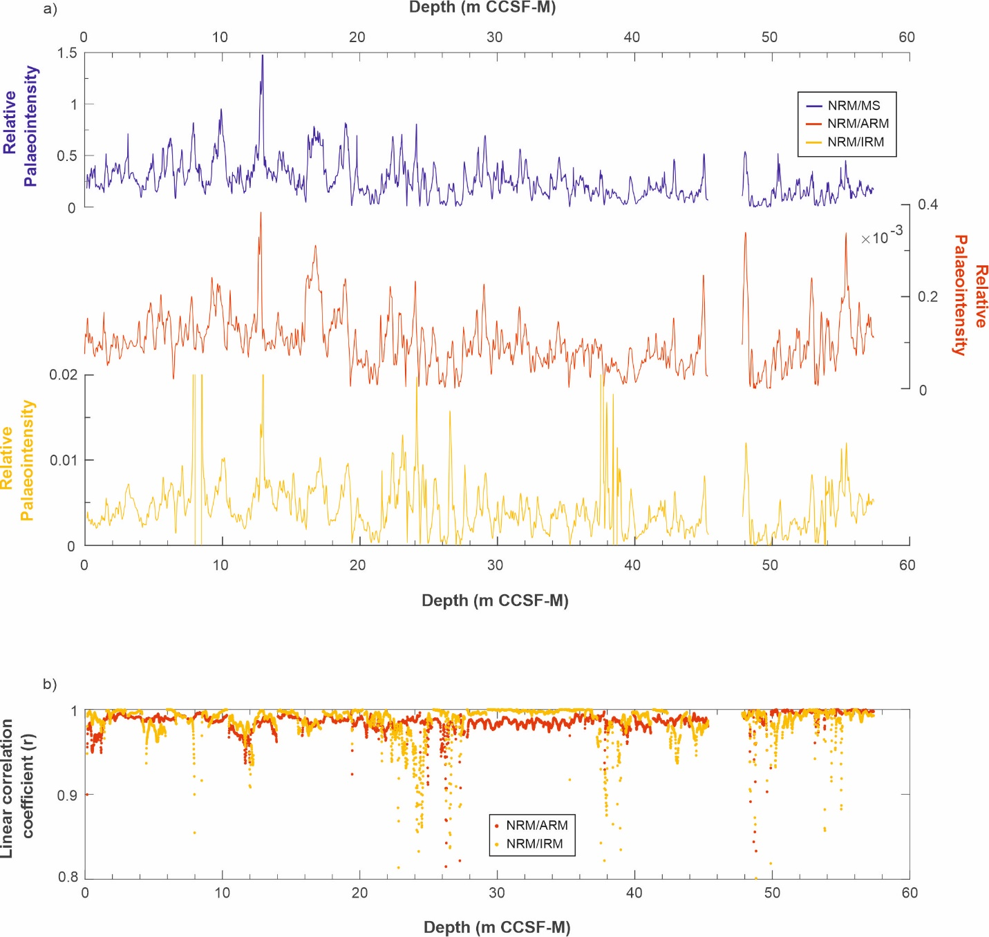
Supplementary Figure S1. Comparison of Site U1533 geomagnetic relative palaeointensity (RPI) estimates using different normalisers: a) Natural remanent magnetisation (NRM) normalised by magnetic susceptibility (MS, blue), anhysteretic remanent magnetisation (ARM, red), and isothermal remanent magnetisation (IRM, yellow); b) Linear correlation coefficient r associated with the RPI estimates calculated using the UPmag software (Xuan & Channell, 2009) for NRM/ARM (red) and NRM/IRM (yellow).

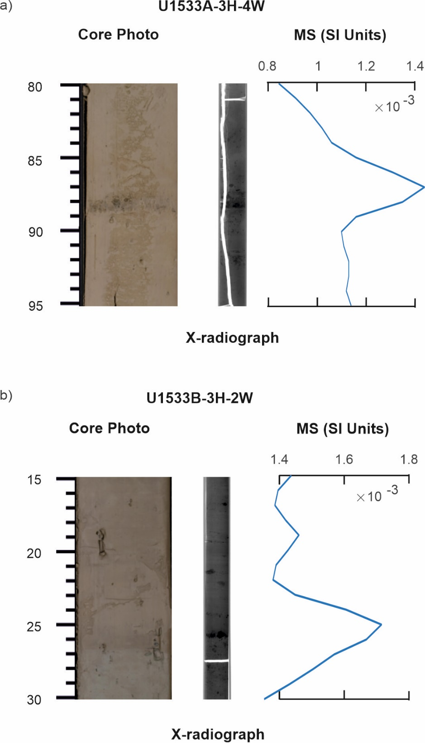
Supplementary Figure S2. Examples of quality control on the palaeomagnetic data from Site U1533 using core photos taken during IODP Exp. 379, x-ray images (darker colours indicate dense material), and magnetic susceptibility (MS) data. a) U1533A-3H-4W 80–95 cm; and b) U1533B-3H-2W 15–30 cm. The x-ray images reveal the presence of clasts and coarse-grained layers in both intervals that often coincide with maxima in MS (e.g., at ~88 cm and ~26 cm in a and b respectively).

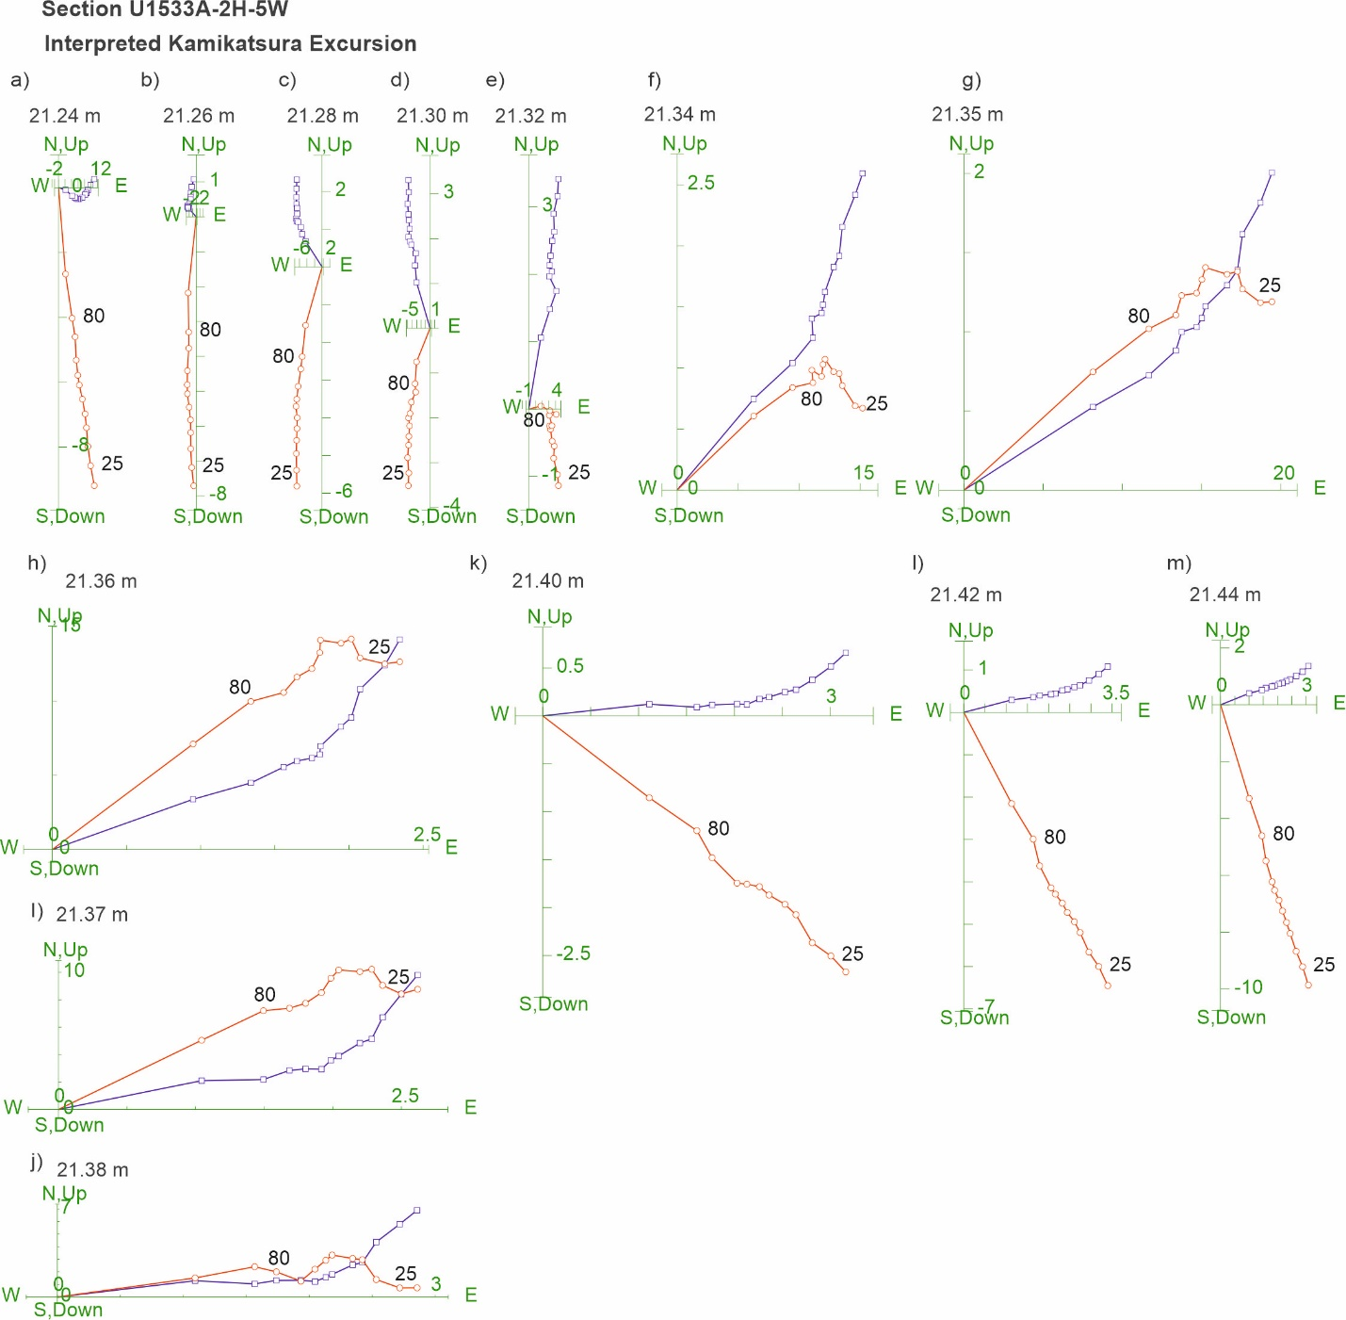
Supplementary Figure S3. Zijderveld diagrams of NRM demagnetisation data for the interpreted Kamikatsura excursion in section U1533A-2H-5W 98–118 cm, with figures a)-m) showing results from varying depths within the core splice. NRM data from the 20–100 mT demagnetisation steps are shown. Red circles indicate projection endpoints on the vertical plane, blue squares indicate projection endpoints on horizontal plane.

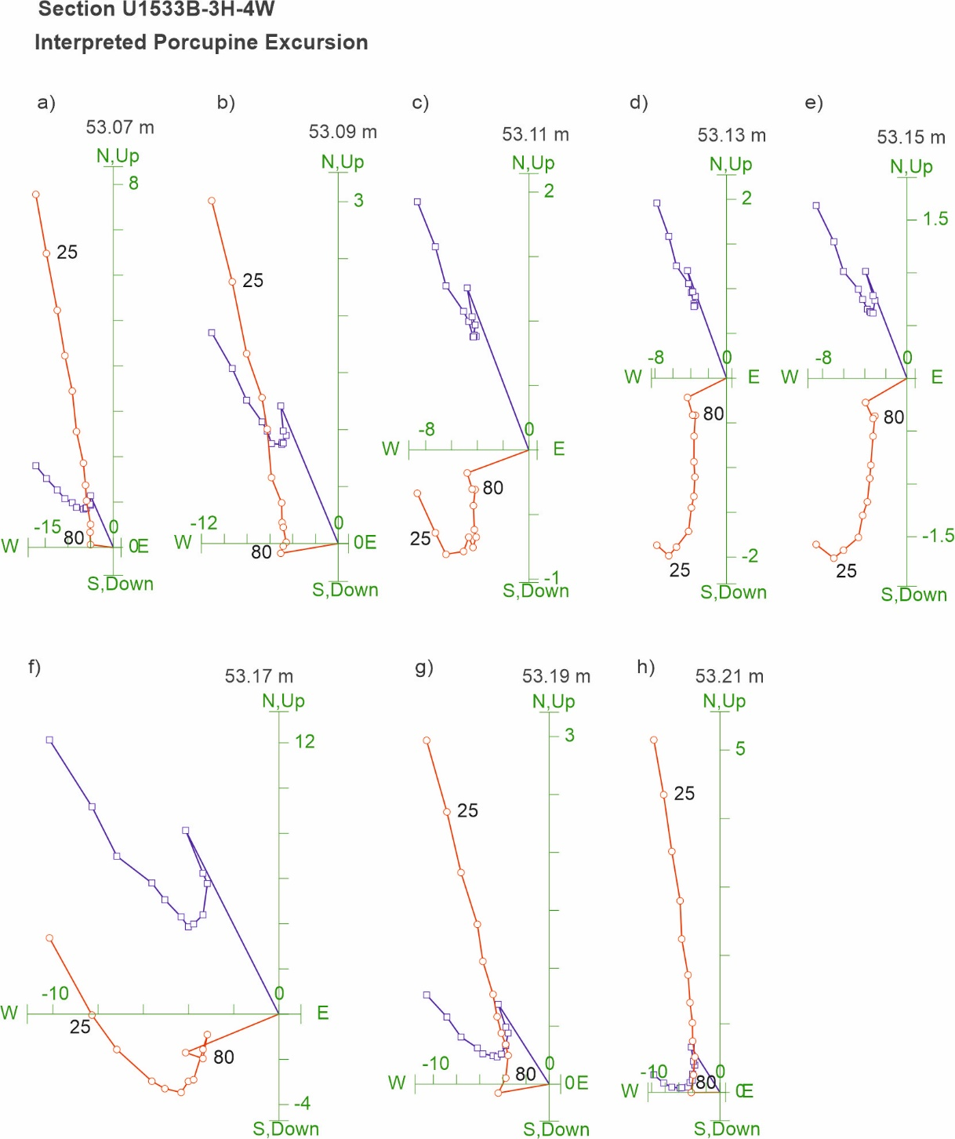
Supplementary Figure S4. Zijderveld diagrams of NRM demagnetisation data for the interpreted Porcupine excursion in section U1533B-3H-4W 87–101 cm, with figures a)-h) showing results from varying depths within the core splice. NRM data from the 20–100 mT demagnetisation steps are shown. Red circles indicate projection endpoints on the vertical plane, blue squares indicate projection endpoints on horizontal plane.

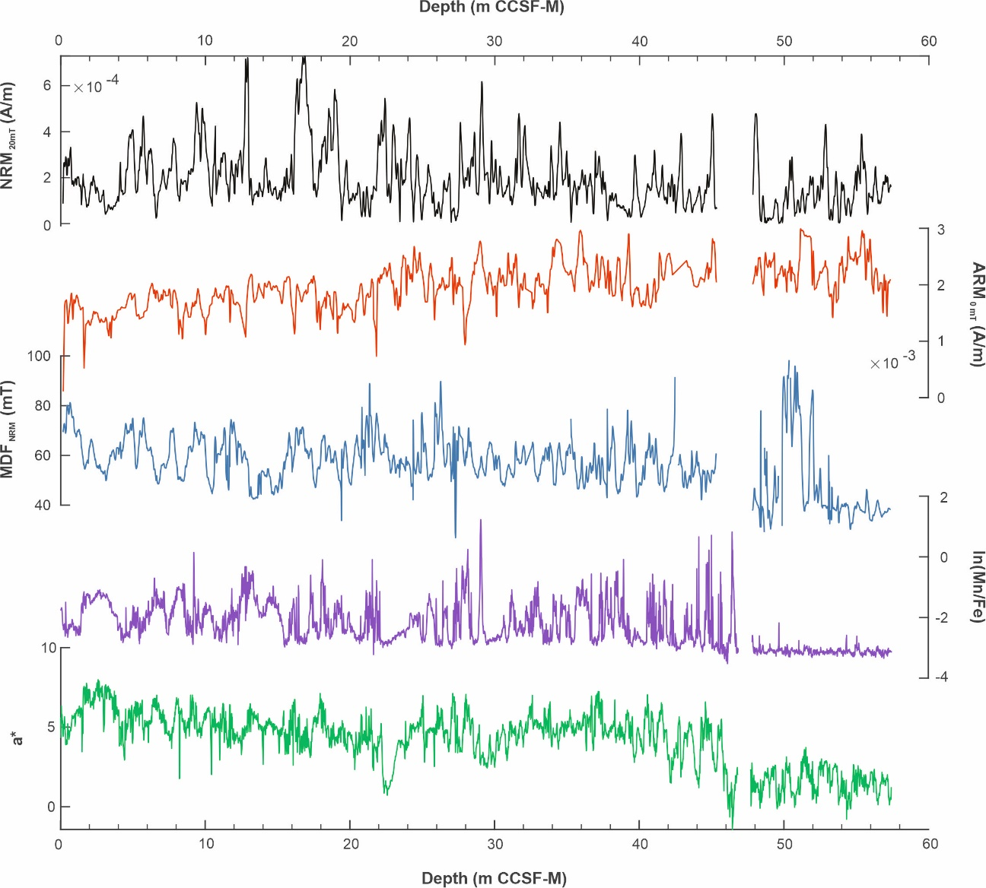
Supplementary Figure S5. Site U1533 magnetic data compared with redox proxy and sediment colour data. Natural remanent magnetisation intensity (NRM; after 20 mT demagnetisation, in black) and anhysteretic remanent magnetisation intensity (ARM; red); median destructive field (MDF)_{NRM} for the range 20-100 mT; the redox proxy ln(Mn/Fe) (pink); and a* colour reflectance (green). Note the major changes in the redox proxy and colour at 45.82 m mapped composite depth (CCSF-M) and the lack of significant change in NRM or ARM around this depth. a* colour reflectance data are from Wellner et al., (2021).

Supplementary Figure S6. Squared wavelet coherence between Site U1533 RPI and ARM intensity (used as a normaliser for RPI estimates) in time-frequency domain for 0–2.9 Ma. Brighter (yellow) colours indicate stronger coherence. Arrows indicate phase relationship between the two records (in-phase pointing right). White dashed line indicates the cone of influence results are slightly influenced by edge effects.
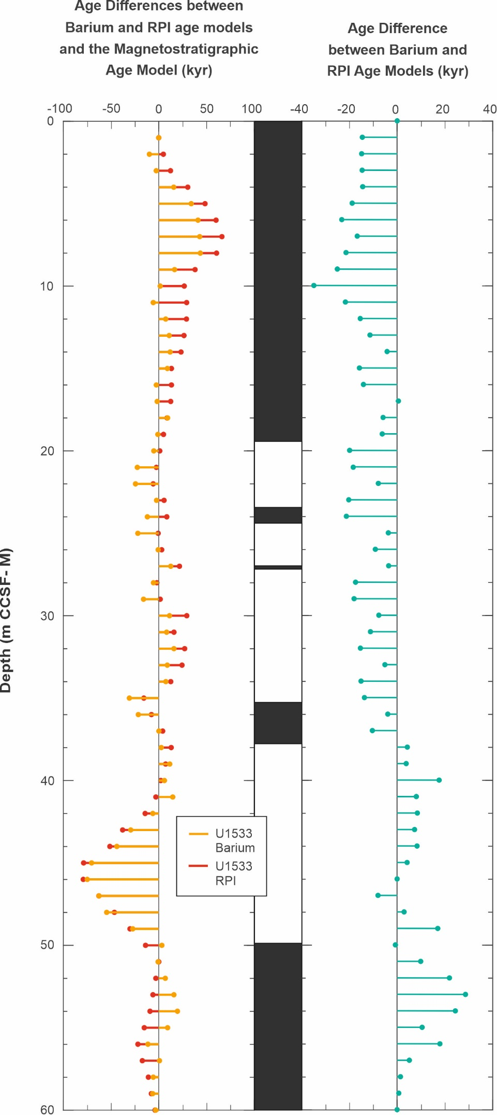
Supplementary Figure S7. Differences (in kyr) between the barium enrichment (Ba) and RPI-derived ages and the updated magnetostratigraphic (M) ages for Site U1533 (left: Ba vs M in yellow; RPI vs M in red), and between the Ba- and RPI-derived ages (right). Note the change in scale for the offset ages between the two panels.

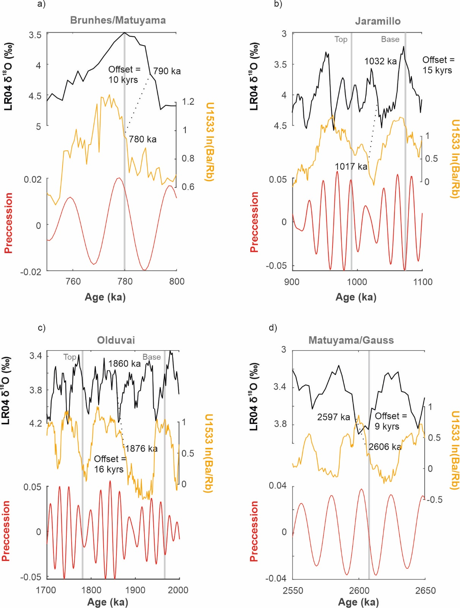
Supplementary Figure S8. Temporal offsets between the barium (ln(Ba/Rb)) record from Site U1533 (yellow) plotted vs. the magnetostratigraphic reversal boundaries using the same magnetic reversal ages as in LR04 (Lisiecki and Raymo, 2005) and the LR04 δ¹⁸O stack on its age model (black) across (sub-)chron boundaries. a) The Brunhes-Matuyama boundary; b) the Jaramillo subchron; c) the Olduvai subchron; and d) the Matuyama-Gauss boundary. Also shown are precession cycles for the plotted intervals (red curves; Laskar et al., 2011). Magnetostratigraphic boundaries are shown as grey vertical lines, and the tie lines between increases in barium at Site U1533 and glacial-interglacial transitions in LR04 used for developing the barium enrichment derived age model for Site U1533 are shown as black dashed lines. Ages (based on the magnetostratigraphic age model for U1533 and the LR04 stack, respectively) and their offsets are given as numbers.

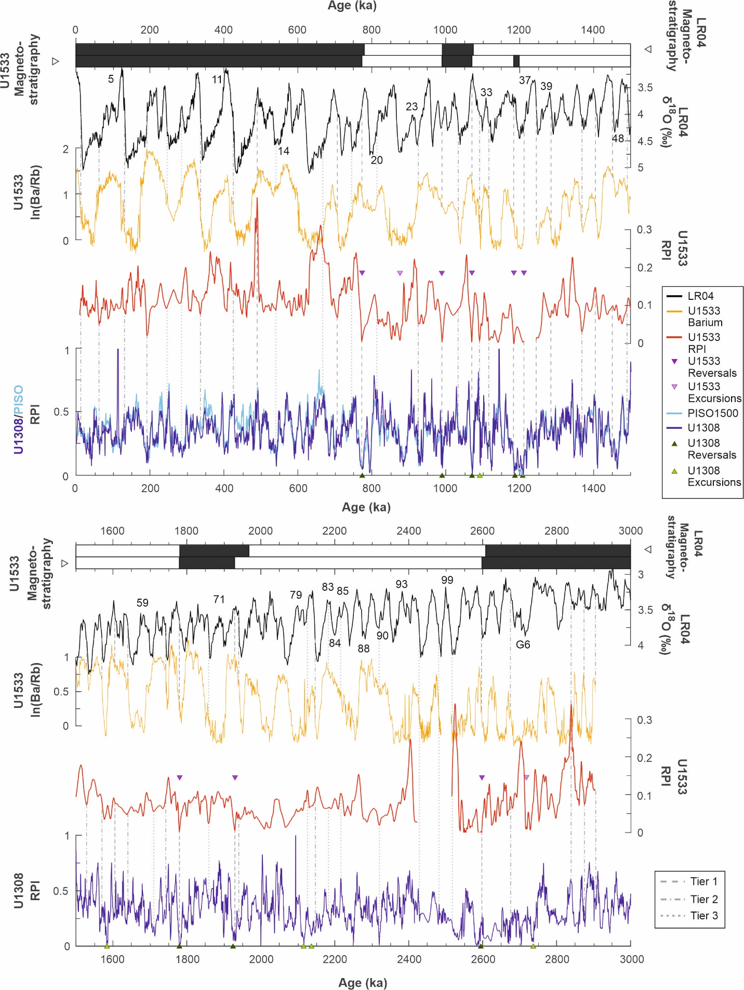
Supplementary Figure S9. Relative geomagnetic palaeointensity (RPI; red) and barium (ln(Ba/Rb), yellow) data from Site U1533 plotted on the hybrid age model, with LR04 (Lisiecki and Raymo, 2005) magnetostratigraphy (top bar) and Site U1533 magnetostratigraphy (bar directly below), the LR04 δ¹⁸O stack (black), PISO-1500 RPI stack (upper panel only, light blue; Channell et al., 2009) and the Site U1308 RPI record (dark blue; Channell et al., 2016). Tie point lines used for establishing the hybrid age model for Site U1533 are also shown (grey vertical lines). Tie points are separated by tiers of confidence (see key; Tier 1: most reliable, Tier 3: least reliable). Magnetic reversals and excursions for Sites U1533 (purple) and U1308 (green) are marked by triangles. Marine Isotope Stages (MIS) mentioned in the text are labelled.

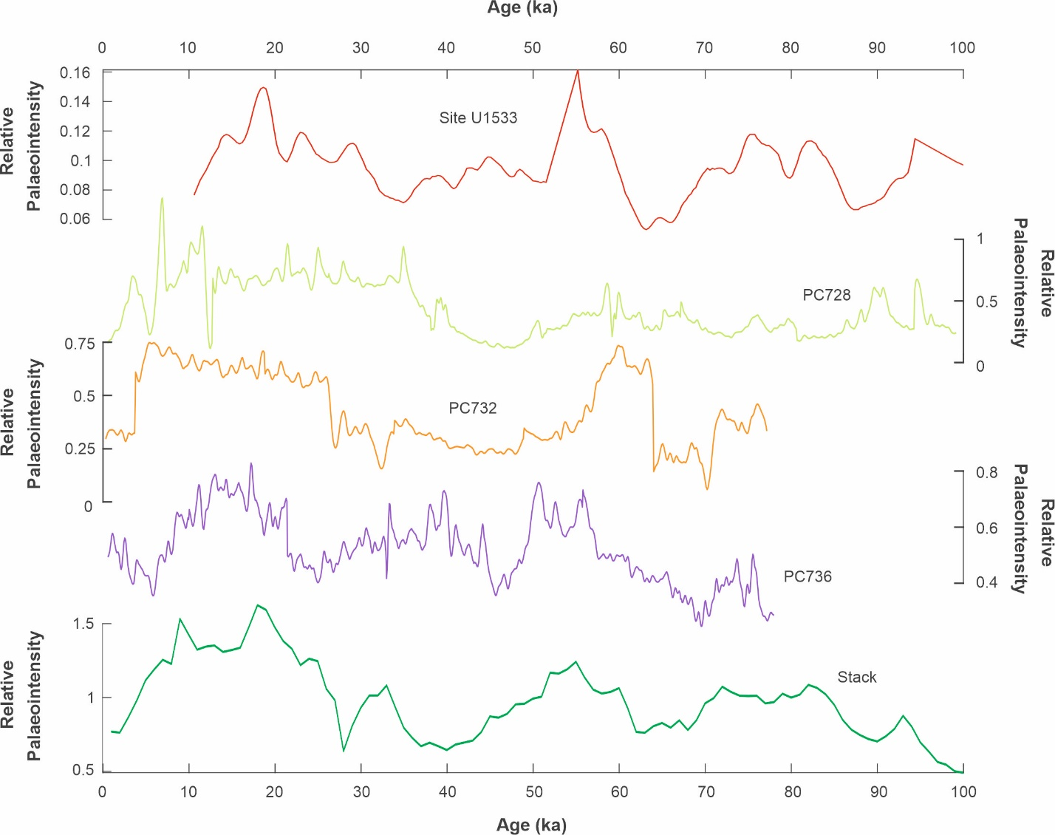
Supplementary Figure S10. Antarctic RPI records used in the ANT-1600 stack compilation for 0–100 ka. RPI records shown include those from Site U1533 (red, this study), cores PC728 (pale green), PC732 (orange) and PC736 (purple) from the western Antarctic Peninsula rise (Channell et al., 2019) and the calculated ANT-1600 stack for this interval (green).

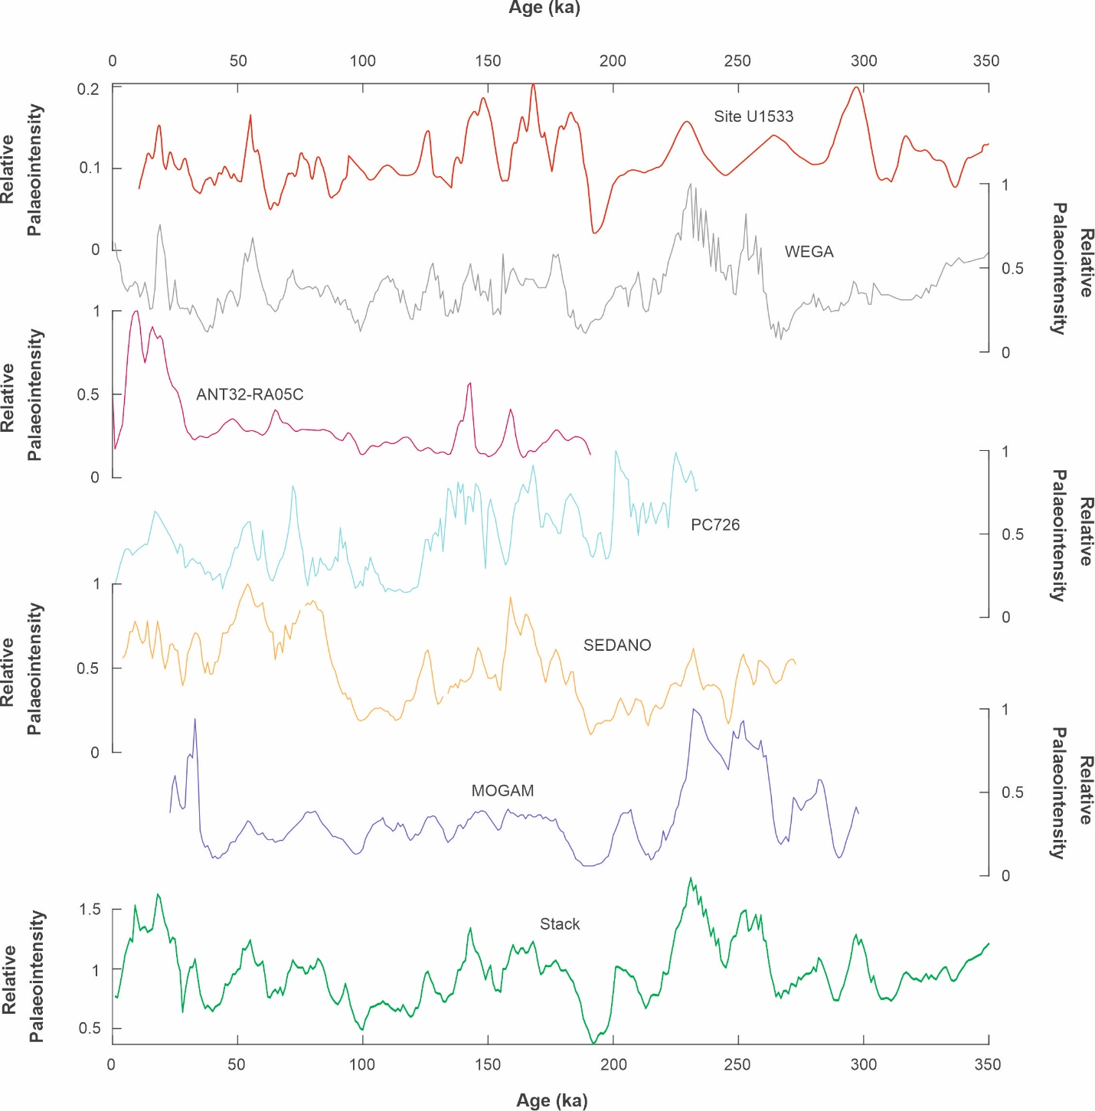
Supplementary Figure S11. Antarctic RPI records used in the ANT-1600 stack compilation for 0–350 ka. RPI records shown include those from Site U1533 (red, this study), WEGA cores PC18–20 and PC25–27 (grey) from the Wilkes Land margin (Macrí et al., 2005), core ANT32-RA05C (pink) from the Ross Sea (Li et al., 2022), core PC726 (pale blue) from the western Antarctic Peninsula rise (Channell et al., 2019), SEDANO cores SED14–17 (peach) from the western Antarctic Peninsula rise (Macrí et al., 2006), MOGAM cores (blue) from the Wilkes Land margin (Jiménez-Espejo et al., 2020); and the calculated ANT-1600 stack for this interval (green).

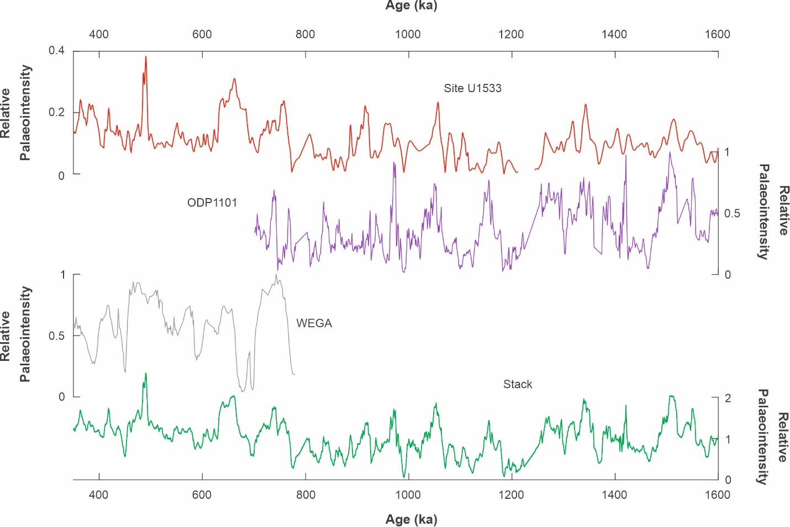
Supplementary Figure S12. Antarctic RPI records used in the ANT-1600 stack compilation for 350–1600 ka. RPI records shown include those from Site U1533 (red, this study), ODP Leg 178 Site 1101 (purple) from the western Antarctic Peninsula rise (Guyodo et al., 2001; Channell et al., 2019) and WEGA cores PC18–20 and PC25–27 (pink) from the Wilkes Land margin (Macrí et al., 2005); and the calculated ANT-1600 stack for this interval (green).

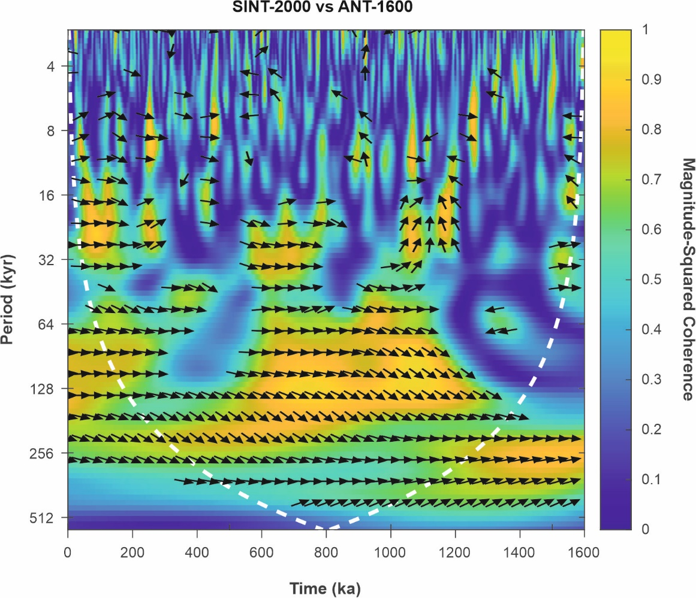
Supplementary Figure S13. Squared wavelet coherence between SINT-2000 and ANT-1600 RPI stacks in the time-frequency domain. Brighter (yellow) colours indicate stronger coherence. Arrows indicate phase relationship between the two records (in-phase pointing right). White dashed line indicates the cone of influence results are significantly influenced by edge effects.

Supplementary Table S1. Compilation of published Southern Ocean RPI records (core locations shown in Figure 1).
Name | Time Period | Period (ka) | Location | Reference
ODP Site 1098 | Holocene | 0-9 | W’ Antarctic Peninsula shelf | Brachfeld et al., 2000
WBB | Holocene | 0.7-8.6 | Antarctic Peninsula shelf | Willmott et al., 2006
KC23 | Holocene | 0-10.5 | E’ Antarctic Peninsula shelf | Brachfeld et al., 2003
LN2 | Holocene | 0-7.2 | E’ Antarctic Peninsula shelf | Smith et al., 2021
VC424 | Holocene | 0-14 | Amundsen Sea shelf | Hillenbrand et al., 2010
PS69/274-1 | Holocene | 0-14 | Amundsen Sea shelf | Hillenbrand et al., 2011
PS69/275-1 | Holocene | 0-14 | Amundsen Sea shelf | Hillenbrand et al., 2012
TPC268 | Pleistocene | 10-50 | Scotia Sea | Collins et al., 2012
TPC063 | Pleistocene | 10-50 | Scotia Sea | Collins et al., 2013
PS67/197-1 | Pleistocene | 0–90 | Scotia Sea | Xiao et al., 2016
PS67/219-1 | Pleistocene | 0–300 | Scotia Sea | Xiao et al., 2016
MD07-3134 | Pleistocene |  | Scotia Sea | Weber et al., 2012
PS97/085-3 | Pleistocene | 0-140 | Scotia Sea | Wu et al., 2021
ODP 1096 | Pleistocene | 0-200 | W’ Antarctic Peninsula rise | Carlon et al., 2021
RS15-LC42 | Pleistocene | 0-1350 | Ross Sea margin | Bollen et al., 2022
ANT32-RA05C | Pleistocene | 0-200 | Ross Sea margin | Li et al., 2022
ODP Site 1101 | Pleistocene | 700-1600 | W’ Antarctic Peninsula rise | Guyodo et al., 2001; Channell et al., 2019
SEDANO | Pleistocene | 0-270 | W’ Antarctic Peninsula rise | Sagnotti et al., 2001; Macrí et al., 2006
PC466 | Pleistocene | 0-75 | W’ Antarctic Peninsula rise | Vautravers et al., 2013
PC726 | Pleistocene | 0–250 | W’ Antarctic Peninsula rise | Channell et al., 2019
PC728 | Pleistocene | 0–100 | W’ Antarctic Peninsula rise | Channell et al., 2019
PC732 | Pleistocene | 0–80 | W’ Antarctic Peninsula rise | Channell et al., 2019
PC736 | Pleistocene | 0–80 | W’ Antarctic Peninsula rise | Channell et al., 2019
MOGAM | Pleistocene | 0-400 | Wilkes Land rise | Jimenez-Espejo et al., 2020
WEGA | Pleistocene | 0-780 | Wilkes Land rise | Macrí et al., 2005
CADO | Pleistocene | 0-800 | Wilkes Land rise | Macrí et al., 2010

Supplementary Table S2. Site U1533 depth intervals showing apparent excursions in characteristic remanent magnetisation (ChRM) directions (Fig. 2) and the criteria to classify them as excursions. Age estimates are based on the Site U1533 RPI age model. Proposed excursion names and ages refer to published excursions that coincide with of the potential excursions at Site U1533.
Depth m CCSF-M | Proposed age (ka) | No major changes in lithology, absence of cracks or disturbance | No major changes in magnetic properties | Well defined reversed magnetisation component | Potential named excursion | Potential excursion age (ka) | Reference
18.22 | 720 | Yes | No | No
21.36 | 884 | Yes | Yes | Yes | Kamikatsura | 886 | Xuan et al., 2016
24.97 | 1092 | No | Yes | No
25.86 | 1113 | Yes | No | No | Punaruu | 1115 | Channell et al., 2002
26.32 | 1128 | Yes | No | No
40.65 | 2100 | No | Yes | No | Feni | 2115 | Channell et al., 2003; Singer, 2014
42.54 | 2249 | No | No | No
48.73 | 2551 | Yes | Yes | No
53.13 | 2734 | Yes | Yes | Unclear | Porcupine | 2737 | Channell et al., 2016

Supplementary Table S3. Tie points and their tiers for the barium enrichment derived age model developed for Site U1533 (Tier 1: most reliable, Tier 3: least reliable).
Tier 1. |  | Tier 2. |  | Tier 3. |  | Combined Tiers
Depth (m CCSF-M) | Age (ka) | Depth (m CCSF-M) | Age (ka) | Depth (m CCSF-M) | Age (ka) | Depth (m CCSF-M) | Age (ka)
 |  |  |  |  |  | 0 | 0
 |  | 0.19 | 13.415 |  |  | 0.19 | 13.415
 |  |  |  | 1.48 | 71 | 1.48 | 71
 |  | 4.316 | 131.8275 |  |  | 4.316 | 131.8275
 |  |  |  | 5.88 | 191 | 5.88 | 191
 |  |  |  | 7.31 | 247 | 7.31 | 247
 |  |  |  | 7.68 | 286 | 7.68 | 286
 |  | 8.685 | 335 |  |  | 8.685 | 335
 |  |  |  | 9.51 | 391 | 9.51 | 391
 |  | 10.884 | 426 |  |  | 10.884 | 426
 |  |  |  | 12.4061 | 481 | 12.4061 | 481
 |  |  |  | 13.81 | 538 | 13.81 | 538
 |  |  |  | 15.445 | 622 | 15.445 | 622
 |  |  |  | 17.04 | 668 | 17.04 | 668
 |  | 17.74 | 707 |  |  | 17.74 | 707
 |  |  |  | 18.77 | 746 | 18.77 | 746
 |  | 19.435 | 789 |  |  | 19.435 | 789
 |  |  |  | 19.85 | 814 | 19.85 | 814
 |  | 20.495 | 866 |  |  | 20.495 | 866
 |  |  |  | 22.2341 | 922 | 22.2341 | 922
 |  |  |  | 23.309 | 1001 | 23.309 | 1001
 |  | 23.7286 | 1034 |  |  | 23.7286 | 1034
 |  |  |  | 24.0284 | 1062 | 24.0284 | 1062
 |  | 24.388 | 1082 |  |  | 24.388 | 1082
 |  | 25.8565 | 1117 |  |  | 25.8565 | 1117
 |  | 26.8492 | 1178 |  |  | 26.8492 | 1178
27.31 | 1212 |  |  |  |  | 27.31 | 1212
27.3100001 | 1244.195 |  |  |  |  | 27.3100001 | 1244.195
27.92 | 1285 |  |  |  |  | 27.92 | 1285
 |  |  |  | 28.86 | 1320 | 28.86 | 1320
 |  | 29.54 | 1368 |  |  | 29.54 | 1368
30.04 | 1405 |  |  |  |  | 30.04 | 1405
30.815 | 1451 |  |  |  |  | 30.815 | 1451
 |  | 31.41 | 1491.195 |  |  | 31.41 | 1491.195
 |  | 31.85735 | 1528.515 |  |  | 31.85735 | 1528.515
 |  | 32.3912 | 1570 |  |  | 32.3912 | 1570
 |  |  |  | 32.65 | 1582.5 | 32.65 | 1582.5
 |  | 33.375 | 1640 |  |  | 33.375 | 1640
 |  |  |  | 33.73 | 1695 | 33.73 | 1695
 |  | 34.3 | 1742.75 |  |  | 34.3 | 1742.75
 |  | 35.22 | 1788.27 |  |  | 35.22 | 1788.27
 |  |  |  | 35.89 | 1813.5 | 35.89 | 1813.5
 |  |  |  | 36.66 | 1863.5 | 36.66 | 1863.5
 |  | 38.115 | 1940 |  |  | 38.115 | 1940
 |  |  |  | 39.06 | 1997.94 | 39.06 | 1997.94
 |  |  |  | 39.68 | 2017.5 | 39.68 | 2017.5
 |  |  |  | 40.32 | 2063 | 40.32 | 2063
 |  |  |  | 40.73 | 2100 | 40.73 | 2100
 |  | 41.53 | 2147 |  |  | 41.53 | 2147
 |  |  |  | 41.83 | 2182.5 | 41.83 | 2182.5
 |  |  |  | 42.9 | 2253.11 | 42.9 | 2253.11
 |  |  |  | 43.4 | 2302.5 | 43.4 | 2302.5
 |  |  |  | 44.12 | 2352.5 | 44.12 | 2352.5
 |  |  |  | 45.425 | 2428 | 45.425 | 2428
 |  |  |  | 46.135 | 2450 | 46.135 | 2450
 |  |  |  | 46.59 | 2481 | 46.59 | 2481
 |  |  |  | 47.89 | 2517.5 | 47.89 | 2517.5
 |  |  |  | 48.93 | 2540 | 48.93 | 2540
 |  |  |  | 49.48 | 2572.5 | 49.48 | 2572.5
49.88 | 2597 |  |  |  |  | 49.88 | 2597
 |  | 51.13 | 2637.5 |  |  | 51.13 | 2637.5
 |  | 52.35 | 2675 |  |  | 52.35 | 2675
 |  |  |  | 53.75 | 2730 | 53.75 | 2730
 |  |  |  | 54.59 | 2800 | 54.59 | 2800
 |  | 56.025 | 2840 |  |  | 56.025 | 2840
 |  | 56.71 | 2872.5 |  |  | 56.71 | 2872.5
 |  | 57.42 | 2905 |  |  | 57.42 | 2905
 |  |  |  |  |  | 60 | 3000

Supplementary Table S4. Tie points and their tiers developed for the RPI age model at Site U1533 (Tier 1: most reliable, Tier 3: least reliable).
Tier 1. |  | Tier 2. |  | Tier 3. |  | Combined Tiers
Depth (m CCSF-M) | Age (ka) | Depth (m CCSF-M) | Age (ka) | Depth (m CCSF-M) | Age (ka) | Depth (m CCSF-M) | Age (ka)
 |  |  |  |  |  | 0 | 0
 |  | 1.8 | 62.88 |  |  | 1.8 | 62.88
 |  |  |  | 4.45 | 120.31 | 4.45 | 120.31
 |  | 6.59 | 192.25 |  |  | 6.59 | 192.25
 |  | 8.1 | 286.34 |  |  | 8.1 | 286.34
 |  |  |  | 8.74 | 321.55 | 8.74 | 321.55
 |  |  |  | 10.47 | 385.98 | 10.47 | 385.98
12.94 | 490.66 |  |  |  |  | 12.94 | 490.66
 |  |  |  | 13.94 | 541.14 | 13.94 | 541.14
 |  |  |  | 15.79 | 614.697 | 15.79 | 614.697
17.75 | 700 |  |  |  |  | 17.75 | 700
19.435 | 773.6 |  |  |  |  | 19.435 | 773.6
 |  |  |  | 21.36 | 884.43 | 21.36 | 884.43
 |  | 22.5695 | 926.24 |  |  | 22.5695 | 926.24
23.435 | 990 |  |  |  |  | 23.435 | 990
24.388 | 1071 |  |  |  |  | 24.388 | 1071
 |  | 24.9577 | 1091.87 |  |  | 24.9577 | 1091.87
 |  |  |  | 26.2667 | 1123 | 26.2667 | 1123
26.98 | 1184 |  |  |  |  | 26.98 | 1184
27.29 | 1208 |  |  |  |  | 27.29 | 1208
 |  |  |  | 27.62 | 1257.51 | 27.62 | 1257.51
 |  |  |  | 28.87 | 1300.25 | 28.87 | 1300.25
 |  | 29.64 | 1368.59 |  |  | 29.64 | 1368.59
 |  | 30.22 | 1410.08 |  |  | 30.22 | 1410.08
 |  |  |  | 31.2 | 1463.11 | 31.2 | 1463.11
 |  |  |  | 32.78 | 1583.7 | 32.78 | 1583.7
 |  |  |  | 34.08 | 1710.24 | 34.08 | 1710.24
35.275 | 1779.6 |  |  |  |  | 35.275 | 1779.6
 |  |  |  | 36.83 | 1859.2 | 36.83 | 1859.2
37.79 | 1925.67 |  |  |  |  | 37.79 | 1925.67
 |  |  |  | 40.09 | 2063.28 | 40.09 | 2063.28
 |  |  |  | 41.03 | 2125.92 | 41.03 | 2125.92
 |  |  |  | 41.58 | 2172.74 | 41.58 | 2172.74
 |  |  |  | 42.2 | 2216.25 | 42.2 | 2216.25
 |  |  |  | 42.55 | 2250 | 42.55 | 2250
 |  |  |  | 42.87 | 2260.23 | 42.87 | 2260.23
 |  |  |  | 43.64 | 2319.96 | 43.64 | 2319.96
 |  |  |  | 44.32 | 2381.49 | 44.32 | 2381.49
49.88 | 2595 |  |  |  |  | 49.88 | 2595
 |  |  |  | 53.17 | 2736.57 | 53.17 | 2736.57
 |  | 55.37 | 2839.2 |  |  | 55.37 | 2839.2
 |  | 56.59 | 2874.2 |  |  | 56.59 | 2874.2
 |  |  |  | 57.16 | 2897.44 | 57.16 | 2897.44
 |  |  |  |  |  | 60 | 3000

Supplementary Table S5. Tie points and their tiers for the hybrid age model developed for Site U1533 (Tier 1: most reliable, Tier 3: least reliable).
Tier 1. |  | Tier 2. |  | Tier 3. |  | Combined Tiers
Depth (m CCSF-M) | Age (ka) | Depth (m CCSF-M) | Age (ka) | Depth (m CCSF-M) | Age (ka) | Depth (m CCSF-M) | Age (ka)
0 | 0 |  |  |  |  | 0 | 0
 |  | 0.19 | 13.415 |  |  | 0.19 | 13.415
 |  | 1.8 | 62.88 |  |  | 1.8 | 62.88
 |  | 4.316 | 131.8275 |  |  | 4.316 | 131.8275
 |  | 6.59 | 192.25 |  |  | 6.59 | 192.25
 |  |  |  | 7.31 | 247 | 7.31 | 247
 |  |  |  | 7.68 | 286 | 7.68 | 286
 |  | 8.74 | 337.28 |  |  | 8.74 | 337.28
 |  | 10.884 | 426 |  |  | 10.884 | 426
12.94 | 490.66 |  |  |  |  | 12.94 | 490.66
 |  |  |  | 13.94 | 541.14 | 13.94 | 541.14
 |  |  |  | 17.04 | 668 | 17.04 | 668
17.74 | 707 |  |  |  |  | 17.74 | 707
 |  |  |  | 18.77 | 746 | 18.77 | 746
19.435 | 773.6 |  |  |  |  | 19.435 | 773.6
 |  |  |  | 19.85 | 814 | 19.85 | 814
 |  | 22.5695 | 926.24 |  |  | 22.5695 | 926.24
23.435 | 990 |  |  |  |  | 23.435 | 990
 |  | 23.7286 | 1034 |  |  | 23.7286 | 1034
24.388 | 1071 |  |  |  |  | 24.388 | 1071
 |  | 24.9577 | 1091.87 |  |  | 24.9577 | 1091.87
 |  | 25.8565 | 1117 |  |  | 25.8565 | 1117
26.98 | 1184 |  |  |  |  | 26.98 | 1184
27.31 | 1212 |  |  |  |  | 27.31 | 1212
27.3100001 | 1244.195 |  |  |  |  | 27.3100001 | 1244.195
27.92 | 1285 |  |  |  |  | 27.92 | 1285
 |  | 29.64 | 1368.59 |  |  | 29.64 | 1368.59
30.04 | 1405 |  |  |  |  | 30.04 | 1405
30.815 | 1451 |  |  |  |  | 30.815 | 1451
 |  | 31.41 | 1491.195 |  |  | 31.41 | 1491.195
 |  | 31.85735 | 1528.515 |  |  | 31.85735 | 1528.515
 |  | 32.3912 | 1570 |  |  | 32.3912 | 1570
32.97 | 1605 |  |  |  |  | 32.97 | 1605
 |  | 33.375 | 1640 |  |  | 33.375 | 1640
 |  |  |  | 34.08 | 1710.24 | 34.08 | 1710.24
 |  | 34.3 | 1742.75 |  |  | 34.3 | 1742.75
35.275 | 1779.6 |  |  |  |  | 35.275 | 1779.6
 |  |  |  | 36.83 | 1859.2 | 36.83 | 1859.2
37.79 | 1929.33 |  |  |  |  | 37.79 | 1929.33
 |  | 38.115 | 1940 |  |  | 38.115 | 1940
 |  |  |  | 41.03 | 2125.92 | 41.03 | 2125.92
 |  | 41.53 | 2147 |  |  | 41.53 | 2147
 |  |  |  | 41.83 | 2182.5 | 41.83 | 2182.5
 |  |  |  | 42.2 | 2216.25 | 42.2 | 2216.25
 |  |  |  | 43.64 | 2319.96 | 43.64 | 2319.96
 |  |  |  | 45.425 | 2428 | 45.425 | 2428
 |  |  |  | 46.59 | 2481 | 46.59 | 2481
 |  |  |  | 47.89 | 2517.5 | 47.89 | 2517.5
49.88 | 2597 |  |  |  |  | 49.88 | 2597
 |  | 52.35 | 2675 |  |  | 52.35 | 2675
 |  | 55.37 | 2839.2 |  |  | 55.37 | 2839.2
 |  | 56.59 | 2874.2 |  |  | 56.59 | 2874.2
 |  | 57.42 | 2905 |  |  | 57.42 | 2905
 |  |  |  |  |  | 60 | 3000

Attached separately:
Supplementary Table S6. ANT-1600 RPI stack and standard error.

