The Tufa Deposits of Marl Crag – Description and Environmental Significance
Paul A. Carling
School of Geography & Environmental Science, University of Southampton,
Southampton, SO17 1BJ, UK
p.a.carling@soton.ac.uk
Introduction
Calcareous tufa (also termed travertine) is primarily calcium carbonate formed by the transfer of carbon dioxide from calcium bicarbonate-rich subterranean water to the epigean (near-soil) atmosphere. In the case of springs, emanating from beds of limestone, tufa can be precipitated at or near the ambient air temperature, especially during the spring and summer (Horvatinči et al., 2003). Given the influence of temperature on the equilibration process, deposition of UK tufa has been associated with the warmer climate of the Early Holocene with limited evidence for its formation in the cool Younger Dryas or during the last glacial period (Pentecost, 1993). Thus, tufa deposits may record changes in climate and in palaeoecology. Deposits within the UK have a widespread distribution, but each outcrop is of limited extent (Pentecost, 1993). Determining the age of tufa deposits using radio-carbon dating often has proven difficult (Barešić et al., 2021), yet successful dating can constrain the timing of climate change and assist in the determination of sequences of landscape processes and form. Within this context, a deposit of tufa in the northern Pennines is described, dated, and the environmental significance considered.
Marl Crag & environs
Marl Crag (NY 63941 05678) is a small outcrop consisting of two blocks of stratified tufa some 2m high at the crest of a steep escarpment (Fig. 1) above the river Lune, near Tebay. The blocks exhibit flat planar upper surfaces ~ 30 m² in total area; thickly covered in moss and detritus. The block furthest down the slope is rotated and tilted outwards from its original location and clearly has been a continuation of the neighbouring block that is slightly up slope and to the east (Fig. 2). The displacement between the two blocks is around 1 m horizontally. The tufa deposits are crudely horizontally laminated with two reactivation surfaces evident (Fig. 2). Slope wash has caused the slope deposits on the underside of the neighbouring block to have been eroded from below the base of the tufa on the outer edge of the scarp to reveal the basal contact with a limestone scree; thus, the block appears to be essentially in-situ. The thickness of the scree is not evident, as only around 30 cm is exposed, but this consists of weakly-cemented angular limestone fragments of large pebble size. Below, coarser limestone fragments are exposed poorly, together with an admixture of glacially rounded limestone pebbles and local sandstones (Fig. 3).
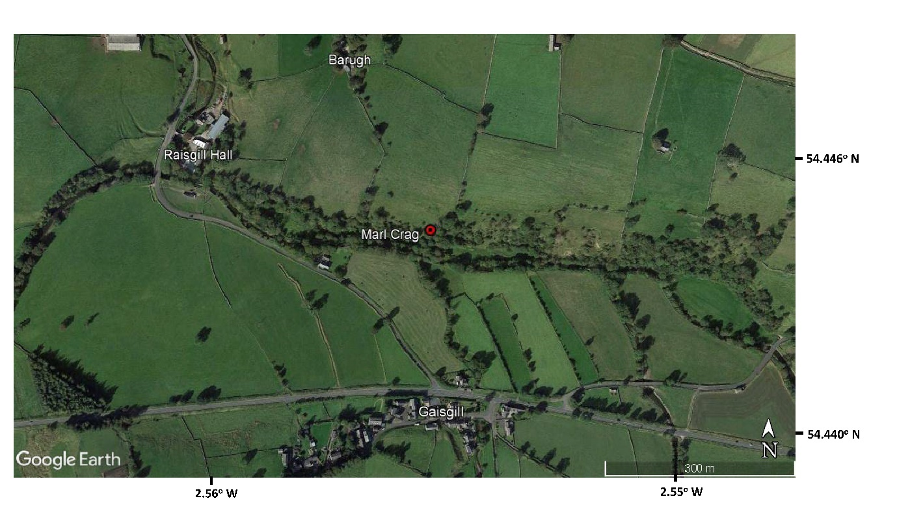
Figure 1: Location of Marl Crag. Copyright Google Earth.
The altitude (above sea level) of the top of the blocks is 207 m, 38 m downslope from an active spring. The site is some 15 m above the neighbouring floodplain of the River Lune beneath the scarp. Pattison (1990) suggested the tufa was deposited on the surface of a fan that had prograded to a former valley level some 5 to 15 m higher than present, indicating up to 15 m of post-glacial incision. The modern spring discharges some 20 m to the east of the blocks at 213 m altitude (where there is no evidence of current tufa deposition), rising at the contact between the overlying Stone Gill Limestone Formation and the underlying Marsett Formation (sandstone) of the Lower Carboniferous Period (McCormac, 2003).
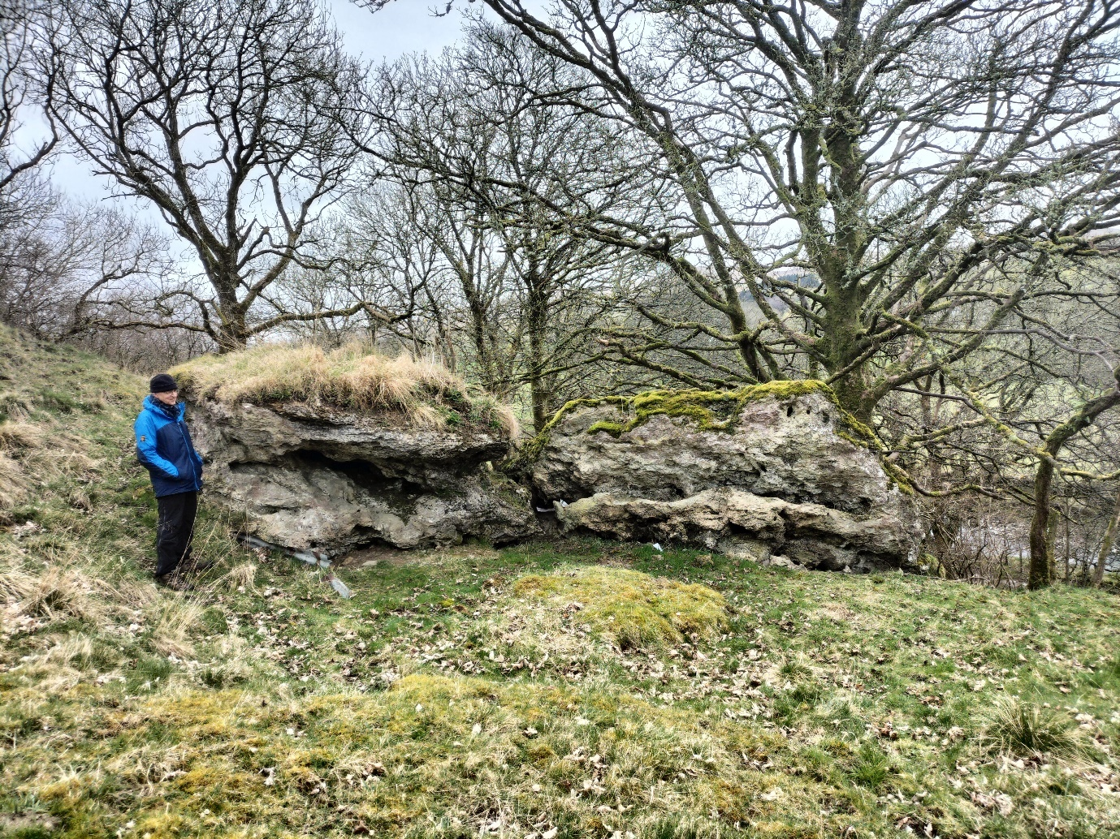
Figure 2: Marl Crag: The protruding top layer (left) and lower protruding shelf (right) may reflect the presence of reactivation surfaces within the laminated vertical sequence. Noel Pearson provides the scale.
The two tufa blocks sit on the eastern margin of a bowl-shaped arcuate depression (Fig. 4) of some 1000 m³ volume of unknown antiquity. The displacement of the tufa block at the bowl margin strongly suggests that a landslide removed a much larger tufa deposit leaving the two remnant blocks at the margin. It is possible that the surcharged loading due to the growth in the thickness of the tufa mass led to the slope failure. The landslide would have entered the river Lune below, so there is no extant evidence for the material that was removed to the river. Alternatively, the depression may be a former marl quarry, as there is a cart track leading from the bowl down the scarp.
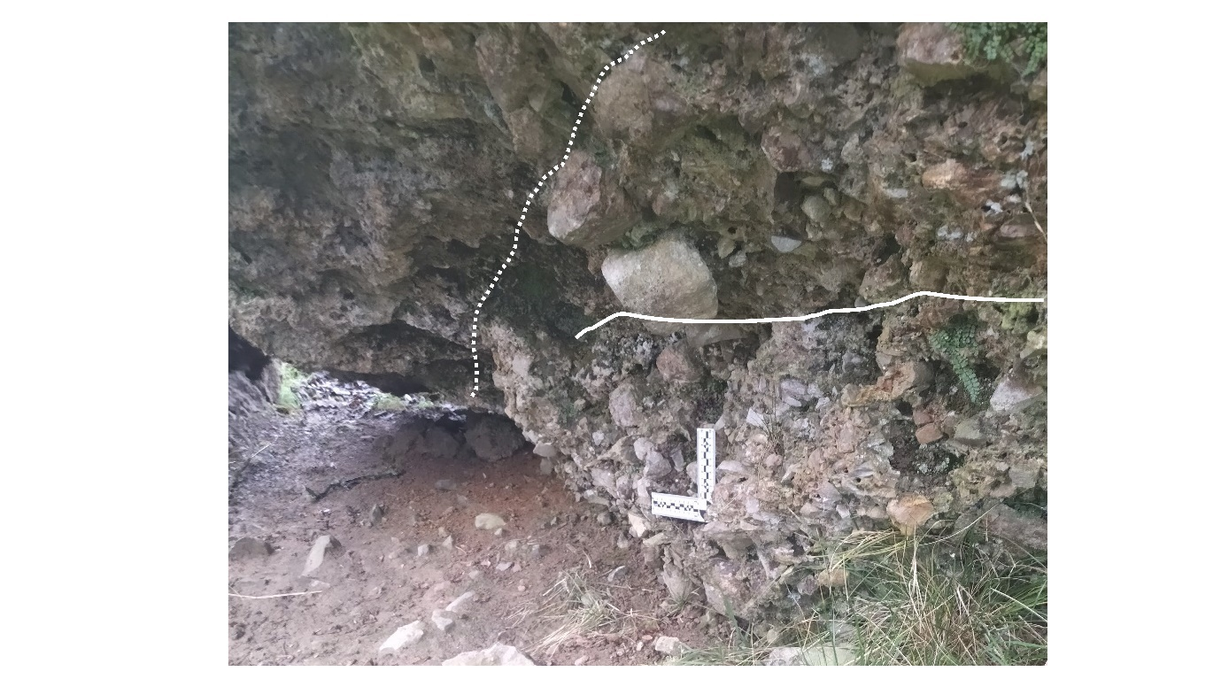
Figure 3: Interface between basal scree and tufa deposit. To the left of the white dotted line, the base of laminated tufa is exposed. Top-right, limestone scree is attached to the base of the tufa as an overhanging projection. Below the solid white line is a vertical section of concreted fine, angular fragments of limestone scree with embedded sub-rounded to well-rounded sandstone clasts, the latter derived from the local till. Scale bar is 10 cm in length.

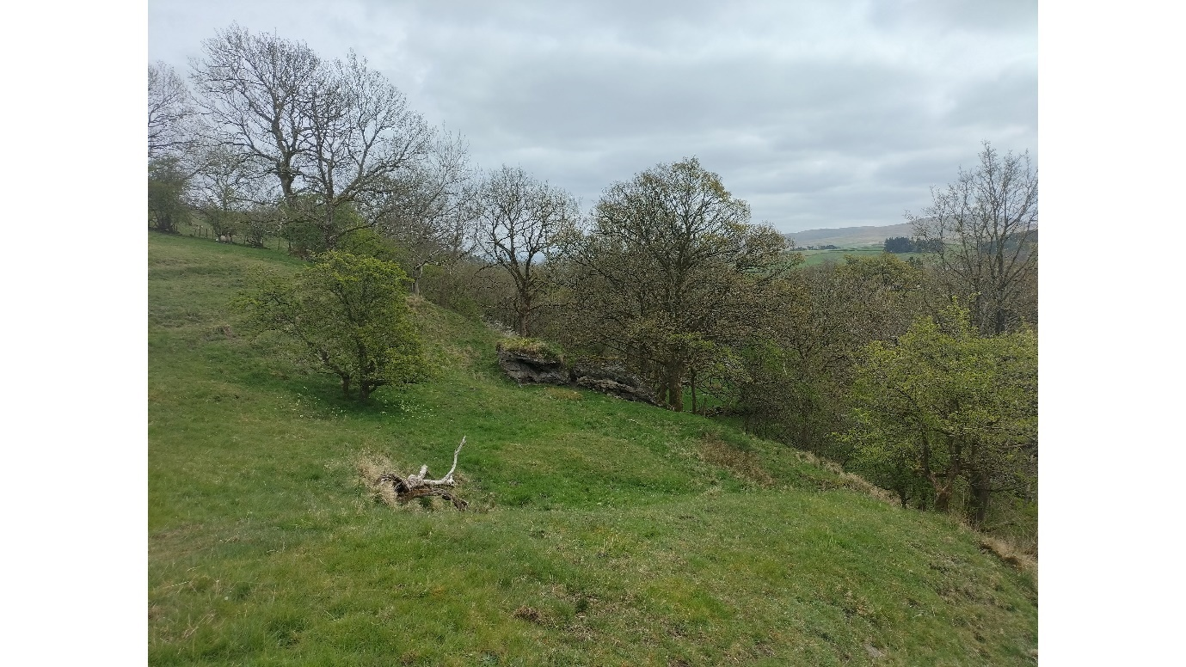
Figure 4: View of Marl Crag (centre) from the west. The bowl-shaped landslide area (?) is in the middle view.
Broader context
The fan gravels beneath Marl Crag represent the top of the crudely stratified sequence of sands and gravels reported by Pattison (1990) at Raynes Wood (NY 64290 05610) some 350m east of Marl Crag; which sedimentary section is no longer exposed. Small rotational slope failures in till are common along the escarpment associated with seepage points and springs. For example, springs occurs at NY 63712 05761 and at Bank Wells (Kelleth), amongst other locations. At NY 64207 05686 a spring is associated with a relict tufa outcrop some 2 m high. At the latter point, seepage is associated with minor modern tufa deposition but otherwise the springs are not associated with current tufa deposition. Millimetre-thick films of tufa occur at seepages nearby (NY 64196 05667; NY 64171 05647). Cessation of tufa deposition can be associated with cooler climatic conditions (Goudie et al., 1993; Pedley, 1993; Taylor et al., 1994), or due to increase in phosphorus loading of the groundwater due to agricultural applications of fertilizers (Stuart & Lapworth, 2016).
Tufa fragments occur scattered in the fields and within the drystone walls adjacent to Marl Crag. These fragments may indicate that locally small tufa outcrops were formerly more extensive and tufa debris was cleared to the field margins. In support of formerly more extensive tufa deposition, Pattison (1990) noted eroded remnants of tufa deposits up to 2 m thick at several points along the escarpment between Raisgill and Kelleth. The heights of these tufa units lie between 5 and 15 m above the modern floodplain (Fig. 5). Assuming the underlying scree graded at a shallow angle (no greater than the angle of repose; red line in Fig. 5) towards the palaeo-River Lune, the height range constrains the potential incision of the River Lune following the tufa formation.
Figure 5: Topographic profile of the escarpment above the River Lune and the modern low-level alluvial terrace level. Red dot represents the active spring. Red line represents the top of the Marl Crag projected towards the valley.
Although an extensive low-level Holocene alluvial terrace occurs below the outcrop (Fig. 5), the lateral cutting-back of the escarpment by the River Lune accords with the presence of landslips along the escarpment and active cutting (in 2023) just west of Raisgill. Lateral cutting also explains the absence here of the high-level terrace that is seen elsewhere along the course of the river Lune (see below).

Method for tufa sampling
Two 10 g samples for ¹⁴C dating were obtained from the NW-facing side of the rotated block of tufa at Marl Crag as this presented a clean and continuous face exposing the near-basal portion of the outcrop which was obscured in the case of the in-situ block, nearby. Vertical flat surfaces free of moss, showing only discoloration, were chosen for sampling. After removing a 5 cm thickness of surface grey tufa, a bright yellow tufa was revealed. Local tube-like vesicles were common, and some contained dark organic-like material. This material was not sampled as it may represent modern rootlets. A ‘top sample’ was taken between 10 and 17 cm from the top of the outcrop, mainly at 13 cm from the top, using a chisel. The section here is 1.9 m high so about 10 cm of the basal section was not revealed here. A ‘base sample’ was obtained 2 m to the right of the top sample, between 7 and 13 cm above the current ground level (mainly at 10 cm) c., 1.9 m from the top of the outcrop. Further details are given in the methodological appendix.

Formation age
The age of formation for the tufa deposits can supply information on climate and post-glacial river incision. The two samples obtained for ¹⁴C dating (see Method for tufa sampling above) at 10 cm above the base of the exposed tufa deposit and at 13 cm below the top, were vertically some 1.75 m apart. The purpose of sampling was to determine when tufa deposition first occurred and when it ended and thus obtain the duration of deposition. Tufa can be difficult to date reliably using ¹⁴C. Nonetheless, the two dates are in the correct stratigraphic order and an interpretation is presented here based on the calibrated radio-carbon dates.
The calibrated radiocarbon dates with δ¹³C correction indicate the base has an age of 14,044 – 13,808 cal BP with 95.4% probability and the 68.2% probability (Table 1 Appendix) also indicates that tufa deposition was occurring before the Younger Dryas (12.9–11.7 cal ka BP; Bickerdike et al., 2018), during the Windermere Interstadial (13.9 ka to 12.9 cal ka BP; Coope and Pennington, 1977). The Windermere Interstadial has been described as a relatively warm period for the region (Jones et al., 2002; Marshall et al., 2002) during which carbonate precipitation and preservation increased significantly in contrast to the negligible production during the preceding glacial-interglacial transition, before declining rapidly between 12.8 ka and 12.5 cal ka BP into the Younger Dryas (Marshall et al., 2002). The top sample has an age of 10,177 – 9,892 cal BP with 95.4% probability and the 68.2% probability (Table 1 Appendix) also indicates that tufa formation was occurring in the Early Holocene (< 11,650 cal BP).

Even though the ¹⁴C dating procedure may have resulted in dates younger than the ‘true’ age (Lykkeberg, pers. comm., 2018), the quantified uncertainty in the ages (Table 1) clearly places periods of tufa precipitation in the Windermere Interstadial and at the beginning of the Holocene. Any tufa formation during the Windermere Interstadial might be related to increased groundwater discharge and vegetation growth during the warm and humid climate. Tufa deposits associated with the Windermere Interstadial have not been identified previously along the upper Lune valley. Yet, the extant tufa outcrops are all eroded (Pattison, 1990) by river incision and lateral cutting such that eroded Windermere Interstadial tufa fragments are found within an aggrading high-level terrace of the River Lune. The high-level terrace is not preserved immediately below the outcrop, but a good exposure occurs at Coatflatt Hall, at altitudes between 181 and 183 m, 1.85 km to the west of the outcrop. Here tufa fragments are frequent in the cryoturbated terrace deposits. Tufa production probably halted during the colder Younger Dryas (when the terrace deposits became cryoturbated) and recommenced in the warmer Early Holocene. From this interpretation, incision by the River Lune to the level of the high terrace had occurred prior to the Younger Dryas with a degree of alluviation on the future terrace level occurring no later than the beginning of the Younger Dryas.

As cryoturbation will not occur beneath running water, further incision must have led the river to abandon the high terrace level sometime during the Younger Dryas, exposing the terrace gravels to frost action. The Windermere Interstadial date for tufa formation at elevations just above the terrace level suggest continuous incision along the course of the upper Lune during the Late Glacial Interglacial Transition with a short hiatus when the terrace level was formed. The Windermere Interstadial date for the base of Marl Crag makes it an early tufa in the UK. Pentecost (1993) reported examples of both Early Holocene tufa and examples that may have formed before the Holocene, dated using a variety of methods. However, it is not always clear if ¹⁴C dates for tufa that were reported in the literature of the last century were calibrated and corrected, as is the case herein. Further investigation of the Marl Crag deposits would seem warranted, not least as the apparent reactivation surfaces may indicate pauses in deposition or a change in the character of the tufa being deposited, both of which likely indicate climatic control on depositional processes. In addition, the local period of the Younger Dryas might be delimited by close interval sampling.
Conclusions
Using calibrated radio-carbon dating, the age range for the formation of the tufa at Marl Crag was constrained and interpreted to reflect changes in regional climate. As this outcrop is the first example of tufa in the western Pennines dated to between the Windermere Interstadial and the Holocene, the tufa has regional significance. Deposition commenced during the Windermere Interstadial but likely ceased during the cooler Younger Dryas when terrace deposits containing eroded tufa fragments were cryoturbated. Tufa precipitation recommenced at the beginning of the Holocene. Although the duration of the Younger Dryas is known nationally, the tufa deposits present an opportunity to determine the exact timing of regional changes in climate. To that end, further investigation of the site seems justified. For example, fine-interval sampling of laminae may show the variation in the composition and thickness of lamination which should serve as sensitive indicators of climate and ecological changes across the duration of the Younger Dryas. Additional dating control would be required, for example, to constrain the ages of the two apparent reactivation surfaces and relate these to possible climatic controls.
Acknowledgements
Edward Beck of Barugh House for access and permission to sample Marl Crag. Leonne Hodgson of Coatflatt Hall for access and permission to sample the high terrace. Anna Lykkeberg (Beta Analytic) for advice on ¹⁴C dating procedures. Xujiao Zhang of the China University of Geosciences (Beijing) provided the funding for the ¹⁴C dates. The review comments of Ian Francis, Allan Pentecost, Noel Pearson and Chris Thompson contributed to the final presentation.

References
Barešić, J., Faivre, S., Sironić, A., Borković, D., Mikelić, I.L., Drysdale, R.N., Bronić, I.K., 2021. The potential of tufa as a tool for paleoenvironmental research— a study of tufa from the Zrmanja River Canyon, Croatia. Geosciences, 11, 376. https://doi.org/10.3390/geosciences11090376

Bickerdike, H.L., Evans, D.J.A., Stokes, C.R., Ó Cofaigh, C., 2018. The glacial geomorphology
of the Loch Lomond (Younger Dryas) Stadial in Britain: a review. Journal of Quaternary
Science, 33, 1–54. https://doi.org/10.1002/jqs.3010
Coope, G.R., Pennington, W., 1977. The Windermere Interstadial of the Late Devensian, pp 337-339 in Discussion of Coope, G.R., 1977. Fossil coleopteran assemblages as sensitive indicators of climatic changes during the Devensian (Last) cold stage. Phil. Trans. Soc. Lond. B., 280, 313-340.
Goudie, A.S., Viles, H.A., Pentecost, A. 1993. The late-Holocene tufa decline in Europe. The Holocene, 3, 181-186. https//doi: 10.1177/095968369300300211
Horvatinči, N.; Krajcar Broni, I.; Obelić, B., 2003. Differences in the 14C age, _13C and _18O of Holocene tufa and speleothem in the Dinaric Karst. Palaeogeogr. Palaeoclim. Palaeoecol., 193, 139–157. https://doi.org/10.1016/S0031-0182(03)00224-4

Jones, R.T., Marshall, J.D., Crowley, S.F., Bedford, A., Richardson, N., Bloemendal, J., and Oldfield, F., 2002. A high resolution, multiproxy Late-glacial record of climate change and intrasystem responses in northwest England. Quaternary Science, 17, 329-340. https//doi: 10.1002/jqs.683

Marshall, JD, Jones, RT, Crowley, SF, Oldfield, F, Nash, S, and Bedford, A, 2002. A high resolution Late-Glacial isotopic record from Hawes Water, Northwest England, Climatic oscillations: calibration and comparison of palaeotemperature proxies. Palaeogeog Palaeoclimatol Palaeoecol, 185, 25-40. https://doi.org/10.1016/S0031-0182(02)00422-4

McCormac, M., 2003. The Upper Palaeozoic rocks of the Shap and Penrith district, Edenside, Cumbria. British Geological Survey Research Report, RR/01/10. https://pubs.bgs.ac.uk/publications.html?pubID=B06511

Pattison, J. 1990. Geology of the Orton and Sunbiggin Tarn districts: 1:10 000 sheets NY 60 NW and NE. British Geological Survey Technical Report, WA/90/12.

Pedley, H.M. 1993. Sedimentology of the late Quaternary barrage tufas in the Wye and Lathkill valleys, north Derbyshire. Proceedings of the Yorkshire Geological Society, 49, part 3, 197-206.
Pentecost, A. 1993. British Travertines: a review. Proceedings of the Geologists’ Association, 104, 23–39.
Reimer, P.J., Austin, W.E.N., Bard, E., Bayliss, A., Blackwell, P.G., Ramsey, C.B., Butzin, M., Cheng, H., Edwards, R.L., Friedrich, M., et al., 2020. The intcal20 northern hemisphere radiocarbon age calibration curve (0–55 CAL kBP). Radiocarbon, 62, 725–757. https://doi.org/10.2458/azu_js_rc.55.16947

Stuart, M.E., Lapworth, D.J., 2016. Macronutrient status of UK groundwater: Nitrogen, phosphorus and organic carbon. Science of the Total Environment, 572, 1543-1560. https://doi.org/10.1016/j.scitotenv.2016.02.181
Taylor, D.M., Griffiths, H.I., Pedley, H.M. and Prince, I. 1994. Radiocarbon-dated Holocene pollen and ostracod sequences from barrage tufa‐dammed fluvial systems in the White Peak, Derbyshire, U.K. The Holocene, 4, 356-364. https://doi.org/10.1177/095968369400400403
Methodological Appendix
Each sample of tufa for radio-carbon dating was double bagged in transparent plastic and wrapped in black opaque plastic. The two samples were submitted to the Beta Analytic Radiocarbon Dating Laboratory for Accelerator Mass Spectrometry (AMS) dating. The IntCal20 calibration curve was used to determine final ages with hard-water corrections for carbonate and organic fractions (Reimer et al., 2020). With respect to the ¹⁴C dating protocol, consideration was given to dating the alkali-soluble and alkali insoluble fractions in case recently mobilized humic acids were present. However, such analyses of tufa often yield problematic inconsistent dates (Barešić et al., 2021), a simple acid wash (as used here) tends to yield consistent dates somewhat younger than the ‘true’ age (Lykkeberg, pers. comm., 2018); an issue addressed in the section ‘Formation Age’.
Given that the basal sample represents a period shortly after deposition commenced, the analysis showed (Table 1) that the base sample has a conventional radiocarbon age 12,060 ± 30 ¹⁴C BP and the top sample has an age of 8,880 ± 30 ¹⁴C BP. Isotope-ratio mass spectrometry (IRMS) δ¹³C value for the top sample was -9.7 o/oo and the IRMS δ18O was -5.1 o/oo, whilst for the base the values were -8.6 o/oo and -5.2 o/oo, respectively. The consistency in these values indicate that, during the tufa deposition, the carbon source did not change and there is no indication of a change in the hard-water effect.
Table 1: Conventional and calibrated radio-carbon ages for Marl Crag tufa
Marl Crag top: Conventional radiocarbon age 8880 ± 30 BP
95.4% probability

94.2% | 8228 - 7943 cal BC | 10177 - 9892 cal BP
1.2% | 7887 – 7871 cal BC | 9836 – 9820 cal BP
68.2% probability
22% | 8094 - 8038 cal BC | 10043 - 9987 cal BP
21.4% | 8015 - 7960 cal BC | 9964 - 9909 cal BP
12.5% | 8194 - 8161 cal BC | 10143 - 10110 cal BP
12.3% | 8144 – 8111 cal BC | 10093 – 10060 cal BP

Marl Crag base: Conventional radiocarbon age 12060 ± 30 BP
95.4% probability

95.4% | 12095 - 11859 cal BC | 14044 - 13808 cal BP
68.2% probability
44.5% | 11991 - 11907 cal BC | 13940 - 13856 cal BP
18.8% | 12088 - 12046 cal BC | 14037 - 13995 cal BP
4.8% | 11878 – 11866 cal BC | 13827 – 13815 cal BP

