The Transaction cost implications from business angel OWNERSHIP in the caribbean

Bruce Hearn*

Venancio Tauringana

Collins Ntim

Abstract
Using a unique, hand-collected sample of 146 firms in the Caribbean region, this paper evaluates the transaction cost implications from business angel (BA) ownership. Our analysis reveals BA ownership decreases these costs, as captured by quoted bid-ask spreads. This association is positively moderated by the focal firm having a subsidiary located in an offshore financial centre and separately by the adoption of shareholder value corporate governance. Our analysis sheds light on the impact of BA financing in stimulating the rejuvenation of small island economies, where such financing is culturally compatible and acts as powerful accreditation for the investee firm.

Keywords: Business angels, Caribbean, Entrepreneurial finance, Offshore financial centres, Developing economies, Bid-ask spreads

* Corresponding author: Bruce Hearn. Centre for Research in Accounting, Accountability and Governance, Department of Accounting, Southampton Business School, University of Southampton, Highfield, Southampton. Hampshire. UK. SO17 1BJ. b.a.hearn@soton.ac.uk

“Par maytay toot zay woo un yon panier” [St Lucian Kweyol]
“Do not put all your eggs in one basket”.

1. Introduction
Business angels (BAs) have been accorded an important disintermediated early-stage financing role within entrepreneurial ecosystems with the capacity to bridge “funding gaps” (Wilson, Wright & Kacer, 2019) for firms after having exhausted funding from friends and family and before being able to access more formalized investment. Their involvement in firms is distinctive in being far broader in remit than merely capital infusions and encompasses their own business acumen shaping the nurturing and mentorship of entrepreneurs and investee recipients. This has led to a rapid recent expansion in BA financing worldwide, which has not been mirrored by the accompanying literature with this almost wholly focussing on large, developed economies, such as the US and Europe. This is especially problematic given the potential for BA stimulated economic rejuvenation in developing economies (Cumming, Peter & Tarsalewska, 2018) and given these are typically subsumed within dense social networks in the light of institutional voids. This motivates our study to focus on the transaction cost implications from BA ownership within investee firms.
Our study focusses on the understudied Caribbean region, which mirrors emerging and developing economies worldwide in being subject to institutional voids accompanied by significant inequalities in the form of formal economies dwarfed by their burgeoning informal counterparts (e.g., Schneider, 2005). Consequently, socialized networks are of paramount importance both in terms of their largely subsuming all economic activity, as well as in underpinning the entrepreneurial ecosystem and early-stage finance. Moreover, while BAs are informal and unregulated, they are wholly focussed on the demographically narrower formal economic sector and opportunity-driven economic activity, as opposed to subsistence (Amorós, Ciravegna, Mandakovic & Stenholm, 2019). These issues question the universality in the application of agency theory which is prevalent in the prior BAs literature, given its assumptions of contractual completeness, minimal consideration of institutional embeddedness of economic relations and emphasis on actors being both rational and myopic. Further shortcomings with agency and institutional theorization arise from a lack of consideration of ex-ante relationship-specific investment or asset specificity of BAs and their investee recipients. This is particularly problematic in developing economy contexts given the minimal theoretical accommodation of ex-ante network-specific non-contractible investments by actors, which are essential for the underlying economic exchange. These shortcomings motivate our novel application of Grossman & Hart’s (1986) incomplete contracting theory, which shares common theoretical foundations to transaction cost economics (TCE) and provides a more fine-grained analysis of BA involvement within investee firms.
Our theoretical framework adopts a twofold approach in first drawing on a novel application of incomplete contracting theory (Grossman & Hart, 1986, Hart & Moore, 1990) to rationalize optimal BA ownership within investee firms followed by a second step in evaluating the implications of this level of ownership in terms of transaction costs (see Foss & Weber, 2016). Incomplete contracting theory emphasises distortions in the ex-ante relationship-specific investments or asset specificity (Hart, 2017) of BAs and their investee recipients to their ex-post equilibrium distributions in the level of ownership-based control (e.g., Pandher, 2019). Such ownership levels constitute the basis of incentivizing BAs and their investee recipients to renege from hold up related opportunism. Our second step then draws on the embeddedness of local stockbrokers within indigenous society’s social fabric in shaping their estimation of the degree of congruity between the corporate governance structure of the investee firm and the heuristics and related biases (Foss & Weber, 2016) of external minority investors. These transaction costs are expressed as stockbrokers’ spread between their quoted bid and ask prices. Our two-step theoretical approach to evaluating the transaction cost implications for minority outside investors from BA ownership within investee firms is our first theoretical contribution.
We further explore our theorization in terms of tensions arising from adopting two moderators of our main association between BA ownership and transactions costs. The first is whether the investee firm has a subsidiary or affiliated entity located in an offshore financial centre (OFC) within its corporate network (e.g., Hearn, Mohr, Khawar & Kaur, 2021). Paradoxically, such an OFC affiliate or subsidiary can be used to enhance profitability, as well as expropriate minority investors in equal measure. Such corporate networks are prevalent in the Caribbean, which also hosts the largest concentration of the world’s biggest OFCs. The extensive use of corporate networks across the Caribbean is reflected in our opening phrase from the St Lucian Kweyol language. Our second moderator is the degree to which investee firms have adopted transparent shareholder value corporate governance. This reflects investee firms’ degree of dis-embedding themselves from the opaque network corporate governance model prevalent within the socio-cultural fabric of indigenous communitarian societies across the region. Our application of both moderators in teasing out tensions within our Grosman & Hart (1986) incomplete contracting theoretic approach and specifically the transaction cost implication from its ability to accommodate environmental contingencies is our second theoretical contribution.
Our sample comprises 146 listed firms drawn from 8 national securities markets from across the Caribbean region. These provide a unique picture of the region’s BA financing, which is restricted to the narrower formal economic sphere and is subject to extensive institutional voids. Importantly, this underscores BAs investment opportunity set in being more heterogenous in terms of age and being less restricted to very early-stages of development than is the case in large, developed economies, which dominate the prior BA literature. These sample attributes underscore the importance of our study in highlighting BA involvement within investee firms relevant to a broader range of emerging and developing economies beyond the focal Caribbean region.
We contribute to the literature in several ways. First, our study and its theorization contribute to addressing a call by Cummings & Zhang (2019: 693) in relation to there being “little theory or evidence on angel investment in most parts of the world, and equally neglected is the impact of international differences in cultural and legal institutions on incidences of angel investments and on their outcomes”. While a recent study by Hearn & Filatotchev (2019) elaborates on the influence of BA ownership on entrepreneurial founder succession in firms undergoing stock market flotations across Africa, there is little, if any prior BA literature focussing on emerging and developing economies (Bruton, Zahra & Cai, 2018).
Second, prior literature on BA investment (see Tenca, Croce & Ughetto, 2018) has been focussed in three areas, namely more descriptive studies of angel characteristics (e.g., Li, Ling, Wu & Li, 2014; Li, Jiang, Long, Tang & Wu, 2014; Van Osnabrugge, 2000), angel markets and sources of funding (e.g., Cipollonea & Giordani, 2019; De Clercq, Meuleman & Wright, 2012; De Clercq, Bouckenooghe, Raja & Matsyborska, 2014), and the heuristics of angel investment decisions (e.g., Huang & Pearce, 2015; Maxwell et al., 2011). Our study contributes in terms of undertaking a transaction cost evaluation of BA decisions to participate within and leverage control over investee firms.
Finally, we contribute to the very small emerging literature on entrepreneurship and enterprise in the Caribbean. In this way, we build on Hearn et al. (2022) and separately a 2018 special issue of seminal work (see Minto-Coy, Lashley & Storey, 2018) in Entrepreneurship & Regional Development. The Caribbean is particularly unique in being in proximity to the largest economies in the world, namely the US and Canada, while both exhibiting the characteristics of smaller developing economies and hosting some of the world’s biggest OFCs. We uniquely elaborate on the implications for firms that have sought BA financing in utilizing OFCs within their tax management arrangements.

2 Caribbean business environment
The Caribbean region is geographically defined by an arc of island territories stretching from the coast of the US state of Florida through to Northeastern Brazil in South America. Arguably, the single biggest influence in shaping the unique attributes of island territories idiosyncratic institutional frameworks is that of their relative size, in terms of geography, population and related economy, and relative remoteness. Size has a number of immediately visible implications.
The first is that larger territories across the region bear striking resemblances to developing economies worldwide inasmuch that in the wake of independence from predominantly European colonial metropoles formed nascent national institutions from the legacy of colonial heritage (see North, 1991, 1994). For the most part independence led to the mere transition of hegemonic control over polities from imperial elites to their local counterparts. These largely lacked the social legitimacy of indigenous populations. The demographic narrowness of polities accompanied by the disenfranchisement of wider population effectively impedes political processes essential for the updating and effective reform of formal institutional architecture (see North, 1991, 1994). This inability to update and reform alongside the inherent incongruity of essentially European formal institutional architecture within an indigenous societal matrix based on very different communitarian cultural fabric has led to the continuity of archaic institutional frameworks following their original historical transplantation. Moreover, these traits have also undermined subsequent reforms underscoring their largely superficial nature. An immediately visible outcome from such formal institutional voids or deficiencies is the near total subsuming of economic activity within social networks and their accompanying socio-cultural relational contracting schema (Greif, & Tabellini, 2010).
The second is that the extreme smallness of smaller territories underscores prohibitively high costs in the provision of public goods and services (e.g., Drinkwater, Lashley and Robinson, 2019), as well as an effective impediment in the equitable distribution of resources and economic opportunities across island societies. Moreover, their smallness impedes effective political reforms (Hines, 2010; Suss et al., 2002) that would be otherwise essential in precipitating endogenous societal reformation and updating of outdated formal institutional architecture. These characteristics lead to a reliance on the extended multibranch oligarchic families to “bridge” such voids caused by island territory’s smallness (Hearn, Oxelheim & Randøy, 2022). Typically, smaller territories are defined by collusion between oligarchic and locally powerful families (see Fogel, 2006) whose influence seamlessly transcends public-private sector boundaries and throughout island societies. Importantly, these families have strong socio-emotional attachments to the island territories (Hearn, 2022) evidenced through their own dynasties being interwoven into the historical evolution of island institutional frameworks. These institutional characteristics also underscore an overwhelming dominance of social networks centring on familial affiliation, which are essential in conducting business.
The third relates to a unique competitive advantage attributable to small territories. While their smallness and accompanying prohibitively high costs in public goods and services has led to their voluntary surrendering of sovereign control in favour of restrictive macroeconomic relationships (Hearn et al., 2022), this has also led to significant benefits. Such binding relationships are exemplified by the adoption of fixed exchange rate regimes, typically with a major trading partner such as US$ (Hines, 2010; Suss et al., 2002), as well as a retention of colonial status with a European metropole. However, while at first glance these involve a loss of sovereign control, at the same time, the smallness and remoteness of the island territory implies considerable autonomy and local discretion for island authorities (Cobb, 2001; Fichtner, 2016). Consequently, local familial-influenced island authorities have considerable discretion over the selective and costless transplantation of sizeable elements of formal institutional architecture from the large, developed European economies which serve as their metropoles. This has led to essentially bifurcated institutional frameworks which are ostensibly amongst the highest quality in the world in terms of protections afforded towards minority property rights yet paradoxically accommodate some of the greatest infringements (Freyer & Morriss, 2013) – mostly in the form of opacity. Such jurisdictional bifurcation initially facilitated the “flags of convenience” registrations prevalent in the international shipping industry prior to further institutional innovation fostering offshore jurisdictional capability. An additional nuance of territories retaining colonial status is their deriving powerful political support from their European metropoles (Fichtner, 2016) with this facilitating recognition through negotiating tax treatise as well as underpinning credibility through their having a “regulator of last resort”. This underscores smaller territories unique competitive niche in terms of offshore financing (Fichtner, 2016; Cobb, 2001), which has in turn propelled their aggregate wealth. This is derived from the raft of fixed fees levied at international corporations (Hearn et al., 2022) seeking to establish subsidiaries to exploit financial engineering strategies associated with reduced revenue-based taxes and opacity.
The aforementioned characteristics lead to a visibly sharp institutional dichotomy across the Caribbean region. On the one hand larger states are characterised by weaker formal institutional quality leading to firms within these jurisdictions seeking to circumvent the resource constraints of such voids through bonding their corporate governance to the formal shareholder value model based on transparency and protections afforded to minority property rights. Conversely, on the other hand smaller territories are associated with stronger formal institutional quality yet paradoxically because of their bifurcation they are largely subsumed within the opaque network corporate governance model with firms therefore shunning the adoption of more formalized shareholder value governance. This dichotomy and correlation between formal institutional quality and the (non)adoption of formalized shareholder value corporate governance is visible in Figure 1.
Figure 1

Furthermore, these institutionalized social networks act to accentuate the concentration of resources and economic opportunities within island societies. This is especially true of oligarchic families, who are prone to accentuate the concentration of human, social and financial capital within societies (Fogel, 2006). This leads to the perpetuation and exacerbation of structural inequalities, such as relatively small formal economies dwarfed by burgeoning informal counterparts based solely on subsistence and out of reach of state institutions (Schneider, 2005). The focus of our study is on the relatively narrow formal economy, which is supportive of ecosystems based on economic opportunity as opposed to subsistence or necessity entrepreneurship (Webb, Khoury & Hitt, 2020) while being the focus of the market for BA financing. This forms the focus of our study.

3. Theoretical framework
Our theoretical framework advances a novel two-step approach in providing a means to evaluate the transaction cost implications from the distribution of ownership-centred control across different owners within firms. We focus specifically on BA ownership involvement. The first step applies a novel incomplete contracting theoretic perspective to rationalize the level of BA ownership within investee firms. The second step provides a distinct means of evaluating this level of BA ownership in terms of transactions costs. We then explore potential tensions in this association between BA ownership levels and investee firms’ transaction costs through interaction with two environmental moderators based on aspects of the investee firms’ corporate governance.
Our starting point is in elaborating on the first step in our main theorization. Incomplete contracting theory, also referred to as modern property rights theory, evolved from a series of influential mathematical logic-based studies by Grossman & Hart (1986), Hart & Moore (1990) and then advanced forwards by studies in the same vein, such as Hart & Moore (2007), Hart (2009), and Hart (2017). It shares common theoretical foundations as TCE (Williamson, 1975) inasmuch considering human actors’ participant to a transaction being inherently limited in their cognitive processing capability thereby rendering them unable to write contracts that can cover all possible eventualities and contingencies, which underpins their incompleteness. Such limitation in cognitive processing capability is encapsulated in a unidimensional definition of bounded rationality (Foss & Weber, 2016) – where actors are intendedly rational but subject to constraints in cognitive capability to interpret all possible information.
At this point, a comparison to agency theory is useful given the overwhelming dominance of this theoretical approach in prior literature on both corporate governance and BAs. Agency theory is fundamentally different from incomplete contracting or TCE in assuming actors are rational, myopic and risk averse (Williamson, 1975; Hart, 2017). The assumption of rationality further leads to an inherent assumption of contractual completeness, with the environment or institutions within which the firm is embedded being relegated merely to an “enforcement” role of potential breaches in complete contracts. In this light the concepts of asymmetric information and then the combination of ex-ante adverse selection and ex-post moral hazard are mutually captured within incomplete contracting and TCE theory’s notion of ex-ante contractual incompleteness and ex-post hold-up and associated opportunism. Agency theory’s basis is the concept of dividend irrelevance whereby the efficiency and profitability of a firm has no bearing on its financial structure and vice-versa. Consequently, the emphasis of agency theory is in appropriately structuring incentives and monitoring oversight to mitigate any differences between transacting actors and thereby restore dividend irrelevance. In contrast, both incomplete contracting theory and TCE focus on why some transactions are best governed through some form of organizational hierarchy as opposed to being subject to the discipline of the open market. This in turn leads to an emphasis on the “lens of contract” providing a means to remedy “market failure”.
Both incomplete contracting theory and TCE emphasise bounded rationality between actors (Hart, 2017), which leads to contractual incompleteness, in capturing the ex-ante dimension of agency theory’s asymmetric information and adverse selection. Incomplete contracting theory and TCE both view actor’s participant to a transaction in having symmetric information and in being risk neutral in regards towards ex-post residual income while choosing the degree of mutual cooperation between themselves (Grossman & Hart, 1986; Hart & Moore, 1990). Essential determinants within this cooperation decision are actor’s relationship-specific investment, or asset specificity, which is similar to sunk costs in relation to the specific transaction as well as the frequency of occurrence of transaction (Williamson, 1975). Also at this juncture, incomplete contracting and TCE theoretically diverge. TCE expressly focuses on the primacy of an overarching corporate governance structure in facilitating effective ex-post bargaining between actors over residual rents, in providing a means to monitor and enforce actors from opportunism. This alleviates potential deadweight losses arising from ex-post maladaptation and disparities in bargaining over residual surpluses (Williamson, 1975). In this regard TCE is arguably constrained in viewing governance structure as a near perfect substitute for incompleteness of contract and that once participant to a governance structure, actor’s motivation for hold up and accompanying opportunism ceases (Hart, 2017). Contrastingly, incomplete contracting theory addresses this visible shortcoming in TCE in terms of assuming that actor’s motivation for opportunism is maintained following their incorporation within a governance structure. Consequently, incomplete contracting theory focusses on the optimal dispersion of residual control rights amongst actors to incentivize (Foss, Klein, Lien, Zellweger & Zenger, 2020) their reneging on hold-up and opportunism (Hart & Moore, 2007; Hart, 2017). The equilibrium distribution of ownership-based control between actors’ privy to the transaction therefore addresses the inherent distortions arising from each actor’s very different levels of ex-ante relationship-specific investment or asset specificity.
We integrate a recent extension of the concept of bounded rationality by Foss & Weber (2016) into enhancing our incomplete contracting theoretic framework. Foss & Weber (2016) address a critical shortcoming of bounded rationality being singularly attributable to limitations in actor’s cognitive processing capability. Notably, Foss & Weber augment the concept of bounded rationality to additionally include cognitive heuristics and cognitive biases dimensions. This tri-dimensional definition has an important theoretical implication. A broader role for bounded rationality is envisaged in not only delineating ex-ante contractual incompleteness, but also contributing to ex-post opportunism and thereby necessitating a more encompassing definition of transaction costs. Foss & Weber argue that this shifts the emphasis of bounded rationality away from its “back seat” relegation to a more forefront role in contributing to ex-post transaction costs alongside opportunism of actors’ privy to a contractual transaction. Usefully, this leads to the plausible reduction or exacerbation of transaction costs between actor’s privy to a contract regarding the degree of synergy versus differences between their cognitive heuristics and associated cognitive biases.

2.1 Hypotheses
Our starting point in theoretically modelling BA involvement in investee firms is in elaborating on the related dimensions of asset specificity, or relationship-specific investments, and the potential for hold-up opportunism. Especially in large, developed economies, BA investment is acutely susceptible to potential hold up owing to it being overwhelmingly associated with entrepreneurial firms at very early stages in their life cycles (Becker-Blease & Sohl, 2015) given the investment is overwhelmingly dominated by the perceived quality of the entrepreneurial founders (Hart, 2017). The quality of entrepreneurial founders’ centres on their track records of success versus failure, which constitutes a critical part of their human capital within entrepreneurship process (Williams and Ramdani, 2018; Hart, 2017), and on their social networks accompanied by embedded social and reputational capital (Hearn & Filatotchev, 2019). Personality traits, such as socially charismatic leadership, resourcefulness, and capability in establishing and maintaining altruism amongst the nascent upper echelons of embryonic evolving firms all stem from these sources of human and social capital (Hearn & Filatotchev, 2019). Therefore, in the early stages of firm’s evolution there is a disproportionate emphasis on the human (Hart, 2017), as opposed to non-human asset specificity or relationship-specific investment by BAs considering participating within such investment opportunities. Moreover, this extensive reliance on human assets underscores an equally large risk of hold up (e.g., Hart, 2009) – be this through shading, which relates to varying degrees of questionable effort attributed to the entrepreneurial process, outright shirking, or a spectrum of both pecuniary and non-pecuniary expropriation from the nascent firm (Hart, 2017). Notably, this risk of hold up related opportunism associated with an exacerbated reliance on human entrepreneurial assets in the early stages of firms’ evolution is akin to the concepts of informational asymmetry and downside risk in comparable agency theory which dominates the BA literature. Moreover, given these preceding arguments, the risks of hold up by insiders would be intuitively expected to be lessened through a cession of control to the BA. In this way, as BA ownership (control) increases, then the aggregate transactions costs associated with potential hold up related opportunism correspondingly decrease.
Next, we elaborate on the relatively constrained market for BA financing in terms of the demographically smaller formal economic sector as is prevalent in developing economies and especially the Caribbean region. In doing so, we address a shortfall in very recent international comparative studies of BA investment, such as Cumming & Zhang (2019), whose samples are over 86% dominated by the US alone. In developing economies, firms which constitute potential investment opportunities are more heterogeneous in age and stages of development. This is a reflection of the overlapping influence of institutional voids, the subsuming of economic activity within networks and the propensity for very early-stage entrepreneurial firms (ventures) to be largely indistinguishable from the typically highly visible and burgeoning informal economic sectors (Amorós et al, 2019). Given BAs remit within only the formal economic sector (Lerner et al., 2018), this largely restricts their role in early-stage financing to firms, which are less early-stage, and which have adopted at least some degree of formalized corporate governance structure however rudimentary. The adoption of such rudimentary corporate governance acts to depersonalize roles within an organizational structure (Hart, 2017) and thereby reduce the overly high dependency on the individual entrepreneur (human asset), which is typical in very early-stage BA investment. In this light, this should reduce the potential hold up and related opportunism risks facing BAs seeking to invest within such firms. Therefore, under such circumstances any increase in BA ownership would be anticipated with a secession of control by insiders and therefore less motivation to engage in hold up opportunism, which would be expected to result in lower transaction costs.
However, by far the most important consideration within smaller developing economies and across the Caribbean region are the prevalence of social networks that wholly subsume almost all economic activity. These engender social trust (Granovetter, 1973; Greif, & Tabellini, 2010) and intertemporal reciprocity (Berger, Silbiger, Herstein & Branes, 2015) between actors’ participant to a transaction and attract substantial legitimacy (Suchman, 1995) from within the cultural fabric of indigenous society. In this sense networks provide an ideal means with which to bridge the voids or deficiencies in the formal institutional architecture that would otherwise facilitate arm’s length external contracting and associated resource intermediation. Such networks act as conduits for BA order flow and deal origination (Ding, Au & Chiang, 2015), while serving as essential pre-screening mechanisms in undertaking preliminary assessments of the risks of hold up and unabated opportunism by potential investee recipients such as entrepreneurs and corporate insiders.
An essential element of such networks is the accentuated importance attached to both an individual’s social standing, in terms of integrity and reputation, as well as that of their personal kin or family affiliation too (Berger et al., 2015). Importantly, networks not only facilitate preferential access to resources through socialised trust they also act as powerful enforcement mechanisms through initiating sanctions on those who breach the trust inherent within network. Typically, sanctions take the form of either the threat of or actual ostracism from the network (Granovetter, 1973; Berger et al., 2015). However, despite these potential benefits of networks bridging voids in formal institutional architecture, at the same time they are susceptible to informal institutional voids. These arise from the emphasis within networks on individual’s affiliation with powerful local entities such as family or social elite kinship. Furthermore, this emphasis is reinforced through embedded relational contracting schemas, which are susceptible to favouritism, nepotism and can form the basis of institutionalized corruption.
Given the importance of social networks in developing economies and in particular those of the Caribbean, we argue that an individual’s social status and dexterity in navigating social networks constitutes a hitherto overlooked and important dimension of asset specificity. The potential success of the BA investment hinges on the combined social status of both the BA and the investee recipient entrepreneur or corporate insider. In this way, retained BA ownership within the firm acts as a form of accreditation in terms of the quality accorded to the firm and its insider management. Furthermore, the threat of BA pre-emptive withdrawal from and liquidation of ownership in the firm is a powerful deterrent towards investee recipient entrepreneurs and insider management from engaging in hold up and opportunism. Such activity would cause irreparable reputational damage within the social network and have far reaching consequences in terms of inhibiting the ability to attract further infusions of capital and resources within the network. Because of these mutually shared network-centred cognitive heuristics and biases between BAs and their investee recipient entrepreneurs and corporate insiders, we argue that risks of hold up and related opportunism are mitigated. Theoretically, these arguments would underscore that any increase in BA ownership within the investee firm would not only be associated with enhanced credibility and social status of entrepreneurial insiders but also at same time a latent awareness of the potential detrimental impact should any breach of trust and/or contract occur. Therefore, increased BA ownership should be associated with a reduction in transaction costs associated with decreasing risks of hold up related opportunism.
Drawing on the preceding theoretical arguments, we argue that this dis-incentivization towards hold up and opportunism from BA ownership is reflected in a closer alignment in the heuristics and accompanying biases (Foss & Weber, 2016) of minority investors who are governed by a rhetoric of protection of minority shareholder property rights and welfare. Usefully, this draws on our extended definition of transactions costs arising from cognitive processing augmented by heuristics and biases yet with the additional advantage of local stockbroker’s only providing an estimated quote implies an omission of opportunism from consideration. This in turn is related to a reduction in transaction costs, which is represented by a decrease in the spread between local stockbrokers’ quoted buy (bid) and sell (ask) prices for the firm’s listed equity, which they set in order to compensate them for their essential role in clearing the market. These theoretical arguments lead us to propose the following:
Hypothesis 1: In developing economies, business angels’ (BAs’) ownership is negatively associated with bid-ask spreads.

Next, we explore tensions in the main theoretical association through moderation by two aspects of governance: the presence of a subsidiary or affiliated firm located within an offshore financial centre (OFC) and the degree of adoption of shareholder value governance.
We exploit a unique characteristic of the Caribbean region and its high concentration of OFCs in terms of considering how the control environment within the firm is impacted by the presence of a subsidiary or affiliate located in such an offshore jurisdiction. The incorporation of such offshore subsidiaries or affiliates on the one hand can simultaneously reduce tax liabilities, leading to increased profitability (Temouri et al., 2020), while on the other hand acting as a powerful vehicle to facilitate extensive tunnelling of both control and wealth from the focal firm (Chernykh & Mityakov, 2017; Doidge et al., 2007). A range of active tax management or financial engineering strategies utilizing networks which are commonly used across the Caribbean are outlined in panel 1 of Appendix Table 1. While the negligible taxation rates in the offshore jurisdiction are important, of equal or greater importance is the multitude of opaque organisational forms the subsidiary can adopt. These range from partnerships to closed-end fund structures, to various forms of trust, as well as a variety of exempted holding companies (see Hearn et al, 2022) – all of whom are defined by their opaqueness, negligible reporting and obfuscation of ultimate owner identity. An outline of legally permissible opaque organizational forms, as well as the negligible taxation rates across the region is provided in panel 2 of Appendix Table 1. Offshore jurisdictional laws range in strength in terms of their support for insider welfare, from outright prosecutable prohibition of information disclosure to minimal reporting requirements (Hines, 2010). While this opacity is a serious obstacle for the tax authorities in developed economies, it is particularly formidable in smaller developing economies, where authorities are typically undercapitalised and subject to inefficient bureaucratic inertia.
We argue that the incorporation of such an opaque governance mechanism within the focal firm’s corporate network will lead to a fundamental change in the managerial discourse. Moreover, there will be a shift in the balance between the beneficial nature of BA collaboration with their entrepreneurial investment recipients, and an increased propensity for this to be associated detrimentally with tunnelling. Tunnelling is essential in the effectiveness of the distribution of capital across an internal corporate network, in association with increased investment horizons of insiders and collaborating BAs, who recognise the longer-term value creation through such network-wide mutual assurance. Paradoxically, such tunnelling is reflective of potential opportunism (Atanasov, Black, Ciccotello and Gyoshev, 2010) from the viewpoint of minority outside investors buying into the firm, who are characterised by short-term capital gains or dividends. Therefore, tunnelling involves a redirection of income streams (Atanasov, Black, Ciccotello and Gyoshev, 2010) that would otherwise be paid to minority investors in the form of capital gains. In turn, this leads to differences between the heuristic frames (Kahneman & Tversky, 1984) derived from the indigenous context and international investment norms. On balance, local stockbrokers evaluate this, leading to increased transaction costs and hence to a greater spread between buy (bid) and sell (ask) prices for the listed equity. These theoretical arguments lead to our moderating hypothesis:
Hypothesis 2: In developing economies, the negative association between BA ownership and bid-ask spreads is positively moderated by the firm having a subsidiary located in an offshore financial centre (OFC).

Next, we consider the moderating impact of the level of firms’ adoption of shareholder value corporate governance on our main association. We argue that given the importance of social networks within developing economies, this leads to a profoundly different evolutional lifecycle for firms as compared to large, developed economies, such as the US and Europe. Prior literature (e.g., Brav & Gompers, 2003) within large, developed economies accords firm’s lifecycles in comprising multiple distinct steps, with these exemplified by milestones, such as the first product launch, engagement with seed capital providers such as BAs or venture capital, then successive individual rounds of funding, and engagement with formal capital markets financiers. Importantly, each milestone reflects a progressively increasing realignment of entrepreneurial insider motivations towards those of the increasing number of external stakeholders engaging with the firm at each step. This leads to the firm progressively reorientating its corporate governance structure towards increased alignment with the expectations of external stakeholders, which are shaped by international capital markets norms and associated shareholder value model of corporate governance.
Contrastingly, we advance a much simpler lifecycle within developing economies in terms of it being dominated by one major juncture rather than a progressive succession of milestone steps involved in the realignment of the firm towards increased conformity with external stakeholder conformity. We argue that given the importance of networks within developing economies (Williams and Ramdani, 2018), then, resources as with the supply of factors or production and even the customer base of indigenous firms is entirely subsumed within extensive social networks. This underscores the importance of networks in resource provision (e.g., Rautiainen, Rosa, Pihkala, Parada and Discua Cruz, 2019), as well as the prevalence of opaque, insider-welfare orientated network corporate governance model. In this way, firms adopting shareholder value corporate governance underscores a major break or juncture with the underlying network governance model in favour of engagement with external stakeholders. This transition is also reflective of a fundamental transition away from indigenously socially legitimate relational contracting, as embedded within networks, to arm’s length, or third-party external contracting (e.g., Aguilera & Jackson, 2003, 2010). Importantly, firms absorb the bonding costs incurred through adoption of shareholder value governance to provide visible assurances to external stakeholders of the optimal protections afforded to their property rights and therefore to attract outside investment.
Consequently, we argue that lower levels of shareholder value corporate governance adoption are associated with a correspondingly elevated embeddedness of the focal firm within the underlying network economy and hence conformity with opaque network corporate governance. In this context, the network itself constitutes the basis of a powerful enforcement or disciplinary mechanism (Berger et al, 2015; Greif, & Tabellini, 2010) in curbing or inhibiting hold up and related opportunism. This is either through the direct potential threat of ostracism from the network or through an array of lesser sanctions related to varying degrees of tarnishes to social reputation within it. Consequently, in contexts of low shareholder value corporate governance adoption any increase in BA ownership would be theoretically anticipated to be associated with a reduction in transactions costs. This in turn would be reflected by local stockbrokers’ correspondingly adjusting their estimated quotes of bid and ask prices in reflecting these transaction costs, which would otherwise be incurred by external stakeholders buying into the firm’s governance structure.
Conversely, we argue higher levels of shareholder value corporate governance adoption are associated with firms seeking legitimacy from external stakeholders, which marks a distinct transition away from conformity with the underlying indigenous opaque network corporate governance model. In this context, there is a markedly reduced disciplinary influence from the network itself, which therefore acts to reduce the socialized influence of BAs in dis-incentivizing potential hold up and related opportunism within investee recipient firms. Consequently, there is an accentuated difference in the bounded rationality of BAs vis-à-vis entrepreneurs and corporate insiders. This is due to a combination of the potential for hold up related opportunism, as well as increased heterogeneity between the decision heuristics shaped in the indigenous social fabric which govern BAs versus those of the international capital markets to whom the firm seeks conformity. Local stockbrokers evaluate these with an increased spread between the buy (bid) and sell (ask) price schedules for the firm’s listed equity. This theoretical argument leads to our final moderating hypothesis:
Hypothesis 3: In developing economies, the negative association between BA ownership and bid-ask spreads is positively moderated by firms’ adoption of shareholder rights governance.

To summarise our theoretical arguments, we propose a contingency model with a base effect and two contingency (moderating) effects, as outlined in Figure 2.
Figure 2

4. Data
Our Caribbean sample comprises formal securities markets, which attract domestic alongside foreign listed firms. The final sample comprises the eight established equity markets of Bermuda, the Bahamas, Barbados, the Cayman Islands, Jamaica, the regional Eastern Caribbean securities exchange, Trinidad & Tobago, and Guyana.
The dataset is unique and was constructed in three stages. The first involved the compilation of a comprehensive list of domestic firms with listed ordinary shares obtained from each national stock exchange. Since these are solely domestic, we avoided foreign firms and funds attracted in considerable numbers by the desire to seek an offshore listing as part of a financial strategy. Such ordinary shares have single class voting rights, namely “one share one vote”. Thus, entities with primary listings of dual or multiple class shares, preference shares, or convertible instruments were removed from consideration. Lists of listed firms were compiled for each Caribbean stock exchange from the year 2000 or its inception, whichever date was earliest. We also considered new listings, suspensions, and de-listings that occurred during the period 2000-2017 inclusive, to account for potential survivorship bias in the final dataset. The listing data were obtained from the national stock exchanges (see Appendix Table 2). This resulted in 179 listed firms.
The second stage of the construction of the dataset involved the procurement of individual listed firms’ annual reports from across the Caribbean region. Some firms’ annual reports were obtained directly from the national stock exchange websites of the Bahamas, Bermuda, Jamaica, and Trinidad & Tobago. Other firms’ annual reports were obtained directly from the exchange of Barbados and the Eastern Caribbean securities exchange, while additional reports were procured directly from the national regulator (GASCI) in the case of Guyana. Individual listed firms’ websites were used in the case of the Cayman Islands, this being relatively time efficient given the handful of listings there. Additional recourse to individual listed firms was also undertaken across the Caribbean region to supplement the original data collection and any missing annual reports. This led to an unbalanced panel sample of 179 listed firms’ annual reports. However, there is some variation in the consistency of the time availability of annual reports: before 2004, there are many omissions. All firm-specific balance sheet and governance variables were then sourced directly from the collected annual reports. All data were converted to US$ end-of-period equivalent values to facilitate comparison in the multi-country sample. This led to a final cross-section of 179 listed firms, with a time series of up to 17 years for each firm.
The third and final step in constructing the dataset was the procurement of secondary-market financial trading data. This entailed the systematic collection of daily bid (buy), ask (sell), and closing prices, daily traded volumes, and numbers of shares issued and outstanding. These data were sourced from Bloomberg exclusively in the case of Jamaica and Trinidad & Tobago. However, they were collected directly from the exchanges of Guyana, the Bahamas, Barbados, the Cayman Islands, Bermuda, and Eastern Caribbean. Once again, all data were converted to US$ end-of-period equivalent values to facilitate comparison in the multi-country sample. This led to a final sample of 146 listed firms with such secondary trading data, across a reduced sample period of 2003 to 2017. The 33 firms omitted due to data availability were largely evenly distributed between the largest markets of Jamaica and Trinidad & Tobago. This led to a final unbalanced panel sample of 1,339 firm-year observations.
Our definition of BAs emphasises their being high net worth individuals who actively involve themselves within the firms they invest in. Their involvement within firms differentiates them from informal individual investors who seek no such engagement in investee firms. We employed a variety of additional resources to identify and confirm the BA investors within the focal listed firms in our sample, owing to the relative informality of the industries involved. We obtained additional support from internet-based local media, stock exchange descriptions and regulatory filings, and non-exhaustive interviews within all of the sample-group markets. To ensure accuracy in a region defined by opacity, we also cross-compared or triangulated each source with other sources, where available, as listed in Appendix Table 2.
The identification of BA investors is complex, partly owing to the inherent lack of transparency in these often extremely informal and unregulated markets, but also due to the plethora of investment websites available in each country, which primarily capture very small individual investments and those from the huge diaspora. Our identification was in line with that undertaken by Bruton et al. (2010) in their study of the UK and France, as well as Hearn and Filatotchev (2019) in their study of Africa. We also supplemented our identification through the extensive use of internet-based access to local indigenous media, to provide further verification (see Appendix Table 2). Using local media and business journals is essential in a region with BA markets that are informal and with relatively few organised associations of angel investors.

4.1 Angel investment in Caribbean listed firms
Angel investors are notoriously informal across the Caribbean. In line with their investment of their own private wealth into nascent firms, angel investors originate from a wider range of backgrounds, beyond that of previous entrepreneurship, than is envisaged in the prior literature. Further examination of the identities of the BA investors within our sample reveals that they originate from director roles in local companies, as well as in local private equity firms. This background of angel investors is reflective of a national concentration of wealth and economic opportunities within relatively small formal economies, vis-à-vis often demographically larger informal economies. Given the need for a concentration of wealth within indigenous economies to act as a reservoir of potential BA investment funds, Jamaica, being the largest Caribbean economy, also has the highest number of BA investors, with the remainder divided between Trinidad & Tobago, the second-largest economy, and the tiny island territories of Bermuda and St Kitts & Nevis.
The fledgling BA industry is important in providing incubatory support for entrepreneurial ventures. BA investors range from those drawn exclusively from large family interests on the islands, to individuals who have made their wealth through working in large, wealthier economies, such as the Bahamas, or the neighbouring US and Canada. They also include the Olympic athlete Usain Bolt, who reinvests in the local Jamaican economy as a BA through a dedicated vehicle entitled Sherwood Holdings, which confers additional benefits from taxation (Månsson and Landström, 2007). Interviews undertaken with senior officials at the Bahamas Development Bank during fieldwork research by the authors reveal that BA markets are informal, unregulated, and only occasionally supported by websites. Table 1 shows that BAs have an average holding period of 5.44 years, and holdings of 6.52%. BAs are more likely to participate in syndicates with approximately three other BAs (p ≤ 0.01). This level of syndication is a feature of the need to pool risk between otherwise undiversified BA investors, who lack the diversification ability of the more formalised venture capitalists who manage large funds on behalf of their own more remote external investors (Butticè, Croce & Ughetto, 2021). It also facilitates risk sharing, where an individual BA can draw on the social linkages and access to the information of others within the syndicate (Lerner et al., 2018). This is especially important in economies such as those of the Caribbean, which are defined by dense overlapping social networks and accompanying culturally imbued relational contracting schemas. Moreover, when in a syndicate, the ex-post bargaining power, monitoring, and prominence in relational contracting, as attained through collective social status, mitigate potential opportunism by insiders and powerful local constituencies within the islands who wield considerable influence over firms and the economy.
Table 1

5. Methods
5.1 Variables
Dependent variable: We measure the potential costs associated with a single buy or sell order submission into the centralised trading system maintained within the securities exchange. This contrasts with the full spread, which is representative of a “round trip” of both buy and sell legs, in buying into and then liquidating a trading position (see Stoll, 2000). The costs we measure are calculated as the average of the current month’s average bid-ask spread and that of the preceding month. We estimate the average monthly bid-ask spread by subtracting the monthly average of the end-of-day closing bid (buy) prices from their ask (sell) price equivalent, and then dividing this by the midpoint of those monthly average bid-ask prices. Our use of averages minimises outliers and averages out the highs or lows in quotes that result from monthly sampling. All bid (buy) and ask (sell) prices are quoted by local stockbrokers.

Explanatory variable: Our study uses a single explanatory variable, namely the percentage ownership by BAs, corresponding to Hypothesis 1. We sourced this value from the ownership sections of the annual reports of listed firms, additionally drawing upon the non-exhaustive list of additional background sources outlined in Appendix Table 2 to identify individual BAs.

Moderating variables: Our study utilises two moderating variables regarding our main effect identified above. The first, corresponding to Hypothesis 2, is a firm-level binary variable, taking a value of unity if the listed firm has a traceable subsidiary or affiliate entity located in an OFC and zero otherwise.
The second is the firm-level adoption of shareholder rights corporate governance, which corresponds to Hypothesis 3. We adopt the “rights of shareholders” sub-index of the Organisation for Economic Co-operation and Development, namely OECD, (2004)’s Principles of Good Governance, which is formed from the equally weighted average of nine elements and sub-indices (A.1 to A.12 in Appendix Table 3). The latter are drawn from 33 individual governance elements isolated annually, per individual firm, from annual reports. The focus of this specific index is on capturing the quality of minority informational rights protections, annually, for each firm. Constructing such a firm-level index is highly labour-intensive and it involved unrestricted access to all annual reports for each firm in each year of listing. This alone resulted in 2,506 firm-year observations for each of the 33 governance elements. Our construction of this index represents an extension of the inaugural firm-level governance “G-index” comprising 24 provisions, of which 22 were firm level, described in the seminal study by Gompers, Ishii & Metrick (2003), and which was restricted in application to the US setting alone. To mitigate collinearity concerns, the firm shareholder rights index was centred and normalised.

Control variables: We adopt three sets of controls. The first is a single ownership control, which is an aggregate total of all other block ownerships in the listed firm, other than that supporting the main effect, namely BA ownership. This is included to mitigate potential omitted variable bias and is reported in annual percentage terms. The values were extracted from the ownership holdings statement or notes/appendices section within the annual report.
The second are institutional controls, the first being that of formal institutional quality, which is the equally weighted average of the six Worldwide Governance Indicators (WGIs), as developed by Kaufman et al. (2009), after they have been rebased on a scale of 0 to 1. The second institutional control is the aggregate stock market capitalisation over GDP, which was sourced from the World Bank database. Both are expressed in annual percentage terms. The former is indicative of the quality protections afforded to external contracting by formal institutional architecture, while the latter is reflective of the relative importance of the securities market within the broader national economy.
The third is a set of four microstructural controls, all converted into their natural logarithms and included given their central importance to the microstructural finance literature (e.g., Stoll, 2000). The first of these is price, defined as the monthly average of the daily closing prices for each stock, calculated across the preceding trading month. This controls for discreteness, which is where there is a lack of smooth transition in order flow given that pricing systems are not continuous and are instead comprised of intervals – being fractions (e.g., eighths) or a designated number of decimal places. Consequently, order flow tends to bunch or cluster at certain intervals (see Christie & Schulz, 1994). The second control is that of volatility – defined as the daily standard deviation of stock price returns formed from differences between daily closing stock prices expressed in local currency. While prior literature argues this controls for inventory holding premiums (Bollen, Smith & Whaley, 2004), in our model it controls for the risks of brokers mis-pricing limit orders on behalf of clients. The price of newly placed limit orders (buy and sell sides) is contingent on the previous optimal bid/ask price, which is assumed to capture all previously available information, in addition to any new information. Thus, the risk of mispricing, and hence volatility or uncertainty, arises through the updating of information sets with new information reflected in the bid-ask spreads.
The third control is traded volume – defined as the total shares traded daily for each listed stock, averaged over each month and then averaged across the preceding year. Transactional volumes are related to order-processing risks, with lower volumes incurring higher order-processing costs, in turn reflected in spreads (Stoll, 1978). However, lower and more erratic order volumes can also disguise information asymmetries, where those with insider information seek to fragment orders into multiple smaller orders to conceal the superior information being used across many single trades rather than one large block deal. The fourth control is that of size – where we follow Schnatterly et al. (2008) in omitting market capitalisation for total assets, measured in US$ millions over the preceding year, obtained from annual reports. This mitigates potential collinearity with the equity price in the time-series dimension of the panel dataset in our later empirical modelling. Intuitively there are lower transaction costs for outside minority investors buying into larger firms than their smaller counterparts, since the former lack the contextual embeddedness of the latter as reflected in the domination of the latter by institutionally embedded block owners such as families accompanied by extreme opacity.

5.2 Empirical model
We construct pooled OLS regression models, based on unbalanced panels with the firm-year as the unit of observation. The pooled estimators draw on both cross-sectional (firms) and time-series dimensions, in line with Schnatterly et al. (2008), and we address potential autocorrelation and heteroskedastic issues regarding the time-series component in the errors by adopting country, industry and time (year) binary effects. These binary effects also help control for latent or unobservable differences between firms, such as differences in industry, levels of regulation, or governance and ownership. Then, we apply White cross-sectional standard errors and covariance, which take account of potential period (time-series) clustering, while clustering by country in the standard errors.

6. Empirical Results
The evidence presented in Table 2 reveals striking features of the Caribbean. The first is the wide dispersion in bid-ask spreads, ranging from 2.85% in Trinidad & Tobago to almost 22% in Bermuda, reflecting considerable information asymmetries within the markets. This finding is also at odds with the traditional view of financial markets being more efficient, with greater liquidity and lower information asymmetry, as institutional quality improves, given that Bermuda has the highest institutional quality, while the opposite is true of Trinidad & Tobago. The second is an inverse trend between increasing formal institutional quality and correspondingly decreasing firm adoption of shareholder rights governance. We argue that this is important since the contextual embeddedness of governance arrangements implies that firms fail to adopt shareholder rights governance in favour of isomorphic conformity with the underlying conservative familial model of governance that forms the basis of asset protection.
Table 2

6.1 Bivariate analysis
Pearson correlations between all variables are minimal (Table 3), although many are statistically significant. The sole exception is that between volatility and the stock price (-0.683, p ≤ 0.01), which is similar to that reported in Stoll (2000). The evidence from the Spearman’s rank correlations, shown in the upper part of the table, above the diagonal of ones, is similar to that from the Pearson correlations. The variance inflation factors (VIFs) of all variables across all models are under 10. Given the sensitivity of financial time-series variables to potential collinearity in the time-series dimension of pooled estimators, we have used VIFs extensively to differentiate between the optimal model that minimises issues and potential risks associated with collinearity, and heteroskedasticity and autocorrelation in errors.
Table 3

6.2 Multivariate analysis
The results outlined in Table 4 reveal consistent statistical support for Hypothesis 1. There is a negative association, -0.256 (p ≤ 0.005), between BA ownership and the bid-ask spreads in model 1, which is consistently negative across all models. This implies a 25.6% reduction in the quoted half (bid-ask) spreads in response to a one-standard-deviation increase in BA ownership.
Next, we focus on the moderation of our main effect. The evidence from model 2 reveals consistency in the main effect, again negative (-0.401, p ≤ 0.005), while the coefficient of the interaction with the binary variable for the presence of an OFC subsidiary is +0.288, p ≤ 0.05, which provides statistical support for Hypothesis 2. Consequently, a one-standard-deviation increase in BA ownership leads to a net reduction of 11.30% in the bid-ask spread if the firm has a subsidiary or affiliate located within an offshore financial jurisdiction, or tax haven. Finally, moderation by firm shareholder rights governance in model 3 leads to a consistently negative main effect (-0.291, p ≤ 0.005) with an interactive coefficient that is positive (+0.147, p ≤ 0.005), which provides statistical support for Hypothesis 3. In economic terms, a one-standard-deviation increase in BA ownership leads to a net reduction of 14.40% in the bid-ask spread under a higher level of shareholder rights governance implemented by the firm.
Finally, in terms of controls, generally, all associations are as anticipated by theory. In terms of institutional controls, the quoted bid-ask spreads increase as formal institutional quality decreases, as the aggregate market capitalisation to GDP ratio decreases, as firm-level shareholder rights governance decreases, and if the firm has a subsidiary or affiliate located in an offshore financial centre. In terms of microstructural controls, the quoted bid-ask spreads increase with increases in the stock price and traded volume. This is intuitively the opposite of the direction anticipated by Stoll (2000), but is in line with highly illiquid markets, where the largest firms may also be the least transparent, with considerably entrenched managerial bureaucracy inherited through their long histories. Being better known, they attract a higher price, yet the scope for opportunism is higher too. In line with market microstructural theory and prior studies (e.g., Stoll, 2000), bid-ask spreads are associated with higher stock price volatility and lower traded volume. This indicates risks regarding broker inventory costs and the costs of attracting and securing a counterparty (Stoll, 2000). Finally, the negative association between quoted half spreads and total assets is intuitively anticipated, with smaller firms with smaller asset bases attracting higher adverse selection costs. Finally, all adjusted R²s are in line with those of similar microstructural models, such as those in Stoll (2000), which focussed on the US equity market.
Table 4

As a supplementary exercise, using the estimated model parameters, we input a range of values for BA ownership, firstly to account for the binary change in whether the investee firm has (has not) an OFC subsidiary, and then secondly over a range of index values of firm adoption of shareholder rights governance. The former results in a two-dimensional interaction plot for the predicted bid-ask spreads, the latter in a three-dimensional probability surface of estimated bid-ask spreads.
The two-dimensional interaction plot shown in Figure 2 reveals that, as BA ownership progressively increases, there is markedly less reduction in the bid-ask spreads for firms with subsidiaries located in OFCs (the dotted line) than for those that do not have such affiliates (the solid line). Evidence from the separation of error bars reveals this relationship increases in statistical significance as BA ownership increases, as revealed by progressively bigger gaps between the lower and upper error bars.
Moderation by firm shareholder rights governance results in a three-dimensional probability surface, as displayed in Figure 3, where an inflexion point is clearly visible. At the lowest levels of firm shareholder rights governance, as BA ownership increases, there is a sharp decrease in the bid-ask spread. As firm shareholder rights governance progressively increases to the highest value, the opposite is apparent, with increasing BA ownership leading to sharp increases in the bid-ask spread. We argue that this evidence mirrors the change in governance associated with the BA role. Specifically, where firms lack motivation to access external finance, there is an enhanced governance role associated with the more concentrated ownership control of BAs. Here, their extensive networks and relational capital constitute intangible resources for the firm, in facilitating its access to resources. Conversely, when external finance increases in importance, as reflected by the firm adopting governance affording elevated minority shareholder protections, retained BA involvement within the firm’s internal affairs becomes cumbersome. At the same time, the firm’s attraction of external investors provides the BAs with an obvious exit from their investee firm.
Figures 2 and 3

6.3 Robustness
We undertook several additional robustness checks, the findings of which are not reported for brevity reasons but are available from the authors upon request. The empirical findings substantiate our earlier statistical support for our three hypotheses.
The first involved re-estimating all our empirical models including a firm performance control, namely the accounting return on assets (ROA). This was found to lack statistical significance across all models. Next, we undertook robustness tests for endogeneity. Consequently, the second robustness test involved a re-estimation of all our empirical models using two-stage least squares (2SLS) with the number of BAs as the instrument. This model corrected for potential endogeneity and reverse causality between the bid-ask spread and BA ownership. The empirical results further substantiate our initial results from the ordinary least squares (OLS) models and the maintenance of our three hypotheses. The third robustness test followed Heflin & Shaw (2000), focussed on reverse causality, and comprised two distinct steps. The initial step took BA ownership as the dependent variable, while the bid-ask spread was moved from a dependent to an explanatory variable. The residuals from this first-step model were then inserted into a final model alongside BA ownership as explanatory variables, with the bid-ask spread being the dependent variable. The results consistently show the coefficient associated with the residuals lacks statistical significance, underpinning a general lack of endogeneity.
Next, our fourth robustness test focussed on monotonicity of ownership, following Bruton et al. (2010), who reported a non-monotonic association between BA and venture capitalist ownership and IPO underpricing. Following their study, we introduced an additional ownership-squared term into the model for BA ownership. However, across all models, the squared terms lack statistical significance at any discernible confidence margin, implying that the main associations between BA ownership and the bid-ask spread are linear and monotonic. We argue this theoretically substantiates the importance of the contextual embeddedness and dense overlapping social networks in governance, which underpin cognitive legitimacy, rather than variations in the intensity of monitoring, which would support the squared ownership terms.
Our fifth robustness test involved the moderation of our main association by formal institutional quality. We exploited the restricted geographic scope of our sample in comprising only the Caribbean, which wholly lacks any developed economies and is solely divided between small OFCs and larger developing economies. The former, offshore centres are notable in having very high formal institutional quality – despite incorporating significant opacity and infringements to minority property rights – while the latter are associated with correspondingly low institutional quality. Our empirical evidence reveals formal institutional quality negatively moderates the main association. We argue this is indicative of higher-quality – yet more opaque – jurisdictions functioning in much the same way as our second binary moderator – whether a firm has a subsidiary located in an OFC. This therefore leads to an increased employment of tax-efficient strategies by the firm to enhance profitability through the reduction in tax liabilities, while at the same time these very strategies are associated with expropriation, given their opacity. On balance, transaction costs increase, as do bid-ask spreads, given the increased potential for opportunism by BAs and corporate insiders, and the shift away from a focus on optimal property rights protections.
Our sixth and final robustness test relates to the dominance of Jamaica within our sample – a reflection of it being the largest indigenous economy. We re-estimated all three main and moderating models and obtained similar results to those from our initial pan-Caribbean sample. This reaffirms our theorisation based on our initial empirical findings.

7. Discussion
Our study advances a novel application of Grossman & Hart’s (1986) incomplete contracting theory to rationalize levels of BA ownership within investee firms in terms of the transaction cost implications arising from the resulting corporate governance structure. Our findings are suggestive of a powerful certification or accreditation effect associated with BAs in relation to their investee firms, which is particularly strong in less developed contexts that are dominated by extensive social networks. In this respect our findings are supportive of similar assertions from very recent cross-country comparative studies undertaken outside of the US context by Lerner et al. (2016) and Cumming & Zhang (2019). Moreover, the powerful effect of increases in BA ownership acting to reduce transactions costs associated with aggregate corporate governance persists even in the context of the investee firm having a subsidiary or corporate affiliate located in an OFC, which is a powerful expropriation vehicle when incorporated within financial engineering strategies. Our empirical results statistically support the maintenance of all three of our hypotheses.
Our application of incomplete contracting theory has focussed specifically on the strand elaborated upon by Grossman & Hart (1986), which focusses on justifying the levels of ownership between actor’s participant to a transaction, in this case BA financing. A major benefit of this perspective is its explicit consideration of ex-ante relationship-specific investment or asset specificity which through our consideration of social networks prevalent in developing economies is a critically important element underpinning our theorization. However, our adopted theoretical strand is not the same as the alternative but closely related incomplete contracting approach advanced by Aghion & Bolton (1992). This is lauded (e.g., Bolton, 2014; Hart, 2017) in terms of its accommodation of environmental contingencies in yielding a more dynamic theorization of shifting control between entrepreneur or investee recipient and the financier, or in this case the BA. The accommodation of changes in the environment, which trigger the consequential shifts in control, are proxied through indexation (Aghion & Holden, 2011), as in visibly verifiable changes in balance sheet items or similar external ques. Moreover, ostensibly the Aghion & Bolton model seemingly has the potential to capture the steps involved in shifting control, with these being mechanisms such as BAs utilizing staged financing rounds and taking directorships within investee recipient firms (see RevUp Caribbean, 2023)
However, while Aghion & Bolton’s perspective seems beneficial, a major shortcoming is that it wholly dispenses with ex-ante relationship specific investment or asset specificity (Hart, 2017) i.e., the non-contractible intangible assets associated with the transaction (Christensen, Nikolaev & Wittenberg-Moerman, 2016). This severely curtails its application in modelling early-stage financing where significant active involvement is undertaken beyond the mere infusion of capital, as well as within a developing economy context given the importance of social networks. Our emphasis here is that much caution should be exercised in respect of the specific strand of incomplete contracting theory which is used in theorization.
Our theorization focusses on BA early-stage financing markets, which are wholly centred within formal economic spheres, despite their informal, unregulated nature. Our study’s developing economy focus addresses significant shortcomings in the very recent prior BA cross-country comparative literature (e.g., Lerner et al., 2018; Cumming & Zhang, 2019), whose sample datasets are typically overwhelmingly dominated by the US. These studies are also somewhat constrained in blanket theorizing, which lacks the deeper fine-grained appraisal of local contextual factors, which distinctively shape the early-stage BA financing market, as well as the entrepreneurial ecosystem within which it is situated. A major limitation of prior literature is in the consideration of social and economic inequalities prevalent in developing economies, which are typically sufficiently advanced as to have crystallized into division between relatively small formal economic spheres and their often visibly substantive informal counterparts. Given the informality of economic opportunity-based entrepreneurial firms at their earliest stages of development, these are typically indistinguishable from their subsistence-centred counterparts within the realm of informal economic sphere. Consequently, BA financing is more restricted to entrepreneurial opportunities within the demographically narrower formal sector, which are more heterogenous in age and stage of formalized governance adoption than that envisaged in prior BA literature centred on large, developed economies.
We also address another major shortcoming in prior theorization of BA financing with prior studies at most considering formal institutional voids and deficiencies in the formal institutional architecture which would otherwise be supportive of external, arm’s length contracting. Instead, we emphasise the importance of social networks, which wholly subsume all economic activity within developing economies. However, while such networks yield an effective means to bridge formal institutional voids and coordinate resources across society, at the same time they are themselves beset with informal institutional voids. These arise from the exclusivity of the network in being by definition a system based on social trust between certain members, but not others which is susceptible to favouritism and nepotism undermining the potential for a more equitable distribution of resources and economic opportunities across society. Often, powerful, socially legitimate relational contracting schemas are embedded within networks which further cement informal institutional voids. Our application of Grossman & Hart’s (1986) strand of incomplete contracting theory enables our capture of these socially powerful networks in terms of an individual’s social status within them and their dexterity in navigating them. We attribute these personal traits associated with both BAs and their investee recipients to an extended definition of ex-ante relationship-specific investment or asset specificity. We argue that in developing network economies, such non-contractible intangible asset specificity often has as much, if not more value attributed to it than in the non-human assets subject to the transaction. Consequently, we argue that BA ownership has a much more profound accreditation role owing to the prevalence of social networks in developing economies. Outside of a recent study by Hearn & Filatotchev (2019) on Africa, the prevalence and importance of social networks has been entirely overlooked in prior BA literature.
The Caribbean region is both severely understudied and under-theorised in the literature. This is a major shortcoming since development policy that has evolved elsewhere is then applied to the region in a “one size fits all” manner, even if with some minor adjustments. The region is susceptible to catastrophic annual hurricanes and seismic events, which has led to a recent impetus in development policy towards economic sustainability and regeneration (OECD, 2011). However, our study also undertakes a unique elaboration on the multiple overlapping institutional influences impeding opportunity-driven entrepreneurial ecosystems and the effective provision of early-stage seed capital and BA financing (OECD, 2011).
A limitation of our study is that it is constrained only to listed firms across the predominantly English-speaking Caribbean region. A major impediment to further research is the severe lack of publicly available data and extremely limited resources with which to collect data in a region dominated by conservatism, informality, and secrecy, attributes that form the bedrock of OFC jurisdictions. This culture of legally mandated secrecy is exemplified by The Guardian (2018) quotation “…According to a 1985 law, anyone on Nevis disclosing financial information without a court order is liable to a prison term of up to a year, as well as a fine of $10,000. (This is another area where Nevis is resisting the trend towards openness. Cayman previously had a similar law against breaching confidentiality but decriminalised the offence in 2016.)”
Finally, in terms of further research, additional avenues of inquiry may build on the role of BAs within predominantly family-based developing economies. The latter could encompass larger, developed economies, such as Italy and Japan, as well as, more broadly, emerging and developing countries, especially those in Asia, such as China and India. In terms of the Caribbean, the research could be widened to include the non-anglophone Caribbean, such as Hispanic, francophone, and Dutch-speaking territories.

8. Conclusions
Our study explores the transaction cost implications of BA ownership in investee recipient firms within Caribbean developing economies. Practitioners and regulatory authorities alike can gain improved insights into the benefits of BA ownership in terms of their accreditation effect for further potential external resource infusions within essentially network economies. Our findings are particularly timely and relevant in terms of development policy relating to BA financing stimulating the entrepreneurial rejuvenation of developing economies.

References
Aguilera, R. V., & Jackson, G. (2003). The Cross-National Diversity of Corporate Governance: Dimensions and Determinants. Academy of Management Review, 28(3), 447-465
Aguilera, R. V., & Jackson, G. (2010). Comparative and international corporate governance. Academy of Management Annals, 4(1), 485–556
Aghion, P., & Bolton, P. (1992). An Incomplete Contracts Approach to Financial Contracting. The Review of Economic Studies, 59(3), 473-494
Aghion, P., & Holden, R. (2011). Incomplete contracts and the theory of the firm: what have we learned over the past 25 years? The Journal of Economic Perspectives, 25(2), 181-197
Amorós, J. E., Ciravegna, L., Mandakovic, V., & Stenholm, P. (2019). Necessity or Opportunity? The Effects of State Fragility and Economic Development on Entrepreneurial Efforts. Entrepreneurship Theory & Practice, 43(4), 725–750
Atanasov, V., Black, B. Ciccotello, C. & Gyoshev, S. (2010). How does law affect finance? An examination of equity tunnelling in Bulgaria. Journal of Financial Economics, 96(1), 155-173
Barnett, A., Yandle, B., & Naufal, G. (2013). Regulation, trust, and cronyism in Middle Eastern societies: The simple economics of “wasta”. The Journal of Socio-Economics, 44, 41-46
Berger, R., Silbiger, A., Herstein, R., & Branes, B.R. (2015). Analyzing business-to-business relationships in an Arab context. Journal of World Business, 50, 454-464
Becker-Blease, J. R., & Sohl, J. E. (2015). New venture legitimacy: the conditions for angel investors. Small Business Economics, 45(4), 735-749
Bollen, N.P.B., Smith, T., & Whaley, R.E. (2004). Modelling the bid/ask spread: measuring the inventory-holding premium. Journal of Financial Economics, 72, 97–141
Bolton, P. (2014). Corporate finance, incomplete contracts and corporate control. Journal of Law, Economics & Organization, 30(1), i64-i84
Brav, A. & Gompers, P. (2003). The role of lockups in initial public offerings. Review of Financial Studies, 16, 1-29.
Bruton, G. D., Zahra, S. A. & Cai, L. (2018). Examining Entrepreneurship Through Indigenous Lenses. Entrepreneurship, Theory and Practice, 42(3), 351–361
Bruton, G., Filatotchev, I. Chahine, S. & Wright, M. (2010). Governance, ownership structure and performance of IPO firms: the impact of different types of private equity investors and institutional environments. Strategic Management Journal, 31(5), 491-509
Bruton, G.D., Filatotchev, I., Chahine, S., & Wright, M. (2010). Governance, ownership structure, and performance of IPO firms: The impact of different types of private equity investors and institutional environments. Strategic Management Journal, 31, 491-509
Butticè, V., Croce, A., & Ughetto, E. (2021). Network dynamics in business angel group investment decisions. Journal of Corporate Finance, 66, 101812
Chahine, S., Filatotchev, I., & Wright, M. (2007). Venture Capitalists, Business Angels, and Performance of Entrepreneurial IPOs in the UK and France. Journal of Business, Finance & Accounting, 34(3-4), 505-528
Chernykh, L. (2008). Ultimate ownership and control in Russia. Journal of Financial Economics, 88, 169–192
Chernykh, L., & Mityakov, S. (2017). Offshore schemes and tax evasion: The role of banks. Journal of Financial Economics, 126(3), 516–542
Christie, W.G., & Schultz, P.H. (1994). Why do NASDAQ market makers avoid odd‐eighth quotes? The Journal of Finance, 49(5), 1813-1840
Christensen, H. B., Nikolaev, V. V., & Wittenberg-Moerman, R. (2016). Accounting information in financial contracting: The incomplete contracting theory. Journal of Accounting Research, 54(2), 397-435
Cipollonea, A. & Giordani, P. E. (2019). Entrepreneurs meet financiers: Evidence from the business angel market. Journal of Business Venturing, 34, 105913
Cobb, S.C. (2001). Globalization in a small island context: creating and marketing competitive advantage for offshore financial services. Geografiska Annaler, 83 B(4), 161–174
Cumming, D. J., Peter, R., & Tarsalewska, M. (2018). Public-to-private buyouts and innovation. Available at SSRN: https://ssrn.com/abstract=3295199
Cumming, D., & Zhang, M. (2019). Angel investors around the world. Journal of International Business Studies, 50, 692–719
Ding, Z., Au, K. & Chiang, F. (2015). Social trust and angel investors' decisions: A multilevel analysis across nations. Journal of Business Venturing, 30, 307–321
De Clercq, D., Meuleman, M., & Wright, M. (2012) A cross-country investigation of micro-angel investment activity: the roles of new business opportunities and institutions. International Business Review, 21(2), 117–129
De Clercq, D., Bouckenooghe, D., Raja, U. & Matsyborska, G. (2014). Servant Leadership and Work Engagement: The Contingency Effects of Leader–Follower Social Capital. Human Resource Development Quarterly, 25(2), 183-212
Doidge, C., Karolyi, A., & Stulz, R. (2007). Why do countries matter so much for corporate governance? Journal of Financial Economics, 86, 1-39
Drinkwater, S., Lashley, J. & Robinson, C. (2018). Barriers to enterprise development in the Caribbean, Entrepreneurship & Regional Development, 30 (9-10), 942-963
Fichtner, J. (2016). The anatomy of the Cayman Islands offshore financial centre: Anglo-America, Japan, and the role of hedge funds. Review of International Political Economy, 23(6), 1034-1063
Fogel, K. (2006). Oligarchic family control, social economic outcomes, and the quality of government. Journal of International Business Studies, 37(5), 603-622
Foss, N. J., & Weber, L. (2016). Moving Opportunism to the Back Seat: Bounded Rationality. Costly Conflict, and Hierarchical Forms. Academy of Management Review, 41(1), 61-79
Foss, N. J., Klein, P. G., Lien, L. B., Zellweger, T., & Zenger, T. (2020). Ownership competence. Strategic Management Journal, 42(2), 302-328
Freyer, T., & Morriss, A.P. (2013). Creating Cayman as an offshore financial center: structure & strategy since 1960, University of Alabama Legal Studies Research Paper No. 2329827. Accessed at http://ssrn.com/abstractD2329827, 20 January 2020
Granovetter, M. S. (1973). The Strength of Weak Ties. American Journal of Sociology, 78(6), 1360-1380
Gompers, P., Ishii, J., & Metrick, A. (2003). Corporate governance and equity prices. The Quarterly Journal of Economics, 118(1), 107-155
Greif, A., & Tabellini, G. (2010). Cultural and Institutional Bifurcation: China and Europe Compared. The American Economic Review, 100(2), 135-140
Grossman, S. J., & Hart, O.D. (1986). The costs and benefits of ownership. A theory of vertical and lateral integration. Journal of Political Economy, 94(4), 691-719
Hart, O., & Moore, J. (2007). Incomplete contracts and ownership: some new thoughts. The American Economic Review, 97(2), 182-186
Hart, O., & Moore, J. (1990). Property rights and the nature of the firm. Journal of Political Economy, 98(6), 1119-1158
Hart, O. (2017). Incomplete contracts and control. The American Economic Review, 107(7), 1731-1752
Hearn, B., & Filatotchev, I. (2019). Founder retention as CEO at IPO in emerging economies: The role of private equity owners and national institutions. Journal of Business Venturing, 34(3), 418-438
Hearn, B. (2022). The Determinants of Foreign Multinational Enterprise Firms’ Board Governance in Caribbean Offshore Island Economies. Journal of International Management, 28, 100936
Hearn, B., Mohr, A. T., Kaur, J., Khawar, M. (2022). Nonexecutive director influence on informational asymmetries in Caribbean offshore financial centers. Corporate Governance: An International Review, https://doi.org/10.1111/corg.12453
Hearn, B., Oxelheim, L., & Randøy, T. (2023) The influence of business groups on board composition in offshore financial multinational enterprises. International Business Review, 32(3), 102084 https://doi.org/10.1016/j.ibusrev.2022.102084
Heflin, F., & Shaw, K. W. (2000). Block holder ownership and market liquidity. Journal of Financial and Quantitative Analysis, 35(4), 621–633
Hines, J. R. Jr. (2010). Treasure Islands. The Journal of Economic Perspectives, 24(4), 103-125
Huang, L. & Pearce, J. L. (2015). Managing the Unknowable: The Effectiveness of Early-stage Investor Gut Feel in Entrepreneurial Investment Decisions. Administrative Science Quarterly, 60(4), 634-670
Kahneman, D., & Tversky, A. (1984). Choices, values, and frames. American Psychologist, 39(4), 341–350
Kahneman, D., & Tversky, A. (1996). On the reality of cognitive illusions. Psychological Review, 103(3), 582-591
Kaufman, D., Kraay, A., & Mastruzzi, M. (2009). Governance Matters VIII: Governance Indicators for 1996-2008. World Bank Policy Research Unit, June 2009
Lerner, J., Schoar, A., Sokolinski, S., & Wilson, K. (2018). The globalization of angel investments: Evidence across countries. Journal of Financial Economics, 127, 1-20
Li, Y., Ling, L., Wu, J., & Li, P. (2014) Who is more likely to become business angels? Evidence of business angels and potential business angels from China. Journal of Entrepreneurship in Emerging Economies, 6(1), 4–20
Li, Y., Jiang, S., Long, D., Tang, H. & Wu, J. (2014). An exploratory study of business angels in China: a research note. Venture Capital, 16(1), 69–83
Månsson, N., & Landström, H. (2006). Business angels in a changing economy: The case of Sweden. Venture Capital, 8(4), 281–301
Maxwell, A. L., & Lévesque, M. (2014). Trustworthiness: A Critical Ingredient for Entrepreneurs Seeking Investors. Entrepreneurship, Theory & Practice, 38(5), 1057-1080
Maxwell, A. L., Jeffrey, S. A. & Lévesque, M. (2011). Business angel early-stage decision making. Journal of Business Venturing, 26, 212–225
Minto-Coy, I. D., Lashley, J. G. & Storey, D. J. (2018). Enterprise and entrepreneurship in the Caribbean region: introduction to the special issue, Entrepreneurship & Regional Development, 30 (9-10), 921-941
North, D.C. (1991). Institutions. Journal of Economic Perspectives, 5, 97-112
North, D.C. (1994). The historical evolution of polities. International Review of Law and Economics, 14, 381-391.
OECD (2004). OECD Principles of corporate governance. OECD: Paris, France
OECD (2011). Financing high growth firms: The role of angel investors. OECD Publishing, Paris. https://doi.org/10.1787/9789264118782-en
Pandher, G. (2019). Financier Search and Boundaries of the Angel and VC Markets. Entrepreneurship, Theory & Practice, 43(6), 1223–1249
Rautiainen, M., Rosa, P., Pihkala, T., Parada, M. J., & Discua Cruz, A. (2019). The family business group phenomenon. Springer International Publishing
RevUP Caribbean (2023). Jamaican business angels interview between Sandra Glasgow and Wayne Sutherland. https://www.youtube.com/watch?v=F0Dm8Pi0ie0 Accessed 11 August 2023
Schnatterly, K., Shaw, K.W., & Jennings, W.W. (2008). Information advantages of large institutional owners. Strategic Management Journal, 29, 219-227
Schneider, F. (2005), Shadow economies around the world: what do we really know? European Journal of Political Economy, 21(4), 598–642
Stoll, H.R. (2000). Friction. Journal of Finance, 1479-1514.
Stoll, H.R. (1978). The pricing of security dealer services: An empirical study of Nasdaq stocks, Journal of Finance, 33, 1153-1172
Suchman, M. C. (1995). Managing Legitimacy: Strategic and Institutional Approaches. The Academy of Management Review, 20 (3), 571-610
Suss, E. C., Williams, O. H., & Mendis, C. (2002). Caribbean offshore financial centres: Past, present and possibilities for the future. IMF Working Paper WP/02/88
Temouri, Y., Ahmed, A., Pereira, V., & Jones, C. (2020). The Relationship Between Corporate Governance and Tax Havens: A Critical Review and Future Research Directions. Annals of Corporate Governance, 5(3), 148–207
Tenca, F., Croce, A., & Ughetto, E. (2018). Business Angels research in entrepreneurial finance: A literature review and a research agenda. Journal of Economic Surveys, 32(5), 1384–1413
The Guardian (2018). Nevis: how the world’s most secretive offshore haven refuses to clean up. https://www.theguardian.com/news/2018/jul/12/nevis-how-the-worlds-most-secretive-offshore-haven-refuses-to-clean-up. Accessed 11 August 2023
Van Osnabrugge M. (2000). A comparison of business angel and venture capitalist investment procedures: an agency theory-based analysis. Venture Capital: An International Journal of Entrepreneurial Finance, 2, 91-110.
Webb, J. W., Khoury, T. A., & Hitt, M. A. (2020). The Influence of Formal and Informal Institutional Voids on Entrepreneurship. Entrepreneurship, Theory and Practice, 44(3), 504–526
Williams, D. A. & Ramdani, B. (2018) Exploring the characteristics of prosperous SMEs in the Caribbean. Entrepreneurship & Regional Development, 30 (9-10), 1012-1026
Williamson, O. E. (1975). Markets and Hierarchies: Analysis and Antitrust Implications. New York: The Free Press
Wilson, N., Wright, M. & Kacer, M. (2019). Equity Finance and the UK Regions: Understanding Regional Variations in the Supply and Demand of Equity and Growth Finance for Business. Unpublished BEIS Research Paper Number 2019/012. Department for Business, Energy & Industrial Strategy, UK Government

Table 1 Summary of Business Angel investment in listed firms
This table provides a count of the number of investments made by BA and the number of listed firms. Next, it provides a breakdown of the number of listed firms with BA per country (namely investee countries), and the target industries to whom they belong. After these count measures, it outlines ownership, board of directors’ participation and the investment strategy (syndication). One sample t-test statistic difference from zero with †p ≤ 0.10; *p ≤ 0.05; **p ≤ 0.01; ***p ≤ 0.005.

Investment profile |  | Target industry |  | Target territory
Mean no. investee firms (#) | 1.13*** | # Banks | 2 | Bermuda | 1
Mean ownership (%) | 6.52*** | # Capital Goods | 1 | Cayman Islands | 0
Mean holding period (years) | 5.44*** | # Commercial & Professional Services | 0 | Bahamas | 0
 |  | # Consumer Services | 8 | Jamaica | 41
# Target firms with Min. 1 director | 8 | # Diversified Financials | 8 | Barbados | 0
Mean # directors in firms that have board participation | 1.00 | # Energy | 0 | ESCE | 1
 |  | # Food & Staples Retailing | 3 | Guyana | 0
# Firms with involvement | 26 | # Food, Beverage & Tobacco | 1 | Trinidad & Tobago | 2
# Investments | 45 | # Health Care Equipment & Services | 0
 |  | # Household & Personal Products | 0
# Investments with syndicates | 26 | # Insurance | 1
Mean # BA in syndicate | 3.02*** | # Materials | 1
 |  | # Media | 2
 |  | # Pharmaceuticals, Biotech & Life Sciences | 2
 |  | # Real Estate | 1
 |  | # Software & Services | 2
 |  | # Technology Hardware & Equipment | 2
 |  | # Telecommunication Services | 0
 |  | # Transportation | 9
 |  | # Utilities | 2
# Total Investments | 45 |  | 45 |  | 45

Table 2 Descriptive statistics
The table reports the number of firms, N, per country and includes all firms currently listed, alongside all firms that were listed and then subsequently delisted or suspended their listings during the sample time frame of 2000 to 2017. This mitigates survivorship bias. The firm-level bid-ask spread is the quoted half spread, defined in Appendix A.1. State-level institutional quality is the equally weighted average of the six WGI metrics, as defined by Kaufman et al (2009) and sourced from http://info.worldbank.org/governance/wgi/index.aspx#faq. Firm-level shareholder rights is the sub-index of OECD good governance and defined in OECD (2004) at http://www.oecd.org/corporate/principles-corporate-governance/. Ownership categories are the country average ownership across listed firms for BA, defined as percentages. SD is the standard deviation across listed firms and years within countries. Note that the values for the regional stock exchange of the Eastern Caribbean Economic and Monetary Union (ECSE) includes all subordinate member state listings, namely St Kitts & Nevis, Dominica, St Lucia, Grenada and St Vincent & the Grenadines.

Market | N | Firm-level |  | State-level | Firm-level |  |  | Business Angels
Market | N | Bid-Ask spread |  | Institutional quality | Shareholder rights | OFC subsidiary |  | No. firms | Average holding | Max holding | Min. holding | Representation on Board of Directors
 |  |  |  |  |  |  |  |  |  |  |  | No. firms with BAs on board of directors | Max. No. Directors
 | # | % [SD] |  | % [SD] | % [SD] | % [SD] |  | # | % | % | % | # | %
Atlantic
Bermuda | 14 | 21.68 [24.32] |  | 77.85 [2.90] | 15.09 [5.04] | 100.00 [0.00] |  | 1 | 8.00 | 8.00 | 8.00 | 0 | 0.00
North
Cayman Islands | 3 | …. |  | 76.44 [4.21] | 18.45 [3.92] | 100.00 [0.00] |  | …. | …. | …. | …. | …. | ….
Bahamas | 18 | 9.95 [17.57] |  | 76.14 [4.75] | 19.57 [14.43] | 100.00 [0.00] |  | …. | …. | …. | …. | …. | ….
Jamaica | 72 | 12.97 [17.79] |  | 55.23 [1.73] | 50.98 [19.36] | 64.62 [6.77] |  | 22 | 7.66 | 43.65 | 0.32 | 5 | 1.00
Eastern
Barbados | 17 | 11.29 [11.12] |  | 80.21 [2.66] | 51.64 [19.61] | 86.39 [7.70] |  | …. | …. | …. | …. | ….
ESCE | 13 | 12.11 [13.90] |  | 68.72 [5.67] | 34.59 [19.67] | 86.60 [10.51] |  | 1 | 16.13 | 18.65 | 10.07 | 1 | 1.00
Leeward Islands
St Kitts & Nevis | 5 | 11.65 [12.50] |  | 69.99 [6.00] | 42.25 [17.73] | 77.65 [7.31] |  | 1 | 16.13 | 18.65 | 10.07 | 1 | 1.00
Windward Islands
Dominica | 1 | 10.19 [6.85] |  | 69.49 [2.54] | 16.67 [0.00] | 100.00 [0.00] |  | …. | …. | …. | …. | …. | ….
St Lucia | 3 | 19.71 [21.59] |  | 72.03 [4.45] | 13.60 [10.20] | 100.00 [0.00] |  | …. | …. | …. | …. | …. | ….
Grenada | 3 | 7.09 [6.07] |  | 62.92 [1.68] | 34.80 [18.57] | 100.00 [0.00] |  | …. | …. | …. | …. | …. | ….
St Vincent & Grenadines | 1 | …. |  | 69.71 [3.39] | 54.00 [0.00] | 100.00 [0.00] |  | …. | …. | …. | …. | …. | ….
South
Guyana | 12 | 18.22 [25.73] |  | 45.76 [1.87] | 55.61 [15.77] | 28.73 [20.85] |  | …. | …. | …. | …. | …. | ….
Trinidad & Tobago | 30 | 2.85 [2.23] |  | 56.97 [1.58] | 49.36 [18.28] | 66.79 [14.24] |  | 2 | 23.65 | 38.00 | 16.12 | 1 | 1.00
Sample average | 179 | 12.17 [17.83] |  | 64.79 [11.88] | 40.94 [22.67] | 79.14 [7.51] |  | 26 | 9.76 | 43.65 | 0.32 | 8 | 1.00

Table 3 Correlations
Table providing descriptive statistics and Pearson bivariate correlations.

 |  | Mean | Std. Dev. | Max | Min | 1 | 2 | 3
1 | Quoted bid-ask spread, % | 0.1217 | 0.1783 | 2.0000 | 0.0001 | 1.0000
2 | BA ownership, % | 0.0090 | 0.0385 | 0.4365 | 0.0000 | -0.0377 | 1.0000
3 | All other block ownership, % | 0.2775 | 0.3099 | 1.0000 | 0.0000 | -0.0023 | -0.1093** | 1.0000
4 | Institutional quality, normalised | 0.5197 | 0.5471 | 1.5481 | -0.5267 | 0.0405 | -0.1135** | -0.0307
5 | Shareholder rights, normalised | 0.0000 | 1.0000 | 2.3653 | -1.8061 | -0.1225** | 0.0612** | 0.1468**
6 | OFC subsidiary, 1-0 | 0.7455 | 0.4357 | 1.0000 | 0.0000 | -0.0185 | -0.0820** | -0.1177**
7 | Log (Price, US$) | -0.4506 | 2.3692 | 5.9276 | -7.6993 | -0.0574** | -0.1707** | 0.0278
8 | Log (Volume) | 11.3279 | 3.0004 | 19.6598 | 1.6094 | -0.1712** | 0.0692** | -0.0497*
9 | Log (Volatility) | -4.2991 | 1.1424 | 1.4007 | -9.9572 | 0.2949** | 0.0154 | -0.0771**
10 | Log (Total Assets) | 18.3805 | 2.2013 | 23.2007 | 7.3159 | -0.2689** | -0.1985** | 0.0455*
11 | Market cap/GDP ratio, % | 0.4803 | 0.5952 | 4.6971 | 0.0210 | -0.0147 | -0.0372† | -0.1302**
†p ≤ 0.10; *p ≤ 0.05; **p ≤ 0.01

Table 3 continued.
Table providing descriptive statistics and Pearson bivariate correlations.

 |  | 4 | 5 | 6 | 7 | 8 | 9 | 10 | 11
1 | Quoted bid-ask spread, %
2 | BA ownership, %
3 | All other block ownership. %
4 | Institutional quality, normalised | 1.0000
5 | Shareholder rights, normalised | -0.4226** | 1.0000
6 | OFC subsidiary, 1-0 | 0.4123** | -0.1268** | 1.0000
7 | Log (Price, US$) | 0.6141** | -0.3683** | 0.3537** | 1.0000
8 | Log (Volume) | -0.5086** | 0.4492** | -0.1314** | -0.6946** | 1.0000
9 | Log (Volatility) | -0.0372 | -0.0303 | 0.0026 | -0.3721** | 0.2504** | 1.0000
10 | Log (Total Assets) | 0.1539** | 0.0961** | 0.3084** | 0.4397** | 0.0038 | -0.2066** | 1.0000
11 | Market cap/GDP ratio, 1-0 | 0.2763** | -0.1224** | 0.0904** | 0.2447** | -0.1025** | -0.0496* | 0.0500* | 1.0000
†p ≤ 0.10; *p ≤ 0.05; **p ≤ 0.01

Table 4 Firm-level quoted bid–ask spread with BAs ownership regression results ^{a, b}
The results of pooled regression tests on a firm-year basis using quoted half spread as dependent variable. This is computed as the annual average of monthly computed values from daily data. BA ownership are annual percentage values. Institutional quality is the equally weighted average of the six WGI dimensions, while shareholder rights is the sub-index of OECD principles of good governance. OFC subsidiary is binary effect taking unity if firm has a subsidiary located in an OFC and zero otherwise. Market Cap/GDP is expressed as a percentage ratio and is based on total market capitalisation, expressed in US$ m, and GDP in constant 2000 prices, also expressed in US$ m. Price, volatility, traded volume, and total assets are all translated into US$ and natural log scaled. No. observations is 1,339 corresponding to 146 firms over 14 years. ª Country and time (year) binary fixed effects included in all cases; ^{b} Robust standard errors are in parentheses; †p ≤ 0.10; *p ≤ 0.05; **p ≤ 0.01; ***p ≤ 0.005.

 | Model 1 | Model 2 | Model 3
Intercept | 0.794 [0.08]*** | 0.796 [0.08]*** | 0.796 [0.08]***
Explanatory variables
H1: BA ownership (%) | -0.256 [0.07]*** | -0.401 [0.11]*** | -0.291 [0.08]***
H2: x OFC subsidiary (1-0) | -- -- | +0.288 [0.16]* | -- --
H3: x Shareholder rights, Normalised | -- -- | -- -- | +0.147 [0.07]*
OFC subsidiary (1-0) | +0.027 [0.01]*** | +0.023 [0.01]** | +0.027 [0.01]***
Firm shareholder rights, Normalised | -0.011 [0.01]** | -0.011 [0.01]** | -0.013 [0.01]**
Ownership control
All other block ownership (%) | +0.003 [0.01] | +0.002 [0.01] | +0.001 [0.01]
Institutional controls
Institutional quality, Normalised | -0.064 [0.02]*** | -0.066 [0.02]*** | -0.066 [0.02]***
Market cap/ GDP (%) | -0.021 [0.01]*** | -0.021 [0.01]*** | -0.021 [0.01]***
Microstructural controls
Log (Price, US$) | +0.002 [0.01] | +0.002 [0.01] | +0.001 [0.01]
Log (Volatility) | +0.040 [0.01]*** | +0.039 [0.01]*** | +0.039 [0.01]***
Log (Volume, ‘000s) | -0.021 [0.00]*** | -0.021 [0.00]*** | -0.021 [0.00]***
Log (Total Assets, US$) | -0.014 [0.00]*** | -0.015 [0.00]*** | -0.014 [0.00]***
N | 1,339 | 1,339 | 1,339
F-statistic (prob.) | 11.96 [0.00] | 11.54 [0.00] | 11.50 [0.00]
Root MSE | 0.14874 | 0.14869 | 0.14871
Adjusted R² | 0.2529 | 0.2539 | 0.2537

FIGURE 1 Caribbean institutional characteristics
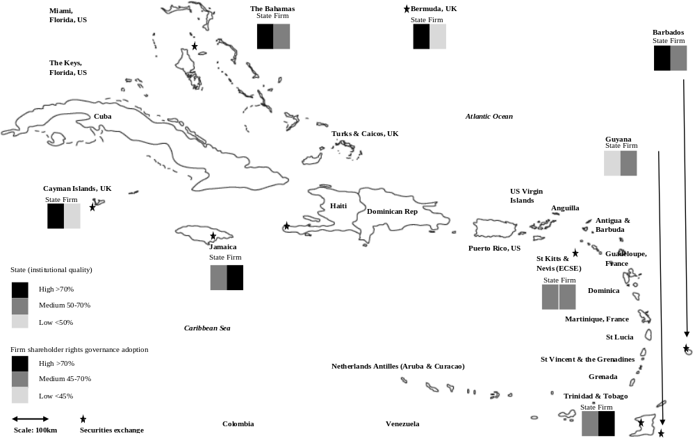
Source: Compiled by authors from the six Worldwide Governance Indicators for national institutional quality and from individual firm annual reports in terms of the firm-level shareholder value corporate governance index

Figure 2 Theoretical associations
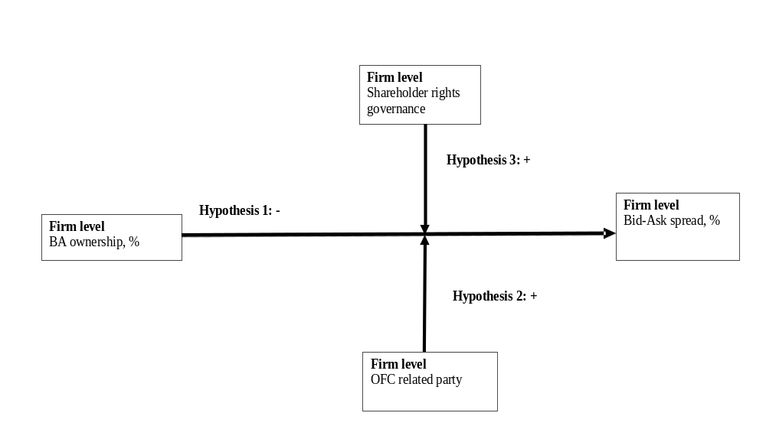

Figure 3 BA ownership and moderation by OFC subsidiary
Note: Error bars are based on standard error at p ≤ 0.05 confidence margin
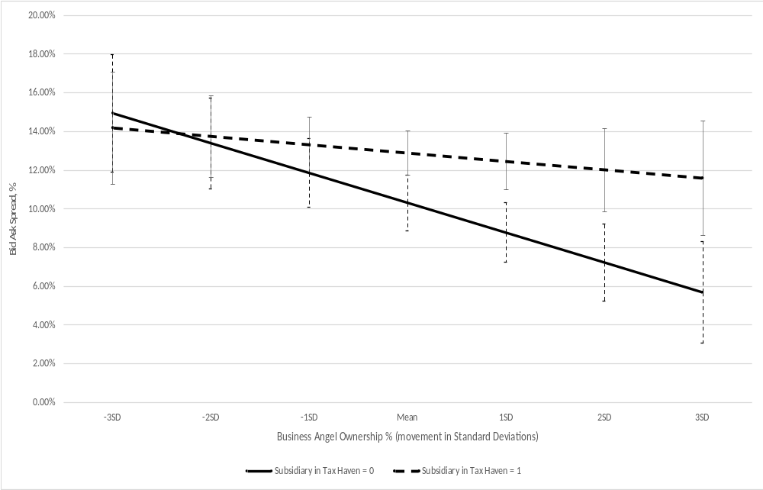

Figure 4 BA ownership and moderation by shareholder rights

Appendix Table 1 Offshore financial centres and tax strategies
This table comprises two panels. In panel 1, five examples of commonly used aggressive tax management or financial strategies from across the Caribbean region are described between sub-panels (A) to (E). In panel 2, it outlines the Organisation for Economic Co-operation and Development (OECD) characterization of each market as either a tax-haven, an offshore financial centre or neither, alongside the corporation, capital gains and dividend withholding taxes. Finally, against each jurisdiction/territory it documents the permissible organizational structures and legal codes regarding tax efficient structures. These are compiled by authors from https://www.offshorecompany.com/company/jurisdictions/ and https://www.offshore-protection.com/company-formations-registrations.

Panel 1: Aggressive tax management scheme examples
A. Interest payment’s structure (simple)
Two example tax strategies falling within this remit are (1) the offshore loan structure, and (2) the corresponding financing via offshore/average structures. These shift income revenues through the interest repayments channel. The tax base in the target entity is reduced via the interest deduction. In contrast to the offshore/average loan structures, the interest payments are not received in a lower tax country or no tax country. Due to a legal mismatch of the treatment of the interest payment in the receiving entity, the financial flow is exempted from taxation.
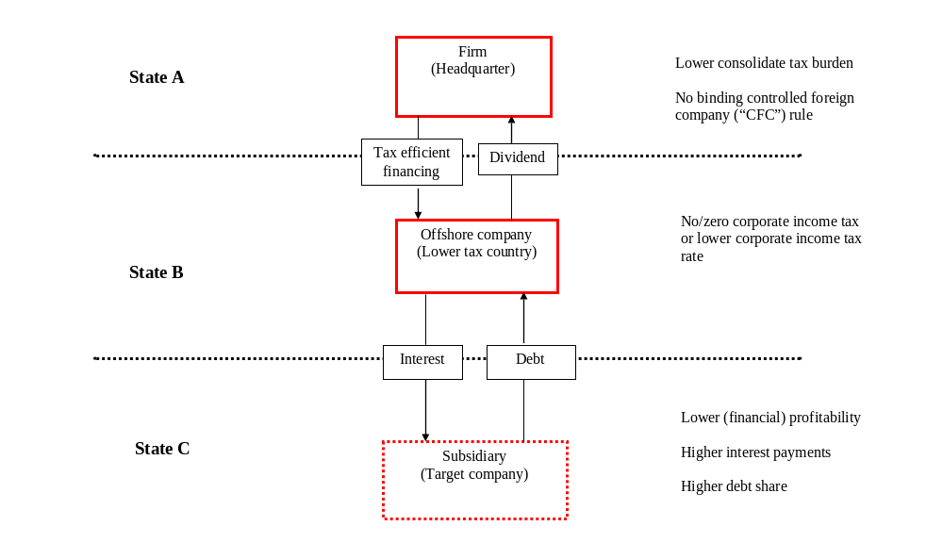
B. Royalty payment’s structure (simple)
Tax strategies based on the income shifting through royalty payments have in common that the tax base in the target entity is reduced through a deduction of royalty costs. The tax saving in most tax strategies using this channel results from lower taxation of the royalty payments in the receiving lower tax entity. This lower tax burden on the royalty received is either due to a generally lower corporate tax rate or to a specific regime benefitting income from intellectual property (a “patent box”)
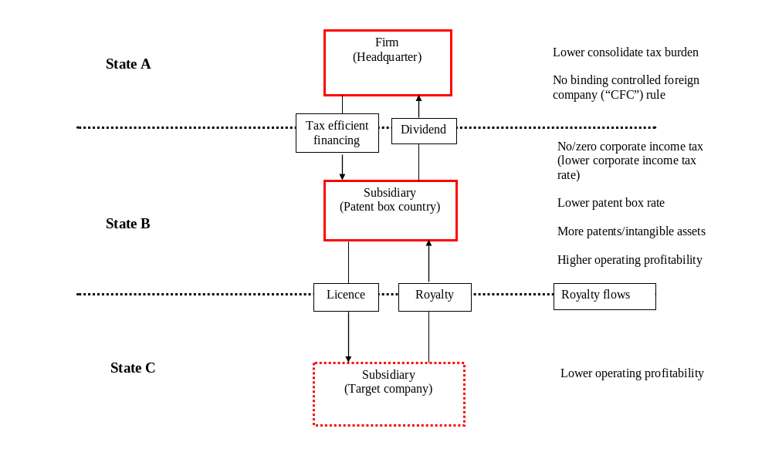
C. Strategic transfer pricing structure (simple)
Strategic transfer pricing of goods and services for internal transactions is associated with the mispricing of internal transactions, where the corporate tax base is reallocated to jurisdictions where lower taxes are levied.
Treaty shopping: This primarily focusses on the diverting of dividend flows with the aim to reduce/eliminate the tax burden on the repatriation of the profits (withholding tax).
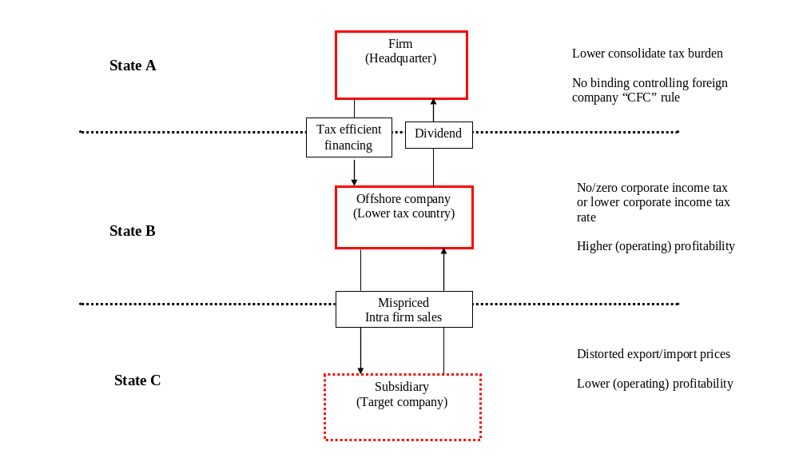
D. Two-tiered intellectual property structure
The central channel of the two-tiered structure is that the intellectual property is transferred to a subsidiary, which is incorporated in country E, but is tax-resident outside that country in a jurisdiction where it is tax-exempt. As a result, the royalty payments made by the target company in state D are deducted from the tax bases there but are not taxes in the entity in country E. The second tier of the structure sees subsidiaries in states B and C with sub-licences and corresponding royalty flows.
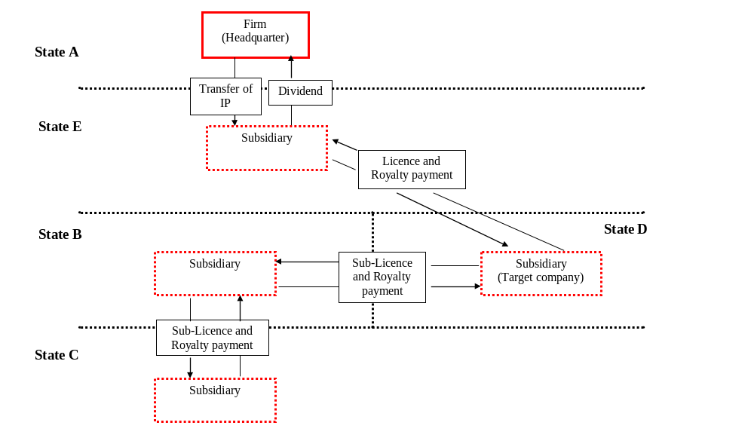
E. Cost contribution agreement’s structure
The tax reduction in this structure originates from the allocation of the royalty payments to a tax-free company in state B in combination with the deduction of R&D costs in member state A and royalty costs in state C. Both member states levy higher taxes which results in the overall tax reduction
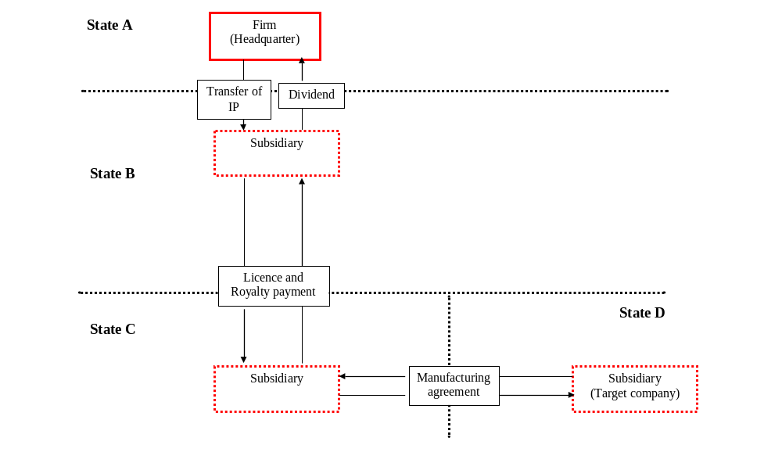
Panel 2: Caribbean tax-haven and offshore financial institutional environment
Bermuda OECD Tax-Haven and Offshore Financial Centre
Taxes: Corporation (0%); Capital Gains (0%) & Dividend Withholding (0%)
Organizational Forms: Types of organizational structure available: Bermuda company, partnership (LLC), segregated accounts company. A Bermuda limited company has the primary benefits listed below.
• Incorporating a company in Bermuda places you under the Companies Act of 1981. Under these statutes, all that a business needs is to incorporate one director and one shareholder. The director and shareholder can be the same person. This law also allows for plenty of leeway, since neither the director(s) nor the shareholder(s) need to be resident in Bermuda.
• Ongoing corporate records are not typically filed or viewed by the government officials in Bermuda. Unlike some other jurisdictions, most companies that incorporate in Bermuda do not need to file reports of financial accounts or annual returns with its government. The records that the business does maintain do not need to be drafted in Bermuda and those files do not need to be filed with the registrar.
• Only one annual filing, called the Statutory Declaration, which lists the authorized share capital, needs to be filed on a yearly basis with the government. This document must be filed with the government so that the government can then use it to base its annual required government fee.
• After incorporating in Bermuda, most corporation, aka limited company, owners receive tax exemption status from taxes in Bermuda. Usually, the corporation will not need to pay taxes on profits, income, capital gains, estate, or death to the government of Bermuda. Some refer to this as a “Bermuda Exempted Company”.
• In Bermuda, it is typically affordable to run a corporation. There is typically only an annual government and agent fee.
• Incorporating in Bermuda is fast and easy once you provide the documentation needed to complete the registration processes. The length of time it takes to incorporate in this country is about three to five days.
Cayman Islands OECD Tax-Haven
Taxes: Corporation (0%); Capital Gains (0%) & Dividend Withholding (0%)
Organizational Forms: Types of organizational structure available: Cayman Islands company, exempted company, foundation company, limited liability company, non-resident company, segregated portfolio company.
A Cayman Islands Exempted Company receive the following benefits:
• 100% Foreign Owners: Foreigners can own all the shares.
• Limited Liability: Only the unpaid amount for all the shares is a shareholder’s liability.
• Privacy: The names of the shareholders and directors are not available to the public. Bearer shares are permitted.
• No Taxation: The Cayman Islands do not levy any type of taxes on the company and shareholders. However, United States residents must declare all global income to the IRS just like residents of other countries taxing global income.
• One Shareholder/Director: Only one shareholder and one director is required who can be the same person.
• No Required Meetings: There are no requirements to hold shareholders or directors’ meetings.
• No Audits: There are no required accounting standards and no required audits.
The Bahamas OECD Tax-Haven and Offshore Financial Centre
Taxes: Corporation (0%); Capital Gains (0%) & Dividend Withholding (0%)
Organizational Forms: Types of organizational structure available: Bahamas corporation, partnership (LLC), foundation, segregated accounts company. Bahamas corporations receive many benefits including:
• Privacy: The Bahamas’ International Business Companies (IBC) Act of 1990 protects the privacy of its corporations and their shareholders. This Act prohibits information sharing of its corporations between the Bahamas and any other country.
• 20 Years Tax Exemption: Another attractive benefit the Bahamas provides for foreigners is tax exemption to both the corporation and its shareholders for twenty years after the process of incorporation is complete. However, citizens of the U.S. and other countries taxing worldwide income may be required to report all income to their tax authorities.
• One Shareholder and One Director: Bahamas corporations only need a minimum of one shareholder and one director.
• No Annual Reports Filing: Bahamas corporations are not required to file annual reports with the Registrar’s Office.
• Annual General Meetings held Anywhere: There is no requirement for Bahamas corporations to hold their annual general meetings in the Bahamas as they can be held anywhere in the world.
Jamaica OECD Offshore Financial Centre
Taxes: Corporation (33.30%); Capital Gains (2%) & Dividend Withholding (33.33%)
Organizational Forms: Types of organizational structure available: Jamaican limited liability company (LLC); Jamaican corporation, Limited company formation.
A Jamaica Limited Liability Company (LLC) can take advantage of the following benefits:
• 100% Ownership by Foreigners: LLC’s can have all of their shares owned by foreigners.
• Privacy: The names of the shareholders are never part of any public records.
• No Minimum Capital: There is no minimum authorized capital.
• Limited Liability: Shareholders’ liabilities are limited to the amount owed on their share capital contributions.
• One Shareholder/One Director: Only one shareholder and one director are required which means the sole shareholder can also be the only director for more control.
• Taxes: Every LLC must obtain a tax registration certificate even if taxes will not be owed. Since 2013, the corporate tax rate for an un-regulated company is 25% and for a regulated company is 33%. Most LLC’s conduct business in un-regulated industries subjecting them to the 25% corporate tax rate.
Barbados OECD Offshore Financial Centre
Taxes: Corporation (25%); Capital Gains (0%) & Dividend Withholding (0%)
Organizational Forms: Types of organizational structure available: Barbados International Business Company (IBC), partnership (LLC). Barbados International Business Company (IBC) receives several benefits including:
• Low Income Tax: Income taxes for company profits are based on a sliding scale starting at 0.25% up to a maximum of 2.5%. A Tax Credit allows for IBC’s who pay taxes outside of the country to be credited against Barbados taxes owed which can reduce the tax to the minimum 0.25% rate. Also, there is no capital gains tax. However, U.S. citizens and others who reside in countries with worldwide taxation must report all income to their tax authority.
• Zero Tax Rate Exception: IBCs owned by a Barbados Offshore Trust and managed in accordance with the Barbados International Financial Services Act pay no income taxes.
• Numerous Exemptions: An IBC is exempt from withholding taxes on dividends, interest, and royalties; and exempt from import duties.
• No Currency Exchange Controls: IBC’s can conduct business in any currency.
• 15 Year Benefits and Exemptions Guaranteed: IBC’s can obtain an agreement from the government to guarantee all current benefits and exemptions remain for a period of 15 years.
• No Minimum Capital: There is no requirement for an authorized minimum capital.
Eastern Caribbean OECD Tax-Haven and Offshore Financial Centre
Taxes: Corporation (0%); Capital Gains (0%) & Dividend Withholding (0%)
St Vincent & the Grenadines
Organizational Forms: Types of organizational structure available: St Vincent & the Grenadines International Business Company (IBC), St Vincent International Business Company (IBC), St Vincent Incorporation, St Vincent Limited liability company
A St. Vincent corporation can expect several benefits including:
• No Taxes: Corporations in St. Vincent are not required to pay capital gains tax, income tax, withholding tax, corporate tax or taxes on all incomes and assets for 25 years from the date of registration. However, U.S. citizens and other citizens of countries which tax worldwide income must reveal their global income to their tax authorities.
• Asset Protection: St. Vincent offers strong asset protection laws to investors incorporating in its jurisdiction. Commercial activities information will not be passed onto a Revenue Authority anywhere.
• Very Small Registration Fee: St. Vincent offers some of the lowest incorporation and annual fees globally. A typical corporation only pays a $125 USD registration fee and for annual renewals plus reasonable local registered agent and registered office fees.
• Strict Confidentiality: St. Vincent has one of the strictest sets of confidentiality laws in the world.
• One Shareholder: Only one shareholder and one director are required for incorporation in St. Vincent. Directors and shareholders do not need to be local residents. Both private persons and corporate bodies can be shareholders.
• Bearer Shares: Corporation bearer shares are allowed in St. Vincent for anonymous ownership and privacy.
• No Accounting: St. Vincent corporations are not required to meet any accounting or auditing requirements. In addition, there is no requirement for corporations to maintain, submit, or keep any corporate records for tax or government approval purposes.
• No Stamp Taxes: St. Vincent offers its offshore corporations’ exemption from stamp duty on any share or property transactions for 25 years from the date of registration.

St Lucia
Organizational Forms: Types of organizational structure available: St Lucia International Business Company (IBC), St Lucia Limited liability company.
A St. Lucia International Business Company (IBC) obtains these types of benefits:
• Safe Jurisdiction: St. Lucia has never been blacklisted nor under suspicions with an international financial watchdog organization.
• Foreigners Welcome: Foreigners can form an IBC and own all of its shares.
• Tax Free: IBC’s do not pay corporate, income, or capital gains taxes. However, U.S. taxpayers and everyone subject to global income taxes must disclose all income to their governments.
• Flexible Business: IBC’s can conduct all types of global business.
• One Shareholder/One Director: Only one shareholder and one director are required which can be the same person or corporate body.
• No Minimum Capital: There is no requirement for a minimum authorized capital or paid up share capital.
• Privacy: None of the shareholders and directors’ names are included in the public records.
• No Filings: IBC’s electing to be tax free are not required to file accounting records or financial statements. No audits are required.

Nevis (part of federation of St Kitts & Nevis)
Organizational Forms: Types of organizational structure available: Nevis corporation, Nevis partnership (LLC), Nevis multiform foundation.
A Nevis International Business Company (IBC) has these benefits:
• 100% Foreign Ownership: Foreigners can own all of the shares in a Nevis IBC.
• Limited Liability: A shareholder’s liability is limited to the capital investment.
• Total Privacy: Shareholders and directors names are anonymous and not part of any public records. Nominee shareholders, directors, and officers are permitted.
• No Taxes: IBC’s do not pay any taxes. Note that U.S. taxpayers and everyone obliged to pay income taxes on global income must declare all income to their tax agency.
• One Shareholder: The minimum number of shareholders is one to form an IBC.
• One Director: The IBC can be managed by only one director for a one shareholder company.
• Fast Registration: It only takes one business day to incorporate an IBC.
• No Accounting or Auditing Requirements: IBCs are free to establish any accounting standards or auditing requirements.
• Low Minimum Share Capital: Currently, the required minimum share capital is $1 USD.
• No Required Authorized Capital: There is no required minimum authorized capital.

Dominica
Organizational Forms: Types of organizational structure available: Dominica corporation, Dominica International Business Company (IBC), Dominica Private Limited Liability Company LLC
A Dominica International Business Company (IBC) can take advantage of the following benefits:
• Completely Foreign: Foreigners may own 100% of the shares in an IBC.
• Tax Free: Dominica grants a 20-year exemption from all taxes upon incorporation. However, U.S. residents and others residing in countries taxing global income must report all income to their governments.
• Privacy: The names of the beneficial owners and shareholders are not included in any public records.
• Confidential: The law makes it a crime for anyone to reveal any information about an IBC without a court order or authority.
• One Shareholder/One Director: Only one shareholder is required who can become the sole director for better control.
• Low Minimum Share Capital: The minimum authorized share capital is only $100 USD.
• No Audits: Audits are not required, and accounting records can be prepared in any manner.
• No Meetings: Shareholders and directors’ meetings are not required.
• Fast Formation: An IBC can be incorporated within one business day.
Guyana No special OECD status
Taxes: Corporation (30%); Capital Gains (20%) & Dividend Withholding (20%)
Organizational Forms: Types of organizational structure available: Guyana private limited liability company (PLLC)
A Guyana Private Limited Liability Company (PLLC) offers these types of benefits:
• 100% Foreign Shareholders: The PLLC’s shares may be totally owned by foreigners.
• Limited Liability: Shareholders’ liabilities limited to their contributions to the company’s share capital.
• Two Shareholders: The law requires at least two shareholders to form a PLLC.
• One Director: Only one director is required which can be one of the shareholders for greater control.
• No Required Capital: There is no required minimum share capital amount.
Trinidad & Tobago OECD Offshore Financial Centre
Taxes: Corporation (25%); Capital Gains (20%) & Dividend Withholding (15%).
Organizational Forms: N/A.

Appendix Table 2 Data sources
Non-exhaustive list of sources of variables
Market | Information source
Caribbean | Databases: Bloomberg LLP; Thomson Perfect Information portal & Datastream.
Bermuda | Bermuda stock exchange library, Hamilton, Bermuda and website: http://www.bsx.com/  Hamilton-based interviews (11/2016 & 05/2019):  Bermuda stock exchange: James S. McKirdy (Chief Compliance Officer).  Bermuda Monetary Authority (BMA): Tessa Ingham (Analyst).  Bermuda Chamber of Commerce: Kendaree Burgess (Executive Director).  Bermuda Government: Victoria Taylor, Executive Officer.  Listed firm: Ozics Holdings Ltd (Auvo Kaikkonen, CEO); Cohort Ltd (Tracey Packwood); Bermuda Commercial Bank Ltd (Charlene Gilbert).
Barbados | Barbados stock exchange, Bridgetown, Barbados and websites: http://www.bse.com.bb/  Bridgetown-based interviews (07/2011 and 11/2016):  Barbados exchange: Marlon E. Yarde (CEO); Barry Blenham & Donna Hope (Operations Managers).  Central Bank of Barbados: Financial Division.
Bahamas | Bahamas stock exchange, Nassau, The Bahamas and websites: http://bisxbahamas.com/  Nassau-based interviews (05/2019):  Bahamas international securities exchange [BISX]: Keith Davies (CEO); Holland Grant (COO).  Chamber of Commerce: Jeffrey N. Beckles (CEO).  Securities Exchange Commission of the Bahamas (Senior Analysts).  Bahamas Venture Capital Fund c/o Baker Tilly Managers: Joan Octaviano (Head of Audit).  Bahamas Development Bank: Director (Mme Pelicanos).  University of the Bahamas graduate school of business: Remelda Moxley (Dean).  Listed firm: Bank of Bahamas (Leashawn McPhee); Emera (Dina Bartolacci Seely); Commonwealth Bank (Gina Greene); ICBL (Jenifer Clarke); Doctors Hospital (Joanne Lowe).
Cayman Islands | CISX, Cayman Islands exchange, Georgetown, Grand Cayman and websites: http://www.csx.ky  Georgetown, Grand Cayman-based interviews (05/2019):  Cayman Islands exchange: Sandy McFarlane (Operations Manageress).  Cayman Islands Development Bank: Tracy Ebanks (General Manager/CEO).  Cayman National Securities: Erol Babayigit (Vice President).
Jamaica | JSE, Jamaican stock exchange, Kingston, Jamaica and website: https://www.jamstockex.com/  Kingston-based interviews (07/2016):  Jamaican stock exchange: Marlene J. Street Forrest (General Manager); Sandra Shirley (Principal e-campus); Charlette Eddie-Nugent (Listings Manager); Neville R. Ellis (Operations Manager).  JSE electronic media marketing event (07/2016): Spanish Court Hotel Annex, Kingston, Jamaica.  Bank of Jamaica: Financial services division interviews.
Eastern Caribbean | ECSE, Basseterre, St Kitts & Nevis and website: http://www.ecseonline.com/  Basseterre-based interviews (11/2011):  Eastern Caribbean stock exchange: Trevor E. Blake (GM); Sherizan Mills (Operations Officer).  Eastern Caribbean Central Bank visit (11/2011).  Telephone-based interviews (06/2016 - 08/2016):  Eastern Caribbean stock exchange: Trevor E. Blake (GM); Sherizan Mills (Operations Officer)  Nevis, Charlestown-based interviews (11/2011): Financial district in Charlestown, Nevis;  St Lucia-based interviews (11/2011): Financial district, Castries, St Lucia.
Guyana | GASCI, Guyana Securities Council, Georgetown and website: http://www.gasci.com/  Telephone-based interviews (08/2015 – 01/2017): Cheryl Ibbott (CEO, Guyana Securities Council c/o Bank of Guyana); Vick (Compliance Officer, Guyana Securities Council).
Trinidad & Tobago | TTSE, Trinidad & Tobago stock exchange, Port of Spain and website: http://ttsec.org.tt/  Trinidad, Port of Spain based procurement (06/2016 - 07/2016):  Trinidad, Ministry of Finance: Melissa Mattoo and Christine Frank (Communications Officers).  Trinidad, Central Bank of Trinidad & Tobago: Candice Dilbar (Research Economist).  Trinidad, Listed firm: National Enterprises Limited (Keisha Armstrong, Head of Secretariat).  Tobago: Scarborough and Canaan-based interviews in financial district (06/2016 - 07/2016).

Appendix Table 3 Shareholder rights index
This table provides the definition of each of the governance elements within the OECD shareholder rights index. All are sourced from individual firm annual reports, and all are measured as binary effect Yes/No which is coded as 1/0. The only exceptions are elements A.7 (ii) and (iii) and E.11, where a count of the number of directors is undertaken. A difference in means tests are reported between firm-year observations in high as opposed to low institutional quality, where high are observations above the median 58.83%. †p ≤ 0.10; *p ≤ 0.05; **p ≤ 0.01; ***p ≤ 0.005.

Index elements | Institutional quality
 | High | Low
A.1 Does the company offer other ownership rights beyond voting? % | 23.58*** | 13.77
(i) Preference shares% | 11.28*** | 11.11
(ii) Convertible Bond/Shares & Options% | 1.37† | 1.50
(iii) Multiple share classes% | 15.72*** | 4.40
A.2 Is the decision on the remuneration of board members or executives approved by the shareholders annually? % | 49.77*** | 90.97
A.3 How is the remuneration of the board presented? % | 70.50*** | 95.60
(i) Are individual directors base cash salaries disclosed? % | 2.16** | 17.27
(ii) Are individual directors’ bonuses disclosed? % | 0.00 | 2.45
(iii) Are individual directors’ long-term incentives (options, pension etc.) disclosed? % | 1.82* | 7.00
(iv) Are benefits paid to directors? % | 12.19*** | 2.80
(v) Are benefits enumerated/ evaluated? % | 10.71*** | 2.80
(vi) Is salary aggregated into one lump sum paid? % | 77.79*** | 82.18
(vii) Is director fees aggregated into lump sum emolument? % | 77.45*** | 81.37
A.4 Quality of Notice to call a Shareholders Meeting in the past one year. % | 42.81*** | 91.55
(i) Appointment of directors, providing their names and background % | 47.27*** | 92.71
(ii) Appointment of auditors, providing their names and fees. % | 40.77*** | 92.71
(iii) Dividend policy, providing the amount and explanation. % | 34.51*** | 87.04
A.5 Did the Chairman of the Board attend at least 1 AGM in the past 2 years? % | 33.26*** | 95.08
A.6 Board effective monitoring % | 13.11*** | 38.12
(i) Did the CEO/Managing Director attend at least 1 AGM in past 2 years? | 31.52*** | 94.88
(ii) Is a name list of board attendance available? % | 16.74*** | 42.48
(iii) How many directors did not attend 100% meetings? # | 2.54* | 3.01
(iv) How many directors did not attend 70% of meetings? # | 1.37*** | 0.92
A.7 Do AGM minutes record that there was an opportunity for shareholders to ask questions/raise issues in the past one year? % | 6.04*** | 17.25
A.8 Does the company have anti-takeover defences? % | 79.61*** | 96.06
(i) Cross shareholding % | 76.08*** | 83.45
(ii) Pyramid holding % | 77.79*** | 82.64
(iii) Board members hold more than 25% of share outstanding % | 8.43*** | 30.90
A.9 Company dual listed? % | 5.47*** | 12.96
(i) Company dual listed on OECD stock exchange % | 1.82* | 0.81
(ii) Controlling parent listed on OECD stock exchange % | 14.81* | 18.06
E.11 What is the size of the board? # | 9.08*** | 8.84
Shareholder rights index: | 30.84*** | 51.05

Our definition of BAs relates to their role as informal investors within entrepreneurial finance ecosystems supported by formal institutions. This is in line with prior BA literature. However, much of this prior literature is focused on large, developed economies while we focus on their small, developing counterparts which are typically characterized by dichotomy between formal and informal economic spheres (Schneider, 2005). However, while prior BA literature focusses on entrepreneurial startups and small and medium enterprises, these are overwhelmingly concentrated in informal subsistence as opposed to formal economic spheres. The focus of our study follows BA financing on somewhat narrower formal economic sectors which are supportive of ecosystems based on economic opportunity as opposed to necessity entrepreneurship that dominate in informal sectors (Webb, Khoury & Hitt, 2020). Moreover, BA investment opportunities within formal sectors are typically more heterogeneous in terms of age and state of development.
This information is available from the authors upon request in Table 2 of the supplementary appendix.
Detailed statistics are available from the authors upon request in Table 5 of the supplementary appendix.
https://www.oecd.org/corporate/principles-corporate-governance.htm.
Binary 1/0 dummy accounting for country or jurisdiction of primary listing and binary 1/0 dummy for 24 industry categories as defined in Global Industry Classification (GICS) codes developed by MSCI (see https://www.msci.com/gics). Four of these contain no firms from our sample, resulting in 20 industry categories being used in our study.
These results are available from the authors upon request in Table 3 of the supplementary appendix.
These results are available from the authors upon request in Table 4 of the supplementary appendix.

