Using functional traits of chironomids to determine habitat changes in subtropical wetlands

Yanmin Cao^{1,2,3,*}, Peter G. Langdon², Shengman Shen¹, Hui Li¹, Deng Pan¹
1. College of Resources and Environment, South-Central Minzu University, Wuhan 430074, China
2. School of Geography and Environmental Science, University of Southampton, Southampton SO17 1BJ, UK
3. Hubei Key Laboratory of Critical Zone Evolution, School of Geography and Information Engineering, China University of Geosciences, Wuhan 430078, China

*Corresponding author; e-mail address: ymcao@scuec.edu.cn; caoyanmin0720@126.com

Abstract: Ecosystem functions in wetlands are increasingly degrading under the multiple stresses of climate change and human disturbances. Traditional wetland bioassessment is usually based on taxonomic approaches but this approach has limitations. To explore the effectiveness of functional traits in response to environmental changes, we compared the traditional taxonomic composition of chironomid communities with a trait-based approach in a subtropical subalpine wetland (Central China) spanning a wide habitat gradient from dry peatland to inundated peatland pools. The results revealed that 57% of functional trait groups but only 38% of taxonomic groups examined were significantly different between diverse peatland habitats. Sphagnum moss hummocks were generally inhabited by larvae of collector-gatherers, small body-sized individuals and sprawlers, while peatland pools supported a high abundance of shredders, large body-sized larvae and burrowers. Ecotones had more niche opportunities and hence possessed high taxonomic and functional diversity. Ordination analyses indicated that three similar environmental variables (loss-on-ignition (LOI), depth to water table (DWT) and K⁺) were the most powerful explanations of the chironomid variability in both taxonomic and functional trait compositions. LOI and DWT interacted strongly and were the dominant controls on both taxonomic and trait communities. Our research demonstrated that functional trait groups of chironomids are more robust and sensitive than taxonomy-based approaches to habitat changes, and therefore could be an alternative approach for the bioassessment of aquatic ecosystem functioning and palaeo-studies in wetlands.
Keywords: Functional traits; Chironomidae; Peatlands; Water level fluctuations; Organic matter

1 Introduction
Major changes in wetlands such as shrinking and degradation due to global climate change and anthropogenic drivers have occurred in recent decades (Xi et al., 2021). Such impacts are likely to degrade the ecosystem functions and services in carbon sequestration, water purification, food supply, flood control, biodiversity conservation and recreation (Hu et al., 2017; Xi et al., 2021). Knowledge of wetland functions and development processes is of crucial importance for wetland conservation and restoration. Increasingly numbers of aquatic bioindicators, such as benthic macroinvertebrates (Morse et al., 2007; Cai et al., 2023), zooplankton (Zebral et al., 2021) and algae (Peng et al., 2023) in rivers and lakes, as well as testate amoebae in peatlands (Mitchell et al., 2000; Qin et al., 2021), are explored and commonly used in the assessment of modern and past environment and ecological functions.
Environmental bioassessments have traditionally been conducted using taxonomic structures including community composition and diversity (Wentzky et al., 2020; Belle et al., 2022). Taxonomic approaches are capable of predicting changes in biotic communities produced by habitat conditions and environmental change, but may not always align with ecosystem functioning which primarily relies on functional characteristics of species (Nevalainen et al., 2015). Function is undoubtedly a key component of ecosystem behavior, like resilience, which would likely be altered with human impacts (Bellwood et al., 2019). Better ways to explore functionality are therefore crucial to understand the response of ecosystems to multiple stressors. Functional trait approaches have provided new ways to assess ecosystem functioning across spatial and temporal scales (Dawson et al., 2021; Haase et al., 2023). Several studies have reported that both taxonomic compositions and functional traits were sensitive to environmental change, but interpretations were not straightforward, highlighting the importance of their combination in exploring environment-biota relationships comprehensively (Luoto et al., 2018; Piano et al., 2020; Li et al., 2019). While trait approaches are considered to have relatively stable relationships with environments, taxonomic compositions may vary considerably due to biogeographic factors and taxonomic accuracy (Dolédec et al., 2011). As such, functional trait approaches are increasingly used to provide a deeper understanding of response mechanisms of biota to environmental change (Adeleye et al., 2023).
Chironomids are prominent aquatic insects having a wide geographic distribution and outstanding capacity to resist unfavorable conditions such as extreme temperature, hydraulic changes, trophic status and substrates (Armitage et al., 2012). The larvae are highly sensitive to environmental change and typically show clear differences in community assemblages between different habitats (Brooks et al., 2007). These advantages allow chironomids (including their subfossil remains) to serve as excellent bioindicators in biological monitoring and proxies in the environmental reconstruction of aquatic systems (Armitage et al., 2012). However, the usage of taxonomy-based measures can be problematic, as outlined above, and they can vary markedly across relatively small scales (Radkova et al., 2014; Cañedo-Argüelles et al., 2020). Insufficient taxonomic resolution can obscure the true biotic structure and environmental status. This problem can be magnified in large scale comparative studies, which are essential in modeling and forecasting ecological responses to future global changes (Bonada et al., 2007). Nevertheless, chironomid larvae play a crucial role in ecosystem functional processes, serving as a key node in food-web structures and biogeochemical cycles by influencing nutrient and pollutant exchanges (Kivilä et al., 2019; Gautreau et al., 2023). Given the challenges with taxonomic approaches, we focus here on functional traits and functional diversity of chironomids and their role in modern bioassessment and inference of environmental history, with a novel focus on peatlands.
We selected the Dajiuhu Wetland for this study. The wetland is situated in the Shennongjia Forest region in Central China. It shows a high heterogeneity in habitat conditions and spans a gradient of Sphagnum moss peatlands, natural and artificial ditches, seasonal and temporary ponds, as well as artificial peatland pools. The wetland is of importance in maintaining biodiversity and regional water supply, and has been listed in UNESCO’s World Network of Biosphere Reserves since the 1990s and designated as a wetland of international importance under the Ramsar Convention in 2014. Hence the knowledge of its changes in habitat conditions and ecosystem functions would enhance wetland conservation and sustainable resource management. Here we investigated the taxonomic and functional trait structure (composition and diversity) of chironomid communities along a habitat gradient from arid Sphagnum moss peatlands to permanent peatland pools and verified their consistency in temporal responses to environmental changes based on a short peat core. We aimed to (1) detect the differences of chironomid community composition (both taxonomic and functional trait) between different types of habitats; (2) assess the effectiveness of taxonomic and functional trait-based measures in identifying habitat types in complex aquatic systems; and (3) determine the environmental parameters driving faunal community composition. We hypothesized that the functional traits of chironomid communities would be robust in responding to habitat variations and could be an alternative approach for contemporary bioassessment and palaeo-studies in peatland-shallow lake complexes like the Dajiuhu Wetland.

2 Material and methods
2.1 Study area
The Dajiuhu National Wetland Park lies in the mountainous area of the western Shennongjia Forest region in central China. It belongs to a closed alpine karst basin with an area of 16 km² and an altitude of 1700-1760 m a.s.l.. The region belongs to the East Asian Monsoon climate zone and is characterized by a mid-latitude subalpine humid climate. The current mean annual temperature is ~7.2℃ and annual precipitation is 1560 mm with maximum rainfall of 3000 mm, whilst the annual evaporation varies from 500 to 800 mm (Li et al., 2013). Cool and high humidity conditions support peatland accumulation and have led to a large coverage of thick peat (average peat coverage of 50%) in the Dajiuhu Wetland (Zhang, 1982). The Dajiuhu Wetland has been designated as an internationally important wetland under the Ramsar Convention since 2014. It is also of vital importance in water conservation for the middle route of the South to North Water Diversion Project in China (Du et al., 2008). As a hotspot of biodiversity and a key ecotone for regional ecological security, the bioassessment of ecosystem health and functions for the Dajiuhu Wetland is becoming increasingly necessary, especially with the spectre of increased future climate change.
2.2 Material and laboratory analyses
We collected a total of 44 surface sediment samples in November 2019 (12 samples), September 2020 (19 samples) and July 2021 (13 samples), respectively (Fig. 1). These sampling sites occurred along a water-level gradient across diverse habitats including Sphagnum moss hummocks and hollows, ditches, temporary or seasonal ponds, and peatland pools. Hummocks and hollows are two distinct growth forms of Sphagnum moss; the former has a higher height of moss growth above the water table than the latter. Ditches here refer to flowing or still streams, and ponds are very shallow (<1 m) and small-sized (generally less than 10 m²) depressions, and store temporary water during the wet season or after rain in the dry season. Open water areas with permanent water in the wetland are classified into peatland pools in the present study (Supplementary Figure 1). At each site, depth to water table (DWT) was measured using a meter ruler. Portable electrodes (Hach HQ40d portable multi-meter, Hach Company, Loveland, CO, USA) were employed to measure other environmental parameters in situ, including pH (Hach HQ40d multi, PHC201), conductivity (Hach HQ40d multi, CDC401), oxidation-reduction potential (ORP; Hach HQ40d multi, MTC101), dissolved oxygen and water temperature (Hach HQ40d multi, LDO101). To collect water samples, a hole was dug at arid hummock sites, or a water sampler was used for peatland pools with relatively deep water (maximum of ~1.5 m in depth). For peaty habitats (both hummocks and hollows), surface peat samples were collected manually, while for inundated sites, surface sediments were retrieved using a 1/32 m² Ekman grab. Between 5-12 samples for each habitat were collected (Fig. 1; Table 1).
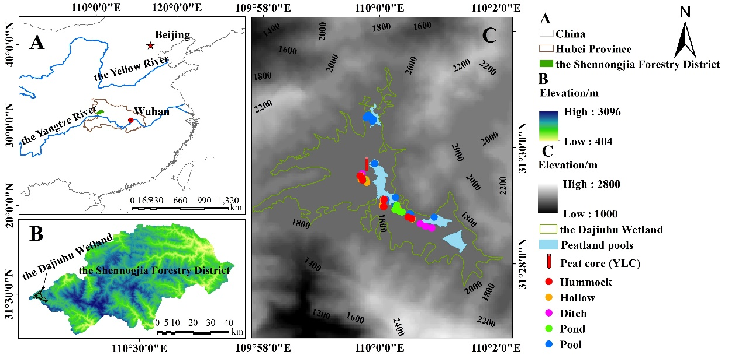
Figure 1 Geographical locations and elevations of the Shennongjia Forestry District (A), the Dajiuhu Wetland (B) and sites of the YLC (Yangluchang Core) peat core and surface samples along diverse habitats (C).

Table 1 Basic characteristics of different habitats. The values are ranges of environmental parameters and their mean values (in the parentheses) of samples from each habitat.
Habitat | Hummock | Hollow | Ditch | Pond | Peatland pool
Sample code | Hu 1-10 | Ho 11-19 | Di 20-27 | Po 28-32 | Pl 33-44
DWT  (cm) | 0.00~11.00  (6.70) | -42.00~-1.00  (-16.22) | -62.00~-5.00  (-31.75) | -70.00~-9.00  (-25.20) | -147.00~-22.00  (-74.33)
LOI  (%) | 29.67~88.66  (67.81) | 8.73~79.47  (58.71) | 9.09~86.85  (30.21) | 8.38~62.39  (24.77) | 4.59~30.59  (12.16)
pH | 4.94~7.54  (5.78) | 4.82~6.71  (5.58) | 5.59~7.56  (6.39) | 5.94~7.16  (6.73) | 6.59~8.96  (7.40)
Conductivity (μS cm⁻¹) | 20.34~128.00  (56.44) | 9.31~85.30  (25.74) | 14.19~88.50  (41.30) | 20.18~81.60  (52.84) | 65.30~151.10  (91.06)
ORP  (mV) | -19.90~272.50  (140.82) | 128.80~280.00  (207.51) | 96.50~231.50  (174.29) | 73.00~240.50  (155.08) | 87.40~213.80  (156.24)
DO  (mg L⁻¹) | 0.56~7.12  (2.53) | 3.18~10.84  (6.35) | 0.55~9.51  (5.50) | 4.61~9.40  (7.27) | 4.65~11.73  (7.89)
TOC  (g kg⁻¹) | 146.21~390.71  (310.83) | 62.98~383.13  (283.68) | 31.73~401.68  (142.95) | 27.12~316.10  (114.98) | 12.09~143.11  (47.29)
TN  (g kg⁻¹) | 11.66~24.20  (19.24) | 3.91~26.35  (19.39) | 3.22~27.50  (10.48) | 3.07~21.74  (8.74) | 1.33~8.34  (4.33)
C/N | 14.64~29.47  (19.02) | 13.93~19.68  (17.48) | 11.26~20.24  (15.22) | 10.30~16.96  (13.93) | 9.35~20.02  (11.92)
K⁺  (mg L⁻¹) | 0.27~1.90  (1.06) | 0.00~1.33  (0.44) | 0.00~1.20  (0.57) | 1.03~1.88  (1.22) | 0.28~1.34  (0.85)
Ca²⁺  (mg L⁻¹) | 1.48~13.35  (3.85) | 1.08~10.71  (2.76) | -0.09~14.15  (4.46) | 0.99~8.30  (3.98) | 8.44~16.28  (10.34)
Na⁺  (mg L⁻¹) | 0.22~1.90  (0.59) | 0.51~3.02  (1.32) | 0.40~2.59  (1.24) | 0.47~0.75  (0.61) | 0.41~4.46  (1.29)
Mg²⁺  (mg L⁻¹) | 0.17~1.50  (0.50) | 0.20~1.14  (0.43) | 0.03~1.32  (0.54) | 0.21~0.92  (0.51) | 1.01~2.13  (1.52)
NO₃-N  (mg L⁻¹) | 0.01~0.15  (0.05) | 0.01~0.50  (0.11) | 0.01~0.55  (0.12) | 0.00~0.09  (0.04) | 0.00~0.33  (0.08)
NH₄⁺-N  (mg L⁻¹) | 0.00~1.73  (0.20) | 0.00~0.46  (0.13) | 0.00~0.25  (0.13) | 0.04~0.15  (0.11) | 0.00~0.78  (0.18)
NO₂-N  (mg L⁻¹) | 0.00~1.26  (0.37) | 0.00~0.19  (0.04) | 0.00~0.09  (0.01) | 0.00~0.01  (0.00) | 0.00~0.21  (0.04)
PO₄-P  (mg L⁻¹) | 0.00~0.08  (0.01) | 0.00~0.01  (0.00) | 0.00~0.01  (0.00) | 0.01~0.02  (0.01) | 0.00~0.01  (0.00)

In the laboratory, concentrations of major cations (K⁺, Na⁺, Mg²⁺ and Ca²⁺) were measured using inductively coupled plasma-atomic emission spectrometry (ICP-AES; Leeman Labs Profile, Leeman Labs, Hudson, NH, USA) and morphological phosphorus (PO₄-P) and nitrogen (NO₃-N, NH₄-N and NO₂-N) in water samples were quantified by a continuous flow autoanalyzer (Skalar San Plus, Skalar Inc., Breda, The Netherlands), with the detection limit of 10 µg L⁻¹ for NH₄-N and 1 µg L⁻¹ for the other three anions. An elemental analyzer (Vario EL cube, Elementary, Hanau, Germany) was used to determine the contents of total organic carbon (TOC) and total nitrogen (TN). Weight-loss-on-ignition (LOI) was calculated after the sediments were burned for 2 hours at 550℃.
Chironomid head capsules were extracted from wet sediment samples following the standard approach recommended by Brooks et al (2007) and identified to genus/species type level under a microscope of 400 magnification using the taxonomy of Brooks et al (2007), with reference to Epler (2001) and Tang (2006). The criterion of 50 minimum identifiable whole head capsules per sample was satisfied to conduct subsequent analyses. To compare the temporal responses of taxonomic and functional trait compositions of chironomid communities to peatland development, chironomids were analysed from a peat core named YLC (Yangluchang Core; 51cm-length), which was collected from the peatland central area (Fig. 1C). The chronology and biota data (taxonomy) for the core has previously been published by Hou et al. (2022), which discussed the sensitivity of chironomid communities to regional climate-driven changes. Relative abundances of subfamilies and genera in all surface and peat core samples were calculated. Only taxonomic groups with abundances exceeding 2% and occurring in at least two samples were used in ordination analyses.

2.3 Functional traits of chironomids
Functional traits for all chironomid taxa in both surface and peat core samples were represented by four traits with 28 categories including feeding guilds (5 categories), morphological types (16 categories), body size (4 categories) and locomotion type (4 categories) in the present study (Table 2). All selected traits are sensitive and responsive to habitat changes (Serra et al., 2016). The taxon trait information (Supplementary Table 1) was obtained from Mandaville (2002), Wang and Wang (2011), Saulino et al. (2017), Heino (2008) and Antczak-Orlewska et al. (2021) and is complemented by European Chironomidae taxa published in Serra et al. (2016).

Table 2 Categories and respective code of four traits used in this study.
Trait | Category | Codes | Main References
Functional feeding guild | Collector-gatherers | CG | Mandaville (2002);  Serra et al. (2016)
 | Collector-filterers | CF
 | Shredders | Shr
 | Predators | Prd
 | Scrapers | Scr
Morphological type | 1-16 proposed by Antczak-Orlewska et al. (2021) | M1-M16 | Antczak-Orlewska et al. (2021)
Body size | <5 mm | Size 1 | Wang and Wang (2011); Serra et al. (2016)
 | >5-10 mm | Size 2
 | >10 mm | Size 3
Locomotion | Burrower | Burrower | Saulino et al. (2017);  Canedo-Arguelles et al. (2016);  Heino (2008);  Serra et al. (2016)
 | Sprawler | Sprawler
 | Climber | Climber
 | Clinger | Clinger

2.4 Data analyses
The taxonomic and functional diversity of chironomid communities in the surface sediments was measured by different indices. Species richness, Pielou’s evenness and Shannon-Wiener index were combined to assess different facets of biodiversity. Three primary components of functional diversity were also used to measure different aspects of functional characteristics of chironomids: functional richness (FRic), functional evenness (FEve) and functional divergence (FDiv). FRic is the range of functional strategies within an assemblage (Martins et al., 2021), measuring how much niche space is filled (Schleuter et al., 2010). FEve is equivalent to species evenness and describes the evenness of abundance distributions in niche space. Low FEve means the niche space the community encompassed was underutilized (Mason et al., 2005). FDiv relates to how abundance is distributed within the volume of functional trait space occupied by species (i.e. niche differentiation) (Villéger et al. 2008). A community with high FDiv is more efficient in resource use and will likely lead to better ecosystem functioning (Mason et al., 2005; Larentis et al., 2022).
Due to non-normality of taxonomic and functional trait data, we conducted non-parametric Kruskal-Wallis rank sum tests to check whether significant differences in compositions existed between the five different habitats. Dunn’s paired comparison test (Dunn, 1964) was then used to identify the pairs of habitats having significant differences in each taxonomic component and functional trait group. The calculations of taxonomic diversity were conducted in Past 2.03 (Hammer et al. 2001), and functional diversity and Dunn’s test were performed in R using the packages of ‘FD’ (Laliberté et al., 2014) and ‘FSA’ (Ogle et al., 2020).
For ordination analysis, principal components analysis (PCA) was first conducted to map the variability of environmental parameters between different habitats. Distance-based redundancy analysis (dbRDA; Legendre and Anderson, 1999) was then performed as the constrained ordination method to explore the relationships of biotic (taxonomic and functional trait) compositions and environmental variables. Bray-Curtis dissimilarity was chosen to calculate sample distances on the basis of a relative abundance matrix of chironomids during the principal coordinate analysis (PCoA) prior to the dbRDA. Forward selection with 999 permutations of environmental factors was used to select a minimum set of significant (p<0.05) variables. To determine the relative importance of DWT, which was hypothesized to be a vital factor in shaping habitats and their biotic communities, variation partitioning analysis (VPA; Borcard et al., 1992; Legendre and Legendre, 1998) was conducted. For chironomids in the sediment core, we used the first PCA axis scores to depict the historical changes in taxonomic and functional trait compositions with climate change. All multivariate analyses were conducted in CANOCO version 5 (Šmilauer and Lepš, 2014).

3 Results
3.1 Environmental characteristics of different habitats
DWT and LOI displayed a large gradient of habitat conditions among sampling sites. Sphagnum moss hummocks had a mean DWT value of 6.7 cm, representing extremely dry conditions, whereas sites in peatland pools had a mean water depth of 74.3 cm. LOI in the 44 sampling sites ranged from 4.6% to 88.7% with the mean values ranging from 12.2% to 67.8% from pools to arid Sphagnum hummocks respectively. Among peatland samples, three sites showed unexpectedly low LOI values: one sample from a Sphagnum moss hummock (29.6% of LOI) and two from hollows (20% and 8% of LOI, respectively). TOC and TN, which also represent primary production, changed in a similar trend to LOI across different habitats. Sphagnum hollows in the peatland showed the highest acidity (mean pH of 5.58), but lowest ion concentrations (mean conductivity of 25.74 μS cm⁻¹). The details of ranges and averages for major environmental parameters in different habitats are given in Table 1.
The PCA of environmental parameters showed that multiple surface samples overlap (Fig. 2), which was expected given that a large proportion of sites were sampled from transitional zones adjoining different habitats. Clear divergence existed between samples from peatland hummocks and pools, indicating their contrasting environmental conditions. The first two axes of the PCA explained 51% of total variation, with the first axis explaining 35.7% and the second one explaining 15.3%. The first axis was highly positively correlated with water pH and cations (Mg²⁺ and Ca²⁺), and negatively correlated with LOI and DWT. The second axis showed a gradient associated with high concentrations of Na⁺ and low concentrations of K⁺.
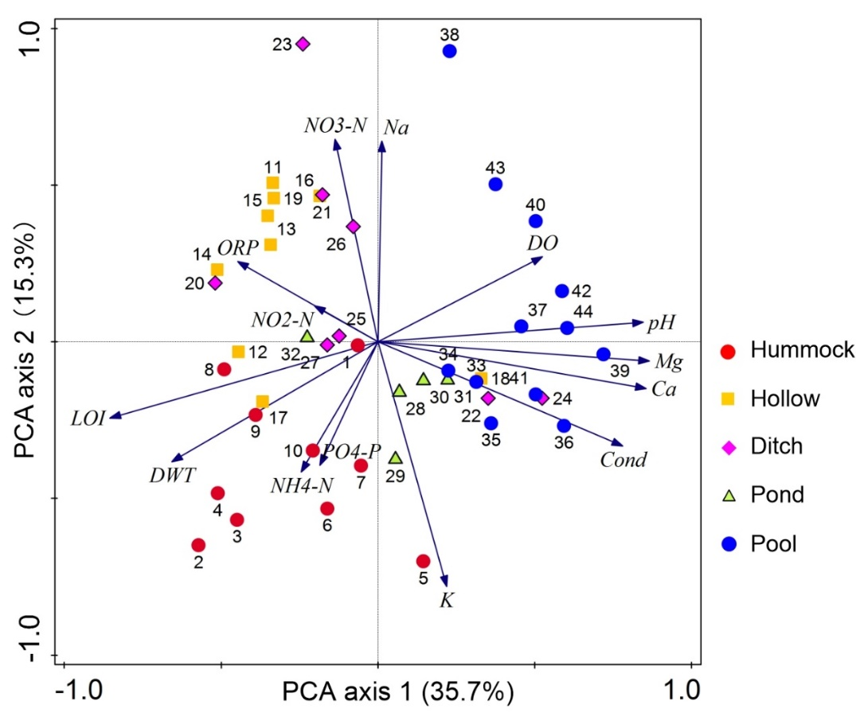
Figure 2 Biplot of principal component analysis (PCA) showing the environmental differences between five different habitats from all the surface samples.

3.2 Taxonomic composition and diversity
A total of 4792 head capsules (HCs) belonging to 52 genera of four subfamilies (Tanypodinae, Chironominae, Orthocladiinae and Diamesinae) were picked from 44 surface samples (Fig. 3). Chironominae were the most abundant subfamily occupying 57.3% of all HCs on average, followed by Orthocladiinae (40.1%). At the genus-level, Polypedilum showed the largest percentage abundance mean value (17.1%), and other dominant genera were Limnophyes (16.3%), Psilometriocnemus (10.1%), Chironomus (6.9%), Neozavrelia (5.7%), Tribelos (5.3%) and Pseudosmittia (5.1%).

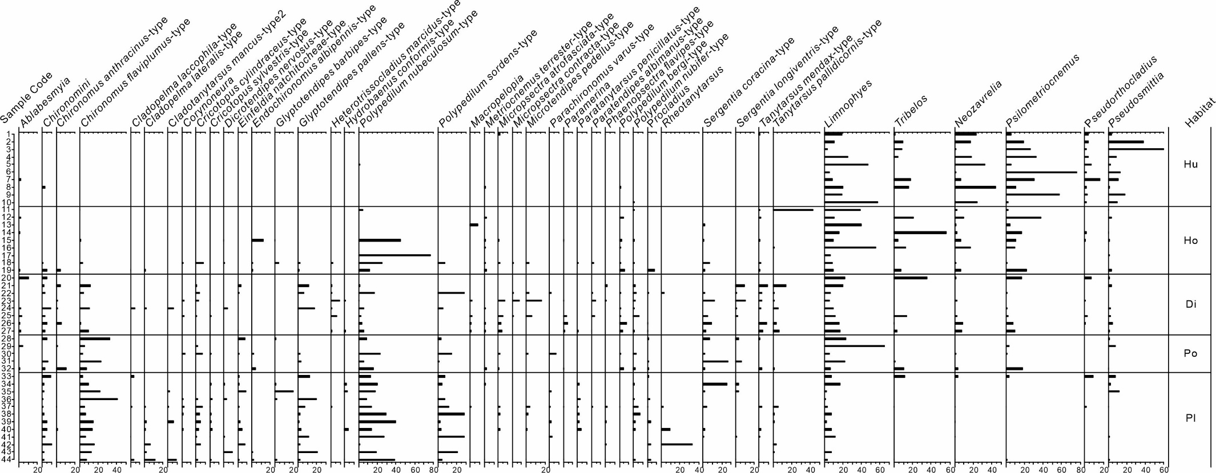
Figure 3 Percentage abundance of chironomid taxa in different habitats (samples in each habitat were ordered based on DWT, so the driest samples are at the top, and the wettest at the base). The five habitats were abbreviated as follows: Hu-Sphagnum hummock; Ho-Sphagnum hollow; Di-ditch; Po-pond; Pl-pool.

The community composition in Sphagnum hummocks was clearly different from other habitats. The dominant taxa were terrestrial/semi-terrestrial chironomids, such as Psilometriocnemus (26.6%), Limnophyes (21.9%), Neozavrelia (16.9%) and Pseudosmittia (16.5%) (Fig. 3). Pseudorthocladius also displayed an increase in its frequency and abundance compared with other habitats. Aquatic chironomid genera were almost absent in these relatively arid hummock samples. Sphagnum hollow samples were characterized by the coexistence of abundant semi-terrestrial taxa, such as Psilometriocnemus (11.9%) and Tribelos (11.1%), and aquatic taxa such as P. nubeculosum (18.1%). Although Limnophyes (17.6%) was dominant in ditches and ponds, other terrestrial/semi-terrestrial taxa such as Psilometriocnemus (4.9%), Neozavrelia (2.1%), Tribelos (4.8%), Pseudosmittia (1.9%) and Pseudorthocladius (0.8%) were reduced in their frequency of abundance. Typical aquatic taxa, such as Chironomus and Polypedilum, occupied pool habitats with relatively high water-levels (22-147 cm in depth). Limnophyes abundances were reduced, and other semi-terrestrial genera were almost absent.
The Kruskal-Wallis rank sum test results suggested that significant differences were shown by three subfamilies/tribes (60% of all subfamilies/tribes) and 20 genera (38%) between diverse habitats (Fig. 4 and 5). The relative abundance of Chironomini rose with the water-level in different habitats (Fig. 4), while Orthocladiinae showed an inverse relationship (Fig. 5). Polypedilum contributed most to the variation of Chironomini, while Psilometriocnemus explained the most variation of Orthocladiinae.

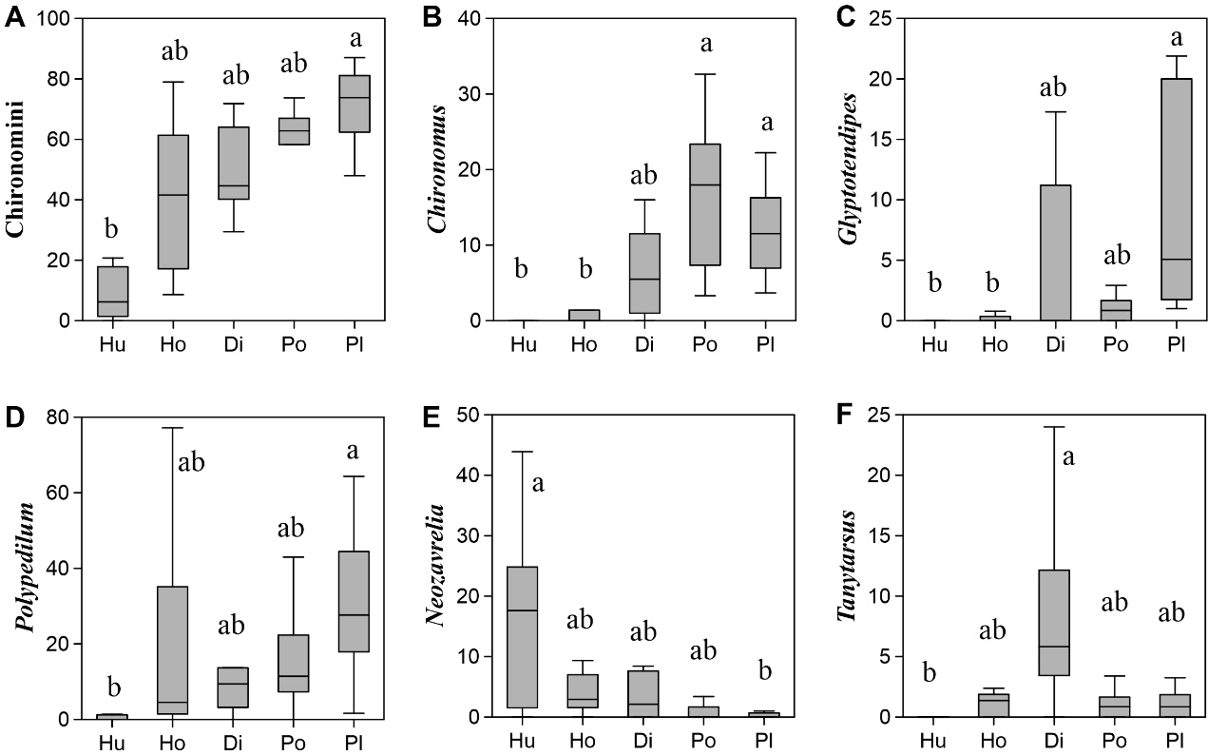
Figure 4 Box-Whisker plots of relative abundance of the tribe Chironomini (A) and the dominant genera (B-F) belonging to the subfamily Chironominae. The upmost, lowest and median line on the box represented the maximum, minimum and median abundance of each genus, respectively. Letters (i.e. a and b) on the bar indicated the significance between habitats tested by Kruskal-Wallis multiple comparisons.
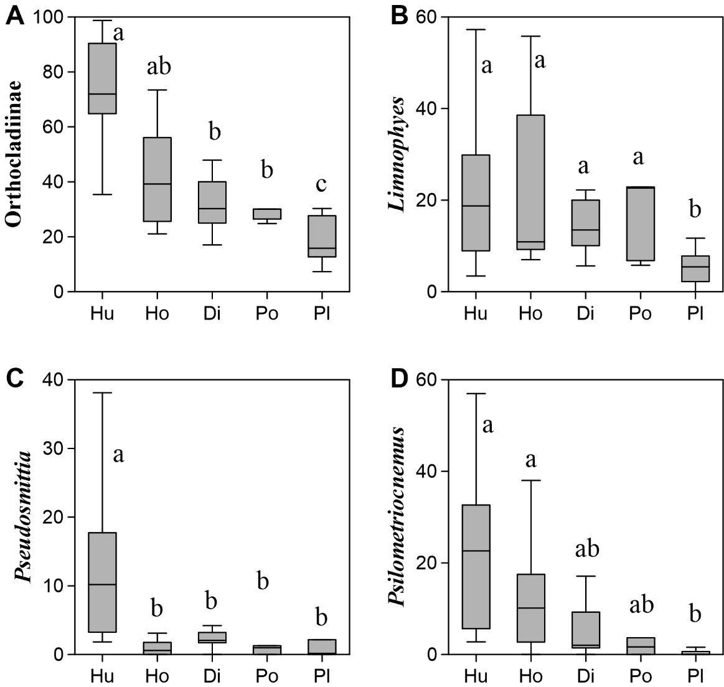
Figure 5 Box-Whisker plots of relative abundance of the subfamily Orthocladiinae (A) and the dominant genera (B-D) having significant differences between habitats. Lines and lower-case letters in the plots are similar to Figure 4.

HC density ranged from 4 to 114 individuals g⁻¹ and showed insignificant differences between the five habitats (Fig. 6A). Taxonomic richness (Taxa S) and diversity (Shannon H) in arid peatland samples were significantly lower than in other inundated habitats (Fig. 6B1 and B2). Ditches supported the most diverse assemblages, with 25 different genera on average, varying from 5 to 47 in each sample. Pools provided habitats for 21 genera while Sphagnum hummocks supported 8 genera on average.

Figure 6 Box-Whisker plots of HC density (A), taxonomic (B1-B2) and functional (C1-C3) diversity. Lines and lower-case letters in the plots are similar to Figure 4.

3.3 Functional trait structure
For functional traits, M15 was the most common morphological type and the abundance was 34.6% on average. Collector-gatherers (CG) was the most common functional feeding group, and sprawlers occupied nearly 40% across four habit types. The body size of chironomid larvae in this study was generally medium to large. 41% of individuals exceeded 10 mm, but no individuals were smaller than 2.5 mm.
Significant differences between the five habitats were shown in 16 functional traits (57%) verified by Kruskal-Wallis rank sum tests (Fig. 7 and 8). All five functional feeding groups displayed distinct differences between Sphagnum hummocks and pools (Fig. 7A1-A5). CG occupied nearly 97% of larvae in Sphagnum hummocks, while shredders (Shr) (43.6%) was the most dominant feeding group within pools. M15 showed a generally declining tendency with water-level but M3 showed the reverse pattern (Fig. 7B7 and B1). Body size increased, but sprawlers decreased gradually with water-level increases (Fig. 8). Similar to taxonomic richness, ditches supported more diverse functional groups indicated by FRic (Fig. 6C2). Dissimilar to FRic, FEve and FDiv failed to show significant differences between the five habitats (Fig. 6C1 and C3).

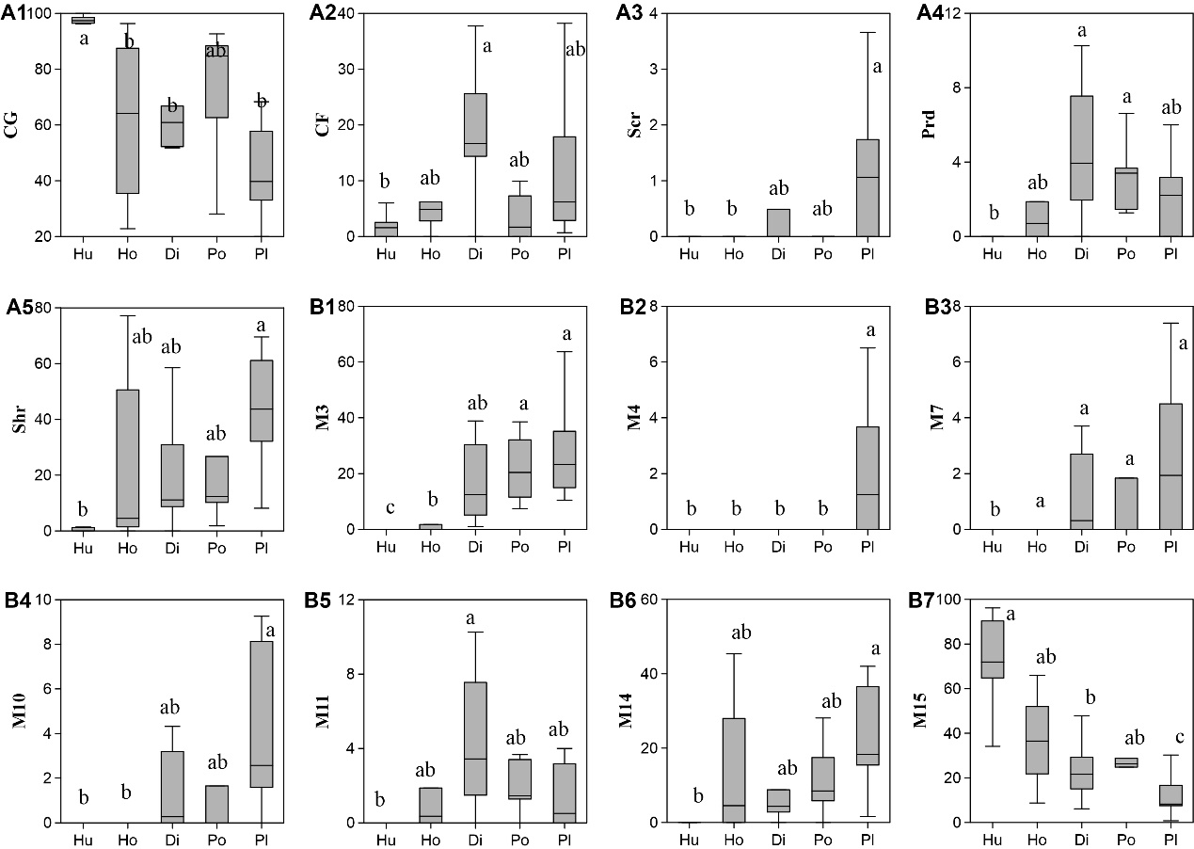
Figure 7 Box-Whisker plots of percentages of functional traits showing significant differences between habitats. A1-A5 represents the traits of functional feeding groups and B1-B7 are trait groups of morphological type. Lines and lower-case letters in the plots are similar to Figure 4.
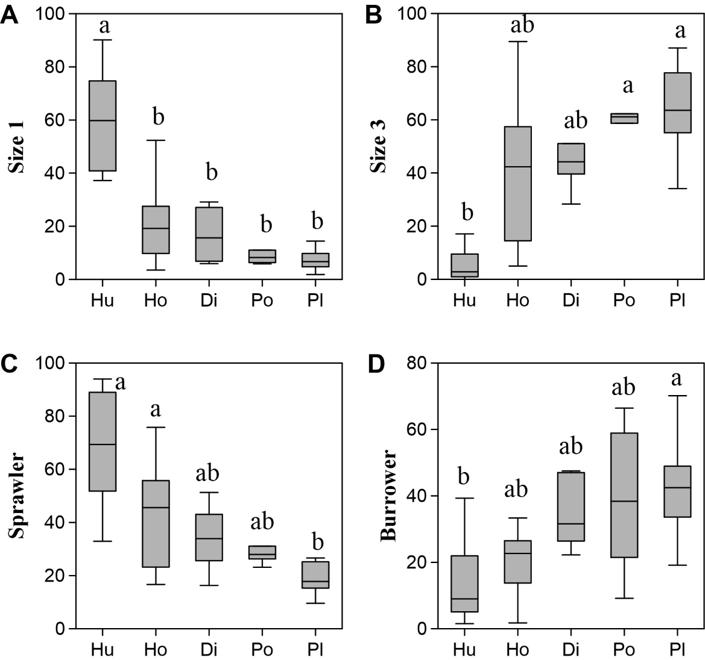
Figure 8 Box-Whisker plots of percentages of trait groups for body size (A-B) and locomotion type (C-D) showing significant differences between habitats. Lines and lower-case letters in the plots are similar to Figure 4.

3.4 Environmental factors controlling taxonomic and functional trait structures
The dbRDA results revealed three significant environmental variables (i.e. LOI, DWT and K⁺) for both community characterizations (taxonomic and trait compositions), capturing around 39% of the total variation in chironomid communities (Fig. 9). For the taxonomic community, VPA suggested the unique effect of LOI and DWT was 10.8% and 4.0%, respectively, and their combined effect was 14.8% (Fig. 10A). Similar results were shown for functional trait composition. Strong interactions also existed between LOI and DWT and occupied 18.5% of functional trait variation. However, the unique effect was only 9.5% for LOI and 5.5% for DWT (Fig. 10B).
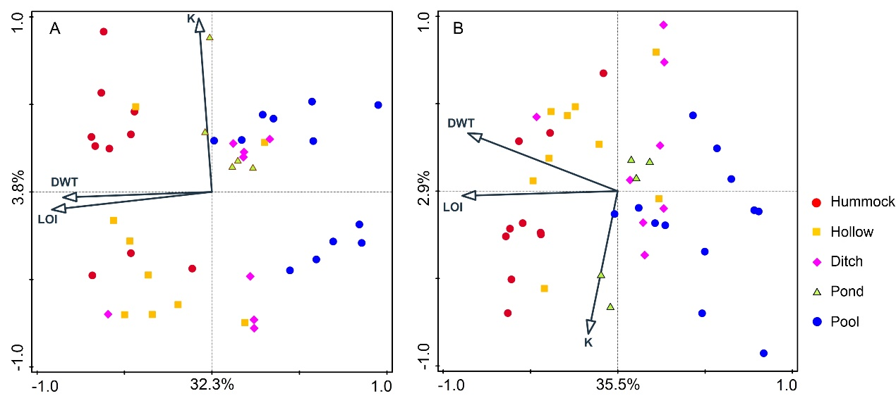
Figure 9 dbRDA biplots of samples and significant environmental parameters based on taxonomic (A) and functional trait (B) compositions of chironomid communities.

Figure 10 Variation partitioning analyses revealed the unique and shared variations (%) of three significant environmental factors on taxonomic (A) and functional trait (B) compositions.

3.5 Taxonomy and traits in the YLC peat core
For taxonomic compositions, chironomids throughout the whole core were dominated by Psilometriocnemus, Pseudosmittia, Limnophyes and Polypedilum (details in Hou et al. (2022)). Major trait categories of chironomids are shown in Figure 11. PCs between taxonomic and different trait compositions displayed significantly negative or positive relationships, indicating their synchronous responses to past environmental changes.

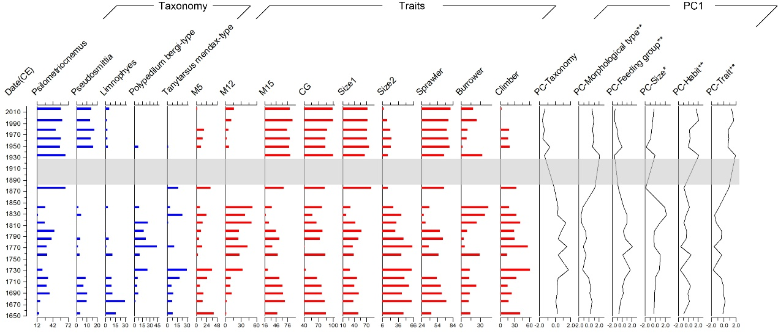
Figure 11 Stratigraphy of major taxonomic and trait components of chironomid communities in the YLC peat core, and scores of the PC1 axis and the relations between traits and taxonomy-based PCs. Statistically significant relationships with a p value less than 0.05 or 0.01 were represented by symbol * and **, respectively. The period covered with a grey bar has no data.

4 Discussion
4.1 Environmental variables influencing the chironomid community
Ordination analyses produced similar results for taxonomic composition and functional traits, showing that LOI, DWT and K⁺ were the most important environmental factors controlling chironomid communities. LOI showed large discrepancies between different habitats. Peatlands store sequestered carbon and generally display a relatively high organic content (Leifeld et al., 2018) and hence it was unexpected that there were three sampling sites having very low LOI values. Two of them were located near ditches, which flow from sandy areas surrounding the basin and carry high mineral content, explaining the relatively low organic matter of the nearby sites. It has been widely reported that organic matter (measured as DOC, TOC or LOI) and/or substrate type is an important control of chironomid communities in lakes (Larocque et al., 2006; Nyman et al., 2005; Luoto et al. 2016), streams (Entrekin et al., 2007), rivers (Syrovátka et al., 2006; Leszczyńska et al., 2019) as well as peatlands (Van Duinen et al., 2006). The quantity of organic matter is crucial to zoobenthos biomass and community composition as it provides both food supply and habitats for organisms (Luoto et al., 2016). Organic matter exclusion in freshwater ecosystems would lead to decreased chironomid abundances and an altered chironomid community assemblage (Entrekin et al., 2007). Nevertheless, a high organic matter content is often accompanied with low pH, poor light and depleted hypolimnetic oxygen (Luoto et al., 2016; Premke et al., 2010), which might exert an inhibitory effect to the survival of zoobenthos. Substrate quality determines the feeding behaviours of invertebrates (Henriques-Oliveira et al., 2003) and collector-gatherers are often found in high humic habitats, while collector-filterers prefer relatively low organic content (Kivilä et al., 2019). Shredders generally feed on coarse particulate organic matter (CPOM>1mm), such as leaf litter and woody debris. However, in our study, this feeding group mainly consisted of the aquatic genus Polypedilum, for which algae are an important part of the diet (Henriques-Oliveira et al., 2003), and therefore they were abundant in pool habitats in the Dajiuhu Wetland. As mouthpart evolution is strongly impacted by feeding ecology, morphological traits are thought to be dependent on feeding traits and serve as a good surrogate for habitat changes (Antczak-Orlewska et al., 2021).The M14 morphological type are mainly composed of taxa preferring algal-rich conditions (e.g. P. nubeculosum-type), and are thus abundant in inundated habitats. M15 is a morphological type having narrow or foot-shaped ventromental plates and mainly consisted of collector-gatherers adapted to semi-terrestrial environments such as Psilometriocnemus, Pseudosmittia, Limnophyes and Pseudorthocladius, and therefore showed an opposite distribution to the M14 morphological type. For body size, habitats with high-quality food supply are undoubtedly prone to support large individuals to improve their competitiveness and survive in relatively stable conditions like peatland pools here (Iglesias et al., 2012).
Water level is an important environmental filter for biotic communities in both taxonomic and functional trait compositions (Cañedo-Argüelles et al., 2016). Chironomid taxonomic compositions showed distinctive variations along the water depth gradient in the current study, in agreement with the relatively limited chironomid work on peatlands (Cao et al., 2019). Semi-terrestrial species (i.e. Psilometriocnemus, Pseudosmittia, Neozavrelia, Pseudorthocladius and Tribelos) are found in dry moss peats whereas lacustrine taxa (i.e. Polypedilum, Glyptotendipes and Chironomus) live predominantly in inundated habitats like pools. This finding might encourage the usage of a taxonomy-based approach of chironomids in tracking the long time-scale history of peatland ontogeny, as peatlands might experience several complex wet-dry transition phases during peat accumulation (Morris et al., 2015). For traits, our results were consistent with other reports in that collectors (especially gatherers) and sprawlers were abundant in intermittent or perennial drought habitats (Cañedo-Argüelles et al., 2016; Jovem-Azevêdo et al., 2019). Conversely, shredders generally show a lack of drought resistance (Bazzanti et al., 2009), as Sphagnum hummocks with continuous drought could be less suitable for shredders to colonize. Drought undoubtedly acted as an ecological filter of body size, as small individuals are commonly found in extreme environments suffering relatively high levels of disturbance (Gomes et al., 2018). Reduced body size allows a high rate of reproduction and growth, as well as a relatively high capacity to surviving disturbances (Bonada et al., 2007).
An orthogonal relationship was identified between K⁺ and variables of LOI and DWT (Fig. 12), suggesting that K⁺ is independent of the other two parameters, and hence it may be related to the mineral type that is influencing the chironomid communities. Potassium mostly exists in the lattice of aluminosilicate minerals (mainly feldspars and micas) in the form of ions, but it is generally difficult to be released naturally. The catchment area of the Dajiuhu Wetland is mostly composed of limestones and dolomites, with a few sandstones and shales in the west (Du et al., 2008). Significant positive relationships were detected between K⁺ and Ca²⁺, as well as Mg²⁺ (Fig. 12), revealing their possible similar sources, indicating that potassium might be released during bedrock decomposition. Potassic fertilizer is increasingly needed in agricultural cultivation in the form of water-soluble salts such as KCl (Skorina and Allanore, 2015). Massive ditches were dug, and natural peatlands were reclaimed in the Dajiuhu basin since the 1980s to promote local agricultural economic development (Zhou et al., 2017). Agricultural activities within and around the Dajiuhu Wetland might contribute to the potassium supply via running water and/or aeolian transport. The significance of K⁺ for chironomid communities could be through a range of related processes. Ionic balance is important for chironomid communities, of which K⁺ has a role (Jonusaite et al., 2011) and indirect processes will also be important, such as via substrate shaping through moss growth (Clymo and Hayward 1982; Rydin and Jeglum 2013; Cao et al., 2019). Potassium deficiency may trigger hypokalemia for specific taxa and threaten their survival (Belowitz et al., 2014), and it also shapes functional trait communities (Antczak-Orlewska et al., 2021). Shredders in our study are positively associated with K⁺, and they were mainly dominated by mining taxa, such as Endochironomus, Glyptochironomus and Polypedilum. These larvae commonly live in lacustrine habitats with coarse organic detritus (Bijlmakers, 1983) containing a mixture of rotten plant and animal material which is therefore likely enriched in potassium (Belowitz and O’Donnell, 2013).
Figure 12 Spearman correlations between different environmental variables.

The transverse zones between pools and Sphagnum moss hummocks in our study supported diverse taxonomic and trait compositions. Edge effects were especially pronounced in ditch habitats since they exhibited the highest abundance, as well as taxonomic and functional diversity of chironomid communities. Natural ecotones possess various habitats and provide more niche opportunities for diverse species assemblages with different functional traits (Kark, 2013), highlighting the vital importance of ecotones in biodiversity maintenance.

4.2 Functional traits are robust in relation to habitat change
Increasing numbers of studies have shown that biotic trait composition is more sensitive to environmental variations than traditional taxonomic structures (Jiang et al., 2019; Paiva et al., 2023), and as such could be a useful bioindicator (Paiva et al., 2023). This aligns with our study as it showed that in total half of all functional trait categories were sensitive to habitat changes, while only 38% of traditional taxonomic compositions were. At the temporal scale, five categories of traits showed consistent and synchronous trends. This reveals that each trait could provide an independent functional response to environmental change (Fig. 9), and hence these traits could be used to infer changes in environment and ecosystem functions. It would be more beneficial to comparative analysis across studies (both modern bioassessment and paleoenvironmental studies) than the taxonomy-based approach, in which the influence of biogeographic factors and biological interactions within communities on taxonomic structures (Heino et al., 2017) should be considered. Moreover, taxonomic compositional changes could reveal the replacement and gain or loss of species ( Mayfield et al., 2022), but traits can reveal changes in ecosystem functions under disturbance, which is conducive to ecosystem management (Haase et al., 2023). Our results indicate that the trait composition of chironomid communities has a robust response to environmental change at spatio-temporal scales.

4.3 Conclusions and implications for bioassessment and paleoenvironmental reconstruction
Our study showed that more chironomid functional trait categories compared to taxonomic assemblages could be used to recognise habitat changes at spatial scales. This result was also verified by sedimentary data, which record the response of biotic communities to environmental change across temporal scales. Both taxonomic and functional trait communities were primarily controlled by sedimentary organic matter content, depth to water table and K⁺. We therefore conclude that a functional trait-based approach could be a good alternative to a traditional taxonomy-based approach in identifying the response of chironomid assemblages to wetland development. Considering the limitations of taxonomic identification accuracy, especially in peat samples, chironomid functional trait composition is strongly recommended to serve as a surrogate in assessments of environments and ecosystem functions, as well as in palaeo-studies in a range of wetlands.

Credit Author Statement
Yanmin Cao: Conceptualization, Funding acquisition, Investigation, Writing-original draft. Peter G. Langdon: Writing-review & editing. Shengman Shen: Methodology, Writing-review & editing. Hui Li: Resources, Investigation. Deng Pan: Methodology, Writing-review & editing.

Conflict of interest
The authors declare that they have no conflict of interest.

Data availability statement
Data will be made available on request.

Acknowledgements
We acknowledge Chen Xu, Hou Guilin, Ge Wenlong and Peng Jia for their kind help with their field and laboratory assistance. This work was supported by the National Natural Science Foundation of China (42271165) and the Fundamental Research Funds for National University, South-Central Minzu University (CZQ23009). Y. Cao was supported by the China Scholarship Council (grant number 202008420139). We thank the very helpful reviewer and editorial comments in shaping this manuscript.

References
Adeleye, M.A., Haberle, S.G., Gallagher, R., Andrew, S.C., Herbert, A., 2023. Changing plant functional diversity over the last 12,000 years provides perspectives for tracking future changes in vegetation communities. Nature Ecology & Evolution 7, 224-235.
Antczak-Orlewska, O., Płóciennik, M., Sobczyk, R., Okupny, D., Stachowicz-Rybka, R., Rzodkiewicz, M., Siciński, J., Mroczkowska, A., Krąpiec, M., Słowiński, M., Kittel, P., 2021. Chironomidae Morphological Types and Functional Feeding Groups as a Habitat Complexity Vestige. 8, 583831.
Armitage, P.D., Pinder, L., Cranston, P., 2012. The Chironomidae: biology and ecology of non-biting midges. Springer Science & Business Media, Dordrecht.
Bazzanti, M., Della Bella, V., Grezzi, F., 2009. Functional characteristics of macroinvertebrate communities in Mediterranean ponds (Central Italy): Influence of water permanence and mesohabitat type. Ann. Limnol. - Int. J. Lim. 45, 29-39.
Belle, S., Klaus, F., González Sagrario, M.d.l.Á., Vrede, T., Goedkoop, W., 2022. Unravelling chironomid biodiversity response to climate change in subarctic lakes across temporal and spatial scales. Hydrobiologia 849, 2621-2633.
Bellwood, D.R., Streit, R.P., Brandl, S.J., Tebbett, S.B., 2019. The meaning of the term ‘function’ in ecology: A coral reef perspective. Funct Ecol 33, 948-961.
Belowitz, R., Leonard, E.M., O'Donnell, M.J., 2014. Effects of exposure to high concentrations of waterborne Tl on K and Tl concentrations in Chironomus riparius larvae. Comparative Biochemistry and Physiology Part C: Toxicology & Pharmacology 166, 59-64.
Belowitz, R., O’Donnell, M.J., 2013. Ion-selective microelectrode measurements of Tl⁺ and K⁺ transport by the gut and associated epithelia in Chironomus riparius. Aquat Toxicol 138-139, 70-80.
Bijlmakers, L., 1983. De verspreiding en oecologie van chironomide larven (Chironomidae: Diptera) in twee vennen in de omgeving van Oisterwijk (N.Br.). Versl: K.U. Nijmegen.
Bonada, N., Dolédec, S., Statzner, B., 2007. Taxonomic and biological trait differences of stream macroinvertebrate communities between mediterranean and temperate regions: implications for future climatic scenarios. Global Change Biology 13, 1658-1671.
Borcard, D., 1992. Partialling out the spatial component of ecological variation. Ecology 71, 1045-1055.
Brooks, S.J., Langdon, P., Heiri, O., 2007. The identification and use of Palaearctic Chironomidae larvae in palaeoecology., QRA Technical Guide No. 10. Quaternary Research Association, London.
Cai, Y., Dong, R., Kattel, G., Zhang, Y., Peng, K., Gong, Z., 2023. Macroinvertebrate diversity and ecosystem functioning across the eutrophication gradients of the middle and lower reaches of Yangtze River lakes (China). Ecology and Evolution 13, e9751.
Cañedo-Argüelles, M., Bogan, M.T., Lytle, D.A., Prat, N., 2016. Are Chironomidae (Diptera) good indicators of water scarcity? Dryland streams as a case study. Ecol Indic 71, 155-162.
Cañedo-Argüelles, M., Gutiérrez-Cánovas, C., Acosta, R., Castro-López, D., Cid, N., Fortuño, P., Munné, A., Múrria, C., Pimentão, A.R., Sarremejane, R., Soria, M., Tarrats, P., Verkaik, I., Prat, N., Bonada, N., 2020. As time goes by: 20 years of changes in the aquatic macroinvertebrate metacommunity of Mediterranean river networks. J Biogeogr 47, 1861-1874.
Cao, Y., Langdon, P.G., Yan, Y., Wang, S., Zheng, Z., Zhang, Z., 2019. Chironomid communities from subalpine peatlands in subtropical China as indicators of environmental change. J Paleolimnol 62, 165-179.
Clymo, R., Hayward, P., 1982. The ecology of Sphagnum, Bryophyte ecology. Springer, Dordrecht.
Dawson, S.K., Carmona, C.P., González-Suárez, M., Jönsson, M., Chichorro, F., Mallen-Cooper, M., Melero, Y., Moor, H., Simaika, J.P., Duthie, A.B., 2021. The traits of “trait ecologists”: An analysis of the use of trait and functional trait terminology. Ecology and Evolution 11, 16434-16445.
Dolédec, S., Phillips, N., Townsend, C., 2011. Invertebrate community responses to land use at a broad spatial scale: trait and taxonomic measures compared in New Zealand rivers. Freshwater Biol 56, 1670-1688.
Du Y., Cai, S.M., Wang, X.L., He, B.Y., Xu, G.L., Jiang, M.X., Xue, H.P., Xiao, F., 2008. Environmental background and ecological restoration of the Dajiuhu sub-alpine wetland in Mt. Shennongjia. Resources and Environment in the Yangtze Basin 17(6), 915-919. (in Chinese)
Dunn, O.J., 1964. Multiple Comparisons Using Rank Sums. Technometrics 6, 241-252.
Entrekin, S.A., Wallace, J.B., Eggert, S.L., 2007. The response of Chironomidae (Diptera) to a long-term exclusion of terrestrial organic matter. Hydrobiologia 575, 401-413.
Epler, J.H. 2001. Identification manual for the larval Chironomidae (Diptera) of North and South Carolina. North Carolina Department of Environment and Natural Resources, Division of Water Quality.
Gautreau, E., Volatier, L., Nogaro, G., Gouze, E., Marmonier, P., Mermillod-Blondin, F., 2023. Interactions between microbial activity and bioturbation modes of benthic invertebrates determine nutrient releases from reservoir sediments. Freshwater Biol 68, 245-259.
Gomes, W.I.A., Jovem-Azevêdo, D.d.S., Paiva, F.F., Milesi, S.V., Molozzi, J., 2018. Functional attributes of Chironomidae for detecting anthropogenic impacts on reservoirs: A biomonitoring approach. Ecol Indic 93, 404-410.
Haase, P., Bowler, D.E., Baker, N.J., et al. 2023. The recovery of European freshwater biodiversity has come to a halt. Nature 620, 582-588.
Hammer, Ø., Harper, D.A.T., Ryan, P.D., 2001. PAST: paleontological statistics software package for education and data analysis. Palaeontologia Electronica 4, 9.
Heino, J., 2008. Patterns of functional biodiversity and function-environment relationships in lake littoral macroinvertebrates. Limnol Oceanogr 53, 1446-1455.
Heino, J., Tolonen, K.T., 2017. Ecological drivers of multiple facets of beta diversity in a lentic macroinvertebrate metacommunity. Limnol Oceanogr 62, 2431-2444.
Henriques-Oliveira, A.L., Nessimian, J.L., Dorvillé, L.F.M., 2003. Feeding habits of Chironomid larvae (Insecta: Diptera) from a stream in the Floresta da Tijuca, Rio de Janeiro, Brazil. Braz J Biol 63, 269-281.
Hou, G.L., Cao. Y.M., Tian, W.L., Deng, P., Shen, S.M., Chen, X., 2022. Response of chironomid assemblages to the changes of wetness in Dajiuhu Peatland of Hubei Province during the past 400 years. J Lake Sci 34, 1030-1042. (in Chinese)
Hu, S., Niu, Z., Chen, Y., Li, L., Zhang, H., 2017. Global wetlands: Potential distribution, wetland loss, and status. Sci Total Environ 586, 319-327.
Iglesias, S., Tracy, C., Bedford, G., Christian, K., 2012. Habitat differences in body size and shape of the Australian agamid lizard, Lophognathus temporalis. Journal of Herpetology 46, 297-303.
Jiang, X., Pan, B., Song, Z., Xie, Z., 2019. Do functional traits of chironomid assemblages respond more readily to eutrophication than taxonomic composition in Chinese floodplain lakes? Ecol Indic 103, 355-362.
Jonusaite, S., Kelly, S.P., Donini, A., 2011. The physiological response of larval Chironomus riparius (Meigen) to abrupt brackish water exposure. Journal of Comparative Physiology B 181, 343-352.
Jovem-Azevêdo, D., Bezerra-Neto, J.F., Azevêdo, E.L., Gomes, W.I.A., Molozzi, J., Feio, M.J., 2019. Dipteran assemblages as functional indicators of extreme droughts. Journal of Arid Environments 164, 12-22.
Kark, S., 2013. Effects of ecotones on biodiversity. Encyclopedia of biodiversity 142, 1.
Kivilä, E.H., Luoto, T.P., Rantala, M.V., Kiljunen, M., Rautio, M., Nevalainen, L., 2019. Environmental controls on benthic food web functions and carbon resource use in subarctic lakes. Freshwater Biol 64, 643-658.
Laliberté, E., Legendre, P., Shipley, B., Lalibert´e, M.E., 2014. Measuring functional diversity from multiple traits, and other tools for functional ecology. R Package FD.
Larentis, C., Pavanelli, C.S., Delariva, R.L., 2022. Do environmental conditions modulated by land use drive fish functional diversity in streams? Hydrobiologia 849, 4465-4483.
Larocque, I., Pienitz, R., Rolland, N., 2006. Factors influencing the distribution of chironomids in lakes distributed along a latitudinal gradient in northwestern Quebec, Canada. Can J Fish Aquat Sci 63, 1286-1297.
Legendre, P., Anderson, M.J., 1999. Distance-based redundancy analysis: testing multispecies responses in multifactorial ecological experiments. Ecol Monogr 69, 1–24.
Legendre, P., Legendre, L., 1998. Numerical ecology, 2nd ed. Elsevier, Amsterdam.
Leifeld, J., Menichetti, L., 2018. The underappreciated potential of peatlands in global climate change mitigation strategies. Nature Communications 9, 1071.
Leszczyńska, J., Grzybkowska, M., Głowacki, Ł., Dukowska, M., 2019. Environmental Variables Influencing Chironomid Assemblages (Diptera: Chironomidae) in Lowland Rivers of Central Poland. Environ Entomol 48, 988-997.
Li, J., Zheng, Z., Huang, K., Yang, S., Chase, B., Valsecchi, V., Carré, M., Cheddadi, R., 2013. Vegetation changes during the past 40,000 years in Central China from a long fossil record. Quatern Int 310, 221-226.
Li, Z., Wang, J., Liu, Z., Meng, X., Heino, J., Jiang, X., Xiong, X., Jiang, X., Xie, Z., 2019. Different responses of taxonomic and functional structures of stream macroinvertebrate communities to local stressors and regional factors in a subtropical biodiversity hotspot. Sci Total Environ 655, 1288-1300.
Luoto, T.P., Ojala, A.E.K., 2018. Controls of climate, catchment erosion and biological production on long-term community and functional changes of chironomids in High Arctic lakes (Svalbard). Palaeogeography, Palaeoclimatology, Palaeoecology 505, 63-72.
Luoto, T.P., Rantala, M.V., Galkin, A., Rautio, M., Nevalainen, L., 2016. Environmental determinants of chironomid communities in remote northern lakes across the treeline – Implications for climate change assessments. Ecol Indic 61, 991-999.
Mandaville, S., 2002. Benthic macroinvertebrates in freshwaters: Taxa tolerance values, metrics, and protocols. Soil & Water Conservation Society of Metro Halifax, Nova Scotia.
Martins, I., Castro, D.M.P., Macedo, D.R., Hughes, R.M., Callisto, M., 2021. Anthropogenic impacts influence the functional traits of Chironomidae (Diptera) assemblages in a neotropical savanna river basin. Aquat Ecol 55, 1081-1095.
Mason, N.W.H., Mouillot, D., Lee, W.G., Wilson, J.B., 2005. Functional richness, functional evenness and functional divergence: the primary components of functional diversity. Oikos 111, 112-118.
Mayfield, R.J., Dearing, J.A., Doncaster, C.P., Langdon, P.G., 2022. Stability of chironomid community structure during historic climatic and environmental change in subarctic Alaska. Limnol Oceanogr 67, S444-S460.
Mitchell, E.A.D., Buttler, A., Grosvernier, P., Rydin, H., Albinsson, C., Greenup, A.L., Heijmans, M.M.P.D., Hoosbeek, M.R., Saarinen, T., 2000. Relationships among testate amoebae (Protozoa), vegetation and water chemistry in five Sphagnum-dominated peatlands in Europe. New Phytologist 145, 95-106.
Morris, P.J., Baird, A.J., Young, D.M., Swindles, G.T., 2015. Untangling climate signals from autogenic changes in long-term peatland development. Geophysical Research Letters 42, 10,788-710,797.
Morse, J.C., Bae, Y.J., Munkhjargal, G., Sangpradub, N., Tanida, K., Vshivkova, T.S., Wang, B., Yang, L., Yule, C.M., 2007. Freshwater biomonitoring with macroinvertebrates in East Asia. Frontiers in Ecology and the Environment 5, 33-42.
Nevalainen, L., Luoto, T.P., Manca, M., Weisse, T., 2015. A paleolimnological perspective on aquatic biodiversity in Austrian mountain lakes. Aquat Sci 77, 59-69.
Nyman, M., Korhola, A., Brooks, S.J., 2005. The distribution and diversity of Chironomidae (Insecta: Diptera) in western Finnish Lapland, with special emphasis on shallow lakes. Global Ecol Biogeogr 14, 137-153.
Ogle, D., Wheeler, P., Dinno, A., 2020. FSA: fisheries stock analysis. R package version 0.8. 30. Boca Raton: Champman & Hall/CRC.
Paiva, F.F., Melo, D.B.D., Dolbeth, M., Molozzi, J., 2023. Functional threshold responses of benthic macroinvertebrates to environmental stressors in reservoirs. Journal of Environmental Management 329, 116970.
Peng, J., Zeng, L., Huang, X., Chen, X., 2023. Climate, atmospheric deposition and catchment process interact to trigger recent diatom community reorganization in alpine lakes of the eastern monsoonal region of China. Quaternary Sci Rev 310, 108131.
Piano, E., Doretto, A., Mammola, S., Falasco, E., Fenoglio, S., Bona, F., 2020. Taxonomic and functional homogenisation of macroinvertebrate communities in recently intermittent Alpine watercourses. Freshwater Biol 65, 2096-2107.
Premke, K., Karlsson, J., Steger, K., Gudasz, C., von Wachenfeldt, E., Tranvik, L.J., 2010. Stable isotope analysis of benthic fauna and their food sources in boreal lakes. J N Am Benthol Soc 29, 1339-1348.
Qin, Y., Li, H., Mazei, Y., Kurina, I., Swindles, G.T., Bobrov, A., Tsyganov, A.N., Gu, Y., Huang, X., Xue, J., Lamentowicz, M., Marcisz, K., Roland, T., Payne, R.J., Mitchell, E.A.D., Xie, S., 2021. Developing a continental-scale testate amoeba hydrological transfer function for Asian peatlands. Quaternary Sci Rev 258, 106868.
Radkova, V., Syrovatka, V., Bojkova, J., Schenkova, J., Kroupalova, V., Horsak, M., 2014. The importance of species replacement and richness differences in small-scale diversity patterns of aquatic macroinvertebrates in spring fens. Limnologica 47, 52-61.
Rydin, H., Jeglum, J.K., 2013. The biology of peatlands, 2e. Oxford University Press, Oxford.
Saulino, H.H., Leite-Rossi, L.A., Trivinho-Strixino, S., 2017. The effect of small reservoirs on chironomid diversity and trait composition in Savanna streams: evidence for Serial Discontinuity Concept. Hydrobiologia 793, 109-119.
Schleuter, D., Daufresne, M., Massol, F., Argillier, C., 2010. A user's guide to functional diversity indices. Ecol Monogr 80, 469-484.
Serra, S.R.Q., Cobo, F., Graça, M.A.S., Dolédec, S., Feio, M.J., 2016. Synthesising the trait information of European Chironomidae (Insecta: Diptera): Towards a new database. Ecol Indic 61, 282-292.
Skorina, T., Allanore, A., 2015. Aqueous alteration of potassium-bearing aluminosilicate minerals: from mechanism to processing. Green Chemistry 17, 2123-2136.
Šmilauer, P., Lepš, J., 2014. Multivariate Analysis ofEcological Data Using CANOCO 5. Cambridge University Press, Cambridge.
Syrovátka, V., Brabec, K., 2006. Effects of physical factors on chironomid larvae distribution and community structure at a mesohabitat scale. Internationale Vereinigung für theoretische und angewandte Limnologie: Verhandlungen 29(4), 1845-1848.
Tang, H.Q., 2006. Biosystematic study on the chironomid larvae in China (Diptera: Chironomidae). Nankai University, Tianjin, Ph. D thesis (in Chinese).
Van Duinen, G., Vermonden, K., Brock, A., Leuven, R., Smolders, A., Van Der Velde, G., Verberk, W., Esselink, H., 2006. Basal food sources for the invertebrate food web in nutrient poor and nutrient enriched raised bog pools. Proceedings of the Section Experimental and Applied Entomology-Netherlands Entomological Society 17, 37.
Villéger, S., Mason, N.W.H., Mouillot, D., 2008. New multidimensional functional diversity indices for a multifaceted framework in functional ecology. Ecology 89, 2290-2301.
Wang, J.C., Wang, X.H., 2011. Chironomidae larval in North China. China Yanshi Press, Beijing.
Wentzky, V.C., Tittel, J., Jäger, C.G., Bruggeman, J., Rinke, K., 2020. Seasonal succession of functional traits in phytoplankton communities and their interaction with trophic state. J Ecol 108, 1649-1663.
Xi, Y., Peng, S., Ciais, P., Chen, Y., 2021. Future impacts of climate change on inland Ramsar wetlands. Nature Climate Change 11, 45-51.
Zebral, Y.D., Righi, B.D.P., Anni, I.S.A., Escarrone, A.L.V., Roza, M., Vieira, C.E.D., Costa, P.G., Bianchini, A., 2021. Pollution levels and biomarker responses in zooplankton from three hydrographic regions of southern Brazil: An integrated approach for water quality monitoring. Journal of Environmental Chemical Engineering 9, 106180.
Zhang, Z.Z., 1982. The formation and distribution of bog in Shenongjia. Journal of Northeast Normal University (Nat. Sci.) 1, 95e103. (in Chinese)
Zhou, W.C., Shen, Y.H., Cui, H.X., Zhang, Z.Q., Yang, J.Y., 2017. The countermeasures for protection and management of Dajiu Lake Wetland in Shennongjia. Wetland Science & Management 13(2), 34-37. (in Chinese)

