Article
Investigating the crash protection performance of a medical carrier bag for drone transport
Fraser McLeod ^{1,*}, Tom Cherrett ¹, Andy Oakey ¹, Katherine Theobald ¹, Tim Waters ¹, Matt Grote ¹, John Armstrong ¹, Jack Denny ¹ and Alex Murray ²
Citation: To be added by editorial staff during production.
Academic Editor: Firstname Lastname
Received: date
Revised: date
Accepted: date
Published: date
Copyright: © 2024 by the authors. Submitted for possible open access publication under the terms and conditions of the Creative Commons Attribution (CC BY) license (https://creativecommons.org/licenses/by/4.0/).
- University of Southampton; f.n.mcleod@soton.ac.uk; t.j.cherrett@soton.ac.uk; a.oakey@soton.ac.uk; k.theobald@soton.ac.uk; t.p.waters@soton.ac.uk; m.j.grote@soton.ac.uk; j.armstrong@soton.ac.uk; jack.denny@soton.ac.uk
- Motion Robotics Limited; alex.murray@motion-robotics.co.uk
* Correspondence: f.n.mcleod@soton.ac.uk
Abstract:
Drone transport regulations in Europe require a crash protected container (CPC) to be used for carriage of dangerous goods. With increasing interest in the use of drones for medical logistics, the motivation behind this research was to investigate whether existing approved medical carriers could also pass as a CPC. To date, there has been little practical experimentation or theoretical research into the crash protection performance of medical containers. Addressing this gap, this paper reports findings from a series of drop test experiments to investigate the crashworthiness of a standard medical carrier bag used by the National Health Service (NHS) in the UK. Drop tests were performed from heights of up to 122 m using standard medical carriers containing bags of dyed saline to examine the robustness of the carrier and whether it could contain any leakages, a key requirement for transporting dangerous goods. Tests found that the medical carrier failed on some drops, with the zipped lid being identified as the main weakness. New understanding of the carrier’s terminal velocity, impact acceleration, and failure mechanisms were gained, and subsequent strengthening and waterproofing remedial measures recommended. New insights and practical recommendations are provided relating to performing the formal drop test and how to conduct these using a drone.
Keywords: drone logistics; crash protection; drop testing; dangerous goods

1. Introduction
The transport of infectious substances and other dangerous goods (DG) has specific regulations depending on the mode of transport [1]. For transport by remotely piloted aircraft (drones), one of the requirements in European Union law is the use of an approved crash protected container (CPC) [2]. This has also been adopted in the United Kingdom (UK), where the national aviation authority (the Civil Aviation Authority (CAA)) is responsible for all guidance and approvals related to the carriage of DG by drones [3]. In association with the CAA, the UK’s Vehicle Certification Agency (VCA) specified a drop testing procedure for a CPC, originally published in April 2022 [4] and amended in January 2024 [5]. Containers meeting the test requirements may, at the discretion of the CAA, be approved as suitable for the carriage of DG by drone. As the CPC regulations and drop testing procedure are recent, there has been no prior reported practical experimentation or theoretical research into determining the crash protection performance (and failure mechanisms) of a standard medical carrier bag or on conducting drop tests from a drone. Without such knowledge, it remains challenging to propose modifications to improve the crashworthiness of standard medical carriers necessary for regulatory approval. This paper directly addresses this research gap by describing drop tests of an insulated carrier bag that is commonly used by the UK National Health Service (NHS) for various medical logistics uses, including the movement of patient diagnostic samples, blood stocks for transfusions, and aseptic medicines carried in intravenous (IV) bags.
Most patient diagnostic samples are transported to testing laboratories by road but there is growing interest in using drones in specific cases, particularly where terrain is challenging, resulting in long and unreliable journey times, or where transported materials must be received urgently [6]. Where the items to be transported are classed as dangerous goods, it is important that the container used does not allow any contents to be released in the worst-case scenario of the drone crashing or the container becoming detached and falling to the ground during flight.
Over the last 10 years, many medical drone logistics applications have been reported worldwide [7-16]. Often, these have been bespoke use cases or trials in rural areas where the logistics of transporting by road is difficult and where air transport can significantly reduce journey times by crossing over geographical features such as water, mountains, or forests. Drones have also been used for humanitarian and emergency relief logistics, delivering urgently needed medical supplies. The related literature has focused on identifying opportunities for using drones for medical logistics, or for other types of cargo transportation, and on identifying the various barriers to their wider implementation, including legal, financial, medical, technical, and logistical issues, but particularly relating to safety and the sharing of airspace with crewed aircraft. Another strand of research covers public attitudes towards the use of drones for cargo deliveries, and how those may shape future trends in use, where noise, privacy, safety, and security tend to be the main concerns [17-19]. Attitudes of healthcare workers have also been surveyed with most expressing positive attitudes towards drone deliveries [20, 21].
Drone crashes can occur for several reasons including mechanical faults, GPS error, battery failure, communications failure, poor weather, magnetic interference, errors made by an autopilot system or by a human controller, or malicious interference [22-24]. As safety is a primary concern, drone flight paths are usually designed to be as far away from buildings and people as possible. Tall buildings in urban environments are not only hazards to be avoided but can induce wind turbulence, making drone navigation more difficult [25]. Nevertheless, with most hospitals situated in urban areas, there is demand for medical drone use in cities. A forerunner in the field of urban medical logistics by drone is Matternet, who have been flying drones (quadcopters with a 20 km range, 36 kph average speed and 2 kg maximum payload) between hospitals and testing laboratories in Switzerland since 2017, with thousands of flights having been made [8].
The consequences of any drone crash will depend on the drone’s construction, size, weight, and speed at impact. This has been studied for crashes into people (‘ground risk’) [26, 27] and into other flying aircraft (‘air risk’) [28]. The analysis and quantification of the potential risks and consequences of a drone crash are complex. In [29], a bespoke software model was developed to predict the risk of a fatality of an individual on the ground due to a drone crash based on dynamic population densities, which allows drone flightpaths to be planned to avoid areas of higher risk. However, this model does not include any additional risks that may be involved due to the specific case of a drone carrying DG cargo. Studies of drone travel impacts on medical cargoes have focused on the effects of drone vibration on cargo quality assurance [8, 30, 31], with no studies found on the impacts of the potential release of DG into the surroundings as a result of a drone crash. Proposed methods for avoiding a drone crash or mitigating against it include the use of a parachute or airbag on detecting a fall [19, 32], and the use of on-board technology to diagnose imminent failure and to redirect the drone to a safe spot to crash land [33].
The ramifications on drone platform design in terms of scale and payload capacity could be significant if bespoke CPC are mandated, in addition to the potential economic considerations to consignors and consignees of having to procure such carriage systems. Of interest here, in the context of medical logistics, is whether existing approved packaging solutions could withstand such catastrophic failures. This study aimed to determine whether a standard carrier bag, approved for general transport use by the UK Medicines and Healthcare Products Regulatory Agency (MHRA), could be approved as a crash protected container for transport by drone. If such approval could be obtained, it would enable the use of drones for the transport of infectious substances and it would avoid the need for the procurement of bespoke containers and associated packaging systems.

1.1 Relevant regulations and background to the test procedure
The overarching principles governing the safe transport of dangerous goods (DG) by air are laid out in Annex 18 to the Convention on International Civil Aviation (known as the Chicago Convention) [34]. These principles have been expanded into the ‘Technical Instructions for the Safe Transport of Dangerous Goods by Air’ (known as the Technical Instructions; TI), published biennially by the International Civil Aviation Organisation (ICAO) [35]. These regulations provide detailed requirements for the transport of each of the 3,000+ substances classified as DG, covering aspects such as packing instructions, quantity limits, loading, documentation, training of personnel, leak/spill procedures, and emergency response. International civil aviation operations must comply with the regulations, and domestic operations are encouraged to do likewise as best practice [36]. The regulations apply to DG carried by all aircraft types, including drones (although national aviation authorities may grant alleviations for drone operations to deviate from the TI, provided an equivalent level of safety is achieved), but have developed over the years exclusively from the perspective of crewed aviation, in particular the operation of large, fixed-wing, airliner-type aircraft that are typically used to transport the vast majority of air freight. The interpretation and application of the regulations to drone operations is an emerging legislative arena, still under development in different regions around the world [37].
In general, the purpose of the TI is to protect packages containing DG from damage, leaks, or spills, during routine aircraft operations [37]. However, in 2021, the European Union Aviation Safety Agency (EASA) published legislation detailing that a crash protected container (CPC) would be required for drones operating in the Specific Category when carrying DG [2], with this legislation also adopted in the UK to support inter-operability. In the absence of a CPC, such that there may be a high risk to third parties in the event of an accident, carriage of DG is only permissible by drones in the Certified Category [38]. The inference of this CPC requirement is that DG should be prevented from escaping into the surroundings not only during routine drone operations but also in situations up to and including the worst-case scenario of a drone crash (i.e., above and beyond expectations for crewed aircraft operations). This is because, with the exception of drones in the Certified Category, drones are not certified to the same rigorous airworthiness standards as crewed aircraft [36].
Following this legislation, a working group, including some of the authors of this paper, was created to establish a test regime for CPC, to enable drones to carry DG [39]. A formal test procedure was specified that require containers carrying a payload to be dropped from height without resulting in leakage of the contents [4], where the payload may be one of: (i) packaging conforming to the TI; (ii) a fine, inert powder or granular material placed directly into the container without the use of lining or inner packaging; (iii) a liquid poured directly into the container without the use of lining or inner packaging.
The key requirements that must be met in the CPC test procedure are as follows:
- A set of three identical containers must be provided for test.
- The gross mass of the test container will dictate the maximum gross mass of the approval.
- Tests must be conducted in ambient conditions (ideally, air temperature 5-25°C), with windspeed < 10 knots (5.14 m/s) and no significant precipitation.
- The container can be elevated to drop height by any suitable means, with the drop height being the maximum height above ground level authorised for a particular drone operation, but where it can be demonstrated that terminal velocity is reached from a lower height, this height (plus 10%) may be used instead.
- If an aircraft is used as the drop platform, it should ideally be stationary (i.e., hovering), but where forward flight is unavoidable, airspeed should be minimised as far as possible.
- The container must be released in its normal transport orientation.
- The container must strike the surface of the designated impact zone, where the surface must be reasonably level, smooth and flat, and constructed of concrete, asphalt or other material of similar hardness that would conform to public highway standards.
- A container shall be deemed to have passed if:
  - there is no major disruption of its structure and no visible hole/gap through which contents might escape (even if they have not escaped), and;
  - its contents are solids and there is no leakage from the container, or;
  - its contents are liquids and there is no leakage from the container, either immediately or (at least) eight hours after the test.
- All three containers must pass. If one container fails, the test is failed overall. A pass for any remaining container cannot be carried forward to a new test, i.e., retesting must be performed using three untested containers.
- For the CPC approval application, a test report shall be produced detailing the conduct of the test and including photographs of the containers at all stages of testing, and wherever possible, a video of the whole test sequence.

A consequence of testing with payload type (i) is that the use of TI-compliant packaging introduces a requirement for a rigid outer packaging, as stipulated in the TI in Packing Instruction (PI) 650 for DG classified as UN 3373 (Biological substance, Category B), as is the case for patient diagnostic samples. The TI-compliant package can either be placed inside another container designed to provide crash protection (i.e., a separate CPC), or the outer packaging of the package itself can be relied on to satisfy the drop test requirements (i.e., the outer packaging effectively forms the CPC). In either case, any approval is limited to the specific packaging configuration tested, so any modifications to the packaging would require separate testing.
Tests to prove compliance with the requirement for a rigid outer packaging do not appear to be clearly defined. The TI do specify a ‘stack test’ (no leakage or distortion liable to reduce strength or cause instability in stacks of packages when a force is applied to the top surface of a package equivalent to a 3 m high stack of identical packages for 24 hours) but this seems more relevant to multiple packages stacked in an aircraft cargo hold rather than single packages carried by drones (e.g., as an underslung load). This highlights the need for drone-specific provisions to be explicitly included in future versions of the TI.
Testing with payload types (ii) or (iii) above has the advantage that approval then allows carriage within the approved CPC of any TI-compliant package configuration for solids or liquids, respectively, up to the tested payload mass.
The test procedure indicates that the drop height should typically be the operational height specified by the competent authority (121.9 m (400 feet), in the UK), with provision to drop from a lower height, where it can be demonstrated that the lower drop height, plus a 10% safety margin, is sufficient for the loaded container to attain terminal velocity.

1.2 Containers for crash protection
In this section, we highlight the desired attributes needed for this application and the types of containers and packaging materials that might be most suitable. Here, the main requirement is that, after a fall from height, the container should not be damaged in such a way that its contents can escape from it. Although not a requirement of the CPC test procedure, it would be desirable if the contents remain undamaged and salvageable. It is also desirable that the container be as light as possible, to reduce overall weight and be able to carry a wide range of packaged items as opposed to a bespoke container and packaging arrangement designed for a specific application.
In general, the key to a good crash (shock) protection system is its ability to absorb the sudden impact energy and release it relatively slowly. Viscoelastic materials such as rubber and neoprene are well suited for shock absorption as they behave both like a viscous (liquid) material, deforming under load and transmitting forces in all directions, and like an elastic material, returning to its original shape when the load is removed; however, viscoelastic materials are notoriously temperature and frequency dependent [40]. Distribution of force across the impact zone is also important and, in some applications, a thin, rigid layer of a metal or composite material can be used to distribute the impact across a large area of soft, energy absorbing material.
In general transportation, a wide variety of materials are used to protect against shock and vibration in normal transit conditions. Bubble-wrap is commonly used to provide cushioning and is very light, with density as low as 11 kg/m³ [41]. Similarly, ‘air bags’ or ‘air pillows’ use air inside a soft plastic cover for cushioning, and some can be deflated and reinflated for reuse. Protective foam materials include expanded polystyrene, expanded polypropylene, expanded polyethylene, polyurethane, and low-density polyethylene films. Most of these materials are versatile as they can be moulded, cut, or glued together to form complex shapes, tailored for the items being transported. Typical forms seen in practice include loose-fill beads, endcaps, egg-box shapes, or ‘foam-in-place’, where polyurethane foam is injected to fill gaps within the container [42]. Most packaging foams are so-called ‘closed cell’ foams, which provide a good barrier against liquids and gases (‘open cell’ foams are more sponge-like)[41]. Styrene-acrylonitrile is a semi-rigid foam which had better shock absorbance than polystyrene foam in drop tests [41], with a density of about 16 kg/m³. Polyolefin foams combine several materials to provide good flexibility and protection from multiple impacts, with typical densities from 16 to 32 kg/m³ and are available in expanded (mouldable) and extruded forms [41]. Sorbothane, a proprietary polyurethane, may be a suitable material to use due to its ability to absorb up to 80% of impact force across a wide range of operating temperatures (–29°C to 72°C)[43].
There is a wide range of commercially available ‘flight cases’ that are designed to prevent damage to sensitive equipment in transit. A common type of these is a ‘rack case’, with standard 19” rails, designed for electronic equipment such as computers or sound systems, often constructed using acrylonitrile butadiene styrene (ABS), a hard thermoplastic, for the outer case, and aluminium supports internally, some of which are designed to act as shock absorbers [44]. Some other flight cases use foam linings for cushioning, which have an advantage in being relatively light [45]. Most of these cases are designed for normal shocks and vibrations expected in transit and are not necessarily designed to be crash resistant. The first CAA approval of a CPC was announced in September 2023 by Viking Drone Packaging [46]. A patent application from the same company, published in February 2023, suggests that the approved container and its related packaging system was designed to carry up to 150 medical sample tubes [47]. Although the patent application mentions the possibility to easily adapt the container to carry different products, the CPC test procedure states that any modifications would be subject to new drop tests and separate CAA approval.

2. Materials and Methods
The type of container (bag) used in all the drop tests undertaken in this research goes by the manufacturer name of ‘Versapak’ (Figure 1) [48]. This type of bag is widely used in medical logistics, as an insulated pathology sample carrier. A medium-sized Versapak was used (external dimensions: 460 x 305 x 255 mm; internal dimensions 400 x 225 x 195 mm (=18 litres); empty weight 2.15 kg). The bag has a zipped lid, four rubber pads on the bottom corners, each 80 x 52 x 7 mm, and covered foam padding inside on all six faces, with each pad having a thickness of 45 mm. The main materials used in the construction of the bag are PVC, nylon thread, foam padding, insulating foil, and stiffening materials.
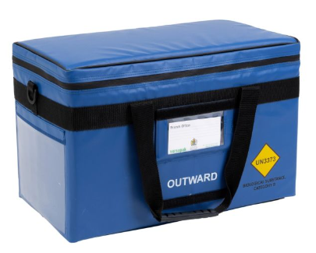

Figure 1. A medium-sized Versapak carrier bag.

The sample (‘specimen’) carried within each Versapak was a 500 ml IV bag [49], with dimensions 300 x 120 x 30 mm, and weighing 0.5 kg, containing saline injected with red dye to allow identification of any leakage. This type of specimen was chosen as the aim was to test whether the Versapak and accompanying packaging would be able to contain a significant spillage in the case that the IV bag bursts on impact. Each IV bag was wrapped in two layers of cling film. Each specimen was carried alongside a frozen cold pack (168 x 87 x 35 mm, 0.45 kg)[50] made with high density polyethylene, which is known for its strength and high impact resistance [51]. The cold pack was used in the tests as it would often be required in practice for temperature control [52]. Each cold pack was wrapped in one layer of bubble wrap, which is common practice to prevent the medical cargo from coming into direct contact with the cold surface and potentially freezing. Only one IV bag was used in these tests to simulate the delivery of a single treatment of aseptic medicine, though it should be noted that, in practice, multiple treatments can be carried in a single consignment [52]. Each of the drop tests used a new Versapak and IV bag, except for one practice drop test which used a repaired Versapak (section 2.1).

2.1. Practice drop testing
Before dropping bags from a drone, three practice drop tests were conducted, in June 2023, using a disused lift shaft inside a closed University of Southampton building. The purpose of these tests was to learn how the bags and their contents would perform when dropped from a height of approximately 49 m (160 feet), where that height represents half of that used in the drone drop tests. Each bag was dropped by hanging it via its handles from a pole, extended into the open lift shaft and pushing it off, slowly, using another pole. The bottom of the lift shaft was made of concrete, with a raised section (ledge) going from side to side, of height 0.59 m, depth 0.69 m, 0.4 m from the lift entrance (front) and 1.04 m from the back wall (Figure 2). The aim was to land bags onto a flat surface, but this proved to be difficult to achieve due to the raised section (see Results (Section 3)). Video recordings were taken of all the practice drop tests.

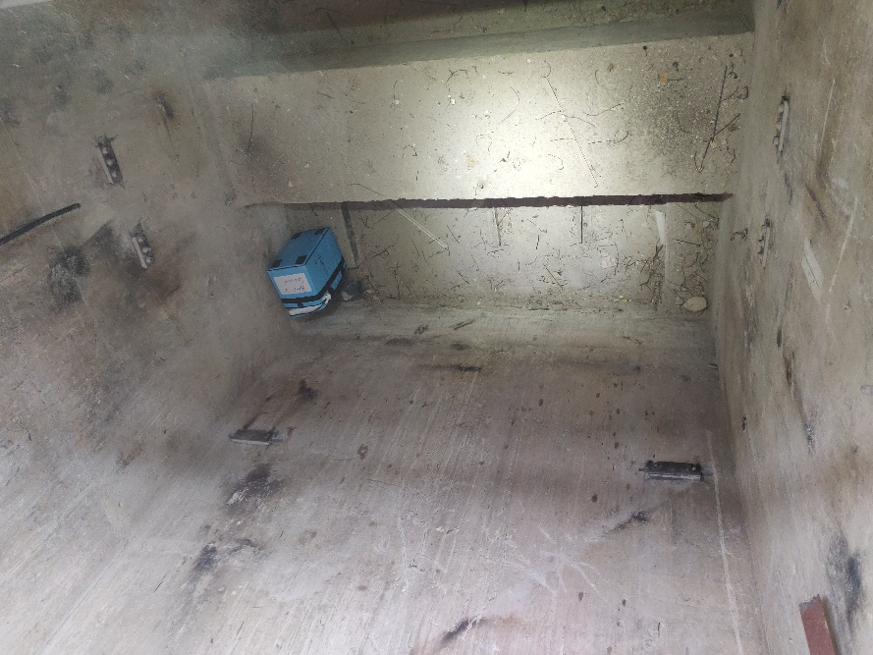
Figure 2. Bottom of lift shaft with second dropped bag near back wall.

The packaging configuration used for each practice drop test was:
- Practice drop test 1 – the specimen was placed inside the Versapak on top of, but not attached to the cold pack (Figure 3)
- Practice drop test 2 - A made-to-measure ‘soft’ foam block was used to fill the interior of the Versapak, with a cut-out made in the foam to receive the specimen and cold pack (Figure 4). According to the foam supplier [53], the ‘soft’ foam had a nominal hardness in the range 100-140 newtons, and a density in the range 31.4 – 34.7 kg/m³
- Practice drop test 3 - This used the same packaging configuration as in the first practice drop test using the same Versapak from the first test but using a new specimen. The Versapak, damaged from the first test, was repaired using gaffer tape to provide added strength, particularly around the zip (Figure 5). This tape seal would also have affected air pressure release on impact.

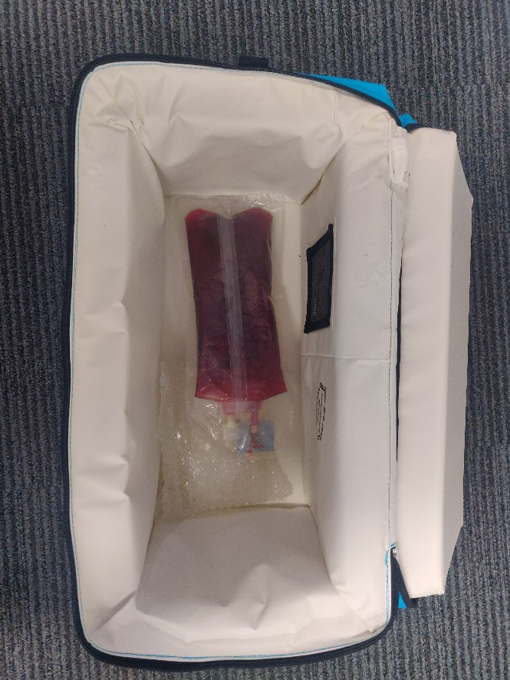

Figure 3. IV bag on cold pack inside Versapak as used in practice drops 1 and 3.

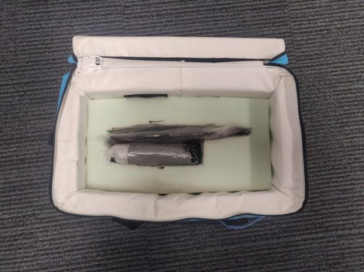

Figure 4. Foam packaging used in practice drop 2.

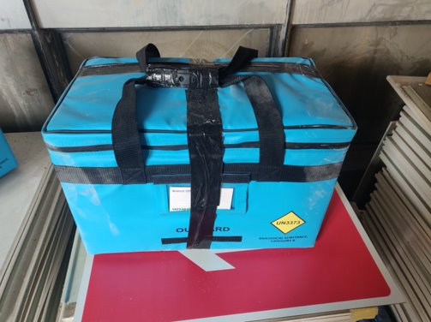
Figure 5. Taped container used in practice drop 3.

2.2. Main drop testing by drone
The main drop tests, by drone, took place at the Snowdonia Aerospace Centre, Llanbedr airfield, in North Wales, in July 2023. Eight drop tests were made over three separate days. Drop tests 2 and 5 are not described here as one test was invalidated when the bag landed on grass to the side of the hardstanding, and the other was for an unrelated test configuration. Video recordings were taken of all the drop tests, both from the ground and air, the latter using a GoPro 360 camera mounted on the drone. Three packaging configurations were tested to assess the level of crash protection needed:
- Drop tests 1 and 4 – Foam protection was used as for practice drop 2 (Figure 4), with the specimen placed inside a polythene ‘freezer bag’ (26 x 35 cm) with tie handles (not tied), inside a polythene bag with a zip seal (30 x 40 cm), alongside a frozen cold pack wrapped in bubble wrap. Drop test 1 used the same ‘soft’ foam as described for practice drop test 2, while drop test 4 used a slightly firmer ‘medium’ foam, described by the supplier [53] as having a nominal hardness in the range 115-155 newtons and a density in the range 31.4 – 34.7 kg/m³;
- Drop tests 3, 6 and 7 - The IV bag was wrapped in cling film then placed inside a polythene ‘freezer bag’ with tie handles (not tied), inside a polythene bag with a zip seal, inside a ‘leak-proof’ polythene liner (610 x 915 mm, 125 micron (500 gauge) thickness)[54] inside a second identical leak-proof liner (Figure 6), alongside a frozen cold pack, wrapped in bubble wrap, and using duct tape to seal bags.
- Drop test 8 - As for drop tests 3, 6, and 7 but not using the freezer bag or zip bag. (The simplest configuration).

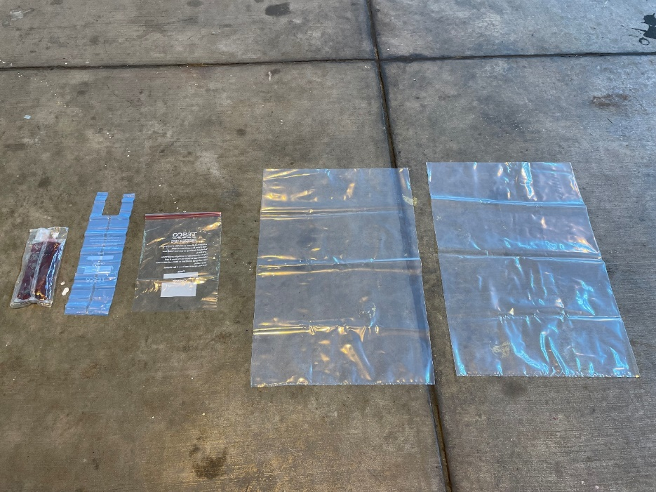

Figure 6. Specimen and packaging used in drop tests 3, 6, 7 (IV bag, freezer bag, zip seal bag, two leak-proof liners) (cold pack not shown).
The wrapped specimen was placed inside the Versapak bag. It was not fixed within the bag so could move during the drop tests, especially vertically, in the bag’s normal orientation, as, while the package nearly filled the Versapak in terms of length and width, it only filled about one quarter of the height (Figure 7). In practice, this would mean that the container could be filled with four packages of this size.

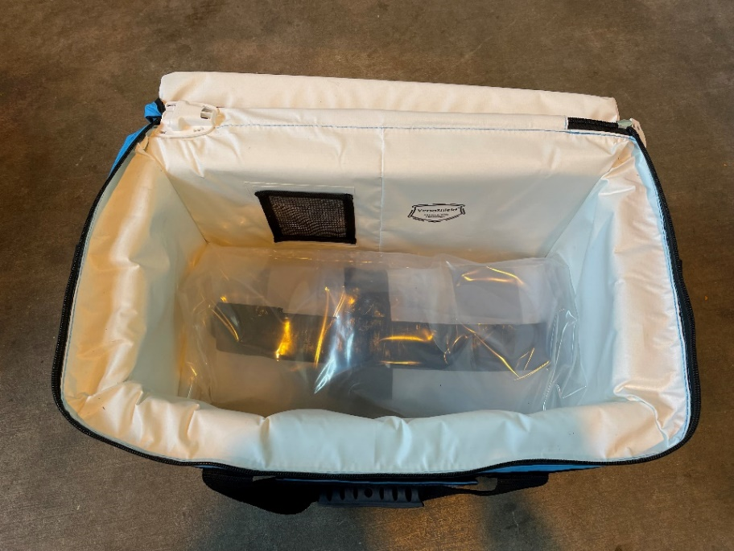
Figure 7. Wrapped specimen inside container.
Each Versapak containing a packaged specimen was held underneath a ‘Titan’ hexacopter drone, designed, manufactured and operated by Motion Robotics Ltd.[55], using a specially designed remote-controlled harness grab/release mechanism on the underside of the drone using two clamps that close/open to grab/release a harness attached to the bag (Figure 8). The drone specification was height 0.682 m, frame size 0.49 m x 0.7 m, rotor diameter 0.762 m, payload capacity 15 kg, maximum take-off weight 38 kg. The total weight of container, specimen, packaging, and harness was approximately 4.57 kg, with some negligible variations for the different packaging configurations.
One of the VCA test requirements was that drops should be made from at least a minimum height that ensures that terminal velocity will be achieved plus a 10% safety margin. All drops were made from a height of 98 m , where this height was determined as explained in appendix A. The drone was positioned above or to the side of the runway, making allowances for any lateral drift expected due to prevailing wind conditions, aiming to drop the bag onto the runway and not onto the softer grassy areas on either side. A stationary hover position was achieved for all the drops.

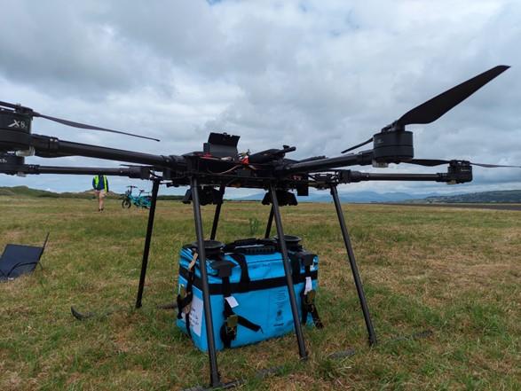
Figure 8. Hexacopter drone with bag to be mounted via attached harness.

Following the test procedure requirements, each dropped container was visually inspected for damage on the runway and then placed on a plastic tray and removed to a nearby hangar for a more detailed inspection after at least eight hours, the purpose of this delay being to ensure that any leaks could be observed. The test procedure requires that the container be stored in an orientation that would allow liquid to escape (e.g., if there was a hole at top, then it should be placed top-down). In these tests, containers were stored upside down as the zipped lid was deemed to be the most likely source of any leakage, in the absence of any obvious holes appearing. Other test requirements include the recording of relative humidity and wind speed at the time of each drop as well as providing photographic or video evidence of the various stages of the drop testing, that is, before, during, and immediately after each drop, and at the bag inspection eight or more hours afterwards.

2.3. Measuring devices
Shock levels experienced during impact were measured for drop tests 1 and 4, using a MEMS data logging triaxial shock accelerometer (the MSR 175)[56]. This sensor was configured to its maximum 6.4 kHz sampling frequency and measured acceleration in the range of ± 200g, with a trigger level of 10g. The sensor was secured within the internal pocket of the Versapak.
Acceleration levels experienced during the drop were measured for drop tests 3 and 7. This used a different triaxial MEMS data logging accelerometer (the Axivity AX6)[57], configured to its maximum sampling frequency of 1.6 kHz and measured acceleration in the range of ±16g. The sensor was secured within the internal pocket of the Versapak.
The drone’s altitude was measured by the flight controller using readings from its three barometers, fed through an extended Kalman filter. This information was fed back to the ground control station and relayed to the pilot during flight. During the drop tests, flight involved manually flying to an altitude of 98 m, followed by a short, automated flight, to a set waypoint above the runway at 98 m. The flight controller then notified the ground control station that the desired position and altitude has been achieved. The drone was also allowed to stabilize at this new waypoint for 10-15 secs before initiating release of the payload.
Wind speeds were measured using a digital anemometer at three locations around the site. Average and maximum gusting wind speeds were measured at all three points immediately prior to commencement of each drone operation, and an average value between these locations was taken.

3. Results

3.1. Practice drops down lift shaft
For all three practice bag drops, there was lateral movement of the bag during the drop, either towards the front or back wall, which caused bags to strike walls before landing. This was likely caused by circulating air effects. The drop time was estimated, in each case, from video recordings, to be about 3.0 s, giving an estimated average drop speed of 16.3 m/s.

3.1.1. Practice drop test 1
During the drop, the bag moved laterally towards the front wall of the lift shaft and struck a lift shaft entrance ledge (Figure 9) about two-thirds of the way down, with the bag then bouncing to and glancing off the back wall before hitting the rear top edge of the ledge at the bottom of the lift shaft and ending near the back wall. The impacts with the lift shaft entrance ledge and the ledge at the bottom of the lift shaft were both observed to be significant. The bag lid was partially opened following the drop test but the IV bag was undamaged, despite the two impacts.

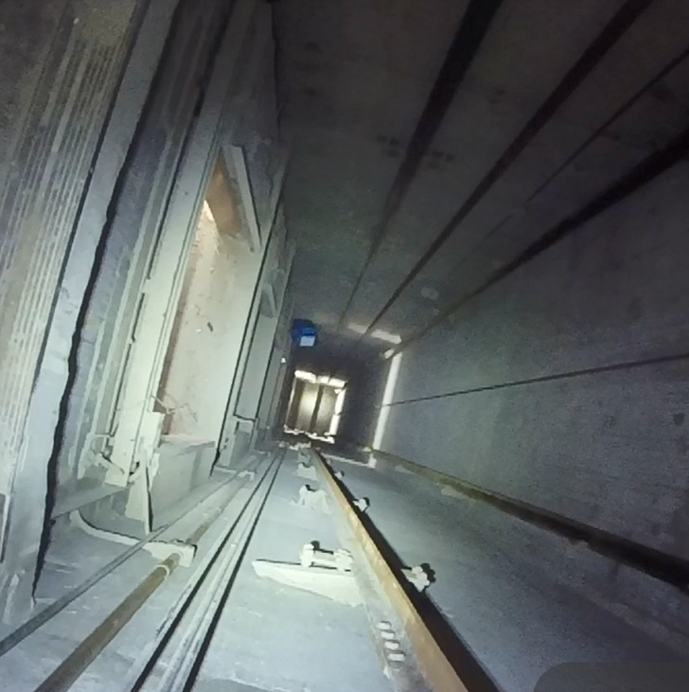
Figure 9. Bag about to hit lift shaft entrance ledge (left side of figure).

3.1.2. Practice drop test 2
During the drop, the bag moved laterally towards the back wall of the lift shaft, glancing off it near the bottom of the drop, with the bag landing behind the ledge, near the back wall. The bag lid partially opened on impact but the IV bag was undamaged.

3.1.3. Practice drop test 3
This bag did not touch the side walls on the way down. The bag struck the front edge of the ledge at the bottom of the lift shaft before falling to the floor below and bouncing back onto the ledge. The taped bag lid did not open but the IV bag was ruptured inside and had leaked its contents, although no liquid escaped outside.

3.1.4. Lessons from practice drop tests
The practice drop tests indicated that the bag’s zip is its weakest point, with its teeth being forced open on impact. Zip strengthening measures could be considered such as a Velcro zip cover to keep the lid closed if the zip fails. ​If the zip is liable to fail, it would be desirable to ensure that the specimen packaging is leak-proof. ​

3.2 Main drop tests by drone
The main drop test results are described here, relating to shock and acceleration measurements, estimation of time to reach terminal velocity, and crash performance. The drop times, from bag release at the drop height of 98 m to hitting the runway below, ranged between 5.69 s and 5.94 s, giving mean drop speeds ranging between 16.5 m/s and 17.2 m/s. In all cases, the IV bag ruptured on impact, splitting along its long edge, and leaking into packaging as described below. The frozen cold pack was undamaged in all cases.

3.2.1. Shock and acceleration measurements
The acceleration measurements during impact (shock) are illustrated for drop test 4 (Figure 10). This shows the measured acceleration values for the three orthogonal directions (x, y, z) and for the ‘resultant acceleration’, given by $\sqrt{{(x}^{2}+ y^{2}+ z^{2}}$). The ±200g maximum limit, configured for the sensor, was reached in all three orthogonal directions from which it is concluded that the resultant acceleration during impact exceeded 346g. Similar results and conclusions were obtained for drop test 1 (not shown) and would be expected for the other drop tests as well (not measured).

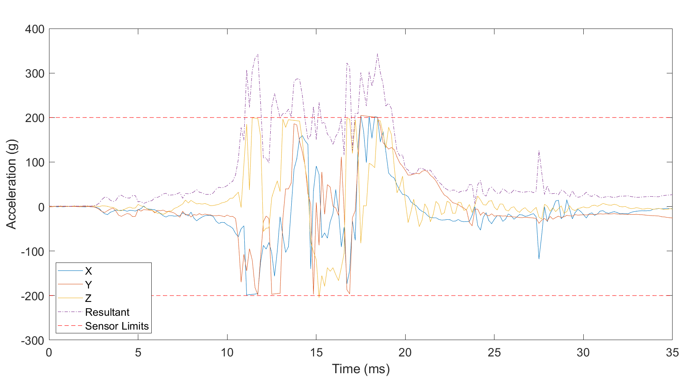
Figure 10. Acceleration levels during impact for drop test 4.
The resultant acceleration measurements recorded for drop tests 3 and 7 (Figure 11) were used to check if the containers reached terminal velocity (zero acceleration) before hitting the ground, as required by the VCA’s drop test procedure. These measurements were low-pass filtered (smoothed) using a zero-phase 8th order Butterworth filter [58] with a cut off frequency of 5 Hz. The results indicated that zero acceleration was reached at 4.26 s for bag 3 and at 4.21 s for bag 7. As the drop times were 5.69 s and 5.68 s, respectively, the results confirmed that terminal velocity was attained for these drop tests and that the chosen drop height of 98 m, which had included a 10% safety margin (appendix A), had been appropriate. For comparison, the measured acceleration curves are shown alongside the theoretical acceleration curve for the descent with the longest theoretical time to reach terminal velocity (5.71 s), where the container falls end face (smallest surface area, 0.077775 m²) downwards, as explained in appendix A. In practice, from video footage of the drops, it was observed that the containers initially fell bottom side down (surface area 0.1173 m²), this being the orientation at release, and then ‘tumbled’ (rotated slowly in varying directions) during the drops. The observed variations in the measured accelerations are assumed to be due to this tumbling motion during descent, resulting in angular accelerations and changes in frontal area and hence drag forces.
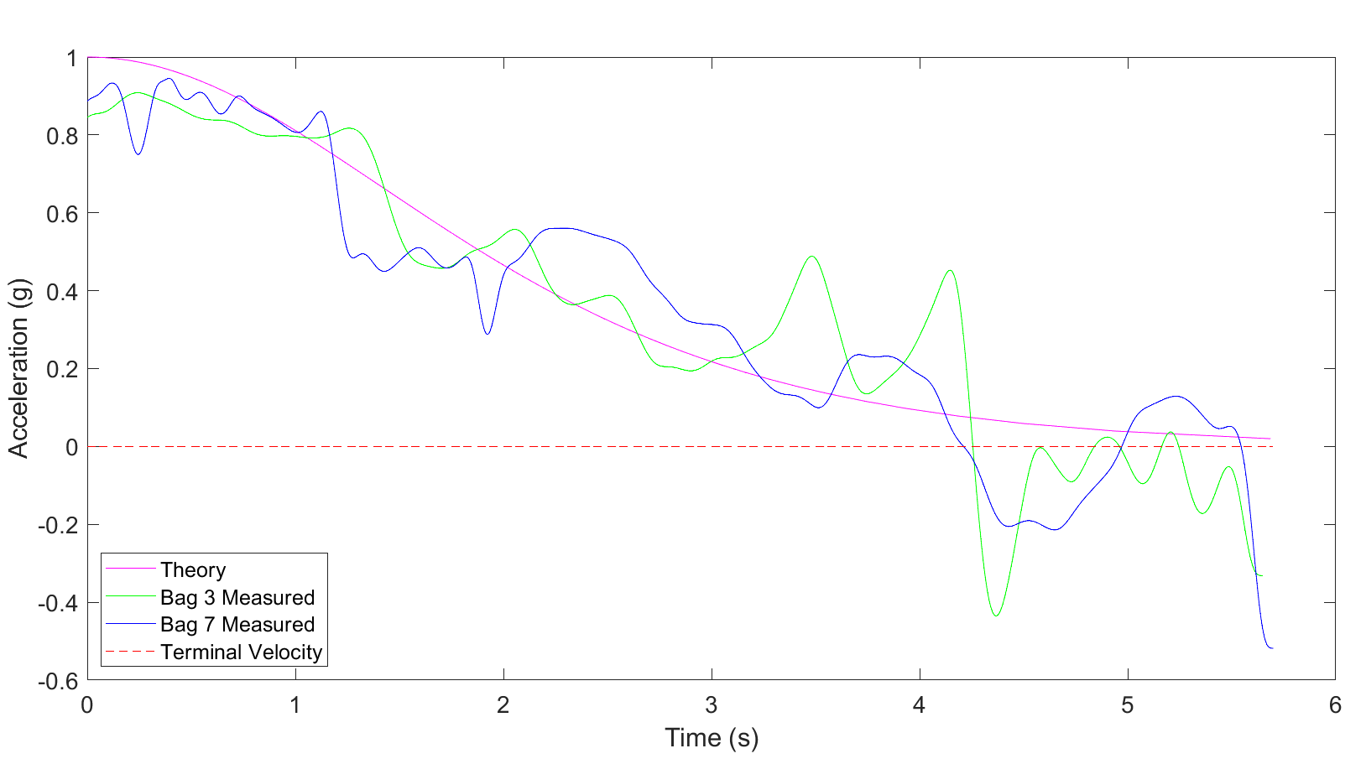
Figure 11. Measured and theoretical accelerations during drops.

3.2.2. Crash performance
For drop tests 1 and 4, the added foam protections (‘soft’ and ‘medium’) did not prevent the IV bags from rupturing. The polythene freezer bag and polythene zip bag were both ineffective in preventing leakage into the container. Although both containers remained intact, without any tears or holes being observed, they both leaked contents onto the runway and thus failed the test procedure. Examination of the containers revealed that liquid had escaped through the zip, suggesting that this may be an area for consideration in design of a CPC.

Figure 12. IV bag split down long edge (drop test 1).

In drop tests 3, 6, 7, and 8, the use of two leak-proof polythene liners was largely effective in containing the liquid that escaped from the ruptured IV bag in each case, aside from a few spots of liquid that escaped into one of the Versapaks (on drop test 7). On three of the four tests, liquid escaped from the inner liner into the outer liner due to the inner liner being punctured. On the other test, all the liquid remained inside the inner liner.
Some relatively minor deformations of each container were observed due to the landing impact. On one of the drop impacts, the zip was forced open, but the lid remained closed; the zip remained intact for the others. No liquid had escaped from any of the containers after the eight-hour observation period.

3.2.3. Lessons from main drops
Despite being dropped from twice the height of the practice drops, the Versapak containers were damaged less in the main drops (from a drone) than in the practice drops (down a lift shaft). This was likely due to landing on the flat surface of the airfield runway as compared to colliding with walls and landing on the edge of a ledge at the bottom of the lift shaft. Nevertheless, the bag zip was forced open on one of the main drop tests, which is a test failure, despite no liquid contents escaping the container. As also observed in the practice drops, some strengthening and waterproofing of the zip will be needed for this type of container to pass the test requirements. General strengthening of the container may also be considered if the container is to be defined as ‘rigid outer packaging’, although it may be preferable to add a layer of rigid outer packaging to the contents instead (e.g., a cardboard box). The use of at least two ‘leak-proof’ liners seems necessary for this application as the inner liner was punctured on three of the drops. Further discussion of potential design refinements can be found in section 4.5.
Gusts of wind of up to 7.2 m/s were experienced during the drop tests which led to lateral bag movements (drifts) of up to 26 m. This made positioning the drone to land bags on the 50 m wide runway quite difficult to achieve and, in one case, the test failed when the expected drift did not occur as the wind subsided when the bag was dropped, resulting in the bag landing on grass to the side of the runway. Ideally, tests would be undertaken in less windy conditions, but this can be difficult to achieve given the substantial operational logistics (e.g., booking of facilities, gaining permissions, number of people involved).

4. Discussion
In addition to the primary objective of testing the potential suitability of the standard medical carrier bag for carrying DG by drone, the drop tests also provided useful information for further research and future testing, including how to estimate terminal velocity and determine a suitable drop height. Here, we suggest improvements to the methods used and discuss how the current regulations (drop testing procedure) may affect the future testing needed to support the use of drones for carrying DG.

4.1 Sensors and monitoring
Based on measurements from the accelerometers during the drop, presented in Figure 11 alongside the theoretical estimates from appendix A, there was good agreement between theory and practice, in terms of the height needed and time taken to reach terminal velocity for the given container dimensions and weight. This suggests that the prediction model (appendix A) may be adequate to determine the drop height for other container sizes and weights. This prediction model could be improved through the measurement of drag forces (e.g., in a wind tunnel) to determine the range of drag coefficients of the container at multiple orientations, as opposed to the assumed fixed value of 2.1, based on the approximation of the container as a cuboid. Validation of the model and additional improvements could be achieved through improvements in the measurements taken during the drop such as recording acceleration in the rotational degrees of freedom, in addition to the orthogonal directions, to provide greater insight into the tumbling movement of the container during drops. Better control and recording of the sensor orientation could also provide additional understanding. During this trial, acceleration sensors were secured within the internal pocket of the Versapak, which gave readings for the container acceleration. It may be of interest, in future research, to affix sensors to the specimen as well, especially where the specimen can move within the container.
To gain a better understanding of the severity of the impact, a sensor with a greater range could be used, as accelerations in this trial exceeded the 200g range of the sensor used.

4.2 Regulatory aspects
Where testing a CPC using TI-compliant packaging (i.e., payload type (i) in Section 1.1) the test procedure states that any approval issued to a successfully tested CPC shall be limited to carriage of the specific packaging configuration tested. At present, with no CAA approval having been received yet for the container used in these drop tests, it is unclear how such an approval will be worded to specify what minor variations in packaging will be permitted, if any. Any approval will only cover payloads up to, but not exceeding, the tested payload mass. In this case, it may be advisable to undertake tests using the maximum expected payload mass. If feasible, it would be useful to have a categorisation of different packaging systems and rank them in terms of their crashworthiness so that it would not be necessary to test them all. If, for example, a lower ranked packaging system successfully passed the test procedure then approval could cover all higher-ranked packaging systems as well.
As medical logistics are often not routine, there may be many variations in DG payloads to be transported and it will not be feasible to test them all individually. If the test procedure approval is overly restrictive, it may severely limit the types of goods and packaging that can be used, whilst adding costs in testing requirements. The test procedures offering the greatest freedom are those where the payloads are unpackaged solids or liquids poured directly into the container, as approval then covers any TI-compliant packaging configuration. The Versapak bags used in these tests are used in medical practice to transport a wide variety of types of samples, medicines, or equipment, most not DG. Non-DG items may have to be carried separately from DG, and the test procedure does not apply to them.
The drop test procedure for payload type (i) requires outer packaging to be rigid, where this refers either to the package inside the container or the container itself. This requirement, stipulated in PI 650 (relevant for UN 3373 substances), appears to be appropriate for the operation of large, crewed airliners, where containers may be stacked on top of each other in the cargo hold and thus must be rigid. For the type of application here, where a single container is held underneath a drone, no stacking is involved and rigidity of the container seems less appropriate, especially as it may not be a desirable property for a CPC if it does not provide good impact absorption. More drone-specific regulation concerning DG packaging would be desirable.
The latest drop test procedure (version 2) was published by the VCA in January 2024. This added some further information and clarifications which were partly a result of the drop tests reported here and our discussions of these with the VCA. The added parts included: advice to consult with the VCA, before testing, if unsure whether proposed CPC design, contents, or drop height are acceptable; statement that a set of three successful tests are required; inclusion of a full description of: a) the container design and construction; b) all packaging used; c) the impact area; d) any terminal velocity calculations used.

4.3 Operational aspects
Undertaking these drop tests was operationally challenging due to the potential risks involved with dropping an object from height, especially in windy conditions. With the container drifting laterally up to 26 m in these tests, accurately hitting a hardstanding area of limited width (50 m here) can be difficult and potentially dangerous. Ideally, drop tests should be made in less windy conditions, as stated in the test procedure, to ensure a safe landing in the desired area. The test requires landing on a hard flat surface, so landing elsewhere, such as on a grassy verge would constitute a test failure. In practice, many different landing conditions could be envisaged, with differing impacts on a dropped CPC. Lower levels of damage would likely occur when landing on water, soft ground, or where cushioned by vegetation, while greater levels of damage would likely occur if landing on an uneven or sharp surface such a building roof, wall, or fence, as was observed here when dropping bags down a lift shaft. The impact angle would also be a factor. The effect of landing conditions on crash impacts can be considered as further research.
Drop tests were made from lower than the maximum permitted drone operating height (121.9 m) to minimise these risks; however, informal feedback has indicated that dropping from a lower height (98 m, here), based on terminal velocity calculations, should only be done when dropping from the maximum operating height is impractical. A perceived concern here is the potential reaction from the public if tests are not made from the maximum operating height. Nevertheless, we would argue that dropping from the minimum height guaranteed to achieve terminal velocity is a valid and safer test method, especially if higher drone operating heights are permitted in future. In this case, guidance on suitable drop heights for different payload weights, container shapes and sizes would be useful, and the formulae presented in appendix A may be useful as a basis for providing an online calculating tool.
Future designs of drone cargo systems may benefit from international standardisation to help reduce the needs for such tests, using technologies similar to the large commercial aircraft standardised air freight containers and pallets, known as ‘unit load devices’ [59].
If using a cold pack, its position relative to the IV bag may affect damage to the IV bag, depending on how the bag lands. This has not been investigated here but could be of interest for further research.
An arguable weakness of the CPC drop test procedure is that it assumes the container falls to the ground in isolation, whereas a drone crash could involve the impact of the drone and container in combination. This situation is likely to alter the dynamics and magnitude of the forces on the container at impact (compared to container impact in isolation) due to factors such as: different terminal velocities for drone/container combinations; powered flight into terrain at various velocities; or size/mass/construction of the drone impacting on the container as it hits the ground. That said, it would be impractical to insist on testing of drone/container combinations in the CPC drop test procedure due to the damage to drones that would be incurred and the many different possible combinations that would need to be tested and approved. Instead, a pragmatic approach has been adopted in designing the CPC drop test procedure based on dropping the container in isolation, which is viewed by the experts at the VCA as adequate to ensure the integrity of containers in combination or isolation, although the veracity of this view has not been established exhaustively.

4.4 Subsequent testing
Following the main drop tests reported in this paper, an opportunity arose to drop three Versapak containers, containing the same specimens, from the maximum permitted operating height (121.9 m) onto a concrete surface using a fixed-wing drone travelling at a speed of 33 m/s. These additional drops did not follow the test requirement of waiting eight hours to inspect the containers, but inspections immediately after crash landing indicated only minor surface damage (scratches) to the containers, with no liquid escaping from the inner liners into the containers.

4.5 Further development of medical crash protected containers
The reported drop tests have indicated elements of the standard bag design that would require modifications to allow use as a CPC. In particular, the zip needs to be considered to ensure that it remains closed during and after impact. Consideration could also be given to using a waterproof zip to potentially limit or negate the need for the use of leak-proof liners in the packaging design. Consideration could also be given to increasing the rigidity of the container to reduce the amount of deformation it undergoes during impact which may reduce the likelihood of the zip failing. An additional consideration for the development of a medical crash protected container could be to reduce the impact force through reducing the terminal velocity. This could be achieved through the incorporation of wings or fins to increase the drag coefficient of the bag. Structural dynamic models of the container could be developed to examine impact behaviour, to further assist with strengthening the carrier design. CPC design should bear in mind that an increase in the mass of the carrier may result in a reduction of the payload capacity or of the range of the drone.
The implementation of any of these design considerations may increase the cost of the carrier in comparison with the current standard version. If so, this would likely result in the development of a specific (non-standard) medical CPC as these changes would have limited or no benefit in business-as-usual ground transport and users would not pay extra for these where not needed. In this case, the non-standard carrier (CPC) would only be purchased for specific use cases involving drone logistics.

5. Conclusions
Prior to this study, the crashworthiness and potential failure mechanisms of a standard medical carrier were not known. New experimental findings from a programme of drop tests provide useful empirical evidence that can guide the container manufacturer to design a modified version of the container for future testing, approval and use as a CPC. These modifications relate to the container’s strength and its water tightness, where its zipped lid was identified as its main weak point. Strengthening of the container may also allow it to qualify as the rigid outer packaging layer in a TI-compliant packaging configuration, although this may not be necessary where the transported goods already have a rigid outer packaging layer. Although liners can be used as part of the packaging to prevent leakage during the testing, the test approval then only applies to that specific packaging configuration, which may be overly restrictive in practice. The research and development of a carrier bag that could be used for both general transport and for transporting dangerous goods by drone is a recommendation of this study, as it would be a highly desirable asset for healthcare services worldwide. The research has also provided useful insights into the practical test requirements and how to conduct the tests as well as informing the VCA in amending the drop test procedure.

Author Contributions: Conceptualization, T.C; methodology, T.C., K.T., A.O., F.M., J.A. and A.M..; software, T.W.; validation, F.M., K.T., A.O. and J.D.; formal analysis, K.T., T.W. and F.M.; investigation, T.C., K.T., A.O., F.M., J.A. and A.M.; resources, T.C., K.T., A.O., F.M., J.A. and A.M.; data curation, A.O. and K.T.; writing—original draft preparation, F.M., M.G., K.T. and A.O.; writing—review and editing, T.C., T.W., J.A. and J.D.; visualization, K.T..; supervision, T.C. and T.W.; project administration, T.C.; funding acquisition, T.C.. All authors have read and agreed to the published version of the manuscript.
Funding: This research was funded by the UK Department for Transport, as part of the Solent Future Transport Zones project.
Data Availability Statement: The data and video footage created during this study were not publicly available at the time of writing for privacy reasons. They may be available on request later, subject to type approvals having been obtained.
Conflicts of Interest: The authors declare no conflict of interest. The funders of the research project had no role in the design of the study; in the collection, analyses, or interpretation of data; in the writing of the manuscript; or in the decision to publish the results.

Appendix A – Determination of drop height
The terminal velocity (V_{t}) of a falling object is given by the formula (1):

$$V_{t}= \sqrt{\frac{2mg}{ρAC_{d}}}$$ |  | (1)
where m=mass (4.57 kg), g=acceleration due to gravity (9.81 m/s²), ρ=density of air (1.225 kg/m³), A=projected area of the object, C_{d}=drag coefficient [60]. A drag coefficient of 2.1 was assumed, based on values given for different types of common shape, where the container (Versapak) shape approximates to that of a cuboid (rectangular box)[61]. The projected (cross-sectional) area of the container is dependent on how it falls and will vary as it tumbles. The minimum projected area is the area of the end face of the container, that is 0.077775 m² (= 0.305 m x 0.255 m), while the maximum is 0.1987 m² calculated by the formula (2):
$$\sqrt{(d^{2} h^{2}+d^{2}w^{2}+h^{2}w^{2}}$$ |  | (2)
where w, d, and h are the three dimensions of the container [62]. This gave the terminal velocity as ranging between 13.24 m/s, for the slowest possible descent (A=0.1987 m²), and 21.17 m/s, for the fastest possible descent (A=0.077775 m²).

The relationship between velocity (v) and time (t) for a falling object is given by the formula (3)[63]:
$$v= V_{t} tanh⁡({gt}/{V_{t}})$$ |  | (3)
Plotting this relationship for the fastest and slowest descents (Figure A1), indicated that the time to reach 99% of terminal velocity ranged between 3.57 s for the slowest possible descent and 5.71 s for the fastest possible descent. [Note: ‘terminal velocity’ is a theoretical upper limit that is never reached, hence the use of 99% here.]

The height needed to achieve terminal velocity was calculated, via numerical integration, to range between 35 m, for the slowest possible descent, and 89 m, for the fastest possible descent (Figure A2). This led to the decision to undertake drop tests from a height of 98 m (=89 m + 10%), where a 10% added safety margin was used, as required by the drop test procedure [4].

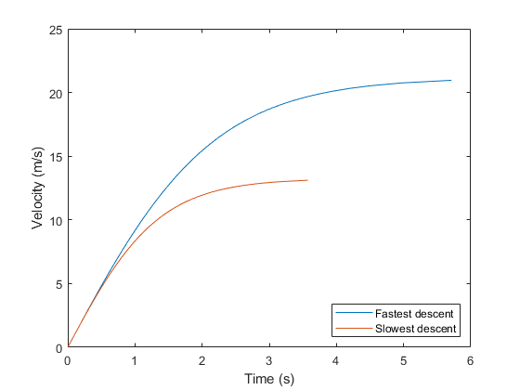
Figure A1. Velocity/time curves, with end point representing 99% of terminal velocity.

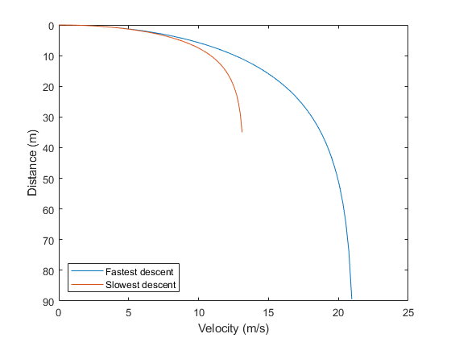
Figure A2. Distance (height)/velocity curves, with end point representing 99% of terminal velocity.

References
1. Sánchez, J. H.; Gouveia, S.; Cameselle, C. Transport of High-Risk Infectious Substances: Packaging for the Transport of Category A Infectious Specimens in Spain. Int. J. Environ. Res. Public Health 2022, 19 (20), 12989. DOI: 10.3390/ijerph192012989.
2. European Union Aviation Safety Agency. Easy Access Rules for Unmanned Aircraft Systems (Regulations (EU) 2019/947 and (EU) 2019/945)), 2022, Cologne, Germany.
3. Civil Aviation Authority. CAP2555: Guidance on the Carriage of Dangerous Goods as Cargo for UAS/RPAS Operators in the Specific Category; 2023. https://publicapps.caa.co.uk/modalapplication.aspx?appid=11&mode=detail&id=12257 (accessed 9 February 2024).
4. Test procedure (Crash protected containers for dangerous goods carried by remotely piloted aircraft systems), Version 01. Available online: https://dc346c11-9b06-4f11-8326-4d9532cfa24c.usrfiles.com/ugd/dc346c_55a117d638ab4062a5531cef5fbb872b.pdf (accessed 2 November 2023).
5. Vehicle Certification Agency. Test procedure (Crash protected containers for dangerous goods carried by remotely piloted aircraft systems), Version 02, 2024, Leatherhead, UK.
6. Flemons, K.; Baylis, B.; Khan, A. Z.; Kirkpatrick, A. W.; Whitehead, K.; Moeini, S.; Schreiber, A.; Lapointe, S.; Ashoori, S.; Arif, M.; et al. The use of drones for the delivery of diagnostic test kits and medical supplies to remote First Nations communities during Covid-19. Am. J. Infect. Control 2022, 50 (8), 849-856. DOI: 10.1016/j.ajic.2022.03.004.
7. Rana, K.; Praharaj, S. C.; Nanda, T. Unmanned Aerial Vehicles ( UAVs ) : An Emerging Technology for Logistics. International Journal of Business and Management Invention 2016, 5 (5), 86-92.
8. Poljak, M.; Šterbenc, A. Use of drones in clinical microbiology and infectious diseases: current status, challenges and barriers. Clinical Microbiology and Infection 2020, 26 (4), 425-430. DOI: 10.1016/j.cmi.2019.09.014.
9. De Silvestri, S.; Capasso, P. J.; Gargiulo, A.; Molinari, S.; Sanna, A. Challenges for the Routine Application of Drones in Healthcare: A Scoping Review. Drones 2023, 7 (12), 685. DOI: 10.3390/drones7120685.
10. Aurambout, J.-P.; Gkoumas, K.; Ciuffo, B. Last mile delivery by drones: an estimation of viable market potential and access to citizens across European cities. European Transport Research Review 2019, 11 (1), 30. DOI: 10.1186/s12544-019-0368-2.
11. Kamat, A.; Shanker, S.; Barve, A.; Muduli, K.; Mangla, S. K.; Luthra, S. Uncovering interrelationships between barriers to unmanned aerial vehicles in humanitarian logistics. Operations Management Research 2022, 15, 1134-1160. DOI: 10.1007/s12063-021-00235-7.
12. Lin, C. A.; Shah, K.; Mauntel, L. C. C.; Shah, S. A. Drone delivery of medications: Review of the landscape and legal considerations. Am. J. Health Syst. Pharm. 2018, 75 (3), 153-158. DOI: 10.2146/ajhp170196 (acccessed 8/30/2023).
13. Rejeb, A.; Rejeb, K.; Simske, S.; Treiblmaier, H. Humanitarian Drones: A Review and Research Agenda. Internet of Things 2021, 16, 100434. DOI: 10.1016/j.iot.2021.100434.
14. Sah, B.; Gupta, R.; Bani-Hani, D. Analysis of barriers to implement drone logistics. International Journal of Logistics Research and Applications 2021, 24 (6), 531-550. DOI: 10.1080/13675567.2020.1782862.
15. NHS drone delivery trial. Available online: https://skyports.net/nhs-trials/ (accessed 19 October 2023).
16. Wankmüller, C.; Kunovjanek, M.; Mayrgündter, S. Drones in emergency response – evidence from cross-border, multi-disciplinary usability tests. International Journal of Disaster Risk Reduction 2021, 65, 102567. DOI: 10.1016/j.ijdrr.2021.102567.
17. Leong, M. K.; Koay, K. Y. Towards a unified model of consumers’ intentions to use drone food delivery services. International Journal of Hospitality Management 2023, 113, 103539. DOI: 10.1016/j.ijhm.2023.103539.
18. Kunze, O. Drones in Freight Transport. In International Encyclopedia of Transportation, Vickerman, R. Ed.; Elsevier, Oxford, 2021; pp 374-381.
19. Aydin, B. Public acceptance of drones: Knowledge, attitudes, and practice. Technology in Society 2019, 59, 101180. DOI: 10.1016/j.techsoc.2019.101180.
20. Comtet, H. E.; Johannessen, K. A. The Moderating Role of Pro-Innovative Leadership and Gender as an Enabler for Future Drone Transports in Healthcare Systems. Int. J. Environ. Res. Public Health 2021, 18 (5), 2637. DOI: 10.3390/ijerph18052637.
21. Sham, R.; Siau, C. S.; Tan, S.; Kiu, D. C.; Sabhi, H.; Thew, H. Z.; Selvachandran, G.; Quek, S. G.; Ahmad, N.; Ramli, M. H. M. Drone Usage for Medicine and Vaccine Delivery during the COVID-19 Pandemic: Attitude of Health Care Workers in Rural Medical Centres. Drones 2022, 6 (5), 109. DOI: 10.3390/drones6050109.
22. Kumar, R.; Singh, J.; Yadav, P.; Semwal, N.; Yadav, S.; Bhorey, A.; Bhaumik; Dhawan, H. Parachute deployment system for safe recovery of a drone. Materials Today: Proceedings 2023. DOI: 10.1016/j.matpr.2023.04.114.
23. Baldini, A.; Felicetti, R.; Ferracuti, F.; Freddi, A.; Iarlori, S.; Monteriù, A. Real-time propeller fault detection for multirotor drones based on vibration data analysis. Engineering Applications of Artificial Intelligence 2023, 123, 106343. DOI: 10.1016/j.engappai.2023.106343.
24. Krichen, M.; Adoni, W. Y. H.; Mihoub, A.; Alzahrani, M. Y.; Nahhal, T. Security Challenges for Drone Communications: Possible Threats, Attacks and Countermeasures. In 2022 2nd International Conference of Smart Systems and Emerging Technologies (SMARTTECH), 9-11 May 2022, 2022; pp 184-189. DOI: 10.1109/SMARTTECH54121.2022.00048.
25. Gianfelice, M.; Aboshosha, H.; Ghazal, T. Real-time Wind Predictions for Safe Drone Flights in Toronto. Results in Engineering 2022, 15, 100534. DOI: 10.1016/j.rineng.2022.100534.
26. Koh, C. H.; Low, K. H.; Li, L.; Zhao, Y.; Deng, C.; Tan, S. K.; Chen, Y.; Yeap, B. C.; Li, X. Weight threshold estimation of falling UAVs (Unmanned Aerial Vehicles) based on impact energy. Transportation Research Part C: Emerging Technologies 2018, 93, 228-255. DOI: 10.1016/j.trc.2018.04.021.
27. Svatý, Z.; Nouzovský, L.; Mičunek, T.; Frydrýn, M. Evaluation of the drone-human collision consequences. Heliyon 2022, 8 (11), e11677. DOI: 10.1016/j.heliyon.2022.e11677.
28. Lu, X.; Liu, X.; Li, Y.; Zhang, Y.; Zuo, H. Simulations of airborne collisions between drones and an aircraft windshield. Aerospace Science and Technology 2020, 98, 105713. DOI: 10.1016/j.ast.2020.105713.
29. Pilko, A.; Sóbester, A.; Scanlan, J. P.; Ferraro, M. Spatiotemporal Ground Risk Mapping for Uncrewed Aircraft Systems Operations. Journal of Aerospace Information Systems 2023, 20 (3), 126-139. DOI: 10.2514/1.I011113.
30. Johannessen, K. A.; Wear, N. K. S.; Toska, K.; Hansbø, M.; Berg, J. P.; Fosse, E. Pathologic Blood Samples Tolerate Exposure to Vibration and High Turbulence in Simulated Drone Flights, but Plasma Samples Should be Centrifuged After Flight. IEEE Journal of Translational Engineering in Health and Medicine 2021, 9, 1-10. DOI: 10.1109/JTEHM.2021.3053172.
31. Oakey, A.; Waters, T.; Zhu, W.; Royall, P. G.; Cherrett, T.; Courtney, P.; Majoe, D.; Jelev, N. Quantifying the Effects of Vibration on Medicines in Transit Caused by Fixed-Wing and Multi-Copter Drones. Drones 2021, 5 (1), 22. DOI: 10.3390/drones5010022.
32. Ansari, K. I. B. H.; Shendge, A.; Pakhrani, K.; Singh, R. Design and development of an auto-inflatable airbag as the failsafe system of unmanned aerial vehicle. Materials Today: Proceedings 2023, 77, 983-990. DOI: 10.1016/j.matpr.2022.12.103.
33. NASA develops technology to help drones crash-land safely during emergencies. Available online: https://geoawesomeness.com/nasa-develops-technology-help-drones-crash-land-safely-emergencies/ (accessed 19 October 2023).
34. International Civil Aviation Organization. Annex 18 to the Convention on International Civil Aviation - The Safe Transport of Dangerous Goods by Air (4th Edition), 2011, Montreal, Canada.
35. International Civil Aviation Organization. Technical Instructions for the Safe Transport of Dangerous Goods by Air (Doc 9284), 2023-2024, Montreal, Canada.
36. Grote, M.; Cherrett, T.; Oakey, A.; Royall, P. G.; Whalley, S.; Dickinson, J. How Do Dangerous Goods Regulations Apply to Uncrewed Aerial Vehicles Transporting Medical Cargos? Drones 2021, 5 (2), 38. DOI: 10.3390/drones5020038.
37. Grote, M.; Oakey, A.; Pilko, A.; Smith, A.; Cherrett, T. Drones - the scope for integration into multi-modal urban logistics services. In The Routledge Handbook of Urban Logistics, Monios, J., Budd, L., Ison, S. Eds.; Routledge, Abingdon, UK, 2023; pp 72-90.
38. Civil Aviation Authority. Guidance on the Carriage of Dangerous Goods as Cargo for UAS/RPAS Operators in the Specific Category (CAP 2555), 2023, Crawley, UK.
39. Civil Aviation Authority. CAP2383: Using Drones to Carry Dangerous Goods using Crash Protected Containers, BEIS RPF2 Project Outcomes; 2022. https://publicapps.caa.co.uk/modalapplication.aspx?appid=11&mode=detail&id=11607 (accessed 9 February 2024).
40. Shu, Z.; You, R.; Zhou, Y. Viscoelastic Materials for Structural Dampers: A Review. Construction and Building Materials 2022, 342, 127955. DOI: 10.1016/j.conbuildmat.2022.127955.
41. Selke, S. E. M.; Culter, J. D. Foams, Cushioning, and Distribution Packaging. In Plastics Packaging, Carl Hanser Verlag, Munich, Germany, 2016; pp 339-352.
42. Mills, N. J. Chapter 12 - Product packaging case study. In Polymer Foams Handbook, Mills, N. J. Ed.; Butterworth-Heinemann, Oxford, 2007; pp 281-306.
43. Data sheets (performance curves). Available online: https://www.sorbothane.com/technical-data/technical-data-sheet/ (accessed 19 October 2023).
44. Pulse (ABS-4U 19 inch Rack ABS Flight Case – 4U). Available online: https://www.pulse-audio.co.uk/product/19-inch-rack-abs-flight-case-4u/ (accessed 20 October 2023).
45. 19 Inch Rack Cases. Available online: https://flightcaseuk.com/ (accessed 20 October 2023).
46. Viking Drone Packaging World’s First to be Certified as a Crash Protected Container. Available online: https://vikingpack.co.uk/viking-drone-packaging-worlds-first-to-be-certified-as-a-crash-protected-container/ (accessed 20 October 2023).
47. Crash protected package for transport by remotely piloted aircraft systems. Available online: https://patentscope.wipo.int/search/en/detail.jsf?docId=WO2023014721&_cid=P11-LNENHB-26244-1 (accessed 20 October 2023).
48. Versapak (Insulated Pathology Sample Carrier (Medium)). Available online: https://www.versapak.co.uk/new-medium-insulated-medical-carrier-pathology (accessed 20 October 2023).
49. Sodium chloride (saline) bag 500 ml. Available online: https://www.henryschein.co.uk/gb-en/medical-gb/p/pharmaceuticals/solvents-and-solutions/sodium-chloride-saline-bag-500ml/pha258 (accessed 23 August 2023).
50. Briquettes (cold packs). Available online: https://www.emballiso.com/en/products-packaging-isothermal/accumulators-cold-industry-transport (accessed 20 October 2023).
51. What is HDPE? Available online: https://www.acmeplastics.com/what-is-hdpe (accessed 20 October 2023).
52. Oakey, A. Investigating the scope for integrating uncrewed aerial vehicles into mixed-mode fleets to support national health service logistics operations. Ph.D. Thesis, University of Southampton, Southampton, UK, 28 September 2023.
53. GB Foam Direct. Available online: https://www.gbfoamdirect.co.uk/ (accessed 20 October 2023).
54. Anti spillage liner for medical carriers. Available online: https://www.versapak.co.uk/anti-spillage-liner-for-medical-carriers (accessed 20 October 2023).
55. Motion Robotics. Available online: https://www.motion-robotics.co.uk/ (accessed 20 October 2023).
56. Transport shock data logger MSR175. Available online: https://www.msr.ch/en/product/transportation-shock-data-logger-msr175/ (accessed 20 October 2023).
57. Axivity AX6. Available online: https://axivity.com/product/ax6 (accessed 20 October 2023).
58. Butterworth filter design. Available online: https://www.electronics-tutorials.ws/filter/filter_8.html (accessed 20 October 2023).
59. Döppner, D. A.; Schoder, D.; Siejka, H. Big Data and the Data Value Chain: Translating Insights from Business Analytics into Actionable Results - The Case of Unit Load Device (ULD) Management in the Air Cargo Industry. In European Conference on Information Systems, Research-in-Progress Papers, Paper 7, 2015.
60. Drag Force and Terminal Speed. Available online: https://openstax.org/books/university-physics-volume-1/pages/6-4-drag-force-and-terminal-speed (accessed 20 October 2023).
61. Drag Coefficient. Available online: https://www.engineeringtoolbox.com/drag-coefficient-d_627.html (accessed 20 October 2023).
62. Projected area of a cuboid. Available online: https://demonstrations.wolfram.com/ProjectedAreaOfACuboid/ (accessed 20 October 2023.
63. Newton's 2nd law, drag. Available online: http://electron6.phys.utk.edu/PhysicsProblems/Mechanics/1-Simple%20point%20particles/2nd%20law-drag.html (accessed 20 October 2023).
Disclaimer/Publisher’s Note: The statements, opinions and data contained in all publications are solely those of the individual author(s) and contributor(s) and not of MDPI and/or the editor(s). MDPI and/or the editor(s) disclaim responsibility for any injury to people or property resulting from any ideas, methods, instructions or products referred to in the content.

