Title: Bioenergetics of simultaneous oxygen and nitrate respiration and nitric oxide production in a *Pseudomonas aeruginosa* agar colony biofilm

ABSTRACT  
*Pseudomonas aeruginosa* is a biofilm forming pathogen commonly associated with infection of the cystic fibrosis (CF) lung, chronic wounds and indwelling medical devices. *P. aeruginosa* is a facultative aerobe that can use nitrate (NO3-) found in healthy and infected tissues and body fluids to generate energy through denitrification. Further, *P. aeruginosa* the expression of denitrification genes has been found in specimens from people with CF. The main aim of this study was to determine the relative energy contribution of oxygen (O2) respiration and denitrification in single *Pseudomonas aeruginosa* PAO1 biofilm colonies under different O2 concentrations to estimate the possible relative importance of these metabolic processes in the context of biofilm infections. We showed that the used strain PAO1 in biofilms denitrified with nitrous oxide (N2O), and not nitrogen (N2), as the end product in our incubations. From simultaneous O2 and N2O microprofiles measured with high spatial resolution by microsensors in agar colony biofilms under air, N2 and pure O2, the rates of aerobic respiration and denitrification were calculated and converted to ATP production rates. Denitrification occurred both in the oxic and anoxic zones, and became increasingly dominant with decreasing O2 concentrations. At O2 concentrations characteristic for tissues and wounds (20-60 µM), denitrification was responsible for 50% of the total energy conservation in the biofilm. In addition the formation of nitric oxide (NO), a precursor of N2O and an important regulator of many cellular processes, was strongly influenced by the local O2 concentrations. NO production was inhibited under pure O2, present under anoxia (~1 µM) and remarkably high (up to 6 µM) under intermediate O2 levels, which can be found in infected tissues. Possible impacts of such NO levels on both the host and the biofilm bacteria are discussed.

INTRODUCTION

*Pseudomonas aeruginosa* is a Gram-negative opportunistic pathogen and is a well characterized biofilm-former responsible for a number of chronic infections (Wu et al., 2019) (Tolker‐Nielsen, 2014). Although originally considered generally an aerobic organism, *P. aeruginosa* is also capable of respiring nitrate (NO3-) as an alternative electron acceptor for growth. In an oxic environment *P. aeruginosa* generates strong oxygen (O2) gradients by rapid consumption of this, energetically most favorable electron acceptor, and the deeper parts of the biofilms can become anoxic(Stewart *et al.*, 2016). Since NO3- is much more soluble in water than O2 its higher concentrations and lower respiration rates allows deeper penetration into the biofilm than O2. This allows metabolic activity deeper in the biofilm independent of O2, thus denitrification may be an important factor in chronic biofilm infections by this pathogen. Both electron acceptors (O2 and NO3-) are present in tissues and fluids in wounds (Debats *et al.*, 2006) and the diseased lung, as might be found in people with cystic fibrosis (Line *et al.*, 2014), which are also commonly infected with *P. aeruginosa*. Further, the expression of *P. aeruginosa* denitrification genes in CF isolates and sputum recovered from chronically infected patients suggesting that denitrification was occurring *in vivo* and might be relevant in the pathogenesis (Hassett *et al.*, 2009, Martin *et al.*, 2023). Previously it was shown that O2 respiration and denitrification could occur at the same depth in a *P. aeruginosa* agar colony biofilm (Schwermer et al., 2022). The aim of the present study was to determine the relative contribution of simultaneous oxygen respiration and denitrification in single *Pseudomonas aeruginosa* agar biofilm colonies under different O2 concentrations to estimate the possible relative importance of these metabolic processes in the context of biofilm infections. We investigated their relative importance for growth under different levels of O2 saturation ranging from hypoxic to hyperoxic by switching headspaces gasses (air, pure O2 and pure nitrogen (N2)). Due to aerobic respiration, mass transfer resistance, and limited O2 solubility, anaerobic micro-niches develop in biofilms (Hong et al., 2014). Furthermore, in environments where O2 levels can rapidly change between anoxia and air saturation, denitrification was reported to be insensitive to O2 (Gao et al., 2010). Therefore, we also investigated whether *P. aeruginosa* PAO1 agar colony biofilms were equally insensitive to O2, and the dynamics of switching between aerobic respiration and denitrification. We used an *in vitro* model to simulate biofilms growing on soft surfaces where colonies of *P. aeruginosa* PAO1 strains grown on agar plates were submerged within a growth medium (Schwermer et al., 2022). Here, we report the changes in local fluxes of O2 and NO3- (from stoichiometry from nitrous oxide (N2O) measurements) into the colonies under different O2 concentrations and determined the consequences for bioenergetics. Since an infecting biofilm may be exposed to varying O2 regimes, we hypothesized that denitrification contributes to energy conservation at varying O2 levels. Secondly, we expect that due to well adapted e-transfer NO remains low (1 nM), independently from the O2 supply.. Bioenergetic calculations for denitrifying communities were based on data from Strous (Chen & Strous, 2013) to estimate the stoichiometry of ATP formed per rate of electron flow with O2 and NO3- as e-acceptor, respectively. Although PAO1 can perform aerobic denitrification we expected effects of local O2 concentrations on the electron flow to NO3- and thus on the denitrification pathway. The effect of different O2 concentrations on the denitrification intermediate NO was determined by a NO microsensor.

MATERIALS AND METHODS

**Bacterial strains, growth conditions and experimental set‑up.**

Details on the growth conditions, the measurement set-up, and the microelectrodes used can be found elsewhere (Schwermer *et al.*, 2022). Briefly, frozen stocks of *P. aeruginosa* PAO1 were streaked onto brain heart infusion (BHI Difco 241830) and incubated for 24 h at 37 °C . The plates were then transferred to a square glass sided (14 × 14 × 7 cm in dimensions) aquarium reservoir which was gently filled with 0.75 L of minimal salts media (MSM, in g/L): 0.7 K2HPO4, 0.3 KH2PO4, 0.01 NH4SO4, 0.05 MgSO4*H2O supplemented with 0.4 g/L glucose (MSM+G, Sigma-Aldrich) to submerge the plate with the biofilm. The pH was 7.3. The Petri plate was either weighed down to the aquarium bottom by wrapping with a flexible plastic-coated lead flask weight or attaching it using dental glue. Air, pure O2, or pure N2 (equating to O2 concentrations of ~21%, 100%, and 0% by volume in the headspace gas respectively) was introduced through an air stone to maintain gas saturation in the water phase and to provide water movement to ensure good mixing. Concentrations of O2 in the media assuming saturation of the various gases were calculated from O2 solubility as a function of temperature, pressure and salinity (Li & Gregory, 1974) exchange with the room atmosphere was reduced by using plastic balls (Allplas, Capricorn Chemicals Corp., Secaucus, NY) floating on the water surface.

**Microelectrodes and calibration.**

O2 and N2O microelectrodes with tip diameters of approximately 10-15 µm were fabricated and calibrated as previously described (Gieseke & de Beer, 2004) (Andersen *et al.*, 2001).). The dissolved O2 electrodes were calibrated using a 2 point linear calibration of fully saturated and anoxic sterile media obtained by sparging with pure O2 and N2 respectively. For the N2O electrodes a saturated solution of N2O was prepared. Since N2O is relatively stable in solution a dilution series was made to obtain a linear calibration between 0 and 400 µM. NO microelectrodes with a tip diameter of 15 μm were obtained from Unisense A/S (Aarhus, Denmark). They were calibrated in N2 flushed water using a NO saturated stock solution to obtain a linear calibration between 0 and 7.3 μM.

The microelectrodes were mounted on micromanipulators positioned opposite of the incubation chamber, connected to a picoampere meters and the signals in picoamperes (pA) were recorded by a data acquisition system (model DAQCard AI16XE50; National Instruments, Austin, TX). Data acquisition and micromanipulator control was performed by laptop using a dedicated program.

**Depth profile measurements and calculations of theoretical nitrate consumption.**

The microelectrodes were positioned at the surface of the same PAO1 colony using a dissecting scope (Figure 1). They were positioned at an angle of 45° to the surface, thus the depth was corrected using the Pythagorean theorem. NO profiles were taken in the same colony while sequentially sparging the reservoir water with either air, O2, or N2.

**Figure 1.** A) Overview of the experimental set up showing the electrodes entering the reservoir containing the agar plate with the colony biofilm. B) Representative image of dissolved O2 and N2O microelectrodes positioned within a *P. aeruginosa* PAO1 colony at as close to the same position as possible. The biofilm colony surface was determined where the tips and shadows of the tips converged and from the signal response.

**Confirmation of N2O as a denitrification endpoint in our system**

Although PAO1 has the genetic potential to denitrify completely to N2 (Cui *et al.*, 2021) *Pseudomonas aeruginosa* has been shown to produce mainly N2O as an endpoint (Davies *et al.*, 1989). We tested whether our biofilms, under the given experimental conditions produce N2 or N2O as the primary end product by inhibiting N2O reductase with acetylene (Yoshinari & Knowles, 1976). The incubation medium was sequentially bubbled with air, N2 or pure O2 and alternatingly approximately 20% acetylene was mixed in. During this procedure the biofilm was constantly profiled by an N2O microsensor. We noted that acetylene addition led to instant swarming and dissolution of the biofilm and to stabilize the biofilm during measurements we coated them with an approximately 50 µm thick layer of 1% agar, by gently flowing 0.5 ml cooled molten agar (40oC) over the colonies on the agar plate. Multiple profiles were taken in two independent experiment (Fig. S1) and the maximum flux of N2O production, which occurred approximately 200 µm depth in the biofilm was calculated from the profiles (Gieseke & de Beer, 2004). Adding acetylene either reduced or did not significantly increase the N2O production in the biofilms (P>0.05), and also did not change the shape of the N2O profiles (Figures 2 and S1). This demonstrated that PAO1 under our experimental conditions performed denitrification to N2O, and not further to N2.

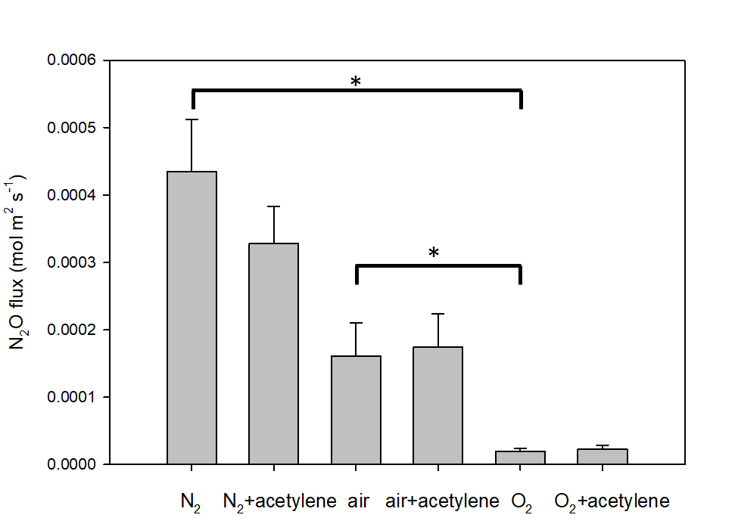

**Figure 2.** Maximum N2O production flux in from multiple profiles of two independent biofilms under different levels of O2 saturation (N2, air and O2) with and without acetylene, a nitrous oxide reductase inhibitor. There was no significant difference between independent replicates or with the addition of acetylene (P>0.05, 2 tailed t-test assuming equal variance, d.f. >8). The flux was significantly decreased under pure O2 compared to air and N2 (P<0.05, indicated by *). The surface of the biofilm is at 0 depth. Data are mean and 1 S.E., n=18.13 and 10 for N2, O2 and air respectively.

**O2 and NO3-****flux calculations**

The distribution of O2 and NO3- consumption by the colonies at steady state were calculated according to Fick’s first law of diffusion: J = Dc (∂c/∂x), where J is the flux (mol m-2 s-1), Dc is the molecular diffusion coefficient (m2 s-1), and ∂c/∂x, is the local concentration gradient (Schreiber *et al.*, 2010). The N2O profiles were converted to NO3- profiles using

$${{(NO}_{3}^{-})}_{x}={{(NO}_{3}^{-})}_{b}-\frac{D_{N2O}}{D_{NO3}} ×{\left(N_{2}O\right)}_{x}×Y$$

with ${{(NO}_{3}^{-})}_{x}$ as the local NO3- concentration, the NO3- concentration in the medium, $D_{N2O}$ the diffusion coefficient of N2O, the diffusion coefficient of NO3-, the measured local N2O concentration, and Y the stoichiometry of NO3-/N2O conversion (mole per mole). Assuming a Dc in water of 2.36x10-9 m2 s-1 for O2, 2.1x109 m2s-1 for N2O and 1.84x10-9 m2 s-1 for NO3- at 24°C (Li & Gregory, 1974, Versteeg & Van Swaaij, 1988), and correcting for an estimated reduced effective Dc (Deff) in the biofilm of approximately 58% and 60% respectively (Stewart, 2003). We used a concentration of 1.2 mM NO3-, approximating reported concentrations in CF sputum (Kolpen *et al.*, 2014). The local consumption rates of O2 and NO3- were then calculated from the microprofiles as described previously (Gieseke & de Beer, 2004). Subsequently, the local volumetric ATP formation rates were calculated from the local O2 and NO3- reduction rates, with 6.7 ATP/O2 and 4 ATP/NO3-, as reported previously (Chen & Strous, 2013).

**Replicates and statistical analysis**

We conducted a series of simultaneous measurements on five independent replicate biofilms on separate petri plates over multiple days. In our previous work we noted under air and N2 at steady state that although profiles were similar for each location they were not the same, likely due to differences in colony size and morphology, local nutrient and mass transfer conditions and activity of the bacteria within the biofilms (Schwermer *et al.*, 2022). A representative additional data set is provided in the supplement.

RESULTS

**O2 flux into the biofilm colony**

The O2 concentrations, controlled by sparging with air, pure O2 or N2, varied between 0.04 and 0.9 mM for the first measured biofilm (Figure 3, S1), corresponding to approximately 23 to 530 mm Hg. N2O was developed in the biofilm at all imposed O2 levels (Figure 3, S2), although it decreased when the bulk medium was sparged by pure O2. Immediately upon decreasing the O2 level in the bulk medium, the N2O levels, driven by NO3- reduction, increased again. Similar results were obtained for replicate experiments (Figs. S2 and S3). We did not detect a threshold concentration of O2 below which N2O was produced, rather there was a steady increase in N2O with a steady decline in O2.

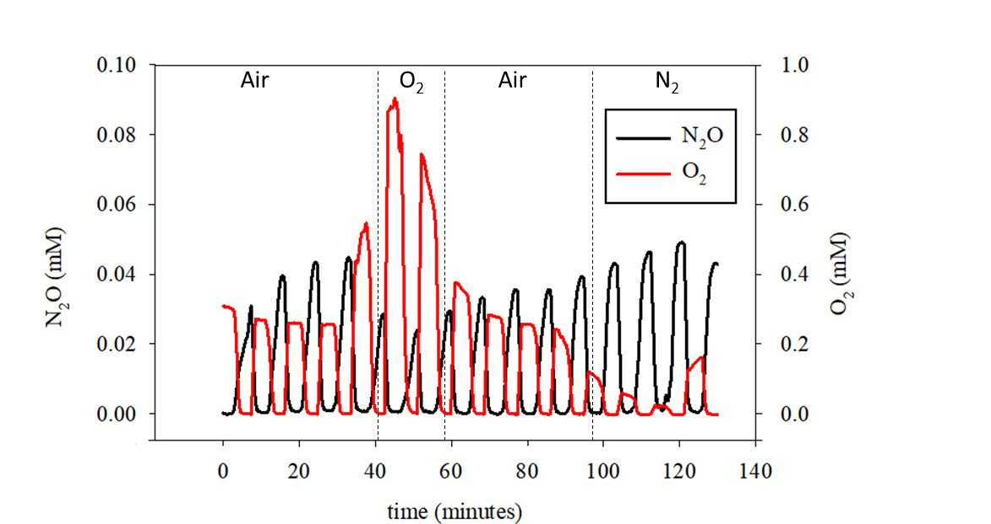

**Figure 3.** Time course of the O2 (red) and N2O (black) concentrations at approximately the same location within an agar colony biofilm. The first 4 profiles were measured under air saturation, then 3 profiles were recorded while the water column was sparged with pure O2, followed by 4 profiles under air saturation, and 3 profiles under N2 sparging. While pure O2 sparging suppressed N2O formation, it did not completely stop it.

Examples of O2 and NO3- microprofiles measured inside *P. aeruginosa* agar colony biofilms under different O2 levels (i.e., O2 oversaturation, air saturation and O2 undersaturation), are shown in Figure 4 and S2. The calculated O2 and NO3- reduction rates and ensuing ATP production show NO3- consumption in the oxic and in the anoxic zone. The O2 penetration depth was controlled by the O2 concentration in the bulk medium. At the highest imposed O2 levels, the NO3- consumption, and thus the coupled ATP production, decreased in the oxic zone. O2 penetrated even at elevated medium levels maximally 0.4 mm, leaving a large part of the biofilm anoxic. At an O2 concentration of ~ 40 µM O2, approximately 50 µM NO3- was produced. This O2 concentration is in the range for tissues (~13–90 µM; (Ast & Mootha, 2019)), and approximately 20% lower than defined hypoxia (<40 mm Hg). This is common for chronic wounds (Hopf & Holm, 2008). O2 penetrated only 0.05 mm, leaving most of the biofilm anoxic.



**Figure. 4.** Representative measured O2 (blue) and calculated NO3- profiles (red) under (a) O2 oversaturation with sparging pure O2, (b) air saturation and (c) O2 undersaturation with sparging pure N2 (c) in terms of concentration (left panels) and local ATP production rates calculated from O2 and NO3- reduction, respectively (right panels).

At decreased O2 concentrations in the bulk medium, denitrification became proportionally more important, as expected (Fig 5). During sparging with pure O2 , over 90% of the ATP in the biofilm was produced by O2 reduction, and when the O2 level dropped below 60 µM approximately 50% of the energy conservation was driven by NO3- reduction.



**Figure. 5.** ATP production rates integrated over the depth of the biofilm, with ATP production by O2 respiration (black), denitrification in the oxic zone (red), and denitrification in the anoxic zone (green).

The NO concentrations in the biofilm varied under different gas conditions (Fig. 6). The highest NO concentrations (~5 µM) were measured under air saturation. Under anoxia the NO concentrations were lower but still relatively high compared to reported physiological concentrations (~1 µM), and NO almost went to zero under pure O2 sparging.



**Figure. 6.** A) Averaged NO profiles in biofilm incubated under air saturation (red, n=4), pure O2 (blue, n=3) and anoxia under N2 (black, n=3) sparged medium over PAO1 cultures, and B) the corresponding O2 profiles. Mean and 1 standard deviation error bars

DISCUSSION

It was recently argued that a detailed description of the microenvironment of living microbial communities is essential for effective treatments of infections (Bjarnsholt *et al.*, 2022). More generally, this holds for understanding the actual behavior of all natural microbial communities. In the present study we used an agar plate colony biofilm model to investigate spatially and temporally resolved O2 and NO3- reduction rates, as well as NO production capability, and inferred energy conservation rates under varying oxygenation conditions. In our biofilms N2O was the sole product of denitrification and accumulated in the biofilm, despite the strain having the genetic capacity to reduce to N2 (Figure 2) (Vollack *et al.*, 1998). This suggests it is necessary to confirm inferences on physiological processes from genomic information by direct measurements. The accumulation of N2O during denitrification was shown to occur in *P. aeruginosa* cultures because of inhibition of nitrous oxide reductase by low levels of O2 (Betlach & Tiedje, 1981) as well as through quorum sensing under high cell densities (Kellermann et al., 2023). However, in our case we saw no effect of acetylene inhibition under anoxic conditions under N2, ruling this possibility out. The incomplete denitrification with N2O as the end product allowed us to base NO3- fluxes into the biofilm and bioenergetics of denitrification and O2 respiration on N2O concentrations and profiles.

The oxic status of the headspace influenced the absolute and relative rates of aerobic respiration and denitrification, and the response to changing headspace gases was relatively rapid occurring at the same location within minutes. When sparged with pure O2, aerobic respiration was greatly stimulated by a factor of 5; but some denitrification continued. Similar to previous work (Schwermer *et al.*, 2022), we found that even under O2 supersaturation the aerobic respiration rate was so high that anoxic conditions were still produced at the base of the colony, thus allowing denitrification. Since antibiotic susceptibility assays for facultative bacteria, such as *P. aeruginosa* are typically conducted in a humidified 5% CO2 incubator ([O2] ~ 180 µM) they may not accurately reflect the susceptibility *in vivo* of bacteria if present within a biofilm, as concluded previously (Martin *et al.*, 2023). Yet, in the oxic zone, denitrification was suppressed. When the bulk fluid was sparged with pure N2, denitrification was stimulated due to part of the community switching from aerobic to anaerobic respiration as the conditions became anoxic. The almost instantaneous increase of denitrification upon lowering the O2 level confirmed that the enzyme system responsible for denitrification was not damaged through oxygenation, but was only temporally inhibited(Bonin *et al.*, 1989). The bacteria within the biofilm were therefore able to switch their metabolism in response to changing oxic-anoxic conditions rapidly, in the range of seconds to minutes. However, another explanation is that under air and O2 supersaturation NO, the intermediate precursor to N2O, is oxidized by O2 ((Lewis & Deen, 1994)), and the removal of O2 contributes to the accumulation of NO and N2O. Thus under these high O2 concentration NO3- and NO2- reduction and the calculated ATP generation from N2O production may be underestimated.

Biological energy conservation in the form of ATP is not proportional to the thermodynamics of metabolic process, but depends on the number of translocated protons per electron pair shuttled through the electron transport chains (Chen & Strous, 2013). With O2 as terminal e-acceptor, 20 protons are translocated per electron pair, while with NO3- 12 protons. As the ATP/H+ stoichiometry is 3 per O2 respired 6.7 ATP is formed, while per NO3- only 4 ATP are formed. Consequently, although O2 and NO3- respiration are thermodynamically close, at equal e-donor supply denitrification will result in lower growth rates than aerobic respiration, as indeed observed (Yang *et al.*, 2008). The lower growth rate by denitrification of *P. aeruginosa* PAO1 (Line *et al.*, 2014) compared to 1.5/hr (27 min doubling time) from aerobic respiration (Yang *et al.*, 2008) may lead to reduced susceptibility to antibiotics (Nguyen *et al.*, 2011, Stewart *et al.*, 2015). The doubling time of *P. aeruginosa* biofilm aggregates in CF sputum was estimated to range between 100 and 200 min. (Yang *et al.*, 2008). In chronic wounds hypoxia (< 40 mm Hg O2) is induced by damage to the vasculature, coagulation and consumption by inflammatory cells (Hopf & Holm, 2008). Hypoxia not only limits neutrophil activity against infecting bacteria but also fibroblast and many other host-mediated wound healing mechanisms (Hopf & Holm, 2008). Compounding the reduction of local oxygenation due to the inflict of a wound and the presence of bacterial biofilms that compete with host cells for O2 further depletes the local O2 concentration. Hyperbaric O2 is used to correct hypoxia in order to enhance wound healing (Tejada *et al.*, 2019) and has been clinically shown to reduce bacterial load by a small amount (Sanford *et al.*, 2018) and *in vitro* studies show an increased susceptibility to antibiotics, presumably through increasing metabolic activity (Jensen *et al.*, 2019). However, our data suggests that even if small aggregates of cells are present as seen clinically (Thaarup *et al.*, 2022), even under hyperbaric therapy localized regions of hypoxia may occur due to the high rate of respiration, even under O2 saturation. Biofilms may also induce local regions of hypoxia in the human CF lung as speculated from the expression of *P. aeruginosa* denitrification genes and supporting nitrate concentrations in samples collected from people with CF.(Hassett *et al.*, 2009, Line *et al.*, 2014) (Martin *et al.*, 2023)

Denitrification has other implications in the context of biofilm infections. It is documented that denitrification can lead to the accumulation of the physiologically relevant concentrations of NO (120-150 nM) in the anaerobic zones of biofilms (Schreiber *et al.*, 2010). This signaling molecule induces vasodilation, inhibits platelet adhesion, inhibits leukocyte adhesion to endothelia and scavenges the superoxide anions (Moncada *et al.*, 1988, McCall *et al.*, 1989). We found unexpectedly high levels of NO, especially at O2 levels typical for wounds and tissues (20-60 µM). NO levels peaked to 5 µM which is above the threshold for causing mammalian physiological effects (Cooper & Giulivi, 2007, Hall & Garthwaite, 2009), but over 3 orders of magnitude below the 2.73 mM found to be required to kill 90% of bacteria in *a P. aeruginosa* biofilm (Neufeld & Reynolds, 2016). Also, under anoxia NO levels were significant, but lower than at low oxygenation. NO was suppressed at high O2 levels. The NO maximum production we observed at moderate O2 levels (air sparged) may be explained by the balance between NO production by denitrification (intermediate accumulation enhanced by O2 as e-transfer to NO3- is reduced) and consumption by oxidation (first order to O2 levels) (Lewis & Deen, 1994). Thus at low O2 concentration NO is low due to efficient reduction to N2O, at high O2 concentrations NO is rapidly oxidized chemically, while at intermediate O2 concentration the production is optimal and degradation minimal. Interestingly, low dose NO is a known mediator of biofilm dispersal (Barraud *et al.*, 2015). We did observe by eye “clouds”, which we presumed to be a high density of released cells, “billowing” out from the biofilm after a few hours of nitrate addition. *In vivo* this could lead to spreading of an infection. However, the role of NO in both health and disease is complex (Lundberg & Weitzberg, 2022) and the impact of bacterially produced NO in localized infections remains to be elucidated. In future experiments it would be interesting to better correlate this observed phenomenon with NO concentrations within the biofilm.

Our novel approach on making simultaneous measurements at the same micro-location in a single colony allows measuring real-time responses to imposed system perturbations. Due to the technical complexity in setting up such experiments and colony-to-colony variability this technique does not lend itself well to obtain fully optimal replicate data for statistical analysis. However, we believe that our data on the transient response and relative contribution of denitrification and O2 respiration with respect to spatial distribution and bioenergetics provides insights into metabolic processes possible within facultative aerobic biofilms. Our main conclusion is that metabolic activity within a biofilm colony is strongly influenced by dissolved gases, and that the response in the microenvironment to a change in conditions is rapid. Although under air-saturating conditions the energy yield of aerobic respiration was much higher than that of anaerobic respiration, the relative contribution of energy yield from anaerobic respiration will increase with reducing O2 levels, as occurs in wounds and infections (Hopf & Holm, 2008). Increased mass transfer limitations, e.g. by thicker biofilms or reduced blood supply, will affect O2 reduction more than NO3- reduction, as NO3- concentrations are much higher than O2, and thus its penetration can be much deeper. Denitrification is thus important for energy generation of this pathogen. Secondly, the effect of O2 on the NO production by these pathogens may well explain the severity of PAO1 infections and understanding this effect will help finding an optimal treatment against infections.

CONCLUSIONS

1. Although *P. aeruginosa* PAO1 has the genetic potential to denitrify to N2 in our biofilm system N2O was allowed to accumulate in the biofilm as the endpoint product, likely due to cell signaling because of high cell density.
2. *P. aeruginosa* PAO1 biofilms can rapidly switch between aerobic oxidation and denitrification in response to changes in O2 concentrations allowing it to quickly adapt as dissolved gas conditions change.
3. *P. aeruginosa* PAO1 biofilms can rapidly consume O2, which *in vivo* may afford it the ability to compete with host mediated wound repair and impair the immune response, even under hyperbaric therapy.
4. The expected lower growth rate by denitrifying cells in the oxic and anoxic zones in the biofilm may render these populations less susceptible to antibiotics.
5. At moderate O2 concentrations as found in tissue and wounds, NO production is the highest and exceeding critical thresholds for physiological effects on host and biofilm, possibly influencing the pathogenicity of *P. aeruginosa*.

LIST OF FIGURES

**Figure 1.** Figure 1. A) Overview of the experimental set up showing the electrodes entering the reservoir containing the agar plate with the colony biofilm. B) Representative image of dissolved O2 and N2O microelectrodes positioned within a P. aeruginosa PAO1 colony at as close to the same position as possible. The biofilm colony surface was determined where the tips and shadows of the tips converged and from the signal response.

**Figure 2.** N2O profiles through an agar colony biofilm with and without acetylene, an inhibitor of nitrous oxide reductase, under N2, air or O2 showed no difference in the profiles, demonstrating that N2O rather than N2 was the primary endpoint of denitrification in our system. If N2 was the primary endpoint the addition of acetylene would be expected to cause a significant increase in N2O production. The surface of the biofilm is at 0 depth.

**Figure 3.** Time course of the O2 (red) and N2O (black) concentrations at approximately the same location within a colony biofilm. The first 4 profiles were measured under air saturation, then 3 profiles were recorded while the water column was sparged with pure O2, followed by 4 profiles under air saturation, and 3 profiles under N2 sparging. While pure O2 sparging suppressed N2O formation, it did not completely stop it.

**Figure. 4.** Representative O2 (blue) and NO3- profiles (red) measured under (a) O2 oversaturation with sparging pure O2, (b) air saturation and (c) O2 undersaturation with sparging pure N2 (c) in terms of concentration (left panels) and local ATP production rates calculated from O2 and NO3- reduction, respectively (right panels). At decreased O2 concentrations in the bulk medium, denitrification became proportionally more important, as expected (Fig 4). During sparging with pure O2 , over 90% of the ATP in the biofilm was produced by O2 reduction, and when the O2 level dropped below 60 µM approximately 50% of the energy conservation was driven by NO3- reduction.

**Figure. 5.** ATP production rates integrated over the depth of the biofilm, with ATP production by O2 respiration (black), denitrification in the oxic zone (red), and denitrification in the anoxic zone (green).

**Figure. 6.** A) Averaged NO profiles under air saturation (red, n=4), pure O2 (blue, n=3) and anoxia under N2 (black, n=3) sparged medium over PAO1 cultures, and B) the corresponding O2 profiles.

AUTHORS AND CONTRIBUTORS

ACKNOWLEDGEMENTS

CONFLICTS OF INTEREST

The authors declare that there are no conflicts of interest.

FUNDING INFORMATION

REFERENCES

Andersen K, Kjær T & Revsbech NP (2001) An oxygen insensitive microsensor for nitrous oxide. Sensors and Actuators B: Chemical 81: 42-48.

Ast T & Mootha VK (2019) Oxygen and mammalian cell culture: are we repeating the experiment of Dr. Ox? Nature Metabolism 1: 858-860.

Barraud N, J Kelso M, A Rice S & Kjelleberg S (2015) Nitric oxide: a key mediator of biofilm dispersal with applications in infectious diseases. Current pharmaceutical design 21: 31-42.

Bjarnsholt T, Whiteley M, Rumbaugh KP, Stewart PS, Jensen PØ & Frimodt-Møller N (2022) The importance of understanding the infectious microenvironment. The Lancet Infectious Diseases 22: e88-e92.

Bonin P, Gilewicz M & Bertrand J (1989) Effects of oxygen on each step of denitrification on *Pseudomonas nautica*. Canadian Journal of Microbiology 35: 1061-1064.

Chen J & Strous M (2013) Denitrification and aerobic respiration, hybrid electron transport chains and co-evolution. Biochimica et Biophysica Acta (BBA) - Bioenergetics 1827: 136-144.

Cooper CE & Giulivi C (2007) Nitric oxide regulation of mitochondrial oxygen consumption II: molecular mechanism and tissue physiology. American Journal of Physiology-Cell Physiology 292: C1993-C2003.

Cui X, Ruan X, Yin J, Wang M, Li N & Shen D (2021) Regulation of las and rhl quorum sensing on aerobic denitrification in *Pseudomonas aeruginosa* PAO1. Current Microbiology 78: 659-667.

Davies KJ, Lloyd D & Boddy L (1989) The effect of oxygen on denitrification in Paracoccus denitrificans and *Pseudomonas aeruginosa*. Microbiology 135: 2445-2451.

Debats IB, Booi D, Deutz NE, Buurman WA, Boeckx WD & van der Hulst RR (2006) Infected chronic wounds show different local and systemic arginine conversion compared with acute wounds. Journal of Surgical Research 134: 205-214.

Gao H, Schreiber F, Collins G, Jensen MM, Kostka JE, Lavik G, de Beer D, Zhou HY & Kuypers MMM (2010) Aerobic denitrification in permeable Wadden Sea sediments. Isme Journal 4: 417-426.

Gieseke A & de Beer D (2004) Use of microelectrodes to measure in situ microbial activities in biofilms, sediments, and microbial mats. Molecular microbial ecology manual 2: 1581-1612.

Hall CN & Garthwaite J (2009) What is the real physiological NO concentration in vivo? Nitric Oxide 21: 92-103.

Hassett DJ, Sutton MD, Schurr MJ, Herr AB, Caldwell CC & Matu JO (2009) *Pseudomonas aeruginosa* hypoxic or anaerobic biofilm infections within cystic fibrosis airways. Trends in microbiology 17: 130-138.

Hong WX, Hu MS, Esquivel M, Liang GY, Rennert RC, McArdle A, Paik KJ, Duscher D, Gurtner GC & Lorenz HP (2014) The role of hypoxia-inducible factor in wound healing. Advances in wound care 3: 390-399.

Hopf HW & Holm J (2008) Hyperoxia and infection. Best Practice & Research Clinical Anaesthesiology 22: 553-569.

Jensen P, Møller S, Lerche C, Moser C, Bjarnsholt T, Ciofu O, Faurholt-Jepsen D, Høiby N & Kolpen M (2019) Improving antibiotic treatment of bacterial biofilm by hyperbaric oxygen therapy: Not just hot air. Biofilm 1: 100008.

Kolpen M, Kühl M, Bjarnsholt T, Moser C, Hansen CR, Liengaard L, Kharazmi A, Pressler T, Høiby N & Jensen PØ (2014) Nitrous oxide production in sputum from cystic fibrosis patients with chronic *Pseudomonas aeruginosa* lung infection. PloS one 9: e84353.

Lewis RS & Deen WM (1994) Kinetics of the reaction of nitric oxide with oxygen in aqueous solutions. Chemical research in toxicology 7: 568-574.

Li Y-H & Gregory S (1974) Diffusion of ions in sea water and in deep-sea sediments. Geochimica et cosmochimica acta 38: 703-714.

Line L, Alhede M, Kolpen M, Kühl M, Ciofu O, Bjarnsholt T, Moser C, Toyofuku M, Nomura N & Høiby N (2014) Physiological levels of nitrate support anoxic growth by denitrification of *Pseudomonas aeruginosa* at growth rates reported in cystic fibrosis lungs and sputum. Frontiers in microbiology 5: 554.

Lundberg JO & Weitzberg E (2022) Nitric oxide signaling in health and disease. Cell 185: 2853-2878.

Martin LW, Gray AR, Brockway B & Lamont IL (2023) *Pseudomonas aeruginosa* is oxygen-deprived during infection in cystic fibrosis lungs, reducing the effectiveness of antibiotics. FEMS Microbiology Letters 370: fnad076.

Martin LW, Gray AR, Brockway B & Lamont IL (2023) *Pseudomonas aeruginosa* is oxygen-deprived during infection in cystic fibrosis lungs, reducing the effectiveness of antibiotics. FEMS Microbiology Letters fnad076.

McCall TB, Boughton-Smith NK, Palmer R, Whittle B & Moncada S (1989) Synthesis of nitric oxide from L-arginine by neutrophils. Release and interaction with superoxide anion. Biochemical Journal 261: 293.

Moncada S, Radomski MW & Palmer RM (1988) Endothelium-derived relaxing factor: identification as nitric oxide and role in the control of vascular tone and platelet function. Biochemical pharmacology 37: 2495-2501.

Neufeld BH & Reynolds MM (2016) Critical nitric oxide concentration for Pseudomonas aeruginosa biofilm reduction on polyurethane substrates. Biointerphases 11.

Nguyen D, Joshi-Datar A, Lepine F, et al. (2011) Active starvation responses mediate antibiotic tolerance in biofilms and nutrient-limited bacteria. Science 334: 982-986.

Sanford NE, Wilkinson JE, Nguyen H, Diaz G & Wolcott R (2018) Efficacy of hyperbaric oxygen therapy in bacterial biofilm eradication. Journal of Wound Care 27: S20-S28.

Schreiber F, Stief P, Gieseke A, Heisterkamp IM, Verstraete W, de Beer D & Stoodley P (2010) Denitrification in human dental plaque. BMC biology 8: 1-11.

Schwermer CU, de Beer D & Stoodley P (2022) Nitrate respiration occurs throughout the depth of mucoid and non-mucoid *Pseudomonas aeruginosa* submerged agar colony biofilms including the oxic zone. Scientific Reports 12: 8557.

Stewart PS (2003) Diffusion in biofilms. Journal of bacteriology 185: 1485-1491.

Stewart PS, Ghannoum M, Parsek M, Whiteley M & Mukherjee P (2015) Antimicrobial Tolerance in Biofilms. Microbiology Spectrum 3: 3.3.07.

Stewart PS, Zhang T, Xu R, Pitts B, Walters MC, Roe F, Kikhney J & Moter A (2016) Reaction–diffusion theory explains hypoxia and heterogeneous growth within microbial biofilms associated with chronic infections. NPJ Biofilms and Microbiomes 2: 1-8.

Tejada S, Batle JM, Ferrer MD, Busquets-Cortés C, Monserrat-Mesquida M, Nabavi SM, del Mar Bibiloni M, Pons A & Sureda A (2019) Therapeutic effects of hyperbaric oxygen in the process of wound healing. Current Pharmaceutical Design 25: 1682-1693.

Thaarup IC, Iversen AKS, Lichtenberg M, Bjarnsholt T & Jakobsen TH (2022) Biofilm Survival Strategies in Chronic Wounds. Microorganisms 10: 775.

Tolker‐Nielsen T (2014) *Pseudomonas aeruginosa* biofilm infections: from molecular biofilm biology to new treatment possibilities. Apmis 122: 1-51.

Versteeg GF & Van Swaaij WP (1988) Solubility and diffusivity of acid gases (carbon dioxide, nitrous oxide) in aqueous alkanolamine solutions. Journal of Chemical & Engineering Data 33: 29-34.

Vollack K-U, Xie J, Härtig E, Römling U & Zumft WG (1998) Localization of denitrification genes on the chromosomal map of *Pseudomonas aeruginosa*. Microbiology 144: 441-448.

Wu Y-K, Cheng N-C & Cheng C-M (2019) Biofilms in chronic wounds: pathogenesis and diagnosis. Trends in biotechnology 37: 505-517.

Yang L, Haagensen JA, Jelsbak L, Johansen HK, Sternberg C, Høiby N & Molin S (2008) In situ growth rates and biofilm development of *Pseudomonas aeruginosa* populations in chronic lung infections.. Am Soc Microbiol. 2767-2776,

**Supplementary Material**

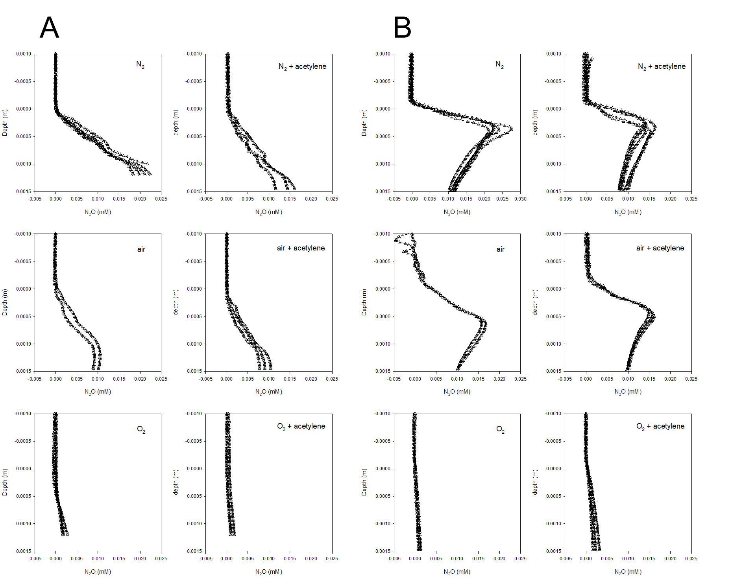

**Supplementary figure 1:**  Multiple N2O profiles in independent biofilms (A and B) under different oxygen saturation levels (N2, air, and O2) with (left column) and without (right column) acetylene, a nitrous oxide reductase inhibitor. Differences in the profile shapes in the two biofilms are due to differences in thickness.

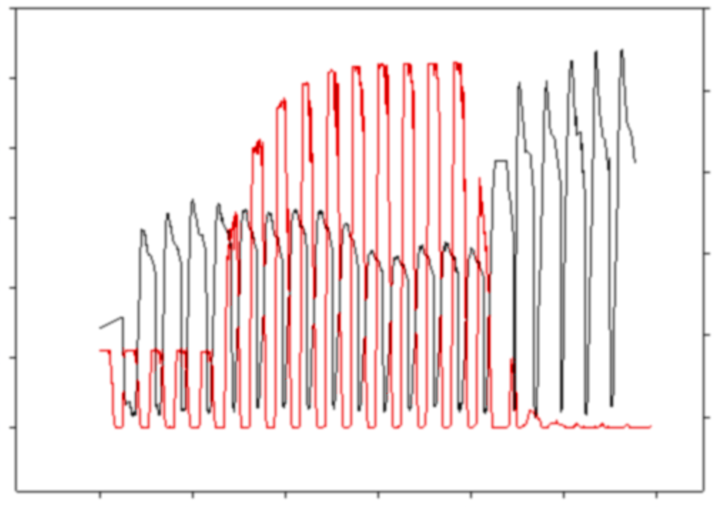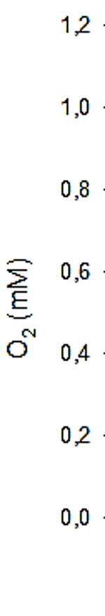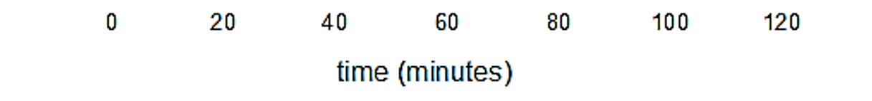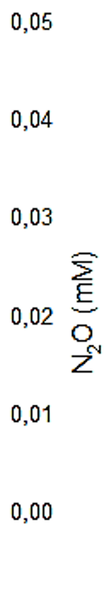

Air

O2

N2

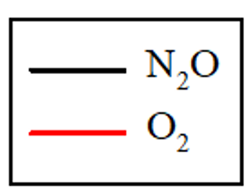

**Supplementary figure 2.** Time course from a replicate experiment, showing the O2 (red) and N2O (black) concentrations during profiling. The first 3 profiles were measured under air saturation, then 10 profiles were recorded while the water column was sparged with pure O2, followed by 8 profiles under N2 sparging.



|  |  |
| --- | --- |
|  |  |
|  |  |

**Supplementary figure 3:**  Representative O2 (blue) and NO3- profiles (red) extracted from the profiles shown in Fig. S2. Profiles were measured under (a) air saturation, (b) O2 oversaturation by sparging pure O2 and (c) O2 undersaturation by sparging pure N2 (c) in terms of concentration (left panels) and local ATP production rates calculated from O2 and NO3- reduction, respectively (right panels).