An Algorithmic Approach for Quantitative Motion Artefact Grading in
HRpQCT Medical Imaging
Thomas Cox^{1a}, Sasan Mahmoodi^{1b}, Nicholas C Harvey ^{c}, Rebecca J Moon^{2d}, Kate Ward^{2e}, Leo D Westbury²
2
f
¹ Faculty of Engineering and Physical Sciences, Electronics and Computer Science, University of Southampton, University Road, Southampton, UK,² MRC Lifecourse Epidemiology Centre, University of Southampton, Southampton, UK tc3u18@soton.ac.uk, sm3@ecs.soton.ac.uk, nch@mrc.soton.ac.uk
Keywords: Medical Imaging, HRpQCT, Motion Artefact, Artefact Detection
Abstract: High Resolution Peripheral Quantitative Computed Tomography (HRpQCT) is a modern form of medical imaging that is used to extract detailed internal texture and structure information from non-invasive scans. The greater resolution means HRpQCT images are more vulnerable to motion artefact than other existing bone imaging methods. Current practice is for scan images to be manually reviewed and graded on a 1 to 5 scale for movement artefact. Analysis of scans with the most severe grades of movement artefact may not be possible. Various approaches to automatically detecting motion artefact in HRpQCT images have been described, but these typically rely on classifying scans based on the qualitative manual gradings instead of determining the amount of artefact. This paper describes research into quantitatively calculating the degree of motion affecting an HRpQCT scan. This is approached by analysing the jumps and shifts present in the raw projection data produced by the HRpQCT instrument, rather than using the reconstructed cross-sectional images. The motivation and methods of this approach are described, and results are provided, along with comparisons to existing work.

BACKGROUND
There are various radiographic clinical methods which allow clinicians to understand overall bone health and detect and diagnose osteoporosis, a condition characterized by low bone mineral density and microarchitectural deterioration in bone structure. The current gold standard method is using Dual-Energy X-ray Absorptiometry (DXA), which is used to calculate areal bone mineral density (BMD). This measurement is currently used in the definition of osteoporosis, but provides no detail on the microstructure of bone. High Resolution Peripheral Qualitative Tomography (HRpQCT) is a modern computed tomography (CT) technique for acquiring highly detailed structural and texture information of bones. In contrast to DXA which generates only a two dimensional image of the skeleton, HRpQCT provides a three dimensional reconstruction of the internal structure of the subject’s bones, which is used to derive further quantitative parameters. The unparalleled resolution and detail of
ª https://orcid.org/0000-0002-1343-8306 ^{b} https://orcid.org/0000-0000-0000-0000 ^{c} https://orcid.org/0000-0002-8194-2512 ^{d} https://orcid.org/0000-0003-2334-2284 ^{e} https://orcid.org/0000-0001-7034-6750 ^{f} https://orcid.org/0009-0008-5853-8096
HRpQCT scans comes at the cost of high sensitivity to motion artefact. Motion artefact in CT scans is different to what is traditionally considered motion artefact in regular images. Whilst motion during traditional photography may appear as a blurring or smearing of the subject, motion artefact in CT scans appears as tangential streaking and a distorted view of the subject. Figure 2 shows an example of this.
Currently, motion artefact in HRpQCT scans is manually graded using a scale from one to five. A grade of one represents no motion artefact, and a grade of five means the scan has an extreme amount of motion artefact. According to the standard operating procedure provided by the hardware manufacturer (Scanco Medical), it is recommended that scans with a motion grade of four or five are excluded from analysis in research studies (Laib, 2023). Previous research suggests that there is a high level of agreement between trained manual graders (Spearman correlation of ρ_{s} = 0.85), but it remains a subjective measure, and does not provide a continuous scale of artefact severity (Pauchard et al., 2012).
The negative impact of motion artefact on
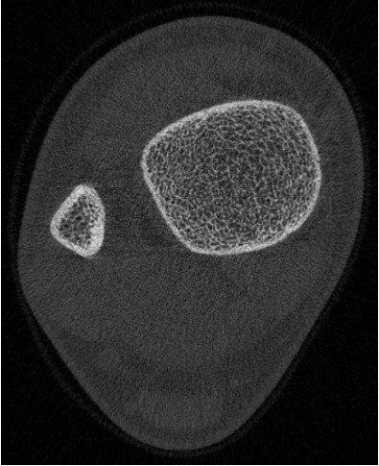
Figure 1: An example of a single 2D slice from a tibial HRpQCT scan. The bright white lines around the edge of the bones is the cortex, while inside of this the trabecular structure can be seen
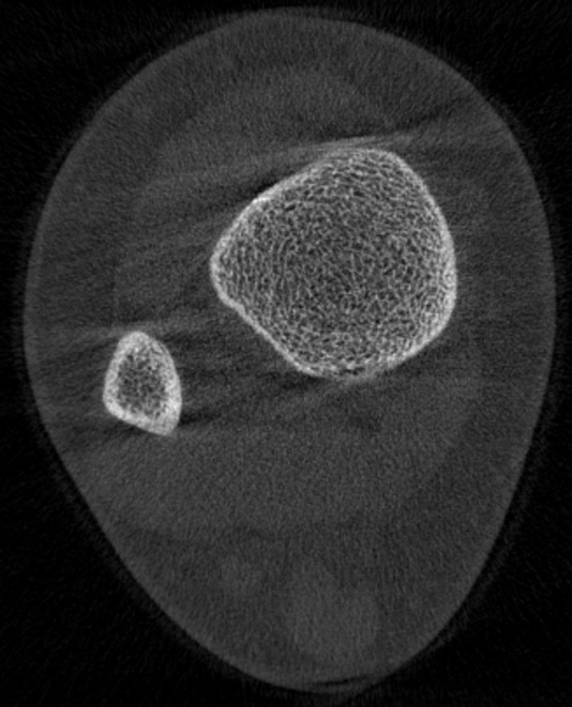
Figure 2: An example of a single 2D slice from a tibial HRpQCT scan with a high level motion artefact. This image has been manually graded with a motion artefact score of 5. Streaking can clearly be seen across the image tangential to the top and bottom of the bones. Additionally the cortex of the tibia can be seen to be distorted as it does not connect together at the top and bottom correctly compared to Figure 1 for an image without motion artefact.
HRpQCT parameters has been investigated in both the scaphoid (Benedikt et al., 2023) and the tibia (Pauchard et al., 2011). Benedikt et al compared scaphoid bone parameters derived from HRpQCT scans of the same patients with and without movement, while Pauchard et al compared images of cadaveric tibiae using a machine to precisely induce movement. Both studies were able to demonstrate significant deviation in HRpQCT derived parameters, highlighting the importance of considering motion artefact while examining these scans.
There has been a wealth of previous research into automatic motion artefact detection in HRpQCT scans, and in the field of motion correction for CT scans in general. Walle et al. constructed and trained a deep convolutions neural network trained on 3312 2D slices taken from 414 manually graded HRpQCT scans. This model was able to successfully differentiate scans graded ≤3 from graded >3,which would require exclusion or a repeated scan, resulting in an f1, precision and recall of 86.8, 87.5 and 86.7 respectively. However, the authors recognised that the performance of this model was lower when classifying the scans by grade with an f1 score of 43.4 due to their model often missclassifying by one artefact grade (Walle et al., 2023). The subjective nature of the manual grading makes it impossible for a network trained using that data to provide a completely objective motion artefact score.
Other researchers have been using convectional neural networks to classify artefact in other types of CT images. In a study identifying motion artefact in head CT scan images, Liu et al. developed a graph based approach whereby 2D slices of cranial CT scans were converted into a complex graph and then used to train a convolution neural network to classify scans into those affected by motion artefact or unaffected. From the construction of these graphs, they demonstrated significant differences in graph node clustering and degree between the two groups of scans, and when trained they showed the model outperformed traditional pixel based learning methods (Liu et al., 2022).

ANALYSING HRPQCT SINOGRAMS

The Radon Transform
Before a radiologist can evaluate a CT image, the raw projection data needs to be processed and transformed to produce a cross sectional slice of the subject. CT instruments are able to do this by emitting X-rays through the subject at many different angles measuring the ”shadow” cast by the internal parts of the object at each angle. At each of these different angles the X-rays will pass through different planes through the subject, and result in different “shadows” or projections of these planes. By combining these projections by using the Radon transform (also known as back projection), the scanner can produce a cross sectional image of the subject such that the internal structure of their bones can be analysed. The raw projection data from a CT scan is known as a sinogram, as off-centre objects in the subject will appear to oscillate as the scanner rotates around them. An example sinogram from a single 2D slice is shown in Figure 3. The Xtreme CT II (XCT II) scanner takes all 110 2D slices over an area of the subject simultaneously and gradually rotates 180◦ around the subject, constructing a sinogram for each slice row by row. Because of this, each row of the sinogram represents a projection taken of the subject from a given angle. In Figure 3 there are three distinct objects: the soft tissue of the leg appearing in light grey, and inside of this there are two darker crossing sections representing the bones. The wider section is the tibia and the narrower section is the fibula. Towards the top of the scan, the tibia and fibula appeared to overlap as the angles those rows were captured at the x-rays passed through both bones. In other words, the scan began with a side on view of the leg but about half way down the scan, the tibia and fibula stop overlapping, and in each row there are two distinct darker patches where there is bone. This is because after the scanner has rotated halfway through the scan, x-rays either pass though one bone or the other, effectively meaning that once the scanner has rotated halfway through the scan (about 90◦) it is projecting a side on view of the leg. Once the scanner has finished rotating around the subject and has all 110 full sinograms, it applies the Radon transform to each one resulting in the cross sectional HRpQCT image shown in Figure 2. The Radon transform effectively maps and combines each row of the sinogram onto a different diameter of a circle, reconstructing the image into a cross section. It is able to extract depth information by the amplitudes of the vertical sine waves in the sinogram. If there was a circular object directly at the centre of the scan, it would remain in the same horizontal position in each row of the sinogram. The further away from the centre a circular object is, the greater its position will vary in different rows of a sinogram.
Additional research that deals with detecting motion artefact in HRpQCT scans focuses on properties of these sinograms, as in these images, motion artefact is much clearer. As each angle of the sinogram is taken sequentially, the vertical axis can be treated as time. Therefore if a subject moves half way through a scan, the sinogram should show motion artefact in the rows in the middle of the sinogram. Figure 3 shows an example of a sinogram with motion artefact. In this sinogram the subject has moved their leg near the beginning of the scan, so when the scanner moves on to subsequent angles, the positions of their soft tissue and bones seem shifted to the side. The single jump shown in Figure 3 is what causes the artefact shown in Figure 2, as the rows in the radon transform no longer agree on where objects are, causing streaking and disconnects in the edges of the bones.

Artefact Detection
By inspecting sinograms, motion artefact is much easier to understand. Artefact is seen simply as the amount that the sinogram jumps or shifts, which begins to provide a way of quantitatively measuring the amount of motion in a HRpQCT image. Pauchard et al have proposed a method to automatically quantify motion artefact based on the first and second moments of the sinogram (Pauchard et al., 2011). The authors show that these moments which they use to calculate the in plane translation during the scan are accurate when compared to experiments where a scan is taken of a sample with controlled motion.
Sode et al. also use HRpQCT sinograms to implement a quantitative way of measuring the motion artefact (Sode et al., 2011). The authors exploited the nature of the sinogram in order to compare the first and last lines and determine the net difference. This is effective as the HRpQCT scanner emits X-rays through just over a 180◦ range. As such, the rows at the top of the sinogram, at around 0◦, should mirror those at the bottom, at around 180◦, as they represent projections of the subject from the opposite side. Given this, assuming the subject has not moved during the duration of the scan, the difference between the top and bottom rows of the sinogram should be minimal. Conversely, if the subject has shifted, these will be noticeably different. This process is however complicated by the nature in which the XCT II scanner emits X-rays; the cone beam configuration causes slight magnification of the subject to different extents at 0◦ and 180◦. Sode et al were able to correct this by transforming the sinogram from the cone beam domain (where X-rays are emitted in a cone from a single point) to the parallel beam domain, as if the X-rays were emitted equally spaced and in parallel. After performing this transformation, they showed that their Quantitative Motion Estimates (QMEs), derived from the sum of the squared difference between the top and bottom rows of the sinogram, correlate with the manual grades given to HRpQCT images. HRpQCT images with a grade of 5 have significantly increased QMEs that those with lower artefact grades.
This method is effective at detecting overall motion during the scan. However it has two major drawbacks. First, it only determines the net motion between the start and end of the scan. Thus, if a subject was to twitch, briefly moving and then moving back, it is possible that this method would result in a mislead-
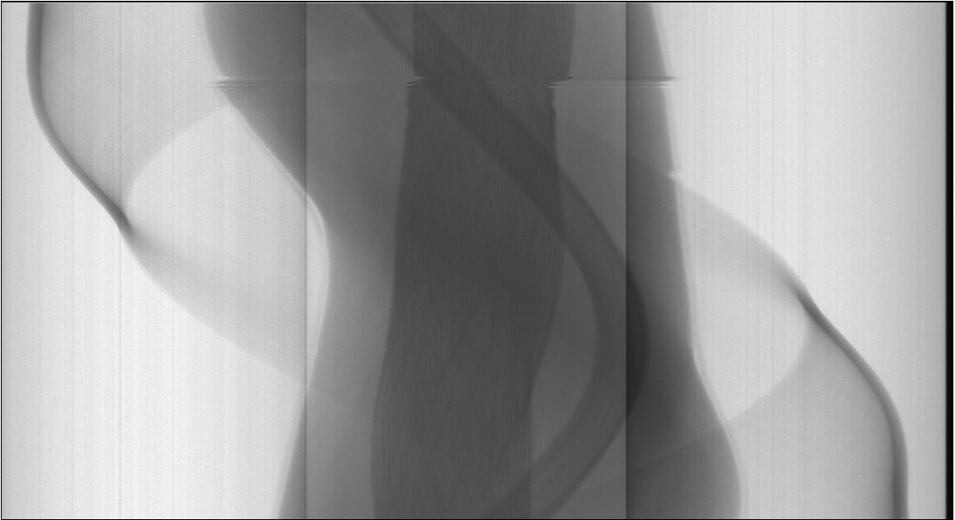
Figure 3: An example sinogram from a slice of a tibial HRpQCT scan with motion artefact. Each row of the scan represents an angle where X-rays were passed through the subject. The pixels in a given row show the projection created by a plane of X-rays passing though the subject’s leg at a given angle. Here a clear jump can be seen roughly a quarter of the way down the scan, this represents where the subject has moved and their leg is now in a different location. This jump is the cause of the
motion artefact seen in Figure 2.
ing low to zero QME, as their method only considers the net difference between the first and last lines of the sinogram. Second, this method provides no means of detecting where or when the jumps occurred during the scan, and therefore does not assist in correcting the artefact. Sode et al also address the fact that while there is a difference in QME derived from scans with a manual quality grade of 5, the QMEs overlap for scans graded between 1 and 4. The authors attribute this in part to the subjective nature of manual grades, but we hypothesis that it is also caused by the global nature of the way their QMEs are calculated. In Section 3, we discuss our proposed strategy for detecting all motion that occurs throughout a sinogram.

IMPLEMENTATION
We initially tried to detect motion artefact entirely algorithmically in the sinogram by using a combination of edge detection and the Hough transform. However we found that the edges were simply too faint in comparison to the CT noise to accurately detect this. This method relied on detecting horizontal lines across the image where “jumps” had occurred, as seen near the top of Figure 3. Unfortunately, where jumps occurred, due to the nature of trabecular bone, there were little to no pixel to pixel differences between lines around the jump, resulting in failure in both edge and ridge detection. Nonetheless, using this method, in conjunction with the Hough transform with tuned parameters, would often detect small segments of lines where jumps occurred along the edges of the bone. Still, we found it difficult to ensure that these jumps were accurately detected in the presence of noise without over-smoothing the image and losing edge information.
Realizing the main indicators of a jump occurring were most evident along the edge of the bones, we began working on detecting and tracing the six major vertical edges of the image, corresponding to the edges of the soft tissue, tibia and fibula. Our motivation was that if we could extract traces of these sinusoidal edges, we would be able to detect where anomalies or jumps occurred in each edge. Then having detected these anomalies in the same place on sufficient edges, we would be able to confidently say that a jump had occurred at that location. With this method, severity and direction of the shift would also be detected by analysing how much the edge deviated from its sinusoidal pattern. This approach has motivated the remainder of our research into motion artefact detection and correction as it should be able to accurately detect where in a sinogram jumps have occurred, as well as measure the severity of each jump independently. This approach will be beneficial both for automatically calculating a quantitative measure of motion artefact in the scan, and to subsequently inform how individual shifts can be corrected or reduced. Initially we used a simple canny edge detection algorithm to detect and trace these six major edges; however, too much noise was included in the traces to allow for accurate detection of where
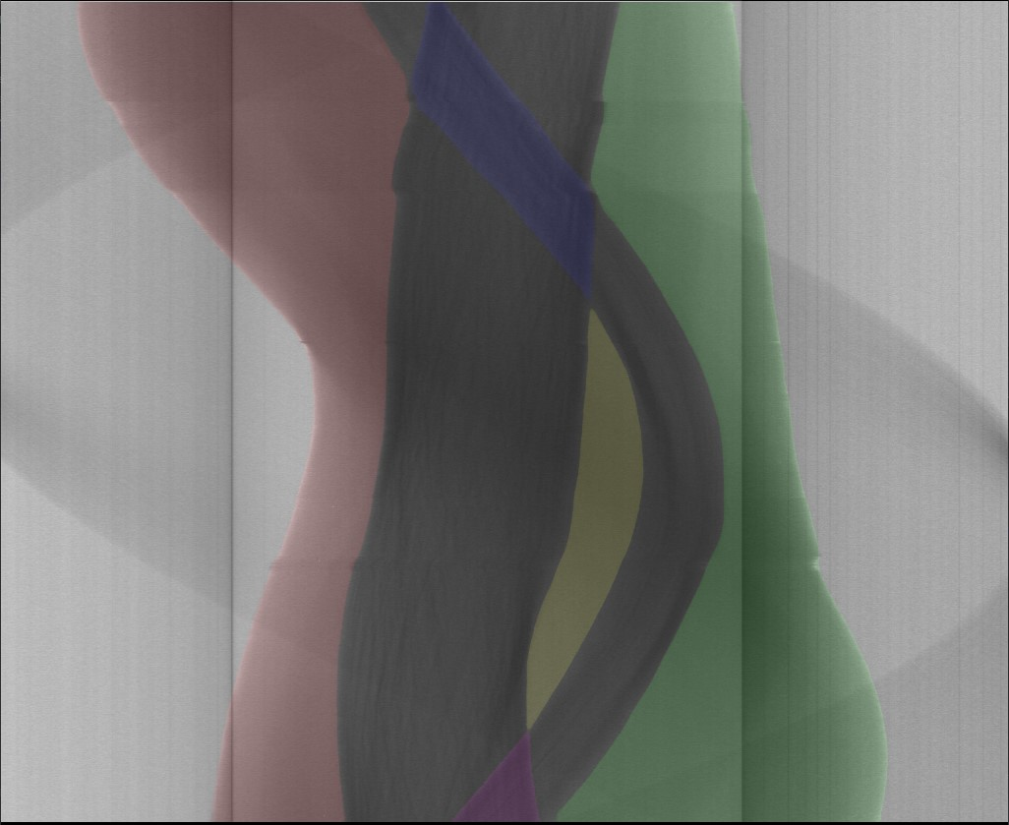
Figure 4: Here an overlay of masks predicted by our U-Net model for the distinct segmented areas in a HRpQCT sinogram is shown. The areas segmented in this image, shown in different colours, accurately trace out the appropriate areas even where motion artefact has occurred during the scan. The scan shown here was manually assigned a motion artefact grade of five.
anomalies occurred. To solve these problems, we segmented the sinograms though machine learning to quickly and accurately find the traces of the edges needed.

U-Net Segmentation
In order to accurately segment the sinogram images, we used the state of the art U-Net architecture. U-Net is a fully convectional neural network that is widely used for CT and other biomedical imaging tasks due to its fast training speed and high accuracy even with comparatively low amounts of data (Yin et al., 2022). Before we could begin training a U-Net model to segment our HRpQCT sinograms, we split the combined scans from the MAVIDOS and SWS cohorts equally into a training and testing group. Then to increase the amount of data we had available, it was decided to sample three random slices from each HRpQCT scan in the training set and treat them as separate images. While different slices of the same scan will be similar, we hypothesised that the differences caused by viewing a different section of bone should increase the data without the risk of over fitting. This resulted in a training sample of 1,110 different sinogram slices. We manually masked 600 of these sinograms in order to gather some preliminary results and determine whether U-Net segmentation would be effective.
With this training sample, we constructed a U-Net model in python with Keras using the segmentation methods library. As a proof of concept, this used the default U-Net construction of 4 encoding and 4 decoding layers. We defined the loss function using a combination of categorical focal loss and dice loss, used a softmax activation function to assign each pixel to its appropriate mask/class. Once the network was constructed, we trained it on the labeled HRpQCT sinograms for 80 epochs with a learning rate of 0.00001 and a batch size of 10 images. After 80 epochs of training, the network reached a loss of 0.0512, an intersection over union score of 0.9154 and an f1-score of 0.9492. Once we were satisfied that it was accurate, we began predicting masks for the sinograms in the test set and were able to confirm that the network was automatically masking images correctly. An example of the output masks that the model predicted for an image with high motion artefact is shown below in Figure 4. As seen in the figure we segmented the sinogram into five main areas: left and right soft tissue, central soft tissue between the tibia and fibula, and where the tibia and fibula overlap at the top and bottom of the sinogram. By segmenting these areas we ensured that every edge was captured by at least one of these segments, ensuring that we can capture any distortion caused by motion artefacts in these masks.
From visual inspection of the results produced by our U-Net model for the testing set, we determined that jumps and shifts in the sinogram were being captured by the masks. Our next challenge was developing an algorithm to piece together traces of the six major edges in the image from these masks. We began by using a simple Canny filter to extract the edges from each of the masks. Then after combining the edges into one image, such as the image shown in Figure 5, our algorithm detects the points where each of the masks get closest to each other to find the points where the edges of the tibia and fibula would intersect in the image. Then it splices together the appropriate parts of each of the edges around these points in order to construct the six major edge traces which are displayed in Figure 6. This figure in fact shows the distance between each of the traces and the vertical centre line of the sinogram.
Figure 5: This figure shows a combined image of all of the edges detected from masks produced by U-Net. In order to convert these edges into the actual edges of the subjects leg, tibia and fibula, our algorithm detects where the edges would cross and splices together edges at these points to construct the edge signals shown in 6.
One disadvantage of the method used to segment the sinograms is that our algorithm will fail to capture any motion artefact in the unlikely case that it occurs in a sinogram exactly where the edges of the tibia and fibula intersect. In future it may be possible to retrain the U-Net with images where the soft tissue, tibia and fibula are segmented more directly, but it would require manually tracing some edges multiple times plus more segmentation regions where the tibia and fibula overlap. For the time being we have accepted this as a shortcoming of our current approach but any net shift in these regions should still be detected.
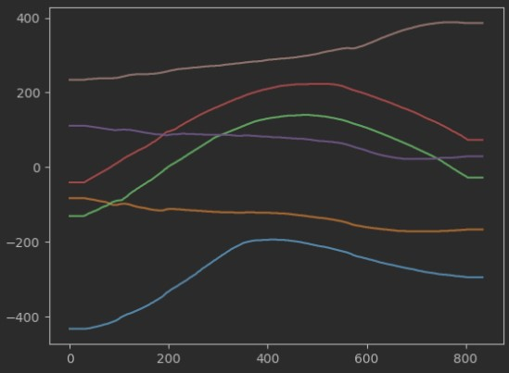
Figure 6: This figure shows the edge traces captured from the masks shown in 4. Each different coloured curve in the image plots the distance between each of the traces and the vertical center line of the sinogram, where the horizontal axis shows the row of the sinogram, and the vertical axis shows the distance. The lines are constant at the beginning and end of the plot where the traces were cropped in order to make the edge detection more robust.

PRELIMINARY RESULTS
As shown in Figure 6, shifts and jumps in a sinogram slice of an HRpQCT scan can be captured via examining edge traces, even when the disruption to the edge is very small. Although the original HRpQCT scan shown in Figure 4 has been assigned a motion artefact grade of 5 and has pronounced discontinuities, the peaks and troughs detected from the edge traces are quite smooth by comparison. Nonetheless we implemented a simple anomaly detection algorithm, where we detected where local peaks and troughs occurring in each signal and measured their prominences. Then to create a simple quantitative measure of motion artefact that occurred in the image, we summed up the prominences at each location across all six of the edges, and set a threshold to determine that if more than one edge agreed, there is a shift or jump at a particular location. This gives a list of locations and prominences for where motion artefact had occurred in the sinogram, which we summed to derive an estimate of how much motion had occurred in a sinogram slice. Subsequently, for 600 images in the test set, U-Net was used to predict masks and capture edge traces and calculate a quantitative motion artefact estimate, as described above. Figure 8 shows the range of grades this algorithm assigned to the test sinograms organized by the pre-assigned manual motion artefact grading. While this figure does show that our rudimentary algorithm gives a larger number of high scores to sinograms from images with a higher manual motion artefact grade, it also suggests that many of the images with high manual grade motion artefact are given very low motion artefact estimates. We had hoped to produce a similar diagram to that by Sode et al. showing a correlation between our motion estimates and the manual grades, however, it appears as though many instances of motion artefact are not being appropriately detected. We are hopeful that through refinement of our algorithm, we will be able to use the edge traces we extracted to better detect motion artefact.
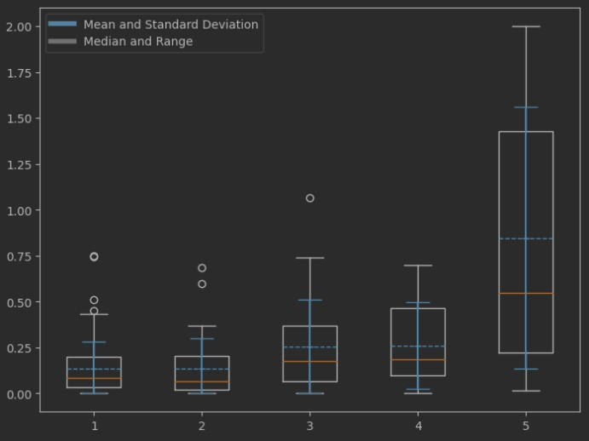
Figure 7: This plot shows the spread and means of motion artefact estimates our algorithm assigned to sinograms from the testing set, organized by their manually assigned quality scores. While there is some correlation showing that scans with a high motion artefact grade receive higher estimated scores,

DISCUSSION
Our numerical results clearly demonstrate a superior performance for our algorithm in motion artefact detection in comparison with the previous work in (Sode et al., 2011). Specially in scans with motion artefact of grade 5, our results show a significant separation between motion artifacts of grade 5 with the other motion artefact levels. . The main limitation of the current algorithm is that it has assigned low scores to scans that visually appear to have high levels of motion artefact. From inspection of the algorithm’s results, the main cause of this missclassification is when the current anomaly detection method fails to detect jumps in the sinogram. We aim to improve the algorithm by retraining our U-Net model with larger number of samples to improve the segmentation accuracy and capture the edges more accurately. , But nonetheless our current algorithm shows promising results. This feature of our algorithm will form the basis for subsequent approaches to correct motion artefact in HRpQCT scans.
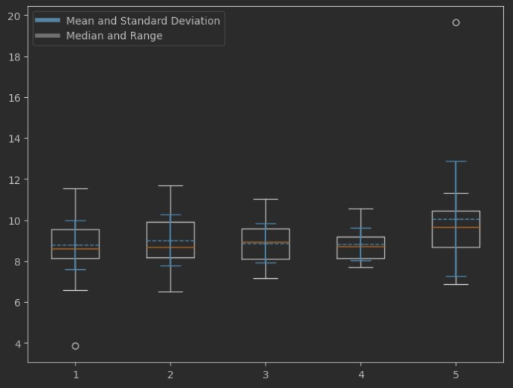
Figure 8: The association between QMEs and manual grading of scans our testing dataset are shown in this plot. For each of the five categories of manually assigned scores, the spread and standard deviation of QMEs in each of those categories are shown. QMEs shown in this plot were calculated using the methods and algorithm described by Sode et al. (Sode et al., 2011).
In order to compare our results, we re-implemented the QME algorithm described by Sode et al in ”Quantitative characterization of subject motion in HRpQCT images of the distal radius and tibia” (Sode et al., 2011) to classify the motion artefact in our dataset. However, their method demonstrate lower performance when applied to our dataset. in their QME results, there is almost no separation between motion artefacts of grade 5 and the other grades. This could be attributed to two factors. First, as part of their approach, the HRpQCT sinogram data is converted into a parallel beam format using proprietary code provided by Scanco Medical. This ensures that differences between the projections from opposite ends of the sinogram are minimized and the QMEs can be calculated correctly.

REFERENCES
Benedikt, S., Horling, L., Stock, K., Degenhart, G., Pallua, J., Schmidle, G., and Arora, R. (2023). The impact of motion induced artifacts in the evaluation of HR-pQCT scans of the scaphoid bone: an assessment of inter- and intraobserver variability and quantitative parameters. Quant. Imaging Med. Surg., 13(3):1336– 1349.
Laib, A. (2023). Sop quality grading.
Liu, Y., Wen, T., Sun, W., Liu, Z., Song, X., He, X., Zhang, S., and Wu, Z. (2022). Graph-based motion artifacts detection method from head computed tomography images. Sensors, 22(15):5666.
Pauchard, Y., Ayres, F. J., and Boyd, S. K. (2011). Automated quantification of three-dimensional subject motion to monitor image quality in high-resolution peripheral quantitative computed tomography. Physics in Medicine & Biology, 56(20):6523.
Pauchard, Y., Liphardt, A.-M., Macdonald, H. M., Hanley, D. A., and Boyd, S. K. (2012). Quality control for bone quality parameters affected by subject motion in high-resolution peripheral quantitative computed tomography. Bone, 50(6):1304–1310.
Sode, M., Burghardt, A. J., Pialat, J.-B., Link, T. M., and Majumdar, S. (2011). Quantitative characterization of subject motion in hr-pqct images of the distal radius and tibia. Bone, 48(6):1291–1297.
Walle, M., Eggemann, D., Atkins, P. R., Kendall, J. J., Stock, K., Muller, R., and Collins, C. J. (2023). Mo-¨ tion grading of high-resolution quantitative computed tomography supported by deep convolutional neural networks. Bone, 166:116607.
Yin, X.-X., Sun, L., Fu, Y., Lu, R., and Zhang, Y. (2022). U-Net-based medical image segmentation. J. Healthc. Eng., 2022:4189781.

