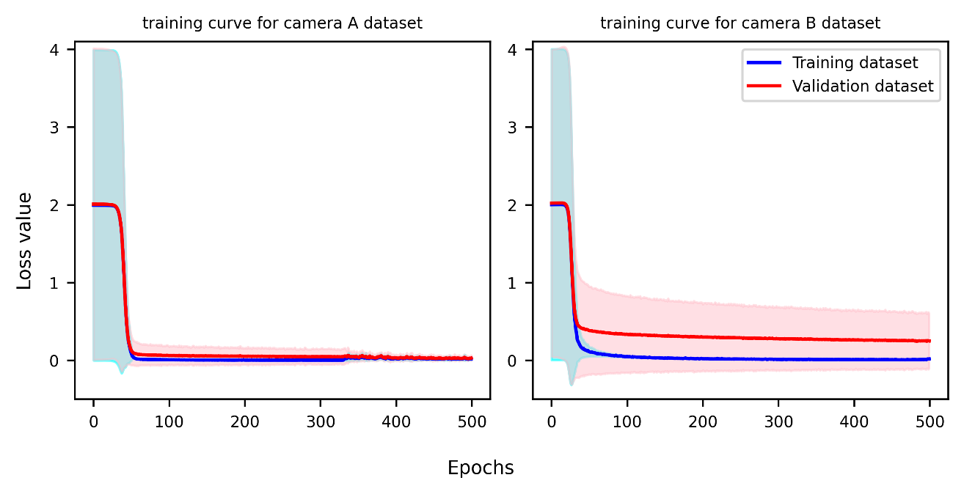
Figure S1. Training curves for the camera A dataset (left) and camera B dataset (right).
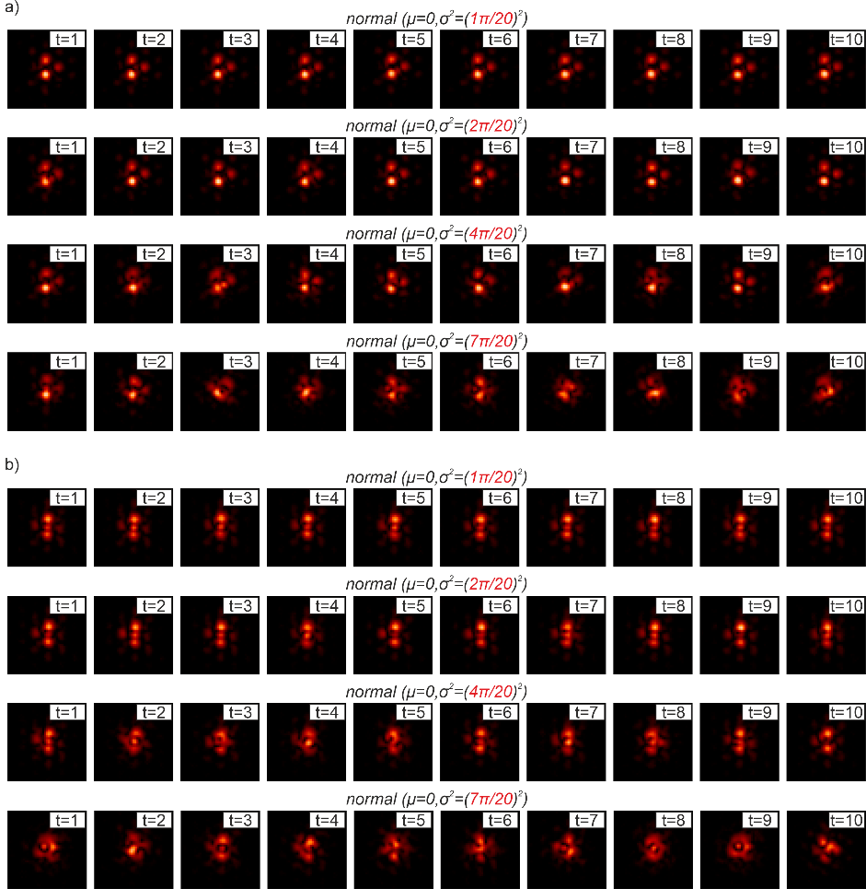
Figure S2. Experimental target intensity patterns for a) clover and b) sandwich designs, under varying degrees of phase noise, using the single-step correction process explained in figure 5.

