Risks of second primary cancers for female and male breast cancer survivors in England: a retrospective cohort study

Isaac Allen BSc^{1,2}, Hend Hassan MPhil^{1,2}, Yvonne Walburga PhD^{1,2}, Catherine Huntley MSc^{1,3}, Lucy Loong MB Bchir^{1,3}, Tameera Rahman PhD^{1,4}, Bethany Torr MSc^{1,3}, Andrew Bacon MSc¹, Craig Knott PhD^{1,4}, Sophie Jose PhD^{1,4}, Sally Vernon Mmath¹, Margreet Lüchtenborg PhD^{1,5}, Joanna Pethick PhD¹, Katrina Lavelle PhD¹, Fiona McRonald PhD¹, Diana Eccles MD⁶, Eva Morris PhD⁷, Steven Hardy PhD¹, Clare Turnbull PhD³, Marc Tischkowitz PhD⁸, Paul Pharoah PhD⁹, Antonis C. Antoniou PhD²

- National Disease Registration Service, National Health Service England, London, United Kingdom
- Centre for Cancer Genetic Epidemiology, Department of Public Health and Primary Care, University of Cambridge, Cambridge, United Kingdom
- Division of Genetics and Epidemiology, Institute of Cancer Research, Sutton, United Kingdom
- Health Data Insight CIC, Cambridge, United Kingdom
- Centre for Cancer, Society and Public Health, Comprehensive Cancer Centre, School of Cancer and Pharmaceutical Sciences, King's College London, London, United Kingdom
- Department of Cancer Sciences, Faculty of Medicine, University of Southampton, Southampton, United Kingdom
- Health Data Epidemiology Group, Big Data Institute, Nuffield Department of Population Health, University of Oxford, Oxford, United Kingdom
- Department of Medical Genetics, Cambridge Biomedical Research Centre, National Institute for Health Research, University of Cambridge, Cambridge, United Kingdom
- Department of Computational Biomedicine, Cedars-Sinai Medical Center, Los Angeles, California

Correspondence to: Isaac Allen, ia377@cam.ac.uk, (+44) 1223 748600

Research in context

Evidence before this study

There have been multiple studies assessing second primary cancer risks following breast cancer in females, and several such studies in males. We conducted two systematic reviews and meta-analyses of second primary cancer (SPC) risks following breast cancer (BC) in females and males. In each of these reviews, we searched PubMed, Embase, and Web of Science for studies reporting standardized incidence ratios (SIRs) for non-breast SPC development published by March 2022. We also reviewed the bibliographies of the studies found in these searches. We found that although non-breast SPC risks were elevated for BC survivors of either gender, few studies were able to examine the effects of patient demographics, BC pathology, or treatments for the first BC on SPC risks, and studies that did were often small. SPC risk estimates were inconsistent between studies and many analyses for male BC survivors were underpowered. Finally, studies rarely accounted for surgeries at potential SPC sites in their censoring processes, despite prophylactic or curative partial or full resections of the breast, and prophylactic partial or full resections of the ovary or endometrium, both being commonly performed in breast cancer survivors and having clear implications for SPC risks at these sites.

Added value of this study

Here, for the first time, we used data on 581,403 female and 3562 male BC survivors from the National Health Service England, with linked electronic health records and comprehensive data quality control, to assess SPC risks and the variation in SPC risks by demographic factors, BC pathology and BC treatment. This is the largest study to date to examine SPC risks in BC survivors of either gender. The results show that both female and male BC survivors have significantly elevated SPC risks at all sites combined, all non-breast sites combined, and specific sites including the contralateral breast, ovary, endometrium, and prostate. To our knowledge, our study is the first to demonstrate that socioeconomically deprived BC survivors are at greater risk of SPCs compared to less deprived BC survivors. The study has provided increased precision in SPC risk estimates in both women and men, further elucidating the factors contributing to the variability in SPC risks.

Implications of all the available evidence

BC survivors may benefit from enhanced surveillance for SPCs, particularly at the contralateral breast, endometrium, and prostate, although specific recommendations would require separate cost-benefit analyses. This study may also aid risk stratification for SPCs in BC survivors, since we found significant evidence for variation in SPC risks in females by the age and calendar year at first BC diagnosis, the size, grade, morphology, estrogen receptor status or Human Epidermal growth factor Receptor 2 status of the first BC, the administration of chemotherapy, radiotherapy or hormonal therapy for the first BC, socioeconomic deprivation, and ethnicity. Finally, this study demonstrates the opportunities arising from the use of population-scale, comprehensive, linked electronic health records datasets, while also enabling us to account for the possible sources of variability in risk. Future studies should aim to examine the influence of deprivation-associated factors such as smoking or obesity on the risks of second primaries following BC.

Abstract

Background

Second primary cancers (SPCs) after breast cancer (BC) present an increasing public health burden, with little existing research on socio-demographic, tumour, and treatment effects. We addressed this in the largest BC survivor cohort to date, using a novel linkage of National Disease Registration Service datasets.

Methods

The cohort included 581,403 female and 3562 male BC survivors diagnosed between 1995-2019. We estimated standardized incidence ratios (SIRs) for combined and site-specific SPCs using incidences for England, overall and by age at BC and socioeconomic status. We estimated incidences and Kaplan-Meier cumulative risks stratified by age at BC, and assessed risk variation by socio-demographic, tumour, and treatment characteristics using Cox regression.

Findings

Both genders were at elevated contralateral breast (SIR:2.02 (95%CI:1.99-2.06) females; 55.4 (35.5-82.4) males) and non-breast (1.10 (1.09-1.11) females, 1.10 (1.00-1.20) males) SPC risks. Non-breast SPC risks were higher for females younger at BC diagnosis (SIR:1.34 (1.31-1.38) <50y, 1.07 (1.06-1.09) >=50y) and more socioeconomically deprived (SIR:1.00 (0.98-1.02) least deprived quintile, 1.34 (1.30-1.37) most).

Interpretations

Enhanced SPC surveillance may benefit BC survivors, although specific recommendations require more detailed multifactorial risk and cost-benefit analyses. The associations between deprivation and SPC risks could provide clinical management insights.

Funding

CRUK Catalyst Award CanGene-CanVar (C61296/A27223).
Cancer Research UK grant: PPRPGM-Nov20\100002.
This work was supported by core funding from the NIHR Cambridge Biomedical Research Centre (NIHR203312)]. The views expressed are those of the author(s) and not necessarily those of the NIHR or the Department of Health and Social Care.

Background:

Breast cancer (BC) was the most common cancer diagnosed globally in 2020¹. 5-year survival has increased from 81% to 87% for those diagnosed between 2001 and 2005 and 2013 and 2017 in England². Male BC accounts for <1% of United Kingdom (UK) BC diagnoses³, but follows similar trends⁴. Accurate estimates of second primary cancer (SPC) risks following BC, and the variation in these risks by sociodemographic factors, first BC pathology, and treatments administered for the first BC, are thus necessary to inform the clinical management of a growing number of BC survivors.

Recent systematic reviews estimated female and male non-breast SPC risks following BC as 24% and 27% greater than population-level^{5,6}, with greater relative increases in those diagnosed with BC below age 50^{5,6}. Female thyroid, endometrial, ovary, kidney, oesophagus, melanoma, leukaemia, lung, stomach, and bladder SPCs risks were elevated⁵, whereas males were at increased thyroid, pancreatic, and colorectal SPC risks⁶. These studies produced disparate risk estimates and relied predominantly on population-based cancer registries without linkages to other data, so were unable to reliably assess risk variation by sociodemographic factors, BC pathology, and BC treatment.

We assessed SPC risks in 581,403 female and 3,562 male BC survivors diagnosed between 1995 and 2019 using the National Cancer Registration Dataset (NCRD)⁷, a population-scale dataset with 98-99% complete case ascertainment⁸. This is the largest study performed to date in BC survivors of either gender and the first to examine the risks in the NCRD. Participant data were linked to obtain comprehensive data on socioeconomic status, BC pathology, BC treatment, curative and prophylactic surgeries, and predominantly self-reported ethnicity. We aimed to estimate combined and site-specific relative and absolute SPC risks in both genders, and assess variability in risks by socioeconomic factors, tumour characteristics and treatments, at sites at particularly elevated risk following BC: the contralateral breast⁹, endometrium⁵, ovary⁵, and all non-breast sites combined^{5,6}.

Methods

Study population

Data originated from the National Cancer Registration Dataset (NCRD)⁷, Hospital Episode Statistics Admitted Patient Care (HES APC)¹⁰ and HES Outpatients (HES OP) datasets within the National Health Service (NHS) England (NHSE). We constructed a retrospective cohort of those diagnosed with invasive first primary BC between 1st January 1995 and 31st Dec 2019. To ensure that the first BC was invasive and non-metastatic, BC survivors with missing staging data were filtered from the cohort. Diagnosis date, person-stated gender (self-declared or inferred by observation, henceforth ‘gender’), age, socioeconomic deprivation, BC pathology, BC laterality, chemotherapy, radiotherapy, hormonal therapy, SPC diagnoses, whether BC survivors had permanently left the UK (henceforth ‘embarked’), and death data were drawn from the NCRD. Surgical procedures data were extracted from the HES APC and HES OP datasets. The data were linked using unique patient and tumour identifiers. Descriptions of the datasets and quality control processes are available in the Supplementary material.

Statistical analyses

The outcome of interest was an invasive SPC diagnosis. Follow-up lasted from 365 days after BC diagnosis to the earliest of death, embarkation, invasive SPC diagnosis, or the 31st of December 2020. Surgeries at the contralateral breast, endometrium, and ovary were also considered censoring events when evaluating site-specific risks (Supplementary material).

We defined SPC sites using the ICD-10 code groups employed by Cancer Research UK¹¹. We did not consider contralateral BC (CBC)s observed within 92 days of BC diagnosis or any ipsilateral BCs as SPCs, to avoid misclassifications of first BC recurrences. We did not consider non-melanoma skin cancer a SPC. Follow-up would thus continue after recorded diagnoses of ipsilateral second BCs, CBCs within 92 days of first BC diagnosis, or non-melanoma skin cancers. We did not consider cancers diagnosed from death certificates only as SPCs.

Standardised Incidence Ratios, Incidences and Cumulative Risks

We estimated standardized incidence ratios (SIRs), incidence rates (IRs) and cumulative risks (CRs) for SPCs. We estimated SIRs for SPCs at all sites combined, all non-breast sites combined, and the 20 most common cancer sites diagnosed between 2016 and 2018 in the UK excluding cancer of unknown primary¹¹, by comparing observed SPC counts in our cohort to expected cancer counts. We examined the risks of myeloid and non-myeloid leukaemia SPCs separately. We calculated expected counts based on age-, calendar year-, cancer site, and gender-specific cancer incidences for England, excluding cancers diagnosed from death certificates only¹². We estimated unstratified SIRs for SPCs in females and males, as well as SIRs for SPCs in females stratified by age at BC diagnosis (<50y and >=50y) and by indices of multiple deprivation (IMD) quintile, a measure of socioeconomic deprivation based on region of residence at first BC diagnosis¹³. We stratified the male SIRs for all non-breast SPCs by age at BC diagnosis and IMD quintile, but did not stratify SIRs for specific sites in males due to low SPC counts. Finally, we stratified SIRs for myeloid leukaemia SPCs in females by receipt of chemotherapy, and stratified SIRs for endometrial SPCs by calendar year of first BC diagnosis and receipt of hormonal therapy.

We estimated incidences per 10,000 person-years (py) for five-year follow-up periods (0-5y, 5-10y, 10-15y, 15-20y, 20-25y) for all non-breast SPCs combined. We also estimated incidences for contralateral breast, ovarian and endometrial SPCs and estimated 25-year CRs using Kaplan-Meier analyses. All incidences and CRs were stratified by age at BC diagnosis (<50y and >=50y).

Associations with socio-demographic, tumour, and treatment characteristics

We used Cox proportional hazards (CPH) modelling to estimate hazard ratios (HRs) for associations between non-breast, contralateral breast (females only), endometrial and ovarian SPC risks and patient characteristics (age at BC diagnosis, calendar year at BC diagnosis, ethnicity, and IMD quintile), tumour characteristics (size, number of nodes involved, grade, morphology, ER status, and HER2 status) and treatment (chemotherapy, radiotherapy, and hormonal therapy administered no later than 1y post-BC diagnosis). Records of borderline ER or HER2 status were regarded as missing information due to their rarity and were imputed. We imputed missing data for ethnicity and for the size, number of nodes involved in, grade, morphology, ER status, and HER2 status of the first breast tumour with multiple imputation by chained equations¹⁴ separately for females and males (Supplementary material), with degrees of missingness for these variables ranging from <0.1% for first BC morphology to 55.3% for first BC ER status in females and from 0% for first BC morphology to 54.8% for first BC HER2 status in males (Supplementary material).

We estimated HRs for a given target variable by first fitting CPH models adjusted only for age at BC diagnosis. We then assessed the correlations between the target variable and all other variables found significant in this first set of models using the chi-squared test to compare two nominal variables, Spearman’s rank test to compare two ordinal variables, and the Kruskal-Wallis test to compare an ordinal to a nominal variable. Finally, we fitted a second, multivariable CPH model adjusted for age and all other variables found to be both significantly correlated with the target variable and significantly associated with SPC risks when adjusted only for age in the first set of models. The only exception to this process was when estimating HRs for the receipt of chemotherapy, radiotherapy, or hormonal therapy. If any of the three treatments were found to be significant when adjusted only for age, all three were included in the multivariable model. This was done to account for the administration of different types of BC treatment as part of the same cycle. For each variable, we visually inspected a plot of the logarithm of the negative logarithm of the survival function across follow-up time against relevant reference categories to assess any deviation from the proportional hazards assumption.

All analyses were performed separately by gender. All statistical analyses were performed in R, with details of the version and packages used in the Supplementary material.

Role of the funding source

The study sponsors had no role in study design, in data collection, analysis, and interpretation, in the writing of this article, or in the decision to submit this article for publication.

Results

Cohort description

Following exclusions (Figure 1), the cohort consisted of 581,403 females and 3,562 males. Participants were predominantly aged 50 or over at first BC diagnosis (females: 78%, males: 92%), diagnosed with BC between 2010 and 2019 (females: 55%, males: 56%) and of White ethnicity (females: 86%, males: 84%). There were 52,620 and 504 SPCs diagnosed among females and males respectively. The mean ages at first primary BC diagnosis were 61 for females and 67 years for males and the corresponding median lengths of follow-up were 5.5 and 4.4 years. Further details are in Table 1.

Standardized incidence ratios

Female BC survivors were at elevated SPC risks at all sites combined (SIR: 1.25 (95%CI:1.24-1.26)), the contralateral breast (SIR: 2.02 (95%CI:1.99-2.06)), and all non-breast sites combined (SIR: 1.10 (95%CI:1.09-1.11)). Site-specific SIR point estimates ranged between 0.87 and 2.02 and were elevated for all SPCs except for non-Hodgkin’s lymphoma, myeloma, and brain and central nervous system (Table 2). The largest SIRs for non-breast sites were observed for endometrial (SIR: 1.87 (95%CI:1.82-1.93)), myeloid leukaemia (SIR: 1.58 (95%CI:1.47-1.70)), and ovarian (SIR: 1.25 (95%CI:1.21-1.30)) SPCs.

SIRs for SPCs at all sites combined were higher for females diagnosed with BC when younger (<50y: SIR: 1.86 (95%CI:1.82-1.90), >=50y: SIR: 1.17 (95%CI:1.16-1.18)) as well as at all non-breast sites combined (<50y: SIR: 1.34 (95%CI:1.31-1.38), >=50y: SIR: 1.07 (95%CI:1.06-1.09)). There were clear differences in SIRs by age at BC diagnosis for contralateral breast (<50y: SIR: 3.36 (95%CI:3.26-3.47), $≥$50y: SIR: 1.73, (95%CI:1.70-1.77)), lung (<50y: SIR: 1.52 (95%CI:1.41-1.63), $≥$50y: SIR: 1.02 (95%CI:1.00-1.05)), pancreatic (<50y: SIR: 1.65 (95%CI:1.40-1.92), $≥$50y: SIR: 1.15 (95%CI:1.09-1.20)), ovarian (<50y: SIR: 1.73 (95%CI:1.58-1.89), $≥$50y: SIR: 1.18 (95%CI:1.13-1.23)), and myeloid leukaemia (<50y: SIR: 2.26 (95%CI:1.85-2.73), $≥$50y: SIR: 1.50 (95%CI:1.38-1.63)) SPCs.

SPC risks were elevated for females in more deprived IMD quintiles (Table 3), with SIRs for SPCs at all sites combined of 1.16 (95%CI:1.14-1.18) and 1.46 (95%CI:1.43-1.49) for the least deprived quintile (LDQ, quintile 5) and most deprived quintile (MDQ, quintile 1). These differences were primarily driven by non-breast sites, where the corresponding SIRs were 1.00 (95%CI:0.98-1.02) and 1.34 (95%CI:1.30-1.37). There were no marked differences in SIRs for CBC by IMD quintile. The clearest differences were for lung (LDQ: SIR: 0.70 (95%CI:0.66-0.74), MDQ: SIR: 1.86 (95%CI:1.77-1.95)), kidney (LDQ: SIR: 0.96 (95%CI:0.86-1.08), MDQ: SIR: 1.37 (95%CI:1.20-1.56)), head and neck (LDQ: SIR: 0.93 (95%CI:0.81-1.06), MDQ: SIR: 1.38 (95%CI:1.19-1.60)), bladder (LDQ: SIR: 0.85 (95%CI:0.73-0.97), MDQ: SIR: 1.30, (95%CI:1.11-1.51)), oesophagus (LDQ: SIR: 0.93 (95%CI:0.81-1.06), MDQ: SIR: 1.44 (95%CI:1.24-1.67)) and stomach (SIR: 0.95 (95%CI:0.82-1.10), MDQ: SIR: 1.69 (95%CI:1.45-1.96)) SPCs. We also found increased second primary melanoma risks in less deprived BC survivors (LDQ: SIR: 1.41 (95%CI:1.30-1.52), MDQ: SIR: 0.68 (95%CI:0.58-0.79)).

We saw a difference in female myeloid leukaemia SIRs by receipt of chemotherapy (Chemotherapy: SIR: 2.71 (95%CI:2.36-3.08). No chemotherapy: SIR: 1.32 (95%CI:1.20-1.44)). We also estimated endometrial SPC SIRs of 2.30 (95%CI:2.21-2.40) for females diagnosed with first breast cancer prior to 2010 who received hormonal therapy, 1.26 (95%CI:1.15-1.39) for females diagnosed with first breast cancer in 2010 or later who received hormonal therapy, 1.95 (95%CI:1.86-2.04) for females diagnosed with first breast cancer prior to 2010 who did not receive hormonal therapy, and 1.26 (95%CI:1.15-1.37) for females diagnosed with first breast cancer in 2010 or later who did not receive hormonal therapy.

Male BC survivors were at elevated risks of SPCs at all sites combined (SIR: 1.15 (95%CI:1.05-1.26)) and all non-breast sites combined (SIR: 1.10 (95%CI:1.00-1.20), p-value <0.05). Male BC survivors were also at elevated contralateral breast (SIR: 55.4 (95%CI:35.5-82.4)), prostate (SIR: 1.58 (95%CI:1.36-1.82)) and thyroid (SIR: 3.74 95%CI:1.01-9.58)) SPC risks (Table 2). We saw no large differences in non-breast SPC risks by age at BC diagnosis or IMD quintile, although the sample sizes were small (Supplementary material).

Incidence rates and cumulative risks

The IRs per 10,000py of non-breast SPCs among females aged under 50 and 50 and over at BC diagnosis peaked at 99.9 (95%CI:89.2-112) and 149 (95%CI:138-161) respectively, between 20 and 25 years of follow-up (Table 4). The corresponding 25-year CRs were 15% (95%CI:14%-16%) and 28% (95%CI:27%-29%) (Table 4).

The IR of CBC among females peaked at 56.6 (95%CI:48.2-66.0) and 54.8 (95%CI:48.1-62.2) in the younger and older age groups respectively between 20-25 years of follow-up, and we estimated the corresponding 25-year CRs as 11% (95%CI:10%-11%) and 9.9% (95%CI:9.4%-10%). Further site-specific IRs and CRs may be seen in Table 4 and the Supplementary material.

Among males, IRs of non-breast SPCs respectively peaked at 85.2 (95%CI:23.6-227) and 309 (95%CI:239-393) between 10 and 15 years of follow-up among those diagnosed with BC at under age 50 and at age 50 or over. The 25-year CRs were 9.5% (95%CI:2.6%-16%) and 51% (95%CI:38-61%).

CBC IRs in males peaked at 25.1 (95%CI:9.54-55.1) among those first diagnosed with BC at age 50 or over, with the peak reached between 10 and 15 years of follow-up. We estimated the 25-year CR as 2.8% (95%CI:1.1%-4.4%). There were low numbers of CBCs in males first diagnosed with BC at under age 50. IRs and CRs for the younger age group may be seen in Table 4.

Associations with socio-demographic factors, tumour characteristics, and treatments

Higher age at BC diagnosis was associated with increasing non-breast SPC risks for both females (HR per year increase: 1.04, 95%CI:1.04-1.04) and males (HR per year increase: 1.04 (95%CI:1.03-1.05)) (Table 5). Analyses which treated age at first BC diagnosis as a 5-year categorical variable provided consistent results (Supplementary Material). After 2004, the risk of non-breast SPCs among females increased with more recent BC diagnosis relative to 1995-1999 (2005-09: HR: 1.07 (95%CI:1.04-1.11), 2010-14: HR: 1.09 (95%CI:1.05-1.13), 2015-19: HR: 1.10 (95%CI:1.05-1.15)). In line with the SIR estimates, we found significant evidence for increased non-breast SPC risks among more deprived females, relative to the IMD LDQ (quintile 4: HR: 1.06 (95%CI:1.03-1.09), quintile 1 (MDQ): HR: 1.35 (95%CI:1.30-1.39), p-trend:<0.01). However, there were no significant differences in CBC risk between females in different IMD quintiles. Non-breast SPC risks differed by ethnicity, with decreased risks for females of Asian (HR: 0.70 (95%CI:0.64-0.77)), Black (HR: 0.82 (95%CI:0.73-0.92)), Chinese (HR: 0.57 (95%CI:0.42-0.77)), and other non-White, non-mixed (HR: 0.82 (95%CI:0.71-0.93)) ethnicities relative to females of White recorded ethnicity.

Female BC survivors diagnosed with grade 3, rather than grade 1, first BC were at increased non-breast SPC risks (HR: 1.08 (95%CI:1.04-1.11)), whereas non-breast SPC risks were lower for those whose first BC was ER-positive rather than ER-negative (HR: 0.93 (95%CI:0.89-0.97)) or HER2-positive rather than HER2-negative (HR: 0.88 (95%CI:0.83-0.94)). Radiotherapy was associated with a 7% increase (95%CI: 5-10%) in non-breast SPC risks.

There was significant evidence that increasing age at BC diagnosis was associated with decreased CBC risk (HR per year increase: 0.99 (95%CI:0.99-0.99)), and with increased endometrial (HR per year increase: 1.03 (95%CI:1.02-1.03)) and ovarian (HR per year increase: 1.02 (95%CI:1.01-1.02)) SPC risks. Radiotherapy was associated with increased CBC risk (HR: 1.04 (95%CI:1.00-1.08, p<0.05)), whereas hormonal therapy was associated with a decreased risk (HR: 0.90 (95%CI:0.87-0.94)). There was significant evidence that radiotherapy (HR: 1.10 (95%CI:1.03-1.16)) and hormonal therapy (HR: 1.09 (95%CI:1.02-1.16)) increased the risk of endometrial SPCs.

HR estimates for the associations of socio-demographic factors and tumour characteristics with SPC risks may be seen in Table 5 and the Supplementary material.

Discussion

In this study we used population-scale linked cancer registration data to estimate SPC risks following male and female BC in England and assess how these risks varied by socio-demographic factors, breast tumour characteristics and treatments. This is the largest published cohort study of its kind to date, with a longer mean follow-up than any other study of comparable size^{5,6}.

There were significantly increased CBC and non-breast SPC risks for BC survivors of either gender compared to population-level risks. The greatest SIRs were observed for second cancer of the contralateral breast, and for endometrium and prostate cancer in females and males, respectively. Non-breast SPC risks were higher for females diagnosed with BC before age 50 and for those from more deprived regions, compared to population-level non-breast cancer risks. We also found that non-breast SPC risks differed by the grade of the first primary, and that breast cancer survivors diagnosed after 2004, who received radiotherapy, or were from more deprived regions were at elevated non-breast SPC risks compared to BC survivors diagnosed from 1995-1999, who did not receive radiotherapy, and who were from the IMD LDQ. Non-breast SPC risks were lower for female BC survivors of Asian, Black, Chinese, or other non-White, non-mixed ethnicities compared to white ethnicity female BC survivors and for females whose first BC was ER-positive rather than ER-negative and HER2-positive rather than HER2-negative.

To our knowledge, no previous study of SPC risks following male BC has accounted for any of these factors other than age at, and year of, BC diagnosis. No study has accounted for socioeconomic deprivation in female BC survivors, and no population-based study has estimated associations between tumour size, lymph node involvement, grade or morphology and SPC risks following BC in females. Only one small study has accounted for treatment with hormonal therapy¹⁵ at combined sites, without examining treatment effects on site-specific risks. The current study therefore has provided evidence on possible causes of heterogeneity among previously published SPC risk estimates^{5,6}. A further strength is that we were able to account for prophylactic and curative surgeries such as partial or full resections at the contralateral breast, ovary, and endometrium in our censoring process when estimating SPC risks at these sites, minimising confounding biases in our risk estimates¹⁶.

Although our estimated SIR for non-breast SPCs in females is lower than the pooled estimate of 1.24 (95%CI:1.14-1.36) from a recent meta-analysis⁵, our findings of elevated SIRs for all non-breast SPCs combined, particularly at the endometrium, are consistent with previous research^{5,9}. These findings suggest that BC survivors may benefit from enhanced surveillance for specific SPC development, but should be taken in context with our 25-year CR estimates, which were notably higher for CBC than endometrial SPCs. Any specific surveillance recommendations would require separate cost-benefit analyses.

We found higher SIRs for females diagnosed with BC at under age 50, which is consistent with the recent meta-analysis⁵. A partial explanation could be the higher proportion of pathogenic variants in BC susceptibility genes among younger BC survivors¹⁷. Women with germline BRCA1/2 pathogenic variants are at elevated CBC¹⁸, ovarian^{18,19}, pancreatic¹⁹, and stomach¹⁹ cancer risks and these were the cancers with the biggest differences in SIRs by age in the present study. It should be noted that the 25-year non-breast cumulative SPC risks were higher in the older age group, suggesting that although younger BC survivors may benefit more from enhanced cancer surveillance relative to their age group, clinicians should remain vigilant of SPC risks in the older group. Pathogenic genetic variation may also explain the very high CBC SIR observed in male BC survivors, since BRCA2 PVs are associated with a high BC risk in males¹⁹. In addition, although we did not find significant associations between chemotherapy receipt and SPC risks at the contralateral breast or at all non-breast sites combined, we did observe a clear elevation in myeloid leukaemia SPC SIRs in females treated with chemotherapy compared to those that were not. It is therefore possible that the increased myeloid leukaemia SIRs in females diagnosed with BC at under age 50 compared to those aged 50 or over are partly attributable to increased chemotherapy usage in the younger age group.

We found increased non-breast SPC SIRs in BC survivors diagnosed in more deprived regions, particularly for lung, kidney, head and neck, bladder, oesophagus and stomach SPCs. These may be explained by higher prevalences of smoking, obesity, and alcohol consumption among more deprived groups²⁰, as these are established risk factors for these cancers²¹⁻²³. There was no trend for increasing CBC risks with increasing deprivation, which is consistent with population-level BC risks²⁴. A notable exception was melanoma, for which SPC risks declined with increasing deprivation. This is also consistent with population-level risks²⁴. The significant decreases in non-breast SPC risks for females of Asian, Black, Chinese, and other non-White, non-mixed ethnicities compared to those of White ethnicity are also consistent with population-level risk differences²⁵, and may be partly explained by lower prevalences of overweight and obesity²⁶, lower alcohol consumption²⁶, and lower screening rates²⁷ in non-White ethnicity groups.

There was a pattern of increasing non-breast SPC risks for females with more recent BC diagnosis, which is broadly consistent with the IR rise for all cancers combined in the UK over the study period¹¹. However, there were respective decreasing CBC and endometrial SPC risks with later BC diagnoses after 2009 and throughout the study period, in contrast to the population-level risks¹¹. This may be attributable to shorter follow-up times contributed by BC survivors diagnosed later, as CBC risks may increase with follow-up time⁹ and the known elevation in endometrial SPC risk after tamoxifen treatment for BC increases further with increasing time since the treatment²⁸. The lower endometrial cancer risks for those diagnosed with BC after 2009 may also be partly due to an increase in aromatase inhibitor usage in BC treatment in later years, which is associated with a lower endometrial SPC risk than tamoxifen²⁹ but a similar decrease in risk was observed in our data among those did not receive hormonal therapy.

There was a significant decrease in CBC risk for females treated with hormonal therapy together with significant increases in non-breast SPC risks for females treated with radiotherapy, which are consistent with previous studies^{30,31}. We also found that BC survivors diagnosed with a first BC 2cm or greater in size, of lobular morphology, of negative ER status, or of negative HER2 status were at significantly elevated CBC risk.

Any findings should be taken in context with the limitations of our study. Firstly, we cannot rule out surveillance bias⁹, although starting our follow-up at one year following the first BC diagnosis should have reduced this⁹. Secondly, data on surgeries were based on coding practices reliant on discharge summaries, which vary in accuracy and completeness between hospitals¹⁰. Furthermore, some surgeries which we treated as censoring events for a given SPC will not have entirely removed the risk of that SPC, such as subtotal hysterectomies for endometrial SPCs. Therefore, a small number of SPCs diagnosed at least one year after relevant surgeries (Supplementary material) were not considered in our risk estimates. We were unable to account for obesity²³, smoking status²¹, alcohol intake²², family history of cancer¹⁸, or germline cancer susceptibility^{18,19} due to a lack of data on these variables. In addition, although we excluded patients with no staging records and confirmed metastatic or non-invasive BC at diagnosis from the cohort, some BC survivors with inconclusive staging data may in fact have had metastatic or non-invasive disease. It should be noted that BC survivors diagnosed in 2013 in the NCRD dataset with missing staging data were found to be older at first breast cancer diagnosis, have higher rates of short-term mortality, be less likely to have received a surgery, be diagnosed with first BC in more socioeconomically deprived regions, present with BC as emergency cases, have higher numbers of comorbidities, and have more severe comorbidities³². We directly adjusted for age at first BC diagnosis in all our SPC risk estimates, stratified or adjusted for year at BC diagnosis and socioeconomic deprivation in our SIR and HR SPC estimates, censored at contralateral breast surgeries, and minimized the influence of the differences in short-term mortality and comorbidities by excluding patients contributing less than one year of follow-up. It is therefore unlikely that the SPC risk estimates would be substantially impacted, but this should be considered when interpreting our results.

Finally, despite the large cohort size and long-term follow-up, some analyses were based on small subgroups of BC survivors or low SPC counts, particularly at rarer cancer sites and in males.

In conclusion, we generated precise relative and absolute SPC risk estimates at combined and specific sites based on comprehensive EHR data, meeting our primary objective. We assessed the variation in SPC risks by a wide range of sociodemographic factors, first tumour characteristics, and BC treatments and found that SPC risks are elevated among BC survivors living in more socioeconomically deprived regions at diagnosis.

These results should facilitate an evidence-based approach to SPC risk management following BC and suggest policy measures to reduce inequalities in smoking and other deprivation-associated cancer risk factors would lessen SPC risks. However, we could not explicitly confirm this due to a lack of smoking, obesity, and alcohol intake data, demonstrating the need for future studies investigating how deprivation-associated factors affect SPC risks. There is also a need for larger studies of SPC risks in non-White ethnicity BC survivors, with less than 14% of this cohort being of non-White ethnicity. Finally, larger studies of SPC risks following male BC are necessary.

Author contributions

IA conducted the statistical analyses and wrote the manuscript. TR, AB, CK, and SJ collected and directly verified the data. HH developed the imputation approach. MT, PP and AA supervised the project and reviewed and edited the manuscript drafts. All authors provided critical feedback to inform the research and analysis.

Declarations of interests

DE is co-investigator on a research grant awarded by AstraZeneca. ACA is listed as creator of the BOADICEA algorithm which has been licensed by Cambridge Enterprise (University of Cambridge). CH receives funding for a clinical fellowship from the Wellcome Trust. BT has received grants from NHS Cancer Programme/SBRI Healthcare and has received personal payments for lecturing at University College London. CT has received honoraria for educational events and scientific participation in a biobanking project (all donated in whole to charity) from Roche and Astrazeneca. IA, HH, and LL receive studentships funded by Cancer Research UK. BT acknowledges payments to her institution from Cancer Research UK. EM notes that Cancer Research UK have funded this program of work. PP acknowledges grant funding from Cancer Research UK received by the University of Cambridge.

Acknowledgement of funding source

This work was funded by the CRUK Catalyst Award CanGene-CanVar (C61296/A27223) and the Cancer Research UK grant PPRPGM-Nov20\100002, and was supported by core funding from the NIHR Cambridge Biomedical Research Centre (NIHR203312). CH is supported by a Wellcome Trust Clinical Research Training Fellowship (Ref 203924/Z/16/Z).

Data sharing statement

This work uses data that has been provided by patients and collected by the NHS as part of their care and support. The data are collated, maintained and quality assured by the National Disease Registration Service (NDRS), which is part of NHS England. Data in this manuscript may be accessed through application to NHS England. The plots used to assess the proportional hazards assumption in the Cox models can be made available upon request.

Figures and tables:

Figure 1: Cohort assembly
Initial cohort: 879,872 BC¹ survivors, diagnosed 1995-2019, with no previously recorded cancer history

Exclusions:
26,154 for having a first BC of bilateral, midline, or unknown laterality
309 for having a second and third primary diagnosed on the same day
54 for having a morphology inconsistent with invasive BC

237,065 for having first BC of missing stage, stage 0 (non-invasive), or stage 4 (metastatic)

1078 for missingness or clear errors in data required for the censoring process, such as dates of death or embarkation

5 for having a surgical procedure inconsistent with recorded gender

30,242 BC survivors due to being censored prior to one year post-BC diagnosis

Final cohort: 584,965 BC survivors
581,403 females (99.4%)
3562 males (0.6%)

1: Breast Cancer

Note: When examining the site-specific risks of second primary CBC, a further 8721 BC survivors were filtered from the cohort (15 male, 8706 female) due to having received a censoring surgery before the start of follow-up.
When examining the site-specific risks of endometrial SPCs, a further 17,081 BC survivors were filtered from the cohort (all female) due to having received a censoring surgery before the start of follow-up.
When examining the site-specific risks of ovarian SPCs, a further 9425 BC survivors were filtered from the cohort (all female) due to having received a censoring surgery before the start of follow-up.

Table 1: Cohort description
 | Female cohort (all) |  | Female cohort (with a SPC¹) |  | Male cohort (all) |  | Male cohort (with a SPC)
 | Mean/median/IQRs²:  Age at BC³ diagnosis (years): 61, 60, 20  Follow-up time (years): 7.4, 5.5, 8.4 |  | Mean/median/IQRs:  Age at BC diagnosis (years): 61, 61, 18  Follow-up time (years): 7.5, 6.3, 8.6 |  | Mean/median/IQRs:  Age at BC diagnosis (years): 67, 68, 16  Follow-up time (years): 6.0, 4.4, 6.4 |  | Mean/median/IQRs:  Age at BC diagnosis (years): 69, 69, 12  Follow-up time (years): 5.7, 4.0, 7.3
 | Number BC (%⁴) | Total FU⁵ (py⁶) (%⁷) | Number BC (%) | Total FU (py) (%) | Number BC (%) | Total FU (py) (%) | Number BC (%) | Total FU (py) (%)
Age at first BC diagnosis
Under 50 | 127048 (21.9) | 1094793 (25.5) | 8772 (16.7) | 79011 (20.0) | 293 (8.2) | 2335 (11.0) | 14 (2.8) | 110 (3.8)
50 or over | 454355 (78.1) | 3191071 (74.5) | 43848 (83.3) | 317009 (80.0) | 3269 (91.8) | 18932 (89.0) | 490 (97.2) | 2765 (96.2)
Year of first BC diagnosis
1995-1999 | 98972 (17.0) | 1243982 (29.0) | 16341 (31.1) | 175508 (44.3) | 635 (17.8) | 5880 (27.6) | 147 (29.2) | 1259 (43.8)
2000-2004 | 93877 (16.1) | 1095236 (25.6) | 14319 (27.2) | 125922 (31.8) | 534 (15.0) | 5008 (23.5) | 111 (22.0) | 793 (27.6)
2005-2009 | 70068 (12.1) | 684389 (16.0) | 8564 (16.3) | 54073 (13.7) | 387 (10.9) | 3097 (14.6) | 68 (13.5) | 396 (12.8)
2010-2014 | 136865 (23.5) | 842092 (19.6) | 9187 (17.5) | 33570 (8.5) | 881 (24.7) | 4882 (23.0) | 123 (24.4) | 379 (13.2)
2015-2019 | 181621 (31.2) | 420164 (9.8) | 4209 (8.0) | 6946 (1.8) | 1125 (31.6) | 2401 (11.3) | 55 (10.9) | 75 (2.6)
Ethnicity
White | 497621 (85.6) | 3698702 (86.3) | 49196 (93.5) | 374861 (94.7) | 2999 (84.2) | 18184 (85.5) | 468 (92.9) | 2728 (94.9)
Asian | 14025 (2.4) | 85475 (2.0) | ;790 (1.5) | 5798 (1.5) | 112 (3.1) | 646 (3.0) | 7 (1.4) | 39 (1.3)
Black | 8240 (1.4) | 46677 (1.1) | 483 (0.9) | 3386 (0.9) | 59 (1.7) | 251 (1.2) | 9 (1.8) | 34 (1.2)
Chinese | 1518 (0.3) | 9984 (0.2) | 66 (0.1) | 465 (0.1) | 4 (0.1) | 21 (<0.1) | 1 (0.2) | 8 (0.2)
Mixed | 2347 (0.4) | 14013 (0.3) | 147 (0.3) | 1168 (0.3) | 15 (0.4) | 85 (0.4) | 2 (0.4) | 7 (0.3)
Other | 6093 (1.0) | 34719 (0.8) | 328 (0.6) | 2350 (0.6) | 33 (0.9) | 175 (0.8) | 3 (0.6) | 15 (0.5)
Data missing | 51559 (8.9) | 396293 (9.2) | 1610 (3.1) | 7991 (2.0) | 340 (9.5) | 1905 (9.0) | 14 (2.8) | 45 (1.6)
Indices of Multiple Deprivation quintile⁸
1 (most deprived) | 86043 (14.8) | 586188 (13.7) | 8178 (15.5) | 58798 (14.8) | 537 (15.1) | 3096 (14.6) | 66 (13.1) | 394 (13.7)
2 | 103326 (17.8) | 737078 (17.2) | 9285 (17.6) | 68551 (17.3) | 641 (18.0) | 3638 (17.1) | 94 (18.7) | 462 (16.1)
3 | 121561 (20.9) | 891441 (20.8) | 10908 (20.7) | 81742 (20.6) | 758 (21.3) | 4508 (21.2) | 108 (21.4) | 545 (19.0)
4 | 132562 (22.8) | 1000633 (23.3) | 11951 (22.7) | 90430 (22.8) | 763 (21.4) | 4715 (22.2) | 112 (22.2) | 702 (24.4)
5 (least deprived) | 137911 (23.7) | 1070593 (25.0) | 12298 (23.4) | 96499 (24.4) | 863 (24.2) | 5310 (25.0) | 124 (24.6) | 773 (26.9)
Has had chemotherapy⁹
Negative¹⁰ | 404945 (69.6) | 3064246 (71.5) | 39958 (75.9) | 301256 (76.1) | 2761 (77.5) | 16772 (78.9) | 409 (81.2) | 2317 (80.6)
Positive | 176458 (30.4) | 1221617 (28.5) | 12662 (24.1) | 94763 (23.9) | 801 (22.5) | 4496 (21.1) | 95 (18.8) | 558 (19.4)
Has had radiotherapy⁹
Negative¹¹ | 240691 (41.4) | 1799483 (42.0) | 22619 (43.0) | 171285 (43.3) | 1996 (56.0) | 11577 (54.4) | 280 (55.6) | 1578 (54.9)
Positive | 340712 (58.6) | 2486381 (58.0) | 30001 (57.0) | 224734 (56.7) | 1566 (44.0) | 9691 (45.6) | 224 (44.4) | 1298 (45.1)
Has had hormonal therapy⁹
Negative¹² | 317875 (54.7) | 2289614 (53.4) | 27279 (51.8) | 203226 (51.3) | 1732 (48.6) | 10250 (48.2) | 242 (48.0) | 1405 (48.9)
Positive | 263528 (45.3) | 1996249 (46.6) | 25341 (48.2) | 192793 (48.7) | 1830 (51.4) | 11018 (51.8) | 262 (52.0) | 1470 (51.1)
Has had contralateral breast surgery¹³
No¹⁴ | 529165 (91.0) | 3897761 (90.9) | 48172 (91.5) | 362834 (91.6) | 3385 (95.0) | 20169 (94.8) | 480 (95.2) | 2757 (95.9)
Yes (before first BC diagnosis) | 7259 (1.2) | 45474 (1.1) | 546 (1.0) | 3547 (0.9) | 6 (0.2) | 52 (0.2) | 2 (4.6) | 2 (<0.1)
Yes (after/at first BC diagnosis) | 44979 (7.7) | 342629 (8.0) | 3902 (7.4) | 29639 (7.5) | 171 (4.8) | 1047 (4.9) | 22 (4.4) | 116 (4.0)
Has had endometrial surgery¹³
No¹⁵ | 549598 (94.5) | 4013722 (93.7) | 49210 (93.5) | 368414 (93.0) | .. | .. | .. | ..
Yes (before first BC diagnosis) | 16921 (2.9) | 96795 (2.3) | 963 (1.8) | 5254 (1.3) | .. | .. | .. | ..
Yes (after/at first BC diagnosis) | 14884 (2.6) | 175347 (4.1) | 2447 (4.7) | 22352 (5.6) | .. | .. | .. | ..
Has had bilateral ovarian surgery¹³
No¹⁶ | 552529 (95.0) | 4038718 (94.2) | 49394 (93.9) | 370191 (93.5) | .. | .. | .. | ..
Yes (before first BC diagnosis) | 9167 (1.6) | 51472 (1.2) | 524 (1.0) | 2917 (0.7) | .. | .. | .. | ..
Yes (after/at first BC diagnosis) | 19707 (3.4) | 195673 (4.6) | 2702 (5.1) | 22912 (5.8) | .. | .. | .. | ..
Totals
Total BC cases/FU (py) | 581403 (100) | 4285864 (100) | 52620 (100) | 396020 (100) | 3562 (100) | 21268 (100) | 504 (100) | 2876 (100)

1: Second Primary Cancer, 2: Inter-Quartile Range, 3: Breast Cancer, 4: Percentage of BC cases, 5: Follow-up, 6: Person-Years, 7: Percentage of follow-up years, 8: To avoid confusion, it should be noted that Indices of Multiple Deprivation quintiles are recorded for the entire population of the United Kingdom based on geographic area, explaining why there are not exact fifths of the cohort recorded in each Indices of Multiple Deprivation quintile 9: By start of follow-up, 10: No record of chemotherapy found in the National Cancer Registration Dataset, 11: No record of radiotherapy found in the National Cancer Registration Dataset, 12: No record of hormonal therapy found in the National Cancer Registration Dataset, 13: By end of follow-up, 14: No record of contralateral breast surgery found in the Hospital Episode Statistics dataset, 15: No record of endometrial surgery found in the Hospital Episode Statistics dataset, 16: No record of bilateral ovarian surgery found in the Hospital Episode Statistics dataset.
Table 2: Standardized incidence ratios for second primaries, unstratified and stratified by age at first breast cancer diagnosis (female survivors only):
Cancer site | Female - unstratified |  | Female: age <50 at first BC¹ dx² |  | Female: age >=50 at first BC dx |  | Male - unstratified
Cancer site | SIR³ (95% CI⁴) | O⁵ | SIR | O | SIR | O | SIR | O
All sites combined | 1.25 (1.24-1.26) | 51767 | 1.86 (1.82-1.90) | 8466 | 1.17 (1.16-1.18) | 43301 | 1.15 (1.05-1.26) | 503
All non-breast sites combined | 1.10 (1.09-1.11) | 38419 | 1.34 (1.31-1.38) | 4548 | 1.07 (1.06-1.09) | 33871 | 1.10 (1.00-1.20)⁶ | 479
Contralateral breast | 2.02 (1.99-2.06) | 13348 | 3.36 (3.26-3.47) | 3918 | 1.73 (1.70-1.77) | 9430 | 55.4 (35.5-82.4) | 24
Lung | 1.06 (1.03-1.08) | 7083 | 1.52 (1.41-1.63) | 729 | 1.02 (1.00-1.05) | 6354 | 0.74 (0.55-0.98) | 49
Colorectum | 1.08 (1.06-1.11) | 6322 | 1.18 (1.08-1.29) | 520 | 1.07 (1.05-1.10) | 5802 | 1.17 (0.91-1.48) | 69
Endometrium | 1.87 (1.82-1.93) | 4842 | 1.92 (1.77-2.07) | 630 | 1.87 (1.81-1.93) | 4212 | .. | ..
Ovary | 1.25 (1.21-1.30) | 2513 | 1.73 (1.58-1.89) | 468 | 1.18 (1.13-1.23) | 2045 | .. | ..
Melanoma | 1.12 (1.07-1.17) | 1976 | 1.15 (1.03-1.28) | 357 | 1.11 (1.06-1.17) | 1619 | 1.14 (0.65-1.85) | 16
Pancreas | 1.18 (1.12-1.23) | 1817 | 1.65 (1.40-1.92) | 162 | 1.15 (1.09-1.20) | 1655 | 1.62 (0.99-2.50) | 20
Non-Hodgkin’s lymphoma | 0.93 (0.89-0.98) | 1712 | 1.05 (0.90-1.21) | 191 | 0.92 (0.88-0.97) | 1521 | 1.12 (0.67-1.78) | 18
Kidney | 1.11 (1.05-1.17) | 1424 | 1.30 (1.12-1.52) | 170 | 1.08 (1.02-1.15) | 1254 | 1.27 (0.77-1.95) | 20
Blood (non-myeloid leukaemia) | 1.07 (0.99-1.15) | 693 | 1.31 (1.01-1.68) | 64 | 1.05 (0.97-1.14) | 629 | 0.86 (0.34-1.77) | 7
Blood (myeloid leukaemia) | 1.58 (1.47-1.70) | 705 | 2.26 (1.85-2.73) | 105 | 1.50 (1.38-1.63) | 600 | 1.31 (0.48-2.84) | 6
Head and neck | 1.09 (1.03-1.16) | 1059 | 1.26 (1.08-1.46) | 180 | 1.06 (0.99-1.14) | 879 | 0.60 (0.26-1.17) | 8
Bladder | 1.03 (0.97-1.09) | 1002 | 1.21 (0.92-1.57) | 57 | 1.02 (0.96-1.09) | 945 | 0.34 (0.15-0.67) | 8
Oesophagus | 1.06 (0.99-1.13) | 986 | 1.35 (1.07-1.69) | 78 | 1.04 (0.97-1.11) | 908 | 0.75 (0.38-1.35) | 11
Stomach | 1.19 (1.11-1.27) | 947 | 1.41 (1.09-1.78) | 69 | 1.17 (1.10-1.25) | 878 | 1.12 (0.63-1.85) | 15
Blood (myeloma) | 0.92 (0.85-0.99) | 708 | 0.90 (0.68-1.17) | 55 | 0.92 (0.85-1.00)⁶ | 653 | 0.76 (0.28-1.65) | 6
Liver | 1.05 (0.97-1.13) | 599 | 1.04 (0.75-1.41) | 42 | 1.05 (0.96-1.14) | 557 | 1.02 (0.44-2.00) | 8
Brain and central nervous system | 0.87 (0.80-0.96) | 489 | 1.00 (0.79-1.25) | 78 | 0.85 (0.77-0.94) | 411 | 0.81 (0.22-2.06) | 4
Thyroid | 1.20 (1.09-1.32) | 460 | 1.29 (1.08-1.52) | 137 | 1.17 (1.05-1.30) | 323 | 3.74 (1.01-9.58) | 4
Prostate | .. | .. | .. | .. | .. | .. | 1.58 (1.36-1.82) | 190

1: Breast Cancer, 2: Diagnosis, 3: Standardized Incidence Ratio, 4: Confidence Interval, 5: Observed count of second primaries, 6: Although the lower/upper confidence interval boundary was rounded to 1.00, the result was significant (p<0.05).
Table 3: Standardized incidence ratios for second primaries among female breast cancer survivors, stratified by Indices of Multiple Deprivation quintile
Cancer site | Female – IMD¹ quintile 1 |  | Female – IMD quintile 2 |  | Female – IMD quintile 3 |  | Female – IMD quintile 4 |  | Female – IMD quintile 5
Cancer site | SIR² (95% CI³) | O⁴ | SIR (95% CI) | O | SIR (95% CI) | O | SIR (95% CI) | O | SIR (95% CI) | O
All sites combined | 1.46 (1.43-1.49) | 8051 | 1.28 (1.26-1.31) | 9134 | 1.23 (1.21-1.26) | 10735 | 1.20 (1.18-1.23) | 11767 | 1.16 (1.14-1.18) | 12080
All non-breast sites combined | 1.34 (1.30-1.37) | 6191 | 1.14 (1.11-1.16) | 6807 | 1.08 (1.06-1.11) | 7955 | 1.06 (1.04-1.08) | 8714 | 1.00 (0.98-1.02) | 8752
Contralateral breast | 2.11 (2.01-2.21) | 1860 | 2.06 (1.98-2.15) | 2327 | 2.02 (1.95-2.10) | 2780 | 1.97 (1.90-2.04) | 3053 | 2.00 (1.93-2.07) | 3328
Lung | 1.86 (1.77-1.95) | 1635 | 1.32 (1.26-1.39) | 1513 | 1.00 (0.95-1.06) | 1411 | 0.85 (0.81-0.90) | 1344 | 0.70 (0.66-0.74) | 1180
Colorectum | 1.10 (1.03-1.18) | 857 | 1.06 (0.99-1.12) | 1062 | 1.07 (1.01-1.12) | 1311 | 1.11 (1.05-1.17) | 1522 | 1.08 (1.03-1.13) | 1570
Endometrium | 2.07 (1.92-2.23) | 706 | 1.93 (1.80-2.06) | 843 | 1.94 (1.83-2.07) | 1049 | 1.82 (1.71-1.93) | 1108 | 1.73 (1.63-1.84) | 1136
Ovary | 1.42 (1.28-1.58) | 380 | 1.21 (1.10-1.34) | 415 | 1.26 (1.16-1.38) | 530 | 1.28 (1.18-1.38) | 601 | 1.16 (1.07-1.26) | 587
Melanoma | 0.68 (0.58-0.79) | 161 | 0.91 (0.80-1.02) | 274 | 1.11 (1.00-1.22)⁵ | 408 | 1.23 (1.12-1.34) | 509 | 1.41 (1.30-1.52) | 624
Pancreas | 1.31 (1.16-1.48) | 267 | 1.21 (1.08-1.35) | 321 | 1.09 (0.98-1.21) | 355 | 1.17 (1.06-1.28) | 424 | 1.17 (1.06-1.28) | 450
Non-Hodgkin’s lymphoma | 1.03 (0.91-1.17) | 250 | 0.92 (0.81-1.03) | 287 | 0.81 (0.72-0.90) | 311 | 1.00 (0.91-1.10) | 431 | 0.94 (0.85-1.03) | 433
Kidney | 1.37 (1.20-1.56) | 233 | 1.12 (0.99-1.27) | 247 | 1.18 (1.05-1.31) | 318 | 1.03 (0.92-1.16) | 314 | 0.96 (0.86-1.08) | 312
Blood (non-myeloid leukaemia) | 1.12 (0.91-1.37) | 96 | 1.02 (0.84-1.22) | 113 | 1.15 (0.98-1.35) | 157 | 1.04 (0.88-1.21) | 158 | 1.05 (0.89-1.22) | 169
Blood (myeloid leukaemia) | 1.51 (1.22-1.86) | 90 | 1.59 (1.32-1.90) | 122 | 1.62 (1.37-1.90) | 152 | 1.61 (1.38-1.87) | 169 | 1.54 (1.32-1.79) | 172
Head and neck | 1.38 (1.19-1.60) | 179 | 1.10 (0.94-1.27) | 182 | 1.06 (0.93-1.22) | 216 | 1.12 (0.99-1.26) | 255 | 0.93 (0.81-1.06) | 227
Bladder | 1.30 (1.11-1.51) | 168 | 1.11 (0.96-1.28) | 188 | 1.10 (0.96-1.25) | 226 | 0.95 (0.82-1.08) | 216 | 0.85 (0.73-0.97) | 204
Oesophagus | 1.44 (1.24-1.67) | 178 | 1.11 (0.96-1.29) | 179 | 0.98 (0.85-1.13) | 193 | 1.02 (0.89-1.16) | 222 | 0.93 (0.81-1.06) | 214
Stomach | 1.69 (1.45-1.96) | 181 | 1.38 (1.19-1.59) | 192 | 1.12 (0.97-1.29) | 189 | 1.06 (0.92-1.22) | 198 | 0.95 (0.82-1.10) | 187
Blood (myeloma) | 0.91 (0.73-1.11) | 92 | 0.81 (0.66-0.97) | 106 | 0.97 (0.83-1.14) | 157 | 1.04 (0.90-1.20) | 189 | 0.85 (0.73-0.99) | 164
Liver | 1.26 (1.02-1.54) | 95 | 0.94 (0.76-1.15) | 92 | 1.05 (0.87-1.25) | 126 | 0.96 (0.81-1.14) | 130 | 1.09 (0.92-1.27) | 156
Brain and central nervous system | 0.94 (0.73-1.19) | 70 | 0.77 (0.60-0.96) | 73 | 0.96 (0.79-1.15) | 112 | 0.79 (0.65-0.96) | 104 | 0.92 (0.77-1.10) | 130
Thyroid | 1.16 (0.89-1.49) | 61 | 1.22 (0.96-1.51) | 80 | 1.33 (1.09-1.61) | 106 | 0.93 (0.74-1.15) | 83 | 1.36 (1.14-1.62) | 130

1: Indices of Multiple Deprivation, 2: Standardized Incidence Ratio, 3: Confidence Interval, 4: Observed count of second primaries, 5: Although the lower/upper confidence interval boundary was rounded to 1.00, the result was significant (p<0.05).
Table 4: Incidence rates, cumulative risks, and associated statistics for second primary cancer risks

Age at BC¹ dx | FU² elapsed | Total py³ | Number BC survivors | O⁴ | IR⁵/10,000 py (95% CI⁶) | Cumulative risk (95% CI)
Second cancer site: all non-breast (among female BC survivors)
Under 50 | 0-5y⁷ | 500849 | 127048 | 1403 | 28.0 (26.6-29.5) | 1.4% (1.3%-1.5%)
Under 50 | 5-10y | 284397 | 75638 | 1113 | 39.1 (36.9-41.5) | 3.4% (3.2%-3.5%)
Under 50 | 10-15y | 175633 | 43167 | 982 | 55.9 (52.5-59.5) | 6.1% (5.9%-6.3%)
Under 50 | 15-20y | 103490 | 27707 | 766 | 74.0 (68.9-79.4) | 9.5% (9.2%-9.8%)
Under 50 | 20-25y | 30424 | 12875 | 304 | 99.9 (89.2-112) | 15% (14%-16%)
50 or over | 0-5y | 1678273 | 454355 | 15095 | 89.9 (88.5-91.4) | 4.5% (4.4%-4.5%)
50 or over | 5-10y | 832385 | 235309 | 9285 | 112 (109-114) | 9.7% (9.6%-9.9%)
50 or over | 10-15y | 433064 | 116223 | 5921 | 137 (133-140) | 16% (16%-16%)
50 or over | 15-20y | 202895 | 61099 | 2933 | 145 (139-150) | 22% (21%-22%)
50 or over | 20-25y | 44455 | 21178 | 664 | 149 (138-161) | 28% (27%-29%)
Second cancer site: all non-breast (among male BC survivors)
Under 50 | 0-5y | 1116 | 293 | 5 | 44.8 (17.0-98.2) | 2.3% (0.25%-4.2%)
Under 50 | 5-10y | 580 | 161 | 1 | 17.2 (1.56-80.3) | 3.1% (0.50%-5.6%)
Under 50 | 10-15y | 352 | 86 | 3 | 85.2 (23.6-227) | 7.5% (1.9%-13%)
Under 50 | 15-20y | 214 | 55 | 1 | 46.6 (4.23-217) | 9.5% (2.6%-16%)
Under 50 | 20-25y | 72 | 29 | 0 | .. | 9.5% (2.6%-16%)
50 or over | 0-5y | 11280 | 3269 | 267 | 237 (210-266) | 11% (9.7%-12%)
50 or over | 5-10y | 4697 | 1452 | 111 | 236 (195-283) | 21% (19%-23%)
50 or over | 10-15y | 2006 | 570 | 62 | 309 (239-393) | 32% (29%-36%)
50 or over | 15-20y | 817 | 260 | 25 | 306 (203-444) | 43% (38%-47%)
50 or over | 20-25y | 132 | 67 | 4 | 303 (101-720) | 51% (38%-61%)
Second cancer site: contralateral breast (among female BC survivors)
Under 50 | 0-5y | 454222 | 125203 | 1454 | 32.0 (30.4-33.7) | 1.6% (1.5%-1.7%)
Under 50 | 5-10y | 253909 | 67225 | 997 | 39.3 (36.9-41.8) | 3.5% (3.4%-3.7%)
Under 50 | 10-15y | 157016 | 38672 | 801 | 51.0 (47.6-54.6) | 6.0% (5.7%-6.2%)
Under 50 | 15-20y | 92193 | 24714 | 511 | 55.4 (50.8-60.4) | 8.6% (8.3%-8.9%)
Under 50 | 20-25y | 27407 | 11502 | 155 | 56.6 (48.2-66.0) | 11% (10%-11%)
50 or over | 0-5y | 1578741 | 447494 | 3775 | 23.9 (23.2-24.7) | 1.2% (1.2%-1.2%)
50 or over | 5-10y | 779312 | 219932 | 2586 | 33.2 (31.9-34.5) | 2.9% (2.8%-3.0%)
50 or over | 10-15y | 405861 | 109023 | 1911 | 47.1 (45.0-49.2) | 5.2% (5.0%-5.3%)
50 or over | 15-20y | 189854 | 57212 | 928 | 48.9 (45.8-52.1) | 7.4% (7.2%-7.6%)
50 or over | 20-25y | 41968 | 19829 | 230 | 54.8 (48.1-62.2) | 9.9% (9.4%-10%)
Second cancer site: contralateral breast (among male BC survivors)
Under 50 | 0-5y | 1101 | 290 | 1 | 9.08 (0.82-42.3) | 0.39% (0.0%-1.1%)
Under 50 | 5-10y | 570 | 158 | 2 | 35.1 (7.00-113) | 2.6% (0.0%-5.7%)
Under 50 | 10-15y | 344 | 84 | 1 | 29.1 (2.64-136) | 4.2% (0.0-8.5%)
Under 50 | 15-20y | 209 | 54 | 0 | .. | 4.2% (0.0-8.5%)
Under 50 | 20-25y | 70 | 28 | 0 | .. | 4.2% (0.0-8.5%)
50 or over | 0-5y | 11237 | 3257 | 8 | 7.12 (3.36-13.4) | 0.33% (0.094%-0.57%)
50 or over | 5-10y | 4675 | 1446 | 6 | 12.8 (5.33-26.5) | 0.97% (0.39%-1.5%)
50 or over | 10-15y | 1988 | 566 | 5 | 25.1 (9.54-55.1) | 2.2% (0.94%-3.5%)
50 or over | 15-20y | 811 | 258 | 1 | 12.3 (1.12-57.5) | 2.8% (1.1%-4.4%)
50 or over | 20-25y | 132 | 67 | 0 | .. | 2.8% (1.1%-4.4%)
Second cancer site: endometrium
Under 50 | 0-5y | 481223 | 124111 | 195 | 4.05 (3.51-4.65) | 0.21% (0.18%-0.24%)
Under 50 | 5-10y | 264930 | 71212 | 196 | 7.40 (6.42-8.49) | 0.58% (0.52%-0.64%)
Under 50 | 10-15y | 162062 | 39935 | 124 | 7.65 (6.39-9.09) | 0.98% (0.89%-11%)
Under 50 | 15-20y | 94947 | 25464 | 87 | 9.16 (7.39-11.2) | 1.4% (1.3%-1.6%)
Under 50 | 20-25y | 27826 | 11785 | 28 | 10.1 (6.83-14.3) | 2.0% (1.7%-2.3%)
50 or over | 0-5y | 1617796 | 440211 | 1676 | 10.4 (9.87-10.9) | 0.54% (0.51%-0.56%)
50 or over | 5-10y | 794676 | 225231 | 1314 | 16.5 (15.7-17.4) | 1.4% (1.3%-1.4%)
50 or over | 10-15y | 411098 | 110653 | 826 | 20.1 (18.8-21.5) | 2.4% (2.3%-2.4%)
50 or over | 15-20y | 191558 | 57794 | 337 | 17.6 (15.8-19.5) | 3.2% (3.1%-3.3%)
50 or over | 20-25y | 41921 | 19974 | 59 | 14.1 (10.8-18.0) | 3.8% (3.5%-4.2%)
Second cancer site: ovary
Under 50 | 0-5y | 477350 | 125873 | 165 | 3.46 (2.96-4.01) | 0.18% (0.15%-0.21%)
Under 50 | 5-10y | 258687 | 69634 | 116 | 4.48 (3.72-5.36) | 0.40% (0.35%-0.45%)
Under 50 | 10-15y | 158414 | 38946 | 96 | 6.06 (4.94-7.37) | 0.71% (0.63%-0.79%)
Under 50 | 15-20y | 93671 | 25004 | 70 | 7.47 (5.87-9.38) | 1.1% (0.95%-1.2%)
Under 50 | 20-25y | 27826 | 11696 | 21 | 7.55 (4.81-11.3) | 1.4% (1.2%-1.6%)
50 or over | 0-5y | 1638765 | 446105 | 942 | 5.75 (5.39-6.12) | 0.29% (0.27%-0.31%)
50 or over | 5-10y | 806857 | 228452 | 597 | 7.40 (6.82-8.01) | 0.67% (0.63%-0.70%)
50 or over | 10-15y | 418814 | 112518 | 331 | 7.90 (7.09-8.79) | 1.1% (1.0%-1.1%)
50 or over | 15-20y | 195633 | 58982 | 128 | 6.54 (5.48-7.75) | 1.4% (1.3%-1.5%)
50 or over | 20-25y | 42862 | 20408 | 47 | 11.0 (8.16-14.4) | 1.9% (1.7%-2.1%)

1: Breast Cancer, 2: Follow up, 3: Person-Years, 4: Observed count of second primaries, 5: Incidence Rate, 6: Confidence Interval, 7: Years

Table 5: Associations between socio-demographic, tumour, and treatment characteristics and second primary cancer risk.

Gender: | Female |  | Female |  | Female |  | Female |  | Male
Second primary cancer site: | All non-breast |  | Contralateral breast |  | Endometrium |  | Ovary |  | All non-breast
 | Adjusted for age at BC¹ dx² only | Multivariable model | Adjusted for age at BC dx only | Multivariable model | Adjusted for age at BC dx only | Multivariable model | Adjusted for age at BC dx only | Multivariable model | Adjusted for age at BC dx only
 | HR³ (95% CI⁴) | HR (95% CI) | HR (95% CI) | HR (95% CI) | HR (95% CI) | HR (95% CI) | HR (95% CI) | HR (95% CI) | HR (95% CI)
Age at first BC diagnosis⁵
1y⁶ of additional age | 1.04 (1.04-1.04) | 1.04 (1.04-1.04) | 0.99 (0.99-0.99) | 0.99 (0.99-0.99) | 1.03 (1.02-1.03) | 1.03 (1.02-1.03) | 1.01 (1.01-1.02) | 1.02 (1.01-1.02) | 1.04 (1.03-1.05)
Year of first BC diagnosis (reference group: 1995-1999)
2000-2004 | 1.02 (0.99-1.05) | 1.02 (0.99-1.05) | 1.09 (1.05-1.14) | 1.09 (1.04-1.14) | 0.83 (0.77-0.89) | 0.83 (0.77-0.89) | 1.02 (0.92-1.13) | 1.00 (0.91-1.11) | 0.84 (0.65-1.09)
2005-2009 | 1.08 (1.05-1.12) | 1.07 (1.04-1.11) | 1.08 (1.03-1.14) | 1.08 (1.02-1.14) | 0.73 (0.67-0.80) | 0.73 (0.66-0.79) | 0.92 (0.82-1.05) | 0.90 (0.80-1.02) | 0.93 (0.68-1.25)
2010-2014 | 1.10 (1.06-1.14) | 1.09 (1.05-1.13) | 0.94 (0.89-1.00)¹¹ | 0.93 (0.87-0.99) | 0.63 (0.57-0.70) | 0.63 (0.57-0.70) | 0.80 (0.70-0.91) | 0.77 (0.67-0.88) | 1.11 (0.85-1.45)
2015-2019 | 1.10 (1.05-1.15) | 1.10 (1.05-1.15) | 0.91 (0.84-0.98) | 0.89 (0.82-0.97) | 0.57 (0.50-0.66) | 0.57 (0.50-0.66) | 0.80 (0.67-0.96) | 0.78 (0.65-0.93) | 0.97 (0.69-1.37)
Ethnicity (reference group: White)
Asian | 0.75 (0.69-0.82) | 0.70 (0.64-0.77) | 1.00 (0.89-1.13) | 1.00 (0.88-1.12) | 1.28 (1.06-1.55) | 1.32 (1.10-1.60) | 0.90 (0.66-1.21) | .. | 0.52 (0.25-1.11)
Black | 0.91 (0.81-1.02) | 0.82 (0.73-0.92) | 1.04 (0.89-1.22) | 1.02 (0.87-1.20) | 1.09 (0.82-1.46) | 1.11 (0.83-1.48) | 0.89 (0.59-1.34) | .. | 1.68 (0.86-3.28)
Chinese | 0.58 (0.43-0.78) | 0.57 (0.42-0.77) | 0.58 (0.38-0.91) | 0.59 (0.38-0.92) | 0.51 (0.21-1.22) | 0.53 (0.22-1.28) | 0.71 (0.26-1.89) | .. | 1.75 (0.22-14.09)
Mixed | 0.90 (0.74-1.10) | 0.87 (0.71-1.06) | 1.08 (0.81-1.43) | 1.08 (0.81-1.43) | 0.91 (0.53-1.57) | 0.94 (0.55-1.62) | 1.51 (0.85-2.66) | .. | 1.02 (0.25-4.11)
Other | 0.83 (0.73-0.95) | 0.82 (0.71-0.93) | 0.77 (0.63-0.95) | 0.78 (0.63-0.96) | 0.85 (0.60-1.22) | 0.87 (0.61-1.24) | 1.01 (0.64-1.58) | .. | 0.61 (0.15-2.46)
Indices of Multiple Deprivation quintile (reference group: 5 – least deprived)
1 – most deprived | 1.33 (1.29-1.37) | 1.35 (1.30-1.39) | 1.06 (1.00-1.12) | .. | 1.19 (1.08-1.30) | 1.17 (1.07-1.29) | 1.21 (1.07-1.38) | 1.21 (1.07-1.38) | 0.88 (0.64-1.20)
2 | 1.13 (1.10-1.17) | 1.14 (1.11-1.18) | 1.04 (0.99-1.10) | .. | 1.10 (1.00-1.20)¹¹ | 1.09 (1.00-1.19) | 1.04 (0.92-1.18) | 1.04 (0.91-1.18) | 1.09 (0.83-1.44)
3 | 1.08 (1.05-1.12) | 1.09 (1.06-1.12) | 1.03 (0.98-1.08) | .. | 1.12 (1.03-1.21) | 1.11 (1.02-1.21) | 1.09 (0.97-1.23) | 1.09 (0.97-1.23) | 1.03 (0.79-1.34)
4 | 1.06 (1.03-1.09) | 1.06 (1.03-1.09) | 0.99 (0.95-1.05) | .. | 1.05 (0.97-1.14) | 1.05 (0.96-1.14) | 1.10 (0.98-1.23) | 1.10 (0.98-1.23) | 1.04 (0.80-1.35)
Size of first breast tumour (reference group: <2cm⁷)
>=2cm | 1.00 (0.98-1.03) | .. | 1.13 (1.09-1.17) | 1.10 (1.05-1.14) | 1.00 (0.94-1.07) | .. | 1.02 (0.93-1.12) | .. | 1.02 (0.84-1.24)
Number of nodes involved in first BC (reference group: 0)
>0 | 0.99 (0.96-1.03) | .. | 1.04 (0.99-1.09) | .. | 0.97 (0.89-1.06) | .. | 0.99 (0.89-1.11) | .. | 1.00 (0.75-1.35)
Grade of first BC (reference group: 1)
2 | 1.02 (0.99-1.05) | 1.02 (0.99-1.05) | 1.05 (1.00-1.10) | 1.01 (0.96-1.06) | 0.95 (0.88-1.02) | .. | 1.08 (0.96-1.20) | 1.08 (0.96-1.21) | 1.15 (0.86-1.53)
3 | 1.09 (1.06-1.12) | 1.08 (1.04-1.11) | 1.16 (1.10-1.22) | 1.05 (0.98-1.12) | 0.93 (0.86-1.01) | .. | 1.49 (1.33-1.67) | 1.39 (1.21-1.60) | 1.26 (0.92-1.72)
Morphology of first BC (reference group: Ductal)
Lobular | 0.97 (0.94-1.00) | 0.99 (0.96-1.02) | 1.11 (1.05-1.17) | 1.13 (1.07-1.20) | 0.94 (0.85-1.02) | .. | 0.91 (0.80-1.03) | .. | 1.76 (0.99-3.13)
Other | 0.97 (0.94-0.99) | 0.99 (0.96-1.02) | 0.97 (0.93-1.02) | 0.98 (0.93-1.02) | 1.01 (0.93-1.09) | .. | 0.98 (0.88-1.09) | .. | 1.00 (0.79-1.27)
ER⁸ status of first BC (reference group: Negative)
Positive | 0.92 (0.89-0.95) | 0.93 (0.89-0.97) | 0.77 (0.73-0.81) | 0.80 (0.75-0.86) | 1.12 (1.00-1.25)¹¹ | 1.07 (0.95-1.20) | 0.70 (0.60-0.82) | 0.85 (0.69-1.03) | 1.40 (0.21-9.54)
HER2⁹ status of first BC (reference group: Negative)
Positive | 0.92 (0.87-0.97) | 0.88 (0.83-0.94) | 0.90 (0.83-0.99) | 0.85 (0.77-0.93) | 0.85 (0.72-1.00)¹¹ | 0.88 (0.74-1.04) | 0.95 (0.81-1.11) | .. | 0.67 (0.36-1.25)
Has had chemotherapy¹⁰ (reference group: Negative)
Positive | 1.05 (1.02-1.08) | 1.02 (0.99-1.05) | 1.09 (1.05-1.13) | 1.02 (0.98-1.07) | 0.93 (0.86-1.00)¹¹ | 1.00 (0.92-1.08) | 1.15 (1.04-1.26) | 1.01 (0.91-1.12) | 1.23 (0.96-1.57)
Has had radiotherapy¹⁰ (reference group: Negative)
Positive | 1.08 (1.06-1.10) | 1.07 (1.05-1.10) | 1.01 (0.98-1.05) | 1.04 (1.00-1.08)¹¹ | 1.07 (1.01-1.13) | 1.10 (1.03-1.16) | 1.02 (0.95-1.11) | 1.06 (0.97-1.15) | 1.00 (0.84-1.20)
Has had hormonal therapy¹⁰ (reference group: Negative)
Positive | 1.02 (1.00-1.04)¹¹ | 1.02 (1.00-1.04) | 0.88 (0.85-0.91) | 0.90 (0.87-0.94) | 1.14 (1.08-1.21) | 1.09 (1.02-1.16) | 0.88 (0.81-0.95) | 0.92 (0.84-1.01) | 0.94 (0.78-1.12)

1: Breast Cancer, 2: Diagnosis/Diagnosed, 3: Hazard Ratio, 4: Confidence Interval, 5: In this section, the results headed ‘Adjusted for age at BC dx only’ are from a univariate Cox model that included only age at BC diagnosis as a predictor, 6: Year, 7: Centimetres, 8: Estrogen Receptor, 9: Human Epidermal growth factor Receptor 2, 10: By start of follow-up, 11: Although the lower/upper confidence interval boundary was rounded to 1.00, the result was significant (p<0.05).
Note: Each multivariable Cox model was adjusted for all variables found significant in the initial set of Cox models adjusted only for age, other than the models fit to assess the effect of IMD quintile, HER2 status, and radiotherapy status on the risks of all non-breast SPCs combined in females and the risks of endometrial SPCs. This is because HER2 status was not significantly correlated with IMD quintile or radiotherapy status in the cohorts used to fit these models (Tables S3-S7). Therefore, when assessing the effect of radiotherapy or IMD quintile on non-breast and endometrial SPC risks, HER2 status was dropped from the corresponding Cox models. When assessing the effect of HER2 status on non-breast and endometrial SPC risks, IMD quintile was dropped from the corresponding Cox models. However, due to the inclusion of chemotherapy and hormonal therapy status, radiotherapy status was retained in the models fit to assess the effect of HER2 status on non-breast and endometrial SPC risks, in order to account for tandem treatment effects (Methods section). Following inspection of the log(-log) plots, no variable was judged to violate the proportional hazards assumption, so no variables were dropped from the Cox models for this reason.

References:

- Sung H, Ferlay J, Siegel RL, et al. Global Cancer Statistics 2020: GLOBOCAN Estimates of Incidence and Mortality Worldwide for 36 Cancers in 185 Countries. CA Cancer J Clin 2021; 71: 209-49.
- Office of National Statistics ‘Cancer Survival in England – Adults diagnosed’ [accessed December 2023]. Available at https://www.ons.gov.uk/peoplepopulationandcommunity/healthandsocialcare/conditionsanddiseases/datasets/cancersurvivalratescancersurvivalinenglandadultsdiagnosed
- Cancer Research UK. Breast cancer in men [Accessed December 2023]. Available at https://www.cancerresearchuk.org/about-cancer/breast-cancer/types/male-breast-cancer
- Pizzato M, Carioli G, Bertuccio P, et al. Trends in male breast cancer mortality: a global overview. Eur J Cancer Prev 2021; 30: 472-9.
- Allen I, Hassan H, Sofianopoulou E, et al. Risks of second non-breast primaries following breast cancer in women: a systematic review and meta-analysis. Breast Cancer Res 2023; 25: 18.
- Allen I, Hassan H, Sofianopoulou E, et al. Risk of developing a second primary cancer in male breast cancer survivors: a systematic review and meta-analysis. Br J Cancer 2022; 127: 1660-9.
- Henson KE, Elliss-Brookes L, Coupland VH, et al. Data Resource Profile: National Cancer Registration Dataset in England. Int J Epidemiol 2020; 49: 16-16h.
- Møller H, Richards S, Hanchett N, et al. Completeness of case ascertainment and survival time error in English cancer registries: impact on 1-year survival estimates. Br J Cancer 2011; 105: 170-6
- Sung H, Freedman RA, Siegel RL, et al. Risks of subsequent primary cancers among breast cancer survivors according to hormone receptor status. Cancer 2021; 127: 3310-24.
- Herbert A, Wijlaars L, Zylbersztejn A, et al. Data Resource Profile: Hospital Episode Statistics Admitted Patient Care (HES APC). Int J Epidemiol 2017; 46: 1093-1093i.
- Cancer Research UK. Cancer Statistics [Accessed June 2023]. Available at https://www.cancerresearchuk.org/health-professional/cancer-statistics
- Office for National Statistics. Estimates of the population for the UK, England, Wales, Scotland and Northern Ireland [Accessed August 2022]. Available at https://www.ons.gov.uk/peoplepopulationandcommunity/populationandmigration/populationestimates/datasets/populationestimatesforukenglandandwalesscotlandandnorthernireland
- Department for Levelling Up, Housing and Communities. English Indices of Multiple Deprivation 2019 [Accessed June 2023]. Available at https://www.gov.uk/government/statistics/english-indices-of-deprivation-2019
- Van Buuren, S; Flexible Imputation of Missing Data. Second Edition. CRC Press, Boca Raton, 2018
- Schaapveld M, Visser O, Louwman MJ, et al. Risk of new primary nonbreast cancers after breast cancer treatment: a Dutch population-based study. J Clin Oncol 2008; 26: 1239-46.
- Hassan H, Allen I, Sofianopoulou E, et al. Long-term outcomes of hysterectomy with bilateral salpingo-oophorectomy: a systematic review and meta-analysis. Am J Obstet Gynecol [published online: June 25, 2023]. 10.1016/j.ajog.2023.06.043
- Haffty BG, Choi DH, Goyal S, et al. Breast cancer in young women (YBC): prevalence of BRCA1/2 mutations and risk of secondary malignancies across diverse racial groups. Ann Oncol 2009; 20: 1653-9.
- Kuchenbaecker KB, Hopper JL, Barnes DR, et al. Risks of Breast, Ovarian, and Contralateral Breast Cancer for BRCA1 and BRCA2 Mutation Carriers. JAMA 2017; 317: 2402-16.
- Li S, Silvestri V, Leslie G, et al. Cancer Risks Associated With BRCA1 and BRCA2 Pathogenic Variants. J Clin Oncol 2022; 40: 1529-41.
- Lawder R, Harding O, Stockton D, et al. Is the Scottish population living dangerously? Prevalence of multiple risk factors: the Scottish Health Survey 2003. BMC Public Health 2010; 10: 330.
- Sasco AJ, Secretan MB, Straif K. Tobacco smoking and cancer: a brief review of recent epidemiological evidence. Lung Cancer 2004; 45 Suppl 2: S3-9.
- Bagnardi V, Rota M, Botteri E, et al. Alcohol consumption and site-specific cancer risk: a comprehensive dose-response meta-analysis. Br J Cancer 2015; 112: 580-93.
- Druesne-Pecollo N, Touvier M, Barrandon E, et al. Excess body weight and second primary cancer risk after breast cancer: a systematic review and meta-analysis of prospective studies. Breast Cancer Res Treat 2012; 135: 647-54.
- Shack L, Jordan C, Thomson CS, et al. Variation in incidence of breast, lung and cervical cancer and malignant melanoma of skin by socioeconomic group in England. BMC Cancer 2008; 8: 271.
- Delon C, Brown KF, Payne NWS, et al. Differences in cancer incidence by broad ethnic group in England, 2013-2017. Br J Cancer 2022; 126: 1765-73.
- NHS Health and Social Care Information Centre. Health Survey for England 2004: The Health of Minority Ethnic Groups – headline tables. 2005 [Accessed Dec 2023]. Available at: https://files.digital.nhs.uk/publicationimport/pub01xxx/pub01170/hea-surv-ethn-min-eng-2004-rep-v3.pdf.
- Gathani T, Chaudhry A, Chagla L, et al. Ethnicity and breast cancer in the UK: Where are we now? Eur J Surg Oncol. 2021; 47: 2978-2981.
- Swerdlow AJ, Jones ME. Tamoxifen treatment for breast cancer and risk of endometrial cancer: a case-control study. J Natl Cancer Inst 2005; 97: 375-84.
- Early Breast Cancer Trialists' Collaborative Group (EBCTCG). Aromatase inhibitors versus tamoxifen in early breast cancer: patient-level meta-analysis of the randomised trials. Lancet 2015 386: 1341-1352.
- Early Breast Cancer Trialists' Collaborative Group. Tamoxifen for early breast cancer: an overview of the randomised trials. Lancet 1998; 351: 1451-67.
- Grantzau T, Overgaard J. Risk of second non-breast cancer among patients treated with and without postoperative radiotherapy for primary breast cancer: A systematic review and meta-analysis of population-based studies including 522,739 patients. Radiother Oncol 2016; 121: 402-13.
- Di Girolamo C, Walters S, Benitez Majano S, et al. Characteristics of patients with missing information on stage: a population-based study of patients diagnosed with colon, lung or breast cancer in England in 2013. BMC Cancer. 2018; 18: 492.

Supplementary material

Methods

Data sources

The NCRD dataset is curated by the National Cancer Registration and Analysis Service (NCRAS), which is part of the National Health Service England, and has collected population-based, individual-level data on those diagnosed with cancer or premalignant conditions in England since 1971⁷. Consent from subjects is not required due to Section 254 of the Health and Social Care Act 2012. Each year NCRAS receives about 25 million records relevant to the NCRD dataset, for around 300,000 diagnosed malignant tumours. Patients are identified primarily by the NHS number (a unique identifier across the English healthcare system), although dates of birth, full names and addresses are also used for identification and data linkage. All new tumour registrations are processed and reviewed by cancer registration officers as a quality control measure, in addition to further automated quality control practices.

The HES APC dataset contains data on hospital of admission, admission dates, discharge dates, diagnoses and procedures occurring during the hospital stay, demographic information, and numerous other variables¹⁰. Data have been collected since 1989, although the HESID (an identifying variable corresponding to a given hospital episode, allowing the longitudinal tracking of such episodes for a given patient) was first added in 1997. Data are entered by clinical coders and undergo quality control performed by NHSE, who also allocate the HESID. The HES APC dataset was linked to the HES OP dataset to collect information on breast surgery laterality.

We checked the data for errors in chronology, such as death and embarkation dates recorded before BC diagnosis dates, or SPC diagnosis dates recorded after death dates. Data were also checked for further inconsistencies, such as records of surgeries inconsistent with recorded gender, or of morphologies inconsistent with invasive BC. Finally, the data were checked for missing information in variables additional to those mentioned above, such as in date of birth or gender. Depending on the variables and the types of errors observed, records were either filtered from the cohort or assigned sensible default values in place of the erroneous information.

Details of imputation model:

We imputed missing data using the random forest method with 10 cycles for 10 imputations, separately by gender. We imputed missing data for the following variables:
- Ethnicity (8.9% missing in females, 9.5% missing in males)
- First breast tumour size in centimetres (23.6% missing in females, 20.2% missing in males)
- Number of nodes involved in first breast tumour (40.5% missing in females, 36.6% missing in males)
- Grade of first breast tumour (7.7% missing in females, 9.1% missing in males)
- Morphology of first breast tumour (<0.1% missing in females, complete in males)
- ER status of first breast tumour (51.4% missing in females, 46.3% missing in males)
- HER2 status of first breast tumour (55.3% missing in females, 54.8% missing in males)
We used the following variables as predictors for the missingness mechanism in the imputation model:
- Year of first BC diagnosis
- Age at first BC diagnosis
- Ethnicity
- IMD quintile
- First breast tumour size in centimetres
- Number of nodes involved in first breast tumour
- Grade of first breast tumour
- Morphology of first breast tumour
- ER status of first breast tumour
- HER2 status of first breast tumour
- Vital status (whether patient lived, died, or embarked the UK during follow-up)
- Whether the patient had chemotherapy by the start of follow-up
- Whether the patient had radiotherapy by the start of follow-up
- Whether the patient had hormonal therapy by the start of follow-up
- Whether the patient developed a SPC during follow-up (without censoring at surgeries)^{S1}
- A Nelson-Aalen estimator for the development of a SPC (without censoring at surgeries)^{S1}

ICD-10 code groupings used for cancer sites:

We defined cancer sites using the ICD-10 code groups used by Cancer Research UK¹¹, which may be seen in table S1.

Table S1: ICD-10 codes used to define cancer sites
Cancer site | ICD-10 code group
All sites combined | C00-C97, excluding C44
All non-breast sites combined | C00-C97, excluding C44 and C50
Contralateral breast | C50
Lung | C33-34
Colorectum | C18-20
Endometrium | C54-55
Ovary | C56-57.4
Melanoma | C43
Pancreas | C25
Non-Hodgkin’s lymphoma | C82-86
Kidney | C64-66, C68
Blood (non-myeloid leukaemia) | C91-95, excluding C92.0, C92.1, C92.4, C92.5, C92.6, C92.8, C93.0, C94.0, C94.2
Blood (myeloid leukaemia) | C92.0, C92.1, C92.4, C92.5, C92.6, C92.8, C93.0, C94.0, C94.2
Head and neck | C00-14, C30-32
Bladder | C67
Oesophagus | C15
Stomach | C16
Blood (myeloma) | C90
Liver | C22
Brain and central nervous system | C70-72
Thyroid | C73
Prostate | C61

Details of surgical censoring:

Follow-up for second ovarian or endometrial cancers was censored at one year following any surgery outlined in table S2. Follow-up for CBC was also censored at one year following any surgery outlined in table S2 unless the laterality of the surgery was unknown. In this case, the surgery was taken as a censoring event for CBC only if it occurred before the first BC diagnosis or at least one year following the first BC diagnosis, as any surgery performed within one year of the first BC diagnosis was assumed to have been performed on the ipsilateral, cancerous breast. The surgeries in Table S2 are a subset of those defined as breast cancer curative within the HES APC dataset and were chosen to capture common surgeries administered to BC patients whilst restricting the number of surgical procedures extracted to a practical number.

Some of our analyses assessed the risks of second primaries at combined sites, including both sites mentioned above and sites which we had no surgical data on. Our censoring approaches for these analyses are described here.

When calculating SIRs for SPCs at all sites and at all non-breast sites combined, we calculated separate SIRs for contralateral breast, ovarian, and endometrial SPCs whilst censoring at one year following relevant surgeries and combined these with a SIR for SPCs at all other sites combined in which we did not censor at any surgery.

When calculating IRs and CRs for SPCs at combined sites, we did not censor at surgeries. We did censor at relevant surgeries (Table S1) when estimating IRs and CRs of contralateral breast, endometrial, and ovarian SPCs.

When calculating HRs to assess associations with SPC risks at combined sites between BC survivors, we did not treat surgeries as censoring events. We did treat surgeries as censoring events when calculating HRs to assess associations with contralateral breast, endometrial, and ovarian SPC risks.

Table S2: Censoring surgeries for contralateral breast, ovarian, and endometrial second primaries
Censoring surgeries for second primary contralateral breast cancer | Censoring surgeries for second primary endometrial cancer | Censoring surgeries for second primary ovarian cancer
Total mastectomy and excision of both pectoral muscles and part of chest wall | Abdominal hysterocolpectomy and excision of periuterine tissue | Abdominal hysterocolpectomy and excision of periuterine tissue
Total mastectomy and excision of both pectoral muscles NEC¹ | Abdominal hysterectomy and excision of periuterine tissue NEC | Abdominal hysterectomy and excision of periuterine tissue NEC
Total mastectomy and excision of pectoralis minor muscle | Abdominal hysterocolpectomy NEC | Vaginal hysterocolpectomy and excision of periuterine tissue
Total mastectomy NEC | Total abdominal hysterectomy NEC | Bilateral salpingoophorectomy
Subcutaneous mastectomy | Subtotal abdominal hysterectomy | Bilateral oophorectomy NEC
Skin sparing mastectomy | Other specified abdominal excision of uterus | Salpingoophorectomy of remaining solitary fallopian tube and ovary
Other specified total excision of breast | Unspecified abdominal excision of uterus | Oophorectomy of remaining solitary ovary NEC
Unspecified total excision of breast | Vaginal hysterocolpectomy and excision of periuterine tissue | Other specified unilateral excision of adnexa of uterus
Quadrantectomy of breast | Vaginal hysterectomy and excision of periuterine tissue NEC | Unspecified unilateral excision of adnexa of uterus
Partial excision of breast NEC | Vaginal hysterocolpectomy NEC | Salpingoophorectomy NEC
Excision of lesion of breast NEC | Other specified vaginal excision of uterus | Oophorectomy NEC
Re-excision of breast margins | Unspecified vaginal excision of uterus | Other specified other open operations on ovary
Wire guided partial excision of breast | Total exenteration of pelvis | Total exenteration of pelvis
Wire guided excision of lesion of breast | Anterior exenteration of pelvis | Anterior exenteration of pelvis
Other specified other excision of breast | Posterior exenteration of pelvis | Posterior exenteration of pelvis
Unspecified other excision of breast | Other specified clearance of pelvis | Other specified clearance of pelvis
Subareolar excision of mammary duct | Unspecified clearance of pelvis | Unspecified clearance of pelvis
Excision of mammary duct NEC | ..
Excision of lesion of mammary duct | .. | ..
Excision of nipple | .. | ..
Extirpation of lesion of nipple | .. | ..
Capsulectomy of breast | .. | ..
Interstitial laser destruction of lesion of breast | .. | ..
Other specified destruction of lesion of breast | .. | ..
Unspecified destruction of lesion of breast | .. | ..

1: Not Elsewhere Specified

R packages used

We used the packages data.table^{S2}, DBI^{S3}, dplyr^{S4}, epiR^{S5}, forcats^{S6}, getPass^{S7}, mice^{S8}, lubridate^{S9}, readxl^{S10}, rJava^{S11}, RJDBC^{S12}, survival^{S13}, survminer^{S14} and svDialogs^{S15} in our statistical analyses, which were all performed in R version 4.2.1^{S16}.

Results

Further description if the cohort – pathology of the first breast cancer

There was a high degree of missingness in the pathology data for the first breast cancer, with over 50% of data on ER status and HER2 status missing. Of the patients without missing data, the majority were diagnosed with a first breast tumour of less than 2 centimetres in size (39.9%, 23.6% missing data), with no nodes involved (39.5%, 40.5% missing data), of grade 2 (46.8%, 7.7% missing data), of ductal morphology (74.5%, <0.1% missing data), ER-positive (41.4%, 51.4% missing data), and HER2-negative (38.2%, 55.3% data missing). Further details of the pathology of the first BC may be seen in Table S3. A comparison of the distributions of ER and HER2 status between imputed data and complete-case data can be seen in Table S4.
Table S3: Further cohort description: pathology of first breast cancer

 | Female cohort (all) |  | Female cohort (with a SPC¹) |  | Male cohort (all) |  | Male cohort (with a SPC)
 | Number BC² (%) | Total FU (py³) (%) | Number BC (%) | Total FU (py) (%) | Number BC (%) | Total FU (py) (%) | Number BC (%) | Total FU (py) (%)
Size of first breast tumour
<2cm⁴ | 231719 (39.9) | 1822537 (42.5) | 21957 (41.7) | 166130 (42.0) | 1292 (36.3) | 8301 (39.0) | 189 (37.5) | 1086 (37.8)
>=2cm | 212524 (36.6) | 1395526 (32.6) | 17549 (33.4) | 119773 (30.2) | 1551 (43.5) | 8263 (38.9) | 204 (40.5) | 1017 (35.4)
Data missing | 137160 (23.6) | 1067801 (24.9) | 13114 (24.9) | 110116 (27.8) | 719 (20.2) | 4704 (22.1) | 111 (22.0) | 772 (26.8)
Number of nodes involved in first BC
0 | 229804 (39.5) | 1506795 (35.2) | 17973 (34.2) | 113854 (28.7) | 1230 (34.5) | 6771 (31.8) | 161 (31.9) | 734 (25.5)
>0 | 115842 (19.9) | 752726 (17.6) | 8562 (16.3) | 58302 (14.7) | 1030 (28.9) | 5149 (24.2) | 126 (25.0) | 610 (21.2)
Data missing | 235757 (40.5) | 2026294 (47.3) | 26085 (49.6) | 223862 (56.5) | 1302 (36.6) | 9348 (44.0) | 217 (43.1) | 1531 (53.2)
Grade of first BC
1 | 95267 (16.4) | 830143 (19.4) | 10232 (19.4) | 83608 (21.1) | 379 (10.6) | 2734 (12.9) | 56 (11.1) | 379 (13.2)
2 | 271961 (46.8) | 1909733 (44.6) | 23321 (44.3) | 167875 (42.4) | 1806 (50.7) | 10216 (48.0) | 239 (47.4) | 1296 (45.1)
3 | 169234 (29.1) | 1148699 (26.9) | 14114 (26.8) | 99651 (25.2) | 1053 (29.6) | 5622 (26.6) | 143 (28.4) | 728 (25.3)
Data missing | 44941 (7.7) | 397288 (9.2) | 4953 (9.4) | 44886 (11.3) | 324 (9.1) | 2697 (12.6) | 66 (13.1) | 473 (16.5)
Morphology of first BC
Ductal | 433383 (74.5) | 3143510 (73.3) | 38031 (72.3) | 283841 (71.7) | 2985 (83.8) | 17418 (81.9) | 404 (80.2) | 2251 (78.3)
Lobular | 67830 (11.7) | 493295 (11.5) | 6283 (11.9) | 46302 (11.7) | 51 (1.4) | 285 (1.3) | 12 (2.4) | 51 (1.8)
Other | 80161 (13.8) | 648612 (15.1) | 8304 (15.8) | 65868 (16.6) | 526 (14.8) | 3564 (16.8) | 88 (17.5) | 574 (20.0)
Data missing | 29 (<0.1) | 447 (<0.1) | 2 (<0.1) | 9 (<0.1) | 0 (0) | 0 (0) | 0 (0) | 0 (0)
ER⁵ status of first BC
Negative | 41906 (7.2) | 196338 (4.6) | 2582 (4.9) | 11366 (2.9) | 26 (0.7) | 70 (0.3) | 1 (0.2) | 8 (0.3)
Positive | 240825 (41.4) | 1232551 (28.8) | 13343 (25.4) | 62848 (15.9) | 1886 (52.9) | 8159 (40.1) | 200 (39.7) | 659 (22.9)
Data missing | 298672 (51.4) | 2856975 (66.7) | 36695 (69.7) | 321806 (81.3) | 1650 (46.3) | 12697 (59.6) | 303 (60.1) | 2209 (76.8)
HER2⁶ status of first BC
Negative | 222360 (38.2) | 983526 (22.9) | 10793 (20.5) | 39051 (9.9) | 1472 (41.3) | 6078 (28.6) | 137 (27.2) | 402 (14.0)
Positive | 37623 (6.5) | 168388 (3.9) | 1558 (3.0) | 5704 (1.4) | 138 (3.9) | 584 (2.7) | 6 (1.2) | 16 (0.6)
Data missing | 321420 (55.3) | 3133950 (73.1) | 40269 (76.5) | 351265 (88.7) | 1952 (54.8) | 14606 (68.7) | 361 (71.6) | 2457 (85.5)

1: Second Primary Cancer, 2: Breast Cancer, 3: Person Years, 4: Centimetres, 5: Estrogen Receptor, 6: Human Epidermal growth factor Receptor

Table S4: Description of ER status and HER2 status of first breast tumour in complete and imputed data

 |  | Female cohort (all) |  | Female cohort (with a SPC¹) |  | Male cohort (all) |  | Male cohort (with a SPC)
 |  | Number BC² (%) – complete data | Number BC (%) – imputed data | Number BC (%) – complete data | Number BC (%) – imputed data | Number BC (%) – complete data | Number BC (%) – imputed data | Number BC (%) – complete data | Number BC (%) – imputed data
 | ER³ status of first BC
 | Negative | 41906 (14.8) | 461646 (15.5) | 2582 (16.2) | 52734 (14.4) | 26 (1.4) | 54 (0.3) | 1 (0.5) | 11 (0.4)
 | Positive | 240825 (85.2) | 2525074 (84.5) | 13343 (83.8) | 314216 (85.6) | 1886 (98.6) | 16446 (99.7) | 200 (99.5) | 3019 (99.6)
 | HER2⁴ status of first BC
 | Negative | 222360 (85.5) | 2804606 (87.3) | 10793 (87.4) | 358407 (89.0) | 1472 (91.4) | 18644 (95.5) | 137 (95.8) | 3487 (96.6)
 | Positive | 37623 (14.5) | 409594 (12.7) | 1558 (12.6) | 44283 (11.0) | 138 (8.6) | 876 (4.5) | 6 (4.2) | 123 (3.4)

1: Second Primary Cancer, 2: Breast Cancer, 3: Estrogen Receptor, 4: Human Epidermal growth factor Receptor 2
Note: The figures for the imputed data include data from all ten imputed datasets.

Further descriptions of standardized incidence ratios, incidence rates, cumulative risks, and associations with socio-demographic factors, tumour characteristics, and treatments administered

Stratified standardized incidence ratios for male BC survivors

We estimated the SIR for non-breast SPCs as 0.91 (95%CI:0.44-1.67) for males aged under 50 at BC diagnosis, and as 1.10 (95%CI:1.00-1.21, p<0.05) for males aged 50 or over at BC diagnosis. We estimated the SIR for non-breast SPCs among the least and most deprived males to respectively be 1.09 (95%CI:0.90-1.30) and 0.94 (95%CI:0.72-1.21).

Incidence rates and cumulative risks

The IRs per 10,000py for second contralateral breast, endometrial, and ovarian primaries all rose throughout the follow-up period and respectively peaked at 56.6 (95%CI:48.2-66.0), 10.1 (95%CI:6.83-14.3), and 7.55 (95%CI:4.81-11.3) at between 20 and 25 years of follow-up for females diagnosed with BC at under age 50 (Table 4).

The IRs for contralateral breast and ovarian SPCs among those diagnosed with first BC at age 50 or over also peaked between 20 and 25 years of follow-up, with the CBC IR peaking at 54.8 (95%CI:48.1-62.2) and the ovarian SPC IR peaking at 11.0 (95%CI:8.16-15.4). Finally, the IR for second endometrial primaries peaked at 20.1 (95%CI:18.8-21.5) between 10 and 15 years of follow-up among BC survivors aged 50 or over at their first BC diagnosis.

We estimated the 25-year CR of contralateral breast, endometrial, and ovarian SPCs to be 11% (95%CI:10%-11%), 2.0% (95%CI:1.7%-2.3%) and 1.4% (95%CI:1.2%-1.6%) for females first diagnosed with BC at under age 50 and as 9.9% (95%CI:9.4%-10%), 3.8% (95%CI:3.5%-4.2%) and 1.9% (95%CI:1.7%-2.1%) for females first diagnosed with BC at age 50 or over.

A visual representation of the 25-year CRs of non-breast, contralateral breast, endometrial and ovarian SPCs may be seen in Figure S1.

Associations with socioeconomic factors, tumour characteristics, and treatments administered

Contralateral BC

We found significant evidence that increasing age at BC diagnosis was associated with decreasing CBC risk (HR per year increase: 0.99, 95%CI: 0.99-0.99) (Table 5). We also found that CBC risk increased with a later first BC diagnosis until 2009 (2000-04: HR: 1.09 (95%CI:1.04-1.14), 2005-09: HR: 1.08 (95%CI:1.02-1.14), relative to 1995-99). At this point, CBC risks decreased with later diagnosis period (2010-14: HR: 0.93 (95%CI:0.87-0.99), 2015-19: HR: 0.89 (95%CI:0.82-0.97)). We also saw significant evidence that females of Chinese ethnicity (HR: 0.59 (95%CI:0.38-0.92)) and other non-White, non-Mixed ethnicities (HR: 0.78 (95%CI:0.63-0.96)) were at lower CBC risk than those of White ethnicity.

We found significant increases in CBC risks among BC survivors whose first breast tumour was at least 2cm in size (HR: 1.10 (95%CI:1.05-1.14)) or had a lobular morphology (HR: 1.13 (95%CI:1.07-1.20)), whereas those whose first breast tumour was ER-positive (HR: 0.80 (95%CI:0.75-0.86)) or HER2-positive (HR: 0.85 (95%CI:0.77-0.93)) were at lower risk.

Endometrial SPCs

We found older BC survivors (HR per year increase: 1.03 (95%CI:1.02-1.03)) to be at significantly increased risk of endometrial SPCs (Table 5). In contrast to the pattern observed for SPC risks at all non-breast sites combined, we saw endometrial SPC risks decrease with a later period of BC diagnosis relative to 1995-1999 (2000-04: HR: 0.83 (95%CI:0.77-0.89), 2005-09: HR: 0.73 (95%CI:0.66-0.79), 2010-14: HR: 0.63 (95%CI:0.57-0.70), 2015-19: HR: 0.57 (95%CI:0.50-0.66)).

We also found BC survivors of Asian ethnicity, from the IMD MDQ, or from IMD quintile 3 to be at significantly elevated risk of endometrial SPCs compared to those of White ethnicity or from the IMD LDQ (Asian ethnicity: HR: 1.32 (95%CI:1.10-1.60), IMD quintile 3: HR: 1.11 (95%CI:1.02-1.21), IMD MDQ: HR: 1.17 (95%CI:1.07-1.29)).

Ovarian SPCs

We found increasing age at BC diagnosis (HR per year increase: 1.02 (95%CI:1.01-1.02)) to be significantly associated with increased ovarian SPC risks (Table 5). We also found that females first diagnosed with BC after 2009 were at decreased risks of ovarian SPCs in comparison to those diagnosed with BC in 1995-99 (2010-14: HR: 0.77 (95%CI:0.67-0.88), 2015-2019: HR: 0.78 (95%CI:0.65-0.93)).

We also observed significant evidence that females from the IMD MDQ were at elevated ovarian SPC risks compared to females from the LDQ (HR: 1.21 (95%CI:1.07-1.38)) and that ovarian SPC risks were increased following a grade 3, rather than a grade 1, initial BC (HR: 1.39 (95%CI:1.21-1.60)).

Treating age at first breast cancer diagnosis as a 5-year categorical variable

We fitted two Cox models respectively assessing the influence of age at first breast cancer diagnosis on non-breast and contralateral breast SPC risks in females. In each model, age was fit as a categorical variable with the following categories: Under 40, 40-44, 45-49, 50-54, 55-59, 60-64, 65-69, 70-74, 75-79, 80 and over, with under 40 taken as the reference category.

We found that increasing age band was associated with an increase in non-breast SPC risks, and a consistent and clear relationship between increasing age band and decreasing contralateral breast cancer risks. The hazard ratios for non-breast SPCs relative to age <40, were 1.39 (95%CI:1.27-1.52) for age 40-45, 1.86 (95%CI:1.72-2.02) for age 45-49, 2.43 (95%CI:2.25-2.63) for age 50-54, 3.24 (95%CI:3.00-3.51) for age 55-59, 3.99 (95%CI:3.69-4.31) for age 60-64, 4.84 (95%CI:4.48-5.23) for age 65-69, 5.61 (95%CI:5.19-6.07) for age 70-74, 6.33 (95%CI:5.84-6.85) for age 75-79, and 6.53 (95%CI:6.03-7.08) for age 80 or over. The hazard ratios for contralateral breast cancer were 0.79 (95%CI:0.73-0.86) for age 40-45, 0.72 (95%CI:0.66-0.77) for age 45-49, 0.72 (95%CI:0.67-0.77) for age 50-54, 0.74 (95%CI:0.69-0.79) for age 55-59, 0.68 (95%CI:0.63-0.74) for age 60-64, 0.62 (95%CI:0.57-0.67) for age 65-69, 0.64 (95%CI:0.59-0.70) for age 70-74, 0.56 (95%CI:0.50-0.61) for age 75-79, and 0.47 (95%CI:0.42-0.52) for age 80 or over.

Note: All references, abbreviations, and figures correspond to those used in the main manuscript, unless marked with the prefix ‘S’ – this indicates a supplementary reference/abbreviation/figure.

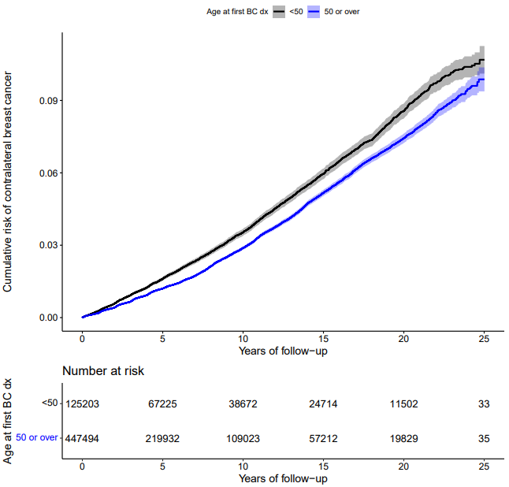
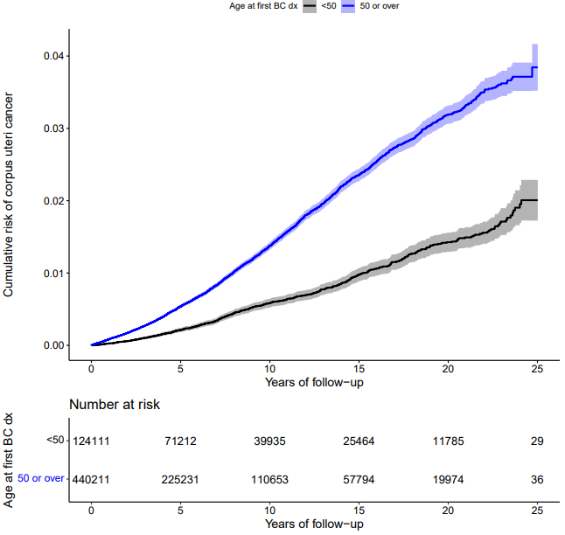
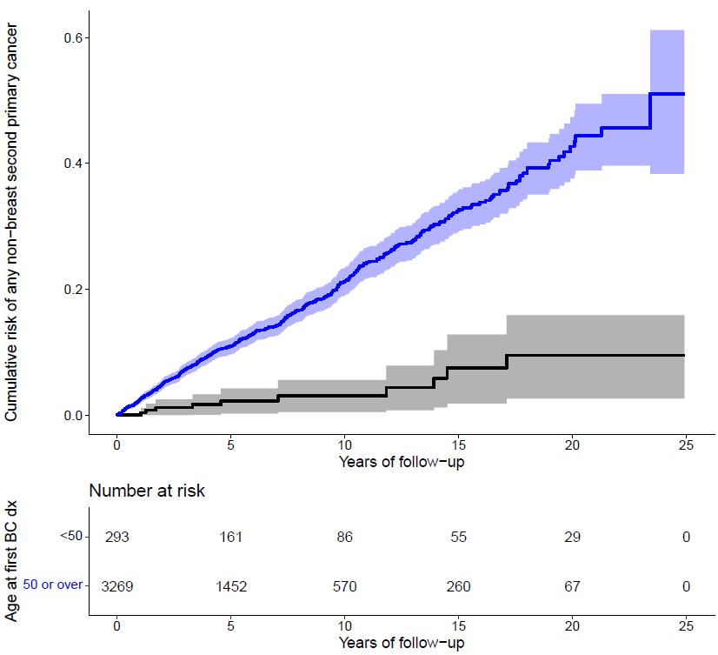
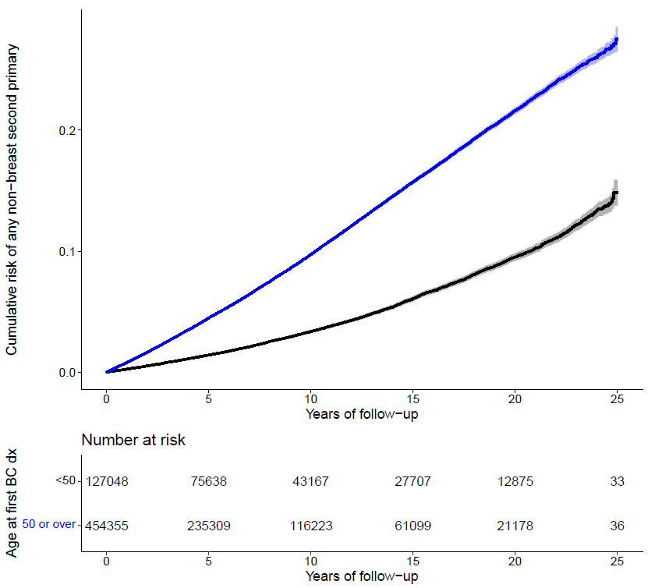
Figure S1: Cumulative risks of second primaries, stratified by age at first breast cancer diagnosis
5:
4:
3:
1:
2:
1: Cumulative risk of non-breast SPCs¹ (female BC² survivors)
2: Cumulative risk of CBC³ (female BC survivors)
3: Cumulative risk of endometrial SPCs (female BC survivors)
4: Cumulative risk of ovarian SPCs (female BC survivors)
5: Cumulative risk of non-breast SPCs (male BC survivors)
Black/grey scheme: Aged <50y⁴ at first BC diagnosis
Blue/light blue scheme: Aged >=50y at first BC diagnosis

1: Second Primary Cancer, 2: Breast Cancer, 3: Contralateral Breast Cancer, 4: Years

Note: We do not present a cumulative risk curve for CBC in males, due to low numbers of events.

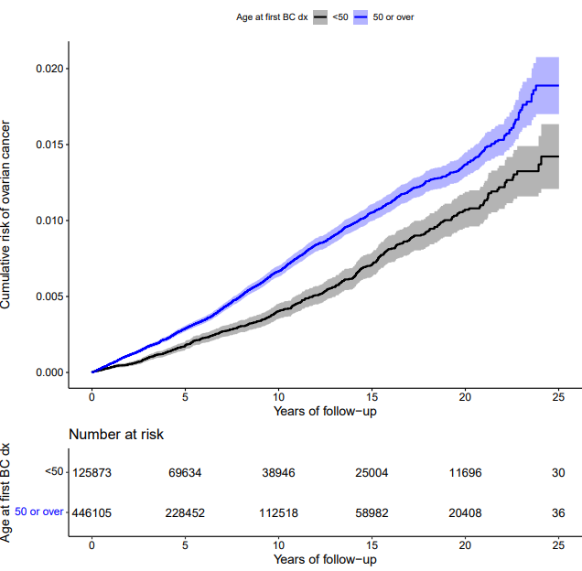
Figure S2: Forest plots of standardized incidence ratios for second primaries in male and female breast cancer survivors
Female breast cancer survivors
Male breast cancer survivors
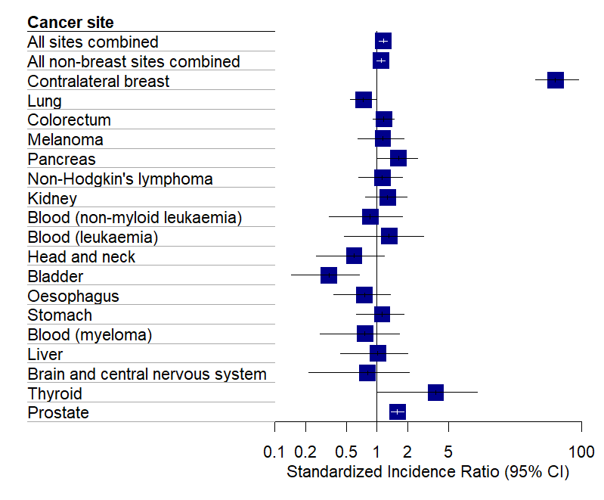
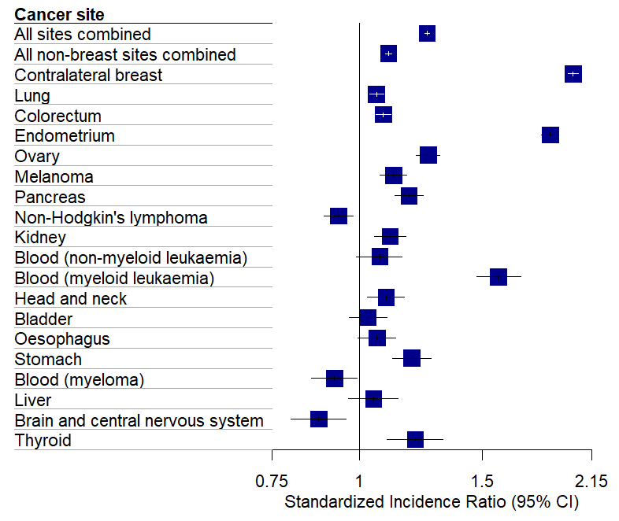

Figure S3: Forest plots of standardized incidence ratios for second primaries by age at first breast cancer diagnosis in female breast cancer survivors
Age 50 or over
Under age 50
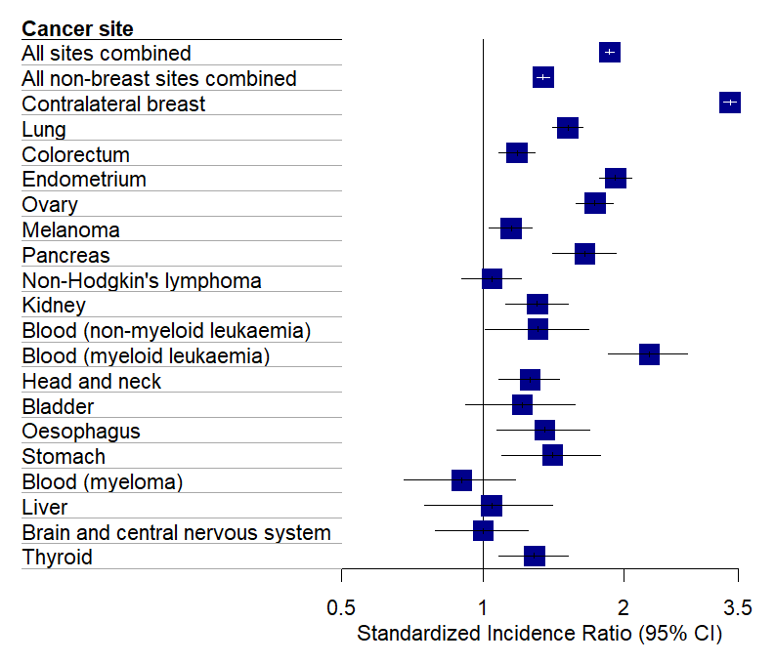
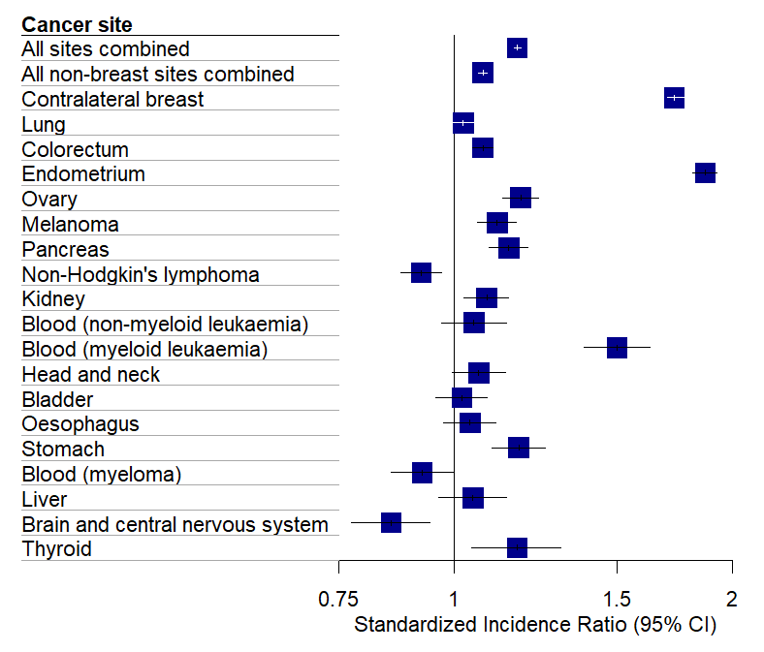

Figure S4: Forest plots of standardized incidence ratios for second primaries by socioeconomic status of region lived in at time of first breast cancer diagnosis in females
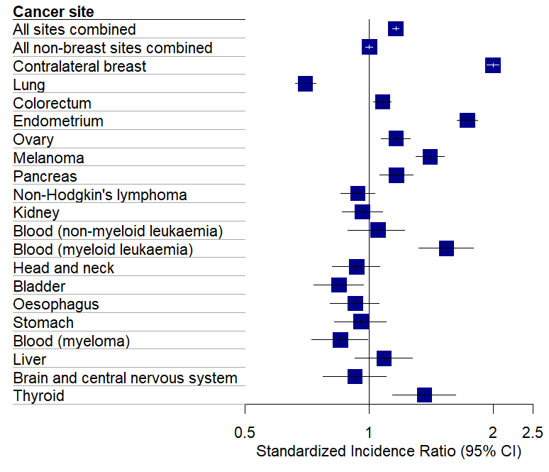
Indices of Multiple Deprivation quintile 1 (most deprived)
Indices of Multiple Deprivation quintile 2 (least deprived)
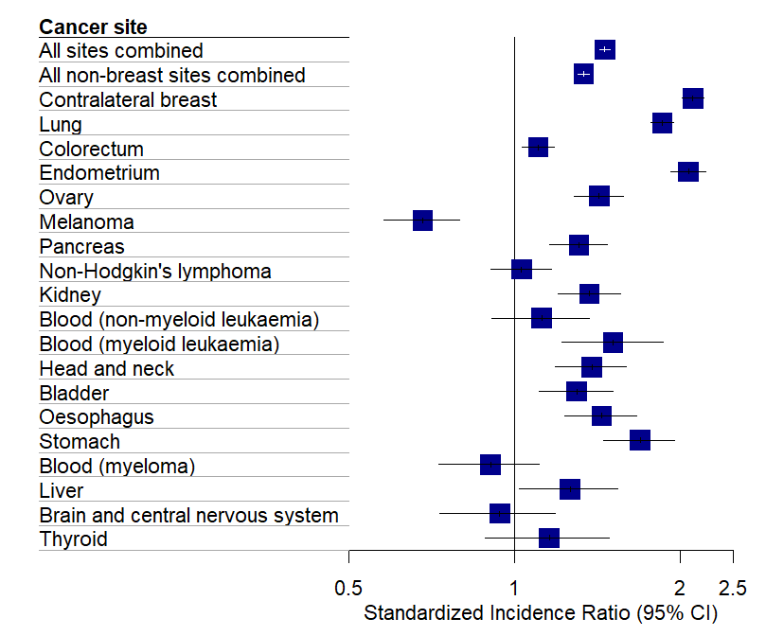

Supplementary references

S1: White IR, Royston P. Imputing missing covariate values for the Cox model. Stat Med. 2009; 28(15): 1982-98.
S2: Dowle M, Srinivasan A (2023). data.table: Extension of ‘data.frame’. R package version 1.14.8, <https://CRAN.R-project.org/package=data.table>
S3: R Special Interest Group on Databases (R-SIG-DB), Hadley Wickham and Kirill Müller (2021). DBI: R Database Interface. R package version 1.1.2, <https://CRAN.R-project.org/package=DBI>
S4: Hadley Wickham, Romain François, Lionel Henry and Kirill Müller (2021). dplyr: A Grammar of Data Manipulation. R package version 1.0.7, <https://CRAN.R-project.org/package=dplyr>
S5: Stevenson M, Sargeant E (2023). epiR: Tools for the Analysis of Epidemiological Data. R package version 2.0.62, <https://CRAN.R-project.org/package=epiR>
S6: Hadley Wickham (2021). forcats: Tools for Working with Categorical Variables (Factors). R package version 0.5.1, <https://CRAN.R-project.org/package=forcats>
S7: Schmidt D, Chen W (2017). “getPass: Masked User Input.” R package version 0.2-2, < https://CRAN.R-project.org/package=getPass>
S8: Stef van Buuren, Karin Groothuis-Oudshoorn (2011). mice: Multiple Imputation by Chained Equations in R. Journal of Statistical Software, 45(3), 1-67. DOI 10.18637/jss.v045.io3.
S9: Garrett Grolemund, Hadley Wickham (2011). Dates and Times Made Easy with lubridate. Journal of Statistical Software, 40(3), 1-25. URL https://www.jstatsoft.org/v40/i03/.
S10: Hadley Wickham and Jennifer Bryan (2022). readxl: Read Excel Files. R package version 1.4.0, <https://CRAN.R-project.org/package=readxl>
S11: Urbanek S (2021). rJava: Low-Level R to Java Interface. R package version 1.0-6, <https://CRAN.R-project.org/package=rJava>
S12: Urbanek S (2022). RJDBC: Provides Access to Databases Through the JDBC Interface. R package version 0.2-10, <https://CRAN.R-project.org/package=RJDBC>
S13: Therneau T (2021). A Package for Survival Analysis in R. R package version 3.2-13, <https://CRAN.R-project.org/package=survival>.
S14: Alboukadel Kassambara, Marcin Kosinski and Przemyslaw Biecek (2021). survminer: Drawing Survival Curves using 'ggplot2'. R package version 0.4.9, <https://CRAN.R-project.org/package=survminer>
S15: Grosjean, Ph. (2023). SciViews::R. UMONS, Mons, Belgium. URL: https://sciviews.r-universe.dev/.
S16: R Core Team (2021). R: A language and environment for statistical computing. R Foundation for Statistical Computing, Vienna, Austria. URL https://www.R-project.org/.

