**An Integrated Geospatial Data Model for Active Travel Infrastructure**

Chris Hill1, Marcus Young2, Simon Blainey2*, Stefano Cavazzi3, Chris Emberson1, Jason Sadler1

1 GeoData Institute, University of Southampton

2 Transportation Research Group, University of Southampton

3 Ordnance Survey, Southampton

*Corresponding author: Transportation Research Group, University of Southampton, Boldrewood Campus, Burgess Road, Southampton, SO16 7QF, United Kingdom, [S.P.Blainey@soton.ac.uk](mailto:S.P.Blainey@soton.ac.uk)

**Acknowledgements**

The research described in this paper has been carried out as part of Phases 1 and 2 of the Routable Active Travel Infrastructure Network project, funded by Ordnance Survey (phase 1 via direct R&D funding, phase 2 via funding from the Public Sector Geospatial Agreement R&D).

**Declarations of interest**: None

**Abstract**: Active travel has received increased investment and interest in many countries both due to COVID-19 and to policies which promote a shift in mobility behaviours to support a wide range of public and individual goods. However, while there has often been substantial investment in the physical infrastructure that can help facilitate active travel, there has not so far always been commensurate investment in the data infrastructure which can help enable people to shift trips to active modes. Current fragmented data and data models and a lack of data standards pose a barrier to the development of the applications which are needed to support planners, users and journey planning. There is therefore a need for a more integrated, better-connected and more richly attributed active travel geospatial network model. This paper describes the development of such a data model, and its initial application to a case study of Great Britain. It demonstrates how the development, population and maintenance of such a data model could facilitate a range of novel applications, such as the personalisation of active travel journey planning to address different user needs and capabilities. If the potential societal benefits from investment in physical active travel infrastructure are to be fully realised, this needs to be supported by the availability of a robust spatial data infrastructure capable of providing the information required by walkers, wheeled users and cyclists to make effective use of the active travel network.

**Key words:** active travel, open data, geospatial information systems, data modelling, spatial data infrastructure

**Graphical Abstract:**

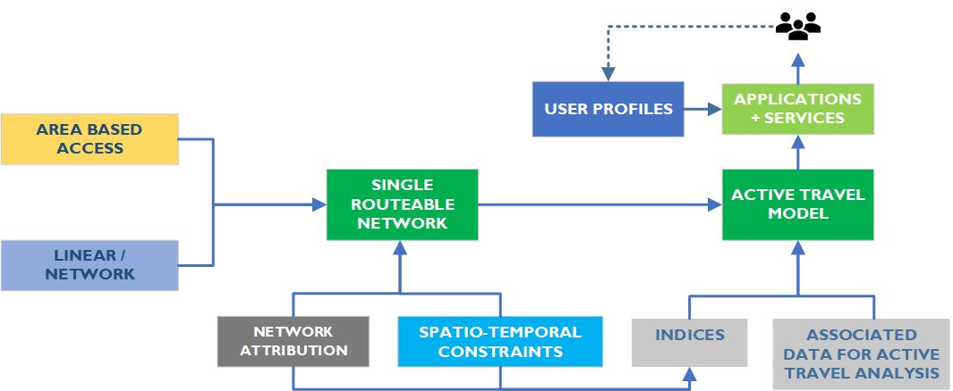

**1) Background**

**1.1 The Need for Geospatial Data on Active Travel Infrastructure**

Greater use of active travel modes (henceforth referred to as ‘AT’), most commonly walking and cycling, can play a significant part in meeting a wide range of broader policy goals. Benefits to both individuals and wider society can be identified from increased levels of walking and cycling. At a societal level, these benefits include reducing greenhouse gas emissions (Brand et al, 2021), congestion (Koska & Rudolph, 2016) and local air pollution (Doorley et al., 2015), increased economic activity (Litman, 2017), and reductions in obesity and other improvements in public health (Mueller et al., 2015). At an individual level, benefits include improved levels of personal well-being (Ettema et al., 2015), reduced social inequalities (for example by providing independent mobility to young people (Fyhri et al., 2011)), and reduced economic inequalities, for example by providing access to key urban functions for otherwise marginalised groups (Hidayati et al, 2019).

In recognition of these benefits, a range of governments around the world have therefore set targets for substantial growth in AT at local, regional and national levels (Winters et al, 2017). For example, the UK government has stated that in order to meet its target to decarbonise transport (Department for Transport, 2021) and achieve net zero carbon emissions by 2050, there needs to be a step-change in the use of AT modes (Department for Transport, 2020a), along with better spatial planning (PHE 2017) and improved provision of cycling and walking infrastructure. Similarly, the German government’s National Cycling Plan 3.0 (Federal Ministry for Digital and Transport, 2020) aims to double the distance travelled by bicycle by 2030 compared to 2017 levels, and the French ‘Plan Vélo & Mobilités Actives’ strategy (French Government, 2018) aimed to triple the mode share of cycling between 2018 and 2024. The importance of AT both as a health intervention in its own right and as a means of enabling physically-distanced travel was highlighted by the impacts of the COVID-19 pandemic, which saw substantial growth in AT use in many contexts (Buehler & Pucher, 2021) along with increased interest from policy makers in infrastructure investments to facilitate walking and cycling (Nurse & Dunning, 2021). However, an overarching issue facing effective active travel use, innovation and planning is that in most contexts there is no comprehensive, connected geospatial network or data framework available for AT data, planning, routing and journey personalisation. Whilst there has been a strong focus in many areas on improved urban design and infrastructure to support AT there has not been a commensurate effort in producing or integrating the associated geospatial network data. This is unfortunate, as geospatial data is just as much a part of the infrastructure needed to support AT growth as the physical infrastructure, provision of supporting services (such as cycle hire schemes) and collection of usage statistics that dominate investment in the sector. This gap in spatial network data provision and associated data models poses a barrier to any strategic review of requirements for future AT infrastructure, to the successful delivery of coordinated active transport policies and planning, and to the provision of comprehensive AT routing services to end users.

For example, existing routing and navigation applications usually provide the shortest journey from A to B by a chosen travel mode. However, the effectiveness of these routing applications is based on a series of assumptions about the completeness and characterisation of the network (including spatio-temporal variations in network attributes) and the capabilities and preferences of the user. These assumptions are often not backed up by reality, with substantial gaps in data on the existence, characterisation and attribution of network elements and therefore an inability of routing applications to account for the individual requirements of the user (e.g. with regard to safety or accessibility). While these limitations have not prevented a range of AT analyses taking place using geospatial data (and being reported in the literature), the accuracy of such analysis will inevitably be limited by the effects of the data gaps. There is therefore a requirement for better, more integrated and more comprehensive data on the AT network, its characteristics, and its relationship with other transport networks and the surrounding environment (e.g., in relation to pollution, noise, traffic, lighting, and safety levels).

This paper contributes to filling this gap by developing a generalised and transferable AT data model, and illustrating its capabilities by populating it using a case study of Great Britain. The remainder of the paper is structured as follows. Section 1.2 summarises the AT policy landscape in the case study area, and Section 2 provides a critical synthesis of previous research on this topic. Section 3 then describes the general framework and process that has been developed for producing a comprehensive and connected AT network in a given area. Section 4 then discusses the application of this framework to Great Britain, before Section 5 summarises the conclusions from the research and sets out priorities for further research in this area.

**1.2 Active Travel Policy Landscape in Great Britain**

In recent years there have been substantial developments in both government policy and investment relating to AT in Great Britain, as summarised by Hirst (2020). AT is a devolved responsibility in Great Britain, and both the Welsh Government and the Scottish Parliament have produced legislation and vision documents relating to AT, such as the Long-Term Vision for Active Travel in Scotland 2030 (Transport Scotland, 2014) and the Active Travel (Wales) Act 2013. In England, the COVID-19 pandemic prompted a £250m Emergency Active Travel Fund (EATF) programme (Department for Transport, 2020b), as part of a longer term £2bn investment in cycling and walking. A new executive agency, Active Travel England (ATE), was established by the Department for Transport (DfT) in 2022, which is responsible for objectives and budgetary control for AT initiatives in England. In early 2023 ATE launched a new £32.9 million Active Travel Capability Fund focused on creating a skilled AT workforce. A range of related national planning policies and principles focused on a Green Infrastructure Framework (National Planning Policy Framework, 2021, NE 2021) also align with the wider benefits of investment in AT. These government initiatives are complemented by policy promotion and AT guidance from NGOs such as the recent Sustrans and Arup report on inclusive cycling (Burns et al, 2020).

However, despite these investment and policy initiatives, relatively little attention has been paid to the spatial data infrastructure required to provide and maintain consistent national datasets on AT infrastructure and usage. This is a major gap in provision, as such datasets are needed to effectively develop strategy at national level, to support local level gap analysis and planning and to deliver routing services to pedestrians and cyclists that fully reflect the reality on the ground for users with different needs. There have been some limited developments in Wales, with the Active Travel (Wales) Act 2013) requiring local authorities to publish AT maps via a central web portal (Welsh Government, 2016). This programme clearly appreciates the value of collated network data and an integrated network in promoting usage, although it is focused only on core and aspirational networks rather than providing comprehensive cover and attribution. Recent work by DfT Active Travel Statistics (Department for Transport, 2022) has promoted the adoption of data collation based on common standards, no such standards for AT geospatial data currently exist. Although there has been some consideration of the overarching standards for the Future of Transport (British Standards Institution, 2020), there are no existing national or international standards that directly support the route network for cycling and walking or the integration between these modes.

There is therefore currently no definitive data source of AT infrastructure in Great Britain, no determination of what that definitive data might look like and no geospatial data model from which such a dataset or datasets could be developed and maintained. This presents a range of challenges in defining a national AT data model, for example around sourcing and ensuring completeness of data, and integrating devolved national differences in access rights and priorities.

**2) Previous Research**

As noted above, the provision of reliable and comprehensive geospatial data plays a crucial role in enabling AT, by providing information on the availability and suitability of AT routes to potential users. The importance of suitable AT infrastructure in enabling growth in AT use has been emphasised frequently in previous research. For example, Buehler and Dill (2015) demonstrate how the provision of dedicated cycling infrastructure can increase cycling levels, particularly when comprehensive networks are provided. Borst et al (2009) show that the presence of pavements (sidewalks in American terminology) can increase the likelihood of streets being used by elderly pedestrians, whereas the presence of blind walls makes the same users less likely to choose particular streets. Painter (1996) provides evidence how the provision of sensitively deployed street lighting can increase pedestrian traffic levels after dark.

However, in order for improved AT infrastructure provision to translate into increased AT usage, it is necessary for users to be made aware of (and given reliable information on) the locations where the various positive characteristics and attributes of AT infrastructure are present. In other words, the provision of infrastructure is insufficient if it is not accompanied by reliable and regularly updated information on the characteristics of that infrastructure. It therefore follows on from this that if users are unable to access data which enables them to identify whether or not an active route is available which meets their requirements, then this is likely to pose a significant barrier to AT. For example, Kelly et al (2011) found that the deficiencies of maps designed around car users could pose a barrier to walking, as such maps miss critical issues raised by pedestrians such as obstructions, security, and the lack of suitable road crossing points.

While the need for suitable and comprehensive datasets is acknowledged, the existing literature on AT data focuses primarily on AT usage statistics, usage patterns and behaviours as a measure of performance, outcomes and impact, and on the impacts of different factors on the propensity to use AT modes, rather than on the spatial framework for the active networks themselves (Alattar et al 2019). Some efforts have been made to develop routing tools which allow active travellers to take account of specific attributes of network elements when planning trips. For example, Wang et al (2022) developed a routing tool which allows pedestrians to choose routes which avoid areas where exposure to high levels of air pollution is expected. Similarly, the ‘Green Paths’ route planning software developed in Finland provides users with information on environmental exposures on specific routes, such as traffic noise, air quality and the presence of greenery (Helle et al, 2021). However, these still present only a partial picture of the AT environment faced by users, and even relatively high fidelity routing and visualisation tools have been criticised for misrepresenting the physical and cognitive demands of navigating roads as an AT user (Bill et al, 2015).

Based on this review of the literature, as far as the authors can establish, no comprehensive framework or data model for a geospatial representation of AT infrastructure networks has yet been produced. This is perhaps unsurprising, given that previous research has also found that financial investment in AT projects often tends to be primarily focused on physical infrastructure, with a comprehensive approach that also includes investment (for example) data collection being relatively uncommon (Maltese et al (2021). While the role of data is sometimes recognised in promotional and operational programmes, such Scotland’s Cycling Open Data portal (UrbanTide, 2023), this again tends to be focused on AT statistics, bike counter data and promoted routes rather than on the provision of geospatial data. Ongoing trends and developments in the AT landscape such as the increased adoption of e-bikes (Sloman and Hopkinson, 2019) and e-scooters and the consequent changes in infrastructure requirements and usage will only increase the need for a comprehensive framework for representing and organising AT data in a geospatial format. The next section of this paper describes a framework which has been developed to meet this need.

**3) Developing a framework for an active travel spatial data infrastructure**

**3.1 High Level Framework**

An AT network is conceived as a collation and procedures for integration of a range of existing geospatial data or routes that have a rich attribution on the segmented network to support personalised or profiled queries and applications for routing across the network and onto other networks (e.g., public transport). In this context, AT is defined as comprising travel by pedestrians and cyclists; this underlies a broader categorisation of different types of wheeled users and pedestrians such as walkers and runners. Although most analysis of AT routing has focused on urban areas, the same concept should be equally applicable to rural areas. The framework presented here envisages an AT network dataset that is complete, topologically connected, and richly-attributed. This network should be based on a maintained and dynamic set of data describing the network that can cater for changes and updates, such as path closures or re-routings (whether temporary or permanent). The creation of such a network will require consideration of issues such as the accuracy of route alignments, de-duplication of routes derived from different source datasets, prioritisation of routes within the data integration, distinguishing between legal and permissive access rights, identification of spatio-temporal restrictions, and the provision of route ‘membership functions’ (e.g. for specific marketed routes and trails). Whilst the use of open data may be desirable from several perspectives this is not specified as an essential criterion, given that the highest quality and most comprehensive datasets in some contexts make use of commercial data.

Figure 1 provides an overview of the concept of the framework and data integration flowline within the AT network. This comprises linear network data, area-based access and associated characteristics and attributes that enable query and categorisation of the network or sections of it. Furthermore, there is a category of ‘associated data’ to support AT analysis in terms of accessibility, usage, quality, and profiling. This latter category includes a series of indices developed for supporting more advanced modelling and categorisations and strategic analyses. This would allow the populated data framework to be used as the basis for AT modelling and application services that are sensitive to individual user requirements. The fundamental component of this framework is the geospatial data infrastructure rather than any applications (such as routing services) which might be built on the data framework.



Figure 1: High-level framework for integrated active travel network data infrastructure

As is shown in Figure 1, the data model combines area-based and linear access into a single routable network that can be used for AT data modelling and to support AT applications. This network would support both walking and cycling usage (with multiple sub-categories of each use type based on user profiles) and is separately navigable and routable by different modalities based on the underlying attribution. Furthermore, where appropriate it is assumed that the AT network data will link to (or potentially integrate with) the rest of the travel network (e.g., linking with the public transport network). A more comprehensive view of the data sources and integration pathways is provided in Figure 2, which includes examples of how the framework can be populated with specific datasets for the case study of Great Britain (see Section 4). The components of this framework are discussed in more detail below.

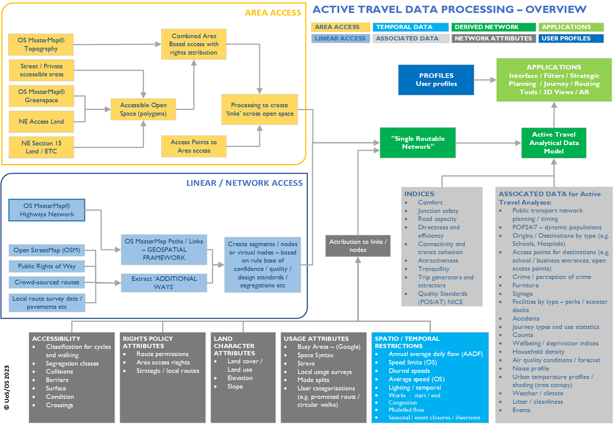

Figure 2: Detailed view of the components of the active travel network and data attribution framework

**3.2 Link-Based Data Framework**

A linear or node and link-based representation of the AT infrastructure which exists in the real world is the logical starting point for any integrated digital network of this kind. While in an ideal situation a single source of truth would exist regarding the location and nature of AT infrastructure links, in most circumstances several datasets will have to be integrated in order to provide a comprehensive representation of the real-world network. This integration process involves selecting a dataset (usually the most comprehensive or reliable) to form the base network, and then augmenting this with additional edges from other sources. The creation of this combined linear route requires processing and the creation of rulesets to integrate only the additional linear network representations that need adding to the framework, as a key challenge to the effective integration of the various street and path datasets is identifying the part of those networks which are unique and ensuring that features are not duplicated once integrated. This is a complex problem, as there is often substantial overlap between the various datasets in terms of the real-world features that they represent. Each dataset has its own view of the world and there is likely to be limited spatial coincidence. The spatial coordinates of edges that represent the same real-world feature may not coincide in part or at all, due to different source and spatial resolution and data accuracy. In addition, the legal or ‘official’ definition of a path location may not correspond with the ‘used path’ which users traverse in reality. Automation of this integration process, which is required for application at a regional or national scale, can be achieved via a combination of attribute comparison (for example the name of a designated path), spatial analysis and/or a graph construction or matching/alignment process.

**3.3 Area-Based Data**

While much of the AT network is comprised of linear links, a significant minority of AT trips will take place in part or (occasionally) entirely on areas of open access land where there may be no specific linear access routes defined. Such open spaces are normally represented in an area-based format as polygons in geospatial data, and this area-based data structure presents challenges for incorporating these open spaces in routable geospatial networks. Although they may have formal routes across them there are often additional ‘desire lines’ not on mapped networks. It is therefore necessary to develop reliable and consistent methods for creating virtual ‘links’ across these open spaces, as well as to locate and geospatially represent access points where the open spaces are joined to the adjacent link-based infrastructure network.

**3.4 Network Attribution and Spatio-Temporal Restrictions**

While the combination of link- and area-based data should provide a comprehensive representation of where people can potentially travel using AT modes, this information is not itself sufficient to provide reliable routing information for journeys using the AT network. A range of attributes of both individual network sections and complete routes will influence both route choice and the extent to which people choose to use AT at all and how routes are planned and promoted. Data on these attributes therefore needs to be incorporated into the AT data framework and associated with specific links and nodes. These attributes can be grouped under five headings, as follows:

* Accessibility attributes, such as path surface type, the existence, width and quality of pavements, and the existence of physical barriers.
* Rights/policy attributes, such as usage permissions.
* Land character attributes, such as land use and slope.
* Usage attributes, such as user volumes and mode split.
* Spatio-temporal restrictions, such as road traffic speeds, congestion, and the presence (or absence) of lighting.

**3.5 Integrated Routable Network**

The attributed combined AT infrastructure network can then be used as the basis for providing accurate routing for journeys by AT, which can take account of the differing requirements and preferences of different potential users. This network should be sufficient for some applications, such as basic AT journey planners, but for other purposes further information may be required, as discussed in the following subsections.

**3.6 Associated Data for Active Travel Analysis and Indices**

In order to undertake more comprehensive analysis of AT infrastructure and behaviour and their broader policy implications, the integrated routable network will need to be linked with other datasets. Examples of these could be spatially disaggregated data on population characteristics, the locations (and access points for) key origins and destinations, public transport routes and timetables and quantitative information on various exogenous factors such as crime rates and air quality. These data may be associated with the network dynamically by spatial overlay techniques rather than integrated into the network data model.

There are also a suite of associated data that are derived as ‘indices’ from the analysis of the routes and the attributes, such as the quality criteria from the National Institute for Health and Care Excellence (NICE) for public open space and for AT routes. Similarly, there are a range of derivative scores and synthetic metrics for factors such as attractiveness, connectivity, comfort etc.

**3.7 Active Travel Analytical Data Model**

Finally, the combined AT infrastructure network and the associated data of related factors should be integrated together to form an AT Analytical Data Model. This should be provided using a common and consistent data structure which can provide a standardised input for a range of potential applications. The data model would be complemented in this by a set of bespoke user profiles to allow personalised user characteristics to be considered.

**4) Implementation of Data Framework in Great Britain**

**4.1 Choice of Base Network Dataset**

Having developed a generalised framework for a geospatial AT data network, the next step in this research was to apply it to a case study of Great Britain. Two main candidates were identified to form the base network for the routable AT network dataset, the Ordnance Survey MasterMap (OSMM) Highways Network and OpenStreetMap (OSM) data. Both are regularly maintained providing dynamic updates, both are already richly attributed (Hulse et al., 2022), and both are widely used by transport practitioners. However, initial analysis demonstrated that neither represent the full AT network that is available on the ground, nor adequately describe the accessibility and attributes of segments and features of this network to support the range of applications. This analysis involved firstly cross-checking the OSMM and OSM data for a case study area against both aerial imagery and GPS traces of actual pedestrian trips logged in the OS Maps mobile application, and secondly comparing the attribution available in OSMM and OSM with the list of desired attributes from the framework shown in Figure 2. In both cases significant gaps were identified, with some frequently used links missing from the network representations, and incomplete or absent coverage of a number of key attributes such as pavement presence, path width and path surface type. This is a major deficiency, as clearly a dataset which is incomplete in both coverage and attribution will not provide reliable outputs when used for a range of practical applications (for example, providing safe and accessible routes to schools). The analysis also identified overlaps between the two data sources and exceptions and licence restrictions that restrict the incorporation of one within the other to build a composite to fill some of the gaps. This meant that, despite their deficiencies, it was necessary to identify one of these datasets to form the base network for the enhanced dataset developed during this research, given that no better alternative was available.

Whilst OSM data has many advantages in terms of open data as volunteered geographic information, it is not a maintained dataset with the requirements for continual update and completeness checks across Great Britain (Roper et al 2021), meaning that it cannot be relied upon to provide a temporally consistent representation of the real-world network. One of the key strengths of the ‘tag’ structure employed in OSM is its flexibility (for example allowing information on barriers to active travel to be collected). However, this ability to define new tags means that often there is a lack of consistency in feature representation, with heterogeneous categorisation and attribution that would require considerable validation (Vyron 2011). The lack of restriction or convention in OSM also means that some geographic features (e.g. ‘sidewalk) may be represented as separate feature or alternatively as a tag on a highway feature. Furthermore, the OSM data has a limited range of highway attributes (Hulse et al., 2022) and even fewer related to walking and cycling routes, whereas Figure 2 demonstrates that complex attribution of infrastructure may be required for AT applications. OSM street and path data is not inherently structured as a routable network (i.e. it does not consist of edge and node tables (in contrast to OSMM Highways Network once imported into a database), and while tools do exist to generate this structure from the data, for example using osm2pgrouting, the outputs will only be as good as the underlying data. There are restrictions on what additional data can be incorporated in OSM due to IP restrictions (for example relating to official data in Great Britain on Public Rights of Way), and challenges with incorporating OSM data within other datasets because of its copyright model, where each individual contributor is a copyright holder. In summary, there are several barriers which prevent OSM being used as a base network for these purposes.

Because OSMM data is the only source that is consistently surveyed and updated on a regular schedule, and because of its simpler licensing model, it was therefore selected to form the base network for this application of the AT framework.

**4.2 Data Standards and Integration**

The proposed foundation for the AT data, the OSMM Highways Network (Ordnance Survey, 2021), adopts geospatial data standards from the INSPIRE Transport Networks Data Specification (INSPIRE, 2010). The network specifications have also been extended to include additional properties included in British Standard for Land and Property Gazetteers (LLPGs) and Local Street Gazetteers (LSGs) (British Standards Institution, 2019), meaning that they follow best practice insofar as they have been codified. However, while the British Standards Institution (BSI) has recently reviewed the transport standards (Millard et al 2022) the concepts here are limited to vehicular transport rather than broader travel. While the British Government has recently developed revised standards for some AT infrastructure (for cycling) (Department for Transport, 2020c), these do not include data or definition standards for the features that are included. A range of AT-related infrastructure features need to be modelled if they are to be represented in geospatial data, but there is currently no convention as to how they should be recorded or mapped. For example there are several differing levels of vertical differentiation and kerb provision associated with different kinds of cycle track, which need to be described (or at least appropriately categorised) if a geospatial model is to provide comprehensive characterisation of separation from traffic. Developing an extended set of data standards fell beyond the scope of this project, as this would require leadership from organisations such as BSI, but bespoke attribution of links to capture infrastructure variations based on the categorisations provided in infrastructure standards can provide a workaround where necessary, enabling key features of AT infrastructure to be associated with the base network dataset.

**4.3 Enhancing the network coverage**

Effective routing applications rely on the completeness of the network dataset (both linear and area-based) and an understanding of access rights and potential usage restrictions (e.g. streets that are pedestrianised at certain times of day). A usable AT network must therefore be spatially and temporally comprehensive, connected and attributed with the variables needed to operate the routing selections. As noted previously, while the OSMM dataset offers the most complete coverage of the AT network that currently exists, there are still significant gaps in its coverage, and an evaluation of these gaps found that there is little consistency as to where the gaps in user paths, tracks and cycleways lie. An assessment of the availability and suitability of additional datasets to fill these gaps was therefore carried out. This built on previous work carried out as part of the development of the Local Cycling and Walking Infrastructure Plans guidance note, which identified datasets of relevance to enhancing the AT network and infrastructure (Department for Transport, 2017). Table 1 summarises the datasets evaluated and their potential role in augmenting the Single Routable Network based on their national (or devolved nation) coverage, categorised into datasets which represent linear and area-based access.

Table 1: Summary of datasets that may be employed to enhance the core network with additional routes and features

|  |  |  |  |
| --- | --- | --- | --- |
| **Dataset** | | **Origin** | **Routes / area access** |
| Linear | OSMM Highways Network products | Survey | Core dataset.  Separate linear network components of Road, Track and Path Networks |
| Public Rights of Way (PRoW) | Survey | Definitive route and classification,  Definitive Map and Statement |
| Long Distance Paths / National Trails | Survey | Linear route categorisation |
| Sustrans | Survey | Great Britain cycle network |
| OS Detailed Path network | Survey | Separate data in National Parks and Areas Of Outstanding Natural Beauty (AONB) |
| OSM Open Street Map App | Crowd-sourced | Linear community data on multiple classes |
| Strava Metro | Crowd-sourced | Linear community data on cycling |
| Highway Authority (County / Unitary Authorities) | Survey | Linear routes, planned projects maintenance, improvements (under Highways Act 1980 (HMSO, 1980)) |
| SlowWays | Crowd-sourced / Survey | Linear routes between urban areas  https://beta.slowways.org/ |
| OS Maps Routes | Crowd-sourced | Individual traces of AT trips in linear format, but including area-based access. |
| Area-based | OSMM Topographic data | Survey | Area access and area of features (e.g. pavements) |
| Access Land | Survey | Mapped Open Country and Registered Common Land CRoW Act 2000 (Natural England) |
| Dedicated land (CRoW ACT S.16) | Survey | Land dedicated under the CRoW Act 2000 (Natural England) |
| Section 15 Land  (CRoW Act 2000) | Survey | Land with Access under other Acts (e.g. Law of Property Act etc) and extends local access to public in general under Commons Act 1899. |
| Town and Village Green | Survey | National Parks and Access to the Countryside Act 1949 – Local Authority |
| Public Open Space | Survey | Local Authority classification |
| *Pseudo*-Public Space (Shenker 2017) | Survey | Private ownership with permissive access (area / linear) |
| *Coastal Margins*  *(MCA Act 2009)* | Survey | English Coast Path and coastal margin (area and linear) |

While these datasets in theory contain a wide range of potentially relevant information, their suitability for enhancing the base network dataset is highly variable. For example, the availability and quality of definitive maps of the Public Rights of Way (PRoW) network varies substantially between different local authorities. PRoW is a legal definition of a path which includes differing access rights for several different user groups on different classes of PRoW. This network is often poorly integrated in routable networks, and its comprehensive inclusion (along with other permissive paths) has the potential to enhance network coverage in both urban and rural settings, but the feasibility of using ‘definitive maps’ for this purpose depends on a) their availability in a GIS-readable vector-based format and b) on the frequency at which they are updated. It should also be noted that the legally-defined routes of paths may not in all circumstances correspond with the location of usable paths ‘on the ground’, meaning that data on these legally accessible locations should not be used in routing applications without careful checking.

Route data from the OS Maps mobile phone app was identified as a particularly promising source for enhancing the coverage of the base network dataset (note that OS Maps is a completely separate product from both OSMM and OSM). This app allows both free access and enhanced, subscription-based access to higher resolution OS map products, 3D and augmented reality and aerial 3D imagery, and AT routes (including recommendations from users). It also collects data on the routes followed by users. Under the End User Licence Agreement (EULA) for OS Maps, anonymised User Generated Activity Data and routes can be aggregated, subject to privacy tags, to provide a basis for checking the routes actually used by walkers and cyclists against the base network. This then allows the identification of ‘missing’ path links which can be used to augment the base network. A two-stage processing workflow was developed to filter the complex data from the raw route records to produce generalised vector representations of these missing links. The first stage involves identifying the GPS traces that use unrecorded pathways by extracting vertices from routes intersecting the area of interest, reconstructing routes (or part routes) based on these vertices, and then removing vertices which are less than 10m from an existing link in the base network. The multiple remaining traces are then converted to a set of distinct vector lines by generating a line density raster using 2m cells with the length of lines within a 10m radius of each pixel being summed. This is then converted to a binary raster (where 1 denotes that a path is present in a cell) and a line density threshold is set to identify paths which are regularly used. The raster cells which pass this threshold are then skeletonised to a vector line, creating additional links which can be integrated in the base network. This thereby provides a more comprehensive geospatial representation of the real world AT network which can then be used for routing applications, enabling users to be given route options which more accurately reflect the infrastructure which is available to them.

**4.4 Enhancing the Network Attribution**

Alongside the use of additional datasets to enhance the coverage of the route alignment data, these datasets (and other resources) may contain information which can be used to enhance the attribution of the network and its links and nodes, for example by adding records of legal access rights and temporal status, or additional environmental characteristics (Labib et al 2022). While in theory identifying the areas of attribution which are required may be straightforward, in practice characterising, deriving and linking this attribution to the base dataset can be a complex process. This is illustrated here through a discussion of the challenges involved in integrating data on pavements with the base dataset in the Great Britain context.

While it may be described using several terms, such as ‘sidewalk’ or ‘footpath’, a ‘pavement’ is at one level a relatively simple concept to define, as in broad terms it is a manmade surface designed for pedestrian traffic that is adjacent to a road. In data and mapping terms, however, and in the context of an AT network or database, pavements are more complex, for four main reasons. Firstly, the OSMM Highways Network data used as the base network here does not have a definitive ‘pavement’ attribute that contains widths, surface types and other attributes that can be used for routing applications. Secondly, even though pavements in Great Britain are notionally subject to a statutory minimum width of 1200mm (free of obstructions), in practice, pavements are often narrower (Gaist, 2021). Such pavements pose a problem for wheeled users, but no minimum width attribute is provided in the OSMM Highways data to satisfy this use-case. Thirdly, the ‘pavement’ may have multiple shared uses as segregated or non-segregated ways (e.g. cycleways), AT crossings, and vertical components, meaning that semantically describing the pavement becomes more complex (Niknam et al 2022, France-Mensah and O’Brien 2019). Finally, specific characteristics of pavements may determine their usability for different types of users, with for example surface type being particularly important for wheelchair users (and conversely with non-manmade surface types such as grass verges being used for walking in some circumstances, even though they would not normally be classified as ‘pavements’).

In order to overcome the first two of these challenges, this case study implementation of the AT data framework compared the use of two methods to derive pavement width information for OSMM Highways Network road links. The first approach derived minimum widths for given pavement polygons using a negative pairwise buffer, building on a method used by ESRI (ESRI 2020) to define pavement widths using OSMM Topographic data during the COVID-19 pandemic (for the purposes of social-distancing) (Labib et al 2022). A very similar approach was used in a study on accessibility for the elderly in the Netherlands (Verschuur, 2013). A standard, positive (pairwise) buffer method is simply a way to generate an enlarged boundary around a geographic feature by a specified distance. A buffer generated with a negative distance however will reduce the feature's boundaries by the distance specified. This is useful because above a given (negative) distance the buffered feature overlaps itself, and this 'internal' buffer can be used to erase the original features that are less than the size of the overlapping buffer. Width attributes can therefore be applied that correspond to features that are erased by certain width thresholds. The ESRI (2020) method applied several width thresholds to the OSMM Topographic data once pavements had been selected using descriptive terms such as ‘manmade’ and ‘roadside’. Our extension of this method applied width thresholds of 500mm increments which gave a greater degree of accuracy than the original ESRI (2020) approach, and therefore allowed estimated pavement widths to align more closely to the requirements of AT users. This did not in itself generate a routable network as the OSMM Topographic data format is not designed for network analysis, but a further method was developed in this research to link the outputs from this process to the enhanced routable network described in Section 3 based on the spatial location of the pavement features.

The second approach tested was developed by Ordnance Survey, and involved spatially matching OSMM Topographic features that denoted the presence of a pavement with OSMM Highways Network road links. resulted in a polyline dataset, with a calculated length. This resulted in a single, linear feature for (potentially both) pavement features along a particular stretch of road, with a subsequently calculated length. However, this method only denoted the presence of a pavement on a road link, and did not identify which side of the road the pavement existed upon. Furthermore, the method involves a dilution of the original polygonal features in the OSMM Topographic data. As a result width calculations could not easily be derived without significant error, and in any case would only give an average width which would not necessarily provide sufficient information for reliable routing where users had an absolute constraint regarding the minimum width of pavement they could negotiate. In contrast, the negative buffer approach provides full flexibility and pavement width information at an appropriate range of widths for a variety of AT use-cases, and with a clear indication of which sides of road links pavements are present on. The negative pairwise buffer method was therefore used here to enhance the base geospatial network dataset with pavement width information, as in comparison the Ordnance Survey method does not give the required level of resolution and therefore flexibility required for the use-cases of an AT routing application. This then provides an enhanced routable geospatial network which could allow users to specify width-related access constraints, with for example wheelchair users able to request routes with paths that are wide enough to accommodate their wheelchairs.

**4.5 Integration with Associated Datasets and Derivation of Indices**

In order to undertake more comprehensive analysis of AT data infrastructure and behaviour and their broader policy implications, the integrated routable network would be linked with other datasets. Example datasets could include spatially disaggregated data on population characteristics, the locations of (and access points for) key origins and destinations, public transport routes and timetables, and quantitative information on various exogenous factors such as crime rates and air quality. Given the wide range of spatial resolutions and update frequencies associated with such datasets, it is assumed that they would be associated with the network dynamically using spatial overlay techniques rather than being integrated into the network data model.

These associated datasets would be linked to the attribute data in the single routable network in order to derive ‘indices’ for network links that can be used to support applications. These indices include a range of derivative scores and synthetic metrics for factors such as attractiveness, connectivity and comfort. Examples of this kind of application in the British context could include the quality criteria from NICE for public open space and AT routes (NICE 2019), and walking and cycling tools such as the Propensity to Cycle Tool (PCT) (Woodcock et al., 2017), the Route Selection Tool (RST) and the Walking Route Audit Tool (WRAT) (Department for Transport, 2017), all of which are used routinely in the context of infrastructure and land use planning.

**4.6 Case Study Implementation of Integrated Dataset**

A demonstrator routing tool which links the comprehensive routable network with datasets providing additional attribution has been produced as part of the case study implementation of the framework. This is illustrated in Figures 3a and 3b, which show how the geospatial pavement network with width attributes has been linked to transport noise and road accident density. It therefore demonstrates how the data model developed here can be used to link datasets from a range of sources in an integrated and customisable routing tool. It also provides three practical examples of how the integrated dataset can provide useful outputs for specific use cases. These are 1) routing where for reasons of personal safety a vulnerable pedestrian requires a route with comprehensive street lighting provision, 2) routing where a wheelchair user needs a route with pavements of at least a certain minimum width, and may have to use a specific side of a road to access these (demonstrating the importance of detailed pavement attribution), and 3) routing where key paths are not included in the baseline geospatial dataset, and where crowd-sourced information is needed to give accurate information on shortest paths.

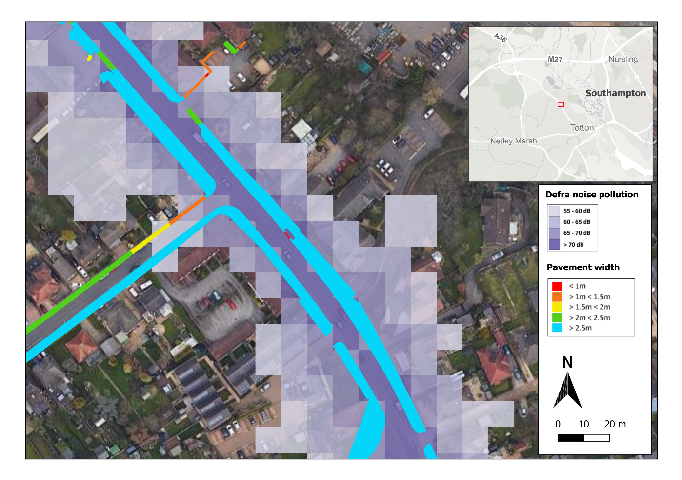

Figure 3a: Example integration of Defra traffic noise and OSMM pavement widths

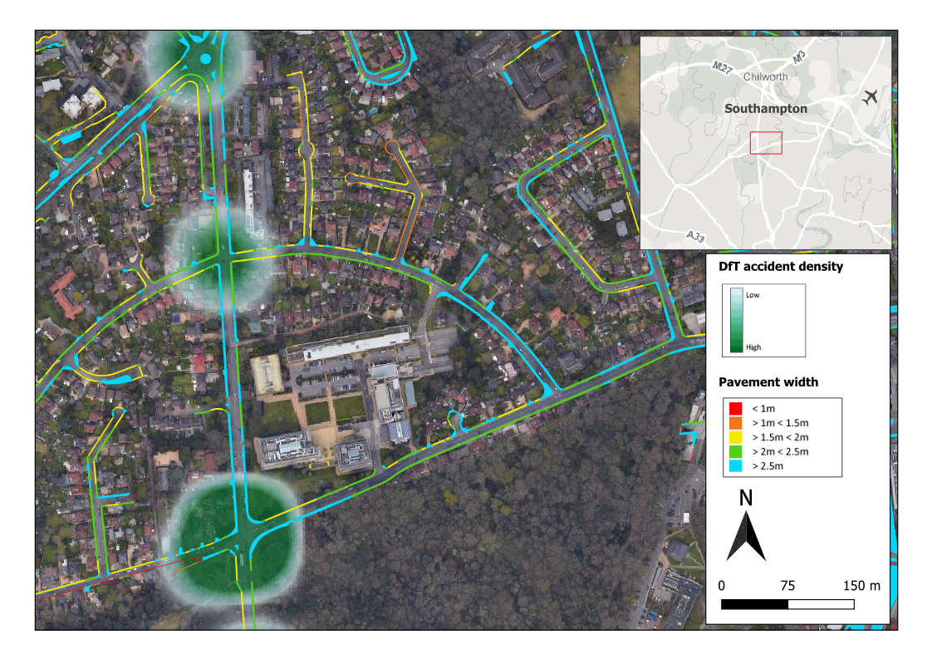

Figure 3b: Example integration of DfT Road Traffic Accident Heatmap and OSMM pavement widths

In particular, the integrated datasets could be used for a range of purposes where work is regularly commissioned by local authorities, such as identifying safe routes for children to walk to school, or modelling air quality. In order to illustrate the practical utility and potential impact of the datasets, the integrated datasets were used to improve the identification of safe routes to school in a local authority area in the United Kingdom. There is a statutory requirement on local authorities to provide safe transport to school, which will often require authorities to assess whether individual roads or paths are suitable for school children to walk along (Hall et al., 2021). However, no automated or transferable methodology has previously existed to enable local authorities to carry out such assessments, meaning that routes have to be assessed manually on an individual basis. Examination of routes assessed as being ‘safe’ within a case study local authority has identified that some such routes have characteristics which mean they are not in fact safe for children to walk along. For example, Figure 4 shows the shortest pedestrian route (based only on travel time) for a child walking from a residential area to a nearby school. This route passes along a road (shown in orange) which has been assessed as suitable to form part of a safe route to school. However, interrogation of the integrated dataset set out in this paper shows that this road has no pavements (sidewalks) and has a 60mph speed limit for road traffic, features which combine to make it unsafe for pedestrian use.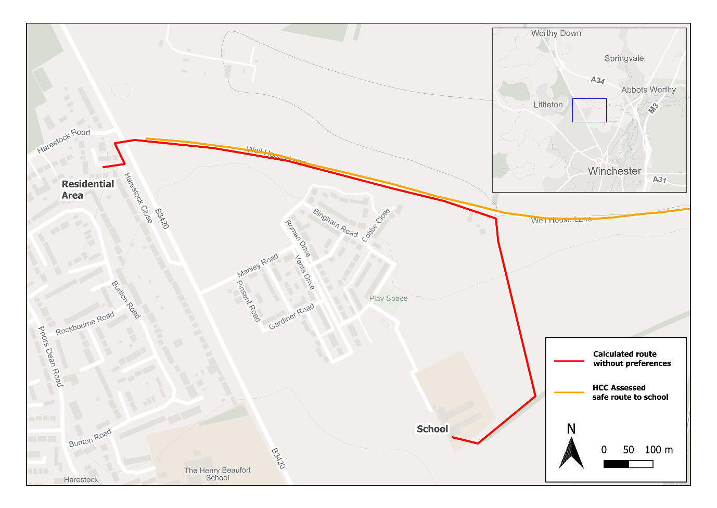

Figure 4: Example Route To School Based On Shortest Path

Using the case study implementation of the integrated dataset it is possible to specify in much more detail the requirements for a truly ‘safe’ pedestrian route to school, with the ability to customise routes to meet the requirements of specific pupils. For example, routes can be calculated that are suitable for wheelchair users by specifying that routes must have pavements which are wide enough to be easily negotiated. Figure 5 shows a route connecting the same residential area and school, but with specific requirements for pavement provision throughout, with a minimum width of 1 metre, a sealed path surface (required for wheelchair users), the provision of street lighting and the use of safe road crossing points. This route was calculated almost instantly, and the use of GIS-based routing software allows large numbers of user-customised routes to be generated reliably in a short space of time, with no requirement for assessors to visit route sections to physically assess their characteristics (as is sometimes required with current assessment methods). This example application thereby demonstrates the potential of the integrated datasets both to deliver higher quality policy-focused outputs than can be generated using current methods, and to provide resource savings for local authorities (and other stakeholders) by reducing the staff time required to fulfil their statutory commitments.

Figure 5: Example Route To School Based On Detailed User Requirements

There are many other areas where the integrated datasets based on the framework could be used to assist in transport planning and the delivery of government policy. These include for example supporting access to open space as promoted by health services (NHS, 2023), mental health charities (Mind, 2021) and nature conservation charities (Wildlife Link, Mapping access to nature in England), improving access to greenspace and nature which is stated as forming an essential part of local plans in recent government legislation (UK Parliament, 2023), and assessing the resilience of active travel networks to the impacts of climate change.

**5) Conclusions and a Route Ahead**

Despite widespread policy efforts to achieve mode shift to AT, and associated investment in physical infrastructure for active modes, most countries have not seen a commensurate investment in spatial infrastructure data associated with AT. While for motorised road traffic the fundamental infrastructure is usually well mapped in integrated national datasets this is not the case for AT modes, and attribution of AT networks covering classifications of routes, access and usage rights, and other factors that affect users’ comfort or usability is even more scarce. The research set out in this paper has taken a major step towards filling this gap by developing a comprehensive and generalisable AT geospatial data model, and identifying processes for populating such a data model in a specific national context. The data model provides a checklist for the information required to build a comprehensive routable AT network, while also providing a consistent structure for organising and linking disparate datasets to produce such a network. Networks which are built based on this data model can then provide a consistent basis for a range of practical applications, such as (in the UK context) the development of Local Cycling and Walking Infrastructure Plans (LCWIPs) which all local authorities are required to produce. By following the data model these networks will either provide a comprehensive representation of the active travel network in a given area or, where suitable data is not available to enable this, will clearly highlight where network sections and/or key attributes may be missing, enabling both transport practitioners and transport users to make informed decisions.

The processes developed to populate the generalisable data model have been designed so that they are both scalable and easily-automated, allowing them to be rolled out across Great Britain in future. While the size of the datasets thus generated would clearly be substantial, the storage and processing requirements are of a similar level of magnitude to many existing Ordnance Survey products, and therefore implementation of the processes at a national scale should not raise any major problems. Similarly, while this example implementation has been based on datasets which are specific to Great Britain and therefore not directly transferable elsewhere, the data model itself should be easily transferable to other national contexts, as it is ‘dataset agnostic’ and sets out common requirements for AT routing and analysis in any location. While the levels or values of particular factors may vary between contexts (e.g. weather-related constraints could be quite different in a tropical climate compared to a humid temperate climate such as the UK), this does not limit the applicability of the general data model. However, the processes used to populate this data model will obviously vary from country to country, depending on the characteristics and extent of the local datasets which do (or do not) exist.

Some challenges remain and additional research and development needs have been identified in order to fully meet the need for a comprehensive integrated geospatial AT dataset. This research has been undertaken largely as secondary data analysis, and further review of the outputs should be undertaken with AT stakeholders to evaluate user requirements, followed by a participatory discovery exercise based on the identified use cases. Data does not currently exist (at least in the British context) for a number of the attributes and indices contained in the generalised data model, and stakeholder engagement could help to prioritise future work designed to fill these data gaps. It could also help identify priorities for work to support associated spatial queries, enabling greater user personalisation in applications based on the integrated dataset. While this work has demonstrated the framework and principles for developing an integrated dataset, it has not yet filled all the data gaps in the case study area, and a more comprehensive prototype is needed to test the processing rules and workflows that could support an operational model and allow for the development of a more formal spatial data model (feature catalogue and application schemas). A routable geospatial network is an active, dynamic resource and just as there may be closures and restrictions on the ground (e.g. for diversions and street works), the spatial data infrastructure and data structure also needs to be able to both be maintained and reflect temporal changes. While the data model acknowledges that AT is not used in isolation, and includes conceptual links to other parts of the public transport network, an evaluation of methods for enabling this integration needs to be undertaken.

Finally, it is important to recognise that significant developments in AT practices are currently taking place, with growth in the use of electric micromobility such as e-bikes and e-scooters (Department for Transport, 2019). AT data standards, guidance, data models and collection processes therefore need to be dynamic in order to keep pace with developments in how AT and shared infrastructure are used in practice. The data model presented here is sufficiently capable to accommodate these developments in AT practices, but it is less clear that associated data collection processes are fit for purpose, at least in Great Britain, and further effort will be required to improve these in the future.

**References**

Alattar MA, Cottrill C & Beecroft M (2021) Sources and Applications of Emerging Active Travel Data: A Review of the Literature. Sustainability 13:7006.

British Standards Institution (2019) BS 7666-1:2019 Spatial datasets for geographical referencing, BSI Group.

Bill EM, Baiker G, Ferguson NS, Drinkwater D & Mutrie N (2015) Representing active travel: a formative evaluation of a computer visualisation tool demonstrating a new walking and cycling route. Environment and Planning B 42:450-567

Borst HC, de Vries SI, Graham JMA, van Dongen JEF, Bakker I and Miedema HME (2009). Influence of environmental street characteristics on walking route choice of elderly people. Journal of Environmental Psychology 29(4):477-484.

Brand C et al. (2021) The climate change mitigation effects of daily active travel in cities. Transportation Research Part D: Transport and Environment 93:102764

Buehler R & Dill J (2014) Bikeway Networks: A Review of Effects on Cycling. Transport Reviews 36(1):9-27

Buehler R & Pucher J (2021) COVID-19 Impacts on Cycling, 2019–2020. Transport Reviews 41(4):393-400

Burns T, Oram MM & Claris (2020) Cycling for Everyone: A Guide For Inclusive Cycling In Towns And Cities, report by Sustrans and Arup, available from <https://www.arup.com/perspectives/publications/research/section/cycling-for-everyone-a-guide-for-inclusive-cycling-in-cities-and-towns>, accessed 10/02/23

Davies JJ, Beresford AR and Hopper A (2006). Scalable, distributed, real-time map generation. IEEE Pervasive Computing, 5(4):47-54.

Department for Transport (2017) Cycling and Walking Infrastructure Plans: technical guidance for Local Authorities, available from <https://www.gov.uk/government/publications/local-cycling-and-walking-infrastructure-plans-technical-guidance-and-tools>, accessed 10/02/23

Department for Transport (2019) Future of Mobility: Urban Strategy, DfT, London.

Department for Transport (2020a) ‘Gear change’: A bold vision for cycling and walking, DfT, London.

Department for Transport (2020b) Active Travel Fund: Local Transport Authority Allocations, available from <https://www.gov.uk/government/publications/emergency-active-travel-fund-local-transport-authority-allocations>, accessed 08/08/22

Department for Transport (2020c) Cycle Infrastructure Design (LTN 1/20). The Stationery Office, London.

Department for Transport (2021) Decarbonising Transport: A Better, Greener Britain. Department for Transport, London.

Department for Transport (2022) Active Travel Discovery Report. CGI Ltd Report to DfT.

Doorley R, Pakrashi V and Ghosh B (2015) Quantifying the Health Impacts of Active Travel: Assessment of Methodologies. Transport Reviews 35(5):559-582

ESRI (2020) How we made the Pavements Width Map, available from https://resource.esriuk.com/blog/how-we-made-the-pavements-width-map/, accessed 12/09/22

Ettema D, Friman M, Garling T and Olsson LE (2015) Travel Mode Use, Travel Mode Shift and Subjective Well-Being: Overview of Theories, Empirical Findings and Policy Implications, in Wang, D., He, S. (eds) Mobility, Sociability and Well-being of Urban Living. Springer, Berlin, Heidelberg, pp.129-150.

Federal Ministry for Digital and Transport (2020) Germany 2030 – a Cycling Nation: National Cycling Plan 3.0, available from <https://bmdv.bund.de/SharedDocs/DE/Artikel/StV/Radverkehr/nationaler-radverkehrsplan-3-0.html>, accessed 09/02/2023

France-Mensah J and O'Brien WJ (2019) A shared ontology for integrated highway planning. Advanced Engineering Informatics 41:100929

French Government (2018) Plan Vélo & Mobilités Actives, report by Le Gouvernement, Republique Francaise, 14 September 2018.

Fyhri A, Hjorthol R, Mackett RL, Fotel TN and Kytta M (2011) Children’s active travel and independent mobility in four countries: Development, social contributing trends and measures. Transport Policy 18(5):703-710

Gaist (2021) Healthy Pavements: 2021 National Assessment of Footways, available from <https://lcrig.org.uk/wp-content/uploads/2022/05/Gaist_Healthy-Pavements_Ed2_June-2021_v5-increased-quality-1.pdf>, accessed 10/02/23

Hall R, Oliver Z, Simpson H, McConnon P & Lloyd N (2021) Assessment of Walked Routes to School. Northallerton, UK: Road Safety GB and ROSPA.

Helle J, Poom A, Willberg E and Toivonen T (2021) The Green Paths route planning software for exposure-optimised travel, OSF preprints, DOI 10.31219/osf.io/vxcp3 .

Hidayati I, Yamu C and Tan W (2019) How neglecting walking increases socio-economic inequalities :Impeding urban sustainable mobility: Insights from Jakarta, Indonesia. Proceedings of the 12th International Space Syntax Symposium, 420.1–420.12.

Hirst, D. (2020). Active Travel: Trends, Policy and Funding. London: House of Commons Library.

HMSO (1980) Highways Act 1980. HMSO. London

Hulse J, Timaite G and Lovelace R (2022) openinfra: Get, Use and Understand Open Data on Transport Infrastructure. Available from https://github.com/udsleeds/openinfra/, <https://udsleeds.github.io/openinfra/>, accessed 09/12/23

INSPIRE (2010) INSPIRE Data Specification on Transport Networks – Guidelines, INSPIRE Thematic Working Group, available from <https://inspire.ec.europa.eu/documents/Data_Specifications/INSPIRE_DataSpecification_TN_v3.1.pdf>, accessed 10/02/23

Kelly CE, Tight MR, Hodgson FC and Page MW (2011), A comparison of three methods for assessing the walkability of the pedestrian environment. Journal of Transport Geography 19(6):1500-1508

Koska T and Rudolph R (2016). The Role of Walking and Cycling in Reducing Congestion: A Portfolio of Measures. FLOW project, Brussels. Available from <http://www.h2020-flow.eu>, accessed 10/02/23

Labib SM, Itova I, Staves C, Zapata DB, Both A, Gunn L, Khreis H, Abbas A, Sivakumar A, Panter J, Giles-Corti B and Woodcock, J (2022). Integrating spatially detailed micro-environmental attributes to a routable transport network for active travel modelling: A pilot study in Greater Manchester. 30th Annual Geographical Information Science Research UK Conference (GISRUK), Liverpool.

Litman, T. (2017), "Economic Value of Walking", in Mulley C, Gebel K & Ding D (eds) Walking: Connecting Sustainable Transport With Health. Transport and Sustainability series Vol. 9, Emerald Publishing Limited, Bingley, ch.9, pp. 81-98.

Maltese I, Gatta V and Marcucci E (2021) Active Travel in Sustainable Urban Mobility Plans. An Italian Overview. Research in Transportation Business and Management, 40:100621

Millard K , Lee P and Fleming N (2022) Future of transport: System interoperability and standards. British Standards Institution.

Mind (2021) Nature and Mental Health. Mind, London, UK.

Mueller N, Rojas-Rueda D, Cole-Hunter T, de Nazelle A, Dons E, Gerike R, Gotschi T, Int Panis L, Kahlmeier S and Nieuwenhuijsen M (2015) Health impact assessment of active transportation: A systematic review. Preventive Medicine 76:103-114

NHS (2023) Green Social Prescribing. Available from <https://www.england.nhs.uk/personalisedcare/social-prescribing/green-social-prescribing/>, accessed 11/12/23

NICE (2019) Physical activity: encouraging activity in the community (QS183): Quality standard. 6 June 2019. Available from [www.nice.org.uk/guidance/qs183](http://www.nice.org.uk/guidance/qs183), accessed 11/09/22

Niknam M, Zhao T and  Karshenas S (2021). A Semantic Model for Pavement Management Data. ASCE International Conference on Computing in Civil Engineering 2021, September 12-14 2021, Orlando, USA.

Nurse A & Dunning R (2021) Is COVID-19 a turning point for active travel in cities? Cities and Health 5:S174-S176

Ordnance Survey (2021) OS MasterMap Highways Network Product Guide.

Painter K (1996) The influence of street lighting improvements on crime, fear and pedestrian street use, after dark. Landscape and Urban Planning 35 (2-3):193-201

Roper B, Chapman A, Martin D & Cavazzi S (2021) Mapping Trusted Paths to VGI. In Glavic B, Braganholo V and Koop D (eds.) Provenance and Annotation of Data and Processes - 8th and 9th International Provenance and Annotation Workshop, IPAW 2020 + IPAW 2021, Proceedings. vol. 12839 LNCS, Springer Science and Business Media Deutschland GmbH. pp. 207-210.

Shenker, J. (2017). Revealed: the insidious creep of pseudo-public space in London. The Guardian. Available from <https://www.theguardian.com/cities/2017/jul/24/revealed-pseudo-public-space-pops-london-investigation-map>

Sloman L and Hopkinson L (2019) Segregated cycleways and e-bikes – the future of urban travel, report for Friends of the Earth. Available from <https://policy.friendsoftheearth.uk/insight/segregated-cycleways-and-e-bikes-future-urban-travel>, accessed 10/02/23

Transport Scotland (2014). Scottish Government’s long-term vision for Active Travel in Scotland

UK Parliament (2023). Levelling-up and Regeneration Act 2023. Available from <https://bills.parliament.uk/bills/3155>, accessed 11/12/23

UrbanTide (2023) Cycling Open Data Portal. Available from <https://usmart.io/org/cyclingscotland/>, accessed 10/02/23

Verschuur, M (2013) A GIS approach to monitor accessibility of public urban space for the elderly. MSc thesis, Utrecht University. Available from https://studenttheses.uu.nl/handle/20.500.12932/15676

Vyron, A (2011). User generated spatial content: an analysis of the phenomenon and its challenges for mapping agencies. PhD Thesis. Available from <https://www.researchgate.net/publication/262388110_User_generated_spatial_content_an_analysis_of_the_phenomenon_and_its_challenges_for_mapping_agencies>

Wang Y, Wu Y, Li Z, Liao K, Li C and Song G (2022). Route planning for active travel considering air pollution exposure. Transportation Research Part D: Transport and Environment, 103:103176.

Welsh Government (2016) Active Travel Approved Routes, available from <https://datamap.gov.wales/layers/inspire-wg:activetravel_routesection_approvedroutes>, accessed 10/02/23

Winters M, Buehler R & Gotschi T (2017) Policies to Promote Active Travel: Evidence from Reviews of the Literature. Current Environmental Health Reports 4:278-285

Woodcock J, Goodman A, Lovelace R & Aldred R (2017) Applying the Propensity to Cycle Tool: Case Studies from England. Journal of Transport & Health 5:S88-S89