Near-infrared metalens empowered dual-mode high resolution and large FOV microscope

Chuang Sun1, Hailong Pi1, Kian Shen Kiang1, Jize Yan1, *, and Jun-Yu Ou2,*

*Chuang Sun, Hailong Pi, Kian Shen Kiang, Jize Yan*

School of Electronics and Computer Science, University of Southampton, Southampton SO17 1BJ, UK  
E-mail: J.Yan@soton.ac.uk

*Jun-Yu Ou*  
Department of Physics and Astronomy, University of Southampton, Southampton SO17 1BJ, UK

E-mail: bruce.ou@soton.ac.uk

Keywords: metalens, bright field image, spiral phase contrast image, edge detection

**Abstract.** The spiral phase contrast microscope can clearly distinguish the morphological information of the low contrast objects (i.e., biological samples) owing to the isotropic edge-enhancement effect, while the bright field microscope can image the overall morphology of amplitude objects. However, the imaging resolution, magnification, and field of view of conventional spiral phase contrast microscopes based on 4f filtering configuration are limited by the system’s complexity. Here, we reported compact dual-mode microscopes working at near-infrared using the engineered metalens which can be tuned between the spiral phase contrast imaging and bright field imaging by polarization control. The metalens combines the high-resolution objective lens and polarization-controlled phase filter into a single-layer nanofins array. We demonstrated two infinity-corrected microscope systems to achieve subwavelength resolution (0.7λ), large magnification (58X), and large field of view (600μm× 800μm). Unstained onion epidermal is imaged by the microscope to show the dual-mode imaging ability for the biological sample. Finally, a singlet dual-mode microscope system is demonstrated to show the edge-detection application for industrial standards. Our results could open new opportunities in applications of biological imaging, industrial machine vision, and semiconductor inspection.

1. Introduction

Bright field microscope is widely used for imaging the overall morphologies of amplitude objects. However, the bright field microscope cannot provide clearly distinguished morphological information of the transparent objects (i.e., low index contrast objects) [1]. To realize high-contrast and edge-enhanced imaging of phase objects, a phase contrast microscope was introduced by the Dutch physicist Frits Zernike in the 1930s [2, 3]. Compared with the algorithm-based edge enhancement image processing, a phase contrast microscope is an all-optical processing and could provide direct edge detection functionality [4]. This technique is used for high-contrast imaging of transparent specimens, including living cells (typically in culture), unstained biological samples, and microorganisms and for low optical contrast specimens [5].

Essentially, a phase contrast microscope is based on filtering image information in its Fourier plane (i.e., frequency domain) [3]. As the spiral phase filtering function can lead to a 2-dimensional (2D) isotropic edge-enhancement effect in amplitude and phase objects, the spiral phase contrast microscope has been implemented in many ways. Conventionally, the spiral phase contrast microscope is implemented by generating a spiral phase profile at the Fourier plane of a 4f filtering system via a spatial light modulate (SLM), which makes the microscope system too bulky and limits the resolution and field of view (FOV) [6, 7].

In recent years, metasurfaces made from arrays of subwavelength nanofins have attracted a lot of attention in the imaging community because of its powerful ability to manipulate amplitude, phase, and polarization of incident light on demand [8-11]. A transmissive dielectric metasurface working as a polarization-controlled phase filter is placed in the Fourier plane of a 4f system for realizing switchable spiral phase contrast imaging [12]. Additionally, reflection configurations based on reflective metasurfaces are proposed as well [13-14]. However, the multiple lenses used in both 4f filtering system or reflection configuration result in a complex and bulky optical system, which fails to exploit the multi-functional merit of a metasurface and hinders the miniaturization of the spiral phase contrast imaging system. Based on the second-order derivative theory, an optical differentiator is obtained via a metasurface for realizing the 2D edge detection [15]. However, an additional microscope system is needed for achieving the edge-enhanced image because the optical differentiator cannot serve as an imaging lens. Inspired by the differential interference contrast microscope, a quantitative phase gradient microscopy is demonstrated by cascading two dedicated designed metasurface for directly edge-enhanced image of the phase-type object [16]. Nevertheless, it could not be used for amplitude-type object, which limits its applications. In contrast, the spiral phase contrast microscope can obtain the edge-enhanced image of both phase and amplitude objects [4, 17]. A single-metalens spiral phase contrast imaging configuration was achieved by compressing the imaging and edge-enhancement functionalities into one transmissive metalens in the visible spectrum [17].

Recently, a dielectric metasurface has been proposed for synchronous spiral phase contrast and bright field imaging at the wavelength of 10.6 [18] with coherent light and visible spectrum with incoherent light [4]. While the large FOVs (~ cm) are achieved in the two studies, their resolutions are 40 [18] and 560 [4], respectively, which are not suitable for microscopy observation. By incorporating with a liquid crystal cell, an electrically tunable dual mode metalens is reported for switchable spiral phase contrast and bright field imaging [19]. However, a low resolution (~3 $λ$) and distorted edge-enhanced image [19] were demonstrated limited by the numerical aperture and the interference from a coherent light source. The partially coherent light sources such as light emitting diodes (LED) are frequently used in semiconductor inspection and biological research (e.g., fluorescence). It is vital to demonstrate a metalens-based dual-mode imaging system with the illumination of partially coherent illumination for applications.

There is no report on the switchable dual-mode (i.e., bright field and phase contrast) microscope with high resolution (< $λ$), large magnification, and large FOV. While the above metalenses work in the visible [4, 19] and Mid-infrared spectrum [18], the near-infrared (NIR) spectrum is attracting increasing attention in biological research, machine vision and semiconductor inspection because of several advantages. Firstly, the NIR light wave can penetrate through the biological tissue deeper than visible light. Secondly, the visible auto-fluorescence of cells and tissues is considered as the main source of background noise in biological imaging, imaging in NIR can achieve a higher signal-to-noise ratio [20, 21]. Moreover, the NIR microscopy provides defect information on the silicon chips compared to visible light for semiconductor inspection.

Here, we demonstrated polarization-controlled dual-mode imaging systems in the NIR imaging window based on the partial coherent LED illumination. Our concept of a polarization-controlled single-layer dielectric metalens where the phase profile can be tuned from a hyperbolic phase to a sum of a hyperbolic phase and a spiral phase with a topologic charge of 1, as shown in **Figure 1**. At 1550nm, the metalens can focus the left-handed circular polarized (LCP) light beam to a donut ring with a topologic charge of 1 for phase contrast imaging mode and focus the right-handed circular polarized (RCP) light beam to a Gaussian focal point for bright field imaging. Two metalens samples with a numerical aperture (NA) of 0.89 and 0.25 are fabricated and characterized in the experiment, and polarization-controlled dual-mode microscopes are demonstrated.

2. Metalens design and characterization

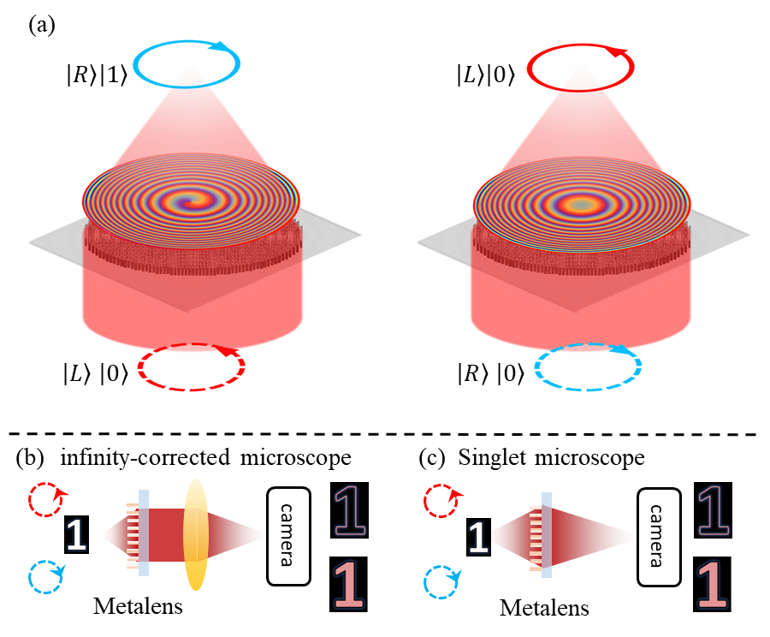

**Figure 1.** Conceptual figure of the polarization-controlled focusing and imaging mode. (a) Principal figure of polarization-controlled focusing mode. Metalens-based infinity-corrected microscope (b) and singlet microscope (c) for polarization-controlled phase contrast imaging and bright field imaging.

We use the spin-multiplexing method imposing two distinct phase profiles on the LCP and RCP light beams in the same metalens, respectively. As shown in **Figure 1a**, to realize phase contrast imaging mode, the metalens impart a sum phase profile (**Equation 1**) of the hyperbolic phase and the spiral phase with a topological charge of 1 on the LCP light beam. A hyperbolic phase profile (**Equation 2**) is imparted onto the RCP light beam to realize bright field imaging mode. Therefore, the metalens in a microscope system can serve as an imaging lens and a polarization-controlled phase plate as shown in **Figure 1b and 1c**.

$Ψ_{L}=\frac{2π}{λ}\left(f-\sqrt{f^{2}+r^{2}}\right)+Φ$ (1)

$Ψ_{R}=\frac{2π}{λ}\left(f-\sqrt{f^{2}+r^{2}}\right)$ (2)

$Ψ_{L}$ (Equation 1) is the phase profile imparted on the incident LCP light beam and $Ψ_{R}$ (Equation 2) is the phase profile imparted on the incident RCP light beam. $f$ is the target focal length, and (*r*, $Φ$) is the polar coordinate of the nanofin overall metalens. As discussed in supporting material S1, the propagation phase $φ_{x}$ depends on the size ( $W_{x}$ and $W_{y}$) of the nanofin (**Figure S1a**), and $θ$ is the rotation angle of the nanofin, **Figure S1b**. A library including eight nanofins in **Figure S2d** with height *H* of 800nm and period *P* of 650nm are designed to realize $2π$ phase coverage. The design details of the library can be seen in supporting material **sections S1 and S4**.

Based on **Equation 1 and 2**, the target propagation phase profile $φ_{x}$ can be confirmed, **Equation S7** in supporting material. Combining the nanofins library in **Figure S2d**, the size of nanofin at each lattice (*r*, $Φ$) is determined. From **Equation 1 and 2**, the rotation angle $θ$ of the nanofin at each lattice (*r*, $Φ$) is determined as well, **Equation S8** in supporting material. Repeating the above process at each lattice, the whole metalens is designed. A metalens was designed and fabricated with a diameter of 4mm, NA of 0.89 and a focal length $f$ of 1mm shown in **Figure 2a**. The second metalens was designed and fabricated with a diameter of 4mm, NA of 0.25 and a focal length $f$ of 8mm, shown in **Figure 2d**.

The metalens samples were fabricated from the 800nm a-Si film which is deposited on a SiO2 substrate via PECVD. The nanofins distribution is transferred to the a-Si film by using electron beam lithography, and the nanofins were etched by the reactive ion etcher. The fabrication details can be obtained from our recent publication [22]. **Figure 2a and 2d** are the optical images of the two metalens samples. In the following, sample 1 refers to the metalens with a target NA of 0.89, and sample 2 refers to the metalens with a target NA of 0.25.

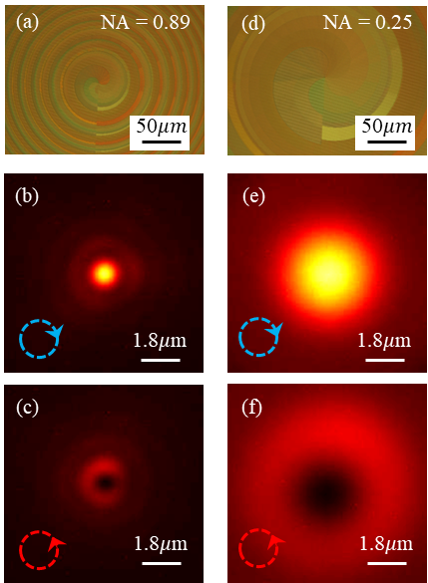

**Figure 2.** Characterization of metalens samples. The (a) – (c) are the optical image, Gaussian focal point, and donut-shaped focal point of the metalens sample 1 (NA = 0.89), respectively; (d) – (f) are the optical image, Gaussian focal point, and donut-shaped focal point of the metalens sample 2 (NA = 0.25), respectively.

A customized microscope with a magnification of 100X and NA of 0.9 was used to characterize the polarization-controlled focusing ability of the two samples (**Figure S3** in supporting material). The Gaussian focal point is first measured to evaluate the NA of two samples under the RCP beam illumination. The full width of half maximum (FWHM) of sample 1 is measured to be 1.1 $μm$, shown in **Figure 2b**, which demonstrates that sample 1 has a NA of 0.89. The FWHM of sample 2’s Gaussian focal point is 3.8 $μm$ corresponding to a NA of 0.25, **Figure 2e**. These results indicate that two diffraction-limited Gaussian focal points are obtained by illuminating samples 1 and 2 via an RCP light beam. As shown in **Figures 2c and 2f**, the two Gaussian focal points were tuned to be two donut rings by changing the illumination light beam to LCP. Supporting video V1 shows the transition process of the focal field of metalens sample 1 by rotating a quarter waveplate (QWP), shown in **Figure S3** in supporting material). The donut ring of sample 1 has a radius of 1.6 $μm$, and the donut ring of sample 2 has a radius of 5.7 $μm$, respectively. As the light energy is spread into a large donut ring with a Gaussian focal point, the intensity of the donut ring shown in **Figures 2c and 2f** is weaker than intensity of the Gaussian focal points shown in **Figures 2b and 2e**, while the two focusing mode has similar efficiency. Specifically, the efficiencies of Gaussian and donut focusing mode are 38.6% and 36.1%, respectively. The working efficiency can be effectively improved by introducing toroidal response [23], employing an inverse design approach [24], and optimizing the fabrication process.

To realize a large-magnification (58X) and a high-resolution (0.7 $λ$) dual-mode imaging system, an infinity-corrected microscope in **Figure 1b** was demonstrated by utilizing the metalens sample 1 as a high-NA objective lens (Section 3.1). A second infinity-corrected dual-mode microscope with large FOV (600 $μm×$ 800 $μm$) and a diffraction-limited imaging resolution (0.61 $λ$/NA) was demonstrated by utilizing the metalens sample 2 as the objective lens (Section 3.2). Finally, a singlet dual-mode microscope system in **Figure 1c** was demonstrated via the metalens sample 2 (Section 3.3).

3. Compact dual-mode imaging experiments

*3.1. High-resolution and large magnification infinity-corrected microscope*

An infinity-corrected microscope in **Figure 1b** was constructed by utilizing the metalens sample 1. The metalens serves as a high-NA (0.89) objective lens and polarization-controlled phase filter. A cemented achromatic doublets lens (Thorlabs, AC254-060-C) with a focal length of 60mm is adopted as the tube lens. One polarizer and QWP are placed between the light source and the resolution target to manipulate the illumination light’s polarization state. The image is captured by an InGaAs camera.

To avoid the imaging quality reduction induced by a laser interference and directly realize edge-enhancement effect in imaging system, a partially coherent LED light source is used for illuminating the USAF 1951 resolution target. In addition, comparing the laser and ambient light, the coherence of the LED is much similar with the coherence of the biological fluorescence. The utilization of LED makes our imaging system be ready for biomedical imaging. However, the edge-enhancement effect would be weakened with lowing the illumination light’s coherence. We experimentally demonstrate that distinct edge images can be immediately achieved by subtracting the bright-field image from the edge-enhanced image.

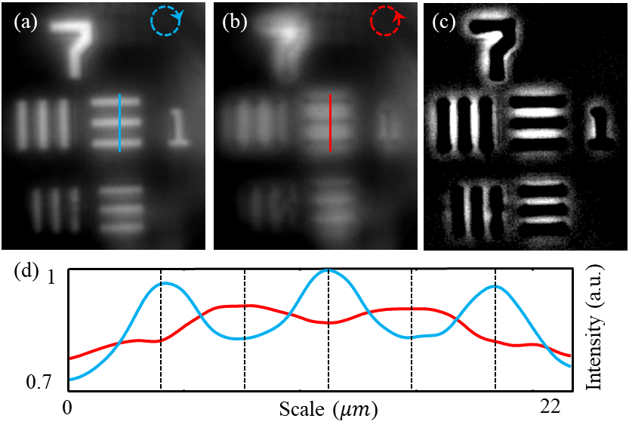

**Figure 3.** Imaging results of the 58X infinity-corrected microscope. (a) and (b) show the bright-field image and edge-enhanced image, (c) is the differential image between edge-enhanced image and bright-field image, and (d) demonstrates the intensity curve.

**Figures 3a and 3b** show the bright-field image and edge-enhanced image of element 1 in group 7, respectively. To quantitively demonstrate the transition of imaging mode, the intensity along the blue and red lines in **Figure 3a and 3b** are depicted in **Figure 3d**, which demonstrates the intensity peaks are tuned to the intensity valley with the imaging mode being tuned from bright-field to phase contrast imaging mode. A distinct edge of the object is obtained via the differential image (Figure 3c) via a one-step subtraction operation. According to the real dimension of element 1 in group 7, the magnification of our compact dual-mode microscope is calculated to be 58 times (i.e., 58X). The bright-field image and edge-enhanced image of the USAF element 6 in group 7 indicate that the microscope could effectively resolve a feature size around 1 $μm$ in both bright field and phase contrast imaging mode, which means the microscope has a diffraction-limited sub-wavelength resolution (0.61 $λ$/NA = 0.7 $λ$ = 1.1 $μm$) at the wavelength of 1550nm, shown in **Figure S4a and S4b**. However, limited by the sensor size of the InGaAs camera, this microscope can only provide us with a small FOV (80 $μm×$ 108 $μm$) in this configuration.

*3.2. Diffraction-limited resolution and large FOV microscope for biological sample*

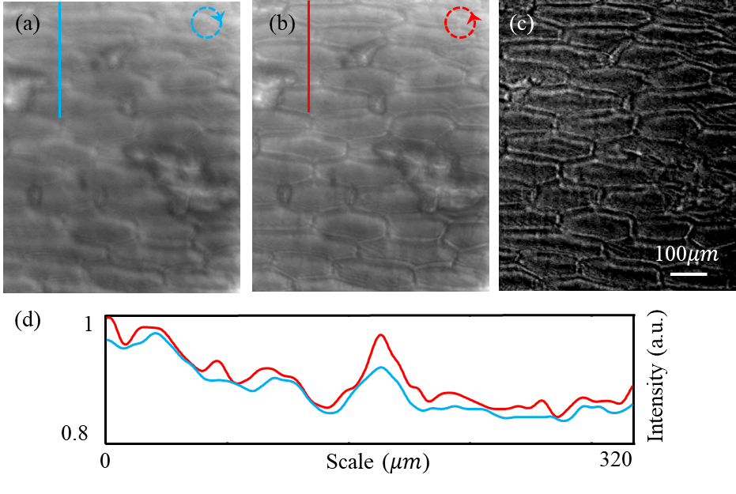

**Figure 4**. Imaging results of the 7.8X microscope. (a) and (b) show the bright-field image and edge-enhanced image, (c) is the differential image, and (d) demonstrates the intensity curve.

We demonstrated the field of view of 600 μm× 800 μm, diffraction-limited image resolution, and biological dual mode imaging by using the metalens sample 2 with a focal length of 8 mm and NA of 0.25 in our custom build microscope. Figure S5 demonstrates the two different field of views achieved by two samples. The imaging resolution and magnification of second microscope are firstly measured by capturing the dual-mode images of the group 7 in resolution target. **Figures S4c and S4d** respectively show the bright-field image and edge-enhanced image of the USAF group 7. Therefore, the imaging magnification and resolution of this microscope are calculated to be 7.8X and 3.78 $μm$ (i.e., diffraction limitation of the metalens sample 2, 0.61 $λ$/NA=2.44 $λ$).

A freshly peeled and unstained onion epidermal is prepared for verifying the dual-mode imaging ability of the microscope in biological samples. The cell wall (i.e., the edge of cells) becomes clear (**Figure 4b**) from blurred (**Figure 4a**) in whole FOV (600 $μm×$ 800 $μm$) with the illumination light is tuned to be LCP from RCP. The intensity along the blue and red lines in **Figures 4a and 4b** are depicted in **Figure 4d** to show the edge-enhancement effect quantitively. While the edge-enhancement effect of this biological experiment is not clear as the USAF experiment, onion cell’s edges can be clearly observed in the differential image (Figure 4c). In theory, the FOV can be further enlarged by adopting a camera with a larger imaging sensor.

*3.3.* *Singlet dual-mode microscope*

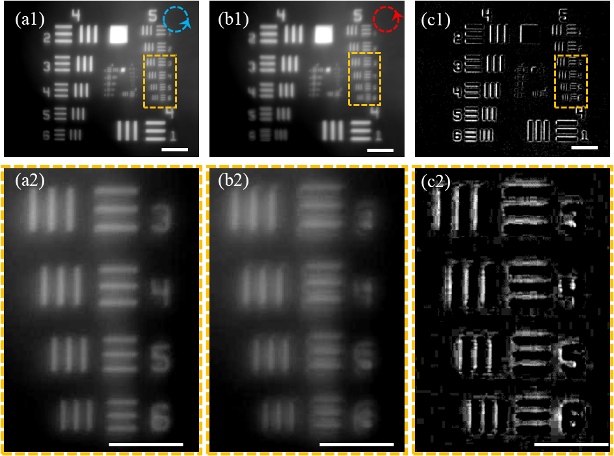

**Figure 5:** Imaging results of the singlet dual-mode microscope.(a) and (b) show the bright-field image and edge-enhanced image, and (c) is the differential image; The second row is the zoom in figure of the first row. The scale bars in the first row are 200 $μm$, and the scale bars in the second row are 100 $μm$.

While edge detection plays an important role in a lot of industrial applications, the edge-detection is mostly achieved by post-processing of a bright-field image via software algorithms. The processing speed of current edge-detection algorithms highly depends on the computer hardware and software. If we directly get the edge-enhanced images of the target objects based on an all-optics system, the edge detection would be improved to be light speed, which would boost the industrial application. In addition, the imaging system should be simplified as much as possible to improve the system’s robustness and reduce the cost. In the following, a singlet dual-mode microscope is demonstrated to realize all-optical edge-detection at 1550 nm wavelength.

The metalens sample 2 is mounted 40mm in front of the InGaAs camera sensor (i.e., the imaging distance is 40mm) via a 3D-printed holder. The USAF 1951 resolution test target is placed 10mm in front of the metalens to get a clear image in the camera. **Figures 5a1 and 5b1** show the bright-field image and edge-enhanced image of the whole FOV, respectively. To show the resolution of the singlet microscope, the zoom-in figures of the group 5 are shown in **Figures 5a2 and 5b2**. According to the real dimension of element 5 in group 5 (**Figure 5a2**), the magnification of this singlet dual-mode microscope is calculated to be 4.2X. As the differential image Figure 5c shown, the edge can be fast detected via one-step subtraction. Therefore, a fast edge-detection system with a simple hardware configuration is achieved in this research.

4. Conclusion

In summary, two compact dual-mode (i.e., phase-contrast and bright-field) microscope systems are demonstrated in the near-infrared spectrum based on silicon metalens. We first designed a bi-functional metalens which acts as a polarization-controlled phase plate and a high-NA objective lens. Two metalens samples with a diameter of 4mm are fabricated, and two samples respectively have a NA of 0.89 and 0.25. After characterizing the diffraction-limited focusing performance of two samples, the dual-mode infinity-corrected microscope was demonstrated by using the metalens samples as the objective lenses and a partially coherent LED light source. The microscope can realize a large magnification of 58X and a high resolution of 0.7 $λ$ for the metalens sample 1, and a large field of view of 600 $μm×$ 800 $μm$ is obtained by replacing the sample 1 with the sample 2. The edge-enhanced image of an unstained onion epidermal is observed by the microscope. Finally, a dual-mode singlet microscope is built based on the sample 2 for realizing fast edge-detection. Our experiment results illustrate that the dual-mode microscope systems have enormous potential for applications in biomedical diagnosis, biological and chemical research, and the industrial fields of machine vision and safety monitoring.

**Supporting Information**

Supporting Information is available from the Wiley Online Library or from the author.

Acknowledgements

PhD studentship from the Chinese Scholarship Council is acknowledged.

This work is supported by the UK's Engineering and Physical Sciences Research Council (project number EP/V000624/1, EP/X03495X/1, and EP/T02643X/1), the CHIST-ERA grant (project number CHIST-ERA-21-NOEMS-004) and supported by the Royal Society (project number RG\R2\232531).

**Disclosure**

The authors declare no conflicts of interest.

**Data Availability**

The data that support the findings will be available in the University of Southampton’s ePrints research repository following an embargo from the date of publication.

Received: ((will be filled in by the editorial staff))  
Revised: ((will be filled in by the editorial staff))  
Published online: ((will be filled in by the editorial staff))

References

[1] Y. Z. Zhang, P. C. Lin, P. C. Huo, et al, *Nano Lett.* **2023**, *23*, 2991.

[2] F. Zernike, *Science.* **1955**, *121*, 345.

[3] Bagnell, C. R., *Chapter 10 Phase Contrast*, US: UNC School of Medicine. **2012**.

[4] S. Wang, L. Li, S. Wen, et al, *Nano Lett.* **2024**, *24*, 356.

[5] K. M. Taute, S. Gude, S. J. Tans, T. S. Shimizu, *Nat Commun,* **2015**, *6*, 8776.

[6] S. Furhapter, A. Jesacher, S. Bernet, and M. Ritsch-Marte, *Opt. Express,* **2005**, *13*, 689.

[7] J. K. Wang, W. H. Zhang, Q. Q. Qi, S. S. Zheng, L. X. Chen, *Sci Rep,* **2015**, *5*, 15826.

[8] M. Y. Pan, Y. F. Fu, M. J. Zheng, et al, *Light: Science & Applications,* **2022**, *11*, 195.

[9] D. Jeon, K. Shin, S-W. Moon, J. Rho, *Nano Convergence,* **2023**, *10*, 24.

[10] X. J. Zou, G. G. Zheng, Q. Yuan, et al, *PhotoniX,* **2020**, *1*, 2.

[11] S. Banerji, M. Meem, A. Majumder, et al, *Optica,* **2019**, *6*, 805.

[12] P. C. Huo, C. Zhang, W. Q. Zhu, et al, *Nano Lett.,* **2020**, *20*, 2791.

[13] T. F. Zhu, Y. H. Zhou, Y. J. Lou, et al, *Nat Commun,* **2017**, *8*, 15391.

[14] T. F. Zhu, C. Guo, J. Y. Huang, et al, *Nat Commun,* **2021**, *12*, 680.

[15] Y. Zhou, H. Y. Zheng, I. I. Kravchenko, and J. Valentine, *Nat. Photonics*, **2020**, 14, 316.

[16] H Kwon, E. Arbabi, S. M. Kamali, et al, *Nat. Photonics*, **2020**, 14, 109.

[17] Y. J. Kim, G. Y. Lee, J. W. Sung, et al, *Adv. Funct. Mater,* **2022**, *32*, 2106050.

[18] Q. He, F. Zhang, M. B. Pu, et al, *Nanophotonics*, **2021**, 10, 741.

[19] T. Badloe, Y. Kim, J. Kim, et al, *ACS Nano,* **2023**, *17*, 14678.

[20] X. X. Peng, X. F. Zhu, J. L. Zhang, *Journal of Inorganic Biochemistry,* **2020**, *209*, 111118.

[21] Z. Feng, T. Tang, T. X. Wu, et al, *Light: Science & Applications,* **2021**, *10*, 197.

[22] C. Sun, H. L. Pi, K. S. Kiang, et al, *Nanophotonics*, 2024, <https://doi.org/10.1515/nanoph-2023-0873>.

[23] A. Hassanfiroozi, Z. S. Yang, S. H. Huang, et al, *Adv. Opt. Mater.*, 2023, 11, 2202717.

[24] C. H. Lin, Y. S. Chen, J. T. Lin, et al, *Nano Lett.*, 2021, 21, 4981.

**Table of contents entry**

The spiral phase contrast microscope can clearly distinguish the morphological information of the phase objects because of the isotropic edge-enhancement effect, while the bright field microscope can image the overall morphology of amplitude objects. Here, we reported compact dual-mode microscopes working at near-infrared using the engineered metalens which can be tune between the spiral phase contrast imaging and bright field imaging by polarization control. Our results could open new opportunities in applications of biological imaging, industrial machine vision, and semiconductor inspection.

*Chuang Sun, Hailong Pi, Kian Shen Kian, Jize Yan, and Jun-Yu Ou*

**Title** Near-infrared metalens empowered dual-mode high resolution and large FOV microscope

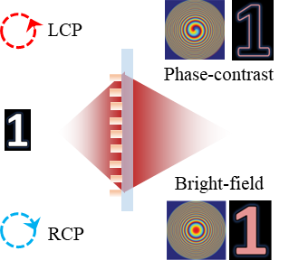

ToC figure