REVERSE ENGINEERING THE NEOLITHIC BOATS OF THE AEGEAN SEA: TYPOLOGICAL CLASSIFICATION, RECONSTRUCTION AND SEAKEEPING ASSESSMENT
P. Tzovaras, University of Southampton, Centre for Maritime Archaeology, Southampton Marine and Maritime Institute, UKS Turnock, Maritime Engineering, University of Southampton, L Blue, Maritime Archaeology, University of Southampton, A G Vlachopoulos, Prehistoric Archaeology, University of Ioannina, Greece, and J Sofaer, Archaeology, University of Southampton

SUMMARY

The hundreds of recently discovered LN-EBA rock-art images of boats from the Aegean Basin, Greece, highlighted their design and structural details. Additionally, their dating in the transition from LN to EBA offers an uninterrupted continuum of the Neolithic boat evolution. A technologically rigorous methodology was incorporated for their analysis by exploiting the concepts of reverse engineering, climatic design and the tools offered by ship science. This enabled their reconstruction and testing, providing insights into their technical traits, such as stability and resistance. These favour the view that trading, gateway communities and seagoing boats have a more dynamic history in a long Aegean tradition that goes back as far as the Neolithic.

NOMENCLATURE

[Symbol] [Definition] (Unit)]
LN Late Neolithic
EBA Early Bronze Age
H-RTI Highlighted-Reflectance Transformation Imaging
EC Early Cycladic
FN Final Neolithic
EN Early Neolithic
MN Middle Neolithic
M&T Mortice-and-tenon
LBA Late Bronze Age
EH Early Helladic
L/∇^{1/3} Slenderness ration
Cu. m Cubic metre
t Tonne
WL Waterline Length m
L/B Length/Breadth m
Kg/sq. m Kilogram square metre
T Draught m
B/T Breadth/Draught
IMO International Maritime Organisation
DWL Digital Waterline Length m
P Total Power kW
kW Kilowatt
Fpeak Paddle force N
N Newton
m/s metres per second
VCG Vertical Centre of Gravity

- INTRODUCTION

This research addresses lacunae concerning prehistoric seafaring and the boatbuilding traditions of the Aegean Basin, Greece, during LN-FN (ca 5400 / 300 – 3300 / 200 BC) and EBA periods (ca. 3200 / 3000 – 2000 BC) (Figure 1). The systematic excavations in the Aegean over the last few years bridged the LN with the EBA period. To this end, the recently discovered depictions of boat representations from Strofilas on Andros [1-2], Vathy on Astypalaia [3-5], and others significantly enhanced the database of boat imagery in the Aegean, providing important structural details, undetected in former evidence (Figures 1-2). Especially the boat evidence from Strofilas and Vathy is crucial to our endeavour since their dating from LN / FN to EC I / II (ca 4th – 3rd millennia BC) offers an uninterrupted continuum of the evolution of the boat’s shape.
Due to the lack of explicit evidence in the Aegean Basin, such as actual shipwreck remains (except for the cargo remains of two EH II shipwrecks (ca. 2700 / 2650- 2200 / 2150 BC) [6-7], this endeavour focuses on the available iconographic data (Figure 2). Due to an apparent morphological similarity, all the EBA data are comparatively examined to Neolithic ones and recorded through first-hand observations and new techniques. Evidence context is also studied comparatively with the period’s watercraft operating environment, raw material and sources, and technological constraints.
Overall, the scope of this research is to re-evaluate the maritime Aegean LN-EBA through a more technologically rigorous approach and examine the period’s seagoing boat types and their capacities. To do so and provide an up-to-date database, the available boat evidence has been recorded via firsthand observations and through novel techniques, such as H-RTI, photogrammetry and silicone rubber for imprints’ production.
Eventually, shape analysis is implemented via the concept of reverse engineering. An informed morphological classification and the definition of the ‘average’ shape for each template is aimed. The latter are used to reproduce the boat types through ship science and based on naval architecture fundamentals, the vessel’s operational environment, the period’s technological constraints, and available resources.
The interpretations and analyses generated by the above-mentioned approach have produced the ability to reconstruct and test the Aegean vessels within the technological envelope in which they were developed. For their digital reconstruction, naval architecture CAD software is exploited to design the vessel types in three-dimensions, produce their lines and test their seafaring properties in simulated conditions. Outputs are further compared to the experimental reconstruction of a scaled-down, 2 m technical boat model, tested at the towing tank of Wolfson Unit (Boldrewood Innovation Campus, University of Southampton). Therefore, the produced performance envelope allows suggestions for the parameters of boats and their performance instead of subjective theories based on ambiguous iconographic data.
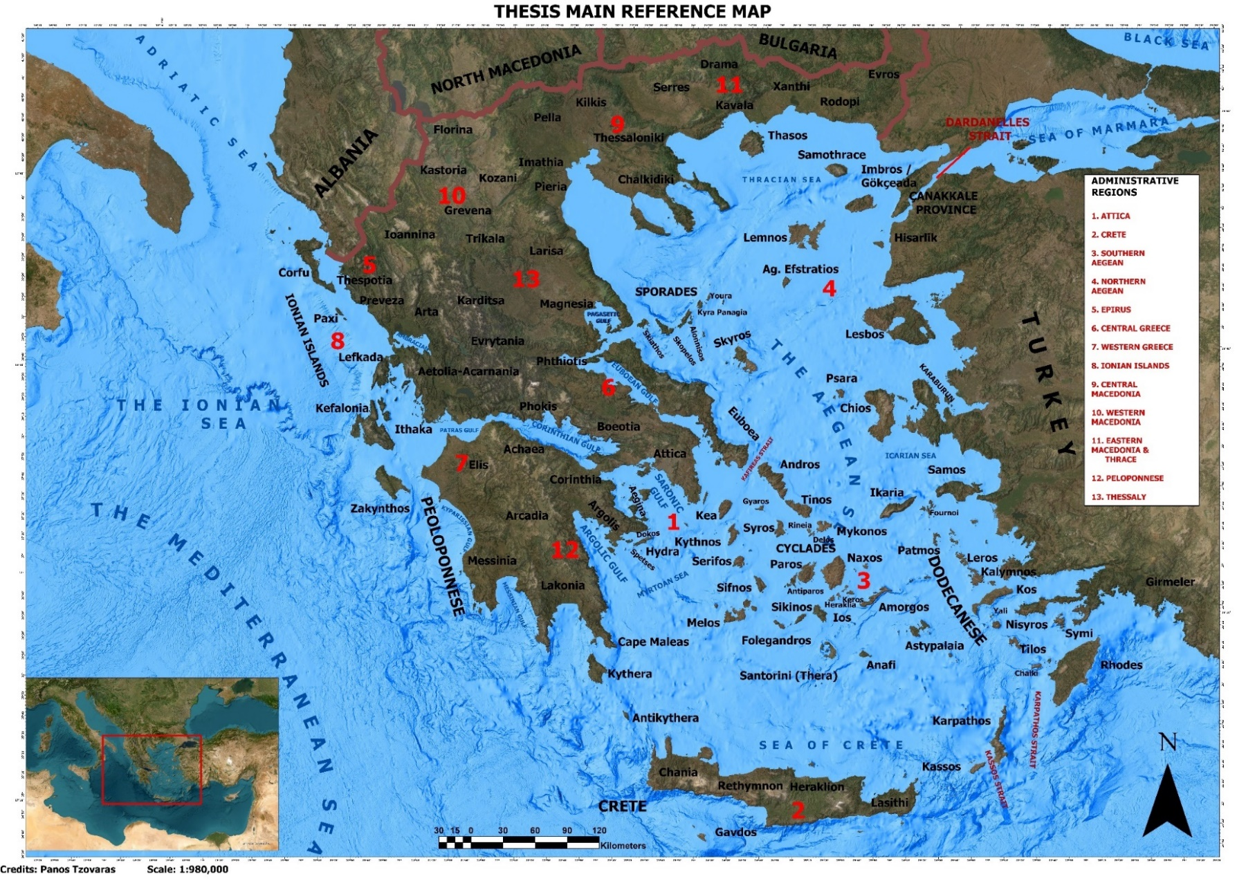
Figure 1: The main reference map with the administrative regions and regional units of Greece. Source: Map Generated by the author. Using: ArcGIS Pro [GIS] Version 3.0.0.

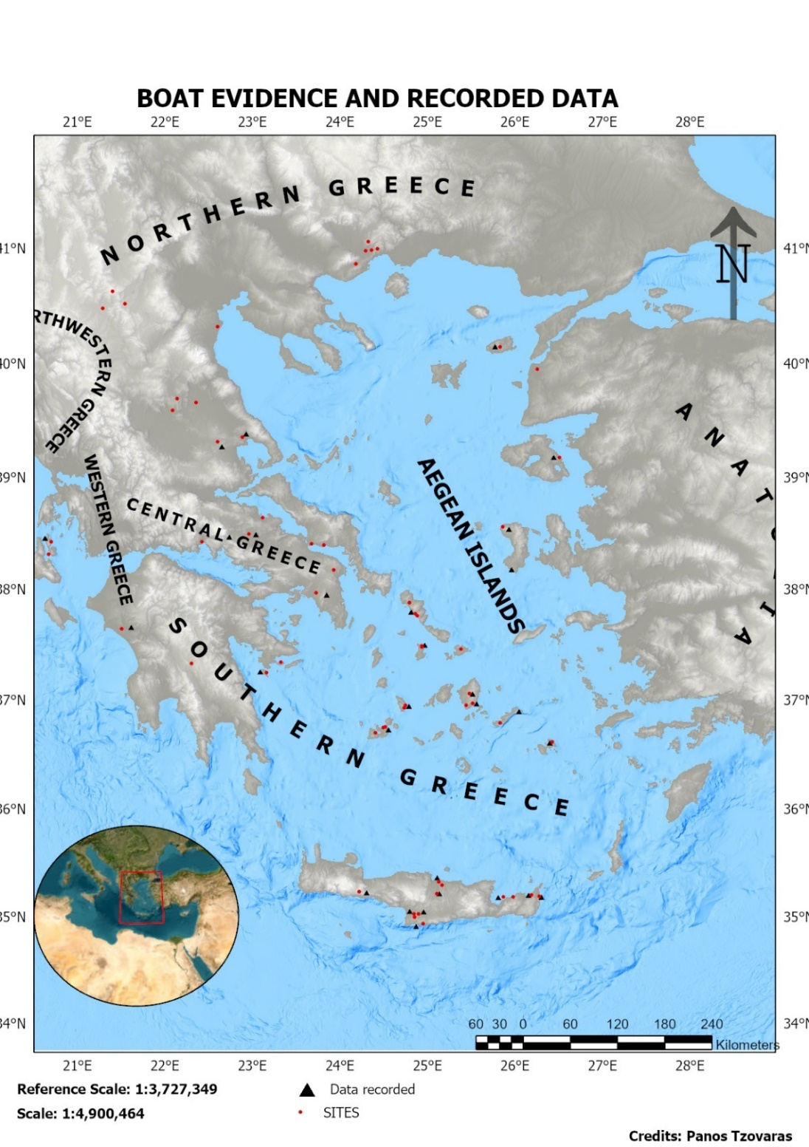
Strofilas, Andros
Vathy, Astypalaia
Figure 2: The location of all the extant evidence and the ones recorded by author. Source: Map Generated by the author. Using: ArcGIS Pro [GIS] Version 2.4.3.

- CONTEXT OF RESEARCH
This research focuses on the corpus of the LN-EBA boat evidence (Figures 1-2). This period was selected due to similarities in boat morphology, artistic execution and the fact that the boats are mainly represented as mastless and possibly paddled. Nevertheless, it would be perilous to perceive the LN-EBA Aegean and mainland Greece as a uniform area (Figure 1), so we should acknowledge the chronological discrepancies for such a large extent of research as well as the ensuing cultural-geographical idiosyncrasies.
- THE NEOLITHIC-EBA DATABASE OF BOATS
So far, through personal surveys, fieldwork, excavation and archival investigation, more than 270 boat and boat-shaped representations have been located spanning the whole Aegean Basin and its immediate hinterland and sites deeper in mainland Greece (Figures 1-2). Around fifty-nine sites have yielded boat evidence. Near twenty-six sites have been visited, and more than two hundred boat images and boat-shaped artefacts have been personally recorded (ca. 70% of the total number) (Figure 2). Generally, the evidence chronological horizon extends from EN to EBAIII (ca. 7th to 3rd millennium BC). Their depositional context is usually associated with settlement or burial deposits, open-air sites, and caves. However, not all the boats fit the classification criteria, selected based on the security of the context, chronology, geographical location and provenance.
The extent of the previously published and unpublished data mostly comprises of two-dimensional evidence, mainly boat representations executed on rocks (incised, pecked, engraved, relief or painted motifs) or ceramic vases (incised, relief, painted or impressed) and potters’ pot-marks. As for the three-dimensional examples, these comprise of clay, wood, stone and metal boat figurines or clay/stone vases/moulds/lamps/boat-shuttles or even crucibles imitating boats and vice versa, sometimes decorated with painted motifs or incisions. To the figurine category, we may add a few boat models with anthropomorphic/zoomorphic traits and examples that constitute parts of broader assemblages. Finally, some tangible evidence exists, such as the imprints and structural remains of wooden boats or the cargo remains of actual shipwrecks.
- THE CASE OF VATHY
The main case study is the boat petroglyphs from Vathy on Astypalaia (the Dodecanese, Aegean) (Figures 1, 3). On the peninsulas’ rocky eastern part lies the Cape Elliniko (or Cape Pyrgos), where traces of an extensive prehistoric occupation were discovered [3-5, 8]. The salvage and systematic archaeological works on the tip of the promontory have been carried out under the auspices of the Archaeological Society at Athens and funded by the University of Ioannina [3-5, 8]. These unearthed an FN-EBAI / II citadel with a sturdy boulder-built circuit and retaining walls, as well as traces of extensive rock-art monuments [3-4]. The east coast’s natural formation has been incorporated into a complex of artificial harbour installations in the form of smooth, slanted slipways, whose construction could have served the launch or retrieval of small boats; these formations develop along the coastline, and are combined and consolidated by fortification constructions [3, 8]; if correct, then it constitutes the oldest known artificial harbour constructions in the Aegean, consolidated by the extensive defensive works, offering protection from the sea.
Rock-art compositions have been identified in numerous locations of the promontory, either explicitly or implicitly related to the citadel [3, 5]. Although there are examples found at a distance from the prehistoric site, these are possibly of the same chronological extent [3, 5]. Vathy’s rock-art covers a wide-ranging repertoire of motifs, either linear, schematic or figurative. Despite the ongoing detrimental effects of erosion caused by various environmental and human agencies, Vathy preserves an outstanding number of rock-art representations, enhancing the iconographic agenda of Aegean art and allowing the tracing of its roots in the Neolithic [3, 5]. These are usually carefully placed and executed on the worked surface of the rock and patently document maritime activities of the Neolithic-EBA island communities. One of the most popular rock-art motifs in the perception of Vathy’s artists is the spiral and its variations, found in numerous locations [3-4, 9-10]. However, the artist Vathy chose the image of the boat to decorate a few of the citadel’s most monumental and important constructions. These are mostly entailed by meticulous attention to detail and artistic proficiency. So far, eight constructions have been identified bearing at least fourteen or fifteen boat petroglyphs [11-12] (Figure 4).

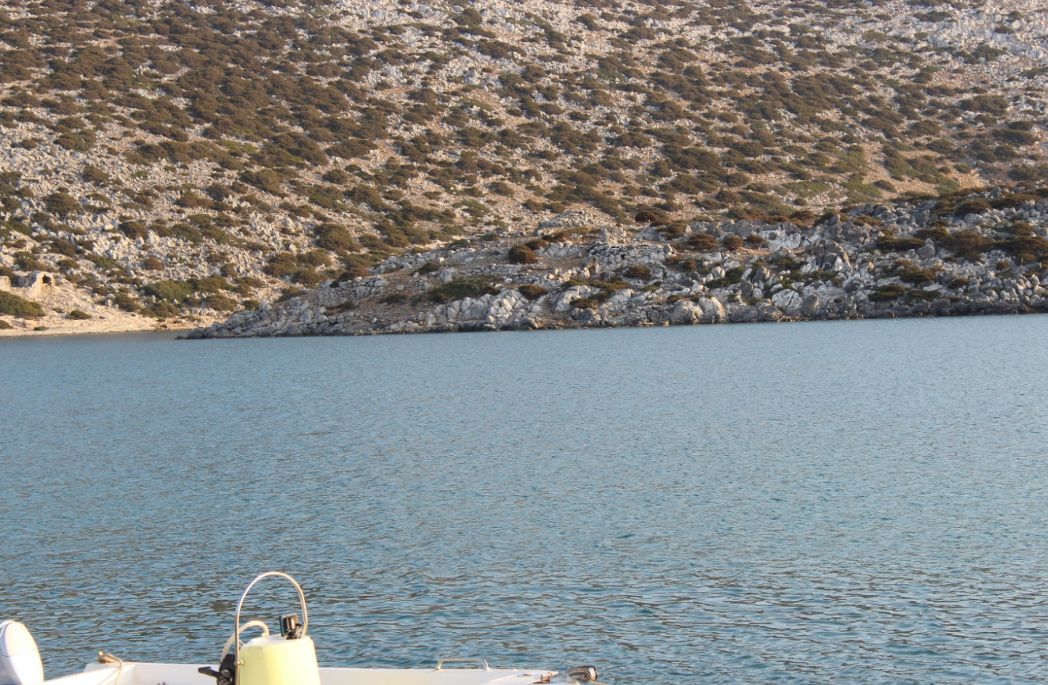
Figure 3: Cape Elliniko and the FN-EBAI / II citadel. Source: Photograph taken by the author during his 2020/2021 fieldwork. Credits: Courtesy Professor A. Vlachopoulos. © Archaeological fieldwork at Vathy, Astypalaia – The Archaeological Society of Athens.
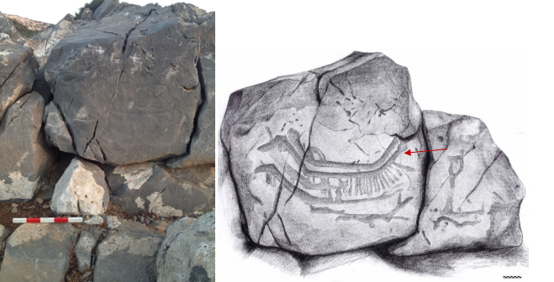
Figure 4: (Left) A detail of the representation on the Gate of Boats. Source: Photograph taken by the author during his 2017/2018 fieldwork. Credits: Courtesy Professor A. Vlachopoulos.© Archaeological fieldwork at Vathy, Astypalaia – The Archaeological Society of Athens. (Right) A drawing representation of the vessels (GoB 1-5) on the Gate of Boats. 1:50 scale. The red arrow points to boat belonging to Type I of the ‘rounded category’. Drawn by the artist Nikos Sepetzoglou. Source: Vlachopoulos 2021a:128 fig. 27.

- TECHNOLOGICAL CAPACITIES, CONSTRUCTION METHODS AND BOATBUILDING: A PATH FROM INVENTION TO INNOVATION
Though the iconographic data imply the presence of several boat types, one may wonder whether the period’s technology was adequate for the design and production of seagoing vessels. By the end of the 7th millennium BC, the Neolithic craftsman was already equipped with an enhanced toolkit of polished tools, such as adzes, axes and chisels, that would have offered greater flexibility in timber felling and manipulation [13]. However, technological progress is better represented a couple of millennia later, when MN (5800-5400 / 300 BC) advancements in pyrotechnology and pottery technology gradually led to the advent of metallurgy and the mastering of metalworking by the Aegean craftsman [14-16]. Therefore, the LN copper awls, chisels, saws, scrapers and axes, attested at various Neolithic sites of the Aegean and mainland Greece, would have further facilitated the Neolithic craftsman [11-12, 17]. These technologies indicate an enhanced toolkit that would have increased the capacity of constructing more seaworthy and spacious logboat types, such as the expanded and extended ones, possibly since the beginning of the Neolithic [18-19].
Ethnographic evidence and experimental work have suggested that these tools would also enable the production and shaping of planks for the construction of more seaworthy, plank-built boats at least since LN and definitely during EBA [11, 17, 19-23]. Further answers can be sought in the Aegean carpentry and architecture, attested since the EN [24]. That general knowledge could have been applied to boatbuilding, considering that a carpenter of a Neolithic community would possibly have various tasks, from constructing tools and furniture to houses, boats and other complex architectural structures [11-12, 17, 22]. Several cases have come to light indicating early knowledge of plank-shaping and joinery, such as planks assembled with wooden pegs, shaped planks and beams, sometimes bearing evidence of mortices, timber frames with systems of joints and mortices, wooden, perforated elements joined with lashes and so on [12]. Finally, intricate wooden structures have been attested to the Neolithic lake settlement of the Amindeon Basin on Florina [25] (Figure 1).
Although speculation, these possible borrowings from housebuilding carpentry can open new horizons in Aegean boatbuilding, allowing us to assume that, if a plank-built boat was a reality, the planks could be edge-joined with the use of pegs, lashings or a combination of these [11-12, 17]. Even though there is a consensus that sewn fastening is the oldest method [18, 26-28], it is equally possible that pegged planks could have been in use. According to Chatzitoulousis [29] the technique attested to the mortices of Displio could find an application to Neolithic boatbuilding; especially the angular mortices that would have been a possibility after the advent of metallurgy. Thus, though we cannot suggest an early implementation of the M&T technique locked with pegs, we might think of the ‘primitive’ use of unpegged ones combined with lashings [11-12]. Besides, a similar approach has also been attested to -the admittedly later- boats of the Old Kingdom Egypt [30-33]. Interestingly, M&T joints have been used in Egyptian carpentry since at least Dynasty I [34]. As far as boatbuilding is concerned, the same technique with locked pegs first appears in the LBA Uluburun shipwreck [34-37]. Such a technique would have increased, to a certain point, the longitudinal strength of the hull against the forces of the Aegean wave regimes (see below). Interestingly, according to Agouridis [38], the forces exerted on the hulls by the waves were the main reason the Aegean boatbuilders insisted, for more than twenty-five centuries, on using the technique.
The water-tightness of the vessel could also be achieved with the well-known caulking, the insertion of any fibrous material (i.e., moss, oakum, animal hair, etc.) into any seam and its covering with an appropriate sealer [32]. This could have also been achieved by using a mixture of a clayish mud with seaweeds that does not absorb water; this water-resistant substance, known as “patelia”, was used to insulate the roofs of the houses of the Aegean from prehistory until recently [12, 17]. Papoulia [39] has also pointed out the possibility of using bitumen or birch bark tar for this purpose. However, a more suitable candidate could be the mineral ‘miltos’ (μίλτος) -in the form of a red pigment- widely used in carpentry and shipbuilding [40] as a sealer and, according to Theophrastus [41], the best source was the Cycladic island of Keos [12, 17] (Map 1). For instance, Homer [42] used the epithet “μιλτοπάριοι”, which stems from the word μίλτος (miltos), to describe the ships having a red-painted bow.
Regarding the construction tradition and whether these boats are logboats (simple or complex), plank-built ones, etc., this is almost impossible to be determined from iconography and our available evidence, except for some theoretical observations. It is stated that the author does not suggest that there were only plank-built boats. On the contrary, various types, such as log, bark or skin-based, would have existed according to the needs, the operational environment and available resources. Consequently, it is not indicated that any of the following examples exclusively belong to a log or plank-built tradition since it is impossible to be determined just from our dataset.
Despite what technique was used, what can be posited is that the LN inhabitants of the Aegean had a more than basic knowledge of architecture and, to a degree, engineering. This is attested to the LN-EBA double-storied houses, complex fortification systems and carefully planned layouts of settlements [24, 48]. All these technological advancements (lithic technology, pyrotechnology, metallurgy, carpentry, joinery, boatbuilding and architecture) triggered a series of processes that affected many facets of the Neolithic individual reality, such as seafaring and long-range mobility in general. The new, enhanced and advanced tools that made their appearance led to specialisation, increased production and, eventually, to surplus [44-45]. Communities no longer aimed to produce enough just to survive. Hence, the need to manage and circulate their products alongside the need for access to metallurgical sources or communities that had mastered metallurgy was one of those processes that affected/drove the boatbuilding technology.
- CATALOGUE OF HULL: FRAMING, SUPERSTRUCTURE AND OTHER ELEMENTS
According to Steffy [32], a good archaeological, ship report must adhere to certain aspects. One of them is the presentation of the hull catalogue, presenting a description of the timbers and hull-related artefacts. Naturally, this comes before the reconstruction and must be presented clearly, precisely and economically, containing all the relevant information your data provides [32]. Though this concerns actual boats, such as shipwrecks, it is also deemed appropriate for our endeavour. Besides, the purpose is common to offer a catalogue that could be used comparatively and as an aid to our reconstruction.
However, we should bear in mind that this catalogue cannot strictly abide by the structure proposed by Steffy [32] because our analysis does not concern a single example but hundreds, possibly of various types and construction methods; additionally, there is only a limited number of the components of the hull that can be identified with relative certainty. What follows is our modified ‘catalogue of the hull’, deriving from the available iconographic data, as discussed in the author’s doctoral thesis [12]. Due to word limit restrictions, this is briefly listed, without being discussed in-depth. Additionally, an approximation of their earliest appearance is offered, based on the evidence’s dating.
- Planking: longitudinal and/or transversal elements defining the exterior surface of the hull. Earliest iconographic appearance: MN.
- Keel/Centre plank: a longitudinal element, usually extending along the length of the bottom, protruding downwards. Earliest iconographic appearance: MN / LN
- Frames: bulkheads, transverse crossbeams, stem-stern decks, transversal framing and other transversal features (i.e., ridges, thwarts, floor timbers, etc.). Earliest iconographic appearance: MN / LN-EBA.
- Transom or transom-like formation: the vertical, athwartship element, fixed on and shaping the stern as well as joining the sides and strengthening the hull. Earliest iconographic appearance: LN.
- Fore/aft projection(s): a pointed projection that obliquely extends from one end, just above the bottom and the waterline, continuing beyond the post. It occasionally occurs on both sides. Earliest iconographic appearance: LN.
- Superstructure: Platforms (ἰκρίον)near the vessel’s extremities, cabins/shelters, masts. Earliest iconographic appearance: LN / FN-EBA.
- Head-moulding (ἄφλαστον) and posts decorations: all these elements that usually appear fixed on the post or hung by it and have no structural purpose. Earliest iconographic appearance: LN.
- Vail (θύσανος) and banners with hanging tassels (φᾶρος): as such, we describe the elements typically hanging below the head-mouldings or appearing alone. They are also attached to one of the extremities and do not have any structural significance. Earliest iconographic appearance: LN / FN.
- Paraphernalia: in this category, we include the boats’ equipment that is not related to its structure or superstructure, such as anchors and fishing equipment. Earliest iconographic appearance: LN / FN.
- Modes of propulsion: paddling, sailing. Earliest iconographic appearance: LN / FN.
- Steering system: single steering oar/paddle with a triangular blade, single steering oar/paddle with a leaf-shaped blade, double steering oar/paddle with a shovel-like blade (πτυόσχημη λεπίδα), trapezoidal steering (rudder?). Earliest iconographic appearance: LN / FN-EBA.

- METHODOLOGICAL AND DATA ANALYSIS IMPLICATIONS: THE ‘EMERGENCE’ OF THE BOAT’S TYPOLOGY
Indisputably, the conceptualisation of something you do not have actual remains of, but just two and three-dimensional pictorial evidence, is an uphill battle. Hence, the extant dataset has a great degree of ambiguity, considering aspects of artistic conventions, local varieties, medium, execution technique, errors, erosion and so forth. Moreover, there is always the question of the dating of the data, which can be very problematic, especially when it comes to not safely stratified findings. Hence, it was decided to find a way to assist the researcher in the process of shape segmentation, definition, and classification. To do so, reverse engineering and descriptive statistics are implemented to completely ‘deconstruct’ the object to try and grasp its design and architecture, considering that its function is explicitly associated with its structure and form [46]. Although reductive in its conception, this approach has the merit of giving you the ability to reproduce the product of another manufacturer through the meticulous study of its composition and by using its very same components and going back to its production cycle [46]. Hence, we should imagine the boat image as lines compiling a complex geometrical shape in a two or three-dimensional space. In fact, this method is an image analysis one and does not require any measurements, just observations of the shape under study. These geometrical shapes are analysed through descriptive statistics, where the researcher describes the observed basic features to organise and summarise them. Then, based on the various primary and secondary morphological traits and characteristics that the vessels share as well as their differences, a dataset of variables can be generated that can find further use in an informed, typological classification and the production of templates of the ‘average’ boat shapes, that accumulates most of the basic morphological features defining each group/subgroup. Thereby, the produced templates represent each boat type, that can be afterwards reconstructed.
In terms of the overall description of the hull’s shape, this is deduced by the morphological elements that comprise these boats. Treating, though, the two-dimensional data exactly as the three-dimensional ones could be misleading. Obviously, a two-dimensional representation primarily informs us regarding the image’s dimensions, as far as the length and height are concerned; additionally, about the representation’s general morphology, and most usually the profile view, but fails to inform us of the rest. Nonetheless, a two-dimensional ‘drawing’ can be more detailed than a three-dimensional model due to the limitations imposed by sculpting. Contrarywise, the three-dimensional boat figurines or boat-shaped vases can give us a glimpse of the missing dimensions and views and a relatively detailed understanding of the hull’s architecture, superstructure, design and the elements extending into the hull’s interior or exterior. Thus, the granularity degree is more significant than a two-dimensional image since it illustrates all these features more nuancedly.
The next step is the implementation of the tools offered by ship science. Once the identification of general types and their parameters have been determined, several interpretations can be digitally modelled in three dimensions and tested in CAD environment. In a way, an informed computer simulation can assist in the examination of an artefact as a “dynamic object” and not passive, revealing the underlying prehistoric/ancient mechanics [46] within a certain envelope that contains aspects of the micro and macro context [11-12]. Once again, it is stated that our aim is not to reconstruct the actual boat representation but explore the specific vessel type they may represent or signify through testing various scenarios. Thereby, the vessels’ lines plan and surface models can be built via MAXSURF Modeler software. The hydrostatics, stability and resistance analyses are performed through the software MAXSURF Stability and MAXSURF Resistance, respectively, in simulated conditions based on the pre-defined environmental factors of the period. By utilising the same software, various proposed hypotheses for the structure of the vessels’ representation can be tested and validated accordingly. Complementary, the results are compared to the ones produced during the towing tank tests of the 2 m technical boat model.
- DATA ANALYSIS TECHNIQUE – REVERSE ENGINEERING ITINERARY
As mentioned, to perform a shape analysis and extract the missing information it was decided to implement the concept of reverse engineering. This concept has been recently applied in Archaeology, where an itinerary has been proposed that will assist in going back to its development cycle; the following data analysis technique partly adheres to the proposed steps [46] (Figure 6).
Step 1: Data digitisation
The first step is to digitise the raw data (archaeological artefact), when possible, through personal recordings.
Step 2: Data segmentation/extraction
Each boat shape should be segmented and differentiated from the others via descriptive statistics to be assessed as geometrical shapes. For the segmentation to be relevant, a few variables have been determined based on the aspects that most commonly appear in each representation. Inevitably, the selection of variables and their description represent two major parts of this methodology with a substantial level of potential arbitrariness.
Step 3: Data typology
The ‘disassembled’ components should be ‘reassembled’ through an informed frequency analysis that assesses the frequency with which a trait appears in a dataset. This not only helps in the identification of patterns in our dataset but also the possibility of errors in our data by providing us with a cumulative percentage for each variable. Hence, the next step contains the typological classification; to provide a hierarchical structure and assist in the visualisation of the base types and their variations, a decision tree has been produced for each group. Each is assigned to a representative master type.
Step 4: Data integration and computer simulation
The next step is to produce a template for each boat type based on the determined variables, demonstrating the ‘average’ shape, as well as reproduce the product (3D surface and models and a physical one) (Figure 6a-b). Additionally, to integrate further data into these in order to produce the ‘climatic design’ that assesses aspects of the operational environment [47].
Step 5: Specifications
This step concerns the defined boat types’ stability, resistance and performance tests that highlight their specifications.
Step 6: Recontextualisation
The final step contains the discussion and re-contextualisation of the data based on the produced results.
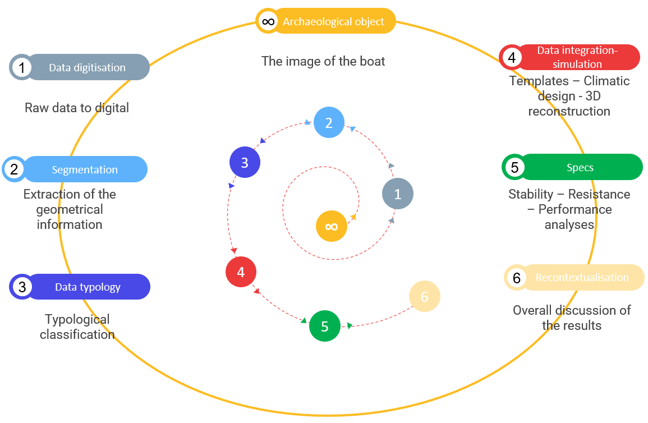
Figure 5: The itinerary exemplifying the application of reverse engineering in order to move backwards to the development cycle of the archaeological object of concern. Source: the author.
- RESULTS: DATA CLASSIFICATION AND AVERAGE SHAPES
Based on the discussed methodology, the boat evidence has been ‘deconstructed’ and classified based on certain morphological features. There are three major groups based on the hull’s general shape and symmetry/asymmetry of the extremities. Each group was further divided into subgroups based on the transverse plane and plan view shapes. Each subgroup contains several variations based on the formation of the posts and the bottom as well as the presence/absence of the oblique, pointed projection and a keel/centre plank.
4.2 (a) The templates of shapes of the LN-EBA boat types
Based on the preceding classification analysis, there is a significant number of variations. The author attempted to illustrate this variability by accounting for any minute detail that differentiates a boat from another in order to point out the richness of the dataset. Even though some of the examples bear some resemblance to others, they always have a small attribute that differentiates them. Hence, a more generalised approach is followed for the production of the shape templates due to this variability and the ambiguity of the dataset. Thereby, it was decided only to attempt to define the ones that are better represented regarding the population number and the state of preservation. Interestingly, most of the templates of the boats are represented both in the LN and EBA period, suggesting a continuity of the local boatbuilding tradition.
Two main categories of templates are discerned from the previous analysis. The first contains the rounded designs, and the second the angled ones. The variables picked for each one comply with their general design and the classified data. Hence, each template contains the design and a simplified, rationalised version of the plan, profile views, and body plans (Figure 6).
Rounded shapes (Types I-V of the rounded category)
- Template 1: convex bottom, symmetrical posts, one convex and another obtuse. U-shaped transverse plane and elliptical/lanceolate plan view.
- Template 2: convex bottom and symmetrical convex posts. U-shaped transverse plane and elliptical plan view (meniscus-like/double-ended).
- Template 3: convex bottom and asymmetrical, convex posts. U-shaped transverse plane and lanceolate plan view.
- Template 4: convex bottom, asymmetrical posts, one concave and another vertical. U-shaped transverse section and lanceolate/ogive plan view.
- Template 5: flattened bottom and symmetrical, convex posts. U-shaped transverse plane and elliptical plan view.
Angled shapes (Types I-VI of the angular category)
- Template 6: flat/flattened bottom, asymmetrical posts, one concave and another oblique. Rectangular/trapezoidal transverse section and secant-ogive/lanceolate plan view.
- Template 7: flat/flattened bottom and oblique, asymmetrical posts. Rectangular/trapezoidal transverse section and secant-ogive/lanceolate plan view.
- Template 8: V-shaped bottom, an oblique post and another vertical. V-shaped transverse section and pentagonal plan view.
- Template 9: flat/flattened bottom, asymmetrical posts, one convex and another oblique. Rectangular/trapezoidal transverse section and lanceolate plan view.
- Template 10: flat/flattened bottom, symmetrical, obtuse posts. Rectangular/trapezoidal transverse section and rectangular/oval plan view.
- Template 11: flat/flattened bottom, symmetrical, obtuse posts. Rectangular/trapezoidal transverse section and elliptical plan view (double-ended).
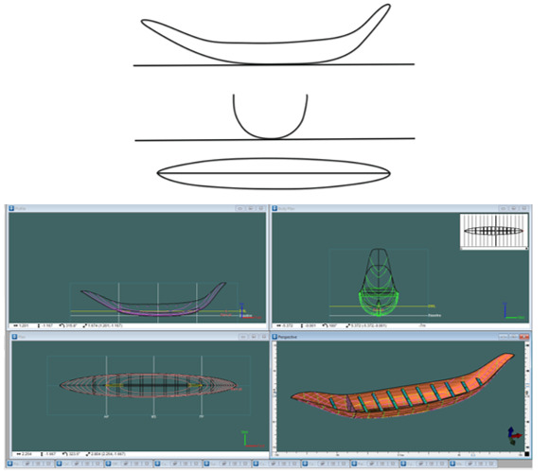
Figure 6: (Top) Template 1 of the rounded boat shapes. The simplified, basic profile and plan views as well as the body plan view that was digitally reconstructed in MAXSURF. Source: digitally drawn the author, using CorelDRAW 2020. (Bottom) A 3D surface model and the lines of the Type I boats of the ‘rounded’ shapes (Template 1). With framing and keel/centre plank. Displacement: 6 t, plus 1.5 t extra cargo capacity. Source: produced by the author in MAXSURF Modeler.
- SHIP DESIGN AND RECONSTRUCTION
This section uses the templates produced to reconstruct and assess the viability of the defined boat types through computational means as well as ship science and naval architecture. It mainly focuses on seagoing, presumably paddled vessels, not on sailing ones. However, before reconstruction, some environmental parameters that could have affected the boats’ characteristics (i.e., dimensions) and performance must be addressed. This is based on what has been termed ‘climatic design’ and concerns the operational environment and how a boat’s structure would be affected [47]. Thereby, their validity would be evaluated through their inclusion within a performance, an environmental and technological envelope that will facilitate suggestions for the parameters of boats and their seaworthiness.
- DESIGN PARAMETERS, RECONSTRUCTION AND TESTING
The theoretical estimation and selection of the main dimensions of a ship before the reconstruction process is termed “Concept Design” [48]. Thus, the following analysis for the approximation of the boats’ dimensions is also based on acclaimed ship science and design endeavours that offer some typical ratios to which any seacraft should adhere, based on physics, experimentation and empirical observations [47, 49-51]
Our design scheme is primarily influenced by the forces of specific operational environments that affect a boat in seaways, as related to its geometric shape and size [47, 49, 52]. Subsequently, the design parameters laid out by Wilson [51] are considered. Next, the parameters concerning us are the technological capacities of the LN-EBA period, timber sources and construction methods.
Certainly, some major phenomena would have concerned the seafarers of the period, especially during heavy weather circumstances. According to the International Code of Intact Stability [53], a ship in these conditions can be ‘trapped’ in critical stability situations and extreme pitch/roll angles. Therefore, these phenomena would have a bearing on the vessel’s performance and, most importantly, stability. It has been argued that the most fearsome aspect of the Aegean Sea would have been the force of the breaking wave; these would have been a usual phenomenon in the Aegean due to the short period of the wave trains [12]. Moreover, we can infer that most boats would have launched from a beach, especially considering the apparent absence of harbour installations (except for Vathy). Therefore, the issue of breaking waves should have been of concern since it could have easily damaged or capsized an inadequate boat.
It has been argued that a boat’ length should measure more than 30-40% of the height of the wave [50]; thus, this could be a rough guide to estimate their length. It has been observed that the climatic and meteorological conditions of the LN-FN would be similar to today’s [12]. If we consider that the mean annual wave height is between ca. 0.8-2 m alongside the 30-40% limit, a boat of more than 5 m long would be safe on an ordinary day in the Aegean; a 10 m one would also survive most of the rough seas as well as a 15 m and a 20-25 m long boat.
Another aspect we should account for is the slenderness ratio (L/∇^{1/3}), providing a good “hydrodynamic length”, that should be in the range of 5.5-8 [47]. To determine this, we need to approximately calculate the displacement of the abovementioned sizes and their WL. This must correspond to the estimated weight of the hull and the crew (1 cu. m = 1 t). We first need to calculate the vessel’s breadth for accurate results. As suggested by Basch [54] and other scholars [12, 56] and indicated by the Aegean iconography, the most probable position of paddlers would be this of working abreast or in a single row. So, if operating side by side or in a staggered formation, their transversal separation must be about 0.85 m to 1 m [12]. Of course, this will not be enough since it would result in extreme slenderness and lack of transverse stability. A good L/B ratio usually ranges between 5-7 [47] which can be estimated by using the previously determined lengths (5, 10, 15, 20 and 25 m) based on the height of a wave versus the length of a boat. A 5 m boat should have a maximum beam of no more than 1 m to have an L/B ratio of 5. A 10 m boat must have no more than a 2 m maximum beam to score an L/B ratio of 5. A 15 m boat should have a 3 m maximum beam for an L/B of 5; a beam of 2 m gives an L/B of 7.5, above that threshold. A 20 m boat needs to be 3 or 4 m wide to have an L/B of 6.5 or 5, respectively. Finally, a 25 m boat needs to have a breadth of 4 or 5 m to score an L/B of 6.2 and 5 m, respectively. However, too much beam can also adversely affect the boat’s stability and overall performance.
Having approximately identified various sizes, as far as the length and breadth of the boats are concerned, we may return to our initial problem, the calculation of the L/∇^{1/3} ratio. This should be within the range of 5.5-8 [47]. If we consider the paddler’s interscalmium (ca. 0.75-1 m) [11-12, 54-57] a 5 m boat can accommodate ca. 2-3 paddlers on each side, a 10 m boat ca. 7-8 paddlers, a 15 m boat around 10-12 paddlers, a 20 m boat around 12-15 paddlers and a 25 one ca. 15-20 paddlers. Thereby, the weight of the hull for boats of 5 m, 10 m, 15 m and 25 m can be estimated at upwards of 25 kg/sq. m, including other woodwork at 15 kg/sq. m (Weight of hull = Surface area of hull x Weight per sq. m). Thereby, at least approximately, a 5 m boat (WL ca. 3 m) would displace around 0.5 t, a 10 m boat (WL ca. 5.5 m) about 1.5-17 t, a 15 m boat (WL ca. 8 m) around 4 t, a 20 m boat (WL ca. 10.7 m) around 5 t and a 25 m one (WL ca. 13.5 m.) around 7 t. Hence, the L/∇^{1/3} ratio for a 5 m boat is 3.7; for a 10 m boat, it is around 4.8; for a 15 m boat is around 5; for a 20 m boat, is around 6.2; for a 25 m boat is around 7 (the basic hydrostatics have been approximated in MAXSURF).
Regarding the freeboard and T, these can be estimated by accepting paddling as the mode of propulsion and the above-estimated displacement values. If paddling was employed by paddlers being sat or kneeled for increased stability, then, based on ethnographical and archaeological data, the lowest height of the sides would be between 0.8-1 m above the waterline (freeboard), at least in normal see states [12]. These freeboard numbers have been successfully confirmed in the Aegean Sea context with the paddling of the Bracciano replica during the Monoxylon III expedition [58]. Hence, this freeboard roughly yields a T of ca. 0.2-05 m. Accordingly, the overall height of the sides (the vertical distance from the gunwale to the bottom of the boat) should be around 1.2-1.5 m or more. Another aspect included is the B/T ratio. It has been proposed that a moderate beam should be no more than three to four times the body depth of the hull or have a B/T ratio of 2.5-5 [47, 59].
Based on these estimations, we can exclude from our reconstruction process the boats of ≤ 5 m since their ratios would be lower than the proposed ones [47, 59], at least for open sea boats able to safely transport people and cargo. The boats that measure 10 x 2 m check some of the abovementioned criteria. The 15 x 3 m long ones, indicate some of the best examples, scoring well in all ratio categories. The 20 x 3 m would also be a fine example. As far as the 25 m long, this requires a 4 or 5 m breadth. However, a 5 m beam seems extreme and would make the boat considerably stiff. Consequently, a 25 x 4 boat appears a more plausible option, as far as the abovementioned ratios are concerned.
Next, it remains to be seen whether these four sets of longitudinal dimensions (10 m, 15 m, 20 m and 25 m) were technologically viable or supported by the timber availability and the boat evidence of the period. In terms of technology, we proposed that the necessary knowhow and toolset to fell and process a log in order to construct an extended/expanded logboat or shape it into planks is evident at least since the LN period; likewise, the necessary joinery techniques [11-12]. In terms of timber availability, it has been recommended that the tree species required to construct a ≥ 10 m logboat were present, such as Pinus nigra and brutia or oaks; similarly, adequate timber for shaping the planking of a plank-built hull [11-12]. Hence, at least theoretically, one could produce quite long, solid planks from a single log. However, since there were adequate joinery techniques in the LN-EBA Aegean, considerable lengths could have been attained by joining shorter planks.
Regardless, there should have been a limitation in a boat’s length, either built from a log or planks exclusively, especially if we accept that the most expensive aspect of boatbuilding is to increase the boat’s length [47]. Possibly, in our spatiotemporal context, one should also consider the increase in breadth and depth as expensive. However, in our case, the expensiveness might not be that much associated with economic incentives but with demographic ones. Thereby, we should also consider Broodbank’s [21-22] estimates about the considerable labour intensiveness of big-sized boats, as well as Tzovaras’ [17] discussion on the logistics and risk-to-benefit ratio for the construction of long vessels (more than 25 m), whose sinking can lead to a demographic and economic disaster. Furthermore, we should also consider that the longer the boat, the more power is required, hence more paddlers. Did the settlements of the period have the available ‘manpower’ to operate a more than 20-25 m long boat? In terms of the ones that could measure 25 x 4/5, they seem too excessive. By decreasing the beam of a 25 m long boat to below 4 m, it would be too narrow, tender and unstable in heavy seas; if we maintain its beam to 4-5 m, it would be considerably beamy and stiff.
Thus, based on the rationale of moderation, we can infer the following. First, the boats whose dimensions vary from 10x2 m to 15 x 2 m seem more than feasible, considering that 10-15 m would be the estimated length of the EH II Dokos shipwreck [60] (Figures 1-2). Though the 20x3/4 m boats would also be massive for the period (see below), we decided to digitally reconstruct and test them for the sake of experimentation.
Based on these criteria, the eleven defined templates were modified and digitally reconstructed. There are two versions of them, one without framing or a keel/centre plank and another with frames. The line plans and digital models were produced in MAXSURF Modeler (Figure 6). Each has been reconstructed x 3 times based on the previously defined set of dimensions. Thereby, the author digitally reconstructed and tested sixty-six variations of the eleven boat types. The 15 m long digital design ‘Type I’ of the rounded shapes (represented by the rock-art boat images from Vathy, Figure 6) has been scaled down in order to physically reconstruct a 2 m long technical boat model (scale: 1:7:5), to be tested in the towing tank of the University of Southampton (Boldrewood Campus, Wolfson Unit) (the exemplary reconstruction has been carried out by RFH PIERCE) (Figure 7).

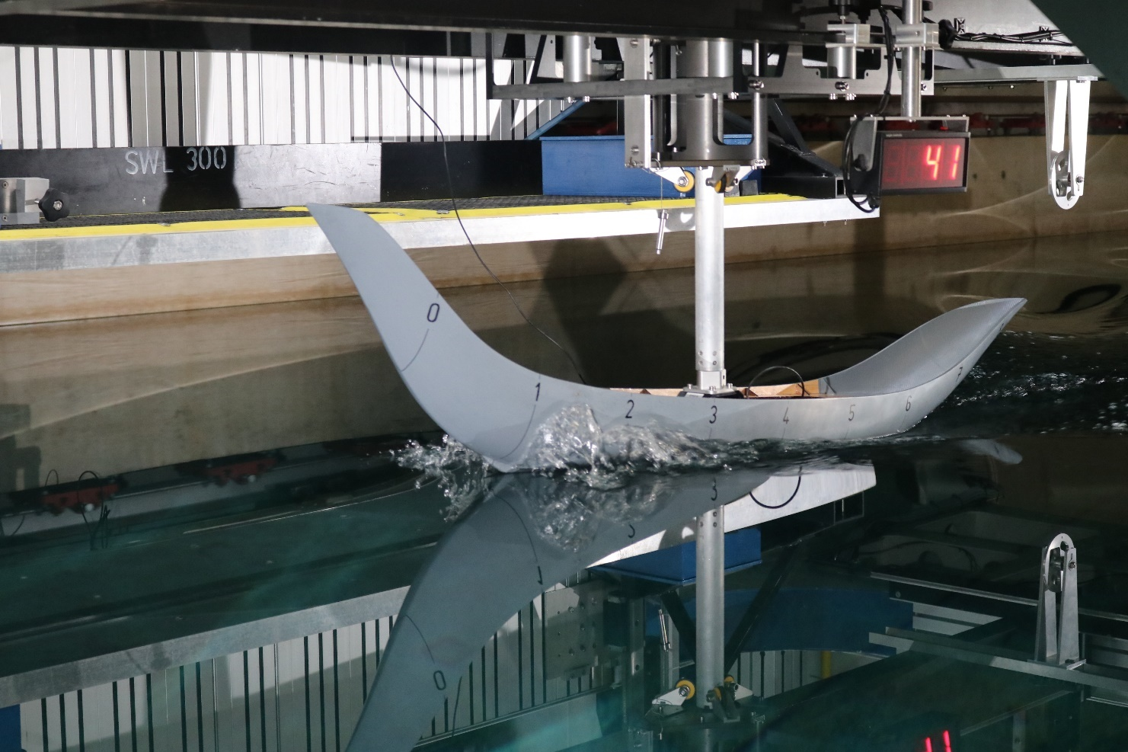
Figure 7: The testing of the 2 m technical boat model in the towing tank of the University of Southampton (Boldrewood Campus, Wolfson Unit). Lightship condition.
5.1 (a) Stability
The resulting values from the stability analysis are evaluated based on the Stability Criteria Evaluation data loaded in the MAXSURF software, which adheres to international codes and regulations on stability. Hence, we decided to compare the overall stability with the criteria set by the IMO and Code of Intact Stability. More specifically, IMO A.749 (18), Chapter 3, design criteria applicable to all ships, which provides a pass or fail to certain stability categories. Additionally, via the STIX Stability Index (ISO 12217-2:2002 €), intended for boats measuring between 6 to 24 m in length and having a beam greater than 1 m. This provided a rating on the overall stability of the boats and enabled its assignment to certain design categories (A-D), specifying the wind and wave conditions that the boat can sustain (see below). The higher the rating, the better, indicating safe and seaworthy crafts with increased dynamic stability. The STIX Stability Index (via MAXSURF) was also implemented with success in the reconstruction project of the Min of the Dessert, a prehistoric seagoing boat from the period of the reign of Hatshepsut (early New Kingdom) [61]; thereby, it has been suggested that, though these criteria concern modern boats and ships, they can still be beneficial comparators of stability of ancient crafts [62].
It was decided to test our digital models in fully laden conditions to assess how well or poorly these boats can react if we stretch them to their capacity limits (see below). The extent of the loadcase condition is determined in MAXSURF based on the stability tests and by making sure that the DWL is always below the margin line.
5.1 (b) Resistance
The resistance analysis is carried out in MAXSURF Resistance through analytical methods. We build on the premise that we can determine an average and maximum speed by observing the resistance curve of each boat type. So, we examine the curve’s ‘humps’ and ‘hollows’ produced by the wave interference triggered after the vessel’s speed increases. When the boat reaches a certain speed and the hump starts getting too steep, the drag and, consequently, the P (kW) required to overcome it would surpass the power output of the crew of a paddled boat. Therefore, this could be used as an initial threshold. To further validate how realistic the produced speed figures are, we examined whether a certain number of paddlers can achieve these based on the energy expenditure required to move a boat. Thus, the number of paddlers necessary to move a boat at a specified speed requires an x amount of power (kW).
Thereby, the number of paddlers can be estimated by dividing P by the paddler’s peak power, which can be estimated as Fpeak multiplied by a relative paddle speed -applied to the paddle- per paddler. Typically, this paddle speed will be related to the stroke frequency, e.g., how many ‘paddles’ occur in a given time. The relative speed is found from the stroke length divided by the active stroke phase minus the boat speed. As boat speed rises, the paddler needs to raise frequency and stroke length.
For example, suppose a 10 m boat requires thirty paddlers in order to reach the specified speed by expending an x amount of power. In that case, one can logically infer that this number is unrealistic since they cannot fit in a 10 m-long boat, considering the limitations of the paddler’s interscalmium. The MAXSURF Stability software can determine the P. For the Fpeak, we need to resort to experimental and empirical data concerning paddling performance and the paddler’s physiology and to studies on kinematics and biomechanics. Besides, the speed of a boat is explicitly associated with the power output delivered by the paddler, transferred to the water via the paddle’s blade in order to overcome the hull’s aerodynamic and hydrodynamic drag and instigate forward movement [63-66]. Several studies indicate that Fpeak averages around 300N and is also adopted by the present research [63-65,67-69].
Therefore, reaching and maintaining average or high speeds requires significant amounts of energy, and a wrong ‘strategy’ can lead the crew to overexert itself unnecessarily and, consequently, to fatigue [66]. Several stages of loss of energy have been defined during this process [12, 66, 70] and are detailed as follows:
Human fuels themselves with food → Loss of energy in food in the conversion process → Muscles use energy to pull the paddle → Oxygen uptake and heart rating increases → Loss of energy in muscles (heat) into force through arms/legs/back → Lever force on the paddle to force in water → Minor loss of energy in mechanical system → Paddle blade → Significant loss of energy in converting force into paddle into axial thrust as well as stirring up the water. Thus, it is also critical to determine the mechanical efficiency of paddling, “the ratio between the energy expended by muscle contraction and the mechanical work done” [67]. We can also understand it as an eta value describing the difference between mechanical power loss and power input. Obviously, this value cannot be the same as the efficiency of conventional ship powering. Instead, it should be determined -and limited- based on the mechanical efficiency of muscular work when paddling. Several studies have been undertaken, indicating an efficiency value ranging from 16-30% [67, 70-73]. Thus, this range is opted for by this endeavour.
These data were loaded in MAXSURF Resistance. The analytical slender body method was chosen as described by Couser [74] and Couser et al. [75]. The resistance is calculated by the form factor derived from Holtrop’s formulation and ITTC’57 friction coefficient, and the correlation allowance is 0.0004 [76] The efficiency chosen is the one defined above (ca. 30%). Regarding the range of speeds, we tested the boats in a range of 0-10 Knotts. In our case, this maximum speed value might be extreme, and we know that it is almost impossible to achieve by our boat types. Nevertheless, we required an upper-speed threshold based on empirical and experimental observations on modern paddling [64]. The author provides two sets of maximum and average speed estimates, one based on the possibility of two rows of paddlers working abreast and another of a single/staggered row of paddlers. The maximum speeds are validated via the resistance curve and the method described above. The average ones are estimated based on the flatter parts of the curve and before the major humps, where the drag is minimal and, consequently, the effort and the power output. Thus, the following data are summarised in Figure 8a-d.
In terms of the technical boat model, a series of tests were performed. Overall, we completed 26 runs. Each run examined the model’s drag (N), heave (mm) and trim (°) at a predefined speed (carriage speed) and loading condition (Runs 1-10 (lightship condition): 0.3-2.3 m/s, Runs 10-15 (laden-ballasts): 0.7-1.9 m/s, Runs 16-20 (trim by the bow/stern): 0.9-1.6 m/s, Runs 21-26 (regular-irregular sea states): 1.3 m/s) (Figure 9).

Figure 8: a) The speed, resistance and power values of the boat types of the rounded shapes, generated through the MAXSURF Resistance software. This table demonstrates the values of boats propelled by a single row of paddlers. b) the values of the rounded boats propelled by a two rows of paddlers working abreast. c) the values of the angular boats propelled by a single row of paddlers. d) the values of the angular boats propelled by two rows of paddlers working abreast. The average values have been calculated in Microsoft Excel. Source: produced by the author, by using MAXSURF Resistance and Microsoft Excel.
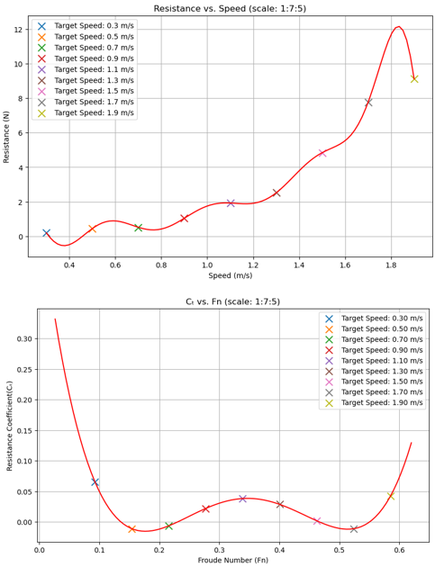
Figure 9: (Top) Resistance (N) vs Speed (m/s). (Bottom) Resistance Coefficient vs Froude Number. Source: the author.
- CONCLUSION: AN OVERAL DISCUSSION OF THE RESULTS
All the boat types passed the IMO and STIX criteria, mostly achieving ‘Category A’ and have an exemplary range of positive stability and an adequate maximum righting moment (Figure 10). In terms of performance, the resistance analysis demonstrated no significant differences among the types of rounded and angular shapes. However, the latter yielded slightly better values (Figure 8a-d). It is interesting to point out that the difference between the results of boats paddled by a single row of paddlers and those by two rows of paddlers working abreast is insignificant (Figure 8a-d). This is probably due to the great drag imposed on the vessels, which would require much power to overcome (Figure 8a-d). More specifically, the average speed of both categories, with a single row of paddlers, varies from ca. 2-4 knots (maximum speed ca. 4-5.5 knots) while for those with two rows from ca. 3-4 knots (maximum speed ca. 4.5-6.8 knots) (Figure 8a-d). Hence, it would be sensible to assume that these boats would most likely be paddled by a single row of paddlers, which would have minimised the demographic risks for a community in case of death at sea or the risks imposed by their absence for an extensive period. In any case, by looking at all these values, we can suggest that they align with the speeds suggested by other scholars based on their observations of archaeological, empirical, experimental and ethnographical data [22, 58, 77]. Interestingly, the results produced by the technical boat model are not that far to MAXSURF-generated ones (Figures 8-9).
Returning to stability, we can also point out that the ones with framing and a keel/centre plank usually have better results due to the changes in VCG and the addition of a keel/centre plank (Figure 10). Although the differences in the stability results among all the types are minute, a few stand out. Regarding the increased displacement, we notice that the most balanced results are usually produced by the 15 m boats, requiring minimal ballast in the case of a trimmed bow/stern. At the same time, the bigger vessels have performance issues due to increased drag. For instance, there are cases where the smaller boats (i.e., of 10 m) yield equal or even better speed values with less drag in comparison to the bigger ones (Figure 8a-d). Thus, we can conclude that it is unnecessary for all the boat types to be more than 10 m long to achieve good speeds. Besides, there is little to no evidence of boats more than 15 m in length in the prehistoric Aegean; even the shipwrecks of the LBA are hardly over 15 m (restored length), such as the Uluburun one [37]. However, the bigger vessels usually have better stability results since they are heavier, lengthier and beamier. Additionally, we can observe a more extensive range of average speeds (Figure 8a-d). Still, though, that does not mean that they existed.
Having in mind that all the types fall within Category A of the STIX criteria we can suggest that all the variations of the rounded and angular shapes are seaworthy and able to complete extended, long-range voyages and survive in extreme conditions, even in fully laden states, as far as their stability is concerned. This is underpinned by their performance that advocates the possibility that some vessel types would not have been required to travel along the coasts or depend on island hopping. This observation is further underlined by the Monoxylon III expedition, during which the Bracciano replica covered the distance between the islands of Santorini-Dia (ca. 120 km) without any other intermediary stops [77] (Figure 1). Therefore, at least theoretically, some of the boats with the best performance could cover the same distance within a day, even if they just travel during the daylight. Based on these scenarios, one can ponder how conceptionally far were other distant destinations, when these could be reached within a few days or so. Thereby, a vessel with all these elements identified in the catalogue of the hull, such as a keel/centre plank, frames, a sound steering system, anchors, and other auxiliary aspects (i.e., cabins, shelters, platforms, etc.), would have even more increased capabilities for long-range seafaring. Moreover, the necessary capacities to transport with safety all these commodities that were of prime importance and in demand by the Aegean communities. The development of these practices and the level of their distribution is embedded in and in accordance with other emerging LN / FN phenomena, such as metallurgy and maritime specialization. Consequently, our results open a new window into Aegean prehistory, not only about the regional maritime networks of the LN-EBA periods but also the ‘international’ ones.
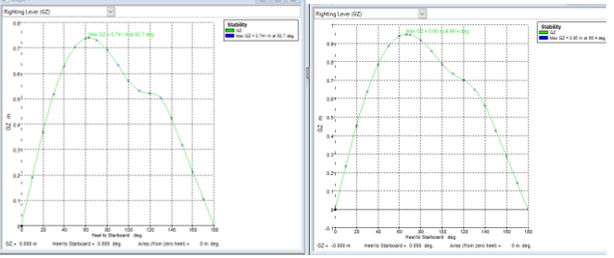
Figure 10. (Left) Type I of the rounded shapes. The ‘unframed’ 15 m long boat variation in fully laden condition. STIX score: Category A, 58.1 (margin +81.56%). Maximum righting moment: 0.741 m at 62.7°. (Right) Type I of the rounded shapes. The 15 m long boat variation with frames – keel/centre plank. Fully laden condition. STIX score: Category A, 63.9 (margin +99.53%). Maximum righting moment: 0.95 m at 66.4°. Source: Generated by the author by using MAXSURF Stability.
- ACKNOWLEDGEMENTS
The author would like to thank Professor Stephen Turnock for his valuable support and guidance. Many thanks are also due to Professor Lucy Blue, Professor Andreas Vlachopoulos and Professor Joanna Sofaer.

- LIABILITY
The opinions expressed are solely those of the author.
- REFERENCES

- TELEVANTOU, CHR., A, ‘Strofilas: a Neolithic settlement on Andros’, Horizon. A Colloquium on the Prehistory of the Cyclades, 2008.
- TELEVATNOU, CHR. A, ‘The Neolithic Settlement at Strofilas, Andros’, Papyri - Scientific Journal 8, 2019.
- VLACHOPOULOS, A. G, ‘Βαθύ Αστυπάλαιας: Έρευνα και µελέτη σε ένα διαχρονικό παλίµψηστο της νησιωτικής Aρχαιολογίας/Vathy, Astypalaia. Research in a diachronic palimpsest of the Aegean’, Δωδεκανησιακά Χρονικά ΚΘ, 2021.
- VLACHOPOULOS, A. G (ed.), Δέκα χρόνια έρευνας σε ένα διαχρονικό παλίμψηστο του Αιγαίου. Τόμος ΙΙ. Η Διεπιστημονική Έρευνα στο Βαθύ / Vathy, Astypalaia 2011-2021. Ten years of research (2011-2020) on a diachronic palimpsest of the Aegean. VOLUME II. Archaeological Fieldwork at Vathy, forthcoming.
- VLACHOPOULOS, A. G, ‘Vathy Astypalaia. An Early Cycladic site in the Dodecanese’, AM 2021.
- PAPATHANASOPOULOS, G. ‘ Το Πρωτοελλαδικό ναυάγιο της Δοκού’, Αρχαιολογικά Ανάλεκτα εξ Αθηνών ΙΧ, 1976.
- EVAGGELISTIS, ‘Γιαγάνα’ Αρχαιολογικόν Δελτίον 55, 2000.
- VLACHOPOULOS Α. G., ‘Αρχαιολογικές έρευνες πεδίου στο Βαθύ Αστυπάλαιας’ Δωδώνη (Ιστορία-Αρχαιολογία) V. ΜΓ'-ΜΔ', 2017.
- VLACHOPOULOS, A. G., ‘The rock-art fleet of Astypalaia’, Conference presentation. Nostoi II. Traveling in the Eastern Mediterranean. Sea and Inland Routes from the Early Bronze to the End of the Early Iron Ages, 2022
- VLACHOPOULOS, A. G. and ANGELOPOULOU, A., ‘Early Cycladic figurines from Vathy, Astypalaia’, Beyond the Cyclades. Early Cycladic sculpture in context from mainland Greece, the North and East Aegean, 2019.
- TZOVARAS, P., ‘Technological and typological analysis of the ships in the rock-art representations at Vathy, Astypalaia’, Δέκα χρόνια έρευνας σε ένα διαχρονικό παλίμψηστο του Αιγαίου. Τόμος ΙΙ. Η Διεπιστημονική Έρευνα στο Βαθύ / Vathy, Astypalaia 2011-2021. Ten years of research (2011-2020) on a diachronic palimpsest of the Aegean. VOLUME II. Archaeological Fieldwork at Vathy, 2023.
- TZOVARAS, P., The boatbuilding tradition of the Aegean during the Late Neolithic – Early Bronze Age periods. Typological classification, digital reconstruction and seakeeping assessment, 2023
- MOUNDREA-AGRAFIOTI, A., ‘H λάξευση του λίθου στην Παλαιολιθική Εποχή’, Αρχαιολογία και τέχνες 61, 1996.
- ZACHOS, K. ‘Metallurgy’, Neolithic Culture in Greece, 1996.
- ZACHOS, K., ‘The Neolithic background: A reassessment’, Metallurgy in the Early Bronze Age Aegean. Sheffield archaeological monographs Volume 7, Sheffield studies in Aegean archaeology, 2007.
- PAPANGELOPOULOU, T. 2016. ‘Metallurgy-Metalwork’, Cycladic Society. 5000 years ago, 2016.
- TZOVARAS, P., ‘Before 'Thalassocracies': Reconstructing the 'longboat' and rethinking its use and social implications in the 4th and 3rd millennium South Aegean’, Ships, Boats, Ports, Trade, and War in the Mediterranean and Beyond. Proceedings of the Maritime Archaeology Graduate Symposium 2018, 2020.
- MCGRAIL, S., Ancient boats in North-West Europe: The archaeology of water transport to AD 1500, 1987.
- MCGRAIL, S., Boats of the world: from the Stone Age to Medieval times, 2001.
- BROODBANK, C., The making of the Middle Sea. A history of the Mediterranean from the beginning to the emergence of the Classical world, 2013.
- BROODBANK, C., ‘The longboat and society in the Cyclades in the Keros-Syros Culture’ American Journal of Archaeology 93(3), 1989.
- BROODBANK, C., An Island Archaeology of the Early Cyclades, 2000
- TZOVARAS P., ‘Nejstarsi Zobrazena plavidla’, Epos o předchůdcích Gilgameše: archeologický kontext expedice Monoxylon III, 2022.
- PALIVOU, C., ‘Οικοδομική Τεχνολογία των προϊστορικών χρόνων’, Αρχαιολογία και Τέχνες 94, 2005.
- GIAGKOULIS, T., The pile-field and the wooden structures from the Neolithic lakeside settlement Anarghiri IXb, Western Macedonia, Greece. Vol. I., 2019.
- LANDELS, J. G., Engineering in the Ancient World, 1978.
- GREENHILL, B., The archaeology of the boat. A new introductory study, 1976.
- ERKURT, G., ‘Experimental Archaeology: Project for the re-animation of Cycladic boat’, Across: The Cyclades and Western Anatolia during the 3rd Millennium BC, 2011.
- CHATZITOULOUSIS, S. ‘Woodworking technology at the Neolithic lakeside settlement of Dispilio, Kastoria’, Anaskamma 1, 2008.
- WACHSMANN, S., Seagoing ships and seamanship in the Bronze Age Levant, 1998.
- JOHNSTONE, P. ‘The sea-craft of Prehistory, 1980.
- STEFFY, R. J., Wooden ship building and the interpretation of shipwrecks, 1994
- MORRISON, J., ‘Ships and boats of the Mediterranean from 3000-500 BC’, The archaeology of boats & ships. An introduction, 1995.
- PULAK, C., ‘Mortise-and-tenon joints of Bronze Age seagoing ships’, Boats, Ships and Shipyards/ Proceedings of the Ninth International Symposium on Boat and Ship Archaeology, Venice 2000, 2003.
- PULAK, C., ‘The Uluburun shipwreck: An overview,’ The International Journal of Nautical Archaeology 27, 1998.
- PULAK, C., ‘The Late Bronze Age shipwreck at Uluburun: aspects of hull construction’, The Point Iria Wreck. Interconnections in the Mediterranean ca. 1200 BC, 1999.
- PULAK, C., ‘The Uluburun shipwreck and Late Bronze Age trade’, Beyond Babylon: Art, Trade, and Diplomacy in the Second Millennium B.C, 2006.
- AGOURIDIS, C., ‘Sea routes and navigation in the third millennium Aegean’ Oxford Journal of Archaeology 16(1), 1997.
- PAPOULIA, CHR., ‘Seaward dispersals to the N.E. Mediterranean islands in the Pleistocene. The lithic evidence in retrospect,’ Quaternary International 431, 2006.
- PHOTOS-JONES, E., COTTIER, A., HALL, A. J. and MENDONI L. G., ‘Kean Miltos: The well- known iron oxides of antiquity’, The Annual of the British School at Athens, Volume 92, 1997.
- THEOPHRASTUS, De Lapidibus, trans. Apostolodis, N., Chr., 1975.
- HOMER, ‘Iliad, trans. Murray, A. T. Revised by Wyatt, W. F., 1924’, Loeb Classical Library 170, 1924.
- PALIVOU, C., ‘Η πολυωροφία στο Αιγαίο κατά τους προϊστορικούς χρόνους’, Ήρως κτίστης, Μνήμη Χαράλαμπου Μπούρα, 2018.
- RENFREW, C., The emergence of civilization. The Cyclades and the Aegean in the third millennium B.C., 1972.
- PERLÈS, C. and VITELI, K. D., ‘Craft specialization in the Neolithic of Greece’, Neolithic Society in Greece. Sheffield Studies in Aegean Archaeology, Volume 2, 1999.
- DE ALMEIDA, V. M., Towards functional analysis of archaeological objects through reverse engineering processes, 2013.
- MOLLAND, A., TURNOCK, S. and HUDSON, D., Ship Resistance and Propulsion: Practical Estimation of Propulsive Power, 2011
- PAPANIKOLAOU, A., Ship design. Methodologies of preliminary design, 2014.
- RAWSON, K. J. and TUPPER, E. C. Basic ship theory. Vol. 1. 4th ed., 1994.
- CLAUGHTON, A., ‘The stability of yachts in large breaking waves’, Adlard Coles' heavy weather sailing. 6th edition, 2008.
- WILSON, P. A., Basic Naval Architecture. Ship stability, 2018.
- WILLERTON, P. F., Basic shiphandling for masters, mates and pilots, 1980.
- INTERNATIONAL CODE OF INTACT STABILITY, ‘Resolution msc.267(85) (adopted on December 4 2008). Adoption of the international code on intact stability (2008 IS CODE) [online]’. Available at: https://assets.publishing.service.gov.uk/government/uploads/system/uploads/attachment_data/file/915778/MSIS43_Intact_Stability_R05.20.pdf [Access March 10 2022], 2008.
- BASCH, L., Le musée imaginaire de la marine antique, 1987.
- WEDDE, M., Towards a hermeneutics of Aegean Bronze Age ship imagery, 2000.
- MARINATOS, S., ‘La marine Créto-Mycénienne’, Bulletin de correspondance hellénique, Vol. 57, 1933.
- MARINATOS, S., ‘Das Schiffsfresko von Akrotiri, Thera’, Seewesen. Archaeologia Homerica, Band I Kapital G, 1974.
- TICHY, R. 2020., ‘Monoxylon III: Return of the logboat to the Eastern Mediterranean’, Revue de l’Archéologie du Bateau, 1, 2020.
- STEPHENS, O., ‘Yacht design and construction for heavy weather’, Adlard Coles' heavy weather sailing. 6th edition, 2008.
- PAPATHANASOPOULOS, G., VICHOS G, CHATZIDAKI, E. and LOLOS, Y., ‘Δοκός: Ανασκαφική περίοδος 1990’, Ενάλια ΙΙ (3/4), 1992.
- WARD, C. 2012., ‘Building pharaoh's ship: Cedar, incense and sailing the Great Green’, British Museum Studies in Ancient Egypt and Sudan 18, 2012.
- COUSER, P., WARD, C. and VOSMER, T., ‘Hypothetical reconstruction of an ancient Egyptian sea-going vessel from the Reign of Hatshepsut, 1500BCE’, International Conference on Historic Ships. The Royal Institution of Naval Architects, London, United Kingdom, 19-20 November 2009, 2011.
- JACKSON, P. S., ‘Performance prediction for Olympic kayaks’, Journal of Sports Sciences 13, 1995.
- MICHAEL, J. S., SMITH, R. and ROONEY, K. B., ‘Determinants of kayak paddling performance’, Sports Biomechanics 8(2), 2009.
- ONG, K., ELLIOTT, B., ACKLAND, T. and LYTTLE, A., ‘ Performance tolerance and boat set‐up in elite sprint Kayaking’, Sports Biomechanics 5(1), 2006.
- HIGGENS, A., CONWAY, L., BANKS, J., TAUNTON, D., HUDSON, D. and TURNOCK, S., ‘Development of a kayak race prediction including environmental and athlete effects’, 11th Conference of the International Sports Engineering Association (ISEA 2016). 1-14 July 2016, Delft, Netherlands. The Engineering of SPORT 11. Procedia Engineering Volume 147, 2016.
- FUKUNAGA, T, MATSUO, A., YAMAMOTO, K. and ASAMI, T. ‘Mechanical efficiency in rowing’, European Journal of Applied Physiology 55, 1986.
- GOMES, B. B., RAMOS, N. V., CONCEIÇÃO, F. A. V., SANDERS, R. H., VAZ, M. A. P. and VILAS-BOAS, J. P., ‘Paddling Force Profiles at Different Stroke Rates in Elite Sprint Kayaking’, Journal of Applied Biomechanics 31, 2015.
- TORNBERG, Å. B., HÅKANSSON, P., SVENSSON, I. and WOLLMER, P., ‘Forces applied at the footrest during ergometer kayaking among female athletes at different competing levels - a pilot study,’ BMC Sports Science, Medicine and Rehabilitation 11(1), 2009.
- HENDERSON, Y. and HAGGARD, H. W., ‘The maximum of human power and its fuel’, American Journal of Physiology 72, 1925.
- CUNNINGHAM, D. A., GOODE, P. B. and CRITZ, J. B., ‘Cardiorespiratory response of exercise on a rowing and bicycle ergometer’, Medicine and Science in Sports and Exercise 7, 1975,
- HAGERMAN, F. C., CONNERS, M. C., GAULT, J. A., HAGERMAN, G. R. and POLINSKI, W. J, ‘Energy expenditure during simulated rowing’, Journal of Applied Physiology 45, 1978.
- ASAMI, T., ADACHI, N. and YAMAMOTO, K., ‘Biomechanical analysis of rowing performances,’ Biomechanics VII-B, 1981.
- COUSER, P., An investigation into the performance of high-speed catamarans in calm water and waves, 1996.
- COUSER, P., WELLICOME, J. F., and MOLLAND, A. F., ‘An improved method for the theoretical prediction of the wave resistance of transom-stern hulls using a slender body approach’, International Shipbuilding Progress, 1998.
- MAXSURF, User manual. MAXSURF Resistance, 2018.
- TICHY, R., ‘Archaeology of the wind natural conditions and early sea navigation in the Eastern Mediterranean,’ ŽIVÁ ARCHEOLOGIE – REA, 2021.

- AUTHOR’S BIOGRAPHY
Panos Tzovaras is a post-doctoral researcher at the University of Ioannina. The author studies the impact of early boats and seafaring on the colonisation and neolithisation of the eastern Mediterranean, through the lenses of archaeology, paleogeology, ship science and engineering. The author’s previous experience includes a doctoral thesis (University of Southampton) on the Neolithic boatbuilding tradition of the Aegean and the classification, digital reconstruction and testing of the period’s boat types. Additionally, the design, reconstruction and towing tank testing of the technical boat model. Finally, he has participated in various excavations works (i.e., at Strofilas on Andros, Vathy on Astypalaia, etc.) and recorded numerous, two and three-dimensional boat representations.

