efficacy of neuromuscular exercises to promote movement quality and reduce musculoskeletal injury during initial military training in Royal Navy recruits

*P. E. MUCKELT,^{1,2,3} C. POWER,¹ J. PATTERSON,⁴ L. STEVENS,⁵ C. POWELL,⁶ M.B. WARNER, ^{1,2,3} M. J. STOKES^{1,2,3} AND J.L. FALLOWFIELD⁷

¹ School of Health Sciences, University of Southampton, Southampton, UK.
² Centre for Sport, Exercise and Osteoarthritis Research Versus Arthritis, University of Southampton, Southampton, UK.
³ Southampton NIHR Biomedical Research Centre, Southampton, UK.
⁴ HMS DRAKE, Plymouth, PL2 2BG
⁵ Headquarters Defence Medical Services Group, DMS Whittington, Lichfield, WS14 9PY
⁶ Primary Care Rehabilitation Facility, Defence Primary Healthcare, Britannia Royal Naval College, Dartmouth, TQ6 0HJ.
⁷ Institute of Naval Medicine, Gosport, UK

*Corresponding author:
Paul E Muckelt
p.muckelt@soton.ac.uk
School of Health Sciences
University of Southampton
Southampton, SO17 1BJ
United Kingdom

Data availability statement
Data are available on reasonable request.

Ethics approval
The protocol for this study was approved by the Ministry of Defence Research Ethics Committee (Reference: 781/MODREC/2017) and was conducted in accordance with the ethical standards of the Declaration of Helsinki.
Patient consent for publication
Not applicable.

Acknowledgments
The study team would like to thank The Institute of Naval Medicine, Ministry of Defence, UK, for its support, and express their gratitude to HMS Raleigh Physical Training Instructors, Medical Centre/ Rehabilitation Staff, Training Delivery Staff and recruits who assisted in this study. The team would especially like to thank POPT Charlotte Mason, CPOPT Keir Woodhead and Lt Jordan Bate (LPT Bate at the time of the study) who delivered the neuromuscular intervention, and Rachel Fitzgerald, Ailsa Gray, Richard Underwood, PO Andrew Davey, Samantha Kelly and PO Leah Ravuoco who assisted in administering the HLLMS. Co-author C. Power is now at Department of Sport and Health, Solent University, Southampton, SO14 0YN.

Contributors:
All authors read and approved the final manuscript and met the four primary I.C.M.J.E. criteria for authorship. In addition, all authors have been actively involved in the study in different capacities: P.E.M drafted the paper with contributions and approval from all authors. P.E.M, C.P, L.S, M.B.W, M.J.S and J.L.F were involved in the concept and design of the study. P.E.M, C.P, J.P, L.S, M.B.W, C.P, M.J.S and J.L.F were involved in the acquisition and analysis of the data.

Funding:
This work was funded by Centre for Sport, Exercise and Osteoarthritis Research Versus Arthritis (Grant reference 21595).

Competing interests:
None declared.

Pertinent Party Involvement:
Physiotherapists were involved in decisions on when the HLLMS could be undertaken and how this would be best implemented and PTIs were consulted on how best in integrate the neuromuscular exercise programme into Initial Naval Training and when it could be administered.

Abstract
Introduction
Musculoskeletal injuries (MSKI) are a significant problem in the Royal Navy, contributing to 48% of all medical discharges from Service between 2019 and 2020. The objective of the study was to assess efficacy of implementing a neuromuscular training intervention to improve movement quality and reduce MSKI in Royal Navy recruits undertaking initial military training.
Methods
Neuromuscular training (pre-activation exercises, focusing on hip control) was integrated into the warm-up exercise regimen preceding physical training during the 10-week Initial Naval Training (Recruits) programme (Jan-Mar 2020) at HMS Raleigh (Intervention group; n 162). A Control group comprised (n 90) recruits entering training from Jan 2019, who completed the standard warm-up programme prior to physical training. Movement control of the intervention group (Intervention) was assessed pre- and post the 10-week programme using the Hip and Lower-Limb Movement Screen (HLLMS). Injury incidence proportion for both groups was determined retrospectively by review of medical notes.
Results
The Control group MSKI incidence proportion was 31%, which was higher (P<0.05) than the 8% reported in the Intervention group. The majority of MSKI were of the lower limb, and were reported in weeks 1, 2 and 5 of the 10-week training programme. Movement control, as assessed from the HLLMS score, improved (pre-training (Week-1) and post-training (Week-10) HLLMS score (mean [SD] Pre: 11.2 (5.6); Post: 8.4 (3.9); t=5.829, P<0.001)) following the neuromuscular training in the Intervention group but was not assessed in the Control group.
Conclusion
A neuromuscular control intervention was successfully implemented during Initial Military Training in the Royal Navy. The cohort undertaking the intervention demonstrated lower injury incidence compared to an equivalent cohort of recruits who undertook standard training. Movement control improved following the intervention, indicating better movement quality. Continued use of the programme may reduce military training attrition in the Royal Navy.
What is already known on this topic?
- Musculoskeletal injuries are a significant problem in the Royal Navy, contributing to 48% of all medical discharges from Service between 2019 and 2020.
- Previous studies investigating mechanisms of MSKI in military populations have highlighted poor movement quality as a potential risk factor.

What this study adds?
- Movement quality improved in those who undertook the neuromuscular programme.
- Fewer injuries occurred in the intervention group compared to the control group, which potentially reflects a reduced injury risk.

How might this study affect research, practice or policy?
- This study provides a sound basis for further definitive research to seek evidence of clinical and economic impact of implementing the neuromuscular training programme to help reduce medical discharges due to MSKI and hence improve trainee retention, therefore justifying policy to change routine practice.
- Early implementation of the neuromuscular training with potential military trainees might assist in better preparing candidates for military occupational roles and assist in reducing MSKI that occur in the first few weeks of Service.

Introduction
Recovering and rehabilitating Musculoskeletal injuries (MSKI) in soldiers will cost the British Army alone at least £1.6bn between 2018-2028 (1). The full economic burden to the Armed Forces, and the Royal Navy specifically, is yet to be determined. In 2019/20, 48% of Royal Navy medical discharges were due to MSKI (2). The prevalence of MSKI medical downgrades during initial military training are a concern for younger (<21 y) personnel (3), leading to non-completion of training, and potential discharge.
A recent systematic review identified 57 risk factors for MSKI in military personnel (4), the most relevant of which were: low physical fitness (50 studies); female sex (29 studies); low rank (six studies); high levels of physical training (eight studies). A number of these factors are unmodifiable. However, studies into injury mechanisms in military populations have indicated that movement quality and being able to move effectively and efficiently within anatomical limits is a potential modifiable risk factor (5, 6).
A neuromuscular exercise programme is a strength and fitness training method that combines context-specific and fundamental movements (including resistance, balance, core strength, dynamic stability, agility exercises and plyometrics) to improve skills and occupational fitness (6). Such programmes has shown to reduce overall injury rate (circa 20-50%), (7) as well as contributing to a reduction in joint injuries in specific body locations. For example, a 14-week Anterior Knee Pain Prevention Training Programme reduced anterior knee pain incidence (Risk Ratio 0.27, CI 0.14 to 0.54) in military trainees (8). Furthermore, such exercise programmes have shown to improve movement quality in professional sporting cohorts (9, 10).
Interventions need to be transferable from research to real-world settings to be of value. The present study examined whether a neuromuscular exercise programme, aiming to improve movement quality and reduce MSKI, is effective when implemented into a 10-week initial military training programme in the Royal Navy.

Methods

Study design
A quasi-experimental mixed prospective and retrospective study design was followed to examine the efficacy of a neuromuscular exercise programme in improving movement quality and reducing MSKI during Royal Navy initial military training. A previous (season-matched) cohort, who undertook the conventional warm-up (lasting approximately 10 minutes and varied over sessions) prior to physical training serials, provided a comparator Control group for injury incidence retrospectively. The warm-up for an Intervention group comprised neuromuscular training exercises integrated into the business-as-usual delivery of the recruits’ physical training programme, with movement quality scores taken before and after their training, and injury incidence collected following completion.

Study Participants
The Control group comprised of data (training participation and injury outcomes) compiled retrospectively from Royal Navy recruits who completed the 10-week initial training programme between January-April 2019at HMS Raleigh,. The Intervention group was planned to comprise Royal Navy initial military training recruits joining HMS Raleigh from January 2020. The Intervention group was planned to be circa 300 participants the COVID-19 pandemic impacted data collection , which was terminated earlier than planned. The syllabi completed by the Control and Intervention groups were substantively the same in terms of physical load/training exposure and training progression.
Potential participants to the Intervention group were provided with a study brief, after which those volunteering to participate in the study completed the Participant Consent form. All participant recruits had been passed medically and physically fit to undertake Initial Naval Training.

Neuromuscular exercise programme-Intervention
A neuromuscular exercise programme (Appendix 1) was implemented for nine weeks (Week-1 to -9) of the 10-week training programme (Week-10 did not include physical training sessions). The neuromuscular programme comprised pre-activation exercises, planned to be undertaken within the warm-up at the start of each physical training session. This targeted intervention aimed to support better management of movement quality and hip range of motion (ROM) restrictions. This programme was developed from a combination of current exercise batteries ( 11+ (11), Functional Movement Screen [FMS](movement pattern programme) (12), Movement Optimising Training, Kinetic Control, Non-operative treatment/conservative management (13)), to focus on the hip and pelvic region (14, 15). Neuromuscular training was scheduled to take 10 minutes, consisting of six exercises, with three progression levels.

Study Procedure
A schematic of the study design is presented in Figure 1.

[Insert figure 1 here]

The Intervention group completed all study preliminary measurements: height, body mass waist circumference, and Body Mass Index (BMI) was calculated. Intervention group movement control was assessed pre (Week-1) and post (Week-10) Initial Naval Training using the Hip and Lower-Limb Movement Screen (HLLMS), which has been shown to be valid and reliable (16), which has been revised for use in the military occupational setting (16). Administration of the HLLMS was completed by trained Naval Medical Centre Rehabilitation practitioners. The maximum possible HLLMS score was 30, where a lower score indicated fewer movement faults and hence represented better movement control. The HLLMS movements included: small knee bend; small knee bend with trunk rotation; standing hip flexion to 100°–110°; and deep squat.

Collation of musculoskeletal Injury Data
Injury occurrence, type and severity were collated retrospectively (both groups) from a review of the medical notes by one clinician from the HMS Raleigh Medical Centre (LS), where details of their injury and week-of-training were entered onto the Defence Medical Information Capability Programme. Injuries were defined as a musculoskeletal condition causing the recruit to miss two or more days of physical training, including acute and overuse injuries. Only injury occurrence falling within the 10 weeks of Initial Naval Training were recorded.

Data Analysis
Pre- and post intervention HLLMS score (Intervention group), injury occurrence during the 10-week training programme (Intervention and Control groups), were the dependent variables. Condition group (Control or Intervention group) was the independent variable.
The percentage incidence proportions of recruits in each group, who experienced an injury over the 10-week Initial Naval Training period were calculated (Equation 1) (18). The incident rate per 100 person days (taking into account training exposure during the 10 weeks) was also calculated (Equation 2) (19):
Equation 1: $Percentge incidence= \left(\frac{Number of Injuries}{Number of Recruits}\right)100$
Equation 2: $Incidence rate per 100 person days\left(\frac{Number of Injuries}{Number of Recruits * 70 days }\right)100$
Data were checked for normality using the Shapiro Wilk Test. Demographic data were compared by Condition group and sex (males vs. females) using Mann Whitney U tests. Injury incidence was compared between Condition groups using Chi-Squared tests.
Changes in movement control in the Intervention group (assessed by HLLMS) were compared pre- (Week-1) to post- (Week-10) for male and female recruits using a Wilcoxon test, and between males and females using a Mann-Whitney U-test. All tests were conducted on SPSS version 28.0.1.1 (SPSS Inc., Chicago, IL, USA). An alpha of 0.05 was set.

Results

Study Participants
A total of 252 Initial Naval Training recruits participated in the study, comprising the Control (n 90 [72 (80%) males, 18 (20%) females]) and Intervention (n 162 [140 (86%) males, 22 (14%) females]) groups. The Control group had a higher percentage of female recruits (20%) compared to the Intervention group (14%), and a smaller waist circumference (P<0.05; Table 1). There were no differences in demographic data between the groups.

Table 1. Initial Naval Training Recruit Demographic Data for the Control and Intervention groups; median (IQR)

Group  (Sample Size; %) | Age (Years) | Body Mass (kg) | Height (cm) | BMI (kg/m²) | Waist circumference (cm)
CONTROL (Male)  (n 72; 80%) | 21 (5) | 73 (13) | 177 (9) | 23 (4) | 80 (9)
CONTROL (Female)  (n 18; 20%) | 23 (9) | 64.50 (8) | 167.5 (7.75) | 23.5 (3.25) | 74.5 (10)
CONTROL (Total)  (n 90) | 21.5 (5) | 71.50 (14) | 176 (12.25) | 23 (4) | 79 (10)*
Intervention (Male)  (n 140; 86%) | Not Available ^{ꬸ} | 75 (14) | 178 (9) | 24 (5) | 82 (12)
Intervention (Female)  (n 22; 14%) | Not Available ^{ꬸ} | 63 (9) | 162.5 (5.5) | 24 (4) | 74 (11)
Intervention (Total)  (n 162) | Not Available ^{ꬸ} | 73 (15) | 176 (11) | 24 (5) | 81 (11)*
Notes. Groups compared by ‘total’ and ‘sex’ (male, female) with Mann Whitney U test; (*) denotes significant difference (P<0.05) with the counterpart group (sex – male vs. female; by group – Control vs Intervention). ^{ꬸ}Age data for the Intervention group were not available at time of reporting due to not being extracted from DMICP prior to anonymisation.

Use of the neuromuscular exercise programme
On average, the neuromuscular exercise programme was implemented twice a week (number of sessions varying by week of training). Intervention delivery was by two Royal Navy Physical Training Instructors (PTI), both having received the same training on intervention. Each PTI supported the same recruits for the intervention period. One PTI progressed their group every three weeks, regardless of exercise proficiency. This approach resulted in all recruits completing all three levels of the programme by the end of Week-9. The other PTI progressed recruits to the next level only when proficient in all exercises, this resulted in three sections of recruits at the end of the nine-week intervention performing at different levels of the neuromuscular exercise programme.

Injury Incidence
Thirteen injuries were sustained by recruits in the Intervention group compared with 28 injuries sustained in the Control group (P<0.05). No recruits in the Intervention or Control groups incurred more than one injury. The incidence proportion was higher in the Control compared with the Intervention group (Table 2).

Table 2. Injury Number (Count), Incidence Proportion (%) and Rate (per 100 person days) during Initial Naval Training in the Control (n 90) and Intervention (n 162) Groups.

 | Non-Injured Recruits  (Count) | Injured Recruits
 | Non-Injured Recruits  (Count) | Number of Injuries  (Count) | Incidence Proportion  (%) | Incident Rate  (per 100 person days)
CONTROL (n 90) | 62 (69%) | 28 | 31 % | 0.44
Intervention (n 162) | 149 (92%) | 13 * | 8 % * | 0.11 *
Notes. The groups were compared with Chi-Squared; (*) denotes significant difference (P<0.05).

Type of Injury
Most injuries reported for both groups were to the lower limbs (Figure 2). The highest recorded frequencies of condition in the Control group were ‘soft tissue injury to the lower limb’ and ‘sprain/strains to the collateral knee’ and for the Intervention group was ‘traumatic disorders of the knee’.

[Insert figure 2 here]

Week of Injury
Most injuries in the Control group occurred in Week-1 of training; Week-5 was the second highest week of injury reporting (Figure 3). Most injuries for the Intervention group were reported in Week-5.

[Insert figure 3 here]

Hip and Lower Limb Movement Screen (HLLMS) total score
The HLLMS data for the Intervention group were normally distributed. There was an improvement in HLLMS score (2.8) between the pre-training (Week-1) and post-training (Week-10) (mean [SD] Pre: 11.2 (5.6); Post: 8.4 (3.9); t=5.829, P<0.001).

Hip and Lower Limb Movement Screen (HLLMS) Score; Injured vs. Non-injured recruits.
There was no difference in pre-training HLLMS between injured and non-injured recruits in the Intervention group (median (IQR): 10 (5, 12) vs. 10.50 (7, 15); U=742, P=0.162). Similarly, there was no difference in post-training HLLMS scores between injured and non-injured recruits (8 (7, 9) vs. 8 (5.25, 11); U=437, P=0.913). Comparing pre- and post-training HLLMS for injured and non-injured recruits: there was no difference in scores for the injured recruits (pre 10 (5, 12), post median 8 (7, 9); Z=-0.172, P=863); but HLLMS score improved in non-injured recruits (pre 10.5 (7, 15), post median 8 (5.25, 11); Z=-5.186, P<0.001).

Discussion
This study examined the efficacy of a neuromuscular exercise programme on movement control and MSKI occurrence in male and female Royal Navy Initial Naval Training recruits. The neuromuscular exercise programme, which was undertaken as the warm-up to physical training serials, was associated with improved movement control and lower MSKI incidence proportion relative to a Control group, who undertook the standard warm-up programme.

Incidence Proportion and Injury Incident Rate
In the Control group, 22% of females and 33% of males incurred an MSKI. In previous studies in Royal Navy personnel, 38% of females and 17-27% of males suffered MSKI (20, 21). The MSKI incidence rates during US Basic Combat Training ranged between 41% to 67% for women and 14% to 42% for men (22). However, the US training was longer (14 weeks vs. 10 weeks), more arduous (Army Infantry Training vs. Initial Naval Training), and at a different stage of careers, potentially contributing to the higher MSKI rates. The Intervention group MSKI incidence proportion (8%) was four-fold lower than the Control group (33%). Expressed relative to training exposure, the Intervention group incidence equated to 0.11 injuries per 100 person days compared with 0.44 per 100 person days in the Control group. These incidence rates compare with the 5.9 injuries per 1000 person days (i.e. 0.59 injuries per 100 person days) in British Army recruits (23).

Injury Types
The majority of injuries sustained in the present study (90%) were to the lower limbs. This is similar to previous reports in Royal Navy cohorts (21, 24), as well as other UK military cohorts (23, 25). Indeed, Robinson, Siddall, Bilzonet al (23) reported lower leg injuries accounting for 81% of all MSKI in military trainees.

Week of Injury
The highest MSKI reporting rates were in Weeks 1, 2 and 5. The first three weeks of Initial Naval Training were previously found to have the highest rates for MSKI reporting (24). The high rate in Week-5 may be associated with the scheduling of the Royal Navy Fitness Test (RNFT) that week. It is possible that the RNFT either aggravated previous injuries, caused new injury occurrences, or recruits might declare previously unreported injuries due to concerns about the potential impact on test performance.

Movement Control (HLLMS) Score
The intervention aimed to improve movement control through repetition of exercises that would primarily engage and activate the larger, more powerful proximal muscles of the hip. (26). Thus, the neuromuscular exercise programme’s intent was to improve biomechanical and neuromuscular function of the limb(s) through muscle pre-activation exercises. Similar observations to the present improvements in movement quality have been reported in sport. Nemati, Norasteh and Alizadeh (11) and Baeza, Paredes, Vegaet al (27) observed that the 11+ movement intervention (three sessions per week for 4-6 weeks) improved FMS scores of adolescent male footballers . Both studies reported improved movement control in an Intervention group relative to a Control group. However, Nemati, Norasteh and Alizadeh (11) also observed impaired movement control in a Control group post-intervention. Power (17) has similarly reported that military training, without attention to movement control, was associated with impaired movement quality. If poor movement quality is a risk factor for injury, as suggested by Whittaker, Booysen, De La Motteet al (28), opens the possibility of improving movement control to mitigate MSKI risk.

Injury and HLLMS Score in the Intervention Group
The median HLLMS score for the Intervention group improved following the neuromuscular exercise programme. The ability of the HLLMS to discriminate injury risk was further investigated in the Intervention group. There was no difference in the pre-Initial Naval Training (Week-1) HLLMS score for recruits who went on to sustain an MSKI compared with those who did not. It is likely that the low rate of MSKI occurrence in the Intervention group (13 injuries in a group of 162 trainees), impacted the ability of the HLLMS to discriminate MSKI risk in this cohort (i.e. effect size and statistical power). There was no difference in HLLMS in the Intervention group post-Initial Naval Training. In contrast, it has been asserted that a categorical FMS score of ≤14 will discriminate MSKI risk (29). However, this is not a universal finding with the FMS (30). As such it is unwise to rely on a single score to predict injury and individual scores should be reviewed to inform interventions to reduce injury risk.

Limitations
There were several limitations with the present study. First, the study was undertaken in a real-world military setting. This impacted the ability of the study team to control all potential factors impacting the delivery of the neuromuscular exercise programme and the experience of intervention participants. However, this is the context in which the intervention will be implemented, such that feasibility and efficacy in a busy military training establishment needed to be confirmed. Second, the comparator Control group was a previous cohort of Royal Navy Initial Naval Training recruits who had completed training across the same months of the previous calendar year due to pragmatic implications in military training. It was therefore not possible to assess HLLMS scores for the Control group and unknown if score changes are due to the introduction of the intervention. However, previously, it was reported that military training per se adversely impacted movement control (17).
Noting that age is a MSKI risk factor (4), it was not possible to compile the age data for the Intervention group due to retrospective data access issues. However, from previous studies (21, 24), and due to the lower- and upper-age limits to Royal Navy recruitment, it is asserted that the ages of the Intervention and Control cohorts were unlikely to differ. There could be concerns raised with respect to comparing MSKI incidences and types of injuries between the two groups. However, both groups: were recruited to the same physical fitness standards at Service entry; completed Initial Naval Training during the same season and time of year; and followed the same training syllabus, aside from the different warm-up exercises. The injury profile of the Control group was consistent with that reported previously in this military cohort (21). There is the possibility of recruits being influenced to take part by power dynamics. However, this is mitigated by MODREC guidelines requiring a full briefing and consent session with no military personnel to be present. Decisions not to take part are respected.

Further research and implications for other cohorts
This study indicated that there were reduced MSKI and improved movement quality following the neuromuscular exercise programme. Evidence of reduced MSKI with this training intervention suggests that it should be continued in this military cohort. The potential benefit for other military and non-military groups should be explored. The acceptability of the intervention by the military trainers and recruits needs to be established using qualitative research. Further definitive research should be conducted to confirm the findings of improved movement control and reduced MSKI occurrence, and to assess the minimum clinically important difference. Due to the limited injury exposure, the relationship between movement quality and MSKI could not be fully explored; a larger participant sample will be needed. Moreover, it would be important to understand the full economic impact of this intervention (i.e. implementation costs versus the savings associated with reduced MSKI) in order to justify change in policy to implement neuromuscular training as part of routine practice. Finally, further research should be conducted to work with the physical training instructors delivering the intervention to establish their perceptions on implementation and sustainment to ensure acceptability.

Conclusions
The MSKI incidence proportion of the Control group was 31%, compared with 8% in the Intervention group. As the groups were matched for important demographics for MSKI risk, physical training received and time of year, this indicated that the neuromuscular exercise programme had a positive effect on MSKI. The majority of MSKI were of the lower limb, and occurred in Weeks 1, 2 and 5 of the 10-week Initial Naval Training. Movement control (assessed by the HLLMS score) improved in the Intervention group. This indicated that movement quality can be improved, although the link between movement quality and MSKI could not be established in the present study due to the low number of MSKI in the Intervention group.
Legends: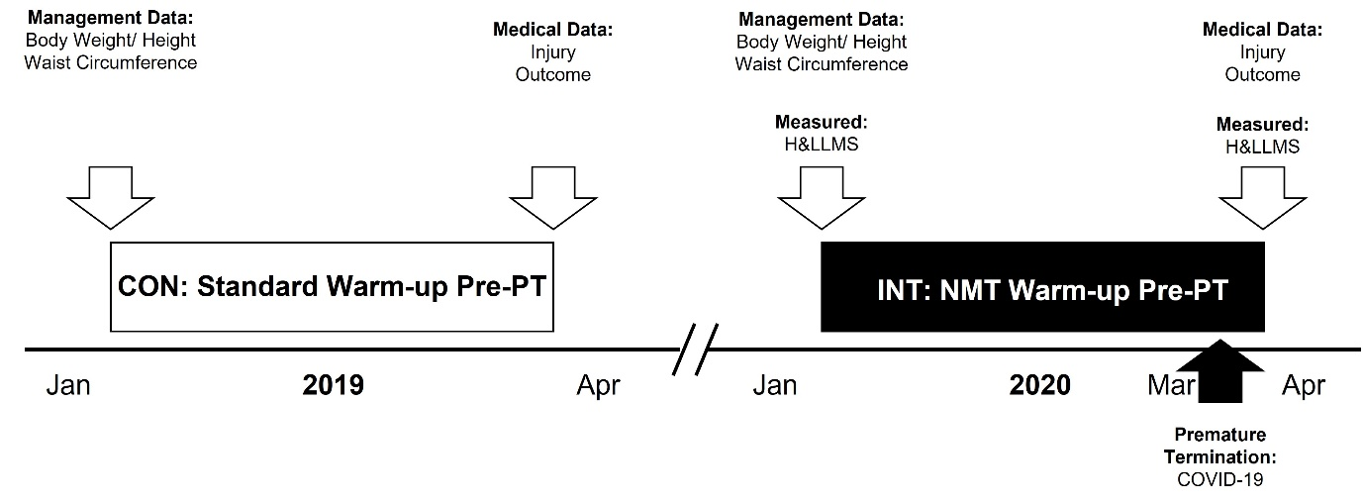
Figure 1 Schematic of Study Procedures
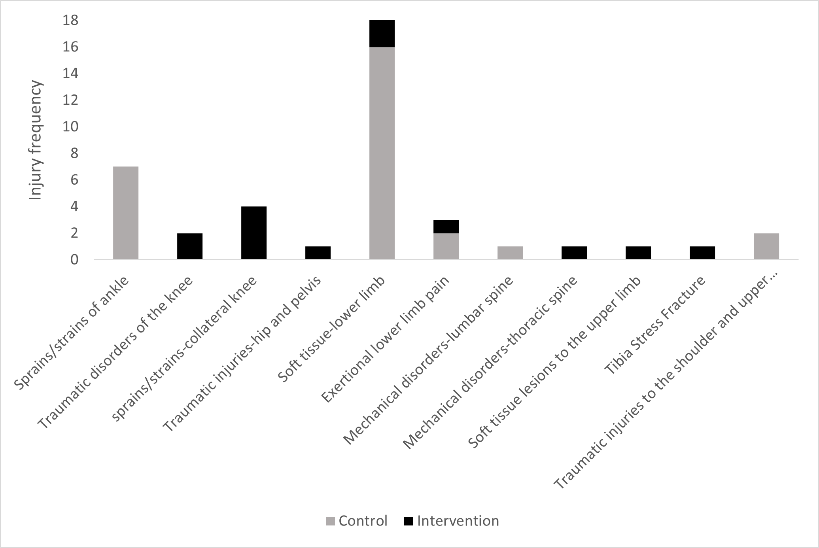
Figure 2. Type and Frequency (Count) of Injuries sustained in the Control (Grey) and Intervention (Black) Groups.
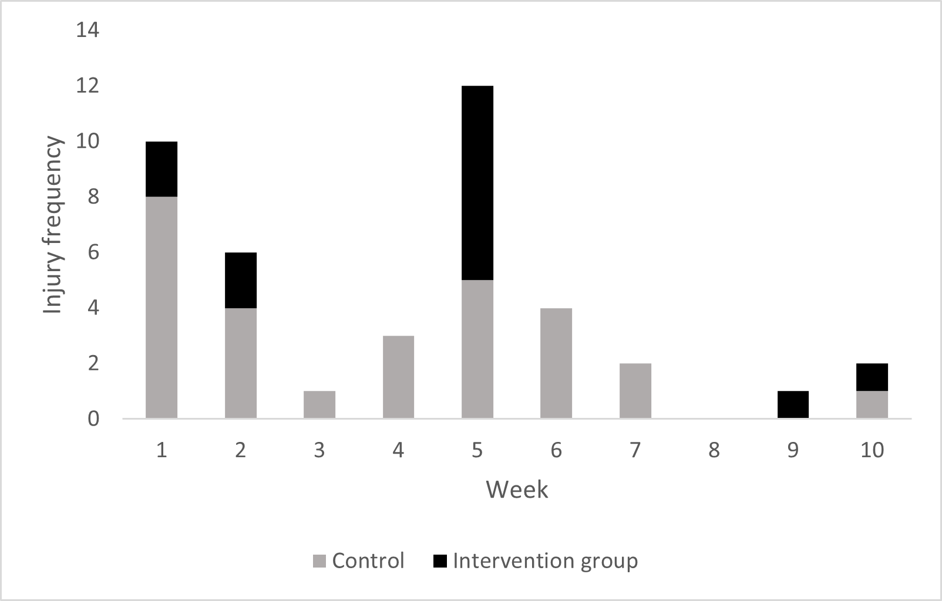
Figure 3. Week of Injury in the Control (Grey) and Intervention (Black) Groups.

References
1. (Army). MAS. Understanding The Financial Cost of Muscular Skeletal Injuries 2 (MSKI2). . Reference: ArmyHQ/Res/MAS(A)/Projects/1-085, dated 27 Feb 2018. 2018.
2. Defence Mo. Annual Medical Discharges in the UK Regular Armed Forces 1 April 2015 to 31 (From: https://assets.publishing.service.gov.uk/government/uploads/system/uploads/attachment_data/file/909874/20200814_-_MedicalDisBulletinFinal_-_O.pdf; Accessed 05 Jun 2023). 2020.
3. Blacker SD, Wilkinson DM, Bilzon JL, Rayson MP. Risk factors for training injuries among British Army recruits. Military medicine. 2008;173(3):278-86.
4. Sammito S, Hadzic V, Karakolis T, Kelly KR, Proctor SP, Stepens A, et al. Risk factors for musculoskeletal injuries in the military: a qualitative systematic review of the literature from the past two decades and a new prioritizing injury model. Military Medical Research. 2021;8(1):1-40.
5. de la Motte SJ, Lisman P, Gribbin TC, Murphy K, Deuster PA. Systematic review of the association between physical fitness and musculoskeletal injury risk: part 3—flexibility, power, speed, balance, and agility. The Journal of strength & conditioning research. 2019;33(6):1723-35.
6. Myer GD, Faigenbaum AD, Ford KR, Best TM, Bergeron MF, Hewett TE. When to initiate integrative neuromuscular training to reduce sports-related injuries in youth? Current sports medicine reports. 2011;10(3):155.
7. Emery CA, Roy T-O, Whittaker JL, Nettel-Aguirre A, Van Mechelen W. Neuromuscular training injury prevention strategies in youth sport: a systematic review and meta-analysis. Br J Sports Med. 2015;49(13):865-70.
8. Coppack RJ, Etherington J, Wills AK. The effects of exercise for the prevention of overuse anterior knee pain: a randomized controlled trial. The American journal of sports medicine. 2011;39(5):940-8.
9. Kiesel K, Plisky P, Butler R. Functional movement test scores improve following a standardized off‐season intervention program in professional football players. Scandinavian journal of medicine & science in sports. 2011;21(2):287-92.
10. Bodden JG, Needham RA, Chockalingam N. The effect of an intervention program on functional movement screen test scores in mixed martial arts athletes. The Journal of Strength & Conditioning Research. 2015;29(1):219-25.
11. Nemati N, Norasteh AA, Alizadeh MH. The effect of FIFA+ 11 program on functional movement screen scores of junior soccer players. Annals of Applied Sport Science. 2017;5(3):23-9.
12. Song H-S, Woo S-S, So W-Y, Kim K-J, Lee J, Kim J-Y. Effects of 16-week functional movement screen training program on strength and flexibility of elite high school baseball players. Journal of exercise rehabilitation. 2014;10(2):124.
13. Loudon JK, Reiman MP. Conservative management of femoroacetabular impingement (FAI) in the long distance runner. Physical Therapy in Sport. 2014;15(2):82-90.
14. Booysen N. Exercise programmes for hip control to improve lower limb movement quality in young footballers: a proof of concept and feasibility trial 2020
15. Mottram S, Comerford M. A new perspective on risk assessment. Physical Therapy in sport. 2008;9(1):40-51.
16. Booysen N, Wilson DA, Lewis CL, Warner MB, Gimpel M, Mottram S, et al. Assessing movement quality using the hip and lower limb movement screen: Development, reliability and potential applications. Journal of Musculoskeletal Research. 2019;22(03n04):1950008.
17. Power C. Improving Movement Quality of Military Personnel to Protect Hips and Lower Limbs from Injury: University of Southampton; 2020.
18. Norell SE. Workbook of epidemiology: Oxford University Press, USA; 1995.
19. Injury IOC, Group IEC, Bahr R, Clarsen B, Derman W, Dvorak J, et al. International Olympic Committee consensus statement: methods for recording and reporting of epidemiological data on injury and illness in sports 2020 (including the STROBE extension for sports injury and illness surveillance (STROBE-SIIS)). Orthopaedic journal of sports medicine. 2020;8(2):2325967120902908.
20. Allsopp A, Scarpello E, Andrews S, Pethybridge R. Survival of the fittest? The scientific basis for the Royal Navy pre-joining fitness test. Journal of the Royal Naval Medical Service. 2003;89(1):11-8.
21. Gibbs JS, et al. . The predictive validity of the functional movement screen for identifying injury risk in royal navy recruits: A pilot study. Institute of Naval Medicine Report 2014010. 2014.
22. Knapik JJ, Trone DW, Swedler DI, Villasenor A, Bullock SH, Schmied E, et al. Injury reduction effectiveness of assigning running shoes based on plantar shape in Marine Corps basic training. The American Journal of Sports Medicine. 2010;38(9):1759-67.
23. Robinson M, Siddall A, Bilzon J, Thompson D, Greeves J, Izard R, et al. Low fitness, low body mass and prior injury predict injury risk during military recruit training: a prospective cohort study in the British Army. BMJ open sport & exercise medicine. 2016;2(1):e000100.
24. Dziubak Aea. An evaluation of physical training progression, dietary intake & bone health in royal navy phase-1 recruits at HMS Raleigh. . Institute of Naval Medicine Report 2011042. 2011.
25. Statistics OoN. UK Armed Forces Biannual Diversity Statistics, 1 April 2022. (From: https://www.gov.uk/government/statistics/uk-armed-forces-biannual-diversity-statistics-april-2022/uk-armed-forces-biannual-diversity-statistics-1-april-2022; Accessed 02 May 2023). 2022.
26. Padua DA, DiStefano LJ, Marshall SW, Beutler AI, de la Motte SJ, DiStefano MJ. Retention of movement pattern changes after a lower extremity injury prevention program is affected by program duration. The American journal of sports medicine. 2012;40(2):300-6.
27. Baeza G, Paredes G, Vega P, Monrroy M, Gajardo-Burgos R. Effect of “FIFA 11+” on the pattern of fundamental movements in under-14 soccer players. Revista brasileira de medicina do Esporte. 2017;23:465-8.
28. Whittaker JL, Booysen N, De La Motte S, Dennett L, Lewis CL, Wilson D, et al. Predicting sport and occupational lower extremity injury risk through movement quality screening: a systematic review. British journal of sports medicine. 2017;51(7):580-5.
29. Kiesel K, Plisky PJ, Voight ML. Can serious injury in professional football be predicted by a preseason functional movement screen? North American journal of sports physical therapy: NAJSPT. 2007;2(3):147.
30. Dorrel BS, Long T, Shaffer S, Myer GD. Evaluation of the functional movement screen as an injury prediction tool among active adult populations: a systematic review and meta-analysis. Sports health. 2015;7(6):532-7.

