# Evaluation Tool for Two Stakeholders

## Introduction and Reference Sheet

### What is the Evaluation Tool?

This evaluation tool provides a means for reflection, assessment, and improvement of projects that engage communities in the archaeological or heritage management process. It helps you analyse your work against your goals, identify strengths, and areas for improvement. The evaluation tool consists of three short, two-page evaluations—the Starting Evaluation, the In-Progress Evaluation, and the Post-Project Evaluation—and a one-page Reflection.

The **Starting Evaluation** sets intentions for the project and a baseline to compare the In-Progress and Post-Project Evaluations to. This evaluation is completed prior to beginning the project. The **In-Progress Evaluation** functions as a progress check, describing the current state of the project, areas of success, and things that might not have gone according to plan. This evaluation is completed at the half-way point in the project. The **Post-Project Evaluation** reflects on the project as a whole and in comparison to the Starting Evaluation. Use this evaluation at the end of the project. The **Reflection** asks you to think about and write down what you learned and would do differently.

### How do I use the Evaluation Tool?

Before beginning a project, complete the Starting Evaluation. Halfway through your project, work through the In-Progress Evaluation. At the end of the project, complete the Post-Project Evaluation and Reflection.

### Who fills out this evaluation?

The user of this tool is up to you. It depends on your project, goals, and level of stakeholder or community involvement. In some projects, project leaders might be the most appropriate users. In others, users might be archaeologists and communities who collaboratively complete it or fill out the evaluation independently and compare answers together, stimulating conversation about the current project and future directions. This is a tool for you. Alter and use it as works best for you.

### What will the Evaluations ask?

Each evaluation contains three sections aimed at helping you reflect. These sections are Relationships, Impacts, and Legacy:

#### Relationships

The Relationships section features a ‘Spectrum of Collaboration’ to help you think about the people involved. Projects involving communities occur across an engagement spectrum. The Spectrum of Collaboration helps describe this spectrum, from archaeologist-only projects on the far left to community-only projects on the far right. Each row below describes a different project element that indicates its place along the spectrum: whose needs are considered, who holds the power, who sets the goals, who holds the information, who is involved, and whose voices are heard. This section asks you to think about the people involved in your project, the goals of the work, and levels of communication involved. Where does your project lie on the spectrum? A space for you to reflect on your answer is beneath each diagram. The diagram as presented shows two stakeholders. If there are more stakeholders involved, make your own diagram to describe the relationships involved.

#### Impacts

Impacts are the effects or influence of people, places, heritage, things, or actions on each other. These can be tangible and intangible as well as intended or unexpected. Impacts can also be things that went well and things you would not repeat. Examples of impacts include stronger working relationships between communities and archaeologists, increased knowledge about the heritage place, higher traffic to archaeological sites, increased community pride and cohesion, more frequent looting and more.

#### Legacy

Some projects strive to leave a legacy, whilst others only plan on impacting those involved during the project. Examples of lasting legacies include inspiring a new generation of archaeologists, improved management strategies, and building stewards of heritage. Examples of short-term impacts include providing an informative day out, conducting a site survey, and training volunteers without the infrastructure for them to employ their new skills. For the Starting Evaluation, consider what legacy you intend to leave. For the In-Progress Evaluation, reflect on whether your intentions have changed or if any unintended impacts have changed your plans. For the Post-Project Evaluation, contemplate whether the relationships and impacts of your project will endure beyond your end-date.

#### Evidence

Funders, universities, or other parties may require evidence of the impacts your project claims to make and the legacy it leaves behind. Examples of evidence include numbers of people engaged, quantity and quality of work conducted, qualitative feedback from participants, and more. As you work through the first evaluation, contemplate whether any of your project impacts or intended legacy requires evidence to support your claims. If required, plan to gather this evidence through your project and reflect on it in the In-Progress and Post-Project evaluations.

### Can I alter the questions?

This evaluation tool is a tool for **you**. Each project engaging communities differs in countless ways. Evaluation needs therefore differ. Please alter, add, or remove questions and topics to best suit your project, who the evaluation is for, and the reasons why you would like to evaluate.

### What can I do with these evaluations once finished?

Comparing the three evaluations together helps illustrate if you met your goals, how the intended relationships, impacts, and legacy may have changed over the course of the project, and why. Honest reflections of things that may not have gone according to plan will help you think about what not to repeat in the future and how to alter your methodology accordingly. The Reflection helps unpick these ideas and provides the opportunity for you to write them out.

If your stakeholders or communities did not complete their own evaluations or work on the same evaluation with you, consider using this evaluation to start a conversation with your stakeholders and communities to understand how they feel the project went.

Consider sharing these reflections and moments of learning in publications or with colleagues in other formats. Learning from each other provides opportunities for collective improvement and prevents issues from repeating. This evaluation is also something you could share with your funders, universities, or other parties. You may find the collections of evaluations and reflection helpful in writing up your project findings or contributing to other outputs.

# Starting Evaluation

Date: Completed By:

Work through this evaluation before you begin your project. It may be helpful to complete the following checklist before you proceed:

* Have you defined ‘community’ for your project?
* Do you have your project proposal or plan?
* Do you have 30 minutes or longer of uninterrupted time to consider your project?
* Do you have the Introduction and Reference Sheet if you need further explanation?

**Before beginning, please state who these evaluations are for and why are they being conducted:**

## Relationships

Community engagement occurs along a spectrum. The Spectrum of Collaboration below helps describe this spectrum. Each row highlights a different element of the project: needs, power, goals, information, involvement, and voice.

Think about the people involved in your project, the goals of the work, and levels of communication involved. Where does your project lie on the spectrum? On the line below each row, star where your project rests.

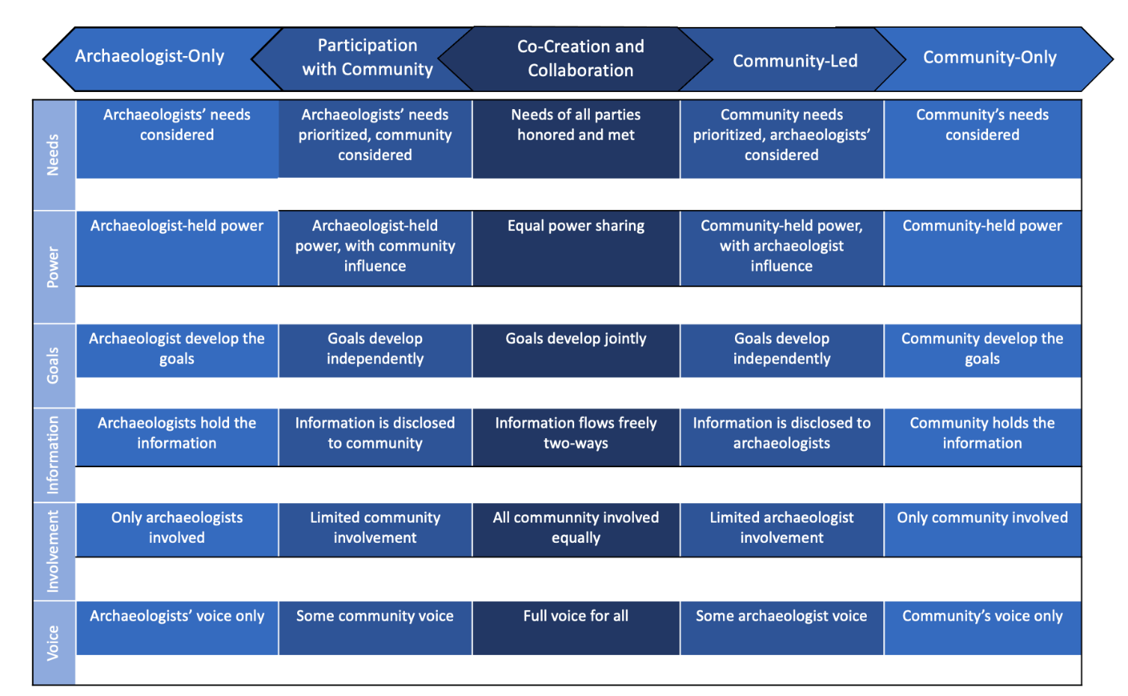

Reflect on your choices here:

## Impacts

Impacts are the effects or influence of people, places, heritage, things, or actions on each other. These can be tangible and intangible outcomes as well as intended or unexpected. Impacts can also include things that went well and things you would not repeat. See the introduction for examples.

Reflect on who or what may be impacted through your project and how. First list all parties involved in this project (i.e. the heritage itself, communities, archaeologists). Next, reflect on how your project will impact them.

1. Who or what may be impacted through this project?
2. How do you intend for them to be impacted? Do you need to gather evidence of these impacts? If so, how?

## Legacy

Some projects strive to have lasting effects (i.e. better management of heritage), whilst others only plan on impacts during the project. Reflect on the impacts you listed in the previous section.

1. What are your aspirations for the legacy of these impacts and this project?
2. If you desire to create lasting impacts, how will you gather evidence?

# In-Progress Evaluation

Date: Completed By:

Near the half-way point of your project, work through the following sections to reflect on the current state of your project. It may be helpful to complete the following checklist before beginning:

* Do you have your ‘Starting Evaluation’?
* Do you have 30 minutes or longer of uninterrupted time to consider your project?
* Do you have the Introduction and Reference Sheet if you need further explanation?

## Relationships

Community engagement occurs across a spectrum. The diagram below helps describe this spectrum. Each row highlights a different element of the project: needs, power, goals, information, involvement, and voice.

Reflect on the relationships in your project. Where does your project lie? On the line below each row, star where your project rests.



Refer to your ‘Starting Evaluation’. Have your answers changed? If so, why?

## Impacts

Impacts are the effects or influence of people, places, heritage, things, or actions on each other. These can be tangible and intangible outcomes as well as intended or unexpected. Impacts can also include things that went well and things you would not repeat.

Think about who or what your project is impacting.

1. In the space below, list everything and everyone being impacted through your project.
2. How are each of the above being impacted? What evidence, if any, do you have of this? If you would like, include evidence or examples at the end of this evaluation.
3. Refer to your ‘Starting Evaluation’. Did your intentions differ from what is currently happening? If so, why?

## Legacy

Project outcomes can be intended for the moment or endure for years to come. Consider your answers in the Impacts section.

1. Would you like the impacts listed above to endure beyond the ‘end’ of the project? If so, how? If not, why not?
2. If you want this project to leave a legacy, are you gathering evidence of whether your impacts endure? If so, how?

# Post-Project Evaluation

Date: Completed By:

At the end of your project, complete the following evaluation. Think about what went well, things you would not repeat, and the legacy of your project. It may be helpful to complete the following checklist before you begin:

* Do you have your previous two evaluations?
* Do you have 30 minutes or longer of uninterrupted time to consider your project?
* Do you have the Introduction and Reference Sheet if you need further explanation?

## Relationships

Reflect on the relationships and goals of your project. Where does your project sit on the Spectrum of Collaboration? On the line below each row, star where your project rests.



Refer to your previous two evaluations. Have your answers changed? If so, why?

## Impacts

Impacts are the effects or influence of people, places, heritage, things, or actions on each other. These can be tangible and intangible, intended or unexpected, and positive or challenging.

Reflect on who or what was impacted through your project and how.

1. List who or what was impacted through this project. Compare this to your starting evaluation. Who or what is missing that you set out to impact but did not? Who or what is on your list now you did not intend to impact?
2. How were they impacted? What evidence, if any, do you have? If you would like, include evidence or examples at the end of this evaluation.
3. Refer to your ‘Starting Evaluation’. How do your intended and actual impacts compare? Does anything surprise you?

## Legacy

Reflect on the impacts you listed above and how long these impacts may endure.

1. How long might the impacts above last? How does this compare to your intentions?
2. If you think the impacts will endure, have you or will you gather evidence of this?

# Reflection

Date: Completed By:

Answer the following questions honestly and in as much detail as possible. See the introduction for examples on what you can use this reflection for. Complete the following checklist before beginning.

* Do you have all three evaluations?
* Do you have 30 minutes of uninterrupted time to reflect on your project?

## What have you learned…

### …methodologically?

### …about yourself?

### …about your stakeholders or collaborators?

### …about archaeology or heritage?

## What would you repeat from this project?

## What would you change?

## What surprised you?