# Starting Evaluation

Date: Completed By:

Work through this evaluation before you begin your project. It may be helpful to complete the following checklist before you proceed:

* Have you defined ‘community’ for your project?
* Do you have your project proposal or plan?
* Do you have 30 minutes or longer of uninterrupted time to consider your project?
* Do you have the Introduction and Reference Sheet if you need further explanation?

**Before beginning, please state who these evaluations are for and why are they being conducted:**

## Relationships

Community engagement occurs along a spectrum. The Spectrum of Collaboration below helps describe this spectrum. Each row highlights a different element of the project: needs, power, goals, information, involvement, and voice.

Think about the people involved in your project, the goals of the work, and levels of communication involved. Where does your project lie on the spectrum? On the line below each row, star where your project rests.

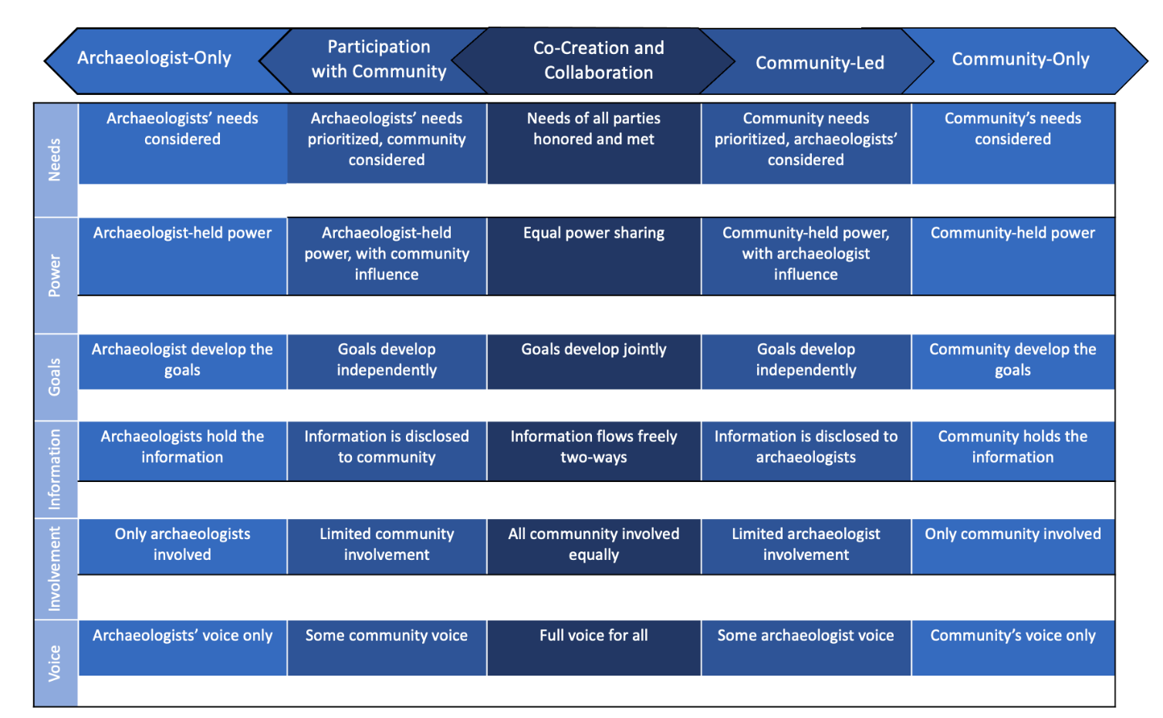

Reflect on your choices here:

## Impacts

Impacts are the effects or influence of people, places, heritage, things, or actions on each other. These can be tangible and intangible outcomes as well as intended or unexpected. Impacts can also include things that went well and things you would not repeat. See the introduction for examples.

Reflect on who or what may be impacted through your project and how. First list all parties involved in this project (i.e. the heritage itself, communities, archaeologists). Next, reflect on how your project will impact them.

1. Who or what may be impacted through this project?
2. How do you intend for them to be impacted? Do you need to gather evidence of these impacts? If so, how?

## Legacy

Some projects strive to have lasting effects (i.e. better management of heritage), whilst others only plan on impacts during the project. Reflect on the impacts you listed in the previous section.

1. What are your aspirations for the legacy of these impacts and this project?
2. If you desire to create lasting impacts, how will you gather evidence?