# In-Progress Evaluation

Date: Completed By:

Near the half-way point of your project, work through the following sections to reflect on the current state of your project. It may be helpful to complete the following checklist before beginning:

* Do you have your ‘Starting Evaluation’?
* Do you have 30 minutes or longer of uninterrupted time to consider your project?
* Do you have the Introduction and Reference Sheet if you need further explanation?

## Relationships

Community engagement occurs across a spectrum. The diagram below helps describe this spectrum. Each row highlights a different element of the project: needs, power, goals, information, involvement, and voice.

Reflect on the relationships in your project. Where does your project lie? On the line below each row, star where your project rests.

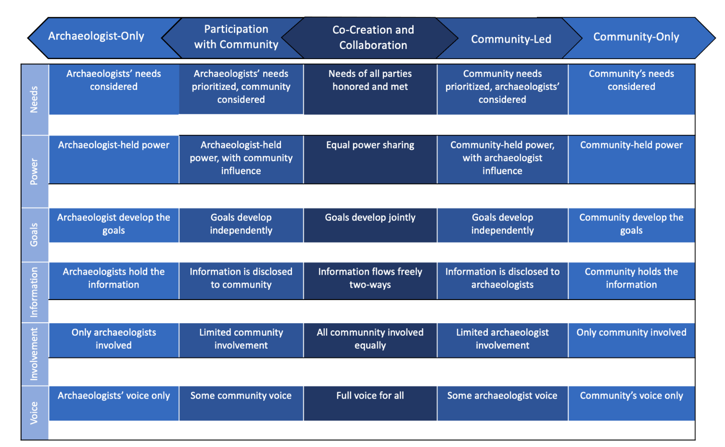

Refer to your ‘Starting Evaluation’. Have your answers changed? If so, why?

## Impacts

Impacts are the effects or influence of people, places, heritage, things, or actions on each other. These can be tangible and intangible outcomes as well as intended or unexpected. Impacts can also include things that went well and things you would not repeat.

Think about who or what your project is impacting.

1. In the space below, list everything and everyone being impacted through your project.
2. How are each of the above being impacted? What evidence, if any, do you have of this? If you would like, include evidence or examples at the end of this evaluation.
3. Refer to your ‘Starting Evaluation’. Did your intentions differ from what is currently happening? If so, why?

## Legacy

Project outcomes can be intended for the moment or endure for years to come. Consider your answers in the Impacts section.

1. Would you like the impacts listed above to endure beyond the ‘end’ of the project? If so, how? If not, why not?
2. If you want this project to leave a legacy, are you gathering evidence of whether your impacts endure? If so, how?