Post-Project Evaluation
Date: Completed By:

At the end of your project, complete the following evaluation. Think about what went well, things you would not repeat, and the legacy of your project. It may be helpful to complete the following checklist before you begin:
- Do you have your previous two evaluations?
- Do you have 30 minutes or longer of uninterrupted time to consider your project?
- Do you have the Introduction and Reference Sheet if you need further explanation?

Relationships
Reflect on the relationships and goals of your project. Where does your project sit on the Spectrum of Collaboration? On the line below each row, star where your project rests.

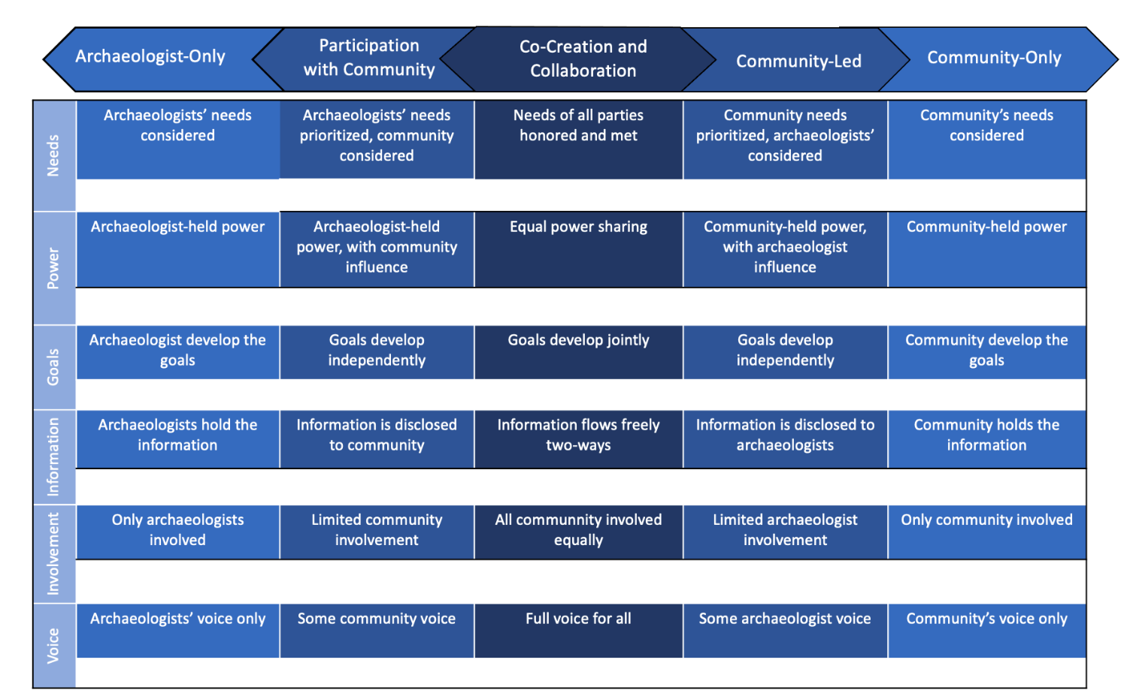

Refer to your previous two evaluations. Have your answers changed? If so, why?

Impacts
Impacts are the effects or influence of people, places, heritage, things, or actions on each other. These can be tangible and intangible, intended or unexpected, and positive or challenging.

Reflect on who or what was impacted through your project and how.

- List who or what was impacted through this project. Compare this to your starting evaluation. Who or what is missing that you set out to impact but did not? Who or what is on your list now you did not intend to impact?

- How were they impacted? What evidence, if any, do you have? If you would like, include evidence or examples at the end of this evaluation.

- Refer to your ‘Starting Evaluation’. How do your intended and actual impacts compare? Does anything surprise you?

Legacy
Reflect on the impacts you listed above and how long these impacts may endure.

- How long might the impacts above last? How does this compare to your intentions?

- If you think the impacts will endure, have you or will you gather evidence of this?

