Combining multiple stable isotope methods elucidates diet, trophic position and foraging areas of Southern Ocean humpback whales (Megaptera novaeangliae)

Sarah J. Bury^{1*}, Katharina J. Peters^{2,3,4}, Amandine J.M. Sabadel^{1,5}, Katie St John Glew⁶, Clive Trueman⁶, Wunder, M.B.⁷, Matthew R.D. Cobain⁸, Natalie Schmitt^{9,10}, David Donnelly^{9,11}, Sarah Magozzi¹², Kylie Owen¹³, Julie C.S. Brown^{1,14}, Pablo Escobar-Flores¹, Rochelle Constantine¹⁵, Richard L. O’Driscoll¹, Mike Double⁹, Nick Gales^{9,16}, Simon Childerhouse^{17,18}, Matthew H. Pinkerton¹

Author Affiliations:

¹ National Institute of Water & Atmospheric Research (NIWA), Greta Point, Hataitai, Wellington 6021, New Zealand
² School of Earth, Atmospheric and Life Sciences, University of Wollongong, NSW 2522, Australia
³ Cetacean Ecology Research Group, School of Natural Sciences, Massey University, 0745 Auckland, New Zealand.
⁴ Evolutionary Genetics Group, Department of Anthropology, University of Zurich, 8057 Zurich, Switzerland.
⁵ Department of Zoology, University of Otago, PO Box 56, Dunedin, New Zealand.
⁶ Ocean and Earth Sciences, University of Southampton Waterfront Campus, Southampton SO14 3ZH, United Kingdom.
⁷ Department of Integrative Biology Campus Box 171 P.O. Box 173364. Denver, CO 80217-3364.
⁸ Department of Biological and Environmental Science, University of Jyväskylä, P.O. Box 35, FI-40014, Finland.
⁹ Australian Antarctic Division, Department of Agriculture, Water and the Environment, Kingston, Tasmania 7050, Australia.
¹⁰ Department of Biochemistry and Biomedical Sciences, McMaster University, Hamilton, Ontario, Canada.
¹¹ Killer Whales Australia, 17 Eric Crescent, Mornington, Victoria, Australia 3931.
¹² Department of Integrated Marine Ecology, Stazione Zoologica Anton Dohrn, Fano Marine Centre, 61032 Fano (PU), Italy.
¹³ Department of Environmental Research and Monitoring, Swedish Museum of Natural History, PO Box 50007, Stockholm, Sweden, 104 05.
¹⁴ Bloomsbury Environmental Isotope Facility, Department of Earth Sciences, University College London, London, United Kingdom.
¹⁴ School of Biological Sciences, University of Auckland - Waipapa Tuamata Rau, Private Bag 92019, Auckland, New Zealand.
¹⁵ 30 Power Road, North Bruny, Tasmania 7150, Australia.
¹⁶ Cawthron Institute, Nelson 7010, New Zealand.
¹⁷ Environmental Law Initiative, Epworth House, 75 Taranaki Street, Te Aro, Wellington 6011.

*Corresponding author: sarah.bury@niwa.co.nz
ORCID ID: 0009-0004-0871-5833

Running title: Southern Ocean humpback whale trophic ecology

ABSTRACT
Southern Ocean humpback whales (Megaptera novaeangliae) are capital breeders, breeding in the warm tropics/subtropics in the winter and migrating to nutrient-rich Antarctic feeding grounds in the summer. The classic feeding model is for the species to fast when migrating and breeding, surviving on blubber energy stores. Whilst northern hemisphere humpback whales are generalists, southern hemisphere counterparts are perceived as krill specialists, but for many populations, uncertainties remain regarding their diet and preferred feeding locations. This study used bulk and compound-specific stable isotope analyses and isoscape-based feeding location assignments to assess the diet, trophic ecology and likely feeding areas of humpback whales sampled in the Ross Sea region and around the Balleny Islands. Sampled whales had a mixed diet of plankton, krill and fish, similar to the diet of northern hemisphere humpback whales. Proportions of fish consumed varied but were often high (2-60%), thus challenging the widely held paradigm of Southern Ocean humpback whales being exclusive krill feeders. These whales had lower ẟ¹⁵N values and trophic position estimates than their northern hemisphere counterparts likely due to lower Southern Ocean baseline ẟ¹⁵N surface water values and a lower percentage consumption of fish respectively. Most whales fed in the Ross Sea shelf/slope and Balleny Islands high productivity regions, but some isotopically distinct whales (mostly males) fed at higher trophic levels either around the Balleny Islands and frontal upwelling areas to the north, or en-route to Antarctica in temperate waters off southern Australia and New Zealand. These results support other observations of humpback whales feeding during migration, highlighting the species’ dietary plasticity, which may increase their foraging and breeding success and provide them with greater resilience to anthropogenically-mediated ecological change. This study highlights the importance of combining in-situ field data with regional-scale isoscapes to reliably assess trophic structure and animal feeding locations, and to better inform ecosystem conservation and management of Marine Protected Areas.

Keywords: feeding ecology; δ¹⁵N; δ¹³C; amino acids; MixSIAR; isoscapes; Antarctica, UNSDG14 Life Below Water

- INTRODUCTION
Humpback whales (Megaptera novaeangliae) are balaenopterid cetaceans, which are distributed throughout the world’s oceans and are the most extensively studied of all large cetaceans (Fleming & Jackson 2011). Southern hemisphere humpback whales complete annual migrations of over 8000 km between cold, nutrient-rich Southern Ocean feeding grounds in summer, and warmer calving grounds (also often referred to as breeding grounds) in low latitude waters in winter (Clapham 1966, Corkeron & Connor 1999, Clapham 2018). Apart from the gray whale (Eschrichtius robustus), they have one of the longest recorded mammalian migrations (Clapham 2001, Rasmussen et al. 2007, Stevick et al. 2011). They are capital breeders, traditionally thought to fast during migration and breeding (Lockyer & Brown 1981), surviving on energy or “capital” from their blubber stores built up from feeding on high density prey patches during the feeding season (Hain et al. 1981, Hazen et al. 2009, Cade et al. 2020). However, uncertainties remain surrounding humpback whale movement patterns and mixing of different populations, their diet, and their degree of feeding whilst migrating (Gales et al. 2009, Barendse et al. 2010, Owen et al. companion paper in review). Given the large body size (12-17 m), high energy requirements and the importance of humpback whales as consumers in Southern Ocean foodwebs (Witteveen et al. 2006) there is a need to better understand their diet and foraging ecology to effectively manage and conserve this species and their associated ecosystems. This is particularly relevant considering the commercial harvesting of Antarctic krill (Euphausia superba) in the Scotia Sea region and ecosystem shifts resulting from global climate (Kawaguchi et al. 2013, Stock et al. 2014, Schine et al. 2016) and oceanic change (Nicol et al. 2008).

Humpback whales feed by lunge feeding, advancing on prey with their mouths open engulfing large quantities of water, then closing their mouths forcing water out through their baleen plates to trap filtered prey (Dolphin 1988, Baraff et al. 1991, Owen et al. 2017). In the northern hemisphere, they are classified as generalists, feeding on a mixed diet of fish and krill (Christensen et al. 1990, 1992, Ryan et al. 2014, Wittteveen & Wynne 2016), however in the southern hemisphere, numerous studies have recorded humpback whales as feeding predominantly on krill (Matthews 1937, Chittleborough 1965, Kawamura 1994, Bannister & Hedley 2001, Paterson et al. 2001, Friedlaender et al. 2006, 2008, Waugh et al. 2012, Groß et al. 2020). Southern Ocean humpback whales were thought to confine their feeding to Antarctic waters, fasting whilst on their calving grounds and when migrating (Dawbin 1966, Lockyer 1981, Baraff et al. 1991). However, there is now increasing evidence of humpback whales feeding on high density krill patches and fish during migration, both in the southern hemisphere (e.g., Gill et al. 1998, Stamation et al. 2007, Gales et al. 2009, Barendse et al. 2013, Eisenmann et al. 2017, Andrews-Goff et al. 2018, Owen et al. companion paper in review) and northern hemisphere (Baraff et al. 1991, Swingle et al. 1993, Laerm et al. 1997, Visser et al. 2011). Indeed, four of the seven humpback whale breeding populations have been observed to feed along migration routes (International Whaling Commission, 2011) with feeding events lasting from days to weeks in highly productive temperate areas (Gales et al. 2009, Owen et al. 2015). Seasonal aerial surveys recorded regular aggregations of more than 20 humpback whales feeding on baitfish between 37-42°S off the coast of Australia during migration (D Donnelly, unpublished data). Due to the mobile nature of this species and the remote location of their foraging grounds, long-term tracking of individuals to establish feeding sites is logistically challenging and expensive. Standard techniques for tracking whale movements have included observations from whaling records and ‘Discovery’ tag data (Rayner 1939, Chittleborough 1959, Dawbin 1964), photo-identification (Garrigue et al. 2004, Constantine et al. 2014, Franklin et al. 2014), satellite tagging (Dalla Rosa et al. 2008, Riekkola et al. 2018) and genetic analysis (Constantine et al. 2014, Schmitt et al. 2014a,b, Steel et al. 2018). More recently, stable isotope analysis has emerged as a powerful tool to investigate the trophic ecology and foraging ranges of humpback whales by analysing the stable isotope values of their tissues and prey within their foraging environments (Eisenmann et al. 2016, Witteveen & Wynne 2016, Mackenzie et al. 2022).

The isotopic composition of phytoplankton at the base of the food chain (the isotopic baseline) is transferred to higher trophic levels with relatively predictable relationships (De Niro & Epstein 1978, 1981, Minagawa & Wada 1984, Vander Zanden & Rasmussen 1999). The bulk nitrogen isotope value (the ratio of ¹⁵N to ¹⁴N, expressed as ẟ¹⁵N in ‰ units) in a consumer, such as a humpback whale, can be increased by 3-4 ‰ relative to its diet. This difference in isotopic composition, referred to variously as fractionation factor, tissue-diet (isotopic) spacing or trophic discrimination factor (TDF), makes nitrogen isotopes a valuable tool for trophic studies (Peterson & Fry 1987, Post 2002, Vander Zanden & Rasmussen 2001). However, TDFs can be variable within individuals, among species, and within different environments (Vander Zanden & Rasmussen 2001, McCutchan et al. 2003; see also Methods 2.5.1) so knowledge of the species and ecosystem is important. Baseline δ¹⁵N values can also vary greatly across space (Somes et al. 2010, McMahon et al. 2013, MacKenzie et al. 2014) and time (Schmittner & Somes, 2016, Espinasse et al. 2019, St John Glew & Espinasse et al. 2021), so the importance of mapping phytoplankton δ¹⁵N values to estimate the trophic position of consumers in food webs is widely recognised (Hobson & Welch 1992, Cabana & Rasmussen 1996, Jennings & Warr 2003). Complementary to baseline and consumer tissue bulk δ¹⁵N analysis, an additional assessment of trophic position (TP) can be made via compound-specific stable isotope analysis (CSIA) of nitrogen in amino acids (N-AA), using δ¹⁵N values of certain amino acids (δ¹⁵N_{AA}) (McClelland & Montoya 2002, Chikaraishi et al. 2009, 2014). This approach is based on the fractionation between the so-called ‘source’ and ‘trophic’ amino acids in metabolic processes (Popp et al. 2007, Hannides et al. 2009). Source amino acids cannot be synthesised and must be acquired through diet, therefore their δ¹⁵N values reflect the isotopic baseline, whereas trophic amino acids can be acquired or synthesised, and their δ¹⁵N values reflect the isotopic baseline plus trophic and physiological effects. As ¹⁴N is preferentially excreted, exchange of nitrogen with the available nitrogen pool results in an enrichment in ¹⁵N in an organism’s tissue as biomass is transferred from one trophic level to another, thereby increasing ẟ¹⁵N_{AA} values of trophic amino acids in secondary consumers (Hannides et al. 2009, Chikaraishi et al. 2014). Thus, a general equation based on δ¹⁵N_{Glx} (glutamic acid, trophic) and δ¹⁵N_{Phe} (phenylalanine, source) can be used to assess the TP (TP_{Glx/Phe}) of any organism across different environments (Chikaraishi et al. 2009, 2014; see also Materials and Methods).

Carbon is less affected by trophic fractionation than nitrogen, with an approximate 0.4 – 0.8 ‰ increase per trophic level (Vander Zanden & Rasmussen 2001, Post 2002). This means that bulk carbon isotope values (the ratio of ¹³C to ¹²C, expressed as δ¹³C in ‰ units) are more suitable to trace the source of carbon to an organism or system, where sources are isotopically distinct (Fry & Sherr 1984, Rounick & Winterbourne 1986, France & Peters 1997). Nevertheless, carbon isotopes also show variable trophic enrichment and highly dynamic baseline values. Pelagic suspended particulate organic matter (SPOM), a proxy for marine phytoplankton (which strictly speaking comprises phytoplankton and detritus) in open ocean waters, shows a positive relationship between water temperature and δ¹³C values (Sackett et al. 1965, Rau et al. 1989, Goericke & Fry 1994). The relationship is particularly strong in the Southern Ocean between 40°S and 80°S where persistent carbon isotopic gradients have been measured (Cherel & Hobson 2007, Quillfeldt et al. 2010, Espinasse et al. 2019). The predictable relationship between carbon isotope compositions of SPOM and spatially-determined environmental variables has enabled the development of both data- and process-based models of natural spatio-temporal variations in isotopic baselines, which are termed isoscapes. These models enable trophic levels and diet (St John Glew et al. 2018), feeding grounds (Cherel & Hobson 2007, Cherel et al. 2007, Jaeger et al. 2010) and movements or migrations of marine organisms (Graham et al. 2010, Hobson et al. 2010, Trueman et al. 2019) to be inferred from consumer tissue isotope data. Isoscape applications are now widespread and summarised in several review papers (Hobson 1999, Ramos & González-Solís 2012, Trueman et al. 2012, McMahon et al. 2013, Trueman & St John Glew 2019) and the recent development of large-scale oceanic modelled isoscapes for carbon (Magozzi et al. 2017, St John Glew & Espinasse et al. 2021) and nitrogen (Somes et al. 2010, Schmittner & Somes 2016, St John Glew & Espinasse et al. 2021) has increased confidence in large basin-scale animal movement inferences from tissue isotope values.

This study focussed on humpback whales feeding during the summer months in the vicinity of the Balleny Islands and the Ross Sea slope, East Antarctica, a known high-density feeding ground (Franklin et al. 2012, Harrison et al. 2020). Animals feeding in this region most likely belong to groups of humpback whales that migrate in the autumn to calving grounds in north-eastern Australian and New Caledonian waters (Constantine et al. 2014, Schmitt et al. 2014a, Riekkola et al. 2018), classified by the International Whaling Commission as the E1 breeding population (International Whaling Commission 2011). The hypothesis that “Southern Ocean humpback whales have a similar diet to northern hemisphere humpback whales, eating a mixed diet of fish and krill” was tested. Combining multiple stable isotope methods and data from three voyages to the Balleny Islands and Ross Sea, the TP, diet and likely feeding locations of humpback whales were determined. After examining the whale isotopic niche data, the hypothesis that “some whales may feed at higher trophic levels than others” was also explored through modelling the relative proportions of prey taken by whales occupying different isotopic niches and through CSIA analysis. A literature review of carbon and nitrogen stable isotope and trophic position values was completed to compare Southern Ocean humpback whales of this study with northern hemisphere populations.

- MATERIALS AND METHODS
2.1 Overview
Surface water SPOM (used as a proxy for phytoplankton in this study) was sampled along transect lines from New Zealand to the Ross Sea to provide baseline data for estimates of whale TP and to generate field data to validate carbon and nitrogen isoscapes. A combination of bulk carbon and nitrogen stable isotope analyses of whale skin biopsies and muscle from potential whale prey, and CSIA of N-AA of the whale skin were used to determine the diet and TP of humpback whales sampled around the Balleny Islands and the Ross Sea slope. The TP of the whales was validated using a Bayesian estimate of trophic position (Quezada-Romegialli et al. 2018). Bayesian modelling was used to determine niche width and isotopic niche overlap to assess if whale clusters were isotopically distinct (Jackson et al. 2011). In addition, MixSIAR modelling (Stock et al. 2018) was applied to determine the proportions of prey that humpback whales were feeding on. Finally, data-derived and modelled carbon and nitrogen isoscapes (St Glew & Espinasse et al. 2021) were used to ascertain where the humpback whales were most likely to have been feeding over the integrated time period of their skin biopsy record.

2.2 Study area and sampling
2.2.1 Study area
Biological samples were collected during three oceanographic voyages from New Zealand to the Ross Sea on the Research Vessel (RV) Tangaroa: 1) International Polar Year – Census of Antarctic Marine Life voyage, January-March 2008 (Pinkerton et al. 2011); 2) Antarctic Whale Expedition voyage, February-March 2010 (Gales 2010, Hull 2010) and; 3) New Zealand-Australia Antarctic Ecosystems voyage, February-March 2015 (O’Driscoll & Double 2015). Henceforth the sampling trips are referred to respectively as: 1) V2008, 2) V2010 and 3) V2015, where “V” represents “voyage”. The vessel tracks for each voyage and the key sampling locations of SPOM and marine fauna are shown in Figs. 1 and 2. Whale skin and SPOM samples were collected during V2010 and V2015, whilst prey samples were collected on all three voyages. Details of the sample types and numbers taken on each voyage are provided in Table S1.

2.2.2 Suspended particulate organic material (SPOM) sampling and processing
SPOM samples were obtained by underway sampling of near-surface water at six-hourly intervals from 5.5 m beneath the RV Tangaroa via the Underway Flow Through System on V2010 and V2015 (Fig. 1). For sample processing details see Supplementary Material, Extended Methods, Text S1.

2.2.3 Humpback whale biopsy sampling and tissue processing
A total of 65 humpback whale biopsies were sampled for stable isotope analysis, genetics and sex determination (Table S1, Text S2) with 55 humpback whale biopsies obtained between 12 February-8 March 2010, and 10 biopsies sampled between 7 February-2 March 2015 (Fig. 1). The arrival time of humpback whales on their Antarctic feeding grounds is between October-December (Chittleborough 1965, Dawbin 1966, Andrews-Goff et al. 2018). Given an estimated skin turnover rate of three to four months (Text S3), for skin biopsies taken in February/March the stable isotopic composition of a whale’s prey should be almost fully integrated into the whale skin after three to five months of feeding. The measured isotopic values of the whale skin were therefore expected to primarily reflect the Antarctic feeding ground signal.

In 2010, 31 biopsies were sampled in the vicinity of the Balleny Islands (hereafter BI: 162.0°E-166.0°E, 66.0°S-67.5°S), 22 south-east of the Balleny Islands (hereafter SEBI: 166.0°E-170.0°E, 67.5°S-70.0°S) and two along the Ross Sea slope (hereafter RSS: 175.0°E-165.0°W, 69.0°S-70.5°S). In 2015, seven humpback whales were sampled around BI and three along the RSS. For detailed sampling methods and processing information see Text S2.

2.2.4 Prey sampling and analytical preparation
Sampling locations of fish, Antarctic krill and mixed community zooplankton (which were not identified to species) are shown in Fig. 2, with sample numbers provided in Table S1 and methods and tissue processing details in Text S4. The fish sampled included five myctophid (lantern fish) species (Electrona carlsbergi, E. antarctica, Gymnoscopelus nicholsi, G. opisthopterus and G. braueri), and Antarctic silverfish (Pleuragramma antarctica). These species were the only prey species sampled that were deemed to be relevant as potential humpback whale prey and together are amongst the commonest encountered in the Southern Ocean (Koubbi et al. 2011, Woods et al. 2023).

2.2.5 Lipid extraction of biological samples
Lipid synthesis strongly discriminates against the ¹³C isotope (De Niro & Epstein 1977, 1978), leading to more negative δ¹³C values in lipid-rich tissues, relative to proteins and carbohydrates (Rounick & Winterbourn 1986). To reduce bias in stable isotope results due to “lipid contamination” (Hebert & Keenleyside 1995, Post et al. 2007, Mintenbeck et al. 2008) we followed the recommended method of analysing bulk (whole) samples for nitrogen content (%N) and δ¹⁵N values, and lipid-extracting samples to obtain accurate carbon content (%C) and δ¹³C values (Ricca et al. 2007, Logan et al. 2008) for all whale biopsy (V2010, V2015), krill (V2008), and myctophid (V2010, V2015) samples (methodological details in Text S5). Krill (V2015) and silverfish (V2008, V2015) were analysed as whole bulk samples, with a sub-set analysed lipid-extracted to derive a species-specific δ¹³C correction formula. Where bulk C:N mass ratios exceeded 3.5 we corrected the δ¹³C values using these derived formulae. For mixed community zooplankton samples, where sample material was limited, δ¹³C data were corrected for lipid content using C:N molar ratios following equations in Fry (2002).

2.3 Stable isotope analysis
2.3.1 Bulk stable isotope analysis
All bulk stable isotope analyses were carried out at the NIWA Environmental and Ecological Stable Isotope Analytical Facility in Wellington, New Zealand, using two intercalibrated elemental analyser (EA) continuous flow isotope ratio mass spectrometer (CF-IRMS) analytical systems. Most analyses were carried out using a MAS200 autosampler connected to a Flash 2000 EA coupled with a DELTA V Plus (Thermo Fisher Scientific, Bremen, Germany) CF-IRMS. A small number of samples were analysed using an AS200_LS autosampler on an NA-1500 EA (Fisons Instruments, Rodano, Italy) linked to a DELTA^{Plus} CF-IRMS. For details of analysis, standards used, isotopic calculations and normalisation, accuracy and precision refer to Text S6. All estimates of variance reported are given as ± 1 standard deviation (SD), reporting using the format “mean$, SD"$.

2.3.2 Amino acid hydrolysis and derivatisation for compound-specific isotope analysis of whale biopsy samples
Fourteen humpback whale skin samples were selected for CSIA of δ¹⁵N_{AA} from cluster A and B (see 2.4.2), from samples where sufficient skin biopsy material was available to encompass the maximum range of bulk isotope values and both sexes (eight males and six females). One sample was analysed in duplicate providing replication of analysis (Table S2: sample 2010_216a and b). Amino acids are non-volatile molecules that require hydrolysis and derivatisation prior to analysis. Whale biopsy samples were hydrolysed into individual amino acids with 6N hydrochloric acid, then derivatised using acetyl chloride-isopropanol followed by trifluoroacetic anhydride to produce trifluoroacetic amino acid esters (Macko et al. 1997). The hydrolysis and derivatisation method of Hannides et al. (2009) was closely followed with only minor deviations, which are reported in Text S7.

2.3.3 Compound-specific stable isotope analysis of nitrogen in amino acids
Derivatised samples were transferred into ethyl acetate and diluted to the appropriate concentration for analysis on the gas chromatograph (GC) IRMS. Eleven amino acids were detected and reported: seven “trophic” amino acids (alanine, valine, leucine, isoleucine, proline, aspartic acid and glutamic acid), a “source” amino acid (phenylalanine), a “metabolic” amino acid (threonine) and two “intermediate” amino acids (glycine and serine). Glycine and serine cannot easily be classified as either “source” or “trophic” amino acids (Cherel et al. 2019) and are thus considered “intermediate” (Shen et al. 2021).

The CSIA of N-AA was carried out on a TRACE Ultra GC with GC IsoLink interface coupled via a ConFlo IV to a DELTA V Plus IRMS (Thermo Fisher Scientific, Bremen, Germany), with GC PAL autosampler (CTC Analytics, Switzerland). For details of analysis, standards used, raw data corrections, accuracy and precision refer to Text S8 and Fig. S1.

2.4 Statistical analyses
2.4.1 Comparing stable isotope values between locations, age groups and sexes
Differences in δ¹⁵N and δ¹³C values between locations (BI, SEBI, RSS), age groups (adult, subadult, dependent young), and sexes were investigated using generalised linear models (GLMs) with a Gaussian distribution and an identity link function. Twelve models were built for δ¹⁵N and δ¹³C respectively, including all possible combinations of variables. Models were then ranked according to their Akaike’s information criterion corrected for small sample sizes (AIC_{C}) (Burnham et al. 2011) to select the model that best explained the data. Final models were checked for interactions between variables and homogeneity of variance, and residual distributions were checked for normality. All statistical analyses were completed in R (R Core Team 2020).

2.4.2 Niche comparison
K-means cluster analysis (MacQueen 1967, Lloyd 1982) was used to define two clusters (A and B) of humpback whales based on their respective δ¹⁵N and δ¹³C values. K-means clustering is an established unsupervised machine learning algorithm for segregating a data set into k groups or clusters, where k represents the number of clusters pre-specified by the user (here, k = 2, chosen a priori after visual inspection of the data), and objects within the same cluster are as similar as possible.
Six different Layman metrics (δ¹⁵N range, δ¹³C range, total area (TA), mean distance to centroid (CD), mean nearest neighbour distance (MNND), and standard deviation of nearest neighbour distance (SDNND)) (Layman et al. 2007) were used to compare isotopic niches between clusters (Table S3). All Layman metrics were bootstrapped with replacement (n = 10,000, indicated with a subscript ‘_{boot}’) based on the smallest sample size in the data set (n = 9) to enable statistical comparison between clusters (Manly 1997, Jackson et al. 2012). To further assess niche widths and isotopic niche overlap between clusters, standard ellipse areas (SEAs), the bivariate equivalent to standard deviation in univariate analyses, were calculated with correction for small sample size (SEAc, Jackson et al. 2011). In addition, Bayesian SEAs (SEA_{B}) were calculated using 1000 posterior draws to statistically compare niche width and to estimate the niche overlap between clusters, calculated as the proportion of the total SEA_{B} for each sex respectively. All metrics were calculated using the R package Stable Isotope Bayesian Ellipses in R (SIBER) (Jackson et al. 2011, R Core Team 2020).

2.5 Prey apportionment modelling
2.5.1 Selection of diet-tissue trophic discrimination factors
Quantifying the diet of an organism using prey apportionment modelling requires knowledge of the isotopic enrichment (i.e., TDF) in the predator relative to prey (DeNiro & Epstein 1978, 1981). TDFs can be highly variable depending on species, physiology, ontogeny, habitat, and food type (see summary by Broecklen et al. 2011, Table 1 therein) and in large marine mammals they are difficult to measure. However, from a study of wild fin whales (Balaenoptera physalus) feeding exclusively on euphausiid krill (Meganyctiphanes norvegica) Borrell et al. (2012) calculated whale skin TDFs of 1.28, 0.38 ‰ for carbon and 2.82, 0.30 ‰ for nitrogen. The authors suggest that TDFs are relatively constant between taxonomically-close species and that fin whale values can be extrapolated to other cetaceans. We therefore used the Borrell et al. (2012) TDF values (hereafter referred to as “Borrell TDF”), but for comparison we also present data in the Supplementary Materials using the traditionally accepted Post (2002) TDF values of 0.39, 1.3 ‰ for carbon and 3.4, 0.98 ‰ for nitrogen (hereafter referred to as “Post TDF”).

2.5.2 Mixing Model
The contribution of different prey sources to the humpback whale diet was estimated using two isotopic tracers (δ¹³C and δ¹⁵N), applying the Stock et al. (2018) isotopic mixing model, which incorporates uncertainties in isotope values of both sources and consumers, TDFs and tissue turnover rates. The model included δ¹³C and δ¹⁵N values from five potential prey (phytoplankton, mixed community zooplankton, Antarctic krill, myctophids, and silverfish), from three sampling locations (BI, RSS and Ross Sea (RS)). Phytoplankton were included as possible prey, as potentially significant proportions of phytoplankton can be entrained and consumed during the feeding filtration process, particularly in densely aggregated patches of food. These various combinations of prey isotope values and locations were grouped using Ward’s hierarchical cluster analysis based on the mean δ¹³C and δ¹⁵N values of the prey (Fig. S2) to minimise the number of sources within the mixing model (Phillips & Greg 2003, Moore & Semmens 2008, Parnell et al. 2010). Data were checked for normal distribution using Shapiro-Wilk T-test and visual inspection (Table S4). To test the hypothesis that some of the male humpback whales may have been feeding at higher trophic levels than the rest of the sampled males and most females (see Results 3.2 Niche comparison) data were modelled to work out the relative proportions of prey taken by whales in the two clusters A and B (see Methods 2.4.2 Niche comparison).

To test whether data met the point-in-polygon requirement for every consumer (i.e. “all consumer isotopic values must lie within a polygon bounded by the isotopic signatures of the sources” (Phillips & Gregg 2003)), a simulated mixing polygon was computed (Smith et al. 2013). No tissue correction factor was applied to whale skin isotope data when plotted with whale prey muscle isotope data, as previous analysis of necropsied Hector’s dolphin (Cephalorhynchus hectori), Māui dolphin (C. h. maui) and killer whales (Orcinus orca) cetacean skin and muscle samples showed minimal fractionation for carbon or nitrogen between these two tissue types (S Bury, unpublished data). Similar findings were reported for fin whales by Borrell et al. (2012) and for humpback whales by Todd et al. (1997), who reported differences of less than 0.4 ‰ between whale skin and muscle.

Two iterations of MixSIAR were run using firstly, the Post TDF (reported only in Supplementary Materials) and secondly, the Borrell TDF (reported in the Results). To test which factors were involved in predicting dietary proportions, for each TDF the null model including all whales with no clustering, was compared with the model including the variable ‘whale cluster’ as a fixed categorical effect with two levels (cluster A and cluster B) (Table S5). Models had a multiplicative error term (Stock & Semmens 2016) and specifications were three Markov chain Monte Carlo (MCMC) chains, 200,000 iterations as burn-in, and 100,000 iterations thinned by a factor of 100, providing a total of 3000 draws for estimating posterior distributions and credible intervals. Model diagnostics were checked to ensure convergence and models were evaluated by comparing their Akaike information criterion weights (wAIC) (Burnham & Anderson 2002) and approximate leave-one-out cross-validation information criterion (LOO_{ic}) (Vehtari et al. 2017).

2.6 Estimation of humpback whale trophic position
Due to the difficulty of directly measuring a TDF for humpback whales, three different methods of TP calculations were applied to corroborate the results:
1) simple mathematical TP estimates using SPOM, whale prey and whale δ¹⁵N data from this study, combined with best estimates of TDFs between the consumer and the prey, taken from the literature (details provided in Results);
2) a Bayesian estimation of TP from consumer stable isotope ratios using the R package tRophicPosition (Quezada-Romegialli et al. 2018), which enables within-population variability to be accounted for and considers uncertainties and error propagation of the calculations. For the Bayesian model, krill were used as the nitrogen isotopic baseline. Carbon data were not incorporated in the model, as δ¹³C values in this study were primarily driven by latitudinal feeding location, which would confound the TP estimates.
3) TP estimates from CSIA data. Using the CSIA data, Equation 1 (based on δ¹⁵N values for the “trophic” amino acid glutamic acid (δ¹⁵N_{Glx}) and the “source” amino acid phenylalanine (δ¹⁵N_{Phe})), was used to assess the TP (TP_{Glx/Phe}) of the humpback whales (Chikaraishi et al. 2009, 2014):

TP_{Glx/Phe} = [δ¹⁵N_{Glx} – δ¹⁵N_{Phe} - β / TDF] + 1 (Equation 1)

where β represents the isotopic difference between δ¹⁵N_{Glx} and δ¹⁵N_{Phe} in primary producers (taken to be +3.4, 0.9 ‰ for marine algae). In a recent review, Ramirez et al. (2021) showed that β values are taxon- and tissue-specific, but they also note that variability in β values dissipates at higher trophic levels. We therefore used the widely accepted marine algal value of +3.4 ‰. The validity of the TP_{Glx/Phe} estimate depends on the consistency of both β and TDF values (Chikaraishi et al. 2014, Ramirez et al. 2021). In this study, the humpback whale data-derived TDF value used for the TP_{Glx/Phe} calculations was based on a whale TP of 3.32 (taken from (1) simple mathematical TP estimate above – see also Results, 3.6.1), where
TDF_{whale} = (Glx-Phe - 3.4)/(TP_{whale}-1), where TP_{whale}= 3.58 (Equation 2)

2.7 Isoscapes
Whale skin δ¹³C values for individuals from the whale clusters A and B (as defined by the K-means cluster analysis) were used to identify the spatially explicit posterior probability for the origin of food resources incorporated into skin tissue of each individual whale. Assignment methods followed Wunder (2010) and were implemented with the R package ASSIGNR (Ma et al. 2020) using carbon and nitrogen isoscape models for SPOM in the Southern Ocean (St. John Glew et al. 2021). Since whale tissue of known origin was not available, δ¹³C and δ¹⁵N whale tissue values were adjusted by assuming a constant offset between whale skin and the isoscape model for SPOM of 1.67 ‰ for carbon (0.39 ‰ phytoplankton-krill Post TDF + 1.28 ‰ krill-whale Borrell TDF) and 6.22 ‰ for nitrogen (3.40 ‰ phytoplankton-krill Post TDF + 2.82 ‰ krill-whale Borrell TDF).

Spatially-explicit posterior probability densities were estimated for each whale individually.
Assignments were first carried out using only δ¹³C values and were then repeated using both δ¹³C and δ¹⁵N data. For the single carbon-only isoscape assignments, the estimated variance model from St. John Glew et al. (2021) was used. For the dual-isoscape assignments, single isotope variances estimated by St. John Glew et al. (2021) were used for the diagonal of the variance-covariance matrix, and the off-diagonals were estimated from the expected values for δ¹⁵N and δ¹³C from the isoscape models for each raster cell (Ma et al. 2020). In both assignment model cases, the bounding box for the posterior densities ranged from 140°E to 220°E longitude and from 77.5°S to 39.5°S latitude. Probability densities were averaged across all whales in each of the two previously identified feeding clusters, A and B. The resultant probability densities are spatially-explicit representations for the average feeding origin of the whales in each cluster.

2.8 Factors to consider when interpreting isotope data
Several factors should be considered when interpreting stable isotope data in the context of TP status, diet apportionment, and feeding location assignments (Gannes et al. 1997, Jardine et al. 2006, Inger & Bearhop 2008). Useful summaries are provided in Bearhop et al. (2004) and review papers of Martínez del Rio et al. (2009), Newsome et al. (2010), Boecklen et al. (2011) and Thomas & Crowther (2015). Briefly, factors include isotopic incorporation rates into an animal’s tissue and the metabolic activity of that tissue affecting its turnover rates (Text S3), tissue type correction factors (Cherel et al. 2005b), diet-tissue TDFs (Hobson & Clark 1992, Vander Zanden & Ramussen 2001, Caut et al. 2009, Text S3), nutritional stress (Fuller et al. 2005), the sex, age, reproductive and physiological status of the organism (Fuller et al. 2004, Cherel et al. 2005a), estimates of isotopic baselines (including the calculation of β values in the CSIA TP calculation, Ramirez et al. 2021), and isoscape baseline-organism spacing values (see section 2.7). Furthermore, isoscape-based animal assignments generally rely on isoscapes constructed using surface SPOM stable isotope values, which only provide an approximation of isotopic baselines, since SPOM stable isotope values vary with depth (Lourey et al. 2003) and both humpback whales and their prey undergo vertical diel movements. Varying degrees of uncertainty exist for all these issues, with some information still unknown, generating caveats that need to be acknowledged.

- RESULTS
3.1 Humpback whale skin isotopic variability between sampling locations, whale age groups and sexes
Individual humpback whale skin δ¹³C values ranged from -26.77 to -20.90 ‰ and δ¹⁵N values ranged from 6.49 to 9.48 ‰ across all sampling locations and years with an overall arithmetic mean (henceforth just referred to as “mean”) of -25.23, 1.03 ‰ and 7.57, 0.66 ‰, respectively (Figs. 3a and 3b, Table S1). A similar spread of δ¹³C and δ¹⁵N values occurred across all sampled regions (BI, RSS, and RS) resulting in mean values overlapping between sampling regions and years. There was little isotopic variation in the mean and SD values of δ¹³C and δ¹⁵N values between adult whales sampled in 2015 (n = 10), and adults (n = 44), subadults (n = 6) and dependent young (n = 5) sampled in 2010 (Fig. S3b, Table S6).

Genetic analysis identified 29 males and 26 females sampled in 2010, with one male and nine females sampled in 2015, giving a total of 30 male and 35 females sampled overall. The temporal sampling of males and females was evenly spread throughout the 2010 voyage. There was considerable overlap between male and female δ¹³C and δ¹⁵N values (Fig. S4), but across the dataset, mean male values were slightly more enriched in ¹³C and ¹⁵N (ẟ¹³C -24.86, 1.27 ‰; ẟ¹⁵N 7.88, 0.65 ‰) than female values (ẟ¹³C -25.56, 0.62 ‰; ẟ¹⁵N 7.31, 0.55 ‰ (Table S7).

Generalised linear models showed that sex, age and sampling year were the main predictors of both δ¹³C and δ¹⁵N values (Table S8). The top models retained sex and age for higher δ¹³C values, and sex and year for higher δ¹⁵N values. However, the second and third-best models for δ¹³C (retaining sex and year; and sex, age, and year) and the second-best models for δ¹⁵N (retaining sex and year; and sex and age) explained the data almost equally well as the respective top-ranked models (Table S8). Values of δ¹⁵N increased slightly with year, and dependent young had lower, and subadult had higher δ¹³C values. However, although age and year were retained in the final models for δ¹³C and δ¹⁵N values respectively, the effects were not significant (Table S9). While sex and age had comparable variable importance contributing to the overall model fit for δ¹³C values, the final model for δ¹⁵N values was mainly driven by sex (Fig. S5). The deviance explained was low for top-ranked models for both δ¹³C and δ¹⁵N values (18.9% and 17.9% respectively), indicating that part of the data variation is not explained by the predictor variables.

3.2 Niche comparison
Two clusters (A and B) of individual humpback whales were identified, based on their respective δ¹³C and δ¹⁵N values (Fig. 4). Cluster A whales had a mean δ¹³C value of -25.57, 0.50 ‰ and a δ¹⁵N value of 7.38, 0.43 ‰, whilst cluster B whales had a mean δ¹³C value of -23.66, 0.43 ‰ and a δ¹⁵N value of 8.81, 0.48 ‰ (Table S1). Cluster B whales had 1.90 ‰ higher mean δ¹³C values and 1.43 ‰ higher mean δ¹⁵N values than cluster A whales. Isotopic niche metrics varied between the two clusters (Table S3), with cluster B having a higher probability for larger bootstrapped values than Cluster A for all metrics, except MNND (97.2% cluster A > cluster B), and SDNND (79.2% cluster A > cluster B). Niche differentiation between the two clusters was further demonstrated by the negligible SEA_{B} overlap for both clusters (SEA_{B} overlap: cluster A = 0.4%, cluster B = 0.1%). Both A and B clusters included whales sampled from all locations (BI, SEBI and RSS) (Fig. S6). However, cluster B comprised predominantly male whales: seven males and two females, with the two females plotting in the lower range of δ¹³C and δ¹⁵N values (Fig. 4). This led to our hypothesis that some of the male humpback whales (those in cluster B) may have been feeding at higher trophic levels than the rest of the sampled males (those in cluster A), and most females (cluster A).

3.3 Carbon and nitrogen stable isotope values of humpback whale prey
Phytoplankton from all areas showed high variability in both δ¹³C and δ¹⁵N values and this wide isotopic variability was reflected up the food chain and observed in mixed community zooplankton, Antarctic krill, myctophids and Antarctic silverfish (Figs. 5a and 5b). BI phytoplankton had higher mean isotope values (δ¹³C -24.05, 1.66 ‰; δ¹⁵N 1.49, 0.95 ‰) than RSS (δ¹³C -28.41, 1.01 ‰; δ¹⁵N 0.39, 1.97 ‰) and RS phytoplankton (δ¹³C -28.56, 0.98 ‰; δ¹⁵N 0.06, 0.96 ‰), which were similar (Table S1). Antarctic krill from BI had higher isotope values (δ¹³C -24.39, 1.07 ‰; δ¹⁵N 4.96, 0.60 ‰) compared to Antarctic krill from RSS (δ¹³C -26.23, 0.65 ‰; δ¹⁵N 4.11, 0.62 ‰) and RS (δ¹³C 26.09, 0.59 ‰; δ¹⁵N 4.10, 0.62 ‰). The same pattern was also observed for BI mixed community zooplankton (δ¹³C -23.39, 1.25 ‰), which had higher δ¹³C values than mixed community zooplankton from the RSS (δ¹³C -27.45, 1.01 ‰) and RS (δ¹³C -27.19, 1.53 ‰). Notably, RSS mixed community zooplankton were enriched in ¹⁵N (δ¹⁵N 7.03, 2.04 ‰) compared to both RS (δ¹⁵N 5.29, 2.26 ‰) and BI (δ¹⁵N 4.81, 1.01 ‰) zooplankton. Myctophids from RSS and RS had similar δ¹³C values (-25.5 ‰) with BI values 1 ‰ higher, and all three locations had similar δ¹⁵N values, ranging from 9.08, 0.61 ‰ (RSS) to 9.57, 0.77 ‰ (RS). Myctophid carbon isotope values overlapped with Antarctic silverfish values (δ¹³C -25.11, 0.68 ‰), which had marginally higher nitrogen isotope values (RS δ¹⁵N 10.24, 0.8 ‰) than myctophids.

The isotopic prey polygon biplot (Fig. 5c) shows the isotopic means of the prey clusters 1-6 (as defined based on the δ¹³C and δ¹⁵N values in Fig. S2), with the prey cluster numerals plotted on Fig. 5b and 5c. Humpback whale skin means (±1 SD) for “all whales”, “cluster A whales” and “cluster B whales” are shown with the Borrell TDF subtracted (Fig. 5c). The simulated mixing prey polygon plot (Smith et al. 2013) (Fig. S7) validated the use of these prey cluster data in the MixSIAR prey apportionment mixing model (Stock et al. 2018) with the exemption of one outlier, which was removed from the dataset used for the MixSIAR model prior to analysis.

3.4 MixSIAR Mixing Model Outputs: proportions of different prey ingested by humpback whales
T-tests showed that all prey clusters 1-6 (Fig. S2) had significantly different means in one or both of the isotope ratios (Table S4). Myctophids and silverfish grouped together in cluster 6 and are collectively referred to as “fish” in the dietary discussion.

The Bayesian mixing model containing ‘whale cluster’ as a categorical variable was ranked highest (Table S5) and this model had lower multiplicative error terms (ξ_{j}) than the null model. The posterior distributions of the proportional contributions of each prey cluster to humpback whale diet for Borrell TDFs are shown in Fig. 6 and Table S10 (with results for Post TDFs provided for comparison in Fig. S8). Whilst the model outputs generate a range of possible prey proportions, the means of these ranges and the modes are also given in Fig. 6 and Table S10 to facilitate interpretation of the relative importance of each potential prey.

3.4.1 Cluster A whale diet
The dominant prey item for cluster A whales were RSS and RS phytoplankton (prey cluster 1: mean 34, 6%; range 11-50%), followed by fish (prey cluster 6: mean 27, 7%; range 2-46%), and RSS and RS mixed community zooplankton (prey cluster 5: mean 25, 10%; range 1-57%) (Fig. 6a). Contributions from RSS and RS krill (prey cluster 3), and BI phytoplankton (prey cluster 2), mixed community zooplankton and krill (prey cluster 4) were minimal. Cluster A whales appear therefore to be sourcing most of their diet from the RSS and RS.

3.4.2 Cluster B whale diet
Cluster B whales had a more varied diet than cluster A, with the greatest proportion of their diet from BI mixed community zooplankton and krill (prey cluster 4: mean 41, 30%; range 0.1-83% with a bimodal result, meaning there were two plausible solutions for the proportion vector) (Fig. 6b). Fish (prey cluster 6: mean 34, 14%; range 3-60%, bimodal) and BI phytoplankton (prey cluster 2: mean 13, 16; range 0-46%, bimodal) mostly made up the rest of their diet. Contributions from RSS phytoplankton, RSS and RS krill, and mixed community zooplankton (prey clusters 1, 3 and 5 respectively) were small. The bimodal results suggest that either: a) the diet was approximately two thirds BI mixed community zooplankton and krill with around a quarter fish and other minor components, or b) that the diet was approximately 50% fish balanced by around one third BI phytoplankton and little BI mixed community zooplankton and krill. However posterior modal peak heights suggest that the former diet is more probable. These results indicated a relative importance of fish in the diet of both cluster A and B whales, and suggested that cluster B whales derived a high proportion of their diet from around the BI.

3.5 Compound-specific stable isotope analysis of nitrogen in amino acids
Of the 14 humpback whale skin samples analysed for CSIA of N-AA, nine were from cluster A (five males and four females) and five from cluster B (3 males and 2 females) (Table S2). Values of δ¹⁵N_{Glx} and δ¹⁵N_{Phe}, along with TP were plotted against bulk δ¹⁵N data (Figs. 7a and 7b). These plots illustrate a “flat” trend line for δ¹⁵N_{Phe} with those values remaining relatively constant with increasing bulk δ¹⁵N values, compared to a steeper trendline for δ¹⁵N_{Glu}, which showed ¹⁵N enrichment in glutamic acid as bulk δ¹⁵N values increased. The AA δ¹⁵N data were examined applying the amino acid “fasting” and “foraging” indicators outlined in Lübcker et al. (2020): mean ẟ¹⁵N alanine values were similar between cluster A (16.34, 5.43 ‰) and cluster B whales (16.62, 3.50 ‰) (Table S2), whilst ẟ¹⁵N threonine values were generally higher for cluster B than cluster A whales (mean -23.14, 3.01 ‰ compared to -27.82, 4.37 ‰ respectively), although high standard deviations indicate there is considerable overlap in these data. No consistent trends were observed in any of the other amino acids.

3.6 Estimates of whale trophic position
Humpback whale ẟ¹⁵N values ranged from 6.49-9.58 ‰ across the 65 skin biopsy analyses (Fig. 3, Table S1). This range of 3.1 ‰ corresponds to slightly more than one TP when applying the Borrell et al. (2012) TDF.

3.6.1 Simple mathematical trophic position calculation
A simple calculation of whale TP values (Table 1) was carried out using data presented in Table S11. Using bulk δ¹⁵N data averaged over years 2010 and 2015 for whales, and years 2008, 2010 and 2015 for prey from all sampled regions south of 66⁰S, the following was noted. If the mean Southern Ocean phytoplankton baseline δ¹⁵N value in regions where whales were most likely feeding is 0.45 ‰, the phytoplankton-krill TDF is 3.40 ‰ (Post 2002), and the krill-whale TDF is 2.82 ‰ (Borrell et al. 2012), then if whales were exclusively eating krill, one would expect their mean δ¹⁵N isotope value to be 0.45 + 3.40 + 2.82 = 6.67 ‰. However, their mean δ¹⁵N value was 7.57 ‰, which is 0.90 ‰ greater than predicted, confirming that humpback whales in this study are likely to be incorporating fish into their diet to elevate the bulk δ¹⁵N value in their tissue, which is also supported by the Bayesian Modelling output presented above. Assuming a fish–whale TDF of 2.82 (after Borrell et al. 2012), then that means that the 0.90 ‰ increase of measured versus predicted δ¹⁵N value for whales represents 0.32 of a TP (0.90/2.82). If whales consumed a pure krill diet, then their expected TP would be 3.00. The mean TP of these humpback whales is therefore likely to be 3.32. The same calculation was carried out for the two whale clusters A and B, and for all females, and all males. Cluster A had a mean TP of 3.25, whilst the cluster B mean TP was 3.76. Female mean TP was 3.23, whilst male mean TP was 3.43 (Table 1).

3.6.2 Modelled tRophicPosition calculation
The Quezada-Romegialli et al. (2018) tRophicPosition model gave humpback whale mean TP estimates of 3.07 using the Borrell TDF (Table 1). The female mean TP value was 2.98 compared to the male value of 3.18. Bayesian modelling posterior pairwise comparisons gave a probability of 99.8% that males had higher TP than females. The cluster A mean TP value was 3.00 compared to the cluster B value of 3.51. Bayesian modelling posterior pairwise comparisons gave a probability of 100% that cluster B whales had higher TP than cluster A whales.

3.6.3 Compound-specific stable isotope analysis trophic position and trophic discrimination factor calculation
A biplot of δ¹⁵N_{Glx} versus δ¹⁵N_{Phe} values over trophic isoclines showed that male humpback whales generally had higher TP values than females, supporting the TP calculations presented above, with male TPs ranging from 2.82-4.23 compared to female values of 2.58-3.35 (Fig. 8, Table S2). Male mean TP values were 3.57, 0.53 compared to female mean TP values of 3.00, 0.28. Two male whales in cluster B had the highest TP of above 4.2, with cluster B whales having a mean TP of 3.67, 0.60, compared to whales in cluster A with a mean TP of 3.14, 0.38. The mean TP of the sub-set of 14 whales analysed for CSIA was 3.33, 0.52.

3.6.4 Comparison of the three methods of trophic position calculation
The simple mathematical calculation using mean bulk δ¹⁵N data from humpback whales and prey produced a mean whale TP of 3.32, which was very close to the CSIA-calculated value of 3.33, whilst the tRophicPosition model produced a mean value of 3.07.

3.7 Isoscapes
When assigning whales to the most probable feeding locations based on comparisons between whale isotope data and isoscapes, the mean posterior probability density for the 56 whales in cluster A was strongly bimodal when using only δ¹³C data. This suggested that some individual cluster A whales were feeding north of the BI, between ~53°S and ~63°S between the Subantarctic Front and the Southern Antarctic Circumpolar Current Front (Fig. 1), whereas another subset were feeding further south along the edge of and within the RS at ~75°S latitude (Fig. 9a). When using both δ¹³C and δ¹⁵N values for the cluster A whale assignments, the mean posterior probability was multi-modal: the density was much greater for regions around the RS, with lower density assignments between ~61°S and ~67°S around the BI and just north of the islands within the Southern Antarctic Circumpolar Current Front, and a few assignments around 50°S to the south-east of New Zealand (Fig. 9c). The mean posterior probability density of assignments based on δ¹³C values for the nine whales in cluster B, by contrast, suggested a more diffuse bimodal distribution that extended further north, from ~50°S to ~60°S with low probability density to the southwest and east of New Zealand (Fig. 9b). When using both δ¹³C and δ¹⁵N data for the cluster B assignments, the mean posterior probability was still multi-modal, however the density was much greater for regions off the south-western and south-eastern coasts of New Zealand and around Tasmania, with an additional lower density mode along the edge of the RS (Figs. 9d and S9).

- DISCUSSION
This study applied multiple stable isotope methods to better constrain and understand Southern Ocean humpback whale trophic ecology. The primary hypothesis that Southern Ocean humpback whales have a similar diet to northern hemisphere humpback whales, eating a mixed diet of fish and krill was confirmed. The secondary hypothesis, that some of the male humpback whales (those in cluster B) were feeding at higher trophic levels than the rest of the sampled males (those in cluster A), and most females (cluster A) was also validated.

4.1 Comparison of humpback whale bulk stable isotope values, trophic position and diet with other published studies
The tRophicPosition model calculations gave results consistent with the simple arithmetic and CSIA TP estimates providing confidence in these methods. To place the bulk isotope values, TP calculations and MixSIAR dietary conclusions from this study in context, a literature review of baleen whale stable isotope and TP data, and likely consumed prey was carried out (Table 2). Whilst it is acknowledged that there is no control or correction made for any variability in ẟ¹⁵N baselines for the data collated in the table, there are some interesting general trends. For example, for whales sampled in similar locations, whales that fed mainly on zooplankton generally had lower ẟ¹⁵N values compared to whales sampled in the same area feeding predominantly on fish.

4.1.1 Southern hemisphere humpback whale ẟ¹⁵N values
The mean humpback whale ẟ¹⁵N value of 7.5, 0.7 ‰ from this study, was relatively close to Southern Ocean humpback whale supplementary feeders of E1 breeding stock sampled off east Australia (7.1, 1.0 ‰), feeding on Antarctic krill and Antarctic or temperate fish (Eisenmann et al. 2016). It was slightly higher than the mean value of 6.8, 0.4 ‰ reported for the E1 breeding stock in Groß et al. (in press), but close to the mean values measured for population D (7.1, 0.5 ‰) and E2 (7.3, 0.5 ‰) in the same study (see Table 2 for descriptions of whale breeding stocks). Bengtson Nash et al. (2018) obtained ẟ¹⁵N values closely aligned to this study for humpback whales sampled off Moreton Bay, south-east Queensland, Australia, with values ranging from 7.8, 1.2 ‰ for males and 7.4, 1.6 ‰ for females, reported as eating Antarctic krill. They too observed higher values for males than females. Owen et al. (companion paper in review) recorded ẟ¹⁵N values of 7.4, 0.2 ‰ to 8.0, 0.1 ‰ for whales sampled off south-east Australia in the sub-tropics. In contrast, whales sampled in temperate waters off south-east Australia, observed to be eating temperate krill (Nyctiphanes australis) and pilchards (Sardinops sagax), had higher values of 8.1, 0.2 ‰ to 9.2, 0.2 ‰ (Owen et al. companion paper in review). Southern Ocean whales reported as being exclusive Antarctic krill ‘classical feeders’ of D breeding stock had lower ẟ¹⁵N values of 5.4, 0.7 ‰, and ‘classical feeders’ of E1 breeding stock had values of 6.0, 0.7 ‰ (Eisenmann et al. 2016). These whales, which feed purely on Antarctic krill, had ẟ¹⁵N values that were 1-2 ‰ lower than whales in the same study that were supplementing their diet with fish, and were between 1.5-2 ‰ lower than whales sampled around the BI in this study. These comparisons provide confidence in the Borrell MixSIAR modelling results, which indicated that the Southern Ocean humpback whales of this study had high contributions of fish in their diet (posterior means: cluster A 27%; cluster B 35%). These proportions are plausible in the context of ẟ¹⁵N values and dietary information from other studies presented in Table 2.

4.1.2 Comparison of Southern Ocean and northern hemisphere humpback whale ẟ¹⁵N values
The wide range of ẟ¹⁵N values reported for northern hemisphere humpback whales (Table 2) suggests that these whales are flexible generalists, feeding across multiple trophic levels or varying isotopic baselines (Christensen et al. 1992, Filatova et al. 2013, MacKenzie et al. 2022). North-west Atlantic humpback whales (Gavrilchuk et al. 2014) and North Pacific Ocean humpback whales (Witteveen et al. 2008, 2009b, 2011, Fleming et al. 2011, Filatova et al. 2013, Wright et al. 2015, 2016),) which consume a high proportion of fish in their diet, have much higher ẟ¹⁵N values (13.0 - 14.7 ‰) than southern hemisphere humpback whales. This prevails even for those whales reported as predominantly eating krill, with some fish contributing to their diet (e.g., ẟ¹⁵N values of 12.3 -13.1 ‰: Fleming et al. 2011, Witteveen et al. 2011, Mackenzie et al. 2022). These ẟ¹⁵N values are around 5 ‰ higher than Southern Ocean humpback whales in this study, thought to have a similar diet. This difference is likely driven by higher nitrogen isotopic baseline values in northern hemisphere oceanic regions where whales were feeding compared to Southern Ocean feeding areas, in addition to potentially higher percentage fish contributions to the whales’ diet. Mechanistic models of ẟ¹⁵N baseline values in Somes et al. (2010) give values of 2-4 ‰ in the North Pacific Ocean and 4-8 ‰ in the north-east Pacific Ocean, whereas Southern Ocean spatial statistical models of compiled measured ẟ¹⁵N data suggest baseline values of 0-2 ‰ (Somes et al. 2010) and -3 to 2 ‰ (St John Glew & Espinasse et al. 2021). Mean SPOM ẟ¹⁵N values measured in this study (Table S1) ranged from 0.1-1.5 ‰, which were considerably lower than northern hemisphere values given in Somes et al. (2010) and could explain the lower southern hemisphere ẟ¹⁵N values of humpback whales.

4.1.3 Nitrogen isotope values and diets of other baleen whale species
Like humpback whales, fin whales have diets that range from almost exclusively foraging on copepods and krill, to supplementation of zooplankton with fish. Various studies of northern hemisphere fin whales report ẟ¹⁵N values ranging from around 9.5-11 ‰ for whales with a predominantly zooplankton diet (Aguila et al. 2014, Silva et al. 2019, MacKenzie et al. 2022), to 12-15 ‰ for fin whales that have fish in their diet (Gendron et al. 2001, Gavrilchuk et al. 2014, Ryan et al. 2014, Witteveen & Wynne, 2016, Wild et al. 2018). Northern hemisphere blue whales (B. musculus), feeding exclusively on zooplankton, have ẟ¹⁵N values ranging from 9-10 ‰ (Ostrom et al. 1993, Gavrilchuk et al. 2014, Silva et al. 2019, MacKenzie et al. 2022). These values for northern hemisphere fin and blue whales with pure zooplankton diets are around 1.5 ‰ higher than values for the Southern Ocean humpback whales in this study, shown to have a mixed diet of zooplankton and fish. A Southern Ocean blue whale skin biopsy obtained from the 2015 voyage had a ẟ¹⁵N value of 6.9 ‰ (Bury, unpublished data, Table 2) which was 2-3 ‰ lower than northern hemisphere blue whale values. Although it is only a single blue whale ẟ¹⁵N value, this measurement lends support to the concept that higher nitrogen baseline values in the northern hemisphere oceans drive up the ẟ¹⁵N values of whales feeding in those areas. The humpback whale mean ẟ¹⁵N value of this study was 0.6 ‰ higher than the 2015 blue whale skin value, likely indicating that most of this study’s humpback whales were feeding at a higher trophic level than blue whales, further supporting fish being a marked component of the humpback whale diet.

4.1.4 Trophic position comparison of southern and northern hemisphere humpback whales
The mean simple arithmetic and CSIA TP values of 3.3, and the tRophicPosition Borrell model value of 3.1 for humpback whales in this study (Table 1) agree with other published Southern Ocean humpback whale TP estimates (Table 2). For southern hemisphere whales, Groß et al. (in press) calculated a mean TP of 3.0, 0.1 for the E1 humpback whale population, and a value of 3.1, 0.1 for the E2 population, which from fatty acid concentration data, they concluded included some higher TP prey in their diet. Haro et al. (2020) derived a TP of 3.4 from an ecosystem model for south-east Pacific humpback whales in the Magellan Strait.
In contrast, in the northern hemisphere, North Pacific Ocean humpback whales eating a diet of predominantly zooplankton and fish had TP values of between 3.1 and 3.3 (Hirons 2001, Witteveen et al. 2011, Wright et al. 2015, 2016). North Pacific Ocean humpback whales from the northern Gulf of Alaska that predominantly ate fish had a higher TP of 3.7 (Hirons 2001, Witteveen et al. 2008, 2011, Wright et al. 2015), whilst whales sampled from California to southern British Columbia with a similarly high fish content in their diet had a mean TP of 3.9 (Miller, 2006. Witteveen et al. 2011). Pauly et al. (1998) used stomach content analysis to derive a mean TP value of 3.6 for humpback whales from a variety of northern hemisphere locations estimating a diet of 55% zooplankton and 45% fish, which is much in line with the 3.7 TP value for cluster B whales in this study consuming a posterior mean of 34% fish estimated from the MixSIAR Borrell model. A high TP value of 4.1 was assigned to European Arctic humpback whales by MacKenzie et al. (2022) who reported whales consuming a diet of euphausiids and fish. The highest value of 4.5 was reported by Ostrom et al. (1993) for humpback whales feeding off the coast of Newfoundland consuming a diet of zooplankton, euphausiids, crustaceans, small fish and small squid, with squid likely elevating the TP of these whales.

4.1.5 Trophic position and diet of other baleen whale species
Interestingly, fin whales consuming a similar diet to Southern Ocean humpback whales had TP values aligned to a value of 3.3 in this study (TP 3.4. Pauly et al. 1998; TP 3.0, MacKenzie et al. 2022). The higher fin whale TP value of 4.5 reported by Haro et al. (2020) for whales feeding in the Magellan Strait off Chile, can be explained by a diet of higher trophic level organisms including fish and cephalopods. Blue whale TP values ranged from 3.0 (MacKenzie et al. 2022) to 3.2 (Ostrom et al. 1993, Pauly et al. 1998) being slightly lower than the TP for whales in this study. These TP comparisons provide further evidence that the Southern Ocean humpback whales of this study were consuming a diet predominantly of zooplankton, supplemented with a small proportion of fish.

4.2 Isotopic niche space and diet of cluster A and B humpback whales
An organism’s isotopic niche space provides insight into its ecological range, resource use and geographical diversity, where niche parameters can respond rapidly to changes in prey abundance and intra- and interspecific competition (Bearhop et al. 2004, Newsome et al. 2007, Fry & Davis 2015). The smaller isotopic niche area of cluster A compared to cluster B whales in this study, suggested that cluster B individuals might be more specialised, have more similar ecological behaviour, and be more vulnerable to change (Newsome et al. 2012). The higher isotopic values and TP of males and cluster B whales compared to females, suggested the former were either feeding at a higher trophic level or in areas where baseline δ¹⁵N values were elevated. The CSIA “flat” trend line for δ¹⁵N_{Phe} which remained relatively constant with increasing bulk δ¹⁵N values, indicated that the elevated δ¹⁵N values of male and cluster B humpback whales were most likely due to trophic influences, rather than isotopic baseline effects. In addition, δ¹⁵N values of threonine were generally higher for cluster B whales, than cluster A whales, suggesting foraging at a higher trophic level (Lübcker et al. 2020) of the cluster B whales.

4.3 Feeding locations of the whales

There was good agreement on feeding locations of the humpback whales surmised from the MixSIAR modelling data and from the isoscape-based whale feeding location assignments. MixSIAR modelling data indicated that cluster B whales likely fed closer to the highly productive BI, than along the RSS and in the RS, feeding on more fish than the cluster A whales, whilst cluster A whales fed mostly in the RSS and RS area. In both cases, whales consumed varying but sometimes high proportions of fish (2-60%), contrary to the paradigm of them being exclusive krill feeders (Chittleborough 1965, Bannister & Hedley 2001, Waugh et al. 2012). These data are consistent with more recent observations that Southern Ocean humpback whales consume fish as part of their diet during migration (Eisenmann 2016, Groß et al. 2020, Owen et al. companion paper in review) and that they are seemingly quite plastic in their feeding behaviour (Gavrilchuk et al. 2014, Haro et al. 2016).

The strong latitudinal gradient of SPOM ẟ¹³C values (Fig. 10), enabled the feeding areas of cluster A and B whales to be estimated using the isoscape-based whale assignment method (Wunder 2010, St John Glew & Espinasse et al. 2021). From the δ¹³C and δ¹⁵N assignments, cluster A and cluster B whales likely fed in different locations: cluster A whales probably fed further south, mainly in the RSS and RS region with lower density assignments around and to the north of the BI, whilst cluster B whales, seem to have predominantly fed south-east of Australia and south-west and south-east of New Zealand, with one or two individuals assigned to the RS.

The assignments using both δ¹³C and δ¹⁵N data (Figs. 9c and d) produced results that seem more plausible than assignments using only δ¹³C data (Figs. 9a and b). This is likely because the field-measured δ¹⁵N SPOM values more closely matched those predicted by the δ¹⁵N isoscape model, than the equivalent field- and isoscapes-modelled δ¹³C values (Figs. 10 and S10). Trends in measured SPOM ẟ¹³C values (Transect SPOM) and modelled data from the St John Glew & Espinasse et al. (2021) isoscape with latitude were quite closely aligned between 40-60°S (Fig. 11). However, there were clear anomalies, which likely reflect localised regional variability in baseline carbon isotope values due to enhanced primary productivity within the Subantarctic Front, Polar Front and Southern Antarctic Circumpolar Current Front regions, areas of enhanced upwelling, such as around the BI, and the ice-melt regions of the RSS and RS. These small-scale high productivity areas, such as around the BI and other localised highly productive frontal regions are not captured in large-scale spatial modelling (such as St John Glew & Espinasse et al. (2021).

The elevated δ¹³C values of cluster B whales indicate that these whales were either predominantly feeding: 1) further north than the other whales; 2) in more productive waters and/or closer inshore; 3) on benthic or ice-associated fauna; or 4) off the shores of eastern Australia or New Zealand during migration. The assignment results support 1) and 4), but 2) and 3) could be equally plausible explanations. During the whale sampling periods in 2010 and 2015, high productivity around the BI produced locally high δ¹³C phytoplankton values and large swarms of krill and silverfish (O’Driscoll & Double 2015, Harrison et al. 2020). It is known from observational data (Gales 2010) that the BI is an important feeding ground for Southern Ocean humpback whales that primarily originate from east Australia (Andrews-Goff et al. 2018, Constantine et al. 2012) and the data from this study support this.

Cetacean distributions generally reflect patterns of oceanographic processes, such as fronts, generating regional biological activity (Bost et al. 2009, Riekkola et al. 2019). Southern Ocean humpback whales have been observed to largely feed along the marginal ice zone, the RSS and slope, and seamount/island areas characterised by local hotspots of productivity (Kaschner 2008, Harrison et al. 2020, Bestley et al. 2019). Seamounts and plateaus represent key feeding areas for cetaceans (Skov et al. 2008, Johnston et al. 2008, Morato et al. 2010) and are important for the New Caledonia humpback whale breeding stock and the E1 population (Garrique et al. 2015) and Western Australian humpback whales, which also feed along the western boundary current (Bestley et al. 2019). Surface waters around oceanic islands and plateaus often have high nutrient and iron concentrations due to upwelling effects (Blain et al. 2001, Schallenberg et al. 2018), high chlorophyll a concentrations (Sokolov & Rintoul 2007) and elevated primary productivity. These phenomena, collectively recognised as the Island Mass Effect (Doty & Aguri 1956, Blain et al. 2001), generate increased δ¹³C and δ¹⁵N SPOM values (Bidigare et al. 1997, Popp et al. 1998), resulting in higher isotopic values in humpback whales feeding in these areas.

Key predictors of foraging behaviour are water temperature (Owen et al. 2018), distance from the ice edge, ice melt rate, and variability in ice concentration two months prior to arrival on the feeding grounds (Nicol et al. 2008, Andrews-Goff et al. 2018, Riekkola et al. 2019). Humpback whale feeding is thus sustained by a biological cascade, in which new biological productivity is triggered by ice melting, which in turn supports phytoplankton grazers such as krill and other zooplankton, and ultimately whales. Humpback whales can show persistent space use and site fidelity (Tynan 1998, Branch 2011, Bombosch et al. 2014), with whales moving through the same location or occupying adjacent habitats over consecutive austral summers (Andrews-Goff et al. 2018). The similarity between 2010 and 2015 whale skin isotopic values in this study supports this observation.

4.4 Potential factors affecting stable isotope values of Southern Ocean humpback whales
4.4.1 Whale sex and pregnancy
Although this study found no isotopic difference between humpback whale age groups, sampling location or year, males had slightly higher ẟ¹³C and ẟ¹⁵N values than females. Several studies of humpback whales have found no difference in ẟ¹³C or ẟ¹⁵N values between sexes (Witteveen et al. 2011, Gavrilchuk et al. 2014, Fleming et al. 2016, Bengston Nash et al. 2018). In addition, a study of southern hemisphere humpback whale blubber fatty acid profiles showed no clear nutritional status separation between females and males (Eisenmann 2016). The mean isotopic difference between males and females in this study, was not large (Tables S2 and S7) and may be due to a small sub-set of male whales feeding at a higher trophic level (Figs. 4 and S4). However, there are other factors that should also be considered.

Differences in size, time spent on feeding grounds and associated fasting duration between male and female humpback whales, plus the reproductive status of females, could contribute to the isotopic difference in their skin tissues superimposed on diet effects. Adult female humpback whales range in length from 12-17 m and are between 40-150 cm longer than males. Considering the potential positive relationship between size and ẟ¹⁵N value (Jennings et al. 2002, 2008) one might expect higher ẟ¹⁵N values in females than males. Unfortunately, there were no size-based data within this study to assess if size had any effect on stable isotope ratios. Movement modelling studies of humpback whales migrating from Western Australia to the Southern Ocean showed that females moved faster than males during resident and transit periods, which Bestley et al. (2019) attributed to either their larger size or different energetic requirements. A difference in metabolism and energetic requirements between males and females could also contribute to sex-related isotopic differences.

Pregnancy is also known to affect the stable isotope composition of females, such that their isotopic values do not exclusively reflect diet (Clark et al. 2016). Pregnant mammals often have lower ẟ¹⁵N values as they become net anabolic (i.e., as they increase protein synthesis) and decrease the excretion of nitrogenous waste (Fuller et al. 2004, Martínez Del Rio et al. 2009, Kurle et al. 2014). Carbon isotope values also decrease as pregnant females mobilise lipid stores to meet the energetic demands of pregnancy (Kelly 2000, Kurle & Worthy 2001). The existence and magnitude of these effects vary among species (Kurle 2002, Habran et al. 2010, Newsome et al. 2010). There was no information relating to the pregnancy status of females in this study. However, Southern Ocean humpback whale pregnancy rate estimates of 37% (Chittleborough 1965), 18-48% (Clark et al. 2016), and 30-86% (mean 52%) (Pallin et al. 2023) in the Western Antarctic Peninsula, and an estimate of 57% obtained from whales sampled around the Kermadec Islands (Riekkola et al. 2018), indicate that pregnancy could have accounted for the overall lower mean ẟ¹³C and ẟ¹⁵N values in females compared to males. For future studies, it would be useful to carry out progesterone analysis of biopsied blubber to obtain information on the proportion of pregnant females in the population. Without this information, pregnancy-related changes in stable isotope values are difficult to assess and complicate interpretations of data to infer diet and migration (Newsome et al. 2010, Clark et al. 2016).

4.4.2 Time spent on feeding grounds and feeding and fasting effects on whale stable isotope values
Another factor contributing to humpback whale isotopic variability is the length of time spent on the feeding grounds. Male and female humpback whales arrive at and depart from Antarctic feeding grounds at different times: the first whales to arrive from October onwards are pregnant females, then males, then lactating females with a calf, with whales departing around April in the order of lactating females with a calf, males, then pregnant females (Chittleborough 1965, Dawbin 1966, 1997). In addition, Riekkola et al. (2018) noted that Oceania humpback whales migrated to different feeding grounds based on their life history stages, with all tagged females with calves in their study migrating to the Ross Sea region. Some non-pregnant females also overwinter in Antarctica to improve body condition for the next reproductive cycle (Clark et al. 2016). For the whole population, if around 20-60% of whales are pregnant, then between approximately one fifth to two thirds of the females may arrive before males and the remaining proportion of females (those that are lactating) after them. Differences in arrival time may therefore not account for male/female differences in isotope values, since arrival times for males/females over the whole population could be averaged out to be quite similar, however differences in arrival time could contribute to greater isotopic variability within the population.

Later arrival on the feeding grounds could mean that those whales spend longer migrating and fasting. Some studies have shown that fasting increases ẟ¹⁵N values of some organisms by up to 1 ‰ (Hobson et al. 1993, Cherel et al. 2005a), due to protein synthesis using ¹⁵N-enriched amino acids derived from catabolism of endogenous protein (Hatch 2012). Other studies, however observed that ẟ¹⁵N values declined during periods of reduced feeding, reflecting changing nitrogen baselines between summer and winter feeding grounds, rather than tissue metabolism effects (Matthews & Ferguson 2015, Pomerleau et al. 2018). Furthermore, several studies suggest that ẟ¹⁵N values are not affected by fasting (Hobson & Schell 1998, Ben David et al. 1999, Williams et al. 2007, Gomez-Campos et al. 2011, Aguilar et al. 2014, Owen et al. companion paper, in review). For humpback whales this is likely because they have evolved to endure long predictable periods of fasting, so the effects of fasting are not equivalent (in terms of metabolic and biochemical processes) to starvation; i.e. they do not experience ‘nutritional stress’ during these times, due to physiological adaptation (Kempster et al. 2007, Witteveen et al. 2009a). In addition, Riekkola et al. (2020) surmise from humpback whale tracking and energetic studies that even extreme long-distance migration does not appear to adversely affect the energetic expenditure of these animals.

Blubber stores are likely to be the primary source of energy until stages of extreme nutritional stress are reached (Aguilar et al. 2014). This is because the quantity of lipid reserves stored by an organism influences the degree to which protein versus lipid is catabolised for energy (Elia et al. 1999). Large fat reserves mean the whales are less likely to metabolise ¹⁵N-enriched proteins during fasting (Polishuk et al. 2001, Aguilar et al. 2014). Evidence to support minimal effect of fasting on ẟ¹⁵N values is provided by Bengtson Nash et al. (2018) who sampled E1 breeding stock humpback whales off the south-east Queensland coast and measured very similar ẟ¹⁵N values in southward-migrating “fasting” whales (7.5, 1.3 ‰) compared to the northward migrating “post-feeding” whales (7.7, 1.8 ‰). These southward-migrating “fasting whales” not only had similar ẟ¹⁵N values, but also similar ẟ¹³C values (-24.9, 1.0 ‰) to humpback whales in this study, which had been feeding in Antarctica for several months (ẟ¹³C -25.2, 1.0; ẟ¹⁵N 7.6, 0.7). Owen et al. (companion paper, in review) also noted that southward migrating whales in the sub-tropics had similar isotope values to whales feeding in the Antarctic, supporting the notion that there is little change in isotopic values due to whale fasting. Furthermore, alanine δ¹⁵N values (which if higher, are indicative of fasting: Lübcker et al. 2020) were similar between cluster A and B whales, indicating fasting was likely not affecting nitrogen isotope values.

A further consideration is that delayed arrival on the feeding grounds could mean that those whales had more time for migratory feeding on fish and krill in temperate waters (Gales et al. 2009, Andrews-Goff et al. 2018, Owen et al. companion paper in review) which would increase their ẟ¹⁵N values. Stable isotope analysis of baleen whale plates showed that supplementary feeding may be a common strategy for about 30% of east Australian humpback whales (Eisenmann, 2016). It is likely that the cluster B whales with higher isotope values were late arrival males engaged in feeding in temperate waters off south-east Australia or southern New Zealand during south-ward migration (corroborated by the whale assignment locations in Figs. 9d and S9), while migrating en-route to Antarctica supporting observations of Gales et al. (2009). This supplementary feeding whilst migrating may be an indicator that the Southern Ocean ecosystem does not meet the energetic requirements of the humpback whales during the summer feeding season as suggested by Riekkola et al. (2018), or it could just be opportunistic feeding behaviour.

4.4.3 The effects of quality, abundance, and location of prey on humpback whale stable isotope values
Humpback whales are largely opportunistic foragers that depend on quality, high lipid-content, energy-dense prey to maximise fat deposition in their blubber layers, providing a sustained energy source (Worthy & Edwards 1990, Koopman et al. 2002, Witteveen et al. 2011). At low latitudes, humpback whales can lose between a third to half of their body mass (Dawbin 1966, Lockyer 1981, Baraff et al. 1991) due to lipids being catabolised during migration and periods of limited nutrient intake (Lockyer 1986, Castellini & Rea 1992, Parrish 1997). As has been shown for other animals (Urton & Hobson 2005, Inger et al. 2006), prey choice for humpback whales can therefore significantly impact survival, migration and reproductive success (Witteveen et al. 2011). In addition, baleen whales need to feed on aggregated prey above a threshold density to ensure positive net energy gain from a feeding event (Piatt & Methven 1990, Hazen et al. 2009, Goldbogen et al. 2011). It is thus possible that the consumption of a higher quality diet (McCutchan et al. 2003, Vanderklift & Ponsard 2003) was a contributor to the higher ẟ¹⁵N values of cluster B whales of this study.

As confirmed by this study, Southern Ocean humpback whales are dependent on Antarctic krill as a major dietary component. Krill are strongly associated with the sea ice extent and abundance of associated sea ice algae (Atkinson et al. 2004, Loeb et al. 1997) and are thus vulnerable to climate change (Flores et al. 2012). They are recruited at the sea ice edge and disperse northwards following sea ice melt (Ward et al. 1990, Brierley et al. 1999). Their abundance is dependent on high levels of primary productivity, which in turn is affected by ocean circulation, bathymetry, coastline morphology, localised upwelling and frontal dynamics (Bathman et al. 1997, Strutton et al. 2000, Martinson et al. 2008). These factors, combined with climate change, exert important controls on isotopic baselines and prey availability for humpback whales (Gross 2005, Fountain et al. 2012, Pallin et al. 2023). Higher encounter rates of humpback whales tend to be observed in the northern RS (65-70°S), where this study was located, which is a region of rapid ice retreat and high chlorophyll productivity (Moore & Abbott 2000, Nicol et al. 2006). Clarke and Tyler (2008) observed that, whilst most post-larval Antarctic krill populate the upper 150 m of the water column, some can be found in abyssal waters as deep as 3500 m, where omnivory is increased with resultant higher ẟ¹⁵N values (Cresswell et al. 2009, Bengtson Nash et al. 2018). This could explain the wide variability observed in krill ẟ¹⁵N values in this study, ranging from 2.03-7.39 ‰ (Table S1), which is reflected up the food chain in myctophids and Antarctic silverfish.

Since there is lower abundance of Antarctic krill in the RS region compared to the Scotia Sea (Atkinson et al. 2004, 2017), it is likely that humpback whales feeding in the RS area have lower dependence on krill than those elsewhere in the Southern Ocean. Due to ocean acidification, a complete collapse of Antarctic krill populations is forecasted by 2300 if current CO₂ emissions are not mitigated (Kawaguchi et al. 2013). In this scenario, humpback whales may avoid the threat of starvation by being highly responsive to environmental oscillations through dietary diversification (Bengtson Nash et al. 2018). Diversity in the interannual feeding strategies of humpback whales from eastern Australian E1 breeding stocks demonstrates plasticity in prey selection and migratory behaviour of this species (Eisenmann et al. 2016), which provides hope for adaptive strategies and their long-term survival. The more diverse diet of Southern Ocean humpback whales confirmed by this study provides further evidence for possible dietary plasticity in the face of potential anthropogenically-mediated changes to the trophic structure and prey abundance and distributions within the Southern Ocean.

Humpback whales in the north-east Pacific Ocean have shown temporal and geographical variability in diet driven by changes in prey abundance (Fleming et al. 2016). Changes at lower trophic levels are often amplified at higher trophic levels due to non-linear responses of biological communities and predatory interactions (Friedland et al. 2012, Stock et al. 2014). Such top-predator responses are due to the dynamic interactions and cumulative effects between changing oceanographic conditions, mid-trophic level prey dynamics, and predator foraging behaviour (Hilty & Merenlender 2000, Abraham & Sydeman 2004, Sydeman et al. 2013). Although our data show an isotopic difference between males and females this difference is not marked (<1‰ between female and male mean values for both ẟ¹³C and ẟ¹⁵N), with humpback whale isotope values primarily reflecting consumption of the dominant prey types in the ecosystem. Changes in prey abundance likely drive changes in whale diet at the population level (males and females combined), such that humpback whale prey composition can be an indicator of dominant prey types in the ecosystem (Fleming et al. 2016). Thus, multi-decadal changes in foraging behaviour of humpback whales could be a useful synoptic indicator of changing oceanographic and ecological conditions.

The variety and complexity of factors that can influence humpback whale carbon and nitrogen stable isotope values makes it difficult to provide a definitive assessment of the relative importance of different drivers determining their isotopic composition. Additionally, biopsy collection could be affected by sampling biases, since animals that spend more time at the surface, are more easily sighted and sampled and may therefore be overrepresented in the sampling. Cows with calves may be more readily sighted and sampled as they are often more active at the surface than non-nursing females or males. Whales that spend less time at the surface and perhaps feed in deeper waters may be underrepresented, such that the full dietary range of isotopic values is not captured by biopsy sampling. Nonetheless, dietary intake and feeding location are likely to be the dominant determinants of isotopic values, with other factors potentially also contributing to isotopic variation.

- CONCLUSIONS
This study combined multiple stable isotope methods to quantify diet and trophic position and to identify foraging areas of Southern Ocean humpback whales. It confirmed the hypothesis that Southern Ocean humpback whales sampled around the Balleny Islands and in the Ross Sea had a mixed diet of plankton, krill and fish, similar to the diet of northern hemisphere humpback whales. The percentage of fish consumed varied (2-60%), but proportions were often high, thus challenging the widely held paradigm of Southern Ocean humpback whales being exclusive krill feeders and re-enforcing the notion that they have dietary plasticity. Southern Ocean humpback whales had lower ẟ¹⁵N values than northern hemisphere populations and lower trophic position values likely due to a combination of lower baseline ẟ¹⁵N surface water values in the Southern Ocean compared to the northern hemisphere and a lower percentage consumption of fish respectively.

MixSIAR prey apportionment modelling and trophic position calculations using the Borrell et al. (2012) trophic discrimination factor produced data that closely aligned with trophic information from other studies, hence placing more confidence on the Borrell et al. (2012) factors than the Post (2002) values. It is recommended that future studies of humpback whale trophic ecology utilise the Borrell et al. (2012) trophic enrichment factors.

The majority of the whales sampled in this study appeared to be foraging in the Ross Sea, along the Ross Sea Shelf and in the vicinity of the Balleny Islands. An isotopically-distinct subset of male humpback whales with higher trophic position was identified through bulk carbon and nitrogen and compound specific isotope analysis of nitrogen in amino acids. Isoscape-based whale assignments combined with regional isotopic baseline field measurements indicated these whales were either taking higher quality food sourced from productivity hotspots such as the Balleny Islands and/or frontal upwelling areas, or that they had fed en-route to Antarctica in temperate waters off south-eastern Australia, south-west or south-east New Zealand.

Since Antarctic ecosystems are particularly vulnerable to climate change, warming, freshening, ocean acidification and shifts in primary production patterns leading to variable krill abundance, an improved understanding of ocean biogeochemistry and trophic interactions is becoming increasingly important, both for predicting change and for robust ecosystem management of the Ross Sea region. It is hoped that the development of seasonal and regional smaller-scale isoscapes combined with improvements in remote sensing techniques and oceanic modelling will enhance the applicability of isotopic tools to better understand and manage such ecosystems. As demonstrated by this study, in-situ field data are essential to inform and rationalise these models to improve data interpretations, and to assist managerial decisions and policy implementation to better protect and conserve Southern Ocean humpback whales and their environment, particularly within the Ross Sea region Marine Protected Area. The revelation of a more diverse Southern Ocean humpback whale diet has implications for predicting the impact of future ecosystem changes on the foraging and hence breeding success of humpback whales. It also highlights the need for further dietary studies on other marine predators in the Southern Ocean that are thought to be highly dependent on Antarctic krill.

ACKNOWLEDGEMENTS
We are grateful to the masters and crew of RV Tangaroa on the 2008, 2010 and 2015 voyages and to the following people for their sampling assistance: Paul Sagar, Stéphane Gauthier and Dylan Amyes for underway phytoplankton sampling in 2010; Dave Paton, Curt Jenner, Jean-Benoit Charrassin, and Sarah Laverick for whale biopsy sample collection in 2010; Owen Anderson, Darren Stevens, Blake Hornblow, and Zac Penman, for biological sampling in 2015; and Andrea Polanowski for sample freighting. Animal ethics permit #AEC195 and SC544 were obtained to biopsy whales in 2010 and 2015 respectively. Samples were held in New Zealand under permits #NO/2009/05, #NO/2010/01 and WE-34273_MAR. Many thanks to the NIWA analytical team Andrew Kingston, Thomas Max, Brittany Graham, Greg Olsen, Anna Kilimnik, Josette Delgado, Jaret Bilewitch, and Rahul Peethambaran who assisted with bulk and compound specific stable isotope analysis and to Jeff Foreman who carried out post-voyage processing of whale prey. Thanks to Leigh Torres, Jill Schwarz and Moira Decima for helpful discussions in the early stages of this project and to Kim Goetz for assistance with whale field work on V2015. Helpful advice and improvements to the manuscript from the associate editor and two anonymous reviewers are gratefully acknowledged.

FUNDING INFORMATION
Funding for this work was provided through the following projects: New Zealand’s International Polar Year Census of Antarctic Marine life; the Ministry for Primary Industries (MPI) Management of Ross Sea Toothfish Fishery; MPI Isoscapes for Trophic and Animal Movement Studies; MPI Humpback whale connectivity - determining the migration path and Antarctic feeding grounds of New Zealand's humpback whales; the Ministry of Business, Innovation and Employment (MBIE) Protecting the structure and function of Ross Sea Ecosystems; MBIE Ross Sea Climate and Ecosystem; Land Information New Zealand Ocean Survey 2020; MBIE Ross Sea Research and Monitoring Programme (Ross-RAMP, C01X1710); Antarctic Science Platform, Project 3 (ANTA1801); Antarctica New Zealand; Australian Antarctic Division and NIWA. KJP was supported by a postdoctoral grant from the University of Zurich.
LITERATURE CITED

Abraham CL, Sydeman WJ (2004) Ocean climate, euphausiids and auklet nesting: inter-annual trends and variation in phenology, diet and growth of a planktivorous seabird, Ptychoramphus aleuticus. Mar Ecol Prog Ser 274:235–250

Aguila A, Giménez J, Gómez-Campos E, Cardona L, Borrell A (2014) ẟ¹⁵N value does not reflect fasting in mysticetes. PLoS ONE 9(3): e92288, doi:10.1371/journal.pone.0092288

Andrews-Goff V, Bestley S, Gales NJ, Laverick SM, Paton D, Polanowski AM, Schmitt NT, Double MC (2018) Humpback whale migrations to Antarctic summer foraging grounds through the southwest Pacific Ocean. Sci Rep 8:12333 DOI:10.1038/s41598-018-30748-4

Atkinson A, Siegel V, Pakhomov E, Rothery P (2004) Long-term decline in krill stock and increase in salps within the Southern Ocean. Nature 432:100-103

Atkinson A, Hill SL, Pakhomov EA, Siegel V , Anadon R , Chiba S , Daly KL , Downie R, Fielding S, Fretwell P, Gerrish L, Hosie GW, Jessopp M, Kawaguchi S, Krafft BA, Loeb V, Nishikawa J, Peat HJ, Reiss CS, Ross RM, Quetin LB, Schmidt K, Steinberg DK, Subramaniam RC, Tarling GA, Ward P (2017) KRILLBASE: a circumpolar database of Antarctic krill and salp numerical densities, 1926–2016. Earth Syst. Sci. Data 9:193-210

Bannister JL, Hedley S (2001) Southern Hemisphere Group IV humpback whales: their status from recent aerial survey. Mem Queensl Mus 47:587−598

Baraff LS, Clapham P J, Mattila DK, Bowman RS (1991) Feeding behaviour of a humpback whale in low latitude waters. Mar Mamm Sci 7:197-202

Barendse J, Best PB, Thornton M, Pomilla C, Carvalho I, Rosenbaum HC (2010) Migration redefined? Seasonality, movements and group composition of humpback whales Megaptera novaeangliae off the west coast of South Africa. Afr J Mar Sci 32:1−22

Barendse J, Best PB, Carvalho I, Pomilla C (2013) Mother knows best: occurrence and associations of resighted humpback whales suggest maternally derived fidelity to a Southern Hemisphere coastal feeding ground. PLoS ONE 8(12):e81238, doi:10.1371/journal.pone.0081238

Bathman UV, Scharek R, Klass C, Dubisher CD, Smetacek V (1997) Spring development of phytoplankton biomass and composition in major water masses of the Atlantic sector of the Southern Ocean. Deep-Sea Res II 44:51-67

Bearhop S, Adams CE, Waldron S, Fuller RA, MacLeod H (2004) Determining trophic niche width: a novel approach using stable isotope analysis. J Anim Ecol 73:1007−1012

Ben-David M, McColl CJ, Boonstra R, Karels TJ (1999) N-15 signatures do not reflect body condition in Arctic ground squirrels. Can J Zool 77:1373–1378

Bengston Nash SM, Castrillon J, Eisenmann P, Fry B, Shuker JD, Cropp RA, Dawson A, Bignert A, Bohlin-Nizzetto P, Waugh CA, Poklinghorne BJ, Dalle Luche G, McLagan D (2018) Signals from the south; humpback whales carry messages of Antarctic sea-ice ecosystem variability. Glob Change Biol 24:1500-1510

Best PB, Schell DM (1996) Stable isotopes in southern right whale (Eubalaena australis) baleen as indicators of seasonal movements, feeding and growth. Mar Biol 124:483-494

Bestley S, Andrews-Goff V, van Wijk E, Rintoul SR, Double MC, How J (2019) New insights into prime Southern Ocean forage grounds for thriving Western Australian humpback whales. Sci Rep 9:13988. https://doi.org/10.1038/s41598-019-50497-2

Bidigare RR, Fluegge A, Freeman KH, Hanson KL, Hayes JM, Hollander D, Jasper JP, King LL, Laws EA, Milder J, Millero FJ, Pancost R, Popp, BN, Steinberg PA, Wakeham SG (1997) Consistent fraction of ¹³C in nature and in the laboratory: growth-rate effects in some haptophyte algae. Global Biogeochem Cycles 11:279–292

Blain S, Treguer P, Belviso S, Bucciarelli E, Denis M, Desabre S, Fiala M, Jezequel VM, Le Fevre J, Mayzaud P, Marty J-C, Razouls S (2001) A biogeochemical study of the island mass effect in the context of the iron hypothesis: Kerguelen Islands, Southern Ocean. Deep-Sea Res I 48:163–187

Boecklen WJ, Yarnes CT, Cook BA, James AC (2011) On the use of stable isotopes in trophic ecology. Ann Rev Ecology Evol Syst 42:411-440

Bombosch A, Zitterbart DP, Van Opzeeland I, Frickenhaus S, Burkhardt E, Wisz MS, Boebel O (2014) Predictive habitat modelling of humpback (Megaptera novaeangliae) and Antarctic minke (Balaenoptera bonaerensis) whales in the Southern Ocean as a planning tool for seismic surveys, Deep-Sea Res I 91:101-114

Borrell A, Abad-Oliva N, Gómez-Campos E, Giménez J, Aguilar A (2012) Discrimination of stable isotopes in fin whale tissues and application to diet assessment in cetaceans. Rapid Commun Mass Spectrom 26:1596-1602

Bost CA, Cotté C, Bailleul F, Cherel Y, Charrassin JB, Guinet C, Ainley DG, Weimerskirch H (2009) The importance of oceanographic fronts to marine birds and mammals of the southern oceans. J Mar Syst 78:363–376

Branch TA (2011) Humpback whale abundance south of 60°S from three complete circumpolar sets of surveys. J Cetacean Res Manage (Special Issue) 3:53-69

Brierley AS, Demer DA, Watkins JL, Hewitt RP (1999) Concordance of interannual fluctuations in acoustically estimated densities of Antarctic krill around South Georgia and Elephant Island: biological evidence of same-year teleconnections across the Scotia Sea. Mar Biol 134:675-681

Broecklen WJ, Yarnes CT, Cook BA, James AC (2011) On the use of stable isotopes in trophic ecology. Annu Rev Ecol Evol Syst 42:411-440

Burnham KP, Anderson DR (2002) Information and likelihood theory: a basis for model selection and inference, in: Burnham KP, Anderson DR (eds) Model selection and multimodel inference: a practical information-theoretic approach. Springer, New York, p 49-97

Burnham KP, Anderson DR, Huyvaert KP (2011) AIC model selection and multimodel inference in behavioral ecology: some background, observations, and comparisons. Behav Ecol Sociobiol 65:23-35

Cabana G, Rasmussen JB (1996) Comparison of aquatic food chains using nitrogen isotopes. Proc Natl Acad Sci 93:10844–10847

Cade DE, Carey N, Domenici P, Potvin J, Goldbogen JA (2020) Predator-informed looming stimulus experiments reveal how large filter feeding whales capture highly manoeuvrable forage fish. PNAS 117:472-478

Castellini MA & Rea LD (1992) The biochemistry of natural fasting at its limits. Experientia 48:575-582

Caut S, Angulo E, Courchamp F (2009) Variation in discrimination factors (δ¹⁵N and δ¹³C): the effect of diet isotopic values and applications for diet reconstruction. J Appl Ecol 46:443-453

Cherel Y, Hobson KA (2007) Geographical variation in carbon stable isotope signatures of marine predators: a tool to investigate their foraging areas in the Southern Ocean. Mar Ecol Prog Ser 329:281–87

Cherel Y, Hobson KA, Bailleul F, Groscolas R (2005a) Nutrition, physiology, and stable isotopes: new information from fasting and molting penguins. Ecology 86:2881–2888

Cherel Y, Hobson KA, Hassani S (2005b) Isotopic discrimination between food and blood and feathers of captive penguins: Implications for dietary studies in the wild. Physiol Biochem Zool 78:106–115

Cherel Y, Hobson KA, Guinet C, Vanpe C (2007) Stable isotopes document seasonal changes in trophic niches and winter foraging individual specialization in diving predators from the Southern Ocean. J of Anim Ecol 76:826−836

Cherel Y, Bustamante P, Richard P (2019) Amino acid δ¹³C and δ¹⁵N from sclerotized beaks: a new tool to investigate the foraging ecology of cephalopods, including giant and colossal squids. Mar Ecol Prog Ser 624:89–102

Chikaraishi Y, Ogawa NO, Kashiyama Y, Takano Y, Suga H, Tomitani A, Miyashita H, Kitazato H, Ohkouchi N (2009) Determination of aquatic food-web structure based on compound-specific nitrogen isotopic composition of amino acids. Limnol Oceanog Methods 7:740–750

Chikaraishi Y, Steffan SA, Ogawa NO, Ishikawa NF, Sasaki Y, Tsuchiya M, Ohkouchi N (2014) High-resolution food webs based on nitrogen isotopic composition of amino acids. Ecol Evol 4:2423–2449

Chittleborough RG (1959) Australian marking of humpback whales. Norsk Hvalfangst Tidende 48:47-55

Chittleborough RG (1965) Dynamics of two populations of humpback whale, Megaptera nodosa (Bonnaterie). Aust J Mar Freshw Res 16:33−128

Christensen I, Haug T, Øien N (1990) A review of the distribution, migrations, food, reproduction, exploitation and present abundance of humpback whales (Megaptera novaeangliae) in the Northeast Atlantic. ICES CM 1990/ N:10

Christensen I, Haug T, Øien N (1992) A review of feeding and reproduction in large baleen whales (Mysticeti) and sperm whales Physeter macrocephalus in Norwegian and adjacent waters. Fauna Nor Ser A 13:39–48

Clapham PJ (1996) The social and reproductive biology of humpback whales: an ecological perspective. Mammal Rev 26:27−49

Clapham PJ (2018) Humpback whale Megaptera novaeangliae. In Wursig B, Thewissen JGM, Kovacs K, (eds) Encyclopedia of Marine Mammals, 3rd edition, Elsevier Science Publishing Co Inc. Academic Press, San Diego, USA, p 489-492

Clapham PJ (2001) Why do baleen whales migrate? Mar Mamm Sci 17:432-436

Clarke A, Tyler PA (2008) Adult Antarctic krill feeding at abyssal depths. Curr Biol 18:282–285

Clark CT, Fleming AH, Calambokidis J, Kellar NM, Allen CD, Catelani KN, Robbins M, Beaullieu NE, Steel D, Harvey JT (2016) Heavy with child? Pregnancy status and stable isotope ratios as determined from biopsies of humpback whales. Conserv Physio 4:1-13

Constantine R, Jackson J, Steel D, Baker CS, Brooks L, Burns D, Clapham P, Hauser N, Madon B, Mattila D, Oremus M, Poole M, Robbins J, Thompson K, Garrigue C (2012) Abundance of humpback whales in Oceania using photo-identification and microsatellite genotyping. Mar Ecol Prog Ser 453:249–261

Constantine R, Steel D, Allen J, Anderson M, Andrews O, Baker CS, Baverstock P, Beeman P, Burns D, Charrassin J, Childerhouse S, Double MC, Ensor P, Franklin T, Franklin W, Gales N, Garrigue C, Gates E, Gibbs N, Harrison P, Hauser N, Hutsel A, Jenner C, Jenner M, Kaufman G, Macie A, Mattila D.K, Olavarría C, Oosterman A, Paton D, Poole M, Robbins J, Schmitt NT, Stevick P, Tagarino A, Thompson K, Ward J (2014) Remote Antarctic feeding ground important for east Australian humpback whales. Mar Biol 161:1087-1093

Corkeron PJ, Connor RC (1999) Why do baleen whales migrate? Mar Mamm Sci 15:1228–45

Cresswell KA, Tarling GA, Thorpe SE, Burrows MT, Wiedenmann J, Mangel M (2009) Diel vertical migration of Antarctic krill (Euphausia superba) is flexible during advection across the Scotia Sea. J Plankton Res 31:1265–1281

Dalla Rosa L, Secchi ER, Maia YG, Zerbini AN, Heide-Jørgensen, MP (2008) Movements of satellite-monitored humpback whales on their feeding ground along the Antarctic Peninsula. Polar Biol 31:771-781

Dawbin WH (1964) Movements of humpback whales marked in the southwest Pacific Ocean 1952 to 1962. Norsk Hvalfangst Tidende 53:68-78

Dawbin WH (1966) The seasonal migratory cycle of humpback whales, In: Norris KS (ed) Whales, Dolphins and Porpoises. University of California Press, Berkeley, California, p 145-170.

Dawbin WH (1997) Temporal segregation of humpback whales during migration in southern hemisphere waters. Memoirs Queensland Mus 42:105–138

DeNiro MJ, Epstein S (1977) Mechanism of carbon isotope fractionation associated with lipid synthesis. Science 197:261-263

DeNiro MJ, Epstein S (1978) Influence of diet on distribution of carbon isotopes in animals. Geochim Cosmochim Acta 42:495–506

DeNiro MJ, Epstein S (1981) Influence of diet on the distribution of nitrogen isotopes in animals. Geochim Cosmochim Acta 45:341–51

Dolphin WF (1988) Foraging dive patterns of humpback whales, Megaptera novaeangliae, in southeast Alaska: A cost-benefit analysis. Can J Zool 66:2432–2441

Doty MS, Oguri M (1956) The island mass effect. ICES J Mar Sci 22:33–37

Eisenmann P (2016) Interpreting the feeding ecology of Southern Hemisphere humpback whales through biochemical assessment. PhD thesis. Griffith University, Queensland, Australia, 338 pp. https://doi.org/10.25904/1912/2987

Eisenmann P, Fry B, Holyoake C, Coughran D, Nicol S, Bengtson Nash S (2016) Isotopic evidence of a wide spectrum of feeding strategies in Southern Hemisphere humpback whale baleen records. PLoS ONE 11(5): e0156698 doi:10.1371/journal.pone.0156698

Eisenmann P, Fry B, Mazumder D, Jacobsen G, Holyoake CS, Doughran D, Bengtson Nash S (2017) Radiocarbon as a novel tracer of extra-Antarctic feeding in southern hemisphere humpback whales. Sci Rep 7: 4366 doi:10.1038/s41598-017-04698-2

Elia M, Stubbs RJ, Henry CJK (1999) Differences in fat, carbohydrate, and protein metabolism between lean and obese subjects undergoing total starvation. Obes Res 7:597–604

Escobar-Flores PC, O’Driscoll RL, Montgomery JC, Ladroit Y, Jendersie S (2020) Estimates of density of mesopelagic fish in the Southern Ocean derived from bulk acoustic data collected by ships of opportunity. Polar Biology 43:43-61

Espinasse B, Pakhomov EA, Hunt BPV, Bury SJ (2019) Latitudinal gradient consistency in carbon and nitrogen stable isotopes of particulate organic matter in the Southern Ocean. Mar Ecol Prog Ser 631:19-30

Fetterer F, Knowles K, Meier WN, Savoie M, Windnagel AK (2017) Sea Ice Index, Version 3. Sea Ice Extent. Boulder, Colorado USA. NSIDC: National Snow and Ice Data Center doi: https://doi.org/10.7265/N5K072F8

Filatova OA, Witteveen BH, Goncharov AA, Tiunov AV, Goncharova MI, Burdin AM, Hoyt E (2013) The diets of humpback whales (Megaptera novaeangliae) on the shelf and oceanic feeding grounds in the western North Pacific inferred from stable isotope analysis. Mar Mamm Sci 29(3):E253-E265

Fleming AH, Jackson J (2011) Global review of humpback whales (Megaptera novaeangliae). NOAA Technical Memorandum. NOAA-TM-NMFS-SWFSC-474, 206 pp.

Fleming AH, Clark CT, Calambokidis J, Barlow J (2016) Humpback whale diets respond to variance in ocean climate and ecosystem conditions in the California Current. Glob Chang Biol 22:1214–1224

Flores H, Atkinson A, Kawaguchi S, Krafft B, Milinevsky G, Nicol S, Reiss C, Tarling GA, Werner R, Bravo Rebolledo E, Cirelli V, Cuzin-Roudy J, Fielding S, Groeneveld JJ, Haraldsson M, Lombana A, Marschoff E, Meyer B, Pakhomov EA, Rombolá E, Schmidt K, Siegel V, Teschke M, Tonkes H, Toullec JY, Trathan PN, Tremblay N, Van de Putte AP, van Franeker JA, Werner T (2012) Impact of climate change on Antarctic krill. Mar Ecol Prog Ser 458:1–19

Fountain A, Campbell J, Schuur E, Stammerjohn S, Williams M, Ducklow H (2012) The disappearing cryosphere: Impacts and ecosystem responses to rapid cryosphere loss. Bioscience 62:405– 415

France RL, Peters RH (1997) Ecosystem differences in the trophic enrichment of C-13 in aquatic food webs. Can J Fish Aquat Sci 54:1255–1258

Franklin W, Franklin T, Brooks L, Gibbs N, Childerhouse S, Smith F, Burns D, Paton D, Garrigue C, Constantine R, Poole MM, Hauser N, Donoghue M, Russell K, Mattila DK, Robbins J, Oosterman A, Leaper R, Harrison P, Baker S, Clapham P (2012) Antarctic waters (Area V) near the Balleny Islands are a summer feeding area for some eastern Australian breeding stock E(i) humpback whales (Megaptera Novaeangliae). J Cetacean Res Manage 12:321-327

Franklin W, Franklin T, Gibbs N, Childerhouse S, Garrigue C, Constantine R, Brooks L, Burns D, Paton D, Poole M, Hauser N, Donoghue M, Russell K, Mattila DK, Robbins J, Anderson M, Olavarría C, Jackson J, Noad M, Harrison1 P, Baverstock P, Leaper R, Baker S, Clapham P (2014) Photo-identification confirms that humpback whales (Megaptera novaeangliae) from eastern Australia migrate past New Zealand but indicates low levels of interchange with breeding grounds of Oceania. J Cetacea Res Manage 14:133-140

Friedlaender AS, Halpin PN, Qian SS Lawson GL, Wiebe PH, Thiele D, Read AJ (2006) Whale distribution in relation to prey abundance and oceanographic processes in shelf water of the western Antarctic Peninsula. Mar Ecol Prog Ser 317:297-310

Friedlaender AS, Fraser WR, Patterson D, Qian SS (2008) The effects of prey demography on humpback whale (Megaptera novaeangliae) abundance around Anvers Island, Antarctica. Polar Biol 31:1217-1224

Friedland KD, Stock C, Drinkwater K F, Link JS, Leaf RT, Shank BV, Rose JM, Pilskaln CH, Fogarty MJ (2012) Pathways between primary production and fisheries yields of large marine ecosystems, Plos One 7: e28945 doi:10.1371/journal.pone.0028945

Fry B (2002) Stable isotopic indicators of habitat use by Mississippi River fish. J N Am Benthol Soc 21:676-685

Fry B, Sher EB (1984) ẟ¹³C measurements as indicators of carbon flow in marine and freshwater ecosystems. Contrib Mar Sci 27:13–47

Fry B, Davis J (2015) Rescaling stable isotope data for standardized evaluations of food webs and species niches. Mar Ecol Prog Ser 528:7–17

Fuller BT, Fuller JL, Sage NE, Harris DA, O’Connell TC, Hedges REM (2004) Nitrogen balance and δ¹⁵N: why you’re not what you eat during pregnancy. Rapid Commun Mass Spectrom 18:2889–2896

Fuller BT, Fuller JL, Sage NE, Harris DA, O’Connell TC, Hedges REM (2005) Nitrogen balance and ¹⁵N: why you’re not what you eat during nutritional stress. Rapid Commun Mass Spectrom 19:2497-2506

Gales, N. (2010). Antarctic whale expedition: Preliminary science field report and summary. R.V. Tangaroa Feb/Mar 2010. Report to SORP 2010. Australian Marine Mammal Centre, Australian Antarctic Division, Hobart, Australia. https://www.marinemammals.gov.au/site/assets/files/1080/sc-62-o12.pdf

Gales N, Double MC, Robinson S, Jenner KCS, Jenner M, King E, Gedamke J, Paton DA, Raymond B (2009) Satellite tracking of southbound east Australian humpback whales (Megaptera novaeangliae): challenging the feast or famine model for migrating whales. Paper submitted to the Scientific Committee of the International Whaling Commission, Madeira, Portugal, Paper SC/61/SH17 12 pp.

Gannes LZ, O'Brien DM, Martínez del Rio C (1997) Stable isotopes in animal ecology: assumptions, caveats, and a call for more laboratory experiments. Ecology 78:1271–1276

Garrigue C, Dodemont R, Steel D, Baker CS (2004) Organismal and ‘gametic’ capture-recapture using microsatellite genotyping confirm low abundance and reproductive autonomy of humpback whales on the wintering grounds of New Caledonia. Mar Ecol Prog Ser 274:251-262

Garrigue C, Clapham PJ, Geyer Y, Kennedy AS, Zerbini AN (2015) Satellite tracking reveals novel migratory patterns and the importance of seamounts for endangered South Pacific humpback whales. R Soc open sci 2: 150489 http://dx.doi.org/10.1098/rsos.150489

Gavrilchuk K, Lesage V, Ramp C, Sears R, Bérubé, M, Bearhop S and Beauplet G (2014) Trophic niche partitioning among sympatric baleen whale species following the collapse of groundfish stocks in the Northwest Atlantic. Mar Ecol Prog Ser 497:285-301

Gendron D, Aguiniga S, Carriquiry JD (2001) δ¹⁵N and δ¹³C in skin biopsy samples: A note on their applicability for examining the relative trophic level in three rorqual species. J Cetacean Res Manage 3:41-44

Gill PC, Evans KJ, Wapstra H (1998) Feeding by humpback whales in Tasmanian waters. Records of the Queen Victoria Museum 107:1-5

Goericke R, Fry B (1994) Variations of marine plankton delta C-13 with latitude, temperature and dissolved CO₂ in the world ocean, Global Biogeochem Cycles 8:85–90

Goldbogen J, Calambokidis J, Oleson E, Potvin J, Pyenson ND, Schorr G, Shadwick R (2011) Mechanics, hydrodynamics and energetics of blue whale lunge feeding: Efficiency dependence on krill density. J Exp Biol 214:131–146

Gomez-Campos E, Borrell A, Aguilar A (2011) Nitrogen and carbon stable isotopes do not reflect nutritional condition in the striped dolphin. Rapid Commun Mass Spectrom 25:1343–1347

Graham BS, Koch PL, Newsome SD, McMahon KW, Aurioles D (2010) Using isoscapes to trace the movements and foraging behavior of top predators in oceanic ecosystems. In: West J, Bowen GJ, Dawson TE, Tu KP (Eds.) Isoscapes: understanding movement, pattern, and process on earth through isotope mapping, Springer-Verlag, Netherlands, p 299–318

Gross L (2005) As the Antarctic ice pack recedes, a fragile ecosystem hangs in the balance. PLoS Biology, 3(4):e127 https://doi.org/10. 1371/journal.pbio.0030127

Groß J, Virtue P, Nichols PD, Eisenmann P, Waugh CA, Bengtson Nash S (2020) Interannual variability in the lipid and fatty acid profiles of east Australia-migrating humpback whales (Megaptera novaeangliae) across a 10-year timeline. Nature Sci Rep 10:18274 https://doi.org/10.1038/s41598-020-75370-5

Groß J, Franco-Santos RM, Virtue P, Nichols PD, Totterdell J, Marcondes MCC, Garrigue C, Botero-Acosta N, Christiansen F, Castrillion J, Caballero SJ, Friedlaender AS, Kawaguchi S, Double MC, Bell EM, Makabe R, Moteki M, Home N, Fry B, Burford M, Bengtson Nash S (in press) No local cuisines for humpback whales: a population comparison in the Southern Hemisphere. Sci Total Environ

Habran S, Debier C, Crocker DE, Houser DS, Lepoint G, Bouquegneau JM, Das K (2010) Assessment of gestation, lactation and fasting on stable isotope ratios in northern elephant seals (Mirounga angustirostris). Mar Mammal Sci 26:880–895

Hain JH, GR Carter, SD Kraus, Mayo CA Winn HE (1981) Feeding behavior of the humpback whale, Megaptera novaeangliae, in the western North Atlantic. Fish Bull 80:259–268

Hannides CC, Popp BN, Landry MR, Graham BS (2009) Quantification of zooplankton trophic position in the North Pacific Subtropical Gyre using stable nitrogen isotopes. Limnol Oceanog 54:50-61

Haro D, Riccialdelli L, Acevedo J, Aguayo-Lobo A, Montiel A (2016) Trophic ecology of humpback whales (Megaptera novaeangliae) in the Magellan Strait using carbon and nitrogen stable isotopes. Aquat Mamm 42:233−244

Haro D, Sabat P, Areguín-Sánchez F, Neira S, Hernández-Padilla JC (2020) Trophic role of the humpback whale (Megaptera novaeangliae) in the feeding area of Magellan Strait, Chile. Ecol Indic 109:105796 https://doi.org/10.1016/j.ecolind.2019.105796

Haro D, Sabat P, Acevedo J, Capella J, Cáceres B, Aguayo-Lobo A, Martínez F (2021) Ontogenetic and seasonal analysis of the diet and isotopic niche of humpback whales in the Magellan Strait, Chile. Mar Ecol Prog Ser 669:213-226

Harrison L-MK, Goetz K, Cox MJ, Harcourt R (2020) A Southern Ocean archipelago enhances feeding opportunities for a krill predator. Mar Mamm Sci 36:260-275

Hatch KA (2012) The use and application of stable isotope analysis to the study of starvation, fasting, and nutritional stress in animals. In: McCue MD (ed) Comparative physiology of fasting, starvation, and food limitation. Springer, Berlin, Germany, p 337-364

Hazen EL, Friedlaender AS, Thompson MA, Ware CR, Weinrich MT, Halpin PN, Wiley DN (2009) Fine-scale prey aggregations and foraging ecology of humpback whales Megaptera novaeangliae. Mar Ecol Prog Ser 395:75–89

Hebert CE, Keenleyside KA (1995) To normalise of not to normalise? Fat is the question. Environ Toxicol and Chemistry 14:801-807

Hilty J, Merenlender A (2000) Faunal indicator taxa selection for monitoring ecosystem health. Biol Conserv 92:185–197

Hirons AC (2001) Trophic dynamics of pinnipeds in Alaska using stable carbon and nitrogen isotope ratios. PhD dissertation, University of Alaska Fairbanks. 143 pp.

Hobson KA (1999) Tracing origins and migration of wildlife using stable isotopes: a review.
Oecologia 120:314–326

Hobson KA, Clark RG (1992) Assessing avian diets using stable isotopes II: factors influencing diet-tissue fractionation. Condor 94:189-197

Hobson KA, Schell DM (1998) Stable carbon and nitrogen isotope patterns in baleen from eastern Arctic bowhead whales (Balaena mysticetus). Can J Fish Aquat Sci 55:2601–2607

Hobson KA, Welch HE (1992) Determination of trophic relationships within a high arctic marine food web using δ¹³C and δ¹⁵N analysis. Mar Ecol Prog Ser 84:9–18

Hobson KA, Alisauskas RT, Clarke RG (1993) Stable-nitrogen isotope enrichment in avian tissue due to fasting and nutritional stress: implications for isotopic analysis of diet. Condor 95:388-394

Hobson KA, Piatt JF, Pitocchelli J (1994) Using stable isotopes to determine seabird trophic relationships. J Anim Ecol 63:786-798

Hobson KA, Schell DM, Renouf D, Noseworthy E (1996) Stable carbon and nitrogen isotopic fractionation between diet and tissues of captive seals: implications for dietary reconstructions involving marine mammals. Can J Fish Aquat Sci 53:528–533

Hobson KA, Barnett-Johnson R, Cerling T (2010) Using isoscapes to track animal migration. In: West JB, Bowen GJ, Dawson TE, Tu K P (eds) Isoscapes: understanding movement, pattern, and process on earth through isotope mapping, Springer, New York, p 272–298

Hoekstra PF, Dehn LA, George JC, Solomon KR, Muir DCG, O’Hara TM (2002) Trophic ecology of bowhead whales (Balaena mysticetus) compared with that of other arctic marine biota as interpreted from carbon-, nitrogen- and sulfur-isotope signatures. Can J Zool 80:223-231

Hull A (2010) Voyage report TAN 10-02 Antarctic Whale Expedition (AWE) Antarctic and Southern Ocean Scientific Research Voyage RV Tangaroa 31 Jan – 15 March 2010, 85 pp.

Inger R, Bearhop S (2008) Applications of stable isotope analysis to avian ecology. Ibis 150:447-461

Inger R, Ruxton GD, Newton J, Colhoun K, Robinson JA, Jackson AL, Bearhop S (2006) Temporal and intrapopulation variation in prey choice of wintering geese determined by stable isotope analysis. J Anim Ecol 75:1190-1200

International Whaling Commission (2011) Report of the workshop on the comprehensive assessment of Southern Hemisphere humpback whales. J Cetacean Res Manag (Spec Issue) 3:1–50

Jackson AL, Parnell AC, Inger R, Bearhop S (2011) Comparing isotopic niche widths among and within communities: SIBER – Stable Isotope Bayesian Ellipses in R. J Anim Ecol 8:595-602

Jackson MC, Donohue I, Jackson AL, Britton JR, Harper DM, Grey J (2012) Population-level metrics of trophic structure based on stable isotopes and their application to invasion ecology. PLoS ONE 7(2):e31757 https://doi.org/10.1371/journal.pone.0031757

Jaeger A, Lecomte VJ, Weimerskirch H, Richard P, Cherel Y (2010) Seabird satellite tracking validates the use of latitudinal isoscapes to depict predators’ foraging areas in
the Southern Ocean. Rapid Commun Mass Spectrom 24:3456−3460

Jardine TD, Kidd KA, Fisk AT (2006) Applications, considerations, and sources of uncertainty when using stable isotope analysis in ecotoxicology. Environ Sci Technol 40:7501-7511

Jennings S, Warr KJ, Mackinson S (2002) Use of size-based production and stable isotope analyses to predict trophic transfer efficiencies and predator-prey body mass ratios in food webs. Mar Ecol Prog Ser 240:11–20

Jennings S, and Warr KJ (2003) Environmental correlates of large-scale spatial variation in the δ¹⁵N of marine animals. Mar Biol 142:1131-1140

Jennings S, Barnes C, Sweeting CJ, Polunin NVC (2008) Application of nitrogen stable isotope analysis in size-based marine food web and macroecological research, Rapid Commun Mass Spectrom 22:1673-1680

Johnston DW, McDonald M, Polovina J, Domokos R, Wiggins S, Hildebrand J (2008) Temporal patterns in the acoustic signals of beaked whales at Cross Seamount. Biol Lett 4:208–211

Kaschner K (2008) Air-breathing visitors to seamounts: marine mammals. In: Pitcher TJ, Morato T, Hart PJB, Clark MR, Haggan N, Santos RS (eds) Seamounts: ecology, fisheries & conservation. Oxford, UK, Blackwell Publishing Ltd. p 230–238

Kawaguchi S, Ishida A, King R, Raymond B, Waller N, Constable A, Nicol S, Wakita M, Ishimatsu A (2013) Risk maps for Antarctic krill under projected Southern Ocean acidification. Nat Clim Change 3:842–847

Kawamura A (1994) A review of baleen whale feeding in the Southern Ocean. Report of the International Whaling Commission 44:261-271

Kelly JF (2000) Stable isotopes of carbon and nitrogen in the study of avian and mammalian trophic ecology. Can J Zool 78:1–27

Kempster B, Zanette L, Longstaffe FJ, MacDougall-Shackleton SA, Wingfield JC, Clinchy M (2007) Do stable isotopes reflect nutritional stress? Results from a laboratory experiment on song sparrows. Oecologia 151:365–371

Koopman HN, Pabst DA, McLellan WA, Dillaman RM, Read AJ (2002) Changes in blubber distribution and morphology associated with starvation in the harbour porpoise (Phocoena phocoena): Evidence for regional differences in blubber structure and function. Physiol Biochem Zool 75:498-512

Koubbi P, Moteki M, Duhamel G, Goarant A, Hulley PA, O’Driscoll R, Takashi I, Pruvost P, Tavernier E, Hosie GW (2011) Ecoregionalization of myctophid fish in the Indian sector of the Southern Ocean: Results from generalized dissimilarity models. Deep-Sea Res Part II: Topical Stud Oceanogr 58:170-180

Kurle CM (2002) Stable-isotope ratios of blood components from captive northern fur seals (Callorhinus ursinus) and their diet: applications for studying the foraging ecology of wild otariids. Can J Zool 80:902–909

Kurle CM, Worthy GAJ (2001) Stable isotope assessment of temporal and geographic differences in feeding ecology of northern fur seals (Callorhinus ursinus) and their prey. Oecologia 126:254–265

Kurle CM, Koch PL, Tershy BR, Croll DA (2014) The effects of sex, tissue type, and dietary components on stable isotope discrimination factors (Δ¹³C and Δ¹⁵N) in mammalian omnivores. Isotopes Environ Health Stud 50:307–321

Laerm J, Wenzel F, Craddock JE, Weinand D, McGurk J, Harris MJ, Early GA, Mead JG, Potter CW, Barros NB (1997) New prey species for north-western Atlantic humpback whales. Mar Mamm Sci 13:705-711

Layman CA, Arrington DA, Montaña CG, Post DM (2007) Can stable isotope ratios provide for community-wide measures of trophic structure? Ecology 88:42-48

Lee HL, Schell DM, McDonald TL, Richardson WJ (2005) Regional and seasonal feeding by bowhead whales Balaena mysticetus as indicated by stable isotope ratios. Mar Ecol Prog Ser 285:271-298

Lesage V, Hammill M, Kovacs KM (2001) Marine mammals and the community structure of the Estuary and Gulf of St Lawrence, Canada: evidence from stable isotope analysis. Mar Ecol Prog Ser 210:203–221

Lloyd S (1982) Least squares quantization in PCM. IEEE Trans Inf Theory 28:129-137

Lockyer C (1981) Growth and energy budgets of large baleen whales from the Southern Hemisphere. In: Clark G (ed) Mammals in the seas Ser 5, Vol 3: General papers and large cetaceans. FAO Fisheries, Rome, p 379−487

Lockyer C (1986) Body fat condition in Northeast Atlantic fin whales, Balaenoptera physalus, and its relationship with reproduction and food resource. Can J Fish Aquat Sci 43:142-147

Lockyer CH, Brown SG (1981) The migration of whales. In: Aidley DJ (ed.) Animal migration. Cambridge University Press, Cambridge, U.K. p 105–137

Loeb V, Siegel V, Holm-Hansen O, Hewitt RP, Fraser W, Trivelpiece W, Trivelpiece S (1997) Effects of sea-ice extent and krill or salp dominance on the Antarctic food web. Nature 387:897–900

Logan JM, Jardine TD, Miller TJ, Bunn SE, Cunjak RA, Lutcavage ME (2008) Lipid corrections in carbon and nitrogen stable isotope analyses: comparisons of chemical extraction and modelling methods. J Anim Ecol 77:838-846

Lourey M J, Trull TW, Sigman DM (2003) Sensitivity of ẟ¹⁵N of nitrate, surface suspended and deep sinking particulate nitrogen to seasonal nitrate depletion in the Southern Ocean, Global Biogeochem Cycles 17:1081, doi:10.1029/2002GB001973
Lübcker N, Whiteman JP, Millar RP, de Bruyn PJ, Newsome SD (2020) Fasting affects amino acid nitrogen isotope values: a new tool for identifying nitrogen balance of free-ranging mammals. Oecologia 193:53-65

Ma C, Vander Zanden HB, Wunder MB, Bowen GJ (2020) ASSIGNR: An R package for isotope-based geographic assignment. Methods Ecol Evol 11:996-1001

MacKenzie KM, Longmore C, Preece C, Lucas CH, Trueman CN (2014) Testing the long-term stability of marine isoscapes in shelf seas using jellyfish tissues. Biogeochemistry 121:441-454

MacKenzie KM, Lydersen C, Haug T, Routti H, Aars J, Andvik CM, Borga K, Fisk AT, Meier S, Biuw, M, Lowther AD, Lindstrøm U, Kovacs KM (2022) Niches of marine mammals in the European Arctic. Ecol Indic 136: 108661 doi.org/10.1016/j.ecolind.2022.108661

Macko SA, Uhle ME, Engel MH, Andrusevich V (1997) Stable nitrogen isotope analysis of amino acid enantiomers by gas chromatography combustion/isotope ratio mass spectrometry. Anal Chem 69:926–929

MacQueen J (1967) Some methods for classification and analysis of multivariate observations. Proceedings of the fifth Berkeley symposium on mathematical statistics and probability, Oakland, CA, USA p 281-297

Magozzi S, Yool A, Vander Zanden HB, Wunder MB, Trueman CN (2017) Using ocean models to predict spatial and temporal variation in marine carbon isotopes. Ecosphere 8(5):e01763. 10.1002/ecs2.1763

Manly BFJ (1997) Randomization, bootstrap and Monte Carlo methods in biology. 2nd ed. Chapman and Hall, London, 480 pp.

Martínez del Rio CM, Wolf N, Carleton SA, Gannes LZ (2009) Isotopic ecology ten years after a call for more laboratory experiments. Biol Rev 84:91-111

Martinson DG, Stammerjohn SE, Iannuzzi RA, Smith RC, Vernet M (2008) Western Antarctic Peninsula physical oceanography and spatio–temporal variability. Deep-Sea Res II 55:1964–1987

Matthews CJD, Ferguson SH (2015) Seasonal foraging behaviour of Eastern Canada-West Greenland bowhead whales: an assessment of isotopic cycles along baleen. Mar Ecol Prog Ser 522:269–286

Matthews CJD, Ruiz-Cooley RI, Pomerleau C, Ferguson SH (2020) Amino acid δ¹⁵N underestimation of cetacean trophic positions highlights limited understanding of isotopic fractionation in higher marine consumers. Ecol Evol 10:3450–3462

Matthews LH (1937) The humpback whale, Megaptera nodosa. Discov Rep 17:7-92

McClelland JW, Montoya JP (2002) Trophic relationships and the nitrogen isotopic composition of amino acids in phytoplankton. Ecology 83:2173-2180

McCutchan JH, Lewis WM, Kendall C, McGrath CC (2003) Variation in trophic shift for stable isotope ratios of carbon, nitrogen, and sulfur. Oikos 102:378–390

McMahon KW, Hamady LL, Thorrold SR (2013) A review of ecogeochemistry approaches to estimating movements of marine animals. Limnol Oceanogr 58:697–714

Miller TW (2006) Trophic dynamics of marine nekton and zooplankton in the Northern California pelagic ecosystem. PhD dissertation, Oregon State University, Corvallis, 212 pp.

Minagawa M, Wada E (1984) Stepwise enrichment of ¹⁵N along food chains: further evidence and the relation between ẟ¹⁵N and animal age. Geochim Cosmochim Acta 48:1135-1140

Mintenbeck K, Brey T, Jacob U, Knust R, Struck U (2008) How to account for the lipid effect on carbon stable-isotope ratio (δ¹³C): sample treatment effects and model bias. J Fish Biol 72:815-830

Moore JK, Abbott MR (2000) Phytoplankton chlorophyll distributions and primary production in the Southern Ocean. J Geophys Res 105(C12):28709-28722

Moore JW, Semmens BX (2008) Incorporating uncertainty and prior information into stable isotope mixing models. Ecology Letters 11:470-480

Morato T, Hoyle SD, Allain V, Nicol SJ (2010) Seamounts are hotspots of pelagic biodiversity in the open ocean. Proc Natl Acad Sci USA 107:9707–9711

Newsome SD, Martinez del Rio C, Bearhop S, Phillips DL (2007) A niche for isotopic ecology. Front Ecol Environ 5:429–436

Newsome SD, Clementz MT, Koch PL (2010) Using stable isotope biogeochemistry
to study marine mammal ecology. Mar Mamm Sci 26:509‐572

Newsome SD, Yeakel JD, Wheatley PV, Tinker MT (2012) Tools for quantifying isotopic niche space and dietary variation at the individual and population level. J Mammal 93:329–341

Nicol S, Worby AP, Strutton PG, Trull T (2006) Oceanographic influences on Antarctic ecosystems: a summary of observations and insights from East Antarctica (0-150°E). In: Robinson A, Brink K (Eds), The Sea. Harvard University Press, Cambridge, MA, p 1493-1534

Nicol S, Worby A, Leaper R (2008) Changes in the Antarctic sea ice ecosystem: potential effects on krill and baleen whales. Mar Freshw Res 59:361-382

Nielsen JM, Popp BN, Winder M (2015) Meta-analysis of amino acid stable nitrogen isotope ratios for estimating trophic position in marine organisms. Oecologia 178:631–642

O’Driscoll R, Double M (2015) Voyage report TAN1502: New Zealand-Australia Antarctic Ecosytems Voyage, National Institute of Water & Atmospheric Research, Wellington, New Zealand, 93 pp.

Ostrom PH, Lien J, Macko SA (1993) Evaluation of the diet of Sowerby’s beaked whale, Mesoplodon bidens, based on isotopic comparisons among northwestern Atlantic cetaceans. Can J Zool 71:858-861

Owen K, Warren JD, Noad MJ, Donnerly D, Goldizen AW, Dunlop R (2015) Effect of prey type on the fine-scale feeding behaviour of migrating east Australian humpback whales. Mar Ecol Prog Ser 541:231–244

Owen K, Kavanagh AS, Warren J, Noad M, Donnelly DM, Goldizen A, Dunlop R (2017) Potential energy gain by whales outside of the Antarctic: prey preferences and consumption rates of migrating humpback whales (Megaptera novaeangliae). Polar Biol 40:277–289

Owen K, Jenner KCS, Jenner, MNM, McCauley RD, Andrews RD (2018) Water temperature correlates with baleen whale foraging behaviour at multiple scales in the Antarctic. Mar Fresh Res 70:19-32

Owen K, Thompson R, Donnelly D, Noad M, Bury SJ, Pinkerton MH, Dunlop R (companion paper in review) The influence of fasting and opportunistic feeding on skin stable isotope values of migrating baleen whales. In review in Mar Ecol Prog Ser

Pallin LJ, Kellar NM, Steel D, Botero-Acosta N, Baker S, Conroy JA, Costa DP, Johnson CM, Johnston DW, Nichols RC, Nowacek DP, Read AJ, Savenko O, Schofield OM, Stammerjohn SE, Steinberg DK, Friedlaender AS (2023) A surplus no more? Variation in krill availability impacts reproductive rates of Antarctic baleen whales. Glob Chang Biol 29:2108-2121

Parnell AC, Inger R, Bearhop S, Jackson AL (2010) Source partitioning using stable isotopes: coping with too much variation. PLoS One 5:1-5

Parrish JD (1997) Patterns of frugivory and energetic condition in nearctic landbirds during autumn migrations. Condor 99:681-697

Paterson R, Paterson P, Cato D (2001) Status of humpback whales, Megaptera novaeangliae, in east Australia at the end of the 20th century. Mem Queensl Mus 47:579–580

Pauly D, Trites AW, Capuli E, Christensen V (1998) Diet composition and trophic levels of marine mammals. ICES J Mar Sci 55:467-481

Peterson BJ, Fry B (1987) Stable isotopes in ecosystem studies. Ann Rev Ecol Syst 18:293-320

Phillips DL, Gregg JW (2003) Source partitioning using stable isotopes: coping with too many sources. Oecologia 136:261-269

Piatt JF, Methven DA (1990) Threshold foraging behavior of baleen whales. Mar Ecol Prog Ser 84:205–210

Pinkerton MH, Cummings V, Bury SJ, Brown J, Forman J, Stevens D, Bradford-Grieve J (2011) Trophic relationships in the Ross Sea sector of Antarctica: information from stable isotope and gut contents analysis on the IPY-CAML (International Polar Year-Census of Antarctic Marine Life) survey of the Ross Sea, January-March 2008. Final Research Report to Ministry of Fisheries, project IPY200701 Obj10. NIWA, Wellington, New Zealand, 57 pp.

Polischuk SC, Hobson KA, Ramsay MA (2001) Use of stable-carbon and -nitrogen isotopes to assess weaning and fasting in female polar bears and their cubs. Can J Zool 79:499-511

Pomerleau C, Matthews CJD, Gobeil C, Stern GA, Ferguson SH, Macdonald RW (2018) Mercury and stable isotope cycles in baleen plates are consistent with year-round feeding in two bowhead whale (Balaena mysticetus) populations. Polar Biol 41:1881–1893

Popp BN, Laws EA, Bidigare RR, Dore JE, Hanson KL, Wakeham SG (1998) Effect of phytoplankton cell geometry on carbon isotopic fractionation. Geochim Cosmochim Acta 62:69–77

Popp BN, Graham BS, Olson RJ, Hannides CC, Lott MJ, López‐Ibarra GA, Galván-Magaña F, Fry B (2007) Insight into the trophic ecology of yellowfin tuna, Thunnus albacares, from compound‐specific nitrogen isotope analysis of proteinaceous amino acids. In: Dawson T, Siegwolf R (eds) Terrestrial ecology Series: Stable isotopes as indicators of ecological change. Elsevier, Location p 173-190

Post DM (2002) Using stable isotopes to estimate trophic position: models, methods, and assumptions. Ecology 83:703-718

Post DM, Layman CA, Arrington DA, Takimoto G, Quattrochi J, Montaña CG (2007) Getting to the fat of the matter: models, methods and assumption for dealing with lipids in stable isotope analyses. Oecologia 152:179-189

Quezada-Romegialli C, Jackson AL, Hayden B, Kahilainen KK, Lopes C, Harrod C (2018) TRophicPosition, a R package for the Bayesian estimation of trophic position from consumer stable isotope ratios. Method in Ecol Evol 9:1592-1599

Quillfeldt P, Masello JF, McGill RAR, Adams M, Furness RW (2010) Moving polewards in winter: a recent change in the migratory strategy of a pelagic seabird? Front Zool 7:15-26

R Core Team (2020) R: A language and environment for statistical computing. R Foundation for Statistical Computing, Vienna, Austria: URL: https://www.R-project.org/

Ramirez MD, Besser AC, Newsome SD, McMahon KW (2021) Meta-analysis of primary producer amino acid ẟ¹⁵N values and their influence on trophic position estimation. Methods in Ecol Evol 12:1750-1767

Ramos R, González-Solís J (2012) Trace me if you can: the use of intrinsic biogeochemical markers in marine top predators. Front Ecol Environ 10:258–266

Rasmussen K, Palacios DM, Calambokidis J, Saborio MT, Dalla Rosa L, Secchi ER, Steiger GH, Allen JM, Stone GS (2007) Southern hemisphere humpback whales wintering off Central America: Insights from water temperature into the longest mammalian migration. Biol Lett 3:302–305

Rau GH, Takahashi T, Marais DJD (1989) Latitudinal variations in plankton delta C-13 – implications for CO₂ and productivity in past oceans, Nature 341:516-518

Rayner GW (1939) Whale marking progress and results to December 1939. Discov Rep XIX p 245-284

Ricca MA, Miles AK, Anthony RG, Deng X, Hung SSO (2007) Effect of lipid extraction on analyses of stable carbon and stable nitrogen isotopes in coastal organisms of the Aleutian archipelago. Can J Zool 85:40-48

Riekkola L, Zerbini AN, Andrews O, Andrews-Goff V, Baker CS, Chandler D, Childerhouse S, Clapham P, Dodémont R, Donnelly D, Friedlaender A, Gallego R, Garrigue C, Ivashschenko Y, Jarman S, Lindsay R, Pallin L, Robbins J, Steel D, Tremlett J, Vindenes S, Constantine R (2018) Application of a multi-disciplinary approach to reveal population structure and Southern Ocean feeding grounds of humpback whales. Ecol Indic 89:455-465

Riekkola L, Andrews-Goff V, Friedlaender A, Constantine R, Zerbini AN (2019) Environmental drivers of humpback whale foraging behavior in the remote Southern Ocean. J Exp Mar Biol Ecol 517:1–12

Riekkola L, Andrews-Goff V, Friedlaender A, Zerbini AN, Constantine R (2020) Longer migration not necessarily the costliest strategy for migrating humpback whales. Aquat Conserv: Mar Freshw Ecosyst 30:937-948

Rounick JS, Winterbourne MJ (1986) Stable carbon isotopes and carbon flow in ecosystems. BioScience 36:171– 177

Ruiz-Cooley RI, Gerrodette T, Chivers SJ, Danil K (2021) Cooperative feeding in common dolphins as suggested by ontogenetic patterns in δ¹⁵N bulk and amino acids. J Anim Ecol 90:1583–1595

Ryan C, Berrow D, McHugh B, O’Donnell C, Trueman CN, O’Connor I (2014) Prey preferences of sympatric fin (Balaenoptera physalus) and humpback (Megaptera novaeangliae) whales revealed by stable isotope mixing models. Mar Mamm Sci 30:242-258

Sackett W M, Eckelmann W R, Bender M L, Be A W H (1965) Temperature dependence of carbon isotope composition in marine plankton and sediments. Science 148:235-237

Schallenberg C, Bestley S, Klocker A, Trull TW, Davies DM, Gault-Ringoid M, Eriksen R, Roden NP, Sander SG, Sumner M, Townsend AT, van der Merwe P, Westwood K, Wuttig K, Bowie A (2018) Sustained upwelling of subsurface iron supplies seasonally persistent phytoplankton blooms around the southern Kerguelen plateau, Southern Ocean. J Geophys Res Oceans 123: 5986-6003

Schine CMS, van Dijken G, Arrigo KR (2016) Spatial analysis of trends in primary production and relationship with large-scale climate variability in the Ross Sea, Antarctica (1997-2013). J Geophys Res Oceans 121:368-386

Schmitt NT, Double MC, Baker S, Gales N, Childerhouse S, Polanowski AM, Steel D, Albertson R, Olavarría C, Garrigue C, Poole M, Hauser N, Constantine R, Paton D, Jenner S, Jarman SN, Peakall R (2014a) Mixed-stock analysis of humpback whales (Megaptera novaeangliae) on Antarctic feeding grounds. J Cetacean Res Manage 14:141-157

Schmitt NT, Double MC, Baker CS, Steel D, Jenner KCS, Jenner M-NM, Paton D, Gales R, Jarman SN, Gales N, Marthick JR, Polanowski AM, Peakall R (2014b) Low levels of genetic differentiation characterize Australian humpback whale (Megaptera novaeangliae) populations. Mar Mamm Sci 30:221–41

Schmittner A, CJ Somes (2016) Complementary constraints from carbon (¹³C) and nitrogen (¹⁵N) isotopes on the glacial ocean’s soft tissue biological pump. Paleoceanography 31:669– 693

Shen Y, Guilderson TP, Sherwood OA, Castro CG, Chavez FP, McCarthy MD (2021) Amino acid δ¹³C and δ¹⁵N patterns from sediment trap time series and deep-sea corals: Implications for biogeochemical and ecological reconstructions in palaeoarchives. Geochim Cosmochim Acta 297:288-307

Silva MA, Borrell A, Prieto R, Gauffier P, Bérubé M, Palsbøl PJ, Colaço A (2019) Stable isotopes reveal winter feeding in different habitats in blue, fin and sei whales migrating through the Azores. R Soc open sci 6:181800, http://dx.doi.org/10.1098/rsos.1818ostr

Skov H, Gunnlaugsson T, Budgell WP, Horne J, Nøttestad L, Olsen E, Søiland H, Víkingsson G, Waring G (2008) Small-scale spatial variability of sperm and sei whales in relation to oceanographic and topographic features along the Mid-Atlantic Ridge. Deep-Sea Res II 55:254–268

Sokolov S. & Rintoul S R (2007) On the relationship between fronts of the Antarctic Circumpolar Current and surface chlorophyll concentrations in the Southern Ocean. J Geophys Res Oceans 112:C07030, https://doi.org/10.1029/2006JC004072

Somes CJA, Schmittner A, Galbraith ED, Lehmann MF, Altabet MA, Montoya JP, Letelier RM, Mix AC, Bourbonnais A, Eby M (2010) Simulating the global distribution of nitrogen isotopes in the ocean, Global Biogeochem Cycles 24:GB4019, doi:10.1029/2009GB003767

Smith JA, Mazumder D, Suthers IM, Taylor MD (2013) To fit or not to fit: evaluating stable isotope mixing models using simulated mixing polygons. Methods Ecol Evol. 4:612-618

St John Glew K, Wanless S, Harris MP, Daunt F, Erikstad KE, Strom H, Trueman CN (2018) Moult location and diet of auks in the North Sea inferred from coupled light-based and isotope-based geolocation. Mar Ecol Prog Ser 599:239–251

St John Glew K, Espinasse B, Hunt BPV, Pakhomov EA, Bury SJ, Pinkerton MH, Nodder SD, Gutierrez-Rodriguez A, Safi K, Brown JCS, Graham L, Dunbar RB, Mucciarone D, Magozzi S, Somes CJ, Trueman C (2021) Seasonality in Southern Ocean isoscapes. Global Biogeochem Cycles 35: e2020GB006901, https://doi. org/10.1029/2020GB006901

Stamation KA, Croft DB, Shaughnessy PD, Waples KA (2007) Observations of humpback whales (Megaptera novaeangliae) feeding during their southward migration along the coast of south eastern New South Wales, Australia: identification of a possible supplemental feeding ground. Aquat Mamm 33:165-174

Steel D, Anderson M, Garrigue C, Olavarría C, Caballero S, Childerhouse S, Clapham P, Constantine R, Dawson S, Donoghue M, Flórez-González L, Gibbs N, Hauser N, Oremus M, Paton D, Poole MM, Robbins J, Slooten L, Thiele D, Ward J, Baker CS (2018) Migratory interchange of humpback whales (Megaptera novaeangliae) among breeding grounds of Oceania and connections to Antarctic feeding areas based on genotype matching. Polar Biol 41:653–662

Stevick PT, Neves MC, Johansen F, Engel MH, Allen J, Marcondes MCC, Carlson C (2011) A quarter of a world away: female humpback whale moves 10,000 km between breeding areas. Biol Lett 7:299–302

Stock BC, Semmens BX (2016) MixSIAR GUI User Manual. doi:10.5281/zenodo.1209993 Version 3.1, https://github.com/brianstock/MixSIAR

Stock BC, Jackson AL, Ward EJ, Parnell AC, Phillips DL, Semmens BX (2018) Analyzing mixing systems using a new generation of Bayesian tracer mixing models. PeerJ 6:e5096, https://doi.org/10.7717/peerj.5096.

Stock CA, Dunne JP, John JG (2014) Drivers of trophic amplification of ocean productivity trends in a changing climate. Biogeosciences 11:7125–7135

Strutton PG, Griffiths BF, Waters RL, Wright SW, Bindoff NL (2000) Primary productivity in the waters off East Antarctica (80-150°E) January to March 1996. Deep-Sea Res II 47:2327-2362

Swingle WM, Barco SG, Pitchford TD, McClellan WA, Pabst DA1993 (1993) Appearance of juvenile humpback whales feeding in the nearshore waters of Virginia. Mar Mamm Sci 9:309-315

Sydeman WJ, Santora JA, Thompson SA, Marinovic B, Di Lorenzo E (2013) Increasing variance in North Pacific climate relates to unprecedented ecosystem variability off California. Glob Change Biol 19:1662–1675

Thomas SM, Crowther TW (2015) Predicting rates of isotopic turnover across the animal kingdom: a synthesis of existing data. J Anim Ecol 84:861‐870

Todd S, Ostrom P, Lien J, Abrajano J (1997) Use of biopsy samples of humpback whale (Megaptera novaeangliae) skin for stable isotope (¹³C) determination. J Northw Atl Fish Sci 22:71-76

Troina GC, Riekenberg P, van der Meer MTJ, Botta S, Dehairs F, Secchi ER (2021) Combining isotopic analysis of bulk-skin and individual amino acids to investigate the trophic position and foraging areas of multiple cetacean species in the western South Atlantic. Environ Res 20:111610, https://doi.org/10.1016/j.envres.2021.111610

Trueman CN, MacKenzie KM, Palmer MR (2012) Identifying migrations in marine fishes through stable-isotope analysis. J Fish Biol 81:826-847

Trueman CN, St John Glew K (2019) Isotopic tracking of marine animal movement. In: Hobson KA, Wassenaar LI (eds.) Tracking animal migration with stable isotopes. Academic Press, London, p 137-172

Trueman CN, Jackson AL, Chadwick KS, Coombs EJ, Feyrer LJ, Magozzi S, Sabin RC, Cooper N (2019) Combining simulation modeling and stable isotope analyses to reconstruct the last known movements of one of Nature’s giants. PeerJ 7: e7912, https://doi.org/10.7717/peerj.7912

Tynan CT (1998) Ecological importance of the Southern Boundary of the Antarctic Circumpolar Current. Nature 392:708-710

Urton EJM, Hobson KA (2005) Intrapopulation variation in gray wolf isotope (ẟ¹⁵N and ẟ¹³C) profiles: Implications for the ecology of individuals. Oecologia 145:317-326

Vanderklift MA, Ponsard S (2003) Sources of variation in consumer-diet delta N-15 enrichment: a meta-analysis. Oecologia 136:169–182

Vander Zanden MJ, Rasmussen JB (1999) Primary consumer δ¹⁵N and δ¹³C and the trophic position of aquatic consumers. Ecology 80:1395–1404

Vander Zanden MJ, Rasmussen JB (2001) Variation in δ¹⁵N and δ¹³C trophic fractionation: implications for aquatic food web studies. Limnol Oceanogr 46:2061-2066

Vehtari A, Gelman A, Gabry J (2017) Practical Bayesian model evaluation using leave-one-out cross-validation and WAIC. Stat Comput 27:1413-1432

Visser F, Hartman KL, Pierce GJ, Valavanis VD, Huisman J (2011) Timing of migratory baleen whales at the Azores in relation to the North Atlantic spring bloom. Mar Ecol Prog Ser 440:267-279

Ward P, Atkinson A, Peck JM, Wood AG (1990) Euphausiid life cycles and distribution around South Georgia. Antarct Sci 2:43-52

Waugh CA, Nichols PD, Noad MC, Bengston Nash S (2012) Lipid and fatty acid profiles of migrating Southern Hemisphere humpback whales Megaptera novaeangliae. Mar Ecol Prog Ser 471:271-281

Wild LA, Chenoweth EM, Mueter FJ, Straley J (2018) Evidence for dietary time series in layers of cetacean skin using stable carbon and nitrogen isotope ratios. Rapid Commun Mass Spectrom 32:1425-1438

Williams CT, Buck CL, Sears J, Kitaysky AS (2007) Effects of nutritional restriction on nitrogen and carbon stable isotopes in growing seabirds. Oecologia 153:11–18

Witteveen BH, Wynne KM (2016) Trophic niche partitioning and diet composition of sympatric fin (Balaenoptera physalus) and humpback whales (Megaptera novaeangliae) in the Gulf of Alaska revealed through stable isotope analysis. Mar Mamm Sci 32:1319-1339

Witteveen BH, Foy RJ, Wynne KM (2006) The effect of predation (current and historical) by humpback whales (Megaptera novaeangliae) on fish abundance near Kodiak Island, Alaska. Fish Bull 104:10–20

Witteveen BH, Foy RJ, Wynne KM, Tremblay Y (2008) Investigation of foraging habits and prey selection by humpback whales (Megaptera novaeangliae) using acoustic tags and concurrent fish surveys. Mar Mamm Sci 24:516–534

Witteveen BH, Worthy GAJ, Roth JD (2009a) Tracing migratory movements of breeding North Pacific humpback whales using stable isotope analysis. Mar Ecol Prog Ser 393:173-183

Witteveen BH, Worthy GAJ, Wynne KM, Roth JD (2009b) Population structure of North Pacific humpback whales on their feeding grounds revealed by stable carbon and nitrogen isotope ratios. Mar Ecol Prog Ser 379:299-310

Witteveen BH, Worthy GAJ, Wynne KM, Hirons A, Andrews III AG, Market RW (2011) Trophic levels of North Pacific humpback whales (Megaptera novaeangliae) through analysis of stable isotopes: implications on prey and resource quality. Aquat Mamm 37:101-110

Witteveen BH, Worthy GAJ, Foy RJ, Wynne KM (2012) Modeling the diet of humpback whales: an approach using stable carbon and nitrogen isotopes in a Bayesian mixing model. Mar Mamm Sci 28:E233-E250

Woods BL, Van de Putte AP, Hindell MA, Raymond B, Saunders RA, Walters A, Trebilco R (2023) Species distribution models describe spatial variability in mesopelagic fish abundance in the Southern Ocean. Front Mar Sci 9:981434 https://doi.org/10.3389/fmars.2022.981434

Worthy GAJ, Edwards EF (1990) Morphometric and biochemical factors affecting heat loss in a small temperate cetacean (Phocoena phocoena) and a small tropical cetacean (Stenella attenuata). Physiol Zool 63:432-442

Wright DL, Witteveen B, Wynne K, Horstmann-Dehn L (2015) Evidence of two subaggregations of humpback whales on the Kodiak, Alaska, feeding ground revealed from stable isotope analysis. Mar Mamm Sci 31:1378-1400

Wright DL, Witteveen B, Wynne K (2016) Fine-scale spatial differences in humpback whale diet composition near Kodiak, Alaska. Mar Mamm Sci 32:1099-1114

Wunder MB (2010) Using isoscapes to model probability surfaces for determining geographic origins. In: West J, Bowen G, Dawson T, Tu K (eds) Isoscapes: understanding movement, pattern, and process on earth through isotope mapping Springer, Dordrecht, Netherlands p 251-270

Table 1. Trophic position (TP) estimates using three different methods, 1) simple mathematical calculation, 2) the Quezada-Romegialli et al. (2018) tRophicPosition model, and 3) compound-specific stable isotope analysis (CSIA) TP calculation for humpback whales (Megaptera novaeangliae) for a) all whales, b) females, c) males, d) cluster A whales and e) cluster B whales. The tRophicPosition model was run applying Borrell et al. (2012) trophic discrimination factors, using Antarctic krill (Euphausia superba) as the nitrogen isotopic baseline. TP estimates are shown as the median with 95% confidence levels (CL). The whole dataset was used for the simple mathematical calculation and the tRophicPosition model, whilst a sub-set of samples (n = 14) was used for the CSIA calculations as indicated.

Whale Groups | Trophic Position Calculation Method
 | Simple Arithmetic | tRophicPosition Model | CSIA
a) All (n = 65, CSIA n = 14)
Mean | 3.32 | 3.07 | 3.33
Lower 95% CL |  | 2.99
Median |  | 3.07
Upper 95% CL |  | 3.15
b) Females (n = 35, CSIA n = 6)
Mean | 3.23 | 2.98 | 3.00
Lower 95% CL |  | 2.89
Median |  | 2.98
Upper 95% CL |  | 3.06
c) Males (n = 30, CSIA n = 8)
Mean | 3.43 | 3.18 | 3.57
Lower 95% CL |  | 3.08
Median |  | 3.18
Upper 95% CL |  | 3.28
d) Cluster A (n = 56, CSIA n = 9)
Mean | 3.25 | 3.00 | 3.14
Lower 95% CL |  | 2.94
Median |  | 3.00
Upper 95% CL |  | 3.06
e) Cluster B (n = 9, CSIA n = 5)
Mean | 3.76 | 3.51 | 3.67
Lower 95% CL |  | 3.36
Median |  | 3.51
Upper 95% CL |  | 3.67

Table 2. Summary of published carbon and nitrogen stable isotope data, trophic position (TP) calculations and dietary information of northern and southern hemisphere cetaceans. Stable isotope data were obtained from skin biopsy analyses, unless specified in the “Reference Source” column with + for blubber analysis, # for baleen analysis and ^ for muscle analysis. Unless otherwise indicated, all ẟ¹³C data were either lipid-corrected or obtained from lipid-extracted samples. IWC = International Whaling Commission, SD = ±1 standard deviation, TP = trophic position, ND = no data. The International Whaling Commission (International Whaling Commission 2011) identifies southern hemisphere humpback whales (Megaptera novaeangliae) into breeding populations and subpopulations: D population breeds off the west coast of Australia, E1 breeds off the east coast of Australia, and E2 breeds off New Caledonia. Where specified in the reference, information on prey species is provided, otherwise generic groups are given. Humpback whale dietary items are listed in order of relative importance with % contribution provided where known. At the first mention of a species, the common and latin name are provided and thereafter the common name is used. In the location columns, N = north, S = south, W = west, E =east. The equations used to calculate TPs are provided at the base of the table.

Whale Species | Reference Source: IWC whale breeding stock*, movement and feeding details and sex where known | n = | ẟ¹³C  (‰) |  | ẟ¹⁵N  (‰) |  | TP | TP calcul-ation method/ equation number | Dietary information supplied in publication | Sampling Details
 |  |  | Mean | SD | Mean | SD |  |  |  | General Oceanic Location | Regional Location | Location Type | Sampling Year(s)
Humpback whale  (Megaptera novaeangliae) | This study, E1 | 65 | -25.2 | 1.0 | 7.6 | 0.7 | 3.3 | CSIA, Simple arithmetic | Zooplankton and Antarctic krill (Euphausia superba) (approx. 70% combined), fish (approx. 30%) | Antarctic | Southern Ocean, Ross Sea shelf, slope and Balleny Islands | Oceanic, oceanic islands | 2010, 2015
 | Eisenmann et al. (2016) #  D, classical feeders | 184 | -25.1 | 0.6 | 5.4 | 0.7 | ND | ND | Antarctic krill | SW Pacific | W Australia | Coastal, oceanic | 1940-2015
 | Eisenmann et al. (2016) #  E1, classical feeders | 154 | -24.9 | 0.7 | 6.0 | 0.7 | ND | ND | Antarctic krill | SW Pacific | E Australia | Coastal, oceanic | 1940-2015
 | Eisenmann et al. (2016) #  Mostly E1, supplementary feeders | 191 | -24.9 | 0.9 | 7.1 | 1.0 | ND | ND | Antarctic krill, plus Antarctic and temperate water fish | SW Pacific | E Australia | Coastal, oceanic | 1940-2015
 | Eisenmann et al. (2016) #  Temperate zone feeders, may or may not feed in Antarctica | 93 | -20.1 | 2.3 | 10.2 | 1.9 | ND | ND | Mainly temperate water prey e.g., temperate krill (Nyctiphanes australis) and fish | SW Pacific | E Australia | Coastal, oceanic | 1940-2015
 | Bengtson Nash et al. (2018) +  Northward migration, post feeding | 50 | -25.3 | 0.9 | 7.7 | 1.8 | ND | ND | Antarctic krill | SW Pacific | E Australia, SE Queensland, Moreton Bay | Coastal, oceanic | 2008, 2009, 2011, 2013, 2014, 2015
 | Bengtson Nash et al. (2018) +  Southward migration, "fasting" | 110 | -25.0 | 1.1 | 7.5 | 1.3 | ND | ND | Antarctic krill | SW Pacific | E Australia, SE Queensland, Moreton Bay | Coastal, oceanic | 2008, 2009, 2011, 2013, 2014, 2015
 | Bengtson Nash et al. (2018) +  Southward migration 2015 only | 65 | -24.9 | 1.0 | 7.5 | 0.5 | ND | ND | Antarctic krill | SW Pacific | E Australia, SE Queensland, Moreton Bay | Coastal, oceanic | 2015
 | Bengtson Nash et al. (2018) +  Males | 86 | -25.1 | 1.0 | 7.8 | 1.2 | ND | ND | Antarctic krill | SW Pacific | E Australia, SE Queensland, Moreton Bay | Oceanic | 2008, 2009, 2011, 2013, 2014, 2015
 | Bengtson Nash et al. (2018) +  Females | 63 | -25.1 | 1.0 | 7.4 | 1.6 | ND | ND | Antarctic krill | SW Pacific | E Australia, SE Queensland, Moreton Bay | Oceanic | 2008, 2009, 2011, 2013, 2014, 2015
 | Owen et al. (in review)  Subtropical, 2011 | 22 | -26.0 | 0.2 | 8.0 | 0.1 | ND | ND | Antarctic krill | SW Pacific | E Australia, SE Queensland, off Peregian Beach, Sub-tropical Site | Coastal, oceanic | 2011
 | Owen et al. (in review)  Subtropical, 2012 | 8 | -25.9 | 0.2 | 7.4 | 0.2 | ND | ND | Antarctic krill | SW Pacific | E Australia, SE Queensland, off Peregian Beach, Sub-tropical Site | Coastal, oceanic | 2012
 | Owen et al. (in review)  temperate, 2011 | 19 | -25.1 | 0.3 | 9.2 | 0.2 | ND | ND | Antarctic krill, temperate krill, pilchard (Sardinops sagax) | SW Pacific | E Australia, New South Wales, off Eden, Temperate Site | Coastal, oceanic | 2011
 | Owen et al. (in review)  Temperate, 2012 | 19 | -25.2 | 0.2 | 8.1 | 0.2 | ND | ND | Antarctic krill, temperate krill, pilchard | SW Pacific | Temperate Site, off Eden, New South Wales, Australia | Coastal, oceanic | 2012
 | Groß et al. (in press)  D breeding stock | 40 | -25.5 | 0.5 | 7.1 | 0.5 | 2.8, 0.1 | 1 | Mainly krill | SW Pacific | W Australia, 21º55’S, 114º10’E | Coastal, oceanic | 2019
 | Groß et al. (in press)  E1 breeding stock | 21 | -25.5 | 0.5 | 6.8 | 0.4 | 3.0, 0.1 | 1 | Mainly krill | SW Pacific | E Australia, 27º26’S, 153º34’E | Coastal, oceanic | 2019
 | Groß et al. (in press)  E2 breeding stock | 26 | -25.3 | 0.6 | 7.3 | 0.5 | 3.1, 0.2 | 1 | Mainly krill, some fish | SW Pacific | New Caledonia, 22º36’S, 167º00’E | Coastal, oceanic | 2019
 | Haro et al. (2020) | N/A | N.D. | N.D. | N.D. | N.D. | 3.4 | Ecopath plus Ecosim | Coastal sources of lobster krill (Munida gregaria), euphausiids (Euphausia lucens), amphipods, Fuegian sprat (Sprattus fueguensis) | SE Pacific | SE Pacific, Magellan Strait, off Chile | Coastal, oceanic | N/A
 | Haro et al. (2020) | 33 | -16.3 | 0.6 | 14.7 | 1.0 | ND | ND | Coastal sources of lobster krill, euphausiids, amphipods, Fuegian sprat | SE Pacific | SE Pacific, Magellan Strait, off Chile | Coastal, oceanic | 2011, 2012
 | Haro et al. (2021) | 64 | -15.9 | 1.2 | 14.4 | 0.9 | ND | ND | Coastal sources of lobster krill, euphausiids, amphipods, Fuegian sprat | SE Pacific | SE Pacific, Magellan Strait, off Chile | Coastal, oceanic | 2011, 2012, 2017
 | Witteveen et al. (2009a) | 597 | -17.8 | 0.0 | 12.9 | 0.1 | ND | ND | Unspecified | N Pacific | Bering Sea and Coastal areas off: W & E Aleutian Islands, W & N Gulf of Alaska, SE Alaska, N British Columbia, California, Oregon, Washington | Coastal, oceanic | 2004, 2005, 2006
 | Witteveen et al. (2009b) | 1105 | -17.6 | 0.0 | 13.2 | 0.0 | ND | ND | Fish, zooplankton | N Pacific | Bering Sea and Coastal areas off: Russia, W & E Aleutian Islands, W & N Gulf of Alaska, SE Alaska, N British Columbia, California, Oregon, Washington | Coastal, oceanic | 2004, 2005
 | Witteveen et al. (2011) | 1105 | ND | ND | 13.2 | 0.0 | 3.6, 0.02 | 2 | Fish: Pacific herring (Clupea pallasii), capelin (Mallotus villosus), zooplankton (Copepods: Neocalanus spp., Calanus spp.), Crustaceans - krill | N Pacific | All: Bering Sea and Coastal areas off: Russia, W & E Aleutian Islands, W & N Gulf of Alaska, SE Alaska, N British Columbia, California, Oregon, Washington | Coastal, oceanic | 2004, 2005
 | Witteveen et al. (2011)  Recalculated TP values from Wright et al. (2015) | 81 | ND | ND | 12.3 | 0.2 | 3.1, 0.1 | 2 | Predominantly zooplankton, some fish | N Pacific | W Aleutian Islands and Russia (WEST) | Oceanic islands | 2004, 2005
 | Witteveen et al. (2011), Hirons (2001)  Recalculated TP values from Wright et al. (2015) | 282 | ND | ND | 12.6 | 0.1 | 3.3, 0.0 | 3 | Predominantly zooplankton (e.g., Neocalanus spp., Calanus spp.), euphausiids, some fish | N Pacific | W Gulf of Alaska, E Aleutian Islands, and Bering Sea (CENT) | Coastal & oceanic islands | 2004, 2005
 | Witteveen et al. (2008, 2011), Hirons (2001)  Recalculated TP values from Wright et al. (2015) | 199 | ND | ND | 13.6 | 0.1 | 3.7, 0.0 | 3 | Predominantly fish e.g., capelin, some zooplankton (Calanus spp.) | N Pacific | N Gulf of Alaska (NGOA) | Coastal, oceanic | 2004, 2005
 | Witteveen et al. (2011) | 227 | ND | ND | 12.7 | 0.1 | 3.4, 0.03 | 2 | Predominantly zooplankton (euphausiids), some fish | N Pacific | SE Alaska (SEAK) | Coastal, oceanic | 2004, 2005
 | Witteveen et al. (2011)  Recalculated TP values from Wright et al. (2015) | 135 | ND | ND | 13.0 | 0.1 | 3.3, 0.0 | 3 | Predominantly zooplankton (euphausiids), some fish | N Pacific | N British Columbia (NBC) | Coastal, oceanic | 2004, 2005
 | Witteveen et al. (2011), Miller (2006) | 181 | ND | ND | 14.7 | 0.1 | 3.9, 0.03 | 2 | Predominantly Fish, some zooplankton (Calanus spp.) | N Pacific | California, Oregon, Washington, and S British Columbia (COW) | Coastal, oceanic | 2004, 2005
 | Witteveen et al. (2012) | 93 | -17.9 | 0.6 | 13.3 | 0.9 | ND | ND | Predominantly euphausiids (Thysanoessa spp. and Euphausia pacifica), plus juvenile walleye pollock (Gadus chalcogrammus), capelin, and Pacific sand lace (Ammodytes hexapterus) | N Pacific | Kodiak Island, Alaska | Oceanic islands | 2004-2006
 | Wright et al. (2015) (2016) | 63 | -18.0 | 0.6 | 13.7 | 0.8 | 3.3, 0.1 | 3 | Predominantly zooplankton (euphusiids, dominated by Thysanoessa inermis) 39%, forage fish e.g., capelin 27%, walleye pollock 12%, Pacific sand lace 10%, eulachon (Thaleichtys pacificus) <5%, Pacific herring <5%, Pacific sandfish (Trichodon trichodon) <5% | N Pacific | Kodiak Island, Alaska: N feeding ground | Oceanic islands | 2004-2013
 | Wright et al. (2015) (2016) | 55 | -17.9 | 0.7 | 13.0 | 0.8 | 3.0, 0.1 | 3 | Predominantly zooplankton (euphausiids, dominated by Thysanoessa inermis) 66%, some forage fish e.g., capelin <10%, walleye pollock <5%, Pacific sand lace <5%, eulachon <5%, Pacific herring <5%, Pacific sandfish <5% | N Pacific | Kodiak Island, Alaska: S feeding ground | Oceanic islands | 2004-2013
 | Witteveen & Wynne (2016) | 145 | -17.9 | 0.6 | 13.4 | 0.9 | ND | ND | Krill (dominated by Thysanoessa inermis), copepods, juvenile capelin | N Pacific | Gulf of Alaska, Kodiak Island | Oceanic islands | 2003, 2005
 | Witteveen & Wynne (2016) | 86 | -18.3 | 0.7 | 13.2 | 0.7 | ND | ND | Zooplankton, small fish e.g., juvenile capelin | N Pacific | Gulf of Alaska, Shumagin Islands | Oceanic islands | 2004, 2005
 | Wild et al. (2018) | 1 | -17.5 | 0.3 | 12.4 | 0.8 | ND | ND | Krill, herring, small schooling fish | N Pacific | Gulf of Alaska | Coastal, oceanic | 2010
 | Filatova et al. (2013) | 47 | -18.7 | 0.1 | 10.4 | 0.1 | ND | ND | Zooplankton (deep oceanic areas), likely euphausiids (Thysanoessa raschii, T. inermis, T. spinifera, T. longipes, and Euphausia pacifica) | NW Pacific | Russian Far E whale feeding grounds: Commander Islands | Oceanic islands | 2004, 2005, 2009, 2010, 2011
 | Filatova et al. (2013) | 48 | -17.2 | 0.1 | 12.7 | 0.2 | ND | ND | Fish (neritic areas) Pacific sand lance, likely euphausiids (Thysanoessa raschii, T. inermis, T. spinifera, T. longipes, and Euphausia pacifica) | NW Pacific | Russian Far E whale feeding grounds: Karaginsky Gulf | Coastal, oceanic | 2004, 2005, 2009
 | Filatova et al. (2013) | 16 | -17.8 | 0.1 | 14.0 | 0.4 | ND | ND | Fish (neritic areas), likely euphausiids (Thysanoessa raschii, T. inermis, T. spinifera, T. longipes, and Euphausia pacifica) | NW Pacific | Russian Far E whale feeding grounds: Anadyr Gulf | Coastal, oceanic | 2005
 | Fleming et al. (2011) | 204 | -18.4 to -17.7 | ND | 12.8 to 13.1 | ND | lower | ND | Predominantly euphausiids | NE Pacific | California current system, Negative N Pacific Gyre Oscillation | Coastal, oceanic | 1993-2003, 2010-2012
 | Fleming et al. (2011) | 155 | -16.4 | ND | 14.2 | ND | higher | ND | Predominantly Californian anchovy (Engraulis mordax), pilchard | NE Pacific | California current system, Positive N Pacific Gyre Oscillation | Coastal, oceanic | 2004-2006
 | Clark et al. (2016) | 62 | -17.3 to -17.8 | ND | 12.5 to 13 | ND | ND | ND | Unspecified | NE Pacific | Monterey Bay, California coast | Coastal, oceanic | May-Nov 2011
 | Clark et al. (2016) | 64 | -17.8 to -18.2 | ND | 12.3 to 12.9 | ND | ND | ND | Unspecified | NE Pacific | Monterey Bay, California coast | Coastal, oceanic | April-Jul 2012
 | Pauly et al. (1998) | Not given | ND | ND | ND | ND | 3.6 | 4 | Large zooplankton (55%), miscellaneous fishes (30%), small pelagic fish (15%) | N Pacific, NW Atlantic, NE Atlantic, N Atlantic/ Norwegian Sea & unspecified | Unspecified | Unspecified | NW Atlantic & Unspecified
 | MacKenzie et al. (2022) | 6 | -19.4 | 1.1 | 12.7 | 1.5 | 4.1 | 5 | Euphausiids (Thysanoessa inermis), fish e.g., capelin | European Arctic | Near Svalbard and Barents Sea | Oceanic islands | 2013-2018
 | Ostrom et al. (1993) ^ | 1 | -18.7 | ND | 13.4 | ND | 4.5 | 6 | Zooplankton, euphausiids, crustaceans, small fish, small squid | NW Atlantic | Waters off Newfoundland | Coastal, oceanic | 1986-1990
 | Todd et al. (1997) | 4 | -18.8 | 0.1 | 14.2 | 0.1 | ND | ND | Unspecified | NW Atlantic | Newfoundland | Coastal, oceanic | 1992-1994
 | Gavrilchuk et al. (2014) | 97 | -18.7 | 0.4 | 14.3 | 0.6 | ND | ND | Zooplankton, northern krill (Meganyctiphanes norvegica) and American sandlace (48%), capelin and Atlantic herring (Clupea harengus) (44%), Arctic krill (Thysanoessa raschii) (10%) | NW Atlantic | Gulf of St Lawrence, Canada | Coastal, oceanic | 1992-2010
 | Ryan et al. (2014) | 4 | -17.8 | 0.3 | 12.9 | 0.7 | ND | ND | More fish e.g., Atlantic herring, less northern krill (Meganyctiphanes norvegica and Nyctiphanes couchii) (<10%) | NE Atlantic | Celtic Sea | Coastal, oceanic | 2009-2011
Fin whale  (Balaenoptera physalus) | Haro et al. (2020) | N/A | ND | ND | ND | ND | 4.5 | Ecopath plus Ecosim | Fish, cephalopods | SE Pacific | SE Pacific, Magellan Strait, off Chile | Coastal, oceanic | N/A
 | Witteveen & Wynne (2016) | 6 | -18.6 | 1.0 | 12.5 | 0.8 | ND | ND | Copepods, krill | N Pacific | Gulf of Alaska, Kodiak Island | Oceanic islands | 2003, 2005
 | Witteveen & Wynne (2016) | 9 | -18.3 | 0.7 | 12.5 | 1.2 | ND | ND | Copepods, krill | N Pacific | Gulf of Alaska, Shumagin Islands | Oceanic islands | 2004, 2005
 | Wild et al. (2018) | 1 | -20.2 | 0.2 | 12.1 | 0.4 | ND | ND | Euphausiids, copopods, small schooling fish | N Pacific | Gulf of Alaska | Coastal, oceanic | 2016
 | Gendron et al. (2001) | 2 | -16.0 | 0.6 | 15.4 | 1.1 | ND | ND | Euphausiids (e.g., Nyctiphanes simplex), small pelagic fish e.g., pilchard | Central E Pacific | Gulf of California | Coastal, oceanic | 1995, 1996
 | MacKenzie et al. (2022) | 27 | -19.5 | 0.8 | 10.7 | 0.7 | 3.4 | 5 | Pelagic crustacea e.g., krill, amphipods, plus fish e.g., Atlantic herring, capelin | European Arctic | Near Svalbard and Barents Sea | Oceanic islands | 2012-2020
 | Pauly et al. (1998) | Not given | ND | ND | ND | ND | 3.4 | 4 | Large zooplankton (80%), small squid (5%), small pelagics (5%), mesopelagics (5%), miscellaneous fishes (5%) | N Atlantic/ Norwegian Sea & unspecified | Unspecified | Unspecified | Unspecified
 | Gavrilchuk et al. (2014) | 69 | -18.6 | 0.4 | 12.4 | 1.3 | ND | ND | Zooplankton, Arctic krill (56%), northern krill (Meganyctiphanes norvegica) and American sandlace (40%) | NW Atlantic | Gulf of St Lawrence, Canada | Coastal, Oceanic | 1992-2010
 | Aguila et al. (2014) | 55 | ND | ND | 9.8 | 0.4 | ND | ND | Northern krill | NE Atlantic | NW Spain | Coastal, Oceanic | 1983-1985
 | Ryan et al. (2014) | 21 | -18.2 | 0.5 | 12.1 | 1.1 | ND | ND | Northern krill and Nyctiphanes couchii about 50% | NE Atlantic | Celtic Sea | Coastal, oceanic | 2009-2011
 | Silva et al. (2019) | 42 | -19.4 | 0.8 | 9.5 | 0.7 | ND | ND | Euphausiids (37-81%), e.g., Northern krill and Arctic krill, epipelagic and mesopelagic schooling fish | Central N Atlantic | Azores | Oceanic islands | 2002-2014
Blue whale  (Balaenoptera musculus) | Bury (unpublished data) | 1 | -25.5 |  | 6.9 | ND | ND | ND | Zooplankton | Antarctic | Ross Sea Shelf | Oceanic | 2015
 | Gendron et al. (2001) | 2 | -18.2 | 0.6 | 12.9 | 0.3 | ND | ND | Euphausiids (e.g., Nyctiphanes simplex) | Central E Pacific | Gulf of California | Coastal, oceanic | 1995, 1996
 | Pauly et al. (1998) | Not given | ND | ND | ND | ND | 3.2 | 4 | Large zooplankton (100%) | E Pacific, Norwegian Sea & unspecified | Unspecified | Unspecified | Unspecified
 | MacKenzie et al. (2022) | 21 | -18.7 | 1.3 | 9.4 | 0.6 | 3.0 | 5 | Pelagic crustacea e.g., Arctic krill, amphipods | European Arctic | Near Svalbard and Barents Sea | Oceanic islands | 2014-2019
 | Ostrom et al. (1993) * | 1 | -20.1 | ND | 9.6 | ND | 3.2 | 6 | Zooplankton | NW Atlantic | Waters off Newfoundland | Coastal, oceanic | 1986-1990
 | Gavrilchuk et al. (2014) | 22 | -18.7 | 0.4 | 9.9 | 1.4 | ND | ND | Zooplankton, Arctic krill (70%), northern krill + American sandlace (26%) | NW Atlantic | Gulf of St Lawrence, Canada | Coastal, oceanic | 1992-2010
 | Silva et al. (2019) | 17 | -18.7 | 1.0 | 9.1 | 0.7 | ND | ND | Euphausiids, e.g. Northern krill, Arctic krill and Thysanoessa inermis | Central N Atlantic | Azores | Oceanic islands | 2002-2014
Minke whale  (Balaenoptera acutorostrata) | MacKenzie et al. (2022) | 17 | -19.4 | 0.4 | 12.2 | 1.3 | 3.9 | 5 | Generalist diet | European Arctic | Near Svalbard and Barents Sea | Oceanic islands | 2009-2019
 | Ostrom et al. (1993) ^ | 1 | -18.3 | ND | 12.3 | ND | 4.1 | 6 | Zooplankton (euphausiids, crustaceans) small fish, small squid | NW Atlantic | Waters off Newfoundland | Coastal, offshore | 1986-1990
 | Gavrilchuk et al. (2014) | 53 | -18.6 | 0.4 | 13.0 | 1.4 | ND | ND | Northern krill + fish (57%), capelin and Atlantic herring (22%) | NW Atlantic | Gulf of St Lawrence, Canada | Coastal, offshore | 1992-2010
 | Pauly et al. (1998) | Not given | ND | ND | ND | ND | 3.4 | 4 | Large zooplankton (65%) | N Atlantic, NE Atlantic, Norwegian Sea, W Pacific, Antarctic & unspecified | Unspecified | Unspecified | Unspecified
Sei Whale  (Balaenoptera borealis) | Silva et al. (2019) | 36 | -17.5 | 1.0 | 9.0 | 0.6 | ND | ND | Predominantly calenoid copepods, also euphausiids | Central N Atlantic | Azores | Oceanic islands | 2002-2014
 | Pauly et al. (1998) | Not given | ND | ND | ND | ND | 3.4 | 4 | Large zooplankton (80%), small squid (5%), small pelagics (5%), mesopelagics (5%), miscellaneous fishes (5%) | NE Atlantic/ Norwegian Sea & unspecified | Unspecified | Unspecified | Unspecified
Bryde's Whale  (Balaenoptera edeni) | Gendron et al. (2001) | 2 | -18.1 | 1.5 | 15.8 | 0.6 | ND | ND | Small pelagic fish, euphausiids | Central E Pacific | Gulf of California | Coastal | 1995, 1996
 | Pauly et al. (1998) | Not given | ND | ND | ND | ND | 3.7 | 4 | Large zooplankton (40%), small pelagics (20%), mesopelagics (20%), higher invertebrates (20%) | NE Pacific, Arctic & unspecified | Unspecified | Unspecified | Unspecified
Northern right whale (Eubalaena glacialis) | Pauly et al. (1998) | Not given | ND | ND | ND | ND | 3.2 | 4 | Large zooplankton (100%) | NW Atlantic, N Atlantic & unspecified | Unspecified | Unspecified | Unspecified
Southern right whale (Eubalaena mysticetus) | Pauly et al. (1998) | Not given | ND | ND | ND | ND | 3.2 | 4 | Large zooplankton (100%) | Antarctic & unspecified | Unspecified | Unspecified | Unspecified
 | Best & Schell (1996) # | 11 | -26 to -16 | ND | 6 to 11 | ND | ND | ND | Antarctic krill, post-larval lobster krill, zooplankton | SE Atlantic | Off coast of S Africa | Coastal, oceanic | 1963-1994
Bowhead whale  (Balaena mysticetus) | Hoekstra et al. (2002) | 84 | -21.0 | 0.3 | 13.2 | 0.4 | 2.9 | 7 | Zooplankton (calenoid copepods, euphausiids), pelagic & epibenthic crustaceans and invetebrates | N Pacific, Arctic | Bering–Chukchi–Beaufort Sea | Oceanic | 1997-2000
 | Lee et al. (2005) | 27 | -20.7 | 0.6 | 13.2 | 0.7 | ND | ND | Zooplankton (copepods, euphausiids, amphipods, mysids) | N Pacific, Arctic | Bering–Chukchi–Beaufort Sea, Barrow and Kaktovik | Oceanic | 1986-1988
 | Lee et al. (2005) | 25 | -19.5 | 0.5 | 14.3 | 0.8 | ND | ND | Zooplankton (copepods, euphausiids, amphipods, mysids) | N Pacific, Arctic | Bering–Chukchi–Beaufort Sea, Barrow and Kaktovik | Oceanic | 1997-1999
 | Pomerleau et al. (2018) # | 4 | -19.0 | 0.7 | 14.2 | 1.5 | ND | ND | Zooplankton, mainly calenoid copepods | N Pacific, Arctic | Bering–Chukchi–Beaufort Sea | Oceanic | 1988-1996
 | Pomerleau et al. (2018) # | 4 | -17.7 | 0.9 | 13.2 | 1.0 | ND | ND | Zooplankton, mainly calenoid copepods | N Pacific, Arctic | E Canadian Arctic/W Greenland | Oceanic | 1988-1996
 | Pauly et al. (1998) | Not given | ND | ND | ND | ND | 3.2 | 4 | Large zooplankton (80%), benthic invertebrates (20%) | NE Pacific, Bering Sea, Arctic & unspecified | Unspecified | Unspecified | Unspecified
 | Matthews & Ferguson (2015) # | 14 | -18.2 | 0.3 | 13.6 | 0.3 | ND | ND | Pelagic copepods (primarily Calanus spp.) and euphausiids, epibenthic invertebrates | NW Atlantic | Eastern Canadian Arctic/West Greenland (Hudson Bay, Baffin Bay, Davis Strait) | Coastal, oceanic | 1998-2011
 | Matthews & Ferguson (2015) # | 14 | -18.9 | 0.4 | 12.8 | 0.3 | ND | ND | Pelagic copepods (primarily Calanus spp.) and euphausiids, epibenthic invertebrates | NW Atlantic | E Canadian Arctic/W Greenland (Hudson Bay, Baffin Bay, Davis Strait) | Coastal, oceanic | 1998-2011
Pygmy right whale  (Caperea marginata) | Pauly et al. (1998) | Not given | ND | ND | ND | ND | 3.2 | 4 | Large zooplankton (100%) | Unspecified | Unspecified | Unspecified | Unspecified
Sperm whale  (Physeter macrocephalus) | Wild et al. (2018) | 1 | -16.8 | 0.5 | 17.2 | 0.4 | ND | ND | Deep sea fish, including sablefish (Anoplopoma fimbria) and halibut (Hippoglossus stenolepis) from long-line fisheries, and squid | N Pacific | Gulf of Alaska | Coastal, offshore | 2015
 | Wild et al. (2018) | 28 | -17.5 | 0.6 | 16.8 | 0.8 | ND | ND | Deep sea fish, including sablefish and halibut from long-line fisheries, and squid | N Pacific | Gulf of Alaska | Coastal, offshore | 2003-2017
 | Pauly et al. (1998) | Not given | ND | ND | ND | ND | 4.4 | 4 | Large squid (60%), miscellaneous fishes (15%), small squid (10%), benthic invertebrates (5%), small pelagics (5%), mesopelagics (5%) | NE Atlantic, Norwegian Sea, NE Pacific, SE Pacific, W Pacific, SW Pacific & unspecified | Unspecified | Unspecified | Unspecified
 | MacKenzie et al. (2022) | 5 | -16.9 | 1.4 | 13.8 | 0.3 | 4.4 | 5 | Pelagic-benthic/coastal-offshore/sympagic open water prey sources | European Arctic | Near Svalbard and Barents Sea | Oceanic islands | 2020
 | Ostrom et al. (1993) ^ | 1 | -22.8 | ND | 11.1 | ND | 3.7 | 6 | Mainly squid | NW Atlantic | Waters off Newfoundland Canada | Coastal, offshore | 1986-1990
 | Troina et al. (2021) | 6 | -17.2 | 0.2 | 14.4 | 0.6 | 5.3, 0.5 | 8 | Deep water squid | SW Atlantic | Off SE coast of Brazil, S America | Coastal, offshore | 2009-2015
Beluga Whale (Delphinapterus leucas) | Hoekstra et al. (2002) | 22 | -18.7 | 0.2 | 16.6 | 0.1 | 3.8 | 7 | Benthic and pelagic invertebrates, small fish | N Pacific, Arctic | Bering–Chukchi–Beaufort Sea | Coastal, oceanic | 1998-1999
 | Lesage et al. (2001)  Males | 11 | -16.7 | 0.2 | 15.8 | 0.6 | 4.6 | 9 | Benthic or demersal prey, invertebrates, small estuarine and pelagic fish, higher trophic level prey than females | NE Pacific | Gulf of St Lawrence, Canada | Coastal, estuarine | 1988-1990
 | Lesage et al. (2001)  Males | 4 | -16.2 | 0.3 | 16.3 | 1.1 | 4.8 | 9 | Benthic or demersal prey, invertebrates, small estuarine and pelagic fish, higher trophic level prey than females | NE Pacific | Gulf of St Lawrence, Canada | Coastal, estuarine | 1997
 | Lesage et al. (2001)  Females | 16 | -17.3 | 0.2 | 15.1 | 0.4 | 4.4 | 9 | Benthic or demersal prey, invertebrates, small estuarine and pelagic fish, in summer feed in ¹³C-depleted upper estuary | NE Pacific | Gulf of St Lawrence, Canada | Coastal, estuarine | 1988-1990
 | Lesage et al. (2001)  Females | 6 | -16.7 | 0.2 | 15.3 | 0.5 | 4.5 | 9 | Benthic or demersal prey, invertebrates, small estuarine and pelagic fish, in summer feed in ¹³C-depleted upper estuary | NE Pacific | Gulf of St Lawrence, Canada | Coastal, estuarine | 1997
 | MacKenzie et al. (2022) | 10 | -17.2 | 0.5 | 17.5 | 0.5 | 5.7 | 5 | Coastal and benthic prey, preferred prey are ice-reliant gadoids | European Arctic | Near Svalbard | Coastal | 2013-2016
 | Ostrom et al. (1993) ^ | 1 | -17.6 | ND | 13.6 | ND | 4.6 | 6 | Zooplankton, euphausiids, crustaceans, small fish, small squid | NW Atlantic | Waters off Newfoundland | Coastal | 1986-1990
 | Pauly et al. (1998) | Not given | ND | ND | ND | ND | 4.0 | 4 | Miscellaneous fishes (40%), benthic invertebrates (20%), small pelagics (20%), mesopelagics (10%), large squid (5%), small squid (5%) | Unspecified | Unspecified | Unspecified | Unspecified

Trophic Position Equations
1) TP = λ + (ẟ¹⁵N_{consumer} - ẟ¹⁵N_{base})/∆n where λ = TP of the organisms used to estimate ẟ¹⁵N_{base} and ∆n = enrichment of ¹⁵N per trophic level. A λ of 2 was assigned to Antarctic krill (Euphausia superba) using an enrichment of ∆n of 3.4 ‰.
2) TP = 2 + (ẟ¹⁵N_{specimen} - ẟ¹⁵N_{primary consumer})/2.4, where 2 is the TP of the primary consumer and 2.4 is the mean ẟ¹⁵N enrichment per trophic level for marine mammals (Hobson et al., 1994; Post, 2002). Mean TP values for each feeding group were calculated by averaging the TP of individuals within feeding groups.
3) TP = 2 + (ẟ¹⁵N_{humpback whale} - ẟ¹⁵N_{scallop})/2:8, where 2 was the assumed TP of weathervane scallop (Patonopecten caurinus), which was used to define the baseline nitrogen isotope value. The trophic discrimination factor (TDF) of 2.8 was that measured between euphausiids and Fin whale skin (Borrell et al, 2012).
4) TL assigned from stomach contents/observation diet composition data. Diet composition (DCij) Trophic Levels (Tli) were computed for each whale species i. feeding on 8 prey types j, using the Pauly et al. (1998) equation:
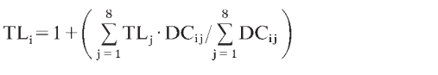
5) TP = (δ¹⁵N_{species} − δ¹⁵N_{base} Δ¹⁵NT−D) + rTP_{base} where δ¹⁵N_{species} and δ¹⁵N_{base} are the mean δ¹⁵N values of the species of interest and of the species used as a proxy baseline, respectively, Δ¹⁵NT-D is the TDF value and rTP_{base} is the relative TP of the proxy baseline species. Blue whales were assigned as the rTPbase with a value of 3, and Δ15NT-D had a value of 3 as a relative scaling factor (Hobson and Welch 1992; Hobson et al. 1996; Hoekstra et al. 2002; e.g., Matthews et al. 2020).
6) TP assigned from ẟ¹⁵N, using a TDF of 3 ‰ and defining basking shark as an operational TP 1. Since basking shark consume zooplankton and small crustaceans 2 TP were added to each value to bring their estimates in line with usual TP definitions.
7) TP = 2 + (δ¹⁵N_{consumer} – δ¹⁵N_{Calanus spp.})/3.8, TDF was taken to be 3.8 ‰ following Hobson & Welch (1992).
8) TP estimated using ¹⁵N in trophic (Tr) and source (Sr) amino acids (AAs), using a multiple amino acids equation. weighted mean δ¹⁵N values of the trophic AAs (Tr-AA) Alanine, Aspartate, Glutamate, Isoleucine (Ile), Leucine and Valine (δ¹⁵N_{Tr-AA}) and the source AAs (Sr-AA) Phenylalanine and Lysine (δ¹⁵N_{Sr-AA}). A TDF of 3.1, 0.4 ‰ (Ruiz-Cooley et al., 2021) and a β of 3.4, 0.9 ‰ (Nielsen et al. 2015) was used.
TP_{Tr− Sr} = (δ¹⁵N_{Tr− AA} − δ¹⁵N_{Sr− AA} − β)/TDF) +1
9) TP = 2 + (D_{m} – POM – TDF_{mmt})/TDF, where D_{m} = δ¹⁵N value in a consumer’s tissue, TDFmmt is the marine mammal TDF, POM = δ¹⁵N value of particulate organic matter, and TDF is 2.4, calculated from ¹⁵N values of muscle from captive seal feeding experiments (Hobson et al, 1996)
FIGURES

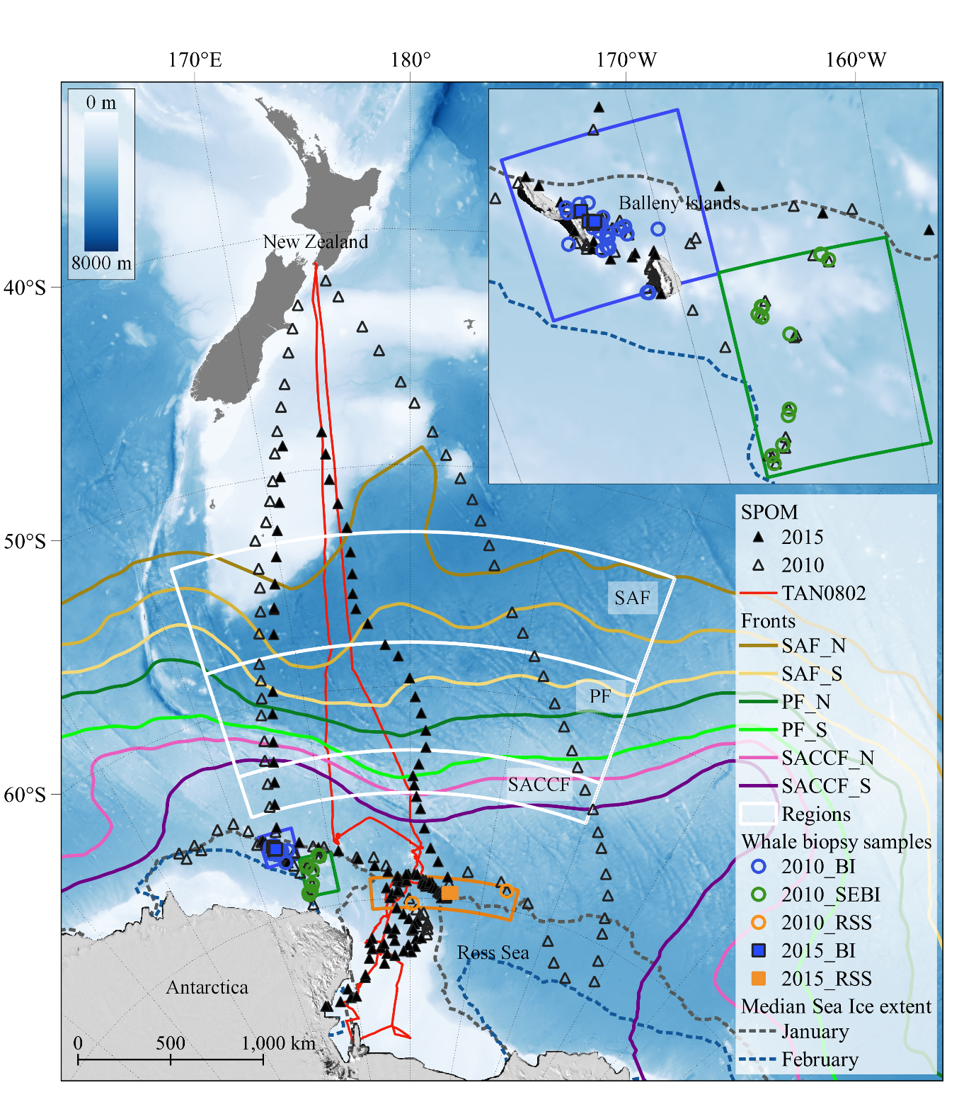

Fig. 1. Map showing the coverage of the International Polar Year-Census of Marine Life voyage (TAN0802, January-March 2008), the Antarctic Whale Expedition voyage (TAN1002, February-March 2010) and the New Zealand-Australia Antarctic Ecosystems voyage (TAN1502, February-March 2015). The locations of suspended particulate organic material (SPOM) samples are shown as open black triangles for the 2010 voyage, and filled black triangles for the 2015 voyage, which also indicate the ship’s tracks in 2010 and 2015. The ship’s track in 2008 is marked by the solid red line (TAN0802) – no SPOM samples were taken on this voyage. The location of humpback whale (Megaptera novaeangliae) skin biopsies sampled during 2010 (open circles) and 2015 (filled squares) are shown, with finer scale detail of sampling locations around the Balleny Islands illustrated in the insert map. Whale skin sample location abbreviations are: BI (Balleny Islands), SEBI (south-east Balleny Islands), RSS (Ross Sea slope). The location of the major oceanographic fronts (after Sokolov and Rintoul, 2009) are marked as SAF_N (Subantarctic Front, northern boundary), SAF_S (Subantarctic Front, southern boundary), PF_N (Polar Front, northern boundary), PF_S (Polar Front, southern boundary), SACCF_N (Southern Antarctic Circumpolar Current Front, northern boundary) and SACCF_S (Southern Antarctic Circumpolar Current Front, southern boundary). The location of the median sea ice extent between 1981 and 2010 is also included for the months of January and February using data from the National Snow and Ice Data Centre (Fetterer et al., 2017). Bathymetry was generated from the General Bathymetric Chart of the Oceans (GEBCO), sourced online at https://www.gebco.net/data_and_products/gridded_bathymetry_data/.
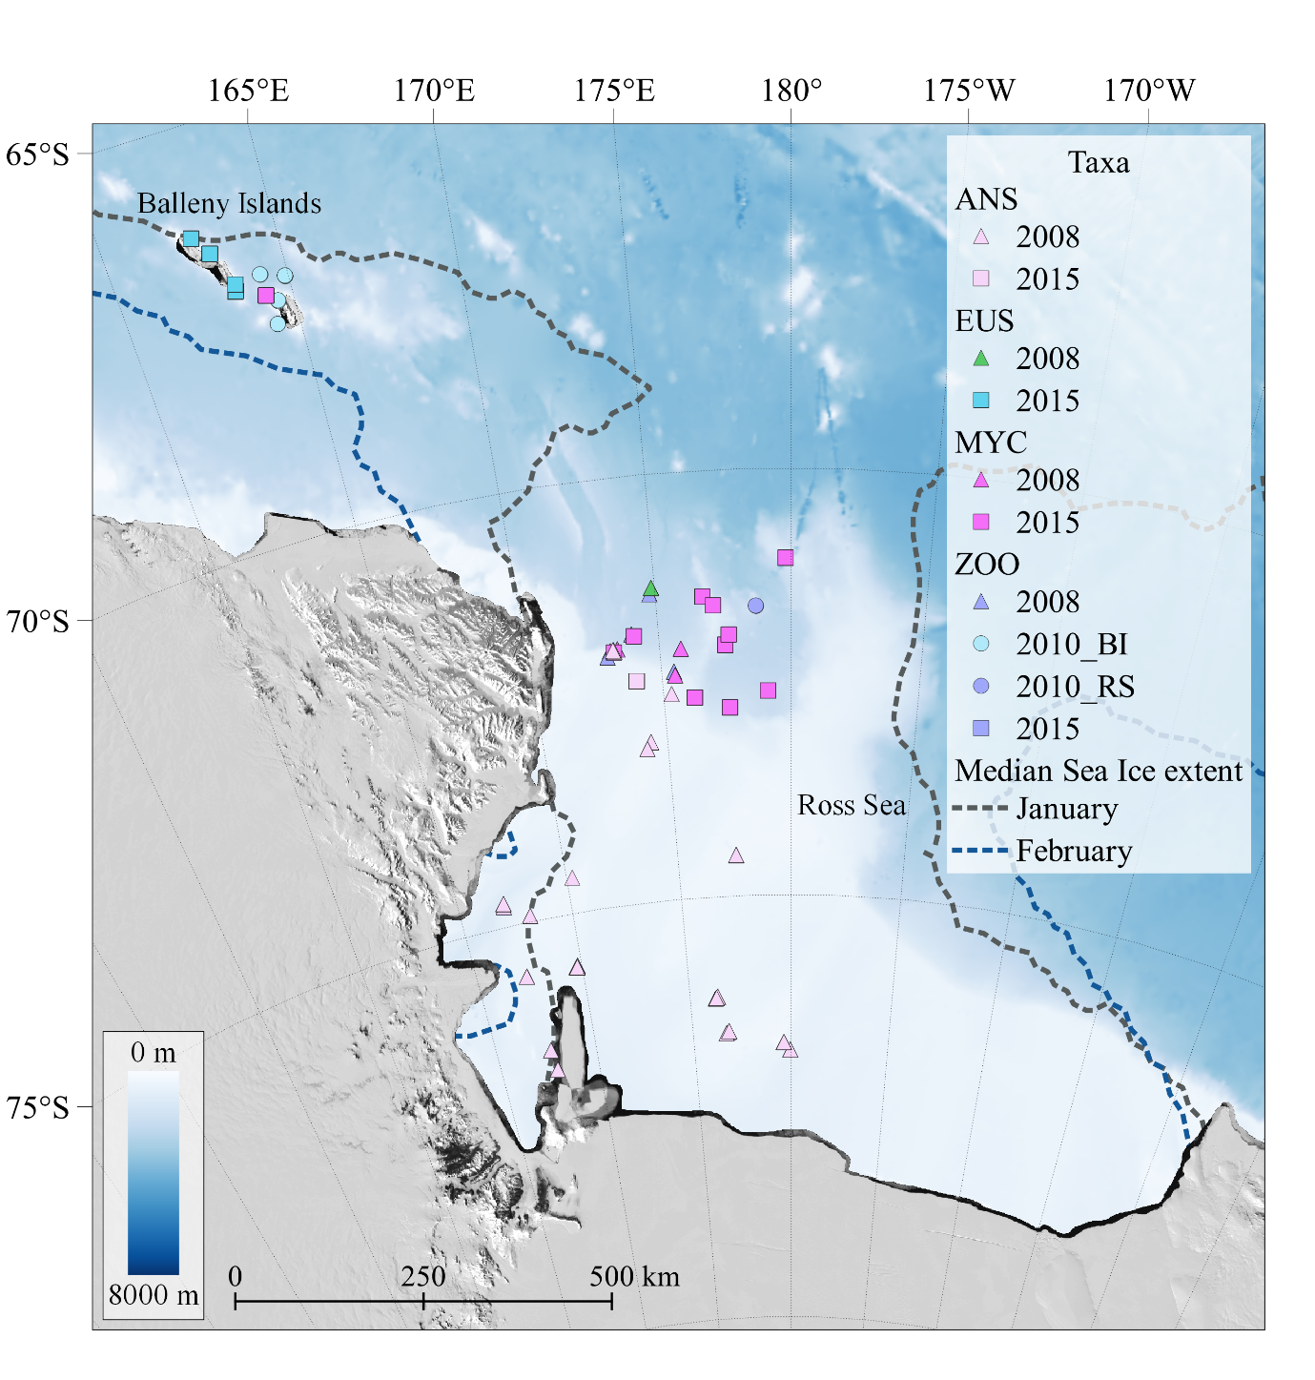

Fig. 2. Map showing the sampling locations of potential humpback whale (Megaptera novaeangliae) prey samples taken during the 2008, 2010 and 2015 voyages. ZOO = zooplankton, EUS = Antarctic krill (Euphausia superba), MYC = myctophids (5 spp.: Electrona carlsbergi, E. antarctica, Gymnoscopelus nicholsi, G. opisthopterus and G. braueri), ANS = Antarctic silverfish (Pleuragramma antarctica). BI denotes Balleny Islands and RS Ross Sea. The colour of the species symbols match those in Fig. 5.
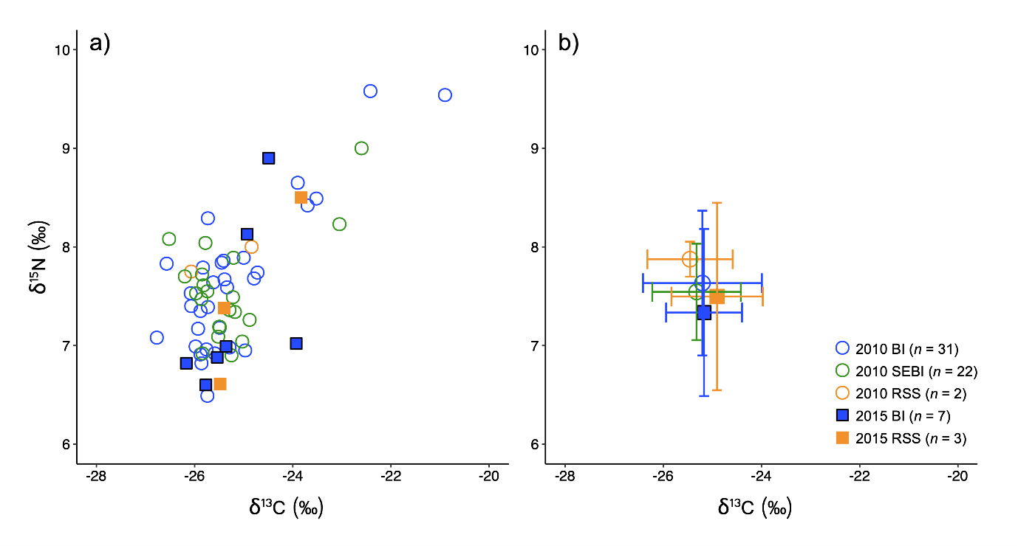
Fig. 3. Lipid-extracted carbon and bulk nitrogen stable isotope biplot of 2010 and 2015 humpback whale (Megaptera novaeangliae) skin biopsy samples, showing sampling year and location for panel a) all values, and panel b) mean and standard deviation (±1 SD) values. Abbreviations in the legend are: BI Balleny Islands, SEBI south-east Balleny Islands, RSS Ross Sea slope, and n= denotes the number of samples taken on each voyage in each region.
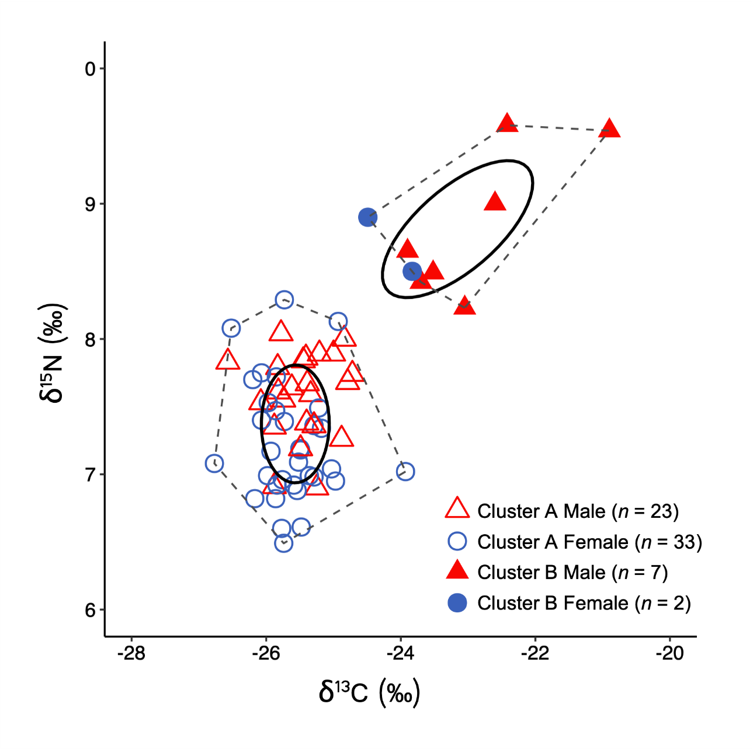
Fig. 4. Lipid-extracted carbon and bulk nitrogen stable isotope biplot showing standard ellipse area corrected for small sample size (SEAc, solid line ovals) and convex hull area (TA, area within dotted lines) for humpback whales (Megaptera novaeangliae) (see Table S3 for definitions). Ellipse areas hold 40% of the data. A niche comparison using “K minus means cluster analysis” (MacQueen 1967; Lloyd 1982) defined two clusters of individual humpback whales based on their respective δ¹⁵N and δ¹³C values: cluster A (open triangles) and cluster B (filled triangles). Males and females are depicted as red and blue symbols respectively. See Figs. 3 and S3 to view year and location of whale biopsy samples for each of the isotopically segregated clusters A and B.
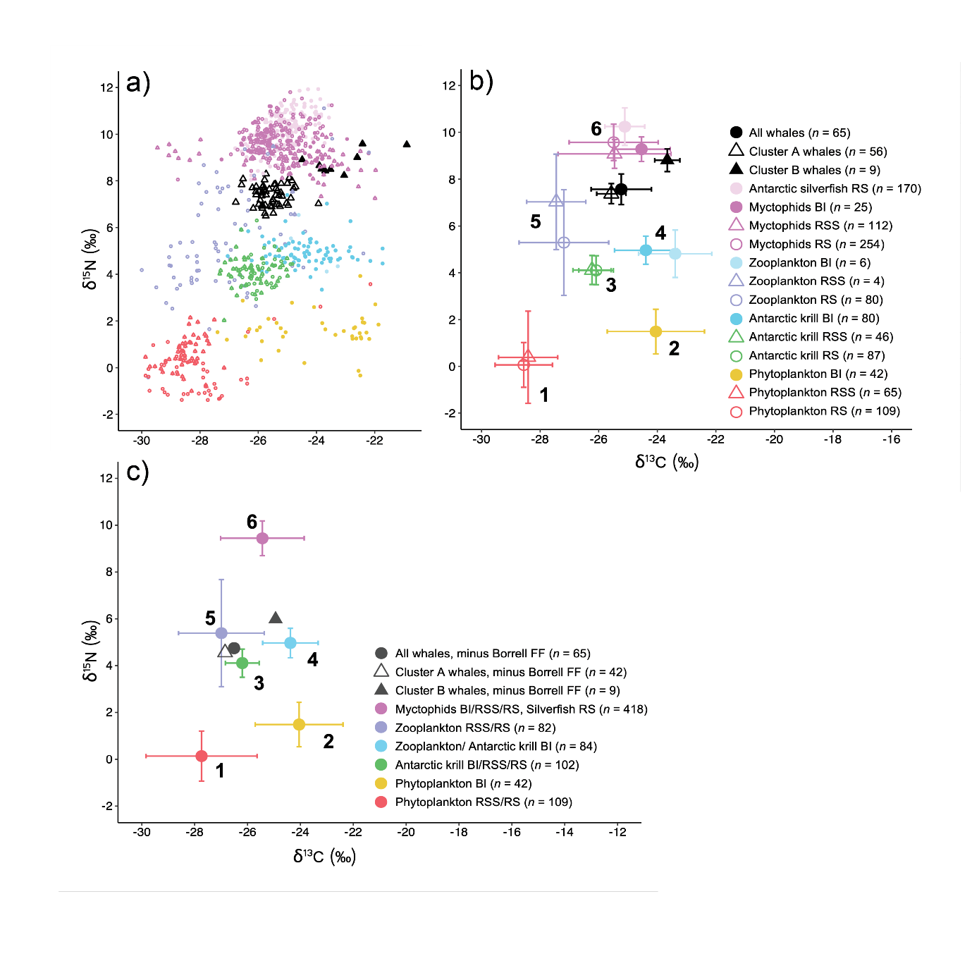

Fig. 5. Panel a) Lipid-extracted or lipid-corrected carbon and bulk nitrogen stable isotope biplot of humpback whale (Megaptera novaeangliae) skin and muscle tissue of potential prey sampled in 2008, 2010 and 2015 from waters around the Balleny Islands (BI), the Ross Sea slope (RSS) and the Ross Sea (RS); panel b) carbon and nitrogen stable isotope biplot of humpback whale skin means (±1 SD) from 2010 and 2015 voyages, and muscle tissue means (±1 SD) of potential prey sampled in 2008, 2010 and 2015 from waters around BI, RSS and RS. Bold numbers on the plot refer to the prey clusters identified in the dendogram of Fig. S2; panel c) carbon and nitrogen stable isotope prey polygon biplot showing meanss (±1 SD) of potential humpback whale prey clusters (as determined in dendrogram, Fig. S2). Humpback whale skin means (±1 SD) for “all whales”, “cluster A” and “cluster B” whales are shown with the Borrell et al. (2012) trophic discrimination factors (TDFs: 1.28, 0.38 ‰ for δ¹³C, and 2.82, 0.30 ‰ for δ¹⁵N) subtracted. Error bars for whale skin isotope values are shown in panel b) but have been omitted in panel c) for image clarity. Colours represent prey clustering used in Ward’s Hierarchical analysis (Fig. S2) and MixSIAR Bayesian mixing model output results (Fig. 6).
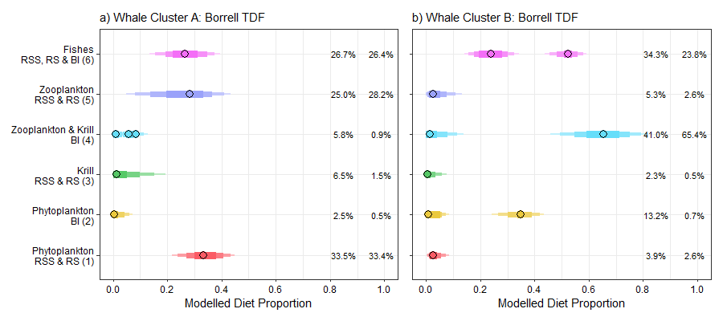
Fig. 6. The posterior distributions of the proportional contributions of each prey cluster to the diet of humpback whales estimated using MixSIAR (Stock et al., 2018) applying the Borrell et al. (2012) trophic discrimination factors (TDFs). Diets were estimated separately for cluster A whales (left hand panel a)) and cluster B whales (right hand panel b). Posteriors are plotted as the Highest Probability Density Intervals (HPDIs), which represent the shortest interval width containing the desired credibility range, and are more appropriate when posteriors are skewed or multimodal compared to equal-tailed credible intervals. HPDIs of 95, 90, 75 and 50% are plotted for each prey cluster with decreasing bar thickness and colour intensity. Posterior peaks (modes) are plotted separately as filled circles. The posterior means and highest posterior peaks are given as percentages at the right-hand side of each panel for each prey cluster, with the mean given first on the left. Abbreviations in the axis labels are as follows: RSS = Ross Sea slope; RS = Ross Sea; BI = Balleny Islands; Krill = Antarctic Krill (Euphausia superba); Fishes = Myctophids (5 spp.: Electrona carlsbergi, E. antarctica, Gymnoscopelus nicholsi, G. opisthopterus and G. braueri) plus Antarctic silverfish (Pleuragramma antarctica). Numbers in brackets for the y axis labels relate to Ward’s hierarchical prey cluster numbers depicted in the dendrogram of Fig. S2.
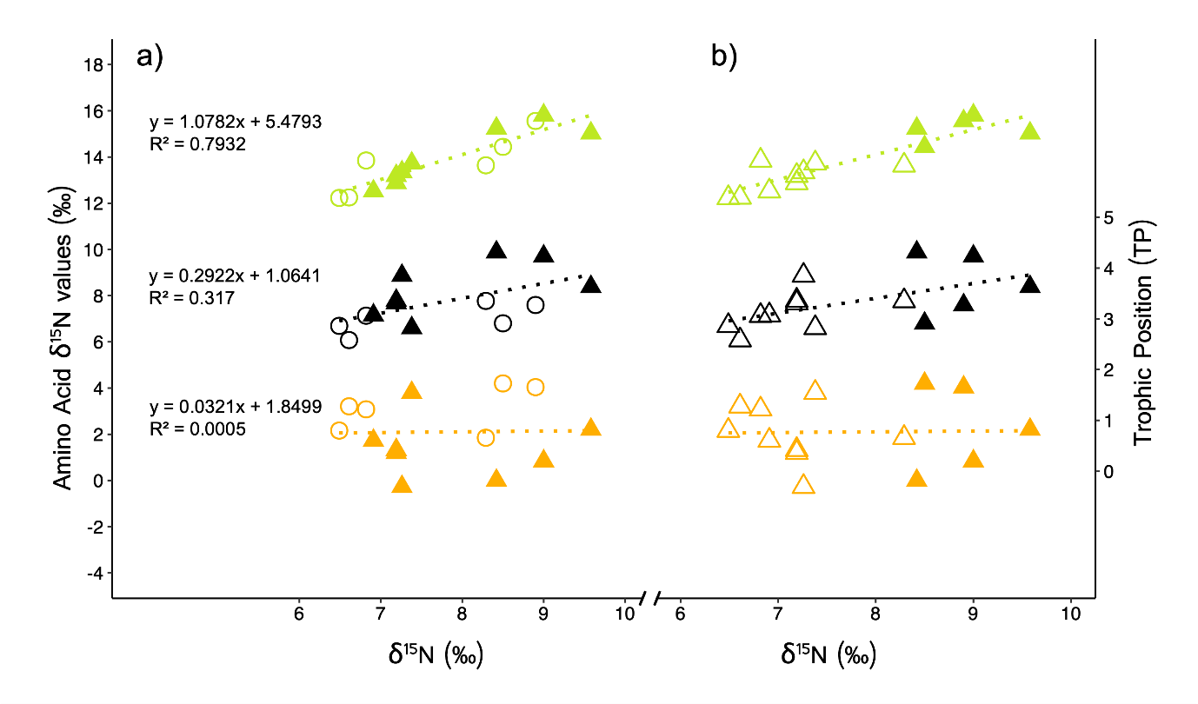
Fig. 7. Amino acid δ¹⁵N values (δ¹⁵N_{AA}) of humpback whale (Megaptera novaeangliae) skin and whale trophic position (TP) plotted against bulk δ¹⁵N values. Glutamic acid (“trophic amino acid”) is shown in green, phenylalanine (“source amino acid”) in orange and TP in black: panel a) depicts males (filled triangles) and females (open circles); panel b) differentiates humpback whales in cluster A (open triangles) and cluster B (filled triangles).
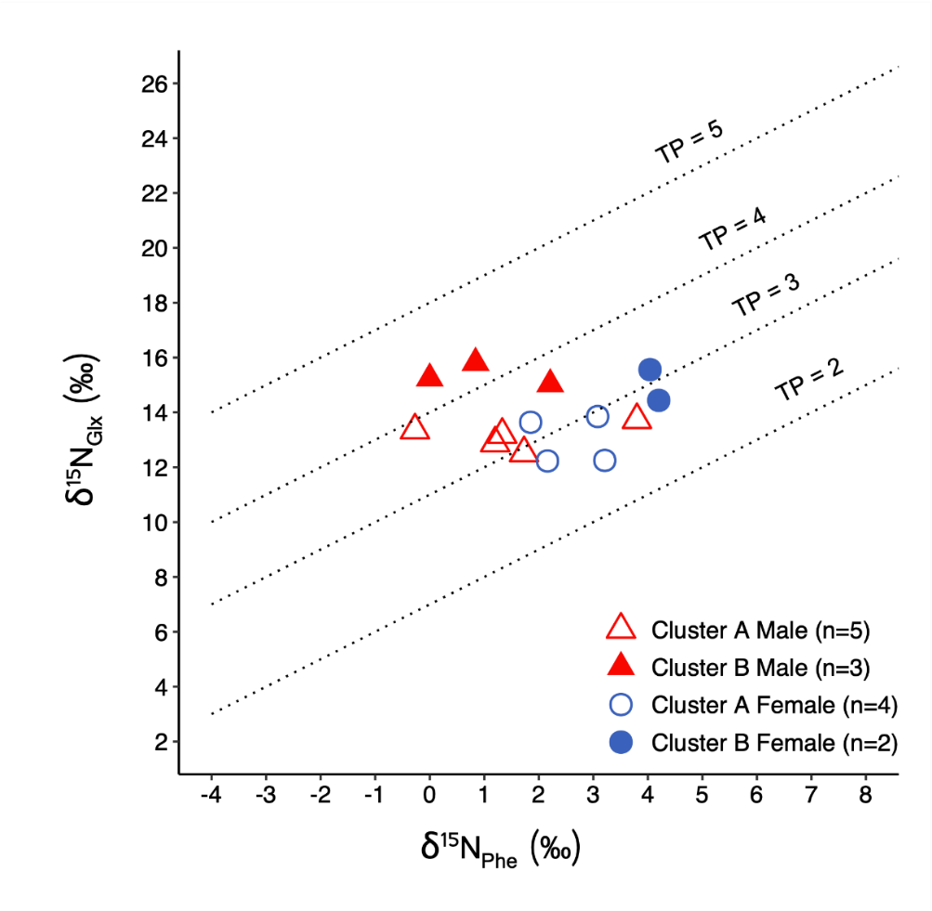
Fig. 8. Nitrogen isotope values of glutamic acid (“trophic amino acid”, δ¹⁵N_{Glx}) plotted against phenylalanine values (“source amino acid”, δ¹⁵N_{Phe}) for humpback whale (Megaptera novaeangliae) skin samples. Trophic isoclines with a slope of 1.0 and y-intercept intervals of 3.58 ‰ represent different trophic positions (TPs = 2, 3, 4 and 5). These isoclines are calculated according to CSIA data-derived trophic discrimination factor of the whale: TDF_{whale} = (Glx-Phe - 3.4)/(TP_{whale}-1) = 3.58, where TP_{whale} is 3.32 based on simple arithmetic TP calculation from bulk nitrogen isotope data (see Methods: Estimation of humpback whale trophic position, and Table S11).
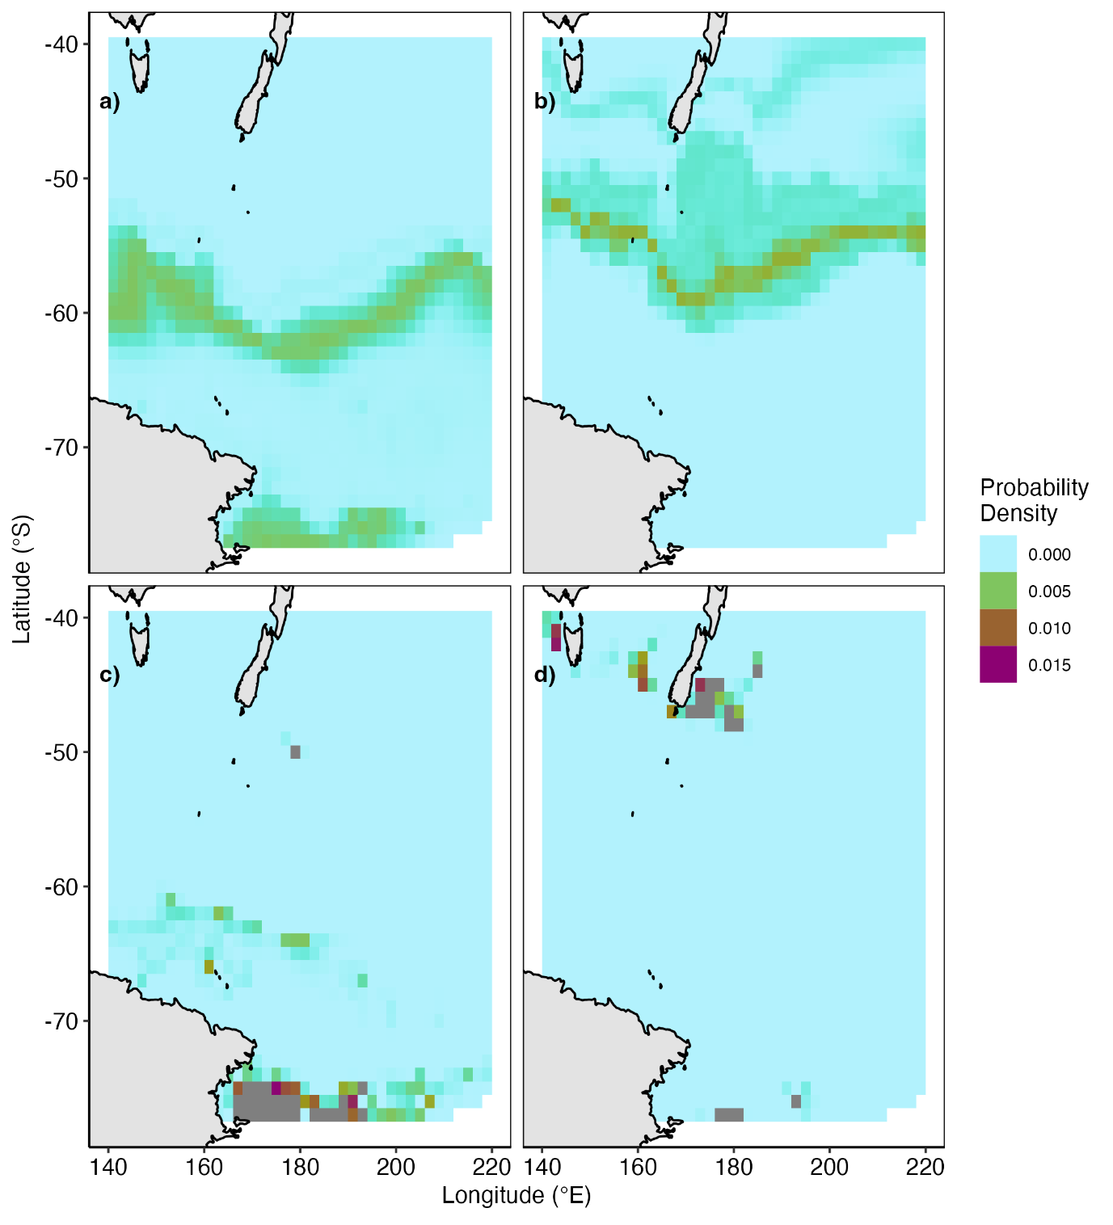
Fig. 9. Mean posterior probability densities for spatial assignment (c.f. Wunder 2010) of individual humpback whale (Megaptera novaeangliae) foraging areas using spatial models (isoscapes) for δ¹³C and δ¹⁵N in suspended particulate organic matter of the Southern Ocean (St. John Glew & Espinasse et al. 2021). Panels a) and b) are the assignments for cluster A and B whales respectively, using only carbon isotope data. Panels c) and d) are the assignments for cluster A and B whales respectively, using both carbon and nitrogen isotope values. Posterior probability densities for the spatial assignment of individual cluster B humpback whale foraging regions are provided in Fig. S9.
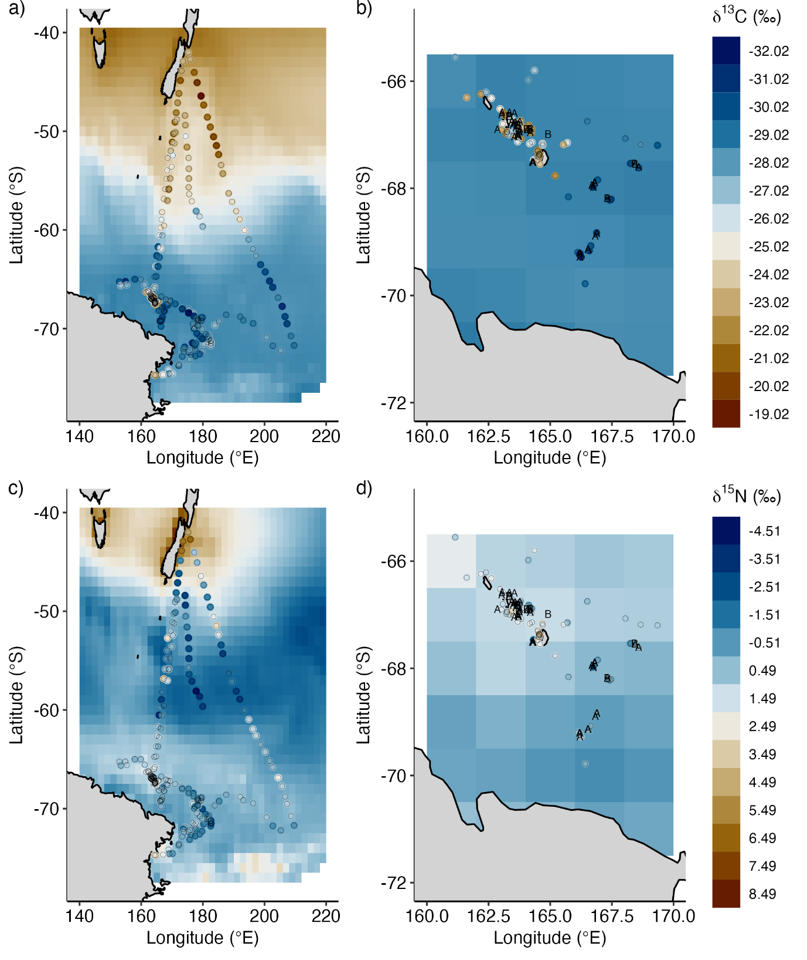Fig. 10: Southern Ocean spatial variability of ẟ¹³C (panel a) and ẟ¹⁵N (panel c) values of suspended particulate organic material (SPOM) derived from the St John Glew & Espinasse et al. (2021) isoscapes model (baseline map) and field-measured SPOM ẟ¹³C and ẟ¹⁵N values (filled circles). Panels on the right show the ẟ¹³C (panel b) and ẟ¹⁵N (panel d) modelled isoscape for SPOM and field data for the regional area around the Balleny Islands. The letters A and B in panels b) and d) indicate the locations of cluster A and cluster B whales when skin biopsies were sampled.
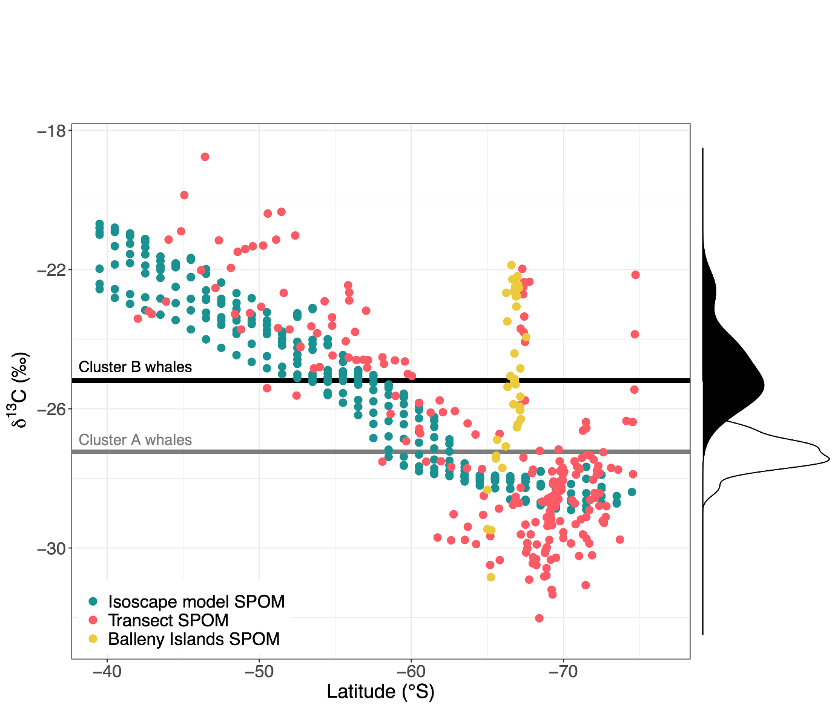
Fig. 11: Variation of ẟ¹³C values in surface suspended particulate organic matter (SPOM) with latitude. “Isoscape model SPOM” are the “no interactions” modelled SPOM isoscape values from St John Glew & Espinasse et al. (2021); “Transect SPOM” are field measured ẟ¹³C SPOM values from 2010 and 2015 voyages on transects from New Zealand to the Ross Sea; “Balleny Islands SPOM” are ẟ¹³C SPOM data from the same voyages measured in the vicinity of the Balleny Islands. The Borrell et al. (2012) ẟ¹³C trophic enrichment factor was subtracted from all plotted humpback whale (Megaptera novaeangliae) skin values to enable comparison to SPOM ẟ¹³C data: the grey solid line is the median ẟ¹³C value of cluster A humpback whale skin, whilst the black solid line is the median ẟ¹³C value of skin from Cluster B whales. The white and black filled histograms are the frequency distributions of ẟ¹³C values for cluster A and cluster B whales respectively.
SUPPLEMENTARY MATERIALS are supplied as a separate electronic file.

