Carbon Footprinting of Railway Infrastructure: A Standardised, Consistent Data Collection Method
Mrs Tracey Najafpour Navaei, PhD Researcher*
Prof. Simon Blainey, Professor of Sustainable Transport*
Prof. John Preston, Professor of Rail Transport*
Prof. William Powrie, Professor of Geotechnical Engineering*
*University of Southampton

Abstract
Greenhouse gas (GHG) emissions from the transport industry, comprised almost entirely of CO₂, account for around 23% of global emissions. Reducing these emissions is crucial if countries are to meet their carbon reduction targets. Given that net zero carbon emissions are beginning to be enacted into various countries’ laws, transport infrastructure owners now have time bound targets to meet. The accurate measurement of carbon currently expended by transport infrastructure is the first, and most critical, step of infrastructure owners’ journey towards carbon reduction as this Business as Usual carbon expenditure will form the basis for both carbon reduction measures and expansion of carbon measurement from limited embodied and construction scopes though to whole life cycle carbon assessment. This paper provides an overview of a transferable method for calculating the carbon footprint of railway infrastructure assets, based on a novel carbon calculation data form. Use of this form will ensure a standardised and consistent approach in data collection methods, enabling the creation of carbon footprints for small scale case studies of individual railway earthworks (around 100m linear length) with a specific focus on the construction life cycle stages. These stages form the basis for future expansions to the whole life cycle and therefore accuracy in carbon footprinting is vital. These figures can also be used for aggregation across multiple interventions and again accurate data is required to ensure inaccuracies are not amplified.

1 Introduction
The sixth IPCC assessment report on climate change, and their special report on the impacts of global warming of 1.5°C [1, 2], highlight the ongoing climate emergency. These reports emphasise the consensus that the global mean surface air temperature is rising, and that this temperature rise has a near linear relationship to cumulative CO₂ emissions. Given that the transport sector accounted for around 23% of global emissions in 2018 [3, p.1056], and 26% of all UK GHG emissions in 2021 [4, p.1] , reductions in this sector will have an impact on both overall global and UK GHG emissions. This reduction is also of particular importance given the need to achieve modal shift away from fossil fuel vehicles and air travel towards rail, which at point of use has virtually zero carbon emissions, where powered by electricity. However, this mode shift may require substantial construction and enhancement of rail infrastructure, and this can incur substantial carbon emissions. With 19,709km High Speed Rail (HSR) under construction (19,643km planned) globally [5, p.15], small reductions in emissions from construction, and subsequently maintenance and renewal will, when multiplied up, have a large overall effect. This is vital, given that construction carbon can account for a large proportion of the life cycle carbon of an earthwork, with figures of 71% found for HSR in China [6, p.7].
Historically, the focus on transport emissions has been at point of use, excluding before use, construction, decommissioning and scrappage emissions costs. With the advent of life cycle assessment (LCA) whole life cycle costs are now coming to the fore, alongside the implementation of Publicly Available Specification (PAS) 2080 [7] and similar standards such as ISO14064 (the standardised framework methodology for GHG reporting which endorses use of a carbon footprint indicator but lacks provision of a calculation methodology [8, p.68]), providing guidance to those wishing to implement carbon management in their business. PAS 2080 was chosen for use in this research as it is a standard for managing carbon in infrastructure, looks at the entire value chain with the aim of reducing both carbon and costs via intelligent design, construction and use of buildings and infrastructure [9], and also includes a calculation methodology disaggregated by life cycle stage. With infrastructure life cycle carbon costs now having the potential to be collated in a consistent and standardised way, the use of carbon footprints split by life cycle stage will aid in identifying carbon “hot spots” to be targeted for emissions reduction. The net zero (NZ) carbon emissions by 2050 obligation has been enacted into United Kingdom (UK) law [10], focusing infrastructure owners’ businesses on the task to meet a time bound target. In line with meeting the 2050 target, an initial task for these businesses is to set baseline emissions data. These baselines could form part of a business’s Science Based Targets (SBTs), illustrating their proposed trajectory to NZ, enabling the creation of an auditable trail of emission reductions as they progress to NZ [11]. Detailed LCA are provided by High Speed 2 (HS2) in their numerous environmental documents [12-16], however, for many smaller infrastructure projects this data capture, and hence quantification of the carbon impacts, is not being achieved. This is an important gap that needs addressing, given that for example maintenance interventions, although individually containing relatively small amounts of carbon in absolute terms, could take place tens of thousands of times across the NR network during a 5 year control period (CP) leading to substantial volumes of carbon when the individual vales are aggregated [17]. Therefore, accurate identification of the A1-5 construction life cycle carbon is vital for both estimating future expansion to whole LCA of an intervention, and further extrapolation to assess the aggregate impact of multiple such interventions. More generally, there is currently no standard tool or method for quantifying the carbon emissions associated with construction of linear infrastructure. While a plethora of more general carbon calculation tools are available as tabulated in the appendices of the Institute of Civil Engineers, ICE Workstream 1 of The Carbon Project [18, p.22], relevant input data needs to be collected in a consistent and replicable way before these tools can be used.
The method outlined here aims to fill this methodological gap by providing a simple, easy to use, and easily replicable method for data capture to enable baseline carbon footprints, specifically consider stages A1-5 of the life cycle, focusing on the construction phase of railway infrastructure where almost 75% of carbon can be expended [6, p.7]. They are created using carbon calculation tools, and are designed to enable future expansion to whole life cycle footprints covering A1-C4 life cycle stages (bearing in mind that the operational (B) stages of in use are not always applicable to earthworks, and also that the deconstruction at end of life (C) stage may involve leaving in situ for some structures). The method is illustrated through a worked example of a railway intervention from a suite of case studies forming a Network Rail (NR) research project of carbon footprints of small-scale linear infrastructure earthworks. The intervention is footprinted using the Rail Carbon Tool (RCT) produced by the UK Rail Safety and Standards Board (RSSB). This is an online and free to use (for those in the UK rail industry) carbon footprint tool, which allows users to input materials, machinery and transport for a project. While other more generally applicable LCA software tools do exist (such as SimaPro and GaBi), the RCT has been used here as NR currently require it to be used for carbon calculations [19, p.2]. It is also one of only two tools available globally that is specifically designed for use on rail projects, the other being e-tool originating in Australia [18, p.22]. The RCT has been used as the carbon footprint calculation tool in this example via use of the RCT PAS 2080 aligned template. Using this template, data can be consistently collected and categorised allowing for comparisons between projects. Carbon “hot spots” can also be identified, thereby enabling determination of where alternative materials and methods of construction could be used to aid decarbonisation efforts. This aim of the data form is to fill the gap of transferring data in a consistent and complete manner from real world case studies into suitable inputs for use in a footprint calculation tool. This method follows the five broad steps to performing a carbon footprint as outlined in Williams, Kemp [20, p.56]: The production of the novel data form specifically addresses the first two steps, whereby all emissions of interest and of relevance are identified and categorised (in line with PAS 2080). The third step is encompassed via the novel carbon calculation form’s layout, whereby “an appropriate method for translating the measurable activities of each emissions source to a weight of CO₂e emissions must be selected” [20, p.56], and is achieved via completion of this form. The fourth step is fulfilled via data conversion to appropriate units in the spreadsheet, where the choice of emissions factor to be used in the tool is documented, fulfilling the fifth step of thorough documentation, auditability, and comparability with other footprints. This paper guides the reader through completion of a data form to ensure accurate, complete, and consistent data capture to produce carbon footprints. What follows is a literature review, description of the method, results, including a worked example, discussion and conclusions.

2 Literature Review
The literature pertaining to rail transport’s emissions has evolved in recent decades to highlight the prominence of environmental impacts of rail infrastructure on a macro scale. Chester and Horvath [21] in their pivotal report on environmental assessment of transportation in California, USA, which includes GHGs, assert that such assessments should include infrastructure and supply chains. This not only began the trend for inclusion of construction in such assessments as standard practice, but also pushed the boundaries further by advocating increased granularity in these assessments with sub-sections including construction, operation, and fuels.
One of the studies demonstrating specifically the contribution of railway infrastructure construction to overall emissions is an International Union of Railways (UIC) report [22] which looked specifically at the carbon footprint of HSR, comparing construction, rolling stock and operational carbon costs per passenger km for the South Europe (SE) Atlantic and Ligne à Grande Vitesse; Mediterranean high-speed line (LGV Mediterranée in France), Taipei-Kaohsiung (Taiwan), and Beijing-Tianjin (China) lines. This report found that construction carbon accounted for 36%, 39%, 17% and 13% respectively, which are not inconsequential figures, and also highlighting that no standard percentage amount can be allocated to HSR construction carbon. Given construction, operation, maintenance and similar interventions can have numerous sub-branches, there is limited data detailing how these top-line figures fit into differing life cycle emissions in the literature, and, where they are present, the boundaries often differ making comparison between studies difficult [23, 24]. The vast majority of work on carbon footprinting for railway infrastructure is based on macro-scale case studies, such as seminal works on HSR by the UIC [22], and more recently LCA of HSR in Portugal [25], analysis of GHG emissions from HSR in Korea [24], carbon footprint and GHG assessment of High Speed 2 in the UK [14-16], and LCA of the Beijing-Shanghai line in China [6]. While some work has begun to differentiate between existing and newly built infrastructure in China [26], and detailed LCA of carbon in NR railway track system interventions has taken place [27], there is still a gap in the literature regarding small scale case studies.
Macro scale case studies often calculate their footprints pre construction, at the design stage such as HS2 [14-16], however some are calculated post construction, including the HSR Beijing-Shanghai line, whereby data collected “from the official documents of the project” is utilised [6, p.4] with the aim to have greater accuracy and precision than studies conducted prior to this. This post construction macro scale case study on the HSR Beijing-Shanghai line utilises material inventories in terms of working hours for construction equipment, yet no record of the original data capture is available for further scrutiny. This use of inventories is the beginning of the journey towards more granular data capture in case studies. The use of data capture as a distinct step in their life cycle is noted and illustrated in the flow diagram provided by Kaewunruen, Sresakoolchai [6, p.8] as a clear distinct step prior to “executing” the life cycle cost assessment. To capture data accurately, detailed auditable and comprehensive record keeping is needed on site, and following this step, crucially, this data needs to be available for further scrutiny. Saxe, Casey [28] in their paper specifically considering GHGs in rail infrastructure in the UK, emphasise the need for “very detailed record keeping” to enable this [28, p.172], and highlight the piecemeal nature of existing GHG assessments of transit infrastructure. The assessment of embodied GHGs can be achieved following completion of this step, and this is where the form proposed will assist in collection of such data. With data collection specifically collected during or shortly after completion aiming to fill the gap of accurate and detailed data for production of robust carbon footprints. The use of consistent and comparable data collection for future comparisons, and the sharing of best practise decarbonisation measures between infrastructure asset owners and maintainers, is noted by Olugbenga, Kalyviotis [29] in their critical literature review. They state that “many of the papers used secondary data for estimates of material or energy use in construction” from other projects, and that where primary data was used the “primary data collection included bills of quantity…bidding documents…and activities schedule” [29, p.11], which again highlights the differing data sources being utilised, and that no unified approach is being utilised in the railway infrastructure sector. This lack of a unified approach is where the form proposed in this paper will bring about consistency and clarity in data collection by collecting the data in a standardised format and enabling footprints to be created aligned to PAS 2080 life cycle stages will enable comparison between footprints on a like-for-like basis. This lack of consensus in data collection methodology is echoed by Marlowe and Clarke [30] in their systematic literature review of carbon accounting in general, who note the “inability to compare results of carbon accounting across differing GHG inventories” [30, p.81]. As noted by Olugbenga, Kalyviotis [29] and Marlowe and Clarke [30], the methods behind data collection in many previous studies are often unclear and undocumented, and, where they are stated, are often dominated by broad assumptions. An example of this, found for HS2, is the mileage used for transport distances which is assumed “100km” for dry construction materials [13, p.24]. This example illustrates that when the granularity of a footprint is delved into, broad assumptions can be found. Use of this form aims to avoid use of broad assumptions via capture of accurate and detailed data during or shortly after the intervention has been completed.
Life cycle stages have been examined previously in the UIC HSR report [22] and more recently in the twin DecarboN8 reports on measuring road and railway infrastructure carbon. However, while materials, material transport, construction, operation and maintenance stages were estimated in the twin DecarboN8 reports [23, 31], clear linkage to the PAS 2080 standard is yet to be fully embraced in the construction industry, with very few case studies that address the differing life cycle stages utilising the PAS 2080 life cycle stages. Consistent reporting and comparability utilising the PAS 2080 life cycle stages’ terminology (A1-3, A4, A5, B1 etc) needs to become fully embedded in the infrastructure and transport industry to aid with comparisons between studies. To address these issues of comparability and consistency PAS 2080 [7], as the inaugural guidance document to carbon management in infrastructure, is proposed to be followed. This publicly available specification provides guidance on differentiating the life cycle stages and a way for differing projects to compare their life cycle carbon in a consistent, replicable, and importantly, more granular manner. Figure 1 illustrates the breakdown of the life cycle into four broad stages aligned with PAS 2080.
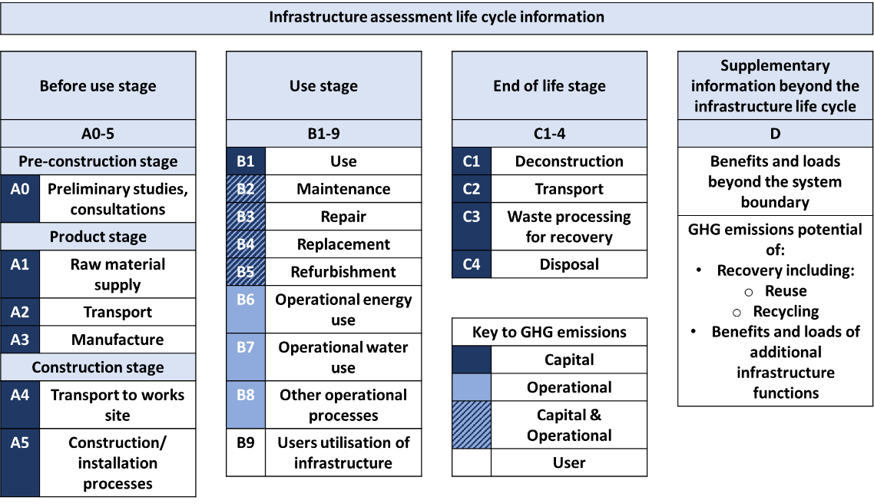
Figure 1 PAS 2080 Life Cycle Stages, amended from [7]
These life cycle stages provide clarity and reduce ambiguity, enabling comparisons between footprints containing the same range of life cycle stages. PAS 2080 contains clear guidance as to what should be included within each stage and this clarity can be applied to other linear infrastructures. However, this division of life cycle stages is yet to be fully embedded in the construction industry policy and practices, and in particular those of linear infrastructure. Details of what data is required to be collected, including transportation figures and generation of electricity, can be found in the GHG Protocol [32], however, on the ground “how-to” data assimilation guidance could not be sourced. Guidance on the steps required in identifying and calculating GHG emissions, shown alongside those proposed via use of the data form, provides this “how-to” data and is shown in Figure 2. Figure 2 illustrates the alignment of the form and method proposed with that of the GHG Protocol. The use of standardised reporting formats is noted in the GHG Protocol as a preferred method as this “can significantly reduce the risk of errors“ [in data collection] [32, P.45].
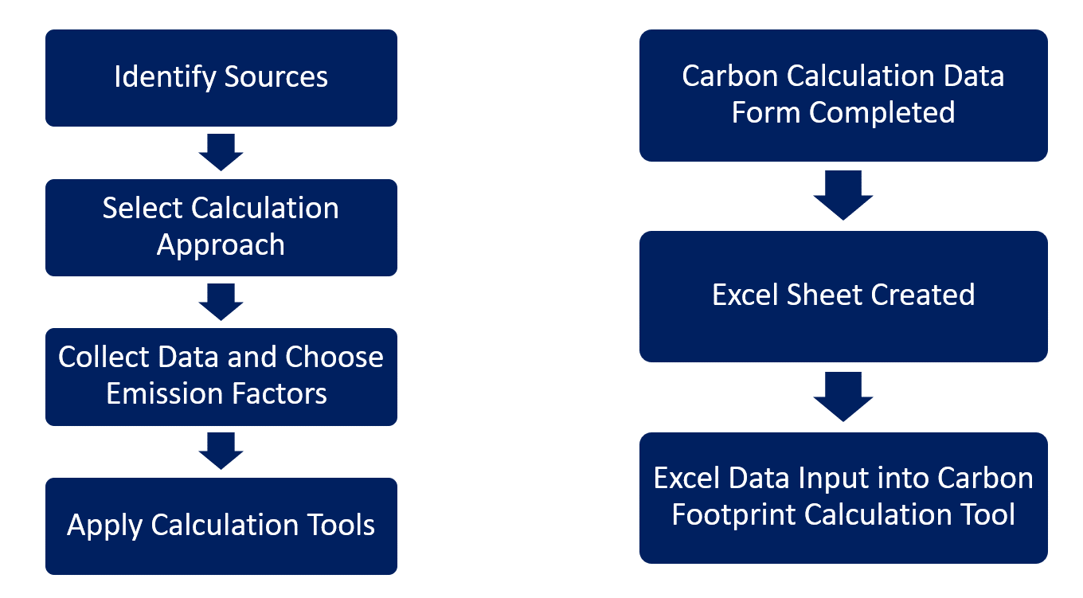
Figure 2 Steps to identify and calculate GHG emissions, amended from [32, p.41]
A recently published track decarbonisation network strategy business case from NR highlights that via use of the RCT “railway infrastructure embodied carbon has been progressively more understood over the past ten years” [33, p.181], thereby validating the increased use of such tools. More recently, specific highway and rail carbon measurements have been conducted by Lokesh [23] in the twin DecarboN8 studies. However, this has a high-level broad focus including discussing the shift to whole life carbon. Lokesh’s studies had clearly defined boundaries, excluding for example verge clearance and rail decommissioning. Lokesh [23] further notes that the “material transport” sub system is one with the highest level of uncertainty [23, p.23], which further highlights the earlier issue of broad sweeping assumptions made in carbon footprinting of HS2 and the need for accurate and verifiable data use in carbon footprinting calculations. Using the above methodology, the form used in this paper was created to collate all required data encompassing PAS 2080 life cycle stages A1-5 to enable transformation via a simple spreadsheet to data consistent with that required to complete a carbon footprint.

3 Method
The form used and illustrated in the worked example in Error: Reference source not found, aligns with the life cycle stages A1-5 of the PAS 2080 template residing in the RCT, illustrated in the screenshots in Section 4. Completion of a carbon data collection form will fill the gap of accurate, robust, and consistent data collection ex-post works on small scale projects to allow for accurate and comparable carbon footprinting to arise. This form also has the potential to be used ex ante for forecasting, although this is dependent on reliable pre-project estimation of the characteristics and materials involved in the work being undertaken (e.g. the type and duration of machinery usage). As part of the research project described here average figures for intervention types based on actual works are being developed, and this should allow long-range forecasting for NR to be undertaken aligned with intervention numbers detailed in their Cost and Volume Handbook [17], which would then in turn allow improved ex ante quantification of carbon footprints for specific interventions.
For this paper the RCT template based on PAS 2080: 2016 is utilised, illustrating the data collection journey and conversion process for a typical rock cutting maintenance case study. The alignment of the proposed carbon data collection form and the life cycle stages residing in the Before Use, A1-5 stages, of PAS 2080: 2016 is illustrated in Figure 3. Other life cycle stages of PAS 2080 given in the RCT template are not included in this illustrated example, based on Business as Usual (BAU) and lifecycle stages A1-5, but can be completed based on this A1-5 data. This A1-5 data can be transformed using assumptions such as disassembly is the inverse of construction, less materials [6]; whereby figures used in the A life cycle stages can easily be re-used in later life cycle stages. The Carbon Data Capture form was created for contractors to complete for small scale interventions of around 5-chains (100m), during or post works, to collate the necessary data to enable creation of an A1-5 life cycle stage BAU footprint. The alignment of the data form with PAS 2080 life cycle stages, has been outlined in Figure 3 and further details of each part of the form are now given: The first part details the works name/reference and is where a unique local name or the infrastructure owners’ reference number will be provided. Type is split into the three main types of earthwork intervention; embankment, rock cutting and soil cutting plus ‘other’ to encompass earthworks which do not fall into these categories, such as surveys. The level of intervention and lifetime is based on railway interventions as outlined in the NR Cost & Volume Handbook [17]. Size of works is the linear length of the intervention. The ‘number of shifts & hrs on shift’ section is to give length of works, to enable calculations such as
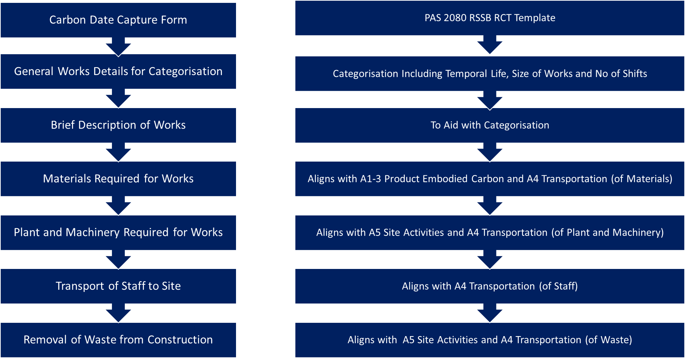
Figure 3 Alignment of Carbon Data Capture Form and PAS 2080 RSSB RCT Template
staff hours and be used as a multiplier for transport distances and machinery working hours. All the metrics detailed above can then be used for categorisation purposes to allow for comparisons between similar size and type of works. Then there is a box to be filled in with a brief paragraph outlining the works undertaken and a photo can also be inserted. Next there is a table where basic details such as description, quantity, method of transport and distance to site can be entered. Additional data sheets are also requested here to aid correct material selection in the carbon footprint tool. The materials part of the form aligns with PAS 2080 life cycle stage A1-3. Potential sources of error/inaccuracy in this part of the form are number of items rather than weight being given without a corresponding unit weight in the description box, or the weight being given in an alternative unit. Next is a table where a description of the plant and/or machinery used on site, the quantity of each item, engine type and running hours along with method of transport and distance to site can be entered. The logic behind this part is to gather as many details as possible about the plant and machinery being used on site so enable correlation with engines listed in the RCT to enable calculation of CO₂e from the hours running of this machinery. Travel distances are required to be used in conjunction with weights to calculate accurate ‘To’ and ‘From’ mileages to site and associated emissions factors. Choice of transport mode is vital here as different vehicles can alter the footprint greatly. ‘HGV Unknown’ is the emissions factor used for the vehicles here as it is unknown whether the vehicle used is rigid or articulated. Whether the vehicle is carrying other items is also unknown, and therefore the average load factor is chosen. Details of weight of plant and machinery can be found from data sheets requested from the contractors or from a web search. This is required, in conjunction with length of construction works, to enable proportional embodied carbon for construction plant & equipment manufacture to be calculated. For this example the Keller Foundations methodology [34], outlined in more detail in the worked example in Section 4, is utilised. This part of the form aligns with several ‘Before Use’ stages of the RCT PAS 2080 template, as detailed: Embodied carbon in the plant/machinery aligns with A1-3 Embodied Carbon Stage; Transport of the plant/machinery aligns with A4 Construction Stage Transportation; Running of the plant/machinery aligns with A5 Construction Stage Site Activities. Potential sources of error/inaccuracy here, are if multiple machines are used with differing running hours, meaning they need to be inserted separately. If data sheets are not provided an assumed similar type machine will need to be found and this may not have an engine size comparable to that of the one used on site. The penultimate part of the form contains a table with the number of people using each method of transport along with their round-trip distance. This can be multiplied by the number of shifts undertaken for the works recorded in Part 1 to find a total staff transport distance per vehicle type. Part 5 of the form aligns with PAS 2080 life cycle stage A4 Construction Stage Transportation, specifically the ‘Worker Travel To-From Site’ stage. Potential sources of error/inaccuracy here, are contractors not indicating if mileages are for only part of the works (the setup of the form assumes that these mileages are per shift), miles rather than km being used as the unit of measure, and vehicle types and fuel types not being indicated. The final part of the form details waste removed from site. A separate entry is required for each differing type of waste as differing emissions factors are required for not only the transport of these but also the treatment carbon emissions factors. As with other items a quantity in kg is required along with method of transport, distance to the final waste destination, and what the destination is. The waste removal part of the form is concerned with waste arising from the A5 construction phase and aligns with several sections of the RCT PAS 2080 template; the transport of the waste section aligns with A4 Before Use Construction Stage Transportation, waste transport from site to final destination. The treatment of the waste aligns with A5 Before Use Construction Stage Site Activities, specifically waste treatment carbon footprint. Potential sources of error/inaccuracy here, are mixed loads, cubic metres of skips being given rather than tonnage, so additional transformation steps need to be taken, and no details of final destination being provided to allow a suitable waste treatment factor to be selected.
The Carbon Data Capture form used in this illustrative example underwent several iterations from R0 to the final version R3 via trial and error during its initial use. The evolution of the form is: R0 Initial pilot version; R1 Further details added to level of works in works details, lifetime of works now requested, size of works box added to list, number of shifts and hours on shift combined into one box; R2 Further text added to materials required for works section with “please include supplier, supplier part No., material and unit weight/No.” being added to description box, and “please include separate entry for each type of waste e.g. soil, aggregate etc” added to waste removal description box; R3 addition of reference to text in works details work name box and addition of check boxes for type of works and level and lifetime. Clarification text added under size of works (5-Chain Length, approximately 100m, is representative length for micro-case studies). The wording of mileage to site was altered to avoid confusion with units, to read distance to site (km) for materials, plant, staff transport and waste removal. Following requests for clarifications for several R3 forms, a FAQs document was created [35] outlining some of the more common areas for clarification, such as indication of whether staff travelled weekly to site and stayed in accommodation or if plant was left on site for duration or transported/towed back and forth weekly or per shift. Form validation was carried out by using the form in its various revisions and creating footprints for the main research project and amending the form as per the revisions to suit the template in the RCT.

4 Results
A worked example of the use of this form in conjunction with the RCT is now presented to highlight its usability, based on a case study of Mossley Cutting, from the NR North West and Central Region. The three broad steps of carbon footprinting, outlined on the right-hand side flow chart of Figure 2 were completed: 1) manual completion of form, completed by the contractor undertaking the works, 2) manual translation of data into format congruent with RCT, via Excel spreadsheet), and 3) manual input into RCT. For this case study both the data input roles detailed in 2) and 3) have been completed by the author, although there is no reason why these two roles could not be undertaken by differing members of staff. The example used is a rock cutting maintenance intervention and was chosen as a typical example owing to the high frequency of such interventions in the UK, and the high frequency of de-vegetation works. The works description is de-vegetation to enable inspection, with arisings spread locally. The works size is 5 chain length (around 100m) and was undertaken in one 9-hour shift. No materials were used for these works and one piece of plant was transported 90km to site on a flatbed lorry; a 13t excavator with a diesel engine which ran for 6 hours. Ten members of staff attended site, travelling round trip distances and using methods of transport as indicated. There was no waste removal required for this site as all arisings were spread locally. The completed Carbon Calculation Data form for Mossley Cutting is illustrated in Appendix A. From the data outlined in Error: Reference source not found a spreadsheet was created to convert this data into a suitable format for input to the RCT. The 13t excavator is added into this spreadsheet. The excavator’s weight is entered as 13,000kg and its engine type as diesel. The running hours are entered as 6hrs for the 1 x 9-hour shift. From a web search a JCB 13t excavator technical spec sheet (JS131) is found and the engine size assumed 55kW. The method of transport is given as flatbed. HGV unknown is chosen, as a flatbed could be rigid or articulated HGV, and this has an emissions factor which lies between that of rigid and articulated. Plant and equipment have a weight associated with them when being brought to site and taken away, therefore this mileage is multiplied by two here. The transport mileage is also entered here. This is entered as one figure of all the mileages added together, as all vehicle types are the same for this example. Separate entries would be required if differing vehicle types were utilised. There is no waste transported from site, therefore this part is not applicable in this example. If waste were taken from site a transport mileage emission factor and a waste treatment factor would need to be applied to the weight of material transported. The next step is to input the converted data from the spreadsheet into the RCT. The various sections of the RCT were then completed in running order of the template, detailed below. Further details of how to input data into this tool can be found at: [36] Figure 4 illustrates the high-level view of the RCT detailing the A1-3, A4 and A5 stages applicable for this form.
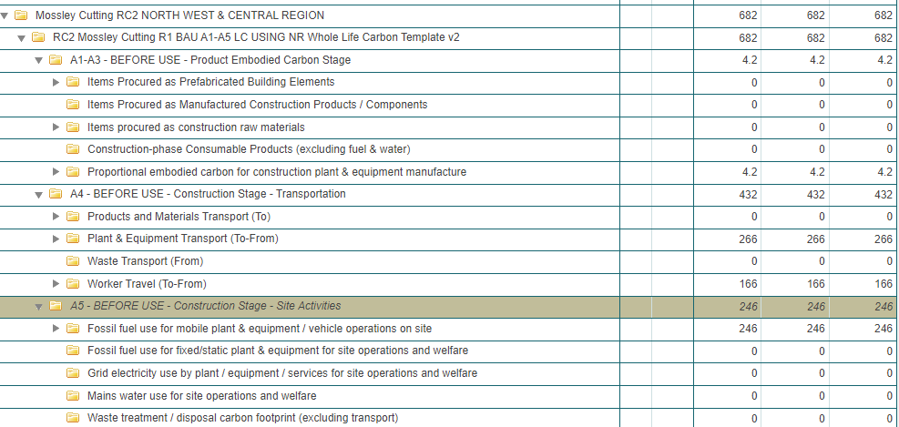
Figure 4 Screenshot of RSSB RCT PAS 2080 Template: Breakdown of Life Cycle Stages
Figure 4 indicates where the CO₂e embodied in the 13t excavator sits within this template. This was calculated as 4.2kg and input as a weight of total CO₂e associated with the production of this item of machinery. The methodology behind calculation of embodied carbon in the 13t excavator utilising Keller Foundations methodology [34]. This methodology takes into account the weight and typical usage of this type of machinery and apportions this based on the length of the project in weeks. One nine-hour shift here has been apportioned to 0.2 of a 5-day working week. Plant and Equipment Transport is indicated in Figure 4 as 266kg. The distance to and from site is inserted here, 180km, along with the weight of the item transported, 13 tonnes. The choice of vehicle is HGV unknown size, average load. Transport of staff to site is where the total mileage of the 10 vans detailed in the spreadsheet is entered as one figure here of 646km, and the van type chosen is Van average size <3.5t unknown fuel for the transit type vans resulting in 166kg emissions. Figure 4 also illustrates the complete fossil fuel use for mobile plant and equipment, in this case the 13t excavator running for 6 hours on site. A 50kW Diesel Engine was chosen from the RCT repository as the closest match to the 55kW engine. The running time of 6 hours was input here as the hours of operation resulting in 246kg emissions.

5 Discussion
Author discussions with NR staff in the Scotland region find that completion of each form, post works, would take approximately 2-3 hours, less if completed during the works. The results obtained appear reasonable when compared to other case studies footprinted so far of rock cutting maintenance case studies by the author. Comparison with an earlier study, in the form of a HS2 data set for embankments and cuttings on Old Oak Common to Euston Station section [37], with the data split by life cycle stage as per the footprint construction outlined in this paper, has allowed for detailed assessment of the similarity of results for different life cycle stages. The two data sets show reasonable alignment and have a similar kurtosis with peaked distributions and skewness values indicating highly skewed data distribution. The footprint created in the RCT can be downloaded in a .csv format for use in a spreadsheet to enable creation of graphs externally, or reports and graphs can be created within the tool. Using this graphical data, the carbon “hot spots” can be easily identified and disaggregated to ascertain which processes and/or materials lie behind this data enabling managers/infrastructure owners to assess if the most effective carbon reduction measures are being used or if alternative materials/methods of construction need to be considered. The results of the carbon footprint for Mossley Cutting are illustrated in Figure 5.
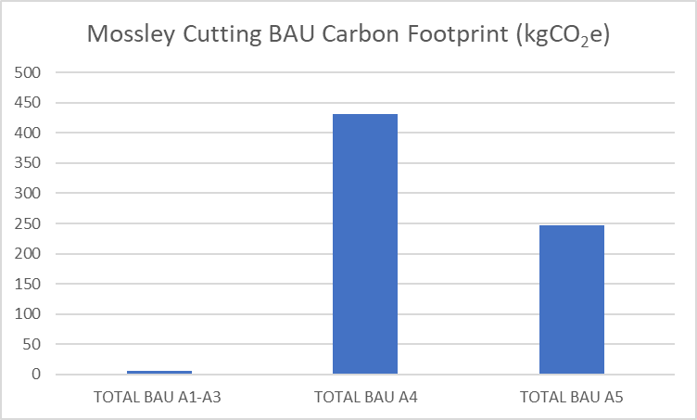
Figure 5 BAU Carbon Footprint of Mossley Cutting Split by Life Cycle Substages
This maintenance intervention is added to the template as a new construction. This footprint illustrates that the majority of the carbon for this intervention lies predominantly in the transport section of the life cycle. Further disaggregation shows that the plant & equipment transport footprint dominates the A4 sub stage, which when combined with the running carbon cost of this equipment, leads to the use and transport of this 13t excavator dominating the BAU A1-5 life cycle stages of this case study. Use of this machinery therefore needs to be analysed to assess if this is the right size equipment for the job and if alternative methods of powering these using electricity could be used to reduce the footprint. The Mossley Cutting example used here was a rock cutting maintenance with a 2-year lifetime. In general the temporal life of maintenance jobs tends to be of shorter duration (than refurbishments or renewals), that is they will require more frequent intervention to maintain the rock cutting, and hence have less, if any, materials, plant and equipment and transport data associated with them to collate for the RCT. The template used for this illustration can be used by all within the rail industry (such as contractors in the supply chain) in the UK as the RCT is free to access for all in the UK rail industry. The main barriers to its implementation would be the final stages of transposition of data to a format suitable for use in carbon tool and access and ability to use a carbon tool. This PAS 2080 template, along with a Project Acceleration in a Controlled Environment (PACE) aligned template have been produced by NR staff in sustainability to aid its roll out. With the PACE template aligning to the phases in PACE of option selection, design development, construction ready design approval and construction complete (as-built) [38]. At present only larger jobs over £1million turnover are mandated to be completed using these templates. Via use of this simple to use form additional case studies of smaller size can be added to the RCT enabling comparisons and sharing of best practice data in carbon reduction measures. A limitation of use of this data collection form is that in its present format may not be suitable for larger more complex sites due to the amounts of materials, numbers of staff and shifts. To overcome this limitation, projects could be divided into sub-sets and then each sub-set footprinted using the form. These BAU footprints are currently being expanded to encompass the whole life cycle as part of a wider research project to encompass life cycle stages A0-D.

6 Conclusions
This paper has set out a robust method for data collection to ensure all items necessary to produce a PAS 2080 compliant carbon footprint are documented and listed logically and sequentially. Additional guidance in the FAQ document [35], builds upon the author’s experience of areas whereby additional clarity is required, such as whether data is project total or shift total, to enable correct multiplications of data and the calculation of embodied carbon in plant and machinery. Use of this novel data collection form, along with an adherence to the steps outlined above, will enable production of comparable footprints and future expansion to encompass the use, end of life and beyond the life cycle stages. The broader implications of this form are the ability, via metrics, to enable quick and easy calculation of estimated carbon expenditure by intervention type at a regional level which align with the NR Cost & Volume Handbook [17] to enable a view as to their current BAU footprints and the actions needed to begin implementing actions to decarbonise these interventions with an associated percentage reduction in carbon to track their trajectory in carbon reduction in line with NR SBTs on the path to net zero by 2050. NR CP6, covering financial year 2019 to 2024, indicates earthworks volumes for rock cuttings planned works at 2,530 [17, p.83]. With each volume being equivalent to 5 chains or around 100m. This figure includes: 218 renewals, 675 refurbishments, and 1,608 maintenance volumes. This illustrates the magnitude to which this data could be multiplied up by, 1,608, and also the power of even small changes when multiplied over this large number of maintenance volumes [17, p.83]. The data collection method detailed here could be transferred and used in other carbon tools, and as such this method is transferable to other linear infrastructure such as highways, and via amendments to the form, other types of infrastructure such as drainage, signalling, and structures. Priorities for future research in this area are to expand the knowledge base of BAU scenarios to encompass further interventions to allow for production of a metric to be used against additional items detailed in the NR Cost & Volume Handbook to allow for full carbon accounting of this portfolio. A spreadsheet or form that is linked to the RCT to enable data transfer into the tool and multiplications by number of journeys/number of shifts would be a further improvement to reduce data input steps, which is where human input errors could potentially be introduced.

Acknowledgements
This research was funded by EPSRC, United Kingdom, grant number EP/L01582X/1, and Network Rail. The authors are grateful to all members of Network Rail who contributed to the collection of data in the course of this research project, and especially to Gavin Jessamy of NR for facilitating the data collection from relevant team members in the regions.

Data Availability Statement
The data that support the findings of this study are available from the corresponding author, TNN, upon reasonable request.

Appendix A
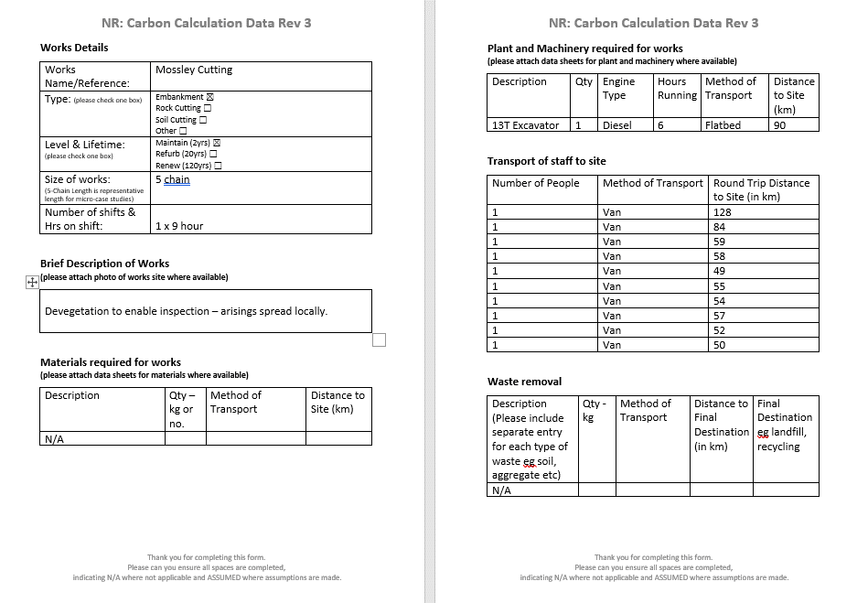
Completed Carbon Calculation Data Form for Mossley Cutting

References

