Flexible thermoelectric fabrics based on self-assembled tellurium nanowires with a large power factor
Sasikumar Arumugam1*, Samuel Perry2, Iris Nandhakumar2, and Steve Beeby1, Senior Member, IEEE
1Smart Electronic Materials and Systems Research Group, 2School of Chemistry, University of Southampton, UK, *Corresponding author e-mail: sa1d13@soton.ac.uk

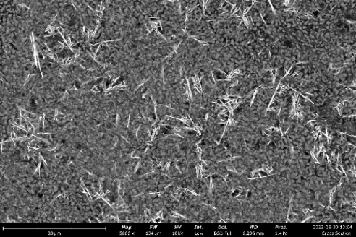
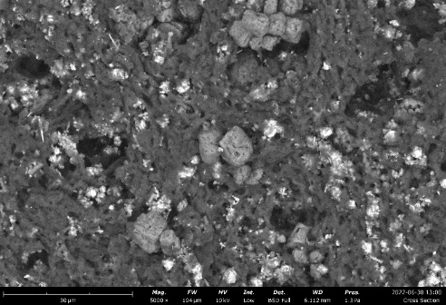

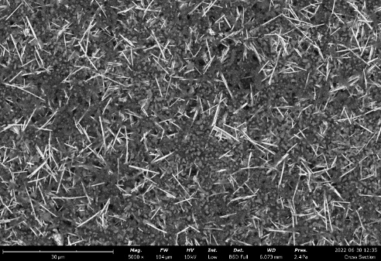
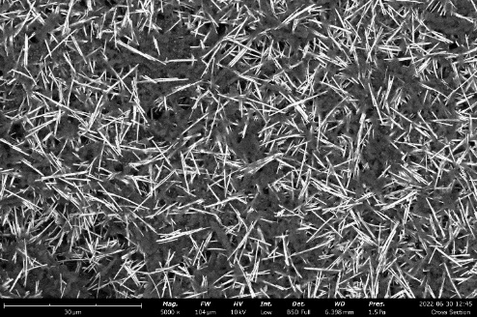

Figure 1: SEM images of plain view of P3HT: TeNW (top left) P3HT: TeNW: S²⁻ (top right) P3HT: TeNW:SET, (bottom left) P3HT: TeNW: SPh (bottom right) for 50:50 ratio

60:40  Ratio  0.01M | Overnight doping method |  |  | Dip method
60:40  Ratio  0.01M | σ (S/m) | S (µV/K) | PF (µW/mK²) | σ (S/m) | S (µV/K) | PF (µW/mK²)
TeNW:P3HT | 412 | 135 | 7.5 | 400 | 135 | 7.2
S²⁻:P3HT | 109 | 113 | 1.3 | 109 | 113 | 1.3
SET:P3HT | 450 | 127 | 7.2 | 470 | 127 | 7.5
SPh:P3HT | 1840 | 143 | 36.6 | 1840 | 143 | 37.6

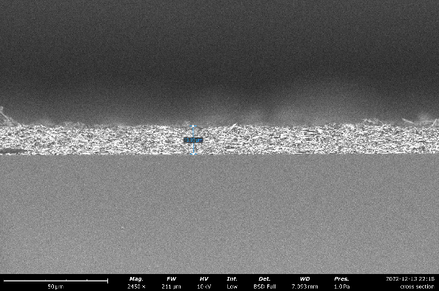
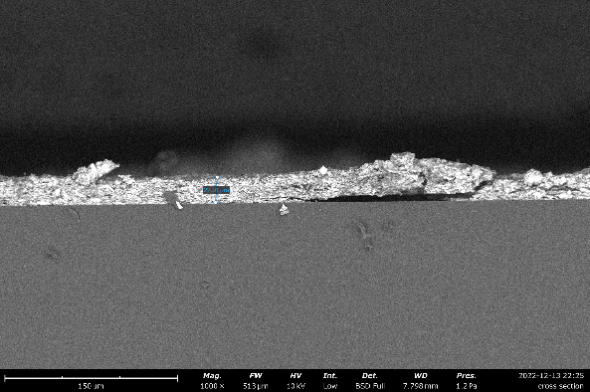

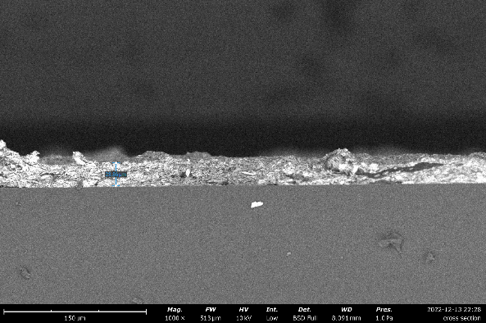
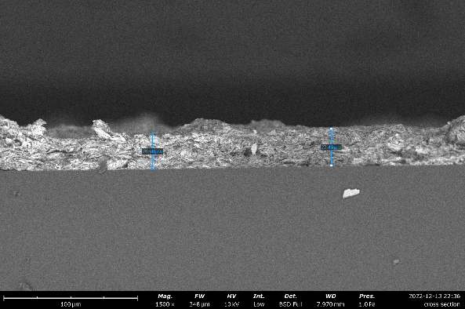

Figure 2: cross sectional SEM images of P3HT: TeNW (top left) P3HT: TeNW: S²⁻ (top right) P3HT: TeNW:SET, (bottom left) P3HT: TeNW: SPh (bottom right) for 40:60 ratio

80:20  Ratio  0.01M | Overnight doping method |  |  | Dip method
80:20  Ratio  0.01M | σ (S/m) | S (µV/K) | PF (µW/mK²) | σ (S/m) | S (µV/K) | PF (µW/mK²)
TeNW:P3HT | 400 | 148 | 8.7 | 813 | 135 | 14.8
S²⁻:P3HT | 109 | 137.6 | 2.0 | 310 | 120 | 4.4
SET:P3HT | 511 | 125.2 | 8.0 | 452 | 125 | 7
SPh:P3HT | 1949 | 143.5 | 40 | 1990 | 140 | 39

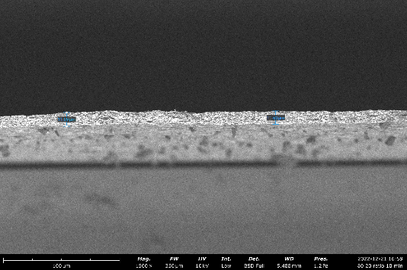
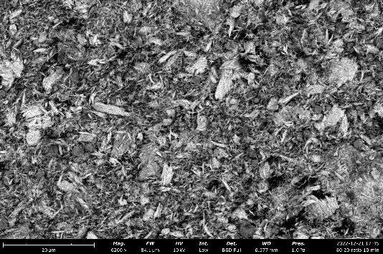
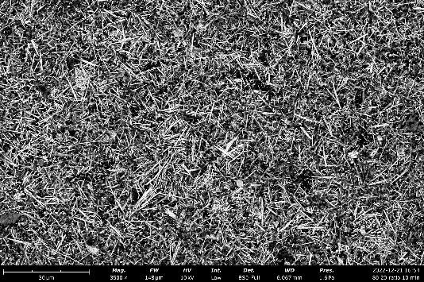
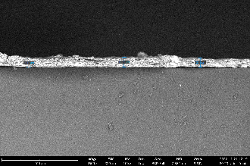
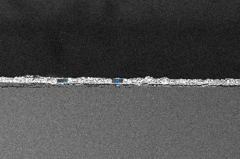

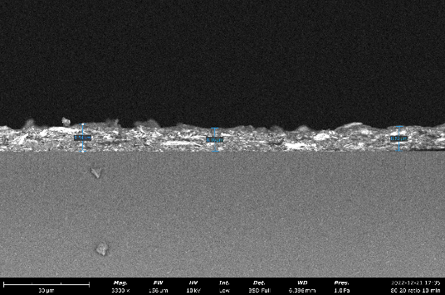

Figure 3: SEM images of plain (top left) and cross sectional (top right) view of P3HT: TeNW (20:80 ratio) and SEM images of plain (bottom left) and cross sectional (bottom right) view of P3HT: TeNW: S²⁻ (20:80 ratio)

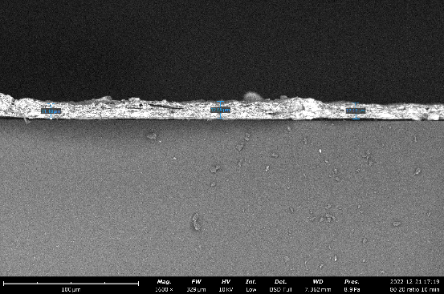
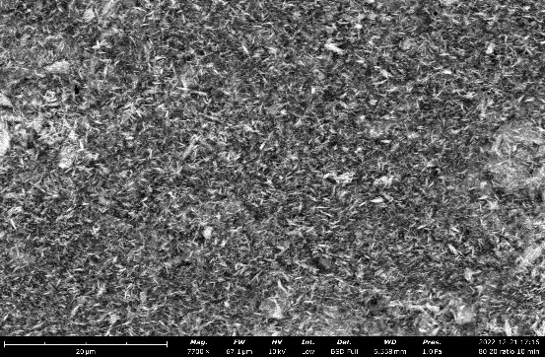
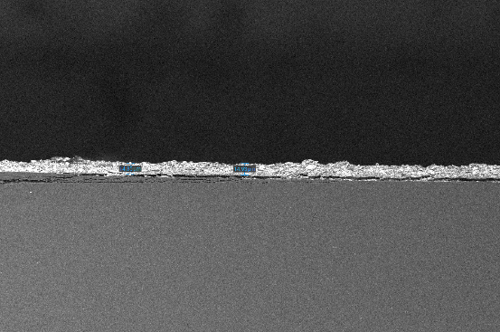
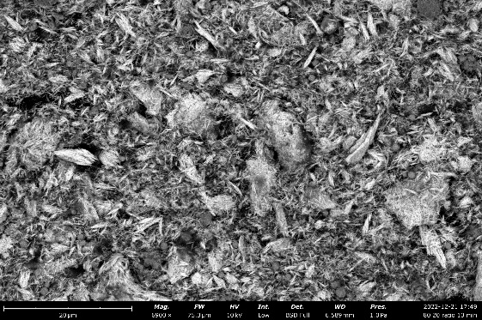

Figure 4: SEM images of plain (top left) and cross sectional (top right) view of P3HT: TeNW:SET (20:80 ratio) and SEM images of plain (bottom left) and cross sectional (bottom right) view of P3HT: TeNW: SPh (20:80 ratio)

80:20  Ratio  0.07M | overnight doping method
80:20  Ratio  0.07M | σ (S/m) | S (µV/K) | PF (µW/mK²)
TeNW:P3HT | 550 | 148 | 12.0
S²⁻:P3HT | 235 | 140 | 4.6
SET:P3HT | 553 | 130 | 9.3
SPh:P3HT | 2270 | 145 | 47.7

