Extending the Ladder: A Comment on Paetkau’s Stairway Proposal

The Nuffield Council on Bioethics introduced an “intervention ladder” to guide policymakers on public health interventions.[1] The ladder’s vertical structure represents an ordering of interventions, from least to most intrusive. In his article, Paetkau acknowledges that this ladder is “a useful tool” (p. 1) for evaluating public health interventions.[2] However, he objects that its focus on individual behaviour is too narrow and obscures “interventions that operate on the level of systems rather than individuals” (p. 2).

To be sure, some of the interventions on the original ladder do involve what might ordinarily be seen as ‘system’ or environmental changes. For instance, we might encourage active transport by building dedicated cycle lanes. However, these measures still have their intended effects through altering individual choices. What Paetkau means by a ‘systemic intervention’ is specifically one that improves public health without changing individual behaviour change (pp. 2-3). For example, reducing pollution or improving public health infrastructure. He suggests that, because the Nuffield ladder focuses on individual behaviour, it may lead policymakers to overlook these possibilities.

Paetkau proposes broadening the ladder to include systemic interventions. This results in what he calls a ‘stairway’ (p. 3). It still has eight steps, like the original ladder. However, each step is now wider, including individual interventions on one side and systemic interventions on the other. This might suggest that interventions on the same stair are somehow equivalent, but that is not Paetkau’s purpose. In fact, he suggests that one can advance up one side (e.g., systemic interventions) without the other (e.g., individual interventions) (p. 5). So, we shouldn’t attach too much significance to these being the same steps. In fact, it might be better to think of there being two separate ladders, placed side-by-side.

Drawing attention to systemic interventions is an important contribution. Policymakers should consider these options as well as – indeed, often before – interventions that focus on individual behaviour. But, while Paetkau’s two-sided stairway is more comprehensive, it is less useful as a guide for policymakers. Though Paetkau provides a ranking of systemic interventions, ranging from adequate funding for public health (least intrusive) to regulating industries (most intrusive), the two sides of his stairway are independent. Therefore, it is not obvious how systemic interventions should be compared to individual ones. Consequently, the stairway offers policymakers more options than the original ladder, but less guidance on when to use the various interventions.

We agree with Paetkau that the Nuffield ladder should be modified to include systemic interventions. However, we suggest extending the ladder in length, rather than width. We take no particular stance on how many rungs there should be, but Paetkau (p. 5) identifies sixteen interventions: eight steps, each with a systemic and an individual side. If we accept this classification, then the ladder would need sixteen different rungs. The extended ladder would thus include all the same interventions, individual and systemic, as Paetkau’s stairway. But, by arranging these hierarchically, it would also provide clearer guidance to policymakers as to how these measures should be prioritised.

Of course, putting both sets of interventions in a single scale requires us to make comparisons between them. Like Paetkau (pp. 4-5), we think systemic interventions are generally less intrusive than individual interventions (with the exception, presumably of the first step on the Nuffield ladder, which is doing nothing or merely monitoring the situation). Therefore, the systemic interventions will likely be on the lower rungs of the ladder. Possibly all eight systemic interventions will be below even the least intrusive individual interventions, such as providing information or enabling choice.

While this ladder offers more guidance, we should emphasise that judgements of proportionality are not as simple as the model suggests. As others have pointed out, it is sometimes difficult to distinguish separate steps.[3] Moreover, even if we can separate them in theory, interventions that are generally less intrusive can sometimes be very intrusive. For instance, Conly provides a vivid illustration of how non-coercive public health information, when taken to extremes, could still be very intrusive; for instance, if calorie counts were painted on the streets, recited in schools, and flown overhead.[4]

This has implications for the ladder. It might be that the interventions on a single step or rung can take more or less intrusive forms.[5] Further, this means that one step might therefore overlap another in intrusiveness. For example, the Nuffield ladder suggests that disincentives (step 6) are more intrusive than incentives (step 5). That may be true in some general sense. However, these measures both vary in degree, depending on the size of the (dis)incentive. Presumably, a larger incentive is more intrusive than a smaller incentive, and likewise for disincentives. But then it might be that a large incentive is more intrusive than a small disincentive. If this is the case, then perhaps the ladder should indeed look more like a staircase viewed side-on (see Figure 1).

Fig. 1: Overlapping steps

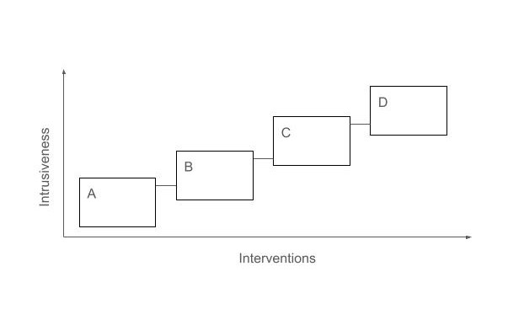

Therefore, we do not propose that policymakers must exhaust the earlier, lower steps before progressing to higher steps. The ladder should be interpreted as a rule of thumb, rather than an exact algorithm. Interventions at lower steps are generally to be preferred to those at higher steps, but this does not mean that we must exhaust these methods, before progressing up the ladder. The ladder is intended to guide, rather than substitute for, a judgement of particular policies. Nonetheless, while this complicates the matter, we think that placing individual and systemic interventions on a single scale is more useful for policymakers than placing them side-by-side.

Contributors

AMS is a doctoral student and BS is his supervisor. AMS and BS conceived and wrote the piece together. Authorship is alphabetical. Both accept equal credit and responsibility.

Funding

AMS is funded by the Economic and Social Research Council (grant number: ES/P000673/1).

References

[1] Nuffield Council on Bioethics. Public health: ethical issues 2007.
[2] Paetkau T. Ladders and stairs: how the intervention ladder focuses blame on individuals and obscures systemic failings and interventions. J Med Ethics 2024;0:1-6.
[3] Dawson AJ. Snakes and ladders: state interventions and the place of liberty in public health policy. J Med Ethics 2016;42:510-3.
[4] Conly S. Response to Resnik. Public Health Ethics 2014;7:178-9.
[5] Saunders B. How mandatory can we make vaccination? Public Health Ethics 2022;15:220-32.

