Valoctocogene roxaparvovec gene therapy provides durable hemostatic control up to 7 years for hemophilia A
Emily Symington, MB, BS¹; Savita Rangarajan, MB, BS²; Will Lester, MB, ChB, PhD³; Bella Madan, MD⁴; Glenn F Pierce, MD, PhD⁵; Priyanka Raheja, MB, BS, MD⁶; Carolyn Millar, MD⁷; Dane Osmond, PharmD⁸; Mingjin Li, MSc⁸; Tara M Robinson, MD, PhD⁸

¹Cambridge University Hospitals NHS Foundation Trust, Cambridge, UK; ²Faculty of Medicine, University of Southampton, Southampton, UK; ³University Hospitals Birmingham NHS Foundation Trust, Birmingham, UK; ⁴Guy’s and St Thomas’ NHS Foundation Trust, London, UK; ⁵Independent Consultant, La Jolla, CA, USA; ⁶The Royal London Hospital Haemophilia Centre, Barts Health NHS Trust, London, UK; ⁷Imperial College Healthcare NHS Trust and Centre for Haematology, Department of Immunology and Inflammation, Imperial College London, London, UK; ⁸BioMarin Pharmaceutical Inc., Novato, CA, USA

Corresponding author
Emily Symington, MB, BS
Cambridge University Hospitals NHS Foundation Trust
Hills Road, Cambridge, CB2 0QQ
emily.symington@Addenbrookes.nhs.uk

Running title: Valoctocogene roxaparvovec 7-year outcomes
Word count: 2994/3000

Keywords: hemophilia; adeno-associated virus; internal carotid artery bleed; factor VIII; gene therapy; clinical trial
Abstract
Introduction: Valoctocogene roxaparvovec is an adeno-associated virus vector serotype 5 (AAV5)-mediated gene therapy approved for severe hemophilia A (HA).
Aim: To report the safety and efficacy of valoctocogene roxaparvovec 7 years after dosing in a phase 1/2 clinical study (NCT02576795).
Methods: Males ≥18 years with severe HA (factor VIII [FVIII] ≤1 international unit [IU]/dL) who were previously receiving exogenous FVIII and had no history of FVIII inhibitors or anti-AAV5 antibodies received valoctocogene roxaparvovec treatment and were followed for 7 (6x10¹³ vg/kg; n=7) and 6 (4x10¹³ vg/kg; n=6) years.
Results: In the last year, 1 participant in each cohort reported treatment-related adverse events (AEs): grade 1 (G1) hepatomegaly (6x10¹³), and G1 splenomegaly and G1 hepatic steatosis (4x10¹³). During all follow-up, mean annualized treated bleeds and exogenous FVIII infusion rates were ≥88% lower than baseline values. At years 7 and 6, mean (median) FVIII activity (chromogenic assay) was 16.2 (10.3) and 6.7 (7.2) IU/dL in the 6x10¹³ (n=5) and 4x10¹³ (n=4) cohorts, respectively, corresponding to mild hemophilia. Regression analyses of the last year estimated rate of change in FVIII activity was −0.001 and −0.07 IU/dL/week for the 6x10¹³ and 4x10¹³ cohorts, respectively. Two participants (6x10¹³) resumed prophylaxis in year 7: one after a non–treatment-related G4 serious AE of spontaneous internal carotid artery bleed, and the other to manage bleeds and FVIII activity.
Conclusions: The safety and efficacy of valoctocogene roxaparvovec remain generally consistent with previous reports, with good hemostatic control for most participants. Two participants returned to prophylaxis.

Introduction
Hemophilia A (HA) is an X-linked bleeding disorder caused by deficiency in coagulation factor VIII (FVIII).¹ Individuals with severe HA (FVIII activity ≤1 IU/dL) experience recurrent, spontaneous bleeding in muscles and joints that can result in chronic pain, reduced mobility due to hemophilic arthropathy, and reduced quality of life.^{1,2} Current standard of care for severe HA is regular prophylaxis with either exogenous FVIII or emicizumab, but these treatments can be burdensome for patients and do not allow for living with a “hemophilia-free mind.”²⁻⁵
Valoctocogene roxaparvovec (AAV5-hFVIII-SQ) is a replication-incompetent adeno-associated virus (AAV) gene therapy that uses an AAV serotype 5 (AAV5) capsid to deliver the SQ variant of the B-domain–deleted (BDD) FVIII coding sequence controlled by a hepatocyte-selective promoter to increase FVIII expression in individuals with severe HA after a single infusion.⁶⁻¹⁰ Phase 1/2 (NCT02576795) and phase 3 (NCT03370913) trials assessing valoctocogene roxaparvovec in individuals with severe HA reported sustained FVIII activity and reduced prevalence of bleeding episodes compared with FVIII prophylaxis.⁶⁻¹⁰ No participants in either trial developed FVIII inhibitors. Asymptomatic elevation of alanine aminotransferase (ALT), which was managed by glucocorticoid administration, was the most common adverse event (AE) in each trial.
Valoctocogene roxaparvovec received conditional marketing authorization by the European Medicines Agency in 2022 and approval by the US Food and Drug Administration in 2023.^{11,12} Here, we present updated findings from the phase 1/2 study describing safety and efficacy during years 7 and 6 following valoctocogene roxaparvovec infusion for the 6x10¹³ and 4x10¹³ vg/kg cohorts, respectively, continuing the longest follow-up from any HA gene therapy trial.

Materials and Methods
Study design
The design of this open-label, phase 1/2 dose-escalation trial has been described previously.⁶⁻⁹ Briefly, males ≥18 years of age with severe HA (FVIII ≤1 IU/dL) who were previously receiving exogenous FVIII received an infusion of 6x10¹² (n = 1), 2x10¹³ (n = 1), 4x10¹³ (n = 6), or 6x10¹³ (n = 7) vg/kg valoctocogene roxaparvovec. Of the 4 cohorts, follow-up from participants in the 4x10¹³ and 6x10¹³ vg/kg cohorts are described. Eligible participants had no history of FVIII inhibitors or anti-AAV5 antibodies, and exclusion criteria included significant liver dysfunction, significant liver fibrosis, and liver cirrhosis.⁶⁻⁹

Assessments
Safety was assessed with laboratory assessments and AEs (graded with Common Terminology Criteria for Adverse Events v4.0.3). Annualized treated bleeding rates (ABRs) and FVIII infusion rates were calculated as described previously.^{6,7} For participants who were using regular FVIII prophylaxis, baseline rates were derived from the 12 months prior to enrollment. As reported previously, FVIII activity was assessed via chromogenic substrate assay (CSA) and one-stage assay (OSA).⁶⁻⁹ During years 6 and 7, FVIII activity was assessed every 26 weeks starting at week 260 for the 4x10¹³ vg/kg cohort and week 312 for the 6x10¹³ vg/kg cohort. Liver ultrasounds were performed at the time of screening, year-end visits starting at year 5, and at the discretion of the physician.⁹

Statistics
Data were summarized with descriptive statistics; missing data were not imputed. Yearly rate of change in FVIII activity was determined using a linear regression model (FVIII activity = intercept + [slope × week], with random intercept and slope). End-of-year mean FVIII activity values were used to calculate annual absolute percent change in FVIII activity. Based on the statistical analysis plan, values from participants who returned to prophylaxis were excluded following resumption of prophylaxis.

Results
Participants
Prior to enrollment, 1 participant from the 6x10¹³ vg/kg cohort was using on-demand FVIII treatment; all others in the 6x10¹³ and 4x10¹³ vg/kg cohorts were receiving prophylaxis with exogenous FVIII. Participant baseline characteristics were published previously.^{6,7}
To date, all 7 participants in the 6x10¹³ cohort and 5 participants in the 4x10¹³ vg/kg cohort have remained on study through 7 and 6 years of follow-up, respectively. One participant from the 4x10¹³ vg/kg cohort was lost to follow-up after week 288; FVIII activity was last assessed during week 288 and was in the moderate hemophilia range (2.9 IU/dL per CSA; 1.5 [the lower limit of quantitation (LLOQ)] to 5 IU/dL).

Safety
Throughout the entire study period, mild to moderate, transient ALT elevations remained the most common AE associated with valoctocogene roxaparvovec treatment (Table 1). In the last year, no ALT elevations were reported and no long-term sequalae were observed from corticosteroid treatment. No participants experienced thrombotic events or developed FVIII inhibitors.
No new treatment-related serious AEs (SAEs) occurred during years 7 and 6 in either cohort; however, 1 participant from each cohort experienced treatment-related AEs in the last year. At the beginning of year 7, one 6x10¹³ vg/kg cohort participant had an ultrasound to screen for hepatocellular carcinoma per protocol. The ultrasound results revealed grade 1 hepatomegaly, which was confirmed by magnetic resonance imaging (MRI). The hepatomegaly lasted for ~35 weeks and was resolved by the cutoff date in May 2023. Prior liver ultrasound results were normal for this participant. Toward the end of year 6, a routine liver ultrasound for 1 individual from the 4x10¹³ vg/kg cohort with a history of fatty liver disease revealed grade 1 splenomegaly in addition to a worsening of hepatic steatosis (grade 1). Prior liver ultrasounds were abnormal only due to fatty liver disease. At the last follow-up, the splenomegaly and hepatic steatosis AEs were resolving. Elevations in ALT enzyme levels associated with either treatment-related AE were not observed. The potential connection between the treatment-related AEs reported in the last year and valoctocogene roxaparvovec treatment could not be ruled out, prompting subsequent categorization as treatment-related.
In the last year, 1 participant from the 6x10¹³ vg/kg cohort experienced a grade 4 non-treatment-related SAE of internal carotid artery (ICA) bleeding due to a carotid artery dissection, which led to a return to prophylaxis. The individual presented to the emergency department (ED) in August 2022 coughing up blood and with difficulty breathing and underwent a tracheostomy for airway management. While at the ED, a separate ICA bleed event was diagnosed with Doppler ultrasound, computed tomography, and MRI scans of the head and neck. Leading up to surgery, on-demand FVIII infusions were administered to treat the bleed. Following surgery, additional exogenous FVIII infusions were administered; this participant remained on FVIII prophylaxis through the cutoff period. The most recent FVIII activity for this participant (5.1 IU/dL per CSA) was assessed 26 weeks prior to the bleeding event. The participant recovered from the ICA bleed; however, during hospitalization, grade 3 hypertension developed, which necessitated administration of a combination of doxazosin, bisoprolol, and amlodipine. During this period, this participant also experienced a spontaneous bleed in the elbow joint, grade 1 anemia, and thrombocytosis, as well as grade 2 iron deficiency. All were resolved by the data cutoff date.
As reported previously, during year 6, one 6x10¹³ vg/kg cohort participant developed an acinar cell carcinoma of the parotid gland that was determined to be unrelated to valoctocogene roxaparvovec treatment after additional analysis.⁹ In year 7, no new tumor growths or additional AEs or SAEs resulted from this event.

Efficacy
Over the entire study period, mean ABR for the 6x10¹³ vg/kg cohort was 0.75 (median, 0.28) bleeds/year, which decreased from baseline by 96% (Figure 1A). Annualized mean FVIII infusion rate for the 6x10¹³ vg/kg cohort was 6.38 (median, 1.58) infusions/year over the entire study period, showing a decline of 95% from baseline. During year 7, mean ABR and FVIII infusion rate for the 6x10¹³ vg/kg cohort was 0.9 (median, 0.0) bleeds/year and 17.4 (median, 0.0) infusions/year, respectively.
Two participants from the 6x10¹³ vg/kg cohort resumed prophylaxis during year 7 due to treated bleeding events, which likely explains the increase in mean FVIII infusion rates compared with year 6. During week 338, participant 8 resumed FVIII prophylaxis after experiencing a grade 4 spontaneous SAE bleed in the ICA. This participant also experienced a spontaneous bleed in the elbow joint while hospitalized for the grade 4 bleed. Participant 6 returned to prophylaxis due to 3 reported right ankle bleeds (a known problem joint). Prior to enrollment, this participant had hemophilic arthropathy in several joints, including elbows, knees, and ankles. While on study, participant 6 reported multiple ankle bleeds that required several on-demand FVIII infusions; however, in the last year, on-demand FVIII infusions began during week 320 and lasted until week 351. Six weeks prior to receiving exogenous FVIII infusions, FVIII activity was 1.9 IU/dL per CSA and remained <2 IU/dL for the duration of year 7. The participant expressed a desire to return to prophylaxis, and the study investigator recommended transitioning to emicizumab prophylaxis. During week 361, this participant began weekly prophylactic emicizumab treatments (1 infusion/week) and transitioned to biweekly infusions (1 infusion/2 weeks) 4 weeks later, which continued through the data cut. By the May 2023 cutoff date, this individual did not report any additional treated bleeds.
Along with participants 6 and 8, one additional participant from the 6x10¹³ vg/kg cohort reported treated bleeding events in the last year. Participant 4 reported 1 bleeding event during year 7: a traumatic bleed in the ring finger following an accidental razor cut. Investigators offered participants with low FVIII activity levels the option to resume prophylaxis; to date, 5 of the 7 participants from the 6x10¹³ vg/kg cohort have chosen to remain off prophylaxis.
Overall mean ABR for the 4x10¹³ vg/kg cohort was 1.45 (median, 0.47) bleeds/year, representing an 88% decrease from baseline (Figure 1B). Annualized mean FVIII infusion rate for the 4x10¹³ vg/kg cohort was 9.32 (median, 5.06) infusions/year over the entire study period, a decline of 93% from baseline. During year 6, mean ABR and FVIII infusion rates for the 4x10¹³ vg/kg cohort were 2.5 (median, 0.0) bleeds/year and 3.5 (median, 1.0) infusions/year, respectively. Following several ankle bleeds, participant 15 from the 4x10¹³ vg/kg cohort transiently returned to a regular FVIII prophylaxis regimen during year 5. One month following return to prophylaxis, this participant switched to on-demand or intermittent prophylaxis to assist with treatment adherence; however, treatment did not carry over into year 6 because on-demand FVIII infusions were no longer needed.⁹
In the last year, 1 participant from the 4x10¹³ vg/kg cohort reported treated bleeding events: participant 11 reported 15 total treated bleeds in his ankle joints associated with chronic bilateral ankle arthropathy. Of these bleeds, 80% were spontaneous; the remaining 20% were traumatic bleeds resulting from overexertion of the joint. On-demand FVIII infusions were used to manage each reported bleed. Return to prophylaxis was presented as a treatment option by the study investigator; however, the participant chose to remain off a regular prophylactic treatment regimen. Similar to the 6x10¹³ vg/kg cohort, resumption of prophylaxis was discussed with all participants with low FVIII levels; to date, participant 11 and the remaining 4 participants in the 4x10¹³ vg/kg cohort have chosen to remain off prophylaxis.

FVIII activity
Beyond 1 year post-dose with valoctocogene roxaparvovec, the decline in FVIII activity was similar to that of the previous year for each cohort. During year 7, a change of −0.001 (95% confidence interval [CI]: −0.18, 0.17) IU/dL/week was estimated for the 6x10¹³ vg/kg cohort (Figure 2A), and a similar change of −0.07 (95% CI: −0.20, 0.06) IU/dL/week was estimated for the 4x10¹³ vg/kg cohort during year 6 (Figure 2B). Mean FVIII activity per CSA for the 6x10¹³ vg/kg cohort was 16.2 (median, 10.3) IU/dL (n = 5) and 6.7 (median, 7.2) IU/dL (n = 4) for the 4x10¹³ vg/kg cohort at the end of years 7 and 6, respectively. In the last year, annual absolute percent change in mean FVIII activity per CSA increased by 65% (n = 5) and decreased by 12% (n = 4) for the 6x10¹³ and 4x10¹³ vg/kg cohorts, respectively. Individual changes in FVIII activity varied among participants in each cohort (Figures 2 & 3); however, calculation of mean and median FVIII activity only included those who did not return to prophylaxis. This was done to reflect the true treatment effect by removing the impact from resuming prophylaxis. When including results prior to resuming prophylaxis, respective mean FVIII activity was 12.6 (median, 5.1) IU/dL (n = 7) and 5.2 (median, 4.5) IU/dL (n = 6) for the 6x10¹³ and 4x10¹³ vg/kg cohorts.
At the most recent follow-up date, the majority of participants had FVIII activity per CSA in the mild to moderate range. Of the 7 participants in the 6x10¹³ vg/kg cohort, 1 had FVIII activity in the non-hemophilic range (>40 IU/dL), 2 had FVIII activity in the mild hemophilia range (>5 to 40 IU/dL), 3 had FVIII activity in the moderate hemophilia range (1.5 [LLOQ] to 5 IU/dL), and 1 had FVIII levels <1.5 IU/dL, potentially within the severe hemophilia range (≤1 IU/dL; Figure 3A). Of the 5 remaining participants from the 4x10¹³ vg/kg cohort, 3 had FVIII activity in the mild hemophilia range and 2 had FVIII activity in the moderate hemophilia range (Figure 3B).

Discussion
This open-label, phase 1/2, dose-escalation trial in adult males with severe HA assessed the safety and efficacy of 6x10¹³ and 4x10¹³ vg/kg valoctocogene roxaparvovec over a 7- and 6-year period, respectively, representing the longest follow-up for any HA gene therapy trial. During the most recent year, the prevalence of valoctocogene roxaparvovec–related AEs in each cohort remained consistent with previous reports. Although 1 participant from each cohort experienced a treatment-related AE, grade 1 hepatomegaly and splenomegaly are not typically concerning if lesions are not seen and the individual is otherwise well.¹³⁻¹⁷ No participants developed FVIII inhibitors through years 7 and 6. These results demonstrate the prolonged clinical benefit of valoctocogene roxaparvovec for severe HA in most patients, considering treated ABRs and exogenous FVIII infusion rates remained low compared with baseline for the 6x10¹³ and 4x10¹³ vg/kg cohorts through years 7 and 6, respectively.
Throughout this phase 1/2 trial, the most commonly reported AEs in the 6x10¹³ and 4x10¹³ vg/kg cohorts were elevations in ALT and AEs of liver dysfunction, which were most prevalent in year 1 shortly after treatment.^{6,7} In line with these data, 85.8% (115/134) of participants from the phase 3, single-arm, open-label trial GENEr8-1 (NCT03370913) investigating the safety and efficacy of valoctocogene roxaparvovec (6x10¹³ vg/kg) in males with severe HA also reported AEs of ALT elevations and liver dysfunction during the first year following gene therapy infusion.¹⁰ Early ALT elevations in both trials were possible manifestations of adaptive immune responses,^{6,18,19} which were sufficiently managed with temporary glucocorticoids.^{6,10} Incidents of infusion-related reactions (37.3%) and systemic hypersensitivity (5.2%) in year 1 were also commonly reported in the phase 3 trial but were limited in this phase 1/2 trial, likely due to the smaller sample size.¹⁰
Between the phase 1/2 and 3 trials, 2 individuals who received a 6x10¹³ vg/kg valoctocogene roxaparvovec infusion reported cancers.^{9,20} During year 6 of the phase 1/2 trial, 1 participant developed an acinar cell carcinoma of the parotid gland, and during year 2 of the phase 3 trial, 1 participant developed B-cell acute lymphoblastic leukemia; however, extensive genomic analyses determined these events were unrelated to treatment. To date, there have been no reports of vector integration leading to tumorigenesis following valoctocogene roxaparvovec infusion.^{6-10,20-24}
Mean ABRs for treated bleeds were markedly reduced following infusion in 6x10¹³ and 4x10¹³ vg/kg cohort participants who were previously on FVIII prophylaxis (n = 12) or on-demand FVIII therapy (n = 1) at baseline. Although isolated bleeding events requiring exogenous FVIII infusions occurred, the mean ABRs for both cohorts remained lower than 2 events/year (ie, 6x10¹³ vg/kg = 0.75 bleeds/year; 4x10¹³ vg/kg = 1.45 bleeds/year) throughout the entire study.
Between each cohort, 2 participants, both from the 6x10¹³ cohort, permanently returned to prophylaxis (FVIII and emicizumab) in the last year. Resumption of FVIII prophylaxis treatment stemmed from a severe spontaneous ICA bleed in 1 of these participants. ICA dissections can lead to substantial complications, including the possibility of stroke;^{25,26} prompt surgery and medical intervention were necessary to avoid any additional safety events. This participant’s FVIII activity levels per CSA were in the mild hemophilia range (5.1 IU/dL; >5 to 40 IU/dL) prior to the incident.² Although FVIII activity levels were not severely low at the time of last assessment 26 weeks prior to the bleed, FVIII levels may have fallen to a point where this participant was at risk for a severe bleed. The second participant required on-demand FVIII infusions to treat multiple spontaneous ankle bleeds in a pre-existing problem joint. At the end of year 6 and throughout year 7, FVIII activity levels for this participant were consistently <2 IU/dL, but at the end of year 7, FVIII levels were <1.5 IU/dL, near the severe hemophilia range (FVIII ≤1 IU/dL). Due to persistent bleeding events and low FVIII activity levels, initiating emicizumab prophylaxis was suggested. Despite reporting multiple treated bleeds, 1 participant from the 4x10¹³ vg/kg cohort remained off prophylaxis by his choice during year 6. One participant from the 4x10¹³ vg/kg cohort transiently returned to FVIII prophylaxis during year 5; however, regular treatment did not continue into year 6. Overall, 10 of the 12 participants continuing in the study remain off prophylaxis.
FVIII activity per CSA showed a small gradual decrease over time, but this decline was slower in the last year than in previous years of follow-up. Within each cohort, the majority of participants’ FVIII levels were either in the mild (>5 to 40 IU/dL) or moderate (1.5 [LLOQ] to 5 IU/dL) range for hemophilia, but in aggregate, the 6x10¹³ (16.2 [10.3] IU/dL) and 4x10¹³ (6.7 [7.2] IU/dL) vg/kg cohorts displayed mean and median FVIII activity consistent with mild hemophilia.² Despite FVIII activity levels slowly declining over time, the majority of participants had sustained hemostatic control. Liver biopsy investigations conducted in a subset of the phase 1/2 trial population suggest formation of circular episomes in hepatocytes drive long-term expression of valoctocogene roxaparvovec–mediated FVIII expression;²⁷ however, the complex mechanisms contributing to interindividual variability and long-term hemostatic efficacy warrant additional exploration.

Conclusion
Over 7 and 6 years, safety outcomes following respective doses of 6x10¹³ and 4x10¹³ vg/kg valoctocogene roxaparvovec remain consistent with previous reports, and no participants developed FVIII inhibitors. Despite the slow decline in FVIII levels, valoctocogene roxaparvovec continues to support hemostasis for most of the trial population.

Author contributions
ES, SR, WL, BM, PR, and CM carried out the clinical study. GFP contributed to the conception and design of the study. TMR and DO oversaw conduct of the study; TMR was the medical monitor. ML performed statistical analyses. All authors critically reviewed the manuscript, provided input on data interpretation, and approved the final draft for submission.

Acknowledgments
We thank all the trial participants, their families, and study site personnel. Medical writing support was provided by Taryn Bosquez-Berger, PhD, of AlphaBioCom, a Red Nucleus company, and funded by BioMarin Pharmaceutical Inc. The first draft was written by Taryn Bosquez-Berger under the direction of the authors; all authors critically reviewed the manuscript and provided substantive input during drafting. Project management support was provided by Jonathan Morton, PhD, of BioMarin Pharmaceutical Inc. Funding for this trial was provided by BioMarin Pharmaceutical Inc.

Conflict of interest statement
ES received grants from BioMarin Pharmaceutical Inc. and travel support from CSL Behring and Novo Nordisk. SR received grants from Roche and Sangamo, travel support from Reliance Life Sciences and Shire/Takeda, and consulting payments from Pfizer, Reliance Life Sciences, Sanofi, and Shire/Takeda. WL received grants from BioMarin Pharmaceutical Inc., personal fees from Bayer, LFB Biopharmaceuticals, Novo Nordisk, Sobi, and Takeda, and travel support from CSL Behring and Takeda. GFP received consulting payments from BioMarin Pharmaceutical Inc., Generation Bio, Novo Nordisk, Regeneron Pharmaceuticals, Spark Therapeutics, and Third Rock Ventures and is a scientific advisory board member of Be Bio, Frontera, the Medical and Scientific Advisory Council of the US National Bleeding Disorders Foundation, and Metagenomi and a board member of Voyager Therapeutics and the World Federation of Hemophilia. PR has received grant/travel support from CSL Behring, Sobi, and Takeda and advisory honoraria from Idogen, Sigilon, Sobi, and Pfizer. TMR, DO, and ML are employees and shareholders of BioMarin Pharmaceutical Inc. ML received grants from BioMarin Pharmaceutical Inc.; personal fees from Bayer, LEO Pharma, LFB Biopharmaceuticals, Pfizer, Roche, Shire, and Sobi; and travel support from Bayer, LFB Biopharmaceuticals, and Sobi. CM has received research support from Baxter/Takeda, CSL Behring, and Grifols and honoraria or consultation fees from CSL Behring, LFB Biopharmaceuticals, Octapharma, and Takeda. She has participated in advisory boards for CSL Behring and Takeda. BM has no conflicts to disclose.

Data availability statement
The de-identified individual participant data that underlie the results reported in this article (including text, tables, figures, and appendices) will be made available together with the research protocol and data dictionaries, for non-commercial academic purposes. Additional supporting documents may be available upon request. Investigators will be able to request access to these data and supporting documents via a data sharing portal beginning 6 months and ending 2 years after publication. Data associated with any ongoing development program will be made available within 6 months after approval of relevant product. Requests must include a research proposal clarifying how the data will be used, including proposed analysis methodology. Research proposals will be evaluated relative to publicly available criteria available at www.BioMarin.com/patients/publication-data-request/ to determine if access will be given, contingent upon execution of a data access agreement with BioMarin Pharmaceutical Inc.

Ethics statement
Procedures were performed in accordance with the Declaration of Helsinki and Good Clinical Practice Guidelines; participants provided written informed consent.

References
1. Bannow BS, Recht M, Negrier C, et al. Factor VIII: long-established role in haemophilia A and emerging evidence beyond haemostasis. Blood Rev. 2019;35:43-50.
2. Srivastava A, Santagostino E, Dougall A, et al. WFH guidelines for the management of hemophilia, 3rd edition. Haemophilia. 2020;26:1-158.
3. Callaghan MU, Negrier C, Paz-Priel I, et al. Long-term outcomes with emicizumab prophylaxis for hemophilia A with or without FVIII inhibitors from the HAVEN 1-4 studies. Blood. 2021;137(16):2231-2242.
4. Krumb E, Hermans C. Living with a “hemophilia-free mind” – The new ambition of hemophilia care? Res Pract Thromb Haemost. 2021;5:e12567.
5. Hermans C, Pierce GF. Towards achieving a haemophilia-free mind. Haemophilia. 2023;29:951-953.
6. Rangarajan S, Walsh L, Lester W, et al. AAV5–factor VIII gene transfer in severe hemophilia A. N Engl J Med. 2017;377(26):2519-2530.
7. Pasi KJ, Rangarajan S, Mitchell N, et al. Multiyear follow-up of AAV5-hFVIII-SQ gene therapy for hemophilia A. N Engl J Med. 2020;382:29-40.
8. Pasi KJ, Laffan M, Rangarajan S, et al. Persistence of haemostatic response following gene therapy with valoctocogene roxaparvovec in severe haemophilia A. Haemophilia. 2021;27(6):947-956.
9. Symington E, Rangarajan S, Lester W, et al. Long-term safety and efficacy outcomes of valoctocogene roxaparvovec gene transfer after six years. Haemophilia. 2024;30:320-330.
10. Ozelo MC, Mahlangu J, Pasi KJ, et al. Valoctocogene roxaparvovec gene therapy for hemophilia A. N Engl J Med. 2022;386:1013-1025.
11. First gene therapy for adults with severe hemophilia A, BioMarin's ROCTAVIAN™ (valoctocogene roxaparvovec), approved by European Commission (EC) [press release]. San Rafael, CA: BioMarin Pharmaceutical Inc.; Aug 24, 2022. https://investors.biomarin.com/2022-08-24-First-Gene-Therapy-for-Adults-with-Severe-Hemophilia-A,-BioMarins-ROCTAVIAN-TM-valoctocogene-roxaparvovec-,-Approved-by-European-Commission-EC.
12. U.S. Food and Drug Administration approves BioMarin's ROCTAVIAN™ (valoctocogene roxaparvovec-rvox), the first and only gene therapy for adults with severe hemophilia A [press release]. San Rafael, CA: BioMarin Pharmaceutical Inc.; June 29, 2023. https://investors.biomarin.com/2023-06-29-U-S-Food-and-Drug-Administration-Approves-BioMarins-ROCTAVIAN-TM-valoctocogene-roxaparvovec-rvox-,-the-First-and-Only-Gene-Therapy-for-Adults-with-Severe-Hemophilia-A.
13. Chapman J, Goyal A, Azevedo AM. Splenomegaly. 2023. StatPearls Publishing. Last updated June 26, 2023. Accessed April 10, 2024. https://www.ncbi.nlm.nih.gov/books/NBK430907/
14. Azizaddini S, Mani S. Liver imaging. 2023. StatPearls Publishing. Last updated February 20, 2023. Accessed April 12, 2024. https://www.ncbi.nlm.nih.gov/books/NBK557460/
15. Aldulaimi S, Mendez AM. Splenomegaly: diagnosis and management in adults. Am Fam Physician. 2021;104(3):271-276.
16. Simone C, Murphy M, Shifrin R, Toro TZ, Reisman D. Rapid liver enlargement and hepatic failure secondary to radiographic occult tumor invasion: two case reports and review of the literature. J Med Case Rep. 2012;6:402.
17. Joshi D, Belgaumkar A, Ratnayake V, Quaglia A, Austin D. A case of hepatomegaly. Postgrad Med J. 2007;83:e2.
18. Gorovits B, Azadeh M, Buchlis G, et al. Evaluation of cellular immune response to adeno‑associated virus‑based gene therapy. AAPS J. 2023;25(3):47.
19. Miesbach W, Batty P, Chowdary P, et al. Methods for the determination and monitoring of immunogenicity in clinical trials and post-approval. Communication of the ISTH SSC gene therapy working group: session on the standardization of methods. International Society on Thrombosis and Hemostasis Congress 2023; Montreal, Canada. Accessed April 23, 2024. https://cdn.ymaws.com/www.isth.org/resource/resmgr/ssc/ssc_admin/Final_2023_Gene_therapy_ISTH.pdf.
20. Madan B, Ozelo MC, Raheja P, et al. Three-year outcomes of valoctocogene roxaparvovec gene therapy for hemophilia A. J Thromb Haemost. 2024;S1538-7836(24)00184-3.
21. Bunting S, Zhang L, Xie L, et al. Gene therapy with BMN 270 results in therapeutic levels of FVIII in mice and primates and normalization of bleeding in hemophilic mice. Mol Ther. 2018;26(2):496-509.
22. Mahlangu J, Kaczmarek R, von Drygalski A, et al. Two-year safety and efficacy of valoctocogene roxaparvovec gene therapy in hemophilia A. N Engl J Med. 2023;388(8):694-705.
23. Sihn CR, Handyside B, Liu S, et al. Molecular analysis of AAV5-hFVIII-SQ vector-genome-processing kinetics in transduced mouse and nonhuman primate livers. Mol Ther Methods Clin Dev. 2022;24:142-153.
24. Zhang L, Yates B, Murphy R, et al. Young mice administered adult doses of AAV5-hFVIII-SQ achieve therapeutic factor VIII expression into adulthood. Mol Ther Methods Clin Dev. 2022;26:519-531.
25. Stapf C, Elkind MS, Mohr JP. Carotid artery dissection. Annu Rev Med. 2000;51:329-347.
26. Patel RR, Adam R, Maldjian C, Lincoln CM, Yuen A, Arneja A. Cervical carotid artery dissection: current review of diagnosis and treatment. Cardiol Rev. 2012;20(3):145-152.
27. Fong S, Yates B, Sihn CR, et al. Interindividual variability in transgene mRNA and protein production following adeno-associated virus gene therapy for hemophilia A. Nat Med. 2022;28:789-797.

Tables
Table 1. Summary of incidence of AEs in each year by cohort
 | 6x10¹³ vg/kg cohort (n = 7) |  |  |  |  |  |  | 4x10¹³ vg/kg cohort (n = 6)
 | Y1 | Y2 | Y3 | Y4 | Y5 | Y6 | Y7 | Y1 | Y2 | Y3 | Y4 | Y5 | Y6
Any AE | 7 (100) | 6 (85.7) | 7 (100) | 7 (100) | 7 (100) | 5 (71.4) | 5 (71.4) | 6 (100) | 5 (83.3) | 5 (83.3) | 4 (66.7) | 6 (100) | 4 (66.7)
Any SAE | 0 | 1 (14.3) | 1 (14.3) | 1 (14.3) | 0 | 1 (14.3) | 1 (14.3) | 1 (16.7) | 0 | 1 (16.7) | 1 (16.7) | 1 (16.7) | 0
Any treatment-related AE | 6 (85.7) | 1 (14.3) | 1 (14.3) | 2 (28.6) | 1 (14.3) | 0 | 1 (14.3) | 6 (100) | 0 | 0 | 0 | 1 (16.7) | 1 (16.7)
Any treatment-related SAE | 0 | 0 | 0 | 0 | 0 | 0 | 0 | 1 (16.7)† | 0 | 0 | 0 | 0 | 0
AEs of special interest
ALT elevation‡ | 6 (85.7) | 0 | 0 | 1 (14.3) | 1 (14.3) | 0 | 0 | 4 (66.7) | 0 | 1 (16.7) | 0 | 0 | 0
AEs of liver dysfunction§ | 6 (85.7) | 1 (14.3) | 0 | 1 (14.3) | 1 (14.3) | 0 | 0 | 5 (83.3) | 0 | 1 (16.7) | 0 | 0 | 0
Potential Hy’s law case | 0 | 0 | 0 | 0 | 0 | 0 | 0 | 0 | 0 | 0 | 0 | 0 | 0
Infusion-related reactions | 3 (42.9) | 0 | 0 | 0 | 0 | 0 | 0 | 4 (66.7) | 0 | 0 | 0 | 0 | 0
Systemic hypersensitivity | 0 | 0 | 0 | 0 | 0 | 0 | 0 | 0 | 0 | 0 | 0 | 0 | 0
Anaphylactic or anaphylactoid reactions | 0 | 0 | 0 | 0 | 0 | 0 | 0 | 0 | 0 | 0 | 0 | 0 | 0
Thromboembolic events | 0 | 0 | 0 | 0 | 0 | 0 | 0 | 0 | 0 | 0 | 0 | 0 | 0
Data are presented as n (%).
†Pyrexia on study day 2. ‡Defined as ALT ≥1.5x ULN or ALT ≥1.5x baseline. §Identified with a MedDRA search strategy using the high-level term “liver function analyses.”
AE, adverse event; ALT, alanine aminotransferase; MedDRA, Medical Dictionary for Regulatory Activities; SAE, serious AE; ULN, upper limit of normal; Y, year.
Figure legends

Figure 1. Annualized rates of treated bleeding and FVIII infusions per year of follow-up for the (A) 6x10¹³ vg/kg cohort and (B) 4x10¹³ vg/kg cohort
†Six of the 7 participants were receiving regular FVIII prophylaxis at baseline (1 participant was receiving on-demand FVIII prophylaxis and was excluded). Baseline (n = 6) ABR mean and median were 16.3 and 16.5 bleeds/y, and the mean ABR over the entire study was 0.77 bleeds/y, representing a 95% decrease from baseline. For these 6 participants, mean and median AFR at baseline were 135.6 infusions/y and 136.6 infusions/y, respectively, and the mean AFR over the entire study period was 7.2 infusions/y, representing a 95% reduction from baseline.
ABR, annualized bleeding rate; AFR, annualized FVIII infusion rate; FVIII, factor VIII.

Figure 2. FVIII activity over (A) 7 years for the 6x10¹³ vg/kg cohort (n = 7) and (B) 6 years for the 4x10¹³ vg/kg cohort (n = 6)
Participants who returned to prophylaxis were excluded. Missing data were not imputed. Slope (95% CI) and mean annual absolute % change are for FVIII activity per CSA.
CI, confidence interval; CSA, chromogenic substrate assay; FVIII, factor VIII; IU, international unit; NA, not applicable; OSA, one-stage assay; Y, year.

Figure 3. Individual FVIII activity trends per CSA for each participant over (A) 7 years for the 6x10¹³ vg/kg cohort (n = 7) and (B) 6 years for the 4x10¹³ vg/kg cohort (n = 6)
†Participant 13 lost to follow-up.
CSA, chromogenic substrate assay; FVIII, factor VIII; IU, international unit.
Figure 1. Annualized rates of treated bleeding and FVIII infusions per year of follow-up for the (A) 6x10¹³ vg/kg cohort and (B) 4x10¹³ vg/kg cohort
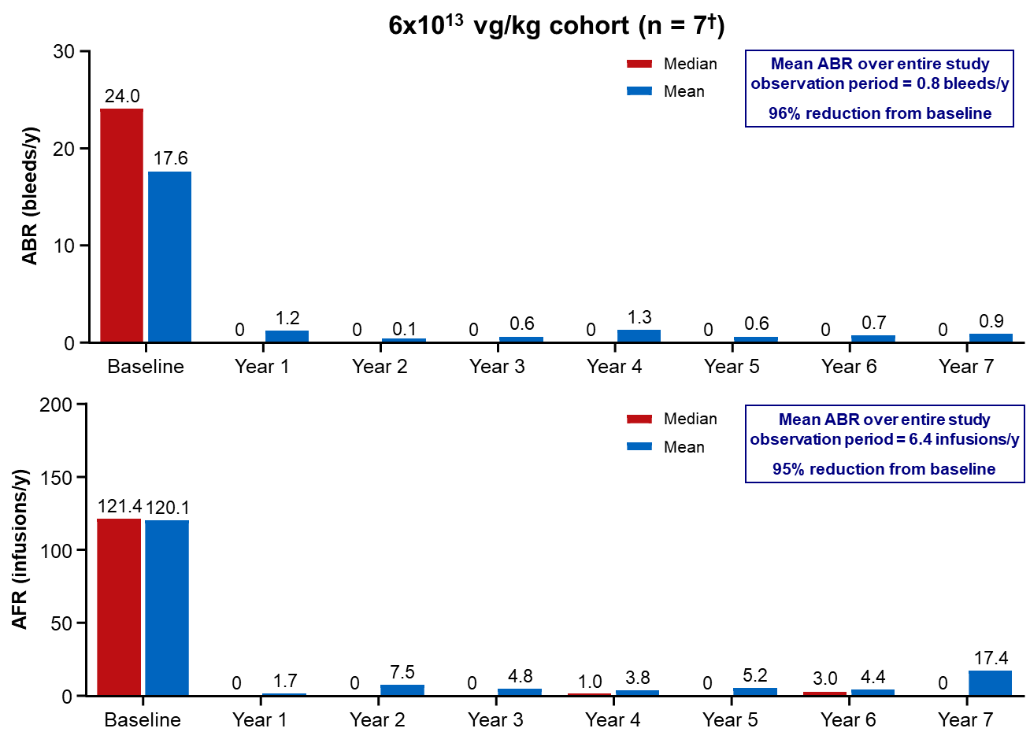
(A)

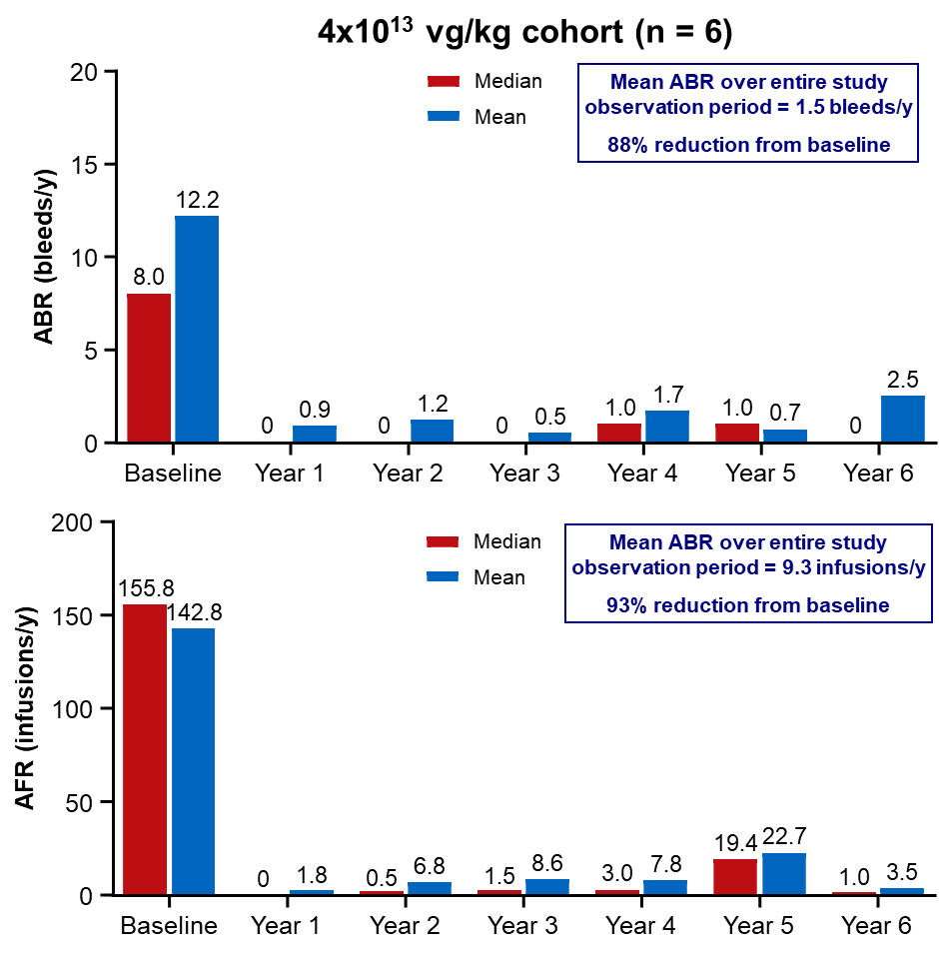
(B)

†Six of the 7 participants were receiving regular FVIII prophylaxis at baseline (1 participant was receiving on-demand FVIII prophylaxis and was excluded). Baseline (n = 6) ABR mean and median were 16.3 and 16.5 bleeds/y, and the mean ABR over the entire study was 0.77 bleeds/y, representing a 95% decrease from baseline. For these 6 participants, mean and median AFR at baseline were 135.6 infusions/y and 136.6 infusions/y, respectively, and the mean AFR over the entire study period was 7.2 infusions/y, representing a 95% reduction from baseline.
ABR, annualized bleeding rate; AFR, annualized FVIII infusion rate; FVIII, factor VIII.
Figure 2. FVIII activity over (A) 7 years for the 6x10¹³ vg/kg cohort (n = 7) and (B) 6 years for the 4x10¹³ vg/kg cohort (n = 6)
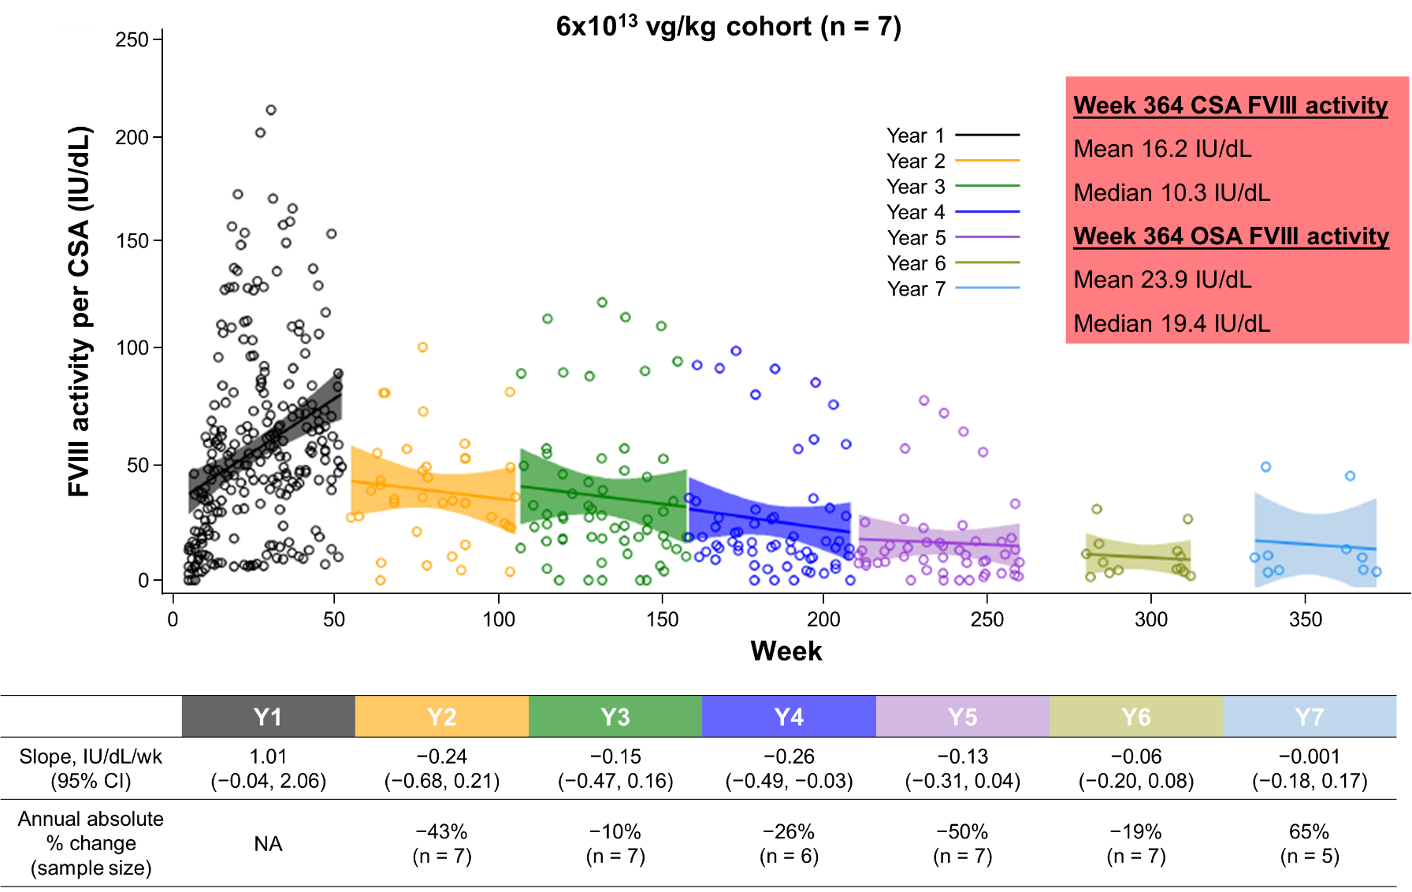
(A)

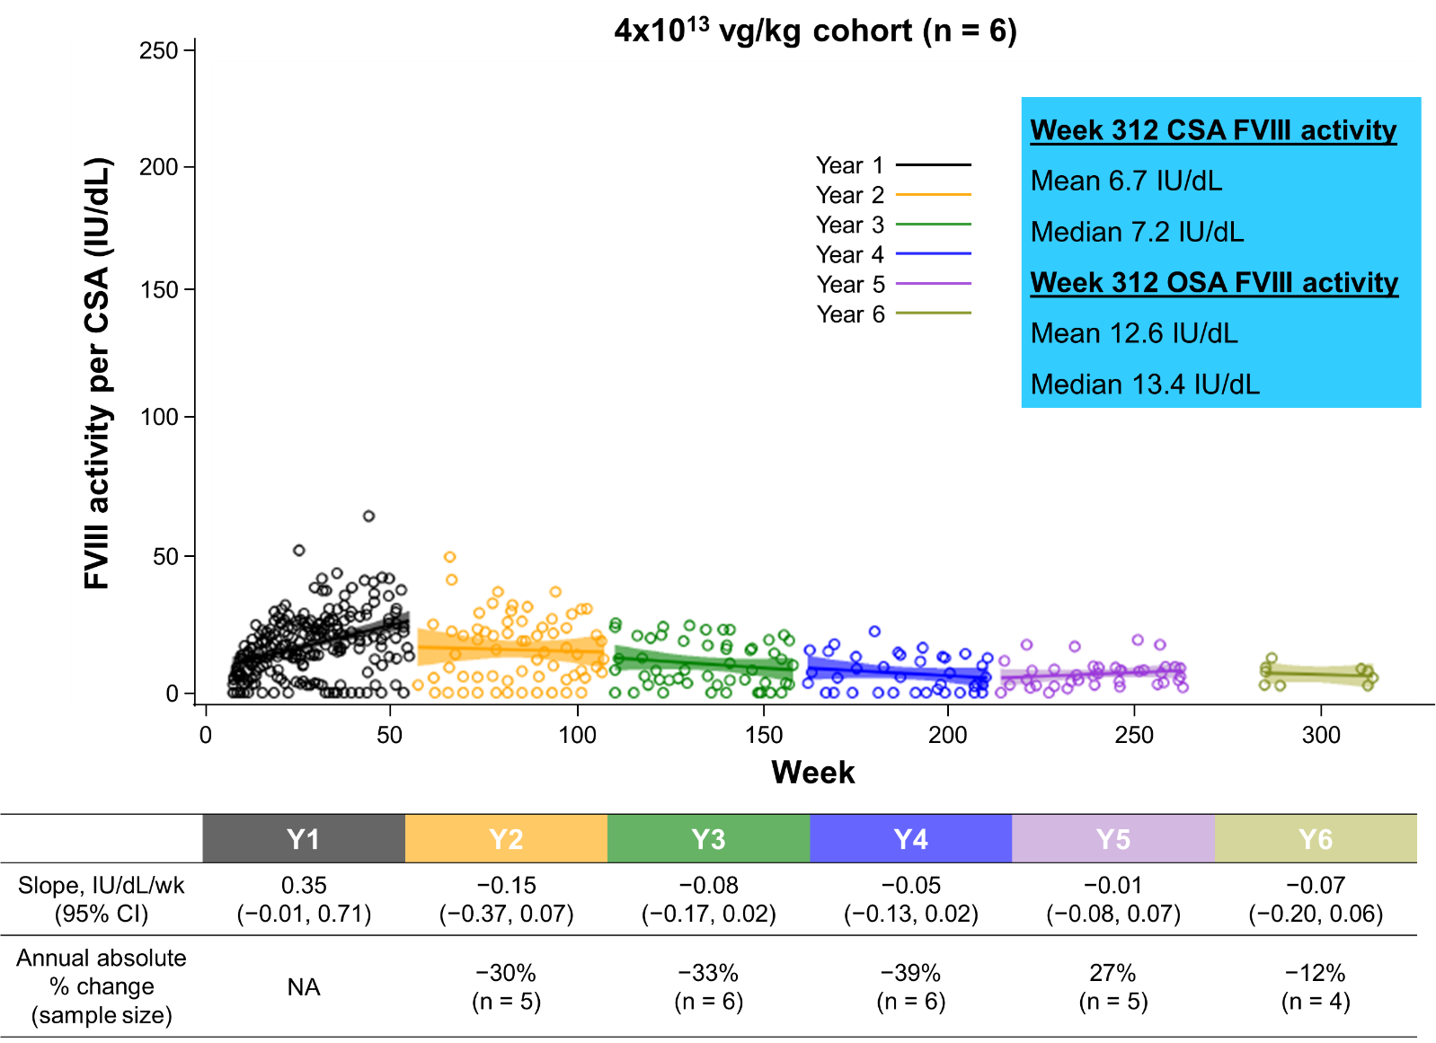
(B)
Participants who returned to prophylaxis were excluded. Missing data were not imputed. Slope (95% CI) and mean annual absolute % change are for FVIII activity per CSA.
CI, confidence interval; CSA, chromogenic substrate assay; FVIII, factor VIII; IU, international unit; NA, not applicable; OSA, one-stage assay; Y, year.

Figure 3. Individual FVIII activity trends per CSA for each participant over (A) 7 years for the 6x10¹³ vg/kg cohort (n = 7) and (B) 6 years for the 4x10¹³ vg/kg cohort (n = 6)
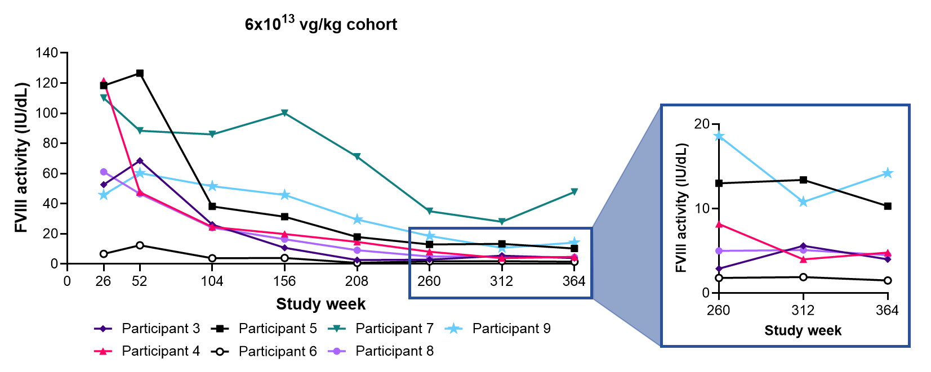
(A)

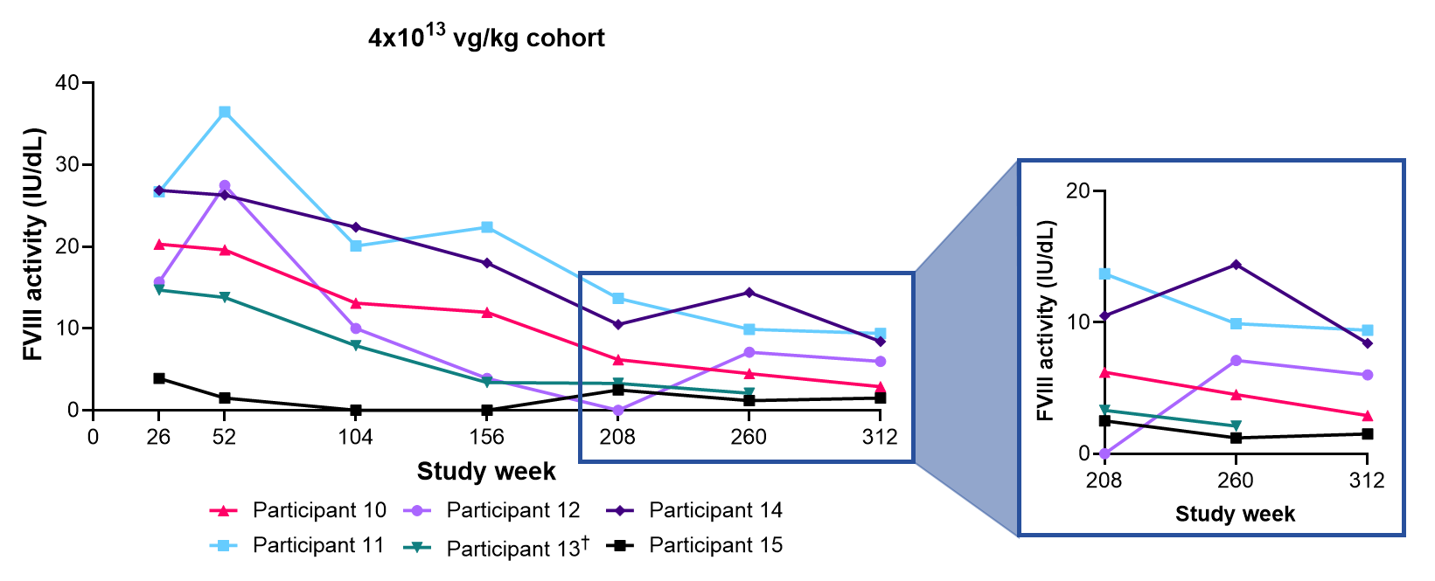
(B)

†Participant 13 lost to follow-up.
CSA, chromogenic substrate assay; FVIII, factor VIII; IU, international unit.

