Title: Screening for psychosis risk in primary mental health care services –
implementation, prevalence and recovery trajectories

Short title: High risk for psychosis in primary mental health care

Katherine Newman-Taylor^{a&b*}, Tess Maguire^{a&b}, Tanya Smart^{c}, Emma Bayford^{c}, Emily Gosden^{d}, Grace Addyman^{d}, Pete Bullard^{d}, Miriam Simmons-Dauvin^{c}, Morad Margoum^{e}, Ben Smart^{e}, and Elizabeth Gravesª

ªUniversity of Southampton, Southampton, UK
^{b}Southern Health NHS Foundation Trust, Southampton, UK
^{c}Solent NHS Trust, Portsmouth, UK
^{d}Isle of Wight NHS Trust, Isle of Wight, UK
^{e}Dorset HealthCare University NHS Foundation Trust, Bournemouth, UK

*Corresponding author: Psychology Department, University of Southampton, Building 44, Highfield Campus, Southampton, SO17 1BJ, UK

Katherine Newman-Taylor: knt@soton.ac.uk; ORCID ID: 0000-0003-1579-7959
Tess Maguire: T.L.Maguire@soton.ac.uk; ORCID ID: 0000-0002-9355-6985
Tanya Smart: Tanya.Smart@solent.nhs.uk; ORCID ID: 0000-0002-3989-3438
Emma Bayford: elb1e20@soton.ac.uk; ORCID ID: 0000-0002-1726-4884
Emily Gosden: Emily.Gosden1@nhs.net
Grace Addyman: GraceClareAddyman@gmail.com
Pete Bullard: Pete.Bullard@nhs.net
Miriam Simmons-Dauvin: Miriam.Simmons-Dauvin@solent.nhs.uk; ORCID ID: 0009-0002-2594-2902
Morad Margoum: M.Margoum@nhs.net
Ben Smart: Ben.Smart1@nhs.net
Elizabeth Graves: Lizi.Graves@southernhealth.nhs.uk; ORCID ID: 0000-0002-4525-6304

CRediT author contribution statement: Conceptualization & Methodology: Katherine Newman-Taylor, Tess Maguire, Elizabeth Graves, Pete Bullard, Morad Margoum. Funding acquisition: Katherine Newman-Taylor, Elizabeth Graves. Data curation: Elizabeth Graves. Formal analysis: Elizabeth Graves, Tess Maguire. Investigation: Tanya Smart, Emma Bayford, Emily Gosden, Grace Addyman, Pete Bullard, Miriam Simmons-Dauvin, Morad Margoum, Ben Smart. Writing–original draft: Katherine Newman-Taylor, Elizabeth Graves. Writing–review and editing: Katherine Newman-Taylor, Elizabeth Graves, Tess Maguire, Tanya Smart, Emma Bayford, Emily Gosden, Grace Addyman, Pete Bullard, Miriam Simmons-Dauvin, Morad Margoum, Ben Smart.

Abstract
Objectives: Early interventions improve outcomes for people at high risk of psychosis and are likely to be cost saving. This group tends to seek help for emotional problems – depression and anxiety – via primary care services, where early detection methods are poor. We sought to determine prevalence rates of high risk for psychosis in UK primary care mental health services, and clinical outcomes following routinely delivered psychological therapies.
Methods: We used a brief screen designed for settings with low base rates and significant time constraints to determine prevalence of high risk for psychosis in UK ‘Talking Therapies’ services. We examined socio-demographic characteristics, presenting problems, and recovery trajectories for this group, compared with people not at risk of psychosis.
Results: A 2-item screen selected for specificity yielded a prevalence rate of 3% in primary care mental health services. People at elevated risk of psychosis were younger and more likely to report at least one long-term physical condition. This group presented with higher levels of depression, anxiety and trauma symptoms at assessment, and were less likely to have recovered at the end of treatment, compared to people not at risk.
Conclusions: Very brief screening tools can be implemented in busy health care settings. The 3% of referrals to UK primary care psychological therapies services at elevated risk of psychosis typically present with more severe symptoms and greater levels of comorbidity, and may require augmented interventions to recover fully.

Key words: At-risk mental state (ARMS); clinical high risk for psychosis (CHR-P); psychotic experience; early detection; outcomes; primary care; Talking Therapies; Improving Access to Psychological Therapies (IAPT)

Data availability statement: The data that support the findings of this study are available from the corresponding author upon reasonable request.

Ethical statement: This work has been carried out in accordance with the Declaration of Helsinki. Privacy rights were observed throughout.

Funding: This project was partially funded by ESRC Impact Acceleration Award funding (ID: 519251215) and the NIHR CRN Wessex Small Grant Scheme.

Declaration of interest: None.

Acknowledgements: We thank the NHS therapists Catherine Blackburn, Keith Das, Sophie Hardy, Catherine Hiscutt, Charlotte Hodges, Adam Holleyman, Hettie Jones, Kate Spurr, and Jessica Trickett, as well as NHS Research Assistants Jessica Grange, Nicola Owens and Sophie Richards for their support in running the study, and all who participated. We thank Joel Hooper for help with the source data, and Eva McKell for her help formatting the paper.

Screening for psychosis risk in primary mental health care services –
implementation, prevalence and recovery trajectories
Abstract
Objectives: Early interventions improve outcomes for people at high risk of psychosis and are likely to be cost saving. This group tends to seek help for emotional problems – depression and anxiety – via primary care services, where early detection methods are poor. We sought to determine prevalence rates of high risk for psychosis in UK primary care mental health services, and clinical outcomes following routinely delivered psychological therapies.
Methods: We used a brief screen designed for settings with low base rates and significant time constraints to determine prevalence of high risk for psychosis in UK ‘Talking Therapies’ services. We examined socio-demographic characteristics, presenting problems, and recovery trajectories for this group, compared with people not at risk of psychosis.
Results: A 2-item screen selected for specificity yielded a prevalence rate of 3% in primary care mental health services. People at elevated risk of psychosis were younger and more likely to report at least one long-term physical condition. This group presented with higher levels of depression, anxiety and trauma symptoms at assessment, and were less likely to have recovered at the end of treatment, compared to people not at risk.
Conclusions: Very brief screening tools can be implemented in busy health care settings. The 3% of referrals to UK primary care psychological therapies services at elevated risk of psychosis typically present with more severe symptoms and greater levels of comorbidity, and may require augmented interventions to recover fully.
Key words: At-risk mental state; psychosis; psychotic experience; early detection; screening; prevalence; recovery; outcomes; primary care; Talking Therapies; Improving Access to Psychological Therapies (IAPT)
Screening for psychosis risk in primary mental health care services –
implementation, prevalence and recovery trajectories
Introduction

Early intervention improves outcomes for people at risk of psychosis [1]. A third of those at clinical high risk (CHR-P) develop psychosis within three years of initial presentation [2], yet early detection methods are poor, particularly in primary care [3]. CHR-P includes familial risk, attenuated psychotic symptoms, and/or short-lived and remitting psychotic symptoms [4]. In a recent meta-analysis of preventive interventions for people at CHR-P, Mei et al. [1] found that psychological interventions (pooled) reduced transition to psychosis by 45% at 12-months, and by 40% at 18-48-months follow-up. This was largely due to the impact of CBT which led to a reduction in incidence at 12-months (RR = 0.52, 95% CI = 0.33–0.82) and 18–48-months (RR = 0.60, 95% CI = 0.42–0.84) (cf. [3,5]). In addition to improving clinical outcomes, preventative interventions are likely to be cost-effective and cost-saving [6]. Scalability of these benefits depends on implementation of practicable screening tools and interventions in primary care.
Epidemiological analyses of national psychiatric morbidity surveys in the UK and US indicate that individuals at elevated risk of psychosis are twice as likely to seek help than those not at risk, and typically do so for emotional problems [7,8]. People who present to primary care who are CHR-P report higher levels of depression and anxiety [9,10], and depression scores may largely account for help-seeking [11]. Primary care services offering interventions for emotional problems are therefore best placed to identify and treat this group. In the UK, primary care ‘Talking Therapies’ deliver evidence-based psychological therapies for depression and anxiety [12,13].
The Comprehensive Assessment of At-Risk Mental States (CAARMS [14]) and Structured Interview for Prodromal Syndromes (SIPS [15,16]) are widely recognised as the gold standard tools for identifying CHR-P in early detection services. These interview assessments are designed to confirm CHR-P, conducted by trained clinicians, and lengthy to administer. In primary care, brief tools are required that can be used with minimal or no training.
Brief screens include the 12-item Prime Screen-Revised (PS-R [16]) with good sensitivity (100%) and specificity (> 70%); the 20- and 6-item versions of the Primary Care Checklist (PCCL [17]) with good sensitivity (89% and 88%) and more modest specificity (60% and 47%); and the 16-Item Prodromal Questionnaire (PQ-16 [18,19]) with good sensitivity (87%) and specificity (87%) (see [20,21] for reviews). While useful in specialist services and for research purposes, these measures have not been widely adopted in primary care, probably due to significant competing clinical and administrative demands. Very brief tools are needed for settings with low CHR-P base rates and significant time constraints [22]. A series of two-item screens has been developed for these settings, using Bayesian modelling of responses to previously validated measures [22].
Initial studies of CHR-P in primary care suggest that one in four people accessing services for emotional problems also report psychotic experiences [10,23,24]. Knight and colleagues [10,23] administered the 15-item CAPE [25,26] in primary mental health psychological services. The measure was completed by just 7% of the eligible caseload of participating services and identified slightly higher than general population rates of psychotic-type experiences (approximately one in five people report paranoid ideation [27]). The Knight studies also show that on average people with CHR-P benefit from interventions for depression and anxiety but are less likely to reach recovery on standardised measures at end of treatment (27%) compared with those without psychotic experiences (62%) [10]. If CHR-P is common in people accessing primary mental health services, and typically goes undetected, very brief tools are needed for use in routine practice. Additionally, a more specific measure could identify those most likely to benefit from adapted interventions designed to address the recovery gap between people with and without psychotic experiences accessing primary care for treatment of depression or anxiety.
In the current study, we used a 2-item screen in primary care mental health services to examine (a) prevalence rates of CHR-P in people seeking help for emotional problems, (b) socio-demographic characteristics and presenting problems for this group, and (c) clinical treatments and outcomes, compared with those not at elevated risk of psychosis.

Methods
The study was approved by the UK NHS Research Ethics Committee and Health Research Authority (ID: 290648), and the University of Southampton (ID: 64425), and was pre-registered on the Open Science Framework (https://osf.io/b3jca).
Design
This is a longitudinal observational study of help-seeking adults who meet criteria for primary mental health services for depression and/or anxiety.
Patient involvement
We organised a patient and public involvement (PPI) group for the study consisting of three people with direct or indirect experience (through family members) of CHR-P and accessing NHS Talking Therapies. We met with the group over the course of the project to discuss the study design, recruitment and implementation. All three members of the group highlighted the importance of asking about unusual experiences at assessment, given the impact on their lives, and reluctance to volunteer this information unless asked (due to the stigma associated with psychosis). The group emphasised the importance of asking these questions sensitively (e.g., using ‘unusual’ rather than ‘odd’ to describe the experiences), commenting on how common these are, and responding warmly and non-judgementally.
Procedure
The assessing clinician gathered routinely collected socio-demographic data (age, ethnicity, gender, relationship status, religious group, employment status, and any long-term conditions), nationally mandated patient reported outcome measures of emotional problems and impact (see Measures, below), and the 2-item CHR-P screen [22]. All information was entered into the service database, in line with routine governance procedures, and pseudonymised data were passed to the research team following removal of personally identifiable information. The screen was administered at the same point, under the same circumstances, and by the same clinicians for CHR-P and nCHR-P groups.
Participants
Three UK NHS Trusts participated in the study. Each delivers primary care ‘Talking Therapies’ comprising evidence-based psychological therapies for depression and anxiety [12,13]. Participating services in these neighbouring NHS Trusts serve a combined population of 670 000, across city, urban and rural geographical areas in the South of England.
Individuals aged 16 and above, with no upper age limit, are referred by health care clinicians or self-refer. All who accessed treatment for depression and/or anxiety between 01.10.21 and 30.09.2022, and who met service criteria (primary diagnosis of depression and/or anxiety), were assessed using the two-item screen for early psychosis. The study sample consisted of 886 participants; 444 people who responded yes to either or both of the two screening items (CHR-P) and started treatment, and 442 controls (nCHR-P) who started treatment. The control group was generated by randomly selecting the same number of individuals as were identified as CHR-P, from all others eligible for the service each month. The full sample was aged between 16 and 86 (M = 34.61, SD = 14.84), of which the majority were female (63% women; 35% men; 2% non-binary). For full demographic details, see supplementary material.
Measures
Psychotic experiences: Two-item Screens for Early Psychosis were constructed from Bayesian analyses of previously validated screening measures [22]. We used the Y-PARQ 12 (“Do you ever hear the voice of someone talking that other people cannot hear?”) and 22 (“Do you see things that others can't or don't see?”) version to optimise specificity (73%) and sensitivity (65%) in help-seeking samples.
Depressed mood: The Physical Health Questionnaire-9 (PHQ-9 [28]) is a 9-item measure of depression over the last two weeks. Items are rated on a 4-point Likert scale from 0 (not at all) to 3 (nearly every day). Responses are summed and higher scores reflect higher levels of depressed mood. Internal consistency is good (α = .89).
Anxiety: The Generalised Anxiety Disorder-7 (GAD-7 [29]) is a 7-item measure of generalised anxiety over the last two weeks. Items are rated on a 4-point Likert scale from 0 (not at all) to 3 (nearly every day). Responses are summed and higher scores reflect higher levels of depressed mood. Internal consistency is excellent (α = .92).
Functioning: The Work and Social Adjustment Scale (WSAS [30]) is a 5-item measure of impaired functioning. Items are rated on a 9-point Likert scale from 0 (not at all) to 8 (very severely). Responses are summed and higher scores reflect higher levels of impairment. Internal consistency is adequate to excellent (αs > .70).
Problem specific measures: In addition to the GAD-7, anxiety specific measures are utilised in these services as indicated by the person’s presentation. These include the Posttraumatic Stress Disorder Checklist for DSM-5 (PCL-5 [31]), a 20-item measure of PTSD symptom severity; the Health Anxiety Inventory (HAI [32]), an 18-item measure of health anxiety/hypochondriasis; the Social Phobia Inventory (SPIN [33]), a 17-item measure of social phobia; the Obsessive-Compulsive Inventory (OCI [34]), a 42-item measure of obsessive compulsive disorder, and the Panic Disorder Severity Scale (PDSS [35]), a 7-item measure of severity of panic disorder. For these measures, items are rated on Likert scales of various lengths. Responses are summed to give totals, with higher scores reflecting higher levels of distress/impairment.
Analysis plan
We calculated prevalence rates for psychosis risk using the 2-item screen. Socio-demographic, presenting problem, and patient reported outcome data were compared for people who reported psychotic experiences (CHR-P) and those who did not (nCHR-P), using t-tests for continuous variables, and chi-square for categorical data. We compared recovery trajectories based on the indices used by UK primary mental health care services, separately for measures of depression and anxiety: reliable improvement (indicative of clinically significant change, specified for each of the outcome measures), clinical change (improvement) (indicative of moving from above to below caseness), and reliable recovery (meeting criteria for both reliable improvement and clinical change (improvement)). In line with national guidelines, therapy was defined as ⩾ two sessions [36]. Finally, we compared change in outcomes pre- to post-therapy between the two groups using MANCOVA, controlling for sessions attended.
Results
Prevalence of psychotic experience
Between 01.10.21 and 30.09.22, participating services completed a total of 14,655 assessments, of which 453 were identified as CHR-P, giving a prevalence rate of 3%.
Socio-demographic characteristics
The CHR-P group (M = 32, SD = 13.78, range 16-81) was on average younger than the nCHR-P group (M = 37, SD = 15.39, range 16-86). There were also differences in rates of employment and employment type; those in the CHR-P group were less likely to be employed, more likely to be in education, and more likely to report at least one long-term condition, X² (1, N = 886) = 7.72, p = 0.005. We found no differences in gender, ethnicity, religion or reported disability. The sample was predominantly female (CHR-P = 59.2%; nCHR-P = 66.1%), White (CHR-P = 86.3%; nCHR-P = 89.4%) and not religious (CHR-P = 61.9%; nCHR-P = 55.7%). See supplementary material for full details.
Presenting problems
There were no differences between groups in presenting problem (depression or anxiety) as recorded by the assessing clinician, X² (4, N = 886) = 3.58, p = 0.47. There were differences in anxiety subtypes, X² (9, N = 101) = 35.73, p < 0.001; the CHR-P group was less likely to present with generalised anxiety disorder and more likely to present with post-traumatic stress disorder – see Figure 1.

Figure 1 about here

Treatments offered
People in the CHR-P group were more likely to receive ‘high intensity’ therapies than those in the nCHR-P group, X² (1, N = 423) = 18.0, p < 0.001 – see Figure 2. We found no differences in number of sessions attended (t = 0.19, p = 0.42), number of sessions not attended (t = -0.80, p = 0.90), or number of sessions cancelled (t = -0.80, p = 0.03).

Figure 2 about here

Clinical outcomes
The CHR-P group reported more severe depression (PHQ-9), anxiety (GAD-7), impact on functioning (WSAS), and trauma symptoms (PCL-5), at both assessment and end of therapy, compared to the nCHR-P group (see Table 1 and Figure 3). We found no differences in any other anxiety disorder specific measures (see supplementary material).

Table 1 about here

There were no differences in change scores for measures of depression (PHQ-9) between groups, though the CHR-P group (M = -4.09) showed less improvement in the measure of anxiety than the nCHR-P group (M = -4.99) (t = -2.05, p = 0.04) – see Table 1.

Figure 3 about here

Recovery trajectories differed between groups; the CHR-P group were less likely to show reliable improvement in anxiety (GAD-7), less likely to show clinical change (improvement) in depression (PHQ-9) and anxiety (GAD-7), and therefore less likely to show reliable recovery in depression (PHQ-9) and anxiety (GAD-7) – see Table 2.

Table 2 about here

We ran a two-way Multivariate Analysis of Covariance (MANCOVA) to examine whether clinical outcomes (PHQ-9 and GAD-7) differed between the two groups (CHR-P and nCHR-P) and type of therapy (whether patients received individual CBT or not), after controlling for number of sessions attended. We controlled for number of sessions because services can offer a limited number of additional sessions at clinicians’ discretion, typically for people with more complex presentations. Using Wilks’ criterion, combined clinical outcomes did not differ by group (Wilk’s Λ = 1.00, F(2, 871) = 45.13, p = 0.17, partial η² = 0.004) or type of therapy (Wilk’s Λ = 1.00, F(2, 871) = 1.08, p = 0.34, partial η² = 0.002), and we found no interaction effect (Wilk’s Λ = 1.00, F(2, 871) = 0.91, p = 0.83, partial η² <0.001), after controlling for number of sessions.

Discussion
Using a longitudinal observational design, we assessed prevalence of high psychosis risk in people seeking help for emotional problems via primary health care services, and the socio-demographic characteristics and recovery trajectories of this group. We found that 3% of all referrals were at elevated risk of psychosis (CHR-P), and that on average people in this group were younger, more likely to be in education, and more likely to report at least one long-term physical condition, compared with those not at risk of psychosis (nCHR-P). The CHR-P group presented with higher levels of depression, anxiety and trauma symptoms at assessment, and were less likely to have recovered at the end of treatment.
Our prevalence rates are considerably lower than previously found [10,23,24]. This is likely to be due to differences in specificity of screening measures. Previous studies have used the CAPE-15 which elicits frequency and distress associated with perceptual abnormalities, persecutory ideation, and bizarre experiences over three months. While this is a valid measure of psychotic experiences, busy health care services require much briefer tools. The 2-item screen used in the current study [22] was implemented as part of routine triage assessments across the three participating services, and yielded prevalence rates in line with more conservative population estimates of sub-clinical psychotic experiences [37].
The 2-item screen was selected for specificity (along with good sensitivity), and so is likely to have identified the most severe/complex sub-group of the population found by Knight and colleagues. This is supported by a recent latent analysis of previous studies’ CAPE-15 data which showed that those scoring most highly on perceptual anomalies (which are assessed by the Phalen screen used here) also score most highly on persecutory ideation and bizarre experiences [10,38].
We found that people with elevated risk of psychosis have more severe depression and anxiety at assessment and are more likely to have at least one long-term physical condition. This aligns with the emerging picture of psychotic experience as an indicator of severity and complexity in primary care settings [10,23,39]. Importantly, this group did benefit from psychological therapies for emotional problems but saw less improvement and were less likely to reach recovery at the end of treatment. These patterns align with the results of Knight et al. [10] and highlight a recovery gap between people presenting to primary mental health services with and without psychotic experiences. We do not yet know if this sub-group would benefit most from facilitated access to specialist services, or augmented therapies for emotional problems delivered in primary care settings. Insofar as this group are seeking help for their depression and/or anxiety via primary mental health services, augmented therapies for depression and/or anxiety may be most acceptable and scalable.
Limitations
CHR-P includes familial risk, attenuated psychotic symptoms, and/or short-lived and remitting psychotic symptoms [4] – we used a measure of psychotic experiences aligned with the latter two risk indicators. The Y-PARQ and 2-item versions were standardised with adolescents and young adults, while our sample included people aged 16 to 86. That said, our PPI group included adults in middle age who found the items to be relevant and the wording acceptable. Relying on self-report responses to questions about psychotic experiences may under-estimate prevalence due to stigma associated with psychosis and schizophrenia related diagnoses (cf. Skrobinska et al. [40]). Relying on routinely collected service data allowed us to gather a large, representative sample, but patient electronic data records are sometimes incomplete. For example, ethnicity data was recorded for just 35% of UK secondary care data during 2001/2002 ([41]), although primary care NHS Talking Therapies services have more robust data systems (ethnicity data was reported in 97% of our sample). Finally, the age difference we found is interesting, and future research should consider whether any discrepancy in clinical outcomes between CHR-P and nCHR-P groups varies by age, e.g., is greater for younger people.
Implications
Early detection of psychosis risk via primary care settings presents a unique opportunity to identify, engage and treat people at elevated risk of psychosis. This is likely to yield considerable health and economic benefits given evidence that psychological interventions reduce depression, anxiety [10] and transition to psychosis [1] in people at elevated risk for psychosis. This also supports current UK national guidance to increase access to CBT and not offer antipsychotic medication to people at risk for psychosis [42].
Scalability of these benefits depends on practicable screening tools. The Phalen et al. 2-item screen [22] can be used to identify people with psychotic experiences in busy primary mental health services. The UK NHS Trusts involved in the current study have incorporated this brief screen into their routine assessment process, and now use as an indicator of severity/complexity for all referrals. Patient involvement in the current study shaped implementation of the screen; we encouraged clinicians to communicate non-judgement and warmth when asking these questions given the stigma associated with psychosis.
The high rates of trauma symptoms reported by people at elevated risk of psychosis aligns with the wider literature linking early adversity and psychosis [43,44], and indicates that we should be asking about past and present trauma in our clinical practice. This can be done briefly and sensitively, weaving key questions into routine assessment processes [45].
Further research is now needed to determine how best to treat people who access primary care services for depression and/or anxiety, and whether augmented therapies for emotional problems delivered in these settings can close the recovery gap between help-seeking populations with and without psychotic experiences, and if this has an impact on subsequent transition rates for the third of people at CHR-P who are likely to go on to develop psychosis.
Conclusion
This is the first study to assess psychosis risk in primary mental health care services utilising a practicable screen designed for settings with low base rates and significant time constraints. We found that 3% of people seeking treatment for depression and/or anxiety are at risk for psychosis. This group is younger, presents with higher levels of depression, anxiety and trauma, and are less likely to have recovered at the end of treatment. Screening for psychosis risk in primary care enables early identification and treatment of particularly vulnerable individuals at a time when they are seeking help. This group are likely to require augmented interventions to recover fully.

Table 1: Outcomes at assessment and end of treatment for high and low psychosis risk groups
 | N |  | M |  | SD |  | t | p | Cohen’s d
 | CHR-P | nCHR-P | CHR-P | nCHR-P | CHR-P | nCHR-P
PHQ-9 assessment | 354 | 343 | 18.21 | 15.19 | 5.18 | 5.27 | -7.63 | <0.001** | -0.58
PHQ-9 end | 349 | 341 | 13.41 | 9.72 | 7.50 | 6.21 | -7.04 | <0.001** | -0.54
GAD-7 assessment | 354 | 343 | 14.97 | 13.66 | 4.37 | 4.38 | -3.94 | <0.001** | -0.30
GAD-7 end | 349 | 341 | 10.91 | 8.66 | 6.25 | 5.45 | -5.04 | <0.001** | -0.38
WSAS assessment | 354 | 343 | 22.26 | 19.11 | 8.87 | 8.72 | -4.73 | <0.001** | -0.36
WSAS end | 349 | 341 | 18.84 | 14.57 | 10.61 | 9.89 | -5.47 | <0.001** | -0.42
PCL-5 assessment | 258 | 240 | 8.14 | 4.33 | 20.48 | 14.95 | -2.35 | 0.02* | -0.21
PCL-5 end | 259 | 240 | 4.81 | 1.93 | 15.22 | 8.85 | -2.57 | 0.01* | -0.23
PHQ-9 change | 349 | 340 | -4.79 | -5.52 | 6.76 | 6.41 | -1.45 | 0.15 | -0.11
GAD-7 change | 349 | 340 | -4.09 | -4.99 | 5.93 | 5.66 | -2.05 | 0.04* | -0.16
Note. CHR-P, clinical high risk for psychosis; nCHR-P, not clinical high risk for psychosis; PHQ-9, Physical Health Questionnaire-9 measure of depression; GAD-7, Generalised Anxiety Disorder-7 measure of anxiety; WSAS, Work and Social Adjustment Scale measure of functioning; PCL-5, Posttraumatic Stress Disorder Checklist for DSM-5 measure of trauma symptoms. Measures taken at assessment and end of therapy. *p < 0.05. **p < 0.001.

Table 2: Recovery trajectories for high and low psychosis risk groups
 |  | N |  | %
 |  | CHR-P | nCHR-P | CHR-P | nCHR-P | X² (df) | p
PHQ-9 reliable improvement | Yes | 150 | 160 | 42.4 | 46.5 | 1.21 (1) | 0.27
 | No | 204 | 184 | 57.6 | 53.5
GAD-7 reliable improvement | Yes | 170 | 201 | 48.0 | 58.4 | 7.59 (1) | 0.006*
 | No | 184 | 143 | 52.0 | 41.6
PHQ-9 clinical change | Improvement | 117 | 161 | 33.1 | 46.8 | 15.59 (2) | <0.001**
 | No change | 233 | 176 | 65.8 | 52.1
 | Deterioration | 4 | 7 | 1.1 | 2.0
GAD-7 clinical change | Improvement | 114 | 169 | 32.2 | 49.1 | 22.70 (2) | <0.001**
 | No change | 232 | 164 | 65.5 | 47.7
 | Deterioration | 8 | 11 | 2.3 | 3.2
PHQ-9 reliable recovery | Yes | 98 | 130 | 27.7 | 37.8 | 8.10 (1) | 0.004*
 | No | 256 | 214 | 72.3 | 62.2
GAD-7 reliable recovery | Yes | 102 | 145 | 28.8 | 42.2 | 13.57 (1) | <0.001**
 | No | 252 | 199 | 71.2 | 57.8
Note. CHR-P, clinical high risk for psychosis; nCHR-P, not clinical high risk for psychosis; PHQ-9, Physical Health Questionnaire-9 measure of depression; GAD-7, Generalised Anxiety Disorder-7 measure of anxiety; WSAS, Work and Social Adjustment Scale measure of functioning; PCL-5, Posttraumatic Stress Disorder Checklist for DSM-5 measure of trauma symptoms. *p < 0.005. **p < 0.001.

Figure 1: Primary presenting problem at assessment for high and low psychosis risk groups
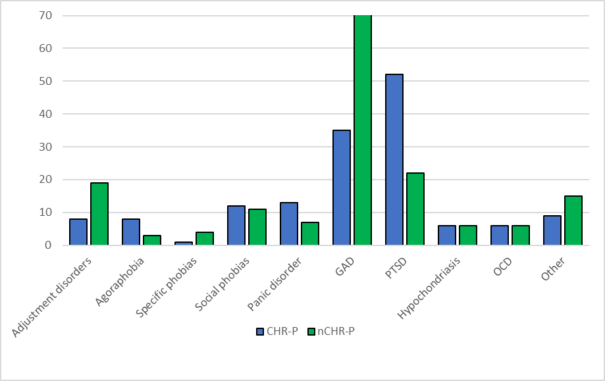
Note. Primary presenting problem at assessment for high and low psychosis risk groups. CHR-P, clinical high risk for psychosis; nCHR-P, not clinical high risk for psychosis; GAD, generalised anxiety disorder; PTSD, post-traumatic stress disorder; OCD, obsessive compulsive disorder.

Figure 2: Treatments offered to high and low psychosis risk groups

Note. CHR-P, clinical high risk for psychosis; nCHR-P, not clinical high risk for psychosis. ‘Low intensity therapies’: guided self-help, computerised CBT (cCBT) and manualised groups. ‘High intensity therapies’: individual CBT, formulation-based groups and other individual therapies.

Figure 3: Outcomes at assessment and end of treatment for high and low psychosis risk groups

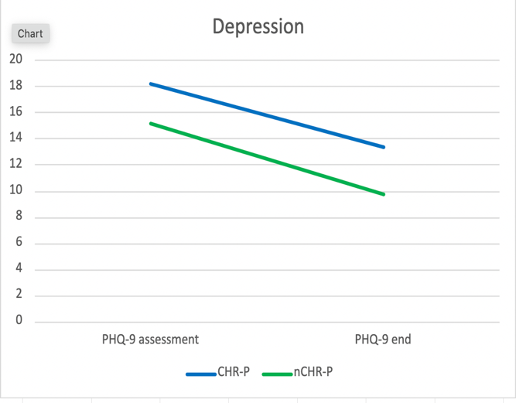
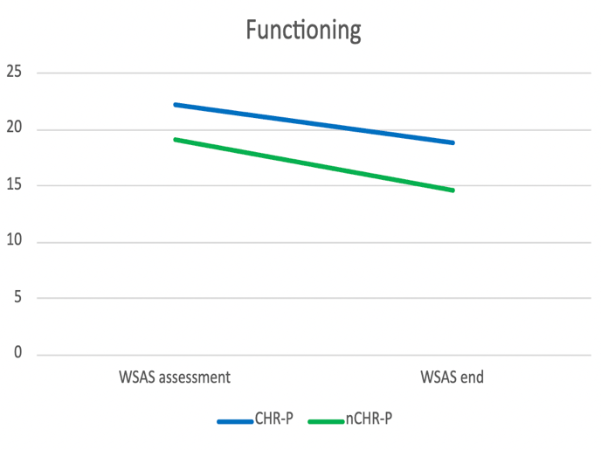
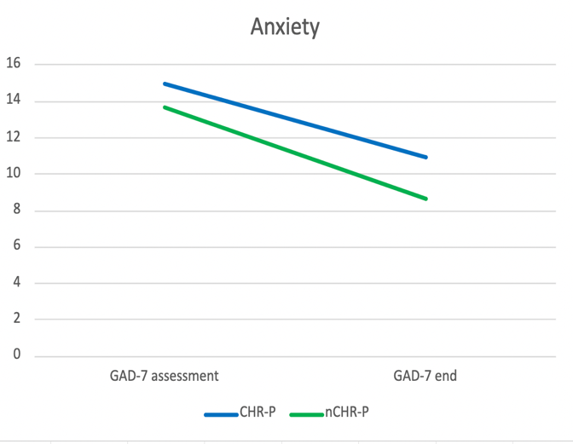
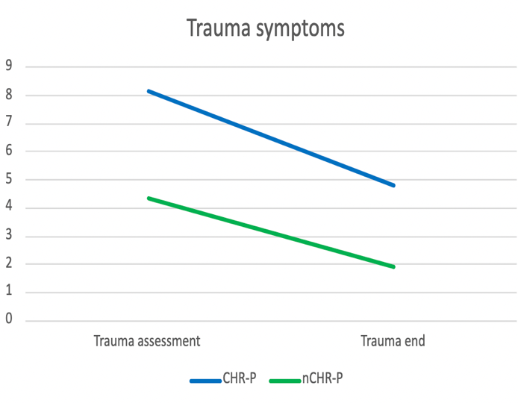

Note. CHR-P, clinical high risk for psychosis; nCHR-P, not clinical high risk for psychosis; PHQ-9, Physical Health Questionnaire-9 measure of depression; GAD-7, Generalised Anxiety Disorder-7 measure of anxiety; WSAS, Work and Social Adjustment Scale measure of functioning; PCL-5, Posttraumatic Stress Disorder Checklist for DSM-5 measure of trauma symptoms. Measures taken at assessment and end of therapy (end).

References
[1] Mei C, van der Gaag M, Nelson B, Smit F, Yuen HP, Berger M, et al. Preventive interventions for individuals at ultra high risk for psychosis: An updated and extended meta-analysis. Clin Psychol Rev 2021;86:102005. https://doi.org/10.1016/j.cpr.2021.102005.
[2] Fusar-Poli P. Predicting psychosis. Arch Gen Psychiatry 2012;69:220–9. https://doi.org/10.1001/archgenpsychiatry.2011.1472.
[3] Fusar-Poli P, Davies C, Solmi M, Brondino N, De Micheli A, Kotlicka-Antczak M, et al. Preventive treatments for psychosis: Umbrella review (just the evidence). Front Psychiatry 2019;10:764. https://doi.org/10.3389/fpsyt.2019.00764.
[4] Yung AR, McGorry PD, McFarlane CA, Jackson HJ, Patton GC, Rakkar A. Monitoring and care of young people at incipient risk of psychosis. Schizophr Bull 1996;22:283–303. https://doi.org/10.1093/schbul/22.2.283.
[5] Nelson B, Amminger GP, Thompson A, Wood SJ, Yung AR, McGorry PD. Commentary: Preventive treatments for psychosis: Umbrella review (just the evidence). Front Psychiatry 2020;11:488. https://doi.org/10.3389/fpsyt.2020.00488.
[6] Ologundudu OM. Risk stratification for treatment decisions in people at ultra-high risk for psychosis: A cost-effectiveness analysis. University of Western Ontario, 2020.
[7] DeVylder JE, Muchomba FM, Gill KE, Ben-David S, Walder DJ, Malaspina D, et al. Symptom trajectories and psychosis onset in a clinical high-risk cohort: The relevance of subthreshold thought disorder. Schizophr Res 2014;159:278–83. https://doi.org/10.1016/j.schres.2014.08.008.
[8] Murphy J, Shevlin M, Houston J, Adamson G. A population based analysis of subclinical psychosis and help-seeking behavior. Schizophr Bull 2012;38:360–7. https://doi.org/10.1093/schbul/sbq092.
[9] Heinze K, Lin A, Nelson B, Reniers RLEP, Upthegrove R, Clarke L, et al. The impact of psychotic experiences in the early stages of mental health problems in young people. BMC Psychiatry 2018;18:214. https://doi.org/10.1186/s12888-018-1767-y.
[10] Knight C, Russo D, Stochl J, Croudace T, Fowler D, Grey N, et al. Prevalence of and recovery from common mental disorder including psychotic experiences in the UK Primary Care Improving Access to Psychological Therapies (IAPT) Programme. J Affect Disord 2020;272:84–90. https://doi.org/10.1016/j.jad.2020.04.015.
[11] Kobayashi H, Nemoto T, Murakami M, Kashima H, Mizuno M. Lack of association between psychosis-like experiences and seeking help from professionals: A case-controlled study. Schizophr Res 2011;132:208–12. https://doi.org/10.1016/j.schres.2011.07.029.
[12] Wakefield S, Kellett S, Simmonds‐Buckley M, Stockton D, Bradbury A, Delgadillo J. Improving Access to Psychological Therapies (IAPT) in the United Kingdom: A systematic review and meta‐analysis of 10‐years of practice‐based evidence. British Journal of Clinical Psychology 2021;60:1–37. https://doi.org/10.1111/bjc.12259.
[13] Clark DM. Realizing the Mass Public Benefit of Evidence-Based Psychological Therapies: The IAPT Program. Annu Rev Clin Psychol 2018;14:159–83. https://doi.org/10.1146/annurev-clinpsy-050817-084833.
[14] Yung AR, O’Dwyer LE, Francey SM, Simmons MB, Nelson B. Assessing those at high risk of psychotic disorder – an experiential workshop using the comprehensive assessment of at risk mental states (CAARMS). Schizophr Res 2006;86:S82. https://doi.org/10.1016/S0920-9964(06)70244-4.
[15] Miller TJ, McGlashan TH, Woods SW, Stein K, Driesen N, Corcoran CM, et al. Symptom assessment in schizophrenic prodromal states. Psychiatric Quarterly 1999;70:273–87. https://doi.org/10.1023/A:1022034115078.
[16] Miller TJ, McGlashan TH, Rosen JL, Cadenhead K, Ventura J, McFarlane W, et al. Prodromal assessment with the Structured Interview for Prodromal Syndromes and the Scale of Prodromal Symptoms: Predictive validity, interrater reliability, and training to reliability. Schizophr Bull 2003;29:703–15. https://doi.org/10.1093/oxfordjournals.schbul.a007040.
[17] French P, Owens J, Parker S, Dunn G. Identification of young people in the early stages of psychosis: Validation of a checklist for use in primary care. Psychiatry Res 2012;200:911–6. https://doi.org/10.1016/j.psychres.2012.07.040.
[18] Ising HK, Veling W, Loewy RL, Rietveld MW, Rietdijk J, Dragt S, et al. The validity of the 16-Item version of the Prodromal Questionnaire (PQ-16) to screen for ultra high risk of developing psychosis in the general help-seeking population. Schizophr Bull 2012;38:1288–96. https://doi.org/10.1093/schbul/sbs068.
[19] Loewy RL, Bearden CE, Johnson JK, Raine A, Cannon TD. The prodromal questionnaire (PQ): Preliminary validation of a self-report screening measure for prodromal and psychotic syndromes. Schizophr Res 2005;79:117–25. https://doi.org/10.1016/j.schres.2005.03.007.
[20] Kline E, Schiffman J. Psychosis risk screening: A systematic review. Schizophr Res 2014;158:11–8. https://doi.org/10.1016/j.schres.2014.06.036.
[21] Kline E, Thompson E, Demro C, Bussell K, Reeves G, Schiffman J. Longitudinal validation of psychosis risk screening tools. Schizophr Res 2015;165:116–22. https://doi.org/10.1016/j.schres.2015.04.026.
[22] Phalen PL, Rouhakhtar PR, Millman ZB, Thompson E, DeVylder J, Mittal V, et al. Validity of a two-item screen for early psychosis. Psychiatry Res 2018;270:861–8. https://doi.org/10.1016/j.psychres.2018.11.002.
[23] Knight C, Stochl J, Soneson E, Russo DA, Jones PB, Perez J. Revisiting CAPE-P15 cut-off values to increase sensitivity for detecting psychotic experiences in primary care. Schizophr Res 2020;216:507–10. https://doi.org/10.1016/j.schres.2019.11.051.
[24] Perez J, Russo DA, Stochl J, Clarke J, Martin Z, Jassi C, et al. Common mental disorder including psychotic experiences: Trailblazing a new recovery pathway within the Improving Access to Psychological Therapies programme in England. Early Interv Psychiatry 2018;12:497–504. https://doi.org/10.1111/eip.12434.
[25] Capra C, Kavanagh DJ, Hides L, Scott J. Brief screening for psychosis-like experiences. Schizophr Res 2013;149:104–7. https://doi.org/10.1016/j.schres.2013.05.020.
[26] Capra C, Kavanagh DJ, Hides L, Scott JG. Current CAPE‐15: a measure of recent psychotic‐like experiences and associated distress. Early Interv Psychiatry 2017;11:411–7. https://doi.org/10.1111/eip.12245.
[27] Bebbington PE, McBride O, Steel C, Kuipers E, Radovanoviĉ M, Brugha T, et al. The structure of paranoia in the general population. British Journal of Psychiatry 2013;202:419–27. https://doi.org/10.1192/bjp.bp.112.119032.
[28] Kroenke K, Spitzer RL, Williams JBW. The PHQ-9. J Gen Intern Med 2001;16:606–13. https://doi.org/10.1046/j.1525-1497.2001.016009606.x.
[29] Spitzer RL, Kroenke K, Williams JBW, Löwe B. A brief measure for assessing generalized anxiety disorder. Arch Intern Med 2006;166:1092–7. https://doi.org/10.1001/archinte.166.10.1092.
[30] Mundt JC, Marks IM, Shear MK, Greist JM. The Work and Social Adjustment Scale: a simple measure of impairment in functioning. British Journal of Psychiatry 2002;180:461–4. https://doi.org/10.1192/bjp.180.5.461.
[31] Weathers FW, Marx BP, Friedman MJ, Schnurr PP. Posttraumatic Stress Disorder in DSM-5: New criteria, new measures, and implications for assessment. Psychol Inj Law 2014;7:93–107. https://doi.org/10.1007/s12207-014-9191-1.
[32] Salkovskis PM, Rimes KA, Warwick HMC, Clark DM. The Health Anxiety Inventory: development and validation of scales for the measurement of health anxiety and hypochondriasis. Psychol Med 2002;32:843–53. https://doi.org/10.1017/S0033291702005822.
[33] Connor KM, Davidson JRT, Churchill LE, Sherwood A, Weisler RH, Foa E. Psychometric properties of the Social Phobia Inventory (SPIN). British Journal of Psychiatry 2000;176:379–86. https://doi.org/10.1192/bjp.176.4.379.
[34] Foa EB, Kozak MJ, Salkovskis PM, Coles ME, Amir N. The validation of a new obsessive–compulsive disorder scale: The Obsessive–Compulsive Inventory. Psychol Assess 1998;10:206–14. https://doi.org/10.1037/1040-3590.10.3.206.
[35] Shear MK, Rucci P, Williams J, Frank E, Grochocinski V, Vander Bilt J, et al. Reliability and validity of the Panic Disorder Severity Scale: replication and extension. J Psychiatr Res 2001;35:293–6. https://doi.org/10.1016/S0022-3956(01)00028-0.
[36] NHS England. NHS Talking Therapies for anxiety and depression manual. Https://WwwEnglandNhsUk/Publication/the-Improving-Access-to-Psychological-Therapies-Manual/ 2024.
[37] van Os J, Linscott RJ, Myin-Germeys I, Delespaul P, Krabbendam L. A systematic review and meta-analysis of the psychosis continuum: evidence for a psychosis proneness–persistence–impairment model of psychotic disorder. Psychol Med 2009;39:179–95. https://doi.org/10.1017/S0033291708003814.
[38] Wiedemann A, Stochl J, Russo D, Patel U, Ashford P-A, Ali N, et al. Clinical presentation of psychotic experiences in patients with common mental disorders attending the UK primary care improving access to psychological therapies (IAPT) Programme. J Affect Disord 2024;344:233–41. https://doi.org/10.1016/j.jad.2023.10.073.
[39] Perez J, Russo DA, Stochl J, Clarke J, Martin Z, Jassi C, et al. Common mental disorder including psychotic experiences: Trailblazing a new recovery pathway within the Improving Access to Psychological Therapies programme in England. Early Interv Psychiatry 2018;12:497–504. https://doi.org/10.1111/eip.12434.
[40] Tiller J, Maguire T, Newman-Taylor K. Early intervention in psychosis services: A systematic review and narrative synthesis of barriers and facilitators to seeking access. European Psychiatry 2023;66:e92. https://doi.org/10.1192/j.eurpsy.2023.2465.
[41] Iqbal G, Gumber A, Johnson M, Szczepura A, Wilson S, Dunn J. Improving ethnicity data collection for health statistics in the UK. Divers Equal Health Care 2009;6:267–85.
[42] NICE clinical guideline [CG178]. Psychosis and schizophrenia in adults: prevention and management. NICE 2014.
[43] Kraan T, Velthorst E, Smit F, de Haan L, van der Gaag M. Trauma and recent life events in individuals at ultra high risk for psychosis: Review and meta-analysis. Schizophr Res 2015;161:143–9. https://doi.org/10.1016/j.schres.2014.11.026.
[44] Loewy RL, Corey S, Amirfathi F, Dabit S, Fulford D, Pearson R, et al. Childhood trauma and clinical high risk for psychosis. Schizophr Res 2019;205:10–4. https://doi.org/10.1016/j.schres.2018.05.003.
[45] Read J, Hammersley P, Rudegeair T. Why, when and how to ask about childhood abuse. Advances in Psychiatric Treatment 2007;13:101–10. https://doi.org/10.1192/apt.bp.106.002840.

Screening for psychosis risk in primary mental health care services –
implementation, prevalence and recovery trajectories

Supplementary material

Age for high and low psychosis risk groups

 | M |  | SD |  | Range
 | CHR-P | nCHR-P | CHR-P | nCHR-P | CHR-P | nCHR-P | t | p | Cohen’s d
Age | 32 | 37 | 13.78 | 15.39 | 16-81 | 16-86 | 5.48 | <0.001 ** | 0.37
Note. CHR-P = clinical high risk for psychosis. nCHR-P – not clinical high risk for psychosis.

Demographic characteristics for high and low psychosis risk groups

 | N |  | %
 | CHR-P | nCHR-P | CHR-P | nCHR-P | X² (df) | p
Total participants
 | 444 | 442 | 50.1 | 49.9
Gender
Female | 263 | 292 | 59.2 | 66.1 | 4.88 (2) | 0.09
Male | 168 | 142 | 37.8 | 32.1
Non-binary term specified | 13 | 8 | 2.9 | 1.8
Ethnicity
Asian | 12 | 13 | 2.7 | 2.9 | 9.83 (5) | 0.08
Black | 5 | 2 | 1.1 | 0.5
Mixed | 18 | 7 | 4.1 | 1.6
Not known/not stated | 20 | 13 | 4.5 | 2.9
Other ethnicity | 6 | 12 | 1.4 | 2.7
White | 383 | 395 | 86.3 | 89.4
Religion
Agnostic | 4 | 6 | 0.9 | 1.4 | 17.15 (10) | 0.07
Atheist | 2 | 1 | 0.5 | 0.2
Buddhist | 1 | 1 | 0.2 | 0.2
Christian | 66 | 106 | 14.9 | 24.0
Hindu | 2 | 0 | 0.5 | 0
Muslim | 11 | 12 | 2.5 | 2.7
Not religious | 275 | 246 | 61.9 | 55.7
Not specified | 6 | 8 | 1.4 | 1.8
Unknown/declined | 75 | 58 | 16.9 | 13.1
Pagan | 1 | 1 | 0.2 | 0.2
Sikh | 1 | 3 | 0.2 | 0.7
Employment status
Employed (full- or part-time or self-employed) | 175 | 262 | 39.4 | 59.3 | 38.55 (6) | <0.001**
Unemployed | 111 | 71 | 25.0 | 16.1
Student (full- or part-time) | 65 | 36 | 14.6 | 8.1
Long-term sick or disabled | 33 | 20 | 7.4 | 4.5
Maternity leave | 10 | 9 | 2.3 | 2.0
Unpaid voluntary work | 1 | 2 | 0.2 | 0.5
Not stated | 49 | 42 | 11.0 | 9.5
Long-term physical condition
Yes | 191 | 150 | 43.0 | 33.9 | 7.72 (1) | 0.005*
No | 253 | 292 | 57.0 | 66.1
Disability
Yes | 86 | 72 | 19.4 | 16.3 | 1.43 (1) | 0.231
No | 358 | 370 | 80.6 | 83.7
Presenting problem
Not specified/not known | 71 | 70 | 16.0 | 15.8 | 3.58 (4) | 0.47
Other mental health diagnoses | 6 | 3 | 1.4 | 0.7
Depression | 217 | 205 | 48.6 | 46.4
Mixed anxiety/depression | 107 | 106 | 24.1 | 24.0
Anxiety | 43 | 58 | 9.7 | 13.1
- Adjustment disorders | 8 | 19 | 5.3 | 11.6 | 35.73 (9) | <0.001**
- Agoraphobia | 8 | 3 | 5.3 | 1.8
- Specific phobias | 1 | 4 | 0.7 | 2.4
- Social phobias | 12 | 11 | 8.0 | 6.7
- Panic disorder | 13 | 7 | 8.7 | 4.3
- GAD | 35 | 71 | 23.3 | 43.3
- PTSD | 52 | 22 | 34.7 | 13.4
- Hypochondriacal disorders | 6 | 6 | 4.0 | 3.7
- Other NOS | 9 | 15 | 6.0 | 9.1
- OCD | 6 | 6 | 4.0 | 3.7
Note. CHR-P = clinical high risk for psychosis. nCHR-P – not clinical high risk for psychosis.

Sessions attended

 | M |  | SD |  | Range
 | CHR-P | nCHR-P | CHR-P | nCHR-P | CHR-P | nCHR-P | t | p | Cohen’s d
Sessions attended | 7.52 | 7.61 | 6.71 | 6.83 | 0-34 | 0-50 | 0.19 | 0.42 | 0.01
Sessions DNA | 0.98 | 0.91 | 1.23 | 1.21 | 0-6 | 0-7 | -0.80 | 0.90 | -0.05
Sessions cancelled | 1.31 | 1.22 | 1.81 | 1.66 | 0-10 | 0-11 | -0.80 | 0.03 | -0.05
Note. DNA = Did not attend

Previously ‘Improving Access to Psychological Therapies’ (IAPT) – the first freely accessible national psychological therapies service
Services also use clinical change to calculate recovery. indicative of moving from above caseness (for either depression or anxiety) to below caseness (for both depression and anxiety)
Reliable improvement: clinically significant change, specified for different scales
Clinical change (improvement): moving from above to below likely caseness for depression or anxiety
Reliable recovery: meeting criteria for both reliable improvement and clinical change (improvement)

