Supplementary File

Clinical Decision Aids and Computed Tomography Coronary Angiography in Patients with Suspected Acute Coronary Syndrome
A secondary analysis of the RAPID-CTCA trial

Kang-Ling Wang, MD, Caelan Taggart, MD, Michael McDermott, MD, Rachel O’Brien, BN, Katherine Oatey, BSc, Liza Keating, MB ChB, Robert F Storey, MD, Dirk Felmeden, MD, Nick Curzen, BM, PhD, Attila Kardos, MD, PhD, Carl Roobottom, MD, PhD, Jason E Smith, MD, Steve Goodacre, MB ChB, PhD, David E Newby, MD, PhD, and Alasdair J Gray, MB ChB, on behalf of the RAPID-CTCA Investigators

Table of Contents
Appendix 1 – Committees, Members, and Investigators
Appendix 2 – Supplementary Tables
Supplementary Table 1. Cardiac troponin assays and reference values
Supplementary Table 2. The HEART score
Supplementary Table 3. The T-MACS model
Supplementary Table 4. The GRACE score
Supplementary Table 5. Diagnostic performance for index hospital diagnosis of acute coronary syndrome by subgroup
Supplementary Table 6. Performance metrics for index hospital diagnosis of acute coronary syndrome using ‘high-risk’ thresholds
Supplementary Table 7. Diagnostic performance for 30-day coronary revascularisation by subgroup
Supplementary Table 8. Performance metrics for 30-day coronary revascularisation.
Supplementary Table 9. Improvement in the diagnostic and the prognostic performance
Supplementary Table 10. Prevalence of outcomes by T-MACS estimate and by CTCA finding
Appendix 3 – Supplementary Figures
Supplementary Figure 1. Distribution of risk groups and coronary artery disease
Supplementary Figure 2. The classification tree for index hospital diagnosis of acute coronary syndrome
Supplementary Figure 3. The classification tree for 30-day coronary revascularisation

Steering Committee
Prof Tim Coats (Chairperson, University of Leicester), Prof Alasdair Gray (Chief Investigator, University of Edinburgh), Prof Steff Lewis (Trial Statistician, University of Edinburgh), Mr Kenneth Archibald (Layperson), Mr Graham Bell (Layperson), Mr Rodney Mycock (Layperson), Dr Russell Bull (Royal Bournemouth and Christchurch Hospitals NHS Foundation Trust), Prof Gerry McCann (University of Leicester), Dr Tarun Mittal (Royal Brompton and Harefield NHS Foundation Trust), and Dr James Rudd (University of Cambridge).

Data Monitoring Committee
Prof Carrol Gamble (Chairperson, University of Liverpool), Prof Simon Carley (Manchester University NHS Foundation Trust), and Prof Simon Padley (Royal Brompton and Harefield NHS Foundation Trust).

Endpoint Adjudication Committee
Prof Nicholas Mills (University of Edinburgh), Dr Anoop Shah (London School of Hygiene and Tropical Medicine), and Dr Andrew Chapman (University of Edinburgh).

CTCA Quality Assurance Group
University Hospitals Plymouth NHS Trust – Prof Carl Roobottom, Dr Gareth Morgan-Hughes, Dr Vikram Raju, and Ms Kym Luke.
Royal Infirmary of Edinburgh – Dr Mark Jones and Dr Fergus Perks.

Participating Centres, Principal Investigators, and Research Teams
Edinburgh – Royal Infirmary of Edinburgh – Prof Alasdair Gray – Polly Black, Caroline Blackstock, Julia Grahamslaw, Mark Jones, Collette Keanie, Margaret MacLeod, Siobhan McLaughlin, Rachel O’Brien, Fergus Perks, Alyson Phillips, Ewan Pirie, Janet Summerside, Gordon Truong, Kirsty Weston, and Jennifer Wooton.
Sheffield – Northern General Hospital – Prof Steve Goodacre – Sarah Bird, Peter Brown, Hridesh Chatha, Alan Fletcher, Catherine Hill, Shery Mofidi, Hasan Qayyum, Robert Storey, Judith Sugden, and Anna Wilson.
Plymouth – Derriford Hospital – Prof Carl Roobottom and Prof Jason Smith – Alison Jeffrey, Memory Mwadeyi, Rosalyn Squire, and Peter Wafer.
Torquay – Torbay Hospital – Dr Dirk Feldman – Lesley Archer, Lisa Felmeden, Guy Gribbin, Sarah Harrison, Debbie Hughes, Philip Keeling, Ian Mahy, Allison Summerhayes, Justine Sutton, and Abdullah Yonis.
Kirkcaldy – Victoria Hospital – Dr Andrew Kinnon and Dr Ajay Yerramasu – Susan Fowler, Amanda McGregor, Karen Grey, Tom Hartley, David Szapiro, Lorraine Dinnel, and Dennis Sandeman.
Dudley – Russells Hall Hospital – Dr Robert Huggett – Julie Dean and Amy Pugh.
Reading – Royal Berkshire Hospital – Dr Liza Keating – Parminder Bhuie, James Briggs, Claire Burnett, Abby Gandy, Nicola Jacques, Sarah MacGill, Archie Speirs, and Niamh Tolan.
Bradford – Bradford Royal Infirmary – Dr Sudantha Bulugahapitiya – Craig Atkinson, Mark Kon, Carita Krannila, and Manitha Thomas.
Bournemouth – Royal Bournemouth Hospital – Dr Jehangir Din – Russell Bull, Stephanie Horler, Nicki Lakeman, Jane McLeod, Sara Nix, and Sue Thomas.
St Helier – Jersey General Hospital – Dr Andrew Mitchell – Daniel Ahlert, Christopher Edmond, Christopher Hare, Kelly Anne Kinsella, Jessica Langtree, James Speakman, and Ranjit Thomas.
Melrose – Borders General Hospital – Dr Anne Scott – Gillian Donaldson, Fiona Hall, Terry Fairbairn, and Christopher Rofe.
Newcastle – Royal Victoria Infirmary – Dr Anna Beattie – Jennifer Adams-Hall, Ange Bailey, Kris Bailey, Leslie Bremner, Ifti Haq, and Angela Phillipson.
London – University Hospital Lewisham – Dr Khalid Alfakih – Saroj David, Osman Najam, and Samia Pilgrim.
Glasgow – Glasgow Royal Infirmary – Dr Adrian Brady – Claire Adams, Ammani Brown, Andrew Dougherty, Ailsa Geddes, Karen Lang, David Lowe, Ross MacDuff, Lorraine McGregor, Giles Roditi, Susan Thornton, and Joyce Triscott.
Milton Keynes – Milton Keynes University Hospital – Prof Attila Kardos – Felicia Adjei, Antoanela Colda, Caitlin Chapman, Veronica Edgell, Michael Fell, Laszlo Halmai, Aarzoo Khan, John Northfield, Cheryl Padilla-Harris, Mike Pashler, Gill Richie, Diane Scaletta, Sarah–Beth Sunderland, Joanne Turner, Lois Vickery, Sonya Walia, Felicity Williams, Lynn Wren, and Nicola Wright.
Stoke-on-Trent – Royal Stoke University Hospital – Dr Hefin Jones – Holly Maguire and Resti Varquez.
West Bromwich – Sandwell General Hospital – Dr Derek Connolly – Anthony D’Sa, Vinoda Sharma, and Ashley Turner.
London – St Thomas' Hospital – Dr Ronak Rajani – Megan Bell, Giulia Benedetti, Kirsty Gibson, Sze Mun Mak, Rebecca Preston, Amy Raynsford, and Ruth Sanchez-Vidal.
Rotherham – Rotherham Hospital – Dr Rangasamy Muthusamy and Dr Simon Smith – Susan Biggins, Kathryn Dixon, Peter Kraut, Mwada Lawan, Victoria Murray, Tom Mwambingu, Rachel Walker, and Carol Weston.
Leeds – Leeds General Infirmary – Dr Abdel-Rahman Saif-El-Dean – Roo Byrom-Goulthorp, Michael Darby, Eunice Ikongo, Annette Johnstone, Alan Lin, and Melanie Mcginlay.
Birmingham – Queen Elizabeth Hospital Birmingham – Dr Ben Holloway – Tania Albutt, Vicky Dawson, Claire Dowling, Karen Isaacs, Cheyanne Kaila, Gareth Lewis, Nicky Mortimer, Sunitha San, Kelly Tabor, and Kealy Wright.
Redhill – East Surrey Hospital – Dr Ansuman Saha – Riaz Ahmed, Sally Collins, Sarah Davies, and Nokukhanya Ndlovu.
Southampton – Southampton General Hospital – Dr Nick Curzen – Ausami Abbas, Alison Calver, Simon Corbett, Peter Cowburn, Andrew Flett, Huon Gray, Stephen Harden, Paul Haydock, Michael Mahmoudi, John Paisey, Charles Peebles, Drew Rakhit, John Rawlins, Paul Roberts, Benoy Shah, James Shambrook, Iain Simpson, Rohit Sirohi, Wagas Ullah, Katharine Vedwan, James Wilkinson, and Arthur Yue.
Manchester – Wythenshawe Hospital – Dr Matthias Schmitt – Sarra Giannopoulou, Melanie Greaves, Stephen McGlynn, Chris Miller, Lindsay Murray, Akhila Muthuswamy, and Anie Nicholas.
Luton – Luton and Dunstable University Hospital – Dr Christopher Travill – Susan Gent and Nafisa Hussain.
London – Royal London Hospital and Whipps Cross University Hospital – Dr Ceri Davies, Prof Tim Harris, and Dr Ben Bloom – Raine Astin-Chamberlain, Olivia Bolton, Dan Martin, Lyrics Noba, Georgia Norman, Shelley Page, Helen Power, Imogen Skene, David Smith, and Jon Walters.
Worcester – Worcestershire Royal Hospital – Dr Will Roberts – Angela Doughty, Elaine Byng-Hollander, and Helen Routledge.
Belfast – Ulster Hospital – Dr Patrick Donnelly – Leah Hammond, Jayne Hutchinson, Stephanie Kelly, Susan Regan, and Aileen Smith.
Stockton-on-Tees – University Hospital of North Tees – Dr Justin Carter – Julie Gray, Sarah Purvis, and Pam Race.
Dundee – Ninewells Hospital – Dr John Irving – Christine Almaden-Boyle, Kim Bissett, Carol Blues, Jackie Duff, Scot Dundas, Shirley Fawcett, Graeme Houston, Emma Hutchison, Debbie Letham, Ann Mackintosh, Laura Meach, Laura Jayne Queripcz, and Alan Webster.
Portsmouth – Queen Alexandra Hospital – Dr Chris Vorwerk – Julian Atchley, Zoe Daly, and Kat Ellinor.
Wrexham – Wrexham Maelor Hospital – Dr Ash Basu – Richard Cowell, Helen Craddock, Rachel Hughes, Lynda Sackett, Victoria Saul, Fiona Smith, Jane Stockport, and Clare Watkins.
Basildon – Basildon University Hospital – Dr Jason Dungu – Edward Barden, Jackie Colnet, Swamy Gedeza, Laura Hoskin, Lauren Kittridge, Gracie Maloney, Claire McCormick, Anne Nicholson, Stacey Pepper, Joanne Riches, and Annaliza Sevillano.
Wolverhampton – New Cross Hospital – Dr Elisa McAlindon, Dr Sandeep Hothi, Dr David Rosewarne, and Dr Arivalagan Bapusamy – Vincent Amoah, Stacey Aulton, Victoria Cottam, Stella Metherell, Sarah Milgate, Elizabeth Radford, and Andy Smallwood.
Inverness – Raigmore Hospital – Dr Jonathan Watt – Charlotte Barr, Jonathan Broadie, David Eason, Ing-Marie Logie, Debbie McDonald, Laura O’Keeffe, Donna Patience, and Lesley Patience.
Glasgow – Queen Elizabeth University Hospital – Dr Claire McGroarty – Faheem Ahmad, Nicola Baxter, Ammani Brown, John Byrne, Damien Collison, Tracey Hopkins, Hayley King, David Lowe, Evonne McLennan, Giles Roditi, David Stobo, Mark Wilson, and Rosie Woodward.

Supplementary Table 1. Cardiac troponin assays and reference values.
 | Cardiac troponin assay | 99th centile upper reference limit
Royal Infirmary of Edinburgh, Edinburgh | Abbott ARCHITECT | 26
Northern General Hospital, Sheffield | Roche Elecsys | 14
Derriford Hospital, Plymouth | Roche Elecsys | 14
Torbay Hospital, Torquay | Roche Elecsys | 14
Victoria Hospital, Kirkcaldy | Roche Elecsys | 14
Russells Hall Hospital, Dudley | Roche Elecsys | 14
Royal Berkshire Hospital, Reading | Roche Elecsys | 14
Bradford Royal Infirmary, Bradford | Siemens ADVIA Centaur | 40
Royal Bournemouth Hospital, Bournemouth | Roche Elecsys | 14
Jersey General Hospital, St Helier | Ortho VITROS | 34
Borders General Hospital, Melrose | Abbott ARCHITECT | 26
Royal Victoria Infirmary, Newcastle | Roche Elecsys | 14
University Hospital Lewisham, London | Roche Elecsys (since March 2017) | 14
Glasgow Royal Infirmary, Glasgow | Abbott ARCHITECT | 26
Milton Keynes University Hospital, Milton Keynes | Beckman Coulter Access | 40
Royal Stoke University Hospital, Stoke-on-Trent | Siemens ADVIA Centaur | 40
Sandwell General Hospital, West Bromwich | Roche Elecsys | 14
St Thomas' Hospital, London | Roche Elecsys | 14
Rotherham Hospital, Rotherham | Siemens ADVIA Centaur | 40
Leeds General Infirmary, Leeds | Siemens ADVIA Centaur | 40
Queen Elizabeth Hospital Birmingham, Birmingham | Roche Elecsys | 14
East Surrey Hospital, Redhill | Roche Elecsys | 14
Southampton General Hospital, Southampton | Beckman Coulter Access | 40
Wythenshawe Hospital, Manchester | Abbott ARCHITECT | 26
Luton and Dunstable University Hospital, Luton | Roche Elecsys | 14
Royal London Hospital, London | Roche Elecsys (laboratory assay) | 14
Whipps Cross University Hospital, London | Siemens ADVIA Centaur | 40
Worcestershire Royal Hospital, Worcester | Roche Elecsys | 14
Ulster Hospital, Belfast | Roche Elecsys | 14
University Hospital of North Tees, Stockton-on-Tees | Beckman Coulter Access | 40
Ninewells Hospital, Dundee | Siemens Dimension Vista | 45
Queen Alexandra Hospital, Portsmouth | Beckman Coulter Access | 40
Wrexham Maelor Hospital, Wrexham | Beckman Coulter Access | 40
Basildon University Hospital, Basildon | Roche Elecsys | 14
New Cross Hospital, Wolverhampton | Abbott ARCHITECT | 26
Raigmore Hospital, Inverness | Abbott ARCHITECT (since June 2017) | 26
Queen Elizabeth University Hospital, Glasgow | Abbott ARCHITECT | 26
* Contemporary cardiac troponin assays are in italics.
† All upper reference limits are in ng/L.
‡ References are based on cardiac troponin assay analytical characteristics designated by manufacturer v052022 (https://ifcc.org/ifcc-education-division/emd-committees/committee-on-clinical-applications-of-cardiac-bio-markers-c-cb/biomarkers-reference-tables/, accessed on 16 June 2023).

Supplementary Table 2. The HEART score.
Component | Points
History (clinical suspicion of acute coronary syndrome) | Highly suspicious  Moderately suspicious  Slightly or non-suspicious | 2  1  0
ECG | ST-segment deviation  Any abnormalities except for ST-segment deviation  Normal | 2  1  0
Age, years | ≥65  45–65  ≤45 | 2  1  0
Risk factors of coronary artery disease | Three and more risk factors or a history of atherosclerotic disease  One or two risk factors  No risk factor s | 2  1  0
Cardiac troponin (at presentation) | ≥3x upper reference limit  1–3x upper reference limit  ≤1x upper reference limit | 2  1  0
* History is clinical suspicion of acute coronary syndrome rated by the treating physicians.
† ST-segment deviation includes ST-segment depression and transient ST-segment elevation.
‡ Risk factors of coronary artery disease include diabetes mellitus, hypertension, dyslipidaemia, body mass index >30 kg/m², current smoker, and family history of premature coronary artery disease (first-degree relative with coronary artery disease at <60 years).
§ A history of atherosclerotic disease includes history of myocardial infarction, coronary revascularisation, known coronary artery disease on invasive coronary angiography, cerebrovascular disease, and peripheral vascular disease.
‖ The total score is the sum of the points assigned in each component.
ECG = electrocardiogram

Supplementary Table 3. The T-MCAS model.
Component | Measurement scale
Cardiac troponin (at presentation), ng/L | Continuous
Ischaemic ECG | Dichotomous
Worsening angina | Dichotomous
Pain radiating to the right arm | Dichotomous
Sweating | Dichotomous
Vomiting | Dichotomous
Low systolic blood pressure (<100 mm Hg) at presentation | Dichotomous
* Ischaemic ECG includes ST-segment depression, transient ST-segment elevation, and T-wave inversion.
† Worsening angina is chest pain that is persistent or could not be relieved by rest or the use of nitrates.
‡ The probability of acute coronary syndrome is estimated as follows:
$$\frac{1}{1 + e^{-\left(-4.766 + 0.089 * cardiac troponin + 1.713 * ischaemic ECG + 0.847 * worsening angina + 0.607 * radiating pain + 2.058 * sweating + 1.417 * vomiting + 1.208 * low systolic blood pressure\right)}}$$
ECG = electrocardiogram

Supplementary Table 4. The GRACE score.
Component | Points
Killip class | IV  III  II  I | 59  39  20  0
Systolic blood pressure, mm Hg | ≤80  80–99  100–119  120–139  140–159  160–199  ≥200 | 58  53  43  34  24  10  0
Heart rate, beats per minute | ≥200  150–199  110–149  90–109  70–89  50–69  ≤50 | 46  38  24  15  9  3  0
Age, years | ≥90  80–89  70–79  60–69  50–59  40–49  30–39  ≤30 | 100  91  75  58  41  25  8  0
Creatinine, mg/dL | >4.00  2.00–3.99  1.60–1.99  1.20–1.59  0.80–1.19  0.40–0.79  0.00–0.39 | 28  21  13  10  7  4  1
Others | Cardiac arrest at presentation  Ischaemic ECG  Cardiac troponin (at presentation) > upper reference limit | 39  28  14
* Ischaemic ECG includes ST-segment depression and transient ST-segment elevation.
† The total score is the sum of the points assigned in each component.
ECG = electrocardiogram

Supplementary Table 5. Diagnostic performance for index hospital diagnosis of acute coronary syndrome by subgroup.
 | Overall | Subgroup
 |  | Age <65 years | Age ≥65 years | Female sex | Male sex
HEART score | 0.74 (0.71 to 0.78) | 0.77 (0.73 to 0.82) | 0.70 (0.64 to 0.76) | 0.79 (0.74 to 0.85) | 0.72 (0.67 to 0.76)
T-MACS model | 0.78 (0.74 to 0.81) | 0.80 (0.76 to 0.85) | 0.75 (0.69 to 0.80) | 0.79 (0.73 to 0.85) | 0.78 (0.74 to 0.83)
GRACE score | 0.60 (0.55 to 0.64) | 0.60 (0.54 to 0.65) | 0.56 (0.49 to 0.62) | 0.64 (0.58 to 0.71) | 0.58 (0.52 to 0.63)
CTCA | 0.80 (0.77 to 0.83) | 0.85 (0.82 to 0.89) | 0.70 (0.65 to 0.76) | 0.82 (0.78 to 0.87) | 0.77 (0.73 to 0.81)
* Values are C-statistics (95% confidence interval).
CTCA = computed tomography coronary angiography

Supplementary Table 6. Performance metrics for index hospital diagnosis of acute coronary syndrome using ‘high-risk’ thresholds.
 | Sensitivity (95% confidence interval) | Specificity (95% confidence interval) | Negative predictive value (95% confidence interval) | Positive predictive value (95% confidence interval) | No. considered high risk
HEART score | 0.42 (0.37 to 0.47) | 0.88 (0.84 to 0.91) | 0.59 (0.55 to 0.63) | 0.78 (0.72 to 0.84) | 192 (27)
T-MACS model | 0.47 (0.42 to 0.53) | 0.89 (0.85 to 0.92) | 0.62 (0.57 to 0.66) | 0.81 (0.75 to 0.86) | 209 (30)
GRACE score | 0.15 (0.12 to 0.19) | 0.89 (0.86 to 0.92) | 0.50 (0.46 to 0.54) | 0.60 (0.49 to 0.70) | 90 (13)
CTCA | 0.74 (0.69 to 0.78) | 0.79 (0.74 to 0.83) | 0.74 (0.69 to 0.79) | 0.79 (0.74 to 0.83) | 336 (48)
* High-risk’ thresholds are a HEART score of 6, a T-MACS estimate of 0.95, a GRACE score of 140, and obstructive coronary artery disease on CTCA.
CTCA = computed tomography coronary angiography

Supplementary Table 7. Diagnostic performance for 30-day coronary revascularisation by subgroup.
 | Overall | Subgroup
 |  | Age <65 years | Age ≥65 years | Female sex | Male sex
HEART score | 0.65 (0.61 to 0.70) | 0.72 (0.67 to 0.77) | 0.62 (0.56 to 0.69) | 0.77 (0.70 to 0.84) | 0.60 (0.55 to 0.66)
T-MACS model | 0.71 (0.67 to 0.75) | 0.73 (0.69 to 0.78) | 0.68 (0.61 to 0.75) | 0.74 (0.67 to 0.82) | 0.71 (0.66 to 0.75)
GRACE score | 0.49 (0.45 to 0.54) | 0.58 (0.52 to 0.64) | 0.51 (0.43 to 0.58) | 0.66 (0.58 to 0.74) | 0.55 (0.49 to 0.60)
CTCA | 0.80 (0.77 to 0.83) | 0.86 (0.83 to 0.89) | 0.72 (0.67 to 0.77) | 0.84 (0.79 to 0.90) | 0.75 (0.72 to 0.79)
* Values are C-statistics (95% confidence interval).
CTCA = computed tomography coronary angiography

Supplementary Table 8. Performance metrics for 30-day coronary revascularisation.
 | Sensitivity (95% confidence interval) | Specificity (95% confidence interval) | Negative predictive value (95% confidence interval) | Positive predictive value (95% confidence interval)
‘Low-risk’ threshold
HEART score | 0.92 (0.88 to 0.96) | 0.19 (0.15 to 0.23) | 0.84 (0.76 to 0.90) | 0.35 (0.31 to 0.39)
T-MACS model | 0.94 (0.90 to 0.97) | 0.25 (0.21 to 0.29) | 0.89 (0.83 to 0.94) | 0.37 (0.33 to 0.41)
GRACE score | 0.46 (0.39 to 0.53) | 0.55 (0.50 to 0.59) | 0.68 (0.63 to 0.73) | 0.32 (0.27 to 0.38)
CTCA | 0.97 (0.94 to 0.99) | 0.33 (0.29 to 0.38) | 0.96 (0.92 to 0.99) | 0.41 (0.37 to 0.45)
‘High-risk’ threshold
HEART score | 0.40 (0.34 to 0.47) | 0.78 (0.75 to 0.82) | 0.73 (0.69 to 0.77) | 0.47 (0.40 to 0.54)
T-MACS model | 0.50 (0.43 to 0.56) | 0.80 (0.76 to 0.83) | 0.77 (0.73 to 0.81) | 0.54 (0.47 to 0.60)
GRACE score | 0.10 (0.07 to 0.15) | 0.86 (0.82 to 0.89) | 0.67 (0.63 to 0.71) | 0.26 (0.17 to 0.36)
CTCA | 0.87 (0.82 to 0.91) | 0.70 (0.66 to 0.75) | 0.92 (0.89 to 0.95) | 0.58 (0.53 to 0.64)
* ‘Low-risk’ thresholds are a HEART score of 4, a T-MACS estimate of 0.05, a GRACE score of 109, and coronary artery disease on CTCA.
† ‘High-risk’ thresholds are a HEART score of 6, a T-MACS estimate of 0.95, a GRACE score of 140, and obstructive coronary artery disease on CTCA.
CTCA = computed tomography coronary angiography

Supplementary Table 9. Improvement in the diagnostic and the prognostic performance.
 | Overall | Improvement from clinical decision aids | p value | Improvement from CTCA | p value
Index hospital diagnosis of acute coronary syndrome
HEART score plus CTCA | 0.85 (0.82 to 0.88) | 0.10 (0.07 to 0.13) | <0.001 | 0.05 (0.03 to 0.06) | <0.001
T-MACS model plus CTCA | 0.88 (0.86 to 0.91) | 0.10 (0.07 to 0.13) | <0.001 | 0.08 (0.06 to 0.10) | <0.001
GRACE score plus CTCA | 0.80 (0.77 to 0.84) | 0.21 (0.17 to 0.25) | <0.001 | 0.00 (−0.01 to 0.02) | 0.712
30-day coronary revascularisation
HEART score plus CTCA | 0.82 (0.79 to 0.85) | 0.16 (0.13 to 0.20) | <0.001 | 0.02 (0.00 to 0.03) | 0.042
T-MACS model plus CTCA | 0.85 (0.82 to 0.88) | 0.14 (0.10 to 0.17) | <0.001 | 0.05 (0.03 to 0.07) | <0.001
GRACE score plus CTCA | 0.83 (0.80 to 0.86) | 0.34 (0.29 to 0.39) | <0.001 | 0.03 (0.01 to 0.05) | <0.001
* Values are C-statistics (95% confidence interval).
CTCA = computed tomography coronary angiography

Supplementary Table 10. Prevalence of study outcomes by T-MACS estimate and by CTCA finding.
 |  | CTCA finding
 |  | Normal coronary arteries | Non-obstructive coronary artery disease | Obstructive coronary artery disease
Index hospital diagnosis of acute coronary syndrome
T-MACS estimate | <0.05 | 0/41 (0) | 6/55 (11) | 16/37 (43)
 | 0.05–0.95 | 6/90 (7) | 39/103 (38) | 121/164 (74)
 | >0.95 | 11/32 (34) | 32/42 (76) | 127/135 (94)
30-day coronary revascularisation
T-MACS estimate | <0.05 | 0/41 (0) | 3/55 (5) | 11/37 (30)
 | 0.05–0.95 | 3/90 (3) | 9/103 (9) | 87/164 (53)
 | >0.95 | 3/32 (9) | 11/42 (26) | 98/135 (73)
CTCA = computed tomography coronary angiography

Supplementary Figure 1. Distribution of risk groups and coronary artery disease.
* The extent of coronary artery disease was based on computed tomography coronary angiography.
† Yellow bars represent normal coronary arteries.
‡ Red bars represent coronary artery disease, including both non-obstructive and obstructive coronary artery disease.
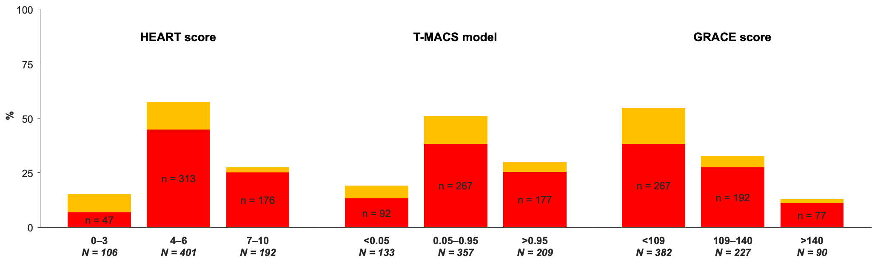

Supplementary Figure 2. The classification tree for index hospital diagnosis of acute coronary syndrome.
CI = confidence interval; CTCA = computed tomography coronary angiography; NPV = negative predictive value, PPV = positive predictive value
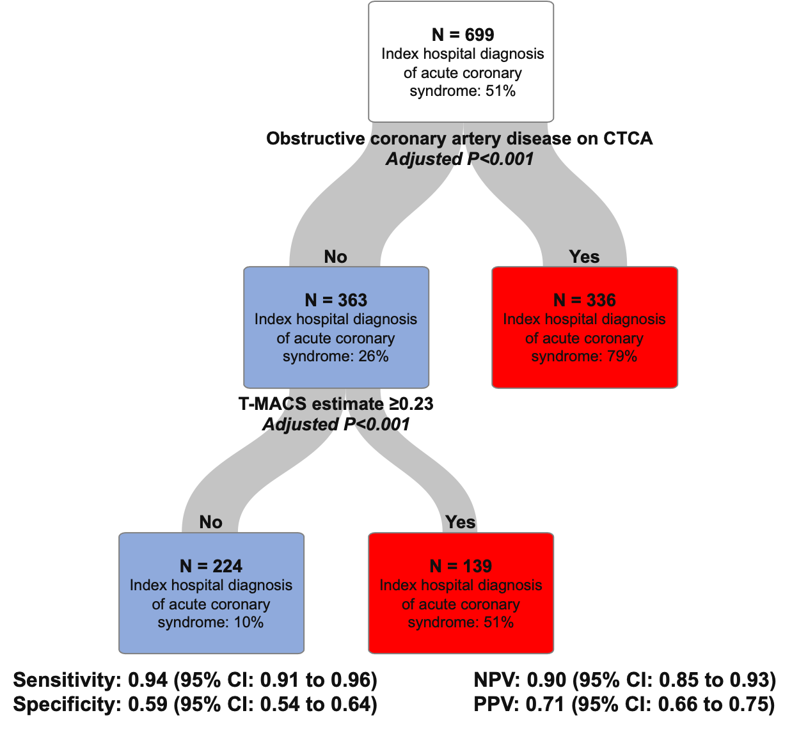

Supplementary Figure 3. The classification tree for 30-day coronary revascularisation.
CI = confidence interval; CTCA = computed tomography coronary angiography; NPV = negative predictive value, PPV = positive predictive value
