Target journal: Behavioural Processes
The role of collective behaviour in fish response to visual cues
James Miles, Andrew S. Vowles, Paul S. Kemp

The International Centre for Ecohydraulics Research, Building 178, Boldrewood Innovation Campus, Burgess Road, University of Southampton, UK, SO16 7QF.

'Declarations of interest: none'.

Abstract
This study investigated the influence of group size (individual, groups of five, and 20) on the response of common minnow to visual cues created by vertical black and white stripes over time. The stripes were displayed on a monitor either at one end of an experimental tank, while the other was uniform white, or both ends simultaneously. Reponses were compared with a control (stripes absent). Visual cues were pseudo-randomly presented every 15-minutes over six-hours. Three predictions were made: first, due to more efficient flow of information, larger groups would respond more rapidly (Rate of response) to the visual cues. Second, assuming visual cues provide a proxy for structure and larger groups experience greater benefits of group membership due to reduced predatory risk, there will be stronger association (Strength of association and Final association) with stripes for individuals and smaller groups compared with larger groups. Consequently, the association with visual cues exhibited by larger groups would diminish over time compared to smaller, more risk averse groups. As expected, larger groups exhibited a faster Rate of response to visual cues, and individual fish a greater Strength of association compared with the largest group size. Final association, however, was more common for larger groups compared to both smaller groups and individuals. Contrary to the final prediction, responses to visual cues did not decrease over time for any group size, suggesting innate behaviour or an experimental duration insufficient to observe habituation.

Keywords
Group decision making, minnow, refuge, shoal, visual ecology, environmental stimuli

Introduction
Group-living has evolved across the animal kingdom because individual members benefit from increased fitness. Although animals aggregate for a multitude of reasons, such as to reduce predation risk (Morrell et al., 2011) or find mates (Krause et al., 2002), more efficient transfer of information is likely one of the most important advantages (Ward & Webster, 2016). Larger groups often perform better at cognitive tasks, such as finding food and identifying predators, than those that are smaller (Ioannou, 2017), possibly because they have a higher probability of detecting threats or changes in their environment (MacGregor et al., 2020). Social information transfer can enhance predator detection by alerting unaware group members (Handegard et al., 2012; van der Marel et al., 2019) and consequently reduce the vigilance of individual members allowing them to allocate more time to foraging (Beauchamp, 2019) and potentially reproduction (Lima & Dill, 1990). Furthermore, larger groups tend to find food more rapidly, encouraging food-sharing and enabling members to profit from a discovery by a single member (Pitcher et al., 1982).
Vision is typically the primary sense used to organise group behaviour in fish (Ioannou et al., 2011). Those within groups often align with neighbours, e.g. as an antipredator defence when schooling (Faucher et al., 2010), or to enhance hydrodynamic performance (Ashraf et al., 2017) and improve the speed and strength of visual information transfer and collective movement (de Bie et al., 2020). However, the role of external visual stimuli in governing these behaviours is often overlooked (Odling-Smee et al., 2011; Schaerf et al., 2017). In particular, space use in relation to non-threatening visual cues has rarely been investigated, despite its importance in navigation (Odling-Smee et al., 2011; Sovrano et al., 2020), seeking refuge from predators (Valdimarsson & Metcalfe, 1998), and rheotactic response (Bak-Coleman et al., 2013).
Fish have been observed to associate with stationary cues when moving under flowing (Miles et al., 2021 for common minnow, Phoxinus phoxinus; Miles et al., 2023 for common minnow and brown trout, Salmo trutta) and static water (Sholtyssek et al., 2014 for Zebrafish, Danio rerio) conditions. This association may be explained if the visual cues provide a point of reference from which to control position and speed of movement in flowing water (the “station holding hypothesis”; Miles et al., 2021). This reasoning fails, however, when considering a similar affinity is exhibited in standing water, as observed for individual minnow that had a stronger association with visual cues than small (5 fish) groups (Miles et al., 2021). This behaviour may reflect the use of stationary visual stimuli, such as vertical black stripes, as a proxy indicator of the presence of physical structure, e.g. in which to seek shelter from a predator (the ‘Predator Refuge Hypothesis’). Furthermore, an alternative mechanism in support of this hypothesis is that a more complex background may reduce the risk of detection (Dimitrova & Merilaita, 2010; Merilaita, 2003) and predation by disrupting the body outline. A stronger preference exhibited by isolated individuals unable to benefit from the antipredator benefits of group membership may indicate a higher perceived value for such proxy shelter (Podolsrky et al., 1995). Although such explanations are logical, they remain largely speculative with little supporting evidence. Further insight is needed to the mechanisms of how group size affects the use of, or response to, stationary visual cues in static water, where the value of such cues to navigation and control of position is unlikely to be as important as when inhabiting a lotic environment.
Social context affects the behaviour of fish. In larger groups, where predation risk or the cost of exploiting resources is generally less severe than that for small groups and isolated individuals, members tend to more rapidly recover from a disturbance or discover resources (Webster et al., 2007). Conversely, members of smaller groups that in comparison are expected to experience higher predation risk exhibit reduced exploratory behaviour and increased group cohesion (Herbert-Read et al., 2017; Magurran & Pitcher, 1983). In essence, larger groups are predicted to respond to changes in their environment more rapidly, while smaller groups are driven to seek shelter and associate more strongly with visual cues. Considering this, the overall association with visual cues may be a trade-off between the rate of response on encountering them and the strength of association thereafter.
How social context, such as group membership and the size of the aggregation, influences the nature and magnitude of behavioural response exhibited over time remains unclear (Ioannou & Laskowski, 2023). Habituation is a form of non-associative learning in which an animal decreases its responsiveness to repeated stimuli (Rankin et al., 2009). For example, European perch (Perca fluviatilis) react strongly on first encountering a predator in an experimental setting, but exhibit a diminished response over time as risk taking increases (Goldenberg et al., 2014). In the case of fish response to static visual cues it is unclear whether or not this remains stable over time or diminishes with repeated exposure, and what influence, if any, group membership and size has on the process. Considering the ‘Predator Refuge Hypothesis’, multiple contradictory hypotheses may be generated. An association with a proxy indicator of refugia might be innate, and as a consequence individual fish follow a ‘rule of thumb’ so that in the absence of fatigue the response remains undiminished over time, independent of group size. Alternatively, the association with visual cues might wane as fish learn, or (in the absence of predators) gain confidence, that they are not in a threatening environment and therefore vertical stripes bestow no benefits associated with physical structure (Dimitrova & Merilaita, 2010; Merilaita, 2003). In the event of habituation, it may be expected that this is greater and more obvious in larger groups because members are less risk averse and more rapidly recover from disturbance (Webster et al., 2007).
To investigate the importance of collective behaviour over time on the response of fish to stationary visual cues under standing water conditions, individuals and groups (five or 20) of common minnow were pseudo-randomly exposed to a series of vertical black and white stripes displayed on a monitor at the ends of a tank over six hours. Focusing on testing the ‘Predator Refuge Hypothesis’, it was predicted that, compared to individuals and small groups, larger groups would: detect the visual cues more rapidly (Rate of response) (Hypothesis [H]1); but exhibit a weaker association due to the higher security associated with group membership (H2). It was also predicted that larger groups would exhibit a diminishing association over time compared to more risk averse smaller groups and individuals (H3). Association was quantified as Strength of association (the proportion of time fish spent in close proximity (<50cm) to the stripes after encountering them) and Final association (whether fish were associating with visual cues at the end of a treatment period). The change in association over time was measured across the entire trial for all three metrics.

Method

Model species and husbandry
The common minnow was selected as the model species due to their widespread distribution, ease of collection and maintenance in the laboratory, and tendency to form well defined shoals. Minnow (N = 336; length ± SD: 53.8 mm ± 5.7 mm; mass ± SD: 1.81 g ± 0.60 g) were caught in the River Itchen (Riverside Park, Southampton, UK, Lat: 50°56'05.2"N Lon: 1°22'23.9"W) on three occasions during October and November 2019 and transported in an 80 L tank containing aerated river water to the International Centre for Ecohydraulics Research (ICER) facility at the University of Southampton (UK). They were maintained in a 1200 L holding tank at a mean ± SD temperature of 15.7°C ± 1.08°C with a photoperiod of 12:12 H generated using overhead fluorescent strip lighting on an automatic timer. Feeding and water quality checks were carried out daily and water changes (20-50%) performed when necessary to ensure high quality was maintained (ammonia < 0.20 mg L⁻¹, nitrite < 0.20 mg L⁻¹, and nitrate < 50 mg L⁻¹).

Experimental setup
Experiments were conducted using a rectangular tank (1.5 m long, 0.5 m wide, 0.6 m deep, Figure 1). The base and inner side walls of the tank were covered with white laminate PVC sheeting to minimise visual cues and improve contrast between the fish and the background for automated video processing. A blackout hide erected around the tank prevented visual disturbance from external sources and indirect LED strip lighting either side of the tank (Brillihood - LED-Batten-4FT-36W, 2950 lumen, frequency peaks: 450nm & 550-600nm) provided uniform illumination during trials. A Logitech webcam (HD Pro Webcam C920; 30 fames/second, Resolution = 1080p) positioned 1.2 m above the centre of the experimental area recorded the movement and behaviour of fish during the trials.

50 cm
50 cm
50 cm
50 cm

Figure 1. Plan view of experimental setup. Black blocks at either end of an experimental tank represent the positions of the computer monitors used to assess fish response to visual cues and the clear rectangle in the centre shows the position of an overhead camera. The dashed lines represent the three equal sized zones used in the analysis.

Visual cues in the form of vertical black and white stripes (40 mm wide) were displayed on two monitors (iiyama ProLite B2283HS) positioned at each end of the tank. The width of stripes matched those used in previous studies in which the same species showed a clear response to visual cues (Miles et al., 2021). There was no evidence that the monitor refresh rate of 60 Hz effected fish behaviour and previous studies have found that flicker fusion frequencies measured in other cyprinids (e.g. zebrafish, (Makhankov, 2005) are lower than this.

Experimental Design and Protocol
Fish were allowed one hour to acclimate to the experimental tank prior to the start of each six-hour trial. A randomised complete block experimental design was used in which fish in each trial were repeatedly exposed to two visual cue treatments and a control and their response recorded over a total of 24 x 15-minute periods. Each trial comprised six blocks, each of which consisted of an initial pre-treatment control period during which both screens presented a uniform white background, followed by three successive and pseudo-randomly selected treatment periods during which three combinations of visual cues were presented as vertical black and white stripes displayed on the screens in a randomised order (six blocks of one control and three treatment periods = 24 x 15-minute periods totalling a single 6 hour trial, Figure 2). In each block, all three possible combinations of stripes (both [B], left [L], right [R] monitors, Figure 2) were presented without replacement after the initial pre-treatment control period to ensure the design was balanced and fish in each trial received all unique transitions exactly twice (e.g. from B to L, Figure 2). Accordingly, there were two visual cue treatments: Treatment 1 (T1) consisted of a single-striped end (L or R monitor while the opposite remained uniform white); and Treatment 2 (T2) presented visual cues on both monitors (B). These were compared to a control (C) during which both monitors displayed a uniform white background. The order of combinations was pseudo-randomised for each trial.
6-hour trial – 24 treatment periods
1-hour acclimatisation
15-minute treatment
15-minute controls
Figure 2. Example sequence of visual cue exposures used to assess the response of common minnow (Phoxinus phoxinus) when alone or in groups of five or 20 members. After the acclimation period, each trial consisted of six blocks of four x 15-minute periods that included a pre-treatment control (clear boxes - C) followed by three randomly selected (without replacement) treatment periods (grey boxes). The three treatments were randomly assigned to have both (B), left-only (L) and right-only [R] monitors display the visual cues.

Trials were performed between 21 October and 12 December 2019 and group treatment (individual fish or groups of five or 20) was selected pseudo-randomly. The fish were selected randomly without replacement from the holding tank and used in one trial only. A total of 42 trials (single fish: n = 15; five fish: n = 15; twenty fish: n = 12) were conducted between 08:00 and 18:00 with a single trial conducted per day. At the end of each trial, the fish were measured and weighed before being returned to a separate holding tank. Water was transferred from the holding tank to the experimental tank and 50% water changes conducted between trials. Mean ± SD water temperature in the experimental tank was 16.8 ± 0.76 °C and did not differ between group treatments (F_{1,42} = 0.14, p = 0.71).

Data processing and analysis
Fish behaviour was quantified using data extracted from video footage using a customised fish tracking algorithm in Matlab (The MathWorks, 2018) that detected fish based on differences in contrast between a mean frame and each subsequent frame. The centroid of each individual within a group and the centroid of the shoal was calculated each second during the trials. From these coordinates the following metrics were quantified: (1) Rate of response (H1) – the time taken for at least 50% of the group to enter the striped end of the tank in T1, or in the case of the control and T2 the opposite third of the tank to which they were located at the start of the treatment period. Periods in which fish did not actively move to associate with the visual cues because they were already located at the end of the tank that displayed the stripes were excluded from further analysis (Table 1). Similarly, those fish that did not enter the opposite third of the tank during the treatment period were also excluded. (2) Association (H2) was measured in two ways: (a) Strength of association, the percentage of time spent at the striped end of the tank during a treatment period after at least 50% of the group had entered the third of the tank displaying visual cues for the first time (i.e. responded to the visual cues), and (b) Final Association, the third of the tank the majority of fish were located throughout the final five minutes of a treatment period. Final association was a binary metric defined as 1 when the majority (> 50%) of the group occupied positions in the striped third of the tank for the median of the final 5 minutes of a treatment period. For the control and T2; each treatment period was allocated a randomly assigned “striped” end so that they could be statistically compared to T1. The final 5 minutes was chosen to allow time for fish to detect and respond to the change in visual cues displayed within the tank. Strength of association was measured from the first instance that the majority of fish entered the third of the tank displaying visual cues when only one-end displayed them, otherwise (for the control and T2) it was measured from the first instance that the majority of fish entered the opposite third of the tank from which they began the treatment period. Metrics were calculated for each 15-minute treatment period within trials. Change over time (H3) for each of the metrics (Rate of response, Strength of association and Final association) was measured over the entire 6-hour trial (i.e. across the 24 periods).

Statistical analysis
Statistical analysis was performed in R using linear mixed-effects models (LMM) and generalised linear mixed-effects models (GLMM) in the lme4 package (Bates et al., 2015; R Core Team, 2020). Each of the three metrics (H1: Rate of response, H2: Strength of association and Final association) were assigned as response variables in separate models with visual cue treatment (T1, T2, C), group size and treatment period as explanatory variables. An initial analysis found no significant difference between T2 and the control for each metric. Therefore, data was pooled for T2 and the control for further statistical comparison with T1. Trial number was included as a random factor in all models to control for non-independence between treatment periods. Interactions were considered and all explanatory variables were included in the final model. Change in response over time (H3) was included in each of the models as an interaction between group size and treatment period. Model fit was assessed using the DHARMa package (Hartig, 2020), and post-hoc comparisons and interactions were assessed using the phia package (De Rosario-Martinez, 2015). The Rate of response and Strength of association metrics were log and arcsine square-root transformed, respectively, to meet assumptions of normality before performing a LMM. The Final association metric was analysed using a binomial GLMM.

Ethical note
Experimental procedures were approved by the University of Southampton Ethics and Research Governance committee. Each fish was exposed to the experimental procedure once only to minimise stress. All fish were returned to an upstream section of the same river from which they were caught after use with approval from the Environment Agency. Experiments were carried out in compliance with UK Home Office regulations. Individuals were handled with care, and handling time was kept to a minimum. There was no evidence of stress or fatigue from exposure to the visual cues during the 6-hour trial time.

Results

Rate of response to visual cues (H1)
There was no difference in Rate of response between visual cue treatments and control for any group size (individuals: χ²₁ = 3.5, p = 0.18; five: χ ²₁ = 1.3, p = 0.52; twenty: χ²₁ = 0.39, p = 0.53). However, as predicted (H1) the largest groups (20 fish) moved more rapidly to the end of the tank that displayed the visual cues (T1) or to the opposite end from that where they were initially located (T2 and C) (median [IQR]: 28.5 [60.0] s) than five fish groups (median [IQR]: 65.0 [136.0] s; χ²₁= 7.0, p = 0.016) or individuals (median [IQR]: 96.0 [300.0] s; χ²₁ = 23.6, p < 0.001; Figure 3), and five fish groups responded more rapidly than single fish (χ²₁= 5.6, p = 0.018).
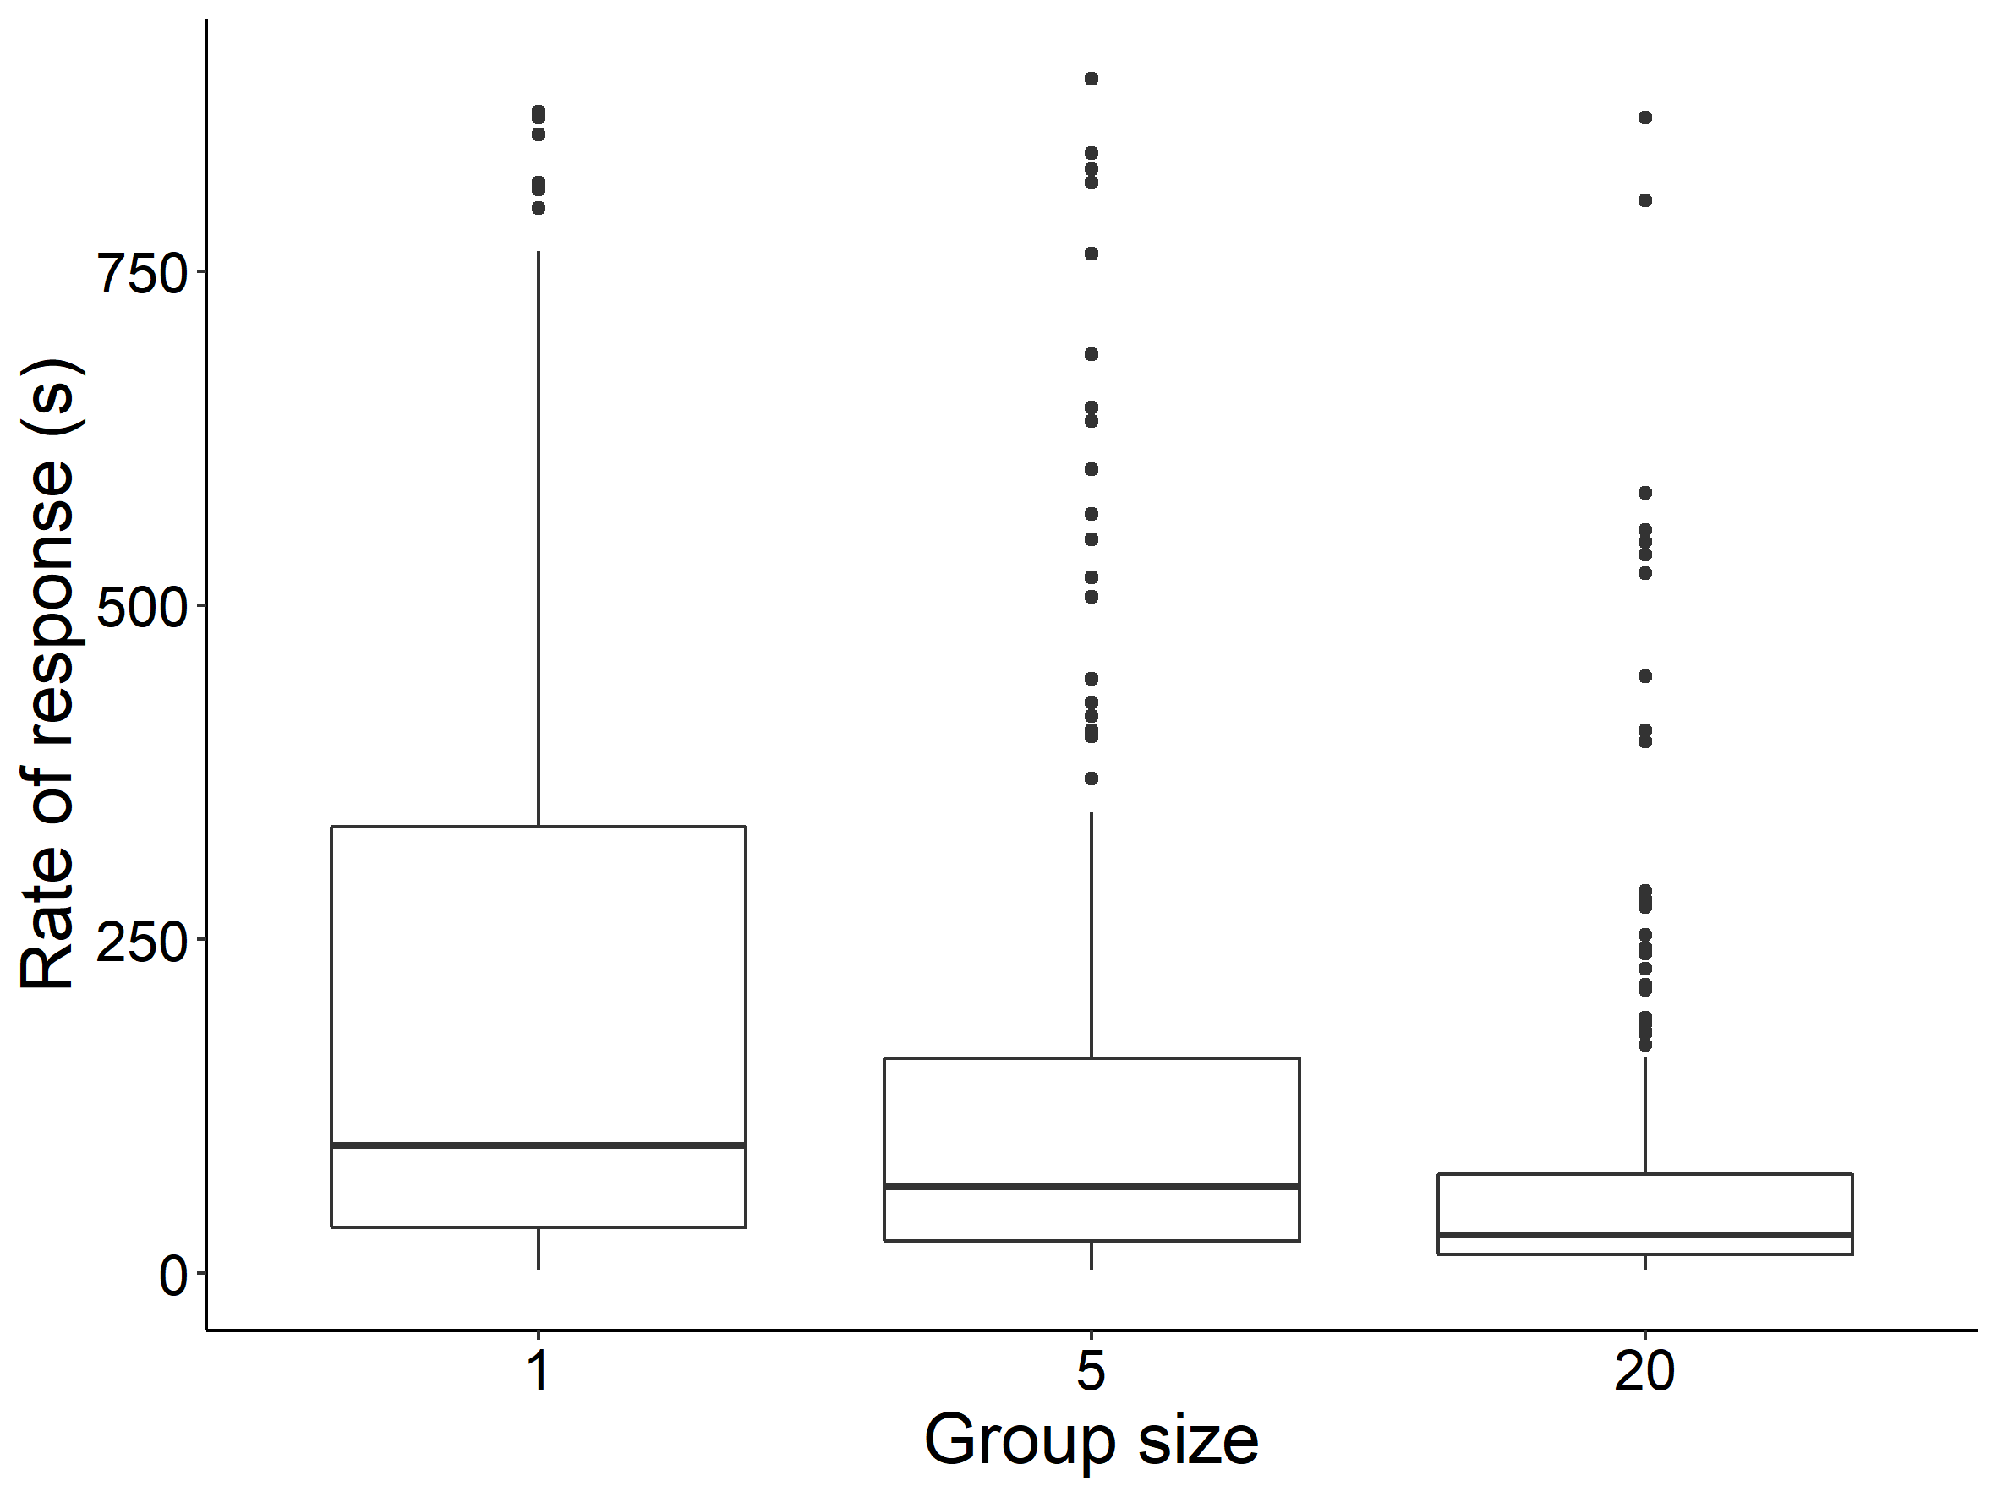
Figure 3. Median time for at least 50% of the group to move into the opposite end of the tank from which they were initially located (T2 and C) or the end displaying the visual cues (T1) (Rate of response) for all three group sizes. Data for all visual cue treatments has been combined.

Groups of twenty fish twice failed to enter the opposite third of the tank displaying the visual cues (T1) or that from where they were initially located (T2 and C), compared to 106 occasions for individual fish (Table 1). Individual minnow were least likely to explore the opposite end of the tank from where they were initially located when one screen only displayed visual cues (T1), whereas groups of five were least likely during T2. Both individuals and groups of five fish were most likely to move from one end of the tank to the opposite end during the control (Table 1).

Table 1. Percentage (%) of exposures during which fish did not enter the opposite third of the tank for each visual cue treatment and group size.
Group size | Control | T1 | T2
1 | 30.2 | 39.8 | 35.5
5 | 10.8 | 13.5 | 20.5
20 | 3.3 | 0.0 | 0.0

Association with visual cues (H2)

Strength of association
When considering all three group sizes, fish that entered the third of the tank that displayed visual cues (T1) showed a strong association, spending a median [IQR] of 72.1 [38.1]% of the remainder of the treatment period in that section compared to 49.2 [50.2]% when both screens displayed visual cues (T2) and 45.0 [41.6]% during the control. There was no difference in association between the control and T2 (χ²₁ = 2.01, p = 0.15).
In support of our second prediction (H2), the largest groups (20 fish) exhibited a weaker Strength of association with visual cues than individuals during both the control (χ²₁ = 12.3, p = 0.002) and T1 (χ²₁ = 13.2, p = 0.002). However, no difference in association was detected between individuals and groups of five fish, or between groups of five and twenty, during the control or T1 (one-five: χ²₁= 2.37, p = 0.12; five-twenty: χ²₁= 3.27, p = 0.07). All group sizes associated more strongly with visual cues in T1 compared to T2 and the control (one fish: χ²₁= 32.7, p < 0.001, five fish: χ²₁= 43.6, p < 0.001; twenty fish: χ²₁= 45.1, p < 0.001, Figure 4).
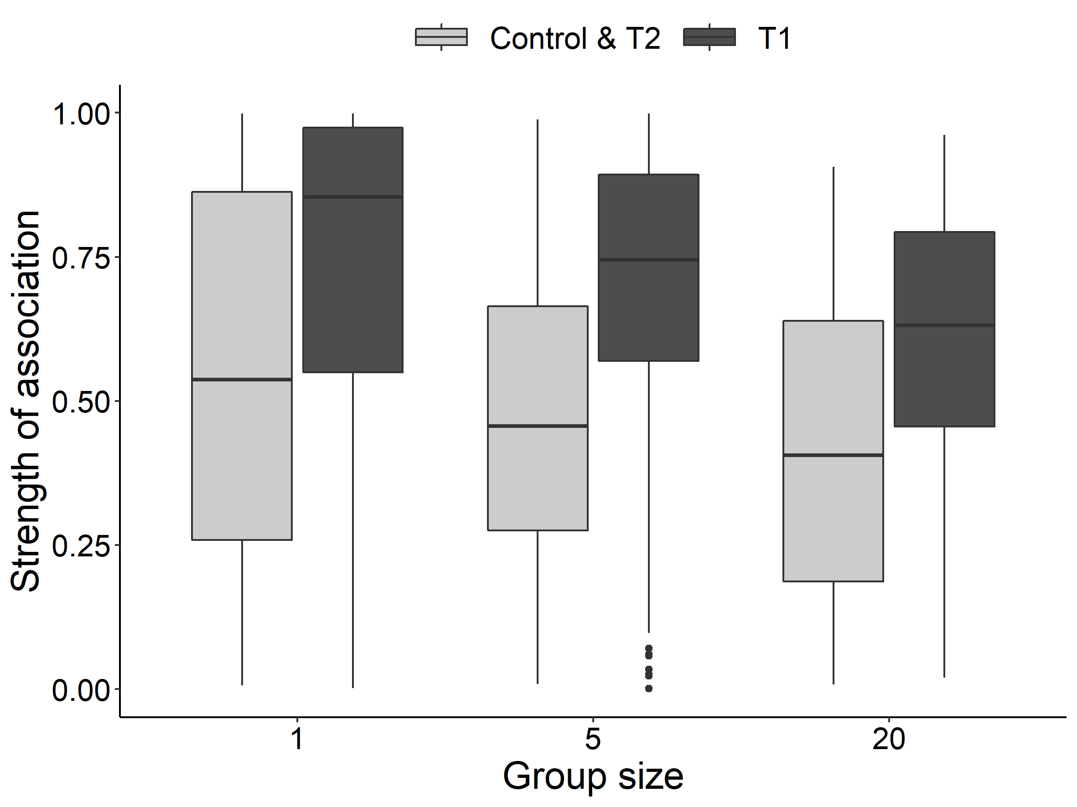
Figure 4. The proportion of time at least 50% of the group spent associating with the visual cues once they had entered the third of the tank that displayed them (T1; dark grey), or in the opposite third to that in which they were initially located once they had entered it during the control & T2 (light grey). The light grey boxes contain data from exposures during which both screens displayed visual cues (T2) and when both were uniform white (control).

Final association
During T1, groups of 20 (χ²₁ = 35.6, p < 0.001) and five (χ²₁ = 17.3, p < 0.001) fish spent the final five minutes of each treatment period associated with the striped end more often than the randomly assigned “striped” end in the control and T2. This was not observed in individuals (χ²₁ = 3.4, p = 0.07; Figure 5).
Final association was not influenced by group size during the control (χ²₁ = 0.06, p = 0.79). However, in contradiction to H2, groups of 20 and five fish more often occupied the striped end of the tank compared to individuals (twenty: χ²₁ = 20.0, p < 0.001; five: χ²₁ = 7.9, p = 0.024). For example, during T1 groups of 20 fish were more likely to associate with visual cues at the end of a treatment period, with this being the case in 83.3% of occasions compared to 75.6% for five fish and 58.0% for individuals (Figure 5). Final association did not differ between groups of 20 and five fish (χ²₁ = 3.89, p = 0.19).
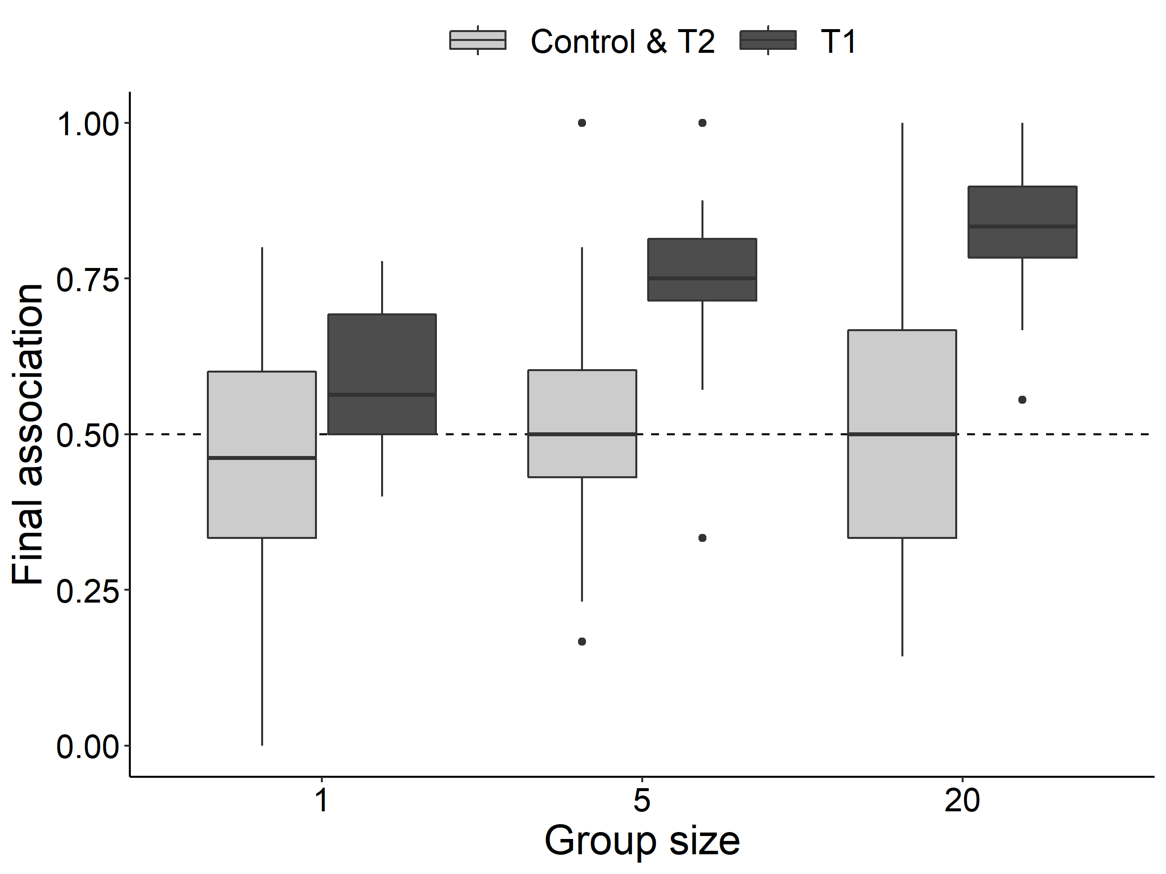
Figure 5. The proportion of exposures during which at least 50% of the group were at the (1) striped end of the tank (T1; dark grey) or (2) randomly assigned end (Control & T2; light grey) at the end of the treatment period.

Change in response to visual cues over time (H3)
In contradiction to our final prediction (H3), the Rate of response (F_{1,37} = 0.66, p = 0.41), Strength of association (F_{1,38} = 0.07, p = 0.78) and Final association (F_{1,38} = 0.01, p = 0.92) with visual cues did not change over time during the trials for any of the group sizes.

Discussion
The aim of this study was to determine how the response of fish to static visual cues is influenced by group size (individuals or shoals of five or 20 members) and how this behaviour varies over time. The experiment was conducted under standing water conditions to test the “predator refuge hypothesis” that predicts fish will associate with a black and white striped background because, in the absence of possible hydrodynamic benefits, it may provide a proxy indicator of physical structure in which to shelter from predators, or indeed search for hiding prey if a predator. An alternative, although not mutually exclusive explanation might be because a more complex background could disrupt the outline of the fish, also reducing predation risk. As expected, when presented with visual cues the larger shoals of minnow formed an association with the striped backgrounds more rapidly than the smaller groups and individuals, suggesting that a greater availability of social information provided by others led to a faster Rate of response. However, despite frequent association with visual cues at the end of each treatment period (Final association), on average this was weaker for the larger groups (Strength of association). This may be because the anti-predator benefits of group membership partially off-set the value of a complex background that is of greater importance to the smaller groups and solitary fish. Finally, and in contradiction to our third hypothesis, there was no evidence of habituation to the visual cues over the time-scales over which the experiment was conducted, as association did not diminish over time for any of the group sizes tested. Overall, our results indicated that membership of larger groups result in a more rapid Rate of response, likely due to more efficient detection of a change in the visual environment as a result of information transfer between conspecifics, and frequent Final association with the visual cues at the end of each treatment period. Furthermore, the Strength of association with visual cues was higher for individuals than for shoals, presumably because alternative anti-predator strategies are required when opportunities for group membership are absent.
In support of our first hypothesis, the largest group reacted the most rapidly to changes in the visual environment, doing so on average twice as quickly as shoals of five fish, and in approximately one-third of the time taken by individuals. However, this was irrespective of which visual cue treatment was presented, suggesting the initial movement was influenced by the abrupt change in the visual environment rather than the presentation of strong visual cues specifically. In the absence of flowing water and a predatory threat, the largest groups formed loose shoals in which members tended to be haphazardly oriented, thus enhancing the collective panoramic visual field (although potentially increasing individual occlusion by neighbours depending on position within the group (Davidson et al., 2021)), and probability of detecting, monitoring and transferring information related to changes in their environment when compared with smaller groups and individuals (MacGregor et al., 2020). A more rapid response by the largest groups was also observed when both ends of the tank displayed the stripes and under the control condition in which visual cues were absent, indicating that the increased responsiveness displayed by larger shoals may be because they were more exploratory rather than as a direct consequence of the change in visual cues. This elevated exploratory behaviour may have reflected greater safety in numbers experienced by larger groups (Mathiron et al., 2015) and the potential to maintain shoal integrity despite occasional dispersal of a proportion of individuals (Hoare et al., 2004), perhaps to access environmental information over greater spatial scales to be later shared with the wider group. In contrast, individual fish exhibited heightened antipredator responses and a reduction in exploratory behaviours compared with group members (Beauchamp, 2019; Magurran et al., 1985). Compared with groups, a large percentage of individuals failed to associate with the stripes or enter the opposite third of the tank to that in which they were located when the treatment period commenced, and particularly when visual cues were displayed at this end. Furthermore, individual fish that initially associated with visual cues tended to continue to do so. This may have been because individual fish did not have access to the additional social information afforded to group members and may have been less motivated to seek alternative refuge even though the visual cues that they initially associated with periodically disappeared. Additionally, the response from individual fish may be more heavily influenced by personal traits, such as levels of boldness, compared with larger groups. This could be reflected here as an underestimation in the rate of response as fewer fish were required to move to be considered associating with the visual cues. The slower rate of response of individuals may therefore be a consequence of the willingness of fish to respond in addition to the reduced likelihood of detection. Further work is needed to understand the influence of individual personality traits on fish response to visual cues.
In agreement with the second hypothesis, and despite responding faster to changes in the visual environment, the subsequent association with strong visual cues was weaker for the largest group size. Conversely, individuals tended to remain strongly faithful to the visual cues displayed after the initial association. Our result agrees with a previous experimental study that also found individual minnow associated more strongly with visual cues than groups of five in both static and flowing water (Miles et al., 2021), perhaps because they were more inclined to seek visual/ cryptic refuge provided by vertical black and white stripes in an otherwise homogeneous environment. The “predator refuge hypothesis” is supported by the observation that under static water conditions all three group sizes associated with visual cues after their initial encounter and the Strength of association was highest for individual fish unable to benefit from the antipredator advantages of group membership. Interestingly, the largest group exhibited more frequent Final association with the visual cues at the end of each treatment period than individuals, illustrating the importance of the complex background despite their exploratory tendencies. Larger groups of fish have been shown to make better cognitive decisions through more efficient social information transfer (Ward et al., 2011), and in this study the shoals of 20 fish were better able to rapidly respond to the presentation of strong visual cues and thus profit from any anti-predator benefits bestowed than smaller groups and individuals. The trends displayed for association between different group sizes are likely to be due to the presence of visual cues, rather than just an artifact of larger groups being more active or bolder. This is because the responses of the groups during the control and T2 differed from the responses from T1, where larger groups also spent more time associating with cues.

Our final prediction was that larger groups were more likely to habituate to changes in their visual environment over time compared to smaller groups and individuals that are more likely to remain risk averse (i.e. the association with visual cues exhibited by larger groups would diminish over time). In contradiction, we observed no temporal changes in response of any of the three group sizes relative to the metrics measured, at least not over the time-scales of this study. Minnow did not alter their association with, or Rate of response to, the display of visual cues, suggesting that the reaction is an innate behaviour and not governed by habituation. The responses appear unlikely driven by inquisitiveness, but rather an instinctive drive to associate with structure or complex backgrounds, which in turn may provide hydrodynamic refuge in the case of lotic environments, reduce predatory risk (Everett & Ruiz, 1993), or assist with spatial cognitive tasks (such as distance estimation; Sibeaux et al. 2022).
Larger groups tended to react faster and more frequently to changes in the visual environment; although once a striped background was first encountered smaller groups tended to associate more strongly. Given the reliability by which fish groups associate with visual cues, several applications may emerge; such as facilitating management of fish within aquaculture systems to improve animal welfare or reduce disease transmission (e.g. as previously trialled with artificial light: Juell & Fosseidengen, 2004). Additionally, the behaviours exhibited in this study could be exploited to develop a passive and inexpensive fish guidance technology that acts to attract fish, in a field that typically employs repellents using stimuli fish may tolerate or habituate to over time (Currie et al. 2020). Further work is needed to quantify the nature and magnitude of response to visual cues for a range of species and life-stages, in addition to validating these findings of experimental studies in field settings where visual fields are generally more complex.

This work was supported by the Natural Environment Research Council (NERC) as part of a NERC studentship [grant number 1786331]. The funders had no role in study design, data collection and analysis, decision to publish, or preparation of the manuscript.

References
Ashraf, I., Bradshaw, H., Ha, T. T., Halloy, J., Godoy-Diana, R., & Thiria, B. (2017). Simple phalanx pattern leads to energy saving in cohesive fish schooling. Proceedings of the National Academy of Sciences of the United States of America, 114(36), 9599–9604. https://doi.org/10.1073/pnas.1706503114
Bak-Coleman, J., Court, A., Paley, D. A., & Coombs, S. (2013). The spatiotemporal dynamics of rheotactic behavior depends on flow speed and available sensory information. Journal of Experimental Biology, 216(21), 4011–4024. https://doi.org/10.1242/jeb.090480
Bates, D., Mächler, M., Bolker, B. M., & Walker, S. C. (2015). Fitting linear mixed-effects models using lme4. Journal of Statistical Software, 67(1), 1–48. https://doi.org/10.18637/jss.v067.i01
Beauchamp, G. (2019). On how risk and group size interact to influence vigilance. Biological Reviews, 94(6), 1918–1934. https://doi.org/10.1111/brv.12540
Couzin, I. D., James, R., Mawdsley, D., Croft, D. P., & Krause, J. (2007). Social Organization and Information Transfer in Schooling Fishes. Fish Cognition and Behavior, 2, 166–185. https://doi.org/10.1002/9780470996058.ch9
Davidson, J. D., Sosna, M. M. G., Twomey, C. R., Sridhar, V. H., Leblanc, S. P., & Couzin, I. D. (2021). Collective detection based on visual information in animal groups. Journal of The Royal Society Interface, 18(180). https://doi.org/10.1098/rsif.2021.0142
de Bie, J., Manes, C., & Kemp, P. S. (2020). Collective behaviour of fish in the presence and absence of flow. Animal Behaviour, 167, 151–159. https://doi.org/10.1016/j.anbehav.2020.07.003
De Rosario-Martinez, H. (2015). phia: Post-Hoc Interaction Analysis. https://cran.r-project.org/package=phia
Dimitrova, M., & Merilaita, S. (2010). Prey concealment: Visual background complexity and prey contrast distribution. Behavioral Ecology, 21(1), 176–181. https://doi.org/10.1093/beheco/arp174
Everett, R. A., & Ruiz, G. M. (1993). Coarse woody debris as a refuge from predation in aquatic communities - An experimental test. Oecologia, 93(4), 475–486. https://doi.org/10.1007/BF00328954
Faucher, K., Parmentier, E., Becco, C., Vandewalle, N., & Vandewalle, P. (2010). Fish lateral system is required for accurate control of shoaling behaviour. Animal Behaviour, 79(3), 679–687. https://doi.org/10.1016/j.anbehav.2009.12.020
Goldenberg, S. U., Borcherding, J., & Heynen, M. (2014). Balancing the response to predation-the effects of shoal size, predation risk and habituation on behaviour of juvenile perch. Behavioral Ecology and Sociobiology, 68(6), 989–998. https://doi.org/10.1007/s00265-014-1711-1
Handegard, N. O., Boswell, K. M., Ioannou, C. C., Leblanc, S. P., Tjostheim, D. B., & Couzin, I. D. (2012). The dynamics of coordinated group hunting and collective information transfer among schooling prey. Current Biology, 22(13), 1213–1217. https://doi.org/10.1016/j.cub.2012.04.050
Hartig, F. (2020). DHARMa: residual diagnostics for hierarchical (Multi-Level/Mixed) regression models. The Comprehensive R Archive Network (CRAN), R package version 0.3. 2.0. https://cran.r-project.org/web/packages/DHARMa/vignettes/DHARMa.html (accessed Jul 4, 2020)
Herbert-Read, J. E., Rosén, E., Szorkovszky, A., Ioannou, C. C., Rogell, B., Perna, A., Ramnarine, I. W., Kotrschal, A., Kolm, N., Krause, J., & Sumpter, D. J. T. (2017). How predation shapes the social interaction rules of shoaling fish. Proceedings of the Royal Society B: Biological Sciences, 284(1861), 20171126. https://doi.org/10.1098/rspb.2017.1126
Hoare, D. J., Couzin, I. D., Godin, J. G. J., & Krause, J. (2004). Context-dependent group size choice in fish. Animal Behaviour, 67(1), 155–164. https://doi.org/10.1016/j.anbehav.2003.04.004
Ioannou, C. C. (2017). Swarm intelligence in fish? The difficulty in demonstrating distributed and self-organised collective intelligence in (some) animal groups. Behavioural Processes, 141, 141–151. https://doi.org/10.1016/j.beproc.2016.10.005
Ioannou, C. C., Couzin, I. D., James, R., Croft, D. P., & Krause, J. (2011). Social organisation and information transfer in schooling fish. Fish Cognition and Behavior, 2, 217–239.
Ioannou, C. C., & Laskowski, K. L. (2023). A multi-scale review of the dynamics of collective behaviour: from rapid responses to ontogeny and evolution. Philosophical Transactions of the Royal Society B: Biological Sciences, 378(1874). https://doi.org/10.1098/rstb.2022.0059
Krause, J., Ruxton, G. D., Ruxton, G., Ruxton, I. G., & others. (2002). Living in groups. Oxford University Press.
Lima, S. L., & Dill, L. M. (1990). Behavioral decisions made under the risk of predation: a review and prospectus. Canadian Journal of Zoology, 68(4), 619–640. https://doi.org/10.1139/z90-092
MacGregor, H. E. A., Herbert-Read, J. E., & Ioannou, C. C. (2020). Information can explain the dynamics of group order in animal collective behaviour. Nature Communications, 11(1), 1–8. https://doi.org/10.1038/s41467-020-16578-x
Magurran, A. E., Oulton, W. J., & Pitcher, T. J. (1985). Vigilant Behaviour and Shoal Size in Minnows. Zeitschrift Für Tierpsychologie, 67(1–4), 167–178. https://doi.org/10.1111/j.1439-0310.1985.tb01386.x
Magurran, A. E., & Pitcher, T. J. (1983). Foraging, timidity and shoal size in minnows and goldfish. Behavioral Ecology and Sociobiology, 12(2), 147–152. https://doi.org/10.1007/BF00343206
Makhankov, Y. (2005). Assessment of outer retinal function in genetically modified zebrafish larvae by electroretinography (ECG). [ETH Zurich]. In Ph.D Dissertation. http://e-collection.library.ethz.ch/eserv/eth:28238/eth- 28238-02.pdf/
Mathiron, A. G. E., Crane, A. L., & Ferrari, M. C. O. (2015). Individual vs. social learning of predator information in fish: does group size affect learning efficacy? Behavioral Ecology and Sociobiology, 69(6), 939–949. https://doi.org/10.1007/s00265-015-1905-1
Merilaita, S. (2003). Visual background complexity facilitates the evolution of camouflage. Evolution, 57(6), 1248–1254. https://doi.org/10.1111/j.0014-3820.2003.tb00333.x
Miles, J., Vowles, A. S., & Kemp, P. S. (2021). The response of common minnows, Phoxinus phoxinus, to visual cues under flowing and static water conditions. Animal Behaviour, 179, 289–296.
Morrell, L. J., Ruxton, G. D., & James, R. (2011). Spatial positioning in the selfish herd. Behavioral Ecology, 22(1), 16–22. https://doi.org/10.1093/beheco/arq157
Odling-Smee, L., Simpson, S. D., & Braithwaite, V. A. (2011). The Role of Learning in Fish Orientation. Fish Cognition and Behavior, 4(3), 166–185. https://doi.org/10.1002/9781444342536.ch8
Pitcher, T. J., Magurran, A. E., & Winfield, I. J. (1982). Fish in larger shoals find food faster. Behavioral Ecology and Sociobiology, 10(2), 149–151. https://doi.org/10.1007/BF00300175
Podolsrky, D., Uiblein, F., & Winkler, H. (1995). Visual habitat choice in cyprinid fishes: an experimental approach. Ecology of Freshwater Fish, 4(4), 160–167. https://doi.org/10.1111/j.1600-0633.1995.tb00028.x
R Core Team. (2020). R: A Language and Environment for Statistical Computing. https://www.r-project.org/
Rankin, C. H., Abrams, T., Barry, R. J., Bhatnagar, S., Clayton, D. F., Colombo, J., Coppola, G., Geyer, M. A., Glanzman, D. L., Marsland, S., McSweeney, F. K., Wilson, D. A., Wu, C. F., & Thompson, R. F. (2009). Habituation revisited: An updated and revised description of the behavioral characteristics of habituation. Neurobiology of Learning and Memory, 92(2), 135–138. https://doi.org/10.1016/j.nlm.2008.09.012
Schaerf, T. M., Dillingham, P. W., & Ward, A. J. W. (2017). The effects of external cues on individual and collective behavior of shoaling fish. Science Advances, 3(6), e1603201. https://doi.org/10.1126/sciadv.1603201
Sovrano, V. A., Baratti, G., & Lee, S. A. (2020). The role of learning and environmental geometry in landmark-based spatial reorientation of fish (Xenotoca eiseni). PloS One, 15(3), e0229608.
The MathWorks, Inc. (2018). MATLAB and Statistics Toolbox Release.
Valdimarsson, S. K., & Metcalfe, N. B. (1998). Shelter selection in juvenile Atlantic salmon, or why do salmon seek shelter in winter? Journal of Fish Biology, 52(1), 42–49.
van der Marel, A., López-Darias, M., & Waterman, J. M. (2019). Group-enhanced predator detection and quality of vigilance in a social ground squirrel. Animal Behaviour, 151, 43–52. https://doi.org/10.1016/j.anbehav.2019.02.017
Ward, A. J. W., Herbert-Read, J. E., Sumpter, D. J. T., & Krause, J. (2011). Fast and accurate decisions through collective vigilance in fish shoals. Proceedings of the National Academy of Sciences of the United States of America, 108(6), 2312–2315. https://doi.org/10.1073/pnas.1007102108
Ward, A., & Webster, M. (2016). Sociality: the behaviour of group-living animals.
Webster, M. M., Ward, A. J. W., & Hart, P. J. B. (2007). Boldness is influenced by social context in threespine sticklebacks (Gasterosteus aculeatus). Behaviour, 144(3), 351.

