Artificial neural network enabled photovoltaic-thermoelectric generator modelling and analysis

***Yuxiao Zhua, Daniel W. Newbrooka, Peng Daia, Jian Liub, Jichao Lib, Chunming Wangb, Harold M. Chonga, Kees de Groota, Ruomeng Huanga\****

aSchool of Electronics and Computer Science, University of Southampton, Southampton, United Kingdom

bSchool of Physics, Shandong University, Shandong, China

***Abstract***

With rising global energy demands and the urgent need for sustainable solutions, enhancing the efficiency of renewable energy sources is crucial. Photovoltaic-Thermoelectric Generator (PV-TEG) systems, which utilize excess heat from PV cells, offer a promising method to boost efficiency. However, optimizing these systems involves managing multiple design parameters, which is challenging due to their complexity. This study introduces a novel 3D model based on Artificial Neural Network (ANN) technology to predict the performance of hybrid PV-TEG systems. The model incorporates various factors, including PV and TEG geometry and environmental conditions. Remarkably, the ANN model demonstrates over 97.6% accuracy compared to COMSOL simulations and offers a 6,000-fold increase in simulation speed. This efficiency allows for extensive parameter sweeps and insightful analysis of PV-TEG systems. The study shows that the PV-TEG system achieves an average increase of 6% in electricity generation and a reduction in PV temperature by 7K compared to standalone PV systems. The model's rapid processing capabilities and high accuracy make it particularly beneficial for large-scale simulations and practical applications in renewable energy technology, enabling real-time data comparison and system optimization.

***Keywords:*** *photovoltaic, thermoelectric generator, artificial neural network, modelling*

|  |  |  |  |
| --- | --- | --- | --- |
| **Nomenclature** |  |  |  |
| $$P_{solar}$$ | solar irradiance (W/m2) |  | width of the N-type leg (mm) |
| $$P_{rad}$$ | radiative heat power (W/m2) |  | width of the P-type leg (mm) |
| $$P_{non-rad}$$ | non-radiative power (W/m2) |  | height of the TE leg (mm) |
|  | PV power (W/m2) |  | electrical contact resistivity (Ωm2) |
|  | average temperature of the PV (K) | $$M_{PV}$$ | morphology of PV |
| $$P_{TEG}$$ | power density of TEG (W/m2) |  | coating of PV |
|  | all power (W/m2) |  | voltage of PV (V) |
| $$A_{PV}$$ | area of PV surface (mm2) |  | ambient temperature (K) |
| $$ρ_{tc}$$ | thermal contact resistivity Km2/W |  | input heat flux of TEG (W/m2) |
|  | convection coefficient (W/(m2K)) |  |  |

***1. Introduction***

The transition to a climate-neutral society is both an urgent challenge and an opportunity to build a better future for all. As depicted in the net-zero emission (NZE) by 2050 scenario, renewable energy technologies play a central part in emission reduction across all sectors and should be accountable for 90% of all electricity generation [1]. Against the backdrop of an accelerating global pursuit of net-zero emissions, an increasingly urgent demand has emerged for innovative and high-efficiency renewable energy solutions. This has also led to an intensified focus on enhancing the efficiency of renewable energy and energy harvesting technologies. Renewable energy comprises diverse sources such as wind, tidal, and solar energy [1]. Photovoltaic (PV) systems have gained notable interest for their streamlined design and high efficiency among various renewable energy sources. Essentially, a PV device is engineered to transform light energy into electrical power. Despite advancements in PV systems, there remains a critical need to enhance their overall efficiency [2]. A typical photovoltaic model can convert around 20% of incident solar radiation into electricity, depending on the type of solar cell and climatic conditions [3]. However, a significant proportion of the remaining incident solar radiation is inadvertently converted into heat. This escalates the operational temperature of PV panels, subsequently leading to efficiency degradation, a challenge that continues to plague the domain of PV systems [4].

The dissipated heat from the PV model can be effectively harvested through the integration of energy-harvesting technologies positioned beneath it. Thermoelectric generator (TEG) is a notable energy harvesting device, proficient in capturing waste heat and directly converting thermal energy into electricity. Operating on the Seebeck effect, TEGs consist of an *n*-type semiconductor material and a *p*-type semiconductor material which are electrically connected in series and thermally in parallel across a temperature gradient, facilitating current flow between them [8][9]. Compared to other energy harvesting technologies, TEGs offer a simple configuration, maintenance-free solid-state operation, and lifetime high reliability that often significantly exceeds those of the devices they power [7].

There is an increasing number of studies on systems related to PV and heat recovery [8]. Combining TEGs with PV panels presents a promising strategy to utilize excess heat, thereby boosting the overall efficiency of the photovoltaic system and generating additional electrical power. There have been many studies in general hybrid PV and TEG systems, showing that such systems may often have higher efficiency than a single PV system. Goldsmid studied solar thermoelectric generation at 1980 [9]. Bjørk studied the performance of PV and TEG systems [10]. Later, Sundarraj reviewed recent research related to thermoelectric materials and solar thermoelectric generators [11]. Then Saleh reviewed the research on hybrid PV-TEG systems [12]. However, the integration of two models together adds to the complexity of the structure design and optimisation. It is therefore imperative to construct a robust model that enables quick and accurate simulation of the performance of the PV-TEG system. However, the development of such a model presents significant challenges. For example, Bjørk *et al.* developed an analytical model to study the PV-TEG system with different PV materials [10]. However, this work estimates the efficiencies of both PV and TEG through an analytical approach. Apart from material variation, all parameters are held constant, thereby constraining the model's versatility for application. Fini *et al.* developed a one-dimensional PV-TEG mathematical model and verified it through experiments [13]. Makki *et al.* developed a one-dimensional mathematical model of PV-TEG with hot pipe [14]. In this model, the primary variables are limited to the ambient temperature, wind speed, and solar radiation while other important parameters for the PV and TEG models are kept constant. The limited scope of these variables indicates that the model may lack broad generalizability. Babu *et al.* developed a one-dimensional PV-TEG mathematical model to analyze the performance of the system with different PV materials and different environmental parameters, achieving an overall improvement of about 6% [15]. Gu *et al.* developed a one-dimensional mathematical model to analyze the PV-TEG system achieving an efficiency improvement of 1.24% to 2.85% relative to the PV system alone [16]. Since these models are inherently one-dimensional, neglecting parameters in the other two dimensions compromises both the accuracy and the comprehensive applicability of the model. Motiei *et al.* further investigated the thickness and melting point of phase change materials (PCM) by performing a two-dimensional modelling of the PV-TEG model [17]. In this model, ambient air temperature, wind speed, heat loss and convection are included with a focus on the impact of different PCMs. In addition, most of the PV-TEG models adopt a simple equation to estimate PV efficiency [18] while using constant values for the thermoelectric material properties. These simplifications inevitably diminish the accuracy of their respective models. Shittu *et al.* evaluated the efficiency of the PV-TEG system, both with and without a flat plate heat pipe. Their analysis was underpinned by the construction of a 1D mathematical model complemented by a 3D finite element analysis model, specifically utilizing COMSOL [19] [20]. Employing temperature-dependent material parameters in their COMSOL model for TEG enhances the model's precision. While 3D FEA modelling for both yields more precise results, its simulation speed is significantly slower compared to mathematical modelling. Therefore, a modelling tool that combines the accuracy of 3D finite element analysis with the efficiency of mathematical modelling is essential.

All the works mentioned above have certain limitations. In this study, more parameters are considered to make the model versatile and incorporated temperature dependent parameters to enhance the model's accuracy. Additionally, artificial neural networks is applied the model to significantly improve the computation speed.

Deep learning, a type of artificial intelligence (AI) technology, has received increasing attention in recent years [21]. The application of deep learning technology is becoming more and more widespread for scientific research in the field such as nano-photonics to provide accurate and efficient design of optical storages [22], metasurfaces [23] and nanostructured colour filters [24]. The underlying premise of this data-driven methodology is to anticipate outcomes through approximations without directly addressing the inherent problem. This method is especially suitable for modelling systems characterized by numerous parameters with intricate interconnections. Prior to using ANNs for prospective forward modelling, an appropriate dataset is required. This dataset usually involves many input and output relationships that can be generated by numerical simulation. Although acquiring this dataset needs an initial investment, it is worth noting that no further computational resources are expended once the neural network is successfully trained. Recently, artificial neural network (ANN) technology has been increasingly utilized in energy sectors to analyse and control the energy consumption in buildings [25], and moto drive applications [26]. More recently, ANN has been adopted to facilitate the modelling and design of renewable energy technologies with high fidelity [27] [28]. For example, Rodriguez et al predicted solar energy generation through ANN [29]. Our group has also reported the fast and accurate modelling and optimisation of TEG with the combination of ANN and genetic algorithm [30]. An iterative ANN training approach has also been proposed to model segmented TEG devices with high accuracy using low computational resources. [31]. Wang *et al* applied an ANN model to model the phase-altering thermoelectric materials-based TEG system [32]. However, most of the reported work focuses on a single type of device where the utilization of ANN technology on complex hybrid PV and TEG systems has never been reported.

In this paper, a novel 3D model for PV-TEG hybrid systems based on ANN technology is proposed. The ANN-based PV-TEG model takes into account all temperature-dependent material properties while also enabling the modelling of a range of different operating conditions, such as geometries as well as PV coatings and morphologies. It maintains a high accuracy level of over 97.6% compared to COMSOL simulations while registering an impressive short simulation time of 0.15 seconds, a 6,000-fold increase in speed. This rapid operation enables us to efficiently conduct complex parameter sweeps and studies using the PV-TEG model.

***2. Method***

2.1 Overview of the hybrid PV-TEG system

Fig. 1 shows the schematic and flowchart of the PV-TEG system built in this work. The PV cell is located at the top with a surface dimension of 10×20 mm2, consistent with the simulation model. The TEG cell is placed underneath the PV cell and separated by a ceramic layer of aluminium nitride with the same dimension of PV cell. The contact thermal conductance between PV and TEG ceramic is ignored. It consists of a pair of *n*-type and *p*-type thermoelectric legs that are connected thermally in parallel and electrically in series. A fin-structured heatsink is implemented at the bottom of the TEG cell for heat dissipation.

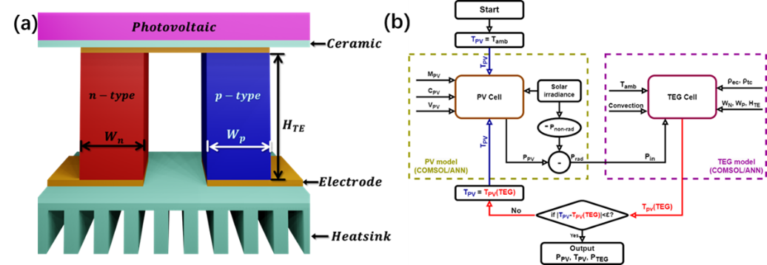

Fig. 1 (a) Schematic of the PV-TEG system developed in this work. (b) Flow chart of cyclic approaches adopted in the PV-TEG model to predict the power performance of the hybrid system.

This hybrid PV-TEG model consists of two standalone 3D PV and TEG models, which were constructed firstly using COMSOL Multiphysics® software for dataset generation and later replaced by ANNs. This commercial FEA simulation tool was chosen because of its high prediction accuracy and versatility. Both models can work independently to predict PV and TEG performance. They can also be connected to model the complex PV-TEG system using a cyclic approach as illustrated in Fig. 1b. When the solar irradiation arrives at the top surface of the model, the power (*Psolar*) will be converted directly into electricity through the PV cell (*PPV*). The remaining power will either be transformed into heat (*Prad*) or stay unabsorbed (*Pnon-rad*), as shown in Eq. (1) [10]:

$P_{solar}=P_{rad}+P_{non-rad}+P_{PV}$ Eq. (1)

Here, *Pnon-rad* is intrinsically linked to the material and can be perceived as a fixed fraction of *Psolar*. In this work, *Pnon-rad* is fixed as 16% of *Psolar* unless otherwise specified [33]. Consequently, *Prad* can be calculated by *Psolar* and *PPV* to serve as the input power to be harvested by the TEG cell in the hybrid system. The key challenge in simulating this hybrid system is that the actual values of all these powers are temperature-dependent [34]. For a given solar irradiance, a feedback loop needs to be established in the hybrid system to update the temperature of the PV and TEG cells as well as the values of *PPV*, *Prad* and *Pnon-rad* until equilibrium is reached in the system. In this study, such a feedback loop is achieved by employing a cyclic approach to model the PV-TEG system. Within this framework, a PV model was developed to calculate the output (*PPV*) based on the PV temperature (*TPV*) alongside other parameters. Simultaneously, a TEG model was developed to determine its output (*PTEG*) as well as the top surface temperature which is the temperature of the PV cell (*TPV*). The *TPV* is assumed to be the same across the PV cell as the temperature difference between the upper and lower surfaces of the PV is very small. As illustrated in Fig. 1b, the initial PV temperature (*TPV*) aligns with the ambient temperature (*Tamb*). Based on the other operational and geometric parameters (details in the section below), *PPV* can be calculated. Then, the heat flux *Pin* into the TEG model is deduced from *Psolar* and *PPV*. Integrating TEG’s operating conditions and geometric parameters, both *PTEG* and *TPV* (TEG) are ascertained through the TEG model, and the new *TPV* will feed back to the PV model to update *PPV* and *Prad*, and subsequently update again *TPV* in the TEG model. This cyclic process will stop when the difference between the previous *TPV* and the updated *TPV* falls below a predetermined threshold (*ε*), which is fixed as 0.01 K in this work. At this time, it is inferred that the PV-TEG system has reached equilibrium and the results of *PPV,* *PTEG*, and *TPV* will be recorded.

2.2 The PV model

The PV cell in the model is made of a 200 µm thick crystalline silicon (c-Si) [35] with the option to include an anti-reflection coating layer which consists of a 65nm SiNx film stacking on a 20nm SiO2 layer [36][37]. In addition, four different PV morphologies (Planar, Upright pyramids, V grooves, and Spherical caps) were also available in the model. The analytic doping for the PV cell was set to *p*-type, with an acceptor concentration of 1016 cm-3. The donor concentration at the top surface of the PV cell is 1019 cm-3. The junction depth is set to be 0.25 µm and trap-assisted recombination is adopted in the model. The PV cell is connected to a top metal that serves as inlet voltage (V) and the bottom metal serves as ground (0V). Both metals are assumed to be ideal in the model. The performance of the PV cell depends strongly on the specific spectrum of solar irradiance. The spectrum of different solar irradiance in this work was assumed proportional to the AM1.5 spectrum. The generation rates of these different PV structures are obtained from the PV lighthouse [38] and shown in Fig. S1. These generation rates were subsequently imported into the PV model to simulate the power outputs of the PV cells. All the input parameters for the PV model are tabulated in Table 1.

Table 1 – Ranges and resolutions of parameters used in the PV model.

|  |  |  |  |
| --- | --- | --- | --- |
| PV Input Parameters | | Range | Resolution |
| Geometric parameters | PV Coating (*CPV*) | [Coating, No coating] |  |
| PV Morphology (*MPV*) | [Planar, Upright pyramids, V grooves, Spherical caps] |  |
| Operating conditions | PV Voltage (*VPV*) | 0-0.65 V | 0.01 V |
| Solar irradiance (*Psolar*) | 0-1000 W/m2 | 1 W/m2 |
| PV Temperature (*TPV*) | 263-363K | 0.1 K |

The configuration of the neural network for the PV model is shown in Fig. 2. The PV-ANN is structured with an input layer of five parameters, which lead to a series of 5 hidden layers each of which contains 400 neurons. The model ultimately converges to a singular output node of the PV output power (*PPV*). 3D simulations from COMSOL Multiphysics® are used to generate the dataset used for neural network training using Semiconductor Module, Electric Current Module and Electrical Circuit Module. Details and validation of the COMSOL PV model can be found in the Supporting Information. The dataset contains 10,000 instances. The set of input parameters was generated randomly based on their ranges and resolutions in Table 1, and their distribution is shown in Fig. S4. These 10.000 sets of parameters were then simulated in COMSOL to obtain the *PPV*, which serves as the output of the dataset. For training purposes, the PV-ANN dataset was grouped into training (8,000 instances), validation (1,000 instances), and testing (1,000 instances) subsets. The mean square error (MSE) serves as the designated loss function. Detailed specifications of other ANN-related hyperparameters can be found in the Supplementary Information. The training subset optimised the network by iteratively updating its neuron weights and biases *via* backpropagation Concurrently, the validation subset data served the purpose of monitoring overfitting in the training process. Once training was complete, the test data subset, previously unseen by the network, was introduced to assess the network's predictive accuracy.

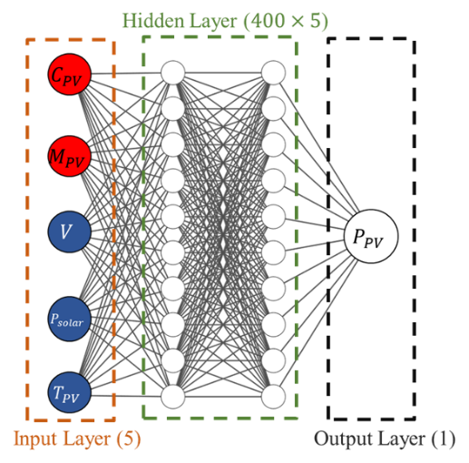

Fig. 2 Architecture of the forward modelling neural network for predicting power performance of the PV model.

2.3 The TEG model

The TEG cell sits underneath the c-Si PV cell, separated by an aluminium nitride ceramic layer. Copper electrode under ceramic connecting the *n*-type Bi2Te2.7Se0.3 [39] and *p*-type Bi0.5Sb1.5Te3 [40] thermoelectric materials. More details on the temperature-dependent thermoelectric material properties can be found in the Supporting Information. The heights of the ceramic and electrode are both 0.5mm. The bottom ceramic is also aluminium nitride, with an extended section of fins as the heatsink. There are a total of ten fins on the bottom, where each has a width of 1 mm, a height of 5 mm, and a depth of 10 mm. During the simulation, convective heat flux (*h*) is applied to the top PV surface and bottom ceramic surfaces (including the heatsink) while all other surfaces are thermally insulated. For electrical boundary conditions, the TEG model connects to an external load to form a circuit. The two Cu electrodes serve as a terminal and the ground (0V) for the model.

Table 2 lists the input parameters of the TEG model which consists of 3 geometric parameters and 5 operating conditions. The geometric parameters include two leg widths (*Wn* and *Wp*) and the leg height (*HTE*). The operating conditions comprise the heat flux injected from the PV cell (*Pin*), surface convection coefficient (*h*), and ambient temperature (*Tamb*) Electrical contact resistance [41] and thermal contact resistance [42] have also been suggested as crucial factors for TEG and were therefore also included in the model by introducing electrical contact resistivity ($ρ_{ec}$) and thermal contact resistivity ($ρ_{tc}$) between the four thermoelectric material and the interconnect interfaces.

Table 2 – Ranges and resolutions of parameters used in the TEG model.

|  |  |  |  |
| --- | --- | --- | --- |
| TEG Input Parameters | | Range | Resolution |
| Geometric parameters | Width of *n*-type leg (*Wn*) | 1-9 mm | 0.1 mm |
| Width of *p*-type leg (*WP*) | 1-9 mm | 0.1 mm |
| Height of the TEG leg (*HTE*) | 5-30 mm | 1 mm |
| Operating conditions | Heat flux (*Pin*) | 0-1000 W/m2 | 1 W/m2 |
| Top and bottom surface convection coefficient (*h*) | 1-25 W/(m2K) | 1 W/(m2K) |
| Electrical contact resistance (*ρec*) | 10-9-10-7 Ωm2 | 10-9Ωm2 |
| Thermal contact resistance (*ρtc*) | 10-6 - 10-4 Km2/W | 10-6 Km2/W |
| Ambient temperature (*Tamb*) | 263-363K | 0.1 K |

Fig. 3 shows the configuration of our TEG neural network. All 8 input parameters are included in the input layer of the network and connect to hidden layers that consist of 4 layers and 700 neurons in each layer. The outputs of the TEG-ANN are the TEG-generated power (*PTEG*) and the top surface temperature which is also the temperature of the PV cell (*TPV*). 5,000 sets of input parameters were randomly generated based on the range of resolution presented in Table 2. The distributions of all parameters are shown in Fig. S8. The power and temperature outputs of these 5,000 parameter sets were simulated in COMSOL to generate a dataset containing 5,000 input-output relations for the ANN training process. During the training process, the TEG dataset was partitioned into three subsets for training (4,000 instances), validation (500 instances), and testing (500 instances). Similar to the PV-ANN training, the loss function was defined as the MSE between the which was used to update the weights and bias for the neurons in the backpropagation process to improve the prediction accuracy. Detailed information on both the TEG COMSOL simulation and ANN training process can be found in the Support Information.

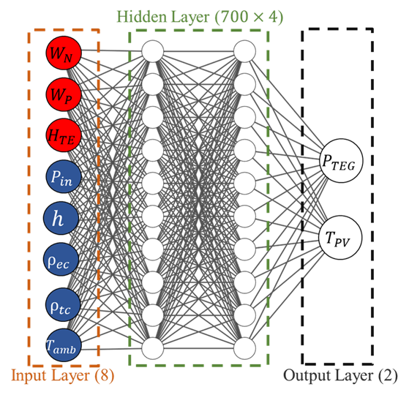

Fig. 3 Architecture of the forward modelling neural network for predicting power performance of the TEG model.

***3. Results and discussion***

3.1 ANN performance evaluation

After the training process (shown in Fig. S9), the performance of both PV and TEG ANNs was evaluated using the test datasets by comparing the ANN predicted results with the ground truth from COMSOL simulation. The prediction accuracy is defined in Eq. (3):

$Accuracy=\left(1-\frac{\left|Prediction-truth\right|}{truth}\right)×100\%$ (3)

where *prediction* is the result of ANN, and *truth* is the result of COMSOL. The accuracy of the PV-ANN model is calculated to be 98.8% which suggests a high fidelity of our ANN model. The comparison between the ANN-predicted *PPV* and the ground truth from the COMSOL simulation is further plotted in Fig. 4. It can be observed that the high prediction accuracy of the ANN prevails across a wide power range, resulting in a high coefficient of determination value (R2) of over 0.999.

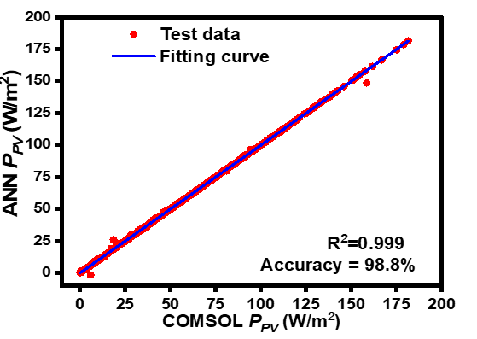

Fig. 4 Scatter plot of the PV-ANN predicted and the true (COMSOL simulated) PV power density (*PPV*).

Similarly, the TEG-ANN also registers very high accuracies of 97.6% for *PTEG* prediction and 99% for *TPV* prediction, leading to an average prediction accuracy of 98.3%. In both cases, the ANN results closely mirror those from COMSOL simulations across the entire power and temperature ranges (shown in Fig. 5) with both R2 values over 0.999. These results demonstrate that ANN can serve as a suitable substitute for the COMSOL model for both PV and TEG modelling with very high prediction accuracy.

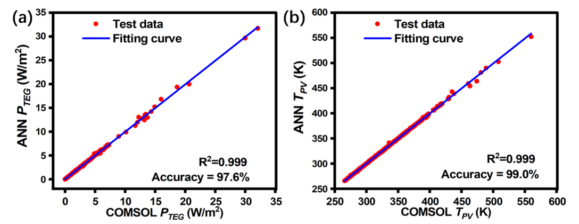

Fig. 5 Scatter plot of the TEG ANN predicted and true (COMSOL simulated) (a) TEG power density (PTEG), and (b) PV temperature (TPV).

The performance of the two ANNs in the hybrid PV-TEG model will now be evaluated by executing the cyclic approach (illustrated in Fig. 1b) to predict the power performance of the hybrid model. Fig. 6a presents the predicted *PPV* and *PTEG* at various stages of the cyclic process while Fig. 6b plots the associated change of *TPV*. In the initial stage (cycle 0), the *TPV* is set to be equal to the ambient temperature, and the power outputs from both PV and TEG models remain 0. As the system begins to operate, drastic increases are observed for both *PPV* and *PTEG* in cycle 1.This is accompanied by the increase in the cell temperature *TPV*, which subsequently leads to a slight reduction of *PPV* (cycle 2). After about 3 cycles, the hybrid PV-TEG system reaches an equilibrium state, and all outputs remain stable in the following cycles. The output values from the final 9th cycle are compared with the results from the COMSOL steady-state simulation (triangle marks), showing a very good much. These results further validate the fidelity of our ANN models and cyclic approach. It is worth noting that, given one PV voltage, despite several cycles required in the approach, the total computational time (including PV and TEG calculation) is only 3 ms, which is significantly shorter than that required in COMSOL simulation (90 s). From this on, all further analysis in this work will be based on the results from the final equilibrium state.

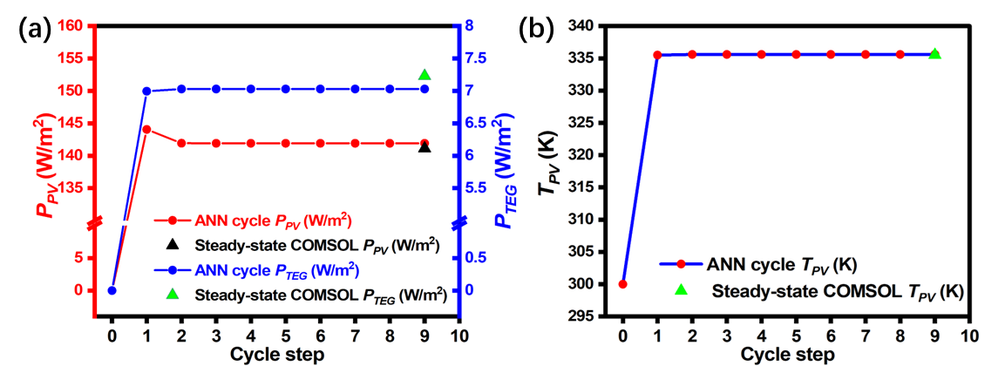

Fig. 6 (a) *PPV* and *PTEG* in cycle sweep of ANN model and the corresponding steady-state COMSOL results (b) TPV in cycle sweep of ANN model and the corresponding steady-state COMSOL results. Other parameters remain constant ($P_{solar}=1000W/m^{2}$, $h=10W/(m^{2}K)$, $W_{n}=W_{p}=5mm$, $H_{TE}=20mm$, $T_{amb}=300K$, $V=0.4V$, $P_{non-rad}=0W/m^{2}$).

3.2 Comprehensive PV-TEG system analysis

Having established the accuracy and fidelity of the ANNs and cyclic approach, a comprehensive analysis of all parameters and their impact on the performance of the hybrid PV-TEG system is now conducted.

3.2.1 PV voltage and surface condition

Fig. 7 illustrates the ANN-predicted performance of the PV-TEG system under varying PV input voltages while keeping other parameters (e.g. geometries, coatings and morphologies) constant. In Fig. 7a, it is observed that the current density of the PV decreases as the voltage increases. Notably, the rate of decrease becomes significantly pronounced when the voltage exceeds 0.4V. The power output of the PV cell, *PPV*, which is the product of current and voltage is shown in Fig. 7b. Fig. 7c shows TEG power as a function of the PV voltage. Fig. S10 shows the *Pin* and TEG efficiency at different voltages. Since *Pin* is directly calculated from *Psolar* and *PPV* in this model, the trend of *Pin* is opposite to that of *PPV*. It is observed that *PTEG* initially decreases but later increases with rising PV voltage. This behaviour is predominantly due to the substantial influence of the PV temperature at the upper surface, which is shown in Fig. 7d as a function of the PV voltage. This trend is because *PPV* also first increases and then decreases with increasing voltage. According to Equation (2), an increase in *PPV* leads to a decrease in *Prad*, and consequently, the heat absorbed by the PV-TEG system decreases, resulting in a lower PV temperature. Subsequently, as *PPV* decreases, *Prad* increases, causing the model to absorb more heat, which leads to an increase in the PV temperature. Fig. 7e illustrates the total output power of the hybrid system *PAll* (comprising *PPV* and *PTEG*) in response to increasing voltage levels. Notably, the trend of *PAll* follows well with that of *PPV*. This is not surprising as *PPV* is still the dominating power contributor in the PV-TEG system. However, it is worth mentioning that the TEG model still contributes to about 3-4% of the total power on average.

For comparison, outputs from the COMSOL simulation are also depicted in the figures in blue dots. The close alignment of the ANN results with those from COMSOL underscores the high accuracy of our ANN model in simulating the performance of PV-TEG systems under varying voltage inputs. It is also worth noting that a sweep of voltage for one set of parameters only takes 0.15s using our ANN models, compared with 900s of COMSOL simulation. This allows us to quickly identify the maximum power output point (*Pmax*) for each parameter set and its associated voltage. From this on, all following analyses will sweep the voltage and present the maximum power output point (*Pmax*) instead.

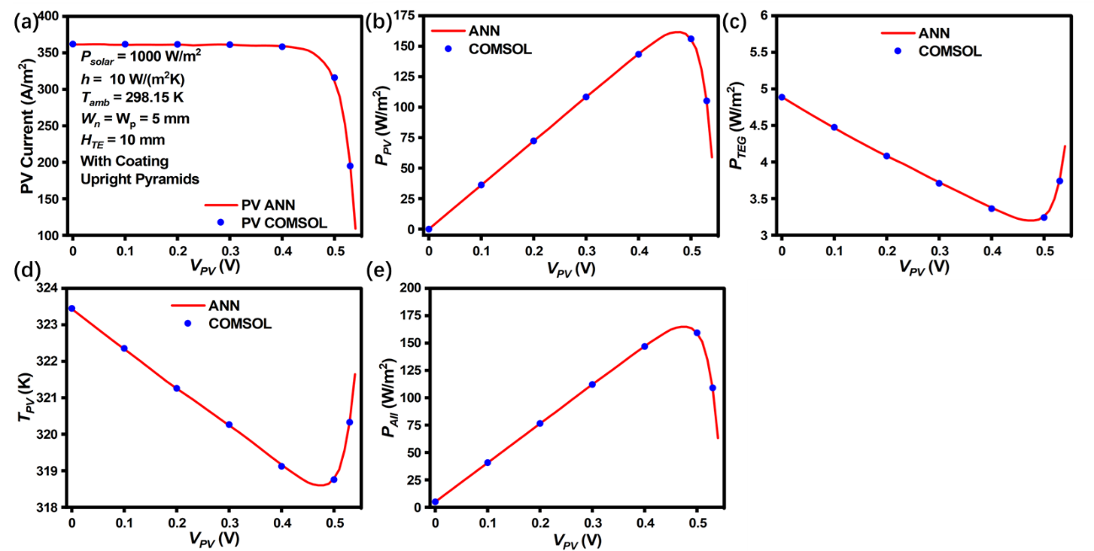

Fig. 7 (a) PV current, (b) PV power density (*PPV*), (c) TEG power density (*PTEG*), (d) the PV temperature (*TPV*) and (e) total power density (*PAll*=*PPV*+*PTEG*) obtained from ANN (line) and COMSOL (dot) as a function of PV voltage (*VPV*). Other parameters remain constant ($P_{solar}=1000W/m^{2}$, $h=10W/(m^{2}K)$, $W_{n}=W_{p}=5mm$, $H_{TE}=10mm$, $T_{amb}=298.15K$, the PV cell has a coating and uses the Upright Pyramid morphology).

Fig. 8 presents the performance of the PV-TEG system under various coatings and morphologies. For simplicity in representation, the combinations of coatings and morphologies are coded in the figure. The first letter in each code denotes the presence or absence of coating as 'C' stands for with coating, and ‘N’ for without coating. The second letter corresponds to the morphology, with ‘P’, ‘S’, ‘U’, and ‘V’ representing the four different morphologies of Planar, Spherical Caps, Upright Pyramid, and V Grooves, respectively [43]. These are depicted in different colours in Fig. 8. Fig. 8a displays the results of *TPV* under various coatings and morphologies. It is observable from the figure that the temperature is marginally higher in configurations without coating compared to those with coating. This can be explained that the absorption rate of PV is higher in the presence of coating, generating more *PPV* and leading to lower *TPV*. Additionally, the various morphologies exhibit different temperatures, which can be attributed to their differing rates of absorption. Fig. 8b shows the distribution of *PAll* in different morphology and coating. The specific analysis is based on Fig. 8c and Fig. 8d. Fig. 8c illustrates the distinct behaviour of PTEG. The Pin and TEG efficiency under different Coating and Morphology conditions can be found in Fig. S11. The output of the TEG in this context is primarily dependent on the temperature of the upper surface. Therefore, it follows a similar trend to that observed in Fig. 8a. Fig. 8d depicts the distribution of *PPV*. The output is significantly higher with coating, as it leads to increased light absorption into the PV. The different morphologies exhibit varying levels of surface roughness, and the more complex morphologies enable light to undergo multiple reflections within the coating, thereby enhancing the absorption rate. In contrast, the planar morphology, with its smoother surface allows for only a single reflection within the PV, resulting in the lowest absorption rate. Overall, the accuracy of all output parameters exceeds 99%, as illustrated in Fig. 8e. This high level of accuracy indicates that the PV-TEG cyclic ANN model is very well-fitted. Additionally, the models in this study can incorporate various morphologies and coatings into their parameters. This feature introduces diversity and enhances the generalizability of the model. Unless specified otherwise, the default configuration for the PV structure in the following investigations will incorporate a coating with the Upright Pyramid morphology.

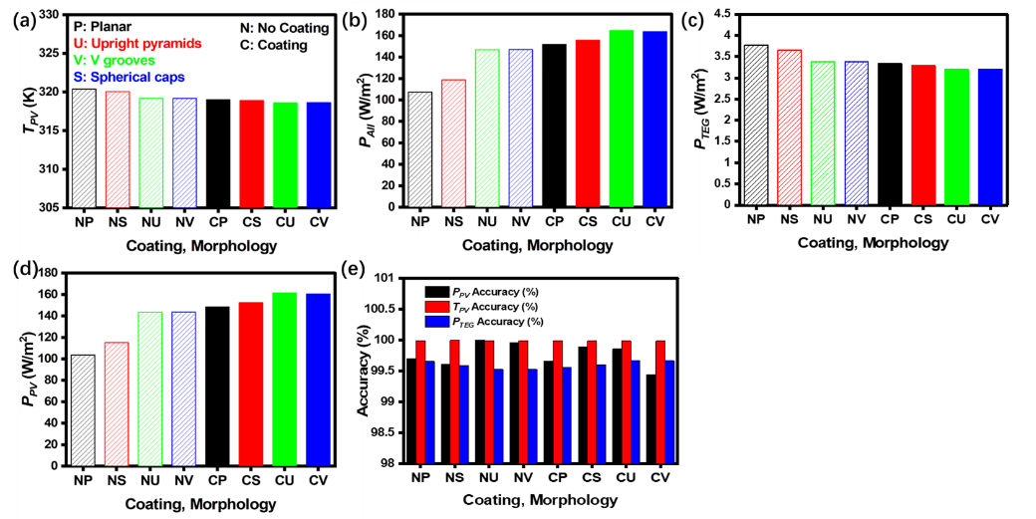

Fig. 8 (a) PV temperature (*TPV*), (b) Total power density (*PAll*), (c) TEG power density (*PTEG*), (d) PV power density (*PPV*) obtained from ANN calculated from COMSOL as a function of coating (*CPV*) and morphology (*MPV*). Other parameters remain constant ($P_{solar}=1000W/m^{2}$, $h=10W/(m^{2}K)$, $W_{n}=W_{p}=5mm$, $H_{TE}=10mm$, $T_{amb}=298.15K$, the PV cell has a coating and uses the Upright Pyramid morphology).

3.2.2 Environmental conditions

Environmental factors like solar irradiance and convection significantly influence the performance of the PV-TEG system. In this section, the performance of the ANN-based PV-TEG model under various scenarios of solar irradiance and convection coefficients will be investigated. Fig. 9a shows a consistent rise in *PPV* with the increase in solar irradiance across all convection conditions. However, this increase tends to slow down at higher levels of solar irradiance under the condition of lower convection (e.g. 1 W/m2K). The reason for this is that lower convection hinders the transfer of energy to the environment, resulting in a significant increase in PV temperature (shown in Fig. 9b), which in turn reduces the efficiency of the PV cells. This observation underscores the critical role of convection in the operation of PV cells. It can also be observed in Fig. 9b that the rate of increase in PV temperature is significantly steeper when the convection coefficient is very small. Fig. 9c illustrates the trend of *PTEG* under varying solar irradiance and convection coefficient conditions. The Pin and TEG efficiency under different convection conditions can be found in Fig. S12. Overall, *PTEG* increases with an increase in solar irradiance. However, as convection intensifies, *PTEG* gradually decreases. Higher convection could lead to more energy being dissipated into the environment and the increase in PV power, resulting in less energy being available to be harvested by the TEG. Fig. 9d displays the variation in the total output power (*PAll*) of the PV-TEG system. The overall trend observed in this figure aligns with that seen in Fig. 9a as *PPV* is still the dominating contributor to the total power generation. The accuracy of the ANN model in comparison to the COMSOL simulations is further corroborated by the line and point fits shown in Fig. 9. These fits showcase the ANN model's ability to closely replicate results from the more complex COMSOL simulations, highlighting its effectiveness and reliability in modelling the PV-TEG system under diverse environmental conditions.

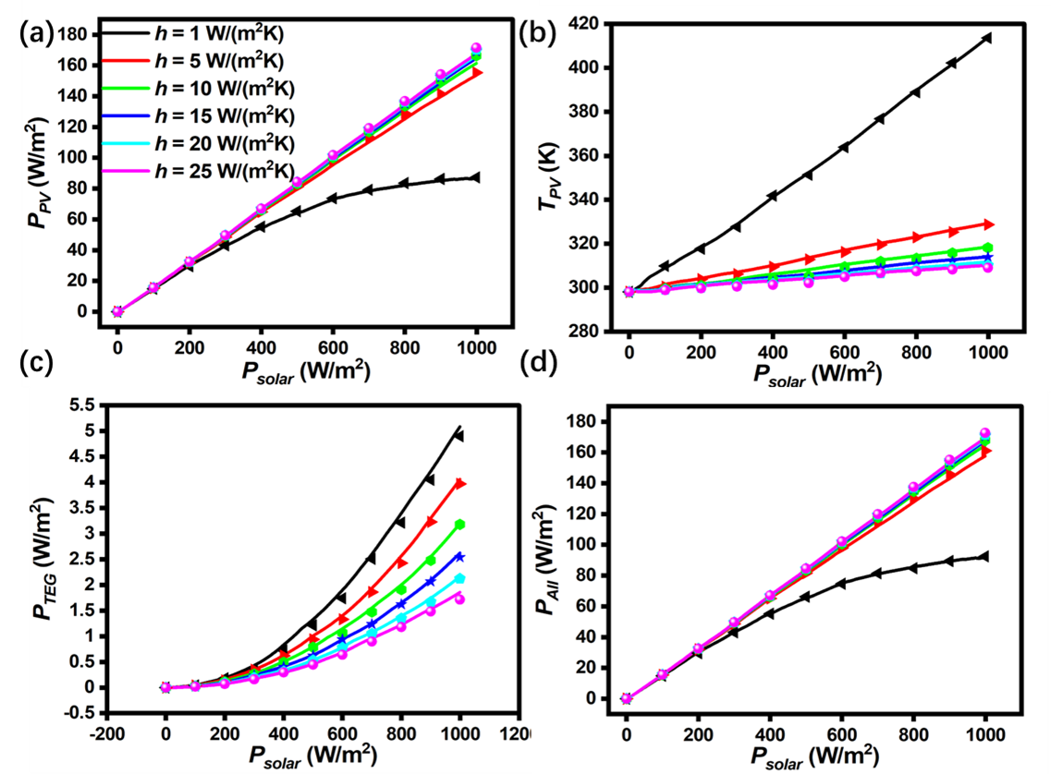

Fig. 9 (a) PV power density (PPV), (b) PV temperature (TPV) (c) TEG power density (PTEG), and (d) total power density (PAll) obtained from ANN (line) and COMSOL (dot) as a function of solar irradiance and convection coefficient. Other parameters are fixed with ($W_{n}=W_{p}=5mm$, $H_{TE}=10mm$, $T_{amb}=298.15K$, the PV cell has a coating and uses the Upright Pyramid morphology).

Fig. 10 demonstrates the performance of the PV-TEG model at different ambient temperatures (*Tamb*) and convection coefficients. The Pin and TEG efficiency under different convection and ambient temperature conditions can be found in Fig. S13. Fig. 10a shows that the *PPV* decreases with increasing ambient temperature, which is mainly on account of the lower PV efficiency caused by the increase in *TPV* as shown in Fig. 10b. At the same ambient temperature, higher convection leads to higher *PPV*. Similarly, this correlation can be attributed to the reduced *TPV* observed with increasing convection. Fig. 10c shows that under lower convection conditions (e.g., 1 W/(m2K)), *PTEG* decreases slightly with an increase in *Tamb*. Conversely, in scenarios with higher convection rates, *PTEG* exhibits a slight increase with rising ambient temperature. This behaviour may be attributed to the fact that the *ZT* (thermoelectric figure of merit) maxima for the two materials used in this study are between 350K and 400K (shown in Fig. S5). The efficiency of the TEG improves when its temperature approaches this optimal range. The trend observed in Fig. 10d aligns with that in Fig. 10a. This consistency further highlights the impact of ambient temperature and convection conditions on the overall performance of the PV-TEG system, especially in terms of their effect on the efficiency and output of the TEG component.

The data presented in Fig. 9 and 10 demonstrate that the model used in this work successfully integrates several crucial environmental parameters. By accounting for factors such as solar irradiance, convection coefficients, and ambient temperature, the model offers a comprehensive and adaptable framework for understanding and predicting the performance of the PV-TEG system in diverse real-world scenarios. This illustration highlights the system's responsiveness to changes in these key environmental conditions.

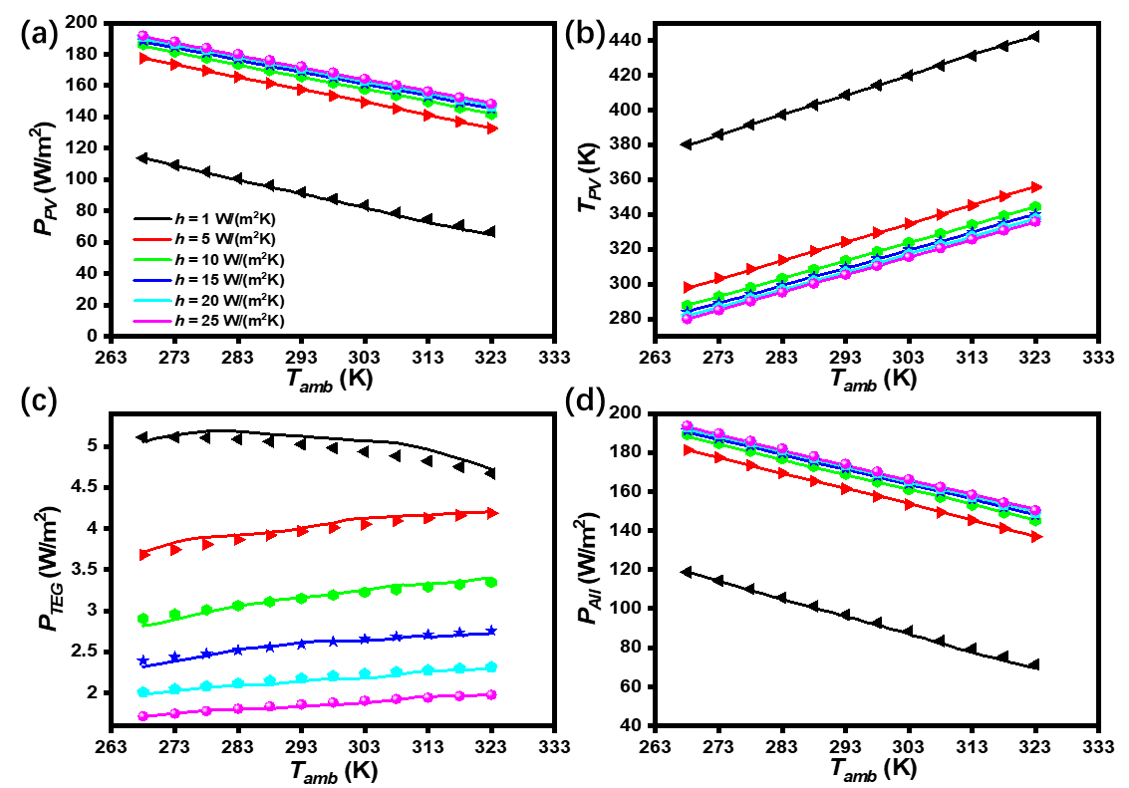

Fig. 10 (a) PV power density (PPV), (b) PV temperature (TPV) (c) TEG power density (PTEG), and (d) total power density (PAll) obtained from ANN (line) and COMSOL (dot) as a function of ambient temperature (Tamb) and convection coefficient. Other parameters are fixed with ($P_{solar}=1000W/m^{2}$, $W_{n}=W_{p}=5mm$, $H_{TE}=10mm$, the PV cell has a coating and uses the Upright Pyramid morphology).

3.2.3 TEG geometry

Fig. 11 demonstrates the performance of PV-TEG at different TEG leg widths (*Wn*, *Wp*) and heights (*HTE*). The Pin and TEG efficiency under different *Wn*, *Wp*, and *HTE* conditions can be found in Fig. S14. Fig. 11a clearly shows that *PPV* experiences a gradual increase as the width of the TEG leg expands. However, this rate of increment slows down as the leg width becomes larger. Notably, under comparable leg width conditions, *PPV* shows a gradual decline with an increase in *HTE*. This phenomenon can be explained by the associated low thermal resistance for the TEG with large leg width, which results in a decreased temperature of the PV as shown in Fig. 11b. Such reduction in temperature, in turn, leads to an increase in the PV power output. This relationship highlights the intricate balance between the physical dimensions of the TEG and its impact on the overall efficiency and performance of the PV-TEG system. In Fig. 11c, a distinct trend is observed where *PTEG* initially increases and then decreases with the change of *Wn* changes. This behaviour can be explained by examining the dynamics of electrical resistance in the system. When *Wn* is small, the system experiences higher electrical resistance, which constrains the output of *PTEG*. As *Wn* increases, the electrical resistance decreases which facilitates the increment of *PTEG*. However, such a decrease in electrical resistance is also accompanied by a reduction in thermal resistance. This reduction leads to smaller temperature gradients across the TEG, which in turn results in a decrease in *PTEG*. This pattern shows the complex interplay between electrical and thermal resistances in the TEG and their combined effect on its power output. As the value of *HTE* increased, a noticeable shift in the peak of *PTEG* towards a higher *Wn* was observed. This shift can also be rationalized by considering the impact of increased *HTE* on the electrical and thermal resistances of the TEG. A higher *HTE* implies greater resistance for a given *Wn*. To achieve a balance between thermal and electrical resistances, an increase in Wn becomes necessary. Fig. 11d displays the variation in the total output power (*PAll*) of the PV-TEG system. Fig. 11 verifies the effectiveness of this model for incorporating TEG structure parameters. Different TEG structures can be selected according to different parameters to increase the generalization of the model.

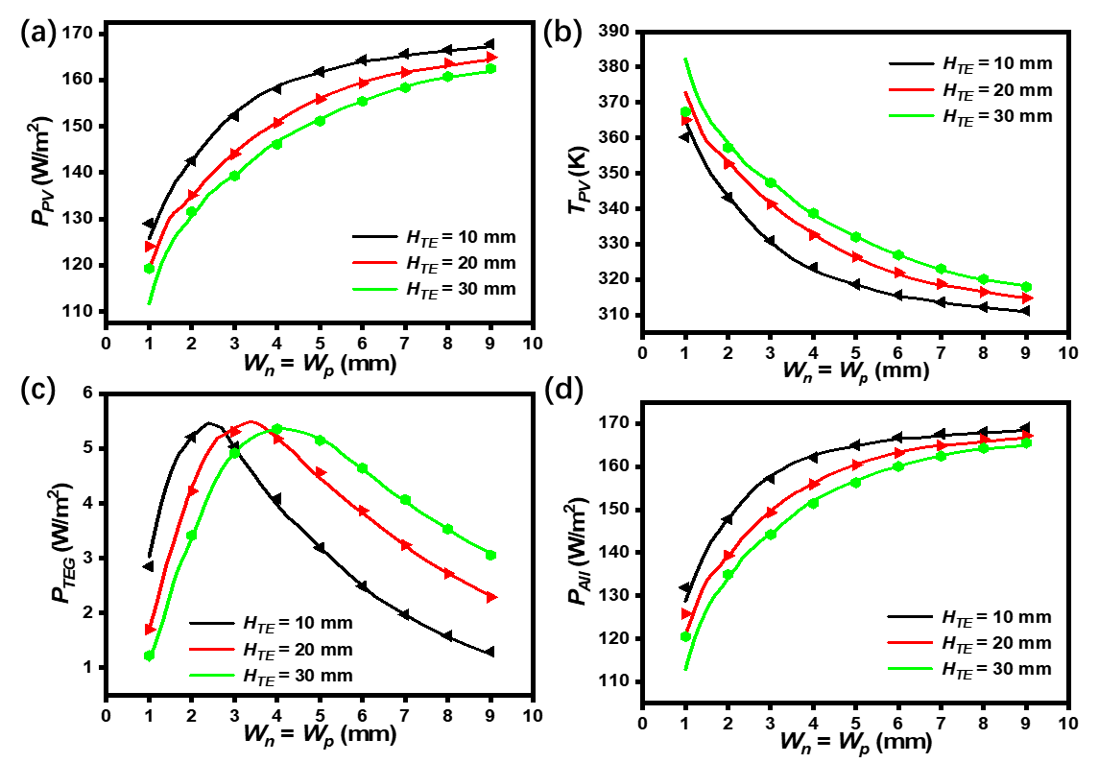

Fig. 11 (a) PV power density (PPV), (b) PV temperature (TPV) (c) TEG power density (PTEG), and (d) total power density (PAll) obtained from ANN (line) and COMSOL (dot) as a function of Wn, Wp and HTE. Other parameters are fixed with ($P_{solar}=1000W/m^{2}$, $h=10W/(m^{2}K)$, $T_{amb}=298.15K$, the PV cell has coating and the Upright Pyramid morphology).

3.3 PV-TEG system real-time data simulation

A primary advantage of our ANN model is its exceptional efficiency. Once the initial training phase is completed, the model can predict the performance of the PV-TEG system much more rapidly than conventional simulation tools like COMSOL where a single simulation time can be dramatically reduced from 15 minutes to a mere 0.15 seconds, registering a 6,000-fold acceleration. This significant acceleration in processing speed allows for the integration of real-time data into the simulation, enhancing the model's applicability and relevance in practical scenarios.

As a demonstration, the ANN models were applied to predict the potential power performance of the hybrid PV-TEG system as well as a standalone PV system under real-time weather conditions in London on June 20th, 2022, over a 24-hour period. The weather conditions are based on data sourced from the Prediction of Worldwide Energy Resources (POWER NASA). The TEG power and TEG efficiency under actual environmental parameters over the course of a day can be seen in Fig. S15. The real-time data includes solar irradiance, ambient temperature, and wind speed, and are presented in Fig. 12a. Fig. 12b plots the total power output of the two systems over 24 hours. The findings indicate that, before 8 a.m., the variance in output between the PV-TEG and the stand-alone PV is negligible. By noon, this disparity amplifies, registering a maximum PV-TEG system power output of 155 W/m2, compared to the 145 W/m2 of the stand-alone PV system. This delineates a 6.8% augmentation in total power for the hybrid system. When aggregated over the entire 24-hour period, the PV-TEG system surpasses the stand-alone PV system in electricity generation by a margin of 7%. Fig. 12c compares the *TPV* values of the two systems together with ambient temperature. It can be inferred that a key factor contributing to the higher power output of the PV-TEG system is the reduction in *TPV*. This decrease in *TPV* suggests that the integrated approach of the PV-TEG model, which combines the functionalities of both PV and TEG systems, results in a more efficient conversion of energy, particularly under varying ambient temperature conditions. This efficiency is a significant aspect of the hybrid system, highlighting its potential advantages over traditional stand-alone PV systems. Fig. 12d showcases the results for the PV voltage at the point of highest power under different solar irradiance levels. Leveraging the rapid computational abilities of the ANN, our model facilitates swift calculation of the voltage at the Maximum Power Point (MPP) in 0.15s, thousands of times faster than COMSOL simulation. This functionality is particularly valuable as it can significantly enhance the efficiency of the PV-TEG system. By quickly determining the optimal operating voltage for maximum power output under varying solar conditions, the model can be instrumental in optimizing the performance of PV-TEG systems, leading to more energy production.

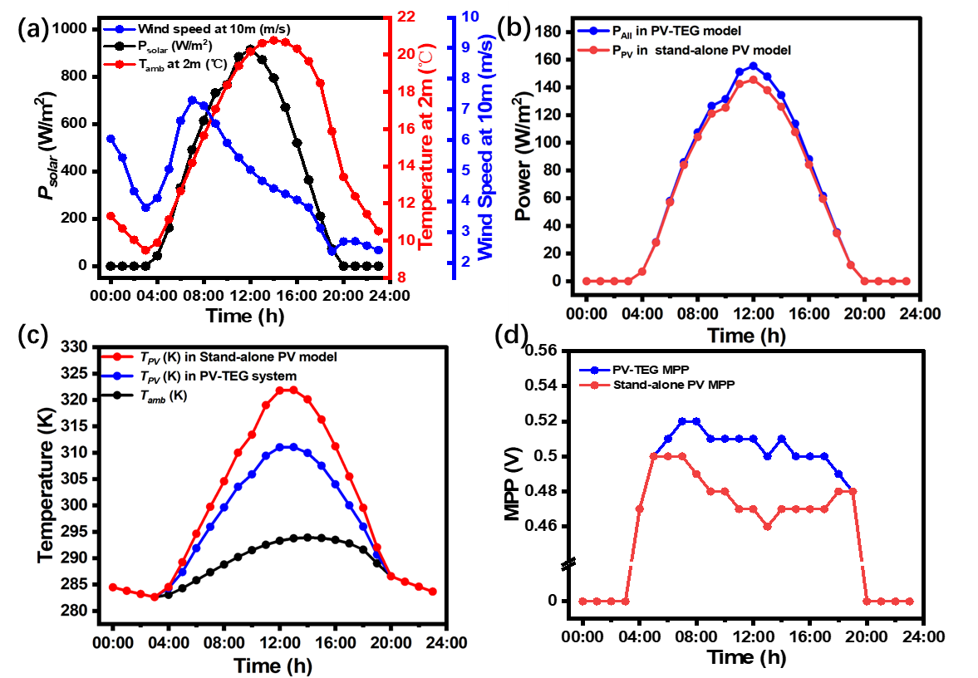

Fig. 12 Real-time data of (a) Solar irradiance (Psolar), ambient temperature (Tamb) and wind speed at elevations above 10 m in London on June 20th, 2022. (b)The power performance of PV-TEG and stand-alone PV. (c)The ambient temperature comparing TPV in PV-TEG and stand-alone PV model. (d) PV maximum power point (MPP) voltage obtained from ANN in the solar-powered period. The geometric parameters of the TEG remain constant, ($W_{n}=W_{p}=5mm$, $H_{TE}=10mm$, the PV cell has coating and the Upright Pyramid morphology)

The real-time data simulation is further extended by introducing comprehensive weather data from Singapore spanning the entire year of 2022 for 363 days (with real-time data on the 7th and 8th of January missing in the database). The monthly average TEG power and TEG efficiency over a year can be seen in Fig. S16. This set of data registers a total number of 8,712 entries of hourly data points (shown in Fig. S17). After feeding this set of data into our ANN-based PV-TEG and PV models, both power output and operating temperature can be simulated and are presented in Fig. 14a and Fig. 14b. Fig. 14c calculates the monthly average power output of the two systems. It can be observed that the average output power of the PV-TEG system is higher than that of the standalone PV system. On the other hand, the monthly average operating temperature shows a clear drop in the hybrid system compared with its standalone counterpart. Overall, within the entire year of 2022, the hybrid PV-TEG model was predicted to generate a total power of 265 kWh/m2, 6% more than that of the standalone PV system. This translates to an increase of 16 kWh/m2. In addition, an average reduction of 7°C was obtained for the hybrid system across the year. Such reduction is beneficial for the longevity and efficiency of the PV units as lower operating temperatures generally correlate with reduced wear and longer lifespans for PV materials.

A key highlight of this study is the computational efficiency of our ANN model. It managed to complete the power output simulation of the entire dataset in 18 minutes. In contrast, a similar number of computations based on COMSOL will necessitate a minimum of 46 days. Even when factoring in the time invested in generating the PV-TEG dataset—approximately 40 hours for the TEG dataset and 20 hours for the PV dataset—totalling about 2.5 days, the cumulative duration remains significantly shorter than the 46 days demanded by COMSOL simulations alone. This duration is impractical for most real-world applications, further emphasising the significant advantage of the ANN model in terms of speed and efficiency for extensive and time-sensitive simulations.

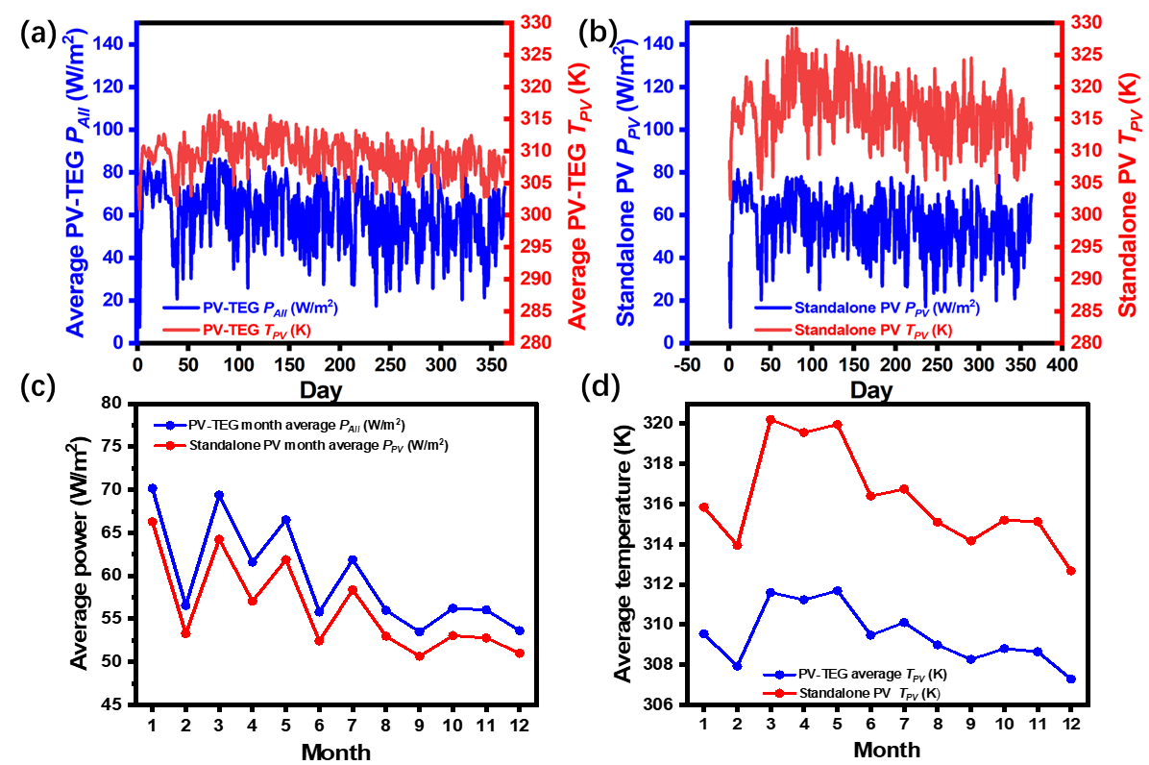

Fig. 13 365-day Real-time data simulation of (a) PV-TEG system and (b) standalone PV on the daily average power and PV operating temperature. (c) The average month output power, and (d) the average month operating PV temperature. Singapore from Jan 1, 2022, to Dec 31, 2022. The geometric parameters of the TEG remain constant, ($W_{n}=W_{p}=5mm$, $H_{TE}=10mm$, the PV cell has a coating and uses the Upright Pyramid morphology).

Based on the results, some recently published PV-TEG related findings were compared, as shown in Table 3. Compared to other studies, the advantages of our model include rapid computation, consideration of more parameters, and greater applicability to a wider range of scenarios.

Table 3 – PV-TEG research compared to this work.

|  |  |  |  |  |  |  |
| --- | --- | --- | --- | --- | --- | --- |
| **Previous research** | **PV model** | **TEG model** | **Temperature-dependent materials** | **Contact resistance** | **PV coating surface selection** | **PV voltage tracking** |
| [10] | mathematical model | mathematical model | No | No | No | No |
| [13] | mathematical model | 3D FEA | No | Yes | No | No |
| [14] | mathematical model | mathematical model | No | Yes | No | No |
| [15] | mathematical model | mathematical model | No | Yes | No | No |
| [16] | mathematical model | mathematical model | No | Yes | No | No |
| [17] | mathematical model | mathematical model | No | No | No | No |
| [19] | mathematical model | 3D FEA | Yes | No | No | No |
| [20] | mathematical model | 3D FEA | Yes | No | No | No |
| [44] | mathematical model | mathematical model | No | No | No | No |
| [45] | mathematical model | mathematical model | No | No | No | No |
| [46] | mathematical model | mathematical model | No | Yes | No | No |
| [47] | mathematical model | mathematical model | Yes | Yes | No | No |
| [48] | mathematical model | 3D FEA | Yes | No | No | No |
| [49] | mathematical model | 3D FEA | No | No | No | No |
| This work | ANN (3D FEA) | ANN (3D FEA) | Yes | Yes | Yes | Yes |

***4. Conclusion***

In the present study, an ANN-based model has been developed to predict the performance of the hybrid PV-TEG system by employing a cyclic approach. The 3D model takes into account a large variety of parameters including the PV coating, morphology, TEG geometry and temperature-dependent material properties, as well as different environmental conditions such as solar irradiance and convection. Owing to its integrated nature, the PV component and TEG component in the model can also be decoupled and used independently. This adaptability significantly amplifies the versatility and generalizability of the PV-TEG model.

When benchmarked against the COMSOL simulation, this ANN model boasts an impressive accuracy of over 98%. A noteworthy enhancement in computational efficiency is also achieved with a single simulation cost of only 0.15 s, which represents a 6,000-fold acceleration compared with COMSOL. The swift computational abilities of the PV-TEG ANN model were fully leveraged in this study to perform extensive parameter sweeps across PV, environment, and TEG parameters. This thorough analysis facilitated a detailed exploration of how various parameters impact the performance of the PV-TEG model. Our model enables thousands of calculations to be easily performed. Compared to standalone PV systems, the PV-TEG in our model shows an improvement of approximately 7%, while also reducing the temperature of the PV. The rapid processing capability of the model is especially important for large-scale simulations and real-world applications, where timely and accurate predictions are essential. The efficiency of the ANN model in handling extensive datasets over extended periods demonstrates its practical utility and effectiveness in the field of renewable energy technology. In the future, the model will be compared with real PV-TEG data. Additionally, the predicted voltage output from the model can be used to control the PV system, verifying the model's application in real-time scenarios.

**Acknowledgements**

This work was supported by the UK STFC project (ST/P00007X/1) and EPSRC ADEPT project (EP/N035437/1). The authors acknowledge the use of the IRIDIS High Performance Computing Facility, and associated support services at the University of Southampton, in the completion of this work. DWN would like to thank both BAE and EPSRC for funding the iCASE studentship (EP/R512096/1). The solar irradiance data were obtained from the NASA Langley Research Center (LaRC) POWER Project funded through the NASA Earth Science/Applied Science Program. All data supporting this study are available from the University of Southampton repository at DOI: https://doi.org/10.5258/SOTON/xxxx.

**References**

[1] V. Khare, S. Nema, and P. Baredar, “Solar-wind hybrid renewable energy system: A review,” *Renew. Sustain. Energy Rev.*, vol. 58, pp. 23–33, 2016, doi: 10.1016/j.rser.2015.12.223.

[2] A. Z. Sahin, K. G. Ismaila, B. S. Yilbas, and A. Al-Sharafi, “A review on the performance of photovoltaic/thermoelectric hybrid generators,” *Int. J. Energy Res.*, vol. 44, no. 5, pp. 3365–3394, 2020, doi: 10.1002/er.5139.

[3] A. Allouhi, S. Rehman, M. S. Buker, and Z. Said, “Recent technical approaches for improving energy efficiency and sustainability of PV and PV-T systems: A comprehensive review,” *Sustain. Energy Technol. Assessments*, vol. 56, no. April 2022, p. 103026, 2023, doi: 10.1016/j.seta.2023.103026.

[4] A. R. Jatoi, S. R. Samo, and A. Q. Jakhrani, “Influence of temperature on electrical characteristics of different photovoltaic module technologies,” *Int. J. Renew. Energy Dev.*, vol. 7, no. 2, pp. 85–91, 2018, doi: 10.14710/ijred.7.2.85-91.

[5] G. J. Snyder and E. S. Toberer, “Complex Thermoelectric Materials,” *Nature Materials*, vol. 7, no. 2. pp. 105–114, Feb. 2008. doi: 10.1038/nmat2090.

[6] T. M. Tritt, “Thermoelectric Phenomena, Materials, and Applications,” *Annu. Rev. Mater. Res.*, vol. 41, no. 1, pp. 433–448, Aug. 2011, doi: 10.1146/annurev-matsci-062910-100453.

[7] Q. H. Zhang, X. Y. Huang, S. Q. Bai, X. Shi, C. Uher, and L. D. Chen, “Thermoelectric devices for power generation: Recent progress and future challenges,” *Adv. Eng. Mater.*, vol. 18, no. 2, pp. 194–213, 2016, doi: 10.1002/adem.201500333.

[8] S. Praveenkumar, E. B. Agyekum, A. Kumar, and V. I. Velkin, “Thermo-enviro-economic analysis of solar photovoltaic/thermal system incorporated with u-shaped grid copper pipe, thermal electric generators and nanofluids: An experimental investigation,” *J. Energy Storage*, vol. 60, no. January, p. 106611, 2023, doi: 10.1016/j.est.2023.106611.

[9] H. J. Goldsmid, J. E. Giutronich, and M. M. Kaila, “Solar thermoelectric generation using bismuth telluride alloys,” *Sol. Energy*, vol. 24, no. 5, pp. 435–440, 1980, doi: https://doi.org/10.1016/0038-092X(80)90311-4.

[10] R. Bjørk and K. K. Nielsen, “The performance of a combined solar photovoltaic (PV) and thermoelectric generator (TEG) system,” *Sol. Energy*, vol. 120, pp. 187–194, 2015, doi: 10.1016/j.solener.2015.07.035.

[11] P. Sundarraj, D. Maity, S. S. Roy, and R. A. Taylor, “Recent advances in thermoelectric materials and solar thermoelectric generators-a critical review,” *RSC Adv.*, vol. 4, no. 87, pp. 46860–46874, 2014, doi: 10.1039/c4ra05322b.

[12] U. A. Saleh, M. A. Johar, S. A. B. Jumaat, M. N. Rejab, and W. A. Wan Jamaludin, “Evaluation of a PV-TEG Hybrid System Configuration for an Improved Energy Output: A Review,” *Int. J. Renew. Energy Dev.*, no. December, 2020, doi: 10.14710/ijred.0.33917.

[13] M. Alian Fini, D. Gharapetian, and M. Asgari, “Efficiency improvement of hybrid PV-TEG system based on an energy, exergy, energy-economic and environmental analysis; experimental, mathematical and numerical approaches,” *Energy Convers. Manag.*, vol. 265, no. December 2021, p. 115767, 2022, doi: 10.1016/j.enconman.2022.115767.

[14] A. Makki, S. Omer, Y. Su, and H. Sabir, “Numerical investigation of heat pipe-based photovoltaic-thermoelectric generator (HP-PV/TEG) hybrid system,” *Energy Convers. Manag.*, vol. 112, pp. 274–287, 2016, doi: 10.1016/j.enconman.2015.12.069.

[15] C. Babu and P. Ponnambalam, “The theoretical performance evaluation of hybrid PV-TEG system,” *Energy Convers. Manag.*, vol. 173, no. April, pp. 450–460, 2018, doi: 10.1016/j.enconman.2018.07.104.

[16] W. Gu, T. Ma, A. Song, M. Li, and L. Shen, “Mathematical modelling and performance evaluation of a hybrid photovoltaic-thermoelectric system,” *Energy Convers. Manag.*, vol. 198, no. June, p. 111800, 2019, doi: 10.1016/j.enconman.2019.111800.

[17] P. Motiei, M. Yaghoubi, and E. GoshtasbiRad, “Transient simulation of a hybrid photovoltaic-thermoelectric system using a phase change material,” *Sustain. Energy Technol. Assessments*, vol. 34, no. April, pp. 200–213, 2019, doi: 10.1016/j.seta.2019.05.004.

[18] D. L. Evans, “Simplified method for predicting photovoltaic array output,” *Sol. Energy*, vol. 27, no. 6, pp. 555–560, 1981, doi: https://doi.org/10.1016/0038-092X(81)90051-7.

[19] S. Shittu, G. Li, X. Zhao, Y. G. Akhlaghi, X. Ma, and M. Yu, “Comparative study of a concentrated photovoltaic-thermoelectric system with and without flat plate heat pipe,” *Energy Convers. Manag.*, vol. 193, no. April, pp. 1–14, 2019, doi: 10.1016/j.enconman.2019.04.055.

[20] Y. Ge, Q. Xiao, W. Wang, Y. Lin, and S. M. Huang, “Design of high-performance photovoltaic-thermoelectric hybrid systems using multi-objective genetic algorithm,” *Renew. Energy*, vol. 200, no. August, pp. 136–145, 2022, doi: 10.1016/j.renene.2022.09.091.

[21] Y. Lecun, Y. Bengio, and G. Hinton, “Deep learning,” *Nature*, vol. 521, no. 7553, pp. 436–444, 2015, doi: 10.1038/nature14539.

[22] P. R. Wiecha, A. Lecestre, N. Mallet, and G. Larrieu, “Pushing the limits of optical information storage using deep learning,” *Nat. Nanotechnol.*, vol. 14, no. 3, pp. 237–244, Mar. 2019, doi: 10.1038/s41565-018-0346-1.

[23] T. Qiu *et al.*, “Deep Learning: A Rapid and Efficient Route to Automatic Metasurface Design,” *Adv. Sci.*, vol. 6, no. 12, 2019, doi: 10.1002/advs.201900128.

[24] P. Dai *et al.*, “Accurate inverse design of Fabry–Perot-cavity-based color filters far beyond sRGB via a bidirectional artificial neural network,” *Photonics Res.*, vol. 9, no. 5, p. B236, 2021, doi: 10.1364/prj.415141.

[25] D. K. Bui, T. N. Nguyen, T. D. Ngo, and H. Nguyen-Xuan, “An artificial neural network (ANN) expert system enhanced with the electromagnetism-based firefly algorithm (EFA) for predicting the energy consumption in buildings,” *Energy*, vol. 190, p. 116370, 2020, doi: 10.1016/j.energy.2019.116370.

[26] O. S. Ebrahim, M. A. Badr, A. S. Elgendy, and P. K. Jain, “ANN-based optimal energy control of induction motor drive in pumping applications,” *IEEE Trans. Energy Convers.*, vol. 25, no. 3, pp. 652–660, 2010, doi: 10.1109/TEC.2010.2041352.

[27] A. P. Marugán, F. P. G. Márquez, J. M. P. Perez, and D. Ruiz-Hernández, “A survey of artificial neural network in wind energy systems,” *Appl. Energy*, vol. 228, no. April, pp. 1822–1836, 2018, doi: 10.1016/j.apenergy.2018.07.084.

[28] H. K. Ghritlahre and R. K. Prasad, “Application of ANN technique to predict the performance of solar collector systems - A review,” *Renew. Sustain. Energy Rev.*, vol. 84, no. September 2017, pp. 75–88, 2018, doi: 10.1016/j.rser.2018.01.001.

[29] F. Rodríguez, A. Fleetwood, A. Galarza, and L. Fontán, “Predicting solar energy generation through artificial neural networks using weather forecasts for microgrid control,” *Renew. Energy*, vol. 126, pp. 855–864, 2018, doi: 10.1016/j.renene.2018.03.070.

[30] Y. Zhu, D. W. Newbrook, P. Dai, C. H. K. de Groot, and R. Huang, “Artificial Neural Network Enabled Accurate Geometrical Design and Optimisation of Thermoelectric Generator,” *Appl. Energy*, vol. 305, no. accepted, p. 117800, Jan. 2022, doi: 10.1016/j.apenergy.2021.117800.

[31] Y. Zhu, D. Newbrook, P. Dai, J. Liu, K. Groot, and R. Huang, “Segmented thermoelectric generator modelling and optimisation using artificial neural networks by iterative training,” *Energy AI*, vol. 12, no. December 2022, p. 100225, 2022, doi: 10.1016/j.egyai.2022.100225.

[32] Z. H. Wang, Y. J. Ma, G. H. Tang, H. Zhang, F. Ji, and Q. Sheng, “Integration of thermal insulation and thermoelectric conversion embedded with phase change materials,” *Energy*, vol. 278, no. December 2022, 2023, doi: 10.1016/j.energy.2023.127784.

[33] B. Lorenzi, M. Acciarri, and D. Narducci, “Analysis of Thermal Losses for a Variety of Single-Junction Photovoltaic Cells: An Interesting Means of Thermoelectric Heat Recovery,” *J. Electron. Mater.*, vol. 44, no. 6, pp. 1809–1813, 2015, doi: 10.1007/s11664-014-3562-y.

[34] E. Skoplaki and J. A. Palyvos, “Operating temperature of photovoltaic modules: A survey of pertinent correlations,” *Renew. Energy*, vol. 34, no. 1, pp. 23–29, 2009, doi: 10.1016/j.renene.2008.04.009.

[35] M. A. Green, “Self-consistent optical parameters of intrinsic silicon at 300 K including temperature coefficients,” *Sol. Energy Mater. Sol. Cells*, vol. 92, no. 11, pp. 1305–1310, 2008, doi: 10.1016/j.solmat.2008.06.009.

[36] D. A. R. Barkhouse, O. Gunawan, T. Gokmen, T. K. Todorov, and D. B. Mitzi, “Yield predictions for photovoltaic power plants:empirical validation,recent advances and remaining uncertainties,” *Prog. Photovoltaics Res. Appl.*, vol. 20, no. 1, pp. 6–11, 2015, doi: 10.1002/pip.

[37] E. Raoult, R. Bodeux, S. Jutteau, and S. Rives, “Optical Characterizations and Modelling of Semitransparent Perovskite Solar Cells for Tandem Applications,” *Eur. Photovolt. Sol. Energy Conf. Exhib. (EU PVSEC)*, vol. 36, no. October, pp. 757–763, 2019, doi: 10.4229/EUPVSEC20192019-3BV.2.53.

[38] “PV lighthouse,” 2022. https://www.pvlighthouse.com.au/

[39] X. Yan *et al.*, “Experimental Studies on Anisotropic Thermoelectric Properties and Structures of n-type Bi2Te2.7Se0.3,” *Nano Lett.*, vol. 10, no. 9, pp. 3373–3378, 2010, doi: 10.1021/nl101156v.

[40] B. Poudel *et al.*, “High-Thermoelectric Performance of Nanostructured Bismuth Antimony Telluride Bulk Alloys,” *Science (80-. ).*, vol. 320, no. 5876, pp. 634–638, May 2008, doi: 10.1126/science.1156446.

[41] R. Bjørk, “The Universal Influence of Contact Resistance on the Efficiency of a Thermoelectric Generator,” *J. Electron. Mater.*, vol. 44, no. 8, pp. 2869–2876, Aug. 2015, doi: 10.1007/s11664-015-3731-7.

[42] Z. Ouyang and D. Li, “Modelling of Segmented High-performance Thermoelectric Generators with Effects of Thermal radiation, Electrical and Thermal Contact Resistances,” *Sci. Rep.*, vol. 6, no. April, pp. 1–12, 2016, doi: 10.1038/srep24123.

[43] S. M. Almenabawy, R. Prinja, and N. P. Kherani, “Comparison of random upright pyramids and inverted pyramid photonic crystals in thin crystalline silicon solar cells: An optical and morphological study,” *Sol. Energy*, vol. 256, no. April, pp. 88–95, 2023, doi: 10.1016/j.solener.2023.03.045.

[44] S. Mahmoudinezhad, A. Rezania, and L. A. Rosendahl, “Behavior of hybrid concentrated photovoltaic-thermoelectric generator under variable solar radiation,” *Energy Convers. Manag.*, vol. 164, no. March, pp. 443–452, 2018, doi: 10.1016/j.enconman.2018.03.025.

[45] Y. Cai, L. Wang, W. W. Wang, D. Liu, and F. Y. Zhao, “Solar energy harvesting potential of a photovoltaic-thermoelectric cooling and power generation system: Bidirectional modeling and performance optimization,” *J. Clean. Prod.*, vol. 254, p. 120150, 2020, doi: 10.1016/j.jclepro.2020.120150.

[46] H. Hashim, J. J. Bomphrey, and G. Min, “Model for geometry optimisation of thermoelectric devices in a hybrid PV/TE system,” *Renew. Energy*, vol. 87, pp. 458–463, 2016, doi: 10.1016/j.renene.2015.10.029.

[47] T. H. Kwan and X. Wu, “Power and mass optimization of the hybrid solar panel and thermoelectric generators,” *Appl. Energy*, vol. 165, pp. 297–307, 2016, doi: 10.1016/j.apenergy.2015.12.016.

[48] S. Shittu, G. Li, X. Zhao, and X. Ma, “Series of detail comparison and optimization of thermoelectric element geometry considering the PV effect,” *Renew. Energy*, vol. 130, pp. 930–942, 2019, doi: 10.1016/j.renene.2018.07.002.

[49] A. A. Kandil, M. M. Awad, G. I. Sultan, and M. S. Salem, “Performance of a photovoltaic/thermoelectric generator hybrid system with a beam splitter under maximum permissible operating conditions,” *Energy Convers. Manag.*, vol. 280, no. October 2022, p. 116795, 2023, doi: 10.1016/j.enconman.2023.116795.