List of Figures

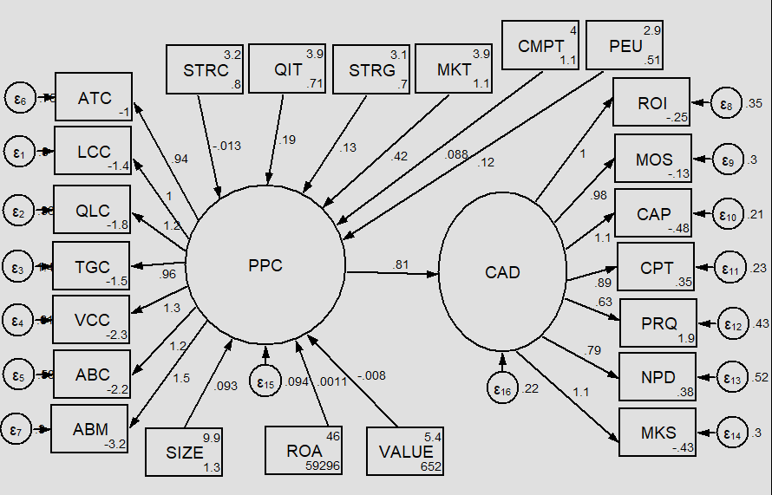
Figure 1: SEM diagram on determinants and impact of PPC on organisational competitiveness
Source: Authors own creation

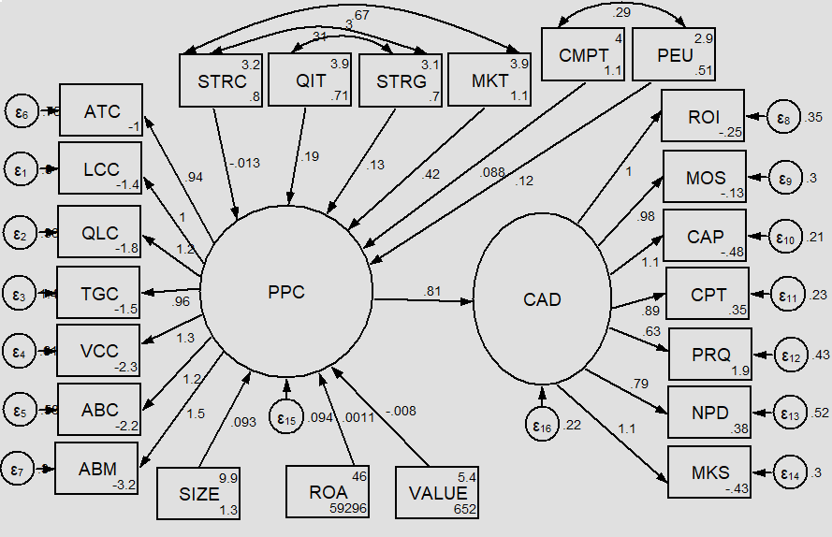
Figure 2: SEM diagram on determinants and impact of PPC on organisational competitiveness with contextual factors linked as covariates
Source: Authors own creation

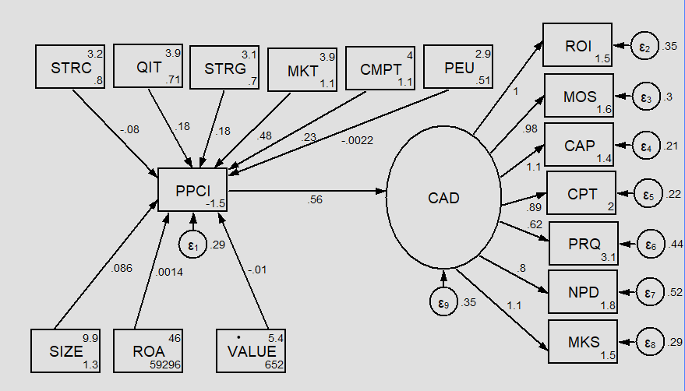
Figure 3: SEM diagram on determinants and impact of PPC on organisational competitiveness using PPC index as an alternative measure of PPC
Source: Authors own creation

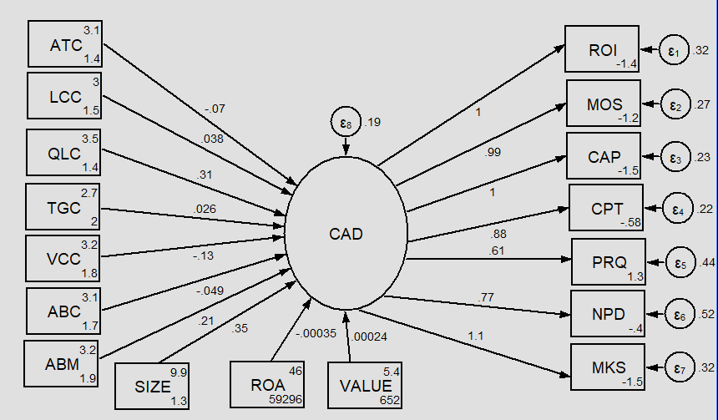
Figure 4: SEM diagram on impact of individual PPC techniques on organisational competitiveness
Source: Authors own creation

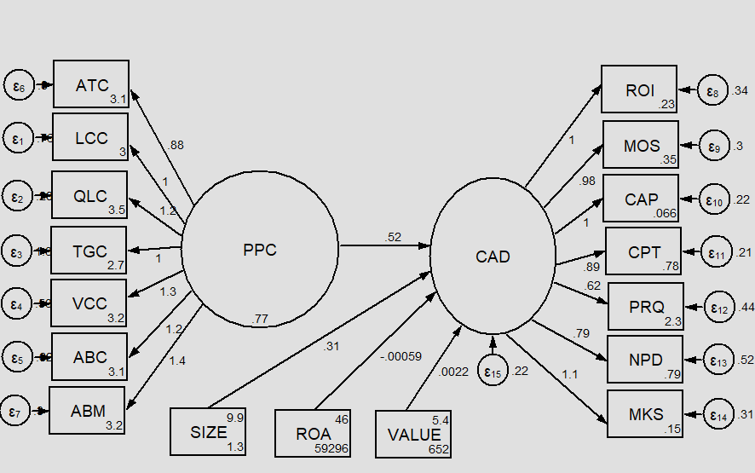
Figure 5: SEM diagram on impact of interactive use of PPC techniques on organisational competitiveness
Source: Authors own creation

