**Multicentre cohort Study of Oesophageal Injuries and related Clinical outcomes (MUSOIC study)**

Richard Owen1,2, Swathikan Chidambaram3, Zoe Scabbiolo1, Ewen A Griffiths4, Shaun Preston5, Javed Sultan6, Alexander Phillips7, Ravindra Vohra8, James Gossage9, George B Hanna3, Tim J. Underwood10, Nick Maynard1,11, Sheraz R. Markar11

1 – Department of Surgery, Churchill Hospital, Oxford University Hospitals NHS Trust, UK

2 – The Ludwig Institute for Cancer Research, University of Oxford, UK

3 – Department of Surgery and Cancer, Imperial College London, London, UK

4 – Department of Surgery, Queen Elizabeth Hospital, Birmingham University Hospitals NHS Foundation Trust, UK

5 – Department of Surgery, Royal Surrey County Hospital, Royal Surrey NHS Foundation Trust, UK

6 – Department of Surgery, Salford Royal Hospital, Salford Royal NHS Foundation Trust, UK

7 – Northern Oesophago-Gastric Cancer Unit, Newcastle upon Tyne Hospitals NHS Foundation Trust, UK

8 – Trent Oesophago-Gastric Unit, Nottingham University Hospitals Trust, UK

9 – Department of Surgery, Guy’s and St Thomas’ Hospitals NHS Foundation Trust, UK

10 – School of Cancer Sciences, University of Southampton, UK

11 – Nuffield Department of Surgery, University of Oxford, UK

**Correspondence to:**

Sheraz R Markar

Nuffield Department of Surgery, Churchill Hospital, Old Road, Headington, Oxford OX3 7LE

Email: [sheraz.markar@nds.ox.ac.uk](mailto:sheraz.markar@nds.ox.ac.uk)

Phone: +44 (0)20 3312 7657

**Word count (excluding abstract and references): 2395**

**Figures: 3**

**Tables: 4**

**Supplementary Material: 4**

**Keywords:**

Oesophagus; perforation; Boerhaave’s

**Abstract (320/300 words)**

**Background**

A previous national UK study showed 90-day mortality of up to 44% with oesophageal perforation. The primary objective of the MUSOIC study was to identify prognostic factors associated with 90-day mortality. The secondary objective was to map the specific timeline from presentation through diagnosis and to intervention and how this relates to mortality.

**Methods**

A multi-centre cohort study (data from January 2016 to December 2020) including eight high volume oesophago-gastric centres. We included adult patients admitted with oesophageal perforation and managed as an inpatient for more than 24 hours. Data were split into a train and test sets in a ratio of 3:1. 90-day mortality model training was performed using random forest, support-vector machines, and logistic regression with and without elastic net regularisation. Model performance was assessed on test data sets using receiver operating characteristics and area under the curve (AUC). Chronological analysis was performed by examining each patient journey timepoint with reference to symptom onset.

**Findings**

Data were collected for 369 patients with a 90-day mortality of 18.9%. Patients treated conservatively, endoscopically, surgically, or with combined approaches had 90-day mortalities of 24.1%, 23.7%, 8.7%, and 18.2%, respectively. After data pre-processing mortality prediction was possible with a high area under curve (>0.8) with most modelling methodologies. The predictive variables for mortality were Charlson comorbidity index, haemoglobin count, leucocyte count, creatinine levels, cause of perforation, presence of cancer, hospital transfer, CT findings, whether a contrast swallow was performed, and the intervention type. Stepwise interval model showed that time to diagnosis was the most significant contributor to mortality.

**Interpretation**

This large multi-centre study demonstrated that with a centralised service for the management of oesophageal perforation the 90-day mortality was 18.9%. Future investigation must seek to validate the developed mortality risk model, and to identify key areas for change that may reduce 90-day mortality further.

**Funding**

None

**Introduction**

Oesophageal perforation remains one of the most serious but rare emergent gastrointestinal conditions [1-3]. The reported in-hospital mortality from treated oesophageal perforation is 10% to 25% if treatment is initiated within 24 hours from onset of symptoms. However, mortality increases steeply up to 60% in cases where treatment is delayed given the often insidious and vague presentation and delays in diagnosis [4,5]. The most common cause of oesophageal perforation is iatrogenic with spontaneous perforations accounting for up to 15% of cases [6]. Given the rarity of condition, high quality evidence regarding management is severely limited and the prospect of any randomised controlled trials in the field remains unlikely.

Historically, patients have been managed based on the personal experience and preference of the treating surgeon, and accordingly most patients underwent surgical management based on data from small retrospective case series [7-11]. Primary closure and wide drainage of the mediastinum was historically the treatment of choice if perforation was detected in less than 24 hours after onset of symptoms. However, recent advances in interventional endoscopy have brought this modality to the forefront [12,13]. Depending on the cause of injury, location of perforation and status of the patient, treatment options now include conservative management; endoscopy (stenting or clipping or vacuum-based therapy); and surgery (drainage, diversion, primary repair, or oesophagectomy). Recently, the World Society of Emergency Surgery (WSES) congress produced guidance on initial stratification of patients using the Pittsburgh Severity Score, diagnostic strategies, patient selection for each treatment modality, and recommendations on operative techniques [14]. However, the majority of these recommendations are based on evidence at grade 1c and below, highlighting the challenges of research in this field [13].

A previous national study utilising an administrative dataset from the UK included 2564 patients over 12 years and showed a 90-day mortality of between 35 and 44%, with hospital volume identified as a key prognostic variable [15]. Follow-up investigations utilising the same administrative dataset, also established the prognostic importance of management of oesophageal perforation within high volume oesophageal cancer centres and by high volume oesophageal cancer surgeons [16,17]. Despite the size of the dataset, these investigations were severely limited by a lack of specific or granular data to allow more in depth understanding of the mechanism for these prognostic effects observed.

The MUSOIC study group designed a multi-centre UK study including eight high volume oesophago-gastric centres, to develop a high granular and valid modern dataset that seeked to address these deficits in previous evidence. The primary objective of the MUSOIC study was to identify key patient, oesophageal perforation specific, hospital and treatment prognostic factors associated with 90-day mortality. The secondary objective was to map the specific timeline from presentation through diagnosis and to intervention for patients with oesophageal perforation and how this relates to mortality.

**Methods**

**Design**

A multi-centre cohort study was designed (data from January 2016 to December 2020) to examine the prognostic factors associated with 90-day mortality following oesophageal perforation (MUSOIC dataset). Local ethical approval was obtained from each participating site for the inclusion of anonymised patient data into the MUSOIC dataset.

**Cohort**

Participating centres were all high volume oesophago-gastric centres experienced in the management of oesophageal perforation and included; (i) St Mary’s Hospital Imperial College London, (ii) Churchill Hospital, Oxford University Hospitals NHS Trust, (iii) Queen Elizabeth Hospital, Birmingham University Hospitals NHS Foundation Trust, (iv) Royal Surrey County Hospital, Royal Surrey NHS Foundation Trust, (v) Salford Royal Hospital, Salford Royal NHS Foundation Trust, (vi) Northern Oesophago-Gastric Cancer Unit, Newcastle upon Tyne Hospitals NHS Foundation Trust, (vii) Guy’s and St Thomas’ Hospitals NHS Foundation Trust and (viii) University Hospital Southampton NHS Foundation Trust.

*Inclusion criteria:*

- Adult patients admitted with oesophageal perforation and managed as an inpatient for more than 24 hours.

- Patients admitted between January 2016 to December 2020 to one of the eight participating hospitals.

*Exclusion criteria:*

- Paediatric population

- Patients with anastomotic leak or conduit necrosis following oesophagectomy

- Patients with incomplete data concerning 90-day mortality (n=1).

**Outcome**

*Primary outcome:* 90-day mortality

*Secondary outcome measures:*Complications including re-intervention and re-admission, length of hospital and ICU stay.

**Statistical analysis**

Descriptive statistics were used for primary and secondary outcome measures. For mortality prediction, raw data were pre-processed as follows (summarised in figure S1): variables with greater than 10% missing data were removed, patients with incomplete mortality data were excluded, and then random forest imputation used to complete the dataset [18]. Backward selection was performed with logistic regression using the Akaike Information Criterion to identify the most informative variables, and these were assessed for collinearity with Pearson correlation coefficients, keeping variables with a correlation coefficient -0.5 to 0.5. Data were then split into a train and test sets in a ratio of 3:1. Model training was performed using random forest, support-vector machines, and logistic regression with and without elastic net regularisation [19]. Model performance was assessed on test data sets using receiver operating characteristics and area under the curve (AUC) [20]. To assess model stability, repeated random subsampling validation was performed (50 iterations). Chronological analysis was performed by examining each patient journey timepoint with reference to symptom onset (time zero). Intervention and surgery timepoints were collapsed into a single time point (intervention), and times to referral and transfer were excluded due to insufficient data. Patients were then excluded that did not have any intervention, or which had greater than two missing time points of the four remaining. Uniform manifold approximation and projection (UMAP) dimensionality reduction was used to visualise chronology data in two dimensions, and outcome measures overlaid. Specific time points were then modelled with logistic regression with reference to outcomes measures which showed a visually assessed pattern in dimensionality reduction. All analysis was performed in R (v4.2) with code available on request.

**Results**

Data were collected for 369 patients and key demographic details are summarised in tables 1 (*ensemble*) and 2 (by intervention type). Overall, 90-day mortality was 18.9%. Patients treated conservatively, endoscopically, surgically, or with combined approaches had 90-day mortalities of 24.1%, 23.7%, 8.7%, and 18.2%, respectively, with a significantly lower mortality in surgically treated patients as compared to conservative or endoscopically treated patients (p=0.001). Complications occurred in 73.3% of patients, with Clavien-Dindo grade III or higher complications in 55.2%. Complications were more common in surgically treated patients and more severe (90.2% vs 61.0% overall, p=4.51e-08; 67.9% vs 46.1% Clavien-Dindo III and above, p=0.0002). Reintervention rates within 90 days were 15.2%, with the most common being radiological interventions after surgery (61.9%). From 333 patients with complete data, the readmission rate was 17.7% with most readmissions occurring after surgical intervention (30.0%, p=0.002; compared to 8.99% and 22.9% in conservatively and endoscopically treated patients, respectively). Median length of stay (LOS) was 25.5 days (interquartile range (IQR) 10-51 days), with significantly longer LOS in patients treated by surgery (40 days, IQR 25-61 days), or combined interventions (74 days, IQR 46-97 days; p<0.001). Median intensive care unit (ICU) stay was 4 days (IQR 0-14 days), which was significantly higher in surgically treated patients (10 days, IQR 4-18 days; p<0.001).

After data pre-processing (see statistical methods and figure S1), mortality prediction was possible with a high area under curve (>0.8) with several modelling methodologies (figure 1a and 1b). Logistic regression generally performed well in comparison to untuned random forest and support-vector machines, with little benefit from elastic net regularisation or model tuning, and therefore logistic regression was preferred due to its simplicity and the transparency of variable relevance (table S1). The predictive variables for mortality after selection were Charlson comorbidity index, haemoglobin count, leucocyte count, creatinine levels, cause of perforation, presence of cancer, hospital transfer, CT findings, whether a contrast swallow was performed, and the intervention type (table 3 and figure 2). Interestingly, the model performed strongly even without American Society of Anesthesiologists physiological status, despite a clear impact on mortality, which was excluded due to the confines of the data pre-processing (figure S3), and when variables which could not realistically be altered were removed (figure 1c and 1d). Whilst currently unvalidated, this model is made freely available for use.

A key strength of MUSOIC is the detailed chronological record of each patient, which can be mapped on a per-patient basis (figure 3a and 3b). Patients who were transferred to a different unit for intervention had no worse mortality, length of stay or complication rate than those treated within the admitting hospital. To better understand whether the intervals between symptom onset, hospital attendance, diagnosis, referral to treating hospital, transfer to treating hospital, intervention and surgery had any impact on the primary and secondary outcomes, data were first processed as described in the statistical methods, leaving 150 patients with sufficient data for imputation, then plotted using dimensionality reduction methods to explore whether the pattern of chronological variables showed any influence on outcomes (figure 3c). Visual inspection suggests mortality was influenced by overall chronology, and not other outcomes such as length of stay in hospital or intensive care (figure 3c, lower plots). Logistic regression showed interval from symptom onset to hospital visit had a significant association with mortality (p=0.029, table 4a). To avoid issues of collinearity from cumulative interval timings, similar analysis was also performed using intervals from each time point to the next. This stepwise interval model showed that time to diagnosis was the most significant contributor to mortality, with a borderline significance (p=0.052, table 4b, supplemental figure 4a and 4b).

**Discussion**

The MUSOIC study included 369 patients from eight high volume oesophago-gastric surgical centres with granular data collected from 2016 to 2020, representing a modern cohort of patients presenting with oesophageal perforation. The 90-day mortality was 18.9%, which compares well with the 44% mortality identified in a previous publication from a nationwide UK cohort study in 2012 [15]. Surgery as primary treatment approach was seen to reduce 90-day mortality (8.7%) compared to endoscopic (24%) or conservative management (24%). However surgical intervention was seen to increase complications and reinterventions when compared to other treatment approaches. Key factors including Charlson comorbidity index, haemoglobin count, leucocyte count, creatinine levels, cause of perforation, presence of cancer, hospital transfer, CT findings, whether a contrast swallow was performed, and the intervention type, when combined into risk prediction models were able to consistently identify patients at risk of 90-day mortality. Removal of factors which could not be determined at the onset of clinical management did not overly impact the performance of the model, meaning clinical application is feasible with model validation. Importantly the granularity of the dataset allowed examination of the timeline of patients with oesophageal perforation and established the prognostic importance of time to diagnosis in this cohort.

It is important to consider the limitations of this study in view of the important findings identified. Firstly, this study includes eight high volume oesophago-gastric surgical centres and is representative of a centralised practice in the management of oesophageal perforation. This is in direct comparison to our previously published national cohort study [15], and thus does have an inherent selection bias given the design of the study. Importantly this present study does represent an analysis of the effects of centralising the management of oesophageal perforation to high volume oesophago-gastric surgical centres to ensure optimal care. Further, given the observational nature of the study design, causation cannot be established, especially when considering the association of reduced 90-day mortality seen with surgical intervention. This may be the result of an inherent selection bias in selecting physiologically fit enough patients for surgical intervention, or those escalated to a centralised care, however this was not captured within the parameters adjusted for in the multivariate analysis. Given the detailed nature of the data requested on every patient there were patients with missing data, especially in the timeline analyses, which may have led to this analysis being underpowered and introduce bias due to non-random missing data.

One of the major findings of the study was that surgical intervention was associated with a significantly reduced 90-day mortality in univariate and multivariate analysis. Esophageal perforation is a complex gastrointestinal condition, with a recent rise in potential available treatment options including vacuum therapy, covered stenting, endoscopic clips and combination therapy [14]. Clearly given the breadth of treatment options available, there is a need for a careful multidisciplinary discussion regarding a patient and pathology tailored treatment approach, such as used by the MUSOIC study centres. Crucially, the prognostic importance of surgery highlighted within the current study illustrates the need for oesophageal surgeons to be at the core of the multi-disciplinary process, in order to utilise a surgical approach when required and available.

A novel aspect of this multi-centre study was the time-line analysis provided within a centralised model for the management of patients with oesophageal perforation. This established that the most prognostically important time interval was time to diagnosis in patients with oesophageal perforation. Given the design of this study it is not possible to identify the nature of the delays to diagnosis that led to an adverse clinical outcome. However, this result does identify the need for access to timely radiological investigation once a clinical suspicion of oesophageal perforation has been identified. More broadly the time-line analysis highlights the time-sensitive nature of this condition in terms of diagnosis, but less so in time to intervention. However, the importance of intervention being undertaken in the correct environment with centres with oesophago-gastric surgical expertise has been previously demonstrated [16,17].

A 90-day mortality risk prediction model was also developed that showed overall good accuracy with an area under the curve of >0.8. This is the first mortality risk prediction model developed within a multi-centre study for oesophageal perforation and is freely available. The combination of baseline patient data, with biochemical measures, aetiology, imaging findings and treatment, establishes the importance of all these factors in patients’ mortality from oesophageal perforation. There is a need for further validation of this risk prediction model, that will be undertaken over the next three years.

In conclusion, this large multi-centre study including eight high volume oesophago-gastric surgical centres was able to establish with a centralised service for the management of oesophageal perforation the 90-day mortality is 18.9%. Key patient, biochemical, aetiological, radiological and treatment factors can be combined into a risk model that accurately identifies patients at risk of mortality from oesophageal perforation. Surgical intervention and time to diagnosis appear to be key prognostic factors in reducing mortality. Future investigation must seek to validate the developed mortality risk model, and to identify key areas for change that may reduce 90-day mortality further.

**Tables**

**Table 1: Summary demographics and clinical details of patients. (IQR – interquartile range.)**

**Table 2: Summary demographics and clinical details of patients by type of intervention. (IQR – interquartile range.)**

**Table 3: Results of logistic regression of variables important in predicting mortality after esophageal perforation. Backward selection was used to identify the variables shown. Asterisks included to highlight low p values (*<0.05, **<0.01, ***<0.001).**

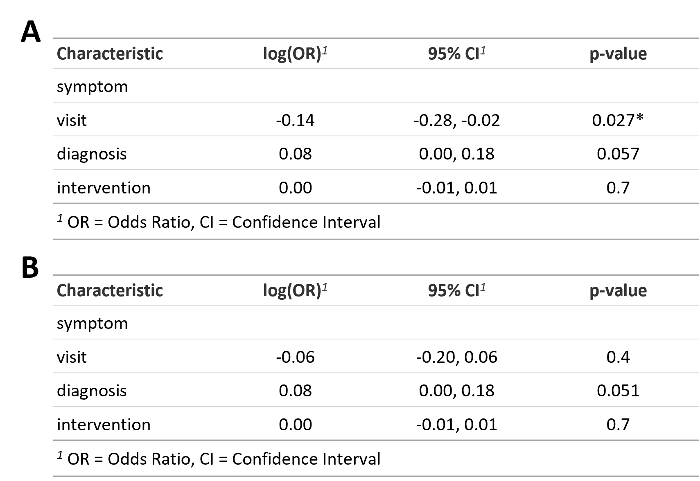

**Table 4: Logistic regression tables showing the effect of patient journey chronology on mortality outcomes. A – Logistic regression table using interval from symptom onset to each defined time point. B – Logistic regression table using interval between each time point (from symptom onset in the first case). Asterisks included to highlight low p values (*<0.05).**

|  |  |  |  |
| --- | --- | --- | --- |
| **Characteristic** | **log(OR)*1*** | **95% CI*1*** | **p-value** |
| age | 0.01 | -0.02, 0.05 | 0.5 |
| sex |  |  |  |
| male | — | — |  |
| female | 0.43 | -0.52, 1.4 | 0.4 |
| respiratory conditions |  |  |  |
| no | — | — |  |
| yes | -0.02 | -1.1, 1.0 | >0.9 |
| type 2 diabetes mellitus |  |  |  |
| no | — | — |  |
| yes | -2.3 | -4.3, -0.36 | 0.021 |
| cause |  |  |  |
| iatrogenic | — | — |  |
| spontaneous | 1.6 | 0.50, 2.7 | 0.004 |
| traumatic | -15 | -8,731, 8,701 | >0.9 |
| caustic/ingestion | 1.5 | -1.3, 4.4 | 0.3 |
| other | -17 | -5,268, 5,234 | >0.9 |
| esophageal tumor |  |  |  |
| no | — | — |  |
| yes | 1.8 | 0.46, 3.1 | 0.008 |
| treating hospital |  |  |  |
| admitting | — | — |  |
| transferred | -1.6 | -2.6, -0.60 | 0.002 |
| CCI | 0.34 | 0.12, 0.57 | 0.003 |
| hb | -0.01 | -0.02, 0.00 | 0.071 |
| wcc | 0.08 | -0.11, 0.27 | 0.4 |
| neuts | -0.09 | -0.30, 0.11 | 0.4 |
| lymph | -0.72 | -1.6, 0.14 | 0.10 |
| creatinine | 0.01 | 0.00, 0.01 | 0.013 |
| urea | 0.02 | -0.02, 0.06 | 0.4 |
| xray findings |  |  |  |
| none | — | — |  |
| mediastinal fluid | 1.7 | -1.5, 4.8 | 0.3 |
| pleural effusion | -0.21 | -1.4, 0.94 | 0.7 |
| pneumomediastinum | -0.85 | -2.2, 0.53 | 0.2 |
| pneumothorax | -0.40 | -2.9, 2.1 | 0.8 |
| subcutaneous emphysema | -1.7 | -4.6, 1.1 | 0.2 |
| CT |  |  |  |
| no | — | — |  |
| yes | -0.75 | -3.1, 1.6 | 0.5 |
| CT findings |  |  |  |
| none | — | — |  |
| contrast leak | -1.0 | -2.4, 0.37 | 0.2 |
| mediastinal fluid | 0.47 | -0.74, 1.7 | 0.4 |
| pleural effusion | -0.69 | -2.0, 0.65 | 0.3 |
| pneumomediastinum | 5.3 | 1.1, 9.5 | 0.013 |
| pneumothorax | -17 | -12,280, 12,246 | >0.9 |
| subcutaneous emphysema | -0.94 | -2.8, 0.93 | 0.3 |
| swallow |  |  |  |
| no | — | — |  |
| yes | -4.4 | -7.1, -1.7 | 0.001 |
| swallow findings |  |  |  |
| none | — | — |  |
| contrast leak | -17 | -13,209, 13,175 | >0.9 |
| mediastinal fluid | -15 | -21,093, 21,062 | >0.9 |
| pleural effusion | -16 | -11,997, 11,966 | >0.9 |
| pneumomediastinum | 1.7 | -24,383, 24,387 | >0.9 |
| pneumothorax | -3.3 | -6.0, -0.56 | 0.018 |
| perforation site |  |  |  |
| unknown | — | — |  |
| cervical | 1.4 | -0.98, 3.8 | 0.2 |
| thoracic | 0.87 | -0.91, 2.6 | 0.3 |
| abdominal | -0.82 | -3.2, 1.5 | 0.5 |
| gastroscopy |  |  |  |
| no | — | — |  |
| yes | -0.05 | -0.96, 0.87 | >0.9 |
| intervention |  |  |  |
| conservative | — | — |  |
| endoscopic | -1.2 | -2.4, 0.10 | 0.071 |
| surgery | -2.2 | -4.8, 0.53 | 0.12 |
| combined | -1.7 | -5.0, 1.7 | 0.3 |
| cervical_incision |  |  |  |
| no | — | — |  |
| yes | -17 | -9,483, 9,449 | >0.9 |
| thoracotomy |  |  |  |
| no | — | — |  |
| yes | -1.4 | -3.3, 0.45 | 0.13 |
| laparotomy |  |  |  |
| no | — | — |  |
| yes | 1.6 | -0.81, 4.1 | 0.2 |
| minimally invasive |  |  |  |
| no | — | — |  |
| yes | -16 | -5,948, 5,916 | >0.9 |
| chest contents |  |  |  |
| none | — | — |  |
| effusion | -17 | -4,699, 4,665 | >0.9 |
| pus | 0.49 | -1.9, 2.8 | 0.7 |
| food | -0.68 | -2.9, 1.6 | 0.6 |
| other | 1.2 | -1.3, 3.6 | 0.4 |

**Supplemental table 1: Logistic regression table showing all variables used to assess mortality outcomes prior to variable selection. (1OR – Odds Ratio, CI – Confidence Interval.)**

**References**

1.Schweigert M, Santos Sousa H, Solymosi N, Yankulov A, Fernández MJ, Beattie R, et al. Spotlight on esophageal perforation: A multinational study using the Pittsburgh esophageal perforation severity scoring system. In: Journal of Thoracic and Cardiovascular Surgery. 2016.

2. Wahed S, Dent B, Jones R, Griffin SM. Spectrum of oesophageal perforations and their influence on management. Br J Surg. 2014;

3. Markar SR, Vidal-Diez A, Holt PJ, Karthikesalingam A, Hanna GB. An International Comparison of the Management of Gastrointestinal Surgical Emergencies in Octogenarians—England versus United States. Ann Surg. 2019;

4. Bladergroen MR, Lowe JE, Postlethwait RW. Diagnosis and Recommended Management of Esophageal Perforation and Rupture. Ann Thorac Surg. 1986;42(3).

5. Sepesi B, Raymond DP, Peters JH. Esophageal perforation: Surgical, endoscopic and medical management strategies. Vol. 26, Current Opinion in Gastroenterology. 2010.

6. Søreide JA, Konradsson A, Sandvik OM, Øvrebø K, Viste A. Esophageal perforation: Clinical patterns and outcomes from a patient cohort of western Norway. Dig Surg. 2013;

7. Gupta NM, Kaman L. Personal management of 57 consecutive patients with esophageal perforation. American Journal of Surgery. 2004;187(1).

8. Hermansson M, Johansson J, Gudbjartsson T, Hambreus G, Jönsson P, Lillo-Gil R, et al. Esophageal perforation in South of Sweden: Results of surgical treatment in 125 consecutive patients. BMC Surgery. 2010;10.

9. Bhatia P, Fortin D, Inculet RI, Malthaner RA. Current concepts in the management of esophageal perforations: A twenty-seven year Canadian experience. Annals of Thoracic Surgery. 2011;92(1).

10. Chao YK, Liu YH, Ko PJ, Wu YC, Hsieh MJ, Liu HP, et al. Treatment of esophageal perforation in a referral center in Taiwan. Surgery Today. 2005;35(10).

11. Vallböhmer D, Hölscher AH, Hölscher M, Bludau M, Gutschow C, Stippel D, et al. Options in the management of esophageal perforation: Analysis over a 12-year period. Diseases of the Esophagus. 2010;23(3).

12. Schweigert M, Dubecz A, Solymosi N, Ofner D, Stein HJ. Times and trends in the treatment of spontaneous perforation of the esophagus: From Herman Boerhaave to the present age. Am Surg. 2013;

13. Brinster CJ, Singhal S, Lee L, Marshall MB, Kaiser LR, Kucharczuk JC. Evolving options in the management of esophageal perforation. Annals of Thoracic Surgery. 2004.

14. Chirica M, Kelly MD, Siboni S, Aiolfi A, Riva CG, Asti E, et al. Esophageal emergencies: WSES guidelines. World Journal of Emergency Surgery. 2019.

15. Markar SR, Mackenzie H, Wiggins T, Askari A, Faiz O, Zaninotto G, et al. Management and outcomes of esophageal perforation: A national study of 2,564 patients in England. Am J Gastroenterol. 2015;

16. Markar SR, Mackenzie H, Wiggins T, et al. Influence of national centralization of oesophagogastric cancer management on clinical outcome from emergency upper gastrointestinal conditions. Br J Surg 2018; 105: 113 – 120.

17. Markar SR, Mackenzie H, Askari A, Faiz O, Hanna GB. Effect of Esophageal Cancer Surgeon Volume on Management and Mortality from Emergency Upper Gastrointestinal Conditions. Ann Surg. 2017;

18. Stekhoven DJ, Buhlmann P. MissForest--non-parametric missing value imputation for mixed-type data. Bioinformatics. 2012 Jan 1;28(1):112–8.

19. Friedman J, Hastie T, Tibshirani R. Regularization Paths for Generalized Linear Models via Coordinate Descent. J Stat Softw. 2010;33(1):1–22.

20. Sing T, Sander O, Beerenwinkel N, Lengauer T. ROCR: visualizing classifier performance in R. Bioinformatics. 2005 Oct 15;21(20):3940–1.

**Figures**

**Figure 1: Mortality prediction models and performance. A – Receiver operator characteristic curves showing the performance of the modelling techniques used with the area under curve values for each method printed within the plot. B – Box plots showing the area under curve values over 50 iterations of repeated random subsampling validation. (tpr – true positive rate; fpr – false positive rate; AUC – area under curve; EN – logistic regression with elastic net regularisation; LR – logistic regression; RF – random forest; SVM – support-vector machines.)**

**Figure 2: Boxplots (upper plots) and proportional barcharts (bottom row) showing the differences in mortality from oesophageal perforation for a selection of significant variables (red=alive, turquoise=deceased/dead). Asterisks above the boxplots denote p value (*<0.05, **<0.01, ***<0.001).**

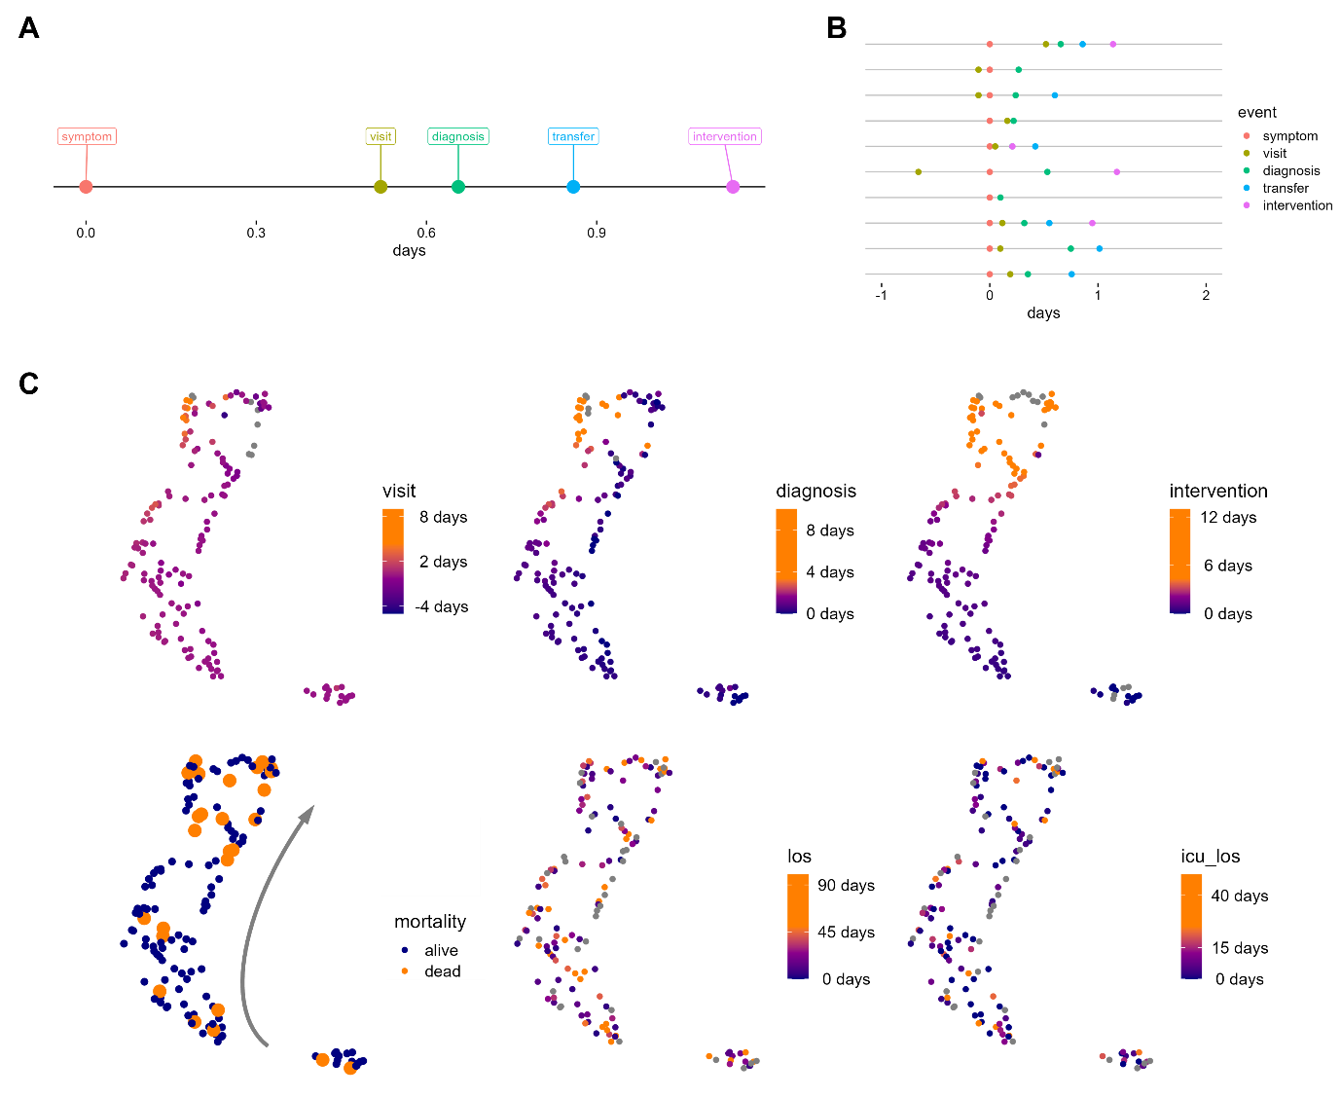

**Figure 3: Chronology mapping and dimensional reduction. A – Example of patient journey chronology across key timepoints of symptom onset, time to hospital visit, time to diagnosis, time to transfer to treating hospital 9where relevant) and time to intervention. B – Summary of first ten patient journey chronologies. C – Uniform manifold approximation and projection plots of all patient journey chronologies. The upper plots show intervals from symptoms onset, and the lower plots show the main outcomes of mortality (bottom left, patient deaths highlighted in larger orange points with grey arrow to indicate visual interpretation of higher density of mortality), length of stay (bottom middle) and intensive care stay (bottom right). (los – length of stay; icu – intensive care unit.)**

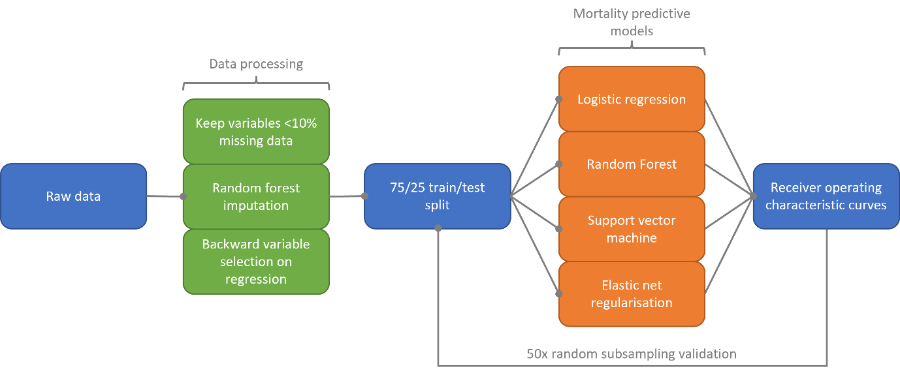

**Supplemental figure 1: Summary of the steps used in data pre-processing (green boxes), and the methods used to predict mortality (orange boxes) and test model performance stability.**

**Supplemental figure 2: Proportional bar charts showing the effect of American Society of Anesthesiologists (ASA) physiological status on mortality.**

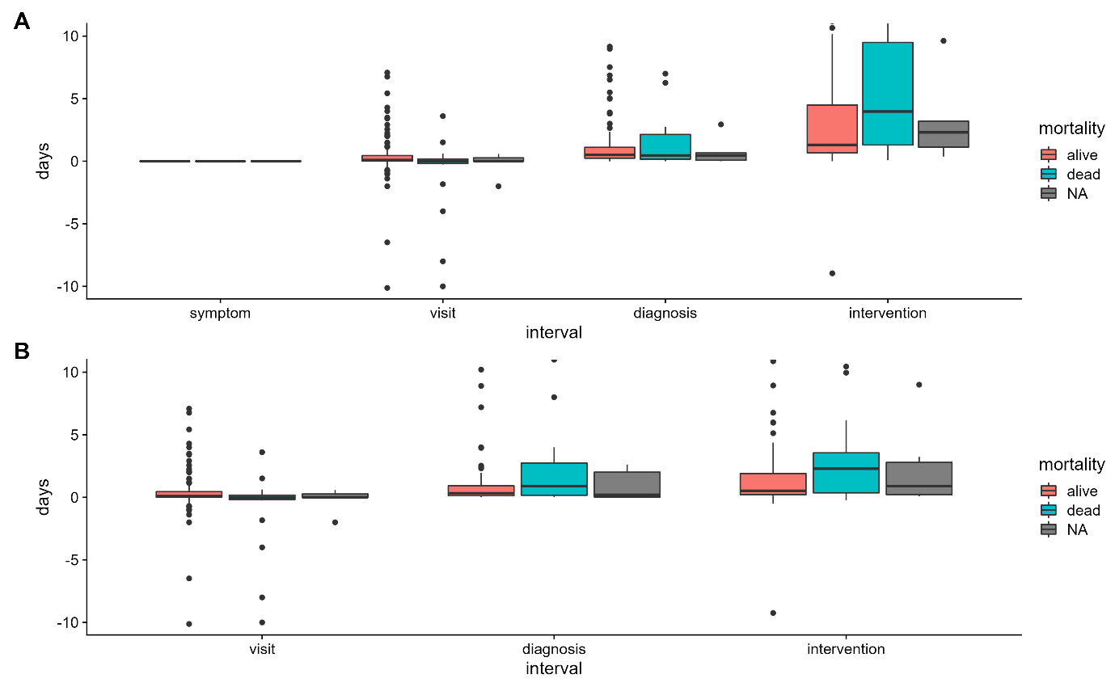

**Supplemental figure 3: Boxplots showing the chronology of patients from symptom onset to intervention. A – Intervals between symptom onset and hospital visit, diagnosis and intervention, respectively, separated by mortality status. B – As in A, but adjusted to interval between each time point, rather than from symptom onset in all cases.**