**A personalised Library welcome for academic and research staff**

Nicki Clarkson, University of Southampton, [nsc@soton.ac.uk](mailto:nsc@soton.ac.uk)

**Published in ALISS Quarterly 19(4), August 2024, 8-11**

This summary is based on a talk at the CILIP North East Beyond the Horizon conference titled: “Building connections: a personalised Library welcome for academic and research staff"

Library information for new University of Southampton students is seamlessly integrated into the centralised emails sent to offer holders before and after their arrival, included in official inductions, highlighted on our webpages, and signposted from the virtual learning environment. However, until recently, there was no equivalent process for new university staff members.

In summer 2023 our Engagement & Innovation team led a workstream to develop an effective, consistent and scalable way of closing this gap, connecting with new members of staff when they join the university.

## Defining the scope

We focused on new starters on the Education, Research and Enterprise pathway. These are a key group of library users (for research, teaching or both) and are associated with a specific School. Each School has a named Engagement Librarian, making it easy to send a personalised welcome message and an offer to meet with their Engagement Librarian.

## Identifying new academic and research staff

Our Bibliometrics team set up an automated report from our current research information system showing all Education, Research and Enterprise staff who have joined the university in the preceding week. The report only includes members of staff who are totally new to the university – we made the decision to exclude anyone who has moved role so that we could start with one clear “welcome to the university” message.

The report is sent to a team email inbox every Monday as a spreadsheet and our Curriculum Engagement library assistants sort the list by School and then send each Engagement Librarian details of their new starters.

## Our ‘welcome’ resource

We created a bespoke resource that underwent several designs and content iterations. Colleagues from all areas of the library provided details of relevant services and resources, with our Digital Scholarship team leading on the design, accessibility and format. This initial phase of work highlighted how much the library has to offer but the volume of information we wanted to share was overwhelming (see Design 1).

## Design 1

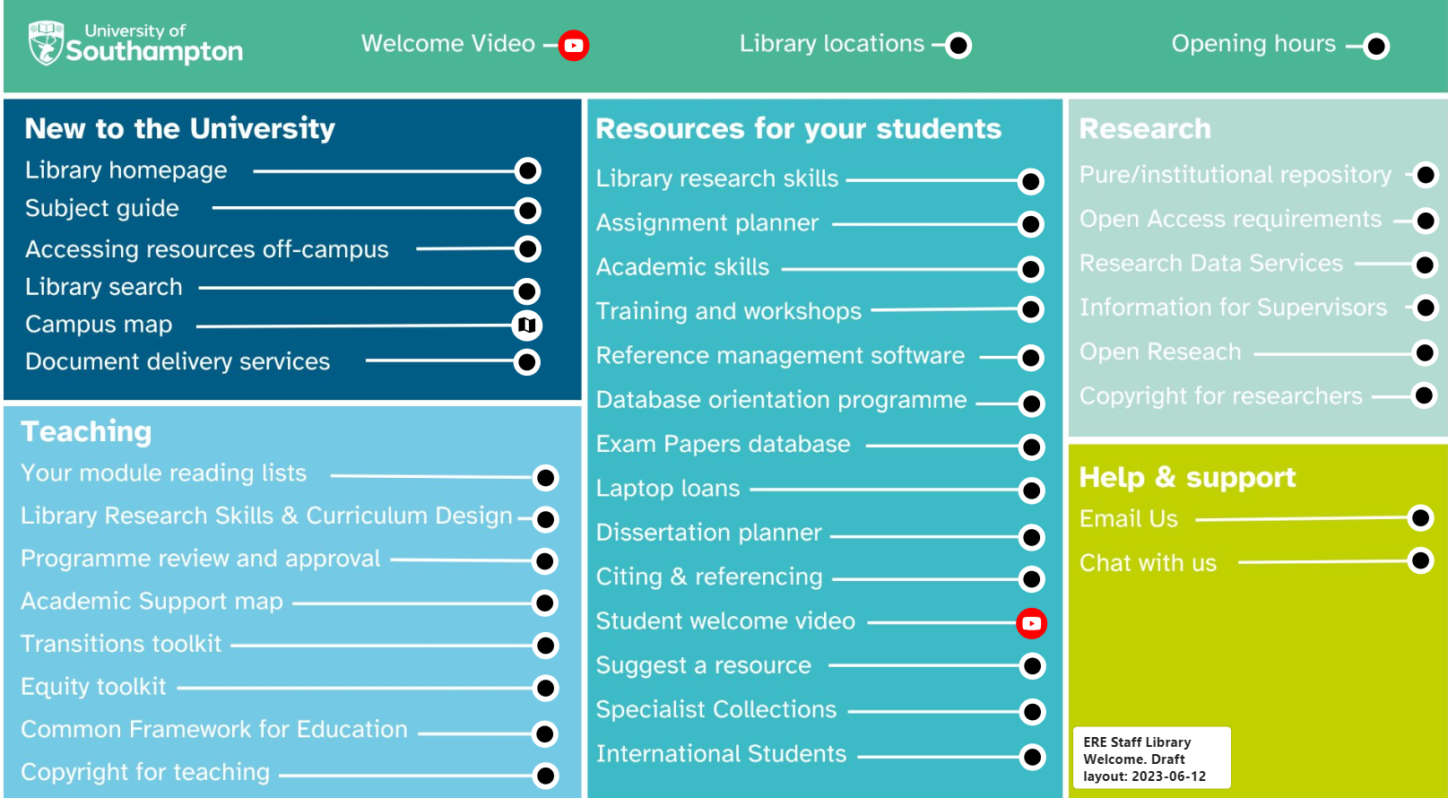**Alt text for Design 1: 6 different sections on the screen, with a total of 40 links. The sections are Library locations and opening hours, new to the university, teaching, resources for your students, research, help and support.**

Following several rounds of refinements, we streamlined the content and selected a design that placed the welcome message at the hub of the page, with 4 spokes covering ‘Finding and accessing resources’, ‘Information for your students’, ‘Your teaching’ and ‘Your research’ (see Design 2).

We carried out user testing with a small group of academics who are familiar with the library ahead of sharing it more widely at the University of Southampton Centre for Higher Education Practice Festival of Learning and Teaching. We received overwhelmingly positive feedback and endorsement from academics of our proposed welcome approach.

Design 2 (available at https://www.thinglink.com/card/1734893194337845734)

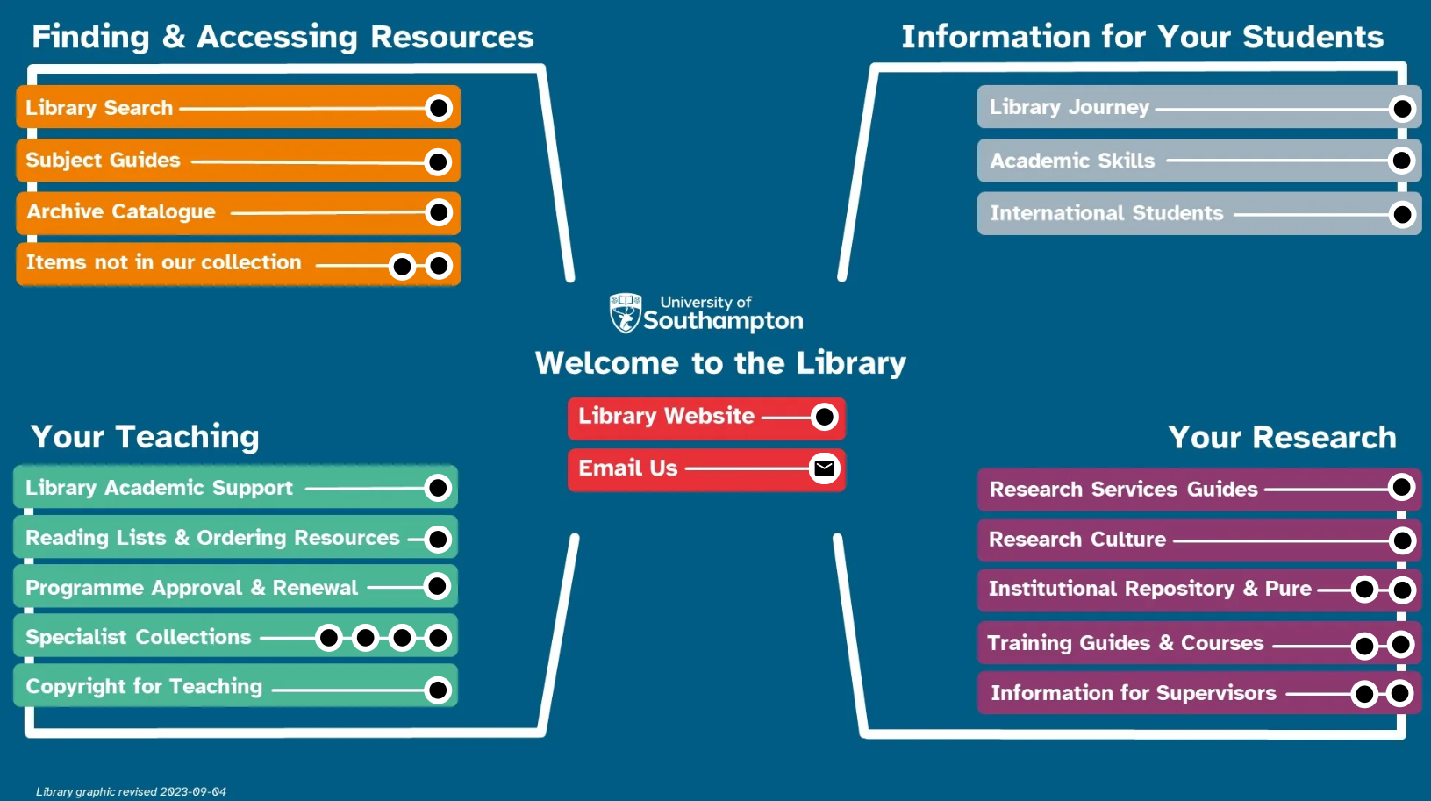**Alt text for Design 2: streamlined design with welcome information in the centre (library website and email us), and 4 sections leading off (finding and accessing resources, information for your students, your teaching, your research)**

## The personal approach

Engagement Librarians use a standard template as the basis for an email to be sent individually to each new member of staff in their School. The template is not prescriptive; the librarians are free to tailor the email ensuring the member of staff is addressed by name, the wording is concise and friendly, there is a link to the [welcome resource](https://www.thinglink.com/card/1734893194337845734), the tone encourages conversation and the email offers the opportunity for a meeting.

## Evaluation and iteration

This approach has resulted in a notable increase in new staff reaching out to find out more about the library services that underpin their teaching and research at an early point in their University of Southampton journey.

Usage statistics from the welcome resource also evidence the impact, with over 950 views in the first 6 months. These views originate from two sources: links in the welcome emails and direct access from our library homepage.

Using ThingLink for the welcome resource enables us to review which are the most popular links and which offer less value and could be removed to further streamline the design. Having said that, our first change will be to add a Recreational Reads link to the hub to highlight our reading for pleasure collection.

## Future plans

Following the success of the process, our Library EDI & Wellbeing Group is currently considering extending the scope of the welcome to new staff starters on non-academic and non-research career pathways. A member of Professional Services asked recently if they could use the library or if it was only for students and academics, so reaching out to new staff on the administrative/professional services and technician pathways would help share the message that the library is for all members of the university community (and beyond).

This work is licensed under [CC BY 4.0](https://creativecommons.org/licenses/by/4.0)