**Table S1: Process parameter combinations used for the experiments.**

|  |  |  |  |  |  |
| --- | --- | --- | --- | --- | --- |
| Specimen | Tool Rotation Speed (RPM) | Table Speed (mm/s) | Actuator Feed Rate (mm/s) | Ω (Table Speed/Actuator Feed Rate) | Hardness  (HV) |
| 1 | 200 | 4.2 | 1.92 | 2.2 | 62±1.5 |
| 2 | 400 | 4.2 | 1.92 | 2.2 | 72±2.3 |
| 3 | 200 | 8.5 | 3.85 | 2.2 | 56±1.0 |
| 4 | 400 | 8.5 | 3.85 | 2.2 | 75±1.3 |
| 5 | 200 | 4.2 | 1.51 | 2.8 | 56±0.8 |
| 6 | 400 | 4.2 | 1.51 | 2.8 | 72±1.9 |
| 7 | 200 | 8.5 | 3.02 | 2.8 | 48±0.8 |
| 8 | 400 | 8.5 | 3.02 | 2.8 | 71±1.1 |
| 9 | 132 | 6.4 | 2.54 | 2.5 | NA |
| 10 | 468 | 6.4 | 2.54 | 2.5 | 73±1.0 |
| 11 | 300 | 2.8 | 1.12 | 2.5 | NA |
| 12 | 300 | 9.9 | 3.96 | 2.5 | 63±1.2 |
| 13 | 300 | 6.4 | 3.18 | 1.99 | 72±0.5 |
| 14 | 300 | 6.4 | 2.11 | 3.0 | 72±2.2 |
| 15 | 300 | 6.4 | 2.54 | 2.5 | 67±4 |
| 16 | 300 | 6.4 | 2.54 | 2.5 | 67±1.4 |
| 17 | 300 | 6.4 | 2.54 | 2.5 | 65±1.9 |
| 18 | 468 | 9.9 | 4.94 | 2.0 | 81 ± 2.4 |

*The hardness value of the feedstock material was 101*± 2 *HV.*

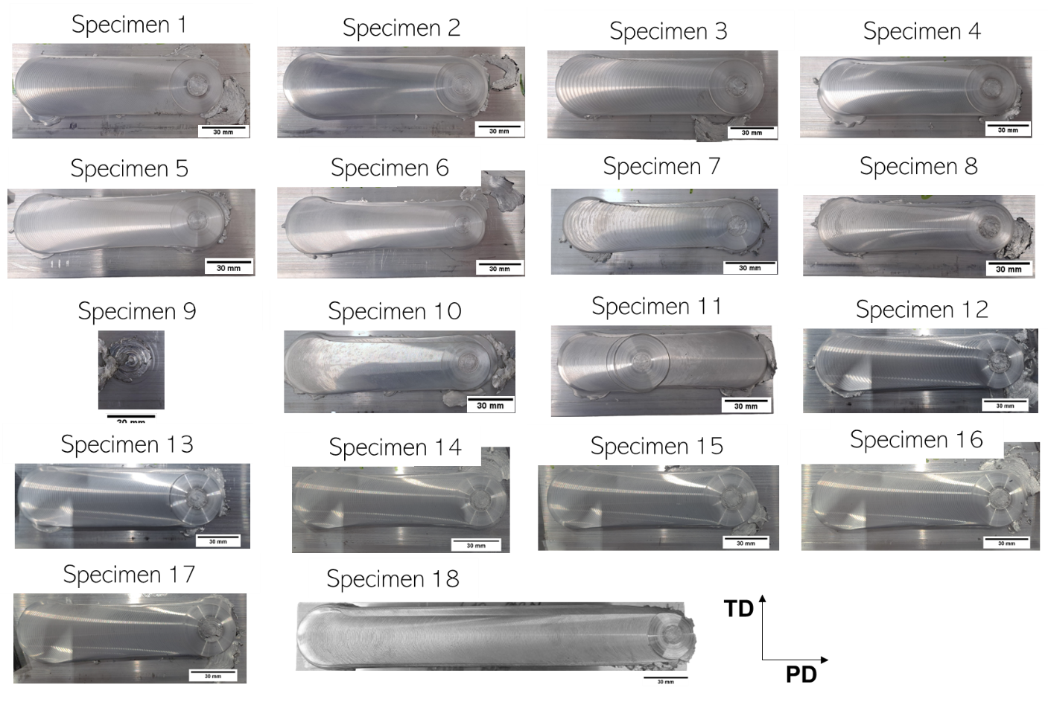

*Fig. S1: Macroscale images of the samples printed using AFSD for the set processing parameter combinations.*

**S1.0 Strengthening mechanism**

The alloy after AFSD exhibited extensive variation in the mechanical properties based on the process parameters that were used. There were several factors identified for the same which included variation in the precipitation behaviour, dislocation density, grain size and extent of recrystallization. In this regard, several mechanisms were identified that would have influenced the overall strength of those samples. They are precipitation strengthening, grain boundary strengthening, dislocation strengthening and solid solution strengthening. Hence, theoretical calculations were made for each strengthening mechanism and their contribution to the overall strength was estimated.

*S1.1 Grain boundary Strengthening*

The Hall-Petch relationship is extensively used to calculate the contribution to the yield strength by the grain boundaries expressed by the equation [1,2]:

$∆σ_{GB}=k_{HP}d^{{-1}/2}$ (1)

Where kHP is 0.06 MPa.m1/2 [2]and d is the grain size. The values of ΔσGB calculatedfor Specimens 4, 7 and 18 were 18 MPa, 27 MPa and 16 MPa, respectively.

*S1.2 Dislocation Strengthening*

The presence of dislocation is known to improve the strength of the material. The increment in strength due to dislocation strengthening is expressed by the equation [3]:

$∆σ_{DD}= MαGb{\left(ρ\right)}^{1/2}$ (2)

Where α ~ 0.2 for FCC metals [3], M is the Taylor factor (M = 3.06), G is the shear modulus of the matrix (G = 26.9 GPa), b is the magnitude of the Burgers vector of the matrix (b = 0.286 nm), ρ is the dislocation density whose values for Specimens 4, 7 and 18 were 1.2 × 1014 m-2, 5.7 × 1013 m-2  and 6.2 × 1013 m-2, respectively. Hence, the values of ΔσDD for the samples were 52 MPa, 35 MPa and 37 MPa, respectively.

*S1.3 Precipitate Strengthening*

There are two ways in which precipitate strengthening can occur: Orowan dislocation bypass and precipitate shearing due to the dislocations. The former occurs when the precipitates are incoherent with the matrix and the size of those precipitates are greater than a critical size [4]. Shearing occurs when the precipitates are small and are coherent with the matrix. The Orowan dislocation bypassing mechanism can be described by the Orowan-Ashby equation [5]:

$∆σ_{Or}= \frac{0.13. G b}{L}\ln{\frac{< r >}{b}}$ (3)

Additionally, L can be represented as [6,7]:

$L=<r>\left(\sqrt{\frac{3π}{4f}}-2\sqrt{\frac{2}{3}}\right)$ (4)

Where ΔσOr is the change in the yield strength due to Orowan bypass mechanism, < r > is the mean radius of the precipitates, L is the inter-precipitate distance and f is the volume fraction of the precipitates. Since the precipitates considered in this alloy were not spherical, which is assumed in the above equations, a mean effective radius was calculated using the principles of equivalent volume. The values of < r > and f for the different samples are shown in Table S2. For Sample 7, this strengthening mechanism would not be active due to the dissolution of the precipitates during AFSD with those combinations of the process parameters.

**Table S2: The effective radii and the volume fraction of the precipitates**

|  |  |  |
| --- | --- | --- |
| **Sample** | **< r >**  **(nm)** | **f** |
| Specimen 4 | 2.33 | 0.02 |
| Specimen 18 | 3.12 | 0.052 |

The change in strength due to the shear mechanism is comprised of coherency strengthening (Δσcs), modulus mismatch strengthening (Δσms) and order strengthening (Δσos). These are given by the equations [3]:

$∆σ_{cs}= Mα_{ε}({Gε_{c})}^{3/2}{\left(\frac{<r>f}{0.5Gb}\right)}^{1/2}$ (5)

Where αε = 2.6 [8] and εc is the constrained lattice parameter mismatch which is expressed as [9]:

$ε_{c}=ε_{eff}\left(1+\frac{2G (1-2ν)}{B_{c}(1+ν)}\right)$ (6)

Where ν is the Poisson ratio of the matrix (ν = 0.33) and Bc is the bulk modulus of the precipitate. εeff can be further expressed as [10]:

$ε_{eff}= \frac{√2}{3} {\left[{(ε_{11}- ε_{22})}^{2}+{(ε_{22}- ε_{33})}^{2}+{(ε_{33}- ε_{11})}^{2}\right]}^{1/{2 }}$ (7)

Where ε11 , ε22 and ε33 are given by the equations:

$ε_{11}= \frac{a_{p}}{{2a}_{m}}-1$ (8) $ε_{22}= \frac{b_{p}}{{1.5\sqrt{2} . a}_{m}}-1$ (9)

$ε_{33}= \frac{c_{p}}{a_{m}}-1$ (10)

Where ap bp cp are the lattice parameters of the precipitate and am is the lattice parameter of the matrix. The values for these parameters are shown in Table S3.

The strength increment due to modulus mismatch strengthening can be expressed as [6]:

$∆σ_{ms}= 0.0055 M(Δ{G)}^{3/2}{\left(\frac{2f}{G}\right)}^{1/2}{\left(\frac{<r>}{b}\right)}^{\left(\frac{3m}{2}-1\right)}$ (11)

Where m = 0.85 [8] and ΔG is the modulus mismatch between the matrix and the precipitates. Lastly, order strengthening can be obtained from the equation [6]:

$∆σ_{os}= 0.81 M\left(\frac{γ_{APB}}{2b}\right){\left(\frac{3πf}{8}\right)}^{1/2}$ (12)

Where γAPB is the anti-phase boundary energy of the precipitate phase which unfortunately is not available for pre-β” phase, and for the calculation, the γAPB of the β” has been utilized. However, this is not a major issue because of the condition that if ΔσOr < Δσcs + Δσms, the operating mechanism is Orowan dislocation bypass irrespective of the value of Δσos [3]. For Specimen 4, the values of ΔσOr,Δσcs, Δσms, and Δσos were 97.6 MPa, 131 GPa, 1.7 MPa and 57.87 MPa, respectively. Since ΔσOr < Δσcs + Δσms, the operating strengthening mechanism in Specimen 4 was Orowan dislocation bypass and hence, the strength increment due to the precipitates in this sample (ΔσPPT)4 was 97.6 MPa. However, for Specimen 7 this strengthening mechanism would not be relevant as most of the strengthening precipitates either dissolved or coarsened. In case of Specimen 18, the values of ΔσOr, Δσcs, Δσms and Δσos were 146 MPa, 247 GPa, 40 MPa and 88 MPa, respectively. The operating strengthening mechanism was Orowan bypass in this case as well as ΔσOr < Δσcs + Δσms. Hence, for Specimen 18 (ΔσPPT)18 was 146 MPa. However, it is to be noted that this is an overestimation because the strengthening β” phase was heterogeneously distributed within the grain and Eq. (3) does not account for that.

**Table S3: The structure parameters and material properties used for the calculations of Δσcs, Δσms, and Δσos**

|  |  |
| --- | --- |
| Shear modulus of pre-β” | 28.2 GPa |
| Bulk modulus of pre-β” | 54.9 GPa |
| Shear modulus of β” | 34.2 GPa |
| Bulk modulus of β” | 61.7 GPa |
| Lattice parameter of pre-β” | ap = 1.478 nm  bp = 0.405 nm  cp = 0.674 nm |
| Lattice parameter of β” | ap = 1.516 nm  bp = 0.405 nm  cp = 0.674 nm |
| Lattice parameter of Al matrix | am = 0.405 nm |
| γAPB | 0.084 J/m2 |

*S1.4 Solid Solution Strengthening*

This strengthening mechanism is active when other elements are present in the metal matrix in solid solution. The difference in the atomic size and the shear modulus between solute atoms and the matrix induces local strain fields that impede dislocation motion. It can be expressed by the equation [11]:

$∆σ_{SS}= \sum_{j}{{GZε}_{j}}({C_{j})}^{1/2}$ (13)

$ε= {\left[{δG}^{2}+α^{2}{δr}^{2}\right]}^{1/{2 }}$ (14)

$δr_{ij}= \frac{2(r_{i}-r_{j})}{(r_{i}+r_{j})}$ (15)

$δG_{ij}= \frac{2(G_{i}-G_{j})}{(G_{i}+G_{j})}$ (16)

Where Cj concentration of a specific alloying element in solid solution in at.%, Z is the fitting coefficient whose value is 4.43 × 10-3. ε is the mismatch parameter and δG and δr are the mismatch of atomic radius and shear modulus, respectively between the atoms of the solute and the matrix. α is constant (α = 0.52 [12]). The ε values for Al-Mg and Al-Mn are 0.38 and 0.27, respectively. Hence, (ΔσSS)Mg and (ΔσSS)Mn values were 42 MPa and 16 MPa, respectively. Hence, the total ΔσSS for this alloy was 58 MPa. However, this value can change depending on the precipitation behaviour which was different for each of the samples in the present study. Nevertheless, Fig. S2 shows the contribution from the other strengthening mechanisms in the samples.



*Fig. S2: Macroscale images of the samples printed using AFSD for the set processing parameter combinations.*

It is interesting to note that the grain boundary strengthening has the lowest contribution in all the samples. Additionally, the precipitates contributed the most in both intermediate and high strength samples (Specimens 4 and 18), which indicated that it is extremely important to optimize and select process parameters that would favour the reprecipitation of the strengthening phase.

**References**

[1] A. Pariyar, C.S. Perugu, L.S. Toth, S.V. Kailas, Microstructure and mechanical behavior of polymer-derived in-situ ceramic reinforced lightweight aluminum matrix composite, Journal of Alloys and Compounds 880 (2021) 160430. https://doi.org/10.1016/j.jallcom.2021.160430.

[2] S. Thangaraju, M. Heilmaier, B.S. Murty, S.S. Vadlamani, On the Estimation of True Hall–Petch Constants and Their Role on the Superposition Law Exponent in Al Alloys, Advanced Engineering Materials 14 (2012) 892–897. https://doi.org/10.1002/adem.201200114.

[3] H. Wen, T.D. Topping, D. Isheim, D.N. Seidman, E.J. Lavernia, Strengthening mechanisms in a high-strength bulk nanostructured Cu–Zn–Al alloy processed via cryomilling and spark plasma sintering, Acta Materialia 61 (2013) 2769–2782. https://doi.org/10.1016/j.actamat.2012.09.036.

[4] T.H. Courtney, Mechanical Behavior of Materials, McGraw Hill Education (Asia), 2000.

[5] Z. Zhang, D.L. Chen, Consideration of Orowan strengthening effect in particulate-reinforced metal matrix nanocomposites: A model for predicting their yield strength, Scripta Materialia 54 (2006) 1321–1326. https://doi.org/10.1016/j.scriptamat.2005.12.017.

[6] J.P. Hou, Q. Wang, Z.J. Zhang, Y.Z. Tian, X.M. Wu, H.J. Yang, X.W. Li, Z.F. Zhang, Nano-scale precipitates: The key to high strength and high conductivity in Al alloy wire, Materials & Design 132 (2017) 148–157. https://doi.org/10.1016/j.matdes.2017.06.062.

[7] J.W. Martin, Micromechanisms in Particle-Hardened Alloys, CUP Archive, 1980.

[8] A.J. Ardell, Precipitation hardening, Metall Trans A 16 (1985) 2131–2165. https://doi.org/10.1007/BF02670416.

[9] R.D. Schueller, F.E. Wawner, A.K. Sachdev, Strengthening potential of the cubic σ precipitate in Al-Cu-Mg-Si alloys, JOURNAL OF MATERIALS SCIENCE 29 (1994) 239–249. https://doi.org/10.1007/BF00356599.

[10] D. Zhao, L. Zhou, Y. Kong, A. Wang, J. Wang, Y. Peng, Y. Du, Y. Ouyang, W. Zhang, Structure and thermodynamics of the key precipitated phases in the Al–Mg–Si alloys from first-principles calculations, J Mater Sci 46 (2011) 7839–7849. https://doi.org/10.1007/s10853-011-5765-4.

[11] J. Zhao, L. Luo, X. Zheng, T. Zhang, H. Luo, Z. Li, T. Liu, L. Wang, Y. Su, The effect of Mn content on a novel Al–Mg–Si-Sc-Zr alloy produced by laser powder bed fusion: The microstructure and mechanical behavior, Journal of Materials Research and Technology 28 (2024) 989–1001. https://doi.org/10.1016/j.jmrt.2023.11.048.

[12] D. Witkin, Z. Lee, R. Rodriguez, S. Nutt, E. Lavernia, Al–Mg alloy engineered with bimodal grain size for high strength and increased ductility, Scripta Materialia 49 (2003) 297–302. https://doi.org/10.1016/S1359-6462(03)00283-5.