A feasibility trial of a digital breathing exercise intervention for adolescents with asthma

Stephanie Easton PhD^{1,2}, Ben Ainsworth PhD³, Mike Thomas PhD⁴, Sue Latter PhD⁵, Rebecca Knibb PhD⁶, Amber Cook BSc Hons¹, Sam Wilding PhD⁷, Michael Bahrami-Hessari MSc¹, Erika Kennington PhD⁸, Denise Gibson PhD⁹, Hannah Wilkins BSc Hons⁹, Graham Roberts DM^{1,2*}
Affiliations:
1: Child Health, University Hospital Southampton NHS Foundation Trust, Southampton, UK. (Research primarily conducted here)¹
2: Human Development and Health, Faculty of Medicine, University of Southampton, Southampton, UK. ²
3: Centre for Clinical and Community Applications of Health Psychology, School of Psychology, Faculty of Environmental and Life Science, University of Southampton, UK. ³
4: Primary Care and Population Sciences, Faculty of Medicine, University of Southampton, Southampton, UK. ⁴
5: School of Health Sciences, University of Southampton, Southampton, UK.
6: School of Psychology, College of Health and Life Sciences, University of Aston, Birmingham, UK.
7: Cancer Research UK Southampton Clinical Trials Unit, University of Southampton and University Hospital Southampton NHS Foundation Trust,, Southampton, UK.
8: Asthma + Lung UK, London, UK.
9: Physiotherapy department, University Hospital Southampton, Southampton, UK.
Funding: This work was supported by National Institute of Health Research (NIHR) grant number [PB-PG-0817-20038].’
*Corresponding author: Graham Roberts, Paediatric Allergy and Respiratory Medicine (Mailpoint 805), Southampton University Hospital NHS Foundation Trust, Tremona Road, Southampton SO16 6YD, United Kingdom. E-mail: g.c.roberts@soton.ac.uk. Tel. 02381206160.
Keywords: Adolescence, asthma, breathing retraining, digital intervention, self-management, quality of life

Word count: 3477 words

Abstract (247/250 words)

Background
Many adolescents with asthma have dysfunctional breathing and poor quality of life. Breathing retraining is recommended for symptom management and breathing efficiency. This trial evaluated the feasibility of conducting a definitive trial to evaluate the effectiveness and cost-effectiveness of a digital breathing retraining intervention for adolescents with asthma (Breathe4T – a mobile-friendly website). Specifically, recruitment, follow-up response rates, acceptability and uptake of the intervention and measures, as well as agreement between two quality of life questionnaires were measured.
Methods
Adolescents (12-17 years) with asthma and impaired quality of life were recruited via UK primary and secondary care clinics and randomised into two, unblinded groups. The intervention group accessed Breathe4T for 6 months whilst the control group gained access after 6 months. Measures included quality of life (paediatric asthma quality of life questionnaire and paediatric quality of life short form), asthma control (asthma control test), healthcare utilisation and demographics at baseline, 2 and 6 months. Website data and interviews explored experiences of the intervention.
Results
64 adolescents were randomised. At 2 months 30.2% of participants returned data, however telephone calls improved the rate to 70.3% at 6-month follow-up Breathing retraining was acceptable to adolescents and was perceived to have various benefits.
Conclusions
The study demonstrates acceptability and feasibility of a future definitive trial to evaluate effectiveness and impacts of a breathing retraining website on quality of life. Implications for recruitment and maximising follow up rates were identified. These learnings are likely to be applicable to other adolescent studies.

Introduction (472 words)

Asthma is a long term health condition estimated to affect around 300 million people globally¹. It is amongst the most common diseases in children and adolescents, with approximately 1 in 14 individuals affected in the UK^{2,3}. Management includes pharmacological treatment such as inhaled corticosteroids. Despite the effectiveness of these treatments, many patients experience persistent symptoms and impaired quality of life (QoL)².
Asthma commonly co-exists with dysfunctional breathing (DB). DB is defined as chronic or recurrent changes in breathing pattern^{4,5} and has been described as hyperventilation (over-breathing) and increasingly, inducible laryngeal obstruction⁴. There is no clear consensus of prevalence in current literature, though a recent study suggests it may be more frequent in females^{4,5}. DB is known to negatively impact asthma control and QoL in adults with asthma. Whilst less is known for children and adolescents, a recent study has found DB to be correlated with poor asthma control in adolescents⁵. DB is often confused with asthma symptoms, exacerbating feelings of anxiety and panic in young adults with asthma⁶. Guidelines recommend breathing retraining (BR) as a useful intervention to improve breathing efficiency, control and QoL⁷. However, breathing retraining typically involves 1-to-1 physiotherapy sessions, which are costly and require the availability of an experienced professional.
Adolescence represents a unique developmental period. For many in this age group, managing a health condition such as asthma or DB can be a low priority for various reasons including competing demands, embarrassment, and pressures from peers^{6,8}. Adolescence is also a transitional period requiring a transfer in responsibility, increase in autonomy and acceptance of self-management⁹. Adherence to treatment is often sub-optimal and personalised approaches to care are needed.
Digital health interventions have become increasingly popular to facilitate patient self-management, with potential to reach large numbers^{10,11}. During a time of transition, adolescents require tools and information to increase their knowledge and understanding of their condition⁶. Currently, there are no evidence-based interventions to support self-guided breathing retraining for adolescents. An intervention for adults with asthma (BREATHE) has been found to successfully improve QoL¹². So, a theory-, evidence and person-based approach was taken to repurpose this intervention into a mobile-friendly website for adolescents with asthma to teach breathing retraining (Breathe4T)^{13,14}. The approach prioritised the behavioural needs of adolescents, maximising the persuasiveness of the intervention¹⁵.
Feasibility is recognised in guidance as a core phase of developing complex interventions¹⁶. A feasibility trial is an opportunity to consider the study design and evaluate and refine an intervention whilst exploring any uncertainties, such as acceptability, uptake and adherence¹⁷. Therefore, a feasibility trial was conducted to evaluate the acceptability and feasibility of conducting a fully powered, definitive, phase III randomised controlled trial (RCT). This future trial would assess whether a breathing retraining digital intervention can lead to clinically important improvements in patient-related asthma measures (above usual care) and demonstrate cost-effectiveness. Specific objectives are listed in Box 1.

Box 1. Feasibility study objectives
- Assess recruitment rate
- Estimate follow-up rate at the 2 and 6-month assessment
- Assess the acceptability and uptake of the intervention via participant interviews and online questionnaires at 2 and 6-month assessment
- Monitor the change in and estimate the variance of asthma-related quality of life and asthma control in each group (intervention group versus control group)
- Determine if data collection methods for process, effectiveness and cost-effectiveness endpoints are appropriate for this population by assessment of completeness of data at 2 and 6-month assessment
- Determine whether the PedsQL Asthma Module (PedsQL SF 22) provides a valid assessment of quality of life, by comparing it with the Paediatric Asthma Quality of Life Questionnaire (PAQLQ) – further details in E-Text.
- Assess degree of participation in qualitative data collection from participants via in-person, video or telephone interviews, to inform format and necessary staffing requirements for a trial
- Examine intervention uptake, engagement and acceptability

Methods (1028 words)

Design
The study was a multi-centre, open-label, two-group, individually randomised controlled feasibility trial, comparing two parallel groups of adolescents with asthma (intervention and control). Intervention participants received immediate access to the self-guided, breathing retraining intervention for 6 months. The control group continued usual care, with access provided to the intervention after 6 months. Ethical approval was given by Leeds West Research Ethics Committee: 21/YH/0033. Two parallel (parent and adolescent) patient and public involvement (PPI) panels met frequently across the wider study (see elsewhere¹³). During the feasibility trial, PPI members were involved in study design and informing recruitment strategies. A process analysis was conducted alongside the trial to provide insight into how the intervention may work, to examine mechanisms of change and further understand any contextual factors that may influence engagement with the intervention.

Participants and recruitment
Eligible participants were 12-17 years with physician-diagnosed asthma, impaired QoL (PedsQL score <85) and under general practice (GP), community or hospital practitioner care for their asthma. Exclusion criteria included co-existing respiratory conditions (such as bronchiectasis), already using breathing techniques or enrolment in another interventional study. Participants were recruited from primary care (general practices) and secondary care hospital clinics in England, UK.

Primary care
The NIHR Wessex Clinical Research Network (CRN) supported the study via advertisements to identify interested primary care practices. Across practices, eligible participants were identified through a diagnosis of asthma in patient records and were invited to take part via a letter from their GP with both parent and age-appropriate (12-14 or 15-17 years) information sheets and instructions to sign up to the website.

Secondary care
Eligible patients from asthma clinics were approached face-to-face or by letter to take part. Potential participants were given age-appropriate information and opportunity to ask questions. Clinic staff guided participants through the sign-up process on the intervention website.
The study was also advertised using posters, social media adverts (Twitter, Instagram and Facebook) and Asthma+Lung UK mailing lists. All participants were given a £10 voucher at the end of the study to compensate for their time on the study. Recruitment was conducted between June and December 2021.

Intervention
The intervention is a self-guided, breathing retraining digital intervention (Breathe4T) that underwent iterative development and optimisation in previous study stages and is based on a successful adult intervention (Breathe)^{12,13}. The intervention uses developmentally appropriate language and behaviour change techniques (BCTs) to provide information about asthma and dysfunctional breathing. Information is presented using short (<2 minute) video clips predominantly peer-led by young adults and featuring physiotherapists and researchers. Eight breathing retraining sessions are available to systematically work through and each includes a video demonstration with a voiceover, in addition to written step-by-step instructions. Other features include a progress chart (reliever inhaler usage), planner with optional reminders, practice diary, peer testimonials and common frequently asked questions (FAQs) from physiotherapists. Personalised tailoring includes reminder format (text or email) and optional parental emails. Emails inform parents of inactivity, top tips and gentle encouragement to invite a conversation with their child about breathing retraining. A flow chart of the intervention is included in E-Figure 1 with screenshots in E-Figure 2.

Procedure
A participant journey overview is provided in Figure 1. To enrol in the study, all participants provided consent (or assent), baseline measures and randomisation via the study website (random-permuted block randomisation 1:1). Parents/guardians of participants aged 15 or under were required to complete a separate consent section before their child could access the website. Intervention participants accessed the website immediately, whilst the control group were notified that they would gain access after six months. Follow-up assessments were completed via the online intervention, or via the telephone. During the sign-up process, participants were able to choose whether they provided consent to be contacted to participate in an interview about the study.

Study data

Baseline demographic data
Demographic information was collected from all participants upon signing up to the study including age, gender, ethnicity, parental education levels and basic asthma history, including treatment and professional care.

Intervention Engagement
Website usage data for each participant in the intervention group over the 6-month trial period included frequency of engagement with the intervention and recorded access to specific intervention components. This data was collected automatically via the online intervention using Google Analytics and BigQuery software^{18,19}. Guided by AMUSeD (a framework for analysing and measuring usage and engagement data in digital interventions), a combination of factors were decided upon during development to enable a detailed understanding of the intervention’s acceptability, uptake and use²⁰. Specifically, we aimed to understand average time spent on the website, pages (re)visited, number of breathing retraining sessions (re)viewed, number of reminders set by users and other features viewed (FAQ’s, diaries, peer testimonials). Participants were given no instructions about how little or often they should use the intervention. Semi-structured qualitative interviews were used to explore participants’ views and experiences of the intervention between 2 and 6 months.

Outcome measures
All other measures were related to outcomes and were collected at baseline, 2- and 6-month time points. Several measures were included to establish expected completion rates for a definitive trial. Measures were judged to be optimal based on their validity, reliability, sensitivity (responsiveness to the intervention), precision and overall burden. Asthma-specific quality of life (PAQLQ and PedSQL), asthma control (ACT), healthcare utilisation and use of breathing retraining exercisess were all measured (see full details of measures in E-Text).

Sample size
Initially, the study had a planned sample size of 116 participants, which was later revised to 58 participants (29 per arm) due to recruitment delays during the Covid-19 pandemic. The final recruitment total reached 64 participants. Key stakeholders, including the funder, study statistician and PPI members, agreed that the objectives were still able to be achieved with a smaller recruitment target.

Analysis
Baseline demographics and feasibility outcome measures were summarised using descriptive statistics in SPSS V28.1. Quantitative usage data was analysed using Google Analytics and BigQuery to describe patterns of intervention usage. As this was a feasibility trial, the study sample size was not powered to perform formal hypothesis testing. However, trends in the data were explored using exploratory bivariate correlations. Qualitative interviews were analysed using thematic analysis ²¹ These will be reported fully elsewhere²².

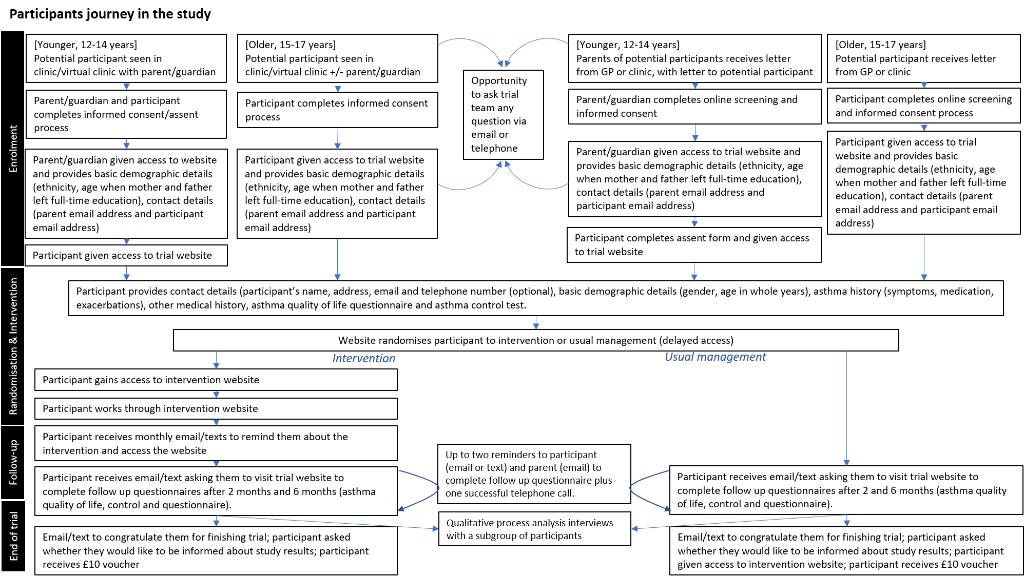
Figure 1. A participant’s journey in the study from enrolment through to the end of the trial.

Results (969 words)

Participants
Table 1 provides self-reported baseline characteristics. Participants were predominantly white and female, with more females in the intervention group. Age was fairly balanced in both groups (median, 15 years), whilst parental education varied. Greater combination inhaler medication suggested more severe asthma in the intervention group. Around 15% of both groups had attended an emergency department in the past year. Most participants in both groups reported missing taking their preventer inhaler occasionally.
 | Intervention group |  | Control group |  | Total
Variable | N | % | N | % | N | %
Gender
Male | 8 | 25% | 12 | 37.5% | 20 | 31.3%
Female | 23 | 71.9% | 18 | 56.3% | 41 | 64.1%
Prefer not to say / unknown | 1 | 3.1% | 2 | 6.3% | 3 | 4.7%
Ethnic Origin
White/English/Scottish/Welsh | 29 | 90.6% | 30 | 93.8% | 59 | 92.2%
White other | 1 | 3.1% | 1 | 3.1% | 2 | 3.1%
Other | 2 | 6.3% | 1 | 3.1% | 3 | 4.7%
Age (years)
12-14 | 13 | 40.6% | 16 | 50% | 29 | 45.3%
15-17 | 19 | 59.4% | 16 | 50% | 35 | 54.7%
Age mother left education
≤16 | 7 | 21.9% | 8 | 25% | 15 | 23.4%
17-18 | 10 | 31.3% | 13 | 40.6% | 23 | 35.9%
>18 | 13 | 40.6% | 10 | 31.3% | 23 | 35.9%
Unknown | 2 | 6.3% | 1 | 3.1% | 3 | 4.7%
Age father left education
≤16 | 12 | 37.5% | 12 | 37.5% | 24 | 37.5%
17-18 | 5 | 15.6% | 11 | 34.4% | 16 | 25%
>18 | 12 | 37.5% | 8 | 25% | 20 | 31.3%
Unknown | 3 | 9.4% | 1 | 3.1% | 4 | 6.3%
Current professionals seen
Primary care | 28 | 87.5% | 28 | 87.5% | 56 | 87.5%
Secondary care | 14 | 43.7% | 12 | 37.5% | 26 | 40.6%
School | 1 | 3.1% | 2 | 6.3% | 3 | 4.7%
Other | 3 | 9.4% | 2 | 6.3% | 5 | 7.8%
Seasons with most asthma symptoms
Spring | 11 | 34.4% | 14 | 43.8% | 25 | 39.1%
Summer | 15 | 46.9% | 18 | 56.3% | 33 | 51.6%
Autumn | 8 | 25% | 15 | 46.9% | 23 |  | 35.9%
Winter | 28 | 87.5% | 27 | 84.4% | 55 |  | 85.9%
Frequency of missed preventer
Never miss | 7 | 21.9% | 5 | 15.6% | 12 |  | 18.8%
Occasionally | 13 | 40.6% | 12 | 37.5% | 25 |  | 39.1%
Once a week | 4 | 12.5% | 7 | 21.9% | 11 |  | 17.2%
Half the time | 2 | 6.3% | 3 | 9.4% | 5 |  | 7.8%
Most of the time | 6 | 18.8% | 5 | 15.6% | 11 |  | 17.2%
Steroid courses in past year
0 | 23 | 71.9% | 21 | 65.6% | 44 |  | 68.8%
1-2 | 3 | 9.4% | 9 | 28.2% | 12 |  | 18.8%
>2 | 6 | 18.7% | 2 | 6.2% | 8 |  | 12.5%
Prevention Medication
Singular (Monkelukast) | 7 | 21.9% | 5 | 15.6% | 12 |  | 18.8%
Inhaled steroid inhalers | 9 | 28.1% | 18 | 56.3% | 27 |  | 42.2%
Combination inhalers | 20 | 62.5% | 15 | 46.9% | 35 |  | 54.7%
Not sure | 1 | 3.1% | 2 | 6.3% | 3 |  | 4.7%
School days missed in past year
0-5 | 23 | 71.9% | 26 | 81.2% | 49 |  | 76.6%
6-10 | 4 | 12.5% | 2 | 6.2% | 6 |  | 9.4%
11-15 | 2 | 6.3% | 1 | 3.1% | 3 |  | 4.7%
>16 | 3 | 9.3% | 3 | 9.4% | 6 |  | 9.4%
Hospital admissions in past year
0 | 18 | 56.3% | 15 | 46.9% | 33 |  | 51.6%
1 | 4 | 12.5% | 4 | 12.5% | 8 |  | 12.5%
>1 | 10 | 31.2% | 13 | 40.6% | 23 |  | 35.9%
Attended A&E in past year
No | 27 | 84.4% | 28 | 87.5% | 55 |  | 85.9%
Yes | 5 | 15.6% | 4 | 12.5% | 9 |  | 14.1%
Table 1. Self-reported baseline characteristics of participants recruited into the trial.

Assess recruitment rate
A total of 129 participants initiated sign-up to the study during the recruitment period (June to December 2021), and 64 (49.6%) were recruited into the study (E-Figure 3). A total of 39 individuals did not complete the sign-up process. Most of these were younger adolescents who did not go on to give assent, after their parents provided consent (69.2%).

Primary care
Invitation letters were sent by 9 GP practices to a total of 1133 participants of which 82 participants (7.2%) attempted to sign-up. Recruitment mostly occurred within a week of the mailout. A total of 37 participants were successfully randomised (57.8% of total sample, mean of 4.1 per practice). 29 didn’t complete the sign-up process and 16 were ineligible. One participant withdrew from the study within the first month, via an email from their parent reporting too much schoolwork.

Secondary care
10 secondary care sites were approached, and 7 agreed to take part. Weekly site recruitment is displayed in E-Figure 4. Forty-seven participants were approached via hospital staff face-to-face to sign up within their clinic appointment or by letter and attempted to sign-up to the website. 27 (57.4%) were recruited, 10 (21.3%) were ineligible and 10 (21.3%) didn’t complete sign-up.
No participants were recruited through community methods (e.g. social media).

Follow-up rate at 2- and 6-month assessments
At baseline, all participants completed the baseline questionnaires via the study website. The paper questionnaire (PAQLQ), (collected separately due to copyright restrictions), via either email attachment, post or during a hospital visit, was returned by 28/64 participants (43.7%). At the 2-month assessment, 19/64 (30.2%) participants logged in and completed the online questionnaires (E-Figure 3). At the 6-month assessment the approach to follow-up was adjusted to include telephone calls, and the number of participants completing online questionnaires substantially increased to 45/64 (70.3%). The paper PAQLQ response rates continued to be much lower than the online PedsQL with 18/64 (28.1%) returned at 6 months.

Change and variance in quality of life and asthma control scores
Baseline and follow-up scores for QoL measures (PedsQL and PAQLQ) and asthma control (ACT) are displayed as boxplots in Figure 2, with full scores provided in E-Table 1. At baseline, minimal group differences in QoL on both the PedsQL and PAQLQ measures were observed. There was no change in PedsQL scores over 6 months in the intervention group, and a slight decrease in score in the control group. However, PAQLQ scores demonstrated a clinically significant improvement in QoL score (>0.5) in the intervention group, and a decrease in the control group (Figure 2). No changes were observed in ACT scores.

PedsQL Asthma Module vs. Paediatric Asthma Quality of Life Questionnaire
A spearman’s correlation between the PedsQL and PAQLQ is available in E-Figure 5. Overall, correlation co-efficient between the questionnaires total scores at baseline was 0.79 and at 6-months was 0.84. This indicates a relatively strong association between the total questionnaire scores at both time points, suggesting convergent validity. The correlation data suggests that the PedsQL does provide a valid assessment of QoL when compared to the PAQLQ.

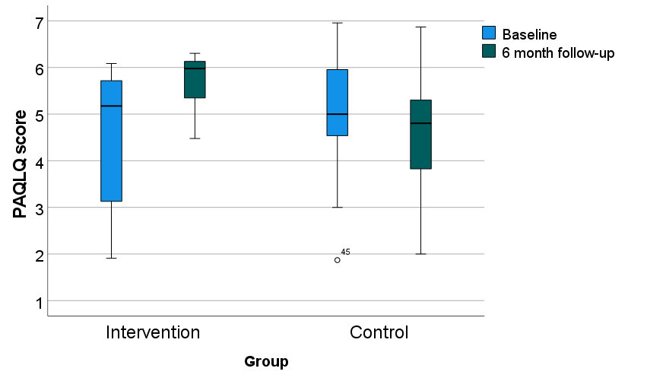

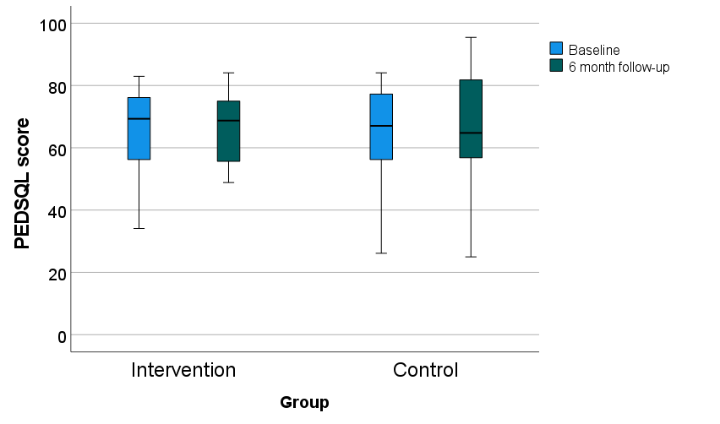

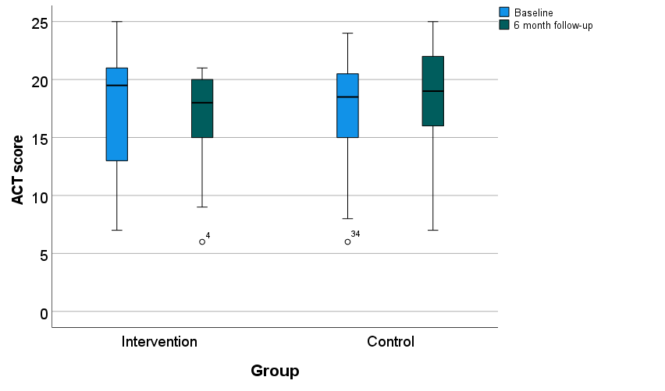
Figure 2. Box plots to show how PAQLQ (top), PedsQL (middle) and asthma control (bottom) scores change in each groups between baseline and 6 month.

Qualitative data collection
Adolescent participants were willing to speak to the research team about their study experiences. Of the 64 participants, 47 (73.4%) gave consent to be contacted for an interview (24 intervention participants and 23 control). At the 6-month time point, 11 intervention group participants couldn’t be contacted or didn’t respond, 3 didn’t attend the interview, 1 declined and 9 were interviewed. Not all control group participants were contacted, but 4 participants were interviewed. Of the 13 participants interviewed, 6 opted for video call and 7 via telephone. No interviews were able to take place in person due to Covid-19 restrictions.

Intervention uptake and engagement
Usage data was available for all 32 participants in the intervention group. Figure 3 provides histograms of the usage data, and further description can be found in the supplementary file in E-Text 2.

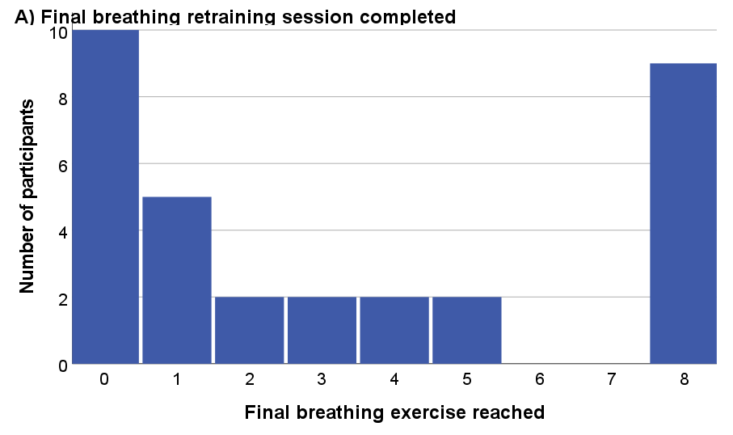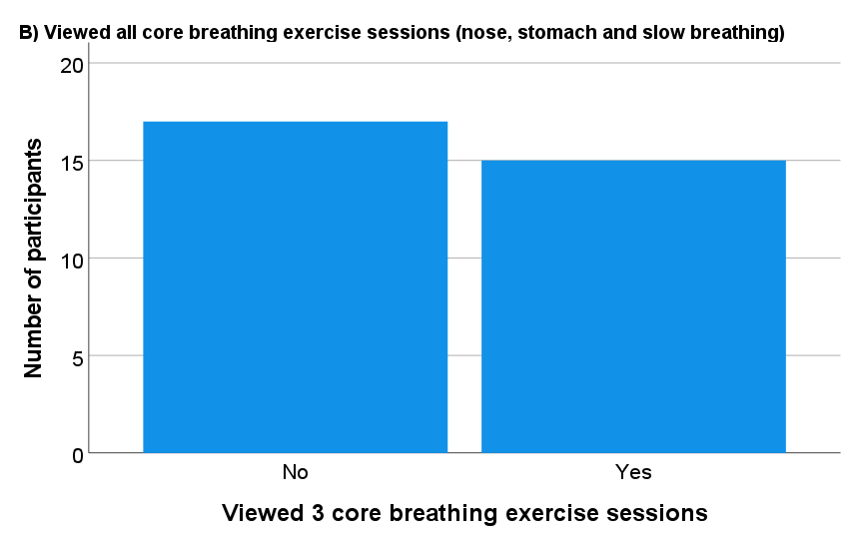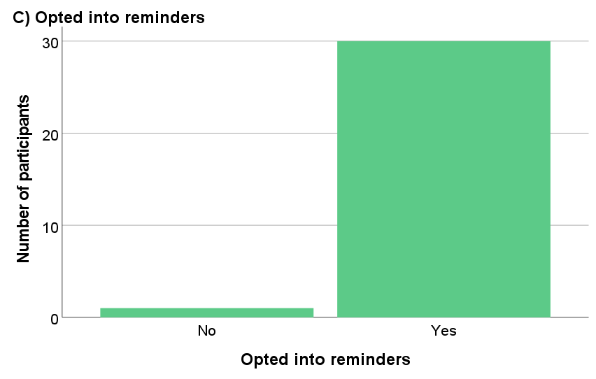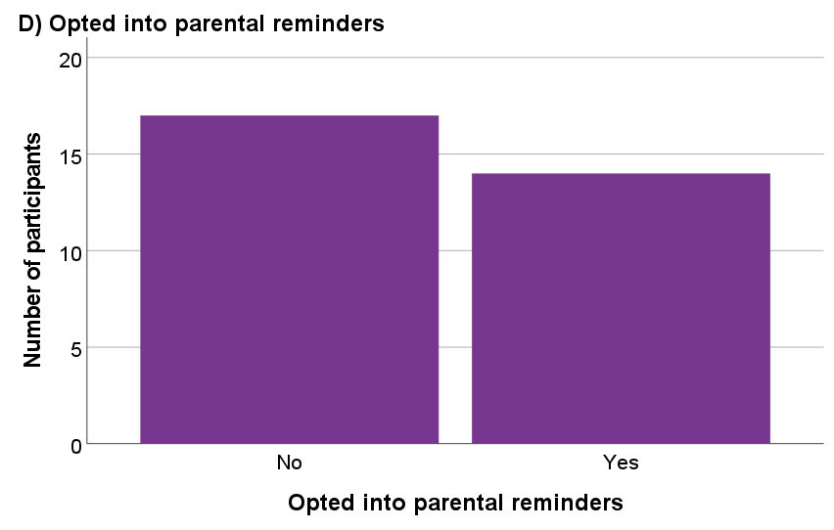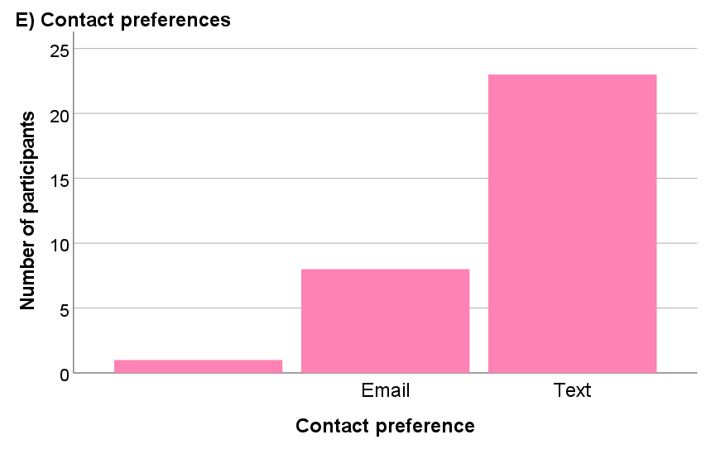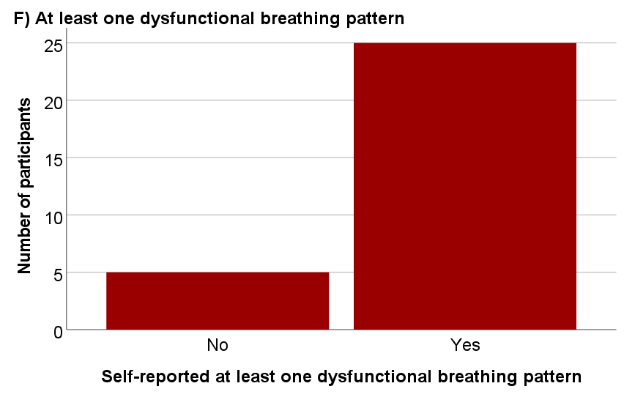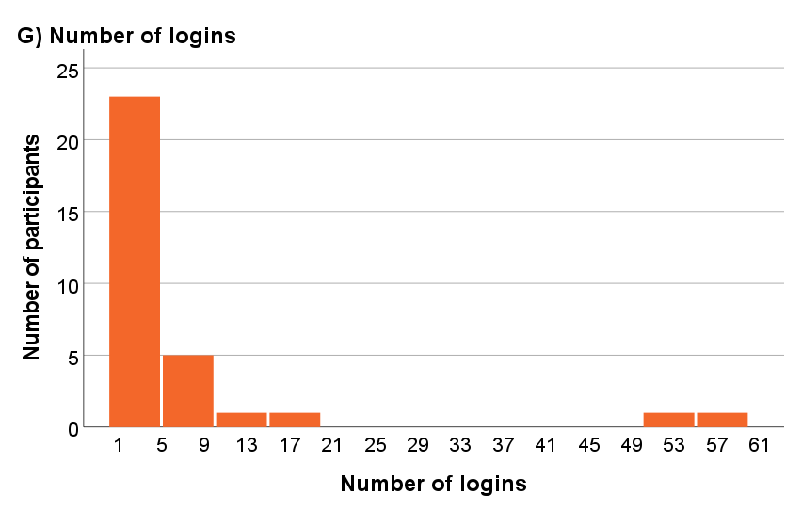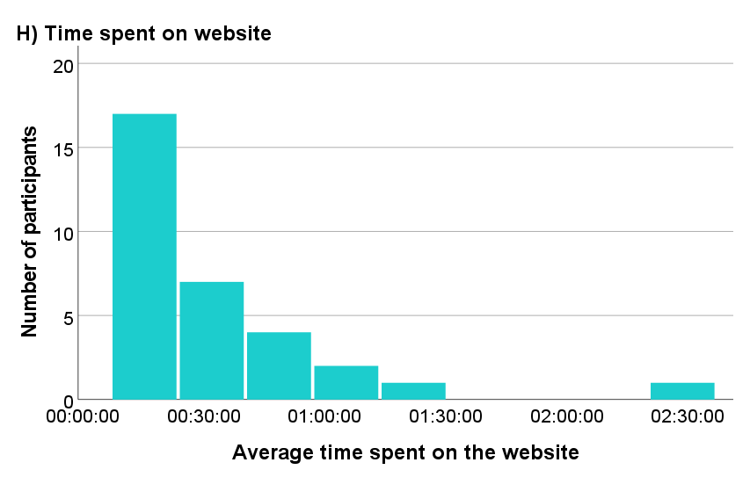
Figure 3. Histograms displaying intervention usage data from 32 participants in the intervention group. From left to right, A) the final breathing exercise session reached by participants from the dashboard, B) number of participants who viewed the first 3 core breathing exercise sessions (nose breathing, stomach breathing and slow breathing), C) number of participants who opted into receiving reminders, D) number of participants who opted into receiving parental reminders, E) participants preferences for being contacted with reminders, F) number of participants who self-reported at least one dysfunctional breathing pattern (chest, mouth of fast breathing), G) number of times participants logged into the intervention, H) average time participants spent on the website.

Breathing exercises
Participants widely varied in their self-reported practice and use of breathing exercises (Figure 4, E-Table 2). In the final two weeks of the study, the majority continued to use breathing retraining techniques at least once or twice a week; only a few participants reported no practice or use. At the end of the study, nearly all participants reported at least a 3 out of 5 in the confidence scenario. All concerns related towards embarrassment, for example “feel people will be looking at me, I will look different” and “being around the people in my class”.

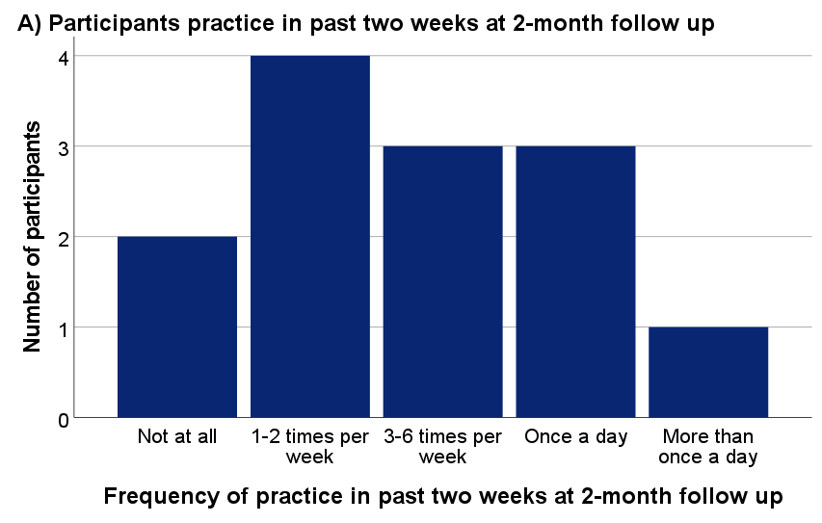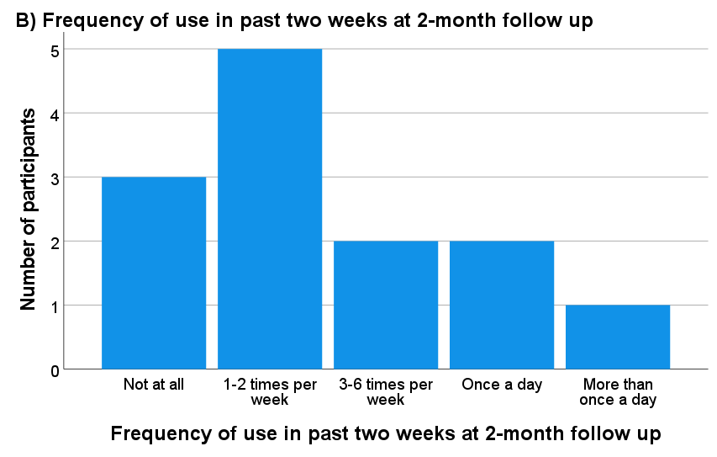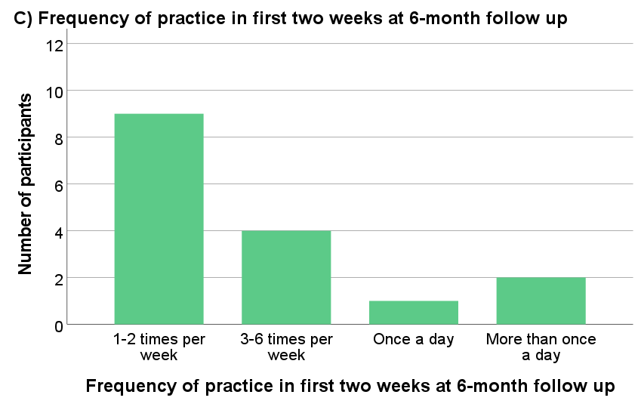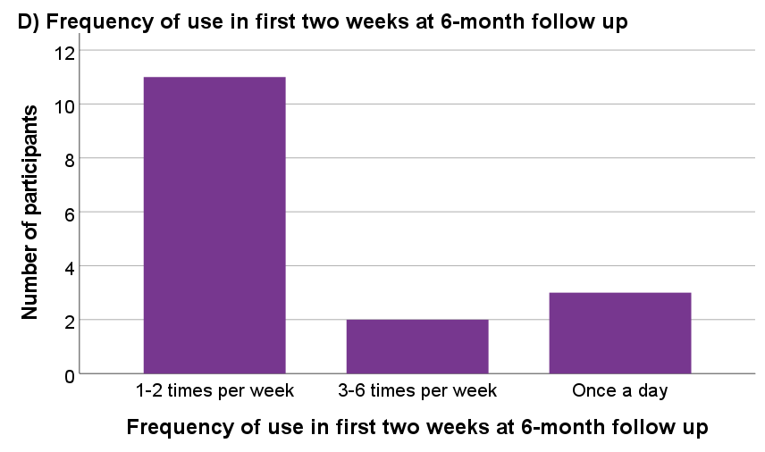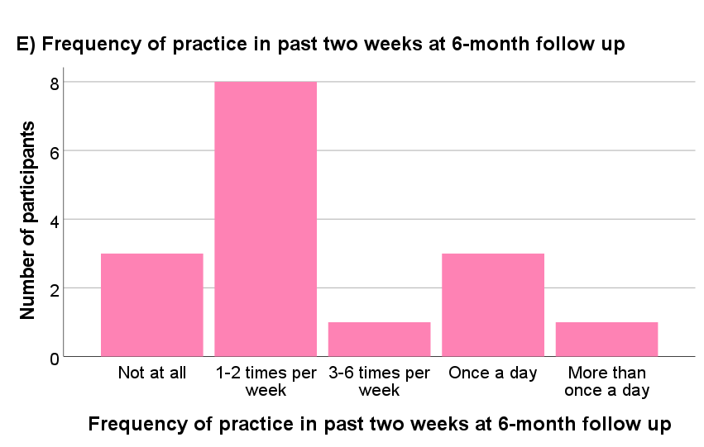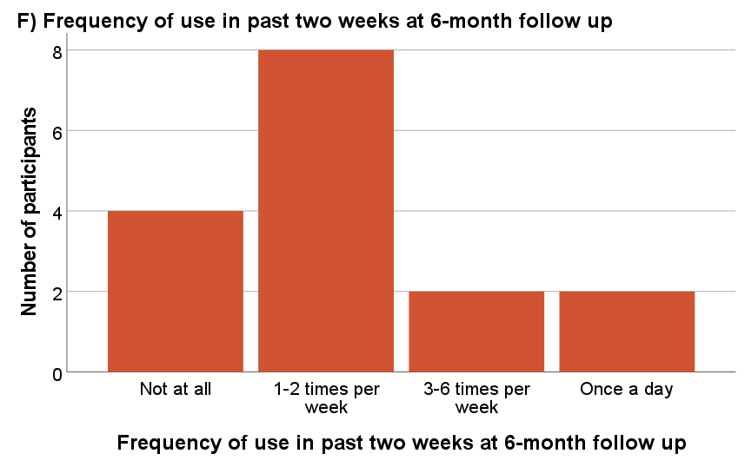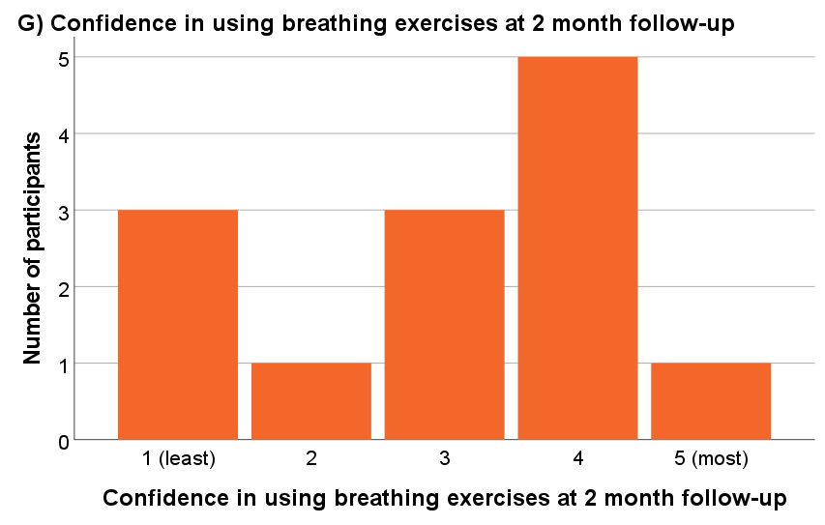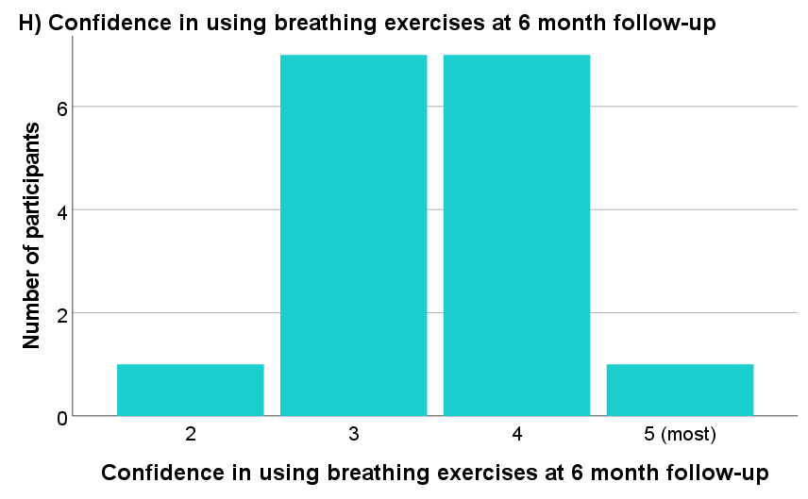
Figure 4. Histograms to show participants self-reported practice, use and confidence of breathing exercises at 2- and 6- month time points.

Intervention acceptability
Interview data showed adolescents felt positive about the intervention content, layout and navigation. Participants described benefits of breathing retraining including increased awareness of breathing and less use of their inhalers. Breathing exercises were described as being used to gain earlier control of asthma symptoms. Challenges included forgetting about breathing exercises, website technical difficulties (not receiving email reminders), and some difficulty with exercises. Factors driving engagement included being motivated by reducing inhaler reliance and having ‘non severe’ symptoms that were perceived as manageable using non-pharmacological therapies. Participants felt the study was easy to sign up to and instructions were clear. Those who signed up within a clinic appointment described it as simple and that they’d been given explanation about the two trial groups. Being invited by a doctor encouraged some participants to sign-up as they trusted the doctor felt this approach may benefit them.

Discussion (1008 words)

Key findings
This study has demonstrated that conducting a fully powered trial of a breathing retraining intervention for adolescents with asthma is likely to be acceptable and feasible. Approaches to recruitment and follow-up were tested to engage this age group and have highlighted valuable adaptations for a full trial, which may also be helpful for other adolescent studies (Box 2).
Adolescents can be notoriously difficult to recruit and follow-up due to competing demands within a challenging developmental period. They are therefore often underrepresented in trials²³. Despite additional challenges due to the Covid-19 pandemic, including a need to revise recruitment targets, adolescents were successfully enrolled into the current study equally via primary care mailouts and approach from secondary care clinicians. Direct approach of participants was unsuccessful via social media (Twitter, Facebook and Instagram). Trust in recommendations from HCPs was mentioned during interviews when discussing motivation to sign up to the study. PPI members suggested lack of trust, caution to provide personal data via online links and paid ads imitating spam as possible reasons for low uptake via social media. However, social media is a pertinent part of young people’s lives and may be useful to consider further, drawing on feedback from the PPI group such as exploring alternative platforms (such as TikTok). Qualitative research suggests that young people view social media recruitment in longitudinal health research positively, and value messages tailored around their motivations^{24,25}.
Overall, recruitment figures suggest that around 20 hospital sites would be needed to reach a target of 500 participants over 12 months in a definitive trial, alongside mailouts from around 60 primary care practices. Recruitment may be further improved by addressing the younger adolescents who didn’t access the website to provide assent. Attempts were made to contact the parents of these potential participants via email to explore why younger children may not have taken part, alongside discussions with PPI members and secondary care clinicians. Issues included a lengthy two-part assent and consent process, adolescents not receiving an email prompting them to continue sign-up after parental consent and forgetting. Addition of an SMS reminder system as opposed to email to mitigate issues with spam, and simplification of assent processes were suggested solutions for a future trial. Parental consent and assent processes are recognised as a specific challenge for this age group²⁶. The study PPI group suggested allowing adolescents the autonomy to sign up and give assent prior to parental consent may ensure adolescents are interested in taking part and remove possibility of parents signing up on behalf of their child. Implied consent processes could also be explored, enabling adolescents’ further autonomy within a low-risk trial.
The study demonstrated feasibility to collect measures online from participants at baseline, however the first follow-up, which relied upon participants responding to an email or text, was sub-optimal. Phone calls to participants or their parents were utilised successfully at 6 months, to encourage completion of questionnaires. Participants may have been encouraged by additional incentives, including a monetary voucher and access to the study website for the control group. Future research should consider telephone prompts and incentives at interim follow-ups. This is in line with young adults’ perspectives that suggest voucher incentives for data collection measures are an assumed part of the research process^{24,27}. Completion rates of the paper PAQLQ questionnaire remained low throughout the study and indicates that follow-up data needs to be collected via one format (in this case electronic) keeping burden to a minimum.
Our findings suggest that asthma QoL is an acceptable primary outcome measure to use in a definitive trial, in line with findings in the adult study¹². Strong correlations were observed between both QoL measures in the study. The data indicates that the PAQLQ may have higher sensitivity than PedsQL. The PAQLQ indicated potential benefit of the intervention, in comparison to the control group whereas there were no changes between either group on the PedsQL across time points.
Engagement with the intervention varied between participants. Notably, around a third of participants didn’t view any breathing exercise sessions on the dashboard, however many participants reported high confidence and use of breathing exercises at follow-up time points. This discrepancy could suggest that some participants benefitted from key behavioural messages in the early introduction intervention content. Other challenges included contacting participants for qualitative interviews, despite many providing initial consent. It may be useful to explore website satisfaction quantitatively for a wider response than qualitative feedback alone.

Strengths and limitations
Overall, a representative range of participants were recruited, including with respect to age and asthma severity. However, a full trial should focus on increasing ethnic diversity of participants to ensure the study is representative of the population. Involvement of ethnically diverse PPI members may provide insight into methods and design that may appropriately reach a more representative sample²⁸. Recruitment should focus on areas with greater diversity, such as via inner London clinical research networks. PPI suggested provision of mobile phone data credits to trial participants as an incentive to minimise costs thereby encouraging higher recruitment from a diverse socioeconomic sample.
Study findings should be considered within the context of the Covid-19 pandemic, which is likely to have intensified challenges faced. Staff shortages and delays with governance processes impacted recruitment with prioritisation given to Covid-19 studies. It should also be noted that the recruitment target size was adjusted down, as it was agreed objectives would be met with a smaller sample size. Recruitment rate timescales may be overestimated, in comparison to the possibilities in a future trial when participants and research staff would have more face-to-face participant contact. As individual’s asthma generally improved during Covid-19, it’s also possible participants were less motivated to engage with complementary techniques to improve their asthma, resulting in less intervention engagement ²⁹.

Conclusion
This study will enable optimisation of a full trial to suit adolescent’s needs. Learnings may also be applicable to other adolescent studies. Despite the intervention being low-cost to deliver, the findings from this study suggest that additional resources to provide incentives and follow-up are needed to carry out trial processes within this context.

Box 2. Key learning points for adolescent trials
- Adolescents can be recruited via strategies that directly approach them and/or their parents (via a letter from their medical team or at an appointment)
- Improved follow-up response rates might be achieved with personally following up young people via telephone calls as opposed to relying on internet-based data collection. Additional resources should be allowed for these methods.
- It is crucial to only collect information and carry out investigations that deliver data that will contribute to the main analyses to prevent study fatigue and disengagement. Data collection methods should be kept to a minimum.
- Burden within study processes should be minimised as much as possible to reduce the risk of technology failures (e.g. combine consent and assent processes, collect all follow-up data in the same format online).
Acknowledgements: We would like to thank the Trial Steering Committee Group members (Prof Steve Turner, Prof Gary Connett, Dr Hans Michael Haitchi, Dr Daniela Ghio, Amanda-Lea Harris and Emma Ray) for their support and feedback throughout the project. We’d also like to thank the patient and public members, parents (Svetlana Inwards, Stephanie Hamm, Trevor Ward, Sheryl Ward and Lynn Tann) and teenagers (Joshua Inwards, Amy Tann, Vikram Taak, Dante Texeira, Helena Ward and Zoe Holley) for their continuing commitment and contribution to the project. We’d like to thank Silverback Web-Developers for developing the Breathe4T website. We’d also like to thank the NIHR CRF, and paediatric asthma team at Southampton Hospital for their support. We’d like to thank Anne Bruton for her input in conceptualising the project, based on the adult BREATHE intervention. We’d like to thank Amy Whitehead and Simone Holley, for their relevant expertise in the design of the study. Finally, we’d like to thank our colleagues at Asthma UK, and Asthma + Lung UK Centre of Applied Research (AUKCAR) for their support with the project.
Ethics: The study was approved by Leeds West Research Ethics Committee (21/YH/0033).
Competing interests: Mike Thomas and Denise Gibson were co-applicants in the adult BREATHE study. The study was funded by NIHR RfPB. Erika Kennington is employed by Asthma & Lung UK.

References
1. Vos T, Lim SS, Abbafati C, et al. Global burden of 369 diseases and injuries in 204 countries and territories, 1990–2019: a systematic analysis for the Global Burden of Disease Study 2019. The Lancet 2020;396(10258):1204-22.
2. Fleming L, Murray C, Bansal AT, et al. The burden of severe asthma in childhood and adolescence: results from the paediatric U-BIOPRED cohorts. European Respiratory Journal 2015;46(5):1322-33.
3. Kurukulaaratchy RJ, Raza A, Scott M, et al. Characterisation of asthma that develops during adolescence; findings from the Isle of Wight Birth Cohort. Respiratory medicine 2012;106(3):329-37.
4. Barker N, Thevasagayam R, Ugonna K, et al. Pediatric dysfunctional breathing: proposed components, mechanisms, diagnosis, and management. Frontiers in Pediatrics 2020;8:379.
5. Vahlkvist S, Jürgensen L, Hell TD, et al. Dysfunctional breathing and its impact on asthma control in children and adolescents. Pediatric Allergy and Immunology 2023;34(1):e13909.
6. Holley S, Walker D, Knibb R, et al. Barriers and facilitators to self‐management of asthma in adolescents: an interview study to inform development of a novel intervention. Clinical & Experimental Allergy 2018;48(8):944-56.
7. Prevention. GSfAMa. Global Initiative for Asthma (GINA) Main Report., 2022.
8. Holley S, Morris R, Knibb R, et al. Barriers and facilitators to asthma self‐management in adolescents: A systematic review of qualitative and quantitative studies. Pediatric pulmonology 2017;52(4):430-42.
9. Netz M, Fedele DA, Sweenie R, et al. Asthma management responsibility, control, and quality of life among emerging adolescents. Journal of Pediatric Psychology 2020;45(1):40-49.
10. Pité H, Carvalho S, Morais-Almeida M. The challenges and facilitators of self-management in pediatric asthma. Current opinion in allergy and clinical immunology 2021;21(2):135-43.
11. Wittwer LH, Walters E, Jordan K. Improving Pediatric Asthma Care Through Asthma Apps: A Narrative Review. The Journal for Nurse Practitioners 2023;19(5):104500.
12. Bruton A, Lee A, Yardley L, et al. Physiotherapy breathing retraining for asthma: a randomised controlled trial. The Lancet Respiratory Medicine 2018;6(1):19-28.
13. Easton S, Ainsworth B, Thomas M, et al. Planning a digital intervention for adolescents with asthma (BREATHE4T): A theory‐, evidence‐and Person‐Based Approach to identify key behavioural issues. Pediatric pulmonology 2022;57(11):2589-602.
14. Yardley L, Morrison L, Bradbury K, et al. The person-based approach to intervention development: application to digital health-related behavior change interventions. Journal of medical Internet research 2015;17(1):e4055.
15. Yardley L, Ainsworth B, Arden-Close E, et al. The person-based approach to enhancing the acceptability and feasibility of interventions. Pilot and feasibility studies 2015;1(1):1-7.
16. Skivington K, Matthews L, Simpson SA, et al. A new framework for developing and evaluating complex interventions: update of Medical Research Council guidance. bmj 2021;374.
17. Eldridge SM, Lancaster GA, Campbell MJ, et al. Defining feasibility and pilot studies in preparation for randomised controlled trials: development of a conceptual framework. PloS one 2016;11(3):e0150205.
18. BigQuery.
19. Google Analytics.
20. Miller S, Ainsworth B, Yardley L, et al. A framework for analyzing and measuring usage and engagement data (AMUsED) in digital interventions. Journal of medical Internet research 2019;21(2):e10966.
21. Braun V, Clarke V. Using thematic analysis in psychology. Qualitative research in psychology 2006;3(2):77-101.
22. Easton S. A Theory-, Evidence- and Person-Based Approach to Developing a Digital Intervention for Adolescents with Asthma. University of Southampton, 2023.
23. Nuttall A, Wilkinson E, Bedson W, et al. A systematic review of the proportion of adolescents recruited to RCTs of asthma treatments for adults and adolescents: Eur Respiratory Soc, 2021.
24. Jong ST, Stevenson R, Winpenny EM, et al. Recruitment and retention into longitudinal health research from an adolescent perspective: a qualitative study. BMC Medical Research Methodology 2023;23(1):1-13.
25. Schoeppe S, Oliver M, Badland HM, et al. Recruitment and retention of children in behavioral health risk factor studies: REACH strategies. International journal of behavioral medicine 2014;21:794-803.
26. Parrish DE, Duron JF, Oxhandler HK. Adolescent recruitment strategies: lessons learned from a university-based study of social anxiety. Social Work Research 2017;41(4):213-20.
27. Moreno MA, Waite A, Pumper M, et al. Recruiting adolescent research participants: in-person compared to social media approaches. Cyberpsychology, behavior, and social networking 2017;20(1):64-67.
28. Babla K, Akindolie O, Gupta A. Time to address ethnic inclusivity in children & young People's research. EClinicalMedicine 2021;37.
29. Shah SA, Quint JK, Sheikh A. Impact of COVID-19 pandemic on asthma exacerbations: retrospective cohort study of over 500,000 patients in a national English primary care database. The Lancet Regional Health–Europe 2022;19.

