Controlled compositions in Zn-Ni coatings by anode material selection for replacing cadmium

Lijia Yi, Shuncai Wang, Robert J.K. Wood

National Centre for Advanced Tribology, Department of Mechanical Engineering, University of Southampton, Southampton SO17 1BJ, UK

# Abstract:

Cadmium-based sacrificial coatings have long been used in the aerospace industry for anodic protection of high-strength steel components. However, due to the carcinogenic and toxic nature of cadmium, its use is increasingly restricted. Zinc-nickel (Zn-Ni) coatings, with their superior corrosion resistance and mechanical properties, have emerged as a viable alternative. The anodic corrosion protection offered by Zn-Ni alloys makes them an excellent candidate to replace cadmium coatings in aerospace and other industries. It has been reported that Zn-Ni coatings with Ni content in the range of 10- 14 wt% exhibit corrosion resistance five times greater than that of pure zinc. However, maintaining consistent nickel concentration and phase composition within the coatings remains a significant challenge, leading to inconsistent properties, as shown in previous studies which used different kinds of anode material. This study explores the influence of different anode materials (zinc, nickel, mild steel, and stainless steel) on the electrodeposition and performance of Zn-Ni alloy coatings on AISI 1020 steel substrates. The work shows significant differences in voltage during electrodeposition when varying anode materials. X-ray diffraction (XRD) analysis was employed to determine the influence on the phase composition and average crystallite size induced by using different anode materials. Electrochemical tests, including polarization curves and electrochemical impedance spectroscopy, were conducted to evaluate the corrosion resistance of the coatings. The results demonstrated that the choice of anode material significantly affects the nickel content and crystalline phases in the Zn-Ni coatings. The results revealed that zinc and nickel anodes produce higher-quality coatings with better uniformity, density, and corrosion resistance, while mild steel and 316L stainless steel anodes result in coatings with significant defects and lower performance. These findings highlight the critical role of anode material selection in optimising the performance of Zn-Ni coatings for industrial applications.

Cadmium-based sacrificial coatings, widely used in the aerospace industry for anodic protection, are increasingly restricted due to their carcinogenic and toxic nature. Zinc-nickel (Zn-Ni) coatings, with superior corrosion resistance and mechanical properties, have emerged as viable alternatives. Zn-Ni coatings with 10-14 wt% Ni exhibit corrosion resistance five times greater than pure zinc, but maintaining consistent nickel concentration and phase composition is challenging.

This study examines the impact of different anode materials (zinc, nickel, mild steel, stainless steel) on the electrodeposition and performance of Zn-Ni alloy coatings on AISI 1020 steel substrates. Zn and Ni anodes produced superior coatings with better uniformity and corrosion resistance, whereas mild steel and stainless steel anodes resulted in coatings with significant defects. Zn anodes led to coatings with the highest Ni content and 15.5 µm thickness, while Ni anodes produced 14.8 µm coatings. Coatings from 1020 steel and stainless steel anodes were thicker (20-30 µm) but had lower Ni content and higher defect density. Crystallite sizes varied, with Zn anode coatings having the largest grains (>9.0 nm) and 316L stainless steel the smallest (<8.0 nm). Zn anodes yielded the highest microhardness (210 Hv) and lowest corrosion potential (-0.977 V) and current density (30 µA/cm²), indicating superior corrosion resistance.

These findings underscore the critical role of anode material in optimizing Zn-Ni coatings, highlighting Zn anodes for achieving high-quality, corrosion-resistant coatings suitable for industrial applications.

Keywords:

Zn-Ni coatings; phase composition; XRD analysis; electrodeposition; anode material

# Introduction

Cadmium coatings have long been employed to significantly enhance the corrosion resistance of a variety of materials, making them essential for a broad range of components and parts used in many industrial applications. The application of cadmium coatings has been particularly common in industries where maintaining the integrity of steel components is critical [1]. High-strength steel fasteners used in automotive and aerospace industries are often coated with Zn- or Cd-based coatings for anodic protection [2]. However, despite the advantageous properties that make cadmium an effective protective coating, its use has become increasingly contentious. The primary concerns come from cadmium’s carcinogenic and toxic nature, which poses significant health risks to workers and environmental hazards. Despite its extensive use as a coating for steel, cadmium's carcinogenic and toxic nature has raised significant health and environmental concerns, leading to increased restrictions on its use [3].

Electroplated zinc has provided an economical and highly corrosion-resistant coating. However, conventional zinc electroplates are increasingly being replaced by zinc alloys. [4] Zn alloy coatings are extensively used to protect steel components across various industries, including automotive, electrical, construction, aerospace, and fasteners. [5] They are obtained by alloying Zn with more noble metals in the Fe group such as Ni, Co, Sn and Fe. [6-10] The addition of these elements alters the corrosion rate and potential. Zinc-based alloys maintain their anodic behaviour to steel, ensuring sacrificial protection while offering a lower corrosion rate, thereby providing longer-lasting corrosion protection [11].

For decades, Zn-Ni coatings have attracted much attention because they possess higher corrosion resistance and better mechanical characteristics than zinc and other zinc alloy coatings [4, 12] and have become a widely used, eco-friendly alternative to toxic cadmium coatings [13]. It has been reported that Zn–Ni coatings with Ni content in the range of 10–14 wt.% have shown five times better corrosion resistance compared to pure Zn [14-17]. It has been studied by Mosavat et al.[18] that Ni content plays a significant role in the corrosion resistance of deposits. Zn-12%wt Ni coatings had the highest hardness and corrosion resistance among all the alloy coatings while Gnanamuthua et al [19] investigated the structure, hardness and corrosion properties of Zn-Ni coatings on AISI 347 steel substrates. Conde et al.[16] revealed that when Ni content has a higher concentration, exceeding 25–30 wt%, the corrosion resistance of the coating relies only on the barrier properties of the alloy and is no longer sacrificial with respect to the steel substrate.

Significant research has been carried out to understand the characteristics of the electrodeposition process of Zn–Ni alloys [20]. It was found that the features of the deposited coatings are highly dependent on the bath composition, current density, pH, applied voltage, additives, and temperature, as well as the phases and crystal structure.

The use of saccharin as an additive has played a significant role in improving surface homogeneity and grain size. The study of the microstructure has shown brighter coatings when saccharin is added to the Zn -Ni electrodeposition bath [21]. It has been studied that the addition of saccharin to the electrolyte could decrease the surface roughness and the crystallite size in electrodeposited Zn–Ni alloy films by Mosavat et al. [4] and that it works as a ‘carrier’, which is the most effective internal stress reducer and often helps to decrease or eliminate hazes of the deposit [22].

Zn-Ni coatings have attracted significant attention due to their superior properties compared to Cd coatings. Notably, Zn-Ni coatings exhibit exceptional corrosion resistance, enduring up to 1000 hours or more in a salt spray test (ASTM B117), whereas Cd coatings typically last around 500-800 hours [23]. Additionally, Zn-Ni coatings offer high mechanical strength, being significantly harder and more wear-resistant than Cd coatings [2]. These advantages have driven extensive research and development efforts in recent years to further optimise Zn-Ni coatings across various applications. People have been studying the Zn-Ni electrodeposits from varying conditions, such as the choice of using different anode materials. Thangaraj et al. [24], for example, investigated the compositional behaviour of Zn-Ni alloy using a pure zinc anode in a sulphate bath. It was concluded that not only does the corrosion resistance of the coating depend on the wt% Ni in the deposits, but also it depends on their morphology. Farooq et al.[25] conducted the electrodeposition using a nickel anode in an acid sulphate bath with varying concentrations of Ni in the electroplating bath. It was suggested that dissolution characteristics of the Zn-Ni alloy coating can be effectively tuned by varying the Ni2+ concentration in the bath solution. Some experiments were undertaken by using stainless steel as anode. Tafreshi et al. [26] used a 316L stainless steel plate as anode material to deposit the Zn-Ni and Zn-Ni/PTFE coatings and indicated that the wear resistance of Zn–Ni/PTFE composite electrodeposit is about 1.5 times better than the cadmium coating when conducting the dry sliding pin-on-disc wear tests used AISI 52100 steel pins (5 mm diameter, 64 HRC) at room temperature with a 2 N load, 200 m sliding distance, and 0.1 m/s speed.

As seen from the above literature, experimental studies have been implemented on Zn-Ni deposition using Zn, Ni and Stainless Steel anodes. To the best of the authors' knowledge, there has not been a systematic study that especially compares the quality and performance of Zn–Ni alloys deposited using different anodes. Therefore, the present research is directed at investigating and analysing the Zn–Ni alloy deposited under various conditions- with the use of different anode materials.

# Experimental

AISI 1020 steel sheets, with exposed areas of 6 cm2 were used as cathodes. Before electroplating, each substrate was polished with emery papers (the following grades: 120, 800, 1000, 4000) to a roughness Ra of 0.05 µm, and then was put in the acetone bath and ultrasound for 5 minutes. The substrates were then rinsed with distilled water and then immersed immediately in the electroplating bath. Nickel, zinc, mild steel and 316L stainless steel sheets were used as an anode. After electrodeposition, the plated specimens were washed with distilled water and ethanol and then dried with air.

The Zn-Ni alloys were electrodeposited onto AISI 1020 steel substrates. The chemical composition of the 1020 steel is 0.17- 0.23 wt% C, 0.22 wt% Si, 0.4 wt% Mg, <0.04wt% P, <0.05wt% S, and 99.08 -99.53wt% Fe. The experiments were carried out in a two-electrode cell with a capacity of 100mL. After 1 hour of magnetic stirring for the electroplating bath agitation at room temperature, PH was adjusted by adding H2SO4 (10 vol%) from 4.3 to 3.

The optimised bath composition and plating parameters are presented in Table 1.

Table1The composition of the electroplating bath and plating parameters

|  |  |
| --- | --- |
| Bath components | Composition |
| ZnSO4·7H2O | 90 g/L |
| NiSO4·7H2O | 170 g/L |
| Na2SO4 | 80 g/L |
| H3BO3 | 40 g/L |
| NaCl2H25SO4 (SDS) | 0.1 g/L |
| Saccharin | 2 g/L |
| Plating Parameters | |
| Current Density | 4 A/dm2 |
| PH | 3 |
| Temperature | 60 °C |
| Time | 20min |
| Rotation Speed | 350 rpm |

For the corrosion studies, electrochemical measurements were performed in a three-electrode cell using an Ag/AgCl electrode as the reference electrode and a platinum counter electrode. All the corrosion tests were carried out in a 3.5 wt% NaCl solution. Different types of electrochemical tests were used to evaluate the sacrificial and barrier properties, cell diagram shown in Figure 1, as well as the corrosion kinetics of the coatings such as polarisation curves, measurement of the open circuit potential (OCP) and measurement of the mixed potential (Ecorr) and galvanic current density (icorr) in coupled Zn–Ni coated/ steel specimens.

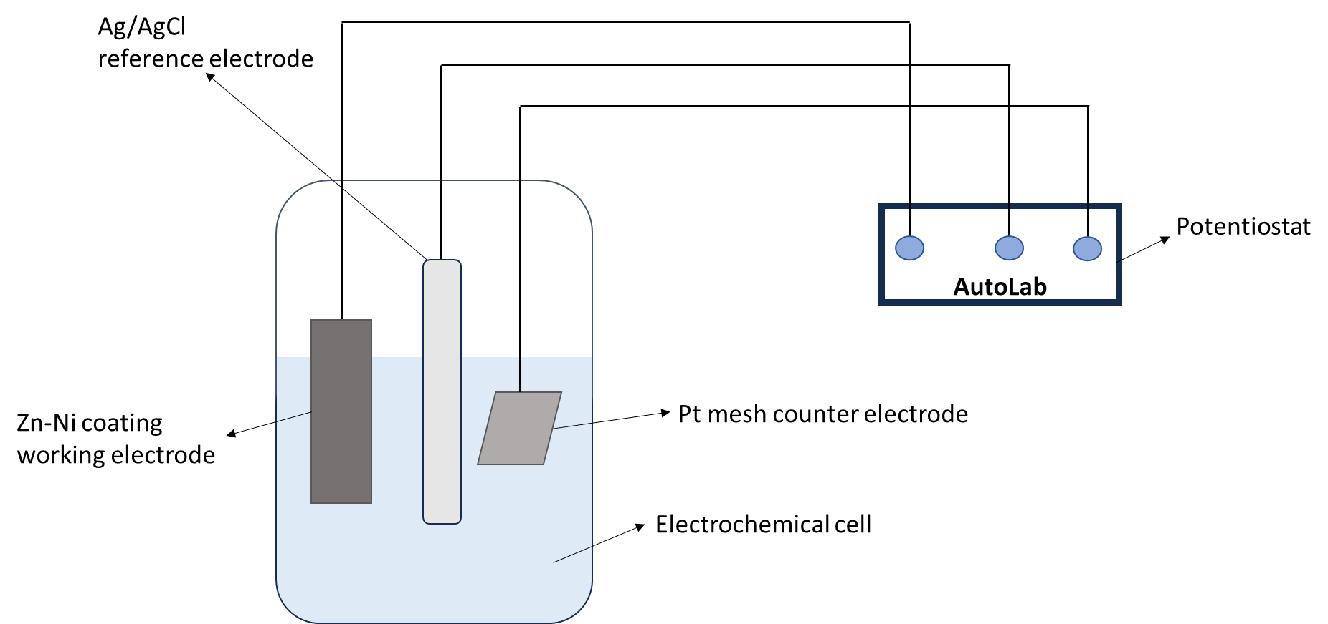

Figure 1 Electrochemical cell diagram

Surface morphologies of the coatings were examined by a JSM7200F scanning electron microscope (SEM). Phase composition of the coatings was determined by X-ray diffraction (XRD) analysis, using a diffractometer (model Rigaku SmartLab) with Cu Kɑ radiation (λ= 0.15405 nm). The 2θ ranged from 10° to 90° and the scan rate was 0.02°/s. The average crystallite size of the coatings was determined from X-ray line broadening using Scherrer equation as follows [27];

D $=\frac{Kλ}{β cosθ}$ (1)

where D is the average crystallite size, λ is the wavelength of the radiation, θ is the Bragg angle and β is the full width at the half maximum (FWHM).

The hardness of deposits was measured by a Vickers microhardness indenter under an applied load of 100 g for 15 seconds at room temperature. An average of five measurements was carried out on each coating.

# Results and Discussion

## Voltage Analysis

The voltage changes observed during direct current electrodeposition varied significantly with different anodes, prompting a detailed investigation into the effect of anode material on voltage behaviour and its impact on the quality and efficiency of Zn-Ni coatings. With the prospect of getting a more compact growth of the layer, other coatings were also deposited at the same conditions with the aim of preserving the Ni content, but with different anodes of Zn, Ni, 1020 steel, and 316L Stainless Steel. Fig. 2 shows the variation of voltage over time for each type of anode used in the Zn-Ni coatings deposition. In the curves for Zn and 316L Stainless Steel anodes, the voltage remains relatively stable over time with only minor fluctuations, the Ni anode curve shows a stable trend with a very gradual decrease in voltage. The 1020 Steel anode curve reveals a distinctive behaviour with a sharp initial voltage drop followed by stabilisation at a lower voltage, which could imply an inefficiency or different deposition dynamics in the initial stages of deposition. The sharp initial voltage drop observed for the 1020 steel anode in Figure 1 can be attributed to rapid electrochemical reactions at the electrode surface, possibly involving the formation of a passive or oxide layer that stabilizes over time. This behaviour may also result from polarization effects, where the potential initially increases due to resistance at the electrode-electrolyte interface and then decreases as the system reaches steady state. The unique properties of 1020 steel, such as its low carbon content (0.18-0.23%) and relatively high surface reactivity, may influence its ionization process and initial interactions with the electrolyte. Additionally, the low carbon content makes 1020 steel less hard and more prone to forming a passivating oxide layer, which could explain the voltage drop. Zn, Ni and 316L Stainless Steel anodes provide more stable voltage trends, which indicate more consistent coating processes.

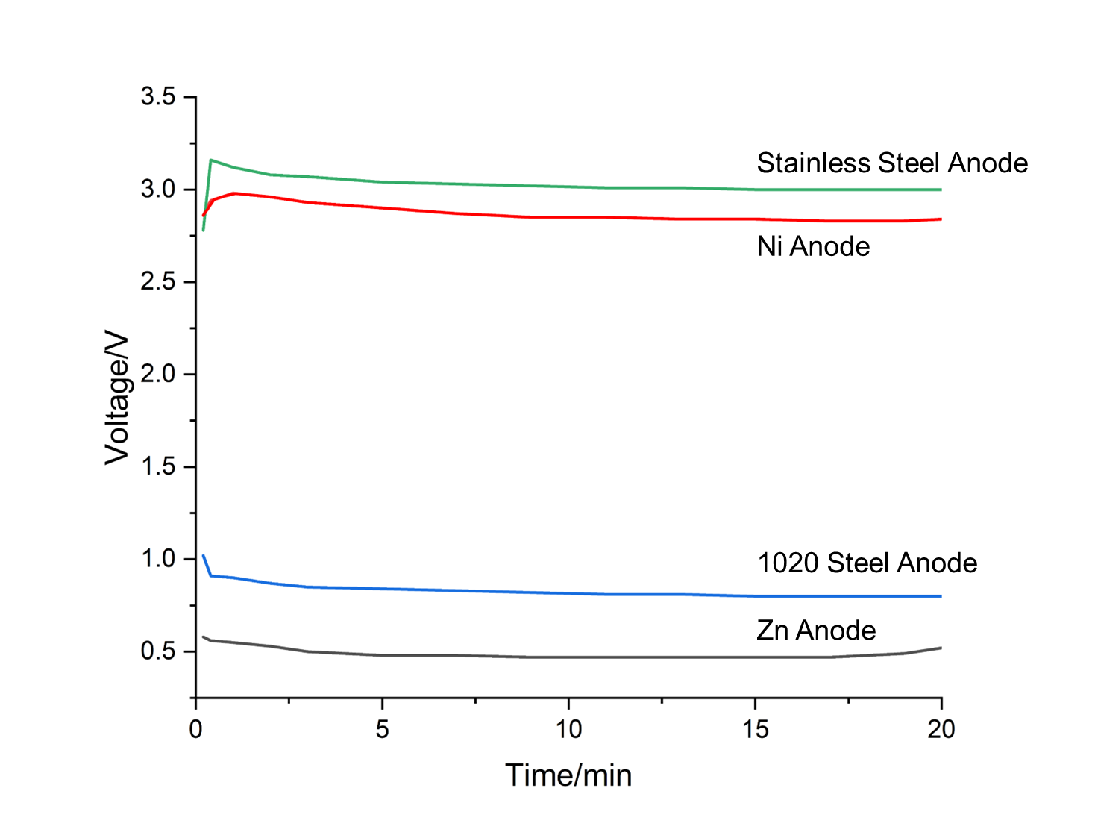

Figure 2 Voltage- time for Zn-Ni coatings during electrodeposition process under 60 °C with a current density of 4A/dm2 with Zn, Ni, 1020 steel and 316L Stainless steel anodes.

Mechanism Behind Voltage Differences:

During the Zn-Ni electroplating process, the applied voltage drives the reduction of metal ions (Zn²⁺ and Ni²⁺) from the electrolyte onto the cathode, forming the Zn-Ni alloy coating. The choice of anode material influences the overall cell potential needed to maintain a stable plating current.

The high and stable voltage indicates that the stainless steel anode offers little interference with the deposition process. The voltage remains high due to the higher overpotential required to sustain the cathodic reaction without significant anode dissolution or side reactions. The stability of the voltage suggests efficient and consistent Zn-Ni deposition. Nickel anode also requires a high voltage, though slightly lower than stainless steel. This is because nickel can participate in the electrochemical reactions to some extent, reducing the overall energy required. The gradual voltage decrease could be due to the surface of the nickel anode becoming more active over time, leading to more efficient ion transfer, and slightly reducing the required voltage. The initial sharp drop with 1020 Steel anode in voltage indicates a high initial resistance, possibly due to surface oxidation or other reactions at the steel anode that temporarily hinder the process. As these reactions stabilize, the voltage drops and remains low, suggesting that the steel anode might be less effective in maintaining the ideal conditions for Zn-Ni deposition, possibly due to side reactions or inefficiencies. The low voltage for the zinc anode suggests that it is more compatible with the Zn-Ni deposition process. Zinc readily dissolves into the electrolyte, which can directly contribute to the plating, reducing the required applied voltage. The slight fluctuations reflect the dynamic nature of zinc dissolution and redeposition.

In each electrodeposition process with different anodes used, the interaction between the anode material and the electrolyte influences the ion composition available for deposition at the mild steel cathode. Active anodes like zinc and nickel contribute directly to the electrolyte, supporting a more efficient and controlled deposition process. Inert or passivating anodes like stainless steel and 1020 steel may require higher voltages and could introduce challenges in maintaining consistent deposition quality, particularly if unwanted ions or passivation effects occur. The careful selection of anode material is crucial to optimizing the electroplating process and achieving the desired coating characteristics on the mild steel substrate.

## Morphology

The Zn-Ni coatings obtained from the acid electrolyte bath showed a strong dependency of the morphology and composition on the deposition conditions of the coatings [28]. The surface morphology of the Zn-Ni alloy coating electrodeposited using different anodes was investigated under scanning electron microscope. The morphology of deposited Zn-Ni alloy coating in terms of its uniformity, presence of porosity onto it, grain size, stress developed etc. changes with the current density and bath composition.

In Figure 3(a), the Zn anode results in a coating with a surface morphology characterized by fine platelets, each measuring less than 1 µm in size, suggesting a relatively smooth and homogeneous deposition. Conversely, the coating shown in Figure 3(b), produced using a Ni anode, exhibits a rougher surface morphology with a granular and nodular appearance, indicative of larger grains and less uniform deposition. Figure 3(c), representing the coating with a 1020 Steel anode, reveals a significantly rough and uneven surface with an absence of distinct spherulitic formations, suggesting a less controlled deposition process and the formation of large, irregular clusters. Finally, in Figure 3(d), the Stainless Steel anode produces a more organized surface structure with uniformly sized and shaped grains; however, the presence of visible cracks suggests mechanical stress or potential instability in the coating, which could compromise its structural integrity.

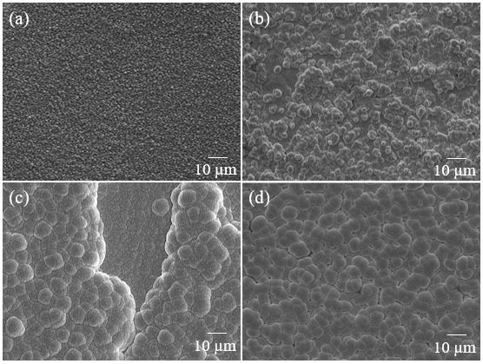

Figure 3 Surface morphologies of as-deposited Zn-Ni coatings using anode material of (a) Zn, (b) Ni, (c) 1020 Steel, (d) Stainless steel.

The study of the cross-sectional morphology of electrodeposited coatings is crucial for understanding the fundamental characteristics and performance of the coatings. Cross-sectional analysis provides detailed insights into the internal structure, thickness, uniformity, and adhesion of the deposited layers. Figure 4 shows the cross-section views for the Zn-Ni coatings using different anodes, and the thickness of the four cross-sectional Zn-Ni coatings is shown in Figure 5. The Zn-Ni coating using Zn anode, as shown in Figure 4(a), produces a coating around 15.5 µm thick with a uniform and fine-grained structure, exhibiting minimal porosity and good adhesion to the substrate, Ni anode coating in Figure 4(b) results in a slightly thinner coating, around 14.8 µm with similar minimal defects and good adhesion, when using 1020 steel as anode, yields a thicker coating with some porosity and a coarser grain structure, indicating potential for higher deposition rates but also increased porosity, as seen in Figure 4(c), whilst as can be seen from Figure 4(d) the coating using 316L Stainless Steel as the anode produces the thickest coating, but it has highest variability in measurements, with significant porosity, adhesion issues, and through-thickness cracks and very rough surface morphology. Therefore, resulting in better coating quality, and the steel anodes, particularly 316L stainless steel, may introduce impurities, alter the electrochemical environment, and disrupt the deposition process leading to poor coating quality.

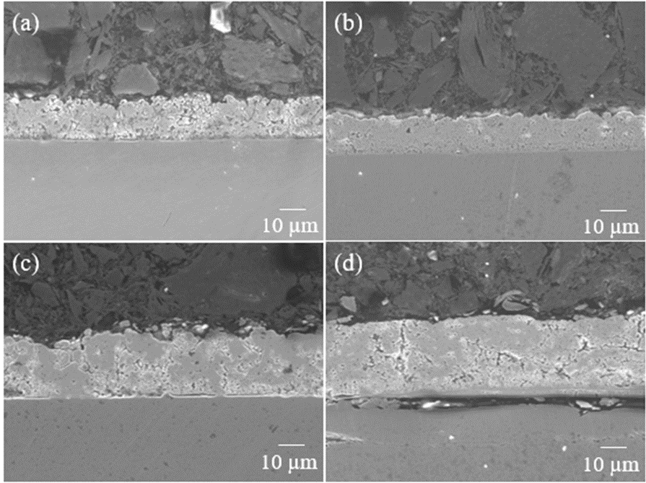

Figure 4 Cross-sectional morphologies of as-deposited Zn-Ni coatings using anode material of (a) Zn, (b) Ni, (c) 1020 Steel, (d) Stainless steel.



Figure 5 Thickness measured from cross-sectional morphologies of Zn-Ni coatings using different anodes.

The cross-sectional and surface morphologies demonstrate that the choice of anode material significantly impacts the quality of Zn-Ni alloy coatings. Zn and Ni anode coatings provide superior coatings with better density, uniformity, and adhesion, with a thickness of around 15µm, while 1020 Steel and 316L Stainless Steel anode coatings suggest higher deposition rates as they are much thicker but result in poor quality coatings with significant defects and porosity.

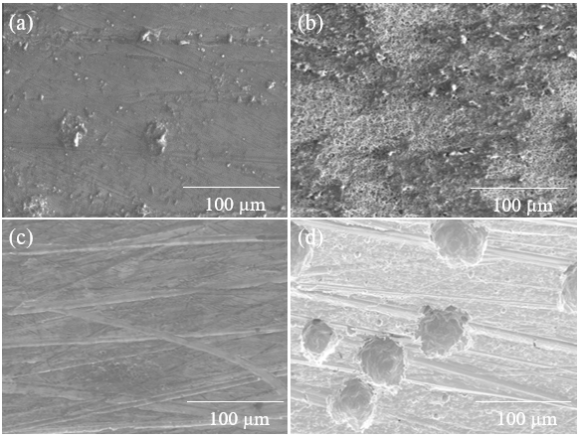

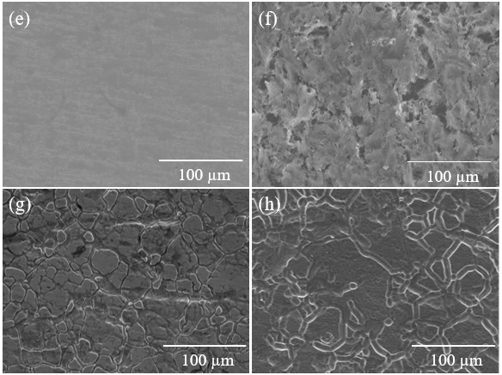

Figure 6 Surface morphologies of anode materials before electrodeposition: (a) Zn, (b) Ni, (c) 1020 Steel, and (d) Stainless Steel, and after electrodeposition: (e) Zn, (f) Ni, (g) 1020 Steel, and (h) Stainless Steel.

The surface morphologies of anode materials before and after electrodeposition are shown in Figure 6, the surface morphology of the Zn anode changes from a relatively smooth texture before electrodeposition to a uniformly smooth surface after deposition, indicating a successful and even coating. The Ni anode transitions from a smoother surface before electrodeposition to a surface with noticeable holes and increased roughness post-deposition. This change may be attributed to oxidation and the loss of Ni ions during the process, leading to the formation of voids and surface degradation. For the 1020 Steel anode, the surface goes from being smooth with linear patterns before deposition to a granular and crystallized structure afterward, indicating substantial changes in surface characteristics. The Stainless Steel anode, initially showing irregular features, develops distinct crystallographic patterns with sharp grain boundaries after electrodeposition, demonstrating a more structured and defined surface.

## Ni Concentration

As shown in Figure 6 the choice of anode material significantly affects the composition of the Zn-Ni coating. With zinc generating the highest Ni content in the coating, while Stainless Steel leads to the lowest. The differences in Ni weight percentage could be due to the electrochemical properties of the anode materials, such as their ability to facilitate or hinder the deposition of Ni in the coating. Zn anode provided Zn ions directly to the solution, providing a continuous supply of electrons for the reduction of ions at the cathode. The high oxidation rate ensures a strong driving force for Ni ion reduction, leading to a higher Ni deposition rate and therefore, a higher weight percentage of Ni in the coating. The Ni anode provides Ni ions directly to the solution that can be immediately reduced at the cathode. The presence of additional Ni ions from the anode maintains a steady concentration of Ni ions in the electrolyte, facilitating a consistent Ni deposition rate. This results in a slightly lower but still substantial Ni content in the coating compared to the Zn anode. The iron in the steel anode oxidises and provides electrons for Ni reduction. However, the Fe ions from the anode may compete with Ni ions in the solution, potentially inhibiting the Ni deposition rate. This competitive effect and possible formation of Fe-containing compounds can reduce the weight percentage of Ni in the coating. Stainless steel introduces both Fe and Cr ions into the solution. Chromium ions can create a passivating layer on the anode, reducing the efficiency of electron transfer. The presence of Cr and Fe ions can further compete with Ni ions, significantly hindering the Ni deposition process. This competition and passivation effect may result in the lowest Ni weight percentage in the coating.

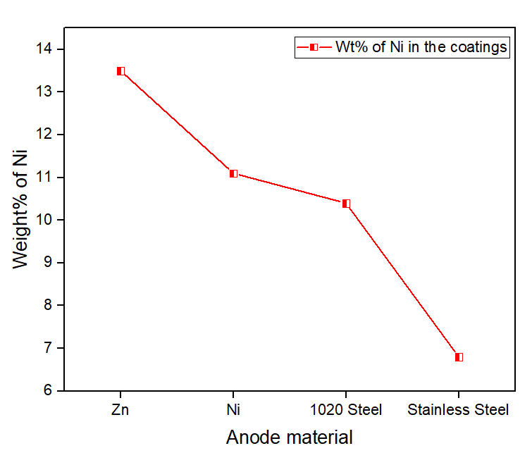

Figure 7 Percentage composition of Ni in the Zn–Ni coatings used various anode materials.

## Crystal Structure and Crystalline Size

The XRD peaks are shown in Figure 7 (a) which illustrates how different anode materials influence the phases present in Zn-Ni coatings. All samples show peaks corresponding to η-Zn and γ-Ni5Zn21 phases, indicating these are predominant phases in the Zn-Ni coatings regardless of the anode used. It can be seen that the intensity of the peak around 43° is the highest among all four curves. The sharp and intense peaks in the Zn anode coating pattern indicate a well-crystallised structure. It implies that regardless of the anode material; the preferred orientation is the γ- (330) / η- (101) plane. However, as the patterns are zoomed in from 35 -50°, we could see the highest peaks (around 43°) are slightly shifted from one another. The reasons might be lattice strain and stress [29], phase composition, and crystallite size effects [30]. Lattice strain can cause a shift in the diffraction peaks. When atoms are displaced from their ideal positions due to stress or strain within the crystal lattice, the interplanar spacing changes. Compressive stress typically shifts peaks to higher 2θ values, while tensile stress shifts peaks to lower 2θ values. Different anode materials can induce different levels of residual stress in the deposited Zn-Ni coatings, leading to peak shifts. As seen in Figure 4, Zn anode coating shows compressive stress whilst the coating used 1020 steel shows tensile stress. Scherrer broadening [31] suggests that smaller crystallite sizes can cause peak broadening and slight shifts due to increased surface energy effects. If the crystallite size varies significantly between samples deposited with different anode materials, it can contribute to peak shifts, as shown in Figure 7.

Furthermore, the highest peak shows overlapping among the samples, which indicates that two different crystallographic planes have similar d-spacings and hence diffract X-rays at nearly the same angle (2θ), or show the presence of multiple phases or compounds in the coating, where some phases have planes with similar d-spacings [32]. When a straight line is drawn at 43° on the 2θ axis, it can be observed that the peak for the 1020 steel anode coating is centred around this line, effectively dividing the peak into two equal halves. In contrast, for the other three curves representing stainless steel, nickel, and zinc, the line intersects their peaks but is positioned more to the left of the peak centres, indicating a shift. This shift could imply a dominance of one phase over the other. Stainless Steel anode coating has a higher γ phase concentration with little ƞ phase contribution. This results in a broader peak slightly left of the centre. Ni and Zn anode coatings demonstrate a strong dominance of the ƞ phase with a very sharp and significantly left-shifted peak, indicating minimal gamma phase presence. Therefore, the 1020 steel peak is centred at 43°, indicating balanced phases. Stainless steel shows a higher γ phase, while Ni and Zn have dominant ƞ phases with left-shifted peaks. It can be concluded that the use of different anodes affects the phase composition and stress characteristics of Zn-Ni coatings.

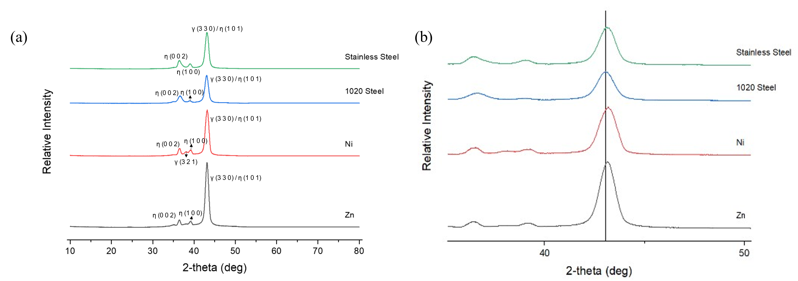

Figure 8 XRD patterns of Zn-Ni coatings deposited with Zn, Ni, 1020 Steel and Stainless Steel: (a) in the range of 10~80°, (b) 35~50°.

The crystallite sizes of the coatings were measured through the Scherrer equation. Fig. 6 illustrates the effect of anode material on the average size of nanocrystalline deposits, The crystallite size of Zn-Ni coatings varies slightly with the choice of anode material. Zn anode leads to larger crystallites, while 1020 Steel and 316L Stainless Steel anodes result in finer grain structures due to the incorporation of Fe and other alloying elements. Larger crystallites suggest that the Zn anode promotes grain growth, possibly due to its relatively high atomic mobility [33], which facilitates recrystallisation. The crystalline size slightly decreases to around 9.0 nm with Nickel as the anode material. Nickel has a face-centred cubic crystal structure, which might result in a slightly smaller crystalline size due to an increase in nucleation and growth rates compared to Zinc [34]. The crystalline size significantly decreases to less than 8.0 nm while using 1020 Steel anode. This might be due to the interaction between the carbon content in 1020 Steel and the Zn-Ni coating process, leading to finer crystalline structures [35]. Grain refinement occurs because the carbon atoms can get incorporated into the grain boundaries, hindering the movement of dislocations and the growth of larger grains. Stainless Steel used as an anode could have a complex electrode potential as it contains chromium, nickel, and other alloying elements. The potential difference with stainless steel can vary significantly, impacting the electrochemical environment and deposition kinetics. This can lead to slight increases in crystalline size due to the specific interactions between the alloying elements and the deposition process.

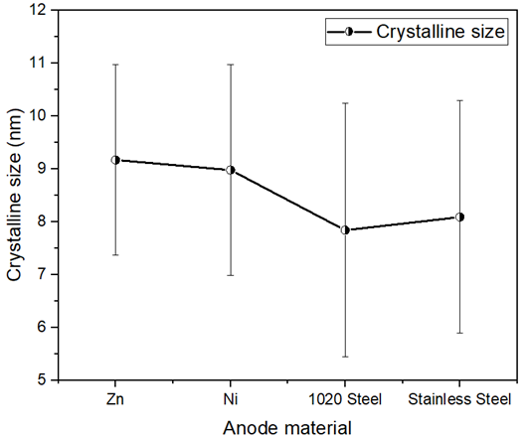

Figure 9 The effect of anode material on crystallite size.

## Microhardness

The microhardness of Zn–Ni alloy coatings electrodeposited at different conditions is shown in Figure 9. The microhardness values of Zn-Ni coatings are relatively consistent across different anode materials, staying within the range of 140 Hv to 210 Hv. Whereas the hardness of Cd coatings was reported to be around 109 Hv, studied by Ganesan et al[36] and 81.6Hv, researched by Sriraman et al. [2]. The hardness of the Zn–Ni alloy coatings shows slight variations with different anode materials, all higher than that of Cd coatings. The highest hardness observed with Zn anodes can be attributed to higher Ni content, and possibly favourable residual stress states. As seen in Figure 4(a), the Zn anode coating has a much denser microstructure which may lead to an increase in the hardness. While the lower hardness with steel and 316L stainless steel anodes may be due to reduced Ni content and the presence of other alloying elements. It may also cause by the impurities introduced to the coatings, as shown in Figure 4 (c) and (d). This suggests that while the deposition parameters are crucial, the choice of anode material can fine-tune the mechanical properties of the coatings.

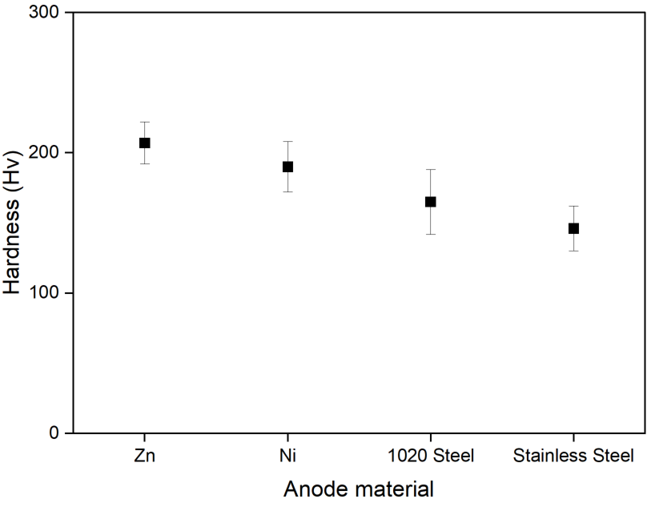

Figure 10 The effect of anode material on the hardness of the electrodeposited Zn–Ni alloy coatings.

## Electrochemical studies

The potentiodynamic polarisation curves for Zn–Ni alloys nanocrystalline coatings using different anodes on 1020 steel using a 3.5 wt.% NaCl solution is shown in Fig. 10. The use of a 3.5 wt.% NaCl solution is justified as it effectively simulates marine environments and provides a consistent medium for evaluating the electrochemical and protective properties of coatings, ensuring the relevance of our findings to both research and industry. The electrochemical parameters (Ecorr, icorr) for Zn–Ni alloy coatings are summarised in Table 2.

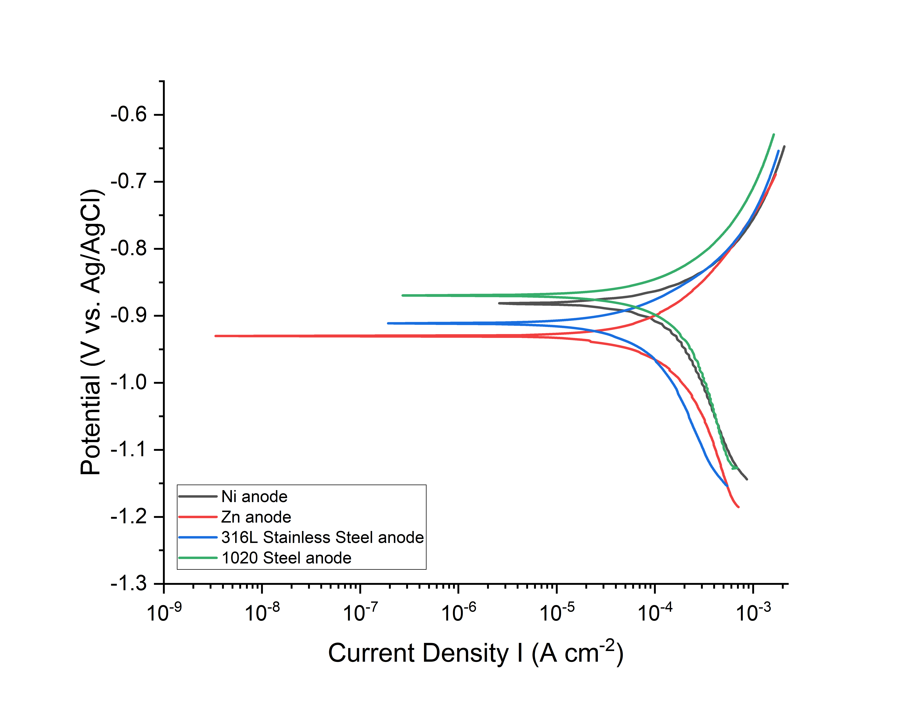

Figure 11 Polarisation curve for Zn–Ni alloy coatings deposited using different anode materials.

The corrosion potentials of all deposits remain negative compared to those of 1020 steel and Cd coatings, with potentials around -0.44V and -0.76V, respectively, reported by Conde et al. [16], which means that all deposits can provide corrosion protection to the 1020 steel and the Zn-Ni coatings show better corrosion behaviour than cadmium coatings. The corrosion potential of Zn-Ni coating using 1020 Steel anode shows the highest corrosion potential, indicating it has more resistance to corrosion compared to the coatings using other anode materials. However, the high corrosion current density suggests a higher rate of metal dissolution, which may be due to the lack of formation of a protective passive layer. The Zn anode coating, despite a more negative corrosion potential, shows a lower corrosion current density, indicating effective sacrificial protection with a slower corrosion rate, making it more susceptible to galvanic corrosion. Its corrosion current density is similar to Conde et al. [16] and Tozar et al. [37],which ranges about 20–30 µA/cm2 and 7-45 µA/cm2 for Zn–Ni coatings. The low corrosion current density suggests a slow rate of corrosion, possibly due to the formation of stable corrosion products. Ni and 316L Stainless Steel anode coatings show intermediate behaviour specifically for the corrosion potential.

The relationship between crystallite size, current density in corrosion, and Ni content in Zn-Ni coatings is critical in determining their corrosion resistance. Smaller crystallite sizes, particularly those under 8 nm, as observed with 1020 Steel anodes, enhance corrosion resistance by increasing grain boundary density, thereby impeding corrosion pathways. In contrast, larger crystallite sizes, around 9-10 nm, associated with Zn anodes, may reduce corrosion resistance. The influence of current density during electrodeposition is also significant; lower current densities generally promote finer microstructures, leading to improved corrosion performance. For example, Zn anodes, which exhibit lower corrosion current densities of approximately 30 µA/cm², correspond to slower corrosion rates, measured at 0.44 mm/year. Ni content further modulates corrosion resistance, with an optimal range around 13.5 wt% Ni, as seen with Zn anode coatings, which enhances the formation of corrosion-resistant γ-Ni5Zn21 phases. However, Ni contents exceeding 25-30 wt% may compromise sacrificial protection by shifting the coating's reliance from sacrificial action to barrier properties [16]. Variations in these results arise from the complex interplay between crystallite size, current density, and Ni content, where adjustments in one parameter can lead to significant changes in corrosion behaviour. This underscores the necessity for precise control of deposition parameters to optimize the corrosion resistance of Zn-Ni coatings.

Table 2 The electrochemical parameters (Ecorr, icorr) of coating samples in a 3.5 wt.% NaCl solution.

|  |  |  |  |  |
| --- | --- | --- | --- | --- |
| Anode material used | Ecorr(V) | βa(V) | βc(V) | Icorr(µA/cm2) |
| Zn | -0.977 | 0.084 | 0.141 | 30 |
| Ni | -0.880 | 0.113 | 0.229 | 105 |
| 1020 Steel | -0.872 | 0.097 | 0.158 | 70 |
| 316L Stainless Steel | -0.912 | 0.088 | 0.171 | 43 |

# Conclusions

This study explored the influence of different anode materials (zinc, nickel, mild steel, and stainless steel) on the electrodeposition, microstructure, defect density, mechanical properties, and electrochemical performance of Zn-Ni alloy coatings.

1. Voltage Stability and Coating Quality

Voltage analysis revealed that Zn and Ni anodes maintained relatively stable voltage trends, indicating a more consistent coating process. In contrast, the 1020 Steel anode exhibited a sharp initial voltage drop, suggesting inefficiencies or different deposition dynamics.

1. Surface and Cross-Sectional Morphologies

Coatings deposited using a zinc anode showed a smooth, dense, and uniform deposition with minimal defects. Nickel anodes produced coatings with good quality but with some roughness and defects. Zn and Ni anodes produce Zn-Ni coatings around 15 µm thick. In contrast, coatings deposited using 1020 Steel and 316L Stainless Steel anodes yield much thicker coatings at 20-30 µm, indicating higher deposition rates, but had significant defects, higher porosity, and irregular morphology.

1. Phase Composition and Ni Content

XRD analysis indicated that coatings from Zn and Ni anodes had well-crystallized structures with predominant η-Zn and γ-Ni5Zn21 phases. Zn anodes resulted in the highest nickel content, enhancing corrosion resistance. In contrast, coatings from 1020 Steel and 316L Stainless Steel anodes showed significant defects and lower nickel content due to their electrochemical properties and residual stress effects.

1. Crystallite Size and Microhardness

The hardness of the Zn-Ni alloy coatings was also affected by the anode material, with zinc anode coatings exhibiting the highest microhardness due to their dense microstructure and higher nickel content.

1. Electrochemical Performance

Electrochemical tests revealed that the corrosion potential of the coatings varied with the anode material. Zn-Ni coatings deposited with zinc anodes showed the lowest corrosion potential, making them more resistant to corrosion, while those with steel anodes showed intermediate behaviour.

Therefore, the results indicate that the anode material plays a crucial role in determining the properties of Zn-Ni coatings. Zn anodes are ideal for achieving the highest quality coatings with excellent nickel content, phase composition, and corrosion resistance. Ni anodes are recommended when moderate roughness and defects are acceptable, providing coatings with decent crystallinity and acceptable corrosion resistance. Mild steel anodes can be explored for studies focusing on cost-effectiveness and higher defect tolerance, resulting in coatings with significant porosity and irregular morphology. 316L Stainless Steel anodes should be used for investigating unique alloying properties, despite resulting in coatings with significant defects, high porosity, and reduced corrosion resistance. The findings provide valuable insights into optimising Zn-Ni coating processes, presenting them as effective and safer alternatives to cadmium coatings. These processes enhance corrosion resistance and mechanical properties, including increased hardness.

The study highlights the significant influence of anode material on the quality and properties of Zn-Ni coatings. Voltage stability analysis showed that Zn and Ni anodes of-fer consistent coating processes, while 1020 Steel exhibited inefficiencies. Morphological studies revealed that Zn and Ni anodes produced coatings with superior quality and thickness, with Zn showing minimal defects and higher density. Conversely, 1020 Steel and 316L Stainless Steel anodes led to thicker coatings but with increased defects and po-rosity. Phase composition analysis showed that Zn anodes resulted in the highest nickel content, enhancing corrosion resistance, while coatings from steel anodes had significant defects and lower nickel content. The microhardness and electrochemical performance of the coatings were also highest with Zn anodes due to their dense microstructure and low-er corrosion potential.

In summary, Zn anodes are ideal for achieving high-quality Zn-Ni coatings with ex-cellent nickel content and corrosion resistance. Ni anodes offer acceptable quality with moderate roughness, while 1020 Steel and 316L Stainless Steel anodes can be considered for applications prioritizing cost-effectiveness or unique alloying properties, albeit with increased defects. These findings provide valuable insights into optimizing Zn-Ni coating processes, making them a safer and more effective alternative to cadmium coatings.

This study highlights the significant influence of anode material on the quality and properties of Zn-Ni coatings, revealing that Zn anodes offer consistent and efficient coating processes, while Ni, 1020 Steel and 316L Stainless Steel exhibit inefficiencies. Voltage analysis showed that Zn anodes maintained the lowest and most stable voltage (~0.5 V), leading to smoother, more homogeneous coatings with minimal defects and a fine platelet structure less than 1 µm in size. Cross-sectional analysis confirmed that Zn anodes produced uniform coatings with a thickness of 14.5 µm, while Stainless Steel anodes, though yielding thicker coatings (33 µm), introduced significant porosity and defects. Phase composition analysis showed that Zn anodes provided the highest Ni content (13.5 wt%), enhancing corrosion resistance, whereas steel anodes resulted in lower Ni content (7 wt%) and more defects. Microhardness tests demonstrated that Zn anodes achieved the highest hardness (~210 Hv), with Stainless Steel anodes producing the lowest (~140 Hv). Electrochemical studies further affirmed the superiority of Zn anodes, showing a low corrosion rate of 0.44 mm/year. In summary, Zn anodes are ideal for achieving high-quality, corrosion-resistant Zn-Ni coatings, making them a safer and more effective alternative to cadmium coatings. Ni anodes offer acceptable quality, while 1020 Steel and 316L Stainless Steel may be considered for cost-sensitive applications with increased defect tolerance.

# References

[1] K. R. Baldwin and C. J. E. Smith, "Advances in Replacements for Cadmium Plating in Aerospace Applications," *Transactions of the IMF,* vol. 74, no. 6, pp. 202-209, 1996/01/01 1996, doi: 10.1080/00202967.1996.11871127.

[2] K. R. Sriraman *et al.*, "Tribological behavior of electrodeposited Zn, Zn–Ni, Cd and Cd–Ti coatings on low carbon steel substrates," *Tribology International,* vol. 56, pp. 107-120, 2012/12/01/ 2012, doi: <https://doi.org/10.1016/j.triboint.2012.06.008>.

[3] M. Ferreira Fernandes, J. R. M. dos Santos, V. M. de Oliveira Velloso, and H. J. C. Voorwald, "AISI 4140 Steel Fatigue Performance: Cd Replacement by Electroplated Zn-Ni Alloy Coating," *Journal of Materials Engineering and Performance,* vol. 29, no. 3, pp. 1567-1578, 2020/03/01 2020, doi: 10.1007/s11665-020-04669-1.

[4] S. H. Mosavat, M. E. Bahrololoom, and M. H. Shariat, "Electrodeposition of nanocrystalline Zn–Ni alloy from alkaline glycinate bath containing saccharin as additive," *Applied Surface Science,* vol. 257, no. 20, pp. 8311-8316, 2011, doi: 10.1016/j.apsusc.2011.03.017.

[5] S. Ghaziof and W. Gao, "Electrodeposition of single gamma phased Zn–Ni alloy coatings from additive-free acidic bath," *Applied Surface Science,* vol. 311, pp. 635-642, 2014/08/30/ 2014, doi: <https://doi.org/10.1016/j.apsusc.2014.05.127>.

[6] O. P. Oladijo, M. H. Mathabatha, A. P. I. Popoola, and T. P. Ntsoane, "Characterization and corrosion behaviour of plasma sprayed Zn-Sn alloy coating on mild steel," *Surface and Coatings Technology,* vol. 352, pp. 654-661, 2018/10/25/ 2018, doi: <https://doi.org/10.1016/j.surfcoat.2017.04.029>.

[7] Z. F. Lodhi, F. D. Tichelaar, C. Kwakernaak, J. M. C. Mol, H. Terryn, and J. H. W. de Wit, "A combined composition and morphology study of electrodeposited Zn–Co and Zn–Co–Fe alloy coatings," *Surface and Coatings Technology,* vol. 202, no. 12, pp. 2755-2764, 2008/03/15/ 2008, doi: <https://doi.org/10.1016/j.surfcoat.2007.10.017>.

[8] A. Hegde, K. Venkatakrishna, and N. Eliaz, "Electrodeposition of Zn–Ni, Zn–Fe and Zn–Ni–Fe alloys," *Surface & Coatings Technology - SURF COAT TECH,* vol. 205, pp. 2031-2041, 12/01 2010, doi: 10.1016/j.surfcoat.2010.08.102.

[9] I. H. Karahan and H. S. Güder, "Electrodeposition and properties of Zn, Zn–Ni, Zn–Fe and Zn–Fe–Ni alloys from acidic chloride–sulphate electrolytes," *Transactions of the IMF,* vol. 87, no. 3, pp. 155-158, 2009/05/01 2009, doi: 10.1179/174591909X438875.

[10] K. K. Maniam and S. Paul, "Corrosion Performance of Electrodeposited Zinc and Zinc-Alloy Coatings in Marine Environment," *Corrosion and Materials Degradation,* vol. 2, no. 2, pp. 163-189, 2021. [Online]. Available: <https://www.mdpi.com/2624-5558/2/2/10>.

[11] T. V. Byk, T. V. Gaevskaya, and L. S. Tsybulskaya, "Effect of electrodeposition conditions on the composition, microstructure, and corrosion resistance of Zn–Ni alloy coatings," *Surface and Coatings Technology,* vol. 202, no. 24, pp. 5817-5823, 2008, doi: 10.1016/j.surfcoat.2008.05.058.

[12] C. Subramaniyam, S. Srinivasan, and M. Pushpavanam, "Properties of Zinc alloy electrodeposits produced from acid and alkaline electrolytes," *Journal of Solid State Electrochemistry,* vol. 13, pp. 781-789, 01/05 2009, doi: 10.1007/s10008-008-0607-2.

[13] M. M. Abou-Krisha, "Electrochemical studies of zinc–nickel codeposition in sulphate bath," *Applied Surface Science,* vol. 252, no. 4, pp. 1035-1048, 2005/11/15/ 2005, doi: <https://doi.org/10.1016/j.apsusc.2005.01.161>.

[14] Y. Boonyongmaneerat, S. Saenapitak, and K. Saengkiettiyut, "Reverse pulse electrodeposition of Zn–Ni alloys from a chloride bath," *Journal of Alloys and Compounds,* vol. 487, no. 1, pp. 479-482, 2009/11/13/ 2009, doi: <https://doi.org/10.1016/j.jallcom.2009.07.163>.

[15] M. Abou-Krisha, F. Assaf, and A. Toghan, "Electrodeposition of Zn–Ni alloys from sulfate bath," *Journal of Solid State Electrochemistry,* vol. 11, no. 2, pp. 244-252, 2007, doi: 10.1007/s10008-006-0099-x.

[16] A. Conde, M. A. Arenas, and J. J. de Damborenea, "Electrodeposition of Zn–Ni coatings as Cd replacement for corrosion protection of high strength steel," *Corrosion Science,* vol. 53, no. 4, pp. 1489-1497, 2011/04/01/ 2011, doi: <https://doi.org/10.1016/j.corsci.2011.01.021>.

[17] Z. Feng, M. An, L. Ren, J. Zhang, P. Yang, and Z. Chen, "Corrosion mechanism of nanocrystalline Zn-Ni alloys as replacement of Zn and Cd coatings in a new DMH-based bath," *RSC Adv.,* vol. 6, 07/06 2016, doi: 10.1039/C6RA10067H.

[18] S. H. Mosavat, M. H. Shariat, and M. E. Bahrololoom, "Study of corrosion performance of electrodeposited nanocrystalline Zn–Ni alloy coatings," *Corrosion Science,* vol. 59, pp. 81-87, 2012/06/01/ 2012, doi: <https://doi.org/10.1016/j.corsci.2012.02.012>.

[19] R. M. Gnanamuthu, S. Mohan, G. Saravanan, and C. W. Lee, "Comparative study on structure, corrosion and hardness of Zn–Ni alloy deposition on AISI 347 steel aircraft material," *Journal of Alloys and Compounds,* vol. 513, pp. 449-454, 2012/02/05/ 2012, doi: <https://doi.org/10.1016/j.jallcom.2011.10.078>.

[20] K. Sadananda, J. H. Yang, N. Iyyer, N. Phan, and A. Rahman, "Sacrificial Zn–Ni coatings by electroplating and hydrogen embrittlement of high-strength steels," *Corrosion Reviews,* vol. 39, no. 6, pp. 487-517, 2021, doi: doi:10.1515/corrrev-2021-0038.

[21] H. Park and J. A. Szpunar, "The Microstructural Characterization of Electrogalvanized Zinc–Iron and Zinc–Nickel Coatings," *Texture, Stress, and Microstructure,* vol. 34, no. 2-3, p. 579539, 2000, doi: <https://doi.org/10.1155/TSM.34.119>.

[22] A. Ciszewski, S. Posluszny, G. Milczarek, and M. Baraniak, "Effects of saccharin and quaternary ammonium chlorides on the electrodeposition of nickel from a Watts-type electrolyte," *Surface and Coatings Technology,* vol. 183, no. 2, pp. 127-133, 2004/05/24/ 2004, doi: <https://doi.org/10.1016/j.surfcoat.2003.09.054>.

[23] G. Sundaramali *et al.*, "Experimental investigations of electrodeposited Zn–Ni, Zn–Co, and Ni–Cr–Co–based novel coatings on AA7075 substrate to ameliorate the mechanical, abrasion, morphological, and corrosion properties for automotive applications," *REVIEWS ON ADVANCED MATERIALS SCIENCE,* vol. 62, no. 1, 2023, doi: doi:10.1515/rams-2022-0324.

[24] V. Thangaraj and A. Hegde, "Electrodeposition and compositional behaviour of Zn-Ni alloy," *Indian Journal of Chemical Technology,* vol. 14, 05/01 2007.

[25] A. Farooq, S. Ahmad, K. Hamad, and K. M. Deen, "Effect of Ni Concentration on the Surface Morphology and Corrosion Behavior of Zn-Ni Alloy Coatings," *Metals,* vol. 12, no. 1, 2022, doi: 10.3390/met12010096.

[26] M. Tafreshi, S. R. Allahkaram, and S. Mahdavi, "Effect of PTFE on characteristics, corrosion, and tribological behavior of Zn–Ni electrodeposits," *Surface Topography: Metrology and Properties,* vol. 8, no. 4, p. 045013, 2020/10/21 2020, doi: 10.1088/2051-672X/ab9f05.

[27] P. Lindley and D. Moss, "Elements of X-ray crystallography by L. V. Azaroff," *Acta Crystallographica Section A,* vol. 26, 11/01 1970, doi: 10.1107/S0567739470001808.

[28] N. Lotfi, M. Aliofkhazraei, H. Rahmani, and G. Darband, "Zinc–Nickel Alloy Electrodeposition: Characterization, Properties, Multilayers and Composites," *Protection of metals and physical chemistry of surfaces,* 11/28 2018.

[29] W. T. Jiang, D. R. Peacor, P. Árkai, M. Tóth, and J. Kim, "TEM and XRD determination of crystallite size and lattice strain as a function of illite crystallinity in pelitic rocks," *Journal of Metamorphic Geology,* vol. 15, no. 2, pp. 267-281, 1997.

[30] S. Hassanzadeh-Tabrizi, "Precise calculation of crystallite size of nanomaterials: A review," *Journal of Alloys and Compounds,* p. 171914, 2023, doi: 10.1016/j.jallcom.2023.171914.

[31] A. Patterson, "The Scherrer formula for X-ray particle size determination," *Physical review,* vol. 56, no. 10, p. 978, 1939, doi: <https://doi.org/10.1103/PhysRev.56.978>.

[32] H. Khan, A. S. Yerramilli, A. D'Oliveira, T. L. Alford, D. C. Boffito, and G. S. Patience, "Experimental methods in chemical engineering: X‐ray diffraction spectroscopy—XRD," *The Canadian journal of chemical engineering,* vol. 98, no. 6, pp. 1255-1266, 2020, doi: <https://doi.org/10.1002/cjce.23747>.

[33] S. Cui, Y. Du, L. Zhang, Y. Liu, and H. Xu, "Assessment of atomic mobilities in fcc Al-Zn and Ni-Zn alloys," *Calphad,* vol. 34, no. 4, pp. 446-451, 2010, doi: 10.1016/j.calphad.2010.08.002.

[34] S. Anwar, Y. Zhang, and F. Khan, "Electrochemical behaviour and analysis of Zn and Zn–Ni alloy anti-corrosive coatings deposited from citrate baths," *RSC Advances,* vol. 8, pp. 28861-28873, 08/14 2018, doi: 10.1039/C8RA04650F.

[35] R. H. E. Jones, *Environmental Effects on Engineered Materials (1st ed.). CRC Press.* 2001.

[36] P. Ganesan, S. P. Kumaraguru, and B. N. Popov, "Development of compositionally modulated multilayer Zn–Ni deposits as replacement for cadmium," *Surface and Coatings Technology,* vol. 201, no. 18, pp. 7896-7904, 2007/06/25/ 2007, doi: <https://doi.org/10.1016/j.surfcoat.2007.03.033>.

[37] A. Tozar and İ. H. Karahan, "Structural and corrosion protection properties of electrochemically deposited nano-sized Zn–Ni alloy coatings," *Applied Surface Science,* vol. 318, pp. 15-23, 2014/11/01/ 2014, doi: <https://doi.org/10.1016/j.apsusc.2013.12.020>.