**Impact of Localised Skin Cooling at the Sacrum on Microvascular Responses to Sustained Pressure-induced Ischemia**

Ralph Gordon1,2*, Peter Worsley2, Davide Filingeri1

1 ThermosenseLab, Skin Sensing Research Group, School of Health Science, University of Southampton, UK

2 PressureLab, Skin Sensing Research Group, School of Health Science, University of Southampton, UK

*Correspondence [r.j.f.h.gordon@soton.ac.uk](mailto:r.j.f.h.gordon@soton.ac.uk)

**Keywords:** Cooling, Pressure ulcers, Skin blood flow

**Introduction**

Pressure ulcers (PUs) constitute a localised damage to the skin resulting from prolonged periods of pressure and shear forces (1). In the United Kingdom alone, the annual cost of treating chronic wounds, including PUs, has been estimated to be approximately £8.3 billion (2). Accordingly, an improved understanding of the fundamental mechanisms underlying the physiological tolerance of human skin to mechanical loading could lead to the development of cost-effective, personalised solutions to prevent these wounds and improve patient care and quality of life. Early animal studies revealed that reduced skin temperature minimises the risk of PU formation through altered microvascular responses (3). While this evidence highlights the potential therapeutic role of skin cooling for protecting tissue health, the mechanisms by which cooling enhances skin tolerance to pressure remain poorly understood in humans (4). The aim of this study was to examine how different levels of localised cooling (i.e. 24°C or 16°C vs. 38°C) alter the skin’ microvascular responses to sustained pressure and the recovery characteristics when load is removed, in a cohort of healthy young individuals.

**Methods**

Eleven healthy participants (7M/4F; 24±5 y in age; 73±10 kg in body weight; 175±10 cm in height) partook in 3 experimental sessions separated by a minimum of 24 hrs in a randomised cross-over design. During each session, participants underwent a standardised 75-min protocol to cause pressure-induced ischemia and post-occlusive hyperaemia at the sacrum, involving: i) a 10-minute baseline stabilisation with minimal pressure [17.5 mmHg (2.3 kPa)], ii) 45-minute loading phase [60 mmHg (7.9 kPa)], and iii) a 20-minute minimal pressure phase [17.5 mmHg (2.3 kPa)]). Participants’ skin over the sacrum was mechanically loaded and unloaded with a custom-built thermal probe, which, depending on the session, was set to either 38°C, 24°C, or 16°C. Skin blood flow at the loading site was measured continuously throughout the protocol via Laser Doppler Flowmetry (integrated within the thermal probe). Skin blood flow was normalised to the baseline and expressed as a percentage change from the final 3-min of the initial 10-min period. Peak skin blood flow was used as the index of peak reactive hyperaemia and defined as the maximum value after unloading occurred (Figure 1). Data are presented as means (± SD) and were analysed by means of a one-way repeated measures ANOVA with *Bonferroni* corrected paired T-tests.

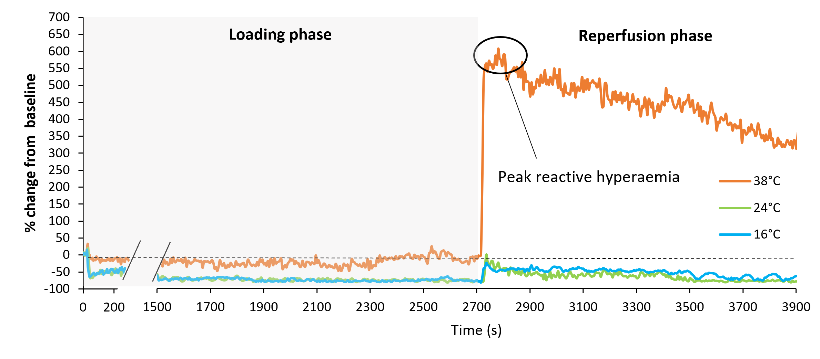

**Figure 1.** Skin blood flow responses at the sacrum (i.e. % change from baseline) from a representative participant during the loading and unloading phases of each temperature condition (i.e. 38°C, 24°C, and 16°C).

**Results and Discussion**

Baseline skin blood flow did not differ between thermal conditions (*P* = 0.390; 16°C, mean 14.5, 95%CI [12.1, 17.0], 24°C, mean 16.4, 95%CI [10.4, 22.3], 38°C, mean 13.3, 95%CI [11.0, 15.6]. During the unloading phase, we found a statistically significant main effect of temperature (*P* < 0.001) on normalised peak skin blood flow (Figure 2). Specifically, when compared to 38°C, both 24°C (mean difference -226.2%, 95%CI [-316.9%, -135.6%], *P* < 0.001) and 16°C conditions (mean difference -250.0%, 95%CI [-368.3%, -131.6%], *P* < 0.001) exhibited a decreased peak skin blood flow following pressured-induced ischemia. No statistically significant differences were observed between 24°C and 16°C (mean difference 23.5%, 95%CI [-73.2%, 25.9%], *P* = 0.602). These preliminary data indicated that both mild (i.e. 24°C) and more pronounced (i.e. 16°C) cooling reduced the magnitude of the peak hyperaemic response observed during the 38°C-trial, thereby offering potential protective effect to the underlying tissues during reperfusion after pressure-induced ischemia at the sacrum.

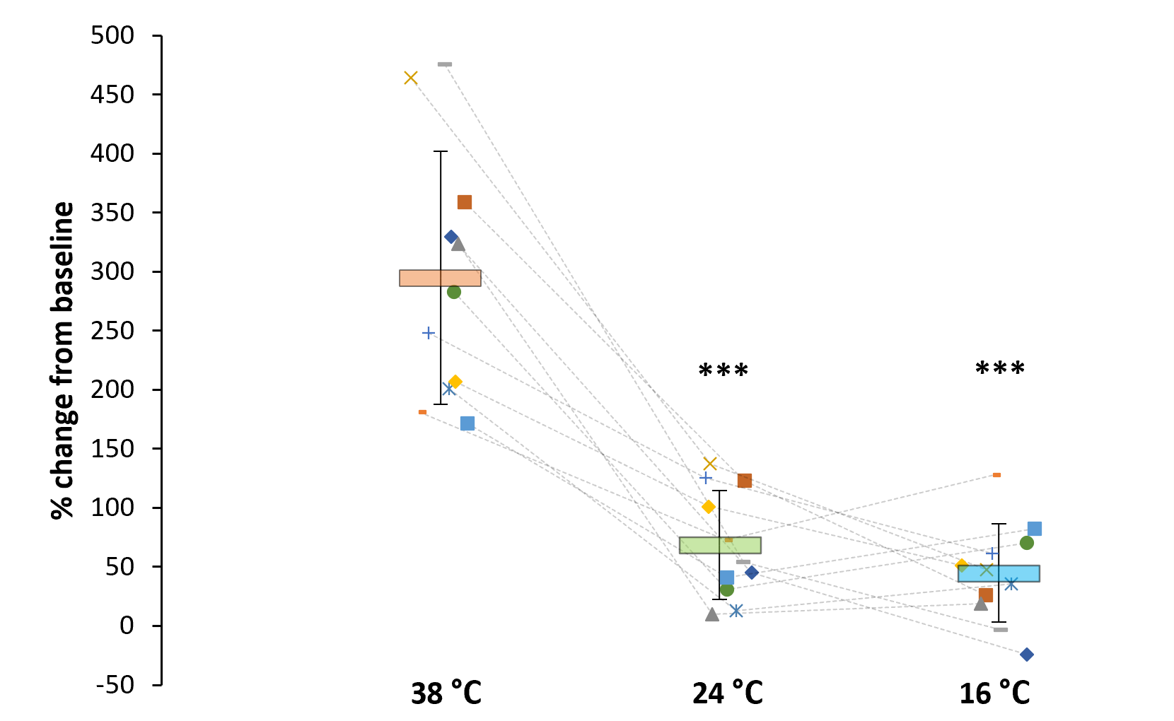

**Figure 2.** Normalised peak skin blood flow at the sacrum under three temperature conditions. Data are presented as individual responses (n=11). Horizontal bars indicate group mean values with SD. Significant differences from 38°C-condition are denoted by \*\*\**P* < 0.001.

**Conclusions**  
Localised cooling at the sacrum reduces the peak skin blood flow response following pressure induced ischemia, offering a protective effect on the underlying tissues. The use of localised cooling could offer novel therapeutic benefits in the prevention and management of pressure ulcers.

**References**

1. Coleman S, Nixon J, Keen J, Wilson L, McGinnis E, Dealey C, et al. (2014) A new pressure ulcer conceptual framework. *J Adv Nurs* 70(10), 2222-2034.

2. Guest JF, Ayoub N, McIlwraith T, Uchegbu I, Gerrish A, Weidlich D, et al. (2015) Health economic burden that wounds impose on the National Health Service in the UK. *BMJ Open* 5(12), e009283.

3. Kokate JY, Leland KJ, Held AM, Hansen GL, Kveen GL, Johnson BA, et al. (1995) Temperature-modulated pressure ulcers: a porcine model. *Arch Phys Med Rehabil* 76(7), 666-673.

4. Lachenbruch C (2005) Skin cooling surfaces: estimating the importance of limiting skin temperature. *Ostomy Wound Manage* 51(2), 70-79.