  - Bonus Petrographic Images & Geochemistry Figures, Mindola North
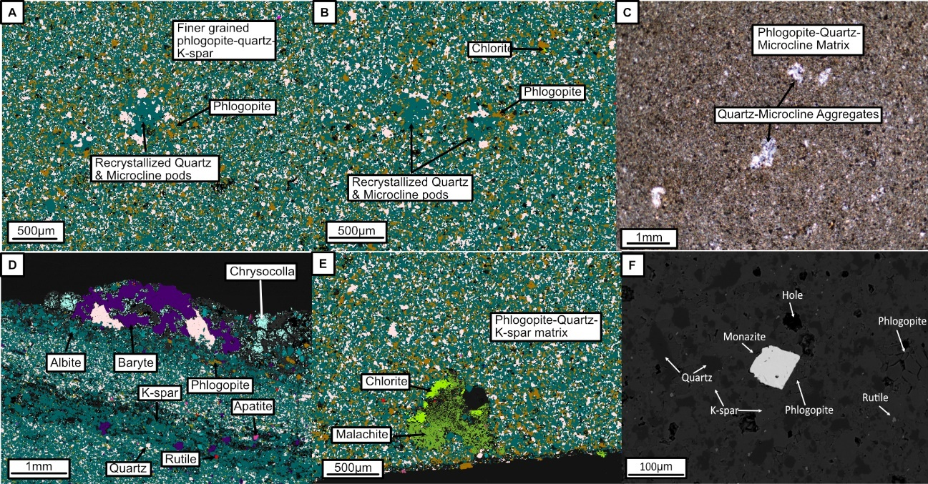
Figure C.5-1 TESCAN TIMA, Optical microscopy and SEM images of micaceous siltstone textures. (A-B) TIMA images showing recrystallized quartz-K-spar (microcline) aggregates among a finer grained phlogopite-quartz-microcline matrix. (C) Thin section photo of recrystallized quartz-microcline pods. Phlogopite is shown flowing around or embaying into the aggregates in these images. (D) Patch of baryte at the top of Jaz36 and showing albite infilling pore spaces after microcline. (E) Intergrowth of chlorite with malachite in a pore space in Jaz35. (F) SEM image showing euhedral monazite in the matrix of Jaz35.
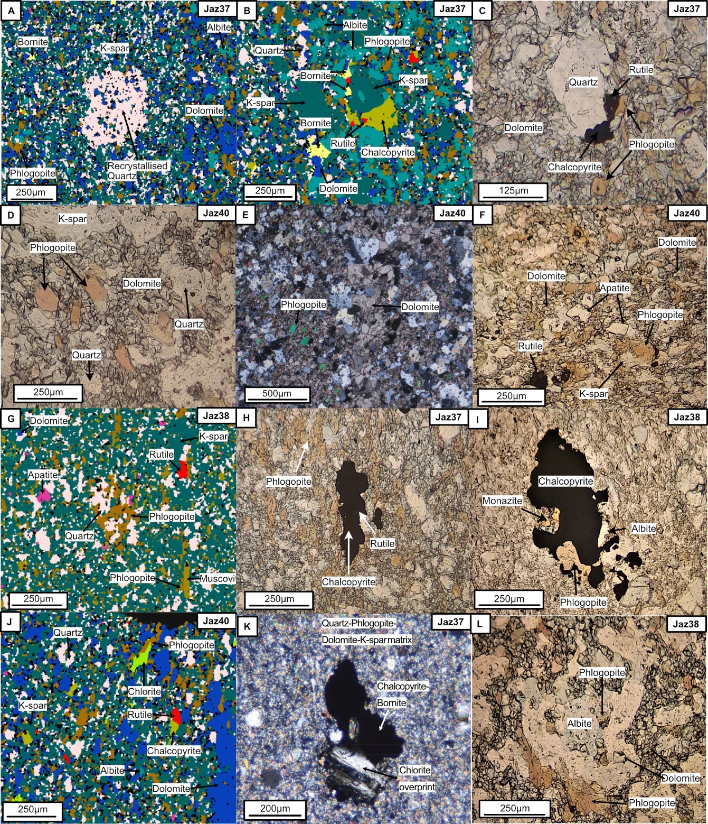
Figure C.5-2: General petrography of the dolomitic siltstones.
(A) TIMA image showing recrystallized quartz aggregate (B) TIMA image showing chalcopyrite nucleating around earlier K-spar. (C) Chalcopyrite and rutile forming around earlier quartz (ppl). Phlogopite also shown overprinting dolomite. (D) Phlogopite crosscutting blocky dolomite (ppl). (E) Same as D but showing coarser, decussate dolomite (xpl). (F) Phlogopite, rutile and apatite shown overprinting K-spar and dolomite (ppl). (G) TIMA image revealing phlogopite crosscutting quartz and forming around muscovite. (H) Phlogopite forming around deformed chalcopyrite-rutile occurrence. (I) Phlogopite crosscutting chalcopyrite (ppl). (J) Chlorite overprinting phlogopite (K) Chlorite crosscutting chalcopyrite-bornite (L) Albite enclosing phlogopite inclusions

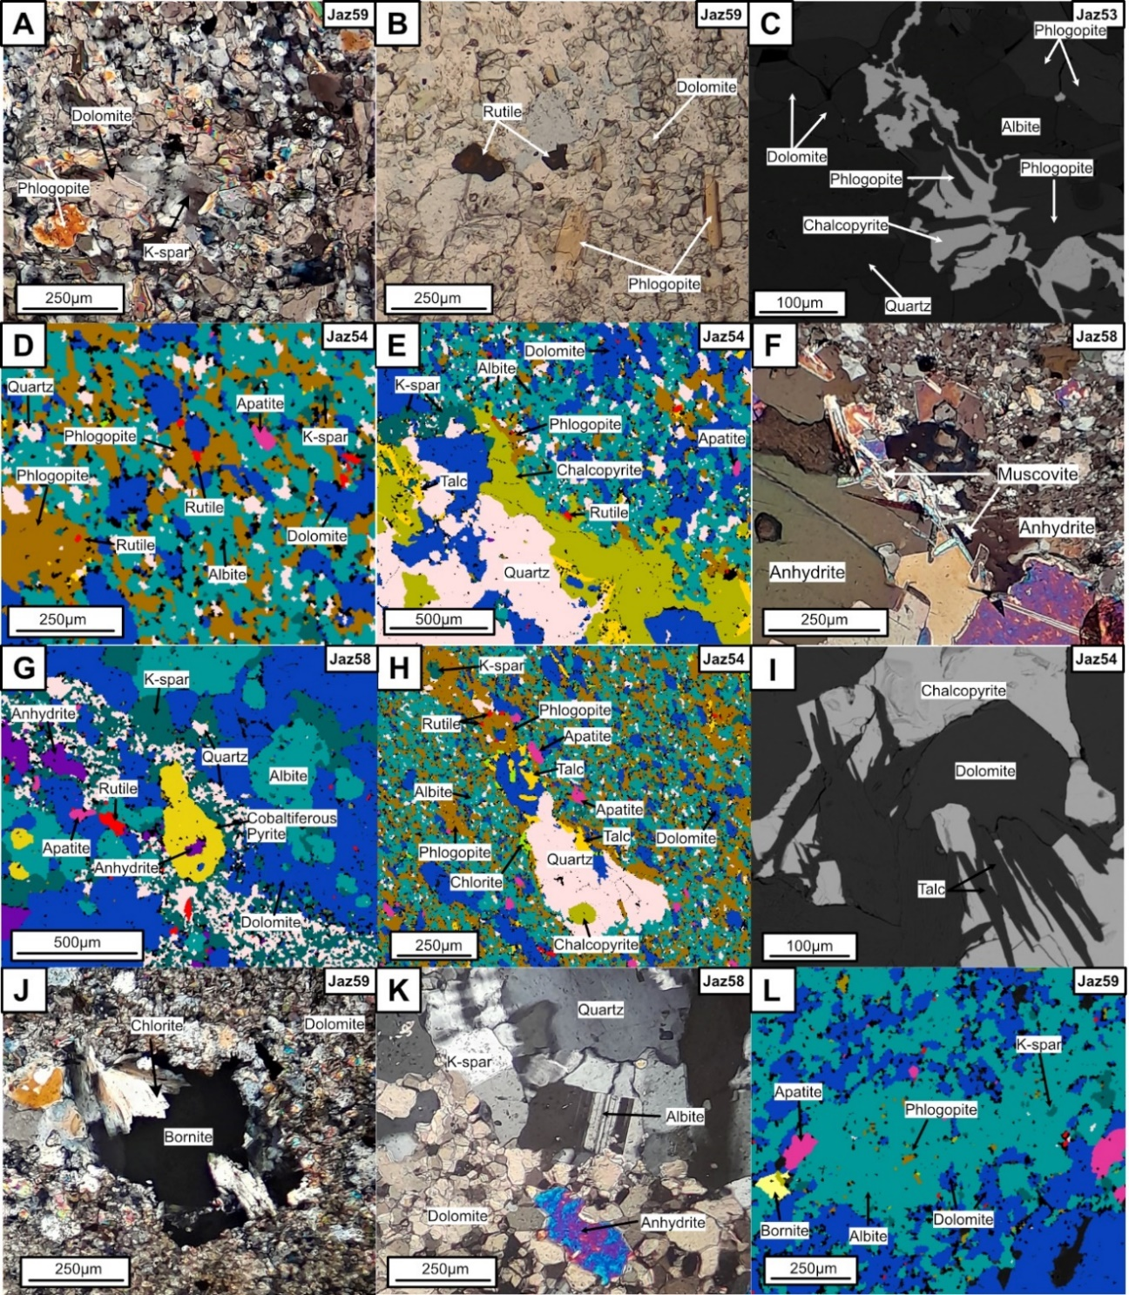
Fig. C.5-3: Petrography of the impure dolostones.
(A) K-spar being overprinting by dolomite (xpl), (B) Phlogopite crosscutting dolomite and isolated rutile overlapping grain boundaries of quartz and dolomite (ppl). (C) BSE image showing phlogopite crosscutting chalcopyrite. (D) TIMA scan showing phlogopite crosscutting dolomite in albitised portion of the slide. (E) TIMA scan showing phlogopite at the margins of chalcopyrite within a quartz-dolomite vein. (F) Muscovite overprinting anhydrite (xpl). (G) Anhydrite inclusion in cobaltiferous pyrite shown using TIMA. (H) Hydrothermal talc crosscutting dolomite and quartz under TIMA. Apatite is developed in the albite-dolomite rich matrix. (I) BSE image of talc crosscutting chalcopyrite. (J) Chlorite overprinting bornite (xpl). (K) Albite overprinting K-spar and quartz. Dolomite encloses anhydrite. (L) Phlogopite inclusions in albite shown by TIMA. Apatite appears to crosscut dolomite and albite. Albite has replaced K-Spar. Xpl = cross polarized light, ppl = plane polarized light
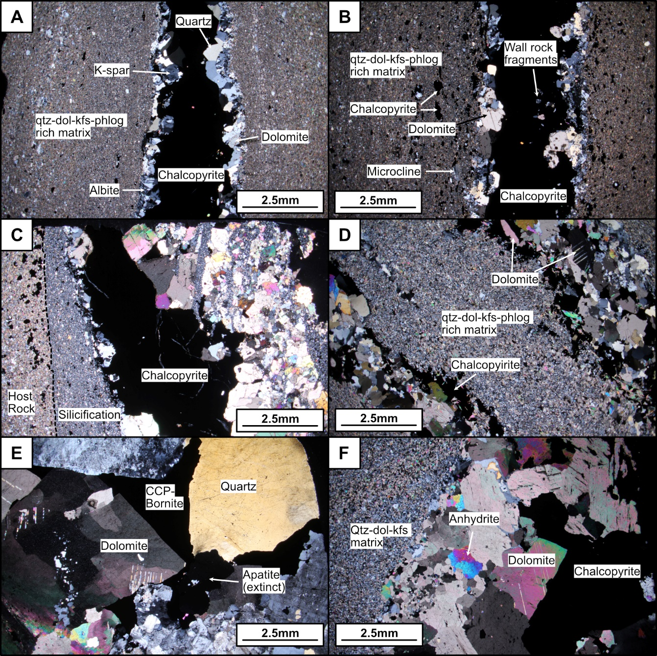
Fig. C.5-4: Photomicrographs of different vein textures across the Mindola North Orebody.
(A-B) Syntaxial vein growth of quartz, dolomite and feldspar and a core of sulphide. Vein wall fragments occasionally found contained within chalcopyrite. (C) Silicified vein margin to a chalcopyrite mineralised, layer-parallel quartz-carbonate veinlet. (D) Dipping, but layer-parallel chalcopyrite mineralised quartz-carbonate veins. Chalcopyrite encloses gangue mineral phases and vein does not show syntaxial growth. (E) Chalcopyrite-bornite infilling void space between quartz and dolomite in cm-sized quartz-carbonate veins. (F) Anhydrite bearing, layer-parallel mineralised veins in the impure dolostones
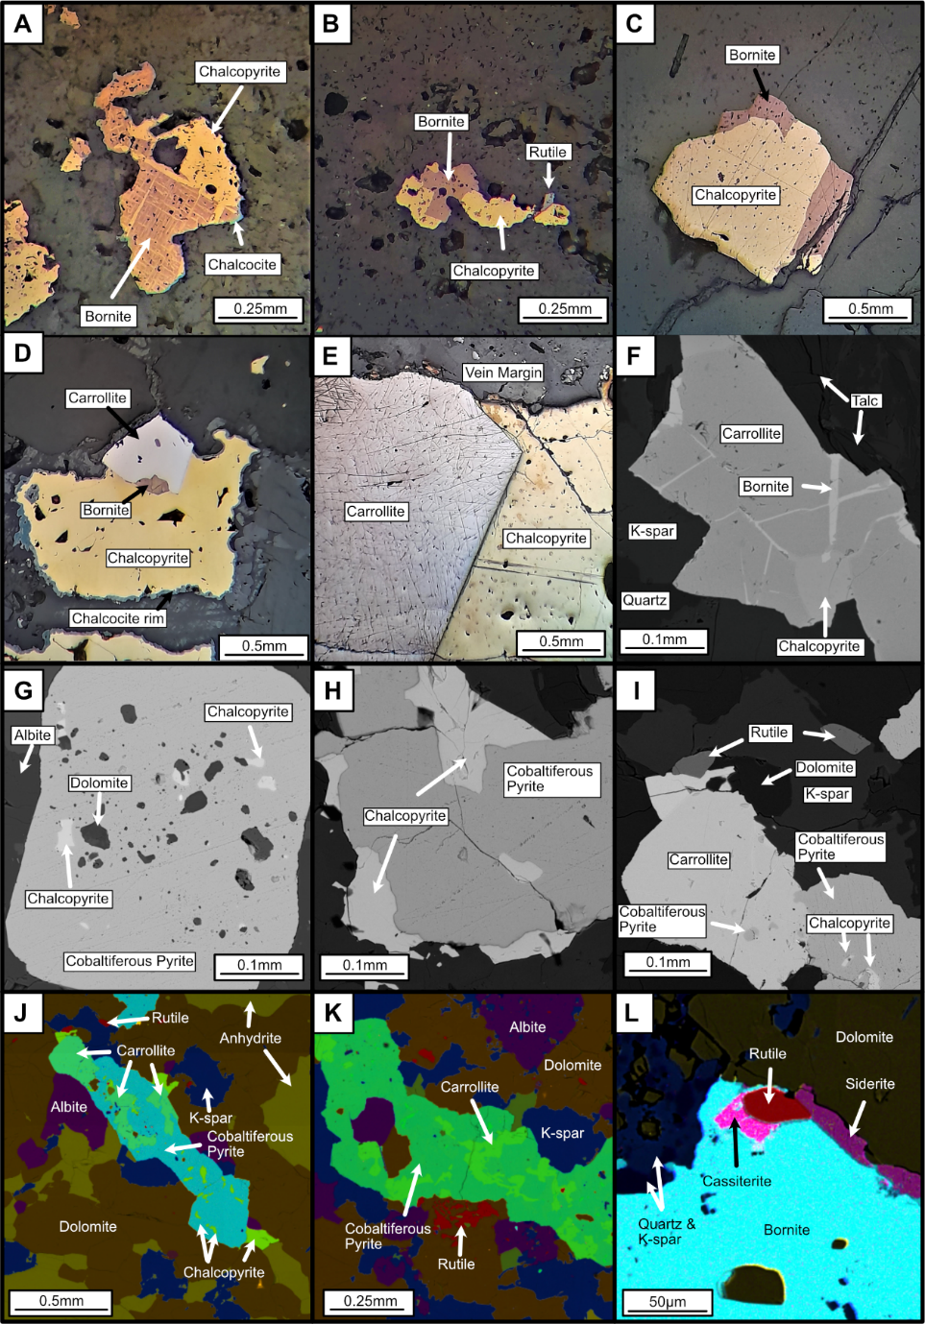
Fig. C.5-5: Sulphide textures from Mindola North.
(A-C) Bornite replacing chalcopyrite (RL). (D-E) Carrollite and chalcopyrite hosted within quartz-carbonate veins. Carrollite appears to form later. (F) Bornite replacing fractures in carrollite (BSE). (G) Cobaltiferous pyrite within inclusions of dolomite and chalcopyrite (BSE). (H) Intergrown chalcopyrite and cobaltiferous pyrite (BSE). (I) Carrollite with cobaltiferous pyrite inclusion and nucleating around chalcopyrite (BSE). (J-K) EDS maps showing carrollite replacement textures with cobaltiferous pyrite. (L) Rare cassiterite alongside rutile at the margins of bornite (EDS map). RL = reflected light, BSE = backscattered electron
Fig. C.5-6: Images showing the textural context of monazite.
(A) Isolated prismatic monazite in a quartz, k-spar, albite matrix (BSE). (B) TIMA image showing monazite interstitial to phlogopite and albite. (C) TIMA highlighting prismatic monazite enclosed by phlogopite. (D) Chalcopyrite-monazite relationships showing chalcopyrite nucleating around monazite with rutile (BSE). (E) Chalcopyrite occurring as microinclusions alongside dolomite and quartz in monazite (BSE). (F) TIMA showing chalcopyrite forming around monazite. BSE = backscattered electron image
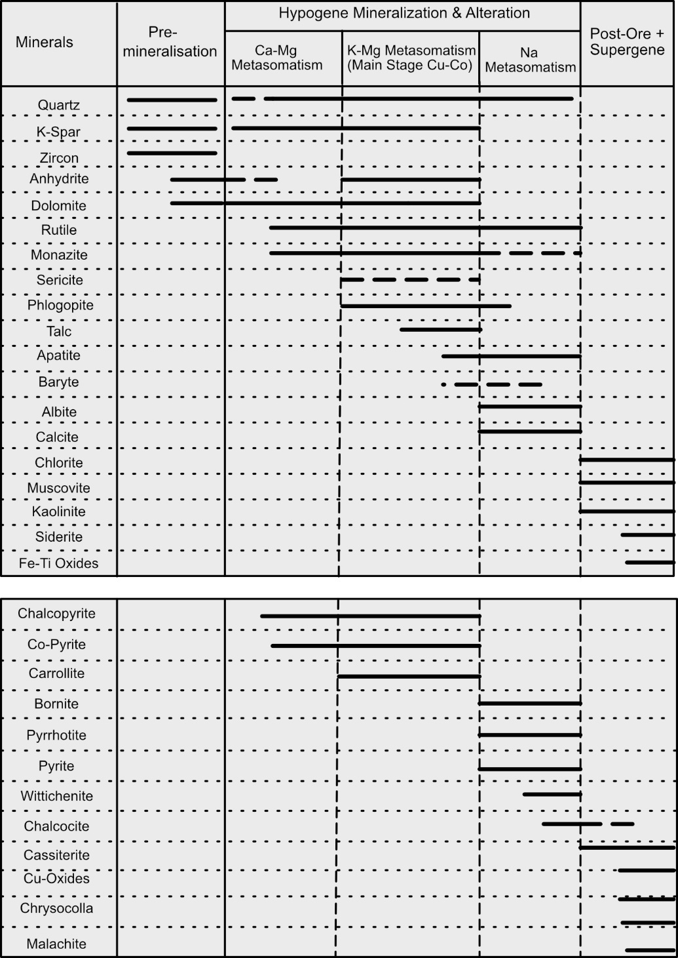
Fig. C.5-7: Paragenetic sequence for the Mindola North deposit
, produced from petrographic observations in the dolomitic siltstones and impure dolostones Note rutile is coeval with the earliest phase of Cu mineralisation and is persistently developed throughout the evolution of the deposit. Apatite develops later in the waning stages of main stage Cu-Co mineralisation, in alignment with Na metasomatism and bornite development.
Fig. C.5-8: Box plot of major substituting elements into rutile for Ti.
(A) Divalent (2+), trivalent (3+) and isovalent cations (4+). (B) Pentavalent (5+) and hexavalent cations (6+). Note some trace elements can occur in multiple valence states such as Fe, U and Cr however are given here in their preferred oxidation state that substitutes into rutile. The different generations of rutile show very similar trace element substituting behaviour and characteristics.
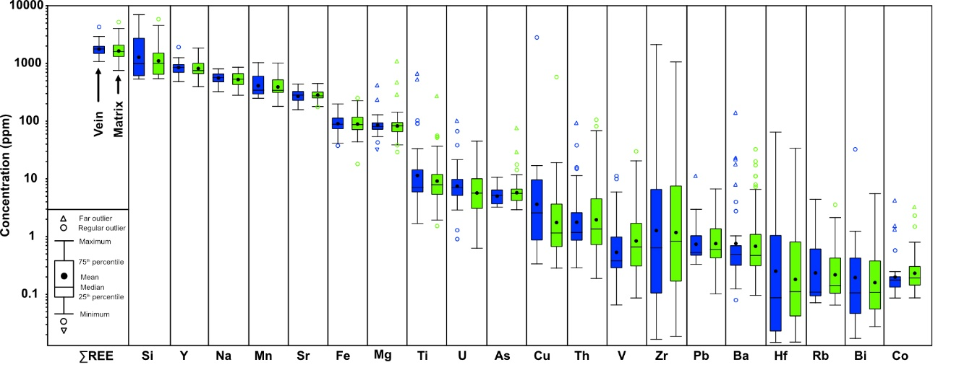
Fig. C.5-9: Box plot of major substituting elements (n ≥ 50) in apatite at Mindola North.
Vein apatite is represented by blue boxes, matrix apatite by green boxes.
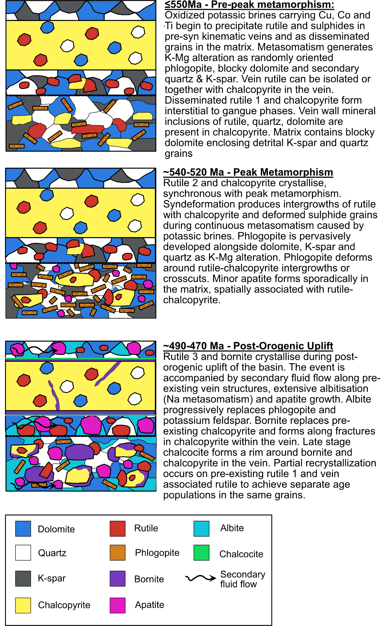
Fig. C.5-10: Schematic timeline of rutile and apatite formation, linked to different stages of ZCB evolution.
Rutile and chalcopyrite are intimately associated and intergrown during precipitation from potassic brines from pre-peak to peak metamorphism. Subsequent post-orogenic uplift generates secondary fluid flow and precipitation of the majority of apatite, bornite and recrystallization of earlier rutile phases.

