**Influence of localised cooling on repeated shearing stress and friction at the heel**

**Introduction:** Pressure ulcers (PUs) arise from sustained pressure and repeated shear causing localised damage to the skin(1). Evaluating the tolerance of human skin to shearing forces may help prevent the development of PUs and improve patient care. Prior research has shown increased skin temperature and humidity decrease mechanical stiffness and strength of the skin, and increase interface friction(2). Our recent data indicated a dose-response reduction in the coefficient of friction (CoF) in the index finger pad following a period of thermal pre-cooling(3). However, the interactions of different skin temperatures on shearing forces at the heel are not well understood. This study aimed to investigate how different levels of localised cooling at the heel influence the CoF at the skin interface during repeated shearing stress.

**Methods:** Twelve healthy participants (8M/4F; 24±5y; 73±10Kg; 175±10cm) partook in 3 experimental sessions in a randomised cross-over design. Participants underwent a standardised shearing protocol at the centre of the heel, involving a 60s thermal pre-conditioning phase, and 10 repeated bidirectional axial shearing movements. The heel was placed on a custom-built friction rig with integrated thermal plate. The friction rig was mounted on a linear rail system and attached to a servomotor to displace the friction rig by 10cm (3.3cm/s). The thermal plate was set to either 38°C, 24°C, or 16°C. Skin conductance was taken pre-and post the 10 repetitive shearing movements. Data were analysed using a two-way repeated measures ANOVA.

**Results:** There was a main effect of repetition (*P*=0.020)on the CoF at the heel (Figure 1A), with friction increasing from repetition 1 to 10 across all temperature conditions (mean difference +0.3 (35% increase), 95%CI [0.04, 0.56], *P*=0.018). There was also a main effect (*P*=0.047) of temperature and CoF was greater in the 38°C (mean 1.38, 95%CI [1.02, 1.73]) condition compared to 24°C (mean 0.91, 95%CI [0.62, 1.21]) and 16°C (mean 0.97, 95%CI [0.63, 1.31]). No interaction effect was observed (*P*=0.102). There were no significant differences observed on skin conductance for time (*P*=0.062), temperature (*P*=0.639) or interaction (*P*=0.110; Figure 1B).

**Conclusions:** Both milder (24°C) and more pronounced (16°C) cooling decrease kinetic friction during a repeated shearing stress protocol compared to warmer temperatures (38°C). The use of cooling may offer therapeutic benefits for PU prevention by minimising frictional forces at the skin interface of the heel.

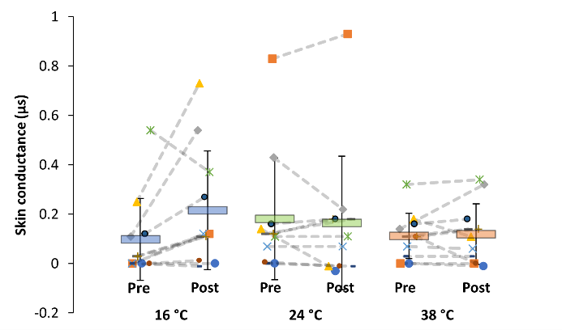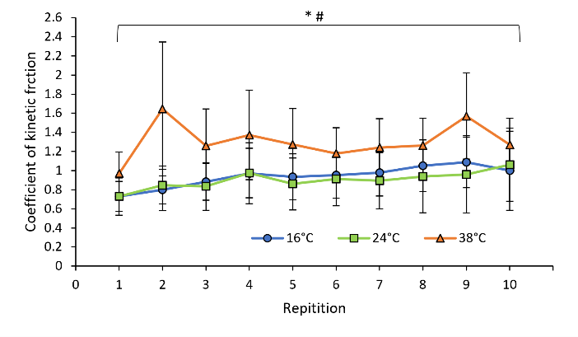

B

A

**Figure 1. (A)** CoF during a standardised protocol consisting of 10 repeated shearing movements. Data (n=12) are presented as means and ±95%CI. *Main effect of time (*P*<0.05). #main effect of temperature (*P*<0.05). **(B)** Skin conductance pre-and post the shearing protocol. Data (n=11) are presented as individual responses. Group mean values are denoted by horizontal bars and ±SD.

**References:**

1. Kottner J, et al. Prevention and treatment of pressure ulcers/injuries. J Tissue Viability. 2019;28(2):51-8.

2. Kokate JY, et al. Temperature-modulated pressure ulcers: a porcine model. Arch Phys Med Rehabil. 1995;76(7):666-73.

3. Valenza A, et al. Thermal modulation of skin friction at the finger pad. J Mech Behav Biomed Mater. 2023;146:106072.