Balancing Politics and Parenthood: Public Perceptions of MPs Taking Parental Leave in the UK

Short title: Balancing Politics and Parenthood: Perceptions of MPs’ Parental Leave

Author: Dr Jessica C. Smith, Department of Politics and International Relations, University of Southampton j.c.smith@soton.ac.uk

Competing Interests: The author declares none.

Funding Statement: Funding by the British Academy (SRG2021\210828)

Ethics approval: Approved by University of Southampton Ethics Committee ERGO number 64121

Data availability statement: All data to enable replication is available upon request from the corresponding author.

Abstract:

Family-friendly practices in parliaments are central to the recruitment and retention of diverse representatives. Yet, instituting such reforms raises questions about public reactions, something little tested in current work. A conjoint experiment in the UK tests if the public punish MPs for taking time off their elected roles for a baby. And, importantly, asks who pays the price? Against expectations, MPs who take parental leave are not punished by the public. Voters prefer MPs who are parents, even when they take leave. Crucially, this preference is contingent upon MP sex. Women MPs who take parental leave are consistently the preferred choice over their male counterparts. When the "costs" of parenthood are emphasized, women MPs receive a parenthood benefit, while men MPs do not. The findings align with the recent positive bias for women in electoral choice experiments and lend further support to implementing family-friendly policies in politics.

Keywords: political representation, gender bias, parental leave, voting behaviour, parliamentary reform

- Introduction

In January 2019, the memorable image of heavily pregnant Tulip Siddiq MP being wheeled through the voting lobby of the UK Parliament, delaying childbirth to vote in a critical Brexit division, highlighted a long-standing issue: parliaments are not adequately family-friendly workplaces. Siddiq’s experience reflects similar incidents in multiple parliaments, for instance in Japan, Germany and Denmark women MPs have been asked to leave when, for varying reasons related to a lack of childcare, they have brought young babies into their parliamentary chambers (Inter-Parliamentary Union, 2023). In the UK, shortly after Siddiq’s case, a policy was implemented to avoid a similar situation in the future: the new ‘baby leave’ pilot system. The system, later made permanent in September 2020, allows for new parent Members of Parliament (MPs) to nominate a proxy to vote on their behalf, eliminating the need for them to be physically present to vote. By 2022, additional provisions allowed MPs to claim expenses for extra staffing costs if they take leave as a new parent. These are welcome changes, family-friendly working practices are vital to the retention and recruitment of diverse representatives. Yet, instituting such reforms raises questions about public reactions, something little tested in current work. Whilst normal for most workers to take leave, MPs are judged as representatives and may face a sceptical public. Do citizens punish MPs for taking time off their elected duties for a baby? Using a pre-registered conjoint experiment, this note asks what public perceptions of MPs taking parental leave are. Is there a penalty for taking leave, and importantly, who pays the price?

Two clear contributions are made in this note. Firstly, while to date, work on the role of family-friendly reforms in the diversification of political institutions has primarily focused on institutions and elites (Childs, 2004; Krook, 2010; e.g., Allen, Cutts and Winn, 2016), this study brings in the "demand side" - how the public perceives the use of family-friendly measures. The democratic costs of unrepresentative institutions have long been made clear (Phillips, 1995; Childs and Celis, 2020). Both academics and campaigners argue that institutional practices, such as childcare and parental leave provisions, can determine the diversity of elected representatives and (limited) action has been taken by institutions to initiate family-friendly working practices. Bringing in the demand side contributes to understandings of electoral biases towards underrepresented groups in politics. Negative biases towards women in politics are increasingly contended, with recent studies revealing an overall positive bias for women in electoral choice experiments (Schwarz and Coppock, 2022) as well as how gender biases still operate through mediating factors such as partisanship, behaviour, candidate qualifications, and candidates’ intersecting identities (Bauer, 2020; Martin and Blinder, 2020; van Oosten, Mügge and van der Pas, 2023). Parenthood, which directly relates to gendered norms of caring, is an established mechanism through which gender bias has traditionally manifested in voter behaviour. In this study, experimental data enables the identification of electoral costs associated with parental leave while in office and, most importantly, reveals who bears the consequences.

Against expectations, the results show there is little punishment for MPs who take parental leave. Overall, voters prefer MPs who are parents compared to those without children, in line with previous evidence (Campbell and Cowley, 2018). And within MPs with children there is no punishment for taking leave. MPs still receive a parenthood benefit even when the "costs" of parenthood, i.e. taking leave, are explicitly considered. MPs with children who take up to six months of parental leave are still preferred over MPs without children by approximately 5-percentage-points. Importantly, these findings are contingent upon MP’s sex. Women MPs who take parental leave are the preferred choice over their male counterparts, by up to 8-percentage-points when taking one year of leave. Therefore, when the "costs" of parenthood are emphasized, i.e. that having children could mean a representative is absent by taking periods of parental leave, women MPs receive a parenthood benefit, while men MPs do not. MPs’ use of parental leave, however, does not lead to differential evaluations of an MP’s job performance, strength, assertiveness, or compassion. The preference for women MPs who balance motherhood and public office does not appear to be rooted in perceived competency advantages.

This research advances the understanding of gender biases in politics. The preference for women MPs taking parental leave aligns with a broader positive bias for women candidates now present in electoral choice experiments. This challenges traditional ideas that women must conform to masculine norms when in office for voter approval. Additionally, it supports calls for family-friendly policies in politics promoting a more inclusive democratic system, as it assuages concerns that MPs who use such practices will face significant electoral backlash.

- Politics, Parliaments, and Parenthood
Established scholarship shows legislatures are institutionally sexist in their formal and informal workings, including the difficulties of combining caring responsibilities with elected office (Kenny, 2013; Childs, 2016). Globally, there continues to be a lack of adequate childcare and parental leave for members in elected institutions (Joshi and Goehrung, 2020; Inter-Parliamentary Union, 2023). These work as a barrier to both the recruitment and retention of diverse representatives. A US survey of likely political candidates found that having responsibility for a majority of the household income negatively affects women’s political ambitions, especially for mothers (Bernhard, Shames and Teele, 2020). Critical actors, both academic and non-academic, create and campaign for ‘diversity sensitive’ or ‘gender sensitive’ frameworks for legislative reform (Childs and Challender, 2019), including more family-friendly practices (e.g, IPU Action Plan for Gender Senstive Parliaments 2017) Yet, there is a lack of understanding of public opinion of these measures. Bringing in the electorate view of politicians taking parental leave directly addresses questions of parliamentary diversity and electoral discrimination and illuminates emergent ideas of the ‘good parliamentarian’ (Challender and Deane, 2021), by making explicit the balance between required physical presence in Parliament and MPs’ family lives. The difficulty and likely inequities in family and public life balance for Members, and institutional support of this, was highlighted in the recent, wider international debate about presence during the Coronavirus pandemic which saw many parliaments shift from physical to virtual proceedings (Smith and Childs, 2021; Smith, 2022).

Previous UK experimental evidence finds that, regardless of MP sex, voters prefer a parent MP (Campbell and Cowley, 2018). However, given voter scepticism and distrust of MPs it is expected that: MPs taking explicit leave from their role is disliked by voters and this negative effect will increase the longer the length of leave. Leave can be seen as a ‘cost’ to voters here as it is not specified in the vignette that the representational duties of the MP were covered and there is no formal system of locum or reserved MPs in the UK. Any effect of leave is expected to be gendered, however. A growing debate surrounds the extent and prevalence of direct bias against women seeking political office. A recent meta-analysis of 67 studies on gender and candidate choice using experimental data, revealed that women actually enjoy a slight advantage in voter choice compared to men, becoming slightly more positive in studies after 2014 (Schwarz and Coppock, 2022). However, it is evident that biases can manifest in complex ways and may depend on factors such as partisanship, behaviour, candidate qualifications and candidates’ intersecting identities (King and Matland, 2003; Bauer, 2020; Martin and Blinder, 2020).

Parental leave directly relates to gendered norms associated with caregiving, an established mechanism through which gender bias influences voter behaviour (Bell and Kaufmann, 2015). Traditional accounts of gender-based stereotyping depict motherhood as a disadvantage for women in politics. Motherhood is perceived as incongruent with public life and reinforces the association of women with feminized traits, such as compassion, weakness, and diminished assertiveness. These traits are considered incongruent with the preferred (masculine) traits typically associated with politics and politicians (Huddy and Terkildsen, 1993; Stalsburg, 2010; Bauer, 2015). Experimental evidence finds that women candidates with young children are viewed as less viable, with less time capacity, than their male counterparts, (Stalsburg, 2010). Women in public life have also faced scrutiny regarding their ability to fulfil their public duties while managing their domestic responsibilities, as exemplified by the case of Sarah Palin in the US (Carlin and Winfrey, 2009). If these traditional accounts hold, it is expected that: Women MPs who take parental leave will be punished by voters and will be more associated with traditional feminine traits of being more caring, less assertive, and weaker.

At the same time, father MPs taking parental leave also break gendered norms and may be emasculated. Previous work in other workplaces finds that men taking parental leave face a higher penalty than women (Wayne and Cordeiro, 2003; Gloor, Li and Puhl, 2018). In the context of politics, taking parental leave may break two norms for men – both gendered and workplace norms, under this thesis then it is expected that: Any negative effect of taking parental leave will be larger for men MPs than women MPs.

The competing politicalised parenthood thesis offers alternative expectations: that taking parental leave will have a positive effect on vote evaluations of both men and women MPs. Recent research challenges the prevalence of hostility to women as their political presence becomes normalized and gendered norms evolve. In this context, motherhood is “politicized” and even serves as an electoral advantage for women (Deason, Greenlee and Langner, 2015; Teele, Kalla and Rosenbluth, 2018), including within the UK context (Campbell and Cowley, 2018). For instance, when Jacinda Ardern took maternity leave as the second global leader ever to give birth whilst in office, international coverage portrayed her positively (Galy-Badenas and Sommier, 2021; Żukiewicz and Piel Martín, 2022). The "politicized motherhood thesis" contends mother politicians can present themselves as having an additional level of competence, making them "special, different, and powerful" (Deason, Greenlee and Langner, 2015, p. 136). Therefore, it is expected: Women MPs who take parental leave will be rated as more caring, assertive and stronger. Media coverage in Canada, Australia, and the US has framed women politicians' juggling of motherhood and work as evidence of their competency, relatability, and effectiveness in their political roles (Deason, Greenlee and Langner, 2015; Auer et al., 2020). In Germany, recent work finds that women Mayors are not penalised (nor rewarded, however) for mentioning family and private life (Denner, Schäfer and Schemer, 2022). Politicised motherhood warrants caution, however. As Teele at al (2018) assert, a preference for the married with children candidate creates a double bind for women: those with demanding family roles have less time and resources to campaign compared to their male counterparts and women with less traditional family structures.

With an increasing personalization of politics we may expect a politicization of not only motherhood but parenthood in general, encompassing fatherhood (Smith, 2018). As gender norms for men and masculinity evolve, even within the realm of political masculinities, men politicians often present as "modern men" who highlight their familial roles to emphasize their human or communal nature. In the British context, leaders like Tony Blair and David Cameron utilized their fatherhood in public imagery as part of their modernization agenda (Smith, 2016, 2021). Campbell and Cowley (2018) found that men and women MPs in the UK equally prioritize their parenthood on their websites. In Germany, experimental evidence suggests men Mayors can benefit from portraying a ‘modern’ family life compared to a traditional one (Denner, Schäfer and Schemer, 2022). Appeals to fatherhood, whether in traditional or modern ways, can frame men politicians as "good guys", showcasing their sound character and likability (Auer et al., 2020).

However, actively embracing fatherhood, like taking parental leave, may challenge traditional gendered conceptions of masculinity. Some experimental studies find a fatherhood penalty, disadvantaging men with young children compared to men without children (Stalsburg, 2010). Alongside, or perhaps in response to, modern man imagery there is a recent rise of hypermasculinity in political leadership, characterized by "purposeful and aggressive displays of masculinity with exaggerated displays of traditionally stereotyped masculine characteristics" (Smith, 2021, p. 451). Additionally, while fathers may choose to leverage their parenthood, they have more leeway in deciding whether or not to politicize it, unlike women who may find their parenthood subject to discussion regardless of their public disclosure (Trimble, 2017; Smith, 2018). It is expected that: Men MPs who take parental leave will be rated as more caring, less assertive and weaker as a more feminised notion of masculinity may be associated with more compassion but lower levels of assertiveness and strength away from traditional masculine stereotypes.

The UK Case

The empirical case for this paper is the UK. As noted, recent parliamentary reforms in the national parliament introduced limited parental leave provisions: new parent MPs can nominate a proxy to vote on their behalf, eliminating the need for them to be physically present to vote, and MPs can claim expenses for extra staffing costs if they take leave as a new parent. A lack of formalised, extensive parental leave and childcare for MPs is not unique to the UK however, as across democracies family-friendly practices in Parliaments have been found to be inadequate (Inter-Parliamentary Union, 2023). Empirical evidence from a range of countries informs the theoretical frameworks above, and so expectations are not specific to the UK case. However, it may be that in countries with more equitable parental leave for ‘normal’ workplaces, e.g. Scandinavian countries, a negative electoral impact of MP parental leave would not be expected and differential responses to men and women MPs may be less likely as men taking parental leave is more normalised and experiences of leave by voters themselves can promote gender egalitarian attitudes (Tavits et al., 2024).

- Methodology

I use a ‘forced-choice’ conjoint experiment to test the causal impact of an MP taking parental leave on citizen evaluations in the UK. In this experiment, respondents are presented with two hypothetical Members of Parliament. Fictitious politicians are commonly employed in experimental studies (Huddy and Terkildsen, 1993; e.g., Campbell and Cowley, 2014). The experimental design was fielded by YouGov to their UK online panel in November 2021. The design, hypotheses, and analysis plan were pre-registered. The sample was 1,852 people who are nationally representative of the British public on a range of attitudinal and demographic criteria. The demographics of the sample can be found in the online Appendix.

In the design, the sex, race, class, sexuality, parenthood, taking parental leave, length of leave, party, level of office and policy positions are randomised. Whether an MP had children or not was perfectly randomised. Within the MPs with children the length of leave was perfectly randomised between: no leave, 2 weeks, 6-months or one year of leave. All MPs were described as married as single parenthood effects were not tested, and this also more naturally varied sexuality as their married partner could be same-sex. Some randomisation restrictions were applied: (i) An MP cannot take parental leave if he or she has no children (in this case, leave information is omitted); (ii) Same-sex couples appear in 10% of profiles for realism (De La Cuesta, Egami and Imai, 2022). All other values are completely randomised. Table 1 lists all attributes and levels; positions on political issues are included to mask the interest in parental leave and demographics. Other demographics were varied to test further pre-registered hypotheses (see online Appendix). The sex of the MP and their ethnicity was varied by the use of different names, as is common in studies of gender and ethnicity in candidate experiments (Martin and Blinder, 2020). A full list of names can be found in the PAP. Ethnicity was also varied in the profile with information provided about background. The profiles were presented as two vignettes with information in full, bullet-pointed sentences. Respondents viewed two profiles of MPs simultaneously. They repeated the task twice. Example profiles are in the online Appendix.

Dependent Variables

There are three dependent variables. (i) Forced Choice: respondents make a forced choice between the two profiles, by answering ‘overall which MP do you feel most positive about’. The question is not framed as a direct electoral decision, as in the British political system it is not plausible to cast a vote between incumbent MPs. (ii) Traits: Respondents rate MPs on three traits based on similar measures of gendered stereotypes: strength and assertiveness (masculine) and caring (feminine) (Huddy and Terkildsen, 1993; Bauer, 2015; Schneider and Bos, 2019). These are measured on semantic differential scales of 0 to 7 from weak to strong, not assertive to assertive and distant to caring. (iii) Job Approval: a measure of general job approval asks “On a scale ranging from 0 to 7, where 0 means strongly disapprove and 7 means strongly approve, how much do you disapprove or approve of the way each MP is handling their job?”

Table 1. Table of Attributes
Attribute | Values
Sex | Male, Female
Sexual Orientation | Heterosexual, Gay or Lesbian
Race/Ethnicity | White British/Pakistani/Black Caribbean
Class Background | Working-class, middle-class
Level of Office | Backbench MP, Minister (not in Cabinet)/Shadow Minister (not in Shadow Cabinet), Secretary of State (in the Cabinet)/Shadow Secretary of State (in the Shadow Cabinet)
Marital Status | Married no children, married with children
Leave Taken | 2 weeks of parental leave taken after the birth of [his/her] child during their time as MP, 6 months of parental leave taken after the birth of [his/her] child during their time as MP, 1 year of parental leave taken after the birth of [his/her] child during their time as MP, no leave taken in the parliamentary term
Party | Conservative, Labour
Policy 1 | Voted for the introduction of a ‘sugar tax’ on sugary drinks, voted against a ‘sugar tax’ on sugary drinks
Policy 2 | Has supported extending the right to buy council houses, Is against extending the right to buy council houses

- Analysis

Unconditional Effects

Parenthood and leave length are combined into one attribute in the analysis. Previous findings show the public prefer MPs with children (Campbell and Cowley, 2018) therefore, the effect of parental leave could be driven by an MP having children compared to not or by the act of them taking leave. Therefore, two possible baseline categories are used: (i) an MP does not have children (left-hand panel Figure 1); (ii) an MP has children and takes no parental leave (right-hand panel Figure 1). Average marginal component effects (AMCEs) for each attribute compared to the baseline of that attribute are presented for the forced choice and job approval (Figure 1) with the two baseline categories. Marginal mean plots and full AMCE models are in the online Appendix.

Figure 1. AMCE for forced choice and job approval
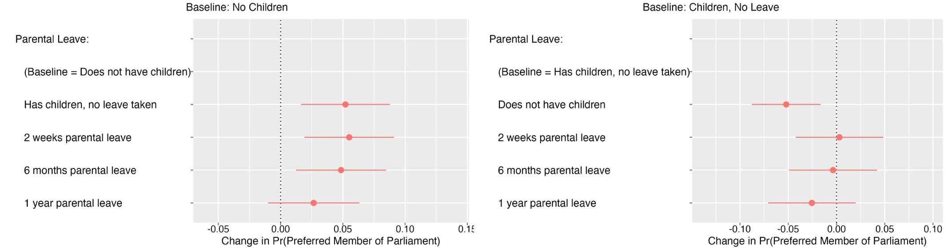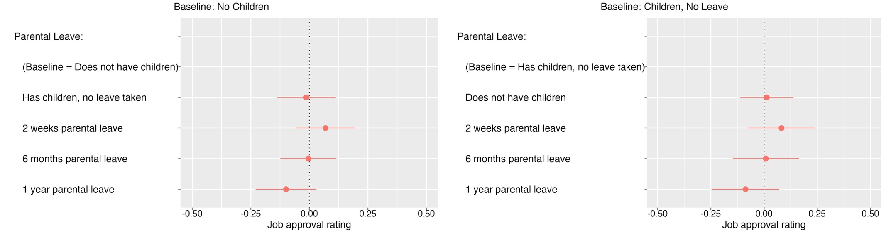

Against expectations, Figure 1 shows that, compared to not having children, having children has a significant and positive effect on the likelihood respondents choose the MP as their preferred MP, even if the MP took parental leave. Once length of leave reaches one year the positive effect is smaller and non-significant, although notably remains positive. But, having children and taking up to 6-months parental leave increases the preferability of an MP by around 5-percentage-points compared to not having children. When compared to an MP who has children and does not take leave there is no significant difference in preferability of MPs who take parental leave. Again, there is a parenthood benefit here – there is a significant and negative effect of not having children compared to having children and not taking parental leave. An MP taking a full year of leave does have some negative effect compared to taking no leave although this is non-significant. Taking periods of parental leave does not impact job approval (Figure 1 bottom panel), with non-significant and small effects for MPs with children who took leave or not.

Overall voters express a general preference for the parent MP, even when they take parental leave. This positive effect does not seem to come from thinking parents are doing a better job.

Conditional Effects

Figure 2. Difference in Marginal Means by MP Sex: Forced Choice

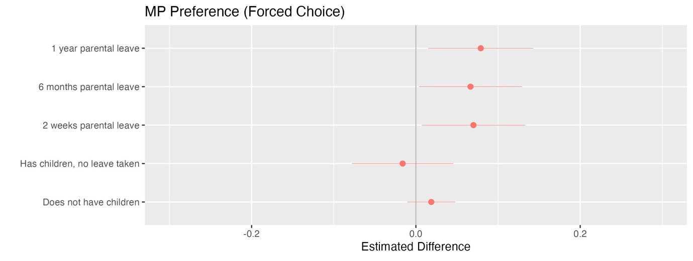

Competing theories offer differing expectations on how gender will mediate the effect of parental leave. Figure 2 shows the marginal mean differences in the forced choice dependent on MP sex. The plot shows the differences in means for women MPs minus the mean for men MPs. For forced choice, this can be interpreted as positive estimates which mean women score higher. For example, if the preference on a given attribute for women MPs is 55 and for men it is 47, the difference in marginal means is (55-47=)8, meaning women are preferred on that attribute relative to men by 8-percentage-points. For instance: relative to men, women who take one year of parental leave are preferred by approximately 8-percentage-points.

In line with the politicised motherhood thesis, which theorises that women politicians benefit from motherhood, the differences in marginal means show that for MP choice, there is a significant and positive effect of women having children and taking parental leave compared to men. Women MPs with children who take parental leave are consistently the preferred MP compared to men by up to 8-percentage-points for one year of leave taken. There are no significant differences between men and women MPs not having children or having children and taking no leave. However, when we make the ‘costs’ of parenthood clear (i.e. that having children could mean a representative is absent by taking periods of parental leave) women receive a parenthood benefit but men do not. However, these effects do not hold for job approval where there are no significant differences between men and women MPs (see online Appendix).

Figure 3. Marginal Means by Sex of MP on Trait Outcomes
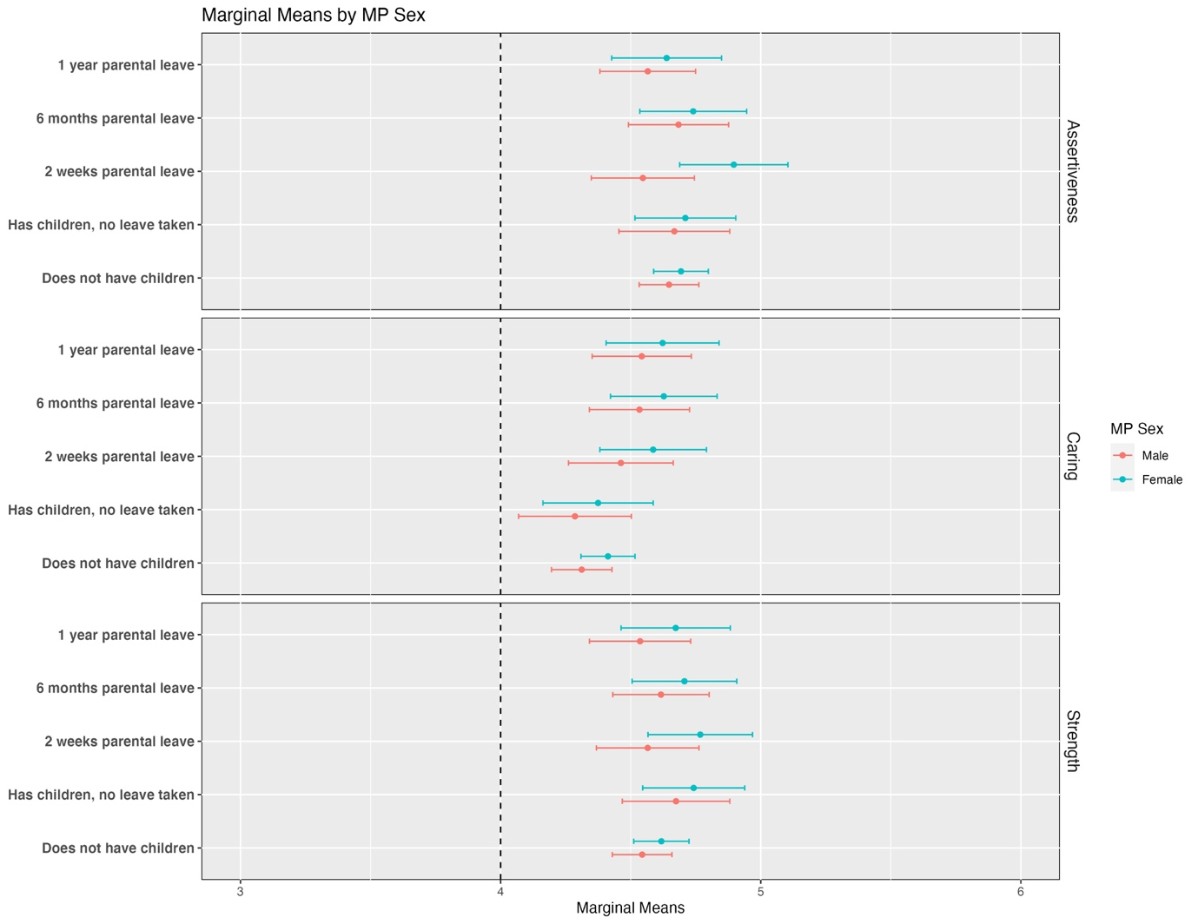

These differences are not driven by gendered trait stereotypes of men and women taking parental leave. Figure 3 shows the marginal means for the trait variables for men and women MPs. There are no significant differences within or between MPs by sex. Meaning that men or women MPs were not rated differently on caring, assertiveness or strength when they took parental leave, both compared to the opposing sex and compared to their own sex not taking leave after having a child or not having children. There is no support for either the traditional stereotyping nor the politicised parenthood hypotheses in relation to trait evaluations.

Respondent Demographics

Heterogenous effects by respondent demographics are tested using subgroup marginal means, considered the best method to test for group differences (Leeper, Hobolt and Tilley, 2020). The marginal means for the forced choice variable by different respondent subgroups are shown in Figures 4 and 5. For sex of respondent there are no significant differences, men and women responded in similar ways to the MP profiles. In terms of having children, respondents with children under 18 although non-significant are more likely to choose the MPs who have taken longer lengths of parental leave (6-months or a year) compared to respondents with no children or children over 18.

Figure 4. Subgroup Marginal Means for Forced Choice by Respondent Sex

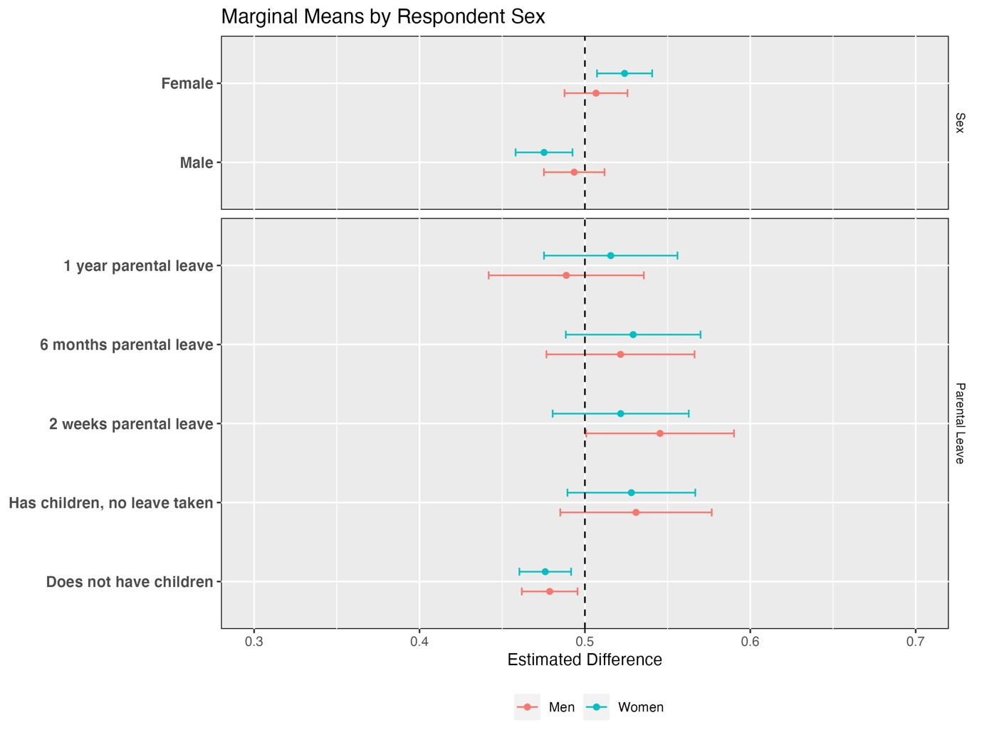

Figure 5. Subgroup Marginal Means for Forced Choice by Respondent Parenthood

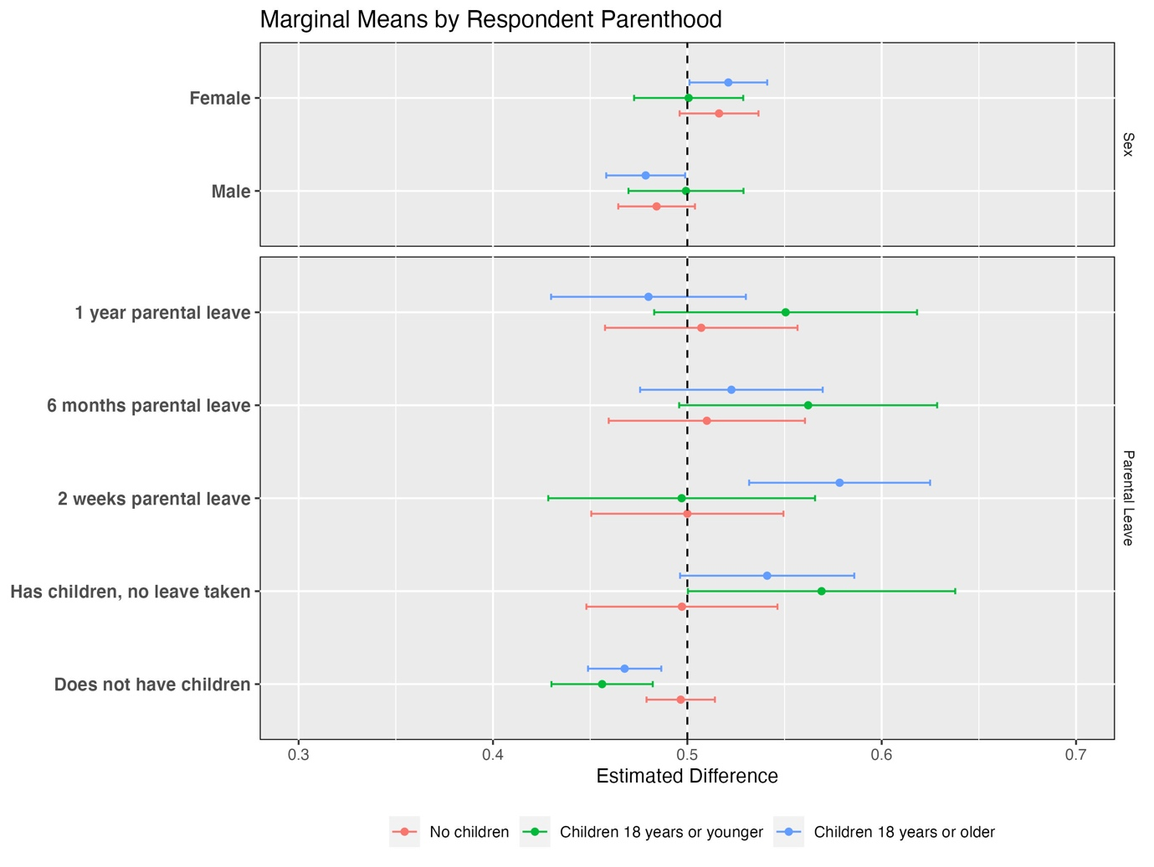

Discussion and Conclusion
Family-friendly working practices are needed to increase the retention and recruitment of diverse elected representatives in legislatures. Yet instituting such reforms raises questions about public reactions, something little tested in current work. Do the public punish MPs for taking time off their elected roles for a baby? And, importantly, who pays the price? The results from pre-registered conjoint experiments demonstrate that there exists little punishment for MPs who take parental leave. In line with previous research (Campbell and Cowley, 2018), the results show a preference for the parent MP. Notably, this "parenthood benefit" endures even when the potential "costs" of parenthood, taking parental leave, are explicitly stated. MPs who take up to 6-months of parental leave experience an increase in preferability by approximately 5-percentage-points compared to those without children. However, the effect does reduce for MPs who take a longer leave of one year, rendering the benefit non-significant.

Crucially, these findings reveal that voter preferences are contingent upon the sex of the MP. Women MPs who take parental leave consistently emerge as the preferred choice over their male counterparts, with up to 8-percentage-points when one year of leave is taken. Strikingly, when the "costs" of parenthood are emphasized, women MPs receive a parenthood benefit, while men MPs do not. Nevertheless, the study also highlights that voter preferences do not translate into differential evaluations of job performance, strength, assertiveness, or compassion based on the MPs' parenthood or use of parental leave. Hence, the preference for women MPs who balance motherhood and public office does not appear to be rooted in perceived competency advantages.

This research contributes on two significant fronts. Firstly, it furthers understandings of gender biases in politics, exploring these biases once politicians are in elected office. The preference for women MPs who take parental leave aligns with the notion of politicized motherhood, as women politicians benefit from embracing motherhood (Deason, Greenlee and Langner, 2015). Yet this is not driven by voters perceiving mothers as more competent or from the trait stereotypes examined as the thesis suggests. A more generalised preference for women, and in this case the ‘most feminine’ woman – the mother who takes parental leave – aligns with new evidence of a positive bias for women candidates in electoral choice experiments (Schwarz and Coppock, 2022). These findings continue to challenge the traditional thesis that women must act in masculine ways to gain voter approval. Yet, politicised motherhood is not entirely advantageous for women in politics. Women with the gender-congruent family lives (i.e. married with children) have fewer resources and less time to campaign for office (Teele et al 2018). This presents a further puzzle when compared to men MPs. Whilst men MPs did not face an explicit cost when they took parental leave in the experiments, both men and women generally benefit from parenthood. However, once an MP is described as taking leave, women receive a parenthood benefit, but men do not. This opens the possibility that men politicians are punished for gender-incongruent behaviour. Potentially, traditional gender norms exist behind these biases driving a positive preference for women’s gender conforming behaviour of parental leave and a more negative response to men’s gender-incongruent behaviour. Understanding more on the role of gender (in)congruent behaviour, such as in terms of politicians’ family lives, in driving the recent positive preference for women can advance our understanding of gender dynamics and inequities in our political landscape.

Secondly, it lends support to academic and practitioner calls for family-friendly practices to diversify representative bodies. Moving beyond a focus solely on the institutional and elite levels (Allen, Cutts and Winn, 2016; Childs and Celis, 2020) to consider public perceptions it is found that MPs are unlikely to pay an electoral cost for the use of family-friendly practices. For practitioners and policymakers, the most compelling takeaway is the lack of significant opposition or punishment from the public towards MPs who take parental leave. This finding should encourage further support and implementation of family-friendly policies and practices in politics, fostering a more inclusive and representative democratic system.

ACKNOWLEDGEMNTS

I would like to thank various colleagues who have been kind enough to read and comment on this paper and the experimental design including Daniel Devine, Sarah Childs, Lotte Hargrave, and Stuart Turnbull-Dugarte. Thank you also to participants at seminars at the Universities of Bath and Manchester for insightful comments and feedback.

REFERENCES
Allen, P., Cutts, D. and Winn, M. (2016) ‘Understanding Legislator Experiences of Family-Friendly Working Practices in Political Institutions’, Politics & Gender, 12(03), pp. 549–572. Available at: https://doi.org/10.1017/S1743923X16000040.
Auer, M. et al. (2020) ‘Invoking the idealized family to assess political leadership and legitimacy: news coverage of Australian and Canadian premiers’, Feminist Media Studies, pp. 1–16. Available at: https://doi.org/10.1080/14680777.2020.1790627.
Bauer, N.M. (2015) ‘Emotional, Sensitive, and Unfit for Office? Gender Stereotype Activation and Support Female Candidates: Emotional, Sensitive, and Unfit for Office?’, Political Psychology, 36(6), pp. 691–708. Available at: https://doi.org/10.1111/pops.12186.
Bauer, N.M. (2020) The Qualification Gap: Why Women Must Be Better Than Men to Win Political Office. Cambridge: Cambridge University Press.
Bell, M.A. and Kaufmann, K.M. (2015) ‘The Electoral Consequences of Marriage and Motherhood: How Gender Traits Influence Voter Evaluations of Female Candidates’, Journal of Women, Politics & Policy, 36(1), pp. 1–21. Available at: https://doi.org/10.1080/1554477X.2015.985150.
Bernhard, R., Shames, S. and Teele, D.L. (2020) ‘To Emerge? Breadwinning, Motherhood, and Women’s Decisions to Run for Office’, American Political Science Review, pp. 1–16. Available at: https://doi.org/10.1017/S0003055420000970.
Campbell, R. and Cowley, P. (2014) ‘What Voters Want: Reactions to Candidate Characteristics in a Survey Experiment’, Political Studies, 62(4), pp. 745–765. Available at: https://doi.org/10.1111/1467-9248.12048.
Campbell, R. and Cowley, P. (2018) ‘The impact of parental status on the visibility and evaluations of politicians’, The British Journal of Politics and International Relations, 20(3), pp. 753–769. Available at: https://doi.org/10.1177/1369148118775032.
Carlin, D.B. and Winfrey, K.L. (2009) ‘Have You Come a Long Way, Baby? Hillary Clinton, Sarah Palin, and Sexism in 2008 Campaign Coverage’, Communication Studies, 60(4), pp. 326–343. Available at: https://doi.org/10.1080/10510970903109904.
Challender, C. and Deane, H. (2021) ‘Critical Reflections on the 2020 Pandemic and UK Legislatures: The construction of the “Good Parliamentarian” within the House of Commons’, in Evans, Sillk, and White (eds) Study of Parliament Group.
Childs, S. (2004) New Labour Women MPs: Women Representing Women. London: Routledge.
Childs, S. (2016) The Good Parliament. Bristol.
Childs, S. and Celis, K. (2020) Feminist Democratic Representation. Oxford: Oxford University Press.
Childs, S. and Challender, C. (2019) ‘Re-gendering the UK House of Commons: The Academic Critical Actor and Her “Feminist in Residence”’, Political Studies Review, 17(4), pp. 428–435. Available at: https://doi.org/10.1177/1478929919866388.
De La Cuesta, B., Egami, N. and Imai, K. (2022) ‘Improving the External Validity of Conjoint Analysis: The Essential Role of Profile Distribution’, Political Analysis, 30(1), pp. 19–45. Available at: https://doi.org/10.1017/pan.2020.40.
Deason, G., Greenlee, J.S. and Langner, C.A. (2015) ‘Mothers on the campaign trail: implications of Politicized Motherhood for women in politics’, Politics, Groups, and Identities, 3(1), pp. 133–148. Available at: https://doi.org/10.1080/21565503.2014.992792.
Denner, N., Schäfer, S. and Schemer, C. (2022) ‘Passionate Hiking Fan or Loving Parent? How Personalized Self-Presentation in the Media Affects the Perception of Female and Male Politicians’, International Journal of Communication, 16.
Galy-Badenas, F. and Sommier, M. (2021) ‘“A baby bump for women’s rights”: Analysing Local and International Media Coverage of Prime Minister Jacinda Ardern’s Pregnancy’, Feminist Media Studies, pp. 1–22. Available at: https://doi.org/10.1080/14680777.2021.1928257.
Gloor, J.L., Li, X. and Puhl, R.M. (2018) ‘Predictors of parental leave support: Bad news for (big) dads and a policy for equality’, Group Processes & Intergroup Relations, 21(5), pp. 810–830. Available at: https://doi.org/10.1177/1368430217751630.
Huddy, L. and Terkildsen, N. (1993) ‘Gender Stereotypes and the Perception of Male and Female Candidates’, American Journal of Political Science, 37(1), p. 119. Available at: https://doi.org/10.2307/2111526.
Inter-Parliamentary Union (2023) ‘Babies on the back benches’, News in Brief, 14 August. Available at: https://www.ipu.org/news/news-in-brief/2023-08/babies-back-benches (Accessed: 11 June 2024).
IPU (2017) Plan of Action for Gender-Sensitive Parliaments. Inter-Parliamentary Union (IPU).
Joshi, D.K. and Goehrung, R. (2020) ‘Mothers and Fathers in Parliament: MP Parental Status and Family Gaps from a Global Perspective’, Parliamentary Affairs, p. gsaa003. Available at: https://doi.org/10.1093/pa/gsaa003.
Kenny, M. (2013) Gender and Political Recruitment - Theorizing Institutional change. Palgrave Macmillan UK.
King, D.C. and Matland, R.E. (2003) ‘Sex and the Grand Old Party’, American Politics Research, 31(6), pp. 595–612.
Krook, M.L. (2010) ‘Beyond Supply and Demand: A Feminist Institutionalist Theory of Candidate Selection’, POLITICAL RESEARCH QUARTERLY, 63(4), pp. 707–720.
Leeper, T.J., Hobolt, S.B. and Tilley, J. (2020) ‘Measuring Subgroup Preferences in Conjoint Experiments’, Political Analysis, 28(2), pp. 207–221. Available at: https://doi.org/10.1017/pan.2019.30.
Martin, N.S. and Blinder, S. (2020) ‘Biases at the Ballot Box: How Multiple Forms of Voter Discrimination Impede the Descriptive and Substantive Representation of Ethnic Minority Groups’, Political Behavior [Preprint]. Available at: https://doi.org/10.1007/s11109-020-09596-4.
Miratrix, L.W. et al. (2018) ‘Worth Weighting? How to Think About and Use Weights in Survey Experiments’, Political Analysis, 26(3), pp. 275–291. Available at: https://doi.org/10.1017/pan.2018.1.
van Oosten, S., Mügge, L. and van der Pas, D. (2023) ‘Race/Ethnicity in Candidate Experiments: a Meta-Analysis and the Case for Shared Identification’, Acta Politica [Preprint]. Available at: https://doi.org/10.1057/s41269-022-00279-y.
Phillips, A. (1995) Politics of Presence. Oxford: Oxford University Press.
Schneider, M.C. and Bos, A.L. (2019) ‘The Application of Social Role Theory to the Study of Gender in Politics’, Political Psychology, 40(S1), pp. 173–213. Available at: https://doi.org/10.1111/pops.12573.
Schwarz, S. and Coppock, A. (2022) ‘What Have We Learned about Gender from Candidate Choice Experiments? A Meta-Analysis of Sixty-Seven Factorial Survey Experiments’, The Journal of Politics, 84(2), pp. 665–668. Available at: https://doi.org/10.1086/716290.
Smith, A. (2016) ‘Mediated political masculinities: the commander-in-chief vs. the new man’, Social Semiotics, 26(1), pp. 94–110. Available at: https://doi.org/10.1080/10350330.2015.1075293.
Smith, J.C. (2018) ‘Politics and Parenthood: An Examination of UK Party Leadership Elections’, Parliamentary Affairs, 71(1), pp. 196–217. Available at: https://doi.org/10.1093/pa/gsx016.
Smith, J.C. (2021) ‘Masculinity and femininity in media representations of party leadership candidates: men “play the gender card” too’, British Politics [Preprint]. Available at: https://doi.org/10.1057/s41293-021-00172-w.
Smith, J.C. (2022) Effective and Inclusive Parliaments. Commonwealth Parliamentary Association.
Smith, J.C. and Childs, S. (2021) The Remotely Representative House: Lesson Learning from the Hybrid Commons. Centenary Action Group.
Stalsburg, B.L. (2010) ‘Voting For Mom: The Political Consequences of Being a Parent for Male and Female Candidates’, Politics & Gender, 6(03), pp. 373–404. Available at: https://doi.org/10.1017/S1743923X10000309.
Tavits, M. et al. (2024) ‘Fathers’ Leave Reduces Sexist Attitudes’, American Political Science Review, 118(1), pp. 488–494. Available at: https://doi.org/10.1017/S0003055423000369.
Teele, D.L., Kalla, J. and Rosenbluth, F. (2018) ‘The Ties That Double Bind: Social Roles and Women’s Underrepresentation in Politics’, American Political Science Review, 112(3), pp. 525–541. Available at: https://doi.org/10.1017/S0003055418000217.
Trimble, L. (2017) Ms Prime Minister. Toronto: University of Toronto Press.
Wayne, J.H. and Cordeiro, B.L. (2003) ‘Who Is a Good Organizational Citizen? Social Perception of Male and Female Employees Who Use Family Leave’, Sex Roles, p. 14.
Żukiewicz, P. and Piel Martín, L. (2022) ‘Beyond dichotomous gender stereotyping: An analysis of global news coverage of Jacinda Ardern’s leadership1’, in Barczyszyn-Madziarz, P. and Żukiewicz, P., Gender and LGBTQ Issues in Election Processes. 1st edn. London: Routledge, pp. 95–112. Available at: https://doi.org/10.4324/9781003204411-7.

Excludes Northern Ireland
Unweighted samples are used in all analyses. Using the weighted survey sample made little difference to estimates but can increase uncertainty and decrease power (Miratrix et al., 2018)

